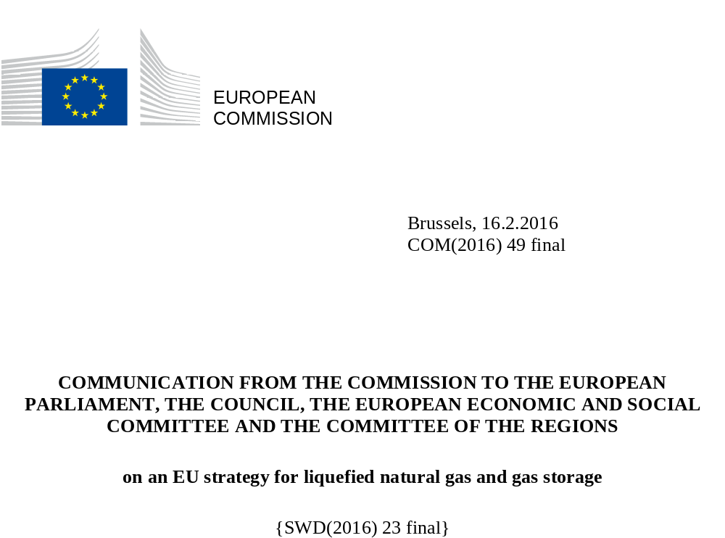

INTRODUCTION: EXPLOITING THE FULL POTENTIAL OF LNG AND STORAGE IN THE INTERNAL MARKET

The European Commission's "Framework Strategy for a Resilient Energy Union with a Forward-Looking Climate Change Policy" gives concrete expression to the EU's ambition to bring about a transition to a sustainable, secure and competitive energy system. Energy efficiency "as an energy source in its own right" and the development of low carbon sources such as renewables are paramount in this context.

As stressed in the State of the Energy Union, the geopolitical challenges linked to ensuring secure and resilient supplies of fossil fuels also remain significant, particularly as regards commodities for which the EU is highly dependent on imports. In this context the further diversification of the EU's natural gas supply remains a key objective, particularly as domestic production in the EU will continue to decline in coming decades. Vulnerability due to increasing import dependency can also be mitigated if the gas system remains flexible and able to respond to fluctuations in supply. The present strategy aims to exploit the potential of liquefied natural gas (LNG) and gas storage to make the EU gas system more diverse and flexible, thus contributing to the key Energy Union objective of a secure, resilient and competitive gas supply.

As regards LNG, the prospect of a dramatic (50%) expansion in global supply over the next few years and consequently of lower prices presents a major opportunity for the EU, particularly when it comes to gas security and resilience. While many Member States enjoy mature and liquid gas markets, as the 2014 EU Energy Security Strategy and the Communication on the short term resilience of the European gas system make clear, four Member States in the Baltic, central-eastern and south-eastern European regions are heavily dependent on a single supplier, and hence vulnerable to supply interruptions.

These Member States need rapidly to develop access to a diverse range of energy sources, and the availability of LNG could make a major contribution in this regard, alongside existing pipeline sources, gas storage, the development of both the Southern Gas Corridor and of liquid gas hubs in the Mediterranean. Energy efficiency measures and lower carbon sources such as renewables are also crucial, and care should be taken with regard to investment in LNG or gas infrastructure to avoid the risk of technology lock-in or stranded assets in fossil fuel infrastructure.

LNG can also bring benefits in terms of competitiveness, as markets become exposed to greater competitive challenges from international suppliers. In some cases the impact of such changes can be significant, as in the case of Lithuania.

To exploit the full potential of access to a growing international LNG market and to make the EU an attractive market for suppliers the EU needs to do three things:

Firstly, it needs to ensure that the necessary infrastructure is in place to complete the internal market and allow all Member States to benefit from access to international LNG markets, either directly or via other Member States. This is particularly urgent for Member States that are overly dependent on a single supplier.

Secondly, the EU needs to complete the internal gas market so that it sends the right price signals – both to attract LNG to where it is needed and to allow the necessary investments in infrastructure to take place.

Thirdly, the EU step up its efforts to cooperate closely with international partners to promote free, liquid and transparent global LNG markets. This means intensifying dialogues with current and future suppliers and other major LNG consumers to remove obstacles to the trading of LNG on global markets.

In addition to improving security and competitiveness, LNG has the potential in some cases to reduce environmental impacts, and hence support the EU's sustainability objective. A key sector in this respect is transport, where LNG will increasingly be used as an alternative to marine fuels in shipping and to diesel in heavy duty vehicles such as lorries. Small scale LNG may also play a role in reducing environmental impacts in the supply of heat and power, for example to industry or other consumers in remote and/or off-grid areas currently dependent on more polluting fossil fuels.

The changing situation on gas markets also means change for EU gas storage facilities, which play a key role in optimising gas infrastructure use and balancing the system. Robust and sufficient gas storage facilities are crucial to energy security and resilience in times of major supply disruption.

However, as with LNG, the full potential of storage to contribute to gas security and resilience is not currently being exploited. Investment in gas storage facilities is hampered by obstacles that reduce the cross-border availability of stored gas between Member States and by unfavourable market conditions. The profits of storage operations are under pressure and this may jeopardise not only future planned investments but also existing levels of storage capacity.

This strategy, which fulfils a commitment in the Energy Union Framework Strategy and has been prepared in consultation with a wide range of stakeholders, goes into the above issues in further detail and draws conclusions as to what specific measures may be necessary.
- COMPLETING MISSING INFRASTRUCTURE

LNG infrastructure

Over a number of decades, the EU has built up a very extensive gas grid stretching across the continent. In addition to significant domestic production, it benefits from pipeline connections to some of the world's largest gas supply sources, including Russia, Norway and Algeria.

The EU's current LNG terminals provide sufficient overall regasification capacity, with further additions planned. However, they are not optimally distributed across the EU, which is one of the factors contributing to the supply vulnerability of certain Member States that have little or no choice of gas supplier. At the same time, existing terminals across Europe have in recent years had a relatively low utilisation rate due to higher Asian LNG prices attracting cargos away from Europe and competition from pipeline gas.

The challenge of non-optimal distribution of LNG terminals can be tackled either by building new terminals in the appropriate locations or by improving access to existing terminals. Increased interconnection to liquid hubs where gas from existing LNG terminals or from pipeline sources is traded would improve security of supply for those Member States who currently have access to only a limited number of supply sources, while also helping to integrate markets across borders.

With any new infrastructure, the key issue is commercial viability. For an LNG terminal, that may depend on it having access to more than just a national market. Also, the emergence of floating storage and regasification units (FSRUs) as cost-effective solutions has also changed the dynamics of investment in import capacity. The example of the Klaipėda FSRU shows that just the prospect of a new LNG source in the market can drive improvements in terms of gas security of supply and price competitiveness.

Even with a sound business case, the financing of LNG terminals or other infrastructure investments may still face challenges. In principle, LNG terminals should be financed through tariffs but in some cases market participants bear the risk of the investment. EU funds can help to make up for the weak commercial viability of terminals that are particularly important for security of supply. European Investment Bank loans, including under the European Fund for Strategic Investments (EFSI), may be another source of long-term financing for LNG infrastructure. However, it is still important that the full economic case for new terminals be considered and the most cost-effective solutions be adopted.

Storage infrastructure

Total gas storage capacities in the EU have been growing strongly over the last 10 years and, combined with alternative flexibility mechanisms such as more fluid cross-border trade, pipeline swing and the increasing availability of LNG, this has led to some excess capacity in some areas and smaller differences between summer and winter gas prices. The availability and type of storage infrastructure differ significantly across the EU depending on energy mix, supply portfolio and geological situation.

In general, greater interconnectivity and regional cooperation could result in a better and more efficient use of storage. Also, some countries in the EU’s neighbourhood, such as Ukraine, have substantial storage capacity that could in principle be developed further and connected to the EU gas grid. If that capacity were available for supplies to the EU, the EU could optimise its own volumes of stored gas.

Although current storage capacity appears sufficient, interconnection and regulation still need to be adjusted to improve its cross-border and wider regional availability.

Connecting LNG and storage to markets

The TEN-E Regulation, adopted in 2013 together with the Connecting Europe Facility, has established a stable European policy framework for supporting also the EU's gas infrastructure (including transmission, LNG terminals and storage), identifying the projects Europe needs and ensuring their timely implementation.

Delivery of the TEN-E policy has been further reinforced through regional high-level groups focusing on the regions identified as vulnerable in the EU gas stress tests of 2014 and on ending the situation of the Iberian Peninsula as an 'energy island'. These groups have agreed on a limited number of key projects of common interest (PCIs) that should be implemented as a matter of priority and urgency.
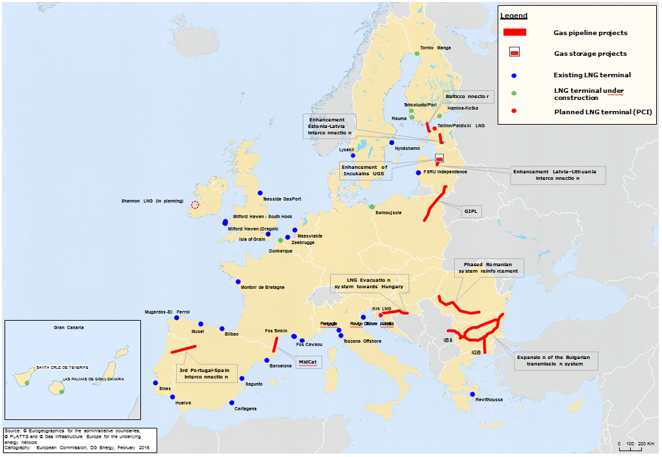
EU infrastructure relevant for the LNG and storage strategy. Missing links: Infrastructure to be built/reinforced to improve connections of LNG terminals to the internal market. The blue dots indicate existing LNG terminals.

The LNG and storage strategy identified a subset of these projects specifically contributing to its objectives (see map). Modelling shows that implementation of these key PCIs would end single-source dependency and give all Member States access to LNG, either via terminals or indirectly via interconnectors and/or access to liquid hubs. These projects would bring real gas security and price competition to EU markets. More specifically:

- the Central East South Europe Gas Connectivity group (CESEC) group identified six key priority projects that contribute to LNG access for all countries in the region along two main corridors from the Krk terminal towards the east and from Greece to the north;

- the Baltic Energy Market Interconnection Plan (BEMIP) group identified six key priority projects that contribute to LNG and storage access in the region by connecting the three Baltic states and Finland to the European network; and

- the South-West Europe high level group identified two projects that would serve to eliminate bottlenecks and connect regional markets.

Moreover, analysis has consistently highlighted Ireland as lacking diversity of supply and Cyprus and Malta as being energy islands.

The EU and Member States should commit themselves to moving towards rapid final investment decisions on these priority projects, the completion of which will ensure that the entire EU has access to multiple sources of gas. In doing so, they will go a long way towards providing all EU citizens with affordable and secure gas supply. The Commission will highlight progress and additional action needed on a project-by-project basis in its annual State of the Energy Union Report.

Action points:

- The Commission supports the work being carried out in the high-level groups mentioned above and encourages Member States and project promoters to accelerate final decisions on these key projects as a priority. It calls on Member States and the regional groups to make rapid progress in this respect and in reaching swift conclusions on the future viability of LNG terminals. Progress should be discussed in the recently launched Energy Infrastructure Forum;

- Work should be stepped up to complete the cost benefit analyses to determine which LNG terminals and/or further interconnections to link them to markets are most optimal; and

- In cooperation with the regional groups, the Commission should ensure that project promoters are aware of available project financing options (i.e. under the European Fund for Strategic Investments, the Connecting Europe facility, and, where relevant, European Regional Development Fund) and that technical solutions (such as FSRUs) are considered, paying particular attention to projects affected by barriers or delays.

- COMPLETING THE INTERNAL GAS MARKET: COMMERCIAL, LEGAL AND REGULATORY ASPECTS

Making the EU an attractive market for LNG

In addition to sufficient infrastructure, properly functioning and liquid gas markets are also required if EU consumers are to benefit from LNG's potential in terms of diversification and, at least in the short- to medium-term, as a highly competitive alternative to pipeline gas.

Substantial progress has been made in implementing existing EU energy legislation, in particular the Third Energy Package and the network codes. Continued implementation of all the provisions should ensure the emergence of a fully functioning internal gas market.

Like existing pipelines, existing LNG terminals, are subject to the Third Energy Package. While this aims to make the external entry points to the internal market more flexible and regards third-party access as the regulatory norm, a significant number of the LNG terminals are currently exempted from third-party access. In this regard, National Regulatory Authorities should:
- continue to ensure a level playing field for existing terminals;
- enable the introduction of new services, including those in relation to new technologies at LNG terminals; and
- continue to enforce transparent and effective market-based capacity allocation mechanisms at exempted LNG terminals, so as to attract new entrants to reach EU gas markets.

The easiest way for LNG supplies to change hands in European markets is through liquid gas hubs, where there are a high number of sellers and buyers and gas comes from several sources. Currently only a limited number of EU Member States have sufficiently liquid markets. In other parts of Europe, gas markets are far less developed: the central-, south-east and south-west regions do not have sufficiently liquid markets of their own and cannot access those in the north-west. There is a risk of countries in central- and southeast regions missing out on the benefits that access to international LNG markets – and gas market competition in general – can offer.

It is therefore crucial that Member States, in cooperation with national regulatory authorities (NRAs), take all necessary action to complete the internal gas market, eliminate the remaining regulatory, commercial and legal barriers and provide access for these markets to effective regional gas hubs. In several instances the regional approach has proven effective in launching countries on the right path to improving market functioning; these regional initiatives should also take on board the priorities of this strategy in order to make the EU an attractive market place for LNG.

Action points:
- In the context of BEMIP, the Commission invites NRAs to draw up an action plan, by mid-2016, identifying measures (i) to manage the end of the derogation under the Third Package, so as to open the Baltic gas market fully as soon as possible and (ii) to identify the necessary steps to creating a single market zone;
- In the context of CESEC, the Commission invites the NRAs to propose an ambitious roadmap of regulatory solutions by mid-2016 which will support the CESEC process, and to report regularly to the High Level Group and ministers on progress achieved in this regard; and
- In the context of the South-West Europe High Level Group, the Commission aims to work closely as a priority on both technical and political levels to support completion of the Eastern Gas Axis, which is needed to connect the Iberian Peninsula better to the internal gas market and allow access to liquid gas hubs, thereby contributing to the further diversification of the EU's gas portfolio.

Gas storage in the internal market

The regional context largely determines the need for and availability of storage capacity and the role that storage plays in gas supply and energy security. Accordingly, approaches to regulating storage vary widely between countries and regions.

Similarly, tariffs on transmission to and from storage vary considerably across the EU; in some cases suppliers have to pay twice, when injecting and when withdrawing gas. Such tariff structures may make storing gas less attractive and even, where tariffs are unduly high, uncompetitive. Therefore, the question of transmission tariffs to and from storage should be addressed in work to develop EU-wide network codes so as to ensure a level playing-field between competing flexibility instruments, and tariff structures should reflect costs.

Technological aspects of storage also need to be addressed to ensure that new storage facilities and gas infrastructure can in future accommodate different types of gas, including bio-methane and other renewable gases. This should in turn facilitate increased use of storage capacity for biogas and hence the transition to a low-carbon economy. However, storage operators face a declining spread between the gas price in summer and winter, resulting in lower profitability of gas storage, which makes storage sensitive to any cost increases.

To allow storage to reach its full potential as a flexible instrument and to ensure efficient use of infrastructure, regulators should allow and encourage storage operators to develop and provide new services that are freely tradable on secondary markets and across borders. Such developments and arrangements should not discriminate between storage users. Competition between operators will ensure that storage providers and their customers can negotiate contractual terms reflecting their needs in the most cost-efficient manner. A strict enforcement of competition rules will ensure that this in indeed the case.

The EU’s strategy on storage should also involve better-connected regional markets, as there is still potential for storage to benefit from synergies in the internal energy market. The effective use of storage sites will require Member States to cooperate closely on a regional basis and consult with neighbouring countries. Increased regional cooperation will improve trust as regards the availability and accessibility of storage facilities outside the territory of a given Member State.

In this context, and with regard to cooperation between Member States and regions, the allocation of storage and transmission capacity at interconnection points does not always appear to be satisfactorily harmonised and this may create congestion problems. With regard to storage and transmission capacity at interconnection points attribution processes should allow operators to book them simultaneously and an adequate time in advance of their needs; this could contribute for optimising the regional use of storage. The Commission encourages Member States to work and consult more closely with neighbouring countries on this issue.
Action points:

- The Commission calls on Member States to ensure adequate physical access to storage, including in terms of capacity in the transmission network

- The Commission encourages Member States to work closely with neighbouring countries to optimise the regional use of storage; and

- The Commission aims to optimise the use of storage through the completion and adjustment of network codes, where necessary.

Optimising the role of storage for security of gas supply

While available storage capacity in the EU appears adequate, there may be a risk of sites having to close if the volume of gas stored continues to fall. In most cases, it would be technically impossible to re-open storage capacity and any such closure would be permanent. This risk may arise as a result of the fact that the market does not fully reward the security-of-supply benefits of gas stored for crisis situations. Some Member States address this by using strategic reserves and storage obligations. Whereas volumes earmarked as strategic reserves are permanently withdrawn from the market, a storage obligation requires market participants to place and hold a certain minimum level of gas in storage at specific points in time, in particular during the winter.

However, to avoid unnecessary costs to the gas system that would reduce the overall competitiveness of gas vis-à-vis other fuels, these should be subject to strict conditions set out in detail in regional risk assessments, preventive action plans and emergency plans, as proposed under the revised Security of Supply (SoS) Regulation. In particular, Member States should ensure that such measures do not impact negatively on other Member States’ ability to ensure gas supply to their consumers or on the development of national gas markets.

To ensure that all market participants in Member States have access to sufficient storage on a regional basis, the Commission will work to remove existing barriers, including regulatory ones, preventing storage from competing as an instrument of supply flexibility and ensure, in the context of the regional preventive action and emergency plans, that it can achieve its full potential.

Action points:

- Building on the proposed revision of the Gas Security of Supply Regulation, the Commission calls on Member States to optimise the effectiveness and efficiency of the use of storage across borders through regional preventive action and emergency plans; and

- The Commission invites Member States to take action in the context of these plans to facilitate the availability of and access to storage on a wider regional level.

- THE EU AS A PLAYER ON INTERNATIONAL LNG MARKETS

International LNG markets are set for major change, with substantial liquefaction capacity coming on stream in Australia and the United States in the period to 2020 and potential for significant future supply from elsewhere, including the Mediterranean. LNG prices over the next few years are expected to be lower than in the recent past, and EU imports are therefore likely to increase.

A larger and more liquid global LNG market presents an opportunity for the EU. However the globalisation of the LNG market also has an important foreign policy dimension: as a major importer of LNG (the second largest after Japan), the EU has a keen interest in promoting free, liquid and transparent LNG markets around the world. To this end, the EU needs to work closely with international partners and in international fora to ensure that market participants are not prevented from establishing commercial relationships (for example by territorial restrictions) and that there are no limitations on free trade – either under normal market conditions or in the event of external shocks. EU energy diplomacy instruments, as described in the Energy Diplomacy Action Plan, should actively be deployed in pursuit of this aim in bilateral and multilateral contexts, as set out in the action points below.

Action points:
- The Commission, together with the High Representative and Vice-President, should pursue regular discussions on LNG with Australia and continue to work closely with other current and potential suppliers such as Qatar, Nigeria, Egypt, Angola, Mozambique, Tanzania, Israel, Lebanon, Iran, Iraq and Libya. Priority should also continue to be given to high level energy dialogues with Algeria, the US and Canada.
- The EU should work closely with other major LNG importers such as Japan, notably in the context of its G7 Presidency in 2016, South Korea, China and India, with the International Energy Agency, and in multilateral fora to pursue common interests in promoting transparent and liquid LNG markets resilient to external shocks.
- In line with the revision of the Inter-Governmental Agreements (IGA) Decision published alongside this Communication, the Commission should check that relevant IGAs, including those between Member States and non-EU countries on LNG, are in compliance with EU law.

- SUSTAINABILITY AND THE USE OF LNG AS AN ALTERNATIVE FUEL IN TRANSPORT, HEAT AND POWER

As noted in the introduction, LNG has the potential in some cases to reduce current environmental impacts, for example in the transport sector when it replaces fuels such as diesel or heavy fuel oil. The use of LNG in lorries and shipping can reduce emissions of various pollutants and in the case of shipping, can allow the sector to meet the requirements for decreasing the sulphur and nitrogen content in marine fuels used in the Emission Control Areas. In both cases the use of LNG can reduce greenhouse gas emissions, in particular when blended with liquid biomethane, provided methane emissions are minimised (see below). Similar considerations can apply to small scale LNG use for heat and power, and the EU should continue to support the growth of LNG as an alternative fuel where it replaces more polluting conventional fuels and does not take the place of renewable energy sources, consistent with sustainability goals.

The precise environmental impacts will depend on a range of factors at different points in the LNG supply chain, and should be assessed case by case. A key factor in this regard (as for pipelines and for natural gas use in general), is the extent of any methane emissions, and manufacturers and operators of all LNG supply facilities or technologies should aim to minimise such emissions and hence the overall greenhouse gas impact of LNG use.

Another key factor is the long term availability of lower carbon alternatives. Renewable energy sources and/or energy efficiency can be highly cost-effective solutions in many cases and such options should be considered carefully alongside any decisions on LNG infrastructure – particularly in the interests of avoiding technology lock-in or stranded assets. Further detail on the above issues can be found in the staff working document accompanying this Communication.

Action points:
- The Commission calls on Member States ensure full implementation of Directive 2014/94/EU on alternative fuels, including the establishment of LNG refuelling points across the TEN-T corridors and at maritime and inland ports.
- The Commission continues to pursue its works to establish a harmonised regulatory and standardisation framework that encourages the development of LNG in shipping, in cooperation with stakeholders inter alia through the European Sustainable Shipping Forum.

CONCLUSIONS

The creation of liquid and competitive markets so that LNG and other new gas supplies can reach and compete in previously isolated markets is of fundamental importance to achieving the objectives of the Energy Union. The Commission's analysis indicates that full implementation of the key PCIs highlighted by the high level groups will remove, or at least mitigate, the main vulnerabilities identified by the gas stress tests. It is therefore vital that the missing infrastructure links rapidly be constructed, and the requisite measures taken to promote liquid and competitive markets, including those to enable access to LNG and to promote new liquid hubs in the central and south eastern, Baltic and south western regions and the Mediterranean.

Where the geological conditions allow for it, storage plays a major role in balancing the usual daily and seasonal fluctuation of supply and demand. However, the effectiveness and efficiency of the use of storage across Member States' borders and at regional level, both under normal market conditions and in crisis situations, could be improved. This should be addressed in the future regional preventive action and emergency plans under the proposed revision of the gas SoS Regulation.

The measures identified in this Communication go to the heart of the Energy Union and have the potential to achieve the aim of a secure and competitive gas market across the EU, but will require resolute action, particularly at Member State and regional level. The Commission will report on progress as regards the strategic LNG and storage objectives presented here in its annual State of the Energy Union, identifying, any additional measures required.

COM(2015)80.
COM(2015)572.
COM(2014)330
COM(2014)654
As part of this the Commission conducted a three-month public consultation – the results of this are discussed further in the Commission staff working document accompanying this Communication.
A table showing the import capacity of existing and planned LNG terminals is included in section 4 of the staff working document (SWD(2016)23).
20% compared to the global average of 33%. See also staff working document.
The project at Krk (Croatia) is a clear example of this.
Due to lower investment costs and shorter lead times. The last six LNG terminals established have all been FSRUs.
See section 4 of staff working document
Exempted terminals; see also sections 3 and 4 of staff working document
No State aid would in principle be allowed if the under-utilisation of existing relevant infrastructures indicates that no new infrastructure is needed.
See section 5 of staff working document.
See also section 5 of staff working document.
Regulation (EU) No 347/2013 on guidelines for trans-European energy infrastructure; OJ L 115, 25.4.2013, p. 39-75.
The second Union list of projects of common interest (PCIs) was adopted on 18 November 2015. C(2015) 8052 final
The Ten Year Network Development Plan 2015 identified the Iberian Peninsula as an area lacking integration with the rest of the EU and therefore exposed to price volatility on the global LNG market.
A detailed list and project descriptions can be found in section 7 of the staff working document
The results of the modelling both for LNG and storage and further background can be found in section 8 of the staff working document.
Modelling also shows the need to complete the North-South corridor in central Europe to allow gas to move freely in all directions.
Competition rules are also being strictly enforced, thereby preventing distortions of the internal gas market and enhancing security of supply
See section 4 of staff working document
These markets cover some 75% of total EU gas demand (source: ACER based on Gas Target Model)
Notably BEMIP, CESEC, and South-West Europe
See section 5 of staff working document.
See section 6 of staff working document for more details.
Proposal for a Regulation of the European Parliament and of the Council concerning measures to safeguard security of gas supply and repealing Council Regulation 994/210.
See section 2 of the staff working document

