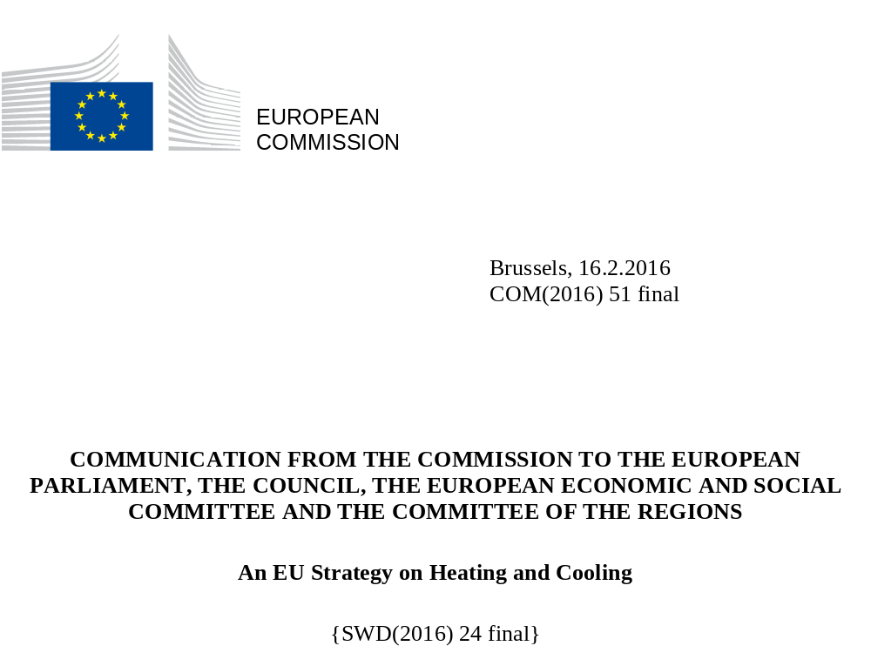

Introduction
Heating and cooling consume half of the EU's energy and much of it is wasted. Developing a strategy to make heating and cooling more efficient and sustainable is a priority for the Energy Union. It should help to reduce energy imports and dependency, to cut costs for households and businesses, and to deliver the EU's greenhouse gas emission reduction goal and meet its commitment under the climate agreement reached at the COP21 climate conference in Paris.
Although the heating and cooling sector is moving to clean low carbon energy, 75% of the fuel it uses still comes from fossil fuels (nearly half from gas). While this strategy will contribute to reducing import dependency, security of supply remains a priority, especially in Member States that rely on a single supplier.
Heating and cooling and the electricity system can support each other in the effort to decarbonise. It is essential to recognise the links between them and exploit synergies.
This strategy provides a framework for integrating efficient heating and cooling into EU energy policies by focusing action on stopping the energy leakage from buildings, maximising the efficiency and sustainability of heating and cooling systems, supporting efficiency in industry and reaping the benefits of integrating heating and cooling into the electricity system. It is accompanied by a Staff Working Document giving an overview of this complex sector. The solutions will be examined in the ongoing reviews of legislation under the Energy Union.
A smarter and more sustainable use of heating and cooling is within reach as the technology is available. Actions can be deployed rapidly, without prior investment in new infrastructure, and with substantial benefits for both the economy and individual consumers, provided that (household) consumers can afford to invest or have access to the finance needed to do so.

Vision and Goals
To achieve our decarbonisation objectives, buildings must be decarbonized. This entails renovating the existing building stock, along with intensified efforts in energy efficiency and renewable energy, supported by decarbonized electricity and district heating. Buildings can use automation and controls to serve their occupants better, and to provide flexibility for the electricity system through reducing and shifting demand, and thermal storage.
Industry can move in the same direction, taking advantage of the economic case for efficiency and new technical solutions to use more renewable energy. In this sector, however, some fossil fuel demand can be expected for very high temperature processes. Industrial processes will continue to produce waste heat and cold, as will infrastructure. Much of it could be reused in buildings nearby.
While this is a vision for the longer term, big gains can be reaped immediately.

Challenges
With 50% (546 Mtoe) of final energy consumption in 2012, heating and cooling is the EU’s biggest energy sector. It is expected to remain so.
Renewables accounted for 18% of the primary energy supply for heating and cooling in 2012, while fossil fuels accounted for 75%.
Figure 1: Primary energy for heating and cooling, 2012
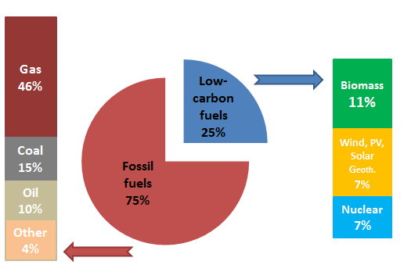

With the EU targets for 2020, renewable energy is growing. In their National Renewable Energy Action Plans, each Member State adopted a renewable energy target for heating and cooling. Most are on track to achieve them; some are switching faster than planned. Renewable energy sources (RES) share of energy used in heating is highest in Baltic and Nordic Member States (ranging from 43% in Estonia to 67% in Sweden). Biomass is the most widely used renewable energy for heating today, representing some 90% of all renewable heating. The Commission will propose at the end of 2016 a bioenergy sustainability policy, which will take into account the impact of bioenergy on the environment, land-use and food production.

Figure 2: Final energy consumption for heating and cooling, 2012

45% of energy for heating and cooling in the EU is used in the residential sector, 37% in industry and 18% in services. Each sector has potential to reduce demand, increase efficiency and shift to renewable sources.
Barriers to energy renovation of buildings
Buildings (and people living in them) are the first consumers of heating and cooling. Space heating accounts for more than 80% of heating and cooling consumption in colder climates. In warmer climates, space cooling is the most important - and is growing.
Buildings frequently lose heat or cold due to poor quality. Two thirds of the EU's buildings were built when energy efficiency requirements were limited or non-existent; most of these will still be standing in 2050. Big savings can be made through simple renovations such as insulating the attic, walls and foundations, and installing double or triple glazing. These are cheapest when they are done as part of other building works. Nature-based solutions, such as well-designed street vegetation, green roofs and walls providing insulation and shade to buildings also reduce energy demand by limiting the need for heating and cooling.
Different forms of building ownership require different measures to drive energy-efficient renovation.
Around 70% of the EU population lives in privately owned residential buildings. Owners often do not undertake cost-efficient renovations because they lack awareness of the benefits, lack advice on the technical possibilities, face split incentives (for instance in multi-apartment buildings) and have financing constraints.
In privately-owned rented buildings – a large share in some countries – the main challenges are split incentives, tenancy rules and finance. Incentives are 'split' in the sense that property owners have little incentive to invest if the tenant pays the energy bill. Some countries have systems under which lower energy costs due to energy efficiency improvements can be used to justify an increase in the rent.
Buildings owned by public bodies, including social housing, account for a considerable share of the stock. Buildings like schools, universities and hospitals are highly visible and often energy intensive.
The main challenge for renovation of public buildings is shortage of funds. Energy Performance Contracting and Energy Service Companies (ESCOs) can offer technical assistance, expertise and access to capital. In the US, it is standard practice to involve ESCOs in refurbishing public sector buildings, and the sector has revenues of more than USD 6 billion. In the EU, this market is underdeveloped.
Service buildings, such as banks, offices and shops, make up a quarter of the stock. Energy consumption per square meter is on average 40% higher than in residential buildings. Electricity consumption is particularly high with complex systems for lighting, air conditioning or ventilation. This sector also consumes most of Europe's space cooling. Refrigeration demand is high in supermarkets (where it typically accounts for more than 40% of energy consumption) and data centres (25-60% of operating costs).
Lack of expertise and training affects all sectors. Too few professionals have the required expertise in energy efficient construction and in efficient and renewable energy technologies. Architects can incorporate advanced design and construction materials and smart technologies into all aspects of buildings, from insulation to lighting. But installers are the “market makers” for many technologies.
On average, Europeans spend 6% of their consumption expenditure on heating and cooling; 11% cannot afford to keep their homes warm enough in winter. Consumer choice is limited by a lack of information on actual energy consumption and costs, and often by lack of financial means to invest in the most efficient technology. It is difficult to compare technologies and solutions on the basis of lifetime costs and benefits, quality and reliability.
Financing
Despite the compelling economic rationale, there are few attractive financial products for building renovation.
The EU budget for 2014-2020 significantly increased its contribution. The European Structural and Investment Funds (ESIF) will allocate some EUR 19 billion for energy efficiency and EUR 6 billion for renewable energy, notably in buildings and district heating and cooling, around EUR 1 billion for smart distribution grids, and funding for research and innovation based also on priorities chosen in the national or regional Smart Specialisation Strategies. The Horizon 2020 research and innovation programme will allocate EUR 2.5 billion for energy efficiency and EUR 1.85 billion for renewable energy. Furthermore, due to the European Fund for Strategic Investments based on the EU guarantee, mobilisation of at least 315 billion EUR of additional investment is expected. Boosting investment in sustainable energy projects is one of strategic priorities of EFSI and some of them have been already approved.
But public finance neither can nor should play the primary role. The energy efficiency market must mature and become fully investible. As confirmed in the report from the Energy Efficiency Financial Institutions Group (EEFIG), project promoters and investors still need to understand and trust that energy cost savings lead to additional available cash-flow and better energy performance leads to higher asset values. The Commission will address these issues under the 'Smart Finance for Smart Buildings' initiative, in cooperation with EEFIG, as announced in the Energy Union Strategy.

Heating and cooling equipment
Almost half of the EU's buildings have individual boilers installed before 1992, with efficiency of 60% or less. 22% of individual gas boilers, 34% of direct electric heaters, 47% of oil boilers and 58% of coal boilers are older than their technical lifetime.
Decisions on replacing old appliances are typically made under pressure, when the heating system breaks down. Comparison of prices between solutions, as well as information on how their existing system performs, is not easily available for most consumers. This leads them to continue using older, less efficient technologies.
In some parts of Europe, up to three quarters of outdoor fine particulate matter pollution is attributable to household heating with solid fuels (including coal and biomass). The Commission has initiated infringement procedures on ambient air quality against several Member States, referring two cases regarding persistently high levels of fine particulate matter to the European Court of Justice in 2015. The Commission warns about the negative impact on air quality from the use of coal (lignite) and boilers and stoves with poor emission standards for heating as healthier solutions are available, easily accessible and more efficient and cheaper in the long run.
Ecodesign and energy labelling requirements for space and water heaters came into application in 2015. The sale of inefficient boilers is now banned. Consumers see efficiency ratings – both for single technologies and for packages that include the use of renewables. The transition that these measures are expected to foster should bring annual energy savings of 600 TWh and CO₂ emission reductions of 135 million tonnes by 2030. At the same time, emissions of air pollutants will also be reduced.
The new Regulation on fluorinated greenhouse gases will also accelerate the refurbishment of heating and cooling. Climate-friendly refrigerants offer great energy saving potentials, but require for some applications an update of existing standards to ensure their safe use. To that end the Commission has initiated the process of reviewing the relevant European standards.
A good time to replace an old heating system is when a building is refurbished. Transformation to an efficient building makes it possible to shift to heat pumps, solar or geothermal heating or waste heat. These appliances save costs. Heat pumps can turn one unit of electricity or gas into 3 or more units of heating or cooling, while solar thermal does not need fuel input for heating. In addition, there is a number of innovative highly efficient technologies that quickly approach market-readiness, such as stationary fuel cells.
Figure 3: Efficiency rating of new space heating appliances
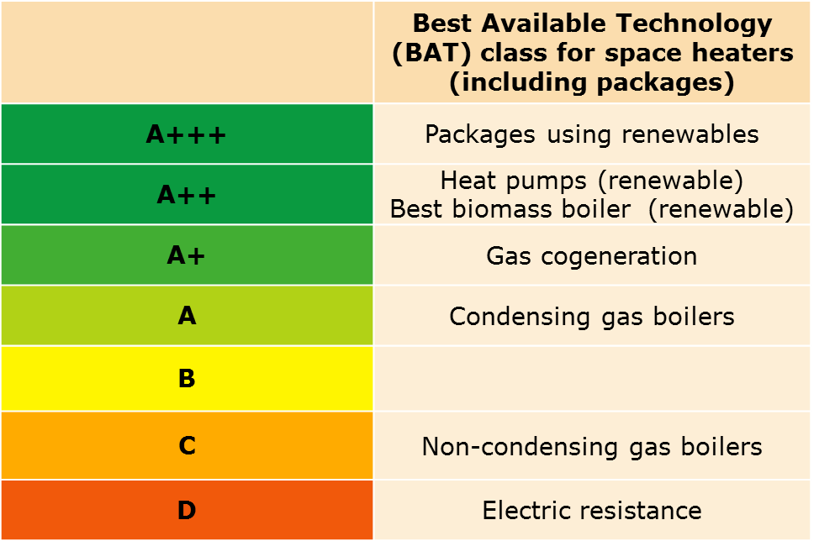
A wide range of renewable heating and cooling solutions is available and scaling-up the market would reduce their price. The Energy Labelling Directive (2010/30/EU) states that Member State incentives for products such as heaters need to aim at the highest performance levels. In line with the G20 2020 statement about inefficient fossil fuel subsidies, the Commission is calling on Member States to focus incentives on non-fossil fuel based heating and cooling technologies.
Cooling comes mostly from electric devices, although there are promising innovative low energy cooling technologies. A recently adopted ecodesign regulation covering cooling products completes the set of requirements for heating and cooling. It will bring fuel savings of 5 Mtoe per year in 2030, corresponding to 9 million tonnes of CO₂.

Industry
Industry accounted for a quarter of the EU's final energy consumption in 2012. 73% of this is used for heating and cooling. European industry has cut its energy intensity twice as fast as the US since 2000. The improvement rate is steeper in energy intensive sectors. The reason is clear: energy is an important cost. By putting a price on CO₂ emissions, the EU Emissions Trading Scheme has provided an incentive to use low carbon fuels and to invest in energy efficiency.
Significant potential remains. Using existing technologies, it is possible to reduce energy costs in industry by 4-10% with investments that pay for themselves in less than 5 years. However, the visibility of energy savings is low.
Collectively, SMEs' energy demand is considerable. They often have fewer resources and less access to finance to make improvements. They may lack the capacity to run such projects and, not having a direct carbon-price incentive, they rarely view energy efficiency as a priority, especially in their early years.
Financial institutions often remain reluctant to provide financial products due to perceived risks.
The use of renewable energy in industry is limited. Nearly all is biomass, despite the market maturity – at least for low-temperature heat – of heat pumps, solar and geothermal. With technological development, more applications for medium-temperature heat (up to 250°C) will become market feasible.

Waste heat and cold
Some industries generate heat as a by-product. Much more of this could be reused within plants or sold to heat buildings nearby. The same applies to waste heat from power stations, the service sector and infrastructure such as metros.
Waste cold is generated in sites such as liquefied natural gas terminals and gas grids. It is rarely reused, although the technology to do so is already used on a commercial basis in some district cooling systems. Integrating the production, consumption and reuse of waste cold creates environmental and economic benefits and reduces the primary energy demand for cold.
The barriers to the use of these resources are lack of awareness and of information on the resource available; inadequate business models and incentives; a lack of heat networks; and lack of cooperation between industry and district heating companies.

Synergies in the energy system
The future electricity grid will integrate more renewable energy, especially wind and solar including decentralised supplies. So supply and demand must become more flexible, through wider use of demand reduction, demand response mechanisms and energy storage.
Linking heating and cooling with electricity networks will reduce the cost of the energy system – to the benefit of consumers. For example, off-peak electricity can be used to heat water in lagged tanks which can store energy for days and even weeks.

District heating and cooling
District heating provides 9% of the EU's heating. In 2012 the main fuel was gas (40%), followed by coal (29%) and biomass (16%). District heating can integrate renewable electricity (through heat pumps), geothermal and solar thermal energy, waste heat and municipal waste. It can offer flexibility to the energy system by cheaply storing thermal energy, for instance in hot water tanks or underground.
District heating has long traditions in Member States with cold winters. In some countries, district heating is seen as an attractive option for companies and consumers and as a means of improving energy efficiency and renewables deployment. Elsewhere, though, old systems have shrunk due to lack of investment or unfavourable price regulation, low performance and negative consumer perceptions. Some Member States are making efforts to modernise and expand old systems – others, where the technology is hardly known, are building new ones. District heating and cooling can also contribute to air quality objectives, especially if it substitutes or avoids solid fuel domestic heating.
Synergies between waste-to-energy processes and district heating/cooling could provide a secure, renewable, and in some cases, more affordable energy in displacing fossil fuels. A forthcoming Commission's Communication on waste-to-energy will address this issue in detail.

Cogeneration of heat and power (CHP)
CHP can produce significant energy and CO₂ savings compared with separate generation of heat and power. It is used in industry and the services sector to save money and ensure a stable and reliable heat and electricity supply.
Combination with thermal storage increases the efficiency of CHP as heat production can be stored rather than curtailed if not needed at that moment. Many CHP technologies are capable of using renewable energy (geothermal, biogas), alternative fuels (e.g. hydrogen) and waste heat. Tri-generation should also be exploited to use the heat production for cooling in summer.
The economic potential of cogeneration is not being exploited. The sector faces barriers such as the complex need to comply with both electricity and heat supply regulations. Smaller units face grid connection and grid access barriers, such as slow processes for granting permits and high charges. These regulatory and administrative barriers have not been fully addressed yet by Member States.

Smart buildings
A smart building connected to a smart grid allows remote or automatic control of heating and cooling, water heating, appliances and lighting depending on the time and date, humidity, outdoor temperature, and whether the building is occupied.
The automatic management of energy demand in buildings allows consumers to take part in demand response, adjusting the timing of their consumption in response to the price of electricity.
The trend for businesses and households to produce their own electricity opens new cost-containment opportunities. In addition to allowing active participation in energy markets, self-consumption can lower energy system costs e.g. solar PV can meet peak demand for electricity for air conditioning. Generating and consuming electricity locally can also reduce losses to the system and increase its resilience.

Tools and solutions
Heating and cooling are produced locally in markets that are fragmented. Tackling the obstacles to more efficient and sustainable heating and cooling will require action at local, regional and national level, within a supportive European framework.
Under the Energy Efficiency Directive (EED), Member States have already developed National Energy Efficiency Action Plans setting out actions to reduce demand for heating and cooling; building renovation strategies which provide a better framework for investment; and comprehensive assessments of the potential for high-efficiency cogeneration and district heating.
The Commission invites Member States:
- To review their property laws to address how to share gains from energy improvements in private rented properties between landlords and tenants, and how to share benefits and costs among residents of multi-apartment buildings. This could be set out in the legal status of condominiums or the regulation of building associations;

- To ensure that a share of energy efficiency funding is dedicated to improvements for energy-poor households or (as a proxy) for those living in the most deprived areas, for example, by investing in energy-efficient heating and cooling equipment;

- To work with stakeholders to raise consumer awareness of household energy efficiency aspects, and especially with bodies, such as consumer associations, that can advise consumers about efficient and sustainable forms of heating, cooling and insulation;
- To stimulate the take-up of the recommendations of company energy audits;
- To support local and regional actors who can improve the bankability of investments through ‘bundling’ individual projects into bigger investment packages. Initiatives such as the ELENA Facility, Smart Cities and Communities and the new integrated Covenant of Mayors for Climate & Energy could encourage this approach.
As part of the Energy Union governance, Member States' national energy and climate plans should integrate the heating and cooling sector.

Buildings
The Energy Performance of Buildings Directive (EPBD) lays down a framework for improving the energy performance of Europe's building stock. The uptake of energy performance requirements will gradually reduce energy demand and increase supply from renewable sources. However, the rate of building renovation is low (0.4 to 1.2% per year).
As part of the review of the EPBD (including REFIT component) in 2016, the Commission will look into strengthening the reliability of energy performance certificates and reinforcing their signals for renewable energy.
The Commission will examine:
- Developing a toolbox of measures to facilitate renovation in multi-apartment buildings;

- Promoting proven energy efficiency models for publicly owned educational buildings and hospitals;

- Using inspections of boilers to provide information on the efficiency of existing heating and cooling systems;

- Facilitating the market uptake of voluntary certification schemes for non-residential buildings.

The EED established consumer rights to information on heating and cooling consumption. However, the frequency of metering and billing information may still not be sufficient to provide consumers with real- or near- time consumption data. When preparing the review of the energy efficiency legislation and the electricity market design initiative in 2016, the Commission will look into:
- Strengthened feedback to consumers through advanced metering and billing;

- Making advanced tools for metering, control and automation based on real time information standard requirements for service sector buildings;

- Empowering consumers to participate in demand response, thus saving them money.

Renewable-based and efficient heating and cooling
In the reviews of the EPBD, the EED and the Renewable Energy Directive, the Commission will look into:
- Promoting renewable energy through a comprehensive approach to speed up the replacement of obsolete fossil fuel boilers with efficient renewable heating and increasing the deployment of renewable energy in district heating and CHP;

- Supporting local authorities in preparing strategies for the promotion of renewable heating and cooling;

- Setting up a website with price comparison tools on the lifetime costs and benefits of heating and cooling systems.

Smart systems
Smart grids, smart metering, smart homes and buildings, self-generation and thermal and electrical and chemical storage need to be promoted by a modern market design.
As part of the Electricity Market Design, Renewable Energy Directive and EED reviews, the Commission will look into:
- Rules to integrate thermal storage (in buildings and district heating) into flexibility and balancing mechanisms of the grid;
- Incentivising citizen participation in the energy market through decentralised production and consumption of electricity;
- Incentivising the uptake of renewable energy in heat production, including CHP;
- Incentivising the take-up of fully interoperable smart buildings solutions, systems and appliances.
The Commission will:
- Intensify cooperation with European consumer associations;

- Extend the work of the BUILD UP skills campaign to improve training for building professionals, in particular through a new module for energy experts and architects ;
- Set up sectoral round tables with industry and develop benchmarks/guidance for best practice on energy efficiency and renewable energy. Such round table could also feed information into the Best Available Techniques Reference Documents under the Industrial Emissions Directive;
- Provide guidance for companies in identifying cost saving opportunities from energy audits and Energy Management System;
- Assess good practice in how Member States can stimulate the take-up of the recommendations of company energy audits.

Innovation
Under the Strategic Energy Technology Plan the Commission will:
- Integrate the results of the industrial sectoral round tables into EU R&D initiatives;
- Promote renewable and waste heat based CHP;
- Examine new approaches to low temperature heating in industry;
- Develop advanced materials and industrialised construction processes with the construction sector and leading institutions in materials and industry.
Research, innovation and demonstration actions funded by Horizon 2020 will also support the EU strategy on heating and cooling.

In addition, the Commission will support the use of ESIF for the implementation of the national and regional heating and cooling-related smart specialisation priorities.

Financing
Under the 'Smart Finance for Smart Buildings' initiative the Commission will:
- Facilitate the aggregation of small projects into investible packages, and, with EEFIG, test a framework for underwriting procedures for financial institutions to incorporate impacts of energy efficiency in everyday market practice;

- Encourage Member States to establish one stop shops for low-carbon investments (encompassing advisory services, Project Development Assistance and project financing);

- Encourage retail banks to offer products adapted for renovation of privately rented buildings (e.g. deferred mortgages, term loans) and disseminate best practices, also in relation to tax treatment of renovation;

Conclusions
Consumers must be at the centre of this strategy, using modern technologies and innovative solutions to shift to a smart, efficient and sustainable heating and cooling system that can unlock energy and budgetary savings for companies and citizens, improve air quality, increase well-being for individuals and provide benefits to society as a whole.
This strategy builds on a solid base in EU legislation and identifies areas where update or reform is needed to become future-proof and deliver on the Energy Union objectives. In its 2016 impact assessments for the reviews of the EPBD, the EED, the Renewable Energy Directive and for the new Market Design Initiative, the Commission will analyse different options to help buildings and industry shift to efficient, decarbonised energy systems based on renewable energy sources and the use of waste heat. These analyses will include district heating and cooling and electrification of heating through heat pumps. They will study how to expand demand response and reduction and the use of thermal storage in the electricity system, how to create the right incentives for the deployment of smart technologies, and how to increase the effectiveness of public funds and mobilise private investors.
The Commission calls on the European Parliament and Council to endorse this strategy.

COM(2015) 80 final.
See accompanying Proposal for a Regulation concerning measures to safeguard the security of gas supply and Communication on an EU strategy for liquefied natural gas and gas storage.
SWD(2016)24. Sources for the data in this document can be found there.
684 Mtoe of primary energy.
COM(2015) 293 final.
Given the long lifetime of buildings, it is essential to encourage design improvements that will reduce their environmental impacts and increase the durability and recyclability of their components in line with the Circular Economy Communication (COM(2015) 614 final).
Energy Performance Contracting allows energy upgrades to be funded from cost reductions. An ESCO implements a project to deliver energy efficiency or renewable energy, and uses the cost savings/renewable energy sales to repay the costs.
The service sector consumed 96 Mtoe of final energy in 2012 for heating and cooling. Space heating accounted for 62% of this; cooling for 19%; hot water for 14%; and process heating for 5%.
EEFIG (www.eefig.eu) was set up by the European Commission and the United Nations Environment Programme Finance Initiative in 2013 to increase energy efficiency investments across the EU.
Directive 2008/50/EC.
In some Member States the use of biomass in households contributes to more than 50% of their national emissions of particulate matter.
EU Regulation 517/2014.
Packages of space or combination heaters, temperature control and solar device ranked A+++ include a heat pump or a heater using fossil fuel or biomass, temperature controls and a solar device.
The chemical sector halved its energy intensity over the last 20 years.
Several small solar thermal process heat systems exist in Europe with heat costs between €38 and €120 per MWh. At present solar heat can mainly be used for processes ranging from 20°C to 100°C.
The technical potential has been estimated to cover all the EU’s space heating demand; the economically recoverable potential, however, requires analysis of local conditions.
Tri-generation refers to the simultaneous generation of three forms of energy - heating, power and cooling.
This is being introduced for instance in Germany. Boilers older than 15 years will have to be labelled by experts.
BUILD UP Skills is a Commission initiative to boost the education and training of craftsmen and other on-site construction workers and system installers in the building sector. The aim is to increase the number of workers qualified to deliver nearly-zero-energy buildings and renovations to high energy performance.

