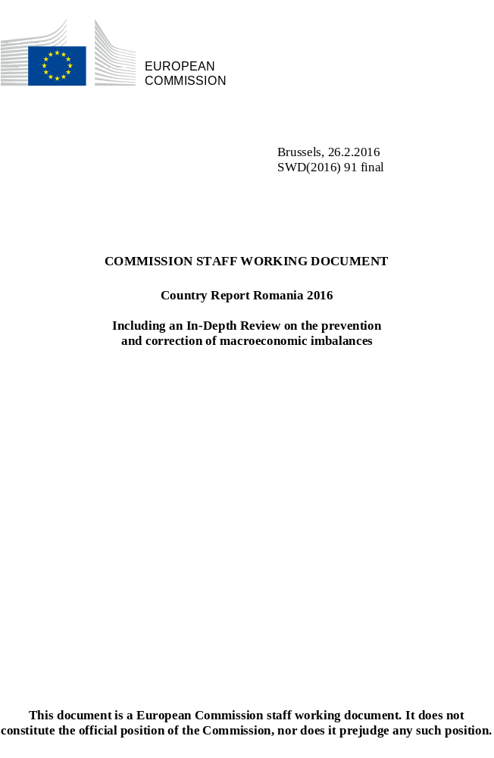

Contents
Executive summary 1
1. Scene setter: Economic situation and outlook 4
2. Imbalances, risks, and adjustment issues 14
2.1 External balance and competitiveness 14
2.2. Financial sector 26
2.3. Medium-term risks of imbalances 32
2.4. MIP assessment matrix 43
3. Additional structural issues 45
3.1 governance and Business environment 45
3.2. Labour market, social protection, health and education 55
3.3. Development challenges of the rural areas 63
A. Overview Table 67
B. MIP scoreboard 74
C. Standard Tables 75

LIST OF Tables
1.1. EU funds absorption (programme 2007-2013) 8
1.2. Key economic, financial and social indicators 13
2.3.1. Public sector wages adopted in 2015 and special pensions reintroduced in 2015 33
2.4.1. MIP assessment matrix*- Romania 43
3.1.1. Paying taxes indicators 47
B.1. MIP scoreboard 74
C.1. Financial market indicators 75
C.2. Labour market and social indicators 76
C.3. Labour market and social indicators (continued) 77
C.4. Structural policy and business environment indicators 78
C.5. Green growth 79

LIST OF Graphs
1.1. Real GDP growth and contributions, output gap 4
1.2. Components of potential growth 5
1.3. Inflation 6
1.4. Key employment indicators 6
1.5. Deficit, structural balance and MTO 7
1.6. Tax revenue* as % of GDP, 2014 7
2.1.1. Net international investment position in Romania and peer countries 14
2.1.2. NIIP financing 15
2.1.3. Inward FDI flows by activity 15
2.1.4. NIIP sensitivity to macroeconomic shocks 16
2.1.5. The importance of structural funds for Romania's NIIP 16
2.1.6. Current account balance by components 16
2.1.7. Cyclical and non-cyclical current account balance 17
2.1.8. Balance of goods and services 17
2.1.9. Energy dependence 18
2.1.10. Imports of capital, consumption and intermediate goods 18
2.1.11. Savings-investment gap and the current account 18
2.1.12. Geographical specialisation 19
2.1.13. Product specialisation 19
2.1.14. Change in real effective exchange rate 20
2.1.15. Unit labour costs by components 20
2.1.16. Wage growth and internal equilibrium wage growth rate 20
2.1.17. Unit labour costs versus export market shares 21
2.1.18. Labour productivity (in thousand RON) 21
2.1.19. Nominal unit labour costs in the tradable and non-tradable sectors 21
2.1.20. Quality of exports 22
2.1.21. Share of high-tech products in exports in Romania and peer countries 22
2.1.22. Compensation of employees by sector 23
2.2.1. Non-performing loans 26
2.2.2. Return on assets, return on equity, net profit 26
2.3.1. Real and potential GDP, 2000-2017 32
2.3.2. Debt sustainability 34
2.3.3. Credit developments — stocks 35
2.3.4. Domestic credit in foreign and local currency 36
2.3.5. Credit developments 2000-2015 36
2.3.6. Evolution of the house price index and monetary financial institutions (MFI) loans for house purchases 37
2.3.7. Quality of public infrastructure index, Romania and regional peers 37
2.3.8. Public investment as % of GDP 38
2.3.9. Capital expenditures, budget data 38
2.3.10. EU funds absorption (SCF) 38
2.3.11. EU funds absorption per Operational Programme 39
2.3.12. EIB lending 2010-2014, Romania and regional peers 39
2.3.13. Developments in R&D intensity 41
3.1.1. Number of reorganisations of public authorities and institutions as approved by the Civil Service Agency 46
3.1.2. ICT share of GDP 52
3.1.3. Digital economy and society index, performance 53
3.2.1. Mobility rate 55
3.2.2. Employment growth, selected sectors 55
3.2.3. Youth: in education and training, employment rate, unemployment rate, unemployment-to-population ratio, NEET 56
3.2.4. Changes in labour market status of long-term unemployed, 2014 56
3.2.5. Early leavers from education and training 58
3.2.6. At-risk-of-poverty or social exclusion rate and its components 59
3.2.7. Poverty reduction impact of social transfers 60
3.3.1. Employment by status in employment and by urban/rural area, 2014 63
3.3.2. Distribution of farms, per utilised agricultural area, 2013 64
3.3.3. Rate of early school leaving by degree of urbanisation 65
3.3.4. Infant mortality rate 65
3.3.5. Percentage of households with indoor flushing toilet 66
3.3.6. Length of public roads by type of road surface 66

LIST OF Boxes
1.1. Investment challenges 10
1.2. European Structural and Investment Funds 12
2.1.1. Minimum wage developments 24

Executive summary
This report assesses Romania's economy in the light of the European Commission's 2016 Annual Growth Survey published on 26 November 2015. The survey recommends three priorities for the EU's economic and social policy 2016: re-launching investment, pursuing structural reforms to modernise Member States' economies and responsible fiscal policies. At the same time, the Commission published the Alert Mechanism Report that initiated the fifth annual round of the macroeconomic imbalance procedure. The Alert Mechanism Report identified Romania as warranting a further in-depth review.
Economic growth has been strong over the last three years, gradually broadening its base. In the wake of the 2009 crisis the Romanian economy stabilised with the support of EU-IMF financial assistance programmes. It has been expanding strongly since 2013, the drivers of growth switching gradually from net exports to domestic demand. Private consumption recovered to its post-2008 peak on the back of higher household disposable income boosted by strong wage growth and negative inflation. Investment was slower to recover but has returned to near pre-crisis growth rates. Conversely, imports are being fostered by robust domestic demand, but the current account deficit expanded only marginally last year as export market shares continued to grow, especially in the services sector. Fiscal stimuli are expected to boost real GDP growth above potential in 2016-2017. These measures combined with accelerating wage growth will add further pressure on already robust domestic demand. At the same time, policy measures on the supply side of the economy, such as investment in innovation and infrastructure or improvements to the business environment and public administration, remain limited. The main challenge will be to ensure balanced and durable growth in the future.
The labour market is tightening on the back of robust economic growth. The unemployment rate has been broadly stable below 7 % and is expected to decrease somewhat in the coming two years. Employment has been increasing and is forecast to sustain its upward trend and growth has been concentrated in high value-added sectors. However, strong outward migration, including of the highly-skilled workers, coupled with an ageing population represent a challenge to support a competitive economy. The 2014 reduction of the social security contribution has helped contain unit labour costs so far but they may outpace labour productivity in the future as the labour market tightens.
Public finances were stable in 2015 but they are set to deteriorate following expenditure increases and cuts in the VAT and other taxes. Romania reached in 2014 its medium-term objective of a deficit of 1 % of GDP in structural terms. In 2015, improved tax collection enabled Romania to remain at its medium-term objective despite slippages in expenditures. However, new tax cuts in 2016 and 2017 and increases of public wages are forecast to raise the deficit to 3¾ % of GDP by 2017. The public debt is expected to rise above 40 % in the same period.
With the financial assistance programme over, market confidence will rest on preserving financial sector stability and implementing sustainable fiscal policy and structural reforms. The third consecutive balance-of-payments assistance programme for Romania (2013-2015) ended in September. Given the disbursements made under the first programme (2009-2011), Romania will be under post-programme surveillance until spring 2018, when 70 % of the loan from the European Union is expected to be repaid. Preserving favourable market conditions and balanced growth prospects as well as promoting positive social and labour market outcomes are linked to the implementation of structural reforms to improve competiveness, employment and social cohesion.
Romania has made limited progress in addressing the 2015 country-specific recommendations. The third balance-of-payments financial assistance programme (2013-2015) ended in September 2015 without any completed review. Romania remained at its medium-term objective in 2015, but is forecast to deviate significantly from it in 2016 and 2017. Limited progress was made in tax compliance. No progress was made on equalising the pensionable age for men and women. Limited progress was made in adequately staffing the National Employment Agency, strengthening active labour market measures, and reducing early school leaving. Some progress was made as regards the provision and quality of early childhood education and care, especially for children above three years old. There was limited progress on improving the minimum-wage setting and on introducing the minimum inclusion income. Progress in pursuing the 2014-2020 national health strategy was mixed. Amendments to the draft law reforming corporate governance of state-owned enterprises were submitted to Parliament but have yet to be discussed.
Regarding the progress in reaching the national targets under the Europe 2020 Strategy, Romania is performing well in national greenhouse gas emission, renewable energy, energy efficiency, tertiary education, and reduction of population at risk of poverty or social exclusion, while more effort is needed in employment rate, R&D intensity, and early school leaving.
The main findings of the in-depth review contained in this report and the related policy challenges are as follows:
- Vulnerabilities related to the external position have been reduced against the background of strong economic growth, and Romania's economy is becoming more resilient. This is borne out by the significant improvement of the net international investment position since 2012, the sustained rebalancing of the current account, and gains in export market share.
- The net international investment position is set to improve further. Challenges may arise in 2016 and 2017 with the acceleration of import growth due to surging domestic demand in response to the fiscal stimulus. Even in this case, however, the current account deficit is forecast to remain contained below 3 % of GDP. Cost competitiveness has been re-established in the post-2010 period, but pressures may resurface if the current acceleration of wage growth is sustained and outpaces productivity gains. Strengthening non-cost competitiveness to support the transition to a higher value added economy is another challenge.
- Risks from domestic legal initiatives threatening the stability of the financial sector have increased. A balance sheet assessment and stress test in the insurance sector were completed in July 2015. An asset quality review and stress test have been launched in the banking sector. Effective measures were implemented to reduce non-performing loans, among other efforts to strengthen market confidence. Despite these positive developments and the presence of overall reassuring capital and liquidity buffers, some domestic legal initiatives could increase the vulnerability of the banking sector. Of particular relevance here are court rulings in the implementation of the law concerning unfair contract terms ('abusive clauses') and the law on debt discharge. The retroactive application of the law on debt discharge on the existing stock of loans, as laid down in the current form of this law, may constitute a challenge for several credit institutions and lead to weaker credit activity going forward. The law is still in draft, as it was sent back by the President to Parliament for re-examination. If passed by Parliament in its original form again, the law on debt discharge may generate a systemic risk for the entire banking sector, with risks for financial sector stability and implications for the whole economy.
- An expansionary fiscal policy in a strong growth environment is a source of concern. Strong economic growth in 2015 was reinforced by tax cuts and public wage increases. These were decided in an ad hoc manner and approved outside the budget process without provision for their financing as laid down in national legislation. Further expansionary fiscal measures became effective from January 2016 and more are planned for 2017. The fiscal deficit is expected to more than triple as a percentage of GDP in only two years. This undermines the budgetary consolidation gradually achieved over the last years and indicates that the fiscal framework has not been applied effectively to ensure fiscal sustainability. At the same time, potential growth is constrained by inefficient public investment planning and coordination, the lowest EU funds absorption rate, an unfavourable business environment, low research and development intensity and protracted structural reforms, including of state-owned enterprises. Fiscal expansion, stimulating primarily domestic consumption, in the context of an already robust economic growth without supplementary supply-side measures could lead to new internal and external imbalances.
Other key economic issues analysed in this report which point to particular challenges for Romania's economy are the following:
- The effectiveness and efficiency of the public administration are limited and the business environment has hardly improved. Inconsistent human and financial resources management weakens the capacity of the public administration to develop and implement policies in a strategic and coordinated manner. Despite important steps to tackle corruption, this persists as a systemic problem. Judicial independence and respect for court decisions continue to face challenges. The complexity of administrative procedures, the volatility of fiscal and tax policies and the extensive use of government emergency ordinances create uncertainty and weigh on investment decisions. Access to financing for small and medium sized enterprises remains limited. High tax evasion and undeclared work reduce tax revenue and distort the economy. Despite some progress, the public procurement system is still inefficient.
- Labour market conditions have been favourable but structural problems persist. Unemployment is low and the employment rate has been increasing but is still below the EU average. Labour market institutions, including social dialogue and the public employment service, are not functioning properly. The National Employment Agency has yet to offer tailored and personalised services, either to jobseekers or to employers. Access to the labour market for vulnerable groups is limited. The percentage of young people not in employment, education or training is above the EU average and outreach tailor-made to activate them remain limited. The early school leaving rate is high, in particular for the Roma and the rural population. Prevention and remedial programs are limited. For vocational education and training, quality issues persist and participation in adult education is very low.
- The effectiveness of social protection and the health system is limited. Poverty and social exclusion are among the highest in the European Union, particularly for children and Roma. Social transfers have a limited impact on reducing poverty and the provision of social services is insufficient. The low adequacy of social benefits is further hampered by the lack of a coherent adjustment mechanism. Progress with activation and labour market integration of social assistance beneficiaries has been limited. The equalisation of the pensionable age for men and women is still pending. Health outcomes remain poor due to limited access to healthcare, inefficient use of public resources and widespread corruption. Informal payments are prevalent and there is an overreliance on hospital care.
- Rural areas face particular challenges such as severe under-utilisation of human capital and deeply embedded pockets of poverty and social exclusion. Agriculture, the typical occupation in rural areas, accounts for 29 % of total employment in Romania, but only 5 % of GDP. A high proportion of the rural labour force works in subsistence or semi-subsistence agriculture, associated with informal work or non-remunerated family work, low productivity and poverty. Rural areas face a multitude of challenges related to education, health, social inclusion, basic infrastructure, diversification of employment, outwards migration, and population ageing.

1. Scene setter: Economic situation and outlook
Real and potential growth
Economic growth in Romania is among the highest in the EU and is forecast to remain above potential in 2016 and 2017. Growth has been robust since 2013, driven by (i) strong exports after abundant harvests and strong industrial production in 2013 and 2014, and (ii) the gradual recovery of domestic demand as of 2014. Real GDP is estimated to have increased by 3.6 % in 2015 on account of surging consumption and recovering investment. The pace of growth is forecast to accelerate to 4.2 % in 2016 in response to the significant fiscal stimulus including tax cuts and increases of the minimum wage and public wages. Economic growth is estimated to moderate somewhat to 3.7 % in 2017, but still to remain above potential (Graph 1.1).
Graph 1.1: Real GDP growth and contributions, output gap
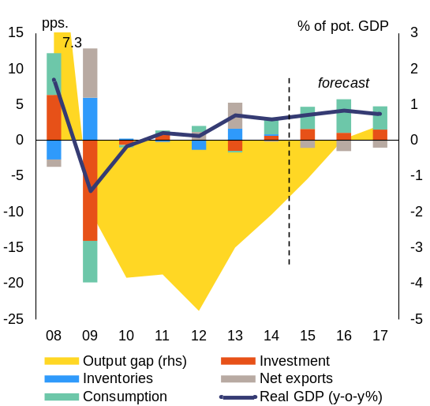
Source: European Commission
Private consumption is accelerating, stimulating strong import growth. Private consumption is projected to have expanded by 4.8 % in 2015 on higher disposable incomes after the cut of value-added tax (VAT) for food, solid wage growth and low inflation. Private consumption growth is expected to speed up in 2016 after the reduction of the standard VAT rate by 4 percentage points Buoyant consumption is mirrored in a negative contribution of net exports to growth, estimated at -1.1 percentage points for 2015. The contribution of net exports to growth is expected to remain negative in 2016 and 2017.
Investment recovered from its drop in 2013 and is expected to sustain high growth rates until 2017. Investment is estimated to have increased by 6.5 % in 2015. Housing construction rebounded, supported by lower borrowing costs, the 'Prima Casa' state guarantee scheme for the purchase of first homes, and higher investor confidence due to robust economic growth prospects. Private investment is projected to continue growing in 2016 and 2017, albeit at a slower pace than in 2015. Public investment peaked in 2015, but its growth rate is set to slow down in 2016 and 2017. This is mostly due to the EU funds' absorption, which is expected to fall with the end of the 2007-2013 programming period while the implementation of the 2014-2020 programmes has just started.
Romania's economy is approaching a turning point in its business cycle with the output gap projected to close and turn positive. With the onset of the crisis, potential growth plunged and the output gap sank abruptly from an estimated 7½ % in 2008 to -2 % in 2009. The output gap bottomed out at -5 % in 2012. It started diminishing in 2013, as actual GDP growth surpassed potential output growth. The output gap is projected to close in 2016 (Graph 1.1), but to remain contained at levels below 1 % by 2017. This is still well below the gap between actual and potential output in the pre-crisis years. However, expansionary pro-cyclical fiscal policies at this point of the business cycle, as implemented with the changes in the Fiscal Code, could initiate the build-up of excess demand and risks of overheating the economy if not accompanied by appropriate supply-side measures to strengthen productivity and competitiveness (see section 2.3).
Potential growth estimates show that a recovery to pre-crisis growth rates is unlikely. Potential growth is estimated at 2.6 % in 2015, compared with an average of 3.5 % in 1996-2008 and 6.0 % in the five years before the crisis (Graph 1.2). Potential growth is expected to increase gradually before stabilising slightly above 3 % in the medium term, driven mainly by investment and total factor productivity. Total factor productivity is forecast to improve slowly, whereas the contribution of investment to potential growth and to Romania's overall competitiveness is restrained by inefficiencies and delays in public investment, lack of prioritisation of investment projects and low absorption of EU structural funds (see section 2.3). Labour contribution to growth is broadly neutral.
Graph 1.2: Components of potential growth
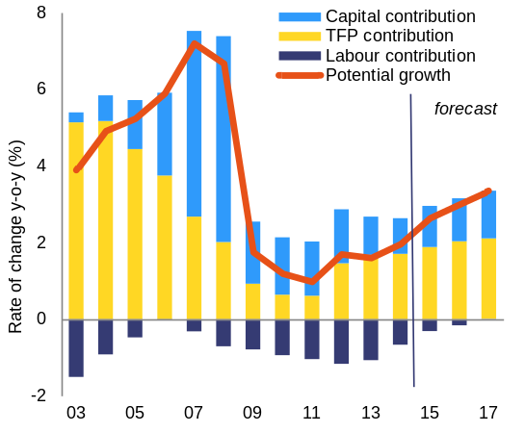
Source: European Commission
The current account balance has improved substantially since the beginning of the crisis in 2008. After reaching -12.7 % of GDP in 2007, the current account deficit contracted significantly in two stages: a considerable leap forward in 2009, mainly due to lower imports, and a further improvement in 2012-2014. This second stage was broader in scope, driven simultaneously by higher exports, stagnant imports and a declining deficit in primary incomes. In 2015, Romania's current account is estimated to have narrowed to around 1 % of GDP. The current account deficit is forecast to widen slightly in 2016 and 2017, reflecting the deterioration in the trade balance driven by higher imports. However, it is still expected to remain contained at 3 % of GDP.
In spite of recent positive developments, medium-term challenges may arise in the external sector. Import growth is forecast to remain strong, boosted by robust consumption. Exports are expected to grow moderately due to the global trade slowdown and the expected moderate growth in several of the EU Member States that are Romania's main trading partners. The negative trade balance implies a worsening of the current account and hence also a somewhat higher need for external financing.
The large negative net international investment position (NIIP) has been improving since 2012 and is expected to sustain this trend in the coming years. The main drivers of this improvement were strong nominal GDP growth and low current account deficits. Going forward, the NIIP is expected to improve further. However, it remains sensitive to macroeconomic shocks.
Price developments
Inflation has been falling in recent years, plunging to historical lows in 2015. Annual average inflation has been on a downward trend since 2013 as a consequence of abundant harvests (in 2013 and 2014), falling global oil prices and consecutive reductions in VAT rates for different categories of products and services. In 2015, inflation turned negative after the cut of the VAT rate for all food items and non-alcoholic beverages from 24 % to 9 % from 1 June (Graph 1.3). In August 2015 inflation recorded a historical low of -1.7 % (year-on-year), ending 2015 at an annual average of -0.4 %. At the same time, the harmonised consumer price index in constant taxes excluding energy and volatile food prices doubled within the course of 2015, pointing towards increasing pressure on prices.
Inflation is expected to re-enter the central bank's target band (2.5 %±1 percentage point) by 2017. Inflationary pressures are likely to grow stronger in 2016 with the surge in domestic demand and the increase of the minimum wage from May. The reduction of the standard VAT rate by 4 pps. from January 2016 still works in the opposite direction and annual average inflation is expected to remain negative (-0.2 %). However, the output gap is projected to close in the second half of 2016 and the impact of the VAT cuts is set to wear out by the end of the year. Therefore, despite the additional 1 pp. VAT cut envisaged for January 2017, the annual average inflation rate is forecast to reach 2.5 % in 2017.
Graph 1.3: Inflation
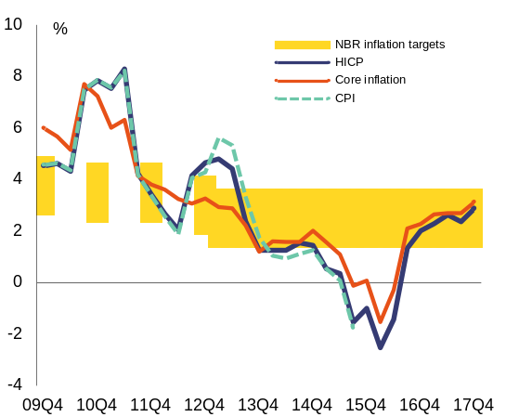
Source: European Commission
Labour market developments
The labour market is stable and forecast to improve gradually. Unemployment remained broadly stable at 6.7 % in 2015, but is expected to decrease to 6.5 % in 2017. The low unemployment rate is to be seen in the context of a continuous decline in the working-age population due to ageing and net outward migration. Employment is projected to grow in 2016 and 2017 along with sustained economic growth. Nominal unit labour costs are forecast to increase significantly in 2016 and 2017 on the back of accelerating wage growth(), as the labour market is expected to tighten. The 2014 cut in the social security contribution has helped contain unit labour costs so far, but wage increases may outpace labour productivity in the future.
Despite employment growth, especially in high value-added sectors, structural problems persist on the labour market. The employment rate has been increasing in recent years, but below the EU average. At 17 % of the population, the share of young people not in employment, education or training is well above the EU average of 12 %. Challenges remain in raising the average skills level of the workforce, addressing the high rate of early school leaving and strengthening the capacity of labour market institutions. Labour market and social challenges are closely related and there are big disparities between rural and urban areas. Romania faces very high risks of poverty, social exclusion, and income inequalities. All these factors weigh on the growth potential of the economy (see sections 3.2 and 3.3).
Graph 1.4: Key employment indicators
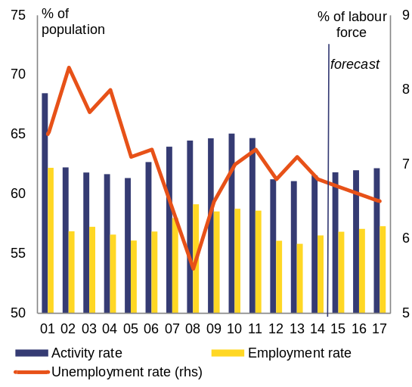
Age 15-74
Source: European Commission
Public finances
Since the height of the crisis, fiscal imbalances have gradually moderated. In 2009, the budget deficit hit 9 % of GDP. With the support of the measures implemented under three consecutive EU/IMF financial assistance programmes, the budget deficit was progressively reduced and in 2014 Romania reached its medium-term budgetary objective of a deficit of 1 % of GDP in structural terms. This was one year earlier than planned. In 2015, strong economic growth and better tax compliance contributed to high revenues. At the same time, savings from unintendedly low public investment and lower co-financing of EU-funded projects compared with the budget led to lower expenditure. Consequently, the 2015 budget deficit is estimated to have reached 1.1 % of GDP in nominal terms() and 1 % of GDP in structural terms and thus to have remained at the medium-term objective.
Signs of fiscal easing are becoming more prominent since the second half of 2014. A cut of 5 percentage points in social security contributions was implemented as from October 2014 and the cut of the VAT rate on food and the doubling of child benefits from mid-2015. Additional ad-hoc deficit-increasing measures were adopted in the second half of 2015, including the reduction of the standard VAT rate from 24 % to 19 % in two steps, and additional expenditure, such as sectoral and general public wage hikes (see section 2.3). As a consequence, the headline deficit is expected to widen to 3.0 % of GDP in 2016 and 3.8 % of GDP in 2017 (Graph 1.5). The structural deficit is thus forecast to deviate from Romania's MTO by 2 % of GDP in 2016 and 3 % of GDP in 2017, assuming no further policy changes are made. The public debt is expected to gradually rise above 40 % of GDP by 2017 and above 60 % by 2026().
Financing conditions have been generally stable and favourable, despite recent global market developments. Romania lost access to international financial markets in 2009, requiring EU/IMF financial assistance. It quickly regained market access and has been able to finance fully its deficit and debt on the financial markets since 2011. Sovereign yields fell steadily throughout 2014 and 2015. The fiscal adjustment reduced financing requirements and the future redemption profile looks favourable, although there are risks stemming from the fiscal outlook.
Tax revenues are relatively low, but their composition is overall favourable to growth. Romania has the lowest tax revenue share of GDP among peer countries (Graph 1.6) and in EU. In 2014, indirect taxes were substantially above the EU average(), while direct taxation was substantially below the EU average(). Tax collection, however, remains weak. The VAT gap(), at 41 % in 2013, was the highest in the EU. More recent data suggest an improved tax collection, also reflecting the impact of measures undertaken during the financial assistance programmes.
Graph 1.5: Deficit, structural balance and MTO
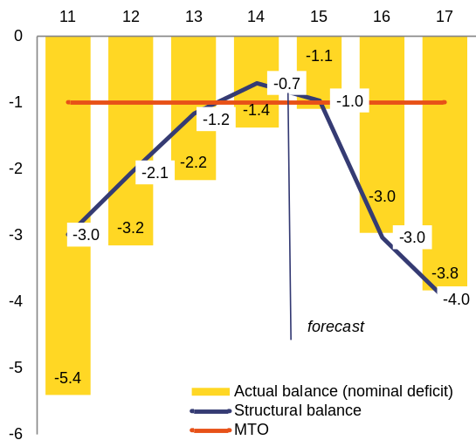
Source: European Commission

Graph 1.6: Tax revenue* as % of GDP, 2014
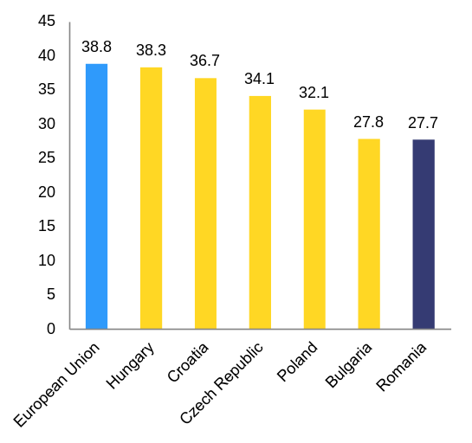
(*) It includes total receipts from taxes and compulsory social security contributions
Source: European Commission
The budgetary process often lacks proper planning and targeting. Spending decisions and priorities can be changed relatively easily during the budget year. Public investment expenditure is frequently under-executed. Other investment financing resources, such as EU funds, are being under-exploited. Absorption of structural and cohesion funds was 63.3 % in 2015, the lowest in EU, while for the European Agricultural Fund for Rural Development the figure was 82.3 % (Table 1.1). Decisions were taken to reintroduce special pension rights and to increase public sector wages without progress towards implementing a unified wage grid (see sections 2.3 and 3.1).
Table 1.1: EU funds absorption (programme 2007-2013)
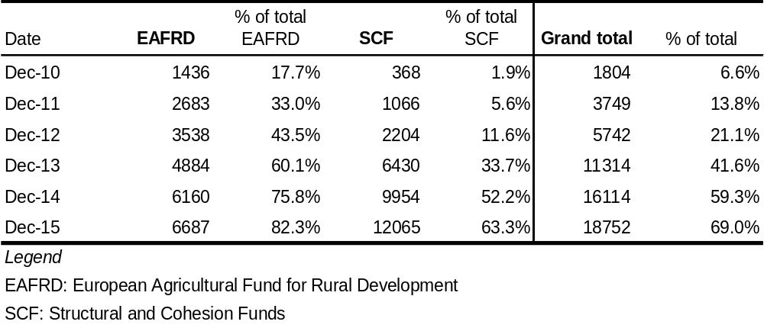
Source: Ministry of Finance, Romania
Financial sector
Financial intermediation continues to be dominated by credit institutions. Based on data for the end of 2014, credit institutions hold the largest share of assets of the financial system (roughly 78 %), well ahead of investment funds (8 %), private pension funds (3.7 %) and insurance undertakings (3.5 %). Whereas investment funds and private pension funds have expanded their activities, the insurance sector faced adverse developments, which have been more marked since the beginning of 2014.
The overall resilience of the banking sector has continued to improve in 2015. Capital adequacy at system level increased to 18.7 % in September 2015, from 17.6 % at the end of 2014. The common equity tier 1 ratio went up by roughly 1.8 percentage points in the first nine months of 2015 and reached 16.3 %. Non-performing loans continued their downward trend. The non-performing loans coverage ratio remained at a reassuring level, just below 70 % at the end of September 2015. Banking sector profitability, which was heavily impacted by the cleaning-up of bank balance sheets in 2014, returned to positive territory in 2015.
Recent developments point to a further decline in the share of foreign currency loans in the portfolios of banks. The share of foreign currency loans in total loans to the private sector went down from roughly 58 % in June 2014 to 52.4 % in June 2015. Notwithstanding the decline in the share of new loans granted in foreign currency in total loans, the outstanding stock still poses challenges. Loans in foreign currency granted to households and corporates still have a higher level of impairment as compared with loans denominated in local currency.
Whereas bank prudential indicators have strengthened since 2014, recent legislative developments are likely to put strain on the banking sector and on financial stability. The banking sector remains vulnerable to several legislative initiatives with negative unwarranted impact (see section 2.2). The current form of the law on the discharge of debt obligations stemming from loan contracts through the transfer to the creditor of immovable property is likely to weaken payment discipline, impact credit activity and pose challenges to financial stability. Furthermore, the implementation of the law on abusive clauses in loan contracts, in case uniform jurisprudence by courts is not ensured, constitutes an additional pocket of vulnerability.
Macroeconomic risks
Macroeconomic risks are tilted to the downside. A major downward risk to macroeconomic developments is the potential implementation of the law on debt discharge in its current form. As initially approved by Parliament, the law poses a serious challenge to the stability of the banking sector and could impact negatively domestic demand as well as consumer and investor confidence. Expansionary fiscal policies in a strong-growth environment increase the medium-term risks of unbalanced growth and could lead to new internal and external imbalances. There are upward risks associated with a better-than-expected EU funds absorption and a higher-than-estimated multiplier effect from the fiscal stimulus.

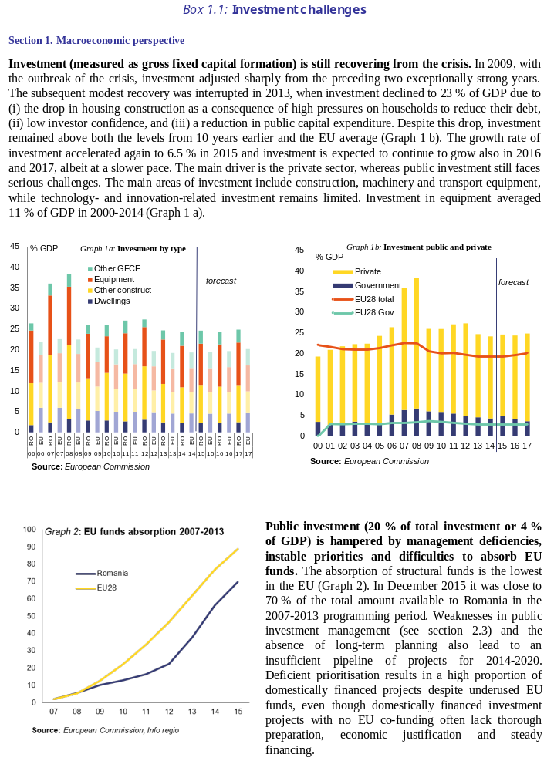
(Continued on the next page)

Box (continued)
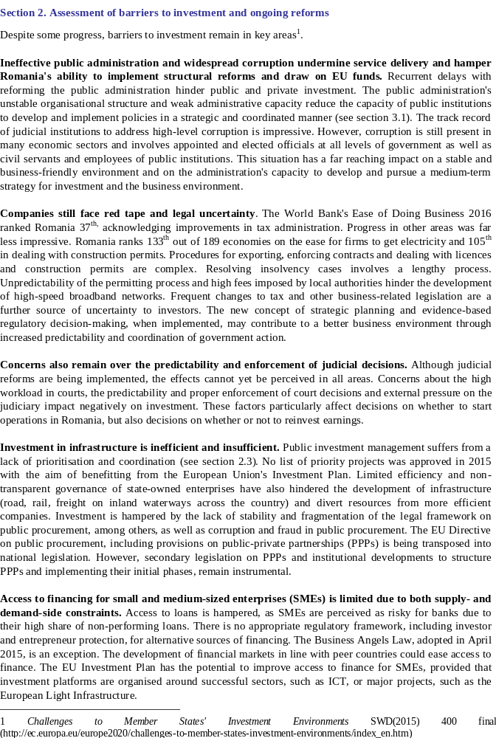

Box 1.2: Contribution of the EU Budget to structural change
Romania is a major beneficiary of the European Structural and Investment Funds (ESIF) and can receive up to EUR 31 billion for the period 2014-2020. This is equivalent to 2.6% of GDP annually and 53% of the expected national public investment in areas supported by the ESI funds.
A number of reforms were passed as ex-ante conditionalities in areas to benefit from the Funds to ensure successful investments. Reforms in areas such as public procurement, health care investments, railways, waste management and the water sector, employment, social inclusion, education and public administration are still pending, with actions plans to be completed by end-2016. Where ex-ante conditionalities are not fulfilled by end 2016, the Commission may suspend interim payment to the priorities of the programme concerned.
The programming of the Funds focuses on priorities and challenges identified in recent years in the context of the European Semester and country specific recommendations. A number of CSR are directly relevant for ESIF including those on strengthening active labour‐market measures, the integration of Roma in the labour market and increasing school attendance and reducing early school leaving, improving efficiency in energy consumption and the transport sector strengthening the management and control systems of EU funds and improve capacity of strategic planning and tackling persisting shortcomings in public procurement, amongst others. Romania will receive EUR 106 million from the Youth Employment Initiative (matched by the same amount from the European Social Fund) to implement measures targeting young people not in employment, education or training (NEETs), in line with the country specific recommendations to support unregistered young people. Regular monitoring of implementation includes reporting in mid-2017 on the contribution of the funds to Europe 2020 objectives and progress in addressing relevant structural reforms to maximise the use of EU financing (notably, in the health, rail, R&DI, employment, education and social inclusion).
Financing under the new European Fund for Strategic Investments (EFSI), Horizon 2020, the Connecting Europe Facility and other directly managed EU funds would be additional to the ESI Funds. Following the first rounds of calls for projects under the Connecting Europe Facility, Romania has signed agreements for EUR 715 million for transport projects. For more information on the use of ESIF in Romania, see: https://cohesiondata.ec.europa.eu/countries/RO.

Table 1.2: Key economic, financial and social indicators
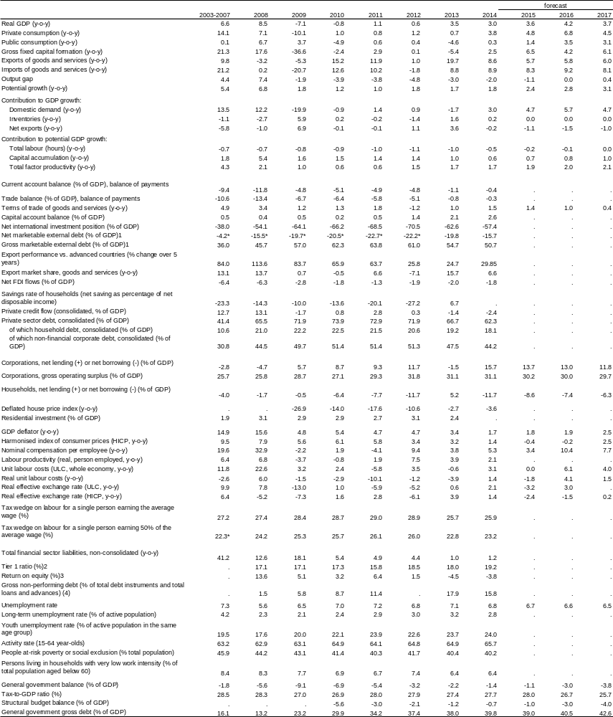
(1) Sum of portfolio debt instruments, other investment and reserve assets
(2,3) Domestic banking groups and stand-alone banks.
(4) Domestic banking groups and stand-alone banks, foreign (EU and non-EU) controlled subsidiaries and foreign (EU and non-EU) controlled branches.
(*) Indicates the fifth edition of the Balance of Payments Manual and/or the 1995 ESA
Source: European Commission 2016 winter forecast; ECB

2. Imbalances, risks, and adjustment issues
This section provides the in-depth review foreseen under the macroeconomic imbalances procedure (MIP)(). It focuses on the risks and vulnerabilities flagged in the Alert Mechanism Report 2016. The section analyses the reasons behind the recent improvements in the current account deficit and net international investment position, as well as the composition of its external financing. Taking note of Romania's improved international competitiveness, the section also analyses the impact of rising labour costs in the context of its low-cost, low-quality pattern of exports. Second, the section assesses the robustness of the financial sector and the effectiveness of the measures taken in recent years and looks into the potential impact of emerging domestic legislation on financial stability. Finally, the section explores the implications of the ongoing fiscal loosening on Romania's growth trajectory and on debt sustainability given the emphasis on demand-side stimulus over measures to boost potential output. Credit developments and the housing market are assessed in the light of a potential build-up of a credit-driven boom or housing boom. Looking at supply-side measures, the analysis focuses on public investment, in particular in infrastructure, and on barriers to investment in general. The section concludes with the MIP assessment matrix which summarises the main findings of the in-depth review.
2.1 External balance and competitiveness
External sustainability
Romania's net international investment position (NIIP) has been improving since 2012 as a result of a shrinking current account deficit and strong nominal GDP growth. Romania's relatively large negative NIIP reflects the accumulation of current account deficits in the pre-2010 period. The NIIP hit a record of -70 %() of GDP in 2012. It has been improving since then (Graph 2.1.1) on the back of strong nominal GDP growth and low current account deficits, in spite of a deteriorating investment-income balance and mostly negative valuation effects. The upward trend continued in 2015, when the NIIP is estimated to have reached -54 % of GDP.
The level and the recent adjustment of the NIIP fit a wider pattern among peer countries. A negative NIIP is typical for a catching-up economy which is expected to attract foreign investment because of comparative advantages and differentials in yields for portfolio and direct investments. Compared with its peers, Romania's net external debt is relatively small. In 2014, among the peer countries only the Czech Republic registered a smaller NIIP (-36 % of GDP) than Romania (-57 % of GDP, Graph 2.1.1).
Graph 2.1.1: Net international investment position in Romania and peer countries
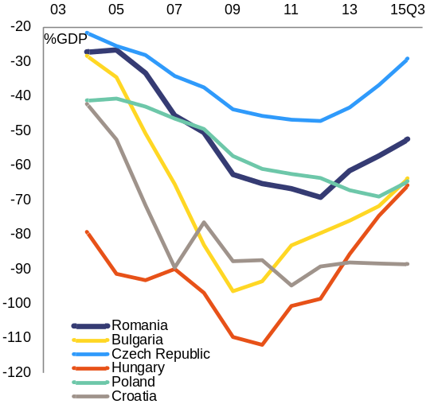
Source: European Commission
The composition of the NIIP reveals a relatively high share of volatile sources of financing, but the share of foreign direct investment is increasing. Net portfolio investment (debt and equity securities) and other investment added up to 38 % of GDP in 2014 (Graph 2.1.2). However, foreign direct investment (FDI) has been gradually reclaiming its role as the main source of external funding for the economy. In 2014, net foreign direct investment (39 % of GDP) surpassed the sum of net portfolio investment (debt and equity securities) and other investment for the first time since 2007.
Graph 2.1.2: NIIP financing
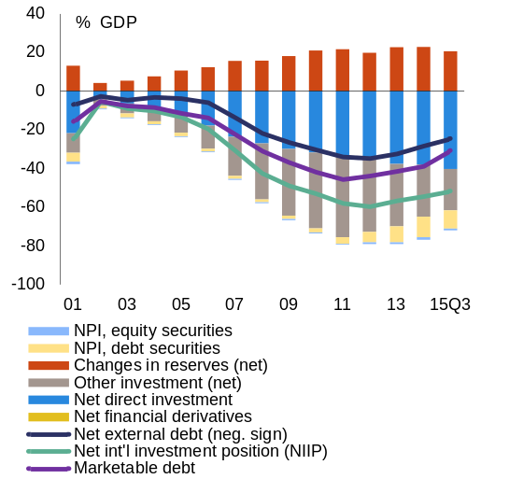
Source: European Commission
Inward foreign direct investment flows have been gradually recovering since 2011. Despite an 11 % reduction in foreign direct investment inflows in 2014 (Graph 2.1.3), the stock of foreign direct investment as a percentage of GDP has been rising continuously since 2005. Simultaneously, the total accumulated value of foreign-owned assets has been progressively increasing. Despite the drop in 2014, the savings-investment gap was historically never so low. Therefore, the need for external financing is also small.
Romania is still missing out on potential gains from higher foreign direct investment. In 2014 Romania registered the lowest FDI in percentage of GDP among its peers for both inflows and stock. The average of inward foreign direct investment stock in peer countries (the Czech Republic, Hungary, Poland and Bulgaria) was around 100 % of GDP, while for Romania it was just below 40 %. The peers' inflow of foreign direct investment was 4 % of GDP versus Romania's 2 %. Romania has the lowest foreign direct investment ratio to total financial sources of funding among peers (48 %) except for Bulgaria (41 %).

Graph 2.1.3: Inward FDI flows by activity
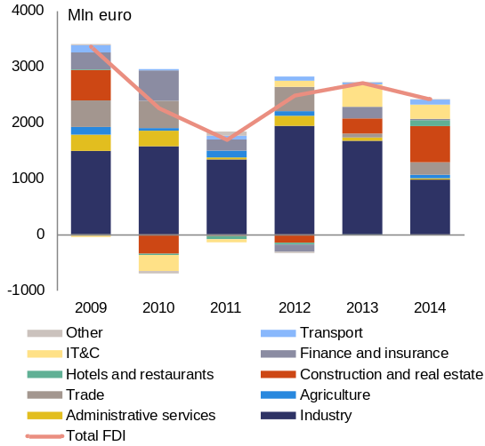
Source: National Bank of Romania
A simulation of unfavourable macroeconomic developments shows that the main risks to the NIIP arise from shocks to growth and inflation. In the baseline scenario of the sensitivity analysis, the current account registers a deficit of 1.6 % of GDP on average from 2013-2030 and a deficit of 1.8 % of GDP for the trade balance. The capital account is assumed to be 2.3 % of GDP on average in that period, while GDP deflator is projected at 2.1 % and real GDP growth at 2.8 %. These values are based on recent trends and European Commission estimates. A simulation of adverse macroeconomic scenarios reveals that the NIIP is particularly sensitive to inflation and growth shocks (Graph 2.1.4). A negative shock to GDP growth or to domestic inflation has an impact of the same magnitude on the NIIP. Moreover, the scenario simulation analysis shows that, if all other factors are equal, positive shocks to the trade balance might be insufficient to compensate for possible negative shocks of the same amplitude to growth or inflation. Keeping everything else constant, larger trade deficits lead to a larger NIIP and slow down the pace of its adjustment. Therefore, a stimulus of domestic demand could lead to higher trade-balance deficits, if not matched by supply increasing measures. This would have a negative effect on the NIIP's level and the pace of adjustment.
Graph 2.1.4: NIIP sensitivity to macroeconomic shocks
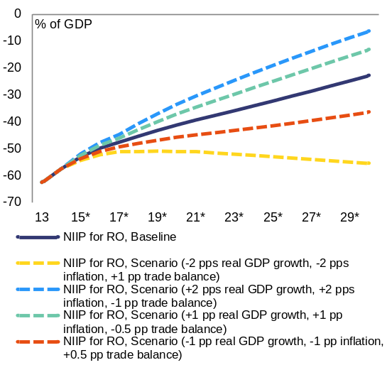
(1) * forecast values
Source: European Commission

Graph 2.1.5: The importance of structural funds for Romania's NIIP
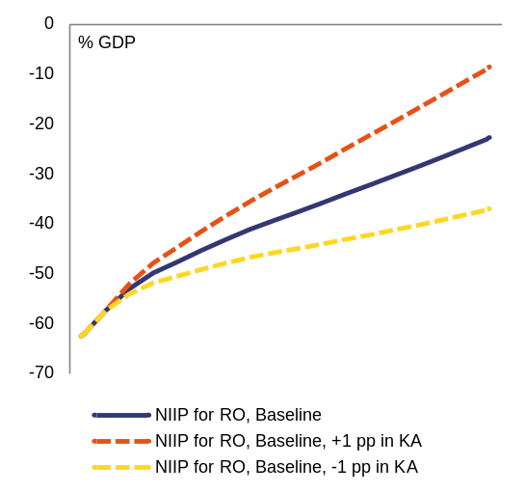
Source: European Commission
EU structural funds, the largest part of the capital account, have a significant impact on the evolution of the NIIP. The scenario simulation analysis reveals that, if all other factors are equal, a 1 pp. of GDP negative shock to the capital account results in a substantial deterioration of the NIIP (Graph 2.1.5). This negative shock to the capital account could come from funds absorption problems, higher import demand or significant financial corrections (see section 2.3). In addition to the benefits discussed later in the report, higher EU funds absorption would help to improve the NIIP or at least to avoid its deterioration.
Current account developments
The current account deficit has decreased significantly in recent years(). The reduction of macroeconomic imbalances under the balance-of-payments programmes contributed to the significant improvement of the current account deficit to an average of 4 % of GDP in 2009-2012 (Graph 2.1.6). Since 2013, the current account deficit has shrunk to about 1 % of GDP, a level previously registered only in 2002.
Graph 2.1.6: Current account balance by components
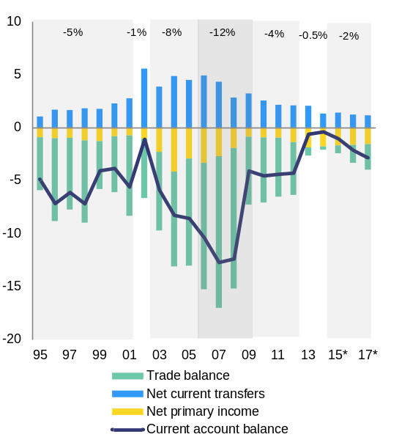
Source: European Commission
The recent adjustment of the current account deficit has been mainly due to non-cyclical factors, including the structural improvement in the trade balance. The cyclical and non-cyclical current account balances as percentage of GDP have converged towards a balanced level since 2012 (Graph 2.1.7). The substantial improvement of the trade balance was driving the current account adjustment. Until 2012, the trade balance, in particular the balance of goods, was the main component of the current account deficit (Graph 2.1.8). Since 2013, mainly non-cyclical factors have been contributing to the adjustment. Robust export performance led to a significant decline in the trade balance, leaving the primary income balance as the main contributor to a much smaller current account deficit. In 2014, the trade balance registered a slight deficit, with only a small negative output gap. This implies that the adjustment of the trade balance is structural in nature, as it can be explained by factors other than the business cycle. Strong growth along with low unemployment, rapid wage growth and loosening of the fiscal stance, are expected to boost domestic demand leaking out through imports in 2016 and 2017, resulting in a deterioration of the current account balance.
Graph 2.1.7: Cyclical and non-cyclical current account balance
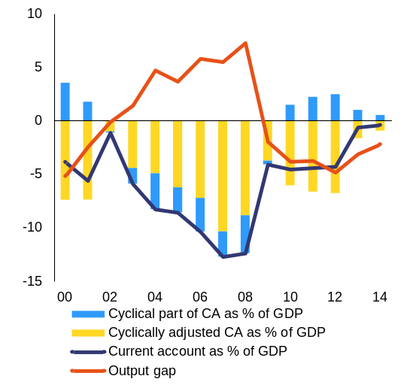
Source: European Commission
The improvement in the trade balance is due to a considerable decrease in the balance of goods deficit and a rising surplus in the services balance. The deficit of the balance of goods has been gradually decreasing, from an average of 10 % of GDP in 2001-2008 to 6 % in 2009-2014. It hit a record level just before the crisis and started improving again since then. In the same period, the balance of services went from near balance to a surplus of almost 5 % of GDP. The improvement in the services account is therefore an important factor that contributed to the rebalancing of the current account in 2013-2015.
Graph 2.1.8: Balance of goods and services
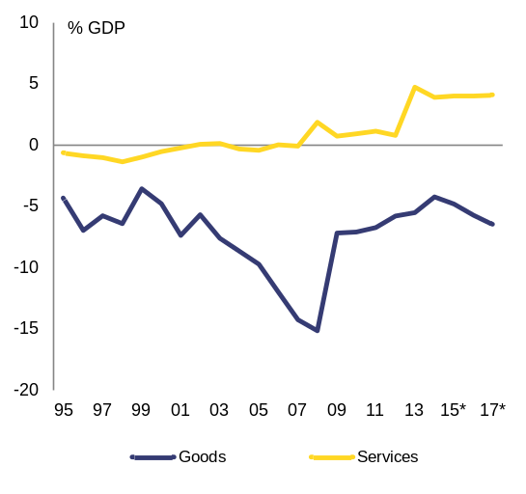
Source: European Commission
Reduced dependence on imports of gas and petroleum products further contributed to the improvement in the cyclically adjusted current account in 2013-2015. Energy import values fell due to both a significant decrease in dependence on energy imports (Graph 2.1.9) and lower global energy prices. Historically, most of the imports of goods are intermediate goods (66 % in 2014). Imports of consumption goods — 19 % of imports in 2014 — have been increasing since 2011. At the same time, the share of capital goods in imports has followed a downward trend since 2008 (Graph 2.1.10).
Graph 2.1.9: Energy dependence
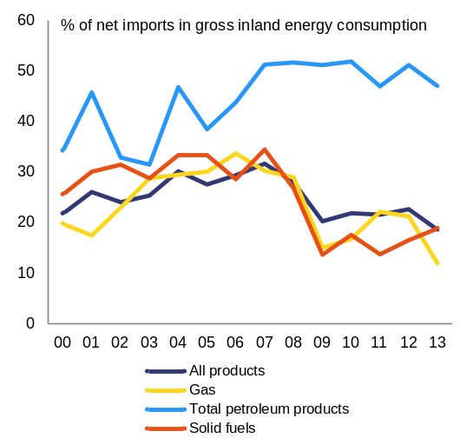
Source: European Commission

Graph 2.1.10: Imports of capital, consumption and intermediate goods
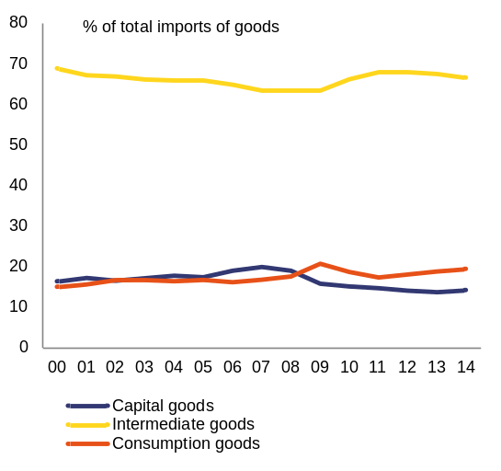
Source: United Nations Commodity Trade Statistics (Comtrade) database
The current account adjustment was supported by corrections of savings-investment balances both in the private and public sectors. Up to 2007, credit-fuelled investment in the private sector was driving the fast widening of the current account deficit on the back of relatively low savings. However, in 2008 the negative saving-investment gap in the private sector started to contract in the aftermath of the crisis. The current account, however, did not adjust immediately. The smaller private sector savings-investment gap was offset by a widening gap in the public sector, generated among other things by unsustainable expenditure decisions including higher public wages and pension payments to the private sector. The adjustment of the current account deficit in nominal terms took place in 2009. This followed the correction in the public deficit but was mostly due to a large adjustment in the private sector which that year was a net international investor (Graph 2.1.11). The current account deficit remained broadly stable between 2009-2012, in the context of fiscal consolidation under two joint EU/IMF financial assistance programmes and a modest recovery in private sector investment. It improved further in 2013-2014 as both the private and the public sector continued to adjust in parallel with improving financial conditions.
Graph 2.1.11: Savings-investment gap and the current account
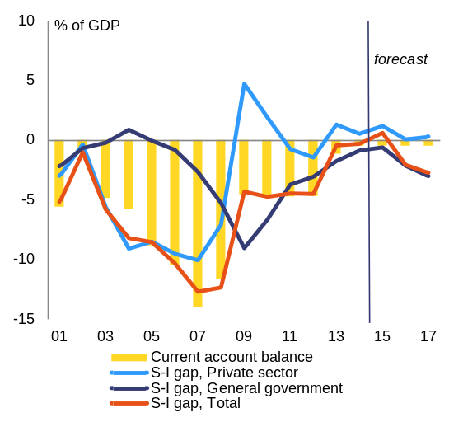
Source: European Commission
The current account deficit is forecast to widen as domestic demand accelerates, but to remain contained. In 2015, the current account deficit is estimated at around 1.0 % of GDP. It is projected to widen to 2.1 % of GDP in 2016 and 2.9 % in 2017, mainly on account of robust import growth. While imports are expected to accelerate driven by domestic demand, exports are set to moderate in line with growth in the main trading partners.
Foreign-owned enterprises heavily contribute to Romania's strong export performance. According to the National Bank of Romania, foreign-owned firms accounted for 71 % of total exports and 65 % of total imports of goods in 2014. They contributed about 51 % to the exports and imports of services. Foreign-owned enterprises in manufacturing contributed the most. The most relevant sectors were transport (23 % of total exports and 14 % of imports) and oil processing and chemicals (10 % of exports and 7 % of imports).
The sectoral breakdown reflects a decrease of FDI inflows to the industrial sector, while construction and real estate are gaining weight. Manufacturing is attracting the most FDI, but inflows have been decreasing since 2012 (Graph 2.1.3). Within the manufacturing sector, oil processing and chemicals still have the largest share in terms of FDI stock. In terms of inflows, the largest share goes to transport (44 % of total FDI in manufacturing in 2014). However, in the last two years, industry has been losing its share of FDI inflows (40 % in 2014), while construction and real estate sector — sectors that prior to 2009 had contributed to the boom-bust cycle — have increased by 138 % in 2014 (from EUR 271 million in 2013 to EUR 646 million in 2014). This sectoral shift, if it continues, may weigh on export capacity.
Cost and non-cost competitiveness
Romania's competitiveness is attested to by one of the highest growth rates in export market shares in the EU (4.2 %) in 2010-2014. Competitiveness on the EU market was the major driver behind this performance. In 2014, the dynamism of markets outside the EU also made a considerable positive contribution to exports (Graph 2.1.12).
More than half of the growth in export market share in 2014 came from machinery and electrical as well as mineral products. Since 2006, market share growth in machinery and electrical goods was the product category responsible for most of the total market share gains. Romania has also been gaining market share in the minerals market (Graph 2.1.13) due to a competitiveness improvement as external-market dynamics were rather low.
Graph 2.1.12: Geographical specialisation
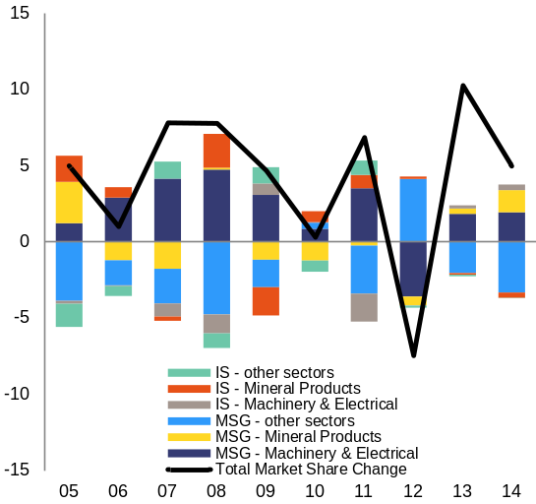
Source: European Commission

Graph 2.1.13: Product specialisation
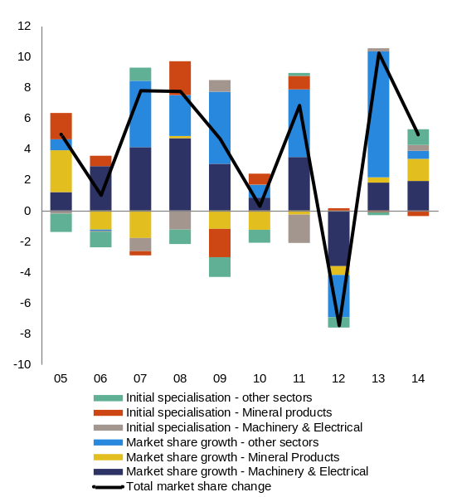
Source: European Commission
Export performance has been fuelled by improvements in cost competitiveness. Since the crisis, the nominal effective exchange rate has either depreciated or appreciated only moderately (Graph 2.1.14). This is favourable to price competitiveness. More importantly, the real effective exchange rate, based on both consumer prices and on unit labour costs, has equally registered negative or low positive growth rates, implying that inflation and wage growth have not undermined the country's cost competitiveness so far. Wage growth in particular has been in line with a constant unit-labour-cost-based real effective exchange rate benchmark().
Graph 2.1.14: Change in real effective exchange rate
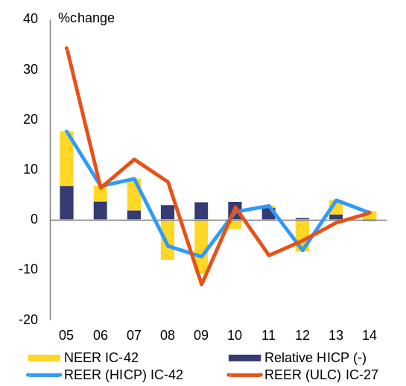
Source: European Commission
The expansion in export market share has been associated with contained unit labour costs. Since 2010, actual wage growth, assessed against projections based on long-term relationships with key economic variables, appears to have been in line with internal labour market equilibrium (Graph 2.1.16). This development has supported the expansion of export market shares (Graph 2.1.17). Meanwhile, the reduction in social security contributions introduced in October 2014 has helped contain the growth in labour costs.
Graph 2.1.15: Unit labour costs by components
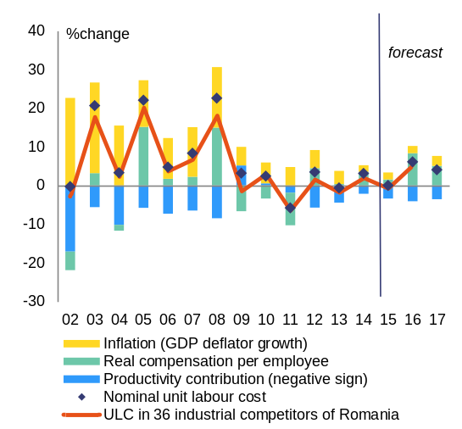
Source: European Commission

Graph 2.1.16: Wage growth and internal equilibrium wage growth rate
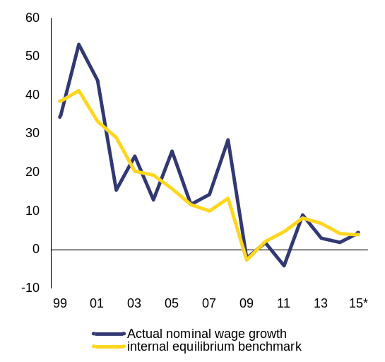
For methodology see: Arpaia, A. and A. Kiss (2015) Benchmarks for the assessment of wage developments. Spring 2015, DG Employment, Social Affairs and Inclusion, Analytical Web Note 2/2015
Source: European Commission

Graph 2.1.17: Unit labour costs versus export market shares
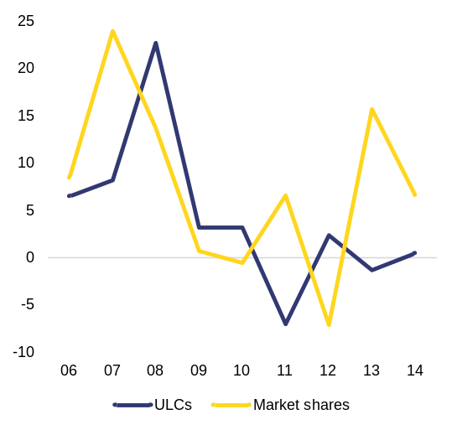
Source: European Commission
Following a period of stagnation after the crisis, labour productivity started to improve in 2012. Labour productivity registered considerable increases in the run-up to the economic crisis (2005-2008). Productivity stagnated between 2009 and 2012 because of the recession and low economic growth, alongside a reduction in the number of domestic employees. Since 2012, labour productivity has been increasing with robust economic growth, but at a slower rate than before the crisis (Graph 2.1.18).
Unit labour costs in the tradable sector increased in 2014, but more slowly than in the non-tradable sector. In 2009, costs in the tradable sector fell below costs in the non-tradable sector and have remained largely stable since then. Unit labour costs in the non-tradable sector grew moderately (Graph 2.1.19). Owing to international pressure, unit labour costs in the tradable sector tend to be lower than in the non-tradable sector. However, excessively high unit labour costs in the non-tradable sector might potentially threaten Romania's price competitiveness as they could feed into the tradable sector and be ultimately reflected in the final price of exports. Between 2009 and 2014 productivity in both the tradable and non-tradable sectors rose by 6 %, while compensation per employee grew during the same period by 2 % and 3 % respectively.
Graph 2.1.18: Labour productivity (in thousand RON)
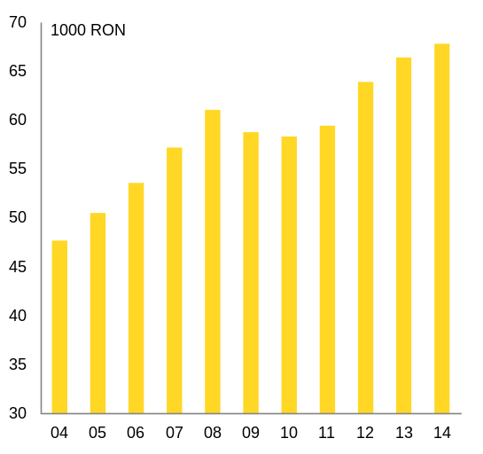
Source: European Commission

Graph 2.1.19: Nominal unit labour costs in the tradable and non-tradable sectors
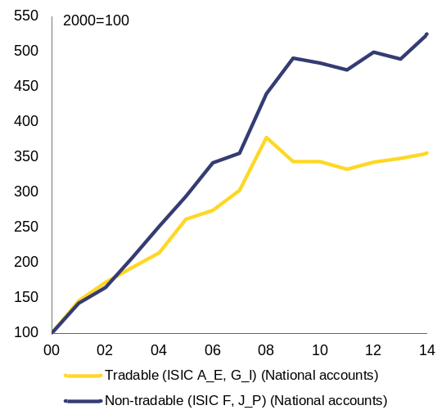
Source: European Commission
Romania still competes mostly on price rather than quality. This is confirmed by the low level of high-tech products exported. Wage developments commonly accompany the transition to a higher value-added economy and help attract and retain skilled workers, notably in ICT and high technology. However, if rapid wage growth is sustained, labour costs might start growing faster than productivity. Rising unit labour costs could have a negative impact on export growth and export market share.
Despite an increase in the middle quality segment, Romania's exports were still mainly composed of low-quality products in 2010-2014. Most of Romanian exports, measured in terms of density (frequency), defined as the difference to the rest of the EU and China, USA and Japan between the production cost and the price of the final product compared, were located in the lower half of the quality spectrum in the 2014 ranking (Graph 2.1.20). Compared with 2008, there was an increase in the middle-quality part of the spectrum accompanied by a significant fall in the below-average category.
Graph 2.1.20: Quality of exports
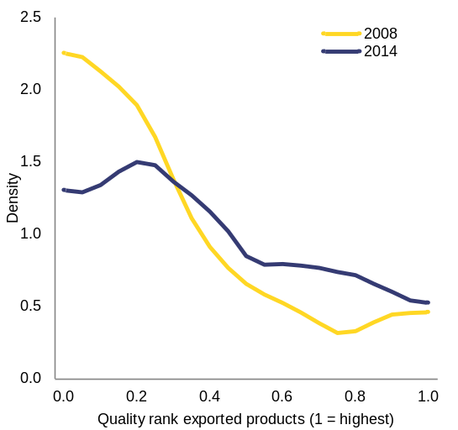
Source: European Commission
Insufficient investment in R&D, the unfavourable business environment and the limited number of highly qualified workers are some of the factors contributing to the low share of high-tech exports. The importance of high-tech products has been decreasing since 2011, when it reached a peak at 10 % of exports (Graph 2.1.21). Romania lags considerably behind other EU Member States in the resources it invests in research and development (see section 2.3). Insufficient funding and a fragmented institutional setting affect public policies for innovation and R&D. Underdeveloped basic transport infrastructure, unfavourable business environment, an unstable regulatory framework, inefficient public administration and the scarcity of highly qualified workers play a significant role in this context (see sections 3.1 and 3.2).
Looking forward, strong increases in employees' compensation in the context of a growth slowdown may reduce competitiveness if not accompanied by productivity improvements. Competitive unit labour costs reflecting low wages are still a significant component of attractiveness for foreign direct investment (Graph 2.1.22). Given the increasing pressures to the wage distribution, a more robust wage growth is forecast for 2015-2017. The latter is expected to be matched by stronger productivity gains. However, if these fail to materialise, fast wage growth, particularly in industry, might erode the economy's price competitiveness (Box 2.1.1).
Graph 2.1.21: Share of high-tech products in exports in Romania and peer countries
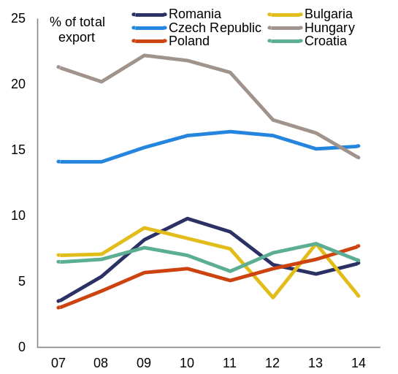
Source: European Commission

Graph 2.1.22: Compensation of employees by sector
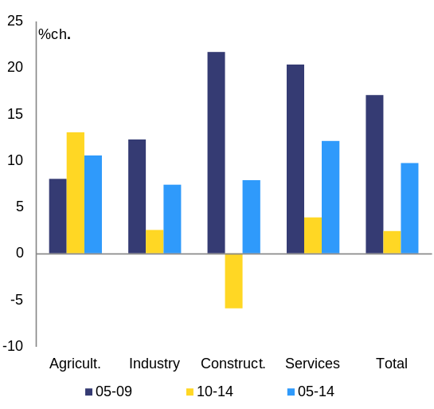
Source: European Commission

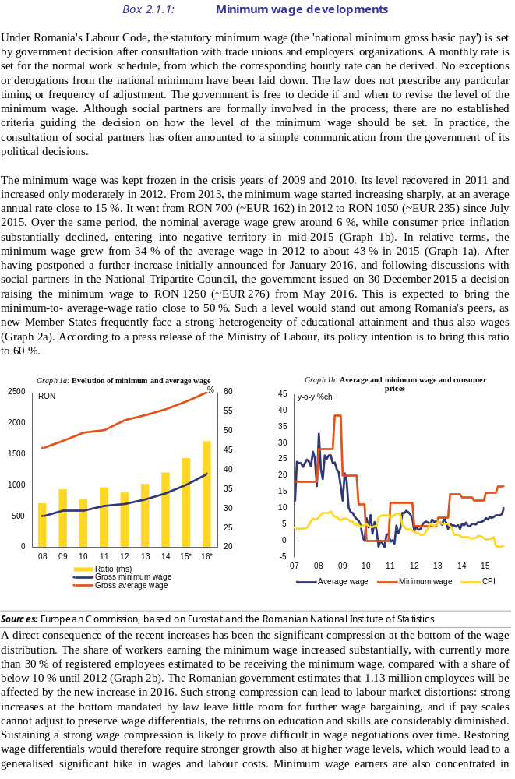
(Continued on the next page)

Box (continued)
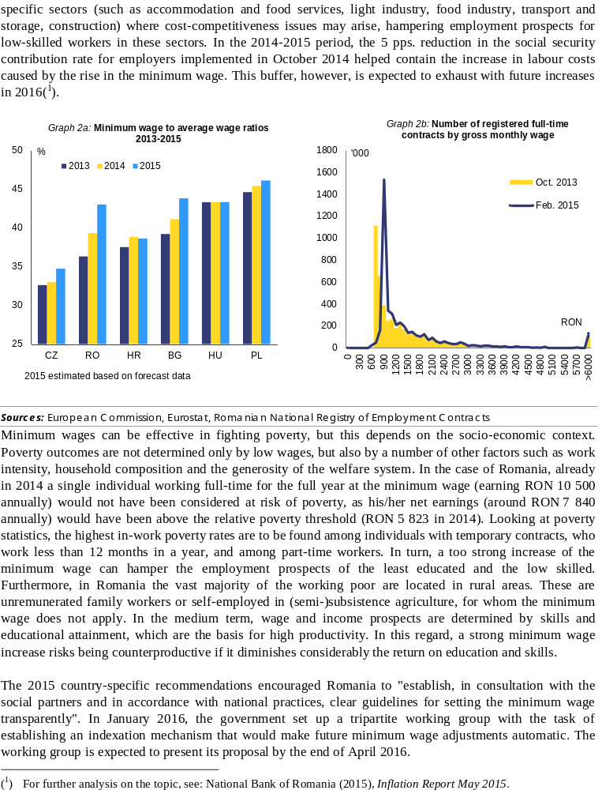

2.2. Financial sector
Banking sector
Following the progress made in 2014, the cleaning up of bank balance sheets continued in 2015. The implementation of the 2014 plan of the National Bank of Romania on the resolution of non-performing loans resulted into a significant decline in the non-performing loans ratio at system level, as non-performing loans decreased from 22.6 % in February 2014 to 11.6 % in November 2015. The cleaning up of bank balance sheets was primarily done through the write-off of fully or partially provisioned unrecoverable loans. In addition, in 2014 and 2015, the Romanian market was one of the most buoyant markets in central and eastern Europe for sales of impaired assets. In 2014, for instance, banks sold non-performing loans amounting to roughly RON 8.9 billion.
Graph 2.2.1: Non-performing loans
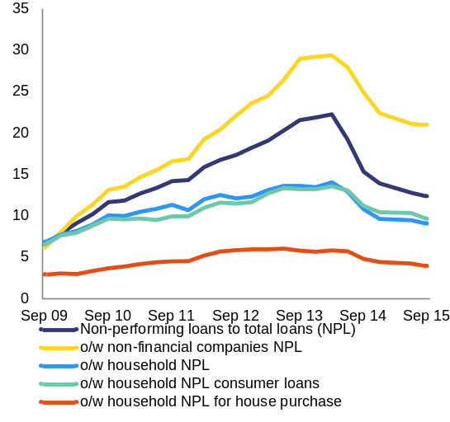
Source: NBR
Banking sector profitability recovered in 2015 after the unfavourable developments in 2014. In 2014, profitability was eroded by the significant provisioning effort necessary to support the cleaning up of bank balance sheets. After the negative financial result, which led to a return on equity of -12.5 % at the end of 2014, the banking sector returned to profitability in 2015. The cleaning up of balance sheets has not impacted banking sector capitalisation, which improved in 2015, as the common equity tier 1 ratio increased from 14.5 % at the end of December 2014 to 16.3 % at the end of September 2015. Besides retained earnings, the strengthening of capitalisation was supported by new capital contributions of shareholders.
Graph 2.2.2: Return on assets, return on equity, net profit
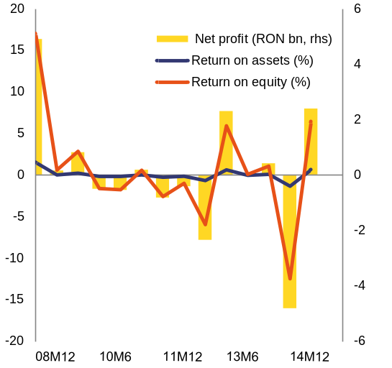
Source: NBR
In 2015, the National Bank of Romania decided to perform a comprehensive asset quality review and stress test of the Romanian banking sector. The comprehensive assessment is expected to contribute to strengthening market confidence. It is also intended to provide the supervisor with insights into the capacity of the banking sector to cope with shocks from a potential deterioration in the macroeconomic environment. The exercise aims to facilitate the disposal and resolution of non-performing loans and create favourable conditions for an increase in lending to households. A transparent approach to the evaluation of assets of credit institutions will dissipate potential uncertainties regarding the fair value of assets, thereby accelerating the cleaning-up of bank balance sheets.
The asset quality review and stress test will be conducted with the support of independent and reputable third parties. The exercise will cover 11 credit institutions, identified by the National Bank of Romania as having systemic relevance. These institutions have a combined market share of roughly 76 % (end of September 2015)(). External third parties, i.e. the stress test consultant, project manager, external auditors and real estate appraisal companies, shall be selected through a transparent and competitive process based on strict qualification and selection criteria. This should ensure that the exercise is carried out to the highest possible standards.
The comprehensive assessment is overseen by a Steering Committee with international participation. The asset quality review, which will start once the selection process for third parties has been completed, will be based on the European Central Bank (ECB) methodology for the 2014 ECB comprehensive assessment of the largest banks in the euro area. The stress test will be broadly based on the common methodology, developed by the European Banking Authority for the 2016 EU-wide stress test. The Steering Committee overseeing the exercise includes representatives of the National Bank of Romania as members as well as of the European Commission and European Banking Authority as observers. The International Monetary Fund is also an adviser on certain topics. This comprehensive assessment is expected to be finalised by October-November 2016 and the results will be published.
Legislative developments
Notwithstanding overall reassuring capital and liquidity buffers, the banking sector remains exposed to domestic sources of vulnerabilities. Whereas authorities have taken effective action to significantly reduce of non-performing loans at system level, the banking sector has been increasingly subject to risks from unwarranted domestic legislative developments. Several laws with negative impact on the banking sector have been averted or amended during the financial assistance programme period. Nevertheless, the implementation of some laws already in place or of draft laws is likely to put a strain on the banking sector. For the time being, the current version of the law on debt relief and the impact of some court decisions implementing the law on abusive clauses() seem to be the most challenging for banks. In addition, some of the legislative initiatives on the conversion of foreign currency loans into local currency loans include provisions with potential negative impact on banks. These legislative initiatives have been discussed over the last two years, but have not been finalised yet.
Several provisions of the draft law on debt discharge recently approved by Parliament raise serious concerns in terms of their potential impact on the economy and financial stability. In November 2015, Parliament adopted a draft law on the discharge of debt obligations stemming from loan contracts through the transfer to the creditor of immovable property (datio in solutum). The draft law was adopted without due consideration of concerns raised by various stakeholders (including the National Bank of Romania) on the unwarranted negative impact the law may have on the banking sector and without an assessment of the potential impact on both creditors and debtors. However, the draft law was not promulgated by the President, who decided in December 2015 to send it back to Parliament for re-examination. In line with its powers under the Treaty on the Functioning of the European Union, the ECB issued an own initiative opinion on this draft law on 18 December 2015. It highlighted the potential unwarranted negative impact that some of the provisions of the draft law could have on the economy and financial stability().
The draft law on debt discharge introduces significant changes to the legal framework applicable to loan contracts. The Romanian Civil Code includes already provisions allowing for the datio in solutum, which is one of the options for the settlement of debt obligations stemming from loan contracts. The draft law on debt discharge, however, introduces a general right for debtors to discharge their debt obligations stemming from loan agreements by transferring the property title over the mortgaged immovable property to creditors instead of repayment, without the need of the creditor to agree to this. These provisions transform the datio in solutum into a mandatory obligation for creditors when settling debt obligations related to loans that have been secured by immovable assets at the request of debtors. However, according to the Directive 2014/17/EU (the Mortgage Credit Directive)(), datio in solutum constitutes only one of the voluntary options which should be available for debt repayment. Under Article 28(4) of Directive 2014/17/EU, Member States shall not prevent the parties to a credit agreement from voluntarily agreeing that return or transfer to the creditor of the security or proceeds from the sale of the security is sufficient to repay the credit.
A major concern is the retroactive applicability of the provisions of the current draft law, as this poses serious concerns to legal certainty and financial sector stability. The scope of the draft law covers not only loan contracts concluded after its entry into force, but also ongoing loan contracts, i.e. it also applies retroactively to the current stock of loans agreed between both parties before these key provisions for the decision process were known. This poses risks to legal certainty and questions about compliance with the principle of legitimate expectations(). In addition, these provisions could also have a major impact on financial sector stability (see below).
An additional concern is the wide applicability of the draft law to all types of loans. The draft law on debt discharge covers any loan contract between natural persons and credit institutions that is secured by immovable property. Although the draft law is intended to protect natural persons, the general formulation of several of its provisions leaves open the possibility for it to apply to loans granted to companies, if there is a co-debtor, who is a natural person and jointly liable with the borrowing entity. For instance, the provisions of the law could apply to loans granted to companies, which are secured additionally to other guarantees by a personal guarantee of the shareholder. Furthermore, the law is applicable to all types of loans (i.e. consumer loans, mortgage loans) irrespective of their status (performing or non-performing) and currency denomination (local or foreign currency loans).
Several provisions of the draft law, if applied without further amendments, are likely to undermine payment discipline and investor sentiment going forward. Making datio in solutum mandatory and henceforth available to all debtors, independent of their financial situation and capacity to continue servicing their debt obligations, is likely to increase moral hazard in the banking sector and weaken credit discipline. While primary residence should always be more protected than assets used for investment purposes, the draft law does not differentiate between immovable property, which is used as primary residence by debtors, and other immovable assets such as land and commercial property. Furthermore, any debtor, irrespective of whether he/she lives or not in the mortgaged property or owns further property, can benefit from the provisions of this law. Since the law is not only targeted at consumers or vulnerable debtors experiencing financial difficulties, but at all debtors, it does not discourage speculative behaviour by debtors who decide to stop debt repayment even though they would have had the capacity to continue paying. Last but not least, foreign investors are likely to assess this piece of legislation as a source of legal uncertainty and to revise their investment strategy regarding Romania.
In its current form, the draft law on debt discharge is prone to impacting credit activity. According to the National Bank of Romania, the total number of loan agreements secured by immovable property amounted to 491 600 at the end of October 2015. Only 37 % of these loan contracts were mortgage loans. The remaining 63 % were loans for real estate investment and other loans secured by immovable assets. Data of the National Bank of Romania also show that the higher the value of the loan, the weaker the payment discipline. The latter has deteriorated more rapidly for loans above EUR 150 000. As the law is likely to impact the cash flow of credit institutions, these will most likely adjust their lending behaviour by further tightening lending standards. Credit institutions will most probably significantly increase the requested down payment for loans. Going forward, this will negatively impact the access to credit for natural persons.
Some provisions of the draft law on debt discharge may generate a systemic risk and its implementation may constitute a challenge to financial stability. The full impact of the law is difficult to assess because the future behaviour of borrowers is uncertain, especially the behaviour of those with loans with high loan-to-value ratios and loans for which the value of the pledged assets is significantly lower than the outstanding value of loans. However, based on preliminary estimates by the National Bank of Romania, the law is likely to negatively impact the profitability and capitalisation of banks. In a more severe scenario, the implementation of the law could lead to capital shortfalls for several banks and the need to adopt prudential measures.
Some court decisions on unfair contract terms in loan contracts may have a considerable impact on the banking sector. During the financial-assistance programme period authorities committed to ensure that (i) court cases involving unfair contract terms are dealt with by higher ranking courts or by a unique specialised court and (ii) to take all other necessary measures to ensure a harmonised application of these provisions, such as the training of judges. The government decided to set up a specialised court to deal with unfair contract terms. The specialised court has still not been set up, in spite of a previous commitment to ensure that it is fully operational by March 2014. This specialised court, which should be established in conformity with EU law while safeguarding all consumer rights, should contribute to ensuring consistent jurisprudence for cases involving unfair contract terms clauses, including regarding collective actions with cross-portfolio impact against banks initiated by the Consumer Protection Agency. Several banks are currently involved in court cases regarding collective actions initiated by the Consumer Protection Agency. Some of these law suits are in the final stages of litigation and banks might be requested to make repayments to clients, which depending on their magnitude may put significant pressure on their capital buffers.
Insurance sector
A comprehensive balance sheet review and stress test with third party involvement of the insurance sector was completed in July 2015. The balance sheet review and stress test included 13 insurance undertakings covering roughly 82 % of the insurance market. It was launched in the second half of 2014 and completed in July 2015, when the final results were published. This exercise was carried out by the Authority for Financial Supervision (ASF) with the support of the European Commission and the European Insurance and Occupational Pensions Authority (EIOPA). The balance sheet review was based on the Solvency I prudential regime and a common methodology applied in a consistent manner to all participating insurance companies. It was performed by four external auditors with international experience selected by the Authority for Financial Supervision through a public tender. The stress test, which was based on the EIOPA methodology for the 2014 EU-wide stress test of the insurance sector, assessed the resilience of the Romanian insurance sector to several economic and insurance-specific shocks.
The comprehensive balance sheet review and stress test of the insurance sector revealed several deficiencies, which required corrective measures. The results of the review revealed that five insurance companies — Astra, Axa, Carpatica, Euroins and Exim — were not in compliance with solvency requirements at the cut-off date for the exercise (June 2014). The results of the stress test indicated that the insurance sector would not be sufficiently capitalised under the Solvency II regime. After the completion of the balance sheet review and stress test, the participating insurance undertakings submitted action plans to the Authority for Financial Supervision, including follow-up measures to address the deficiencies identified during the exercise. For Astra and Carpatica, which were already under financial recovery procedures, the Authority decided in mid-August 2015 that these undertakings will continue to implement the financial recovery procedure, but also comply with additional measures. The Authority for Financial Supervision requested that Euroins submit a revised action plan, which also includes a capital increase of RON 400 million in two tranches of RON 200 million each. According to the Authority for Financial Supervision, the first tranche of the capital increase would ensure compliance with Solvency I requirements by the end of 2015. However, by end-2015 Euroins had brought in only RON 80 million. On 22 January, the Board of the Authority decided to put Carpatica under resolution and designated the Insurance Guarantee Fund as temporary administrator.
Despite intense recovery efforts under a special administration procedure, Astra had to be put into insolvency in August 2015. Due to significant deterioration in its prudential indicators, Astra, the largest player in the Romanian insurance market, was placed by the Authority for Financial Supervision under special administration in February 2014. Due to the lack of sufficient progress in implementing the financial recovery plan during the 18 months of special administration and the failure to find a third party strategic investor, the Authority for Financial Supervision withdrew Astra's licence of at the end of August 2015 and requested the opening of insolvency procedures. In December 2015, the Bucharest Tribunal ruled in favour of opening of the insolvency procedure for Astra. The court decision is however not final as it still can be appealed by Astra. The pay-out of compensations to policyholders by the Insurance Guarantee Fund can start only after the final decision of the court on the opening of the insolvency procedure for Astra.
In the second half of 2015, the Authority for Financial Supervision conducted a balance sheet review of insurance undertakings, which were not included in the 2014 exercise. Following the completion of the initial balance sheet review and stress test of 13 insurance companies, the Authority decided to perform a similar exercise for the rest of the insurance market. This exercise included 21 insurance undertakings with a combined market share of 15.3 % (end-2014). The aim was to assess the financial soundness and solvency of the participating undertakings under the Solvency I regime and their preparedness for the introduction of the Solvency II regime from 2016(). The methodology of this extended balance sheet review was similar to the one used for the 2014 review, except that the cut-off date for the balance sheet data was end-2014. The extended balance sheet review and stress test was performed with the support of seven external auditors, which were selected by the participating undertakings based on the same qualification and selection criteria as for the 2014 exercise.
The extended balance sheet review showed that several insurance undertakings do not comply with the Solvency I requirements. The results of the extended balance sheet review were published on 23 November 2015. Five undertakings did not meet the solvency requirements under the Solvency I prudential regime. Four insurance undertakings (Forte, ABC, Asito Kapital and Certasig) had a solvency ratio of below 100 %, whereas one insurer (LIG) had negative equity. The extended balance sheet review showed that the aggregate assets admitted to cover technical provisions for life and non-life insurance of RON 2.7 billion were sufficient to cover the adjusted technical provisions (RON 2.4 billion), which resulted in a coverage of 112.5 %. At individual level, three non-life insurance undertakings — Forte, LIG and Certasig — did not have sufficient assets to cover non-life technical provisions.
Most insurance undertakings need further efforts to prepare for Solvency II. Regarding the Solvency II results, 19 out of the 21 participating undertakings (except Asimed and Grawe) had their total assets reduced under the Solvency II regime as compared with the adjusted value of assets under the Solvency I regime. One insurer (LIG) had negative own funds, whereas three other undertakings — Signal Iduna, Forte and Gothaer -— were not in compliance with both the minimum capital requirement and solvency capital requirements. Certasig, Credit Europe and City, which met the minimal capital requirement, did not have adequate financial resources to cover the solvency capital requirements. ABC, ATE and Asito Kapital had own funds eligible to cover solvency capital requirements, but did not have sufficient own funds to meet the minimal capital requirement.
The insurance companies have to implement follow-up measures to restore solvency or remedy identified deficiencies. Following the receipt of the decision of the Authority for Financial Supervision on the balance sheet review results, the participating insurance companies submitted action plans to the Authority with measures to remedy the shortcomings identified by the extended review. In the assessment of the proposed measures, the Authority took into account measures already implemented by the participating undertakings after December 2014 (the cut-off date for the review). In mid-December 2015, the Authority for Financial Supervision approved the measures included in the action plans presented by the 21 insurance undertakings.

2.3. Medium-term risks of imbalances
Recent decisions aiming at stimulating growth have boosted domestic demand, but potential GDP growth is restrained. Demand-stimulating policies, such as the successive increases of the minimum wage since 2011, the reduction of the VAT rates in 2013-2015 and the public sector wage increases in 2015, were successful in accelerating economic growth (Graph 2.3.1). At the same time, potential growth remained constrained. Potential GDP growth is far below its pre-crisis levels and measures to increase it are still limited. Investment rebounded in 2015, but it is driven by housing despite some positive signs from non-housing private investment. Public investment, especially in infrastructure, is lagging behind.
Graph 2.3.1: Real and potential GDP, 2000-2017
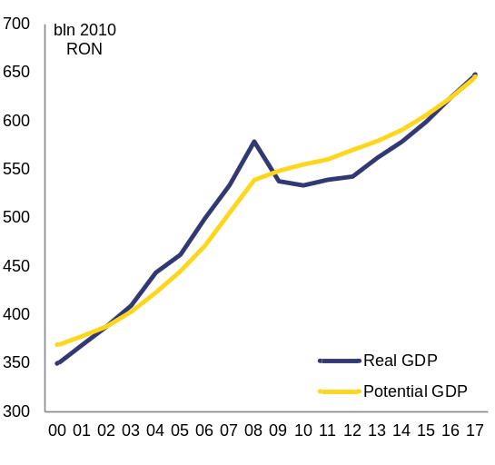
Source: European Commission
Growth driven mainly by consumption could be the source of new internal and external macroeconomic imbalances. Pro-cyclical demand-side policies, such as tax reductions combined with wage increases, have a short-term impact, concentrated mainly on consumption. If not complemented by supply-side measures, demand-boosting policies risk overheating the economy, triggering the accumulation of excess demand and the build-up of inflationary pressures. They may also pose a risk to the external sustainability through higher imports and trade deficits and through the potential diversion of resources from the exporting sector. Unbalanced growth in the past led to the boom-bust cycle in Romania between 2001 and 2009. Even though the output gap is now much smaller than in 2004-2008, expansionary fiscal policies in the context of a positive output gap tend to accelerate the business cycle and may be the seed for new internal and external imbalances.
Increasing investment is paramount to raising potential output to counterbalance the fiscal expansion and generate sustainable non-inflationary growth in the medium term(). Enhancing public investment, especially in infrastructure, inter alia by increasing EU funds absorption, improving total factor productivity by investing in research and innovation, and increasing energy efficiency are decisive for boosting potential growth, which would bring about a more balanced economic expansion.
Pro-cyclical fiscal policy
The current fiscal policy provides pro-cyclical impetus because it stimulates demand when the output gap is turning positive. The fiscal stance has been loosened by a series of deficit-increasing measures since end-2014. Following the 5 pps. cut in the social security contribution at the end of 2014, further fiscal easing measures were implemented in 2015, which were not included in the original budget. For example, the VAT for food was cut by 15 pps. and public sector wages were raised, including a general wage hike and specific increases in selected sectors with an annual fiscal impact of 1.7 % of GDP (Table 2.3.1). These public sector wage increases were decided in several, non-coordinated steps over the course of the year and were not targeted at moving towards an unified public wage system. The minimum wage was raised in two steps in 2015, which affected also public workers. The gross full-year impact of these wage increases on the 2015 budget balance is more than 1½ % of GDP. The net impact is close to 1 % of GDP and the final net impact could be estimated at around ¾ % of GDP if second-round effects are also taken into account.
Further deficit-increasing measures are being implemented from 2016. On the revenue side, the amendment of the Fiscal Code adopted in 2015 reduced inter alia the standard VAT rate from 24 % to 20 % from January 2016 and further to 19 % from January 2017. The dividend tax was also reduced from 16 % to 5 %. The new Fiscal Code eliminates the special construction tax and the extra excise duty on fuel from 2017. Public expenditures, such as a higher increase in pensions than suggested by the relevant rules, also contribute to an increasing deficit from 2016. According to the European Commission winter 2016 forecast, the ESA headline deficit is expected to increase by more than 2½ % of GDP — from 1.1 % of GDP in 2015 to well above 3 % of GDP in 2017. Consequently, the structural balance would deteriorate by close to 3 % of GDP. The deviation from the medium-term fiscal objective is expected to be of a similar magnitude. These developments put public debt on an upward path and put fiscal sustainability at risk. They could also kick-start a new boom-bust economic cycle.

Table 2.3.1: Public sector wages adopted in 2015 and special pensions reintroduced in 2015
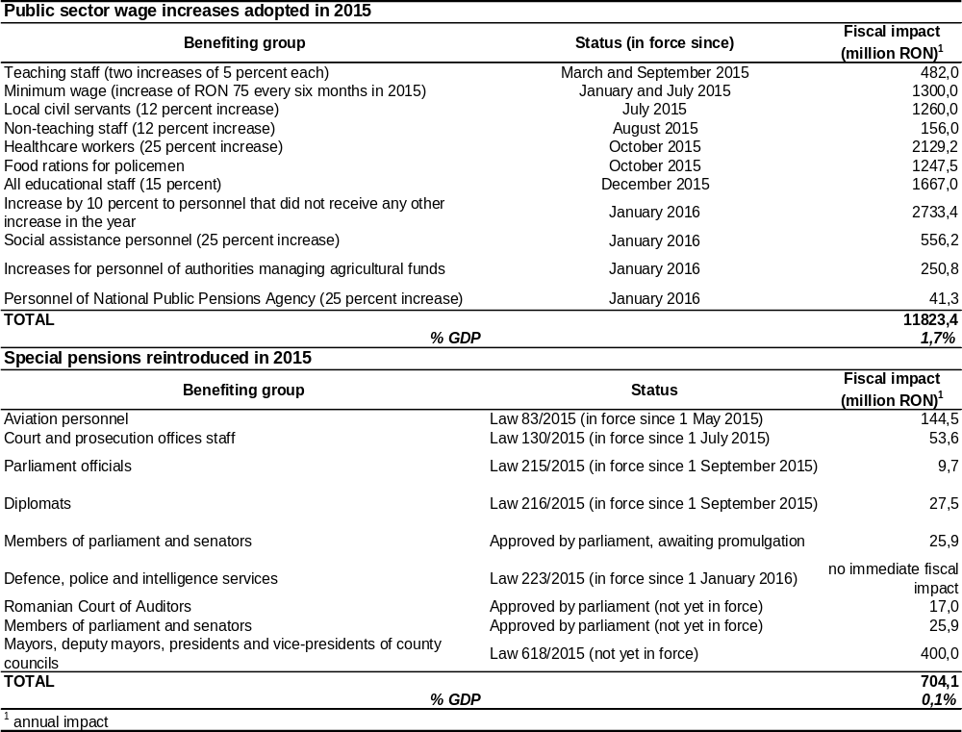
Source: Ministry of Public Finance Romania
A number of legislative initiatives on pensions and wages are being promoted without proper impact assessment. In 2010 Romania introduced a uniform pension system. Despite the favourable provisions of the new system for some categories of workers facing hazardous or other special working conditions, in 2015 a number of additional 'special' pension rights were reintroduced (Table 2.3.1). The reintroduction of a multi-tier pension system that weakens the link between contributions and pensions has a full-year impact of 0.1 % GDP (2016 estimations) and is expected to have an adverse impact on the long-term sustainability of the pension system. In 2015 the government also announced plans to amend the unified wage law adopted in 2010 but never entirely implemented. The potential implementation of this long-expected reform would constitute an additional fiscal stimulus and risk in the coming years, which is estimated at more than 2.5 % of GDP (based on 2016 estimated data).
Lack of medium-term vision and poor implementation of the fiscal rules are key drivers of pro-cyclicality. None of the recent deficit-increasing fiscal measures were initiated and adopted as part of the standard budgetary process. Ad hoc wage and pension increases and tax cuts were adopted by Parliament in 2015, without taking into account the fiscal space, the fiscal policy priorities and the potential fiscal consequences. The integrity of the budgetary process as laid down in the national fiscal framework is not always respected (see section 3.1). Moreover, the economic performance and financial situation of state-owned enterprises (see section 3.1) is a further risk to the state budget.
Fiscal sustainability
The macroeconomic environment has an impact on sovereign financing conditions through market perception of public debt sustainability. In 2009, even though public debt was low, Romania could no longer finance it due to unfolding macroeconomic imbalances. Successive financial assistance programmes helped restore and improve public-debt financing conditions. Romania has enjoyed full market access since mid-2011. Nevertheless, sovereign financing remains sensitive to debt sustainability as perceived by the markets, which depends not only on fiscal conditions, but also on macroeconomic performance and policy responses to macroeconomic challenges.
No significant risks of fiscal stress are expected in the short run. Within one year Romania does not appear to face major risks of fiscal stress arising from the fiscal or the macro-financial side of the economy. The analysis of the structure of public-debt financing highlights some short-term risks over foreign currency denomination and non-resident creditor base, but it does not raise concerns over the debt maturity structure().
Graph 2.3.2: Debt sustainability
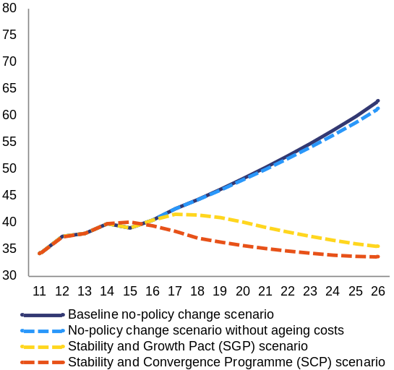
Source: European Commission
The debt sustainability analysis points towards high risks in the medium-term. Under normal economic conditions and assuming no changes of fiscal policy (baseline scenario), Romania's public debt would steadily increase from just below 40 % of GDP in 2015 to above 60 % of GDP in 2026 (last projection year) (Graph 2.3.2). This scenario assumes a constant structural primary deficit of 2.3 % of GDP from 2017 to 2026. This is the value in 2017, according to the European Commission winter 2016 forecast. A debt ratio above 60 % of GDP in 2026, combined with high risks from additional sensitivity tests (on shocks to the primary balance and the exchange rate), point towards high debt sustainability risks for Romania in the medium term.
If the structural balance converged towards the medium-term objective, Romanian public debt would decrease to around 35 % of GDP in 2026. In a scenario where the structural balance develops in compliance with the preventive arm of the Stability and Growth Pact and in line with the fiscal adjustment indicated in the Commission Communication on flexibility in the Stability and Growth Pact, Romanian public debt would be 27 percentage points lower in 2026 than in the baseline scenario (Graph 2.3.2).
Over the long run, there are additional sustainability risks related to ageing. These risks stem primarily from the forecast unfavourable initial budgetary position, compounded by age-related public spending, notably for healthcare and long-term care. Implementing reforms to contain the projected age-related increase in spending could improve fiscal sustainability over the long-term. This includes completing the pension reform and implementing the second pension pillar. Under national legislation, the completion of the second pillar requires the financing of privately managed pension funds to reach 6 percentage points of the employees' contribution to the pension system. Contrary to the legal provisions, the 2016 budget provides for transfers corresponding to only 5.1 percentage points of contributions, in effect delaying the implementation of the pension reform.
Credit developments and housing market
A credit boom supported unsustainably high GDP growth rates in Romania during 2001-2008. Annual real GDP growth averaged 6.5 % in this period. Such growth rates, supported by higher levels of debt, proved unsustainable as the increasing levels of imports brought about substantial external imbalances, which were financed by volatile capital inflows().
After several years of decline, credit to households returned to positive growth rates in 2015. Tighter credit standards as a consequence of the repairing of banks' balance sheets, combined with high pressures on households to reduce their debt, kept the growth of credit to households in negative territory throughout 2012-2014. Progress in the banks' balance sheet clean-up, combined with lower interest rates, led to the gradual recovery of loans to households. Credit to households returned to positive growth rates from January 2015 (Graph 2.3.3).
Graph 2.3.3: Credit developments — stocks
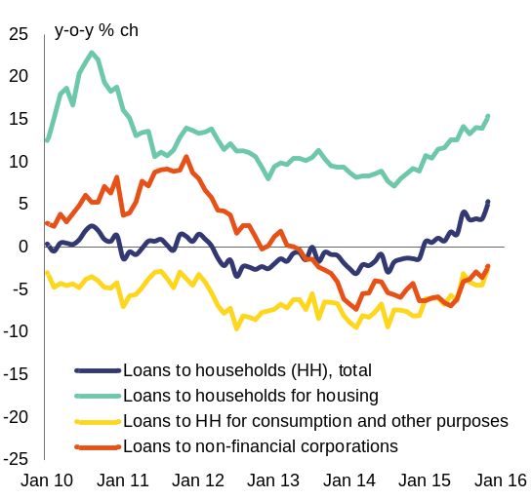
Source: European Commission
The recovery of household lending was driven by consumption loans in local currency and supported by a robust growth in loans for housing. Domestic credit to households in lei increased rapidly in 2015 (by 31 % for the year in nominal terms) (Graph 2.3.4). This was driven by declining interest rates for consumer loans and some easing of the credit standards. The growth rate of loans for housing, which now account for about 47 % of total loans to households, has also been increasing steadily since the second half of 2014 (by 16.5 % for the year in nominal terms in 2015). About 60 % of the total mortgage loans in local currency were guaranteed under the 'Prima Casa' state guarantee scheme to help people buy their first home.
Graph 2.3.4: Domestic credit in foreign and local currency
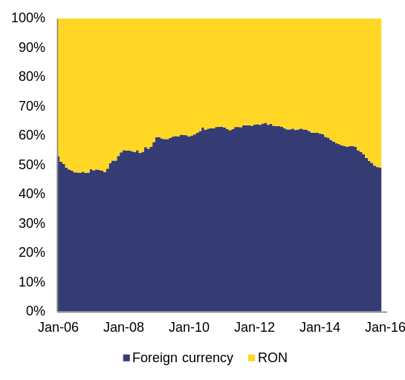
Source: National Bank of Romania
Credit growth to non-financial corporations remains in negative territory. Corporate lending started declining from mid-2013 and has not been able to recover since. Credit demand is subdued due to balance sheet adjustments of domestic companies, still high (although decreasing) interest rates and the preference of companies to reinvest profits rather than apply for new loans. On the supply side, corporate credit is affected by the high level of non-performing loans (21 % for non-financial corporations by September 2015) and tight credit conditions. Corporate loans picked up somewhat in the second half of 2015, but their recovery is still to come.
The subdued credit growth is an argument against the development of a credit-driven boom in the short run. Credit both to households and to non-financial corporations remains far below pre-crisis levels (Graph 2.3.5). Easier access to financing is set to support consumption growth in 2016 and beyond, but a credit-driven boom is not likely to develop in the short run.
Graph 2.3.5: Credit developments 2000-2015
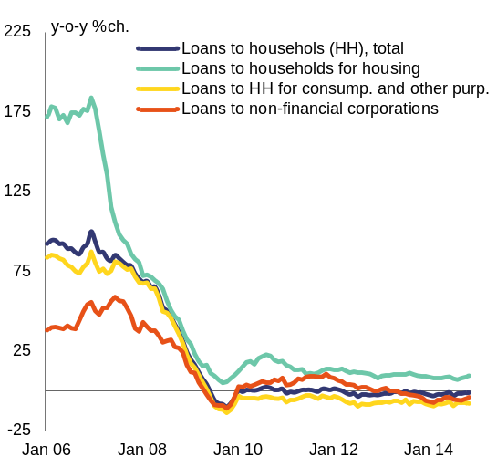
Source: European Commission
The build-up of a housing bubble is unlikely at this stage. Housing prices in Romania have been falling in recent years, both in nominal and real terms (Graph 2.3.6). Despite a small increase in the second half of 2014 and the beginning of 2015, they dropped again in the second quarter of 2015. Housing prices are forecast to increase slightly in 2016-2017, but still to remain considerably below their pre-crisis levels. A housing price bubble is therefore unlikely in the short term.
Graph 2.3.6: Evolution of the house price index and monetary financial institutions (MFI) loans for house purchases
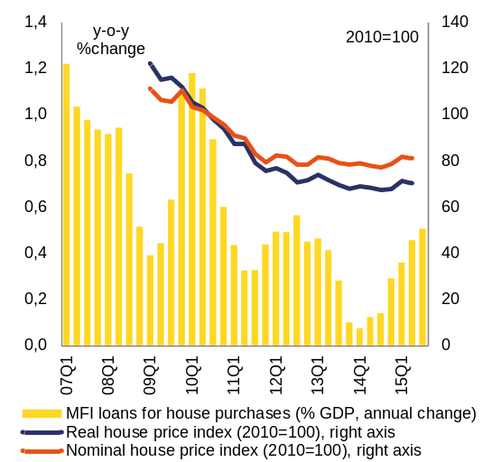
Source: European Commission
Infrastructure and public investment
Insufficient or low-quality infrastructure reduces accessibility and may limit investment. The inadequate supply of infrastructure is among the most problematic factors for doing business in Romania. The Global Competitiveness Report() has registered a slight improvement in the quality of infrastructure in recent years. Nonetheless, Romania still ranks last among its regional peers in the perceived quality of transport and communication infrastructure (Graph 2.3.7). Romania's roads and motorways network is small compared with that of peers and the size of the country(). It has been slow to expand and urgent repairs are often necessary even on newly built roads. Railways have very low commercial speed and the network reorganisation is yet in its early stages, despite the fact that Romania's railway system has one of the highest potential to increase passengers and productivity in the EU(). The insufficient development of infrastructure is a barrier to trade and economic development.
Graph 2.3.7: Quality of public infrastructure index, Romania and regional peers
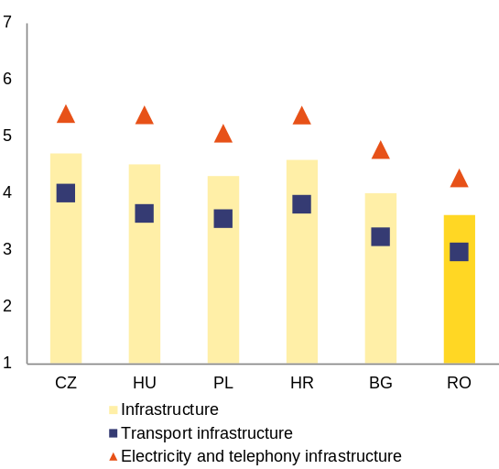
Scale: 1-7 (best)
Source: World Economic Forum, The Global Competitiveness Report 2015-2016
Public investment in Romania has been decreasing despite ample availability of financing. Public investment in Romania accounted for 4.3 % of GDP in 2014. This is still above the public investment levels of the pre-accession period, but below the record 6.7 % of GDP in 2008 (Graph 2.3.8). Romania has the second lowest level of public investment among peer countries and it is alone among its peers in that public investment has decreased every year since 2008. The main sources of investment financing are state budget funds, EU structural funds and loans by international financial institutions such as the European Investment Bank and the European Bank for Reconstruction and Development.
Graph 2.3.8: Public investment as % of GDP
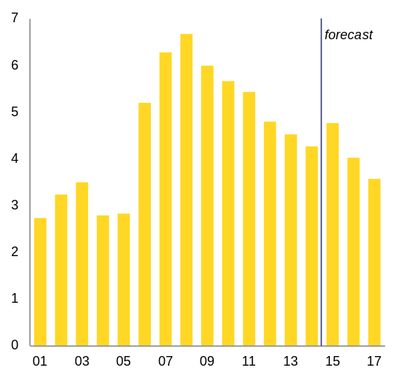
Source: European Commission
Financing opportunities from both national and international sources are under-exploited. Investment solely financed by national resources corresponds to 9 % of total public expenditure or 2.6 % of GDP. Capital expenditure is frequently under-executed relative to the budgeted amounts and a substantial part of it tends to be spent towards the end of the year (Graph 2.3.9). The level of state budget spending on investment is decreasing every year. This is partly due to the overall amount available for public investment spending and partly due to replacement of national with EU financing. EU-funds-related expenditure (EU and national financing, including non-eligible expenditure) corresponds to an additional 1 % of GDP. Absorption of EU funds for the 2007-2013 programmes, however, remains the lowest in the region (Graph 2.3.10). The Operational Programmes for basic infrastructure building, such as Environment, Transport and Regional Development, have absorption rates below or around the national average (Graph 2.3.11). The use of other financing sources is in parallel limited. Lending of the European Investment Bank in Romania, for example, is among the lowest in the region both in nominal and per capita terms (Graph 2.3.12).
Graph 2.3.9: Capital expenditures, budget data
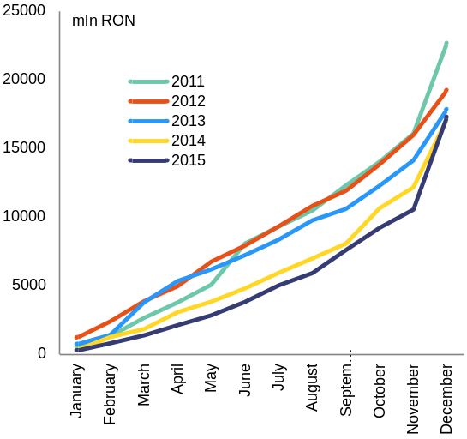
Source: Ministry of finance

Graph 2.3.10: EU funds absorption (SCF)
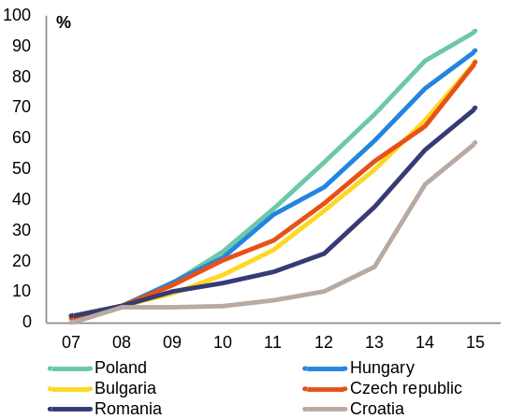
SCF: Structural and Cohesion Funds
Source: European Commission

Graph 2.3.11: EU funds absorption per Operational Programme
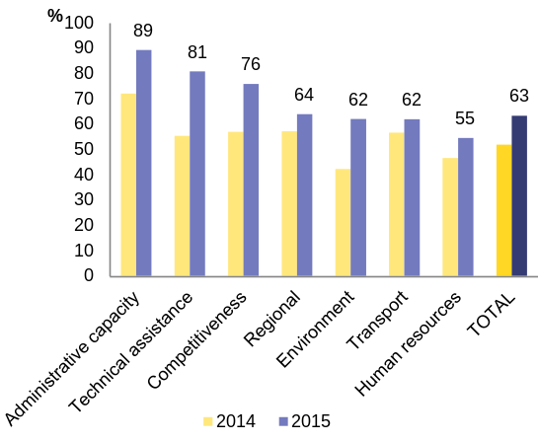
Source: European Commission

Graph 2.3.12: EIB lending 2010-2014, Romania and regional peers
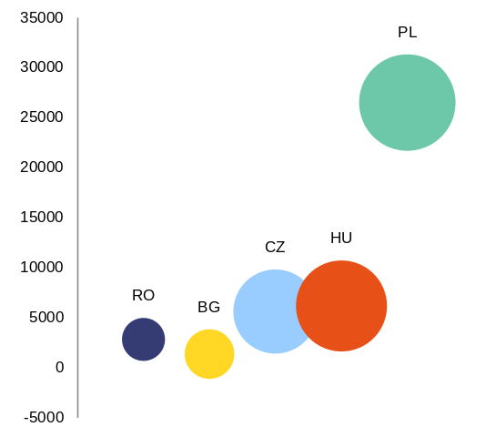
Source: European Commission
Despite various efforts, Romania's capacity to absorb EU structural funds remains constrained. Romania has absorbed less than two-thirds of the total funds (SCF and EAFRD) allocated under the 2007-2013 programming period (69 % in December 2015). In 2015 a task force was set up by the European Commission to tackle implementation difficulties in Member States, reduce the risk of decommitment of funds and maximise the absorption capacity. This enabled the implementation of major projects currently at risk, mainly through the 'phasing' of projects. As a result, a number of projects started but not finalised during the 2007-2013 programming period are financed in the 2014-2020 programming period.
Romania lacks medium- to long-term strategic planning on infrastructure development. Despite ample room for investment and the need to develop its infrastructure, Romania does not have sufficient mature new projects in the pipeline to kick-start absorption of the programming period that started in 2014. Strategic priorities are often affected by the political cycle, changes in political authority in line ministries and other politically motivated factors. The absence of medium- to long-term planning has a direct impact on the quality of investment proposals and on the commitment to implement ongoing projects (see section 3.1). In view of these factors, the ex ante conditionality for 2014-2020 EU funds requires Member States to prepare and adopt a number of sectoral strategies. In transport infrastructure, the preparation of a master plan for the 2014-2030 period is the ex ante conditionality for the Operational Programme 'Large Infrastructure'. The Transport Master Plan and the accompanying railway reform aim to provide Romania with a stable, visible and sustainable roadmap for future investments, but their adoption has been successively delayed.
The preparation of projects is usually insufficient and often susceptible to external influence. The technical preparation phase, which includes pre-feasibility and feasibility studies as well as technical and economic studies, is usually timed with the political calendar or other short-term priorities unrelated to technical aspects. This frequently leads to low-quality studies that do not meet the standards for opening the implementation phase. Moreover, the lack of mature projects and of solid feasibility studies and technical preparation for major investments impede the setting-up of financing schemes.
Project selection and prioritisation mechanisms are non-standardised and fragmented. Selection of public investment projects, including investment co-financed by EU funds and by international financial institutions, is usually done at the level of line ministries, local authorities, or other public institutions such as the National Company for National Highways and Roads in Romania (CNADR - Compania Națională de Autostrăzi si Drumuri Naționale din România). State budget-financed projects worth more than RON 30 million need the approval of government. Yet governments tend to have difficulties in arbitrating between numerous players (often line ministries) with different policy and political agendas. This selection process results in a long list of approved projects without earmarked financing, generating uncertainties for their financing and implementation. In addition, the public procurement system lacks transparency and efficiency (see section 3.1)
Difficulties in prioritisation are especially acute at the local level. Local public investment projects are developed under the National Programme for Local Development, which is managed by the Ministry of Regional Development and Public Administration. The programme has no strict selection criteria and no clear rationale for the financing decisions. It is also not aligned with sectoral strategies. Currently the programme includes more than 3 500 projects with total financing needs of almost RON 16 billion that have not been fully provided for in the medium-term budget planning, thus leading to financing irregularities. In order to improve the financial management of the National Programme for Local Development budget, a new mechanism was set up on a first-come-first-served basis. The budget authorities have limited control over the quality and the absorption capacity of the projects.
The prioritisation of significant projects is more centralised, but not sufficiently steered. The Public Investment Evaluation Unit of the Ministry of Public Finance was established in 2013 (Government Emergency Ordinance 88/2013). The Unit's role is to (i) evaluate significant projects, defined as those above RON 100 million, and (ii) prepare a priority list of projects to be financed by the budget, either exclusively or with the support of EU financing. The unit examines the projects' readiness, based usually on their pre-feasibility study, and prepares an annual update of the priority list to be approved by the government. The establishment of the Unit has been an improvement in the public investment management system. However, the unit operates simply as a recipient of proposals. It does not have the power to assess strategic coherence, to reject proposals or to monitor progress. It also cannot propose appropriate management solutions, including changes to the financing decisions based on project performance.
Additional barriers to investment
Romania has succeeded in attracting several major foreign investors in high-value-added activities. Anecdotal evidence suggests that foreign investors like Renault, Continental and Bosch are attracted to Romania by competence at low relative costs, particularly the potential of the labour force to find simple creative solutions at low cost. These companies cooperate closely with universities and invest heavily in the training of their employees, expanding their research cluster beyond the peri-urban areas where they are currently located.
Despite these positive developments, numerous barriers to investment are still present and are restraining potential growth (see Box 1.1 and section 3.1). Research and innovation activities are hampered by insufficient funding, weak public-private collaboration and fragmented institutional setting(). The process of restructuring of state-owned enterprises is ongoing, but the limited efficiency of such enterprises has hindered the development of infrastructure (see section 3.1). Regulated energy prices and related domestic supply obligations limit investment incentives. All these factors suppress potential growth.
R&D and innovation expenditure is low and inefficient. R&D intensity has been continuously falling since 2011, reaching 0.38 % of GDP in 2014. This is the lowest level in the EU and far away from the Europe2020 target of 2 %. Public R&D expenditure fell to 0.22 % of GDP in 2014, placing Romania last in the EU. Structural funds in the 2007-2013 period of EU funding accounted for merely 20 % of public R&D expenditure. For the 2014-2020 programming period only 15 % of the funds available to Romania are allocated to R&D. A more positive development is the higher allocation of funds to R&D in the 2016 budget, which would increase the public R&D expenditure to 0.29 % of GDP in 2016.
Graph 2.3.13: Developments in R&D intensity
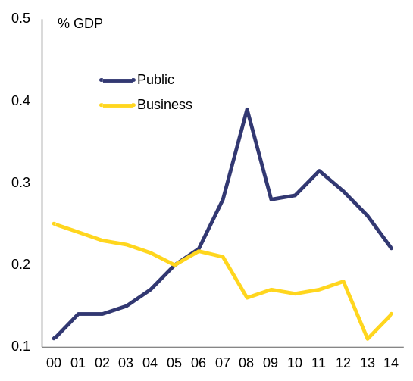
Business R&D intensity: Business enterprise expenditure on R&D (BERD) as % of GDP
Public R&D intensity: Government intramural expenditure on R&D (GOVERD) plus higher education expenditure on R&D (HERD) as % of GDP
Both series have a break in the series between 2011 and previous years
Source: European Commission
Business investment in R&D is still under-developed in spite of new incentives. Romania has one of the lowest values of business R&D expenditure in the EU (0.16 % of GDP in 2014, 27th in the EU). Low business sophistication and the overall low quality of the science base() hamper Romania’s capacity to attract business R&D investment and to foster public-private cooperation in research and innovation. In recent years, technology start-ups have gained ground around some entrepreneurial hubs in ICT, but the phenomenon remains limited. Tax incentives for R&D expenditures were adopted in 2010 with the aim to provide incentives for increasing business investment in R&D, but they are not yet operational. The adoption in 2014 of a law on inventions by employees is also expected to encourage multinationals to locate more of their R&D activities in Romania and to invest in innovation activities with a higher added value to the economy.
Resource efficiency is low and the circular economy is underdeveloped. In 2014, resource productivity was substantially below the EU average: EUR 0.3217 per kilogramme compared with EUR 1.9492 per kilogramme in the EU(). Romania is late to adopt the relevant planning instruments concerning waste management. Its landfilling rate is the highest in the EU (96.8 %). This indicates that resources are not kept within the economy when a product has reached the end of its life.
Access to credit for SMEs is difficult and support for knowledge-based start-ups and product development is still at an early stage. A Business Angels Law was adopted in 2015 and support for other new forms of financing is being exploited. The creation of two investment funds is envisaged — one with opening and seed capital for entrepreneurs with innovative ideas and one with venture and growth capital for innovative start-ups. The success of all these measures will depend on the development and maintenance of solid innovation governance, combined with a coordinated and integrated perspective of the research, development and innovation system in a context of a smart specialisation approach, and supported by resource stability and predictability and better public-private partnership.
State-owned enterprises dominating key economic sectors tend to underperform(). State-owned entreprises generate 8 % of the output of non-financial corporations in Romania and employ close to 4 % of the workforce. They are especially relevant in key infrastructure industries, generating 44 % of turnover and 77 % of employment in the energy sector and 24 % and 28% of turnover and employment respectively in the transport sector. Romanian state-owned enterprises are less profitable and less productive than their privately owned peers and their counterparts in neighbouring countries. They also pay higher salaries (see section 3.1). The difficulties in restructuring loss-making state-owned enterprises are a burden to the state budget in the form of needed funds and foregone profits. The operational and financial performance suggests a misallocation of resources that could be slowing down the build-up of key infrastructure and consequently harming the overall efficiency of the economy.
Electricity and gas-price deregulation and a stable legal framework could boost competition and investment in sustainable and cost-efficient supply. Retail electricity and gas markets remain very concentrated() and competition is limited by negative or slim margins allowed by price regulation. Electricity and gas prices for non-households have been fully liberalised since 2014 and 2015 respectively. The liberalisation of household markets is scheduled to be concluded by 2018 for electricity and by 2021 for gas. Until then, household prices remain fixed at levels substantially below the EU average, limiting the price signal and the incentives for investment in energy efficiency. This may also entail further risks for the absorption of EU funding for energy efficiency in buildings. Further sources of uncertainty for investors are: changes to the liberalization schedule, delays with implementing EU legislation on energy efficiency, the dominance of state-owned enterprises and the absence of a national strategy for climate and energy covering the period beyond 2020.
Cross-border energy interconnections still require substantial investment. Several Romanian energy infrastructure projects with significant cross-border impact are included in the 2015 list of projects of common interest (). The aim is to promote the interconnections in the bi-directional system between neighbouring Member States and to diversify energy sources and supply routes. Relevant projects in the list of projects of common interest include the reinforcement of the electricity interconnection between Bulgaria and Romania and the capacity increase on the Bulgaria-Romania-Hungary-Austria bi-directional gas transmission corridor ('ROHUAT/BRUA').

2.4. MIP assessment matrix
This MIP assessment matrix summarises the main findings of the in-depth review in the country report. It focuses on imbalances and adjustment issues relevant for the MIP.
Table 2.4.1: MIP assessment matrix*- Romania
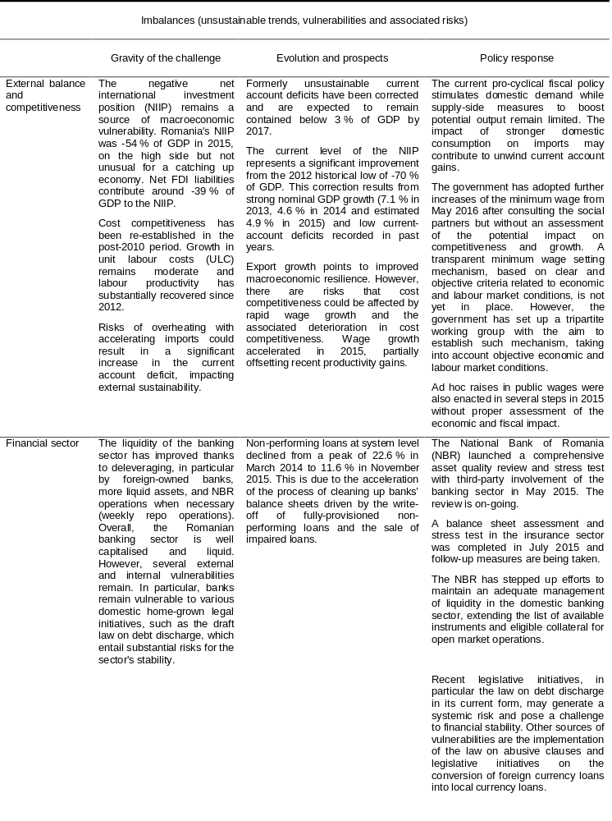
(Continued on the next page)

Table (continued)
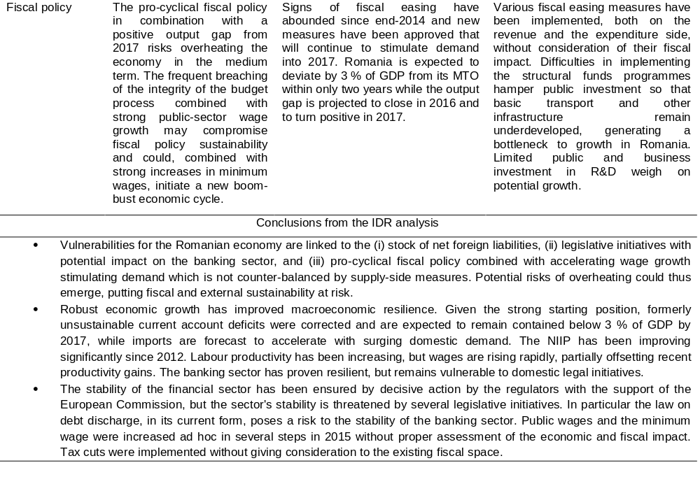
(*)The first column summarises "gravity" issues which aim at providing an order of magnitude of the level of imbalances. The second column reports findings concerning the "evolution and prospects" of imbalances. The third column reports recent and planned relevant measures. Findings are reported for each source of imbalance and adjustment issue. The final three paragraphs of the matrix summarise the overall challenges, in terms of their gravity, developments and prospects, policy response.
Source: European Commission

3. Additional structural issues
In addition to the macroeconomic imbalances and adjustments issues addressed in section 2, this section provides an analysis of other economic and social challenges for Romania. Focusing on the policy areas covered in the 2015 country-specific recommendations, this section analyses broad governance issues with impact on economic growth potential. The topics covered are public administration, including taxation and fiscal governance, state-owned enterprises, business environment and the judicial system. Second, it reviews labour-market policies, education, social protection and healthcare, as labour market and social challenges are closely intertwined. Romania still faces very high risks of poverty, social exclusion and income inequalities. Finally, the section addresses the development challenges of rural areas and the deep and growing rural-urban gap in terms of employment, poverty, education and access to services.
3.1 governance and Business environment
Weaknesses in Romania's governance structure and an unfavourable business environment create uncertainty, impede competitiveness and are barriers to investment. The limited effectiveness of public administration coupled with widespread corruption constrains service delivery and hampers the ability to implement structural reforms and draw on EU funds (see section 2.3). The 2015 country-specific recommendations advised Romania to further improve tax collection and the governance of state-owned enterprises. In spite of the simplification of certain administrative procedures, companies still face red tape and legal uncertainty. Concerns also remain over the predictability and enforcement of judicial decisions.
Public administration
The effectiveness and efficiency of public administration remain limited. An unstable organisational structure, weak administrative capacity and inconsistent human and financial resources policies limit the capacity of public institutions to develop and implement policies in a strategic and coordinated manner. Inefficiencies are not only related to low professionalization, but also to politicisation and lack of empowerment of civil servants(). Decision-making and legislation often lack predictability and transparency. This situation has a far reaching impact on a wide variety of issues, from the delivery of structural reforms up to the success in providing efficient and effective services to the population and a stable and business-friendly environment to investors.
Human resource management is inconsistent and the organisational structure of the public administration is unstable. The public administration currently lacks a uniform approach to human resources management. Only 13 % of staff are civil servants and under the responsibility of the Civil Service Agency. The remaining personnel, mainly contract staff, fall under the general rules of the Labour Code and other labour legislation. Frequent institutional reorganisations (Graph 3.1.1), linked in most cases to the electoral cycle, and over-used provisional appointments in management positions() impact negatively on the independence of the civil service, the predictability of decision-making, and on career-building for civil servants. Ad hoc salary increases for some departments or sectors of public administration take place outside an overall plan to improve human resource management and to address recruitment, evaluation, appraisal, and promotion.
Strategic planning is not a common practice and is mostly driven by the use of EU funds. Medium- to long-term strategic planning is weak (see section 2.3). Strategies are developed mostly as a part of the ex ante conditionality for access to EU funds and other sources of external financing. They are often developed by external consultants with uneven participation and ownership by the public bodies responsible for their implementation. Monitoring takes place mainly under the responsibility of inter-ministerial committees, with limited effectiveness and coordination. A new concept of strategic planning and evidence-based regulatory decision-making was developed in 2015. It clarifies the roles and responsibilities of the centre of government and the line ministries. A number of administrative capacity prerequisites, however, still need to be met before it becomes operational.
Graph 3.1.1: Number of reorganisations of public authorities and institutions as approved by the Civil Service Agency
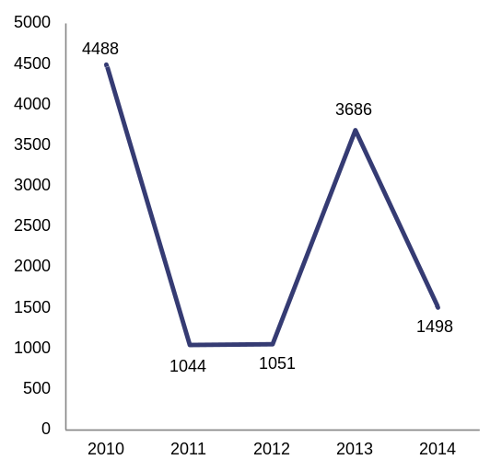
Source:
Reform of the public administration is still to gain pace. A Public Administration Strategy, adopted in October 2014, seeks to encourage reform of the public administration in five areas: public policies and regulation, reduction of red tape, human resources, public services and local public administration. Its implementation requires strong political leadership, but the reform has not been a priority in 2015. A public administration platform created with the support of the European Commission seeks to bring together all relevant stakeholders with the aim to speed up proper implementation of the strategy. Romania aims to improve the predictability and the transparency of public administration through the recent adoption of new mechanisms for improved and coordinated decision-making at government level and for consulting the civil society, including the setting-up of a dedicated ministry. The new government priorities for improving human resources management include a civil service strategy closely interlinked with the revision of the unitary wage law.
Corruption persists at all levels of public administration. Corruption is present in many economic sectors and involves appointed and elected officials at all levels of government as well as civil servants and employees of public institutions. This is borne out by the record of criminal investigations and convictions for corruption(). Preventing corruption in public administration was one of the key priorities of the 2012-2015 national anti-corruption strategy. The evaluation of the strategy shows some progress in putting in place corruption prevention measures at the level of national administration. It concludes, however, that local administration structures are lagging behind in terms of building up the necessary capacity to prevent corruption effectively. The government plans an extension of the strategy that will include additional measures to remedy the weaknesses identified in the evaluation.
The ongoing reorganisation of the public procurement system is expected to increase its transparency and efficiency. In July 2015, with the support of the Commission, the authorities adopted a dedicated strategy and an implementation action plan to tackle the deficiencies of the public procurement system in a holistic way. A new Public Procurement Authority was created under the coordination of the Ministry of Finance. Further effort is needed to streamline the overly fragmented institutional framework, to eliminate overlapping competences while improving institutional checks and balances, to provide a strategic dimension to the public procurement policy, and to improve the administrative capacity of public purchasers and the quality of competition in public procurement. These deficiencies are an obstacle to providing value added to public investment and are responsible for substantial financial corrections and low absorption of EU funds.
Public procurement remains highly vulnerable to corruption. Over half of the companies that participated in a public procurement procedure over the past three years believe that corruption prevented them from winning a public tender or public procurement contract. Tailor-made (59 %) or unclear (54 %) specifications, conflict of interest in the evaluation of bids (53 %) and collusive bidding (57 %) are cited among the most widespread corrupt practices in public procurement. Bribes and kickbacks (58 %) and funding of political parties (39 %) in exchange for public contracts or influence over policy-making are also perceived to be widespread().
Table 3.1.1: Paying taxes indicators
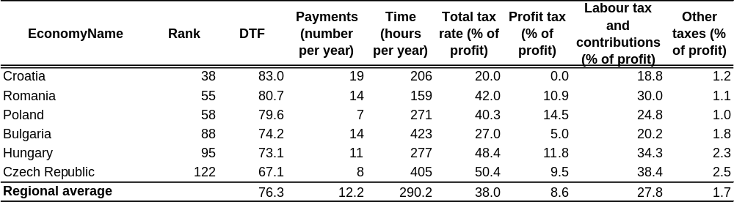
Source: World bank, Doing business 2016
E-government solutions to improve the efficiency of public administration are under-developed. The use of e-government in Romania is the lowest in the EU. In 2015, only 8 % of Romanian internet users sent forms to the public administration online compared with 32 % on EU average(). The digitalisation of public administration has been slow and fragmented and the level of sophistication of online public services needs improvement. For instance, on average only 54 % of the steps in a standard interaction with the public administration can be performed entirely online compared to an EU average of 81 %. The point of single contact is difficult to use and a significant number of administrative procedures cannot be completed online. In 2013 only 65 % of SMEs interacted online with the authorities, compared with an EU average of 88 % and only 5.8 % of the citizens aged 16-74 used e-government services(). A positive sign is that the new government made one of its priorities to support interoperability at national level and to provide better digital services.
Taxation
The tax system is relatively favourable to business and growth, but some risks of aggressive tax planning exist. The standard corporate income tax rate of 16 % is among the lowest in EU and second lowest in the region. The dividend tax was reduced and the special construction tax is due to be fully abolished from 2017, after having been reduced to 1 % in 2015 (see section 2.3). From 2016 the property tax is also differentiated according to its use, i.e. residential or business. Tax revenues are based more on indirect than direct taxation. The overall paying-taxes ranking of the country has been improving and is the second best among the regional peer countries (Table 3.1.1). Several features of the Romanian corporate tax system can be used in structures of aggressive tax planning(). In particular, the absence of anti-abuse rules() might risk creating an attractive environment for certain aggressive tax planning structures.
Frequent changes to tax legislation are a source of concern and uncertainty for businesses. In 2015, Romania's key piece of tax policy legislation, the Fiscal Code, was substantially amended and adopted after intensive works running over several years. The amended Fiscal Code will apply mostly from 2016. Even though one of the aims of this overhaul of the tax legislation was to increase legal certainty and predictability, several further amendments were subsequently made by way of government acts. The lack of continuity and predictability of taxation have a negative impact on the business climate, in particular investment decisions.
High tax evasion, especially in VAT, and low level of tax compliance remain a challenge. Since 2000, the average VAT gap exceeds 40 %. In 2013 the VAT gap was estimated at 41 %, the highest in the EU and significantly above the EU average of 15 %. The VAT revenue ratio was 46.8 % in 2014, slightly below the EU average of 48.1 %(). Tax collection, especially in VAT, is gradually improving and is expected to further increase as a result of the measures currently being implemented. However, the reduced VAT rate to bakery products from September 2013 does not seem to have met the announced target to reduce tax evasion in the sector(). This and other reductions of the VAT rates for different categories of products and services narrow the tax base and add to the revenue-side risks. They also increase the complexity of the VAT administration and the risk of tax evasion.
A number of measures are being implemented to improve tax collection and to increase tax compliance. Mandatory cash registers are being progressively introduced in sales points. Under national legislation (Law No 267/2015), all such cash registers will be progressively connected to the IT system of the national tax authority (Agenţia Naţională de Administrare Fiscală, ANAF). At the beginning of 2015 ANAF launched a toll-free telephone number where consumers can register complaints and report cases where they have not received a receipt for their purchases. Cash-payment rules have been further strengthened and VAT reimbursement procedures have been streamlined. Since February 2015, a new VAT registration procedure based on pre-defined risk criteria was put in place and is expected to reduce VAT fraud. As a result of this new procedure, about 50 % of the new requests for registration were rejected in the first nine months of 2015. ANAF intensified its efforts by carrying out an extensive audit action targeted at wholesale operators throughout the country. However, the results released by ANAF (on 9 November 2015) after the first inspections (i.e. the surprise effect) indicate that the degree of voluntary compliance is low: a significant number of the taxpayers concerned either fled upon the arrival of the tax inspectors or could not present the documentary evidence of the merchandise.
The ongoing reorganisation of ANAF, the Romanian tax authority, is intended to increase flexibility and efficiency. Steps have been taken to simplify and modernise the tax administration. These include the restructuring of the Large Taxpayers Offices, establishment of a Compulsory Enforcement Directorate (dealing with special cases), redistribution of staff inside ANAF (which employs almost 27 000 people country-wide), mandatory automatic submission by banks of information on taxpayers' bank accounts, and the implementation of a pilot project on under-declared earnings. In 2016, ANAF, in cooperation with the World Bank, plans to update its tax compliance strategy. From 2016, the Large Taxpayers Offices will operate as an independent general directorate under the authority of ANAF. The effectiveness of these reforms will be assessed in the future, but some collection disruption risks exist.
Undeclared work and under-declared earnings continue to weigh on tax revenue and distort the economy. The discrepancy between the relatively high tax wedge on labour (calculated on the basis of the legal tax obligation) and the low implicit tax rate() on labour (derived from actual tax receipts) suggests a high amount of concealed earnings with a serious negative impact on fiscal revenues. Work in the shadow economy is often marked by low working standards, little or no human-capital investment and low labour productivity. The pilot compliance project targeting undeclared labour and under-declared wages and tax evasion launched mid-2014 was extended in 2015 to the entire country. Efforts made in 2015 by the labour inspectorate as part of its framework actions programme seem to have been slowing down(). Overall, efforts towards ensuring formalisation of work relationships beyond fining offenders and collecting tax arrears remain limited. The intended restructuring of the labour inspectorate, which has been merged with the National Agency for Payments and Social Inspections, has so far not happened, as the law implementing the restructuring has not been adopted yet by Parliament. It is not clear whether this merger will improve or create disruptions in the work and organisation of the institution.
Fiscal framework
The fiscal framework in Romania is sound in its provisions, but not applied effectively in practice. The main legal documents governing the budgetary process and the medium-term fiscal policy are the fiscal responsibility law (Law 69/2010), the public finances law (Law 500/2002) and the local public finances law (Law 273/2006). The fiscal responsibility law was updated in 2013 (by Law 377/2013) to incorporate certain provisions of the Stability and Growth Pact and the Fiscal Compact and to better comply with the fiscal framework pillars. These include fiscal rules, medium-term fiscal planning and the setting-up of an independent fiscal institution (the Fiscal Council). None of these pillars are fully complied with, neither during the design and implementation of fiscal policy by the government nor during its approval and scrutiny by Parliament.
The implementation of fiscal rules is loose, with ad hoc government acts providing for derogation from the fiscal responsibility law. This law explicitly lays down numerical fiscal rules that should be complied with both during the planning and the implementation of the budget. These include: compliance with or convergence to the medium-term budgetary objective; compliance with the expenditure and debt levels required by EU regulations and the Fiscal Compact; upper ceilings for a large number of budgetary indicators including staff expenditures; restrictions on the redistribution of unused investment expenditure; restrictions on the use of a better-than-expected general government balance. For the deficit, the fiscal responsibility law requires the annual structural general government balance to remain or converge towards the medium-term budgetary objective of -1 % of GDP. So far fiscal rules have always been complied with ex ante, i.e. during the preparation of the budget. However, the 2016 budget is the first draft budget that is already in breach of the deficit rule at its adoption. During implementation, deviations from the rules are addressed with amendments of the budget (budget rectifications) and supplementary government acts providing for derogations from the provisions of the fiscal responsibility law.
The budgetary process is not effectively guided by medium-term fiscal plans. Under the fiscal responsibility law, the fiscal strategy sets out the macroeconomic assumptions, the medium-term budget planning and the expenditure ceilings that guide the annual budget process. The fiscal responsibility law also provides that the strategy must be updated annually and presented to Parliament before 15 August, together with a draft law approving the expenditure ceilings. The fiscal strategy has almost never been prepared on time. Both in 2014 and 2015 it was sent to Parliament simultaneously with the budget law in December. As a result, instead of guiding fiscal policy and ensuring that expenditure and revenue decisions are made at the same time, the fiscal strategy essentially mirrors and accommodates ex post ad hoc decisions taken during the year.
Fiscal measures are often not adopted in full compliance with the provisions of the fiscal responsibility law. Under this law, new legislative initiatives that involve an increase in public spending (Article 7) or a reduction of public revenues (Article 13) must include an impact assessment verified by the Ministry of Finance. In this context, expenditure increases should also comply with the annual expenditure ceilings, while revenue reductions should be accompanied by proposals for compensatory measures. Endorsement by Fiscal Council is obligatory in the case of revenue measures, while its opinion may also be required for expenditures increasing measures. For a number of legislative initiatives in 2015 these provisions were breached. These include Parliament's initiatives to reintroduce special pensions and increase wages outside the expenditure ceilings and without proper impact assessment, as well as the significant tax cuts included in the Fiscal Code amendments without compensating measures and without the endorsement of the Fiscal Council.
The role of the Fiscal Council could be further strengthened. The Fiscal Council is the independent authority established by the fiscal responsibility law. Its mandate includes issuing opinions and recommendations on macroeconomic and fiscal forecasts, policy documents and policies as well as the monitoring of compliance with fiscal rules. Since its creation, the Fiscal Council has had an active presence in Romania and its work has been increasingly reported in the media. However, its opinions and recommendations are not sufficiently taken into account in actual policy-making. Moreover, on many occasions the Fiscal Council is given very little time to react to budgetary proposals before they were adopted by the government.
State-owned enterprises
Improvements to the governance of state-owned enterprises are being prepared. Corporate governance of state-owned enterprises is regulated by Government Emergency Ordinance 109/2011. The limitations of this government act() and low political ownership have led to weak implementation. In the light of the importance of state-owned enterprises for the economy (see section 2.3), the government is seeking to address some of the shortcomings of Government Emergency Ordinance 109/2011 during its conversion into law by Parliament. This conversion was one of the country-specific recommendations addressed to Romania in 2015(). Amendments to the draft law have been prepared with the support of the Commission, the IMF and the World Bank. They were submitted to Parliament in early January 2016, but have yet to be discussed. The revisions seek, among other, to clarify the obligations of managers, management boards and other entities involved in the governance of state-owned enterprises, improve performance and rewarding criteria, and strengthen the monitoring powers of the Ministry of Finance. Currently no change is being proposed to the ownership structure of state-owned enterprises, which will remain fragmented between the different line ministries.
The privatisation of loss-making state-owned enterprises has stalled. In 2013, in the context of an EU/IMF balance-of-payments assistance programme, the government announced its intention to sell stakes in six of the largest companies under public control. The goal was to increase private oversight and the operational efficiency of management of state-owned enterprises. A complementary objective was the development of the local stock market. However, after three successful initial public offerings in October and November 2013 and June 2014(), the privatisation process has stalled. The remaining privatisations, those of CFR Marfa, Hidroelectrica and CE Oltenia, have been de facto suspended(). Only one privatisation is being currently pursued, that of Oltchim, a troubled chemicals producer under special administration and with open state-aid related questions. However, this particular privatisation was not part of the 2013 package.
A new law on privatisations is in the making, but it may fail to improve governance and transparency. A new law on privatisations is an opportunity to address several of the current shortcomings, such as inactive but remunerated technical and steering privatisation committees, as well as the need for privatisation committees themselves, given that the technical work is normally conducted by external consultants. Concerns have been raised regarding potential conflicts with the corporate governance rules defined in Government Emergency Ordinance 109/2011 (see above). Of particular concern are likely overlaps in the responsibilities of the privatisation's special administrator and the company's management. Also, shielding companies under privatisation from procedures to recover tax arrears would be hard to justify on economic grounds and could raise state aid concerns.
State-owned enterprises in Romania continue to complement low salaries in the administration. The remuneration of civil servants serving in boards and general shareholders meetings of state-owned enterprises is regulated by Government Ordinance No 26/2013. Many of the rules in Government Ordinance No 26/2013 are not in line with international good practices: payments are not linked to responsibilities, they are not harmonised across line ministries and are generous even by international standards. Payments are also inflated by the exceptionally high number of meetings — shareholder meetings often take place monthly, sometimes even several times per month — and from the fact that many civil servants and political appointees sit in multiple boards, shareholder meetings and privatisation committees. The law approving Government Ordinance No 26/2013 was returned by the President to Parliament in November 2013 with the aim to improve it. However, it was never discussed again, meaning that the government ordinance remains in force. A limitation on the number of paid shareholder meetings per year and on the number of state representatives per meeting was extensively discussed in the past, but now seems to have been abandoned.
Other measures to improve transparency and accountability are also progressing slowly. The number of state-owned enterprises complying with obligations to approve and publish their budgets and accounts improved in 2015, but deadlines are not respected and compliance remains low. Very few state-owned enterprises had their 2015 budgets approved within one month of the approval of the state budget, which was a government objective for all big state-owned enterprises. Thirty-seven of such enterprises, mostly small ones, had not had their budget approved by the end of November. Only 136 of the 232 active state-owned enterprises under the central government had published audited accounts by the end of November 2015. Increasing transparency and external oversight was also the objective of the initial public offerings of small stakes in the largest state-owned enterprises. In that sense, the de facto suspension of privatisations described in section 2.3 also affects progress in this area.
Business environment
Romania is making progress in several areas of interaction between businesses and public administration. In 2014, it took less time to start a business in Romania compared with the EU average (two days as against the EU average of 3.5 days) and it cost less (EUR 100 compared with the EU average of EUR 313)(). Paid-in minimum capital (in percentage of income per capita) was 0.7 %, well below the EU average of 11.3 %. It was also both quicker and less expensive to transfer property: it took 19 days in Romania (EU average 26) and cost 1.5 % of the property value (EU average 4.5 %).
Despite this progress, the burden of government regulation and legal uncertainty continue to weigh on competitiveness (see sections 2.1 and 2.3). According to the World Bank 2015 Worldwide Governance Indicators, Romania's score for the regulatory quality is well below the EU average, even if it has improved (from 0.2 in 2004 to 0.6 in 2014). The complexity of administrative procedures as well as fast-changing legislation and policies constitute major obstacles to doing business. The practice of replacing the normal legislative process by government emergency ordinances, with a single ordinance occasionally covering several policy areas, is not consistent with the objective of streamlining and simplifying legislation, embedded in Romania's Public Administration Strategy. The conversion of the emergency ordinances into law often languishes in Parliament for years. The cost of enforcing contracts remains higher than the EU average (29 % of the claim compared with 22 %) and licences and permit systems are perceived as more complex. A related Better Regulation Strategy, adopted in December 2014, remains without an action plan to implement it.
Romania's business environment is negatively affected by the absence of a rescue culture in the case of corporate insolvency. There is still a high bankruptcy stigma and an almost exclusive focus on liquidation instead of reorganisation and rescue. While individual entrepreneurs can use a simplified procedure by going straight into bankruptcy and liquidating their assets, there is no possibility of reorganization or a repayment plan. Companies in financial distress are usually targeted by creditors in court. In addition, the insolvency procedures are among the longest in the EU(). On company law in general, a lack of procedures allowing companies to directly transfer their registered office from Romania abroad and vice versa adds extra costs and red tape.
The lack of transport infrastructure, particularly between the west of the country and the capital is a major drag on competitiveness and a bottleneck to growth. The low availability and quality of transport infrastructure hampers the competiveness of local businesses, particularly manufacturers, and further limits the attractiveness of the country for investments.
The new government has announced plans to improve the business environment. As part of its economic priorities, the government wants to place further emphasis on promoting and diversifying exports and FDI, supporting entrepreneurship and SMEs, easing access to finance, stimulating the development of creative industries, tourism, agriculture and research as priority business sectors, and restructuring the mining and defence industries(). A strategic and selective medium- to long-term economic development plan and a national competitiveness strategy can help implement concrete steps and facilitate the transition to a higher value added economy.
Digital skills and ICT sector
The information and communication technology (ICT) sector is dynamic and competitive. The ICT sector's share of Romania's GDP is 6 %, one of the highest in the EU (Graph 3.1.2). With nearly half of fixed broadband subscriptions with speeds of at least 100 Mbps, Romania has the highest take-up of ultra-fast broadband in the EU. The take-up of broadband subscriptions, however, is among the lowest in the EU. Access to ICT services consequently remains uneven().
Graph 3.1.2: ICT share of GDP
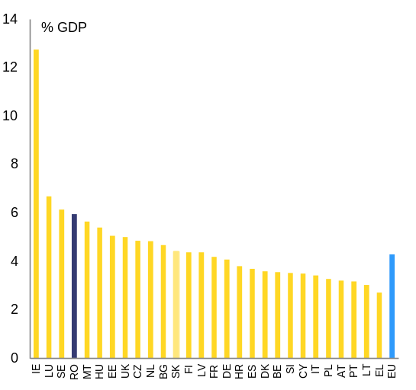
Source: European Commission
At the same time, more than one-third of the population cannot partake on the possibilities offered by the internet and cannot contribute to the digital economy. According to Eurostat data, in 2015 Romania had the lowest percentage of regular internet users in the EU (52 % vs 76 % in the EU) and 32 % of the population had never used the internet (vs 16 % in the EU). Less than half (46 %) of the workforce possesses basic or above digital skills (vs 72 % in the EU). This might become a major barrier to the country’s economic development. Improving digital literacy and digital skills can generate digital jobs and support the development of e-commerce and e-government.
Despite progress in recent years, the potential of e-commerce is still largely untapped. Romania ranks among the last in the EU in online engagement, as reflected in the Commission's Digital Economy and Society Index(). Consumer and retailer confidence in domestic online transactions is also below the EU average(). Strengthening the enforcement capacity of consumer protection authorities would ensure that rules are better enforced, also in the digital world, and thus increase trust in online transactions.
Graph 3.1.3: Digital economy and society index, performance
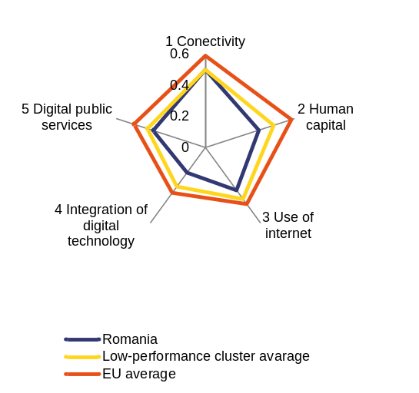
Source: European Commission
Judicial system()
Romania is consolidating the implementation of major reforms of its civil and criminal law codes. There is evidence that the goal of greater effectiveness in the provision of justice is being achieved, although some legal steps still need to be finalised. The 2015-2020 strategy for the development of the judiciary and the draft action plan for its implementation set out measures to improve judicial efficiency, quality and independence. The action plan still has to be adopted by the new government and further implemented by government that will take office after the 2016 elections. Its impact will depend on the effectiveness and sustainability of the proposed action, the allocation of the necessary resources and the implementation and ownership of the action plan by different governments and key stakeholders in the judicial system.
In the meantime, concerns about the efficiency of the judicial system remain. An increase in non-litigious enforcement cases and in litigious civil and commercial cases and high numbers of repetitive standardised cases are adding to the workload of courts. According to the 2016 EU Justice Scoreboard, the time needed for courts to resolve administrative cases at first instance has increased somewhat. The distribution of workload among courts is uneven. This brings about a greater workload and backlogs in some judicial districts and courts, which may affect the efficiency and quality of their work. The judicial system has, however, developed management tools, such as statistical information tools in all courts, which allow them to monitor the situation and take corrective action. The legislative initiative for a judicial map reform, which aimed to address systemic inefficiencies country-wide, was ultimately rejected in Parliament. The government is therefore considering alternative measures under the draft action plan.
Businesses have expressed concerns over the predictability of judgments. Inconsistent case law continues to be reported at lower instance courts. The High Court of Cassation and Justice, however, is playing an active role in ensuring consistent interpretation via preliminary ruling procedures and appeals in the interest of the law. In addition, the ROLII project for the online publication of case law was launched in December 2015. This could contribute to consistency by making existing case law transparent and easily accessible.
Prolonged non-enforcement of final court decisions may negatively affect business confidence. The effective enforcement of court decisions by public authorities can come with delays or not at all. While a legal framework seems to be in place both for monetary and non-monetary claims, consistent implementation by different public authorities seems to be lacking. The draft government action plan includes measures to modernise the profession of bailiffs, such as the creation of an electronic database on enforcement, which could potentially boost the role and performance of bailiffs.
While business perception of judicial independence continues to improve, external pressure on the judiciary remains high. There has been a significant improvement of business perceptions of judicial independence since 2010(). However, throughout 2015, the judiciary continued to experience pressures from politicians and the media through politically motivated criticism targeting judges, prosecutors and the judiciary as a whole. In 2015, the Superior Council of Magistracy took 16 decisions defending the independence of the judiciary and 10 decisions defending the professional reputation, independence and impartiality of magistrates.

3.2. Labour market, social protection, health and education
Labour market
Labour market conditions have been broadly stable, but the employment rate is still below targets. The Romanian labour market is faring overall better than in previous years. The unemployment rate remained broadly stable just below 7 % and well below the EU average of 9.5 %. It is expected to decrease further by 2017 on the back of sustained economic growth(). The employment rate has been on an upward trend over the last 10 years (67.8 % in the third quarter of 2015), but remains below the EU average and the national Europe 2020 target (both at 70 %). The labour market was rather resilient during the crisis, as employment in subsistence agriculture often acted as a buffer in recession periods.
Graph 3.2.1: Mobility rate
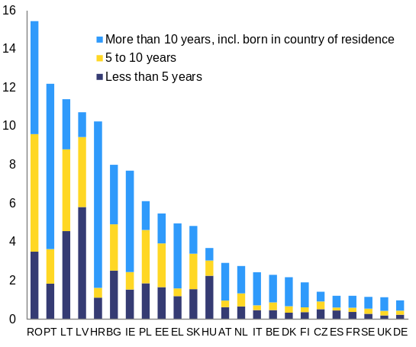
The mobility rate is the number of working-age citizens living in another Member State in 2014, as a % of the working age population of the country of citizenship.
Figures for Cyprus, Luxembourg, Malta and Slovenia are too small to be reliable.
The reliability of the figures for Denmark, Estonia, Finland and Croatia is limited due to the small size of the sample.
Source: European Commission
Strong outward migration weighs on human capital and adds to the challenges of an ageing society. In 2013 2.5 million Romanians (about 12.5 % of the population) were estimated to be living abroad (Graph 3.2.1). Emigrants are frequently low-skilled and come from rural areas, but also many high-skilled workers have left the country. This adds to the challenges of a shrinking working-age population due to an ageing society(). Faced with this challenge, the government plans to implement a programme to stimulate internal and external mobility, with a focus on highly skilled workers.
Employment growth is concentrated mainly in high value-added sectors. The highest employment increases in 2015 were in ICT and professional, scientific and technical activities as well as in industry and construction(). The proportion of highly-skilled people in the active workforce is forecast to increase considerably by 44 %(), the highest increase in the EU by 2025. In contrast, agriculture and manufacturing account for 29 % and 21 % of employment respectively, and have been shrinking in recent years (Graph 3.2.2).
Graph 3.2.2: Employment growth, selected sectors
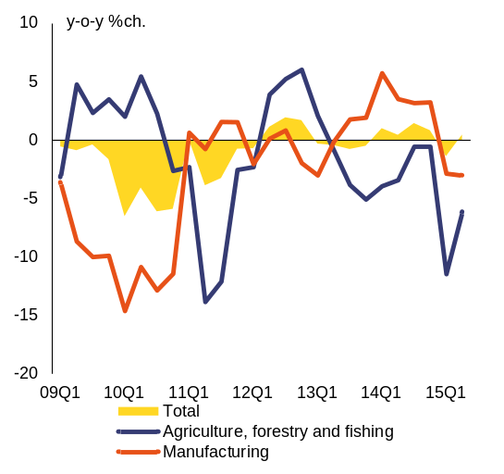
Source: European Commission
Integration of young people in the labour market remains a challenge. In 2015, youth unemployment decreased to 22 %, but remains slightly above the EU average. The share of young people not in employment, education or training (NEET) (Graph 3.2.3) is significantly above the EU average (17 % versus 12 %). Key measures such as support for traineeships and apprenticeships, skills certification and mobility packages have had a more limited take-up than initially expected. Cooperation between the public employment service, social and health services, schools, universities, social partners and private stakeholders is not yet sufficiently developed. Pilot measures in several counties have had only limited success in reaching NEETs who are not registered with the public employment service. The new government intends to draw up a national apprenticeship plan for the priority sectors identified in the national competitiveness strategy. A more integrated approach, offering pathways to NEETs and centred on the public employment service, is being developed with the support of EU funds.
Graph 3.2.3: Youth: in education and training, employment rate, unemployment rate, unemployment-to-population ratio, NEET
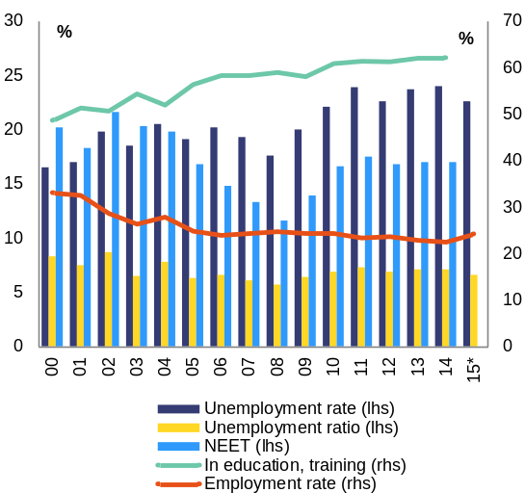
Source: European Commission
The employment potential of the long-term unemployed, older workers, Roma and people with disabilities is largely untapped. The long-term unemployment rate is 2.8 %, around half of EU average. Its proportion in unemployment decreased from 45 % in 2013 to 41 % in 2014. However, only 15 % of those unemployed for one to two years found a job in 2014 (Graph 3.2.4). The employment rate for older workers increased gradually between 2011 and 2014. It has returned to its pre-crisis levels at 43 % thanks to the adoption of supporting measures, but remains below the EU average of 52 %. The increased participation of older workers in the labour market is essential considering the projected doubling of the old age dependency ratio by 2050 and the steep reduction in the average replacement rate of pensions (by 30 pps. for men and by 20 pps. for women by 2050). The law on equalisation of the pensionable age for men and women has been in Parliament since 2013. Without its adoption, the labour market participation of older women will continue to decrease considerably, sustaining the gender pension gap and increasing their risk of old-age poverty. The employment rate of Roma is estimated at 30 %(). Discrimination, limited job opportunities, low physical accessibility, and fiscal disincentives() affect the employment rate of people with disabilities (38.8 % in 2013).
Graph 3.2.4: Changes in labour market status of long-term unemployed, 2014
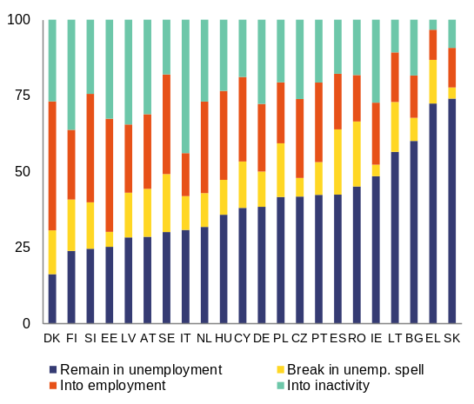
Data from 2014 including long-term unemployed for one year or more from 2013. Data for Belgium, France, Croatia, Luxembourg, Malta and the UK not available or unreliable.
Source: European Commission
National spending on labour market policies is low and not well coordinated with the European Social Fund (ESF). National expenditure on active labour market policies has decreased to slightly above 40 % of its level before EU accession().It is overly reliant on the ESF, which could create a problem in the long run for the sustainability of government policies. Lack of coordination between nationally-funded and ESF-funded measures results in competing schemes. In this context, the Ministry of Labour intends to develop an integrated catalogue of services financed from both the ESF and the national budget.
The majority of the short-term unemployed are not covered by unemployment benefits. Even if passive policies absorb 85 % of the national spending on labour market policies, the coverage of the short-term unemployed by unemployment benefits is estimated to be among the lowest in the European Union. This low coverage reflects both the eligibility conditions for entitlement to unemployment benefits in the case of termination of employment() and the large number of uninsured self-employed. The adequacy of unemployment benefits is low and deteriorating().
The National Employment Agency is lagging behind in offering personalised services to jobseekers and employers. Only 3.1 % of those wanting to work participated in active labour market programmes in 2013 (most recent available data). The range of active labour market measures is insufficient to address the specific needs of different groups in the labour market. The operational autonomy of the public employment service is limited by prescriptive legislation on active labour market policies. In spite of mandatory referral of vacancies to the National Employment Agency, its capacity to attract vacancies or to offer attractive services to employers is limited. In addition, there is still no clear procedure for profiling and segmentation of the various categories of unemployed in order to offer tailor-made support, despite some plans in this area. Forecasts of labour market needs have been introduced in several regions and an electronic registration card is being rolled out, but the impact of these measures remains to be seen. A reintroduction of public works is envisaged, with unclear impact on raising employability and sustainable labour market integration.
Weak social dialogue has been limiting collective bargaining. Romania has the lowest perceived degree of cooperation in labour-employers relations in the EU(). The social dialogue law enacted in 2011 promoted a decentralisation of collective bargaining. However, a combination of factors, including representativeness criteria for trade unions and employers' associations, has hampered collective bargaining at sector and undertaking level. A recent revision of the social dialogue law aims at improving collective bargaining by establishing a representation cascade for trade unions at higher level when no representative trade union exists in the undertaking. A strategy for social dialogue is also being developed. The impact of these measures is uncertain, especially as there was no change on representativeness criteria.
The recently adopted Fiscal Code includes measures that will reduce the tax burden on labour for lower incomes. The threshold for taxation of employment income was increased. Several new tax incentives for micro-enterprises were introduced to foster employment(). These measures follow the untargeted sizable reduction of social security contributions paid by employers introduced in October 2014, which entailed high costs in terms of foregone revenues for the social security fund.
Education and skills
Efforts are being made to improve the public expenditure and governance framework on education. Government expenditure on education rose from 2.8 % in 2013 to 3.2 % of GDP in 2014 and is estimated to have reached 3.7 % of GDP in 2015, a level expected to be sustained in 2016(). In 2015, work started on developing a strategy for the modernisation of education infrastructure and on an integrated coordination framework to implement national strategies for education and training. However, implementation depends on the public administration's limited capacity to access and manage European Structural and Investment Funds ().
Vulnerable groups such as Roma and pupils from poor families continue to face significant obstacles in accessing and completing education, especially in rural areas. Vulnerable groups such as rural communities, Roma, institutionalised children and people with disabilities rank significantly below the general population in access to education, completion rates and performance (see also section 3.3). Despite progress, 27% of Roma children still receive education in de facto segregated schools, as defined by the Roma Inclusion Index (2015) (). The new government intends to focus on disadvantaged groups and areas, with plans to roll out an after-school and hot-meal programme in 1 000 rural schools.
The early school leaving rate remains high due to an insufficient focus on early detection and prevention, poverty and low availability of remedial programmes. Romania’s early school leaving rate increased to 18.1 % in 2014, nearly 7 pps. above the EU average and the national Europe 2020 target (Graph 3.2.5). The early school leaving rate is much higher for rural residents (see section 3.3), Roma and children with special needs. Support for parents and teachers working with pupils at high risk is insufficient. The implementation of the strategy for reducing early school leaving, adopted in 2015, is lagging behind. Second chance programmes do not fully take into account the range and scale of the needs. The integrated information system for education, which includes specific indicators for early school leaving, is still not fully functional.

Graph 3.2.5: Early leavers from education and training
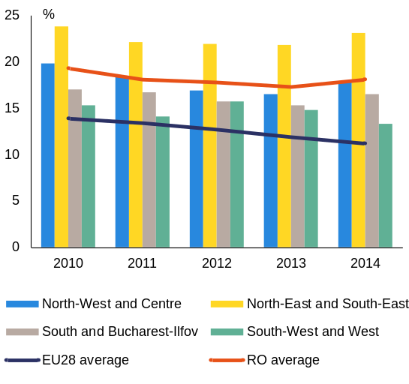
Source: European Commission
Recent legislative measures aim to increase participation of disadvantaged children in early childhood education and care. Only 6 % of the children less than three years old were looked after by formal arrangements for more than 30 hours a week in 2013. This is significantly below the Barcelona target of 33 %(). For children aged three to six there are major disparities in access to early childhood education and care. The law on stimulating participation in early childhood education and carefrom October 2015 offers disadvantaged families the possibility to receive monthly social coupons to purchase school-related supplies if their children aged three to six are enrolled and attend kindergarten or preparatory class. This project is now part of a flagship initiative to fight child poverty.
Demand for vocational education and training (VET) is increasing(), but quality issues remain. At upper secondary level 60 % of students were enrolled in VET in 2013 compared with the EU average of 49 %. Nevertheless, VET schools have a lower pass rate in the final national examination (38 % compared with 76 % in general education in 2013) and a higher drop-out rate. The main challenges for the VET sector are underfinancing, the quality of teaching staff, insufficient systematic links with the labour market (skills forecasts, involvement of employers) and frequent legislative changes. Stepping up the implementation of dual education is among the priorities of the Ministry of Education for 2016.
The tertiary education attainment rate has been increasing but mismatches with labour market needs persist. The tertiary education attainment rate has been steadily increasing over the last decade reaching 25 % in 2014, on track to reach the 26.7 % Europe 2020 national target. However, university enrolment rates have been decreasing sharply since 2008 and the tertiary attainment rate in rural areas is around eight times lower than in cities(). The employment rate of recent tertiary graduates decreased by more than 7 pps. over the last three years, suggesting that universities are still insufficiently responsive to developments on the labour market. Availability and use of labour market assessment and forecasting, and cooperation with business and social partners is still limited.
Despite investment in skills and training in high value-added sectors(), skills supply challenges persist. Skills shortages are most acute in healthcare, the construction sector, hospitality and ICT. There are mismatches in the type of studies offered. In addition, learning mobility and career guidance measures as well as soft skills needed for the labour market, such as entrepreneurship and digital skills, are insufficiently developed. Participation in adult education is the lowest in the EU (1.5 % in 2014 compared with an EU average of 11 %). There are plans to better link curricula with the needs of employers, connect education and labour market databases and improve the functioning of the centres for the evaluation and validation of competences.
Social protection
Although declining, in 2014 the rate of people at risk of poverty or social exclusion in Romania (40 %) was the highest in the EU. Despite the declining trend, more people are facing monetary poverty() against the background of increasing inequalities() and a limited impact of social transfers on reducing poverty. Severe material deprivation continues to be a challenge (Graph 3.2.6): 26 % of the population (three times the EU average) and 31 % of people with disabilities cannot afford items considered to be desirable or necessary to lead an adequate life. In 2014, almost a third (32 %) of Romanian children were living in severe material deprivation and one in two children was at risk of poverty or social exclusion. In-work poverty remains the highest in the EU (see section 3.3).
Graph 3.2.6: At-risk-of-poverty or social exclusion rate and its components
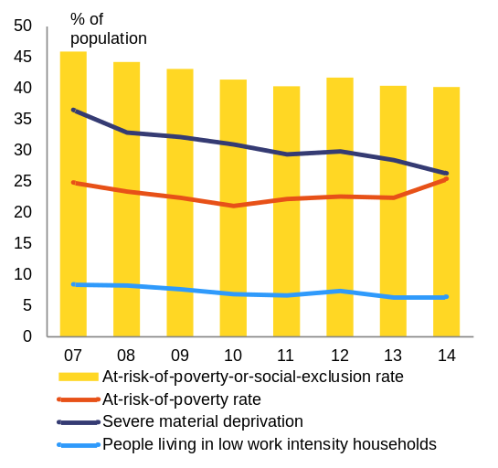
Source: European Commission
The capacity of the social protection system to reduce poverty is limited. Social assistance is mostly limited to cash benefits, while the provision of services is insufficient. To deliver services, local authorities are required to establish a public social assistance service at community level. However, public social assistance services have not been set up everywhere and in many instances they are understaffed. Identification and early intervention services as well as referral systems for vulnerable groups are insufficiently developed at community level. The government intends to develop integrated intervention teams for marginalised communities, subordinated to public social assistance service and a holistic package of anti-poverty measures mainly financed from EU funds. The strategy for social inclusion and poverty reduction, adopted in May 2015, provides a comprehensive framework for poverty reduction, but its success depends on concrete and realistic planning, budget availability and cooperation within the central and local public administration and with civil society.
The lack of a coherent mechanism to adjust social transfers to the economic context diminishes their impact on reducing poverty and the overall adequacy of income support schemes. Spending on social protection as a percentage of GDP and the effectiveness of social transfers are among the lowest in the EU. The social reference index (the basic parameter to which all social transfers are linked) has remained frozen since its introduction in 2008, despite a cumulated inflation of 28.7 % between 2008 and 2014. A regular revision of the social reference index has been shunned in favour of discretionary increases to some of the benefits.
Graph 3.2.7: Poverty reduction impact of social transfers
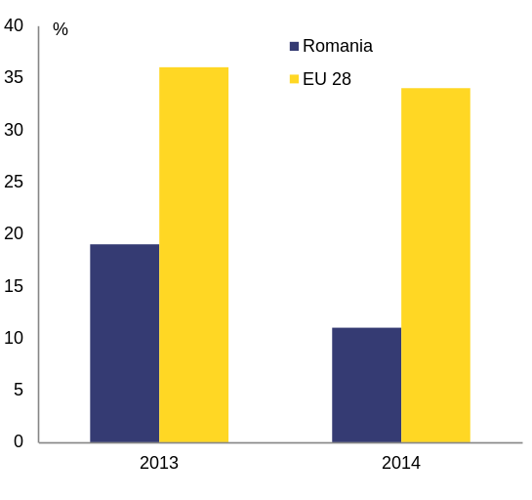
Source: European Commission
The low coverage of means-tested benefits is expected to improve with the introduction of the minimum social inclusion income. The law on the minimum social inclusion income is expected to be adopted in the first half of 2016. It will streamline the existing social benefit system and make it more targeted to those in need. Its provisions, however, are expected to take effect only from 2017. With a proposed higher income-eligibility threshold, an increased level of benefits, and a higher budget, the new scheme is expected to provide better coverage of the poor and to improve the adequacy of transfers. The benefit formula, which disregards 50 % of earned income from agricultural activities, will allow better targeting of the working poor. The new scheme is supposed to combine passive support with active labour market integration services.
At present, the activation of people on social benefits is low. Although beneficiaries of the guaranteed minimum income are required to register with the National Employment Agency, they are not offered tailor-made activation measures. Job-search requirements are not adequately checked and enforced. About 80 % of beneficiaries are in rural areas, where employment opportunities outside (semi-)subsistence agriculture are rather limited. Recipients of the minimum guaranteed income who are able to work are also supposed to participate in the community work scheme organised by the local municipalities, but there is no evidence that this increases employability. Effective activation is impeded by red tape and ad hoc cooperation between social assistance and the public employment service.
Institutionalised children and people with disabilities are at higher risk of poverty. In June 2015 there were approximatively 58 000 children in the child protection system, of which one third in residential institutions. Poverty is the main cause of separation from parents. Prevention remains a key challenge considering that approximately 5 000 children enter the system every year. There are plans to revise the quality standards for childcare services and to simplify and speed up national adoption procedures. Authorities are developing a deinstitutionalisation plan to run from 2016 to 2020. This is expected to cover the closure of classic residential centres and the development of community-based prevention and support services. The implementation of the 2014-2020 national strategy for the promotion and protection of the rights of the child could help build capacities for trained social workers and ensure children's access to quality social services. At the same time, the process for deinstitutionalisation for adults with disabilities is progressing slowly, while the strategy for persons with disabilities has yet to be adopted. In January 2016 the law establishing the mechanisms of the convention on the rights of people with disabilities was adopted.
The situation of Roma is especially problematic. Roma have a much higher risk of poverty, considerably worse educational attainment, much lower employment rates and low participation in early education and care. All these factors act as an obstacle to increasing Roma participation on the labour market and make it difficult to break the cycle of poverty and exclusion(). Roma inclusion is thus also key economic issue, considering that this group accounts for an increasing proportion of new labour market entrants, as the Roma population is growing faster than the non-Roma population. The authorities have estimated that there are up to 100 000 Roma without identity documents (either birth certificates or identity cards). Access to healthcare is particularly difficult, reducing the life expectancy for Roma by seven years compared to the total population. In 2015 Romania revised its Roma inclusion strategy to address the issues referred to above. Its implementation depends on effective inter-institutional cooperation and commitment at local level, particularly in the form of budgeted action plans accompanied by concrete goals and activities, reporting mechanisms and a transparent involvement of all relevant stakeholders.
Health and long-term care
Health outcomes in Romania are poor. Life expectancy at birth is well below the EU average both for men (71.6 years compared with 77.8) and women (78.7 years compared with 83.3). The mortality rates linked to the circulatory system and infant mortality() are particularly high. There is a high gap between healthy life years at birth and life expectancy, showing that people spend a substantial period of life in morbidity and disability (13.0 years for men and 20.8 years for women). Only 55 % of the population have access to water supply and its quality is sub-standard. In addition, Romania has one of the highest rates of potentially amenable and potentially preventable deaths, which should not occur with timely and effective health care.
Access to healthcare remains a major concern. Despite a mandatory health insurance system, only 86 % of the population was insured in 2014. Romanians are among the Europeans with the worst perception of their health status(). Compared with an EU average of 3.7 %, 10.4 % of the Romanians report having had an unmet healthcare needs due to cost, distance or waiting times. Widespread informal payments add to the costs and are among the main reasons for limited access to healthcare, especially for patients with low income. Access to healthcare is further hindered by the unavailability of health professionals. The number of physicians and nurses() per inhabitant is very low compared with the EU average, mainly due to the emigration of qualified physicians to other EU countries, poor working conditions and low salaries. Despite this situation, there is no formal strategy on healthcare human resources in place. The network of social and health mediators is being developed and a draft law on community services has been proposed. However, further measures are needed to address the issue of unmet medical needs.
Low funding and inefficient use of public resources continue to affect the healthcare system. To address these concerns, the authorities made an effort to improve the fiscal sustainability and the efficiency and effectiveness of healthcare service delivery as part of the recent EU balance-of-payments assistance programme. These reforms included e.g. clearing arrears in the health sector, increasing the sustainability of pharmaceutical spending, implementing e-health solutions, improving the funding of the health system and devising a strategy to shift resources from hospital-based care towards preventive and primary care.
The reforms implemented through the balance-of-payments programmes have secured the short-term viability of the system, but key measures remain unfinished. Hospitals' arrears were decreased but not fully eliminated and external audits of public hospitals are planned for 2016 to understand the causes of arrear accumulation. The e-health card was implemented, but its actual utility in ensuring that only delivered medical services are reimbursed under the national health insurance scheme will become visible only in 2016. The pharmaceutical budget is still structurally overspent increasing future fiscal risks. While overspending is recovered via the claw-back tax and is thus budget neutral, it has led to withdrawals of cheap generic medicines from the market. The planned revisions of the claw-back tax and of the public reimbursement for distributors of pharmaceutical products to incentivize the provision of low cost medicines to patients are yet to be implemented. A financing system for hospital services based on real rather than assumed costs of hospital services has not been put into practice. The implementation of the healthcare reform programme with the support of the European Regional Development Fund and the World Bank has been significantly delayed. The system remains underfunded and hospital-centred and there is no clear action to streamline hospital infrastructure and shift from inpatient care to outpatient and primary healthcare.
Corruption remains a challenge in the health sector, despite some recent action to combat the problem. Oversight of public procurement contracts in the health sector is insufficient (see section 3.1). The centralised procurement unit in the Ministry of Health is heavily understaffed and its mandate covers only 25 % of hospitals. The lack of transparency in medical reimbursements constitutes a severe challenge in putting in place measures to prevent fraud and corruption over reimbursement claims. This has a direct impact on the health budget. Although services provided in private health units are partially covered by public funds under the single national health insurance scheme, they are not included in the monitoring exercise for the use of public funds. While healthcare was one of the key sectors addressed by the 2012-2015 national anti-corruption strategy, the sectoral strategy did not produce tangible results. The challenge facing the renewed sectoral strategy is to integrate the findings of existing policy assessments into a comprehensive approach that extends to all relevant players and processes.
Romania still lacks an integrated system of long-term care. There is no clear governance of long-term care services (residential and home care), with different components dealt with by different authorities. Integration is made difficult by fragmented sources of funding for different components of the service. Funding is also low. Public expenditure on long-term care was 0.7 % of GDP in 2014.

3.3. Development challenges of the rural areas
Romania's key development disparities are between urban and rural areas. With 46 % of Romania's population living in rural areas and considering the magnitude of some of the challenges, the impact of the rural-urban gap hampers the achievement of national economic and social development targets. While there has been progress in some areas, partly with the use of European funding, rural areas remain far behind urban areas in terms of poverty reduction, employment and education, access to services and basic infrastructure.
Since 2007, Romania has been receiving support under the common agricultural policy. The 2007-2013 rural development programme (with EUR 8.1 billion in funding) supported investments in setting up and developing farms and in infrastructure, including roads, water and sewage, business creation and skills improvement. The same amount has been made available for 2014-2020, with a focus on increasing agricultural productivity, improving cooperation among small farms, adding value to agricultural products, job creation and development of rural areas.
Human capital and competitiveness
Rural areas experience with a significant under-utilisation of human capital. In 2014, self-employment and non-remunerated family work() — often times associated with (semi-)subsistence agriculture — accounted for 60 % of employment in rural areas. Salaried work accounted for only 39 % of employment in rural areas, compared to 92 % in urban areas (Graph 3.3.1). High employment in agriculture conceals hidden unemployment and lack of alternatives forms of employment.
Graph 3.3.1: Employment by status in employment and by urban/rural area, 2014
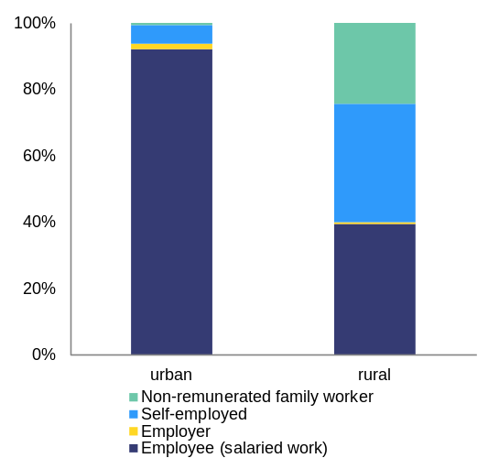
Source: NSI
Job-creation is projected to remain mostly urban, while agriculture is expected to continue losing jobs. Agriculture accounts for 29 % of employment in Romania, but only 5 % of GDP. It is the main economic activity in rural areas. Labour productivity in agriculture, forestry and fishery is more than five times lower than the national average. Increases in agricultural productivity due to technological progress and better job prospects in the rest of the economy are likely to result in a significant loss of jobs in the long run (agriculture to account for 25 % of total employment in 2030 according to CEDEFOP calculations). In the short run, however, employment in subsistence agriculture is likely to remain high. Farms are still uncompetitive, with limited diversification of economic activities, and depend on commodities markets for selling agricultural products, as there is limited local agro-food business (domestic and export potential).
Agricultural development is constrained by the polarised structure of holdings, large fragmentation and limited access to credit. Large and medium farms in need of modernisation account for just 8 % of holdings and manage some 71 % of the utilised agricultural area. In turn, the remaining 92 % small farms are operated on a subsistence or semi-subsistence basis (Graph 3.3.2). They have limited productivity and technical endowment, low or no market orientation and have low or no cooperation to achieve economies of scale. Access to credit remains difficult, which impedes development and the uptake of EU funds. In November 2015, only 14 % of the estimated 32 million rural properties were registered in the eTerra database. However, the figure is increasing steadily with the support of an EU-funded project. Rural development funds in Romania were concentrated on boosting competitiveness, adding value to agricultural products and developing short supply chains for small farmers. Encouraging the association of small farms in agricultural cooperatives is a priority, as is the creation of a credit fund for the agricultural sector.
Graph 3.3.2: Distribution of farms, per utilised agricultural area, 2013
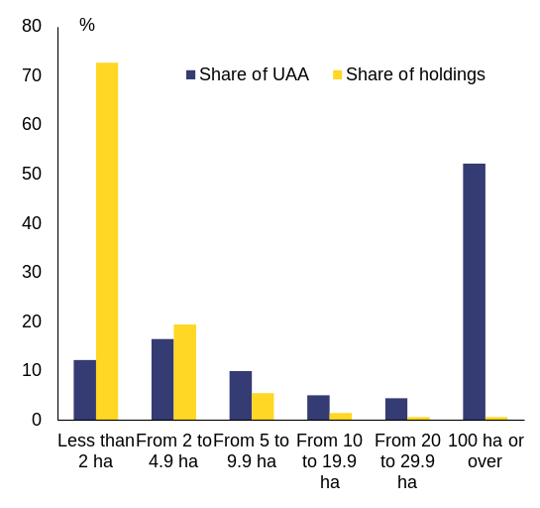
Source: European Commission
Energy-intensive agriculture and deteriorated irrigation infrastructure hamper farms' competitiveness. The total area covered by irrigation infrastructure is 20 % of used agricultural land, but the area irrigated has decreased in recent years due to the inefficiency of the system, expensive maintenance costs and weather conditions. There are plans to improve legislation on irrigation. At the same time, the rural development programme will also finance the modernisation of irrigation infrastructure.
Export trends reflect Romania's underlying agricultural potential. Romania used to be a net importer of agricultural products, but the trade balance on agricultural and food products has been positive since 2013. It increased from EUR 391.2 million in 2013 to EUR 517.8 million in 2014, reflecting a slight improvement in agricultural competitiveness. The improvement in the trade balance was driven by intra-EU exports, which increased by 10 % from 2013 to 2014. Between 2009 and 2014 the share of agricultural imports in total imports was constant at around 9 %, while the share of agricultural exports in total exports gradually increased from 8 % to 11 %.
Poverty, access to education and healthcare
Working in semi-subsistence agriculture is one of the main factors underlying Romania's high risk of poverty or social exclusion. Fifty-five percent of rural residents are at risk of poverty or social exclusion (compared with 31 % in towns and suburbs, and 28 % in cities). Low incomes associated with semi-subsistence agriculture are the cause of the highest rate of in-work poverty in the European Union (20 %) and a concentration of monetary poverty in rural areas (71 %). The high share of the informal sector and non-participation in the contributory pension system translates into poor pension prospects. Furthermore, about 80 %of social assistance recipients() are located in rural areas. Along with the recently announced national integrated anti-poverty package, the government also intends to develop a more focused approach to rural development.
The low educational attainment of rural residents affects economic development, human capital development and social inclusion. The rural-urban gap starts early in the education cycle and becomes more prominent as children advance through the system. In 2013-2014, only 84 % of rural children aged three to five were enrolled in pre-school education (90 % in urban areas). The gross enrolment rate in primary and lower secondary level was 84 % (97 % in urban areas). In 2012/2013, only 22 % of participants in second chance programmes were from rural areas, even if early school leaving is much higher in those areas. Many higher secondary schools are situated in urban areas creating an additional challenge for rural pupils in terms of distance, time and financial costs. Pupils from rural areas have higher enrolment rates in VET compared with urban areas, but the lack of specialized agricultural high-schools limits the level of skills in the sector. In 2013, only 5 % of the rural young people aged 14-24 had graduated from higher education (the figure for urban areas was 20 %).
Early school leaving is predominantly a rural problem, often linked to poverty. Almost one in three children in rural areas drops out of education before the ninth grade (Graph 3.3.3). Among the contributing factors mentioned in the national strategy for early school leaving are poverty, seasonal work by children, the limited educational attainment of parents and low accessibility of education services and limited infrastructure. A third of rural schools do not meet sanitary requirements, almost half lack proper water supply and a fifth are not connected to sewerage — with the related risks to health. More than half are inadequately heated().
Graph 3.3.3: Rate of early school leaving by degree of urbanisation
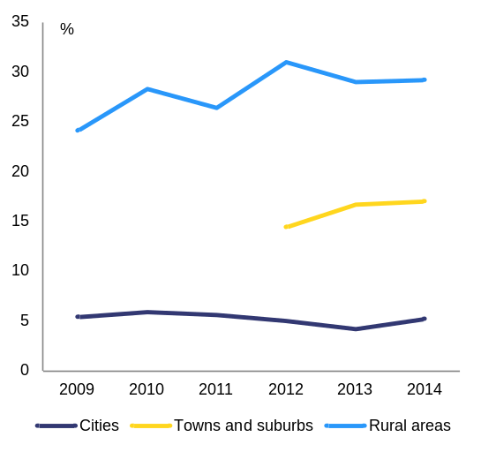
Source: European Commission
Ageing and outward migration create additional social challenges. Many children are left behind by parents working abroad, requiring specific care, but the provision of childcare and social services are rather limited. Rural areas tend to have a lower share of the working-age population, while ageing tends to be more pronounced. This puts pressure on the capacity to work agricultural land, decreases productivity in the sector and tends to limit innovation and uptake of new techniques. Almost 60 % of beneficiaries of direct payments (holding 25 % of the total arable land) are over 60 years old().
Limited access to medical services impairs health outcomes. Health insurance coverage is low (76 % vs 95 % in urban areas in 2014 according to the National Health Insurance House). Health inequalities between rural and urban areas are reflected in the much higher rate of infant mortality, lower life expectancy and vaccination rates for children (Graph 3.3.4).
Graph 3.3.4: Infant mortality rate
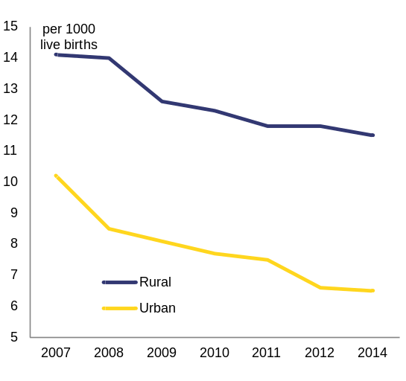
Source: European Commission
Limited access to basic utilities negatively impacts the quality of life. In 2014, 27 % of the rural population was connected to the public water system (92.7 % in urban areas), and only 5.3 % was connected to sewage (82.8 % in urban areas). Only 34 % of rural households had a toilet inside the house (Graph 3.3.5).
Graph 3.3.5: Percentage of households with indoor flushing toilet
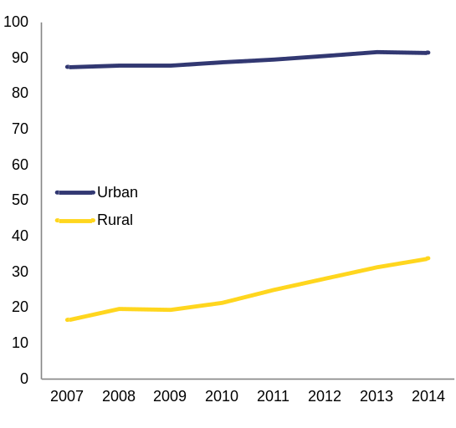
Source: NSI
Infrastructure and administrative capacity
Underdeveloped road infrastructure limits economic growth in rural areas. Only half of all communes have direct access to the national road network(). According to the National Statistical Institute, rural roads represent 38 % of all public roads. However, the quality of roads is much lower in rural areas: around 72 % are covered with stone and dirt, which makes them difficult to use during rain and less than 10 % were qualified as modernised in 2014 (Graphs 3.3.6). Limited public and private transportation coupled with high commuting costs may act as an obstacle to seeking alternative employment in urban areas.
Limited access to broadband infrastructure impacts on business creation and growth in rural areas. In 2015 fixed broadband coverage was available to 81 % of homes in rural areas (vs 91 % in the EU), but only 45 % of the homes covered had a subscription (vs 63 % in the EU). The lack of digital skills is part of the explanation why so few homes have a subscription.
Graph 3.3.6: Length of public roads by type of road surface
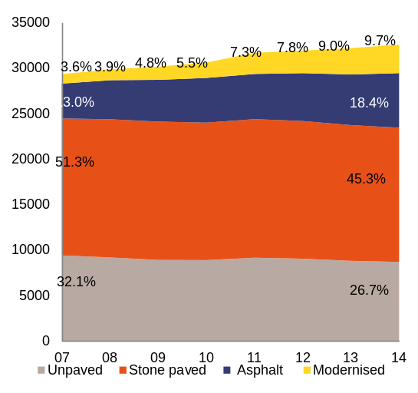
Source: NSI
High administrative fragmentation is coupled with low administrative capacity and budget constraints. Romania has 2 861 communes comprising 12 957 villages. The small size of the communes and villages is coupled with low administrative capacity of rural administrative authorities, weak cooperation among counties and few projects to integrate rural and urban communities. Achieving the critical mass necessary for economies of scale in the delivery of services is therefore difficult. Rural areas are not homogenous, with significant differences between villages in the vicinity of urban growth poles and remote villages, between communes far from and close to European roads and between communes located at the centre or periphery of counties. On average, in 2012, self-generated revenue represented 22 % of local budgets in rural areas, compared with 42 % in urban areas. This reflects a high reliance on central level funding and lower economic development. Only 135 communes (of which 109 are neither small nor remote) had local revenues which represented more than 50 % of the budget().

Annex A  Overview Table  Commitments | Summary assessment ()
2015 country-specific recommendations (CSRs)
CSR1: Take all the necessary measures to complete the financial assistance programme. | Romania has made no progress in addressing CSR 1.  - Romania made no progress as the third formal review mission (16-30 June 2015) to assess the programme's implementation status conditionality was not concluded. Consequently, the 2013-2015 programme ended without a formal review being completed. While some progress was achieved in several policy areas, current and former programme achievements were undermined in key policy areas.
CSR2: Limit the deviation from the medium-term budgetary objective in 2015 to a maximum of 0.25 % of GDP as specified under the 2013-2015 balance-of-payments programme and return to the medium-term budgetary objective in 2016. Implement the comprehensive tax compliance strategy, strengthen verification control systems in order to tackle undeclared work, and push ahead with the equalisation of the pensionable age for men and women. | Romania made limited progress in addressing CSR 2 (this overall assessment of CSR 2 does not include an assessment of compliance with the Stability and Growth Pact):  - Romania made full progress in remaining at the medium-term budgetary objective for its structural deficit in 2015. According to the European Commission winter 2016 forecast the structural deficit for 2015 is 0.7 % of GDP. This is below the medium-term budgetary objective of a structural deficit of 1 % of GDP.  - Romania made no progress in remaining at the medium-term budgetary objective in 2016. According to the 2016 budget and the Commission 2016 winter forecast, the budget deficit in 2016 will be close to 3 % of GDP in both nominal and structural terms.  - Romania made limited progress on implementing the comprehensive tax compliance strategy and strengthening verification control systems to tackle undeclared work. The comprehensive tax compliance strategy is still being developed. Efforts to improve tax collection started to yield some results, but VAT evasion remains high. A pilot project to strengthen checks for undeclared work is being rolled out throughout the whole country, but the activity of labour inspections has gone down and there was limited follow-up on those that did take place.  - Romania made no progress on the equalisation of the pensionable age for men and women. The draft law submitted to Parliament in 2013 has been adopted by the Senate, but not by the lower Chamber.
CSR 3: Strengthen the provision of labour market measures, in particular for unregistered young people and the long-term unemployed. Ensure that the national employment agency is adequately staffed. Establish, in consultation with the social partners and in accordance with national practices, clear guidelines for setting the minimum wage transparently. Introduce the minimum insertion income. Increase the provision and quality of early childhood education and care, in particular for Roma. Take action to implement the national strategy to reduce early school leaving. Pursue the national health strategy 2014-2020 to remedy issues of poor accessibility, low funding and inefficient resources. | Romania made limited progress in addressing CSR 3.  - Romania made limited progress on strengthening active labour market measures, in particular for unregistered young people and for the long-term unemployed. Initiatives such as the Youth Guarantee centres have had a limited effect on the registration of people not in employment, education or training. There is no evaluation of the 27 pilot Youth Guarantee centres. They, however, do not appear to have succeeded in supporting young people who were not previously registered with public employment services. The take-up of apprenticeship and measures such as support for traineeships, skills certification and the mobility package, was more limited than initially expected. The results of the database of young people not in employment, education or training and the professional card remain to be seen. However, a more integrated approach, offering integrated pathways to people not in employment, education or training and centred on the public employment service is being developed with the support of EU funds. There are few activation programmes or employer incentives targeted at the long-term unemployed, with the exception of an employer subsidy for workers older than 45, although that is not specifically targeted at the long-term unemployed.  - Romania made limited progress on adequately staffing the National Employment Agency. There was only a marginal increase in the staff of employment services and no internal reallocation of resources. A large proportion of the staff works on back-office functions, including the administration of European Social Fund programmes. A strategy to modernise the National Employment Agency was adopted at the end of 2014, but its quality is uneven and the Commission has asked for the strategy to be revised. Despite the ex ante conditionality, measures funded through the European Social Fund interventions are not sufficiently coordinated with those financed through the national budget. The public employment service has started to develop a labour market intelligence capacity and to enter into partnerships with several stakeholders. In the context of ex ante conditionality for the European Social Fund, there are action plans to develop procedures for profiling and segmentation of the various categories of unemployed to offer tailor-made support but they are not yet implemented..  - Romania made limited progress in setting guidelines for transparent minimum-wage setting. A study on the impact of minimum wage increases was undertaken, but a transparent minimum wage setting mechanism, based on clear and objective criteria related to economic and labour market conditions, is not yet in place. The government has set up a tripartite working group with the aim to establish such mechanism. The group should present its proposal by April 2016.  - Romania made limited progress in introducing the minimum inclusion income scheme, as the draft law has been put in public consultation, but not yet adopted. Its implementation has been further delayed to 2017 or 2018.  - Romania made some progress in increasing the provision and quality of early childhood education and care, in particular for Roma. A law was adopted with the aim to encourage the participation of disadvantaged children in kindergarten.  - Romania made limited progress on implementing the national strategy to reduce early school leaving. The strategy was adopted in June 2015 but there are significant delays in its implementation. The early school leaving rate increased in 2014 after a period of stagnation and remains around 7 pps. above the EU average. There are significant differences between regions and between urban and rural areas.  - Romania made limited progress on improving access to healthcare with the introduction of some innovative medicines for hepatitis C and cancer based on cost-effectiveness (health technology assessment) criteria. Some other measures have been adopted to ensure access to medicines for low-income pensioners and to make healthcare more accessible to people in remote and isolated communities. Nonetheless, improving access to primary healthcare and outpatient care, especially in rural areas, still remains a challenge. The availability of health professionals is below the EU average on account of their emigration. Widespread informal payments reduce access to healthcare for people with low incomes.  - Romania made limited progress on remedying low funding and some progress on addressing the inefficient use of resources. The use of ICT services in the healthcare sector has been stepped up through the introduction of the national health card and electronic records. Centralised procurement procedures have been established through framework contracts for the supply of some medicines. Lack of administrative capacity is delaying projects to streamline the hospital sector and switch from inpatient care to outpatient care. The implementation of the 2014-2020 national health strategy, which addresses this problem, has stagnated. In addition, the construction of much needed community centres in rural areas could be delayed because of a lack of administrative capacity to develop a mapping of investment necessities.
CSR 4: Adopt the law on reforming corporate governance of state-owned enterprises. | Romania made some progress on addressing CSR 4. On 6 January 2016 the government approved draft amendments to the draft law approving government emergency ordinance 109/2011 on corporate governance of state-owned enterprises and submitted the amendments to Parliament.
Europe 2020 (national targets and progress)
Employment rate target | The national target of 70 % by 2020 remains ambitious, as the employment rate in the age group 20-64 reached 67.8 % in the third quarter of 2015.
R&D target : 2 % of GDP | The Romanian R&D intensity target is ambitious and difficult to reach, given that the country’s R&D intensity in 2014 was 0.38 %. To reach its 2020 target, R&D in Romania will need to grow by an average of 31.7 % per year between 2015 and 2020. However, Romanian R&D intensity fell sharply between 2007 and 2013 at a compound annual rate of -7.5 %. In 2014, public R&D intensities continued to decline, while the business R&D intensity showed a slight increase compared with the previous year. In 2014, business R&D intensity rose to 0.16 % of GDP (27th in the EU) and the public R&D intensity fell to 0.22 % (28th in the EU).
National Greenhouse gas emissions target:  19 % in 2020 compared to 2005 (in non-ETS sectors) | 2020 target: 19 %  According to the latest national projections and taking into account existing measures, the target of 4 % in 2020 compared to 2005 (with a margin of 15 percentage points) is expected to be achieved.  Non-ETS 2014 target: 4 %  According to approximated data for 2014, greenhouse gas emissions from sectors not covered by the Emissions Trading Scheme fell by -9 % between 2005 and 2014.
Renewable energy target:  2020 Renewable energy target: 24 %  Share of renewable energy in all modes of transport:  10 % | With a renewable energy share of 24.9 % in 2014, Romania has already achieved its target for 2020. However, the substantial lack of clarity and stability in renewable support schemes might jeopardise the development of the sector and possibly prevent it from meeting the targets.  With a 3.8 % share of renewable energy sources in transport in 2014, Romania is less than half-way towards its target of a 10 % renewable energy sources in transport by 2020.
Energy efficiency: reduction of energy consumption  Romania's 2020 energy efficiency target is 43 Mtoe expressed in primary energy consumption (30.3 Mtoe expressed in final energy consumption.) | Romania is on track to meet its 2020 energy efficiency target. However, this is in part because the target allowed for substantial growth in energy consumption beyond both past and current levels.
Early school leaving target | Romania made no progress on meeting the target. Its early school leaving rate increased to 18.1 % in 2014. Romania has among the highest early school leaving rates in the EU and is getting further away from its national Europe 2020 target.
Tertiary education target | Romania made some progress on meeting the target. Its tertiary attainment rate improved substantially, reaching 25 % in 2014, and is on track to reach the Europe 2020 national target of 26.7 %.
Target on the reduction of population at risk of poverty or social exclusion in number of persons: | In absolute terms 869 000 people were lifted out of the risk of poverty or social exclusion between 2008 and 2014. The national target was 580 000 people.

Annex B
MIP scoreboard

Table B.1: MIP scoreboard
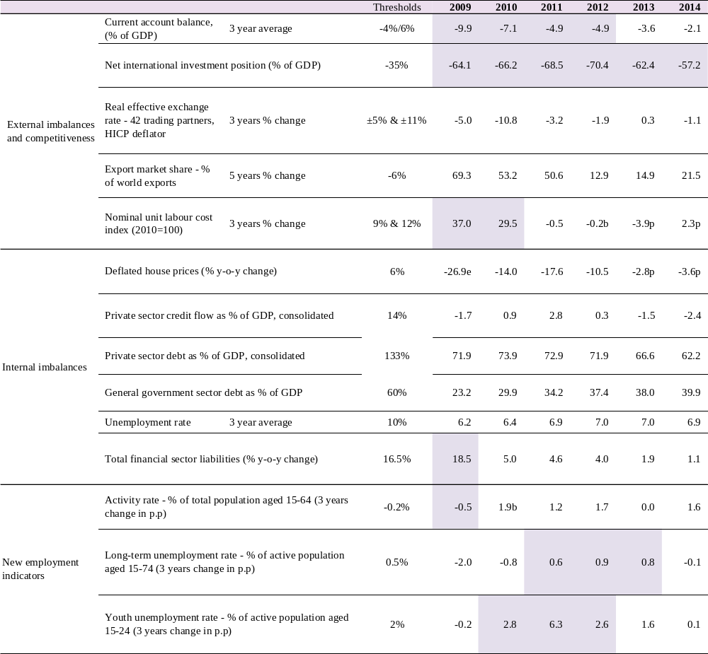
Flags: b: break in time series. e: estimated. p: provisional..
Note: Figures highlighted are those falling outside the threshold established in the European Commission's Alert Mechanism Report. For REER and ULC, the first threshold applies to euro area Member States
Source: European Commission

Annex C
Standard Tables

Table C.1: Financial market indicators
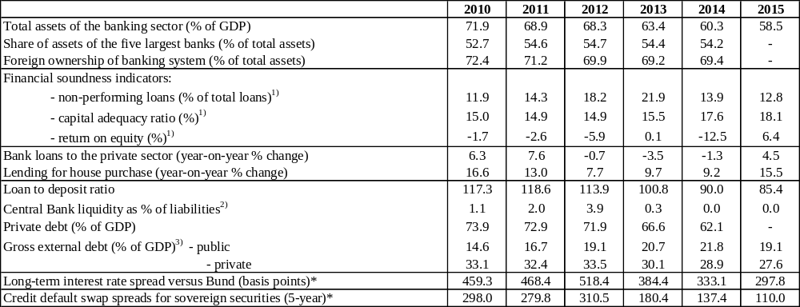
1) Latest data Q2 2015.
2) Latest data October 2015.
3) Latest data September 2015. Monetary authorities, monetary and financial institutions are not included.
* Measured in basis points.
Source: IMF (financial soundness indicators); European Commission (long-term interest rates; private debt); World Bank (gross external debt); ECB (all other indicators).

Table C.2: Labour market and social indicators
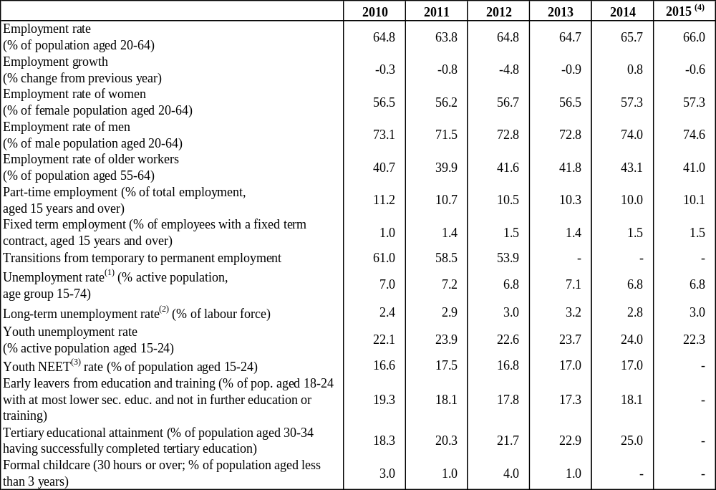
(1) Unemployed persons are all those who were not employed but had actively sought work and were ready to begin working immediately or within two weeks.
(2) Long-term unemployed are peoples who have been unemployed for at least 12 months.
(3) Not in Education Employment or Training.
(4) Average of first three quarters of 2015. Data for total unemployment and youth unemployment rates are seasonally adjusted.
Source: European Commission (EU Labour Force Survey).

Table C.3: Labour market and social indicators (continued)
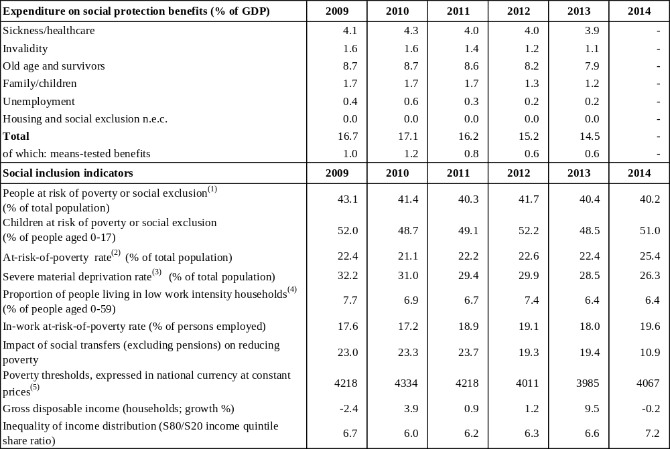
(1) People at risk of poverty or social exclusion (AROPE): individuals who are at risk of poverty (AROP) and/or suffering from severe material deprivation (SMD) and/or living in households with zero or very low work intensity (LWI).
(2) At-risk-of-poverty rate (AROP): proportion of people with an equivalised disposable income below 60 % of the national equivalised median income.
(3)Proportion of people who experience at least four of the following forms of deprivation: not being able to afford to i) pay their rent or utility bills, ii) keep their home adequately warm, iii) face unexpected expenses, iv) eat meat, fish or a protein equivalent every second day, v) enjoy a week of holiday away from home once a year, vi) have a car, vii) have a washing machine, viii) have a colour TV, or ix) have a telephone.
(4) People living in households with very low work intensity: proportion of people aged 0-59 living in households where the adults (excluding dependent children) worked less than 20 % of their total work-time potential in the previous 12 months.
(5) For EE, CY, MT, SI and SK, thresholds in nominal values in euros; harmonised index of consumer prices (HICP) = 100 in 2006 (2007 survey refers to 2006 incomes)
Source: For expenditure for social protection benefits ESSPROS; for social inclusion EU-SILC.

Table C.4: Structural policy and business environment indicators
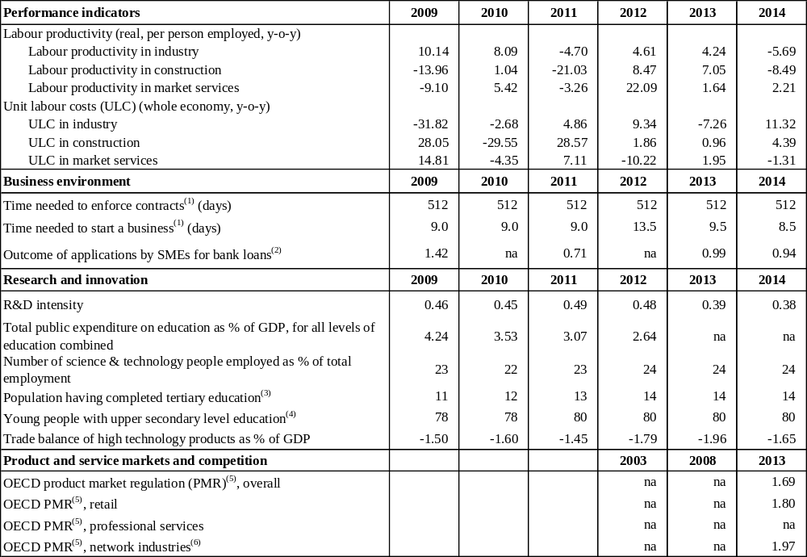
(1) The methodologies, including the assumptions, for this indicator are shown in detail here: http://www.doingbusiness.org/methodology.
(2) Average of the answer to question Q7B_a. "[Bank loan]: If you applied and tried to negotiate for this type of financing over the past six months, what was the outcome?". Answers were codified as follows: zero if received everything, one if received most of it, two if only received a limited part of it, three if refused or rejected and treated as missing values if the application is still pending or don't know.
(3) Percentage population aged 15-64 having completed tertiary education.
(4) Percentage population aged 20-24 having attained at least upper secondary education.
(5) Index: 0 = not regulated; 6 = most regulated. The methodologies of the OECD product market regulation indicators are shown in detail here: http://www.oecd.org/competition/reform/indicatorsofproductmarketregulationhomepage.htm
(6) Aggregate OECD indicators of regulation in energy, transport and communications (ETCR).
Source: European Commission; World Bank - Doing Business (for enforcing contracts and time to start a business); OECD (for the product market regulation indicators); SAFE (for outcome of SMEs' applications for bank loans).

Table C.5: Green growth
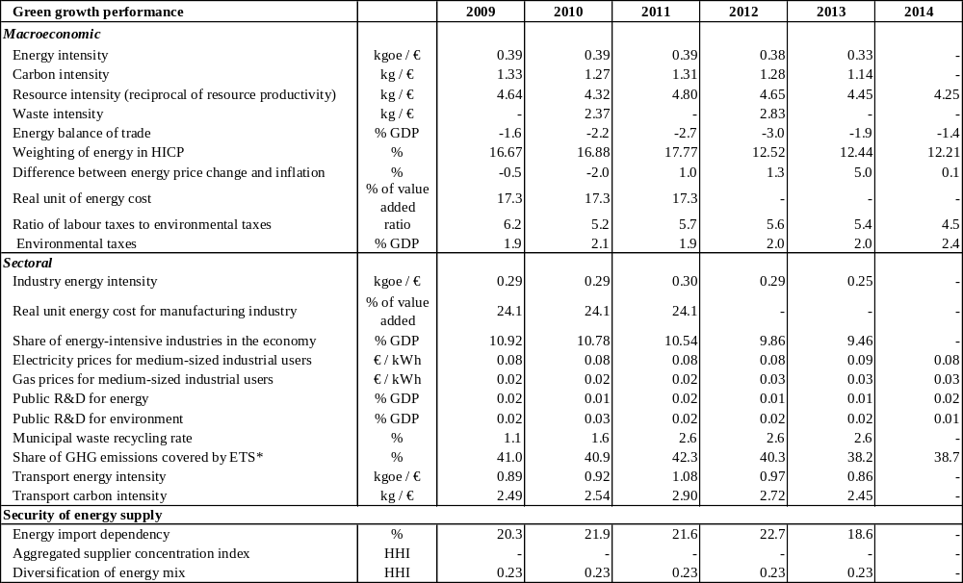
General explanation of the table items:
All macro intensity indicators are expressed as a ratio of a physical quantity to GDP (in 2005 prices)
Energy intensity: gross inland energy consumption (in kgoe) divided by GDP (in EUR)
Carbon intensity: greenhouse gas emissions (in kg CO2 equivalents) divided by GDP (in EUR)
Resource intensity: domestic material consumption (in kg) divided by GDP (in EUR)
Waste intensity: waste (in kg) divided by GDP (in EUR)
Energy balance of trade: the balance of energy exports and imports, expressed as % of GDP
Weighting of energy in HICP: the proportion of energy items in the consumption basket used for the construction of the HICP
Difference between energy price change and inflation: energy component of HICP, and total HICP inflation (annual % change)
Real unit energy cost: real energy costs as a percentage of total value added for the economy
Environmental taxes over labour taxes and GDP: from European Commission's database, ‘Taxation trends in the European Union’
Industry energy intensity: final energy consumption of industry (in kgoe) divided by gross value added of industry (in 2005 EUR)
Real unit energy costs for manufacturing industry: real costs as a percentage of value added for manufacturing sectors
Share of energy-intensive industries in the economy: share of gross value added of the energy-intensive industries in GDP
Electricity and gas prices for medium-sized industrial users: consumption band 500–20 00MWh and 10 000–100 000 GJ; figures excl. VAT.
Municipal waste recycling rate: ratio of recycled municipal waste to total municipal waste
Public R&D for energy or for the environment: government spending on R&D (GBAORD) for these categories as % of GDP
Proportion of greenhouse gas (GHG) emissions covered by EU Emission Trading System (ETS): based on greenhouse gas emissions (excl land use, land use change and forestry) as reported by Member States to the European Environment Agency)
Transport energy intensity: final energy consumption of transport activity (kgoe) divided by transport industry gross value added (in 2005 EUR)
Transport carbon intensity: greenhouse gas emissions in transport activity divided by gross value added of the transport sector
Energy import dependency: net energy imports divided by gross inland energy consumption incl. consumption of international bunker fuels
Aggregated supplier concentration index: covers oil, gas and coal. Smaller values indicate larger diversification and hence lower risk.
Diversification of the energy mix: Herfindahl index over natural gas, total petrol products, nuclear heat, renewable energies and solid fuels
* European Commission and European Environment Agency
Source: European Commission (Eurostat) unless indicated otherwise

() Average gross wages increased by 13.3 % in December 2015 (year-on-year) and by 8.4 % in 2015 as compared with the previous year. Source: NSI.
() In European System of Accounts (ESA) terms.
() European Commission (2015), Fiscal Sustainability Report 2015:http://ec.europa.eu/economy_finance/publications/eeip/pdf/ip018_en.pdf
() 46.6 % of overall tax revenues, against an EU average of 34.0 % (source: Eurostat)
() 22.4 % of overall tax revenues against an EU average of 32.7 % (source: Eurostat)
() The VAT gap is defined as the difference between the theoretical tax liability and the actual revenue collected. For the latest available study of the VAT gap in the EU Member States, see: http://ec.europa.eu/taxation_customs/resources/documents/common/publications/studies/vat_gap2013.pdf
() According to Article 5 of Regulation (EU) No. 1176/2011
() The data on the NIIP are subject to recurrent revisions as the flows are updated, which explains the difference in the numbers between the current and the 2015 country report.
() See European Commission (2015), Country Report Romania 2015, Commission Staff Working Document.
() Arpaia, A. and A. Kiss (2015), Benchmarks for the assessment of wage developments. Spring 2015, DG Employment, Social Affairs and Inclusion, Analytical Web Note 2/2015
() The credit institutions included in the scope of the exercise are: Banca Comercială Română (BCR – Erste Bank Group), Banca Română de Dezvoltare (BRD – Groupe Societe Generale), Banca Transilvania, Raiffeisen Bank, UniCredit Bank, CEC Bank, Alpha Bank Romania, Garanti Bank Romania, Bancpost (Eurobank), Piraeus Bank Romania, Banca Românească (NBG Group).
() Law No. 193/2000 (with subsequent amendments on abusive clauses in contracts signed between professionals and consumers.
() Opinion of the European Central Bank of 18 December 2015 on discharge of mortgage-backed debts through transfer of title over immovable property (CON/2015/56)
() Directive 2014/17/EU of the European Parliament and of the Council of 4 February 2014 on credit agreements for consumers relating to residential immovable property and amending Directives 2008/48/EC and 2013/36/EU and Regulation (EU) No. 1093/2010.
() The legitimate expectations doctrine, which is also a central element of the principle of legal certainty in the EU law, holds that those who act in good faith on the basis of law as it is or seems to be should not be frustrated in their expectations.
() The participating insurance undertakings were the following: ABC, Asito Kapital, Asimed, ATE, BCR Life, BRD Life, Certasig, City Insurance, Credit Europe, Ergo, Eurolife ERB Generale, Eurolife ERB Life, Fata, Forte, Garanta, Gothaer, Grawe, LIG, Onix, Signal Iduna and Uniqa Life.
() For additional measures and structural reforms which could boost potential growth see sections 3.1, 3.2 and 3.3.
() European Commission (2015), Fiscal Sustainability Report 2015:http://ec.europa.eu/economy_finance/publications/eeip/pdf/ip018_en.pdf
() See European Commission (2015), Country Report Romania 2015, Commission Staff Working Document.
() World Economic Forum (2015), The Global Competitiveness Report 2015-2016
() See also European Commission (2015), Country Report Romania 2015, Commission Staff Working Document.
() Steers Davies Gleave (2015), Study on the Cost and Contribution of the Rail Sector, Report prepared for the European Commission: http://ec.europa.eu/transport/modes/rail/studies/doc/2015-09-study-on-the-cost-and-contribution-of-the-rail-sector.pdf
() European Commission (2015), Country Report Romania 2015, Commission Staff Working Document, p. 31
() The low quality of the Romanian science base is evidenced by the share of Romanian scientific publications among the 10 % of the most-cited worldwide publications, where Romania ranks 25th among all EU Member States.
() Resource productivity is defined as the ratio between gross domestic product and domestic material consumption. See http://ec.europa.eu/eurostat/web/europe-2020-indicators/resource-efficient-europe).
() Marrez, H. (2015), The role of state-owned enterprises in Romania, ECFIN Country Focus, and European Commission (2015), Country Report Romania 2015, Commission Staff Working Document.
() The retail electricity market segment of small non-household and households remains highly concentrated, as shown by a Herfindahl-Hirschman Index of 2 445 in 2014. The cumulative share of the three main gas suppliers active on the household segment topped 90 %.
() To help create an integrated EU energy market, the EC has drawn up a list of 248 projects of common interest. For more information, see http://ec.europa.eu/energy/node/22.
() Government of Romania (2014), Strategy for Strengthening Public Administration 2014-2020.
() 3 447 in 2014 according to data from the Ministry of Regional Development and Public Administration: http://www.anfp.gov.ro/R/Doc/2015/Transparenta%20decizionala/Strategia%20FP%202020%20si%20Plan%20transparenta%20decizionala.pdf
() COM (2016) 41 final; SWD (2016) 16 final.
() European Commission (2015), Business Attitudes towards Corruption in the EU, Flash Eurobarometer 328.
() European Commission (2016), Digital Agenda Scoreboard: https://ec.europa.eu/digital-agenda/en/scoreboard/romania
() European Commission (2015), Small Business Act Factsheet — Romania, and European Commission (2015), Digital Agenda Scoreboard, respectively.
() For an overview of the most common structures of aggressive tax planning and the provisions (or lack thereof) necessary for these structures to work, see Ramboll Management Consulting and Corit Advisory (2016), Study on Structures of Aggressive Tax Planning and Indicators, European Commission Taxation Paper No 61. It should be noted that country-specific information provided in the study gives the state of play up to May/June 2015.
() For example, the lack of a beneficial owner test regarding a reduction of withholding tax (dividends, interest), lack of Controlled Foreign Companies rules or of rules addressing mismatches in tax qualification of domestic companies/partnerships and those of a foreign state.
() See European Commission (2015) — Tax Reforms in EU Member States, http://ec.europa.eu/taxation_customs/resources/documents/taxation/gen_info/economic_analysis/tax_papers/taxation_paper_58.pdf
() Fiscal Council (2014), Annual report: http://www.consiliulfiscal.ro/RA2014.pdf
() Implicit tax rate of any type of tax is defined as the ratio of the revenue from the type of tax in question to its maximum possible base. For example, implicit tax rate on labour is the ratio of the sum of all direct and indirect taxes and social security contributions on employment income to total compensation of employees as given in the national accounts (See European Commission (2015) — Tax Reforms in EU Member States, http://ec.europa.eu/taxation_customs/resources/documents/taxation/gen_info/economic_analysis/tax_papers/taxation_paper_58.pdf)
() http://www.inspectmun.ro/site/RELATII DE MUNCA/Relatii de Munca.html In 2014, around 100 000 controls were performed, and 3 478 employers were identified for 11 345 employees without legal arrangements. Between January and September of 2015, around 53 000 controls were performed, with 2 448 employers identified for 7 917 employees without legal arrangements.
() See European Commission (2015), Country Report Romania 2015, Commission Staff Working Document.
() See http://ec.europa.eu/europe2020/pdf/csr2015/csr2015_council_romania_en.pdf
() Respectively, initial public offerings of 10 % of Nuclearelectrica, 15 % of Romgaz, and 51 % of Electrica. A brief description is provided in European Commission (2015), Balance of Payments Assistance Programme, Romania, 2013-2015.
() See European Commission (2015), Balance of Payments Assistance Programme, Romania, 2013-15.
() European Commission (2015), SBA Fact Sheet 2015 Romania. For an overview of start-up procedures in the EU, see also: http://ec.europa.eu/growth/smes/promoting-entrepreneurship/advice-opportunities/start-up-procedures/index_en.htm
() Forthcoming 2016 EU Justice Scoreboard, figure 13
() http://gov.ro/ro/obiective/strategii-politici-programe/prioritati-strategice-i-planuri-de-actiuni-sectoriale-ale-ministerelor-pe-anul-2016&page=1
() European Commission (2016), Digital Agenda Scoreboard 2016
() In 2015 Romania had the lowest percentage of consumers buying online in the EU (11 % compared with 53 % on EU average) and one of the lowest number of enterprises selling online (8 % vs 17 % on EU average). Eurostat Community Survey on ICT usage in households and by individuals (2015) and by enterprises (2015).
() Consumer Conditions Scoreboard 2015
() Progress on judicial reform and fight against corruption are monitored under the Cooperation and Verification Mechanism, COM (2016) 41 final.
() World Economic Forum ranking, as quoted in the 2016 EU Justice Scoreboard: following the latest improvements in 2014-2015, Romania now ranks 66 out of 140 countries
() European Commission winter 2016 forecast.
() The ratio of people older than 65 to the working-age population is estimated at 24.3 % and expected to rise further to around 30 % in 2030 and 50 % in 2050. Eurostat
() CEDEFOP, EU Skills Panorama. Analytical highlight, 2015: http://skillspanorama.cedefop.europa.eu/sites/default/files/EUSP_AH_Romania_0.pdf.
() CEDEFOP, EU Skills Panorama, Analytical Highlight, 2015
() Diagnostics and policy advice for supporting Roma inclusion in Romania, World Bank, 2014.
() The change in legislation made it possible for young people to receive a disability pension without having made prior contributions.
() Ministry of Labour, Family and Social Protection
() Unemployment benefits are not granted in the case of dismissal for reasons imputable to the employee. The authorities include in this category the termination by common agreement between parties, a practice extensively used in Romania.
() The value of the unemployment benefit is 75 % of the social reference index (RON 500 ~ EUR 125, around half the minimum wage) plus 3 % to 10 % of the average gross monthly wage of the last 12 months, depending on the number of years of contribution (3 % for minimum three years up to 10 % for at least 20 years). Despite the fact that the employee contribution to the unemployment insurance is proportional to the employee's wage, the benefit is set largely on the basis of the social reference index.
() Draft national strategy for social dialogue
() Microenterprises will be subject to a regressive income tax rate on their turnover (ranging from 3 % to 1 %, depending on the number of employees). In addition, newly created micro-enterprises with at least one employee will be subject to the lowest rate for two tax years.
() The 2016 budget proposes an allocation of 3.6 % of GDP for education.
() The Ministry reported the implementation between 2007 and 2015 of 337 projects focused on raising quality in education and in initial and continuous VET. The total value of these projects was around EUR 261.5 million.
() Social Inclusion Monitor Europe (2015): http://www.social-inclusion-monitor.eu/social-justice-index/
() Presidency conclusions, Barcelona European Council, 15-16 March 2002: http://www.consilium.europa.eu/uedocs/cms_data/docs/pressdata/en/ec/71025.pdf
() OECD, Reviews of Vocational Education and Training, A Skills Beyond School Commentary on Romania: https://search.oecd.org/countries/romania/ASkillsBeyondSchoolCommentaryOnRomania.pdf.
() In 2014, the tertiary attainment rate was 5.7 % in rural areas, 44.9 % in cities and 21.2 % in towns and suburbs (Eurostat).
() See above and section 2.3
() People living in monetary poverty are those receiving less than 60 % of the equivalised disposable median income.
() Standard measures of inequality, such as the Gini coefficient of equivalised disposable income or the ratio of income of the richest 20 % to that of the poorest 20 % of the population are among the highest in the EU and have increased in 2014.
() Based on a UNDP/WB/EC regional Roma survey (2011), the World Bank estimated that 84 % Roma are at risk of poverty, compared to 31 % of their non-Roma neighbours, 90 % live in severe material deprivation (54 % for non-Roma neighbours), and only 10 % have completed secondary education (58 % for non-Roma neighbours). Some 84% of Roma surveyed live in deprived housing conditions, compared to 52% of their non-Roma neighbours (FRA 2011).
() Standardised rate of 1 039.2 deaths linked to the circulatory system against an EU average of 394.2; 10.9 against 3.5 deaths of children younger than one year of age at death per thousand live births.
() http://ec.europa.eu/public_opinion/archives/eb/eb81/eb81_vie_en.pdf
() 248 physicians per 100 000 inhabitants, compared to an EU average of 347; 601 nurses per 100 000 inhabitants, compared to an EU average of 836.
() Self-employed and non-remunerated family workers in agriculture are considered to be employed in official statistics only if they are the owners of the agricultural production (not necessarily of the land) and (i) their production is intended even partially for sale or barter or (ii) the agricultural production is exclusively intended for self-consumption, provided that it accounts for a significant part of the total household consumption. If several persons of the household work in their own agricultural household, one of them — generally the household head — is considered self-employed, while the others are considered non-remunerated family workers.
() Those who are receiving Guaranteed Minimum Income and family allowance, see Ministry of Labour: http://www.mmuncii.ro/j33/images/buletin_statistic/asistenta-2014.pdf
() Partnership Agreement Romania
() National strategic framework for the sustainable development of the agro-food sector and the rural space 2014-2020: http://www.acad.ro/forumuri/doc2013/d0701-02StrategieCadrulNationalRural.pdf
() World Bank (2014): Advisory Services Agreement on Provision of Inputs for the Preparation of a Draft National Strategy and Action Plan on Social Inclusion and Poverty Reduction (2014-2020), Background Document – Vol. II.
() World Bank (2014): Advisory Services Agreement on Provision of Inputs for the Preparation of a Draft National Strategy and Action Plan on Social Inclusion and Poverty Reduction (2014-2020), Background Document – Vol. II.
() The following categories are used to assess progress in implementing the 2015 CSRs: No progress: The Member State (MS) has neither announced nor adopted measures to address the CSR. This category also applies if the MS has commissioned a study group to evaluate possible measures. Limited progress: The MS has announced some measures to address the CSR, but these appear insufficient and/or their adoption/implementation is at risk. Some progress: The MS has announced or adopted measures to address the CSR. These are promising, but not all of them have been implemented and it is not certain that all will be. Substantial progress: The MS has adopted measures, most of which have been implemented. They go a long way towards addressing the CSR. Fully implemented: The MS has adopted and implemented measures that address the CSR appropriately.

