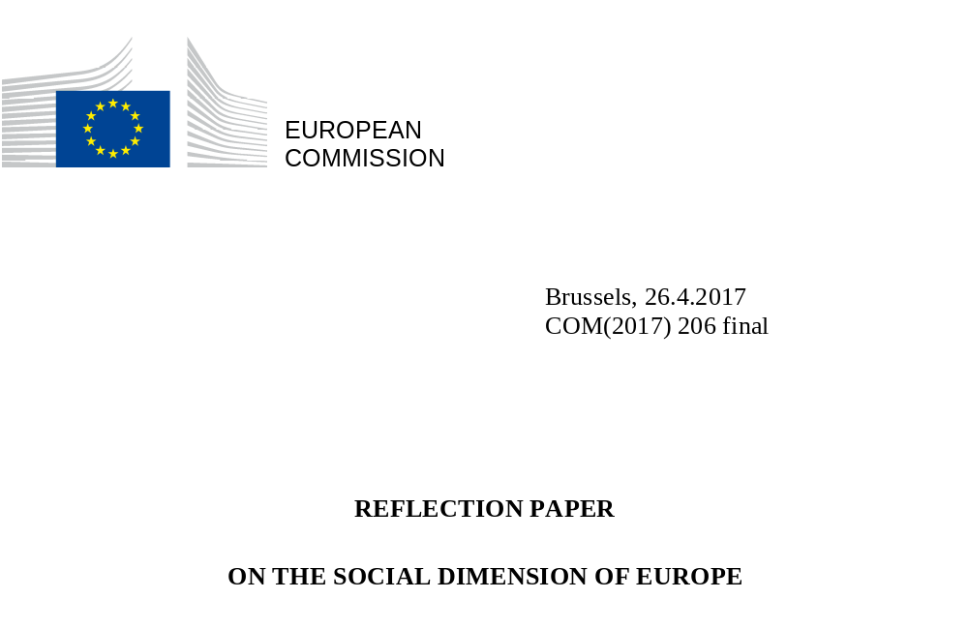

On 1 March 2017, the European Commission presented a White Paper on the future of Europe. It marked the starting point for a wide debate on the future European Union with 27 Member States.
"We want a Union where citizens have new opportunities for cultural and social development and economic growth" the Rome Declaration of 25 March 2017 pledged on the occasion of Europe's sixtieth birthday. In the past six decades, European integration has been very successful in creating those opportunities for all its citizens and in pushing social standards up for each and every Member State.
In spite of its extraordinary achievements, challenges persist across Europe. The economic crisis has left deep marks in people's lives and in our societies. People are questioning whether the benefits and the challenges that come with open markets and societies, with innovation and technological shifts, are evenly spread. Their trust in Europe's ability to shape the future and to deliver fair and prosperous societies has been eroded.
Our shared social aspiration is one way to regain support and take control of our future. Europe is home to the most equal societies in the world – a reality that is hugely valued across the Union. Even though differences in economic development and social traditions between countries remain, we have increasingly strengthened both individual and collective social rights, and improved cooperation with social partners at European and national levels. The EU framework has pushed the momentum for more effective policies and more equitable social outcomes.
Looking ahead, the debate should be about how to adapt our social models to current and future challenges and galvanise Europe's social spirit. This reflection paper on the social dimension of Europe is the European Commission's contribution to this discussion. It maps out the trends and challenges and, most importantly, opens avenues on how to turn our aspirations into a reality, how to empower Europeans for the world in 2025, and how to make our societies stronger and more adaptable.
The economic, social and political case for a social Europe is solid. What we need is to build a consensus on its future shape.
We have so much to fight for and a lot to think about.

"In these times of change, and aware of the concerns of our citizens, we commit to the Rome Agenda, and pledge to work towards (…) a social Europe: a Union which, based on sustainable growth, promotes economic and social progress as well as cohesion and convergence, while upholding the integrity of the internal market; a Union taking into account the diversity of national systems and the key role of social partners; a Union which promotes equality between women and men as well as rights and equal opportunities for all; a Union which fights unemployment, discrimination, social exclusion and poverty; a Union where young people receive the best education and training and can study and find jobs across the continent; a Union which preserves our cultural heritage
and promotes cultural diversity."
Rome Declaration, EU leaders, 25 March 2017

1. Europe's social dimension
By global standards, European societies are prosperous and affluent places to live. They have the highest levels of social protection in the world and rank highly in terms of wellbeing, human development and quality of life. Europeans confirm this. They generally say that they are happy and satisfied with their lives. Yet, when asked about the future, many express anxiety and concern, in particular for future generations.
Preoccupations differ widely between individuals, regions and countries, but there are common challenges. All Member States have gone through radical changes that have had an impact on people's daily lives. In Central and Eastern European Member States, citizens are still facing the consequences of the rapid transformations that they experienced from the 1990s onwards. In others, the effects of the worst economic and social crisis in decades are being deeply felt, even if things are going comparatively better now. Looking ahead, all Member States are undergoing rapid and profound changes– from demographic ageing to new family patterns, from the speed of digitalisation to new forms of work and the impacts of globalisation and urbanisation.
Many of these trends offer unprecedented opportunities in terms of free choice, healthier and longer lives, better living conditions and more innovative and open societies. But they also raise new questions. Are these opportunities accessible to all? Are we, individually and as societies, well prepared for the changes ahead of us? The pace and complexity of many transformations currently underway fuel a perception - and a real risk - of disruptions and insecurity for the lives of many, as well as broader inequity and inequality.
There are diverse views as to whether "Europe" is a cause of problems or a solution to them. This is in part because the term "social Europe" has a different meaning and importance to different parts of society.
For some people, the term "social Europe" is empty words and the EU is perceived as the catalyst of global market forces, the vehicle of commercial interests and the threat of "social dumping" by an unlimited and unframed Single Market.
Others contest the very need for a social dimension of the European Union, regarding social issues as exclusive matters for their national and regional governments. EU social policy and minimum standards are even perceived as a means to lock out competition.
For others still, "social Europe" is core to the EU's contribution to democratic, cohesive, culturally diverse and prosperous societies. It means economic and social progress, fighting against discrimination and social exclusion, making Europeans fit for the labour market and allowing them to live fulfilling lives. They consider Europe to be our best shield to protect and empower our people and defend our shared values, especially at a time of growing threats and uncertainties both at home and abroad.

Europe is a world leader in quality of life
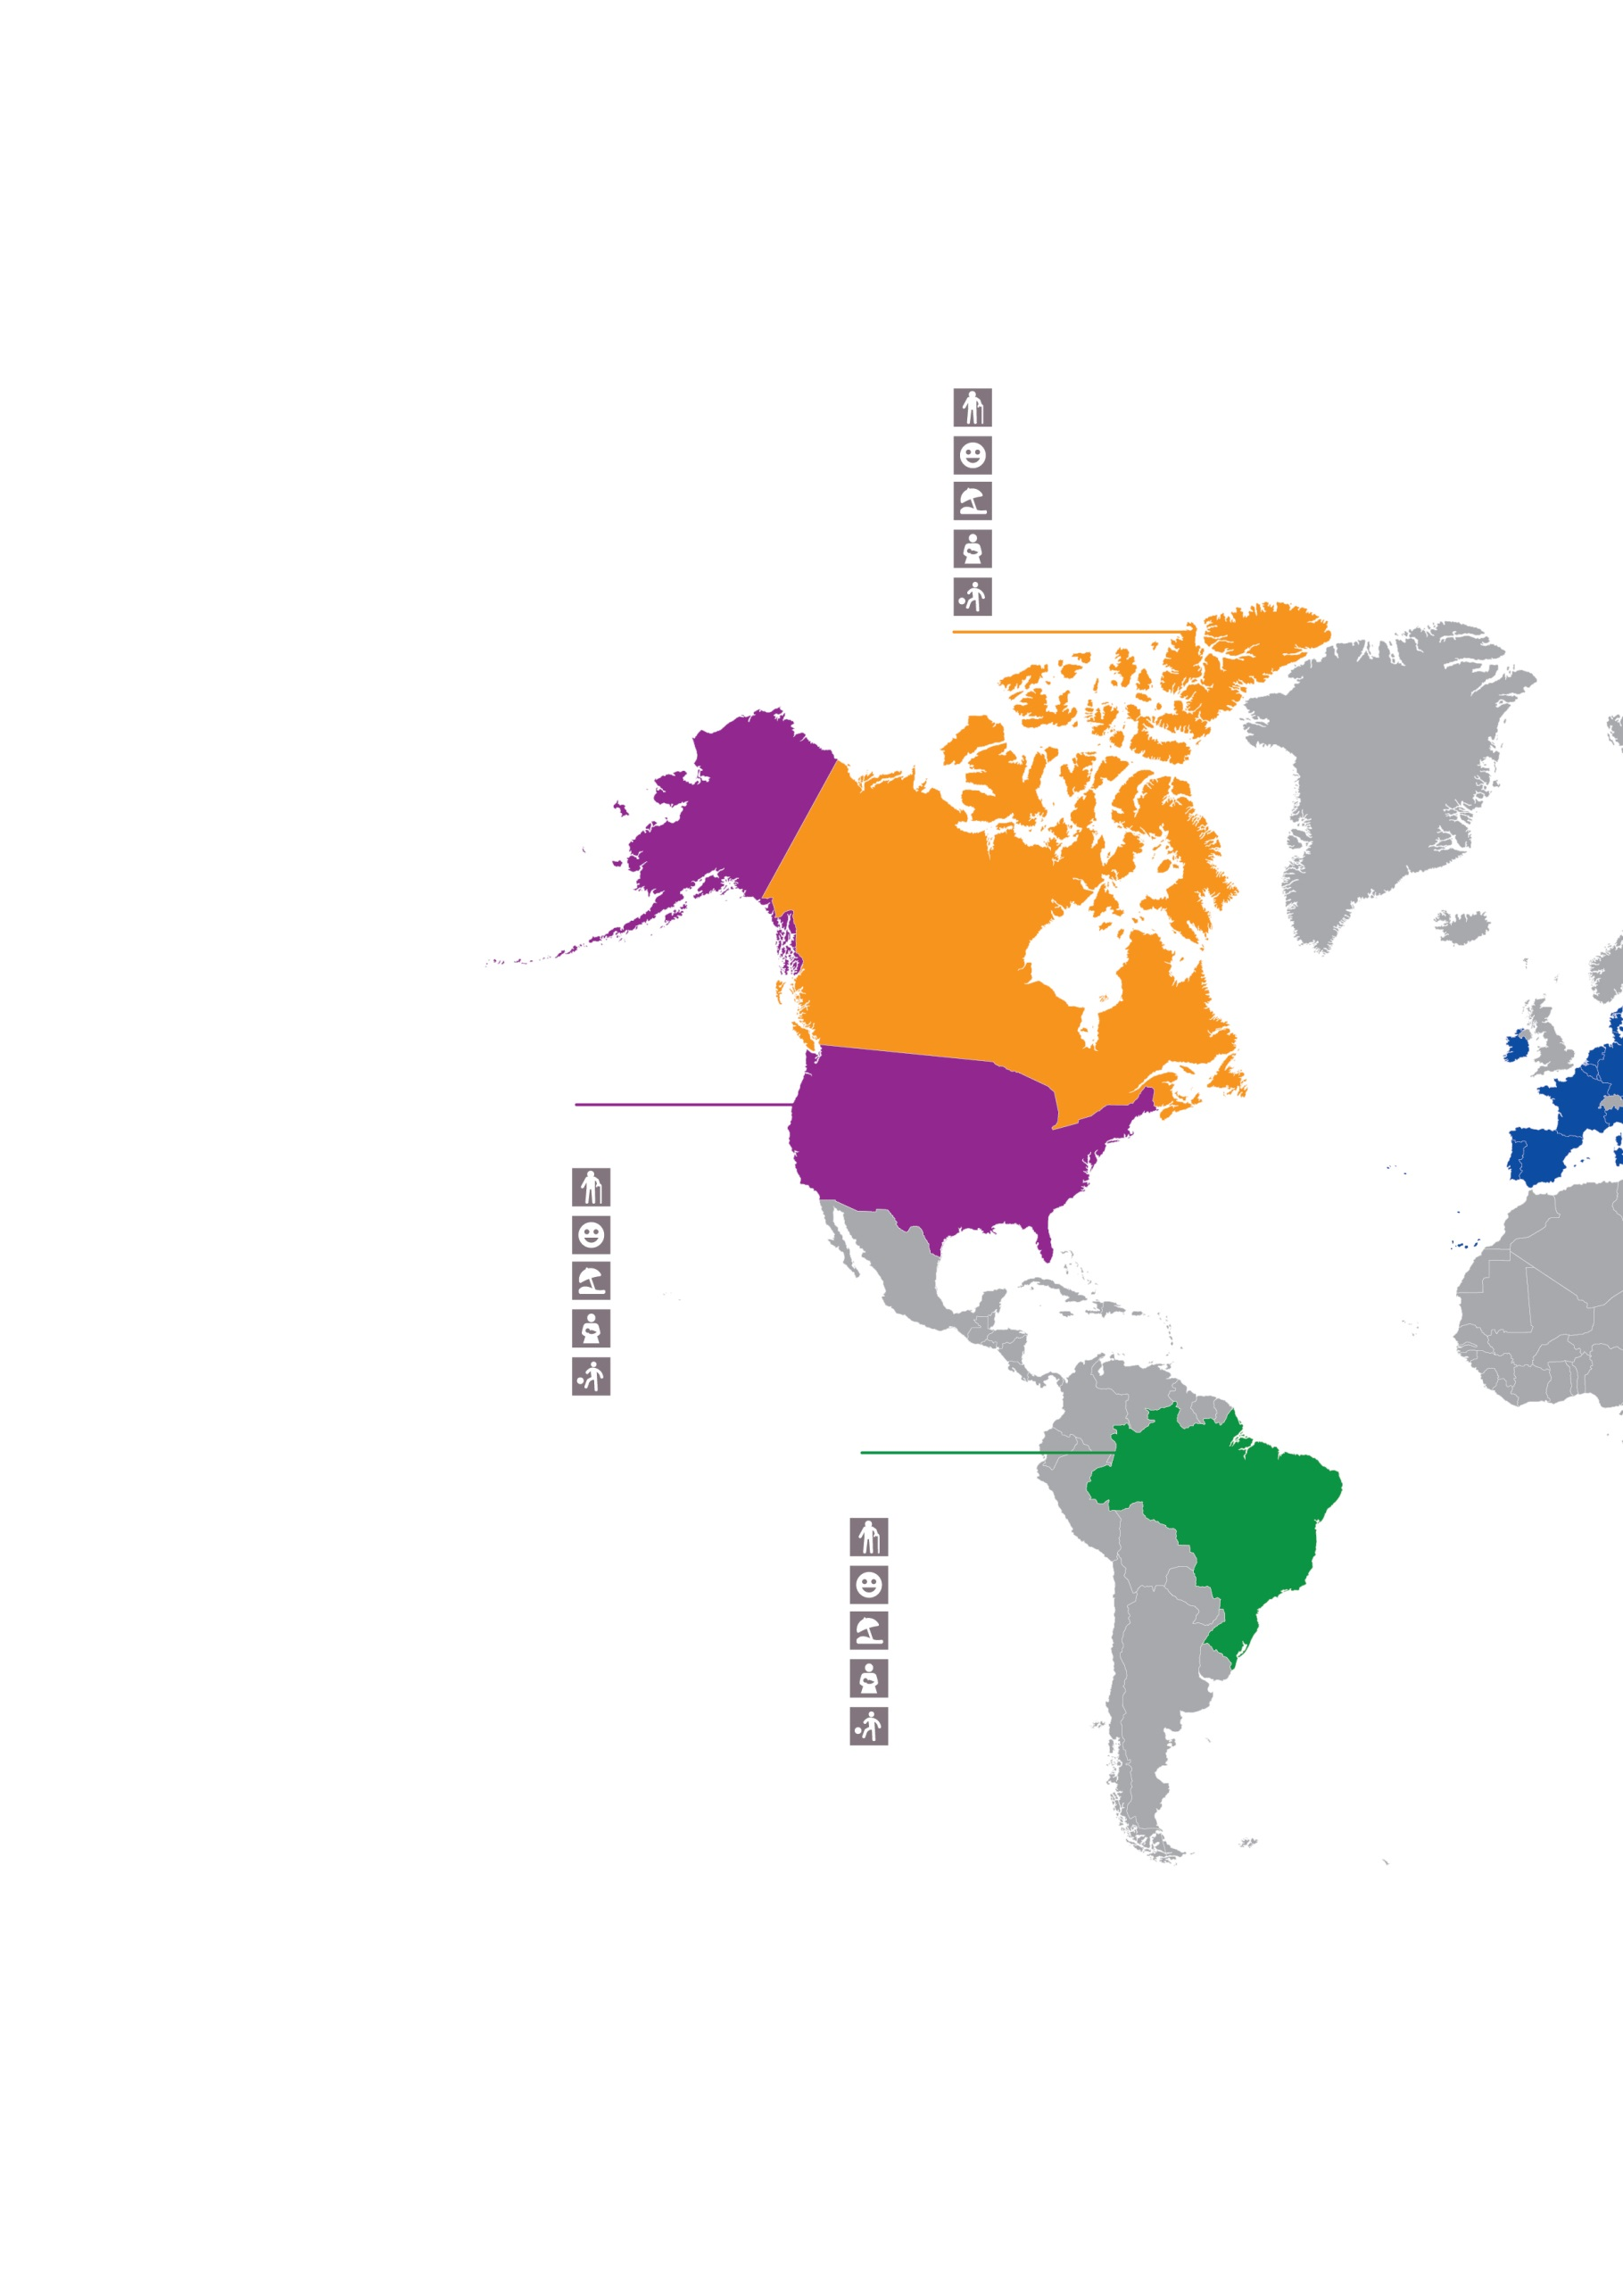

Life expectancy
Happiness
Paid vacation
Maternity leave
Time not at work
Life expectancy
Happiness
Paid vacation
Maternity leave
Time not at work
Life expectancy
Happiness
Paid vacation
Maternity leave
Time not at work
82.2
7.3
10
8.2
14.4
75.0
6.6
22
17
15
79.3
7.0
0
0
14.5
Average life expectancy at birth, in years
Index (10 happiest)
Minimum days of paid annual leave
Full paid maternity leave, in weeks
Time devoted to leisure and personal care per day, in hours
Canada

USA
Brazil

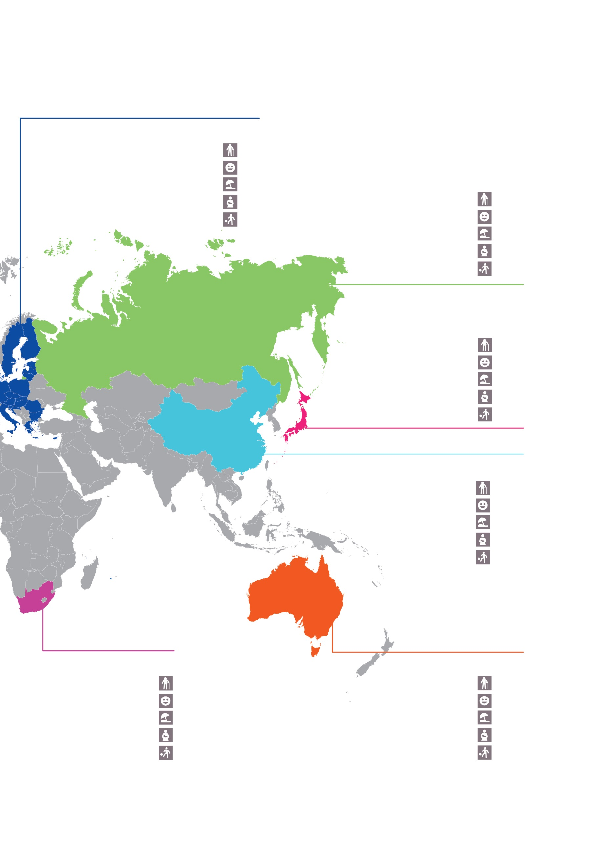
Life expectancy
Happiness
Paid vacation
Maternity leave
Time not at work
Life expectancy
Happiness
Paid vacation
Maternity leave
Time not at work
Australia
South Africa
82.8
7.3
20
2.5
14.4
62.9
4.8
15
10.2
N/A
Life expectancy
Happiness
Paid vacation
Maternity leave
Time not at work
Life expectancy
Happiness
Paid vacation
Maternity leave
Time not at work
Life expectancy
Happiness
Paid vacation
Maternity leave
Time not at work
Life expectancy
Happiness
Paid vacation
Maternity leave
Time not at work
EU27
Russia
Japan
China
80.7
6.7
22
17.3
15.5
70.5
6.0
20
20
15
83.7
5.9
10
9.4
14.9
76.1
5.3
5
14
N/A

The European Union has always had a social dimension, closely linked to its economic ambitions. Improving working conditions, living standards and gender equality have been central objectives of the EU ever since the Treaties of Rome enshrined the principle of equal pay between women and men into law in 1957. Since then, the development of a social dimension has gone hand in hand with the deepening of the Single Market and the concept of EU citizenship, guaranteeing a level playing field and essential rights across countries.
We have come a long way in 60 years. From the European Charter of Fundamental Rights to the United Nations’ Sustainable Development Goals, there is now a strong European and international commitment to uphold fundamental values, rights and social objectives. Europe has a tangible impact on our everyday lives: in education, at work, at home, on holiday, in retirement.
As the Europe of 27 looks to shape its future, the discussion on the social dimension of our Union is timely and essential. In recent years, Europe has been busy with "firefighting", responding to one crisis after another. Now is the time to draw lessons and to open a new chapter. For this, we must take a longer-term perspective and confront the more profound transformations in our economy and society.
This reflection paper and the broader debate following the White Paper enable us to look forward, together. This helps us collectively define and give meaning to a social dimension for Europe that builds on what we have and is fit for 21st century realities. It shows where we have come from, where we now stand and where we could be going. It highlights the differences between countries and regions but also the common challenges. It asks what role the EU should have and how it can better work with Member States, social partners and civil society at large.
As with the White Paper, the ideas presented here are neither prescriptive nor restrictive. Their purpose is to open the reflection, so that action can unfold.

2. Today's social realities
Before depicting the challenges and possible policy choices, it is worth looking at the current situation within and across our 27 countries.
Social realities within Europe differ greatly, depending on where we live and work. In spite of strong commonalities, Europe is home to a range of traditions, experiences and situations. Education and health, employment patterns, wages, incomes and social protection systems still differ greatly.
While Europe is recovering from the crisis, divergences between countries and regions persist.
Europe has always meant convergence towards higher living standards. In the past, this convergence took place almost automatically, through the internal market and support from EU funds, so much so that the World Bank dubbed the EU as “the convergence machine”. Yet, in recent years, convergence has slowed down considerably, if not come to a halt, as the best performers progress faster. Why has this happened and why is it a problem?
The advantages of convergence are manifold. Our societies and our Union become more cohesive and more stable. When living and working conditions converge, it can make the difference between a person moving to another country as a result of a positive choice rather than being driven to move by economic necessity. Where convergence in economic performance over time is accompanied by convergence of social conditions, fears of "social dumping" diminish and support for the Single Market is nourished. This requires, however, for convergence to take place over a reasonable period of time so that countries, people and businesses can adjust.
Living standards vary across Europe
Gross domestic product per capita, in purchasing power standards, in euros, 2015
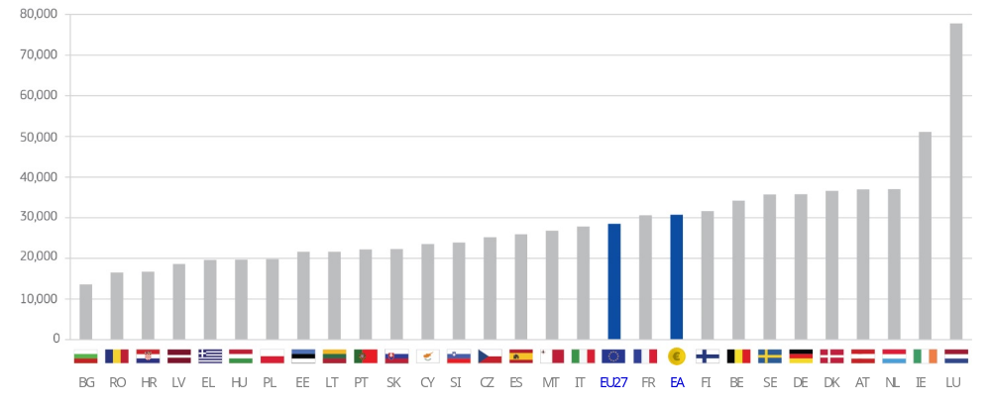
Source: European Commission

Economic indicators of living standards show a varied picture across Europe. And yet, even national averages do not tell the full story, as they mask even greater disparities within the territories of the Member States, with pockets of relative wealth in less well-off countries and vice versa. In general, capital cities are significantly better off than elsewhere. For example, Bratislava and Prague are now respectively the fifth and sixth richest regions in the EU in terms of gross domestic product (GDP) per inhabitant.
The most rapid economic growth in the EU during the period 2008–14 was recorded in the Polish region of Mazowieckie, which includes the capital of Warsaw. GDP per capita in Mazowieckie was 17.1 % below the EU average in 2008, but rose to be 8.4 % higher than the EU-28 average by 2014.
Thanks to the support of agricultural funds, rural areas – three-quarters of Europe's territory - have also seen a significant improvement in their development.
Nevertheless, progress is not evenly felt across all regions or in all parts of society. For instance, while the partial or full delocalisation of companies has not had negative overall effects for some countries and is part of the possibilities offered to enterprises through the Single Market, this has brought about serious hardship and losses for many individual regions.
Unemployment rates are falling but differ substantially across Europe
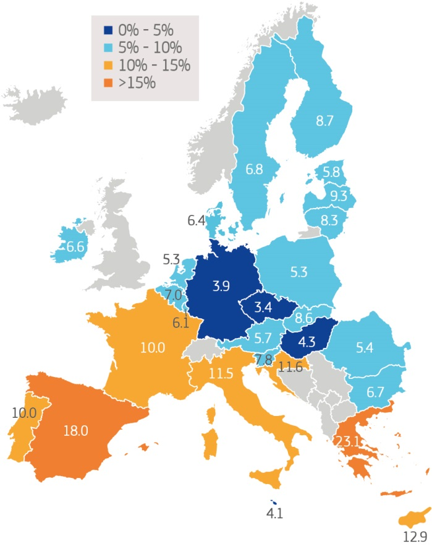
Unemployment rates range from below 5% in the Czech Republic, Germany and Hungary to 18% in Spain and 23% in Greece.
in %, February 2017
Source: European Commission
The crisis has affected parts of Europe in different ways, but across the Union, it is younger generations that have been hit particularly hard. At the end of 2016, the youth unemployment rate stood at 18% in the EU and 20% in the euro area. It was around 40% in Greece, Spain and Italy. For the first time since the Second World War, there is a real risk that today’s young adults – the most educated generation we have ever had – may end up less well-off than their parents.
Youth unemployment is falling but remains high
% of active population, 2005-2016
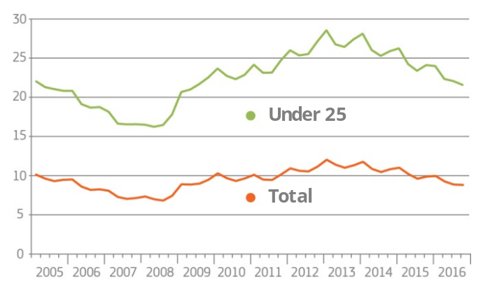
Source: European Commission

Thanks to resolute action and difficult decisions, the economy is now back on a growth path and unemployment rates are falling in all Member States. In both the EU and the euro area, unemployment is now at its lowest level since 2009. This may be partially due to strengthened personalised support provided to the young through the Youth Guarantee.

Employment rates differ
When considering the share of the working age population actually employed – the employment rate – there are again big differences between countries. Sweden, Germany, the Netherlands, Denmark, the Czech Republic, Estonia, Lithuania and Austria have employment rates of over 75%, meeting the target that all EU Member States agreed to reach collectively by 2020. Member States have varying patterns in the labour participation of women and of workers over the age of 55. While their levels of employment are catching up, both groups remain significantly under-employed.
Employment rates differ: They are increasing but remain lower for women and older workers
In %, Q4 2016
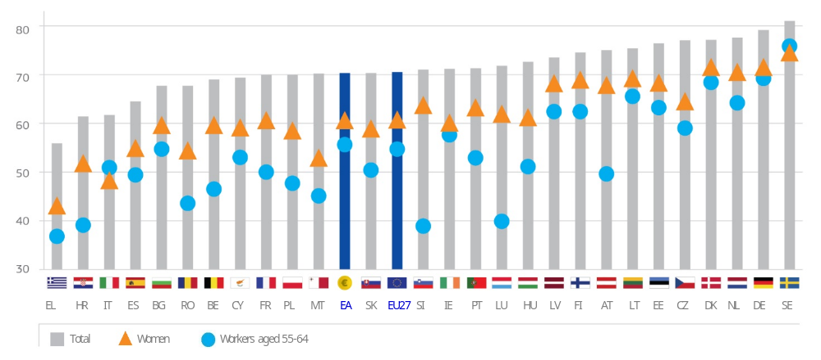
Source: European Commission

Just as unemployment rates are improving, so too are employment rates. The EU employment rate reached 71% in the fourth quarter of 2016, up from 69% in 2010, when the target was set. The EU27 now counts more people in work than ever before, with 201 million people employed, including 154 million in the euro area.
Improvements largely reflect the rising number of women on the labour market. Job creation in the services sector, better childcare facilities and the removal of tax disincentives for second earners to work are contributing to this trend even though significant gender gaps persist. Improvements also reflect the fact that more people are having longer careers. This is partly a result of past pension reforms, but also thanks to better skills, health and working conditions across Europe.
Most of the newly created jobs are good quality jobs, in the sense that they provide adequate income, labour market security and a supportive working environment. Many are created in services, a sector that tends to employ people with higher level qualifications. The highest rates of job creation can be found in information and communication, administrative and support services and professional, scientific and technical activities. 85% of these new jobs are created in small and medium-sized businesses.
Employment is recovering and growing steadily
In millions, 2007-2016
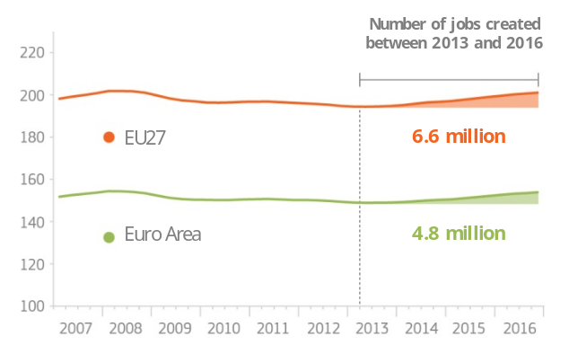
Source: European Commission

Job creation is essentially in the service sector
Employment per sector in EU27, in millions
% change 2005-2016
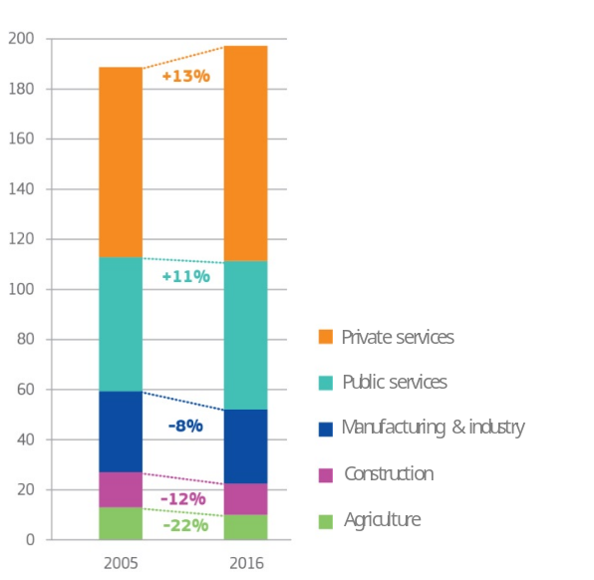
Source: European Commission

Social protection systems differ across Europe
Beyond the labour market, EU27 countries also display a variety of welfare and social protection systems in terms of political preferences and budgets. In 2015, government expenditure on social protection in the EU accounted for about 40% of total public expenditure, almost one fifth of the GDP. Eight Member States – Finland, France, Denmark, Austria, Italy, Sweden, Greece and Belgium – devoted at least 20% of their GDP to social protection.
The ways in which welfare systems work reflect different traditions inherited from the last century. Invented in Europe at the end of the 19th century, they initially sought to address the challenges of the industrial era (see Annex I). Most systems developed after the Second World War, while some only fully developed in the 1980s and 1990s. Among the differences, the size of the budget and the way it is allocated, the source of financing, the degree of coverage of risks in the population and the role of the social partners are defining parameters.
Social protection systems - combined with taxation - help narrow income inequalities. Today, Europe is home to the most equal societies in the world although significant disparities still exist. On average, the wealthiest 20% of households earn 5 times more than the poorest 20%. According to this measure, the highest levels of income inequality are seen in Romania, Lithuania, Bulgaria, Latvia, Cyprus, Estonia and Italy. There is also significant income inequality between regions within Member States.
The crisis has had a marked effect on many Europeans who had to cope with flat or falling incomes. While real disposable income – in other words, the income available to households after taxation - has been rising again lately, these levels of income are basically where they were in 2008.
Lastly, even in our prosperous societies, the risk of poverty remains significant. Almost a quarter of the EU27 population is estimated to be at risk of poverty or social exclusion. Child poverty also remains high and is rising in several Member States. This means that these children have limited access to health care, a higher risk of school drop-out and later, as adults, higher risks of unemployment and poverty. In 2010, EU leaders had committed to reduce the number of people at risk of poverty by 20 million by 2020, yet today, Europe is far off track to deliver on this objective. So far, there has been an increase of 1.7 million people at risk of poverty.

What helps our societies and economies withstand a crisis?
The global financial and economic crisis that started in 2008 left many parts of our Union with high levels of unemployment, public debt and private debt. For many people and families, it meant unprecedentedly difficult situations and struggling to make ends meet. The crisis aggravated problems that already existed for some time, and therefore hit some countries harder than others. The investment environment was better in some countries and some businesses were more competitive, just as some labour markets and social systems better absorbed the shocks and were able more effectively to protect against the negative impacts of the crisis.
In the most resilient countries, jobs were also lost but businesses managed to create new ones faster. Social security systems, in particular unemployment benefits, helped people cope during transitions, and public services focussed on reskilling and reintegration in the labour market. Minimum income schemes helped people meet their basic needs and live in dignity. Countries in which social partners have been strongly involved in reforms of the labour market have shown lasting, positive results as their involvement ensured the ownership of the reform process by a wider range of stakeholders.
Preparing for the future
Among the factors that will increasingly determine our societies' and economies' future are education and skills. Europe is home to some of the most innovative educational and advanced vocational training systems in the world.
It is therefore worrying that across Europe, around a quarter of the adult population struggles with reading and writing or poor numeracy and almost twice that number lacks adequate digital skills. Worse still, we see increasingly poor performance in basic skills among the young.
The latest results of the Programme for International Student Assessment (PISA) survey are unfortunately unambiguous: although some Member States achieve high standards of excellence overall and equity in educational outcomes, most have not been making sufficient progress in reducing the percentage of low achievers in reading, in science and in mathematics. For some parts of the population, the situation is even more concerning as, on average, and after taking their socio- economic status into account, immigrant students are more than twice as likely as their non-immigrant peers to perform below the baseline level of proficiency in science.
Few Europeans are among the top performers in science, reading mathematics worldwide
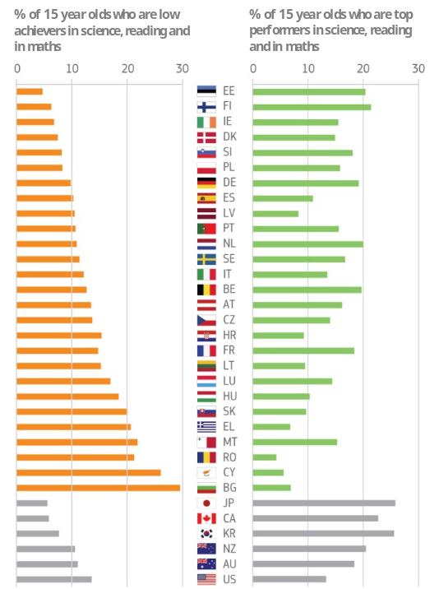
Source: OECD PISA 2015

3. Drivers of change by 2025
Europe's social fabric has changed significantly over the last decade and global factors are having a profound impact on the way we live and work. These trends are largely irreversible and are likely to accelerate in the coming years, in all our 27 countries. They will bring with them many common challenges but they will also create new opportunities.
Europe's population is undergoing rapid change
Europeans are living healthier and longer lives - and this is good news. Thanks to decades of peace, healthcare coverage, medical progress and better living and working conditions, more people are now enjoying a longer and more active retirement.
Life expectancy has dramatically improved. For men, it has gone from an average of 43 years in 1900 to an expected 82 in 2050. For women, it was 46 and is expected to climb to 87 by 2050. Most babies born in Europe between today and 2025 will still be alive 100 years from now. At the same time, healthy life expectancy and access to healthcare services still vary considerably between income groups and regions.
Europeans are also having fewer children. Whereas, in the 1960s, over 2 live births per woman were the norm, today, the EU fertility rate average stands at 1.58. As an illustration, fertility rates in Ireland and Portugal were above 3 and today they stand below 2.
The combination of rising life expectancy and falling fertility rates is leading to a profound ageing of our society. There are already more people aged over 65 than children under 14 living in the EU. By 2050, almost a third of Europeans will be aged 65 or more, compared to less than a fifth today. In comparison to the rest of world, Europe will be the "oldest" region, with a median age of 45 by 2030.
Europeans will be the oldest people in the world by 2030
Median age by regions of the world
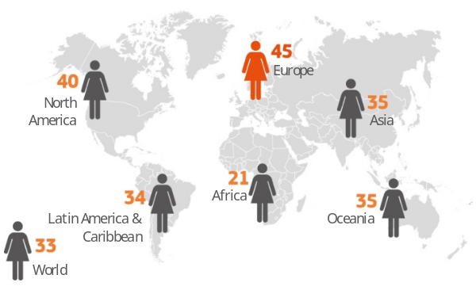
Source: Rand Europe

The increase in life years is, however, not always matched by healthy life years: almost 50 million people in the EU27 suffer from chronic diseases and nearly half a million people of working age die prematurely from these every year. Those deaths are avoidable through more effective public health and prevention policies, or more timely and effective health care.
Longevity will have a deep impact on public policies and social services far beyond the health and care sectors, from the education system all the way to the need for age-friendly housing and mobility. Ageing can be a source of new jobs, with the rapid development of the social economy sector, whether for leisure or for care. However, it also creates new needs to be met. Already today, almost a third of the population over 65 lives alone, and up to two-thirds of people over the age of 75 are dependent on informal care, mostly provided by the immediate family. One in six older people live in poverty, with elderly women particularly exposed to low pensions as a result of incomplete careers.
All this will have an impact on the financial sustainability of our welfare systems and in turn the countries' fiscal situation. For the EU27, associated expenditure related to pensions can be expected to rise to 12.4% of GDP by 2030, 7.7% of GDP for health care costs and up to 2.4% of GDP for long-term care. For every elderly person in 2060, there will only be two people of working age, compared to four in 2008. The impact will be mitigated by recent pensions reforms aimed at aligning pension age with life expectancy, but significant new healthcare costs are likely.
A shrinking workforce may also jeopardise our ability to maintain our level of economic growth. While more people are willing to work and to work longer in every generation, this may not compensate the overall fall in population numbers. Legal migration can provide the EU with the skills needed to address labour market shortages and contribute to the sustainability of welfare systems.
Ageing will also affect Europe's relative weight in the world, as the population grows faster elsewhere. By 2060, Europe will account for only 5% of the world population. No single Member State will have more than 1% of the world population by then. The situation is particularly acute in Lithuania where, under current assumptions, population levels are expected to drop by more than a third by 2080. A reduction of around 30% is projected in Slovakia, Greece, Portugal and Bulgaria.
Fundamentally, ageing also brings the question of intergenerational fairness to the fore. There is today a real risk of a generational divide between younger and older people in terms of decision-making, wealth, material security and access to housing, as well as in terms of sharing the financial and fiscal burden of an ageing society.
There are new ways of living and more diversity in society
Demographic change both explains and reflects broader developments in society, such as new lifestyles, territorial dynamics, consumption habits and housing conditions.
Birth rates are in decline but evidence suggests that the desire to have children sometimes remains unfulfilled. This comes down to a complex combination of factors, including uneven sharing of parenting responsibilities, inadequate childcare facilities, family-unfriendly work organisation and unstable work prospects.
Our changing lifestyles also come with marital break-ups, different types of relationships and a weakening of the bond of the extended family. This means more individual freedom to live independent lives but also growing risks of social isolation and less stability in people's lives. In 2015, one-person households accounted for a third of all households in the EU, and only one third of households had more than two people. This trend is expected to continue in the majority of Member States by 2025. This raises new issues of work-life balance and care responsibilities, with single parent households, in particular, facing a higher risk of poverty in case of unemployment.
Gender equality remains far from a reality, even if progress continues. Gender stereotypes persist and women are still under-represented in the labour market, in economic and political decision-making positions.
Gender gaps persist across the board
2016 or latest available data
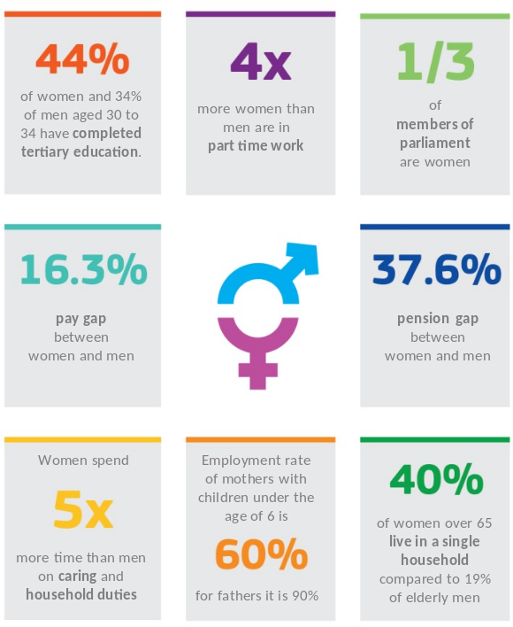
Source: European Commission
On 1 January 2016, 29.7 million people born outside the EU were legally residing in the EU27, having come for different reasons (work, study, protection or to join their family) over the past decades. While migration to the EU remains relatively modest compared to other parts of the world, the large recent inflows in the EU within a relatively short time-frame have caused tensions in some parts of Europe. Ensuring that all third country nationals are effectively integrated, fully participate and contribute is important for the future prosperity and cohesion of European societies as a whole.
Europeans make increasing use of their freedom to move within the Union, to work and study in other countries, creating businesses, paying taxes and contributing to forging a more dynamic society. About 16 million Europeans today live and work for an extended period in another country – perhaps permanently. 1.7 million people, close to 1% of the EU workforce, cross a border daily to work in another country. Beyond that, European society is increasingly integrating as a consequence of the ease with which people can travel, study, retire and do business with each other, with costs reduced and opportunities increased as a result of belonging to a border-free Single Market.
Changes in our population come at a time of growing urbanisation. Over 70% of Europeans already live in towns and cities. By 2050, 80% of us will. Europe is already home to some of the most "smart cities" in the world but there is an opportunity and a responsibility to make them even better connected and efficient in terms of the use of natural and energy resources. A key challenge will also be to make the urban environment more inclusive and accessible, to fit the needs of a diverse population, including working parents, persons with disabilities and older people.
Society is becoming more complex as traditional bonds such as family, social group and religion are changing. Globalisation has increased the exposure to diversity, stimulating curiosity and enriching societies. But it has prompted anxieties about cultural identity, cultural differences and dialogue between groups. This is symptomatic of a shift towards individual values and separate cultures and contributes to the increasing focus on the individual and the consumer rather than on society as a whole. This also raises new issues of tolerance and respect for others. At the same time, new forms of solidarity, social engagement and civic participation are emerging, including through leisure, cultural activities and the use of new technologies.
A new world of work is taking shape
Working life is being radically transformed by the combined effect of technological progress, globalisation and the growth of the services sector. Indeed, entire sectors of the economy are being reshaped through the collaborative economy and online platforms. The workforce has to cope with an increased pace of change for acquiring new skills, adjusting to new business models, or adapting to shifting consumer preferences.
For some, these changes represent unprecedented opportunities and more flexible forms of working, thanks to the use of digital tools and the growing importance of flexi-time and tele-work. For others, these are a source of insecurity.
By 2025, patterns of work and careers will be even more varied than they are today. In the space of a generation or two, the average European worker may have gone from having a job for life to having up to ten jobs in a career. The take-up of remote or mobile working will become easier and more commonplace. This reflects a trend towards the flexibility of workers in a more diverse labour market. Work will become increasingly focused on output and outcomes rather than physical presence in a specific location, with more opportunities for people to work as free-lancers and combine several jobs at the same time. Many of these shifts have already started to take shape; how we respond to and drive these transformations today will determine what the future world of work may look like.

New realities on the labour market
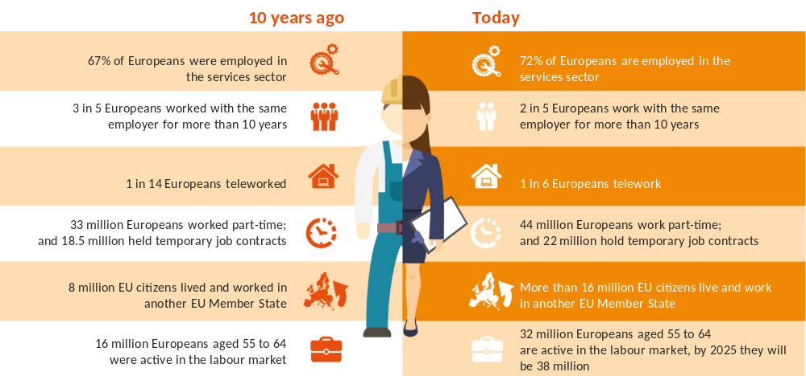

Source: European Commission
This is emblematic of increasingly diverse and irregular working patterns and working conditions that end the prospect of a traditional career. In its place are new forms of contracts, greater geographical mobility and more changes in jobs and working status.
While new types of contracts can be a stepping stone to the world of work, there is also a risk of increasing labour market polarisation, with evidence of rising wage inequalities and people with low skills trapped in low quality jobs with few prospects of advancement.
With the pace of digitalisation and economic change, some of today's jobs will become obsolete and the skills needed to do them will become out-dated. Education systems need to modernise to address these challenges. It is likely that most children entering primary school today will end up working in completely new job types that do not yet exist.
Challenges for tomorrow’s work life
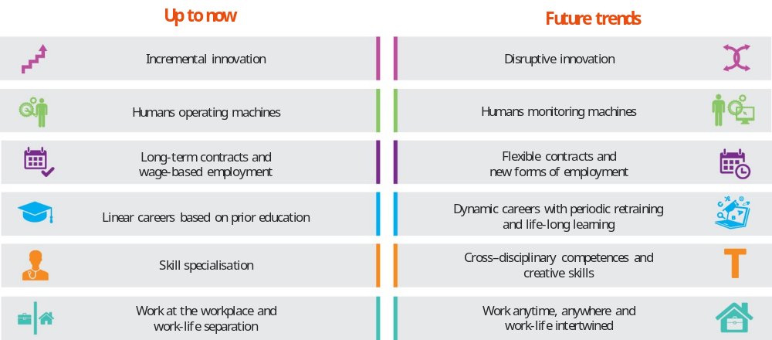Source: European Commission
This raises many questions about the future of work itself. Will there be more or less jobs in the future? Will the jobs that exist be "quality jobs"? Is today’s and tomorrow's workforce equipped with the right skills to fill them? It is difficult to predict the full impact of automation and artificial intelligence on future job availability and the speed at which it may happen. Some studies have suggested that half of today's work activities could be automated by 2055. What is certain is that workers of all ages will be increasingly required to adapt their skills to technological change and to update them continuously. This is the reality that Europe's companies, schools, training centres and universities need to prepare Europeans for.
There are new social risks and there is a need to modernise welfare and lifelong learning systems
The new world of work raises questions about the quality of jobs in the future in terms of earnings, job security and working conditions. It also has an impact in areas such as social assistance networks, benefits, pension planning, childcare and healthcare. It may also entail adapting working time, rest periods and health and safety requirements.
In society more generally, new social problems are emerging such as stress and depression, obesity, environment-related diseases and technology addiction. These add to traditional problems of social isolation, mental illness, drug and alcohol abuse, criminality and insecurity.
The capacity of public authorities, companies and individuals to respond and adapt is at stake. On-going changes will pose significant new challenges in terms of education, training, skills, lifelong learning, the management of human resources and the capacity to manage complex professional transitions during a person's lifetime. It will also entail the roll-out of new social rights to fit the changing world of work.
In spite of many on-going reforms, existing welfare states are not always well attuned to adapt to these new and largely unprecedented challenges. This is not just a matter of financial sustainability. It is a matter of delivering the right safety nets and the new protections to help individuals use their full capacities to live their lives and for society to function. Social protection systems still have many limitations, namely on coverage and access. For example, in countries that have long relied on traditional family support and on pensions as a source of income for the extended family, there has been a need to develop and reinforce systems of taxation and benefits that are more geared towards the individual, more universal and better means-tested. These are also often countries that have long relied on restrictive employment protection legislation as a way to protect people at work, but at the expense of younger job seekers.

Well-targeted welfare policies can have a powerful impact on reducing inequalities
in %, 2014
Reduction in income inequality as a result of social benefits (%)
Spending on social benefits (% of GDP)
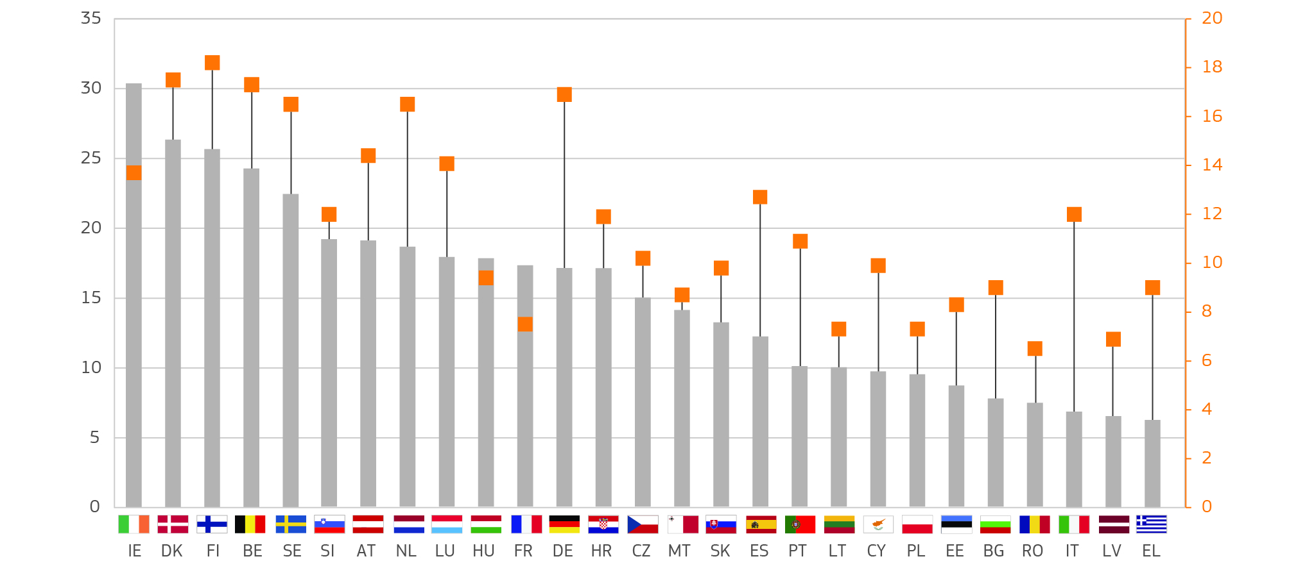
Source: European Commission
Thinking ahead in terms of new protection for the future, one key feature is the need to modernise our education and training systems and expand lifelong learning programmes to facilitate greater occupational mobility and deal with problems of skills mismatches. There is increasing global competition for skills and, although most European countries remain near the top of international skills rankings, some have been overtaken by countries in Asia, Oceania and the Middle East.

Europeans expect governments to tackle these challenges
These trends are well perceived by Europeans and the impact of the crisis has heightened the expectations and concerns of many. Surveys consistently show that jobs and social policy rank among the top priorities for Europeans. Europeans traditionally value their welfare standards and they also point to a relative dissatisfaction in the way their concerns are addressed by the EU and national governments.
Europeans are concerned about the social situation

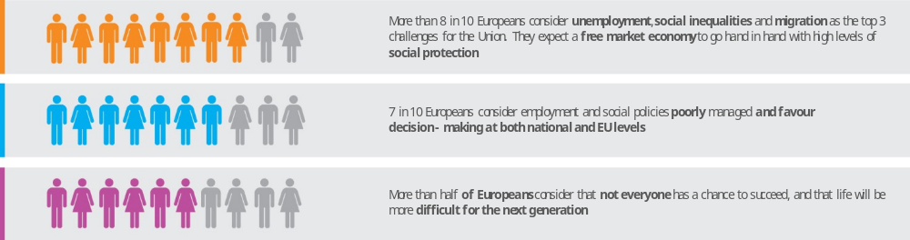
Source: European Commission and Eurobarometer 2017

These expectations are placed into the hands of all authorities – be they local, regional, national or European – and it is not always clear from these surveys who respondents think should be responsible for what. When asked to choose between the national and EU level, people see this primarily as a task for Member States but they also see a role for the EU, even if it may not be fully equipped to solve the problem at hand. At the same time, tapping the full potential of available European funds requires Member States to put in place the necessary structures swiftly and effectively, as the example of youth unemployment shows.

4. A possible way forward for the EU27
Providing answers to the hopes and expectations of citizens presupposes an open discussion about the ability of economic and social systems to continue to meet individual and collective social needs, and about the ways in which the EU and its Member States can work better and more efficiently together.

The 5 scenarios of the White Paper on the future of Europe
SCENARIOS | 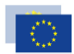 |  | 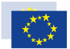 | 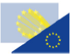 | 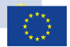
SCENARIOS | Carrying on | Nothing but the Single Market | Those who want more do more | Doing less more efficiently | Doing much more together
WHAT DOES IT ENTAIL? | EU27 implements and upgrades current reform agenda. Priorities are regularly updated, problems are tackled as they arise and new legislation rolled out accordingly | EU27 only deepens key aspects of the single market | EU27 allows willing Member States to do more together in specific policy areas. As a result, Member States agree to specific legal and budgetary arrangements to deepen their cooperation. Other Member states may join over time | Consensus on the need to better tackle certain priorities together makes EU27 focus attention and resources on delivering more and faster in selected policy areas, while in other areas it stops acting or does less | Member States share more power, resources and decision-making across all policy areas, the euro is strengthened, and decisions at EU level are rapidly enforced
WHAT DOES IT MEAN FOR THE SOCIAL DIMENSION? | Citizens’ rights derived from EU law are upheld across the Union | Citizens’ rights derived from EU law may become restricted over time  Persistent differences in consumer, social and environmental standards, taxation and use of public subsidies  Risk of ‘race to the bottom’  Free movement of workers is not guaranteed | Citizens’ rights derived from EU law start to vary depending on whether or not they live in a country that has chosen to do more  A group of Member States choose to harmonise taxation or agree to common social standards thereby reducing compliance costs, limiting tax evasion, and contributing to improved working conditions  Progress is made at 27 to strengthen the Single Market and reinforce the four freedoms | Citizens’ rights derived from EU law are strengthened in areas we choose to do more and reduced elsewhere  New standards for consumer protection, the environment and health and safety at work move away from detailed harmonisation to strict minimum  Salaries, social legislation and taxation levels vary significantly across the Union | Citizens have more rights derived directly from EU law  Greater coordination on fiscal, social and taxation matters among euro area members  Additional EU funding to boost economic development and respond to shocks at regional, sectoral and national levels
Source: European Commission

The role of the EU in the social field will depend on the broader choices made by the EU27 as a whole. As highlighted by the White Paper on the future of Europe, the range of possibilities varies from the status quo, to a change of scope and priorities, to a partial or collective leap forward.
Empowering citizens to create strong societies
Across the EU, there is growing consensus that fostering equal opportunities so that everyone can start well in life, overcome difficulties, and realise her or his own potential is necessary to create resilient societies.
The areas for action are well known: investing in children to ensure they have the best start in life; investing in youth, skills and in lifelong learning; facilitating transitions throughout a career and moving from a “job for life” to an “employment for life” perspective, including self-employment; promoting longer and healthier lives, through prevention and better working conditions and elderly care; promoting gender equality, to overcome remaining gaps and establish the concept of a “dual earner family”; ensuring active inclusion and fighting against discrimination, allowing everyone to have a dignified life; facilitating mobility and ensuring successful integration of migrants; promoting civic participation, culture and dialogue, which are also economic assets – to name just a few.
There is no "one-size-fits-all" approach across Europe, but there are common challenges and there is a shared need to act. At a time of rapid and constant change, the focus should be on empowering individuals and building more resilient societal structures, able to adapt successfully over time.

Our countries can learn from each other
Many European countries are engaged in major reforms of their labour market and welfare systems, with clear common trends: shifting taxation away from labour to reduce the cost of hiring and facilitate job creation; modernising pensions systems by better aligning the retirement age with life expectancy; modernising education and lifelong learning systems to make them deliver better on today’s and tomorrow’s needs; maintaining a link between wages and productivity to sustain competitiveness and job creation over time.
In so doing, Member States can look at established models across Europe that have been proven to work. The combination of a flexible labour market, strong social protection, functioning social dialogue and lifelong learning in Denmark has reduced inequalities and boosted economic performance. The dual vocational training system in Austria and Germany has facilitated the transition between learning and employment by combining education with hands-on practical experience.
At the same time, all countries are led to innovate in a national or European context. From the testing of universal basic income in Finland to the roll-out of a guaranteed minimum income in Greece, there is a growing tendency to try out new models to fit new realities. In France, a new personal activity account brings together all entitlements such as training accounts, occupational risk accounts and unemployment benefits into one single account that can be used throughout a person's career.
Without a doubt, Europe is well placed to provide examples of solutions to societal challenges that are relevant to other parts of the world as well – from rapid ageing in many countries without fully-fledged welfare systems, to the design of “smart cities” across the world, to the healthcare solutions of tomorrow.
The EU is not starting from scratch
Over the last sixty years, the role of the EU has been to support changes, but also to guide them, while respecting the responsibilities of other layers of government.
The Treaty of Rome already included fundamental principles such as equal pay for women and men and the right of workers to move freely to another Member State. Detailed rules have been put in place to make the right to move to another country a reality: rules to ensure the rights of patients to receive treatment abroad and to be compensated for their medical expenses, rules for the mutual recognition of diplomas, and rules to ensure that people do not lose their acquired pension rights when taking up a job in another country. Those provisions have had a direct, positive impact on the lives of millions of people. And our economies and societies as a whole have only benefited.
Together with the development of the Single Market, the EU has developed a set of secondary legislation on safety and health of workers, on equality rights, on atypical forms of work such as part-time work or temporary agency work. This is because we recognised that a common market also requires common rules in a number of areas, setting minimum standards across the board.
Through guidance, Europe enables national governments to draw from other countries' experiences. In the wider social area, this guidance concerns many different areas, from education, to healthcare, to youth policy, to gender equality and anti-discrimination, and sports. When coordinating fiscal and economic policies in the framework of the European Semester, Member States agree to implement economic and labour market reforms to support inclusive growth and to strengthen social fairness, based on responsible public finances.
Whilst a significant part of the EU budget is used to support social innovation and social projects in the Member States, and also to fight poverty, it must be noted that the EU social budget represents only 0.3% of total public social expenditure in the EU. While this share might be re-assessed in the future, there can be no mistaking that social support is and will remain primarily in the hands of Member States. The EU budget serves mainly to support actions to empower Europeans: to integrate disadvantaged groups in the labour market, for example the Roma, and to help workers adapt to changing labour markets. 30 years ago, Europe set up a programme that makes it possible for students to do part of their studies in another country. The Erasmus+ programme has become one of the most successful initiatives in European history, with 9% of European students making use of it so far.
Finally, the EU supports social dialogue, engages with civil society and cooperates with international organisations to promote high social and living standards not just within our Union and in our neighbourhood, but also across the world and far away from our borders. Convergence of social standards is a key element of fair globalisation. To this end, the EU cooperates with international organisations so that international standards on human and social rights are respected and working conditions improve.

The EU has limited but significant tools

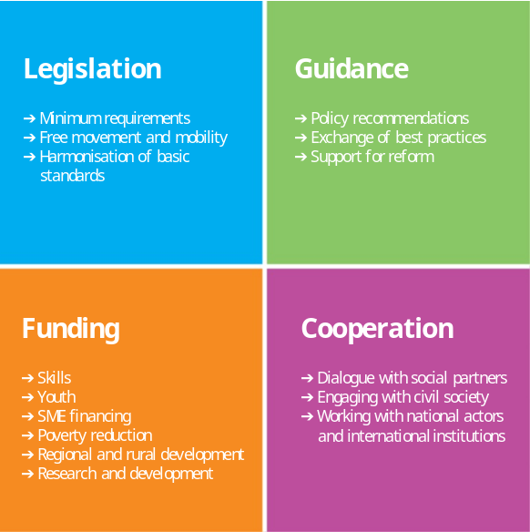
Source: European Commission

The current Commission has stepped up action on all fronts (see Annex II). It has proposed clear, fair and enforceable rules on labour mobility to protect people's rights better, whilst giving Member States better instruments to tackle abuse. It has introduced new legislation to protect workers against exposure to cancer-causing substances – saving 100,000 lives over time, and it has taken initiatives to improve accessibility of goods and services for the disabled. It has proposed an ambitious agenda to ensure that people can develop the right skills and engage in life-long learning.
Today, based on extensive consultation of stakeholders, the Commission is presenting a European Pillar of Social Rights. The Pillar establishes a series of principles and rights, which are to serve as a reference framework for employment and social policy at national and European level. To support the Pillar, the Commission has also launched a new legislative initiative to grant parents and carers across Europe minimum rights to leave and to flexible working arrangements so that they can better combine work and family obligations – an issue that hundreds of thousands of households in Europe are struggling with today. Social partners are being consulted on possible legislation to improve the employment and social protection rights of those who are today insufficiently protected.
Much of the debate in our countries concerns the way EU legislation is applied. The current Commission has made great efforts to provide guidance on how the law is to be applied and to render the legislation clearer wherever possible. The implementation, application and enforcement of European social legislation today lie, however, in the hands of the Member States. They have exclusive competence to carry out inspections and to sanction violations.
The current Commission has stepped up its guidance to Member States, for example on the integration in the labour market of the young, long-term unemployed and third country nationals, on vocational and educational training, on combatting hate speech and radicalisation, and on protecting children in migration.
It has also re-launched the dialogue with social partners at European level and welcomes their commitment, expressed in Rome on the occasion of the EU's sixtieth birthday, to continue contributing to a Europe that delivers for its workers and enterprises.
Finally, the Commission has taken social considerations into account in all policies, including its foreign trade policy - the Comprehensive Economic and Trade Agreement (CETA) with Canada is an example thereof, its economic policy focussed on investment and job creation, and in its agricultural, environment, energy and transport policies.

What options for the future
In the logic of the White Paper, there are several options for the social future of Europe:
- Limit the "social dimension" to free movement;
- Alternatively, those who want to do more could do more in the social field.
- Or, the EU27 could deepen the social dimension together.
The political option chosen will have implications beyond the social field, stretching to the competitiveness of Europe, its capacity to harness and shape globalisation, the stability of the Economic and Monetary Union, cohesion within the Union and solidarity between its people. Any political option should also be seen in the light of the identified challenges, asking where the EU level can provide an added value. As each of the three options suggests a number of concrete proposals for action, also the choice among the possible instruments must be made in light of the challenges. Most of the examples given for the second option are also valid for the third and vice versa.

Limiting the "Social Dimension" to free movement

Some argue that social legislation at EU level is hampering growth, that the administrative burden on businesses is too costly, in particular for small and medium-sized enterprises. They say that our high social standards, next to consumer protection and environmental norms, put European companies at a competitive disadvantage compared to the rest of the world. In their view, it is for Member States only to distribute the benefits of economic growth fairly amongst their citizens, through taxation and social welfare systems. Also education and culture should, in their view, be left exclusively to the Member States.
Focussing on the Single Market only would mean keeping rules to promote cross-border movements of people in place, such as rules on social security rights of mobile citizens, on posting of workers, on cross-border health care and the recognition of diplomas. However, European legislation on the protection of workers, their health and safety, working and rest time would be scrapped. Minimum paid holiday and equality legislation would be abolished at European level. Member States could decide whether to allow temporary agency work or not. Equal treatment of part-time workers would no longer be ensured across Europe. There would be no minimum standards set for maternity and paternity leave, or for parental or carers leave, at European level. The right of workers to be informed, individually and collectively, about their rights would no longer be guaranteed at European level. The framework for European Workers' Councils in multinational companies would be abolished. Social dialogue at EU level would be limited to sectors and issues relevant for the Single Market.
Europe would no longer foster opportunities for Member States to exchange best practices in the fields of social assistance, education, health, culture and sports. Neither would it support Member States with recommendations on how to tackle youth unemployment and long term unemployment, nor with its tools to re-train and skill Europeans, making them fit for employment. European funds to support the reconversion of regions that are hit hard by the effects of globalisation would shrink or be abolished. Social programmes in the Member States that are co-funded substantially by EU money would have to be discontinued or funded nationally.

What this could mean in practice:
- Truck drivers are faced with different drive and rest times in every country; their employer has to pay them a different hourly wage in every country.
- 20 days paid holiday and 14 weeks of maternity leave are no longer guaranteed across Europe.
- Patients can still get treatment in another Member State, but there is no European action plan to fight the increase of antibiotic-resistant bacteria.
- There is no coordination and preparedness in response to common health threats, for example in case of the spread of contagious diseases like Ebola and the Zika virus.
- When a car plant closes down because production is shifted to a low wage country outside Europe, and thousands of people become unemployed at once in a region, there are no European funds available to help them back to a job.
- Even the Erasmus+ programme risks being abandoned and the EU stops any benchmarking on early school leavers and low achievers.
EU support to the European film industry, cultural and creative sectors is stopped. European Capitals of Culture are discontinued.
Pros and cons:
- Most decisions on social and employment matters would be taken at national level and hence "closer" to the citizens.
- Businesses would be released to a greater extent from complying with EU legislation, but they would instead still have to comply with 27 different sets of national legislation.
- Member States would be completely free to test innovative solutions related to globalisation, digitalisation and ageing. But without EU support there would be less opportunity to learn from each other.
- Although many of the challenges could be mastered by skills and training, Europe would not contribute in this respect.
- National labour markets would grow further apart. Instead of converging, there would be an increasing risk of labour costs diverging and the threat of a "race to the bottom".
- In case wages grow further apart, more workers from low wage countries, in particular the young and best skilled, may leave for higher wage countries either within the EU or abroad. This could exacerbate demographic problems in some Member States.
- Combined with the discontinuity of EU funds supporting social projects, including on training and skills, this could ultimately erode support for the Single Market and the European project. Above all and paradoxically, whilst the objective of this option would be to focus the social dimension of Europe on free movement, the Single Market would risk being jeopardised.
- Europe would hence fail to tap on the full potential of its main growth and jobs engine, the Single Market.

Those who want to do more in the social field do more

Many argue that the crisis years have shown that those countries that share the euro as a single currency need to do more together in the social field to preserve the strength and stability of the euro and to avoid abrupt adjustments in the living standards of its citizens. It is recognised that it is better to adjust pre-emptively. That does not mean that their social models and welfare systems need to become identical. But their labour markets and social systems need to function well, so that when the next crisis hits, their economy is more resilient and their people's wellbeing is better protected.
To many, the euro area quite simply is more than just an economic entity, binding our destinies together. The upcoming reflection paper on the future of the Economic and Monetary Union will develop more comprehensive options in this regard, also presenting possible stabilisation instruments, as outlined in the Five Presidents' Report on Completing Europe's Economic and Monetary Union. But the consequences of deepening the social dimension in the euro area, and possibly a few other countries, deserves further discussion in the context of this paper too.
Currently, apart from the coordination and surveillance of fiscal policy, there is no legal framework to develop legislation for the euro area only, but the instrument of 'enhanced cooperation' foreseen in the Treaty could be used. It implies that a group of at least 9 countries, as a last resort and only if the EU27 Member States agree to it, could adopt legal acts that bind only the countries that take part. Common standards could focus primarily on labour markets, competitiveness, the business environment and public administration, as well as certain aspects of tax policy (such as the corporate tax base). The euro area would be better supported and its citizens better protected with more convergence of national employment and social policies. Existing funding at EU level could be used to support joint actions and/or dedicated funds could be set up by the countries taking part.
Enhanced cooperation could also be done by different groups of countries, as shown by some of the examples below.

What this could mean in practice:
- A person's diploma is automatically recognised in some Member States, but not in others.
- A person can easily identify himself or herself in some countries with a single social security number; authorities from those countries can check easily whether that person is insured and can be reimbursed or receive benefits more smoothly.
- A group of countries agree on the common pricing of medicines and vaccines. This will improve coverage and access to healthcare.
- A group of countries agree on joint planning of their health workforce, including the number of doctors and nurses they will train collectively.
- In some Member States, citizens may receive higher unemployment benefits than they do today; in others, the period for which they can rely on unemployment benefits may be shortened.
- The participating Member States could set up joint programmes for the integration of refugees.
- People may still lose their job, but in the countries that opt for a deeper social dimension they have a better chance of finding a new job faster and they are supported during the transition, thanks to joint re-training and skilling instruments.

Pros and cons:
- Those who want to go further could do so. Like-minded countries could adopt bolder measures. There would be no need to accept only the lowest common denominator amongst 27.
- Cooperation by some could serve as a launch pad for new innovative projects addressing global challenges such as ageing, digitalisation and urbanisation. If successful, ultimately all 27 Member States could end up joining.
- Citizens' rights derived from EU law would start to vary depending whether or not they live in a country that has decided to do more.
- The level of complexity in decision making, as well as in monitoring and enforcing the rules would increase.
- The euro area could achieve stronger convergence towards more integrated labour markets, most effective social systems and strongest education and health care systems. This would respond to some of the identified challenges.
- On the other hand, the already existing differences with other countries could widen, making it more difficult for them to integrate into the euro area later.
- Some countries outside the euro area might want to attract business by deliberately lowering their standards – to the detriment of social convergence.
- The Single Market might be hampered by different social standards across the EU, with a risk of repercussions on growth and jobs.

The EU27 deepen the social dimension of Europe together
There is a widespread view in Europe, reflected also in the Rome declaration, that social values are fundamental to the European project itself, and that all EU citizens should have rights and equal opportunities. Others argue that the Single Market is closely intertwined with common social standards, just like it is closely intertwined with common environmental and consumer protection standards. A third group underlines that the commonality in the major challenges that European countries face today – security, demographic changes, migration, technological developments, globalisation - are of such a magnitude and global scope that they need to be addressed on at least the European scale to get a grip on them and shape the future.
At the same time, many argue that going ahead at 27 cannot mean simply "carry on, just try harder". The current balance of competences between the Union and Member States might have to be revaluated, touching on all four instruments: legislation, cooperation, guidance and funding. As a matter of priority, both the EU level and national governments should re-orientate attention to the new challenges. Only then could we defend our social market economy, preserving our unique European way of life.
It is undisputed that the centre of gravity for action in the social field should and will always remain with national and local authorities and their social partners. However, the fields in which the EU may potentially develop further initiatives to support Member State action are manifold, as the ongoing debate shows, making full use of all the instruments in its toolbox.
Legislation would not only set minimum standards but, in selected areas, could fully harmonise citizens' rights across the EU.
With the aim of focusing on convergence in social outcomes, binding benchmarks could be developed for important parameters contributing to effective employment policies, education and health systems and welfare systems. Building on the example of the Youth Guarantee, a Child Guarantee supported by EU funds could be developed.
There are calls to make more funds available at the EU level to support skills development, labour market integration projects, the fight against poverty and promote social innovation. EU funding could be made conditional upon a commitment to reach certain benchmarks or adopt certain reform measures in order to promote convergence towards the best performers. The EU could also further support social investment through EU level instruments.
It is also proposed that complementing Member States' enforcement agencies, European agencies could be set up with a coordination function and enforcement powers in cross-border situations, such as a European Labour Inspectorate and a European Transport Agency.
Member States could agree that all EU27 move forward together in only selected areas.

What this could mean in practice:
- The EU27 agree on common rules determining the employment status of digital platform workers. This enables businesses to tap fully the potential of a single European digital market.
- All Member States mutually recognise each other's diplomas.
- European truck driver wage agreements are coordinated or even bargained collectively by the European social partners and applied uniformly in the Single Market.
- Every European has a single social security number to identify himself/ herself in any country. Claims, checks and payments are made online, seamlessly from one country to another.
- People retire at the same age across Europe in line with trends in life expectancy. In some countries this may mean later, but people's pensions are ensured.
- Businesses may be inspected not only by national but also by European inspectors.
- Member States may have to adjust their IT systems to interoperate with EU Ievel systems.
- The Erasmus+ programme is extended to at least 30% of students, pupils, vocational trainees, apprentices and teachers.
- There is a unified higher education area across all countries.
- A European disability card is valid across all countries.
- There are EU resources to respond to cross-border health threats (Ebola, Zika virus).
- There are mandatory benchmarks to improve public health intervention, for example on fat and sugar content in food.
- Citizens can transfer their medical information electronically when receiving treatment in another Member State and use e-prescriptions to get their medication dispensed.

Pros and cons:
- Citizens would have more equal social rights in all Member States, enhancing their identification with the European project and support for it.
- Citizens would feel further away from the decision making process..
- It would remain difficult at times to agree amongst 27. Political will would have to be there to make compromises without moving standards to the lowest common denominator.
- The Single Market would operate more seamlessly, European labour markets would further integrate and the fear of "social dumping" would diminish. Support for the Single Market would increase, provided a right balance is found between various interests and its integrity preserved.
- Acting together as 27 would facilitate any future accessions to the euro area.
- All European economies would be more resilient to shocks, our countries would respond to the challenges together.
- The EU would make a visible contribution to empower citizens, for example with reinforced training programmes.
- United at 27, Europe would be best placed to overcome common challenges and the strength and international standing of Europe would be highest.

5. Moving the debate forward
Europe's social dimension is ever-changing, influenced by personal choice, economic reality, global trends and political decisions. We can choose to embrace and direct change, or be driven by it.
A gap between alleged "winners" and "losers" of economic and technological change may result in new patterns of inequality, with a persistent risk of poverty coinciding with new forms of exclusion. In a modern and cohesive society, everyone should be able to contribute fully and have access to new "ladders of opportunity" at different stages of their lifetime. This is a matter of social justice and social cohesion.
This is just as much an economic imperative. A well-functioning, confident and buoyant society that invests in its human capital and creates opportunities for individuals to move on throughout their life cycle is essential to sustain economic growth, labour market participation and living standards and to combat social risks.
It is also a political requirement. Building confidence and trust is essential for progress, modernisation and openness to change.
While Europe has a wealth of experience to offer, it is clear that models or “solutions” such as these cannot simply be transposed or exported in their entirety from one Member State to another with a different socio-economic situation, cultural tradition and educational system.
However, every European country is ultimately striving for the same thing: to create a fairer society based on equal opportunity. Our gender, birthplace, family background or wealth on our first day should not determine the level of access to education, services or opportunities.
In their diversity, the EU27 countries have the possibility to respond to common challenges individually and together, in the knowledge that the responsibility for preparing for the future is largely in their hands. The presentation of three avenues in this paper gives a perspective of what might be achieved at the European level and what the limitations could be, depending on the degree of ambition that is pursued and the extent to which some – or all – Member States are prepared to work together.
Whether, tomorrow, the role that Europe plays in support of the EU27 should be changed or not will be discussed further in the coming months. The Commission is committed to deepening and broadening that discussion with citizens, social partners, other EU institutions and EU27 leaders. This reflection paper seeks to set the stage for a debate which should essentially clarify two open questions: What challenges should our countries tackle together? What added value can EU level instruments provide in this struggle?
This discussion should also take into account the fact that social considerations are not limited to areas of "classical" social policy. In this regard, the upcoming reflection papers on harnessing globalisation, the deepening of the Economic and Monetary Union and the future of EU finances will also address issues of relevance for Europe's future social dimension.
Together with the Commission, the Swedish government is preparing a social summit for fair jobs and growth in Gothenburg on 17 November 2017. Until then, the Commission hopes that this reflection paper will prepare the way for a full and open discussion of where our societies want to go and how Europe can help them get there.

