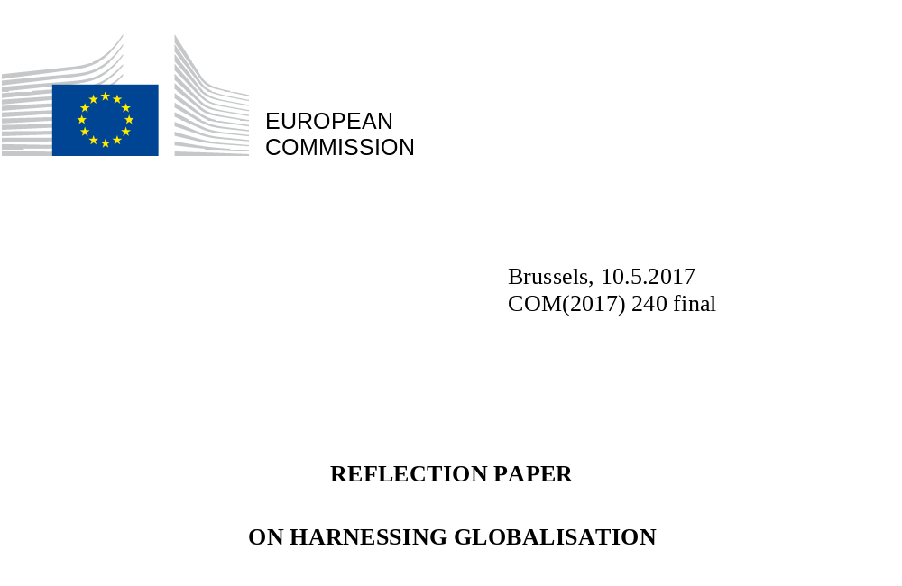

Foreword
On 1 March 2017, the European Commission presented a White Paper on the future of Europe. It is the starting point for an honest and wide-ranging debate on the Union's future at 27. To further contribute to the discussion, the European Commission is putting forward a number of reflection papers on key topics that will define the coming years.
This paper on harnessing globalisation is the second in the series. It aims to make a fair and evidence-based assessment of what globalisation means for Europe and Europeans.
Many Europeans, particularly younger ones, see how being connected to people in other countries and continents can better their lives. They are right to do so – around a third of our national income comes from trade with the rest of the world.
But many Europeans are also apprehensive. They see globalisation as synonymous to job losses, social injustice or low environmental, health and privacy standards. They consider it to be a factor in the erosion of traditions and identities. These concerns need to be addressed. And it is only by confronting these issues openly that we can do so. The debate will make us stronger and better equipped to deliver sustainable and fair responses that meet the aspirations of Europeans.
Today, more than ever, local issues go global, and global issues become local. While globalisation affects nearly every aspect of our lives, our citizens and regions experience these developments very differently.
Now is therefore the time to consider what the EU can do to shape globalisation in line with our shared interests and values. To ask what we can do to protect, defend and empower European citizens, especially the most vulnerable. And to agree on how the EU – from its institutions, to Member States, regions, municipalities, social partners, wider civil society, businesses, universities – and its international partners can come together to harness globalisation.

Declaration of the Leaders of 27 Member States and of
the European Council, the European Parliament and the European Commission

‘The European Union is facing unprecedented challenges, both global and domestic: regional conflicts, terrorism, growing migratory pressures, protectionism and social and economic inequalities. Together, we are determined to address the challenges of a rapidly changing world and to offer to our citizens both security and new opportunities. We will make the European Union stronger and more resilient, through even greater unity and solidarity amongst us and the respect of common rules. Unity is both a necessity and our free choice. Taken individually, we would be side-lined by global dynamics. Standing together is our best chance to influence them, and to defend our common interests and values.'

Rome, 25 March 2017

'Being European also means being open and trading with our neighbours, instead of going to war with them. It means being the world's biggest trading bloc, with trade agreements in place or under negotiation with over 140 partners around the globe.
And trade means jobs – for every EUR 1 billion we get in exports, 14 000 extra jobs are created across the EU. And more than 30 million jobs, 1 in 7 of all jobs in the EU, now depend on exports to the rest of the world.'

Jean-Claude Juncker
President of the European Commission
State of the Union speech, 14 September 2016

Table of contents

1. Taking stock of globalisation and its effects
1.1. Globalisation is not new but is changing fast
1.2. It is a positive force for change…
1.3. … but it also brings challenges
2. LOOKING AHEAD
2.1. Globalisation will look very differently by 2025…
2.2 … and the temptations of isolationism or inaction will have to be resisted
3. Europe's external response: international cooperation to shape globalisation, economic diplomacy and instruments to ensure a level playing field
3.1. The EU is already a force for a fairer global order…
3.2. … but more should be done in the future…
3.3. … and the EU should act to restore a level playing field
4. Europe's internal response: building resilience through better sharing of benefits and promoting long-term competitiveness
4.1. Robust social and education policies are key to ensure resilience and a fair distribution of wealth…
4.2. … while major efforts are needed to make Europe a competitive and innovative economy…
4.3. … in close partnership with more empowered regions
5. Conclusion

- Taking stock of globalisation and its effects
1.1. Globalisation is not new but is changing fast
Global interaction is centuries old, reflecting a human instinct to find new opportunities, discover new people and places, and exchange ideas and goods. The core drivers of globalisation used to be trade in goods and capital flows. Today, spurred on by rapid technological change, it is increasingly knowledge-driven.
Breakthroughs such as the Internet and the rise of emerging economies have further accelerated global exchanges and transformed their nature. Most products are no longer made in one country alone but are rather “made in the world”. They incorporate raw materials, components, technologies and services coming from different countries and continents. Smartphones or medical devices can be designed in Europe or the US and assembled in Asia or Eastern Europe from parts made elsewhere. Supply chains have gone global.

Figure 1: The phases of globalisation
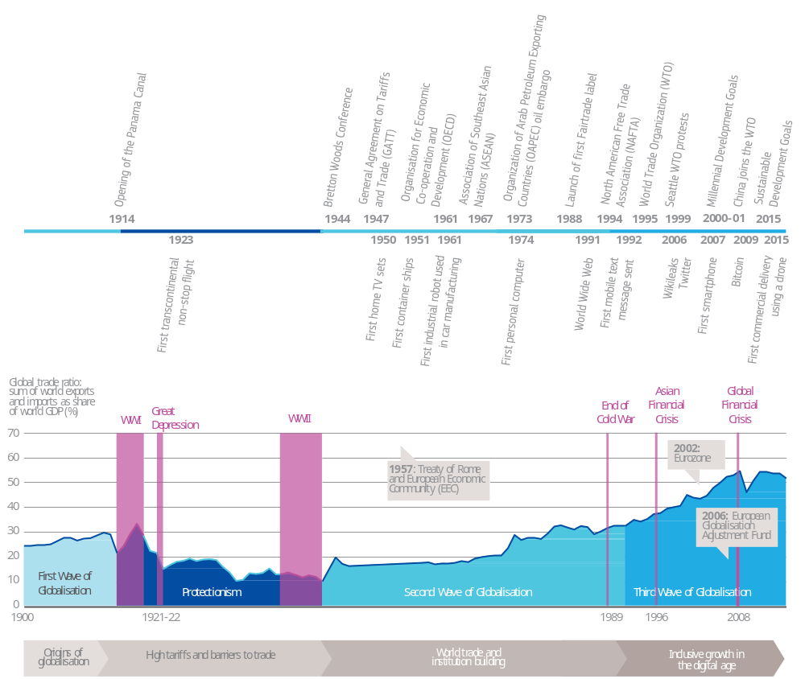
Source: European Commission (2016), Klasing and Milionis (2014), World Bank (2017), adapted from NBER Macrohistory Database

While trade was responsible for less than 20 percent of world GDP in the early 1970s, it now represents around half. And even if the traditional trade in goods is broadly stabilising, other forms or exchange, such as data flows, are still growing exponentially. Estimates show that with an appropriate framework, the value of the data economy will increase to EUR 739 billion by 2020, representing 4% of overall EU GDP, more than doubling today's value.

Figure 2: Global is today's reality
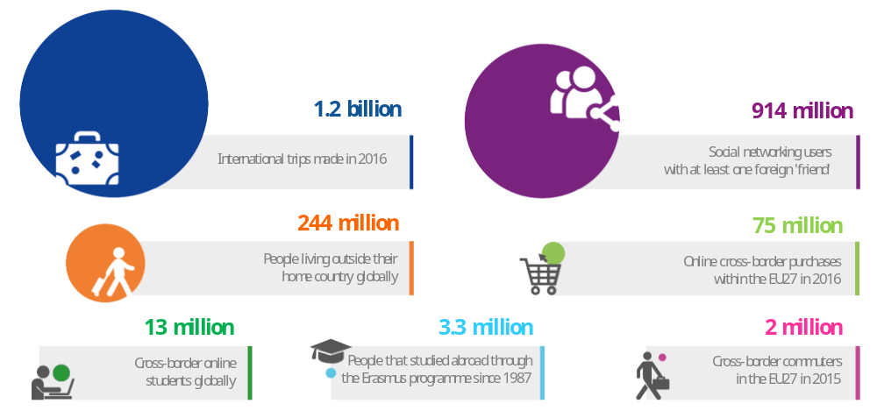
Note: data for 2016 or latest available (2015)
Source: McKinsey Global Institute, United Nations, World Tourism Organisation, OECD, European Commission

At the same time, the world faces more and more transnational challenges, from unprecedented migration flows, to terrorist threats, financial crises, health pandemics or climate change. Even the biggest and richest countries no longer have the capacity to deal with the challenges they face alone. In today's world, global cooperation is increasingly essential.

1.2. It is a positive force for change…
A more connected world has brought with it new opportunities. People now travel, work, learn and live in different countries. They interact with each other on the web, sharing their ideas, cultures and experiences. Students have online access to courses run by leading universities across the world. Countries can produce more for less by specialising in what they do best and exploiting economies of scale in global markets. International competition, global climate action, scientific cooperation and exchange of ideas have stimulated creativity and accelerated innovation. Companies active in international markets remain competitive because they learn and adapt faster.
European exports have grown as customers worldwide demand the high-quality goods and services we supply. Our airplanes, premium cars, industrial machines, cosmetic and healthcare products, high-end clothing and quality foods are highly sought after. Along with the consulting, engineering or transport services that we provide, these contribute to strong EU exports totalling EUR 1 746 billion in 2016 and supporting higher-paid jobs. Every one billion euros of exports supports 14,000 jobs. It is not only large corporations who benefit: over 80% of European exporters are SMEs.
One Italian SME sells precision cleaning machines to clients in the aerospace, medical or luxury industries in Europe, Israel, China or India. It employs dozens of workers in their home region, and contributes to the local economy through their supply chain and tax payments.
Cheaper inputs and new technologies imported from abroad also make our companies more competitive, and therefore help maintain jobs in the EU. 80% of EU imports consist of raw materials, capital goods and components necessary for the European economy to function.
Imports also provide European consumers with greater choice and lower prices. This helps to lift living standards and boost purchasing power, especially for lower-income households which consume more goods and services as a share of their income. Most Europeans now have access to affordable smartphones, computers, clothing, food, medical treatments and transport, which were not available to earlier generations.
Foreign direct investment is a key source of capital and technology transfer. Many people from outside of the EU have successfully integrated into our societies. They have filled critical gaps in the workforce, from care for the elderly, to agricultural labour or specialised research and product development.
The rising cost and scarcity of natural resources, population growth and pollution have spurred emerging economies to rapidly shift away from fossil fuels and to develop more clean energy and resource-efficient technologies, resulting in higher environmental standards.
Global trade openness has boosted EU economic growth, raising prosperity and helping to keep us competitive. The EU's share of global goods exports remains above 15%, having only fractionally declined since the turn of the century and the emergence of China as a World Trade Organisation member and export powerhouse. Some of our Member States that are most integrated in global supply chains also have both higher incomes and lower inequality. This success has provided resources to support our social model and protect the environment.

Figure 3: Open EU economies are not more unequal
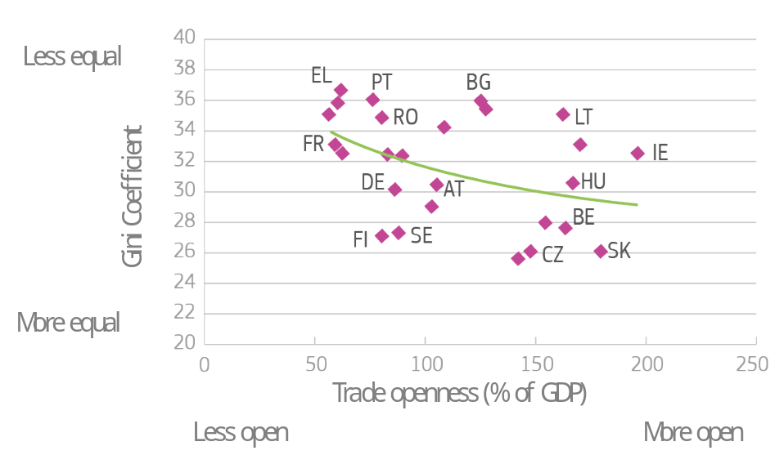
Note: Latest available data (2012). Distribution of income between individuals using the Gini coefficient where 0 represents perfect equality. Trade openness as import and export share of GDP
Source: World Bank, 2017

Globalisation has had similar positive effects around the world. It has helped lift hundreds of millions of people out of poverty and enabled poorer countries to catch up. It has played a role in increasing stability, democracy and peace. The UN Sustainable Development Goals have provided a global framework to address poverty, increase living standards in developing countries – ultimately also creating exports markets of the future. Providing the prospect of a sustainable and prosperous future at home also helps reducing and managing illegal migration flows to Europe.
Figure 4: Every day, more people are lifted out of poverty in the world
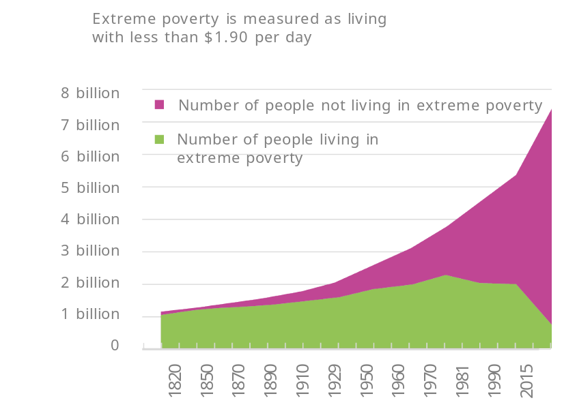
Note: International dollar is adjusted for price differences between countries and for price changes over time (inflation)
Source: Max Roser based on World Bank (2017) and Bourguignon and Morrisson (2002)

1.3. … but it also brings challenges
At the same time, globalisation also poses challenges. Its benefits are spread unequally among people and regions, some of which are less adaptable to change and competition than others. In recent decades, many countries - sometimes with lower wages, environmental standards, or taxes - have increasingly competed with Europe in low-skill and low-value added industry segments. The fact that other countries do not all share the same living, social, environmental, tax and other standards as Europe means that companies can use these differences to their competitive advantage. This has led to factory closures, job losses or downward pressure on workers' pay and conditions. Companies which are unable to compete with more productive or cheaper foreign counterparts close, leaving a lasting impact on those laid off, their families and the wider region.
Some foreign companies and governments have engaged in unfair trade practices. European industries such as steel or shipbuilding have been hurt by 'dumped' imports linked to public subsidies and overcapacity in certain third countries. Other countries enjoy the benefits of international openness through increased exports, but fail to reciprocate and keep their domestic economy closed to foreign companies.
Moreover, large corporations can take advantage of loopholes in international rules and shift profits to low-tax jurisdictions rather than paying taxes where they produce and sell. These strategies deprive EU governments of tax revenues and contribute to unfairness and the perception that global integration only benefits the bigger companies and well-off citizens.
A combination of globalisation and technological change has increased demand for skilled labour but reduced the number of jobs for those with a lower level of qualifications, particularly in manufacturing. Displaced workers struggle to get a new job especially when this means acquiring new skills.
Legal immigration has generally boosted the economies of receiving countries and can provide the EU with the skills needed to address labour market shortages. However, where local infrastructure and integration efforts have not kept pace with the increased scale of migration, this can lead to social tensions in communities. In particular, in countries and regions with high levels of unemployment and exclusion, economic and societal costs can be high whilst marginalisation in some cases can also lead to radicalisation.
Unless active steps continue to be taken, there is a risk that globalisation would compound the effect of technological advances and the recent economic crisis and contribute to further widening inequalities and social polarisation. Over the last decade, real incomes of middle-class households in the EU and other advanced economies have for the most part stagnated even as the economy has grown overall. While inequality in Europe remains much less marked than elsewhere in the world, the wealthiest one percent of our population still own 27 percent of the total wealth.

Figure 5: Europeans' views on globalisation are mixed
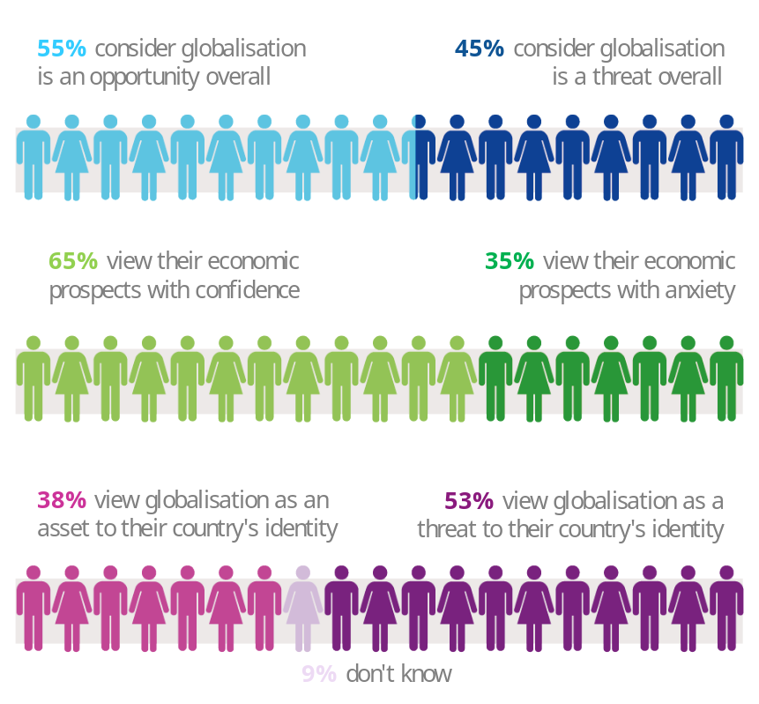
Source: Bertelsmann Stiftung and European Commission (2016)

Many citizens consider that globalisation directly threatens their identities and traditions to the detriment of cultural diversity and their ways of living. Citizens are anxious about not being able to control their future and feel that their children´s prospects will be worse than their own. This is due to the view that governments are no longer in control, not able or willing to shape globalisation and manage its impacts in a way that benefits all. This is the political challenge we must now confront.
2. Looking ahead
2.1. Globalisation will look very different by 2025
We are still in the early phase of the transformation where digitalisation, robots, artificial intelligence, the internet of things, 3D printing will revolutionise how we produce, work, move and consume.
Figure 6: Globalisation then and now
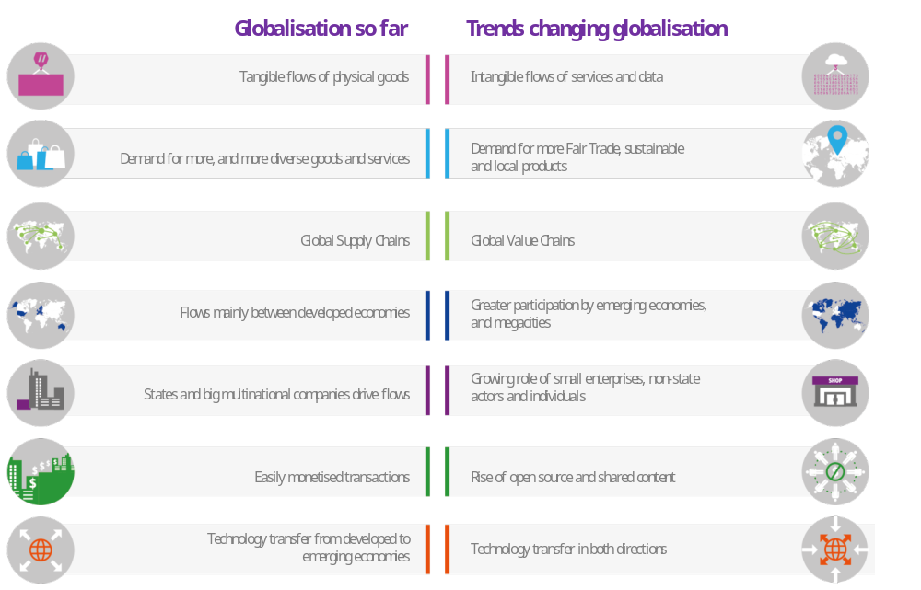
Source: European Commission, McKinsey Global Institute, OECD

Virtually all sectors will be changed, such as:
- transport with e.g. driverless and connected cars, drones or car-sharing,
- energy with e.g. smart grids, renewable energy, distributed generation,
- agri-food with e.g. climate friendly farming, applications to reduce food waste,
- telecommunication with e.g. more powerful networks, virtual reality, virtual workspace,
- distribution with the growing importance of e-commerce,
- financial services with e.g. virtual banks and insurance, or crowdfunding,
- factory production with automation, or
- health care, with e.g. online diagnosis, increased cross border mobility of medical professionals.
Automation makes labour costs less relevant in decisions on where to locate production. This actually helps bring some manufacturing back to Europe as observed by the European Reshoring Monitor.
In 2016, a well-known German maker of sports footwear relocated production in Germany of one specific model of shoes to a factory entirely manned by robots. The company intends to open more such "speed factories" in Europe or the US in the future.
However, simple and repetitive tasks that can be automated will disappear. The jobs that will be created and brought back to Europe will be different from those that moved away years ago. The challenge for Europe will be to innovate in strategic technologies and help workers to gain the right skills to avoid widening the gap in the labour market.
Digital technologies and e-commerce will further increase cross-border opportunities for even the smallest companies. Many businesses are now "born global", reaching buyers worldwide through the internet. On the other hand, some large online platforms are becoming increasingly dominant in the market thanks in part to their ability to track and store personal data. The challenges of managing privacy, data protection, cybersecurity as well as avoiding abuses of market power will increase.
Developed countries have led the way in many of these new technologies. However, competition will increasingly come from emerging economies rapidly moving up the value chain. The divide between more technologically advanced regions and those less advanced risks widening, unless governments invest in education, equip their citizens with the right skills, encourage innovation, ensure fair competition and regulate smartly where needed.
In 2025, 61% of the world's 8 billion-population will be in Asia, predominantly in China and India. Europe's relative share of the world population will decline, with the EU27 accounting for 5.5 %. This may bring about a multipolar world order with different political, technological, economic and military powers. But it also means large new markets for European companies.

Figure 7: Most population growth takes place outside Europe
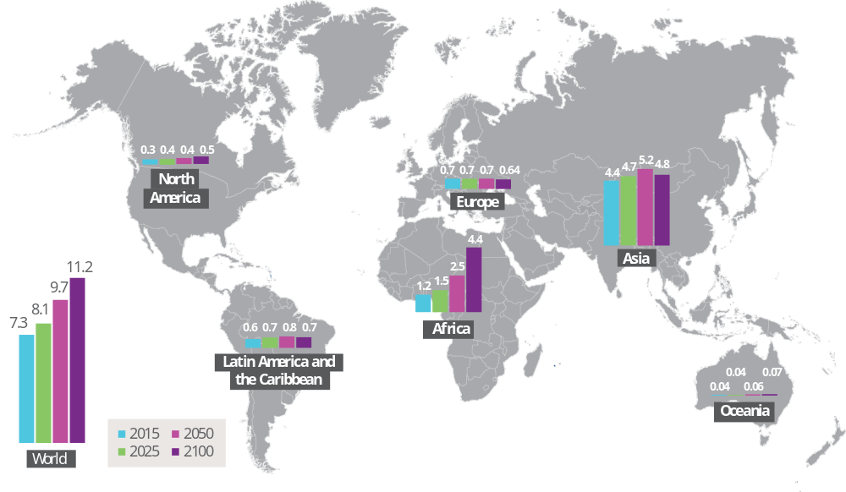
Source: United Nations (2015)
Mobility seems certain to increase. Less than 4% of the world population currently lives outside their country of birth, with the figure even lower for Europeans. By 2025 more people will be on the move. A youth population surge in Africa, instability in our neighbourhood and elsewhere and growing pressure from climate change, will continue to push individuals and families to search for safer and better lives abroad unless investments are made in promoting peaceful and prosperous futures in the countries of origin.
Technologies have made people more aware of opportunities around the world. However, they also make it easier for people to work remotely, including in another country or continent. Participation in the global workforce will depend less on where people live and more on the speed and quality of their internet connection.
A more interconnected world will bring new opportunities as well as increased threats. Criminals and terrorists will continue to seek to exploit increased openness and use new technologies to pursue illicit trades or spread hatred. On the other hand, more and more stakeholders – citizens, civil society groups, businesses and municipalities – are able to engage their peers anywhere around the globe and work together to help tackle common problems.
Networks of cities work together to learn from each other how to combat climate change or integrate newly arrived refugees; regions partner with private companies to develop forward-thinking development plans; citizens mobilise online to show their solidarity with global movements, such as the Women's marches which took place in cities around the world on 21 January 2017.

2.2 … and the temptations of isolationism or inaction will have to be resisted
Changes associated with globalisation can lead to calls for countries to isolate and insulate themselves from what is happening around them. This is particularly acute in regions that have been left behind. Some want to put up barriers and close borders. At the opposite end, others would let globalisation take its course in the belief that self-regulating markets would ultimately ensure the best outcomes.
In the wake of the economic crisis and anti-globalisation backlash, we have already witnessed moves towards isolationism. Multilateral negotiations to bring down barriers to trade have largely stalled in the last decade and protectionism is making a comeback. Even countries that have traditionally championed an open global economy are now looking into ways to put a brake on imports, limit immigration and favour domestic production. These developments have all contributed to the recent marked slowdown in the growth of global trade.
However, a majority of European citizens recognise that protectionism does not protect. It may provide short-term relief, but history shows that it never had lasting success, and has often led to disastrous outcomes. A cautionary example is the 1930s Great Depression which was exacerbated by tit-for-tat protectionism, and ultimately contributed to war.
If we close our borders, others will do the same. We would all be losers. This is especially true for Europe with its high integration into global value chains. Protectionism would disrupt production and increase costs and prices for consumers. European exports would become less competitive putting even more jobs at risk. An increase in trade restrictions by 10% is estimated to lead to a 4% loss of national income. We would lose access to new products, services, technologies and ideas. By hitting the poorest hardest with price increases, protectionism would have the opposite of its desired effect.
To avoid this downward spiral, multilateral institutions and rules are needed to enable countries to jointly promote common solutions in a globalised world. They are essential to tackle issues which require collective action, such as the global economy, climate change or tax avoidance. Without them, the more powerful and less scrupulous countries and companies could impose their rules and interests on weaker ones. This would run counter to the EU's founding values of cooperation, the rule of law, equal rights and solidarity upon which the EU is built.
To better harness globalisation, we need more global governance and global rules. And we need to support that with domestic policies that boost our competitiveness and resilience at home. Europe must now decide how.
3. Europe's external response: international cooperation to shape globalisation, economic diplomacy and instruments to ensure a level playing field
3.1. The EU is already a force for a fairer global order…
Building a fair international rules-based order, based on high standards requires cooperation between many countries with different interests, cultures and levels of development. The aim is to reconcile the means of globalisation - opening markets and technological progress - with its ends – projection of rights and increased human well-being.
After two devastating world wars, Governments created the United Nations (UN), the International Monetary Fund (IMF), the World Bank or the General Agreement on Tariffs and Trade (GATT) which later became the World Trade Organisation (WTO). These institutions brought peace, stability, trust and prosperity to many. Interconnectedness increased and global trade shot up.
After the financial crisis, G20 governments agreed on a coordinated programme to support the global economy and more robust global rules to regulate financial markets and fight tax avoidance. The 2030 Agenda for Sustainable Development and its Sustainable Development Goals (SDGs) were endorsed by all members of the UN in 2015. A binding international agreement was also reached in Paris to fight climate change, kick-starting a process that will improve environmental standards across the world. Leaders at the UN summit in 2016 also committed to developing a global policy to manage large refugee and migrant flows. Earlier this year, a new WTO Agreement on Trade Facilitation entered into force.
These examples are evidence of a new global effort to cooperate on harnessing globalisation. Europe and its Member States played a key role in these achievements. The EU is itself a model of successful regulated integration, enabling us to champion multilateralism and a rules-based order.
3.2. … but more should be done in the future
However, the global rulebook remains far from complete. Some areas, especially on the digital economy, are barely regulated. In others, rules do not provide for a level playing field or sufficiently address harmful and unfair behaviours, such as tax evasion, corruption, resources extraction, illicit financial flows, harmful government subsidies or social dumping.
We not only need to uphold the existing global rules-based order in the face of unprecedented challenges, but also to develop it further. Challenges ahead, particularly in a multipolar world, will require that we continue and strengthen economic policy coordination to ensure strong, sustainable, balanced and inclusive growth. Multilateral cooperation with our global partners remains our preferred approach. To that end, we should contribute to the strength and reform of multilateral institutions to make them fairer and more effective, so that they remain a part of the solution. Yet, in an increasingly contested global order, we should also be ready to push ahead through cooperation with smaller coalitions, while leaving the door open for others to join when ready. Likewise, non-state actors, such as international organisations or NGOs should be appropriately involved.
The EU could continue taking the lead, projecting its values and interests and promoting a 'race-to-the-top'. The 2030 Agenda for Sustainable Development provides a common reference point to prioritise future efforts to benefit prosperity, the planet and people around the world, especially in developing countries.
In June 2017, the EU will adopt a new European Consensus on Development, which will align its development policy to the 2030 Agenda. In order to effectively address the challenges of a globalised world, the EU's development efforts need to go beyond aid. They need to bring together investment and trade, private sector contributions, domestic resource mobilisation, the promotion of good governance, the rule of law and human rights, including a particular focus on youth, gender equality and the empowerment of women. The EU’s proposed External Investment Plan is set to create win-win situations by fostering sustainable growth and jobs in developing countries. This will help to alleviate migratory pressures and create investment opportunities for European companies.
More integrated and pro-active European economic diplomacy would also deliver better outcomes for our citizens. The EU and Member States should improve the coherence of external policies and tools to foster growth and jobs in Europe and become more efficient in pursuing our economic interests abroad. Depending on the country concerned, EU interests could include ensuring macroeconomic stability, supporting key economic and social reforms, or addressing market access barriers.
Economic Diplomacy requires more coordination between the EU, Member States and financial institutions, such as the European Investment Bank. Using the wide network of EU Delegations in the world should also help European businesses, especially SMEs, succeed on global markets. This could be done through support to better seize opportunities created by trade and investment agreements, to overcome persistent market access barriers, or to promote strategic pan-European commercial projects. It could also include engaging in setting international standards for new technologies, or strengthening European business organisations abroad.
The EU should continue to develop a balanced, rules-based and progressive trade and investment agenda that not only opens markets in a reciprocal way but also enhances global governance on issues like human rights, working conditions, food safety, public health, environmental protection and animal welfare. These agreements must uphold the EU and Member States' ability to achieve legitimate public policy objectives and maintain the existing EU high standards in those fields in order to both protect our citizens and safeguard EU industry from unfair competition. They should also contribute to the achievement of the Sustainable Development Goals.
International economic and financial rules should remain an area of focus. In particular we should support more effective mechanisms at the global level to monitor and adjust macroeconomic policies, step up the fight against tax avoidance, ensure the stability of the financial sector, eliminate overcapacity and related government subsidies, facilitate e-commerce while protecting privacy, and promote convergence of technical standards so that they no longer act as unnecessary barriers.
Furthermore, we should take forward efforts to improve social and labour standards and practices, in close cooperation with the International Labour Organisation, but also civil society, social partners and the private sector. In this context, collective bargaining systems should be promoted at global scale.
Globalisation needs to become efficient. Trade helps countries to become more productive through specialization, but true efficiency also implies that external costs are minimised, and economic growth decoupled from resource use. Pollution as a result of transport and packaging, traffic congestion, and the depleting of precious natural resources are key examples of these externalities.
The Paris Agreement on climate change serves both to fight climate change, boost the clean energy transition and provides new business opportunities for EU businesses, notably in clean energy technologies. It gives a competitive advantage to those industries that already reduced their carbon footprint. The priority now is to finalise the rulebook for its implementation to ensure that all countries contribute to CO2 emissions reductions.
Cultural diplomacy is an integral part of our common foreign and economic policy. European culture is major source of jobs and growth while, cultural exchanges and people-to-people can shape globalisation and promote our values and identity.
As the world's largest single market, its largest trader and investor, and the largest provider of development assistance, Europe can shape the global rulebook. But to maintain this influence in the face of demographic, economic and political shifts, we will increasingly have to pull together and speak with a single voice. By 2050, no single European country will be among the top 8 economies by size.
Timely, transparent and inclusive decision-making procedures are needed for collective, international action to be effective. The EU must be able not only to negotiate broad agreements to tackle a wide range of global issues but also to ensure these agreements can be ratified and implemented. The question remains whether the EU's institutional set-up is fully adapted to this challenge. This will need to be addressed following the forthcoming opinion of the European Court of Justice on competence in trade agreements.
3.3. …and the EU should act to restore a level playing field
While standing for openness and cooperation, the EU cannot be naive in its approach to globalisation. There are situations where rules exist but are not respected. Closing the loopholes in global rules and raising standards may take time. In the interim, the EU must have the instruments at its disposal to restore a level playing field and act decisively against countries or companies that engage in unfair practices.
This starts with better enforcement of existing agreements and rules in such areas as trade, labour standards, climate and environment protection. The World Trade Organisation has a binding dispute resolution system which the EU should continue to use when required. Likewise, we should ensure commitments by partners in our bilateral trade and investment agreements are respected. Strong enforcement of our own EU rules will also ensure that all companies present or active in the EU which break the rules are effectively sanctioned. This should be done in cooperation with Member State authorities. Further investments could also be made in EU customs risk management in order to facilitate and accelerate legitimate EU trade, while ensuring the safety and security of citizens by stopping fake or dangerous goods permeating EU borders.
The EU will also continue its efforts to establish fair rules for the protection of international investments while allowing governments to pursue their legitimate policy objectives. Disputes should no longer be decided by arbitrators under the so-called Investor to State Dispute Settlement (ISDS). This is why the Commission has proposed a Multilateral Investment Court which would create a fair and transparent mechanism and is being discussed with our partners.
We also need effective trade defence instruments: these should be overhauled to make them faster, more resilient and more effective in tackling dumping and unfair subsidisation. Similarly, the EU is the world's most open market for public procurement, but access for our companies in other countries is not always reciprocal. The proposal for an International Procurement Instrument would address this. Swift action is necessary on these fronts.
Openness to foreign investment remains a key principle for the EU and a major source of growth. However, concerns have recently been voiced about foreign investors, notably state-owned enterprises, taking over European companies with key technologies for strategic reasons. EU investors often do not enjoy the same rights to invest in the country from which the investment originates. These concerns need careful analysis and appropriate action.
European companies are key partners in shaping globalisation and delivering positive outcomes for all. There are many positive example of how to deliver sustainable growth for shareholders, employees and the communities in which they operate. However, when companies do not take their social or environmental responsibilities seriously they should be held to account.
The EU should continue to take action for global tax justice and transparency. By the end of 2017, the EU will have a common list of non-cooperative jurisdictions. This will provide stronger instruments to tackle external tax avoidance and to deal with third countries that refuse to play fair. The Commission will also continue negotiating international rules that prevent companies established in third countries from avoiding direct and indirect tax obligations, thereby safeguarding Member States' tax bases.

4. Europe's internal response: building resilience through better sharing of benefits and promoting of long-term competitiveness
4.1. Robust social and education policies are key to ensure resilience and a fair distribution of wealth…
Citizens must have confidence that their governments will protect and empower them through robust social policies that are an essential part of our response to globalisation. The Commission released on 27 April a reflection paper on the social dimension of Europe. Even if Europe already has the most equal and inclusive societies in the world, we need to continuously strengthen and adapt our policies for the future and address inequalities through fair and modern tax policies. A better distribution of the benefits of globalisation coupled with effective social protection will help people find a decent job and adapt to change. More broadly, a fair and equitable redistribution of wealth, as well as focused investments fostering social inclusion of more vulnerable categories of people including migrants, will help to strengthen social cohesion. These are exactly the issues the Commission proposes to address with the European Pillar of social Rights. It proposes a compass for improving employment and social policies in the EU and its Member States, to make it fit for purpose for digitalisation and globalisation.
The key to empowerment is lifelong learning. Equal access to high quality education and training is a powerful way of redistributing wealth in a society. This should start with a high standard of basic education and access at all ages to training and skills development. We also need to find new ways of learning for a society that is becoming increasingly mobile and digital and provide the right blend of 'soft' skills notably entrepreneurship as well as robust digital skills. Already 90 % of all jobs require at least some level of digital skills. Europe is improving its digital skills, but more progress is needed. Coupled with help for job-seekers, this will help citizens adapt to an ever-changing workplace and more flexible career paths.
Modern and effective labour market should facilitate access for all to the job market. Policies should also provide adequate employment security, income replacement, and appropriate safety nets for those people going through a difficult transition. Access to quality services should ensure equal opportunities and social inclusion. These can range from health care to child care to raise the participation of women in the labour market, teleworking, promoting work-life balance and to enhancing job opportunities for people with reduced mobility.
The way Member States address these social issues is very diverse. Approaches developed in one country, region or town may not necessarily work elsewhere. Currently, the EU and its Member States should continue to closely coordinate their social policies, while the EU could also support national and local efforts on education. Best practices are shared and there is an important role for social partners.
Germany's dual vocational training ensures that students learn the skills that are really needed by companies, and promotes cooperation between schools, companies and students.
The Scandinavian flexicurity welfare state model strikes a balance between flexible job markets and secure transitions between jobs, so that more and better jobs can be created.
Estonia's e-school system is preparing a future generation that will be more capable and tech-savvy than ever. The use of digital technology has enabled Estonia to come top in the EU member states ' ranking in the OECD's Programme for International Student Assessment (PISA).
At EU level, implementation of the Pillar in the European Semester process will lead to better uptake of distributional impacts of structural policies to make growth more inclusive. Appropriate fiscal and structural policies by Member States also play a key role. EU structural and investment funds can also help promote essential investments to improve infrastructure, innovation, or support the development of human capital and employment. It is essential for the EU to remain a Union of modern and active welfare states. Solidarity is not only a fundamental value of the EU, but also essential for social cohesion in an open economy.
The European Structural and Investment Funds (ESF, ERDF and EAFRD) invest EUR 34.5 billion (EUR 49.2 billion including national contributions) in education and training. The Globalisation Adjustment Fund helps displaced workers find another job or start their own business through co-financing of activities such as search assistance, careers advice, retraining, mentoring and coaching, entrepreneurship, and income support. Since its creation in 2007, the EGF has assisted 140,000 laid-off workers. It is a tangible demonstration of EU solidarity when addressing employment and social consequences of globalisation. Consideration should be given to make the instrument more operational in order to ensure a fast deployment in case of factory closure, and more flexible in order to enable it to support a broader range of economic development actions than the current focus on the affected workers. In doing so, it will be important to bridge the gap between short-term measures and longer term conversion strategies supported by cohesion policy.

4.2 … while major efforts are needed to make Europe a competitive and innovative economy…
Redistributive policies that ensure benefits for all require significant investments by governments, which in turn can only be financed by a thriving and competitive economy. Policies need to help businesses continuously innovate. Only by creating products and services that meet consumers' evolving demands can they thrive on global markets and create prosperity and jobs.
This requires a vision for the future to modernise our economy by embracing digitalisation, technological and social innovation, decarbonisation and the circular economy. Even if our economy becomes increasingly services-based, industry remains an important pillar. It is also an important source of jobs, filling the middle segment of the labour market, and helping to prevent social polarisation. We therefore need to modernise the economy taking concrete actions at EU, Member State, regional and local level (see figure 8). It is not about keeping declining industries on artificial life support; instead we should invest more in the industries and workers of the future, focusing on new manufacturing technologies and related industrial (data) services. European Digital Single Market and innovation strategies should help European companies become global players and pick up quickly on new technological trends.
The essential elements are:
- Innovation: EU Member States and their regions must move up the value chain and exploit their comparative advantages. Start-ups and innovators in EU regions should be brought into collaborations with leading players so that they can enter global value chains. The productivity benefits of innovative technologies should be spread to broader categories of the economy. Technological leaders are five times more productive than other companies, while less than 20% of manufacturing SMEs use advanced technologies so more needs to be done to accelerate their diffusion
AREUS is a project co-financed by the EU (Horizon 2020) focused on reducing energy losses and optimising resource use in robotised manufacturing. Its main outcome is a smart-grid that saves both energy and materials. Overall, it can save 5-9% of a factory’s energy consumption and potentially up to 20%. Italy, Latvia, Sweden, Denmark, Germany and Finland participate in this programme.
Under the Vanguard Initiative, 30 European regions collaborate in innovation investment, for example developing projects, in collaboration with industry, which use 3D-Printing technologies to create metal inserts which are much lighter and flexible.
In Belgium, a tax exemption for highly qualified R&D personnel is available, leading to an effective reduction of employment costs for researchers.
A Portuguese SME has developed an app that allows shoppers to scan products to avoid check-out queues and combine shopping lists with shop layouts. Funded by Horizon 2020 with EUR 1.2 million, they have expanded internationally with offices in Porto, Berlin and San Francisco.
Barcelona, Amsterdam, Copenhagen, Paris, Berlin, Lisbon and several other European cities have developed urban innovation policies to provide low-cost offices, support to incubators, free advice to entrepreneurs, or programmes to support entrepreneurs' communities.
- Investment: Ensuring access for innovative companies to finance, providing investment-friendly regulatory frameworks, and developing critical infrastructure, including digital, energy and transport. Private sector institutions can work together with the European Fund for Strategic Investment, and Capital Markets Union can help increase sources of funding to innovative entrepreneurs and companies.
The Investment Plan for Europe is delivering concrete results. As of early April 2017, it supported total investment of EUR 183.5 billion. These transactions cover all 28 Member States and are expected to benefit over 388 000 SMEs and mid-caps.
With a budget of EUR 42 billion, France's Banque Publique d'Investissement (BPI) supports the emergence of innovative start-ups by providing seed-capital to entrepreneurs and has contributed to many digital success stories.
- Sectoral policies: A key priority is to further strengthen the European transition towards a digital, decarbonised and more circular European economy, to fully integrate the SDGs in European policy and dramatically deepen the Digital Single Market so as to lay down common EU rules and standards, to encourage investment in technologies of the future.
The Communication on the European agenda for the collaborative economy provides clear EU rules and policy recommendations to help citizens, businesses and EU countries fully benefit from the new business models and promote the balanced development of e.g. crowd-sourced transport platforms or crowdsourced house rental platforms.
Thanks to its policy to limit motorised traffic and give priority to pedestrians, cyclists and public transport, the city of Ljubljana was named 2016's European Green Capital. The city's economic growth of 8% in 2016 broke all previous annual records, helped by the enhanced investment opportunities and productivity conditions which emerged from the sustainable infrastructure development which attracted and facilitated tourism.
- Regulation and taxation: New business models should support entrepreneurship while ensuring a level playing field. All levels of policy-making must ensure that the regulatory environment is simple and supportive to entrepreneurs, especially SMEs. This does not mean deregulation or a race to the bottom, but smart regulation. In parallel, governments must ensure that tax policy remains relevant in light of digitalisation and new business models, and that companies pay their taxes where profits are actually made.
Under the Commission’s Better Regulation agenda, the Commission is making business operations easier and less costly by simplifying laws and regulations at EU level. A single European law for data protection adopted in April 2016, will replace 28 national laws and lead to estimated savings of up to EUR 2.3 billion per year. The new EU law means direct benefits for citizens through better data protection and for businesses that will see their administrative burdens reduced and will be able to operate with one single legislative framework throughout the Union.
Thanks to its simple and smart regulatory environment, Denmark has consistently been ranked among the top three countries in the world for the ease of doing business. The possibility to conduct almost all procedures online makes the country one of the frontrunners for efficient business administration.
Getting all these policies right in the EU internal market, which is the largest in the world, will provide a springboard for European companies to expand their business globally. Reinforcing the Single Market involves both taking policy and enforcement actions at EU and country level and refraining from putting up new barriers, such as in the retail sector. In order to ensure a favourable business environment and strengthen Member States' economies, the European Semester should continue as a mechanism for policy coordination in the EU. Member States should deploy policies that enhance productivity, foster inclusiveness, and direct more of their resources towards investment in innovation, education and the long-term drivers of competitiveness.
4.3. … in close partnership with more empowered regions
While the benefits of globalisation are widely spread, the costs are often localised. Fundamental economic transformation happens at the local level, where industry and people interact. We therefore need to target regional and local investment needs, skills gaps and regulatory obstacles to ensure that all regions can benefit from the internal market and better prepare themselves for the challenges of globalisation. The European Structural and Investment Funds, together with the national contributions, provide EUR 67.6 billion to support regions with smart specialisation strategies that build on their strengths, help them move up value chains, and stimulate private sector and target investments on key priorities and challenges, while preventing brain drain and rural flight. In many cases, this transition does not need to mean disruptive and high tech transformation but rather more incremental innovation ensuring a future also for more traditional industries.
Innovation clusters linking up companies, universities, start-ups, investors and local governments must be further developed and linked up across Europe. Many European regions are well positioned to take advantage of the opportunities offered by globalisation. But others face a higher risk of heavy job losses as a result of international competition and technological change. Vulnerable regions can be found across Europe though most are located in Southern or Central and Eastern Europe and are the focus of EU policies to boost competitiveness and strengthen resilience.
After the bankruptcy of a large Swedish car manufacturer in December 2011, more than 3 000 people lost their jobs in the town of Trollhättan in southern Sweden. The European Globalisation Adjustment Fund stepped in to provide EUR 5.4 million to help 1,350 workers made redundant by the company and 16 of its suppliers. Since then, the town has fought back and reduced the unemployment by a quarter despite the layoffs. Unemployment today is even lower than it was before, dropping from 16 to 12 %. The success is a credit to a strong entrepreneurial spirit within sectors like building, transport and aerospace. Many new companies have started and they employ around 1 000 people. Those who were laid off by Saab were offered the possibility to study without losing their unemployment benefits, so many took the chance to train for a new career.
Special attention should also be paid to strengthening the resilience of rural communities who are at risk of being left behind by globalisation or demographic change. A modern Common Agricultural Policy plays a key role in encouraging competitiveness in the agri-food sector and successful integration in international markets by promoting high standards.
Making the European economy more competitive, sustainable, resilient to globalisation and ensuring that it generates the necessary resources to ensure a fairer distribution of its benefits, is a shared responsibility of all levels of government.

Figure 8: Harnessing globalisation – a shared task
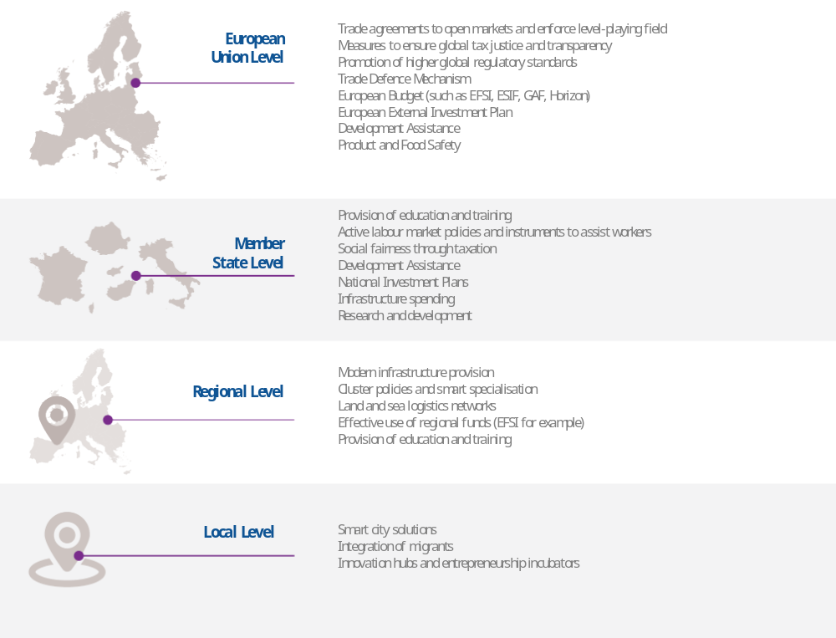
Source: European Commission

5. Conclusion
Enhanced global economic cooperation and technological progress create opportunities and challenges, hopes and fears. While facts show that the European economy, businesses and citizens continue to benefit immensely from globalisation, these benefits are not automatic nor are they evenly distributed among European regions and our citizens.
The fears are just as real and in some cases well-founded. Globalisation and the associated technological change will transform our lives at unprecedented speed. This process will not be smooth but is not going to be stopped or reversed. The question now is whether Europe can find a common understanding on the way forward to effectively manage this transformation.
Some want to pull up the drawbridge even at their own national frontiers. They even question whether the Single Market allows for too much free movement of goods, services, capital and labour inside the EU. But sending European integration into reverse is a dead end.
The EU27 remains the world's largest trader, investor and development assistance provider. We are deeply integrated into global value chains and will continue to carry weight even as other powers emerge. Rather than sitting back and letting globalisation shape our destinies, we have the opportunity to shape globalisation in line with our own values and interests.
The evidence presented here shows clearly that globalisation can be beneficial where it is properly harnessed. Outside the EU, an effective European economic diplomacy will help write the global rulebook and ensure European companies can prosper in fast-growing international markets. Their continuing success will deliver more and better jobs back home for our citizens. Equally we should not shy away from taking measures to restore a level-playing field where this is threatened.
Inside the EU, common rules regulate the world's largest single markets and ensure high standards. Firms that operate in innovative and adaptive domestic ecosystems, such as the German Mittelstand can also prosper in global markets. High quality education and training, such as in Finland or Estonia, give citizens the skills and resilience they need to effectively adapt. Active labour market policies and effective redistribution policies ensure social cohesion and help tackle social exclusion – as they do in Denmark, Sweden and elsewhere.
Harnessing globalisation therefore starts at home. Europe must act to share more fairly the benefits of globalisation in line with our principles of solidarity and sustainability. The EU should also be an innovative and competitive economy with world-leading companies and citizens who can adapt to change and are able to generate the wealth needed to uphold our social model.
The EU institutions cannot do this alone: this must be a joint endeavour of the EU and its Member States. National governments are for the most part are in charge of the key policy tools. Regions, cities and rural areas will all have to adapt. The EU can and will support with its own instruments.
Our citizens expect clear answers on how we can work together. That is why the future of Europe debate, launched by the White Paper, is so important. A Europe that knows where it wants to go can also help the world get to a better place for the benefit of all.

European Commission, 2010, Report Internationalisation of SMEs.
European Commission, 2015, "EU exports to the world: effects on employment and income"
IMF, World Bank, WTO (2017) Making Trade an Engine of Growth for All. The Case for Trade and for Policies to Facilitate adjustments.
OECD (2017), Key Issues Paper : Making Globalisation Work ; Better Lives For All, C(2017)32,
Julius Bear, Wealth Report: Europe. September 2014
https://reshoring.eurofound.europa.eu/
The OECD estimates on average, across countries, 9% of jobs are at high risk of being automated, while for an additional 25% of the workforce, half of the tasks will change significantly because of automation.
UNFPA
WTO, OECD, UNCTAD Report showed that since 2008 over 1,500 new trade restrictions were recorded in G20 economies. Only a quarter of these had been rolled back by May 2016
A majority of Europeans view globalisation as an opportunity for economic growth. An even larger group are confident about their economy. Source: Standard Eurobarometer 86, Autumn 2016
Autarchic experiments of the Soviet Union, Albania until the 1990's, China until the 1970's, Argentina in between the 1970's and the 2000's or more recently Venezuela failed to deliver prosperity
Arto, Iñaki, José M. Rueda-Cantuche, Antonio F. Amores, Erik Dietzenbacher, Nuno Sousa, Letizia Montinari and Anil Markandya,"EU Exports to the World: Effects on employment and income", European Commission, 2015
OECD (2003), “The Sources of Growth in OECD Countries”, Paris.
According to a recent study of 27 European and 13 other large countries, the real income loss from closing off trade would be 63% for the poorest households and 28% for the richest ones because the poor spend a higher share of their income on consumption (source: "Measuring the unequal gains from trade", Pablo D. Fajgelbaum and Amit K. Khandelwal, Quarterly Journal of Economics, August 2016)
Communication COM(2015)497 of 14 October 2015 "Trade for All: Towards a more responsible trade and investment policy"
See Joint Interpretative Instrument on the Comprehensive Economic and Trade Agreement between Canada and the EU and its Member States - http://data.consilium.europa.eu/doc/document/ST-13541-2016-INIT/en/pdf
The world in 2050, PWC, February 2017
European Court of Justice, Opinion Procedure 2/15
See European Commission public consultation on a multilateral reform of investment dispute resolution launched in December 2016.
See Commission Communication "Towards a robust trade policy for the EU in the interest of jobs and growth", October 2016, and Commission proposals COM(2013)191 and COM(2016)721 for Regulations amending Regulation (EU) 2016/1036 on protection against dumped imports from countries not members of the European Union and Regulation (EU) 2016/1037 on protection against subsidised imports from countries not members of the European Union
See Commission proposal COM(2016)34 of 29 January 2016
Reflection Paper on the Social Dimension of Europe, European Commission, COM(2017)206, 26 April 2017.
Communication from the Commission on establishing a European Pillar of Social Rights, COM(2017)250, 26 April 2017. Commission recommendation on the European Pillar of Social Rights, C(2017)2600, 26 April 2017.
European Digital Progress Report (EDPR) 2017, SWD (2017) 160.
70 % or more of the population have basic or advanced digital skills in Finland, Luxembourg and the United Kingdom, compared to less than 40 % in Italy, Cyprus, Greece, Bulgaria and Romania, European Digital Progress Report 2017.
According to the Programme for International Student Assessment (PISA), a premier global metric for education, compiled by the OECD, the results of Estonian 15-year-olds are the best in Europe and among the strongest in the entire world (source: PISA 2015)
See the Digital Single Market Strategy for Europe, COM(2015)192
E.g. in the field of energy intensive industries, food supply chain, space industry, or car industry.
COM(2016)356
World Bank, Doing business 2017

