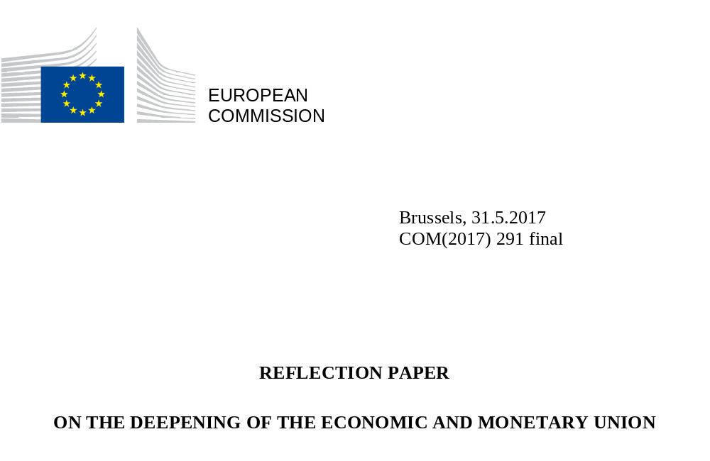

On 1 March 2017, the European Commission presented a White Paper on the future of Europe. It marked the starting point for a wide debate on the future European Union with 27 Member States. To contribute further to the discussion, the European Commission is putting forward a number of reflection papers on key topics that will define the coming years.

This reflection paper – the third in the series – sets out possible ways forward for deepening and completing the Economic and Monetary Union up until 2025. It does so by setting out concrete steps that could be taken by the time of the European Parliament elections in 2019, as well as a series of options for the following years. Building on the Five Presidents’ Report, it is intended both to stimulate the debate on the EMU and to help reach a shared vision of its future design.

The single currency is one of Europe’s most significant and tangible achievements. It has helped our economies to integrate and has brought Europeans closer together. But it has always been much more than a monetary project. It was conceived as a promise of prosperity – and that is how it must remain, also for those that will become members of the euro area in the future.

That promise of prosperity became more important than ever as Europe was shaken by the financial and economic crisis. The painful legacy of those years has left Europeans wanting more of what the single currency offers: more stability, more protection, and more opportunities. Determined action in response to the crisis to improve the instruments and architecture of the euro area partially met these expectations. Today the EU economy is growing again and unemployment has fallen to its lowest level in eight years. But the euro area does not need only firefighters. It also needs builders and long-term architects.

Our Economic and Monetary Union still falls short on three fronts. First, it is not yet able to reverse sufficiently the social and economic divergences between and within euro area members that emerged from the crisis. Second, these centrifugal forces come with a heavy political price. If they remain unaddressed, they are likely to weaken citizens’ support for the euro and create different perceptions of the challenges, rather than a consensus on a vision for the future. Finally, while the EMU is stronger, it is not yet fully shock-proof.

With the Rome Declaration signed on 25 March 2017, EU leaders committed to “working towards completing the Economic and Monetary Union; a Union where economies converge”. Now, this promise must be delivered. This requires political courage, a common vision and the determination to act in the common interest.

A strong euro requires a stronger Economic and Monetary Union.

"In these times of change, and aware of the concerns of our citizens, we commit to the Rome Agenda, and pledge to work towards (…) a Union where (…) a stable and further strengthened single currency open(s) avenues for growth, cohesion, competitiveness, innovation and exchange, especially for small and medium-sized enterprises; a Union promoting sustained and sustainable growth, through investment, structural reforms, investment, structural reforms and working towards completing the Economic and Monetary Union; a Union where economies converge."
Rome Declaration, EU leaders, 25 March 2017

"A complete Economic and Monetary Union is not an end in itself. It is a means to create a better and fairer life for all citizens, to prepare the Union for future global challenges and to enable each of its members to prosper."
The Five Presidents’ Report: Completing Europe's Economic and Monetary Union
Jean-Claude Juncker in close cooperation with Donald Tusk, Jeroen Dijsselbloem, Mario Draghi and Martin Schulz, 22 June 2015

Table of contents
1. Introduction 5
2. The story of the euro so far 8
3. The case for completing the Economic and Monetary Union 14
4. Reflections on a possible way forward 21
5. Conclusion 35

1. Introduction

The euro is more than a currency. For a continent so long divided, euro notes and coins are tangible, every day reminders of the freedom, convenience and opportunities that the European Union offers.

Today, the euro is shared by as many as 340 million Europeans in 19 Member States. Seven of the Member States that joined the EU in 2004 have already adopted the euro. And yet it is only 25 years since the Treaty of Maastricht paved the way for the single currency and only 15 years since the first coin was used.

The euro is the currency of 19 Member States
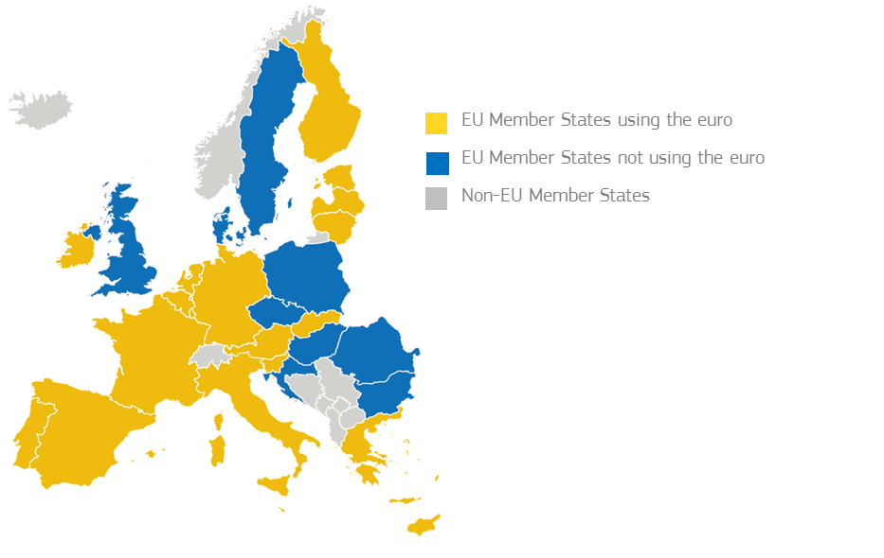
Source: European Commission

Since its launch, the euro has become the second most used currency around the world. Sixty countries and territories, representing another 175 million people, have pegged their own currencies, either directly or indirectly, to the euro.

The euro is the second most important currency in the world
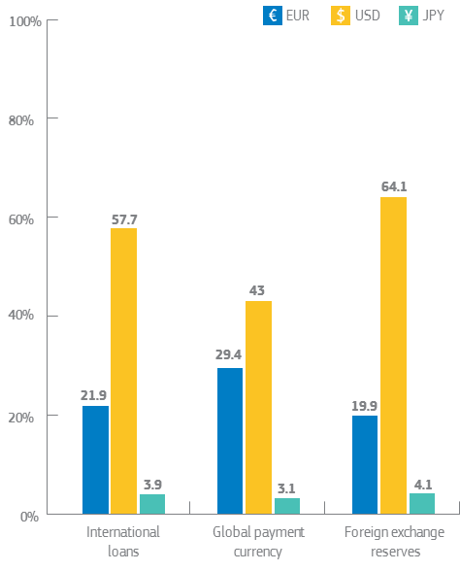
Source: European Central Bank, June 2016
The functioning and future of the Economic and Monetary Union (EMU) is a matter of interest for all European citizens from whichever Member State they come from, including those who will join the euro area in the future. After the departure of the United Kingdom from the EU, the economies of euro area countries will represent 85% of the total GDP of the EU. This highlights the euro’s central role in the future EU at 27. Given its importance for the world, it is just as important to international partners and investors.

The euro is a success story on many levels but the tough times the euro area has endured over the years mean it is not always perceived as such. The financial and economic crisis that started in the United States in 2007-08 led to the worst recession in the European Union’s six-decade history. It also revealed the shortcomings of the initial EMU setup. In adversity, Member States and the EU institutions took strong political decisions to preserve the integrity of the euro and to avoid the worst.

Important lessons have been drawn, with new policy instruments and institutional changes helping to strengthen the euro area. The current situation is much improved but challenges persist. Years of low or no growth have left enduring marks on Europe’s social, economic and political fabric. Many countries are still dealing with the legacies of the crisis – from high unemployment to high levels of public or private debt. And while support for the single currency is strong – and even on the up – there is also a broader questioning about the value-added of the euro and the mechanisms of the EMU.

As robust as it is today, the EMU remains incomplete. The “Monetary” pillar of the EMU is well developed, as illustrated by the role of the European Central Bank (ECB). However, the “Economic” component is lagging behind, with less integration at EU level hampering its ability to support fully the monetary policy and national economic policies. This is symptomatic of the need to strengthen political will to cement the “Union” part of the EMU. More trust is needed across the board, among Member States, between Member States and EU institutions, and with the general public.

That shows that the euro’s journey is only just beginning. There should be no complacency about the need to strengthen its architecture. Backtracking on what has already been achieved is not an option. The Five Presidents’ Report of June 2015 recalled the need to complete Europe’s EMU and mapped out the way forward by 2025. It initiated a first phase of “deepening by doing” until June 2017. The steps needed for the second stage towards 2025, however, still need to be discussed and agreed among Member States.

Such a debate can only happen with a shared understanding of the challenges and of the way forward. Over the years, there has been no shortage of in-depth reports, speeches and political debates. A lot is known about what needs to be done. However, progress is often stalled by disagreement. Some argue that more solidarity is the way forward to tackle the legacy of the crisis, some insist on the necessity to strengthen responsibility of the Member States as a prerequisite for further progress. As a consequence, despite all the efforts made in recent years, the momentum for further reform of the EMU has been partly lost. This might also be due to the reassuring feeling from recent signs of improvement in the economic and social situation. But we simply cannot afford to wait for another crisis before finding the collective will to act.

As Europe discusses its future, now is the time to look beyond what has already been said and done. The White Paper on the future of Europe of 1 March 2017 highlighted the importance of a strong euro area for the future of the EU27. In signing the Rome Declaration of 25 March 2017, Member States reaffirmed their commitment to completing the EMU. And even if the economic environment is not quite sunny yet, we should fix the roof of the EMU now while we have the right conditions.

This reflection paper takes forward the views of the Five Presidents’ Report on completing Europe’s EMU and contributes to the broader debate initiated by the White Paper on the future of Europe. It was prepared by the Commission paying due attention to the debates in the Member States and to the views of the other EU institutions. It describes our common achievements and challenges and offers a practical way forward for the years to come.

There is not one, single answer. What is needed is an overall vision and clear sequencing of what needs to be done. This possible way forward is summarised graphically in Annex 1. On several aspects, this reflection paper is more precise. This is notably the case when it comes to the measures already initiated, promised or needed over the next two years. On others, it is more exploratory and offers a range of options, in line with the overall vision and necessary sequencing.

Much of the discussion on the EMU is technical by nature. Many ideas in this paper are largely about fixing the nuts and bolts in the euro’s “engine room”. But what is at stake is not technical: it is about making the euro deliver better for all. This requires strong political engagement and support at all levels.

2. The story of the euro so far

Tangible benefits for citizens, businesses and Member States

For most Europeans, the euro is part of daily life. For the first “generation euro” it is the only currency they have ever known. Those with longer memories will remember the changes the euro has brought and will have seen first-hand its advantages. Their mortgages and living standards are no longer at the mercy of the high inflation and volatile exchange rates of the 1970s and 1980s. Since the introduction of the euro, inflation has mostly hovered around or below 2%, the reference value of the European Central Bank. Citizens no longer pay expensive charges to change currencies when crossing internal borders in the euro area. They no longer pay more for transferring or withdrawing money in another euro area country.

The euro has brought stable prices
Consumer Price Index, % change on previous year
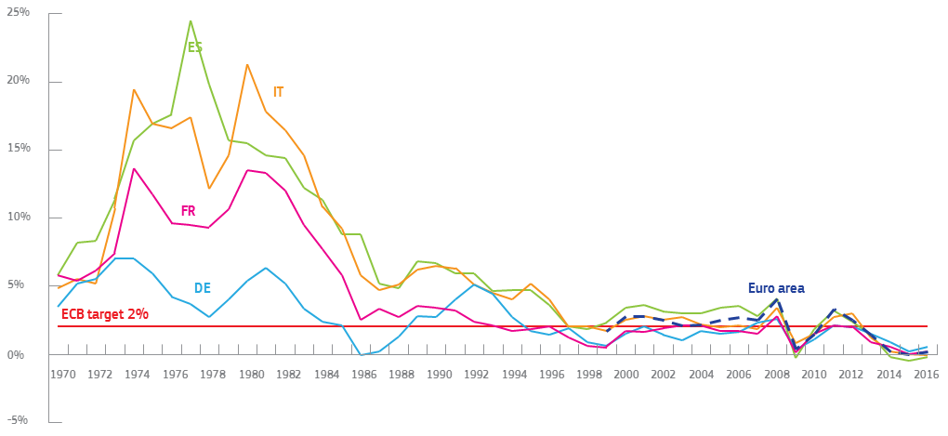
Source: World Bank, OECD

For European businesses, the advantages of the euro are equally clear-cut. It is one of the major attractions and benefits of being part of the world’s largest single market and trade bloc. For them, the single currency has meant big savings in both time and money. Thanks to the euro’s status as the world’s second reserve currency, companies invoice about two thirds of their export and half of their import business in euros. There are no more exchange-rate risks or transaction costs for cross-border operations. Invoices can be issued in one currency for clients in 19 countries. It is easier and on average cheaper to borrow money from banks or other financing sources. And much more worldwide business can be done in euros today than was ever possible with the franc, lira or deutschmark.

The general context of low interest rates has allowed households and businesses to benefit from cheaper credit in recent years. Likewise, euro area governments have saved EUR 50 billion in interest payments annually compared to a few years ago. That means extra money that could be used to reduce public debt or boost public investment or education spending.

Given these benefits, it is easy to see why support for the euro is strong. With the exception of a dip at the height of the financial crisis, Eurobarometer surveys point to consistently strong support for the single currency among citizens living in the euro area, reaching 72% on average in April 2017. This is the highest level since 2004.

Popular support for the single currency has been consistently high in the euro area
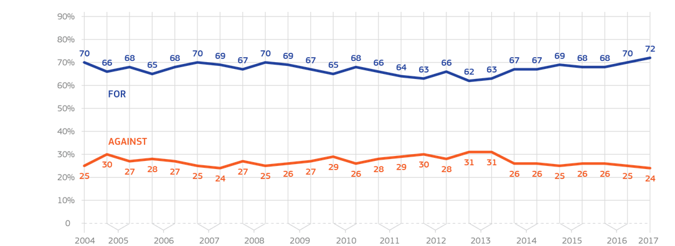
Source: European Commission and Eurobarometer 2017

Hard lessons learned during the crisis

The global crisis that started in 2007-08 exposed the weaknesses of the still young currency and hit the euro area particularly hard. The first European countries affected by the global crisis were not in the euro area, and the euro seemed to act as a shield. However, when perceptions about the vulnerability of some euro area members changed, the disruption was significant. Tough decisions were taken by several Member States to use taxpayers’ money to support banks financially and avoid the risk of collapse. Banks had gotten into trouble after the financial bubbles had accumulated and grown in size in previous years. Combined with lower revenues and higher expenditure resulting from the “great recession”, levels of public debt increased significantly, from below 70% before the crisis to 92% of GDP on average in 2014.

The euro area experienced an “interim recovery” over 2010-11, but this proved short-lived. Given the interplay between banks and public finances, several Member States as well as banks found it increasingly difficult to borrow from the markets. Their capacity to finance themselves was put at risk. Investment collapsed as credit became less available. It fell by more than 18% between 2008 (when it was probably above sustainable levels) and 2013. Unemployment rose sharply. The financial crisis became a crisis of the real economy, affecting millions of citizens and businesses.

Economic activity was hit strongly by the crisis but is now recovering
% change in the level of real GDP of the euro area compared to 2008
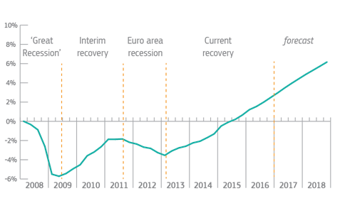
Source: European Commission

The protracted economic downturn and divergences between Member States are the result of pre-crisis imbalances and shortcomings in the way the EMU responds to major shocks. The sudden stop in capital flows exposed the unsustainable debt and competitiveness gaps that had accumulated over time. With lowered expectations and a shortage of financing, investment and consumption contracted sharply in the most affected countries. Millions of jobs were lost and wages came under pressure as one of the tools to restore competitiveness, further reducing household purchasing power. Public spending was at the same time constrained by the need to contain the rise in public debt amidst growing market concerns about the integrity of the euro area. In 2013, the level of real GDP in the euro area was still 3.5% lower than in 2008, and wide gaps in growth had opened between a group of more vulnerable countries and the others, with significant social and political costs.

Investment in the euro area collapsed for several years and is only now picking up
% change in the level of investment in the euro area compared to 2008
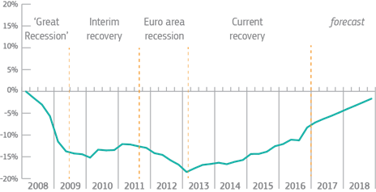
Source: European Commission

A determined response to put the euro back in shape

A determined response was needed. While the European Central Bank played its role in mitigating the effects of the crisis, major new steps were also taken by the other EU institutions to strengthen the integrity of the euro area. Annex 2 recalls the main instruments now available in the “EMU toolbox” as a result of decisions taken over recent years.

Most of these steps were taken under pressure, at the height or in the immediate aftermath of the crisis. However, they provided lasting solutions to key weaknesses in the EMU policy toolbox and institutional architecture. For instance, a European Stability Mechanism (ESM) was put in place on an intergovernmental basis as a way to provide support to those Member States facing financial difficulties. Its lending capacity of EUR 500 billion helped countries like Spain, Cyprus and Greece to finance their public spending and protected them from even more serious harm. The rules for the macroeconomic and fiscal surveillance of the euro area were strengthened, with the adoption of the so-called “six-pack” and “two-pack” EU legislation, as well as a new Fiscal Compact (as part of the intergovernmental Treaty on the Stability, Coordination and Governance in the Economic and Monetary Union (TSCG)). The EU undertook a complete overhaul of its rules on financial services, adopting 40 pieces of legislation since 2009. A new common system of bank supervision and resolution was established.

Significant reforms have also been implemented in many Member States. Reforms ranged from containing costs in the public sector to boosting price and non-price competitiveness as a way to recover much needed growth. Further priorities differed across countries. In general, measures encompassed fixing structural weaknesses in the banking sector or improving the functioning of the labour markets and supporting the unemployed to find new jobs. They also included providing incentives to businesses for innovation and investment, while others focused on modernising public administrations, pension and care systems. Reforms have taken time but are now bearing fruit.

This momentum has been supported by further action at EU level. Since the arrival of the current Commission, EU policy-making was re-centred around the “virtuous triangle” of boosting investment, pursuing structural reforms, and ensuring responsible fiscal policies. Social fairness was enshrined as an overarching objective. The European Semester of economic policy coordination – the main mechanism through which Member States discuss their economic and fiscal policy – was streamlined to cater for more dialogue at all levels and a greater focus on euro area priorities. A new Investment Plan for Europe – also known as the “Juncker Plan” – was launched. It is now being doubled to mobilise EUR 630 billion of extra investment for the EU as a whole.

Several other key initiatives were taken. The single market is being deepened in the fields of capital markets, energy and digital. This is a source of jobs, growth and innovation and helps to make the single currency more robust in the face of a constantly changing global economic environment. From youth employment to the fight against tax evasion, and recently again with the establishment of a European Pillar of Social Rights, new initiatives were also taken to ensure greater social fairness and make sure economic and social priorities are sustainable and work hand-in-hand.

The efforts are paying off, but there is room for further improvements

Progress is visible on all fronts today. The European economy has entered its fifth year of recovery, which is now reaching all euro area Member States. This is expected to continue at a largely steady pace this year and next. Employment is increasing faster than it has since the crisis began: more than 5 million jobs have been created since early 2013 in the euro area. Unemployment has fallen to its lowest level since 2009, at 9.5% in March 2017. At more than 70%, the employment rate is close to an all-time high. Investment is picking up again. The aggregate deficit of the euro area has fallen from over 6% of GDP on average in 2010 to 1.4% of GDP this year. Sovereign debt in the euro area has also started to decline.

Unemployment in the euro area is at its lowest since 2009 but still too high
Unemployment rate in %

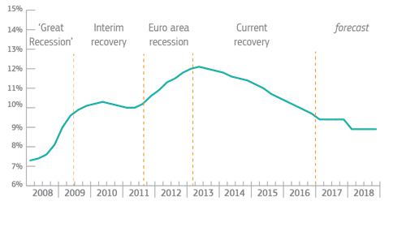
Source: European Commission

The architecture of the euro area is as robust as it has ever been, but there should be no complacency. Together with the decisive action of the European Central Bank, the commitment to strengthen the functioning of the euro and to defend its integrity has been an essential part of the improved performances in recent years. Several further steps have also been taken following the Five Presidents’ Report, which are also recalled in Annex 2. Yet, as the current Commission said while taking office, the crisis is not over as long as unemployment remains so high. 15.4 million people are still without a job in the euro area – we must build on the progress already achieved to secure a truly strong and sustainable recovery.

3. The case for completing the Economic and Monetary Union

In spite of significant improvements over the years, far-reaching legacies from the crisis persist and challenges for the euro area remain. Years of low or no growth have created and exacerbated significant economic and social differences. The crisis also led to financial sector fragmentation across euro area Member States. Weaknesses remain in the quality of public finances and in the way the euro area is governed.

These realities – and the perceptions of challenges – are still quite different across the euro area. Annex 3 provides a snapshot of economic trends across euro area countries. The improved economic context gives us a window of opportunity to draw further lessons from the experience of the first fifteen years with our single currency, to acknowledge and manage better the interdependence of our economies, and to equip the euro area to deliver even better in the years to come.

3.1. The need to tackle persisting economic and social divergences
The convergence trends of the single currency’s first years have proven partly illusory. Before the crisis, the euro area was the symbol of continuously increasing prosperity. Real income per inhabitant in the euro area rose steadily between 1999 and 2007. This was partly fuelled by favourable credit conditions and by large capital flows moving towards the Member States with increasing current account deficits. However, these flows did not always translate into sustainable investment. In some cases they rather fuelled “bubbles”, such as in the real estate and construction sectors, as well as an increase in government spending. The positive developments of the early 2000s also partly hid underlying vulnerabilities in these countries. They were notably related to the financial sector and to a loss of competitiveness. This was in several cases compounded by inefficiencies in labour and product markets. These weaknesses were not fully picked up at the time, either by financial markets or by public authorities. The EMU lacked a developed surveillance framework to track or correct these imbalances.

The crisis of the years 2007-08 marked the end of the convergence trend and the start of a divergence trend, which is only slowly being corrected. This has been particularly costly in those parts of the euro area that had not been sufficiently resilient to withstand the effects of the economic shock. Overall, the GDP per capita of the euro area is only now reaching pre-crisis levels and there are signs of divergences being reduced, but a strong process of re-convergence is not yet visible.
Real GDP per capita is only slowly recovering
Index 1999=100
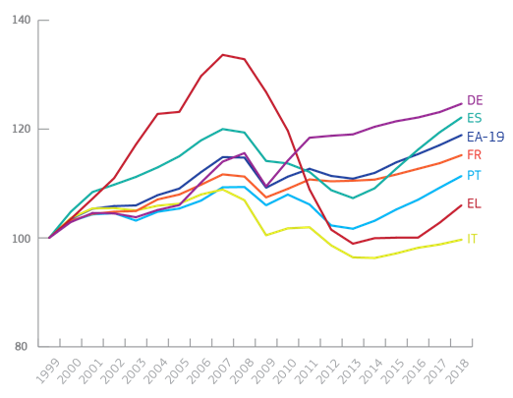
Source: European Commission
While unemployment is declining overall, levels still differ substantially across the euro area. In some countries, such as in Germany, the Netherlands, Estonia and Austria, unemployment is at very low levels. Others – like Spain or Greece – still experience unacceptably high unemployment, especially for young people, with high shares of structural unemployment. This has had far-reaching social consequences, particularly in the countries having had to adjust most during the crisis. For the first time since the Second World War, there is a real risk that the generation of today’s young adults ends up less well-off than their parents. These developments have fuelled doubts about the design and functioning of the EU’s social market economy and the EMU in particular.
Unemployment rates are falling but still differ substantially across Europe
In %, March 2017

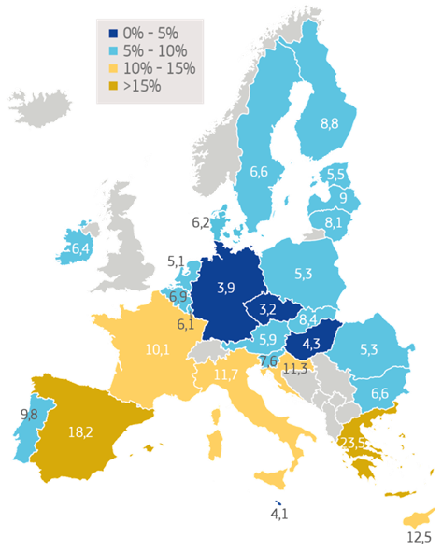
Source: European Commission
Low investment levels, both public and private, and weak productivity trends risk fuelling a further polarisation of national situations and are a major drag on the performance of the euro area as a whole. Investment is only now picking up in many euro area countries, and remains below long-term trends. Given the positive role of investment for productivity and growth, continuous low investment levels could inflict long-term damage in terms of perpetuating differences in growth potential.

3.2. The need to tackle remaining sources of financial vulnerability
The crisis has seen the partial reversal of the financial integration that had been achieved since the introduction of the euro. At the time, the inter-bank lending market was very liquid and the costs of credit to households and businesses had started to converge towards more beneficial conditions throughout the euro area. In the turmoil of the crisis, the euro area banking system became fragile. Lending between banks fell sharply, as did the provision of credit to the real economy. Lending to SMEs was hit hardest in the countries most affected by the crisis, both with tightened lending terms and falling lending volumes. The financing conditions of firms very much depended on their geographical location. The overwhelming reliance on banks as a source of funding and the relative absence of other sources of financing, such as equity markets, exacerbated the problem.
Interest rates on loans to businesses diverged during the crisis
Interest rates in %
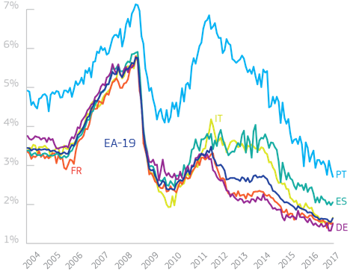
Source: European Central Bank
Whilst the situation has improved significantly since the crisis, the interlinkages between risks associated to the banking sector and the levels of national sovereign debt are still present in the euro area today. As a result of the EU banking legislation adopted in the wake of the crisis, the risks in the financial sector have been substantially reduced. The EU's large banks now have significantly increased liquidity buffers and hold on average a core capital ratio of 13.2 % compared to 8.9 % in 2010. But banks within the euro area still tend to hold substantial amounts of bonds of their “home country” on their books. This leads to a strong correlation between the refinancing costs of banks and their respective sovereigns, and vice-versa. This comes with the risk that if a problem arises in either area, both public finances and the banking sector would be destabilised. Major reforms have taken place to counter these risks but the so-called “feedback loop” between banks and their sovereign is still an issue for financial sector integration and stability.
High levels of public and private debt inherited from the crisis years, as well as large amounts of so-called “non-performing loans” in parts of the banking sector, remain sources of vulnerability. Non-performing loans are loans that are in default or close to default, meaning that there is a very high likelihood that the debtors will not be able to repay them to the banks. The share of such loans has increased in balance sheets of certain banks as a result of the crisis. This still weighs on the profitability and viability of affected institutions, thus hampering their ability to provide financing to the real economy. Writing off these loans comes at a cost that must be borne either by the institutions holding them, by their shareholders or by the public purse. The countries concerned are taking determined action to deal with this matter but reducing large stocks of such loans without adding to social difficulties is a slow and complex process.

Despite significant improvements in recent years, further integration is necessary to ensure the financial system can safely withstand any future crisis. Although financial fragmentation has begun to reverse, the degree of integration still remains well below pre-crisis levels. This limits the ability to unlock additional financing for much-needed investment and constrains the collective capacity to absorb future shocks as they come.

3.3. The need to tackle high debt and to increase collective stabilisation abilities
The crisis led to a sharp increase in levels of public and private debt, which have now been contained but still remain high. On average, levels of sovereign debt in the euro area increased by 30 percentage points in only seven years – from 64% to 94% over 2007-2014. Even Member States with relatively low deficit and debt levels before the crisis – such as Spain or Ireland – came under pressure as concerns emerged over the budgetary costs of difficulties in the financial sector and underlying structural fiscal positions turned out to be worse than headline figures had suggested. This showed that the EU fiscal rules of the time were not enough, and that there was a need to monitor closely trends in private debt as well.

Moreover, the crisis exposed the limits of individual Member States in absorbing the impact of large shocks. During the crisis, national budgets, and notably welfare systems, played their role of “automatic stabilisers”, by cushioning the shocks. However, in several countries, the limited availability of fiscal buffers and the uncertain market access to finance public debt meant that this was not enough to counter the recession. This is a major explanation behind the severe dent in the recovery in the years 2011-13. Several new instruments were thus created to provide collective financial assistance to these Member States. These instruments have proved their worth at the height of the crisis and could now usefully be strengthened or complemented.
High levels of public debt will take time to be absorbed, particularly if the recovery is moderate and if inflation is low. These debt levels cause a number of problems. They reduce the capacity to take action in case of another slowdown or to support public investment needs. They constitute a financial vulnerability, especially if the refinancing costs of banks and their respective sovereigns remain correlated. Moreover, diverse levels of debt create differences of views about how to deal with public finances in the euro area as a whole. Thanks to the efforts of recent years, there is a clear trend towards healthier public finances across the board. But further progress remains imperative overall in the euro area.

Public debt in the euro area increased sharply as a result of the crisis
General government gross debt, as % of GDP
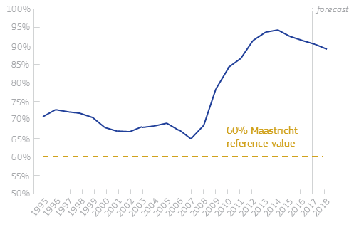
Source: European Commission
The EU fiscal rules – the Stability and Growth Pact – have been reinforced over the years, notably to pay greater attention to levels of debt. Progress over time requires both sound fiscal policies at all levels of government and strong and sustained economic growth. It is essential to take account of what makes economic and budgetary sense for the country concerned at the particular juncture of its economic cycle, but also to consider the situation of the euro area as a whole. In particular, it is important to avoid “pro-cyclical” fiscal policies, i.e. to boost growth artificially when it is not needed, or to be recessionary when the circumstances call for the reverse. The need to capture the diversity of circumstances has brought stronger and more sophisticated rules. At the same time, as the rules cannot be tailor-made for every situation, they foresee a margin of judgment. The Commission has made use of it in recent years, with the Council of Ministers endorsing its recommendations. The Commission has also put a greater focus on the fiscal stance of the euro area as a whole.

3.4. The need to increase the efficiency and transparency of EMU governance
The EMU architecture is based on common legal principles. These spell out its objectives and functioning, the role of the different institutions and the balance of powers between them, as well as between the EU and the national levels. They also spell out the necessary coordination of economic policies, the fiscal rules to be respected, the mechanisms to avoid and correct macro-economic imbalances, as well as the organisation of the Banking Union.

The design of this architecture has been an incremental process for the past thirty years. While the direction was clear, there was no single, overall plan from the outset. As shown by the experience of the last fifteen years, it has too often taken the onset of a crisis to build the collective awareness and political will needed to act together to improve the EMU construction. This largely explains the current state of play, including the remaining weaknesses. The overall governance has improved but remains sub-optimal to allow the euro area to perform as well as it could, to be as responsive as it should be to changing economic circumstances and economic shocks, and to win over the mistrust of some parts of the population. Three main weaknesses can be identified.

First, the governance of the EMU is still unbalanced in many ways. Monetary policy is centralised at the euro area level. Yet, it is coupled with decentralised budgetary and sectoral policies that mainly reflect national circumstances and preferences. This is combined with another mismatch in terms of instruments: on the one hand, the strong, necessary (although often too complex) fiscal rules, leading to possible sanctions; on the other, soft economic guidance provided at EU level through its process of coordination of economic policies, the so-called “European Semester”. Such a governance construct has too often contributed to a lack of progress in very much needed structural reforms and investment. This overburdens monetary policy with the responsibility of cushioning and counterbalancing economic developments. As a result, Member States, business and citizens are not able to reap the full benefits from the EMU.

Second, the institutional architecture of the EMU is a mixed system which is cumbersome and requires greater transparency and accountability. It balances, albeit imperfectly, Union institutions and ways of working with an increasing number of intergovernmental bodies and practices, many of which have emerged since the crisis. This “in-between” governance partly reflects the lack of trust among Member States, as well as towards the EU institutions. This results in multiple and complex “checks and balances”. It also reflects the fact that many new rules or bodies were established in an ad hoc manner over time, often in response to emergencies. This is best illustrated in the interplay between the Eurogroup, the European Commission and the European Stability Mechanism. While every institution and body strives for greater legitimacy and accountability, in practice this means complex decision-making, criticised for not being understandable and transparent enough. Most notably, the involvement of the European Parliament and the democratic accountability for the decisions taken for or on behalf of the euro area should be enhanced.

The governance of the euro area is complex
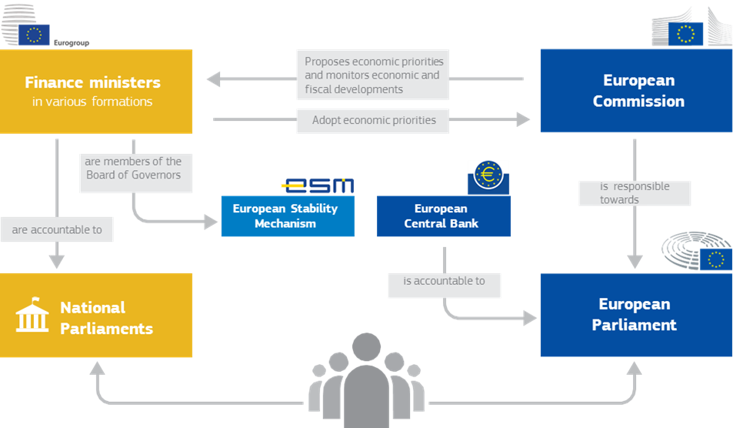
Source: European Commission

Third, the common interest of the euro area is still not sufficiently represented in public debate and decision-making. Without a common understanding of the challenges or vision of the future, the euro area will struggle to overcome the legacies of the crisis and will not make progress on the tools it needs to address common challenges.

4. Reflections on a possible way forward

Member States of the euro area form a diverse group. There will never be a single approach or a “once and for all” common understanding of how to advance best the EMU. The shared goal is, however, to strengthen the single currency and tackle together issues of common interest that go beyond national borders. The challenge is now to turn ideas into practical solutions and to identify a way forward that is pragmatic and flexible, yet effective for all.

4.1. Guiding principles for the deepening of the Economic and Monetary Union
Four principles should guide the way forward:
- Jobs, growth, social fairness, economic convergence and financial stability should be the main objectives of our Economic and Monetary Union. The EMU is not an end in itself.
- Responsibility and solidarity, risk reduction and risk-sharing go hand-in-hand. Greater incentives for risk reduction and conditional support should go together with designing risk-sharing measures, especially in the financial sector, and the conduct of structural reforms.
- The EMU and its completion must remain open to all EU Member States. The integrity of the single market must be preserved. This is also key for a well-functioning single currency. According to the Treaty, except for Denmark and the United Kingdom, all EU Member States are expected eventually to join the euro.
- The decision-making process needs to become more transparent and democratic accountability needs to be ensured. Citizens expect to know how and by whom decisions are made and how they impact on their lives.

Guiding principles for deepening the Economic and Monetary Union

Source: European Commission

4.2. Sequencing
Given the differences of views on some of these matters, it is initially important to find broad political consensus on the overall direction of travel. This not only relates to the design of the overall approach, but also to the sequencing of the various steps to be taken in the short, medium and long term. But this is not about a single, take-it-or-leave-it reform. It is rather a set of actions to consider collectively and take forward. The ideas presented here are therefore not a blueprint of the future design of the EMU.

This reflection paper puts forward a number of steps and options to help build a clear vision for a deepened EMU by 2025. In so doing, this paper is an invitation for Member States and stakeholders to discuss and agree on which elements they believe will best help our single currency over time, beyond making full use of the already existing institutions and rules. Certain elements are indispensable and need to be put in place quickly to ensure a resilient EMU. In some areas, work is already ongoing or could be advanced swiftly, with the aim to take action by 2019 at the latest. Thereafter, a number of other elements would need to be addressed by 2025. Those are presented in a more open way and could be decided later, once initial steps have been taken. Preconditions that are necessary before certain steps could be taken are also specified.

Regardless of the details of each step, having an overall roadmap with clear sequencing will be crucial. If our aim is to improve the performance of the euro area to deliver on jobs and growth while at the same time safeguard and strengthen financial market stability, the sequence of further measures, in particular in the financial sphere, is not neutral. It must follow a certain logic, to avoid that new initiatives result in new uncertainties. In order to find the right balance, some measures will need to be agreed together upfront, even if their actual implementation would come later. Annex 1 sketches out a possible roadmap.
The options presented here would involve taking steps in three key areas: first, completing a genuine Financial Union; second, achieving a more integrated Economic and Fiscal Union; and third, anchoring democratic accountability and strengthening euro area institutions.
4.3. A genuine Financial Union – advancing in parallel on risk-reduction and risk sharing
An integrated and well-functioning financial system is essential for an effective and stable EMU. Building on the momentum of what has already been achieved in recent years, a consensus needs to be found on the way forward. This includes elements that are already on the table but also agreement on what additional steps to take between now and 2025. Progress will need to be made in parallel on both so-called “risk reduction” and “risk-sharing” elements.
Which elements should be agreed by 2019?
Reducing risks
Measures to reduce risks further should be prioritised. As an immediate step, in November 2016, the Commission proposed a comprehensive package to reduce risks carried by banks by further reinforcing prudential management and by strengthening market discipline. The Commission also suggested measures in relation to insolvency, restructuring and second chance. These need to be concluded swiftly.
A European strategy for non-performing loans could help to address one of the most damaging legacies of the crisis and support national actions in the countries concerned. If not tackled, non-performing loans will continue to weigh on the performance of the euro area banking sector at large and will remain a potential source of financial fragility. There is a clear commitment by the Council to agree on a comprehensive strategy by June this year with clear targets, timetables and a monitoring mechanism. However, a comprehensive toolbox and practical implementation on the ground will also be needed. The strategy should address the existing stock of non-performing loans and prevent the build-up of new ones. It should encompass resolute, coordinated action at the EU level and comprise elements of various key policy areas – such as strengthening supervisory practices, measures to develop a secondary market for non-performing loans, reforming national legal frameworks and addressing structural issues, and further restructuring of the banking sector.
Within the European Semester, the Commission assesses regularly challenges in Member States' financial sectors. These assessments lead to specific recommendations for reforms where necessary to reduce risks to financial stability or improve access to finance. In the same spirit, the Commission is currently carrying out a benchmarking exercise to shed light on the features of loan enforcement and insolvency systems which have an impact on banks’ balance sheets. These measures contribute to addressing risks in national banking systems and could be further enhanced (see also section 4.4 below).
Completing the Banking Union
Two key components of the Banking Union remain outstanding, which would allow making progress on risk-sharing in parallel: a common fiscal backstop for the Single Resolution Fund and a European Deposit Insurance Scheme (EDIS). These should now be agreed as soon as possible – ideally by 2019 – with a view to be in place and fully operational by 2025. Both elements are essential to mitigate further the link between banks and public finances. The Commission Communication “Towards the completion of the Banking Union” of November 2015 and the Council’s roadmap to complete the Banking Union of June 2016 set out the necessary, already agreed key steps in this regard.
EDIS would make sure that savings in deposit accounts would be better protected and to the same extent across the euro area. EDIS would thus provide a stronger and more uniform insurance cover for all retail depositors in the Banking Union. The EDIS proposal was put forward by the Commission in November 2015 and negotiations are currently ongoing.
A credible fiscal backstop to the Single Resolution Fund is essential to make the new EU framework for bank resolution effective, and to avoid costs for taxpayers. Under this framework, bank resolution is financed by banks’ shareholders and creditors, and by a Single Resolution Fund, pre-financed by the banking industry. In the event that serious problems would affect several banks at the same time, the financing needs might however exceed the means available in the fund. Therefore, a fiscally neutral financial backstop to the resolution fund is needed as soon as possible as a tool of last resort. Member States already committed to developing a common backstop in December 2013 and reiterated this objective in 2015. This should now be implemented without delay.
Due to its critical role in the event of a potential crisis, the common backstop should be designed with certain features in mind. It should be: of an adequate size to be able to fulfil its role; activated in a swift manner; and fiscally neutral so that industry repays any potential disbursements from the fund, and the use of public resources is limited. This also means that, by definition, no room should remain for national considerations or segmentation. Unnecessary costs should be avoided when it comes to the financial and institutional architecture.

Two options can be considered in this context:

- From the point of view of effectiveness, a credit line from the European Stability Mechanism (ESM) to the Single Resolution Fund would meet the conditions indicated above. The ESM has the lending capacity, market operations knowledge and creditworthiness required to fulfil the common backstop function effectively. However, some decision-making procedures and technical provisions in the ESM may need to be streamlined so that the backstop could be activated in time and ensure maximum cost efficiency for the Single Resolution Fund.
- A less effective option would be for Member States to provide simultaneously either loans or guarantees for the Single Resolution Fund. This approach would probably lead to difficulties in mobilising the committed funds in case of a crisis, making it potentially less effective when most needed. While the backstop should be fiscally neutral in the long-term, Member States would still need to re-finance the financial support provided. Implementation challenges would also arise, with each Member State having to sign agreements with the Single Resolution Board.
Delivering the Capital Markets Union
Progress on the Capital Markets Union (CMU) is paramount to help provide more innovative, sustainable and diversified sources of funding for households and businesses, such as through increased access to venture capital or equity financing and less focus on debt. As such, the CMU will increase risk-sharing via the private sector and the overall resilience of the financial sector. It thereby also contributes to broader macro-financial stability to the economy in case of economic shocks. This applies to all EU Member States, but is particularly important for the euro area. The Commission has made the establishment of a CMU one of its priorities and a number of measures have been taken to this end already. However, this work is now more important than ever. The prospect of Europe's largest financial centre leaving the single market makes the task of building the CMU more challenging, but all the more vital.
A more integrated supervisory framework ensuring common implementation of the rules for the financial sector and more centralised supervisory enforcement is key. As stated in the Five Presidents’ Report, the gradual strengthening of the supervisory framework should ultimately lead to a single European capital markets supervisor.
The CMU is an opportunity to strengthen our single currency, but it is a significant change. To succeed, the commitment of the European Parliament, the Council and all stakeholders is indispensable. Regulatory reform is only one part of the change required to create a new financial eco-system that is truly integrated and less dependent on bank financing. Building a CMU is a process, which needs the full involvement of all parties, including corporates, investors and supervisors. Remaining barriers to a complete CMU, such as taxation rules or insolvency procedures, must also be tackled, including at the national level.
Beyond Banking Union and Capital Markets Union
Greater diversification of banks’ balance sheets would help to address the problem of interconnection between banks and their “home country”. One possibility of promoting more diversification could be the development of so-called sovereign bond-backed securities (SBBS). These financial instruments, currently discussed in the European Systemic Risk Board, are securitised financial products that could be issued by a commercial entity or an institution. There would be no debt mutualisation between Member States. Their use would deliver tangible benefits by increasing the diversification of banks’ balance sheets and by fostering private sector risk sharing. Given the very innovative nature of SBBS, it is likely that issuance would develop only gradually. While changes in the regulatory treatment of securitised assets would help to develop the market for this type of product, changes to the regulatory treatment of the underlying sovereign bonds would not be required. Another possibility to promote more diversification in the long run, as discussed below, would be a change in the regulatory treatment of sovereign debt.
Elements to complete the Financial Union
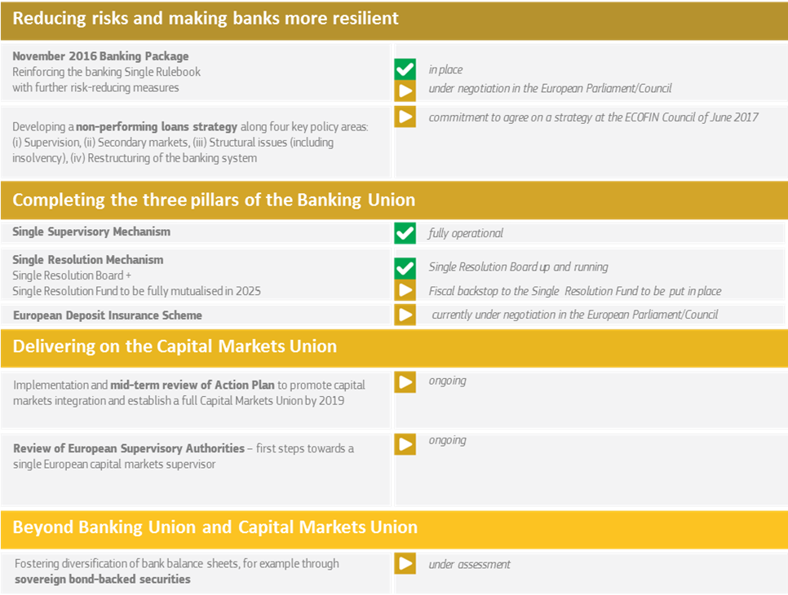
Source: European Commission

Which elements could be considered beyond 2019?
Beyond 2019, a number of additional medium-term measures could be considered. Such measures must include a continued commitment to completing the CMU and the full implementation of EDIS. However, they could also include possible further steps on the development of a so-called European safe asset for the euro area and the regulatory treatment of government bonds.
Safe assets are essential for modern financial systems. It has been argued that the euro area needs a common safe asset that would be comparable to the US Treasury bond. A scarcity and the asymmetric supply of such assets can impact adversely on the availability and on the cost of finance for the economy. Sovereign bonds are typically the safe asset in most financial systems.

A European safe asset would be a new financial instrument for the common issuance of debt, which would reinforce integration and financial stability. However, developing a safe asset for the euro area raises a number of complex legal, political and institutional questions that would need to be explored in great detail. The question of debt mutualisation, in particular, is heavily debated, also in light of concerns about weakening incentives for sound national policies. The Commission will further reflect on different options of safe assets for the euro area in order to encourage a discussion on the possible design of such an asset.
A European safe asset
The euro area is an economy as large as the US and its financial market is of a comparable size, but it does not supply an area-wide safe asset on par with US Treasuries. Instead, individual euro area Member States issue bonds with heterogeneous risk characteristics, generating an asymmetric provision of safe assets. Experience has shown that at times of stress, the current structure of the sovereign bond market and the large exposure of banks to their national sovereign have amplified market volatility, affecting the stability of the financial sector, with tangible and diversified effects on the real economies of the euro area Member States.

A European safe asset, denominated in euro and sizeable enough to become the benchmark for European financial markets, could create numerous benefits for financial markets and the European economy. In particular, it would help diversify the assets held by banks, improve liquidity and the transmission of monetary policy and it would help to address the interconnection between banks and sovereigns.

In recent years, several proposals have been put forward with different design features – ranging from full to partial common issuance, some based on mutualisation and others entailing no joint liabilities. Any further reflections in this complex area would need to focus on the necessary features of such an instrument, to make potential benefits materialise.

Changing the regulatory treatment of sovereign bonds is another issue under discussion to loosen the bank-sovereign loop but which would have important implications for the functioning of the euro area financial system. The regulatory treatment of sovereign debt is a politically and economically complex issue. Like in other advanced economies, EU banking legislation currently foresees the general principle of a risk-free status for sovereign bonds. This is justified by their particular role in funding public expenditure and in providing a low-risk asset for the financial system of the country concerned. At the same time, such a treatment does not provide any incentives for a bank to diversify its holdings away from home-sovereign bonds. If that treatment was changed, euro area banks would most probably react by sharply reducing their holdings of sovereign bonds. This would disrupt not only the functioning of their home financial systems. It would potentially also impact on financial stability for the euro area as a whole. At the same time, such a reform, if implemented wisely and gradually, could increase incentives for governments to reduce the risk profile connected to their own bonds.

To take both measures forward, a joint political decision on both aspects would be needed. Yet, under all circumstances, and in order to avoid any potential negative impact on financial stability, most importantly, the outstanding elements of the Banking Union and Capital Markets Union need to be completed before any regulatory changes to the treatment of government bonds could realistically be implemented. If a level playing field for Europe’s financial sector is desired, an agreement at the global level would also be essential.

4.4. Achieving re-convergence in a more integrated Economic and Fiscal Union
The lack of strong economic and social re-convergence calls for swift and effective action. Progress on economic convergence is of particular relevance for the functioning of the euro area but is equally important for the EU as a whole.
The Five Presidents’ Report recognised the convergence towards more resilient economic and social structures in Member States as an essential element for the successful performance of EMU in the long run. For economies sharing a single currency, having economic structures that are sufficiently responsive in case of shocks, without causing economic or social distress, is particularly important. Structurally, more resilient economies not only do better in times of economic shocks but also more generally. But achieving more convergence towards resilient economic structures is equally important for those Member States in prospect of future euro accession.
Different notions of convergence:
Real convergence: Moving towards high living standards and similar income levels is key to achieving the Union’s objectives, which include economic and social cohesion alongside balanced growth, price stability and full employment.
Nominal convergence: Nominal indicators, such as interest rate, inflation and exchange rates, government deficit and debt ratios, have been used since the Treaty of Maastricht. Fulfilling essential nominal targets is a prerequisite to becoming a member of the euro area.
Cyclical convergence: Cyclical convergence means that countries are in the same stage of the business cycle, such as an up or down swing. This is important for EMU because conducting a single monetary policy is harder and possibly less effective if countries are in very different stages of the economic cycle – some will need a more restrictive/expansionary policy stance than others.
Convergence towards resilient economic structures does not mean harmonisation of policies or situations across the board. There cannot be a “one-size-fits-all” method in an EMU made of Member States with different economic characteristics and at different levels of economic development – from mature large economies, such as Germany, France or Italy, to small economies on a catching-up trajectory, such as most Member States that joined the EU in 2004 or later. It does, however, mean agreeing on a common approach. This is a key question for Member States to discuss as different concepts of convergence entail different implementation tools.

What toolbox for a renewed convergence process?

When looking at how to achieve greater convergence, the euro area Member States could decide to strengthen the different elements already available: the EU-level framework, the economic policy coordination and the use of funding. They could also decide to improve the capacity for macroeconomic stabilisation of the euro area, which would help to prevent further divergence in cases of future shocks. All of this would benefit from greater capacity building.

Using the EU-level framework to converge

European economic integration provides the right framework for convergence. The single market, including the guarantee for the free movement of goods, services, capital and persons, is a powerful engine for integration and the creation of shared growth and prosperity across Member States. Flanked by the Digital Single Market, the Energy Union, and combined with the Banking and Capital Markets Union, it provides the fundamental common framework for convergence in the European Union, including euro area countries. Member States’ commitment to deepening and strengthening the single market is essential to reap the full rewards.

Strengthening the coordination of economic policy

National policies matter for convergence, but their coordination under the European Semester is essential to maximise their effectiveness. Many policy areas that are decisive for economic resilience remain primarily in the hands of the Member States, such as employment, education, taxation and the design of welfare systems, product and services markets, public administration and the judicial system. The European Semester can and should remain the core vehicle for further steps towards stronger convergence and more effective coordination of such policies, both for the euro area countries and the other EU Member States. The European Pillar of Social Rights will also provide a renewed compass for many such policies towards better working and living conditions. It sets out a number of key principles and rights to support fair and well-functioning labour markets and welfare systems. Aligning Member States' business taxation frameworks as envisaged with the proposed Common Consolidated Corporate Tax Base, would also help to drive convergence by facilitating cross-border trade and investment.
Before 2019, the European Semester could be reinforced further. Building on the efforts over the last two years, the Commission will look into ways to:

- foster further cooperation and dialogue with Member States, involving also national parliaments, social partners, National Productivity Boards and other stakeholders, to ensure stronger domestic ownership and encourage better reform implementation;
- increase further the focus on the aggregate euro area dimension, with a stronger role for the euro area recommendations. This would ensure a better correlation between the reform needs from a euro area-wide perspective and the reform priorities of national governments;
- make a closer link between the yearly process of the European Semester and a more multi-annual approach to reforms of national governments.

Such improvements could provide Member States with a clear picture of persisting divergences as well as the means to ensure proper re-convergence.

In addition, the Five Presidents’ Report envisages a formalised and more binding convergence process based on agreed standards. Such a set of standards could include measures to improve the quality of public spending; investment in education and training; embracing more open and more competitive products and services markets, and creating fair and efficient tax and benefit systems. These could be combined with minimum social standards, as envisaged in the European Pillar of Social Rights. The binding nature of such standards could only be acceptable if compliance could be strengthened by a strong link between related reforms, the use of EU funds and access to a potential macroeconomic stabilisation function. The monitoring of progress towards convergence could be embedded in the surveillance system of the European Semester, building on existing scoreboards and benchmarks.

Reinforcing links between national reforms and existing EU funding

In the current programming period of the EU financial framework for 2014-2020, a stronger link was introduced between the priorities of the European Semester and the use of the European Structural and Investment (ESI) Funds. In designing the national and regional programmes co-financed by these Funds, Member States needed to address all relevant country-specific recommendations. Existing rules also allow the Commission to request Member States to review and propose amendments of the programmes. This could be necessary to support the implementation of new, relevant Council recommendations or to maximise the growth and competitiveness impact of the ESI Funds.

While the use of the ESI funds is important for certain Member States to foster economic and social convergence, the EU budget is not designed to play a macroeconomic stabilisation function. For certain economies, the ESI funds play an important stabilisation role, especially during times of an economic downturn, as it provides a constant and predictable flow of financing. However, the stabilising impact of the EU budget on the euro area as a whole is heavily constrained by its size (only close to 1% of the total EU GDP). Moreover, the EU budget is more geared to fostering convergence over time (currently over a seven-year time period) and is not particularly designed to take account of the specific needs of the euro area.

The following options could be considered in order to strengthen the links between the EMU objectives in terms of reforms and convergence, and the EU fiscal tools:

- As a first step by 2019, ways could be considered to strengthen the stabilisation features of the existing EU budget. This could be done, for instance, by modulating co-financing rates more systematically according to the economic conditions in Member States. However, one must also recognise that, given the limited size of the EU budget in comparison to most Member State economies, the overall macroeconomic stabilisation properties of such an approach remain limited by definition (see other options for macroeconomic stabilisation below).

- Looking ahead, the link between policy reforms and the EU budget could be strengthened to foster convergence. This could take the form of either a dedicated fund to provide incentives to Member States to carry out reforms or by making the disbursement of the ESI Funds, or part of them, conditional on progress in implementing concrete reforms to foster convergence. Reform implementation would be monitored within the framework of the European Semester. As part of the follow-up to the White Paper on the Future of Europe, the Commission will also come forward with a reflection paper on the future of EU finances in the coming weeks.

A macroeconomic stabilisation function

The Five Presidents’ Report also envisages the creation of a macroeconomic stabilisation function for the euro area.

- Key principles. A common stabilisation function would bring numerous benefits to the euro area. It would complement the national budget stabilisers in the event of severe asymmetric shocks. It would also allow running smoother aggregate fiscal policies for the euro area in unusual circumstances when monetary policy reaches its limits. The guiding principles for such a function, as specified in the Five Presidents' Report, remain valid. The function should not lead to permanent transfers, minimise moral hazard, and not duplicate the role of the European Stability Mechanism (ESM) as a crisis management tool. It should be developed within the EU framework and could be open to all EU Member States. Access to the stabilisation function should be strictly conditional on clear criteria and continuous sound policies, in particular those leading to more convergence within the euro area. Compliance with EU fiscal rules and the broader economic surveillance framework should be part of this. Any decision to set up such an instrument would need to take due account of possible legal constraints.

- Possible goals. A macroeconomic stabilisation function for the euro area can take different forms. In the public debate, several avenues for a stabilisation function are being discussed, including the creation of a euro area fiscal capacity. The two main areas where such a function could be explored would be the protection of public investment from economic downturn and an unemployment insurance scheme in cases of a sudden rise of unemployment level. It will have to be explored whether certain designs might need to be reflected in the next EU Multiannual Financial Framework (MFF).

- Financing. In designing this future function, Member States would also need to decide on its financing mechanism. In doing so, they could decide to use existing instruments, such as the ESM after necessary legal changes, or the EU budget if these elements were to be integrated in the next MFF. Member States could also decide to design a new instrument for these specific goals, using a dedicated source of financing, such as national contributions based on a share of GDP or a share of VAT, or revenues from excises, levies or corporate taxes. The macroeconomic stabilisation properties would depend also on the capacity to borrow.

The Commission will look into concrete options for a macroeconomic stabilisation function for the euro area. This will encourage a discussion on the specific design of such a function, and prepare the Commission and Member States for putting in place such a capacity at the latest by 2025.

Different options for a stabilisation function
A European Investment Protection Scheme would protect investment in the event of a downturn, by supporting well-identified priorities and already planned projects or activities at national level, such as infrastructure or skills development. In an economic downturn, public investment is usually the first item to be cut in the national budget. This amplifies the economic crisis and risks permanent negative effects on growth, employment and productivity. With the protection scheme, which could be in the form of a financial instrument, investment projects could still be continued. As a consequence, firms and citizens could overcome the crisis more quickly and more robustly.
A European Unemployment Reinsurance Scheme would act as a "reinsurance fund” for national unemployment schemes. Unemployment benefits are an important part of the social safety net and their uptake tends to increase in a downturn, when resources are constrained by the need to contain fiscal deficits. The scheme would provide more breathing space for national public finances and help to emerge from the crisis faster and stronger. The unemployment reinsurance scheme would, however, probably require some prior convergence of labour market policies and characteristics.
A rainy day fund could accumulate funds on a regular basis. Disbursements from the fund would be triggered on a discretionary basis to cushion a large shock. Its effects would be similar to the two options above. A rainy day fund, however, would normally limit its payments strictly to its accumulated contributions. Its capacity might thus be too small in case of a large shock. Alternatively, the fund could be equipped with the capacity to borrow. This would need to be accompanied by a design that clearly provides for savings at other times and limits indebtedness.
There is also an ongoing debate about a dedicated euro area budget. Some ideas go well beyond a funding mechanism and are not only targeted to mitigating economic shocks. A euro area budget could ensure broader objectives, covering both convergence and stabilisation, and would need a stable revenue stream. It may rather be a longer-term goal, taking also into account the relationship with the general EU budget over time with an increasing number of euro area countries.

Capacity building

Technical assistance has a central role to play to support capacity development and spur convergence across Member States. The recently founded Structural Reform Support Service within the Commission complements existing support instruments, for instance the technical assistance of the ESI Funds, made available through the EU budget. The Commission provides further hands-on assistance through the organised sharing of good practice examples, the cross-examination and benchmarking of policy performance across Member States, and supporting the development of common principles for policy approaches in areas such as investment conditions, administrative capacity, and pension reforms. All these efforts help to support convergence and progress towards more resilient economic structures throughout the EU.

Looking ahead, the EU’s capacity for technical assistance could be expanded to assist Member States in the implementation of targeted reforms that are key for convergence and achieving more resilient economic structures. This technical assistance could further enhance the effective use of the EU budget for reforms.

4.5. Strengthening the EMU architecture and anchoring democratic accountability
What political and legal framework for the EMU?

A stronger EMU can only happen if Member States accept to share more competences and decisions on euro area matters, within a common legal framework.

Several models are possible: the EU Treaties and the EU institutions, an intergovernmental approach, or a mixture of both as is already the case today. It should be clear that further political integration should proceed in an incremental way. This should happen in parallel and in support of other concrete steps in completing the EMU, leading to necessary legal changes either in the EU Treaties or in international treaties, such as the Fiscal Compact and the ESM Treaty, with the political constraints that this process entails.

It is foreseen that the relevant provisions of the Fiscal Compact are to be integrated into EU law. This was agreed by 25 EU Member States when they concluded the Treaty on the Stability, Coordination and Governance in the Economic and Monetary Union (TSCG). The integration of the ESM Treaty into the EU legal framework is not foreseen in any EU legal provisions, but could be a necessary step, depending on the model chosen by Member States for future instruments and financing mechanisms.

Finally, the relationship between the euro area countries and other EU Member States is fundamental for the future of the EMU. It is the view of the Commission that all Member States have an interest in designing the future of the EMU. This triggers a debate on the decision-making process. Some argue that mechanisms should be set up to allow euro area Member States to take decisions amongst themselves, with a strengthening of the Eurogroup, and in the European Parliament. This political question might be less of an issue as more Member States join the euro over time. In the meantime, transparency vis-à-vis current non-euro area Member States on further steps of deepening EMU is essential.

How to promote the general interest of the euro area?

A stronger EMU also requires institutions that take account of the general interest of the euro area, make the necessary proposals and act on its behalf.
A new balance could be established between the Commission and the Eurogroup. The Commission is – and should remain – in charge of promoting the general interest of the Union as a whole. By contrast, further steps in the integration of the euro area could require rethinking the balance between its main actors, namely the Commission and the Eurogroup and its Chair. Conferring decision-making competences to the Eurogroup could be a way forward and could in turn justify the appointment of a full-time permanent chair. In the long term, given the growing relative size of the euro area within the Union, the Eurogroup could eventually be turned into a Council configuration. Moreover, the functions of a permanent Eurogroup Chair and of the Member of the Commission in charge of the EMU could be merged.
Stronger internal governance of the euro area should be mirrored by an increasingly unified external representation. The President of the European Central Bank is a key figure globally and already speaks in support of the monetary policy and the euro. However, in the international financial institutions, such as the IMF, the euro area is still not represented as one. This fragmented voice means the euro area is punching significantly below its political and economic weight as each Member State speaks individually, without the general interest perspective. Member States should adopt the proposal made by the Commission to unify their representation by 2019 to achieve a fully unified external representation in the IMF by 2025.
How to reinforce democratic accountability?

Completing the EMU also means greater democratic accountability and higher transparency about who decides what and when at every level of governance. The European Parliament and national parliaments need to be equipped with sufficient powers of oversight, following the principle of accountability at the level where decisions are taken.

Currently, the EU Treaties do not provide much detail about democratic accountability on euro area matters. The Commission has developed a very effective regular dialogue with the European Parliament on these matters, including on matters related to the European Semester and the Stability and Growth Pact. As an immediate improvement, these practices could be formalised by the two institutions before the end of 2018. Such arrangements could be further extended to other institutions and bodies taking decisions on or acting on behalf of the euro area, starting with the Eurogroup, whose members would also remain accountable to their national parliaments.

These arrangements could be translated into an agreement on the democratic accountability of the euro area, signed by all the above mentioned actors in time for the next European Parliament elections in June 2019. Further down the road, this agreement could be integrated into the EU Treaties.

What institutions and rules for a fully-fledged EMU?
The EMU is an original architecture and does not necessarily need to copy other international or national models. That being said, the optimal functioning of the EMU would require further institutional developments to complete its architecture.
The idea of a euro area Treasury is discussed in the public debate. The Commission already today carries out central economic and fiscal surveillance tasks. One could envisage that, at a later stage of the deepening of EMU, within the EU framework, several competences and functions could be regrouped under a single umbrella. Economic and fiscal surveillance of the euro area and of its Member States could be entrusted to a euro area Treasury, with the support of the European Fiscal Board, the coordination of issuing a possible European safe asset, and the management of the macroeconomic stabilisation function.
The Treasury would be tasked with preparing decisions and executing them at the level of the euro area. In order to ensure an appropriate balance of powers, decision-making would be attributed to the Eurogroup. With more decisions taken at the euro area level, it will also be essential to ensure greater parliamentary control of common economic, fiscal and financial instruments and policies. Eurogroup members, as finance ministers in their Member States, remain accountable to national parliaments.
The Treasury could bring together existing competences and services that are today scattered across different institutions and bodies, including the ESM after its integration into the EU legal framework. It could be placed under the responsibility of an EU Finance Minister, who would also be Chair of the Eurogroup/ECOFIN.
The idea of a European Monetary Fund is also debated to give the euro area more autonomy from other international institutions, when it comes to financial stability. Member States would need to discuss this further and decide its possible goals, design and financing. The European Monetary Fund would naturally build on the ESM, which has become a central instrument to manage potential crises in the euro area and which should be integrated into the EU legal framework. The functions of a European Monetary Fund would thus encompass at least the current liquidity assistance mechanisms to Member States and possibly the future last resort common backstop of the Banking Union.

Key functions of a possible Euro Area Treasury and European Monetary Fund
In bold: activities existing in the current setup
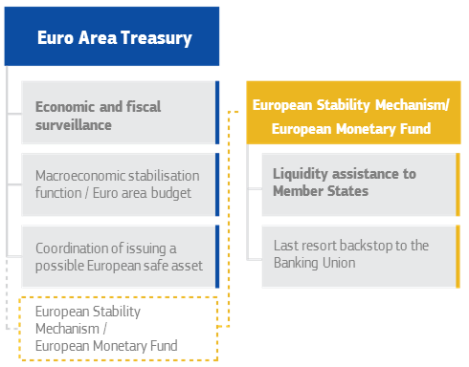
Source: European Commission
Stronger economic, fiscal and financial integration over time would also open the door to review the set of EU fiscal rules. While some see the rules today as too lax, others see them as unduly constraining. Everybody agrees, however, that they have become excessively complex, which hinders ownership and effective implementation. Over time, greater integration providing for adequate safeguards and greater channels to manage economic interdependence together with stronger market discipline would allow for simpler fiscal rules.

5. Conclusion
The euro is a great achievement, strongly supported by Europeans. We must cherish and preserve it. But it is still far from perfect and is in need of reforms to help it deliver even better for all of us. This requires political determination, leadership and courage.

Important lessons have been drawn from the past fifteen years and the economic situation is improving. However, it would be a mistake to consider the status quo as satisfactory. The euro is neither the origin of nor the only solution for the challenges faced today by Europeans. Yet, the euro creates specific opportunities and responsibilities of which we must be fully aware. In a globalised world, it provides us with benefits that national currencies and economies alone could never do. It protects us against global volatile exchange rates and is a strong player on the global currency markets. It oils the engine of the EU internal market. It is the best insurance policy for our savings and pensions against inflation.

There is by now growing awareness that further steps towards completing the Economic and Monetary Union are needed. To guide the work ahead, it is important first to agree on the objective and guiding principles for the way forward. The objective should be obvious: the euro needs to strengthen its role as a source of shared prosperity, economic and social welfare, based on inclusive and balanced growth and price stability.

The importance of the task at hand requires appropriate sequencing. 2025 is not such a distant future. The Commission proposes to move forward in two steps. Annex 1 provides a summary.

The first phase runs to the end of 2019. This time should be used for completing the Banking Union and Capital Markets Union with those elements that are already on the table today. This includes the financial backstop to the Single Resolution Fund, measures to reduce risks in the financial sector further, and the European Deposit Insurance Scheme. A number of new instruments, such as better economic and social convergence standards, could also be tested. The democratic accountability and effectiveness of the EMU architecture would be gradually improved.

The second phase, over 2020-25, would be for completing the EMU architecture. It would include more far-reaching measures to complement the Financial Union, possibly with a European safe asset and a change in the regulatory treatment of sovereign bonds. Additionally, a fiscal stabilisation function could be envisaged. As a result, the institutional architecture could be changed more substantially.

This reflection paper is an invitation for everyone to express their views on the future of our Economic and Monetary Union, as part of the broader debate on the future of Europe. The way forward must be built on a broad consensus and take into account the global challenges ahead. In this regard, the reflection papers on the social dimension of Europe and harnessing globalisation, as well as the upcoming reflection paper on the future of EU finances, also feed the discussion on the future of our EMU.

It is time to put pragmatism before dogma, to put bridge-building before individual mistrust. Fifteen years after the launch of the euro, ten years after the crisis hit us, it is time to look afresh at where our Union should be in the next decade, and to lay the common ground for such a future.

Whilst no asset or investment is entirely safe, the notion “safe asset” is used for instruments that represent reliable and attractive storage of value.

