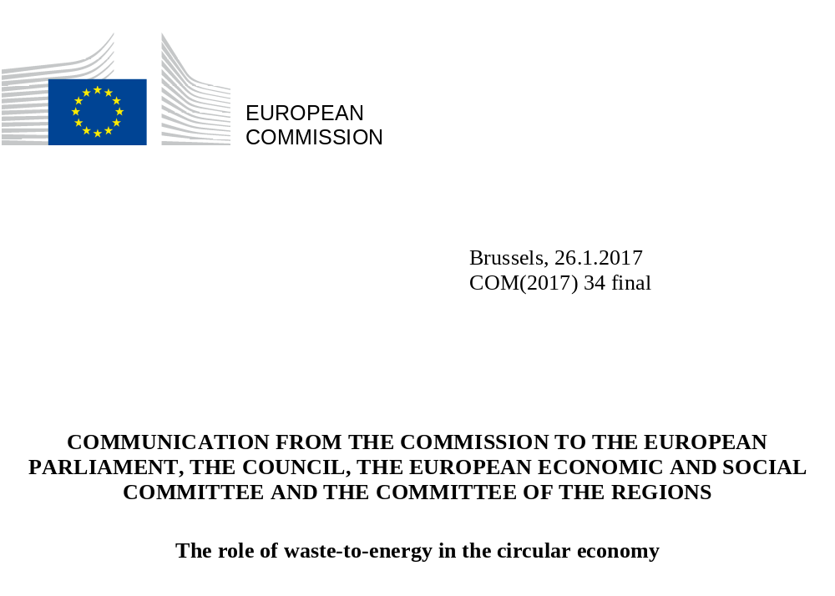

- Introduction
On 2 December 2015, the Commission adopted an EU action plan for the circular economy, offering a transformative agenda with significant new jobs and growth potential and aiming at fostering sustainable consumption and production patterns, in line with EU commitments under the 2030 Agenda for Sustainable Development.

The action plan stressed that the transition to a more circular economy requires action throughout a product’s life-cycle: from production to the creation of markets for ‘secondary’ (i.e. waste-derived) raw materials. Waste management is one of the main areas where further improvements are needed and within reach: increasing waste prevention, reuse and recycling are key objectives both of the action plan and of the legislative package on waste.
Achieving these objectives can open up tangible economic opportunities, improve raw materials supply to industry, create local jobs and reaffirm European leadership in the green technologies sector, which has a proven growth potential also at global level. In the EU, the output of environmental goods and services per unit of gross domestic product has grown by more than 50 % over the last decade and the employment linked to this production has risen to more than 4 million full-time equivalents. At global level, the World Bank has estimates that over the next 10 years EUR 6 trillion will be invested in clean technologies in developing countries, with some EUR 1.6 trillion accessible to SMEs.
In order to tap into this potential, promote innovation and avoid potential economic losses due to stranded assets, investment in new waste treatment capacity needs to be framed in a long-term circular economy perspective and to be consistent with the EU waste hierarchy, which ranks waste management options according to their sustainability and gives top priority to preventing and recycling of waste. EU legislation on waste, including recent proposals for higher recycling targets for municipal and packaging waste and for reducing landfill, is guided by the waste hierarchy and aims to shift waste management upwards towards prevention, reuse and recycling.

This communication focuses on energy recovery from waste and its place in the circular economy. Waste-to-energy is a broad term that covers much more than waste incineration. It encompasses various waste treatment processes generating energy (e.g. in the form of electricity/or heat or produce a waste-derived fuel), each of which has different environmental impacts and circular economy potential.

The main aim of this communication is to ensure that the recovery of energy from waste in the EU supports the objectives of the circular economy action plan and is firmly guided by the EU waste hierarchy. The communication also examines how the role of waste-to-energy processes can be optimised to play a part in meeting the objectives set out in the Energy Union Strategy and in the Paris Agreement. At the same time, by highlighting proven energy-efficient technology the approach to waste-to-energy set out here is meant to provide incentives for innovation and help create high-quality jobs.

To attain these objectives, the communication:

- clarifies the position of different waste-to-energy processes in the waste hierarchy and what this entails for public financial support (section 2);

- provides guidance to Member States on how to make better use of economic instruments and capacity planning with a view to avoiding or addressing potential overcapacity in waste incineration (section 3); and

- identifies the technology and processes which currently hold the greatest potential to optimise energy and material outputs, taking into account expected changes in the feedstock for waste-to-energy processes (section 4).
- Positioning waste-to-energy processes in the waste hierarchy and the role of public financial support
The waste hierarchy is the cornerstone of EU policy and legislation on waste and a key to the transition to the circular economy. Its primary purpose is to establish an order of priority that minimises adverse environmental effects and optimises resource efficiency in waste prevention and management.

This communication covers the following main waste-to-energy processes:

- co-incineration of waste in combustion plants (e.g. power plants) and in cement and lime production;

- waste incineration in dedicated facilities;

- anaerobic digestion of biodegradable waste;

- production of waste-derived solid, liquid or gaseous fuels; and

- other processes including indirect incineration following a pyrolysis or gasification step.
These processes have different environmental impacts and rank differently in the waste hierarchy. In fact, waste-to-energy processes encompass very different waste treatment operations, ranging from ‘disposal’ and ‘recovery’ to ‘recycling'. For example, processes such as anaerobic digestion which result in the production of a biogas and of a digestate are regarded by EU waste legislation as a recycling operation. On the other hand, waste incineration with limited energy recovery is regarded as disposal. The figure 1 below illustrates the positioning of different waste-to-energy processes along the EU waste hierarchy.

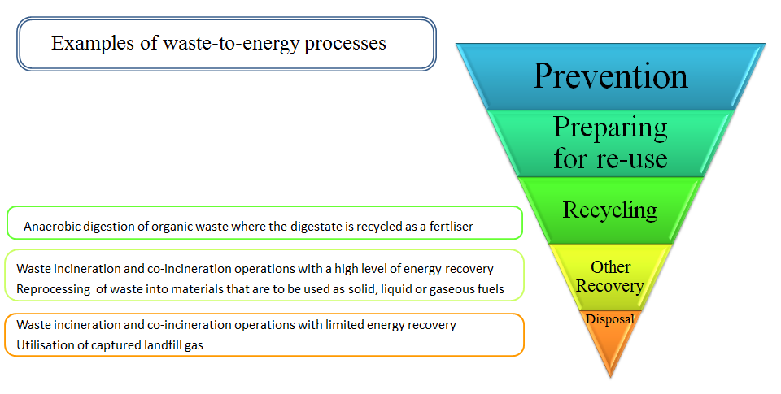
Figure 1. The waste hierarchy and waste-to-energy processes
It important to stress that the waste hierarchy also broadly reflects the preferred environmental option from a climate perspective: disposal, in landfills or through incineration with little or no energy recovery, is usually the least favourable option for reducing greenhouse gas (GHG) emissions; conversely, waste prevention, reuse and recycling have the highest potential to reduce GHG emissions.

It is also worth recalling that Member States have some flexibility in the application of the hierarchy, as the ultimate goal is to encourage those waste management options that deliver the best environmental outcome. For some specific waste streams, achieving the best environmental outcome may entail departing from the priority order of the hierarchy, i.a. for reasons of technical feasibility, economic viability and environmental protection. This must be justified in line with the provisions laid out in Article 4(2) of the Waste Framework Directive. .For instance, in some specific and justified cases, (e.g. materials that contain certain substances of very high concern), disposal or energy recovery may be preferable to recycling.

To support the transition towards a more circular economy, public financing of waste management, whether national or at EU level, should be consistent with the goal of shifting upwards in the implementation of the EU waste hierarchy.

At EU level, the transition towards more sustainable waste management systems receives financial support, mainly through the co-financing of the Cohesion Policy funds In the case of these funds, pre-conditions must be met to ensure that new investments in the waste sector are in line with waste management plans designed by Member States to meet their preparation for reuse and recycling targets. As stated in the circular economy action plan, this means that investments in treatment facilities for residual waste, such as extra incineration capacity would only be granted in limited and well justified cases, where there is no risk of overcapacity and the objectives of the waste hierarchy are fully respected.

Investments channelled through other EU financing mechanisms, such as the European Fund for Strategic Investment (EFSI) also have an important role to play in attracting private financing to the best and most ‘circular’ solutions for waste management through loans, guarantees, equity and other risk-bearing mechanisms. In addition, available EU financial support for research and innovation in waste-to-energy technologies, (e.g. Horizon 2020, but also Cohesion Policy funds) contributes to ensuring continued EU leadership and bringing advanced energy-efficient technologies to the market.

At national level, public financial support has also often played a key role in developing more sustainable waste management solutions and in promoting renewable energy and energy efficiency. When assessing public financial support for waste-to-energy processes, it is particularly important not to undermine the waste hierarchy by discouraging waste management options with higher circular economy potential. This is clearly reflected in the existing guidelines on state aid for environmental protection and energy which state that support for energy from renewable sources using waste or support for cogeneration and district heating installations using waste can make a positive contribution to environmental protection provided it does not circumvent the waste hierarchy. Public funding should also avoid creating overcapacity for non-recyclable waste treatment such as incinerators. In this respect it should be borne in mind that mixed waste as a feedstock for waste-to-energy processes is expected to fall as a result of separate collection obligations and more ambitious EU recycling targets. For these reasons, Member States are advised to gradually phase-out public support for the recovery of energy from mixed waste.

- Waste-to-energy processes for treating residual waste: finding the right balance
The transition towards a circular economy requires striking the right balance when it comes to waste-to-energy capacity for the treatment of non-recyclable waste. This is critical to avoid potential economic losses or the creation of infrastructural barriers to the achievement of higher recycling rates. Previous experience in some Member States shows the risk of stranded assets is real.
A recent study commissioned by the European Environment Agency maps existing dedicated incineration capacity for municipal waste in the EU-28 countries and the flows of municipal waste and refuse-derived fuel (RDF) between Member States. The study shows that between 2010 and 2014, the incineration capacity in the EU-28 countries (plus Switzerland and Norway) increased by 6 % to 81 Mt and that waste flows between some Member States for the incineration of municipal waste and RDF remained significant in some cases. In 2013, close to 2.5 Mt of waste (most of it RDF) was shipped for energy recovery.
The study also confirms that dedicated incineration capacity for municipal waste is unevenly spread in the EU. Germany, France, the Netherlands, Sweden, Italy and the UK account for three quarters of the EU’s incineration capacity. Sweden and Denmark have the highest per capita incineration capacity with 591 kg/cap and 587 kg/cap respectively, followed by the Netherlands, Austria Finland and Belgium. In contrast, the southern and eastern parts of the EU are practically devoid of dedicated incineration capacity and are highly reliant on landfill. This data is in line with Eurostat statistics on the incineration rates of municipal waste which also show great variation across Member States.
Depending on their specific situation, Member States have various options to ensure that waste-to-energy capacity, in particular incineration, is properly balanced:
Member States with low or non-existent dedicated incineration capacity and high reliance on landfill
These Member States should give priority to further development of separate collection schemes and recycling infrastructure in line with EU legislation. The gradual diversion of waste from landfill should go hand-in-hand with the creation of greater recycling capacity. Reducing the landfilling of biodegradable waste is particularly urgent from a climate perspective so as to reduce methane emissions. Here, the development of combined energy recovery and material recycling capacity in the form of anaerobic digestion could represent an attractive management option.
When reviewing national waste management plans and assessing the need for additional waste-to-energy capacity for the treatment of non-recyclable waste (e.g. incineration), Member States should take a long-term perspective and carefully assess the following factors:
- the impact of existing and proposed separate collection obligations and recycling targets on the availability of feedstock to sustain the operation of new incineration plants over their lifespan (20 -30 years);
- the available capacity for co-incineration in combustion plants and in cement and lime kilns or in other suitable industrial processes; and
- planned or existing capacity in neighbouring countries.
In justified cases, the cross-border shipments of waste could help to make optimal use of the waste-to-energy capacity already available in a number of Member States. Exporting non-recyclable waste for energy recovery to another Member State should not necessarily be seen as contradicting the so-called principle of proximity (i.e. using the nearest appropriate facility) that underpins EU waste legislation. However, before opting for such approach competent authorities in the Member States should carry out a life-cycle analysis to ensure that the overall environmental impacts, including those related to the transport of waste, do not offset the sought benefits
Where the creation of new capacity for the treatment of residual waste appears justified based on the assessment of all the factors mentioned above, Member States should pay particular attention to the use of state-of-the-art energy-efficient technologies and to the size and location of the plant (e.g. to avoid future overcapacities and ensure combined supply of electricity and heat or cooling to local residents and industry where possible). It is also crucial to ensure full compliance with the requirements for incineration and co-incineration facilities set out in EU legislation, in particular the Industrial Emissions Directive 2010/75/EC.
Member States with high dedicated incineration capacity
The European Environment Agency study suggests there is currently no incineration overcapacity in the EU as a whole. However, the statistics show that some individual Member States are excessively reliant on incineration of municipal waste. This situation may be partly explained by high demand for heat through district heating networks, the higher efficiency of their waste-to-energy processes and high levels of social acceptance. Nonetheless, such high rates of incineration are inconsistent with more ambitious recycling targets. To address this problem a number of measures can be taken at national level and have already been implemented in some Member States, in particular:
- introducing or increasing incineration taxes, especially for processes with low energy recovery while ensuring they are paired with higher landfill taxes;
- phasing out support schemes for waste incineration and, where appropriate, redirecting support to higher-ranking processes in the waste hierarchy; and
- introducing a moratorium on new facilities and decommissioning older and less efficient ones.
4. Optimising the contribution of waste-to-energy processes to the EU’s climate and energy objectives in the circular economy
According to the Commission study, in 2014 approximately 1.5 % of the EU’s total final energy consumption was met by recovering energy from waste through incineration, co-incineration in cement kilns and anaerobic digestion (i.e. around 676 PJ/year). Whereas this percentage should not significantly increase in the future as more waste is directed to recycling, improving the energy efficiency of waste-to-energy processes and promoting those processes which combine material and energy recovery can contribute to decarbonising key sectors such as heating and cooling or transport and to reducing greenhouse gas emissions from the waste sector. For instance, diverting one tonne of biodegradable waste from a landfill towards anaerobic digestion to produce biogas and fertilisers can prevent up to 2 tonnes of CO₂ equivalent emissions.
Expected changes in waste-to-energy feedstock
Mixed waste still accounts for a substantial share of the waste used in waste-to-energy processes, mainly incineration (52 %). Existing legal requirements and the circular economy waste proposals are bound to change this situation. Rules on separate collection and more ambitious recycling rates covering wood, paper, plastic and biodegradable waste are expected to reduce the amount of waste potentially available for waste-to-energy processes such as incineration and co-incineration. Ljubljana is an example of a city that has already managed to move rapidly and successfully to high levels of separate collection: From 2011 on Ljubljana has invested in the modernisation of the waste management infrastructure leading to the separate collection rate of 60% on total municipal waste generation.
For biodegradable waste, the implementation of the requirements laid down in the Landfill Directive, in combination with the proposed new rules to ensure separate collection of bio-waste, should result in greater production of waste-derived biogas for the use in cogeneration, injection into the gas grid, and the use in transport fuels, and fertilisers through anaerobic digestion. Proposed changes to the Fertilisers Regulation, currently under discussion in Parliament and the Council, should support this trend by opening up the single market for waste-derived fertilisers. The potential of biodegradable waste coupled with anaerobic digestion processing in a biogas plant is seen in Milan. Since 2014, the city has almost reached 100% collection of food and organic waste, providing an average of 120 000 tonnes of biodegradable waste per year. At full capacity (12.8 MW), the city biogas plant should produce some 35 880 MWh of electricity a year, enough to supply 24 000 people, and yield 14 400 tonnes of fertiliser.
In the case of waste edible oils and fats, there is scope for improving the efficiency of collection and treatment systems to produce products such as biodiesel and hydrogenated vegetable oils (HVO). The resulting waste-derived biofuel can be used directly in transport, including the use of HVO in aviation..
As regards plastic waste, industry data shows that disposal and energy recovery remain the most common treatment options and that while landfilling has decreased over the past ten years incineration has been growing with big disparities between Member States linked to various states of implementation of existing EU legislation. This confirms the need for urgent and concrete steps to improve the recyclability and reusability of plastics and to encourage innovation in this field. The upcoming EU strategy on plastics in the circular economy will precisely aim to improve the economics, quality and uptake of plastic recycling and reuse by looking at the entire value chain. It will consider some new developments in the treatment of plastic waste, such as re-refining and innovations in design, so that in the future a higher share of plastic waste can be prevented or diverted from energy recovery to recycling, thus reducing overall GHGs impacts..
The Commission study found that wood waste is commonly used as a feedstock for incineration. As highlighted in the circular economy action plan, a cascading use of renewable resources such as wood, with several reuse and recycling cycles, should be encouraged where appropriate, in line with the waste hierarchy. In this context, it should be recalled that in its legislative package on waste, the Commission has, inter alia, proposed a higher mandatory EU-level target on recycling wood packaging waste. Where reuse or recycling is not possible, energy use of wood waste is desirable to replace fossil fuels and avoid landfilling of wood.
Using the most energy-efficient waste-to-energy techniques
Where waste-to-energy processes are opted for, there is a need to ensure that the most efficient techniques are used: this maximises their contribution to the EU’s climate and energy objectives. The Commission study estimates that if proven techniques and supporting measures are properly implemented, the amount of energy recovered from waste could rise by 29 % to 872 PJ/year, using exactly the same amount of waste as feedstock. This shows the potential for energy efficiency improvements. The Commission study found that the best proven techniques to increase energy efficiency for the four waste-to-energy processes below were as follows:
- co-incineration in combustion plants: gasification of solid recovered fuel (SRF) and co-incineration of the resulting syngas in the combustion plant to replace fossil fuels in the production of electricity and heat;

- co-incineration in cement and lime production: conversion of waste heat to power in cement kilns;

- waste incineration in dedicated facilities:
  - the use of super heaters;
  - harnessing the energy contained in flue gas;
  - the use of heat pumps;
  - supplying chilled water for district cooling networks; and
  - distributing heat from waste through low temperature district heat networks.

- anaerobic digestion: upgrading of the biogas into bio-methane for further distribution and use (e.g. injection into the gas grid and transport fuel).
Apart from the above-mentioned specific techniques, the Commission study highlights the superior energy efficiency levels attainable by installations working in combined heat and power (CHP) mode, compared to plants merely producing either heat or electricity.

In addition to these techniques, the study lists supporting measures to improve energy and/or material efficiency in these processes. This includes the development of industrial parks and symbiosis whereby a waste-to-energy plant processes the waste generated by industries located nearby while providing them heat and power in return; or the recovery of materials found in incinerator bottom ash.

In anaerobic digestion, it is also important to avoid the risk of methane leaks from biogas plants due to poor design or maintenance, as these would offset some of the plants’ environmental benefits.

5. Conclusions

Waste-to-energy processes can play a role in the transition to a circular economy provided that the EU waste hierarchy is used as a guiding principle and that choices made do not prevent higher levels of prevention, reuse and recycling. This is essential in order to ensure the full potential of a circular economy, both environmentally and economically and to reinforce the European leadership in green technology. Moreover, it is only by respecting the waste hierarchy that waste-to-energy can maximise the circular economy's contribution to decarbonisation, in line with the Energy Union Strategy and the Paris agreement. As mentioned earlier, it is waste prevention and recycling that deliver the highest contribution in terms of energy savings and reductions in GHGs emissions.

In the future, more consideration should be given to those processes, such as anaerobic digestion of biodegradable waste, where material recycling is combined with energy recovery. Conversely, the role of waste incineration – currently, the predominant waste-to-energy option - needs to be redefined to ensure that increases in recycling and reuse are not hampered and that overcapacities for residual waste treatment are averted.

The Commission calls on all Member States to take into account the guidance provided in this communication when evaluating and revising their waste management plans under EU legislation. When planning future investments on waste-to-energy capacity, it is essential that Member States take into consideration the risk of stranded assets. When assessing national waste management plans and monitoring progress towards the EU recycling targets, the Commission will continue to provide guidance on ensuring that waste-to-energy capacity planning is consistent with, and supportive of, the waste hierarchy and that it takes into account the potential of new and emerging waste treatment and recycling technologies.

The Commission remains committed to ensuring that EU funding and other public financial support is directed towards waste treatment options that are in line with the waste hierarchy, and that priority is given to waste prevention, reuse, separate collection and recycling.

Closing the loop — An EU action plan for the circular economy, COM(2015) 614 final. A circular economy is one in which the value of products, materials and resources is maintained for as long as possible, minimising waste and resource use.
COM(2015) 593, 594, 595 and 596 final.
http://ec.europa.eu/eurostat/statistics-explained/index.php/Environmental_goods_and_services_sector
Building competitive green industries: The climate and clean technology opportunity for developing countries, The World Bank, 2014.
http://ec.europa.eu/priorities/energy-union-and-climate/state-energy-union_en
http://unfccc.int/paris_agreement/items/9485.php
As set out in Article 4 of Directive 2008/98/EC of the European Parliament and of the Council on waste and repealing certain Directives, OJ L 312, 22.11.2008, p. 3.
As identified in the dedicated Commission study: Towards a better exploitation of the technical potential of waste-to-energy, European Union, 2016. http://publications.jrc.ec.europa.eu/repository/bitstream/JRC104013/wte%20report%20full%2020161212.pdf.
Article 2 (6) of Commission Decision 2011/753/EU establishing rules and calculation methods for verifying compliance with the targets set in Article 11(2) of Directive 2008/98/EC of the European Parliament and of the Council. OJ L 310 of 25.11.2011.
Article 4 (2) of Directive 2008/98/EC in conjunction with the EU guidance on the interpretation of the waste hierarchy: http://ec.europa.eu/environment/waste/framework/pdf/guidance_doc.pdf (pages 48 to 52).
Supporting environmentally sound decisions for waste management, European Union, 2011. http://publications.jrc.ec.europa.eu/repository/bitstream/JRC65850/reqno_jrc65850_lb-na-24916-en-n%20_pdf_.pdf
As announced in the Circular Economy action plan, the Commission is currently analysing options to address the interface between chemicals, products and waste legislation, including how to reduce the presence and improve the tracking of chemicals of concern in products.
In particular, the European Regional Development Fund and the Cohesion Fund.
http://www.eib.org/products/blending/innovfin/
For the purpose of this communication, this category includes the following non-separately collected waste streams: household and similar waste, undifferentiated materials and sorting residues.
Assessment of waste incineration capacity and waste shipments in Europe, WI et al, 2016. European Topic Centre on Waste and Materials in a Green Economy (ETC/WMGE), 2017. http://forum.eionet.europa.eu/nrc-scp-waste/library/waste-incineration
RDF is a fuel produced from the treatment (e.g. shredding and dehydrating) of municipal solid waste.
See Article 16 of Directive 2008/98/EC.
OJ L 334, 17.12.2010. This Directive includes operational requirements and emission limit values based on the best available techniques, aimed at protecting human health and the environment from industrial processes.
http://ec.europa.eu/eurostat/documents/2995521/7214320/8-22032016-AP-EN.pdf
Review of comparative LCAs of food waste management systems – Current status and potential improvements, A. Bernstad, J. la Cour Jansen, Science Direct, Volume 32, Issue 12, December 2012.
http://ec.europa.eu/environment/waste/studies/pdf/Separate%20collection_Final%20Report.pdf
Article 6 (a) of Directive 1999/31/EC on the landfill of waste. OJ L 182 of 16.7.1999.
http://ec.europa.eu/DocsRoom/documents/15949
http://european-biogas.eu/wp-content/uploads/2016/03/Milan.pdf
http://www.plasticseurope.org/Document/plastics---the-facts-2016-15787.aspx?FolID=2
http://eur-lex.europa.eu/legal-content/EN/TXT/?uri=CELEX:52013DC0123
Recycling plastics releases only a forth or even less of the GHG emitted by producing plastics from fossil-based primary feedstock (Increased EU Plastics Recycling Targets: Environmental, Economic and Social Impact Assessment, Bio by Deloitte, 2015).
SRF is a fuel produced from non-hazardous waste in accordance with EU standards EN15359.
See Article 30(1) of Directive 2008/98/EC.

