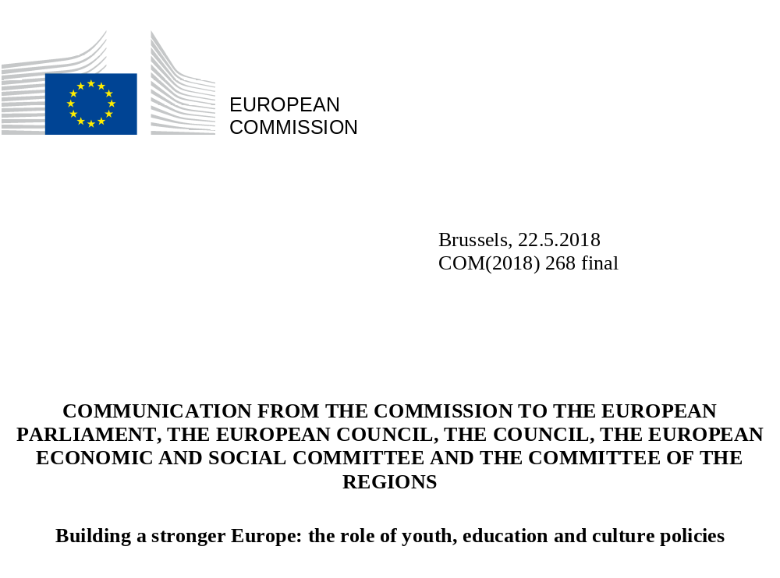

- Introduction
Europe is engaged in a debate about its future. In one year’s time, Leaders will meet in the Romanian city of Sibiu to draw conclusions from this debate, which the Commission launched with its White Paper on the Future of Europe in March 2017.
One key issue is to address citizens' expectations and respond to their concerns about the future in a quickly changing world; a world that offers new opportunities but that also brings uncertainty. Many are worried about how work will develop; the future of the welfare state; how our democratic and diverse societies will evolve; and about Europe's place in the world. Europe needs to enable its citizens, especially its young people, to make the most of opportunities offered by new technologies and global trends. Education and training offer a way forward, as an investment for the individual and for society at large.
The Union is first and foremost a Union of values, as enshrined in Article 2 of the Treaty on the European Union, and education, training and culture are crucial for transmitting and promoting common values and building mutual understanding.
On the economic side, although the crisis left its mark on labour markets and societies, Europe's social market economy showed its mettle in weathering the worst economic crisis in living memory. The ongoing work on completing the Economic and Monetary Union will further strengthen Europe's economic foundation.
When it comes to social priorities, the Union has made clear that the European project is about much more than economics. The European Pillar of Social Rights was jointly proclaimed by the European Parliament, the Council and the Commission in November 2017. The Pillar reinforces the principles and rights in the employment and social field on which the Union is based, and establishes the right to quality education, training and lifelong learning as its first principle.
A stronger role for policies on youth, education and culture
In the Rome Declaration of March 2017, EU Leaders pledged to work towards a "Union where young people receive the best education and training and can study and find jobs across the continent; a Union which preserves our cultural heritage and promotes cultural diversity". If we want to build a stronger Europe, policies on youth, culture, education and training need to play an important role in the European project.
Early on, this Commission took measures to address the situation of young people who had to withstand the worst of the crisis, and to give them better opportunities to participate actively in the European project. A lot has already been achieved. To build the future, Europe requires the support and involvement of young people. Therefore, the Commission, together with the Council, is maintaining its strong focus on young people.
More attention needs to be devoted to education, training and culture enabling them to unlock their full potential to support the European project. Investing in skills, competences and knowledge is essential to boost Europe's resilience. Such investments in people drive innovation, productivity and competitiveness, helping to maintain employability and overcome skills mismatches in a rapidly evolving labour market impacted by globalisation and technological change.
Another aspect is diversity, which is a distinctive feature of Europe and a source of innovation and creativity. Education and culture heighten our awareness, understanding and appreciation of Europe's rich shared cultural heritage, history, experiences, convictions and values. This unites people across borders, helps promote equality between women and men and gives us a sense of belonging together. Education, training and culture can help us discover and experience what it means to be European.
At the November 2017 Gothenburg Summit, EU Leaders chose education and culture for the Leaders' Agenda debate. The discussion among Leaders was informed by a Commission contribution on "Strengthening European Identity through Education and Culture", in which the Commission sets out its vision of working towards a European Education Area. The debate placed education and culture at the top of the policy agenda. Europe is faced with a variety of challenges, including populism, xenophobia, intolerance, discrimination and disinformation. Moreover, few EU countries are high performers in all aspects of education and training. There is therefore a need to strengthen the education and culture dimension within the Union.
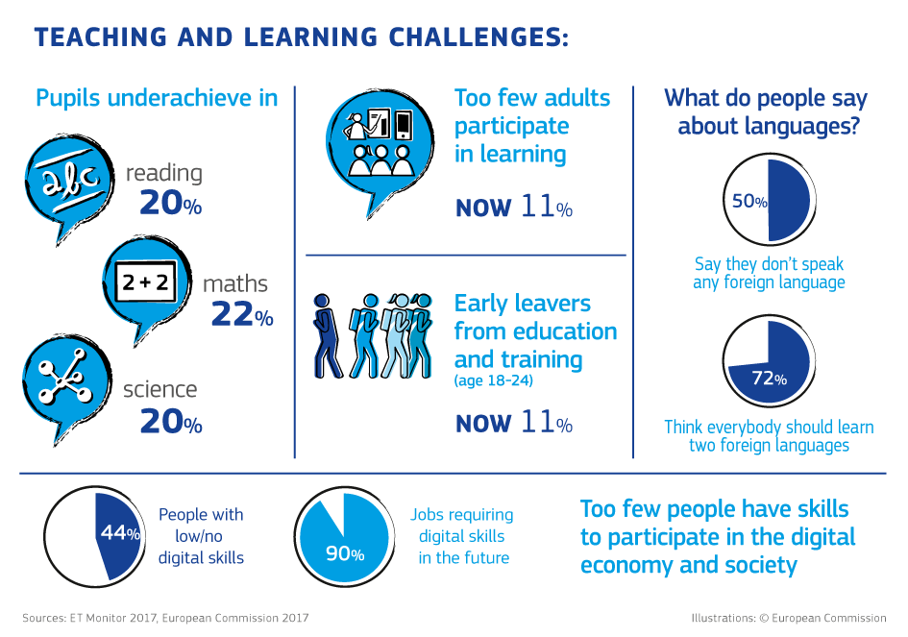
In December 2017, the European Council called on Member States, the Council and the Commission:
- to take work forward on a number of key initiatives, including the Erasmus+ programme, European universities, language learning, the European Student Card, the mutual recognition of diplomas and the European Year of Cultural Heritage;
- to examine possible measures addressing the skills challenges linked to digitisation, cybersecurity, media literacy and artificial intelligence; the need for an inclusive, life-long-learning-based and innovation-driven approach to education and training; and the legal and financial framework conditions for the development of cultural and creative industries and the mobility of professionals of the cultural sector.
In response, the Commission presented on 17 January 2018 a first package of measures, addressing key competences, digital skills as well as common values and inclusive education.
The present Communication is part of a second package of initiatives responding to the European Council. It brings together a set of initiatives in the fields of youth, culture, education and training policy to help secure a more competitive, inclusive and cohesive Europe:
- Building on earlier actions to invest in young people, the Commission presents a "Youth Strategy" for the period 2019 – 2027. The focus is on empowering Europe’s young people and giving them a stronger voice in EU policymaking;
- As announced in its Communication on "Strengthening European Identity through Education and Culture", the Commission presents "A New European Agenda for Culture". This initiative will be instrumental in improving awareness of Europe’s common identity and heritage and in supporting the Union's relations with third countries;
- In line with the goal to work towards a European Education Area, the Commission presents two proposals for Council Recommendations on "Mutual Recognition of Diplomas" and improving the "Teaching and Learning of Languages". Both initiatives are key to facilitating learning mobility in Europe;
- In line also with the European Pillar of Social Rights, the Commission proposes a Council Recommendation on "High Quality Early Childhood Education and Care Systems". This initiative seeks to ensure that all children in Europe can have a good start in life.
As set out in the graphic below, work has commenced and will continue in the coming years. This cooperation will underpin the joint work towards the European Education Area.
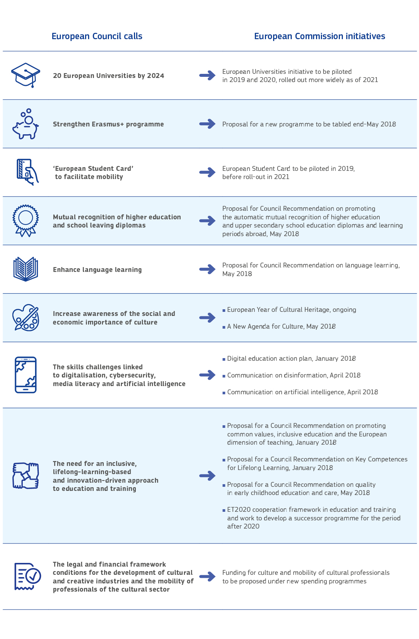

These initiatives are stepping stones in the process towards a strengthened Union on the road to Sibiu. They
- reflect the importance that this Commission attaches to investing in young people and their future. Building on previous actions, in particular the Youth Guarantee, the Youth Employment Initiative, the December 2016 Investing in Youth initiative, the New Skills Agenda for Europe, the Upskilling Pathways initiative, and the European Quality Framework for Apprenticeships, they will help give young people of all backgrounds more promising prospects and enable them to take a more active role in the European project;
- will help people to share Europe's cultural diversity and shared heritage, helping them to experience what the European project is about; and
- are part of a larger vision to work towards a European Education Area, which will help to promote mobility, overcome obstacles to mobility and cross-border cooperation and, building on previous initiatives, support Member States in modernising and improving their education and training systems.
- Working towards a European Education Area

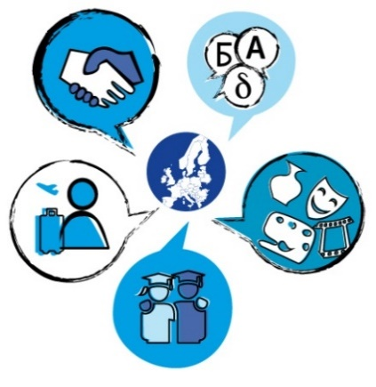
In its contribution to the Leaders' meeting in Gothenburg, the Commission set out a vision for a European Education Area by 2025: "a Europe in which learning, studying and doing research would not be hampered by borders. A continent, where spending time in another Member State – to study, to learn, or to work – has become the standard and where, in addition to one's mother tongue, speaking two other languages has become the norm. A continent in which people have a strong sense of their identity as Europeans, of Europe's cultural heritage and its diversity."
The European Education Area should help achieve three objectives:
- promote cross-border mobility and cooperation in education and training;
- help overcome unjustified obstacles that make it more difficult to learn, train or work in another country with the aim of realising the "free movement of learners" and creating a genuine European learning space;
- support Member States in improving the inclusive, lifelong-learning based and innovation-driven nature of their education and training systems.
Establishing the European Education Area will enable the EU Member States to do more, faster, to drive up the quality, competitiveness and inclusiveness of their education and training systems, while providing inspiration for non-EU countries to follow. It will be implemented building on:
- the flagship Erasmus+ programme and its successor programme, which the Commission will propose at the end of May 2018. Erasmus+ is well-known for its successful promotion of learning mobility. There is a strong consensus for the need to further step up mobility, accompanied by reinforced strategic partnerships and policy support, to drive more innovative and inclusive education, training and youth policies.
- the existing European cooperation in education and training with its focus on sound empirical evidence, benchmarking, exchange of experience and mutual learning. As this framework will end in 2020, the Commission will present in due time proposals to take this cooperation to a more ambitious level. The new framework will be the vehicle for setting priorities, guiding policies and better targeting EU funding. The Commission will also propose a set of indicators and benchmarks to provide evidence on how education and training supports the development of skills and competences at all stages of life.
While the Erasmus+ programme and the future European cooperation framework for education and training will work in synergy to bring about the European Education Area, they will be supported by other relevant policies. The Union will continue to support Member States' reform efforts through the European Semester and through various spending programmes, including the European Social Fund, as a tangible expression of how Europe invests in people and improves their lives.
The competences for education and training lie mainly in the hands of Member States, with the Union having competences to carry out actions that support, coordinate or supplement the actions of the Member States. The work towards a European Education Area does not change this. It will bring the existing partnership and cooperation to a new, higher and more intensive level. The European Education Area will cover learners of all age groups, whatever their background, and all sectors, including early childhood education and care, schools, vocational education and training, higher education and adult learning.
In order to make the European Education Area a reality, and following the first package of January 2018, the Commission is presenting today a new set of specific policy initiatives on mutual recognition, language learning and early childhood education and care. It will also continue dedicated work under the ongoing cooperation framework and funding programmes to develop new actions, including in particular the European Student Card and the European Universities as set out below.
- Automatic mutual recognition of diplomas and learning periods abroad
Despite 30 years of Erasmus+ mobility and considerable progress under the inter-governmental Bologna process on higher education, many people still face obstacles when they ask for formal recognition of their tertiary or upper secondary level qualifications in another Member State. The same applies to learning periods abroad during both tertiary and secondary education. This creates uncertainty and unjustified barriers to mobility.
To overcome this problem, the Commission is proposing a Council Recommendation to establish automatic recognition of qualifications as a default position by 2025: any certificate or diploma – and the outcomes of learning periods abroad of up to one year – awarded by an accredited institution within the Union should be automatically recognised for the purposes of further learning in all Member States. However, such an ambitious plan cannot be implemented in one go. It requires a step-by-step approach, building on strong and reliable quality assurance that brings the transparency and trust needed for automatic recognition. A number of European countries are already pioneering automatic recognition schemes. Drawing on this experience, EU-wide solutions will be developed in close cooperation with Member States.
- Improved language learning
Acquiring foreign languages is not only essential to meet the skills needed in a global economy, it also opens new perspectives, strengthens European citizenship and helps people to discover other cultures. Today, many students spend a lot of time studying languages but too many are ultimately unable to use these languages in real-life situations. While most young Europeans study one foreign language, the ambition to learn a second foreign language is remarkably low.
Against this background, the Commission is proposing a new, comprehensive approach to learning languages in compulsory education, promoting better use of Europe's linguistic diversity. The aim is to ensure that more young people become competent language users and can master two languages in addition to the language of schooling.
- A European Student Card
Against the backdrop of increasing mobility, a European Student Card can help reduce burden and costs for students and education institutions by streamlining administrative processes before, during and after a mobility period, while at the same time being a visible symbol of the European student identity.
One advantage would be that students could identify themselves in a trusted manner at any higher education institution within the Union, allowing for a secure electronic exchange of education-related information (which can include credits and academic records), in full respect of protection of personal data and without the need to create additional information technology infrastructure. The Student Card would help students to get access to various services (library, transport, accommodation) before arriving at the institution abroad. It could be a vital step in making mobility for all a reality by enabling institutions to send and receive more exchange students, to do so more smoothly and to enhance quality in student mobility.
Based on existing EU-funded pilot projects which will be scaled up in 2019, as well as on further analysis and consultations with stakeholders, the Commission aims to start a progressive roll-out of the European Student Card by 2021, including investigating the possibility to extend the card to vocational education and training students.
- European Universities
Europe has a long and proud tradition of universities that cooperate across borders. The new ‘European Universities’ consisting of bottom-up networks of universities should bring this cross-border cooperation to the next level of ambition, where higher education institutions, sharing the same vision and values, develop joint long-term institutional strategies for top-quality education, research and innovation.
European Universities should drive the development of highly integrated and open study programmes combining modules in different countries. Mobility should be a standard feature, embedded at Bachelor, Master and Doctoral levels. This should contribute to the emergence of ‘European degrees’ recognised throughout Europe.
A set of key principles will underpin these European Universities: every type of higher education institution in any Member State would be able to participate by means of fair and balanced criteria. The networks should be geographically balanced and socially inclusive. There will be no one-size-fits-all model. Institutions can propose the model that suits their needs through a bottom-up, open and transparent approach and develop the level of ambition gradually. For funding to be sustainable, European Universities should be able to draw from a combination of EU and national resources.
European Universities should become key elements of the European Education Area by driving excellence and act as models of good practice for other higher education institutions, progressively increasing the international competitiveness and attractiveness of European higher education. They should operate on the basis of multidisciplinary approaches, allowing students, lecturers and researchers to co-create and share knowledge and innovation. This could help to address the big societal challenges and skills shortages that Europe faces. It could also boost the contribution that higher education institutions make to their regions, in particular through their involvement in the development and implementation of Smart Specialisation Strategies.
The Commission aims to foster the emergence of at least twenty European Universities by 2024. However, to put such an ambitious idea into practice requires time for sound preparation and sufficient resources. In the initial phase, the Commission is working closely with Member States and stakeholders to develop the concept. It will propose to launch pilots to start in 2019 and 2020 under the Erasmus+ programme, and with full rollout as of 2021. Based on these pilots and a mapping of existing networks, the Commission will explore, in consultation with stakeholders, the option of creating a dedicated legal statute for European Universities by 2025.
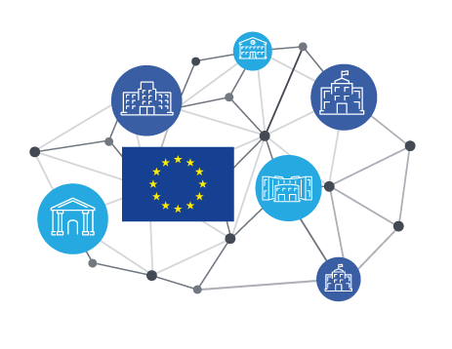
European Universities
- bottom-up networks of existing universities
- top-quality education, research and innovation
- multidisciplinary approach
- geographically balanced
- at least 20 European Universities by 2024
- first pilots in 2019 via Erasmus+

In addition, the School of European and Transnational Governance, set up under the European University Institute in Florence in 2017, will strengthen its activities, including through the development of partnerships with related institutions, to train managers from public, private and civil society organisations.
Other actions to support a lifelong learning-based and innovation-driven approach to education and training will also be developed. For instance, the provision of high quality technical and specific vocational skills is essential to support innovation and competitiveness. To this end, the Commission will propose to support the establishment of Vocational Education and Training Centres of Excellence. These centres should connect reference vocational education and training providers across Member States, foster cooperation, including with stakeholders, and strive to develop high quality curricula and qualifications focused on sectoral skills needs. They should act as drivers of excellence and innovation and promote a proactive role for vocational education and training in local and regional economic development, including by acting as entrepreneurial incubators and catalysts for investment.
All these specific actions are intertwined.
Each action has its role to play in achieving the ambitious overall goal of establishing a European Education Area. Taken together, the various initiatives will create synergies, for example:
- Mobility and language learning mutually reinforce each other: proficiency in foreign languages increases interest in studying abroad; studying abroad improves language skills;
- Language learning increases the understanding of other cultures and one’s own identity;
- Vocational Education and Training Centres of Excellence will build synergies with universities, thus jointly contributing to the provision of the range of skills needed to support innovation and competitiveness;
- Automatic mutual recognition of diplomas and learning periods facilitates further learning abroad and increases the demand for mobility and people's interest in language learning;
- An increased number of mobile participants in the Erasmus+ programme can be handled more easily with smart use of digital solutions and simplification, which is one of the aims of the European Student Card;
- European Universities should become a key element towards the European Education Area by taking cross-border cooperation to a new, more ambitious level, boosting mobility for students and teachers and encouraging language learning, while serving as accelerators for automatic recognition of diplomas.
- Conclusions and outlook
The Union is placing youth, education, training and culture high on its policy agenda, in particular since the Leaders' meeting in Gothenburg and the European Council of December 2017. The Leaders’ Agenda foresees taking stock at the Summit in Sibiu in 2019. With the packages adopted in January 2018 and today, the Commission is delivering an ambitious set of actions to support Member States in their efforts, boosting people's resilience in a world of diversity, mobility, migration, globalisation and technological change. The Commission will continue its work in partnership with the Council and Member States, notably by:
- working towards a European Education Area, which will facilitate mobility and cross-border cooperation, support reforms and make full use of available tools and programmes. This will be achieved through:
- presenting a proposal for a stronger and more inclusive successor programme to Erasmus+ and a proposal for the continuation of the European Solidarity Corps;
- presenting by 2020 proposals to modernise and strengthen EU-level cooperation in the field of education and training, to support better mutual learning and national reform efforts;
- continuing close cooperation with Member States and the Council to work towards inclusive, lifelong-learning-based and innovation-driven approaches to education and training;
- addressing the legal and financial framework conditions for the development of the cultural and creative industries and the mobility of professionals in the cultural and creative sectors.
Strengthening the youth, education, training and culture dimensions of the European project will help build a Union that empowers, is aware of its achievements and has the confidence to tackle future challenges:
- a Union that is closer to its citizens, responding to their concerns and meeting their expectations;
- a Union that makes clear what the European project stands for: peace, security, freedom, democracy, equality, the rule of law, solidarity and mutual respect, open markets, sustainable growth and social inclusion and fairness;
- a Union that fosters, the awareness of cultural diversity and a sense of belonging together as Europeans.
Building on their discussions in Gothenburg and the actions requested at the December 2017 European Council, Leaders will, at their meeting in Sibiu, be in a position to harness education and culture when they lay the foundation for a more united, stronger and more democratic Union.

White Paper on the Future of Europe: Reflections and Scenarios for the EU27 by 2025 (COM (2017)2025).
The Pillar of Social Rights builds on previous initiatives towards a more social Europe, including the Charter of Fundamental Rights of the EU.
‘Everyone has the right to quality and inclusive education, training and life-long learning in order to maintain and acquire skills that enable them to participate fully in society and manage successfully transitions in the labour market.’ Source: Interinstitutional Proclamation on the European Pillar of Social Rights (2017/C 428/09).
http://www.consilium.europa.eu/en/press/press-releases/2017/03/25/rome-declaration/pdf.
The Commission's Communication on Investing in Europe's Youth gives an overview of these measures (COM(2016)940).
Council Conclusions on strategic perspectives for European cooperation in the youth field post-2018, May 2017.
See also Commission Communications on School Development and Excellent Teaching for a Great Start in Life (COM(2017)248) and A Renewed EU Agenda for Higher Education (COM(2017)247).
Commission Communication on Strengthening European Identity through Education and Culture (COM(2017)673).
The Commission presented a Digital Education Action Plan (COM(2018)22), a proposal for a Council Recommendation on Promoting Common Values, Inclusive Education, and the European Dimension of Teaching (COM(2018)23) and a proposal for a Council Recommendation on Key Competences for Lifelong Learning (COM(2018)24). In addition, the Commission also presented in April 2018 Communications on Disinformation (COM(2018)236) and on Artificial Intelligence (COM(2018)237).
Following the proposal of the European Commission, the European Council decided to hold a European Summit in Sibiu, Romania, in May 2019. The purpose is to take stock of developments in the areas set out in the Leaders’ Agenda and to prepare the future of the European Union with 27 Member States.
Council Recommendation of 22 April 2013 on establishing a Youth Guarantee.
European Council Conclusions of 7/8 February 2013.
This package included Commission Communications on Investing in Europe's Youth (COM(2016)0940), on A European Solidarity Corps (COM(2016)0942) and on Improving and Modernising Education (COM (2016)0941).
Commission Communication on A New Skills Agenda for Europe; Working together to strengthen human capital, employability and competitiveness (COM(2016)0381).
Council Recommendation on Upskilling Pathways: New Opportunities for Adults (2016/C484/01).
Council Recommendation on a European Framework for Quality and Effective Apprenticeships (2018/C153/01).
Including those set out in the May 2017 Commission Communications on School Development and Excellent Teaching for a Great Start in Life (COM(2017)0248) and on a Renewed EU Agenda for Higher Education (COM(2017)0247).
Examples include agreements in the Nordic, Baltic and Benelux regions.
Projects supported through Erasmus+ and the Connecting Europe Facility https://ec.europa.eu/inea/en/connecting-europe-facility/cef-telecom.
See Commission Communication on Strengthening Innovation in Europe's Regions: Strategies for Resilient, Inclusive and Sustainable Growth (COM(2017)0376).
Many good examples of transnational networks exist, as well as EU initiatives such as Erasmus Mundus Joint Master Degrees, Marie Skłodowska Curie Actions and the European Institute of Innovation and Technology. The Commission will soon publish a mapping of existing cooperation models between European higher education institutions, indicating the drivers and benefits of these collaborations, identifying challenges and presenting possible solutions.
See footnote 9.

