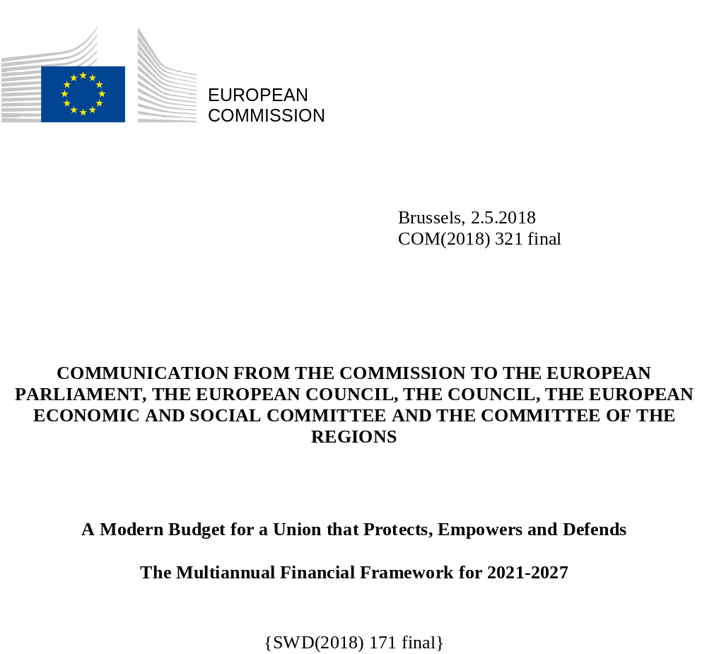

- A NEW, MODERN BUDGET FOR THE UNION OF 27
Once every seven years, the European Union decides on its future long-term budget – the Multiannual Financial Framework. The next such budget, starting on 1 January 2021, will be the first for the European Union of 27.
This is a pivotal moment for our Union. It is an opportunity for Member States and the European institutions to unite around a clear vision for the future of Europe. A time to show unequivocally that the Union is ready to back up its words with the actions needed to deliver on our common vision. A modern, focused EU budget will help to continue bringing to life the positive agenda proposed by President Jean-Claude Juncker in his State of the Union address before the European Parliament on 14 September 2016 and agreed by the Leaders of the 27 Member States in Bratislava on 16 September 2016, as well as in the Rome Declaration of 25 March 2017. A modern, focused EU budget will help to make the Union big on big and small on small things, as agreed in Rome.
Negotiations on the next Multiannual Financial Framework come at a time of new dynamism for the Union, but also of great challenges. The Union acted decisively in the wake of the financial and economic crisis to lay solid foundations for a sustainable recovery. The economy is now growing and creating jobs. The focus of the Union is increasingly on delivering efficiently and fairly on the things that really matter in the daily lives of citizens. And to do this for the citizens in all Member States of the Union. President Juncker’s call to overcome divisions and make the Union more united, stronger and more democratic should therefore also be reflected in the design of the new budget.
Choices taken in the coming months will shape the Union for decades to come. The stakes are high. Technological and demographic change is transforming our economies and society. Climate change and scarce resources are forcing us to look hard at how we can ensure that our way of living is sustainable. Unemployment, notably amongst young people, remains high in many parts of Europe. New security threats require new responses. The refugee crisis, caused by war and terror in Europe's neighbourhood, has shown the need to reinforce our capacity to manage migratory pressures and to address their root causes. Geopolitical instability is increasing and the values and democratic principles on which our Union is founded are being tested.
The proposals the Commission is presenting today for the 2021-2027 Multiannual Financial Framework will help responding to these opportunities and challenges. They are the product of an open and inclusive debate. The Commission has set out options for the future EU budget in its Communication of 14 February 2018. The Commission has listened carefully to the European Parliament, to Member States, to national Parliaments, to the beneficiaries of EU funding and to other stakeholders. Open public consultations held earlier this year generated more than 11,000 responses.
The Commission is proposing a new, modern long-term budget, tightly geared to the political priorities of the Union at 27. The proposed budget combines new instruments with modernised programmes to deliver efficiently on the Union’s priorities and to rise to new challenges. The proposals also show how the financing of the budget could be simplified and reformed to forge a stronger link with the political priorities. These proposals are designed to make a unique impact in building a prosperous, secure and cohesive Europe. They do so by focusing on the areas where the Union is best placed to deliver.
In each area, the Commission proposes the level of funding that will be needed to live up to our collective ambitions. The legal proposals for the individual future financial programmes will follow in the coming weeks.
The proposals also respond in a realistic and balanced way to the budgetary consequences of the withdrawal of the United Kingdom. The departure of an important contributor to the EU budget will have a financial impact and the future Financial Framework must take account of that. Maintaining a level of support that matches our ambitions across the priority areas will require additional contributions from all Member States in a fair and balanced way. In parallel, no effort must be spared to make the EU budget more efficient. The Commission is proposing savings in some of the main spending areas and reforms across the budget to make it more streamlined and to get the most from every euro.
Europe is in the midst of the biggest debate on its future for a generation. It was kickstarted by the Commission’s White Paper on the Future of Europe, published on 1 March 2017, and will culminate at the Informal Leaders’ Meeting in Sibiu, Romania on 9 May 2019. Weeks before Europeans take to the polls, this will be a time for the Leaders of the 27 Member States and for the European Parliament to stand up for the Europe they want and to equip the Union with the means to deliver. Decisive progress on the future long-term budget by this time will send out a strong message of resolve and determination to move forward together.
2019 will be a new start for our Union of 27. We must be ready for it. Time is short to put the new framework into place and make sure that the new programmes are ready to deliver for the EU’s citizens and businesses from day one. The new EU budget will be a simpler, more flexible and more focused budget. A budget guided by the principles of prosperity, sustainability, solidarity and security. A budget for a European Union that protects, empowers and defends. A budget that unites and does not divide. A budget that is fair for all Member States. A budget for Europe’s future. The work on this needs to start now.
- MODERNISING THE EU BUDGET
The EU budget has long been a vital source of growth-enhancing investment for the whole of Europe. Even in times of crisis, it has allowed the Union to support growth and job creation and to drive long-term innovation and economic reform. The creation of the European Fund for Strategic Investments (the “Juncker Fund”) illustrates well how the EU budget was able to provide a much-needed boost to Europe’s economic recovery at a critical moment. The EU budget has also been a decisive part of the response to our many serious challenges, from large-scale migratory flows, to security threats and climate change.
Recent experience has laid bare some weaknesses in the current framework. Despite some improvements, the EU budget is still too rigid. A lack of flexibility has prevented Europe from reacting quickly and effectively enough in a fast-changing world. Complex and divergent funding rules make it harder to access EU funding and divert attention from what really counts: achieving results on the ground. Funds are spread over too many programmes and instruments, both within and outside the budget. More can be done to modernise and simplify the two biggest spending blocks in the budget, the Common Agricultural Policy and Cohesion Policy. Many of the new priorities for a Union that protects, empowers and defends need new, tailored instruments to turn ambitions into reality.
The main message from the Commission’s extensive consultations has been received loud and clear. A more united, stronger and more democratic Europe needs a new, modern budget. And it needs fresh thinking on how that budget can deliver for people across the Union. The Commission’s thorough spending review has helped to pinpoint what has worked well in the past and what should be preserved in the next budget. But it also revealed where reform is needed to unlock the full potential of the EU budget. Based on this assessment, the Commission is proposing a modern framework and a set of new and reformed programmes shaped by the following principles:
- A stronger focus on European added value. The EU budget is modest in comparison with the size of the European economy and national budgets. This makes it vital that it invests in areas where the Union can offer real European added value to public spending at national level. Pooling resources can achieve results that Member States acting alone cannot. Examples include cutting-edge research projects that bring together the best researchers from across Europe, or empowering young people and small businesses to take full advantage of the opportunities the Single Market and the digital economy offer. Other instances when pooling resources helps us do more include catalysing key strategic investments. These investments hold the key to Europe’s future prosperity and its leadership on the global Sustainable Development Goals. The same is true when it comes to equipping the Union to defend and protect its citizens in a fast-changing world where many of the most pressing issues transcend national borders.
- A more streamlined and transparent budget. The Commission is proposing a more coherent, focused and transparent framework. The structure of the budget will be clearer and more closely aligned with priorities. The Commission proposes to reduce the number of programmes by more than a third, for example by bringing fragmented funding sources together into new integrated programmes and radically streamlining the use of financial instruments.
- Less red tape for beneficiaries. The Commission proposes to make rules more coherent on the basis of a single rulebook. This will drastically reduce the administrative burden for beneficiaries and managing authorities. It will facilitate participation in EU programmes and accelerate implementation. It will make it easier for different programmes and instruments to work together to boost the impact of the EU budget. In addition, the Commission will propose to simplify and streamline State aid rules to make it easier to link up instruments from the EU budget with national funding.
- A more flexible, agile budget. In an unstable geopolitical environment, Europe must be able to respond quickly and effectively to unforeseen demands. The Commission is proposing to build on existing mechanisms to make the budget more agile. This includes increasing flexibility within and between programmes, strengthening crisis management tools and creating a new “Union Reserve” to tackle unforeseen events and to respond to emergencies in areas such as security and migration.
- A budget that performs. The EU budget can only be judged a success if it delivers tangible results on the ground. The Commission is proposing to strengthen the focus on performance across all programmes, including by setting clearer objectives and focusing on a smaller number of higher quality performance indicators. This will make it easier to monitor and measure results – and to take make changes when necessary.
The design of future programmes is only the first step. The real test is whether the programmes deliver on the ground. The efficient and effective implementation of the next generation of programmes is therefore a high priority. This is a shared responsibility between the Commission, Member States, regional authorities and everyone involved in managing the EU budget.
It is also essential to strengthen the link between EU funding and the respect for the rule of law. The EU is a Community based on the rule of law, which also means that independent courts at national and EU level are entrusted with watching over the respect of our jointly agreed rules and regulations, and of their implementation in all Member States. Respect for the rule of law is an essential precondition for sound financial management and effective EU funding. The Commission is therefore proposing a new mechanism to protect the EU budget from financial risks linked to generalised deficiencies as regards the rule of law.
THE EU BUDGET AND THE RULE OF LAW
Under current rules, all Member States and beneficiaries are required to show that the regulatory framework for financial management is robust, that relevant EU rules are being complied with and that the necessary administrative and institutional capacity is in place. The current Multiannual Financial Framework also contains provisions to ensure that the effectiveness of EU funding is not undermined by unsound economic and fiscal policies.
The Commission is now proposing to strengthen the protection of the EU budget from financial risks linked to generalised deficiencies as regards the rule of law in the Member States. If such deficiencies impair or threaten to impair sound financial management or the protection of the financial interests of the Union, it must be possible to draw consequences for EU funding. Any measure taken under this new procedure will need to be proportionate to the nature, gravity and scope of the generalised deficiencies in the rule of law. It would not affect the obligations of the Member States concerned with regard to beneficiaries.
The decision as to whether a generalised deficiency in the rule of law risks affecting the financial interests of the EU will be proposed by the Commission and adopted by the Council through reversed qualified majority voting. It will take into account relevant information such as decisions by the Court of Justice of the European Union, reports from the European Court of Auditors, as well as conclusions of relevant international organisations. The Member State concerned will be given the opportunity to set out its reasoning before any decision is taken.

- A BUDGET FOR EUROPE’S PRIORITIES
The future long-term budget will be a budget for the Union’s priorities. The Commission’s proposals will bring the structure and the programmes of the EU budget fully into line with the positive agenda of the Union post-2020 as agreed in Bratislava and Rome. The new architecture of the future Multiannual Financial Framework will provide greater transparency on what the EU budget is for and how the different parts of the budget will contribute. It will also provide the flexibility necessary to respond to evolving needs.
Programmes will be arranged around the main thematic spending priorities. These will correspond to the headings in the formal budget structure. Within each priority, programmes will be grouped in policy clusters, which will be reflected in the titles of the annual budget. This will provide greater clarity on how they will contribute to policy goals.
In practice, the formal structure of the budget only tells part of the story. Many of the Union’s priorities are complex and multi-faceted. It would not be possible to tackle every aspect with a single programme. Under the Commission’s proposals, investment from multiple programmes will combine to address key crosscutting priorities such the digital economy, sustainability, security, migration, human capital and skills, as well as support for small businesses and innovation. The Commission proposes to simplify these interactions under the future framework, providing a much more coherent response to Europe’s challenges. The following sections set out the main reforms and programmes under each of the spending priorities.
More detailed information on the objectives, design and European added value of the individual programmes is contained in the Annex to this Communication.

The new Multiannual Financial Framework 2021-2027:
A Modern Budget for a Union that Protects, Empowers and Defends

 | I. SINGLE MARKET, INNOVATION & DIGITAL
1 Research & Innovation
- Horizon Europe
- Euratom Research & Training Programme
- International Thermonuclear Experimental Reactor (ITER)
2 European Strategic Investments
- InvestEU Fund
- Connecting Europe Facility
- Digital Europe Programme (including Cybersecurity)
3 Single Market
- Single Market Programme (including Competitiveness and Small and Medium-Sized Enterprises - COSME, Food Safety, Statistics, Competition and Administrative Cooperation)
- EU Anti-Fraud Programme
- Cooperation in the Field of Taxation (FISCALIS)
- Cooperation in the Field of Customs (CUSTOMS)
4 Space
- European Space Programme
 | II. COHESION & VALUES
5 Regional Development & Cohesion
- European Regional Development Fund
- Cohesion Fund
- Support to the Turkish-Cypriot Community
6 Economic & Monetary Union
- Reform Support Programme including the Reform Delivery Tool and the Convergence Facility
- Protection of the Euro Against Counterfeiting
7 Investing in People, Social Cohesion & Values
- European Social Fund + (including Integration of Migrants and Health)
- Erasmus+
- European Solidarity Corps
- Justice, Rights & Values
- Creative Europe (including MEDIA)
 | III. NATURAL RESOURCES & ENVIRONMENT
8 Agriculture & Maritime Policy
- European Agricultural Guarantee Fund
- European Agricultural Fund for Rural Development
- European Maritime & Fisheries Fund
9 Environment & Climate Action
- Programme for Environment & Climate Action (LIFE)

 | IV. MIGRATION & BORDER MANAGEMENT
10 Migration
- Asylum & Migration Fund
11 Border Management
- Integrated Border Management Fund
 |  | V. SECURITY & DEFENCE
12 Security
- Internal Security Fund
- Nuclear Decommissioning (Lithuania)
- Nuclear Safety and Decommissioning (including for Bulgaria and Slovakia)
13 Defence
- European Defence Fund
- Connecting Europe Facility – Military Mobility
14 Crisis Response
- Union Civil Protection Mechanism (rescEU)
 | VI. NEIGHBOURHOOD &  THE WORLD
15 External Action*
- Neighbourhood, Development and International Cooperation Instrument (including external aspects of migration)
- Humanitarian Aid
- Common Foreign & Security Policy
- Overseas Countries & Territories (including Greenland)
16 Pre-Accession Assistance
- Pre-Accession Assistance
 | VII. EUROPEAN PUBLIC ADMINISTRATION
17 European Public Administration
- Administrative Expenditure, Pensions and European Schools

 | INSTRUMENTS OUTSIDE THE MFF CEILINGS
- Emergency Aid Reserve
- EU Solidarity Fund
- European Globalisation Adjustment Fund
- Flexibility Instrument
- European Investment Stabilisation Function
*The European Peace Facility is an off-budget fund outside the Financial Framework

I. SINGLE MARKET, INNOVATION & DIGITAL
Investing in:
- Research and Innovation
- Key strategic infrastructure
- Strengthening the Single Market
- Strategic space projects
Europe’s future prosperity depends on the investment decisions we take today. The EU budget has long been a vital source of investment across Europe. Stepping up investment now in areas such as research, strategic infrastructure, digital transformation and the Single Market will be key to unlocking future growth and tackling common challenges such as decarbonisation and demographic change.
The new European research programme, Horizon Europe, will help Europe remain at the forefront of global research and innovation. As highlighted in the report of the High Level Group chaired by Pascal Lamy, investment in research will allow the Union to compete with other developed and emerging economies, ensure a prosperous future for its citizens, and preserve its unique social model. Building on the success of Horizon 2020, the new programme will continue to promote research excellence and strengthen the focus on innovation, for instance through the development of prototypes, intangible assets, knowledge and technology transfer. A new European Innovation Council will provide a one-stop shop for high potential and disruptive innovators, aiming to make Europe a front runner in market-creating innovation.
Building on the success of the European Fund for Strategic Investments in catalysing private investments throughout Europe, the Commission proposes to set up a new, fully integrated investment fund, InvestEU. In this way, a relatively limited amount of public resources can be used to mobilise significant private resources for much needed investments. With the European Investment Bank Group as the main implementing partner and other partners such as National Promotional Banks contributing to the delivery, InvestEU will anchor all centrally managed financial instruments inside the EU in a single, streamlined structure. This new approach will reduce overlaps, simplify access to funding and reduce administrative burden. With a contribution from the EU budget of EUR 15.2 billion, InvestEU is expected to mobilise more than EUR 650 billion of additional investment across Europe.
Cross-border infrastructure is the backbone of the Single Market, helping goods, services, businesses and citizens to move freely across borders. Through the reformed Connecting Europe Facility, the Union will continue to invest in trans-European transport, digital and energy networks. The future programme will better exploit the synergies between transport, digital and energy infrastructure, for example through developing alternative fuels infrastructure or sustainable and smart grids underpinning the Digital Single Market and the Energy Union. Building on the successful approach of the current programming period, part of the Cohesion Fund allocation (EUR 11.3 billion) will be transferred to the Connecting Europe Facility for transport projects offering high European added value.
In order to bridge the current digital investment gap, the Commission proposes to establish a new Digital Europe Programme to shape and support the digital transformation of Europe’s society and economy. Technological change and digitisation are changing our industries, societies, jobs and careers, as well as our education and welfare systems. By supporting strategic projects in frontline areas such as artificial intelligence, supercomputers, cybersecurity or industrial digitisation, and investing in digital skills, the new programme will help to complete the Digital Single Market, a key priority of the Union. The Commission proposes a combined increase of 64% in research, innovation and digital investment under direct management in the next Financial Framework. These investments will be complemented by research, innovation and digital projects supported by the European Structural and Investment Funds.
Investing in the future
In billion euro, current prices
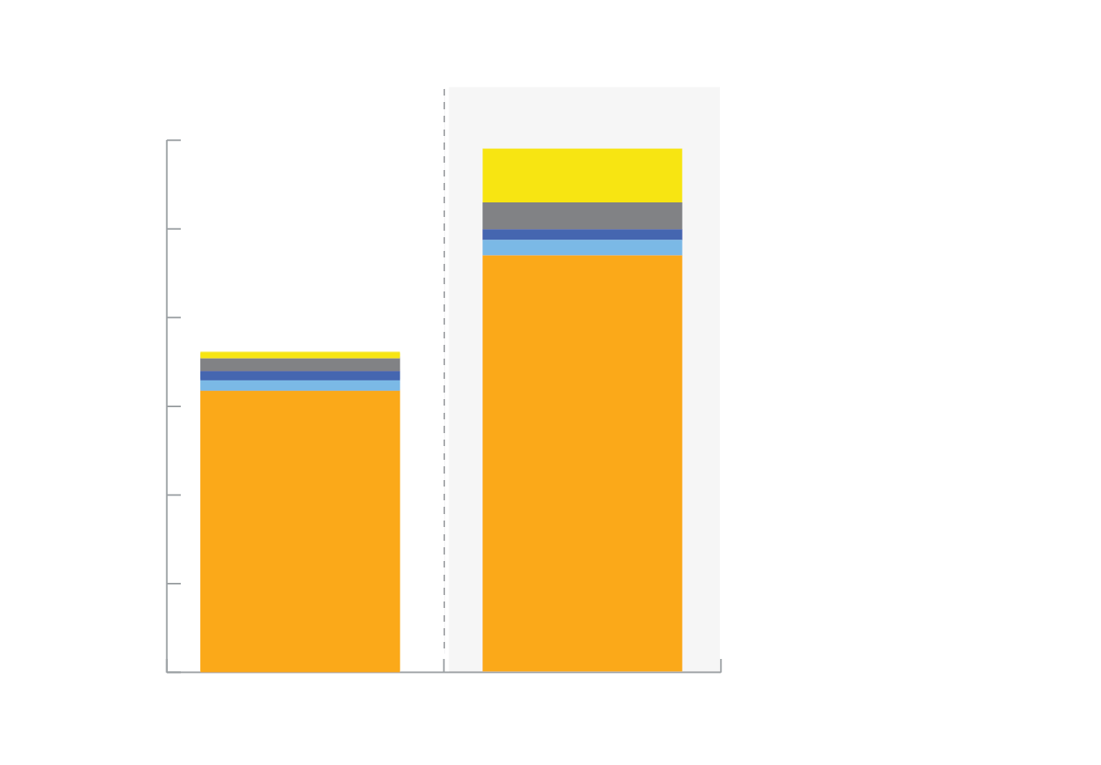
0
20
40
60
100
80
120
2014-2020
2021-2027
Digital Europe Programme and Connecting Europe Facility – Digital
International Thermonuclear Experimental Reactor (ITER)
Euratom Research
and Training Programme
Innovation Window
InvestEU Fund
Horizon Europe
Note: Compared to the Multiannual Financial Framework 2014-2020 at EU-27 (estimate)
Source: European Commission

A fully integrated space programme will bring together all of our activities in this highly strategic field. This will provide a coherent framework for future investment, offering increased visibility and more flexibility. By improving efficiency, it will ultimately help roll out new space-driven services that will benefit all EU citizens. The EU budget will also continue to fund Europe’s contribution to the development of the International Thermonuclear Experimental Reactor (ITER) project to develop a viable source of safe and environmentally friendly energy for the future.
The Commission is also proposing a new, dedicated programme to support the smooth running of the Single Market, Europe's best asset to generate growth in globalised markets, and contribute to the development of a Capital Markets Union. Building on the success of the current programme for the Competitiveness of Enterprises and Small and Medium-sized Enterprises (COSME), the Commission proposes to strengthen the support given to small business – the engine of our economy – to scale up and expand across borders. The new programme will help companies and consumers to better exploit the potential of the Single Market by putting in place information tools, developing standards, and supporting cooperation between administrations.
The Commission proposes to renew and reinforce the Customs programme, so as to support the further digitisation and modernisation of the customs union, which celebrates its 50th anniversary this year. In parallel, the Fiscalis programme will underpin deepened cooperation between tax administrations, including shared efforts to combat tax fraud and tax avoidance.

 | II. COHESION & VALUES
Investing in:
- Regional development and cohesion
- Completing the Economic and Monetary Union
- People, social cohesion and values
Economic and social conditions across Europe are improving and employment is strong in many parts of the Union. However, the effects of the economic crisis are still being felt in some parts of Europe. Some regions have fallen further behind, partly due to the effects of globalisation and the digital transformation. Significant disparities persist in the Union and societies face a range of new challenges. The EU budget plays a crucial role in contributing to sustainable growth and social cohesion, and in promoting common values and a sense of belonging to the EU.
The Commission is proposing to modernise and strengthen Cohesion Policy. Working together with other programmes, the funds will continue to offer essential support to Europe’s Member States and regions. The aim is to drive up convergence, to help reduce economic, social and territorial disparities within Member States and across Europe, as well to support delivering on the political priorities agreed in Bratislava and Rome.
Cohesion Policy will play an increasingly important role in supporting the ongoing economic reform process in the Member States. The Commission proposes to strengthen the link between the EU budget and the European Semester of economic policy coordination, which takes regional specificities into account. The Commission will propose dedicated investment-related guidance alongside the annual Country-Specific Recommendations, both ahead of the programming process and at mid-term to provide a clear roadmap for investment in reforms that hold the key to a prosperous future.
Economic and social conditions differ significantly between regions. Whereas there has been important upward convergence in many areas, some regions have actually diverged in recent years, even in relatively richer countries. This evolution should be reflected in Cohesion Policy, so that no region is left behind. The relative per capita gross domestic product will remain the predominant criterion for the allocation of funds – as the main objective of Cohesion Policy is and will remain to help Member States and regions lagging economically or structurally behind to catch up with the rest of the EU – while other factors such as unemployment (notably youth unemployment), climate change and the reception/integration of migrants will also be taken into account. The Commission also proposes to increase national co-financing rates to better reflect today’s economic realities. This will have the benefit of increasing ownership at national level, sustaining larger investment volumes and improving their quality. Due consideration will be given to the specificities of the outermost regions and sparsely populated areas.
The new legal framework will also allow for more efficient links with other EU programmes. For example, Member States will be able to transfer some of their allocated funds to the InvestEU fund, in order to have access to the guarantee provided by the EU budget. They will also be able to fund “Seal of Excellence” projects identified by the Horizon Europe programme as internationally excellent projects in their regions. This will help ensure that investment in infrastructure is well-coordinated with other EU investment in crucial areas such as research and innovation, digital networks, decarbonisation, social infrastructures and skills.
As announced by the Commission in December 2017, the future of the EU budget cannot be separated from the goal to bring about a more stable and efficient Economic and Monetary Union, to the benefit of the Union as a whole. Under the Treaties, all Member States of the EU are part of the Economic and Monetary Union, also the Member States with a derogation or an opt out, which all participate therefore in the European Semester process. Under the Treaties, the euro is the currency of the EU, and economic convergence and stability are objectives of the Union as a whole. This is why the tools to strengthen the Economic and Monetary Union must not be separate but part and parcel of the overall financial architecture of the Union.
THE EU BUDGET AND THE
ECONOMIC AND MONETARY UNION
A stable euro area is a precondition for the financial stability and prosperity of the entire Union. As announced in the package on Deepening Europe’s Economic and Monetary Union of 6 December 2017, the Commission is proposing new budgetary instruments for a stable euro area and for convergence towards the euro area within the Union framework. These new instruments will complement other EU funds, including the European Structural and Investment Funds and InvestEU, in supporting economic convergence, financial stability, job creation and investment.
A new, strong Reform Support Programme will offer technical and financial support for reforms at national level with an overall budget of EUR 25 billion. This new programme will be separate but complementary to the future European Structural and Investment Funds. It will include a Reform Delivery Tool providing financial incentives across all Member States for key reforms identified as part of the European Semester. It will focus on those reforms that can contribute most to making domestic economies more robust and that have positive spill over effects on other Member States. These include reforms in product and labour markets, education, tax reforms, the development of capital markets, reforms to improve the business environment as well as investment in human capital and public administration reforms. This new programme will also include a dedicated Convergence Facility to support non-euro area Member States seeking to adopt the single currency during the period of the next Multiannual Financial Framework. Allocations foreseen for the Convergence Facility will be transferred to the Reform Delivery Tool if by the end of 2023 an eligible Member State has not taken the necessary steps to claim support from the Convergence Facility. Participation in all three legs of the Reform Support Programme will be voluntary and Member States will keep full ownership of the reforms carried out.
A new European Investment Stabilisation Function will complement existing instruments at national and European level to absorb large asymmetric macroeconomic shocks in the euro area. As shown in the recent crisis, national automatic stabilisers alone may not be sufficient to cope with large asymmetric shocks and the cuts in investment that often result. In addition to the existing mechanisms, it is proposed that the EU budget will guarantee back-to-back loans of up to EUR 30 billion. The loans will be available to Member States complying with strict eligibility criteria for sound fiscal and economic policies. The European Investment Stabilisation Function will also provide an interest rate subsidy in order to provide the necessary funding for national budgets to maintain investment levels. This subsidy will be financed from contributions from euro area Member States equivalent to a share of monetary income (seigniorage). The European Investment Stabilisation Function could be complemented over time by additional sources of financing outside the EU budget, such as an insurance mechanism financed from voluntary contributions by Member States as well as a possible role for the European Stability Mechanism and for the future European Monetary Fund. The European Investment Stabilisation Function will be open to non-euro area Member States if they contribute to its financing according to the European Central Bank capital subscription key.
New budgetary instruments for a stable euro area within the Union
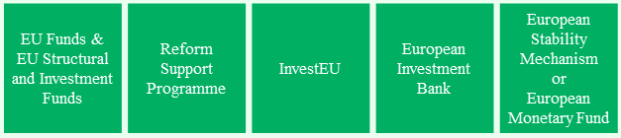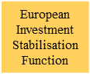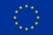
TECHNICAL ASSISTANCE
FINANCIAL CONTRIBUTIONS
LOANS
GRANTS
EXTRA GRANTS AND LOANS
NATIONAL REFORM PRIORITIES
NATIONAL PLATFORM FOR INVESTMENTS
Source: European Commission. Update of COM(2017) 822

The EU budget also has a vital role to play in delivering on the promises made by Leaders at the Gothenburg Social Summit in November 2017. This means strengthening the social dimension of the Union, including through the full implementation of the European Pillar of Social Rights. Within Cohesion Policy, a strengthened and restructured European Social Fund will amount to around EUR 100 billion over the period, representing a share of about 27% of cohesion expenditure. It will provide targeted support to youth employment, up- and re-skilling of workers, social inclusion and poverty reduction. To maximise the impact of funding in this area, the Commission proposes to pool the resources of the European Social Fund, the Youth Employment Initiative, the Fund for European Aid to the Most Deprived, the Employment and Social Innovation programme and the Health programme into one comprehensive instrument.
The Commission proposes a stronger “youth” focus in the next Financial Framework. This will be achieved by more than doubling the size of Erasmus+ and the European Solidarity Corps. The Erasmus+ programme, one of the Union’s most visible success stories, will continue to create opportunities for the education and mobility of young people. The focus will be on inclusiveness, and to reach more young people from disadvantaged backgrounds. This will allow more young people to move to another country to learn or work. A more powerful Erasmus+ programme will reach a size of EUR 30 billion over the period and also include an amount of EUR 700 million for Interrail passes for young people. The Commission also proposes to establish a single European Solidarity Corps, integrating the existing EU Aid Volunteers programme. This will offer European citizens a unique opportunity to engage in humanitarian activities with people in need within and outside Europe.
The Commission proposes a new Justice, Rights and Values Fund, comprising the Rights and Values and Justice programmes. At a time where European societies are confronted with extremism, radicalism and divisions, it is more important than ever to promote, strengthen and defend justice, rights, and EU values, which have profound and direct implications for political, social, cultural and economic life in Europe: respect for human dignity, freedom, democracy, equality, the rule of law and human rights. Creating opportunities for engagement and democratic participation in political and civil society are essential tasks for the future EU budget. As part of the new Fund, the Justice Programme will continue to support the development of an integrated European justice area and cross-border cooperation.
Culture is and must be at the heart of the European project. Cultural and linguistic diversity as well as our cultural heritage are the defining characteristics of our continent and our European identity. Through the Creative Europe programme, the Commission wants to place a strong emphasis in the next budget on support for culture and the audiovisual sector, including with a strong MEDIA strand with reinforced funding to support the European creative and audiovisual industry.
The EU’s crisis management instruments have proven their worth in recent years. Outside the EU budget, the Commission proposes to maintain and reinforce the European Union Solidarity Fund, which supports Member States in recovering after severe natural disasters, and the European Globalisation Adjustment Fund, which offers one-off assistance to workers who have lost their jobs in the context of a significant number of unexpected dismissals caused by the adverse effects of developments in global trade and economic disruption.

III. NATURAL RESOURCES & ENVIRONMENT
Investing in:
- Sustainable agriculture and maritime sectors and a safe, high-quality food supply
- Climate action and environmental protection
Sustainability is a common thread through the work of the Union in many different areas. This is both by necessity and by choice. Through modernised agricultural and maritime policies, dedicated funding for climate action and environmental protection, the mainstreaming of climate across the budget and enhanced integration of environmental objectives, the EU budget is a driver of sustainability.
The Commission is proposing a reformed, modernised Common Agricultural Policy. This will allow a fully integrated Single Market for agricultural goods in the EU to be maintained. It will also ensure access to safe, high quality, affordable, nutritious and diverse food. The reformed policy will place greater emphasis on the environment and climate. It will support the transition towards a fully sustainable agricultural sector and the development of vibrant rural areas.
The reformed policy will, with EUR 365 billion, continue to be built around two pillars: direct payments to farmers and rural development funding. For the latter, the Commission proposes to increase national co-financing rates. Management will be shared between the EU and the Member States. The Commission proposes to introduce a new delivery model, shifting from today’s compliance-based policy to a result-oriented policy to deliver on common objectives set at EU level but more flexibly implemented at national level.
Direct payments to farmers will remain an essential part of the policy, but will be streamlined and better targeted. A more balanced distribution will be promoted and a compulsory cap on amounts received or degressive payments will be introduced at farm level. This will mean that support is redistributed towards medium-sized and smaller farms, and possibly to rural development. Direct payment levels per hectare between Member States will continue to converge towards the EU average.
The new policy will require a higher level of environmental and climate ambition by strengthening conditionality for direct payments, consistent with environmental policies, ring-fencing a significant part of rural development funding for actions beneficial to the climate and the environment and introducing voluntary eco-schemes in the budget for direct payments within a performance-based and strategic framework.
In order to address crises generated by unforeseeable developments in international markets, or by a specific shock to the agricultural sector due to actions undertaken by third countries, a new crisis reserve will be established.
Through the European Maritime and Fisheries Fund, the EU budget will continue to support a sustainable EU fisheries sector and the coastal communities dependent on it. Promoting the blue economy in fisheries and aquaculture, tourism, clean ocean energy or blue biotechnology, provides real European added value by encouraging governments, industry and stakeholders to develop joint approaches to drive growth, while safeguarding the marine environment.
The Commission proposes to continue and strengthen the well-established programme for the environment and climate action, LIFE, which will also support measures promoting energy efficiency and clean energy. To supplement targeted nature preservation efforts, the Commission is also reinforcing the synergies with Cohesion Policy and the Common Agricultural Policy to finance investment in nature and biodiversity.
More broadly, in line with the Paris Agreement and the commitment to the United Nations Sustainable Development Goals, the Commission proposes to set a more ambitious goal for climate mainstreaming across all EU programmes, with a target of 25% of EU expenditure contributing to climate objectives.

IV. MIGRATION & BORDER MANAGEMENT
Investing in:
- A comprehensive approach to managing migration
- Strengthening the management of external borders
The challenges of managing refugee flows and migration confirm the need for action at European level. The EU budget played a key role in funding a common response to the various dimensions of the migration crisis. The Commission proposes to increase support to strengthen our external borders, to improve the asylum system within the Union, and to step up the management and long-term integration of migrants.
The effective protection of our external borders is a prerequisite for ensuring a safe area for the free movement of persons and goods within the Union. This includes the proper management of flows of persons and goods and safeguarding the integrity of the customs union. A new integrated Border Management Fund will provide vital and reinforced support to Member States in the shared responsibility of securing the common external borders of the Union. The Fund will cover border management, visas and customs control equipment. It will help ensure equivalence in the performance of customs controls at the external borders. This will be achieved by addressing the current imbalances between Member States due to geographical, capacity and resource differences. This will not only strengthen customs controls but also facilitate legitimate trade, contributing to a secure and efficient customs union.
In an increasingly interconnected world and given the demographic dynamics and instability in Europe's neighbourhood, migration will continue to remain a long-term challenge for the Union. It is clear that this can be better managed by Member States, with the financial and technical support of the EU. The role of the Union budget is therefore pivotal in supporting the management of asylum seekers and migrants, in developing search and rescue capacities to save the lives of those attempting to reach Europe, in managing effective returns and in other actions that need a coordinated response beyond the capacity of individual Member States.
The Commission proposes to reinforce the Asylum and Migration Fund to support the work of national authorities to provide reception to asylum seekers and migrants in the period immediately after arrival on EU territory, as well as developing a common asylum and migration policy and ensuring effective returns. Cohesion Policy will provide support to facilitate the long-term integration after the initial phase of reception. The instruments under the external policy will address the root causes of migration and support cooperation with third countries on migration management and security, thus contributing to the implementation of the Partnership Framework on migration.
These efforts need to be complemented by a strong and fully operational European Border and Coast Guard (FRONTEX) at the core of a fully integrated EU border management system. The Commission proposes to create a standing corps of around 10,000 border guards by the end of the financial period. It will also provide financial support and training for the increase of the national border guard component in Member States. This will also allow for the stepping up of operational capacity, the reinforcement of existing tools and the development of EU wide information systems for borders, migration management and security.
Overall, the EU budget for the management of external borders, migration and refugee flows will be significantly reinforced, totalling nearly EUR 33 billion, compared to EUR 12.4 billion for the period 2014-2020.
A strong focus on migration and protecting our external border
In billion euro, current prices

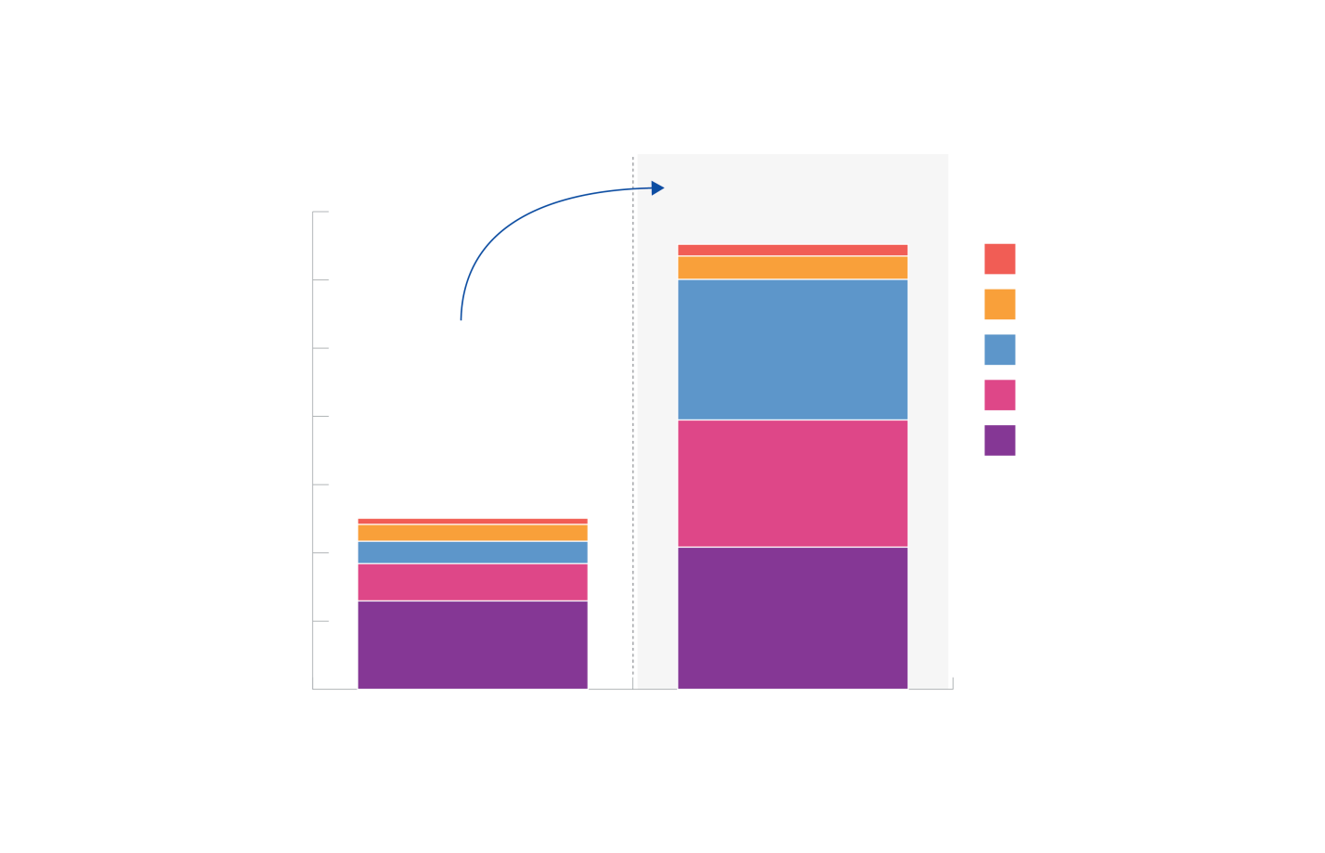
European Asylum Support Office
euLISA*
European Border and Coast Guard Agency
Border Management, incl. Customs Equipment
Asylum and Migration
x 2.6
30
25
15
10
0
20
5
Multiannual Financial Framework 2014-2020
Multiannual Financial Framework 2021-2027
35
* The European Agency for the operational management of large-scale IT Systems in the area of freedom, security and justice
Note: Compared to the Multiannual Financial Framework 2014-2020 at EU-27 (estimate)
Source: European Commission

V. SECURITY & DEFENCE
Investing in:
- The security and safety of Europe’s citizens
- Improving Europe’s defence capacities
- Response to crisis
Over recent years, security threats have intensified and diversified in Europe. They have come in the form of terrorist attacks, new types of organised crime, as well as cybercrime. Security has an inherently cross-border dimension and therefore a strong, coordinated EU response is required. Beyond internal security challenges, Europe faces complex external threats that no Member State can meet on its own. To be ready to protect its citizens, Europe also needs a step change to enhance its strategic autonomy and to build well-designed and streamlined instruments in relation to defence.
The Commission proposes to reinforce the Internal Security Fund in order to develop networks and common systems for efficient cooperation between national authorities and to improve the capacity of the Union to face these security threats. This will be complemented by efforts to strengthen cybersecurity in all relevant programmes focused on digital technologies, infrastructures and networks, research and innovation as well as targeted defence against cybercrime, notably through the Digital Europe Programme and Horizon Europe.
The Commission also proposes to reinforce the European Union Agency for Law Enforcement Cooperation (Europol). This will increase its ability to support the work of national authorities and provide a European response to security threats.
The Union will continue to provide strictly targeted financial support for the decommissioning and safety of nuclear activities in some Member States (Lithuania, Bulgaria and Slovakia), as well as its own nuclear installations. The EU budget will also provide lasting support for the health of workers and the general public, preventing environmental degradation and contributing to nuclear safety and security.
In the area of defence, the Union will need to take greater responsibility for protecting its interests, values and the European way of life, complementing the work of the North Atlantic Treaty Organisation. While Europe cannot substitute Member States’ efforts in defence, it can encourage and leverage their collaboration in developing the defence capabilities needed to address common security challenges. The Commission proposes a strengthened European Defence Fund that will aim to foster the competitiveness and innovative capacity of the defence industry throughout the Union by supporting collaborative actions at each stage of the industrial cycle, starting with research. This will avoid duplication, allow for economies of scale and ultimately result in a more efficient use of taxpayers’ money. In addition, the Commission proposes that the Union enhances its strategic transport infrastructures so as to make them fit for military mobility, through the Connecting Europe Facility.
Developments in recent years have shown that the Union must be able to deploy operational assistance rapidly to deal with unexpected developments, natural and man-made disasters. This is why the Commission is proposing to increase the resources available for crisis response. This will be achieved through a reinforced Civil Protection Mechanism (rescEU) and an enlarged Emergency Aid Reserve, to provide financial means above the ceilings set in the Financial Framework in case of emergencies inside and outside the Union. The Commission also proposes maintaining unallocated reserves in certain programmes, such as the Asylum and Migration Fund and the Internal Security Fund, to be used in the event of crisis and emergency situations.
A step change for security and defence
In billion euro, current prices
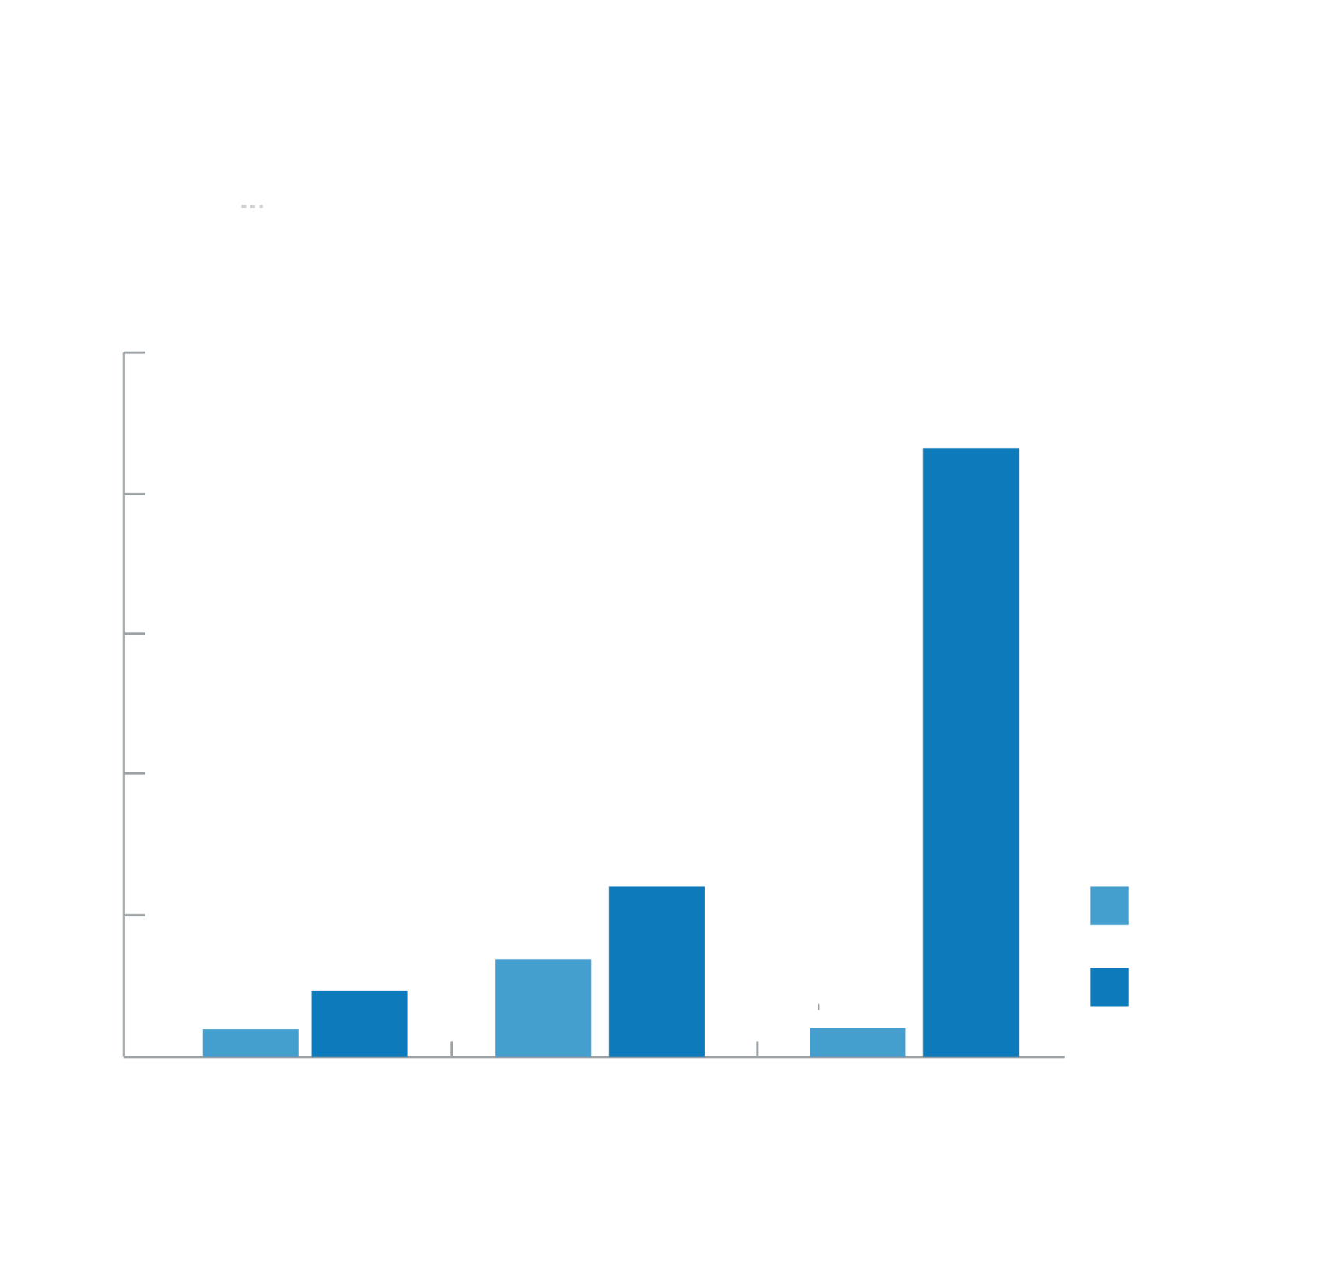
Civil Protection Mechanism (rescEU)
Internal Security
Defence Fund
2014-2020
2021-2027
x 2.5
x 1.8
x 22
3
12
9
6
0
15
Note: Compared to the Multiannual Financial Framework 2014-2020 at EU-27 (estimate)
Source: European Commission

VI. NEIGHBOURHOOD & THE WORLD
Investing in:
- The Union’s external action in its neighbourhood, in developing countries and the rest of the world
- Assistance for countries preparing for accession to the Union
The challenges for the EU’s external action, including those defined in the Global Strategy for the EU Foreign and Security Policy, the reviewed European Neighbourhood Policy, and the new European Consensus on Development, require a significant modernisation of the external dimension of the budget to increase its effectiveness and visibility. Stronger co-ordination between external and internal policies is also needed with a view to implementing the Sustainable Development Goals and the Paris Climate Agreement, as well as the Partnership Framework with third countries on migration.
The Commission is therefore proposing a major restructuring of the Union’s external action instruments to provide more coherence between instruments, to exploit economies of scale and synergies between programmes and to simplify processes. This will make the Union better equipped to pursue its goals and project its interests, policies and values globally.
The proposed new architecture for the Union’s external action instruments reflects the need to focus on strategic priorities both geographically – the European Neighbourhood, Africa and the Western Balkans, as well as countries that are fragile and most in need, but also thematically – security, migration, climate change and human rights.
The Commission proposes to bring together most of its existing instruments into a broad Neighbourhood, Development and International Cooperation Instrument with worldwide coverage. The financial architecture will be further simplified via the integration of the European Development Fund, to date the EU’s main instrument for providing assistance to African, Caribbean and Pacific countries and to overseas countries and territories.
The broad instrument will have ring-fenced budget allocations per geographical region, including the Neighbourhood and Africa. At the same time it will offer more flexibility in responsiveness and a wider range of options for actions to better serve the Union's priorities. This will also include a “emerging challenges and priorities cushion” to allow for flexibility in response to existing or emerging urgent priorities, notably in the areas of stability and migration.
Building on the European External Investment Plan and its European Fund for Sustainable Development, a new external investment architecture will allow for the “crowding-in” of additional resources from other donors and from the private sector. This will help to address development challenges, by complementing grants with budget guarantees, other market-based instruments, technical assistance, “blending”, and possible participation in the capital of development financial institutions, allowing to further advance the Union’s objectives and policies. In addition, macrofinancial assistance will contribute to addressing economic crises.
The Instrument for Pre-Accession Assistance will support candidate countries and potential candidates on their path to fulfilling the accession criteria. It will moreover contribute to the achievement of broader European objectives of ensuring stability, security and prosperity in the immediate neighbourhood of the Union. It will also be positioned in the context of the Western Balkans Strategy and will reflect the developments in relations with Turkey.
Together with its international partners and action by Member States, the Union will continue to play a leading role in humanitarian assistance. The Commission proposes a strengthened Humanitarian Aid instrument to provide needs-based delivery of EU assistance to save and preserve lives, prevent and alleviate human suffering, and safeguard the integrity and dignity of populations affected by natural disasters or man-made crises.
Europe as a strong global player
In billion euro, current prices
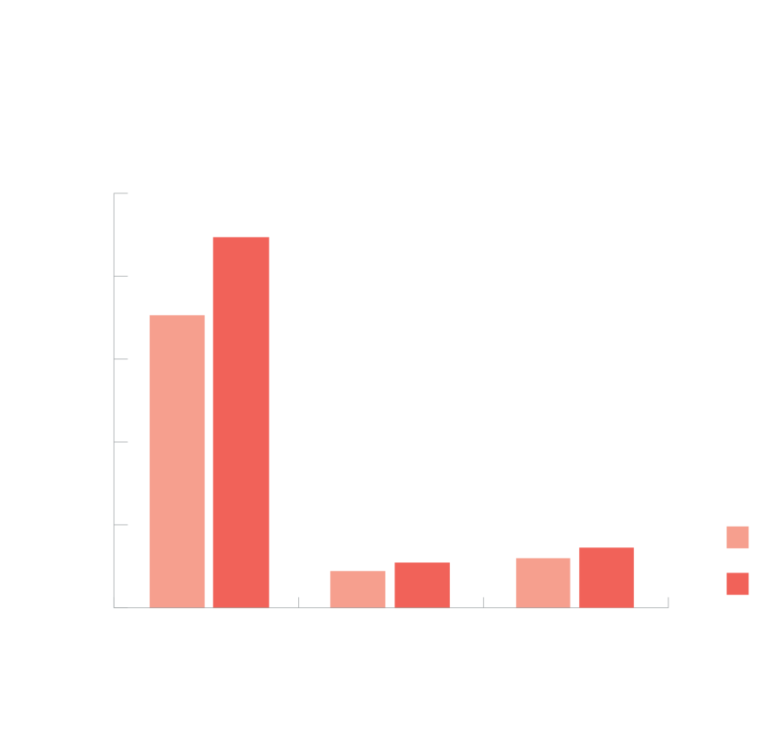
x 1.2
100
80
40
0
60
20
2014-2020
2021-2027
Neighbourhood, Development and International Cooperation Instrument
Humanitarian Aid
Pre-Accession Assistance
x 1.3
x 1.2
Neighbourhood
Sub-Saharan Africa
Asia, Middle East
and Pacific
Americas and Caribbean
Neighbourhood, Development and International Cooperation Instrument
Engage with partners
Emerging Challenges and Priorities Cushion
Rapid Response
Reaching Common Goals
Stability and Peace
Other Global Challenges
Democracy & Human Rights / Civil Society in Development
Note: Compared to the Multiannual Financial Framework 2014-2020 at EU-27, including the European Development Fund (estimate)
Source: European Commission

The Union must also contribute to the prevention of crises, restoration of peace, public order, or stabilisation of all countries or regions in the world faced with conflict or disorder. Under the Treaties, the EU budget is not able to cover all EU areas of action in the field of external security and defence. This has hampered the impact, effectiveness and sustainability of the overall EU action. To address this, the High Representative of the Union for Foreign Affairs and Security Policy, with the support of the Commission, will propose a separate extra-budgetary funding mechanism, the European Peace Facility. This Facility aims to close the current gap in the EU’s ability to conduct Common Security and Defence Policy missions and to provide military and defence assistance to relevant third countries, international and regional organisations. The Facility will allow the Union to do more and to act more swiftly to prevent conflicts, promote human security, address instability and work towards a safer world.

VII. EUROPEAN PUBLIC ADMINISTRATION
Investing in:
- An efficient and modern public administration at the service of all Europeans
The European public administration is small in comparison with national and even many regional and local administrations. However, it plays a crucial role in helping the Union to deliver on its priorities and to implement policies and programmes in the common European interest.
In recent years, the European administration has undergone deep reform. As part of the agreement on the current Multiannual Financial Framework in December 2013, the reform of the staff regulations introduced significant efficiency measures. In addition, institutions undertook to reduce staffing levels by 5%. The Commission has implemented this commitment in full and other institutions, bodies, and agencies are also implementing this reduction, leading to a decrease of the relative share of the Commission’s staff in all European bodies. The Court of Auditors has recently concluded that the reduction has broadly been achieved by all institutions and bodies.
It should be noted that these reforms were made at a time when the Union’s staff needed to intensify work, take on new tasks in new priority areas, and address unforeseen challenges such as the migration and refugee crises.
The European public administration should seek to operate as efficiently as possible. The Commission is continually seeking to make the most of synergies and efficiencies. However, the administration must be adequately resourced to deliver on its essential functions. The need to invest in information technologies and the upgrading of buildings will not disappear in the future. The withdrawal of the United Kingdom will result in a limited reorientation of some functions within the administration but the scope of activities will not change – and in some new priority areas will be intensified. Translation and interpretation services in the English language will also remain unaffected.
The ceiling set for the Union’s administrative expenditure in 2020 represents 6.7% of the overall Multiannual Financial Framework. This covers the administrative expenditure of all EU institutions, pensions and the costs of the European Schools. Following the significant efforts made notably by the Commission in the current period, a further reduction would call into question the functioning of the EU institutions and efficient policy delivery and implementation. A strong European Union with many additional tasks entrusted to it by the Member States needs an efficient and agile civil service, capable of attracting talented people from all Member States to work for the benefit of all Europeans. The Commission therefore proposes to maintain the situation of administrative spending at its current level.

- MATCHING PRIORITIES WITH RESOURCES
To turn the political priorities agreed at EU level into results on the ground, well-designed programmes must be equipped with sufficient resources to make a difference. As explained in the Commission’s contribution to the Informal Leaders’ Meeting in February, decisions taken on levels of financing for the future long-term budget cannot be separated from the Union’s ambitions in each of the priority areas.
The Commission’s proposals are based on a rigorous assessment of the resources needed to deliver efficiently on the Union’s goals, and of the efficiency and added value of spending in each area. Through well-designed programmes, efficient implementation and intelligent combination with other sources of financing, even a modest EU budget can have a significant impact. However, there are limits to what this can achieve and, if Europe wants to move forward together on its positive agenda, it will require a budget to match.
The key challenge for the future EU budget is to provide adequate support for new and existing priorities while also addressing the shortfall in national contributions resulting from the United Kingdom’s withdrawal. The Commission proposes a balanced approach. New priorities should be financed predominantly by new resources. The shortfall arising from the United Kingdom’s departure should be partly matched by new resources and partly by savings and redeployments from existing programmes.
In order for the EU budget to make a meaningful contribution in many of the new priority areas, in particular where new instruments are being created, current levels of funding will need to be increased. Investing now in areas such as research and innovation, young people and the digital economy will pay rich dividends for future generations. This is why the Commission proposes significant increases in priority areas.

New and reinforced priorities for the Union at 27

Research, Innovation, Digital
Youth
LIFE Climate & Environment
Migration & Borders
Security
External Action
x 1.6
x 2.2
x 1.7
x 2.6
x 1.8
Combined increase = + €109 billion
Combined increase = + €114 billion
x 1.3
Climate Mainstreaming
contributing to climate objectives
20% of the Multiannual Financial Framework
2014-2020, EU 28 = € 206 billion
25% of the Multiannual Financial Framework
2021-2027, EU 27 = € 320 billion
x 1.6
Increase under the new long-term EU Budget
Note: Compared to the Multiannual Financial Framework 2014-2020 at EU-27, including the European Development Fund (estimate)
Source: European Commission

At the same time, the Commission has critically examined where savings can be made without undermining the added value of EU programmes. As part of this effort, the Commission proposes that the budget allocation to the Common Agricultural Policy and Cohesion Policy be moderately reduced to reflect the new context and to free up resources for other activities. The modernisation of these policies will allow them to continue to deliver on their core objectives while also contributing to new priorities. For example, Cohesion Policy will have an increasingly important role to play in supporting structural reform and the integration of migrants.
The result of these changes will be a rebalancing of the budget and an increasing focus on the areas where the European added value is highest.

Evolution of main policy areas in the EU budget
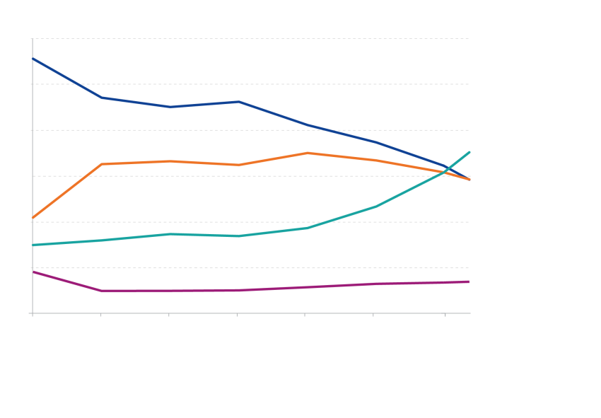
Common Agricultural Policy and Fisheries
Economic, Social and Territorial Cohesion
Other Programmes
European Public Administration
1988-1992
1993-1999
1995-1999*
2000-2006
2007-2013
2014-2020
*Adjusted for 1995 enlargement
2021-2027
0%
10%
20%
30%
40%
50%
60%
Source: European Commission

Overall, through a combination of additional contributions and savings, the Commission proposes a Multiannual Financial Framework of EUR 1,279 billion in commitments over the period 2021-2027, equivalent to 1.114% of the EU-27 gross national income. This is comparable to the size of the current Financial Framework in real terms including the European Development Fund.

The size of the EU budget as a percentage of gross national income (GNI)
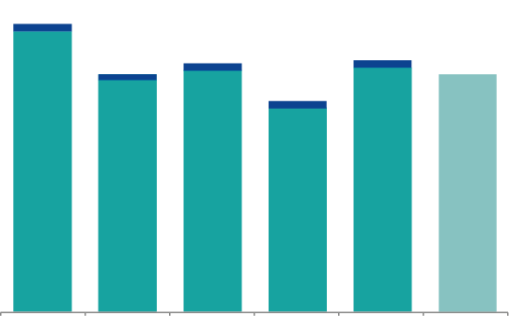
0.03%
Average
1993-1999
Average
2000-2006
Average
2007-2013
Average
2014-2020
2021-2027**
1.25%
1.09%
1.00%
0.03%
0.02%
0.03%
0.03%
1.12%
Commitments ceiling in % EU GNI
*2014-2020 estimated commitments
(UK expenditure excluded) in % EU27 GNI
** European Development Fund integrated ("budgetised")

European Development Fund
Average
2014-2020,
EU-27*
1.11%
1.13%
0.03%

This level of commitments translates into EUR 1,246 billion in payments, corresponding to 1.08% of the EU-27 gross national income, to implement the current and future spending programmes until 2027. In order to ensure compliance with the own resources ceiling in force, in particular in the first two years of the next Multiannual Financial Framework, the Commission proposes a reduction of the pre-financing rate for Cohesion Policy and rural development programmes.
The proposed Financial Framework will run for seven years, from 2021 to 2027, with a mid-term review in 2023. The Commission recognises the merit of progressively synchronising the duration of the Financial Framework with the five-year political cycle of the European institutions. However, moving to a five-year cycle in 2021 would not offer an optimal alignment. The proposed seven-year cycle will give the Commission taking office following the European elections of 2024 the opportunity to present, if it so chooses, a new framework with a duration of five years, starting in 2028.

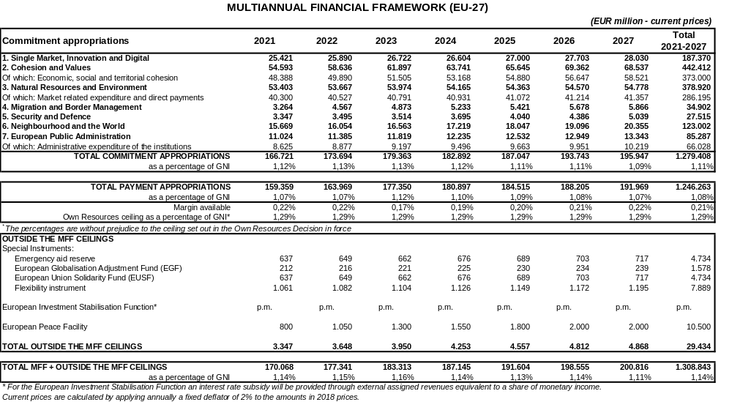

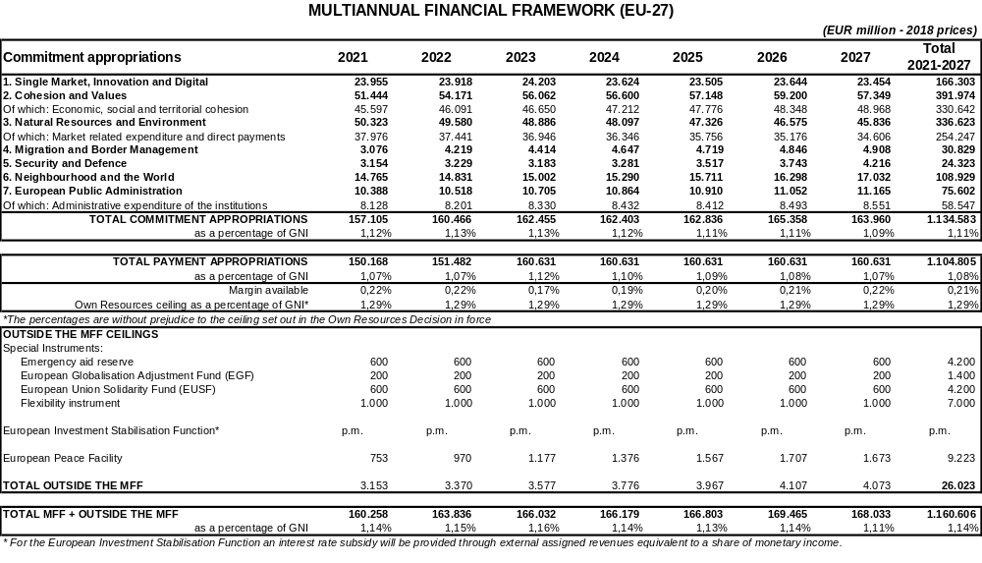

Recent experience has shown that flexibility within the framework is paramount. The numerous challenges that the Union has faced in recent years have stretched the existing flexibilities to their limits. The EU budget must be flexible enough to allow the Union to respond quickly and effectively to unforeseen needs. The Commission is therefore proposing to revamp the existing flexibility mechanisms and to introduce a new “Union Reserve”.
- Flexibility within and between programmes. The Commission will propose built-in reserves to create flexibility within programmes. In addition, it is proposed that the amount that can be transferred from one programme to another within the same heading will be increased from 10% to 15%. The Commission also proposes the possibility of “blending” different forms of financial support, moving between different modes of management, “reprogramming” funding at mid-term as well as specific revisions of national allocations to adjust to developments over the period. This will increase flexibility still further, while preserving the fairness of the system.
- Flexibility between headings and years. Beyond ensuring sufficient unallocated margins, the Commission proposes to fully exploit the Global Margin for Payments introduced under the current framework. The Commission proposes to expand the size and scope of the Global Margin for Commitments in order to establish a “Union Reserve”. This will be financed from margins left available under the ceilings for commitments of the previous financial year, as well as through funds that have been committed to the EU budget but ultimately not spent in the implementation of programmes. This Reserve is a powerful new tool to tackle unforeseen events and to respond to emergencies in areas such as security and migration. It will also help address the economic and social consequences of trade disruptions once other available instruments have been exploited.
- “Special instruments”. The Commission has reviewed the scope of special instruments such as the Emergency Aid Reserve, the European Union Solidarity Fund and the European Globalisation Adjustment Fund. These instruments allow additional financial means to be entered in the EU budget over and above the ceilings set for the Financial Framework. The Commission proposes, where appropriate, to widen the scope of the instruments, for instance by allowing the activation of the Emergency Aid Reserve for emergencies inside the EU. The Commission also proposes to streamline the procedures for mobilising these instruments, and to increase the size of the flexibility instrument to EUR 1 billion (in 2018 prices) per year.
- A MODERN SYSTEM FOR FINANCING THE EU BUDGET
The spending and revenue sides of the budget are two sides of the same coin. Both require modernisation to maximise the contribution of the EU budget to the Union’s political priorities. In line with the recommendations of the High Level Group on the “Future Financing of the EU”, chaired by Mario Monti, the Commission proposes to modernise and simplify the existing Own Resources system and diversify the sources of revenue.
With the withdrawal of the United Kingdom, the associated budgetary rebate will end. The same is true for the rebates on the United Kingdom rebate that have been granted to some Member States. Rebates related to reduced call rates for the Value Added Tax-based Own Resource and the lump sum reductions for contributions based on gross national income will automatically expire at the end of 2020.
This presents an opportunity to simplify and reform the system, and to strengthen the alignment with Union policies and priorities. The Commission proposes to eliminate all corrections on the revenue side as part of a fair and balanced budget package. The collection costs retained by Member States from the traditional Own Resources will be restored from 20% to the original level of 10% to better align financial support for customs equipment, staff and information with the actual costs and needs. The impact of these measures in relation to the burden of customs control will be closely monitored.
The elimination of all rebates and the reduction of collection costs for custom revenue will increase the fairness of the Multiannual Financial Framework. However, the elimination of rebates will entail significant increases of contributions for certain Member States in the next Multiannual Financial Framework compared to their current situation.
In order to avoid a significant and sudden increase in their contribution as of 2021 of these Member States, it is proposed to phase out the current rebates over time. For this purpose all corrections on the revenue side of the budget will be transformed into transparent lump sum payments per Member State. These lump sums should be gradually decreased over five years until the national contributions (measured in percent of gross national income) reach a fair level comparable to other Member States not benefiting from a rebate.
As part of the modernisation of the Own Resources system and in addition to the traditional customs duties and gross national income-based contributions to the EU budget, the Commission proposes to simplify the current Value Added Tax based Own Resource, to base it on standard rated supplies only, while remaining fully compatible with the recent Commission proposal for a definitive Value Added Tax system in the EU. The Commission also proposes to forge a stronger link between the financing of the budget and the Union’s policies by introducing a basket of new Own Resources. This basket is composed of a share of revenues from:
- Emissions Trading System: the European Emissions Trading System is a key tool of EU action to reduce greenhouse gas emissions cost effectively and has a direct link with the functioning of the Single Market. The Commission proposes to allocate a share of 20% of the Emissions Trading System revenues to the EU budget, while protecting the correction mechanisms already embedded in the system.
- The relaunched Common Consolidated Corporate Tax Base, to be phased in once the necessary legislation has been adopted. This will link the financing of the EU budget directly to the benefits enjoyed by companies operating in the Single Market.
- A national contribution calculated on the amount of non-recycled plastic packaging waste. This will create an incentive for Member States to reduce packaging waste and stimulate Europe’s transition towards a circular economy by implementing the European plastics strategy.
On the basis of the Commission's proposals, the new Own Resources could contribute on average EUR 22 billion per year corresponding to about 12% of total EU budget revenue. The new Own Resources will contribute to financing the new priorities in the budget. This will also allow national contributions based on gross national income to be reduced accordingly.
The proposed reforms of the system of Own Resources are about changing the way the budget is funded, not about its overall size. Diversifying the sources of budgetary income will increase the resilience of the EU budget. Coupled with the gradual rebalancing of the budget from nationally allocated programmes towards new priorities, this will help to sharpen the focus on European added value and help ensure that both sides of the budget contribute to the Union’s political priorities.
The integration of the European Development Fund into the EU budget will need to be accompanied by an increase in the ceilings established in the Own Resources decision. A sufficient margin between the payments and the own resources ceiling is necessary to ensure that the Union is able - under any circumstances - to fulfil its financial obligations, even in times of economic downturns. The Commission proposes to increase the own resources ceilings for payments and commitments to 1.29% and 1.35% of the EU-27 gross national income, respectively.
- CONCLUSION – A FRESH START FOR THE UNION AT 27
The Commission’s proposals on the future Multiannual Financial Framework are the beginning of a process that will determine whether the Union has the means to deliver on the positive agenda agreed in Bratislava and Rome. The final decision will fall to the Council, acting by unanimity, with the consent of the European Parliament.
A balanced agreement on a modern EU budget will show that the Union is united, reinvigorated and ready to move forward together.
The proposals are based on an honest assessment of the resources the Union will need to deliver on its collective ambitions. They offer a fair and balanced approach to the challenges of supporting political priorities and addressing the financial consequences of the withdrawal of the United Kingdom. They show how a reformed, simpler, and more flexible budget will allow the Union to put every euro to work for all Member States and all Europeans.
Building on these foundations, the Commission will present detailed proposals for the future financial programmes between 29 May and 12 June. It will then be for the European Parliament and the Council to take them further.
Negotiations on the current Multiannual Financial Framework took too long. As a result, the launch of key financial programmes was delayed. This was more than an administrative inconvenience. It meant that projects with real potential to spur the economic recovery were postponed and vital sources of funding took longer to reach those who needed it.
This is why it is our duty to all Europeans to approach the upcoming negotiations on the long-term EU budget with the clear objective of finding an agreement before the European Parliament elections and the Leaders’ Summit in Sibiu on 9 May 2019.
The Commission will do everything in its power to make a swift agreement possible. We are proposing today a fair and balanced package that, if agreed, will equip the Union at 27 with a budget that delivers efficiently for all. A positive budget for a positive agenda. A modern budget for a Union that protects, empowers and defends. A budget that will prepare our Union well for the future.

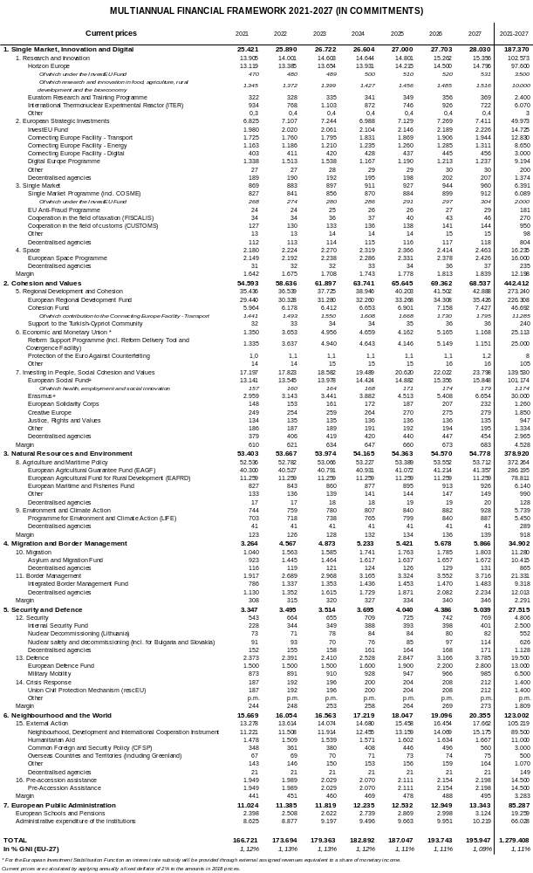
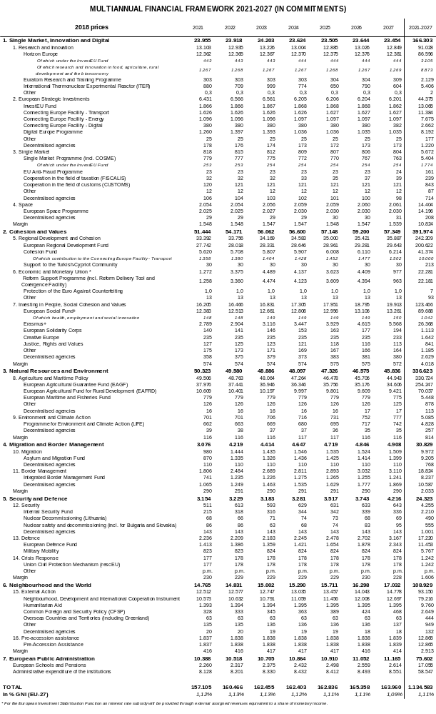

State of the Union Address 2016: “Towards a better Europe – a Europe that protects, empowers and defends”.
State of the Union Address 2017: “Catching the wind in our sails”.
COM(2018) 98.
European Parliament Resolutions of 14 March 2018 on “The next Multiannual Financial Framework: Preparing the Parliament’s position on the Multiannual Financial Framework post-2020 (2017/2052(INI))” and on the “Reform of the European Union’s system of own resources (2017/2053(INI))”.
COM(2017) 2025.
The Commission will adopt at the end of the year a Reflection Paper “Towards a Sustainable Europe by 2030, on the follow-up to the UN Sustainable Development Goals, including on the Paris Agreement on Climate Change” to address possible ways on how to integrate the Sustainable Development Goals further in EU policy making.
See the accompanying Staff Working Document SWD (2018) 171.
See also SWD (2018) 171, page 7.
In line with the recommendations of the High Level Group of Independent Experts on Monitoring Simplification for Beneficiaries of the European Structural and Investment Funds, the recommendations of the European Court of Auditors and the Committee of the Regions, as well as of the European Parliament.
Under reverse qualified majority voting, the Commission’s proposal is deemed to be adopted by the Council unless it decides by qualified majority to reject the Commission's proposal.
See the report on “Investing in the European Future we want – Report of the independent High Level Group on maximising the impact of EU Research and Innovation Programmes”.
Unless indicated otherwise, amounts presented in this Communication are in current prices. Figures expressed in current prices include the effect of inflation. They are calculated using a 2% annual inflation adjustment.
Cohesion Policy is delivered through three main funds, the European Fund for Regional Development, the European Social Fund and the Cohesion Fund.
COM(2017) 822.
In addition, an amount of EUR 10 billion will be foreseen in Horizon Europe to support research and innovation in food, agriculture, rural development and the bioeconomy.
The Commission proposal for the integration of the European Development Fund is among the elements requiring an increase of the Own Resources ceiling. It will in addition be essential that the rules governing the Neighbourhood, Development and International Cooperation Instrument include similar flexibility provisions to those in place for the current European Development Fund.
These reforms included a two-year salary freeze accompanied by an increase of working time to 40 hours a week without compensation, the creation of a more moderate salary scale for secretarial and clerical jobs, and the reduction of annual leave. The reform also substantially affected pension entitlements by means of a reduction in end-of-career salaries, a higher retirement age and reduction of the pension accrual rate.
In the framework of the mid-term review of the Multiannual Financial Framework in 2023, the Commission will reflect on the feasibility of the creation of a capital-based pension fund for EU staff.
COM(2018) 98.
The European Development Fund corresponds to around 0.03% of the EU-27 gross national income.
European Parliament Resolution of 14 March 2018 on “The next Multiannual Financial Framework: Preparing the Parliament’s position on the Multiannual Financial Framework post-2020”, point 23.
EUR 1,127 billion in current prices.
See the report on “Future financing of the EU” presented in January 2017 by the High Level Group set up jointly by the European Parliament, the Council and the European Commission and chaired by Mario Monti.
Member States with specific challenges with respect to customs control will be able to benefit from a strengthened CUSTOMS programme. Furthermore, the Integrated Border Management Fund, specifically with the new Customs Control Equipment component, will help national customs to procure equipment. Finally, the Structural Reform Support Programme will provide assistance in the field of improving administrative capacity of customs.

