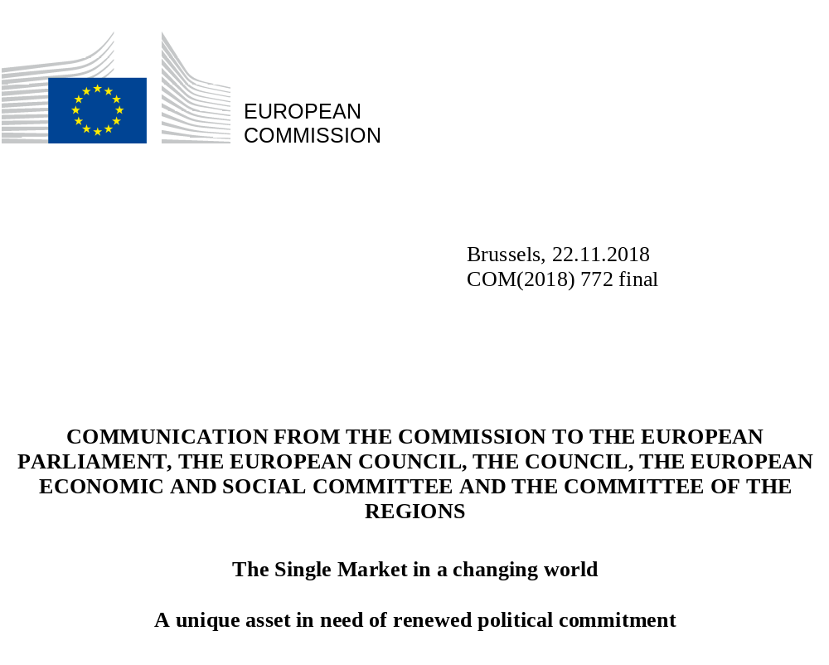

The Single Market is one of the greatest achievements of the European project. It has made Europe one of the most attractive places in the world to live and do business. Over the last 25 years, it has been instrumental in increasing the prosperity and wealth of the citizens of the European Union. By offering firms access to a large and competitive market and by eliminating barriers that impede their growth and their efforts to innovate and to scale up it has boosted the competitiveness of industry. By virtue of its diversification, the Single Market has helped to improve the resilience of the European economy and the Economic and Monetary Union. By virtue of its scale, it has boosted the standing and influence of the European Union in the world. The benefits of the Single Market go far beyond those of a free trade area and a customs union, and include the free movement of products, individuals, services and capital. These four freedoms, which together allow for frictionless trade and economic activity, are the core of the Single Market. The Commission estimates that the economic benefits of the Single Market amount to about 8.5% of the Union's Gross Domestic Product.

While the achievements are significant, the Single Market requires, and always will, efforts to maintain and improve it. For the Single Market to remain a source of growth and opportunities for citizens and businesses, it must continue to adapt to new developments and challenges. There is an increased diversity of views on which priorities should be pursued and there are competing perceptions of potential benefits. Globalisation and new technologies bring enormous opportunities but also raise essential questions of whether, when, what and how to regulate. Inconsistent or weak enforcement of common rules remains a challenge, and ensuring that these rules remain fit for purpose in a rapidly changing environment requires constant effort.

Above all perhaps, the further integration advances, the more politically challenging every "extra mile" becomes as we touch on increasingly sensitive economic and social issues. It is proving difficult, for example, to push integration forward in areas such as services which would provide a significant boost to productivity and growth, and taxation where divergences of applicable rules are perceived by many businesses as a major obstacle in the Single Market. The same applies to the social dimension of the Single Market where progress is essential to allow all citizens to benefit fully from integration.

As a result of these challenges, deeper integration today requires more political courage and determination than 25 years ago, and greater efforts than ever to close the gap between rhetoric and delivery. We are too often confronted with a situation where the consensus which appears to exist at the highest level on the need to deepen the Single Market is not matched by a political willingness to adopt the concrete measures that the Commission proposes and that would make a difference, or to transpose and implement measures which have already been agreed. Even when they express support for further market integration or for further harmonisation, Member States often promote only their domestic approaches as a basis for European rules, which can lead to political tensions. This in turn leads to repeated calls on the Commission to come forward with new ideas but the willingness to follow through is not guaranteed. We therefore need an open debate about these issues, and a renewed commitment by Leaders to all the dimensions of the Single Market.

With the Single Market Strategy, the Capital Markets Union and the Digital Single Market Strategy, the Commission has put forward an ambitious and balanced set of measures over the last four years to deepen the Single Market further and make it fairer. These proposals together build the legal framework for a future-oriented Single Market. Several proposals have already been adopted, but the European Parliament and the Council still have to agree on 44 out of the 67 proposals set out in these strategies (see Annex I). The Commission has also made important and forward-looking proposals in the area of the circular economy, energy, transport and climate policies which will deepen the Single Market and foster sustainable development. To ensure that the Single Market remains fair, the Commission has proposed safeguards in the fields of employment, taxation and company law.

In March 2018, the European Council asked the Commission to assess the state of play of the Single Market regarding the implementation, application and enforcement of existing legislation that is key for the functioning of the Single Market, as well as the remaining barriers and opportunities for a fully functioning Single Market. This Communication is a first response to the request of the European Council and is adopted in conjunction with the Annual Growth Survey and a Communication taking stock of the Investment Plan. It presents a current state of play, recalling the benefits for citizens, consumers and businesses. It highlights the urgent need to agree before the end of the current legislative cycle on the proposals made. It emphasises the need for a more effective implementation, application and enforcement of the Single Market rules. It also assesses the main barriers that will need to be tackled so that the Single Market continues to function effectively, enabling the Union to seize the opportunities of a future-proof Single Market that will ultimately help ensure growth and prosperity for its citizens and businesses and shape the global agenda.

Empowering and Protecting
The Single Market is a powerful engine driving the Union’s competitiveness and the prosperity of its inhabitants. It fulfils an important societal function by creating a shared living space based on common rules for over 512 million Europeans. According to the spring 2018 Eurobarometer, 82% of Union citizens support the freedom to live, work, study and do business in other Member States. This is the highest level of support for any Union policy. In addition, the external dimension of the Single Market is also generating economic and social benefits as it has given the Union unique leverage in international trade negotiations and is an asset that attracts foreign investment and talent. This is all the more important given that the Union's competitors at global level are continent-sized economies.

1.1 More opportunities and benefits for citizens
1.1.1 Wider choice, lower prices and better protection for consumers
The removal of obstacles to the free movement of products and services, including data, has brought considerable economic benefits to consumers and businesses. Consumers benefit from wider choice and high quality products and services at lower prices. Undistorted competition stimulates businesses to innovate and to improve their products and services. Good examples of these direct benefits are the 35% decrease of telecoms prices over the past decade, the abolition of roaming charges and the reduction in costs of air transports.
The Single Market enables citizens to make payments across the euro area in a much cheaper and much faster way. The adoption of the euro, the introduction of the Single Euro Payment Area (SEPA) and the entry into force of Union legislation have aligned fees for cross-border payments in euro to domestic ones in the euro area, making them on average 85% cheaper. It also allows citizens who work and study in another Member State to use their existing account in their home country to receive their salary or pay bills in their country of residence.

For the Single Market to work effectively, consumers must be able to trust the products they want to buy – both goods and services, on- and offline, and provided locally or from another Member State. This trust is ensured through the development of a single set of Union rules to protect consumers. These rules already provide for common standards of protection in many areas, such as product and food safety, environment, passenger rights, privacy and data protection, and animal welfare.

Harmonised Union rules on food information have increased consumer protection and provided legal certainty for food businesses. This enhances the circulation and the availability of foods within the Single Market. In particular, on the basis of legislation, pre-packaged foods and restaurant meals have to indicate clearly the presence of allergens and have to provide clear nutritional information. This protects consumers’ health and allows them to make informed choices.

1.1.2 Free movement within the Union
There are 17 million Union citizens living or working in another Member State and 9.5 million of them are economically active. Around 2 million citizens are cross-border daily commuters who work or study in one country but live in another. The intra-Union mobility of people has significantly increased over the last decade (see graph below). In addition, since the start of the Erasmus Programme, over 9 million citizens have been able to spend time in another country to study, to learn or to train. While progress in these areas has been impressive, the figures remain low for a continent of more than 512 million inhabitants. They should be seen in the context of specific factors such as language and differences in social systems which are difficult to overcome and which mean that labour mobility is always likely to remain lower in the Union than in other integrated markets.

Union citizens living in another Member State

Source: Eurostat – Own calculations

By removing discriminatory, unjustified or disproportionate obstacles to labour mobility and by establishing the principle of equal treatment between national and Union workers, the Single Market opens new employment opportunities for Union citizens who wish to work in another Member State. Economic sectors suffering from labour shortages also benefit from labour mobility. During the economic and financial crisis, this has helped European workers to find work in less affected countries of the Union.

A Union citizen worked for 4 years in Germany and 32 years in Portugal. In Germany, a citizen must have worked for at least 5 years to be entitled to a pension, so she would not normally qualify for the national pension scheme in Germany. Thanks to the Union rules on social security coordination, the German pension authority has to take into account the years the citizen worked in Portugal and pay her part of her pension corresponding to the 4 years worked in Germany.

However, it is also important to recognise that the positive impact of the Single Market has not been spread evenly and that not all citizens are in a position to benefit from its freedoms. There is a clear need to address the concerns of citizens in regions with high unemployment or facing structural changes. An increase in labour mobility or market integration can lead to problems with income and job security. To do this, the Union has taken action to make its workforce more resilient to changes on the labour market, for example through reskilling or retraining, and by putting in place strong labour market standards. The recent revision of the legislation on posted workers, for example, provides strengthened protection and in particular puts in place the principle of equal pay for equal work in the same place. The European Pillar of Social Rights reflects a common understanding of European social standards, sets out an agenda to deliver new and more effective rights for citizens and workers, and addresses emerging social and demographic challenges and the changing world of work. Union cohesion policy also plays an important role in helping citizens and territories to cope with the uneven distribution of the benefits of the Single Market.

In June 2016, the Commission adopted a New Skills Agenda for Europe to make sure that people across the Union have the right training, skills and support in changing labour markets. As part of this, the Commission launched a Blueprint for Sectoral Cooperation to address short and medium-term skills needs in a variety of economic sectors.

Benefits for businesses
Thanks to the harmonisation of national rules, common standards across Member States rather than 28 different sets of standards, and the mutual recognition principle, the Single Market offers access to a market of more than 512 million consumers where new ideas and products can be tested. Union public procurement rules allow for a more strategic approach to public spending and ensure that Member States, regional and local authorities can choose the best offers based on a broader range of criteria than only the lowest price. The diversification, scale, experimentation and innovation which the Single Market makes possible, are all drivers of productivity and are thus instrumental in helping European firms to stay competitive in a globalised world. The Single Market in products, in particular, has been a success. Regulatory obstacles have been removed for over 80% of industrial products through the adoption of common rules and, where no such rules exist, through the principle of mutual recognition. The integration of the Single Market has also deepened. Relative to the Union economy, the intra-Union trade in goods and services has grown from 27% relative to the size of the Union Gross Domestic Product in 2004 to 33% in 2017, albeit the trade in services remains more limited and much below potential.

Intra-Union trade in goods and services (relative to the size of the Union Gross Domestic Product)

Source: Eurostat

For all businesses, small and large, the Single Market creates the possibility to attract investments to grow their business beyond their home country, and to reach a scale that enables them to expand both across the Union and globally. Thanks to one of the biggest markets in the world, the Union helps European businesses to become globally competitive.

Number of European companies in the top 100 global firms in 2017

Source: Fortune, European Political Strategy Centre visualisation

1.2.1 The benefits of the integration of the financial sector
In spite of the financial crisis, the integration of capital markets in Europe has increased over the last 25 years. Capital markets have expanded substantially since 1992 to more than twice the size of the Union economy in 2015. More and more financial service providers are able to offer their services across the Union thanks to a single passport. This stimulates competition and offers new opportunities for businesses which need funding on capital markets. They can now finance more of their activities across the Single Market and are less dependent on bank financing. Reinforced supervision at Union level has led to higher levels of consumer and investor protection. The integration of capital markets also fosters European innovation which is critical to make companies more efficient and productive.

1.2.2 Shaping a rules-based, open and multilateral trading system and ensuring access to international value chains
The Single Market empowers the Union to speak with one voice in international trade negotiations. With more than 512 million consumers and a total Gross Domestic Product of 15 300 billion euro, the Single Market is one of the largest markets in the world. It is thus attractive to our trade partners and can be used as leverage to open markets abroad in a way which is mutually beneficial. This has been seen recently with the signature of the Free Trade Agreements with Japan and with Singapore, the Commission proposal for the signature of the agreement with Vietnam, the conclusion of negotiations with Mexico, and the ongoing negotiations with the Mercosur, Chile, Australia and New Zealand. The Union’s ambitious trade agenda helps to ensure fair competition and a level playing field for European companies on third country markets.

The European economy in a global perspective
(Gross Domestic Product, in trillion euro - current prices, 2007-2017)

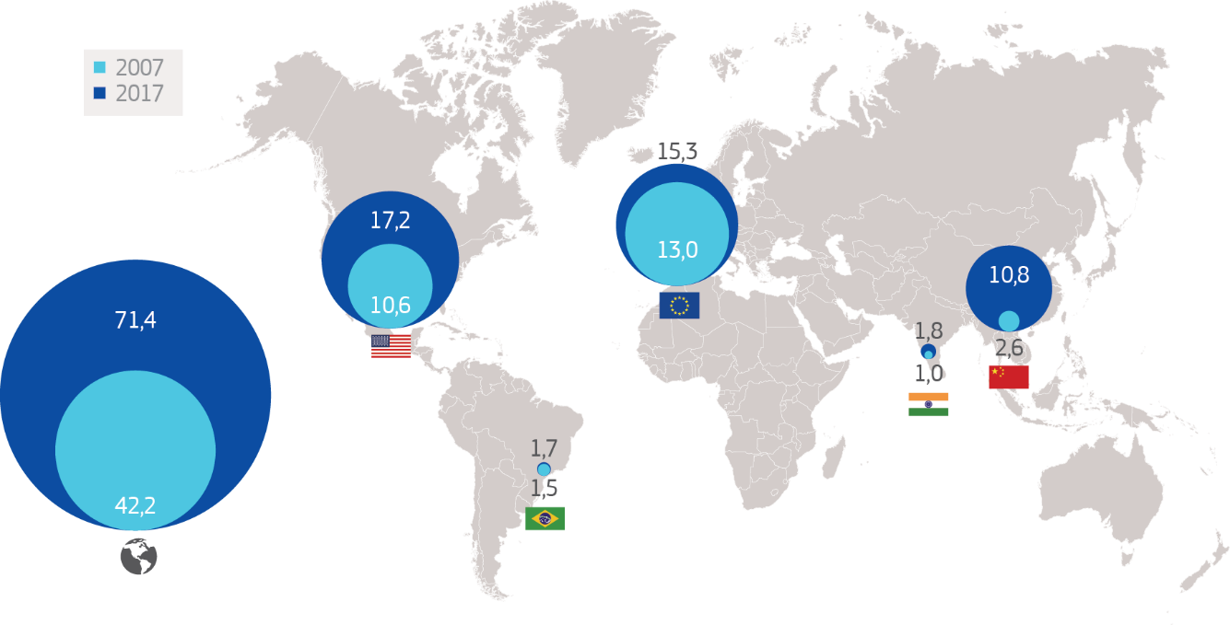

Source: World Bank and European Central Bank, European Political Strategy Centre visualisation

Moreover, the scale of the Single Market also means that the Union is in a position to shape the rules-based, open and multilateral trading system. Businesses from third countries need to comply with Union legislation to access the Single Market, including in the fields of health, environment, food and product safety, and consumer protection. European harmonised standards have often become the models for global standards, and trade policy promotes them through free trade agreements. In full compliance with the Union’s data protection and data privacy rules, the Union has proposed horizontal provisions for cross-border data flows and personal data protection in its trade and investment negotiations with third countries.

The proposed new framework for the screening of foreign direct investments will help to protect the Union's strategic interests through greater transparency and scrutiny. All of this brings significant benefits and opportunities for businesses. In this way the Single Market contributes to the Union's objectives in support of peace, its values and the well-being of its people. The Single Market legislation as well as the Union's ambitious trade agenda reflect and promote these values.

International production is increasingly organised within global value chains in which the innovation and production process spans several countries. Thanks to the Single Market, Union firms have access to more diverse, higher quality and cheaper inputs and are therefore more competitive globally. It facilitates integration of companies in European value chains, which helps to ensure that economic activity remains within the Union. For instance, the share of inputs from other Member States in production chains is on the rise and now exceeds 14%. In the same logic, any new or re-emerging barriers in the Single Market ultimately decrease the competitiveness of Union firms. The Single Market is crucial for small and medium-sized enterprises, offering increasing business opportunities for companies that do not export themselves.

The value chain of European wind turbine manufacturers:
main locations of manufacturing facilities

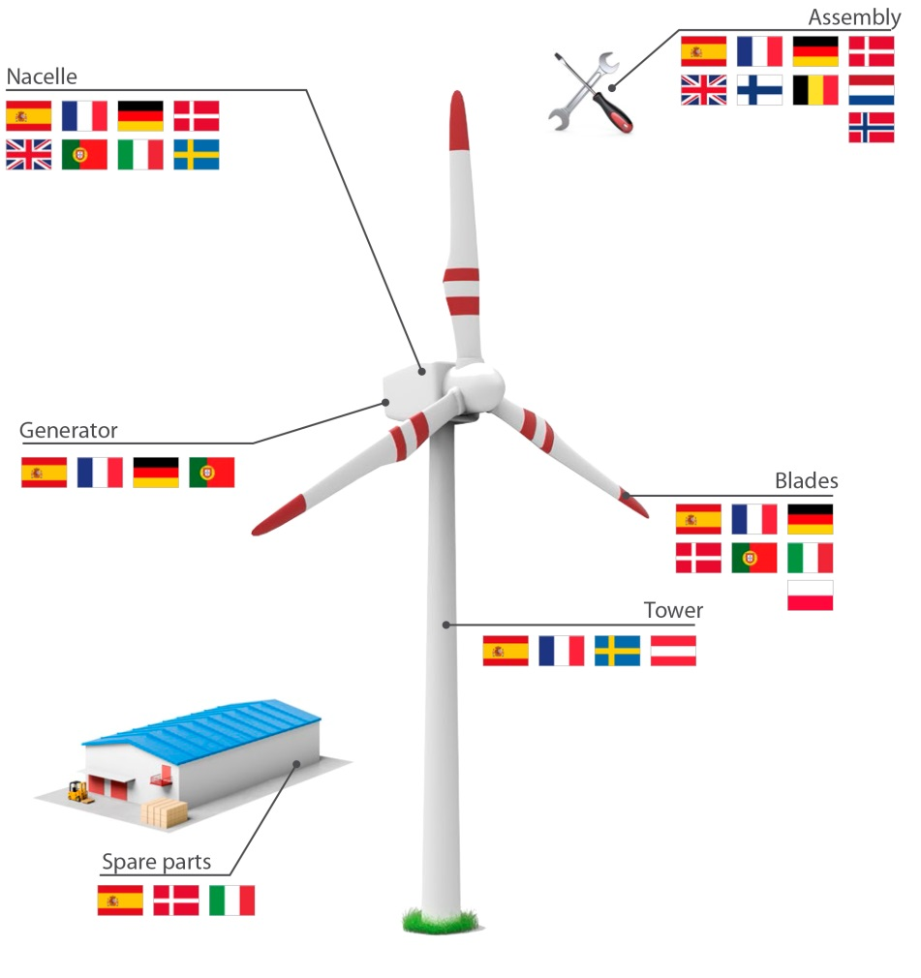

Source: Based on Joint Research Centre data

The European Battery Alliance is a good example of a strategic value chain in Europe which the Single Market makes possible. While battery cells will represent a high proportion of the value added in the car of the future, the Union is currently not able to mass produce them and relies on imports from third countries. This can cause problems with security of supply and increases costs due to transportation, time delays, or weaker quality control. One year on from the launch of the Alliance, Union-based consortia are emerging, the first pilot production facilities are being built, and further projects have been announced to establish the Union as a lead player in this strategic area.

The delivery challenge
The benefits of the Single Market will only reach citizens and businesses if its rules work on the ground. Whether it is for food products, insurance or occupational health and safety requirements, non-compliance with Union law in one Member State can have far-reaching consequences in another. Non-compliance with the legislation can undermine consumers’ trust in the Single Market. It also undermines the level playing field for businesses. Good implementation, application and enforcement of Single Market rules are therefore prerequisites if the professed desire to deepen the Single Market is to materialise.

2.1 Implementing and applying Single Market rules
Member States are responsible for implementing directives into national law. Good progress has been achieved in the transposition of Single Market directives over the last 20 years, as shown by a significant decrease of the average transposition deficit (from 6.3% in 1997 to 0.9% in 2017). However, proper implementation of all the legislation which has been adopted in the last few years to drive forward the Single Market will be a major shared challenge for the immediate future and will require the continued commitment of all Member States. Recent signals have not always been encouraging. For example, the transposition deficit for the 16 directives with transposition dates between December 2017 and May 2018 was 25 % in June 2018. In the case of three public procurement directives to be transposed by April 2016, the Commission had to launch 58 infringements against 21 Member States for not communicating any transposition measure, of which 3 are still ongoing.

In cases of minimum harmonisation of national rules at Union level, it is legitimate for Member States to go beyond what is required by Union rules if they wish so. However, this should not lead to "gold-plating", where national measures may lead to disproportionate burdens on citizens and businesses. The integration, where needed, of the General Data Protection Regulation into national legal frameworks is an example of this risk, with for instance up to 600 pages of additional legislation adopted in one Member State. In 2016, the European Parliament, the Council and the European Commission committed in the Interinstitutional Agreement on Better Law-making to publish the text of national transposition measures and to clarify which provisions stem from Union directives and which go beyond. This transparency in itself can help to ensure that any additional requirements remain proportionate and clearly justified. The Commission has made available a tool for Member States to notify how they have transposed Union directives but to date this has been used by only two Member States in relation to three directives.

Member States authorities are also responsible for applying Single Market rules. In several cases during the recent years, poor application of the rules has had major consequences. Oversight at Union level has been increased as a result.

The Dieselgate scandal revealed weaknesses in the enforcement of Union rules in type approval procedures for cars by competent bodies at Member State level and the lack of legal tools at the disposal of the Commission to remedy this. The new type approval framework adopted in May 2018 will make the application of Union rules more effective and significantly strengthen Union oversight.

To be effective Single Market legislation often requires oversight from independent authorities at national level which are sufficiently staffed and equipped. This is the case in areas such as competition, market surveillance, data protection, energy, transport, telecoms or financial services. These bodies are an additional guarantee of good application of Single Market rules, and the Commission will continue to pay particular attention to ensuring that they function well and are appropriately resourced. Concretely, the Commission will strengthen its support to administrative capacity building, for instance through the proposed Single Market and Reform Support Programmes under the next Multiannual financial framework.

The protection of consumers against fraudulent practices by unscrupulous businesses is a challenge that requires increased cross border cooperation among administrations. The 2017 case of fipronil in eggs has shown for instance that there is scope for increasing cooperation in the field of preventing food fraud. Cross-border cooperation is also needed to help citizens and businesses to make use of their Single Market freedoms and to solve conflicts between public authorities. The Commission has taken decisive action in this field with its proposal for the European Labour Authority. Its objective is to improve the free movement of workers, in particular through cross-border cooperation among national authorities and mediation in cross border conflicts.

As evidenced in the Justice Scoreboard, the Commission recalls that independence, quality and efficiency of the justice system and the respect of the rule of law at national level are key in maintaining trust in the Single Market. Improving national justice systems is therefore a priority for the Commission, be it through the European Semester — the Union’s annual cycle of economic policy coordination – or support to the training and work of judges, for example through the European judicial network. The Commission has also proposed to strengthen citizens' ability to enforce their rights. With the New Deal for Consumers package, qualified entities will be able to launch a legal action on behalf of consumers. If adopted, this will bring cheaper and more effective means to stop and remedy breaches that harm a large number of Union consumers. In areas where breaches of Union law may be difficult to uncover and could cause serious harm to the public interest, whistle-blowers can play a crucial role, as demonstrated by several recent scandals. The Commission proposal dealing with this issue will ensure that whistle-blowers feel safe when reporting such breaches.

2.2 Enforcement at Union level
As guardian of the Treaties, the Commission ensures that Member States respect Union rules, mainly through infringement procedures, in line with the strategic approach set out in the Communication "EU law: Better results through better application", and state aid control. The Union also put in place reinforced supervision mechanisms such as the European Supervisory Authorities in the field of financial services. Given that threats to financial stability and investor protection do not respect borders, the Commission has made proposals to ensure that financial supervision by these authorities is stronger and more integrated, including in the field of money-laundering. In line with its objective to be "bigger and more ambitious on big things, and smaller and more modest on small things" the Commission has also decided to further increase the focus of State aid control and infringements on measures with a significant impact on the Single Market, for example as regards State aid in the field of corporate taxation.

Companies can also hamper the functioning of the Single Market by erecting barriers to trade, investment or entrepreneurship. When they engage in illegal agreements to avoid competition, or when dominant operators prevent competitors from entering their markets, it leads to higher prices and less choice for consumers. It also harms the businesses that are the victims of such practices. In these cases, the Commission will continue to intervene to protect consumers in the Single Market and complement the action of national competition authorities less well equipped to deal with large cross-border cases. New barriers to parts of the Single Market which function well should also be avoided.

In order to identify barriers to the internal market created by companies the Commission has conducted a large scale sector inquiry into e-commerce. As a result, the Commission is focusing competition law enforcement on contractual restrictions which hinder cross-border e-commerce. The Commission fined four companies in July 2018 for restricting the ability of its retailers to determine independently the resale prices of electronic products and for limiting the countries in which retailers could sell online.

Exploiting the full potential of the Single market
In order to move to a sustainably higher path of economic growth, the Union must urgently improve the conditions which foster productivity growth. As pointed out in the Commission’s Annual Growth Survey, together with innovation and diffusion of technology, markets which function efficiently are a key driver of productivity growth. The Single Market is also one of the foundations for the Economic and Monetary Union and Single Market integration is key to improving its resilience. The euro, at the same time, fosters cross-border trade and makes it easier to benefit from economies of scale.

In many areas, the full potential of the Single Market as a tool to generate growth, jobs and international competitiveness remains to be exploited. This is the case for example with digitisation and the emergence of new technologies where the key challenge is deciding what, whether, when and how to regulate, and with the circular economy where the goal is to create a regulatory framework which ensures increased sustainability of economic activities with job creation, increased innovation and growth. In both cases there is a need to ensure a European approach to addressing the issues in order to avoid the fragmentation of the Single Market that would arise from a proliferation of national approaches. There is also significant further potential with services, products, taxation and network industries, where investing in the "extra mile" of economic integration requires more political capital than in the past. The external impact of further integration of the Single Market in an increasingly volatile world should not be underestimated, as it will make the Union even more attractive to international trading partners and provide it with additional leverage on the international stage.

For the Single Market to function properly, it is important that the rules are clear, fair and fit for purpose. The Commission continues to evaluate regularly existing rules as well as carry out public consultations and comprehensive impact assessments when preparing new ones to ensure that the legislative framework delivers on its objectives without unnecessary costs. Moreover, the innovation principle helps to ensure that the legislative framework is future-proof. The Commission continues to develop monitoring tools and to carry out evaluations of benefits and obstacles for the Single Market and impact of Union legislation on the Single Market based on user, consumers and businesses experience.

3.1 From bricks and mortar to digital
Digital technologies have become an integral part of the Single Market to a point that the distinction between the traditional "brick and mortar" Single Market and the “"digital" Single Market is no longer relevant. Digitisation of businesses – including traditional industries – and administrations is essential, and rules for the Single Market need to be designed and kept up to date to ensure that innovation and the diffusion of new technologies boost productivity growth. In this way, the Single Market will continue to support innovative businesses and to ensure that start-ups can scale up and flourish in the Union. This is of particular relevance for e-commerce, platforms, fintech and the collaborative economy.

Digital technologies can enable businesses to sell products and services directly to the homes of more than 512 million consumers across the Union. In 2017, 33% of European consumers and 18% of European businesses sold or purchased online cross-border. However, new barriers put in place by Member States or by businesses hamper e-commerce growth, affect cross-border trade and thus need to be tackled at Union level. A key finding of recent Commission investigations was that almost 40% of websites did not allow customers from other Member States to conclude their sales online.

In the context of the Digital Single Market Strategy, the Commission has put forward a number of initiatives to tackle the biggest barriers to e-commerce. Several of these have already been adopted on Geo-blocking, Cross-border parcel delivery services, Value Added Tax for e-commerce and Consumer Protection Cooperation. The Geo-blocking Regulation, which will apply from 3 December 2018, will prohibit discriminatory practices based on nationality, residence or place of establishment. The proposals for updated Digital contracts, still under negotiation, would provide consumers with the reassurance that they have a comparable level of protection when buying digital content as when buying tangible goods, whether in their home country or abroad.

Online platforms have become prominent players in the Single Market, enabling more than one million businesses to reach customers across the Union. The innovation potential of online platforms is, however, hampered by a lack of trust as well as by the proliferation of national rules. For business-to-business relationships, action at Union level is needed to ensure fair, transparent and trusted online trade and competition. The Commission put forward a proposal for new, harmonised rules for "Platforms to businesses" practices in April 2018. Rules on copyright, as well as taxation rules also need to be adapted to the digital era and the Commission has made proposals to do this.

The emerging collaborative economy offers opportunities for citizens and businesses. More than 400,000 citizens already engage in economic activities such as transport, accommodation and finance. To enable business models building on the collaborative economy to grow to their full potential and scale, it is vital to avoid uncoordinated regulation by Member States, for instance when defining the boundaries between employed work and "peer to peer" provision of services. The right balance needs to be struck between the protection of workers and labour market adaptability as in the recent Commission proposal on transparent and predictable working conditions in the Union. This proposal is part of the implementation of the European Pillar of Social Rights, where the European Parliament and the Council need to make further progress by March 2019 on negotiations of the various legislative initiatives to make it more operational.

3.2 Maximising the opportunities of the European data economy
A thriving digital economy requires a data ecosystem which is built on three foundations: trust, data availability and capacities/infrastructure. The Single Market is the right level to build such an ecosystem. Rapid development and adoption of European and, where relevant, international rules and standards ensuring market harmonisation and interoperability of digital products and services have been identified as priorities.

The General Data Protection Regulation (GDPR) is essential to ensure trust in the Single Market for personal data. It embeds fundamental rights and values in European digital policy and establishes a new global standard. It gives citizens more control over how their personal data is processed by companies including their right to be forgotten, while offering a single set of rules across the Union for businesses.

The proposed ePrivacy Regulation will complement the General Data Protection Regulation by putting in place a single set of rules that ensures a high level of privacy for all electronic communications. Trust in and resilience of the European data ecosystem will also be boosted by measures promoting a Single Market for cybersecurity as set out in the Cybersecurity strategy.

Access to data is essential for the data economy. With the adoption of the regulation on the free flow of non-personal data, barriers to such free flow will become illegal, facilitating the cross-border operation of businesses in the Union data economy. The adoption of the revised public sector information directive will also help to ensure that more high quality data becomes available to businesses and innovators. In order to build the necessary tools to use the data efficiently, the Union needs to boost its capacities in artificial intelligence, high performance computing and quantum technologies. In the field of artificial intelligence work is already on-going on a Coordinated Plan to identify and mobilise the necessary investments, and on ethical guidelines for the development and use of these technologies when they interact with humans.

3.3 Addressing new consumer and investor preferences in a circular economy and sustainable finance
Consumers are increasingly choosing products and services which have been developed and function in a sustainable manner. This trend must be supported as it contributes to a more circular and low-carbon economy and provides new business opportunities. However, a proliferation of initiatives at national or local level can lead to fragmentation and ultimately hamper the achievement of these goals. Through action at Union level, the Single Market helps to ensure favourable conditions for investments and innovation, while at the same time helping to achieve climate, public health and sustainability objectives more effectively.

The circular economy, where the value of products, materials and resources is preserved for as long as possible and the generation of waste is minimised, must become an intrinsic characteristic of the Single Market. With its Circular Economy Action Plan, the Commission has put in place a number of actions to support the circular economy throughout the value chain – from design and production to consumption, repair and remanufacturing, waste management, and secondary raw materials that are fed back into the economy. This approach has already been applied to plastics, where the potential for recycling waste remains largely unexploited. By 2030, all plastics packaging should be recyclable in a cost-effective manner. The Commission has also proposed common rules to ban single-use plastics products, and to prevent the fragmentation of the Single Market that might have been caused by different sets of national rules.

Building a Single Market for capital can also be a tool to help the Union meet its commitments under the Paris Agreement. For private capital to flow into sustainable projects, financial actors need a level playing field. To respond to a growing demand, the Commission has put forward an Action Plan on financing sustainable growth, and has proposed rules to provide for a common understanding of sustainable financial products and the transparency needed to develop them. To set a vision for long-term greenhouse gas emissions reductions in the Union, the Commission will soon present a strategy reflecting the objectives of the Paris Agreement on climate change. It will also soon present a reflection paper on the way to a sustainable Europe by 2030, following up on the United Nations Sustainable Development Goals.

3.4 Persistent challenges in products and services markets
The Single Market is a powerful tool to spread innovation and new technologies which make European economies more productive and generate social progress for citizens. It has been estimated that advancing further reforms to improve the functioning of the Single Market for manufactured products, which is already a success in itself, could generate as much as 183 billion euro per year. The biggest rewards, however, would come from further integration of services, and in particular business services, not least because of the increased merging of manufacturing and services activities such as in the data economy. The possible gain in this area has been estimated at up to 338 billion euro per year. Together with taxation and social rights, services is an area where the gap between the rhetoric on Single Market integration and delivery of the necessary measures is most evident.

Trade of products which rely on the mutual recognition principle because there are no harmonised Union rules remains considerably below trade of products which are subject to such rules (35% versus 55% of domestic consumption). To address this challenge, the Commission proposed the 2017 Goods Package to make it easier for companies to market their products in other Member States and to prove their compliance with their home country legislation.

Standardisation has played a leading role in developing the Single Market by supporting market-based competition and by helping ensure the interoperability of products and services. Products which comply with voluntary, harmonised standards endorsed at Union level benefit from a presumption of conformity and can therefore move freely in the Single Market. This has been very beneficial for instance in the field of engineering or information technologies. While harmonised standards are developed by European standardisation bodies, the Commission initiates, manages and monitors these standards and bears the ultimate responsibility, as recalled by the Court of Justice of the European Union in 2016. While the current system is functional, the Commission recognises that further improvement is necessary and has therefore put forward an Action plan alongside this Communication to make the development of harmonised standards speedier, more efficient and more transparent.

The European Union is a service economy (70% of Union Gross Domestic Product) and yet cross-border trade mostly concerns goods. Only 20% of services are traded across border accounting for only 5% of the Union Gross Domestic Product. Large sections of the service economy are not taking advantage of the Single Market, in particular business services and network industries. In the case of business services (11% of Union Gross Domestic Product), European firms rarely buy services from foreign accountants or tax advisers. Business services are one example of services becoming more and more important for manufacturing: around 80% of outputs from legal, accounting, engineering and architectural services are in fact used as intermediate inputs for other sectors, including manufacturing activities. Similarly, restrictions in the retail sector have negative spill-over effects in other sectors of the economy, in particular upstream in manufacturing.

In the face of rising competition in the global markets for manufactured products, the competitive advantage of the Union rests increasingly in the service input and the service component of the overall value chain. Establishing a more dynamic market for cross-border service provision in the Union is therefore a key component of the future competitiveness of the Union’s industry. The multiplicity of legal and regulatory requirements at national level in many service sectors partly explains the lower degree of cross-border activity. These requirements, covering issues such as legal form and shareholding, prohibition of multidisciplinary activities and advertising, exist in particular in highly regulated professional services. To avoid abuses or disproportionate requirements, a recently agreed Commission proposal requires Member States to carry out proportionality tests before adopting new rules on regulated professions. The Commission has also proposed that Member States notify their draft legislation in the field of services so that the Commission can assess whether they comply with Union law before they are adopted. This proposal is still pending with the
co-legislators and is a recent example of where the desire to drive forward the Single Market is not fully matched by the political will to adopt the necessary measures.

Moreover, the Commission has proposed to update the rules on the coordination of social security to facilitate further the protection of social rights of cross-border workers and to enable better controls by national authorities against fraud. The new European Labour Authority will also help to strengthen cooperation among Member States in this field and to ensure that they have access to the right information on labour mobility.

Intellectual property-intensive sectors are a significant part of the European economy (39% of Union Gross Domestic Product and 35% of jobs in the Union). Recent advances in this area include the adoption of the revised Trademark Directive in 2015 which modernises further the highly successful European acquis in this field. However, the full benefits of a Unitary Patent system require the entry into force of the Agreement on the Unified Patent Court which is still pending.

3.5 Outstanding challenges for network industries

Consumers and businesses are not fully enjoying the benefits of competition in regulated network industries. Good progress has been made in integrating the internal energy market in which energy is traded increasingly freely across borders. However, the significant fall of wholesale electricity prices – around 40% between 2008 and 2017 – has not been fully reflected in consumer prices, which declined on average by only 13% during this period. This is due partly to the market power of incumbents and partly to barriers to the entry of new competitors such as regulated prices. The "market design" proposal of the Clean Energy for All Europeans package, aims to stimulate competition by creating a level playing field between different electricity production technologies and by empowering consumers to become active players in the electricity market. This package will also help to integrate electricity, heat and transport markets through the use of digital technologies which will increase competition and help to achieve decarbonisation goals.

In the field of transport and mobility, numerous barriers still exist and new competitors often face unjustifiable access restrictions in domestic rail and road services. Fragmentation of the transport market and gaps in social legislation are issues which concern primarily road transport. At the same time, insufficient interoperability as a result of diverging national requirements prevents competition in rail freight and international rail services from fully unfolding. The implementation of the 4th railway package will improve interoperability and open up domestic railway markets (for passengers), while the adoption of the acts proposed under the three Mobility packages of 2017 and 2018 will contribute greatly to creating the Single European Transport Area.

The deployment of 4G in Europe has been slow because of divergent national rules and approaches on allocating spectrum bands. The recent adoption of the 5G Action Plan and the European Electronic Communications Code, including new rules for spectrum management, will ensure that bands for new 5G services are available for use by 2020 all over the Union under the same technical conditions. This will support the deployment of 5G and will also provide incentives for the development of very high capacity fixed and mobile networks essential for data economy, artificial intelligence and digitisation of our economy and society.

3.6 Towards more integrated capital markets and a fully-fledged Banking Union
European consumers and businesses are still not benefitting from all the increased opportunities, efficiency and security that fully integrated capital markets and a fully-fledged Banking Union would provide. With the introduction of the euro, integration of Union financial markets has become even more important. In many Member States, the financial crisis had a significant impact on bank lending which led to less credit available for companies and severe disruptions in the real economy. Cross-border bank credit and alternative sources of finance are still underdeveloped in Europe. Europe has only 26 "unicorns", i.e. start-ups valued at more than 1 billion euro, compared to 106 in the US and 59 in China. To stimulate further private and public investments in the economy, it is important to step up efforts to identify and tackle existing barriers at Union and national level as set out in the Communication "Investment Plan for Europe – stock-taking and next steps" adopted today by the Commission.

The diversification of sources of financing for Union businesses is a priority under the Capital Markets Union. The Commission has made proposals to attract new investors (for example on crowdfunding), to enhance the capacity of banks to lend through rules making securitisations simpler, more transparent and standardised and to bring down barriers to cross-border investment. Enhanced consumer and investor protection rules are essential to create the confidence and stability needed for greater cross-border banking activity. The Commission’s proposal for a pan-European personal pension product will give citizens increased opportunities to save for their retirement, including in a cross-border environment. Member States should safeguard its pan-European nature for the benefit of all Union citizens and ensure that divergent tax rules and complex structures do not prevent the future uptake of this product. This has been one of the key objectives of the Banking Union, together with the aim to further integrate European banking systems and sever the links between banks and sovereigns. Since 2012, two pillars of the Banking Union have been introduced: a Single Supervisory Mechanism and a Single Resolution Mechanism for banks, with its own Single Resolution Fund, financed by banks. Work is ongoing on the operationalisation of the common backstop to the Single Resolution Fund, which will be provided by the European Stability Mechanism. Moreover, the Commission has put forward a proposal for a European deposit insurance scheme to offer the same level of protection for bank depositors across the euro area. The completion of the Banking and Capital Markets Unions is now urgent.

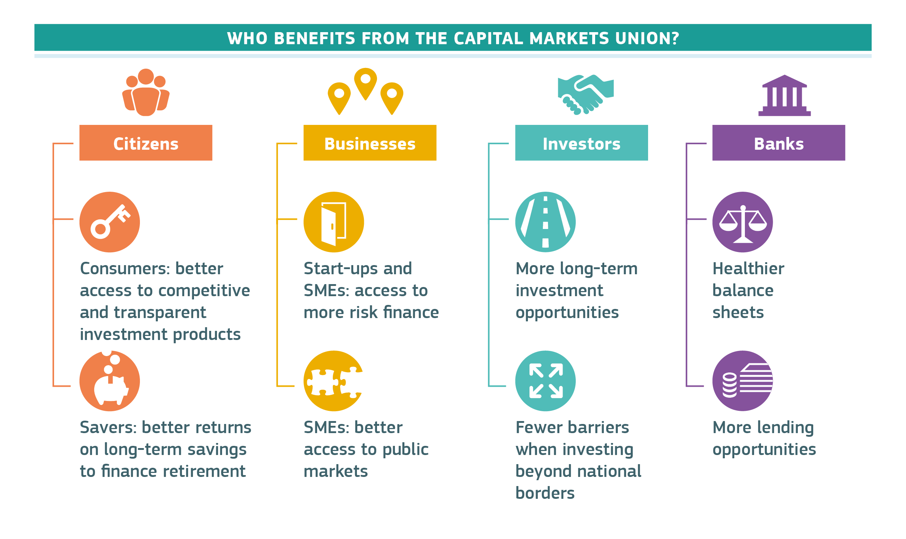
Source: European Commission

3.7 Reducing administrative burden and facilitating tax compliance
Administrative and regulatory barriers continue to discourage small businesses from expanding cross-border. A recent survey shows that companies are more concerned about administrative complexity (83%) than language barriers (45%) when crossing borders. The costs of complying with divergent national requirements and procedures may be beyond the reach of citizens, small and medium-sized enterprises and start-ups.

At Union level, practical support exists and is increasing. This includes for instance the Your Europe Business portal and the Enterprise Europe Network. The recently adopted Single Digital Gateway Regulation will make it even easier for citizens and businesses to access online information about their rights in the Single Market. Common rules for electronic identification and trust services provide safe and transparent tools for citizens and businesses to interact digitally with public administrations and the private sector. Under the Company law package, the Commission has also proposed new rules to set out clear and harmonised common procedures on how a company can move from one Member State to another, merge or divide across borders, accompanied with strong safeguards against abuse. Companies will also be able to register, set up new branches or file documents to the business register online.

Digital transformation has the potential to reduce administrative burdens significantly and to improve the framework conditions for business investment, for example in the area of
e-public procurement. A 2016 survey showed that 82% of public services were available online in Europe. The gap between worst and best performing countries is closing. The priority is to make further progress in the implementation of the e-Government Action Plan adopted in 2016. This contains initiatives facilitating the exchange of information and the development and uptake of the necessary Information Technology tools, such as the Business Registers Interconnection System (BRIS), cross-border eHealth services and digital service infrastructures.

Digital technologies can also simplify compliance and reduce costs in the area of taxation. Value Added Tax compliance has been identified as one of the biggest obstacles to cross-border activity. The Value Added Tax mini-one-stop-shop initiative has already generated more than 500 million euro of savings for businesses. Building on this, the co-legislators agreed in December 2017 on a series of measures introducing simpler and more efficient rules for businesses that sell goods online. The Commission proposal to reduce the Value Added Tax administrative burden for small and medium-sized enterprises could help to increase their cross-border trading by about 13%. The adoption of the proposal on a Common Consolidated Corporate Tax Base (CCCTB) would reduce the additional annual tax compliance cost for a new subsidiary in another Member State by around 65%. This alone would increase investment by up to 3.4% and the Union Gross Domestic Product by up to 1.2%. But more needs to be done. Today, the Single Market remains significantly underdeveloped in tax matters. Member States need to take decisive action to adopt key pending proposals addressing the future competitiveness of the EU. In light of the difficulties Member States have to come to unanimous agreement in the Council on major tax proposals, the Commission will shortly present a Communication exploring the possibility of moving to qualified majority voting for certain tax matters. These issues need further reflection ahead of the future of Europe discussion in Sibiu on 9 May 2019.

3.8 Enabling measures

Rules themselves are not sufficient to make the Single Market work, and the ability to sell products and provide services across the Union depends on the availability of and access to infrastructure or networks, such as transport, energy and telecoms. The Union has invested in those areas and facilitated public and private investments. In the 2014-2020 period, the Connecting Europe Facility, together with the European Fund for Strategic Investments and Horizon 2020 programme are expected to fund over 2000 projects in transport, energy and telecoms to support high performing, sustainable and interconnected networks.

For the period 2021 to 2027, the Commission has proposed a simpler, more streamlined and flexible budget which will allow more effective support in all of these areas which are essential to developing the Single Market. This includes in particular the proposed new Connecting Europe Facility, the Space and Digital Europe Programmes, and the Structural and Investment Funds. These programmes will promote initiatives such as the deployment of cross-border 5G corridors for connected and automated driving, satellite observation and navigation, high performance computing, artificial intelligence or cybersecurity. In parallel, the new Horizon Europe programme will continue to support future research into these technologies. For the Single Market to deliver on the ground, there is also a need for the Union to support national administrations financially. This is especially relevant for administrative cooperation, enforcement activities, access of citizens and businesses to information, and capacity building. Companies wishing to access the Single Market to scale up their activities also need support. This support is foreseen in future programmes such as the Single Market Programme, InvestEU or Taxation and customs cooperation. Rapid agreement on the Commission's proposals for the 2021-2027 budget will allow this support to be deployed in good time.

Education, training and lifelong learning, which are competences of the Member States, facilitate the acquisition of the skills which can support labour mobility in the Single Market. In turn, labour mobility can facilitate the acquisition of new competences and skills. The Union can assist Member States to achieve better results, for instance with the New Skills Agenda for Europe, the Digital Skills and Jobs Coalition, the European Education Area and the European Research Area. Language often remains a practical barrier to labour mobility, to establishing a business in another Member State or to doing cross-border business. In public procurement for instance, 23% of surveyed businesses considered that that language was a "highly relevant barrier" for bidding cross-border. Education, Erasmus exchanges and, to some extent, automatic translation can be part of the solution. The Single Digital Gateway mentioned above provides that information shall be available to citizens and businesses in at least one another language. In addition, bilateral initiatives such as European consumer centres have proven effective at building trust across language borders.

Conclusion

25 years on, the Single Market still has significant untapped potential. It is Europe's best asset to generate growth and innovation, attract investments and foster the competitiveness of its companies in globalised markets. Its benefits are also clear for citizens. Thanks to the Single Market, Europeans can study, travel, live and work where they wish. They benefit from greater choice and lower prices as well as high standards of environmental, social and consumer protection. Faced with low growth and increasing international competition, the Single Market agenda will remain central to making the Union economy more resilient, more innovative, more productive, fairer and more inclusive.

The European Union needs to show leadership and political courage to take the Single market to a new level. Significant political commitment will be required to deepen integration in those areas of the Single Market where there is considerable untapped potential, including services and taxation, and to promote fairness and inclusiveness. An ambitious agenda will also be required to ensure continuous and timely adaptation to new challenges, requiring a deepening of integration in the Single Market, in order to avoid barriers re-emerging in the traditional markets and new ones appearing in strategic sectors for the future such as digital, artificial intelligence or the circular and the low carbon economy. More than ever we need to match rhetoric with delivery and to have an open debate at the highest level leading to a renewed commitment by Leaders to the Single Market in all its dimensions.

In a world where multi-laterism is being challenged, the Single Market is even more relevant today than it was 25 years ago. It is not an end in itself but a delivery tool for citizens’ welfare and the competitiveness of the Union’s economy. It is an essential foundation for a stable and resilient single currency. It underpins the Union’s standing and influence in the world. The Commisison will therefore intensify its monitoring and analysis of the Single Market in close cooperation with the Member States and will keep the European Council informed of developments. The Commission also:

- calls on the European Council to ensure that the Council works swiftly with the European Parliament to adopt by the end of March 2019 the legislative initiatives under the Single Market Strategy, the Digital Single Market and the Capital Markets Union and Banking Union, as mentioned in Annex I, as well as other initiatives mentioned in this Communication, including the social dimension, consumer protection and energy and transport;

- calls on the European Council to ensure that administrations, at national, regional and local level, with the support of the Commission, step up efforts to transpose, apply and enforce all Single Market legislation, while avoiding "gold-plating";

- calls on the European Council to renew their engagement with citizens and businesses to promote continued political and public support for the Single Market, notably in the context of the European Parliament elections;

- invites the European Council, building on this Communication, to dedicate an in-depth discussion at Leaders’ level to the Single Market in all its dimensions to identify common priorities for action and appropriate mechanisms to match the much needed new political commitment to the Single Market with concrete delivery at all levels of governance.

Speech of M. Draghi, Economic and Monetary Union: past and present, 19 September 2018, Berlin, https://www.ecb.europa.eu/press/key/date/2018/html/ecb.sp180919.en.html.
Respectively COM(2018) 770 and COM(2018) 771.
Standard Eurobarometer 89, Spring 2018.
SWD(2018) 198.
Digital Economy and Society Index (DESI) 2018, SWD (2018) 198; reference period: 2006-2015.
Regulation (EC) No 924/2009.
COM (2017) 534.
The intra-Union mobility of people refers to the total number of citizens of the European Union of all ages living in another Member State, i.e. including pensioners, students and workers.
This includes 4.4 million higher education students, 1.4 million youth exchanges, 1.3 million vocational education and training participants, 1.8 million staff, 100 000 volunteers and 100 000 Erasmus Mundus participants.
COM(2017) 250.
Public procurement accounts for a substantial part of public investment in the Union economy: €2 trillion yearly representing 14% of Union Gross Domestic Product. COM(2017) 572.
There are currently 13 484 financial institutions making use of 359 953 passports to provide financial services in the Union.
Data for 2017.
The "Southern Common Market" consisting of Argentina, Brazil, Paraguay and Uruguay.
The figures are significantly higher for the car industry at 32% and the chemical industry at 31%, in both cases up from 23% in 2000.
See for instance "25 years of the European Single Market - Study funded by the Danish Business Authority", http://www.hbseconomics.dk/wp-content/uploads/2018/09/25-years-of-the-Single-Market.pdf.
European Parliament resolution of 26 May 2016 on the Single Market Strategy, 2015/2354(INI); European Parliament resolution of 19 January 2016 Towards a Digital Single Market Strategy, 2015/2147(INI).
See also at Member States level the French initiative to identify and remove several cases of "gold-plating" linked to the transposition of Union directives, https://ue.delegfrance.org/suppression-de-sur-transpositions.
OJ L 123, 12.5.2016, p. 1.
COM(2018) 131.
COM(2018) 364.
COM(2018) 183.
COM(2018) 218.
C(2016) 8600.
COM(2017) 536 and COM(2018) 645.
2017/C 18/02.
Speech of M. Draghi, Economic and Monetary Union: past and present, 19 September 2018, Berlin, https://www.ecb.europa.eu/press/key/date/2018/html/ecb.sp180919.en.html.
In 2018, the Commission presented its Fintech Action Plan (COM(2018) 109) to ensure that the Union financial sector can harness the benefits of digitisation and technological innovation, thereby providing businesses and customers with innovative and accessible financial services.
http://ec.europa.eu/eurostat/statistics-explained/index.php/E-commerce_statistics_for_individuals; http://ec.europa.eu/eurostat/statistics-explained/index.php/E-commerce_statistics.
SWD(2017) 229; https://ec.europa.eu/info/sites/info/files/geoblocking-final-report_en.pdf.
Regulation (EU) 2018/302.
Regulation (EU) 2018/644.
Directive (EU) 2017/2455.
Regulation (EU) 2017/2394.
COM(2015)634; COM(2015) 635.
COM(2018) 238.
COM(2016) 594; COM(2016) 593; COM(2018) 147; COM(2018) 148; COM(2018) 329.
Almost one in five citizens say they either have offered services via platforms or could imagine offering services via platforms, see Flash Eurobarometer 467/2018, "The Use of the Collaborative Economy".
COM(2017) 797.
COM(2017) 10.
JOIN/2017/0450.
COM(2017) 495.
COM(2018) 234.
See for instance COM(2013) 196.
COM(2015) 614.
Agreement of 12 December 2015 within the United Nations Framework Convention on Climate Change (UNFCCC).
COM(2018) 097.
COM(2018) 353, COM(2018) 354 and COM(2018) 355.
Mapping the Cost of Non-Europe, 2014-19, European Parliamentary Research Service, http://www.europarl.europa.eu/EPRS/EPRS_Mapping_the_Cost_of_Non-Europe-June%202014.pdf.
Mapping the Cost of Non-Europe, 2014-19, European Parliamentary Research Service.
See also Copenhagen Economics report «"Making EU Trade in services work for all", November 2018
SWD(2017) 475.
COM(2017) 787.
Case C-613/14, James Elliott Construction, ECLI:EU:C:2016:821.
COM(2018) 764.
Speech of M. Draghi, Economic and Monetary Union: past and present, 19 September 2018, Berlin, https://www.ecb.europa.eu/press/key/date/2018/html/ecb.sp180919.en.html.
COM(2018) 219.
Directive (EU) 2018/958.
COM(2016) 821.
COM(2016) 815.
Directive (EU) 2015/2436.
COM(2016) 860.
COM(2011) 144.
COM(2016) 588.
COM(2016) 590.
COM(2018) 771.
COM(2017) 343.
COM(2015) 586.
Survey carried out by Eurochambres in summer 2015 among 592 entrepreneurs from the Union.
COM(2018) 239; COM(2018) 241.
COM(2016) 179.
COM(2018) 21.
COM(2016) 685; COM(2016) 683.
This Union flagship initiative aims to ensure that learning, studying and doing research is not hampered by borders.

