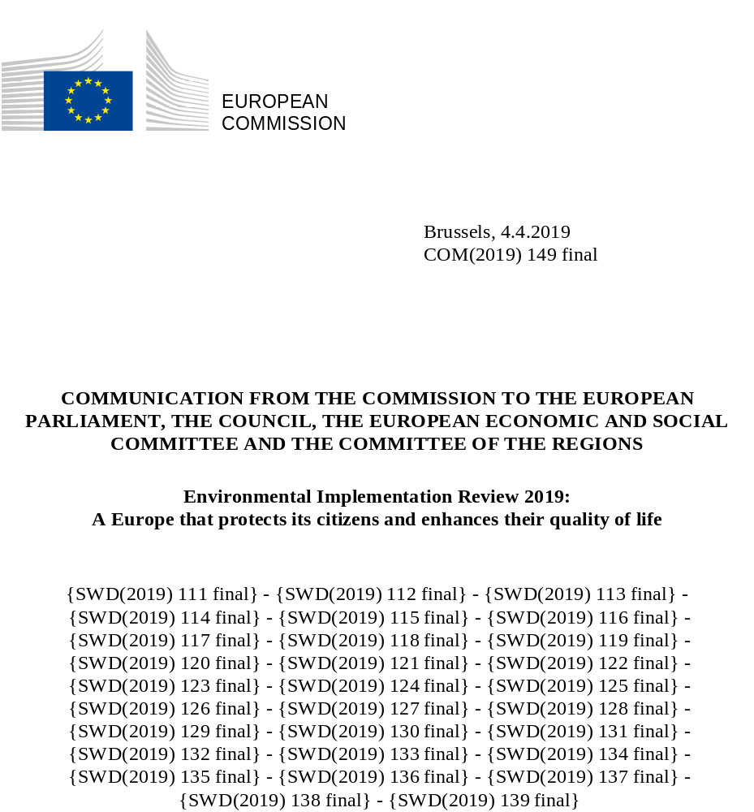

- Environmental implementation gaps cost Europeans around EUR 55 billion per year
Implementation of EU environmental policy and law is essential for a healthy environment. Overcoming the gap between what has been decided and actually implemented is critical to ensure good environmental outcomes for citizens, as well as to preserve a level playing field for economic operators and to create opportunities for social and technological innovations and economic development. A new study estimates that the total costs for society of current environmental implementation gaps are around EUR 55 billion annually.
The Environmental Implementation Review aims at improving implementation in the field of EU environmental policy and legislation by identifying the causes of implementation gaps and addressing systemic obstacles to environmental integration across policy sectors. It maps the main challenges for each Member State, as well as existing good practices and points of excellence.
The first Environmental Implementation Review package was adopted in February 2017. Since its adoption, many Member States have organised national Environmental Implementation Review dialogues on the priority themes identified in their reports. In many cases, regional and local authorities and key stakeholders have been involved. In addition, several sector specific dialogues have been organised. Shortly after the adoption of the first package, a TAIEX-EIR Peer to Peer tool was launched to facilitate peer learning between Member States, regions and municipalities on improving their implementation practices.
This package includes the present Communication, an annex listing the key priority actions, a policy background document and 28 country reports outlining the state of play in the implementation of the main areas and objectives of the EU environmental rulebook, as well as the main challenges and opportunities for each Member State.
Infringement procedures remain an important tool to ensure the proper implementation of legal obligations and, therefore, the Environmental Implementation Review is without prejudice to enforcement actions by the Commission under the Treaties, under the control of the Court of Justice of the European Union. The Environmental Implementation Review makes it possible to enhance compliance with EU environmental laws by addressing the root causes of poor implementation and promoting more effective application, provided that Member States undertake swiftly and decisively at least the priority actions.
The package illustrates the status of environmental implementation as of January 2019 and aims to foster cooperation among public authorities and stakeholders to find tailor-made solutions to address implementation gaps more effectively. The 2019 country reports also cover several new themes compared to 2017, particularly in response to the feedback attained from Member States, the European Parliament, the Economic and Social Committee, the Committee of the Regions and different stakeholders in the first cycle: climate change, invasive alien species, industrial emissions and chemicals, as well as new information. Nevertheless, the structure remains similar to the 2017 Environmental Implementation Review reports.

- The state of implementation: main priorities

2.1. Turning the EU into a circular, resource-efficient, green and competitive low-carbon economy
The transition from a linear to a circular economy is an opportunity to transform our economy and make it more sustainable, switching to a model where products, materials and resources are maintained and used for as long as possible. Sound waste prevention and management is an essential building block of the circular economy as it both helps prevent waste from having a negative impact on the environment and health, and directs it to efficient uses.
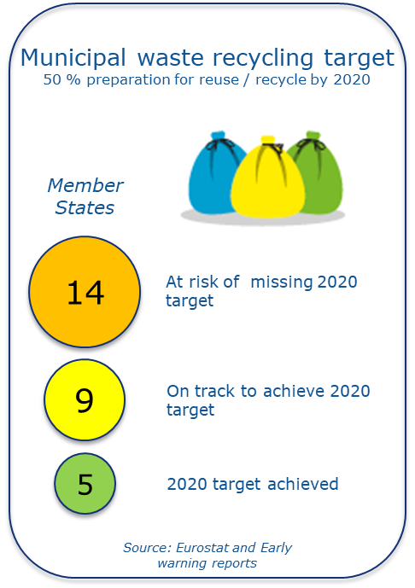
Since 2017, the Commission has been further implementing its Circular Economy action plan, which included the publication of the EU Strategy for Plastics in a Circular Economy within the 2018 Circular Economy package and the adoption of the amendments to waste legislation by the co-legislators. The Commission also adopted a Monitoring Framework for the circular economy, a new tool that will allow policy makers to identify good practices and prioritise areas where further action is needed. A new communication on sustainable bio-economy for Europe was released in October 2018, aimed at strengthening connections between economy, society and the environment. The 2018 proposal to reduce the impact of certain plastics on the environment further illustrates the combined efforts in the EU to tackle more effectively environmental problems linked to the design, production and disposal of plastics; its implementation will be assessed in the following Environmental Implementation Review cycles.
In addition, the Commission has recently proposed various requirements that will contribute to extending the lifetime of products. Consumer protection authorities are increasingly focusing on the issue of premature obsolescence of products. The Commission will further monitor these developments in the framework of the Consumer Protection Cooperation.
In terms of progress, there has been some improvement in meeting EU requirements on waste management. At EU level, recycling rates have increased from 43.7 % in 2014 to 46.4 % in 2017 and the volume of landfilled municipal waste has decreased by 20.6 % between 2013 and 2017. However, the situation varies considerably among Member States. Waste treatment obligations are still not fully met, with large divergences of performance within the EU.
For the countries at risk of not meeting their 2020 preparation for re-use/recycling targets for municipal waste, the Commission has presented early warning reports with blueprints for action to catch up with the EU waste legislation.

Policy findings
- Overall, the policy framework for circular economy has been strengthened since 2017. However, several Member States should better implement circular economy principles in different areas, for instance concerning water and energy savings, waste prevention, the recycling of materials, the promotion of reuse and repair, and the uptake of secondary raw materials.
- Some Member States should further incentivise resource efficiency measures; improve their eco-innovation performance; increase awareness and foster the uptake of voluntary instruments such as the EU Ecolabel and Eco-Management and Audit Schemes; increase recycling and circular measures in the SME sector; and/or facilitate green investments and ease the access to funding.
- Waste prevention remains an important challenge in all Member States, including those with high recycling rates. Six Member States produce at least twice as much municipal waste per inhabitant than the Member State with the lowest waste generation. In addition, the average generation of municipal waste in the EU has increased since 2014: only nine Member States reduced their generation per capita between 2014 and 2016.
- According to data reported to the Commission, only a few Member States have already reached the municipal waste recycling target of 50% by 2020, while several Member States have been identified as at risk of missing it. There is scope for the introduction or improvement of policies, including economic instruments (e.g. landfill taxes, Extended Producer Responsibility, Pay as You Throw schemes), to further implement the waste hierarchy and make reuse and recycling more economically attractive.
Successful practices:
Slovenia illustrates that circular economy policies and improved waste management can be done in short time-frames. A comprehensive strategy on circularity has stimulated separate collection and recycling, with the help of EU funds.
Denmark provides a good example of open cooperation along value chains and innovation to promote the circular economy. The percentage of SMEs offering green products or services is significantly higher than the EU-average.
France adopted an ambitious roadmap for circular economy in 2018, with actions aiming to reduce resource use by 30 % by 2030. It introduced an ambitious target of 100 % recycling for plastics by 2025, with an estimation of creating 300 000 new green jobs.
- Many Member States need to increase the effectiveness of separate waste collection, which is a prerequisite for improving recycling as regards quantity and/or quality. Another issue is the incineration or landfilling of recyclable waste. Nearly all Member States are encouraged to implement new measures aiming at shifting reusable and recyclable waste away from incineration and landfilling, and to improve and extend their separate collection systems. The number of landfills not in line with the requirements of the Landfill Directive remains a matter of concern.
  - Climate change and the environment
Many ecosystems, and some of the services they provide, have already changed due to global warming and are at further risk because of changing climatic conditions.
Climate action is essential to address many environmental challenges such as air pollution, biodiversity, water or invasive species, among others. Conversely, taking action in many environmental areas can have a direct benefit on the climate; inter alia, on agriculture and land use, waste or air pollution. The Commission’s strategic long-term vision for a prosperous, modern, competitive and climate neutral economy confirms Europe's commitment to lead the global climate action and presents a vision that can lead to achieving net-zero greenhouse gas emissions by 2050.
In 2018, the EU adopted legislation aiming to reduce its greenhouse gas emissions by at least 40 % by 2030, as compared to 1990. For the first time, the EU’s framework covers both emissions and removals from land. It has also raised the level of ambition on renewable energy and energy efficiency. When the agreed EU legislation is fully implemented, the cut to EU emissions is estimated to reach around 45 % by 2030.
By the end of 2018, Member States had to submit their draft national energy and climate plans, work on their draft national air pollution control programmes and on their plans for accounting of greenhouse gas emissions and removals from land use, land use change and forestry. These plans should increase consistency between climate, air and energy policies and could therefore become good examples of how to link sector-specific policies, such as agriculture-nature-water and transport-air-health, to address common challenges.
The Commission’s approach to climate change adaptation aims to contribute to a more climate-resilient Europe through better preparation and a stronger capacity to respond to the impacts of climate change at local, regional, national and EU levels. The Commission has evaluated the 2013 EU adaptation strategy suggesting areas where more work needs to be done to prepare vulnerable regions and sectors. Synergies are needed between adaptation, sustainable development and disaster risk reduction efforts to avoid future damage.
Overall, Member States have made good progress in developing a National adaptation strategy and/or a National adaptation plan. This progress suggests that there is a significantly higher baseline of preparation and adaptation policy-making than in 2013. Adaptation goals are to be included also in the national energy and climate plans under the energy union governance framework.
Policy findings:
- Overall, there is a good level of implementation of climate legislation throughout the EU and the 2020 targets are thereby likely to be met.
- All Member States complied with their obligations under the Effort Sharing Decision in 2013-2015. Some Member States need to mobilise the flexibility mechanisms foreseen in the legislation to comply with their current obligations.
- The EU ETS has a very high compliance rate, as each year installations cover around 99% of their emissions with the required number of allowances.
- As of October 2018, twenty-five Member States have already developed National Adaptation Strategies with continued efforts undertaken in the remaining three to finalise theirs.
- Adaptation efforts in each Member State and at EU level need to be intensified, as appropriate action to prevent and/or minimise damage that can be caused by climate change carries significant economic and social benefits.
Successful practices:
Under the Effort Sharing Decision, Sweden did not use its full allocation and cancelled the surplus annual emission allocation to enhance the environmental integrity of the system as a whole.
The EU Strategy for the Danube Region puts a special focus on adaptation to extreme weather events and provides an important platform to foster cooperation between Austria, Bulgaria, Croatia, the Czech Republic, Germany, Hungary, Romania and Slovakia on joint monitoring and flood management.
Furthermore, international conventions on the Alps and Carpathians are in place. There is also transboundary cooperation with non-EU Members on biodiversity and adaptation issues in northern Europe. The Fennoscandia Green Belt initiative supports a joint nature conservation cooperation between Finland, Norway and Russia, among other foci on threats to ecosystem services from climate change.

  - Protecting, conserving and enhancing natural capital
Europe’s unique and rich nature has intrinsic value and is a source of precious resources and benefits to people and the economy. The EU has developed a comprehensive system of rules covering nature, biodiversity, land and marine protection, which are key to achieve the headline target of the Biodiversity Strategy to 2020 of halting the loss of biodiversity and ecosystem services and restoring them as far as possible.
Attaining favourable conservation status of protected species and habitats requires full implementation of the Habitats and Birds Directives. The Action Plan for nature, people and the economy aims to rapidly improve practical implementation of the abovementioned Nature Directives and accelerate the progress towards the EU 2020 goal of halting and reversing the loss of biodiversity and ecosystem services. Every six years, Member States report on progress made in this respect and, therefore, new information is not available for this cycle of the Environmental Implementation Review. Reporting due later in 2019 will be reflected in the Commission’s State of Nature Report in 2020.
Overall, while some important gaps remain, the Natura 2000 network has continued to expand in marine areas and the EU has already achieved the 2020 Aichi target of 10% of coastal and marine areas covered by protected areas. Progress has also been made on the adoption of the necessary conservation measures, such as sites' management plans, although they still cover only 70% of Natura 2000 sites. Major efforts are still necessary to ensure the implementation – including financing- of such measures on the ground and the achievement of their conservation objectives. This also applies to measures in some of the Outermost Regions and the Overseas Countries and Territories.
The introduction and spread of invasive alien species poses a growing threat to Europe’s biodiversity. The invasive alien species Regulation provides a set of measures to be taken across the EU in relation to species included on the list of Union concern.
The available information indicates that marine and land ecosystems as well as soil continue to be affected by several pressures, ranging from inappropriate agricultural practices, land abandonment, climate change, infrastructure development, urban sprawl, pollution of air, soil and water, to increasing pressures from invasive alien species. Addressing such a wide range of pressures requires, among others, the effective integration of biodiversity objectives into other policies, especially those related to funding, and promoting dialogue between actors.
Policy findings:
- Significant gaps in implementation, enforcement, financing and policy integration are affecting efforts to protect European ecosystems. Biodiversity loss continues in the EU, even if some progress has been achieved at local level.
- Despite some progress since 2017 with regard to the completion and management of Natura 2000, most of the Member States need to speed up efforts for the completion of their networks, especially in the marine environment, and complete the process of designation of special areas of conservation while developing and implementing more effective conservation measures. Some Member States should also develop and promote smarter and more streamlined implementation approaches to ensure compliance. Better capacity in national administrations and adequate funding are needed to prevent deterioration and ensure good management of Natura 2000 sites.
- The mapping of ecosystems and their services has generally improved since 2017, but some Member States are still lagging behind.
- Some Member States should improve their protection of forest and grassland habitats through incentives for foresters and farmers, following the EU Forest Strategy of 2013. Sustainable forest management and efficient use of biomass are key for a sustainable use of natural resources.
- Some Member States have not adopted national legislation to comply with the invasive alien species Regulation and/or have failed to notify on time the eradication measures to the Commission.
- Insufficient data, monitoring and reporting is affecting the evaluation of protective measures for marine areas. Some countries have failed to report on time, while many others need to improve their cooperation and monitoring programmes.

Successful practices:
In Romania, the LIFE project ‘Connect Carpathians’ aims to enhance landscape connectivity within ecological corridors of Natura 2000 sites in western Romania. These sites are areas where flagship species such as bears and wolves can move without risk of being hunted or accidentally killed. The project is complemented with several activities to improve administrative capacity, involve local stakeholders and secure land to develop linkage corridors.
Cyprus is one of the countries with advanced implementation of the EU Timber Regulation. Despite its small size, the country performed more checks on domestic and foreign timber operators than any other Member State. 100 % of national operators received training on their legal obligations and the fines applicable to infringements are among the highest in the EU.
  - Ensuring citizens’ health and quality of life
Air quality and noise
Air quality in Europe has improved over the last decades, thanks to joint efforts by the EU and national, regional and local authorities. Since 2000, the EU's Gross Domestic Product grew by 32 % while emissions of the main air pollutants decreased between 10 % and 70 %, depending on the pollutant. Ambient concentrations for most of the air pollutants have also decreased in the last years. However, in most Member States, the quality of life of citizens remains hampered, as the concentration of certain air pollutants are above EU air quality standards. The situation is especially severe in urban areas, where a majority of Europeans live.
In 2018, the Commission came forward with the Communication 'A Europe that protects: Clean air for all', which outlined measures available to help Member States fight air pollution and set into motion more high level national Clean Air Dialogues. A fitness check of the two EU Ambient Air Quality Directives is ongoing, evaluating their relevance, effectiveness, efficiency, coherence and added value. Member States have started compiling their national air pollution control programmes, due in 2019. In addition, Research and Innovation initiatives have been launched to help national and local authorities in understanding and fighting air pollution.
As part of the effort to tackle noise pollution, the EU has laid down a common approach to prevent or reduce the harmful effects of exposure to environmental noise. This approach is based on using common methods to map noise, on providing information to the public and on adopting and implementing tailor-made action plans at local level.
Policy findings:
- There is a risk that air pollution is being underestimated in some instances because it may not always be monitored in the right places. Sampling points shall be located both “where the highest concentrations occur” and in areas “representative of the general population’s exposure”, to measure air quality also near major industries or main urban traffic routes.
- Although the situation has improved in some of these countries, eighteen Member States still need to accelerate reductions in nitrogen oxide (NO_{x}) emissions and nitrogen dioxide (NO₂) concentrations by further reducing transport emissions, particularly in urban areas. This may also require proportionate and targeted restrictions on vehicle access to urban areas and/or fiscal incentives. Where exceedances persist, the Commission has initiated infringement cases, including referring several Member States to the Court of Justice of the European Union.
- Acceleration of reductions in particulate matter (PM_{2.5} and PM₁₀) is needed in fifteen EU Member States, inter alia by promoting cleaner energy production and efficient and clean district heating. In this regard, there are several infringement cases pending. Some of the Member States concerned have been referred to the Court of Justice of the EU over persistently high levels of particulate matter (PM₁₀) and the Court has already ruled in two of these cases.
- Reducing emissions of ammonia (NH₃) in six Member States requires a reduction of emissions from agriculture. This can be achieved by introducing low emission agricultural techniques, including for livestock, manure and fertiliser management.
- Action plans for noise managements are still missing in thirteen Member States and seven countries still need to adopt required noise maps.
Successful practices:
Since 2017, Member States and the Commission have engaged in a round of dialogues focused on air quality. By the end of 2018, six “Clean Air Dialogues” had been organised to address specific challenges in the Czech Republic, Hungary, Ireland, Luxembourg, Slovakia and Spain. These efforts have been complemented by the organisation of thematic workshops with the support of the European Commission’s TAIEX-EIR Peer2Peer mechanism.
In Poland, the LIFE project ‘Małopolska Region’ provides support and advisory services to implement measures tackling severe air pollution in the region.
Industrial emissions
Industry accounts for 24 % of the EU’s Gross Domestic Product and employs 50 million people, making a significant contribution to the economic welfare and development of our continent. Nevertheless, pollution from industrial activities can negatively affect people and the environment. A clean industrial sector is therefore essential. Through a comprehensive approach – spearheaded by the Industrial Emissions Directive – the EU aims to ensure a high level of protection for human health and the environment, while enhancing innovation and competitiveness.
Currently, industry emits 40 % of the total pollutants to air and 20 % of the total pollutants to water. The Industrial Emissions Directive tackles these emissions by monitoring the environmental impact of the 50 thousand largest industrial installations and setting emission limits for more than 80 air and water pollutants. Industry’s environmental impact is also lowered by performance standards. The Directive sets out the main principles for the permitting and control of installations based on an integrated approach and the application of best available techniques to achieve a high level of environmental protection, taking into account costs and benefits. Many breakthrough technologies able to achieve significant reductions in greenhouse gases and pollutants, often combined with technologies for circular industry, are already being deployed.
Policy findings:
- All EU Member States need to review granted permits as regards their compliance with newly adopted best available techniques conclusions as well as strengthen control and enforcement on the ground.
- Air and/or water pollution related to emissions from installations in the power sector are the main pollution source for eleven EU Member States. For seven countries, emissions from the sector of intensive rearing of poultry and pigs represent the largest share of emissions. Furthermore, the current situation in two Member States regarding air pollutant emissions from iron and steel plants gives serious cause for concern. Emissions from waste treatment activities remain a concern in three Member States.
Water quality, floods and water management
The protection of water resources, fresh and seawater ecosystems, and drinking and bathing water is an important component of environmental protection in Europe. The existing body of EU water law has put in place a framework for the management of freshwater and marine waters as well as addressing specific pollution sources. The Common Fisheries Policy aims to limit the impact of fisheries to levels appropriate to sustainably harvest the productive potential of stocks while limiting ecosystem impacts.
Europe’s waters are being increasingly affected by climate change. Compliance with EU water law is already helping to manage the effects of a changing climate, by anticipating more droughts and floods. EU water policy holds considerable potential to mitigate climate change, provided effective action is taken now. In addition, EU water policy has helped develop a dynamic world-leading water sector that includes 9 000 small and medium enterprises and provides almost half a million full-time jobs.
The Commission’s assessment of Member States’ second river basin management plans under the Water Framework Directive concluded that knowledge and reporting on the Water Framework Directive have significantly improved. The Commission’s assessment of Member States’ first flood risk management plans under the Floods Directive concluded that important steps have been taken, even if the practical degree of elaboration varies. The Commission has taken into account the results of the 2018 EU Water Conference in Vienna, which allowed a range of stakeholders and Member States to provide input regarding the implementation of EU water legislation, showing a mixed picture.
Policy findings:
- Based on the Member States’ second generation of river basin management plans, the Commission has assessed compliance with the Water Framework Directive objectives and concluded that it is gradually increasing. However, the path towards full compliance with the Water Framework Directive’s objectives by 2027, after which exemption possibilities are limited, seems very challenging at this stage.
- Much remains to be done to fully achieve the objectives of the Water Framework Directive and other related Directives. Increased investments are essential to meet these objectives. Member States will benefit from a greater involvement of all relevant market and civil society actors to secure a better enforcement of the polluter pays principle. EU funds will continue to support these implementation efforts.
- Although a number of Member States have taken good policy measures, including investments, improvements in water quality will still take some time for many river basins.
- While a large majority of groundwater bodies have achieved good status, less than half of surface water bodies are in good status. Nevertheless, trends in several underlying individual quality elements and substances are more positive.
- Pursuing the Flood Directive’s objective of reducing the potential adverse consequences from significant flooding will require sustained efforts from Member States in the following cycles.
- Urban wastewater is still not treated as it should be in many Member States, which is why most of them are still facing infringement procedures and a few have been subjected to financial penalties. Progress depends on Member States prioritising the investments for urban wastewater treatment plants, including through efficient use of the Cohesion Policy funding where available, and European Investment Bank loans.
- Water pollution from nitrates caused by intensive agricultural practices has decreased in Europe in the last two decades. However, despite this positive overall trend, nitrates pollution and eutrophication continue to cause problems in many Member States, as agricultural pressures on water quality are still increasing in some areas. Member States should step up their efforts to address diffuse pollution from nitrates and phosphates.
Successful practices:
Green infrastructure is being financed within the SIGMA II plan for the Scheldt estuary in Belgium.
Luxembourg and Portugal have recently achieved satisfactory levels of compliance with the requirements of the Urban Waste Water Treatment Directive despite difficulties in the past. They are good examples of how decisive public investments addressing compliance issues can reduce environmental risks and protect citizens in their daily lives.
Chemicals
The environmentally sound management and safe use of chemicals in the Single Market is the primary focus of EU chemicals legislation. The regulations on Registration, Evaluation, Authorisation and Restriction of Chemicals (REACH) and on Classification, Labelling and Packaging of substances and mixtures (CLP) are the spearhead of this legislation. However, specific groups of products, such as biocides, pesticides, pharmaceuticals or cosmetics, are covered by their own legislation.
The directly applicable legislation ensures the free circulation of substances in the internal market while increasing competitiveness and encouraging innovation. June 2018 marked the deadline for registration of the last batch of existing substances under REACH, i.e. those manufactured or imported at one tonne or more. This means that REACH only became fully operational in 2018 with the first implementation report expected in 2021 providing a full picture of implementation in the Member States.
Targeted compliance checks are regularly carried out by the European Chemicals Agency (ECHA) to bring registration dossiers into compliance with information requirements. However, shortcomings in this process have been identified in the Commission Communication ‘Report on the operation of REACH’, and ECHA has been required to significantly increase the efficiency of the evaluation procedures by 2019 through different actions.
While data on the properties of the substances is available at EU level, the above-mentioned Communication has also concluded that “the enforcement of the obligations on all actors, including registrants, downstream users and in particular importers” has to be strengthened. To coordinate and evaluate harmonised enforcement projects and joint inspections, Member States cooperate in the Forum for Exchange of Information on Enforcement established under REACH. An important future task will be better integration of customs border controls to prevent banned substances from entering the internal market on their own or in manufactured articles.
The upcoming Environmental Implementation Review cycles will seek to include more information on compliance at Member State level, dealing with issues such as the number and quality of custom checks by national authorities and the capacity of national inspectorates.
Successful practices:
Italy is using the Commission’s enterprise Europe network to improve awareness of companies of their REACH roles and obligations, a particular challenge considering the high number of micro and small and medium enterprises in the chemical sector in this country.
The Dutch government is preparing a ‘National safe chemicals innovation agenda’ (SCIA), an initiative designed to promote safe materials and products that can replace hazardous chemicals. This research agenda aims to serve as guidance for R&D policies at EU and Member State level.

  - Green taxation, green public procurement and environmental funding
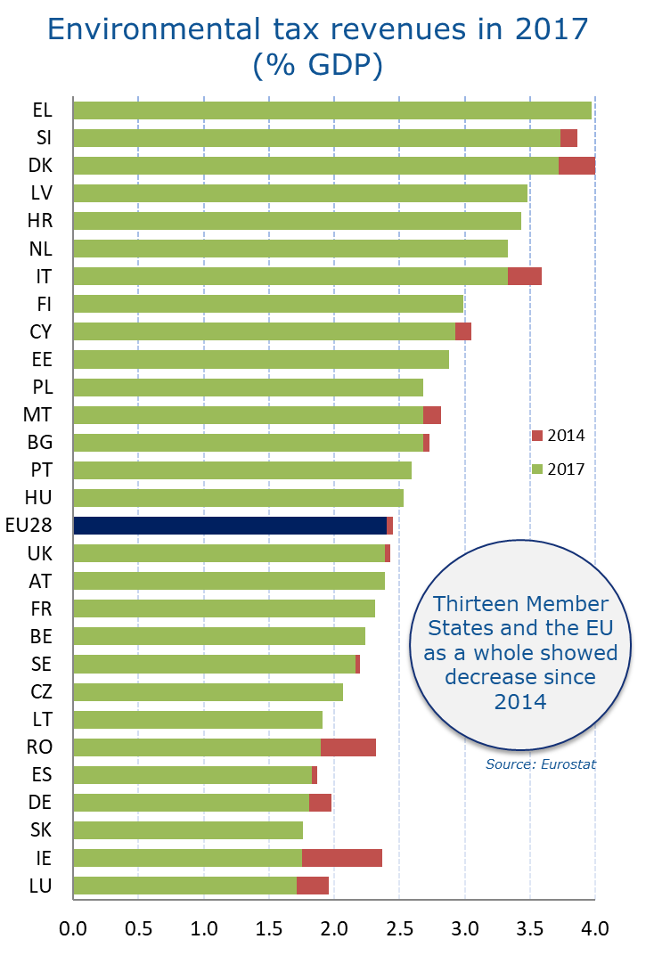
Financial incentives and economic instruments offer an effective and efficient way of achieving environmental policy objectives. The country reports provide an analysis of environmental taxation, the phasing out of environmentally harmful subsidies and green public procurement. The Commission discusses the use of such economic instruments in the broader context of the European Semester and therefore no specific new priority actions are included here.
Dedicated funding is often necessary to achieve environmental goals. Such funding can come from EU and national public funds as well as from loans from the EIB and national banks, and can complement the necessary private investments. The analysis in the country reports attempts to reflect the various sources of public investment and put them into perspective, for instance as a percentage of the GDP.
Policy findings:
- The ratio of environmental taxes to GDP varies from around 1.7 % to 4 %. Several Member States have introduced environmentally related taxes in 2017, including increasing the cost of diesel fuel, or lowering environmentally harmful subsidies. However, tax advantages for the private use of company cars persist in several Member States impeding progress in dealing with traffic congestion and air pollution.
- Within the European Structural and Investment Funds (ESIF), ‘environmental protection and resource efficiency’ constitutes the highest allocation in the 2014-20 period in 12 Member States. In addition, the EU allocations for environment were higher than the national government public expenditure on environment in the period 2014-2018 for 11 Member States.
Successful practices:
The landfill tax in the United Kingdom has begun to produce clear impacts on reducing landfilling. The increasing landfill tax – currently one of the highest in Europe - has effectively reduced the disposal of waste, thus maximising the recycling of dry materials and food waste.
Austria has established a platform and help-desk to facilitate the exchange of experiences between green public procurement officers on different governmental levels.
Poland has a wastewater fee, the revenue of which is used for environmental protection investments. Sweden has NO_{x} and SO₂ taxes in place, which has led to the reduction of these air pollutants; and in 2018 taxes on chemicals, air travel as well as a system of indexation of environmental taxes were introduced. Croatia has a Forest Public Benefit Function Fee, which requires companies to contribute financially to forest management. Baden-Wurttemberg (Germany) remunerates farmers for having wildflower species in their grassland
- In several Member States, the main challenge for environmental financing is to ensure that it remains at an adequate level. In some Member States, there is an issue with the effective use of EU funds, sometimes caused by insufficient capacity of the administrations. Redirecting the funds to non-environment projects may avoid losing money, but this may trigger delays regarding environmental implementation.
2.6. Supporting multilateral action
The EU is committed to strengthening environmental laws and its implementation globally, inter alia by supporting the Global Pact for the Environment process, which was endorsed by the United Nations (UN) General Assembly in May 2018. The Paris agreement on climate change is also of crucial importance, and both the Commission and the Member States work actively on its full implementation. In addition, as part of its international obligations and in light of the global nature of environmental challenges and opportunities, the EU is committed to supporting environmental protection in partner countries through its international cooperation and development mechanisms.
The Environmental Implementation Review is one of the tools to ensure that Member States give a good example by respecting European environmental policies, laws and international agreements, and therefore continues to monitor the ratification status and implementation of international agreements.
The new country reports also look into the administrative frameworks for dealing with international trade in tropical timber, access to genetic resources and international wildlife trade. The EU Timber Regulation is an example of concrete support by the European Commission; in 2018, two multi-country workshops were organised on how to improve its implementation, under the TAIEX-EIR Peer to Peer tool, with the participation of twelve Member States.
Good environmental implementation within the EU is essential to achieve full implementation of the Sustainable Development Goals (SDGs), agreed in 2015. This concerns in particular the goals on protecting water ecosystems from pollution and using water sustainably (SDG6), sustainable consumption and production (SDG12), climate action (SDG13), protecting marine ecosystems (SDG14), and tackling the pressures on Europe’s natural capital (SDG15). To tackle environmental implementation gaps, it is key to have effective institutions and governance (SDG16), and to improve policy coherence and stimulate collaboration in multi-stakeholder partnerships (SDG17). The sustainable development goals also stimulate environmental integration because they link environmental, social and economic policies into a coherent framework.
Policy findings:
- Many Member States still need to sign and ratify one or more multilateral environmental agreements.
- Some Member States should improve their implementation of the EU rules on the use of genetic resources, and several countries are not yet fully implementing the rules on tropical timber.
Successful practices:
Horizontal coordination of actions to achieve the SDGs is gaining momentum in Europe. Spain appointed a High Commissioner for the 2030 Agenda, who reports directly to the President of the Government. France has appointed an Inter-ministerial Delegate for Sustainable Development under the authority of the Prime Minister.
- Strengthening environmental governance

  - Environmental governance
The quality of Member States’ public administration has a significant impact on the results of EU policies. According to a 2018 study, the quality of a country's public services correlates with the level of trust in public administration, the ease of doing business, and societal well-being.
The 2017 Environmental Implementation Review identified a number of common root causes of implementation gaps related to governance, but a more systematic analysis was needed. An assessment of the environmental governance performance of the Member States has been launched as a first step towards mutual learning and finding tailor-made solutions. The Commission will discuss, within the Environmental Compliance and Governance Forum and in the Environmental Implementation Review expert group, how the results and data collected within the project can be used and updated to underpin future Environmental Implementation Review cycles.
In terms of progress since 2017, the important standards for transparency, public participation and access to justice set by the Aarhus Convention have not yet been fully realised across the EU. Further efforts in these areas would benefit citizens, businesses and administrations. The right of concerned stakeholders to bring legal challenges before national courts, often based on the judgments of the Court of Justice of the European Union, is increasingly recognised. To facilitate judicial action by natural and legal persons, an interpretative communication on access to justice in environmental matters was adopted in 2017.
In addition, the Action Plan on Compliance Assurance adopted at the beginning of 2018 is set to deliver good practices and guidance on how to handle complaints, combat environmental crime and ensure compliance in rural areas, as well as a wider framework for assessing how Member States achieve environmental compliance.
The Regulation on the governance of the energy union and climate action entered into force in December 2018, and will significantly strengthen the integration between energy, climate and environment policies, notably with the obligation for Member States to prepare National energy and climate plans.
The need to address environmental crime, and especially wildlife and waste trafficking, has been recognised as a priority as part of the EU policy against organised crime for the period 2018-2021. As a result, many concrete actions, led by enforcement agencies in the Member States, with support from Europol and EU funding, have been carried out throughout the EU against various types of environmental offences.
Not least, the networks of professionals (e.g. IMPEL) are playing a crucial role and the Commission intends to further strengthen their role. Digitalisation and e-Government services can also help to develop a more effective and better integrated enforcement administration. Several EU initiatives support Member States to this end.
Policy findings:
- A stronger environmental governance in the Member States improves the implementation of environmental policy. Member States can further improve their overall environmental governance.
- Increased transparency clearly benefits implementation. It improves knowledge, responsibility, public involvement and support. Member States should make better use of digital opportunities to improve transparency by better informing the public on the actual state of the environment at local/regional level, stimulating behavioural change.
- Despite general progress, Member States still need to improve access to environmental information, particularly to spatial data and services, so they can be easily and freely re-used (in line with the INSPIRE, Access to Environmental Information and the Public Sector Information Directives).
- Several Member States should ensure that there is legal standing for environmental NGOs to bring legal challenges on environmental issues and that environmental claimants stop facing hurdles, such as prohibitely high costs.
- Twenty-six Member States should improve the application of the Environmental Liability Directive in one or more of the following areas: financial security, guidance, and collection and publication of information on environmental damage.

3.2. Environmental integration
The achievement of environment and climate objectives does not solely depend on the implementation of environmental laws, but also requires that environmental considerations are integrated into other policies as underlined repeatedly in the Commission’s environmental action programmes. This can be illustrated with the example of the Common Agriculture Policy (CAP): given that agricultural land covers approximately half of the Union’s surface. The Common Agriculture Policy can significantly contribute to environmental and climate objectives, such as halting the loss of biodiversity, reducing land and soil degradation, ensuring water quality, reducing ammonia emissions, and managing and reducing greenhouse gas emissions. Recent reforms of the Common Agriculture Policy have brought promising changes to the policy framework in terms of improved coherence with environment and climate objectives. The legal proposals for the Common Agriculture Policy post-2020 will further strengthen this coherence. The updated bio-economy strategy is also an attempt to integrate environmental, social and economic objectives in a cross-policy and coherent manner.
Policy and laws made by different authorities in different sectors should be coherent and based on a joint logic, scientific evidence and the good use of available technologies. This is also underlined in Article 11 of the Treaty on the Functioning of the EU. Environmental integration requires effective cooperation between authorities while, in reality, different ministries and subnational authorities still tend to work in isolated ‘silos’. Insufficient policy and institutional coherence is one of the main causes of implementation gaps with regard to achieving the objectives of EU environmental policy and law.
Fostering policy and institutional coherence is a permanent challenge. The country reports show that environmental pressures are closely related to economic sectors (agriculture, transport, industry, food or energy, among others) in many Member States. An example is how the circular economy depends on product innovation, effective waste management and stimulation by sustainable public procurement. At EU level, an analysis of the relations at the nexus between agriculture and water showed that a more integrated approach is possible. In many cases, a collaborative approach with respect to different interests could be a better way forward, rather than adopting new legislation.
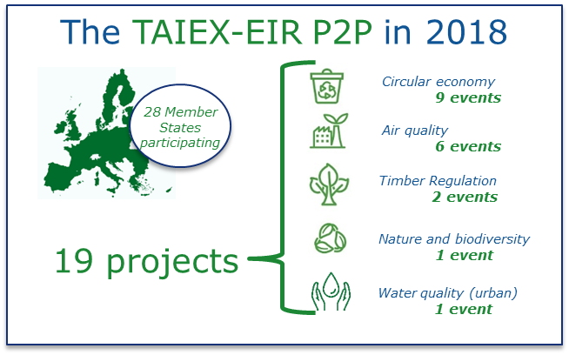
In addition, cross-sectoral meetings at political level (e.g. joint meetings of Council formations) and joint project expert teams provide the means to identify, analyse and solve occurrences of weak environmental integration.
Peer to peer learning proved to be an important instrument in improving environmental implementation. The TAIEX-EIR P2P tool, introduced during the first Environmental Implementation Review cycle, has been well received by the environmental authorities. In 2018, the first operational year of the tool, all Member States were involved in at least one event and more than 50% of the events were multi-country workshops. In the 19 projects executed in 2018, the tool has been used mainly by the environmental authorities, but it may serve better integration by including other relevant authorities, as indicated by the policy findings.

Policy findings:
- All Member States can further improve their overall environmental governance. In several Member States, environmental authorities are severely understaffed and this lack of capacity and resources affects their ability to implement and enforce. Coordination structures across sectoral administrations and at different levels exist in most Member States but their effectiveness varies. Three Member States are strongly encouraged to address regional and local fragmentation by developing better coordination mechanisms for the environment.
- Two Member States still need to complete the transposition of the revised Environmental Impact Assessment Directive (EIA) into national law. Environmental assessment procedures need to be streamlined and efficient public participation needs to be ensured throughout the EU.
- Peer to peer exchanges have been mainly used for thematic challenges, but there is scope for also using the tool for exchanges on the root causes of weak implementation in the area of public administration quality and governance mechanisms.
Successful practices:
Bulgaria has taken steps to provide for streamlined environmental assessments by incorporating the appropriate assessment under the Habitats Directive, the integrated pollution prevention and control (IPPC) permitting process and the ‘Seveso’ process for chemical safety into its EIA procedures. Streamlining helps to reduce the administrative burden, enhances coherence and accelerates decision-making, and efforts should turn towards adequate implementation of these provisions.

- The way forward
The Environmental Implementation Review has identified a few root problems that require special attention in the coming years and has raised the attention of key authorities and citizens to environmental implementation gaps in their countries.
Integration of environmental objectives with other legitimate policy goals is often weak and this has negative effects on implementation. Better integration of all these objectives at the stages of policy planning and implementation is essential for the success of each of the relevant policy areas and ultimately for our societies. The perspectives indicated by the latest State of the Environment report and the Environmental Indicator Report 2018 are rather grim and full implementation of the current EU environmental laws is, indeed, merely a starting point in changing the trends.
The current progress in real implementation is too slow and better environmental integration can be a game-changer. The situation can be improved only if the environmental concerns are taken into consideration in the framing and execution of public policies with a significant environmental footprint, such as energy, transport and agriculture. The 'nexus approach' could be strengthened as a guiding principle: it is about examining issues systematically and in advance, with a view to identify further integrated solutions for the involved sectors and to underpin environment-related investments at EU, national, regional and local level.
The quality of the relevant governance systems is a key catalyser for full implementation. The country reports identified that inefficiency and ineffectiveness of public administrations constitute another important root cause for poor implementation. The Commission already addresses the quality of public administration and governance in the context of the European Semester, through the structural and investment funds, the structural reform support programme and with specific guidance instruments. In particular, it is clear that while the needs differ from one system to another, there cannot be any improvement in this respect without securing the necessary human and financial resources to the relevant administrations.
Environmental implementation cuts across and depends on the active engagement of a wide spectrum of stakeholders, public and private, from decision makers to citizens, businesses and industries. Such a wide range of interested parties can be activated only if the relevant information is made available to them in an effective way. Transparency of environmentally relevant information goes beyond the legal obligations: it is a precondition for effective collaboration in environmental implementation. Without transparency, trust disappears and the mobilisation of stakeholders is not successful.
Tackling the implementation gaps requires solid evidence to identify the ’distance to target’, the underlying difficulties and available options and then to monitor the effectiveness of the chosen solutions. Therefore, the Commission calls upon the Member States to be transparent when implementing EU rules and policies, building on the EU’s open data portal, and using modern information technologies for communication, data and information purposes. These will also enable the Commission to tailor its support to the realities on the ground.
The Commission is committed to supporting the Member States to improve environmental implementation. Expressions of this are the thematic Environmental Implementation Review dialogues and the dedicated Peer 2 Peer tool helping to assess the problems, exchanging good practice and peer learning. Nevertheless, successful country dialogues require active engagement of regional and local authorities and of other stakeholders. There is a need for more thematic debates at and between all levels of administration, which should result in operational conclusions followed by action. The debates should take into consideration possible further environmental integration in other policy areas. The Commission has published documents that can serve as a starting point, including the Communication on Clean Air (2018), the Working Document on agriculture and water (2017), the Action Plan for nature, people and the economy, and the Early warning reports on the re-use/recycling of waste.
The Commission invites Member States to act on the Environmental Implementation Review findings and to use the country reports as a basis for further discussion. Member States are also encouraged to continue working on the implementation of the environmental rules in place to deliver better environmental outcomes to the citizens, to protect their health and to cushion and offset the environmental pressures that are costly for our societies and economies.
A good environment is a common asset of people of the EU, both of the present and future generations, and it constitutes a critical foundation for the other social and economic activities. The EU has put in place comprehensive environmental legislation, with the aim of making sure that air is breathable, water is safe to use, our food is healthy to consume, things around us are safe to use, and pollution is kept at bay. These standards are as good as their implementation. Making implementation happen is in our hands, whether we act in a public or private capacity.

COWI and Eunomia, ‘Costs of not implementing EU environmental law’, 2019.
COM(2017) 63.
TAIEX-EIR Peer to Peer
COM(2016) 316.
The findings as regards specific Member States in this Communication and its accompanying Annex are based on the information available to the Commission before its adoption date and is without prejudice to any legal action that the Commission might take after this date.
COM(2015) 614.
COM(2018) 028.
Publications Office of the European Union, Waste Package (Official Journal of the European Union, L 150, 14 June 2018).
European Commission, Circular Economy Monitoring Framework.
COM(2018) 673.
Provisional inter-institutional agreement on 19 December 2018.
Inter alia, eco-design requirements in product regulations which support better reparability, provision of useful information for repairs and provision of spare parts.
In this context, the Commission held a workshop with the Member States’ consumer protection authorities on planned/premature obsolescence in October 2018.
European Commission, Recycling rate of municipal waste.
COM(2018) 656.
Austria, Bulgaria, Croatia, Cyprus, the Czech Republic, Estonia, Germany, Greece, Hungary, Ireland, Latvia, Malta, Poland, Portugal, Romania, Slovakia and Spain.
Austria, Cyprus, Greece, Hungary, Italy, Malta, the Netherlands, Romania and Slovakia.
European Commission, Municipal waste, by waste operations. Austria, Cyprus, Denmark, Germany, Luxembourg, Malta.
Belgium, Bulgaria, Denmark, France, Germany, Luxembourg, Hungary, the Netherlands and Spain.
Austria, Belgium, Germany, the Netherlands and Slovenia.
The Commission has presented early warning reports for Bulgaria, Croatia, Cyprus, Estonia, Finland, Greece, Hungary, Latvia, Malta, Poland, Portugal, Romania, Slovakia and Spain. See COM(2018) 656.
French Ministry for an Ecological and Solidary Transition, Roadmap for the Circular Economy, 2018.
Bulgaria, Croatia, Cyprus, the Czech Republic, Estonia, Greece, Finland, France, Hungary, Ireland, Italy, Lithuania, Latvia, Malta, Poland, Portugal, Romania, Slovenia, Slovakia, Spain and the United Kingdom.
Directive 1999/31/EC.
The Intergovernmental Panel on Climate Change, Special report on a Global Warming of 1.5°C.
COM(2018)773.
Directive (EU) 2018/410.
COM(2018) 738.
Regulation (EU) 2018/1999.
In 2016, Belgium, Finland, Germany, Ireland, Malta and Poland had higher emissions than their annual emission allocations. In 2017, according to preliminary data, Austria, Bulgaria, Cyprus, Estonia, Finland, Germany, Ireland, Lithuania, Malta and Poland had higher emissions than their annual emission allocations.
All member States but Bulgaria, Croatia and Latvia.
European Commission, Macro-regional strategies.
Alpine Convention, website.
Carpathian Convention, website.
COM(2011) 244.
Directive 92/43/EEC and Directive 2009/147/EC.
COM(2017) 198.
COM(2011) 244.
Regulation (EU) No 1143/2014.
Austria, Belgium, Bulgaria, Croatia, Cyprus, the Czech Republic, Denmark, Estonia, Finland, Germany, Greece, Hungary, Ireland, Italy, Lithuania, Latvia, Malta, the Netherlands, Poland, Portugal, Romania, Spain, Slovakia, Slovenia, Sweden and the United Kingdom.
Bulgaria, Cyprus, Estonia, Greece, Hungary, Italy, Lithuania, Portugal, Romania and Slovenia.
Bulgaria, Croatia, Estonia, France, Greece, Hungary, Ireland, Italy, Lithuania, Luxembourg, Malta, Romania, Slovakia, Slovenia and Spain.
Austria, Belgium, the Czech Republic, Denmark, Estonia, Hungary, Portugal, Slovakia and Sweden.
Finland, Lithuania, Latvia, Poland, Slovakia and Sweden.
COM(2013) 659.
Austria, Belgium, the Czech Republic, Greece, Ireland, Portugal, Romania, Slovakia, Sweden and the United Kingdom.
The Czech Republic, Denmark, Germany, Greece, France, Hungary, Portugal and Spain.
Croatia, Denmark, Estonia, Greece, Lithuania, Romania and Slovenia.
As required under the Marine Strategy Framework Directive (Directive 2008/56/EC).
Belgium, Bulgaria, Cyprus, Denmark, Finland, France, Ireland, Italy, Latvia, Malta, the Netherlands, Poland, Portugal, Spain, Sweden and the United Kingdom.
LIFE Connect Carpathians, website.
European Commission, Emissions of air pollutants, EU-28, 1990-2016.
COM(2018) 330.
European Commission, Air quality fitness check.
As an example, the Horizon Prize on Engine Retrofit for Clean Air has been awarded to an innovative retrofit system for diesel cars with excessive NOx emission that demonstrated very good performance. See European Commission, Engine retrofit for clean air Prize - Evaluation of NOx emissions, Horizon Prize.
The European Court of Auditors (Special Report 23/2018) has also pointed out this finding.
Austria, Belgium, Bulgaria, Croatia, the Czech Republic, Germany, Greece, France, Hungary, Italy, Ireland, Luxembourg, The Netherlands, Poland, Portugal, Romania, Spain, United Kingdom.
Austria, Bulgaria, Croatia, the Czech Republic, Germany, Greece, France, Hungary, Italy, Poland, Romania, Slovakia Slovenia, Spain and Sweden.
Austria, Croatia, Denmark, Germany, Ireland and Spain.
Belgium, Cyprus, the Czech Republic, France, Germany, Greece, Italy, Poland, Portugal, Romania, Slovakia, Sweden and Spain.
Belgium, Greece, Italy, Portugal, Romania, Slovakia and Spain.
European Commission, LIFE Małopolska Region.
European Commission, Cleaner Industry: what is in it for you? 2018, p.2.
Directive 2010/75/EU.
Publications Office of the European Union, Cleaner industry: what is in it for you?, 2018, p. 2.
Bulgaria, the Czech Republic, Estonia, Finland, Greece, Irelands, Portugal, Romania, Slovakia and United Kingdom.
Cyprus, Estonia, Germany, Hungary, Latvia, the Netherlands and Spain.
Italy and Luxembourg.
Estonia, Latvia and Spain.
This includes the Bathing Waters Directive (2006/7/EC); the Urban Waste Water Treatment Directive (91/271/EEC); the Drinking Water Directive (98/83/EC); the Water Framework Directive (2000/60/EC); the Nitrates Directive (91/676/EEC) and the Floods Directive (2007/60/EC).
European Commission, Water reuse: background and policy context.
European Commission, EU Water conference 2018, 20-21 September 2018.
EU report on the Water Framework Directive and the Floods Directive (January 2019).
Bulgaria, Croatia, Cyprus, France, Greece, Hungary, Ireland, Italy, Latvia, Lithuania, Luxembourg, Malta, Poland, Portugal, Romania, Slovakia, Slovenia and Spain.
In particular, Austria, Belgium, Cyprus, the Czech Republic, Denmark, Estonia, Germany, Greece, Finland, France, Italy, Lithuania, Malta, the Netherlands, Poland, Portugal, Slovakia, Slovenia, Sweden, Spain and United Kingdom.
Regulation (EC) No 1907/2006
Regulation (EC) No 1272/2008.
European Commission, Chemicals legislation.
COM(2018) 116, p.6 and p.9.
Government of the Netherlands, Workshop towards a Safe Chemicals Innovation Agenda from Substitution to Safe-by-design.
European Commission, Evaluation study of the payment for agricultural practices beneficial for the climate and the environment, 2017.
Belgium, Denmark, Estonia, Finland, France, Ireland, Lithuania, Luxembourg, Malta, the Netherlands, Romania, Sweden and United Kingdom. European Commission, Taxation Trends in the European Union, 2018 edition.
Belgium, the Czech Republic, France, Hungary, Ireland, Poland, Portugal and Slovakia.
Austria, Bulgaria, Croatia, Cyprus, Denmark, Finland, France, Greece, Ireland, Luxembourg, Malta and Sweden.
Bulgaria, Croatia, Estonia, Hungary, Latvia, Lithuania, Poland, Portugal, Romania, Slovakia and Slovenia.
Austria, Bulgaria, Finland, France, Germany, Greece, Hungary, Italy, Luxembourg, the Netherlands, Portugal, Romania, Slovenia, Spain, Sweden and the United Kingdom.
Croatia, the Czech Republic, Estonia, Greece, Lithuania, Latvia, Poland, Romania and Slovakia.
Austria, Belgium, Cyprus, the Czech Republic, France, Greece, Ireland, Italy, Latvia, Lithuania, Malta, Poland, Portugal, Romania, Slovakia, Slovenia and Spain.
European Commission, A Comparative Overview of Public Administration Characteristics and Performance in EU28.
Ineffective coordination among local, regional and national authorities, lack of administrative capacity and insufficient financing, lack of knowledge and data, insufficient compliance assurance mechanisms and lack of integration and policy coherence. (see COM(2017) 63)
European Commission, Study project “Development of an assessment framework on environmental governance in EU Member States” (see project library).
Environmental Compliance and Governance Forum, website
European Commission, Expert Group Greening the European Semester/EIR.
European Commission, the Aarhus Convention.
COM(2017) 2616.
COM(2018) 10.
Regulation (EU) 2018/1999.
Council of the European Union, Council conclusions on setting the EU’s priorities for the fight against organised and serious international crime between 2018 and 2021.
EU network for Implementation and Enforcement of Environmental Legislation.
Such as e-Government Action Plan, Environmental Compliance and Governance Action Plan and Quality of Public Administration Handbook
INSPIRE: Infrastructure for Spatial Information in the European Community.
Directive 2007/2/EC, Directive 2003/4/EC, Directive 2013/37/EU. A dedicated project is currently analysing national environmental information systems in more detail and preparing guidance for good practices: European Commission, EIS Data.
Bulgaria, Croatia, Cyprus, Finland, Hungary, Ireland, Lithuania, Luxembourg, Malta, Poland and Romania.
Austria, Belgium, Bulgaria, Croatia, Cyprus, the Czech Republic, Denmark, Estonia, Finland, France, Germany, Greece, Hungary, Ireland, Italy, Latvia, Lithuania, Luxembourg, Malta, the Netherlands, Poland, Romania, Slovakia, Slovenia, Sweden and the United Kingdom.
7th Environmental Action Programme 2014-2020.
COM(2015) 614
European Commission, Agriculture and Sustainable Water Management in the EU, 2017.
Greece, Italy and Spain.
Germany and Lithuania.
European Environmental Agency, Report on the State of the Environment, 2015.
European Environment Agency, Environmental Indicator Report 2018.
The "Nexus approach", referred to in the Communication from the Commission, Next steps for a sustainable European future European action for sustainability, COM(2016) 739, examines the interrelatedness and interdependencies of different challenges.
E.g. ‘Quality of Public Administration - A Toolbox for Practitioners’ and the study ‘Public administration characteristics and performance in EU28’.
European Commission, EU Open Data Portal.
COM(2018) 330.
SWD(2017) 153.
COM(2017) 198 and SWD(2017) 139.
European Commission, Report on the implementation of waste legislation, including the early warning report.

