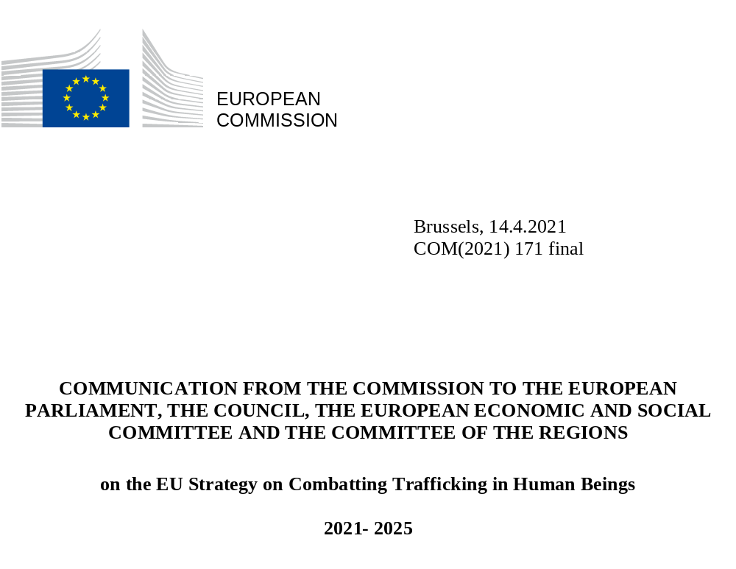

- Introduction
Trafficking in human beings destroys individuals’ lives by depriving people of their dignity, freedom and fundamental rights. It is often a violent crime committed by organised crime networks. It should have no place in today’s society.
Yet, trafficking in human beings is a global phenomenon. It happens in every country and every region. It continues to happen in the European Union, too. According to the latest available data, between 2017 and 2018, there were more than 14 000 registered victims within the European Union. The actual number is likely to be significantly higher as many victims remain undetected. Nearly half of the victims of trafficking within the European Union are EU nationals and a significant number of them are trafficked within their own Member State. The majority of the victims in the EU are women and girls trafficked for sexual exploitation. Almost every fourth victim of trafficking in the EU is a child. The majority of traffickers in the EU are EU citizens and nearly three quarters of perpetrators are men. This crime brings high profits to criminals and carries with it enormous human, social and economic costs. In the EU, the economic cost is estimated to be up to EUR 2.7 billion in a single year.
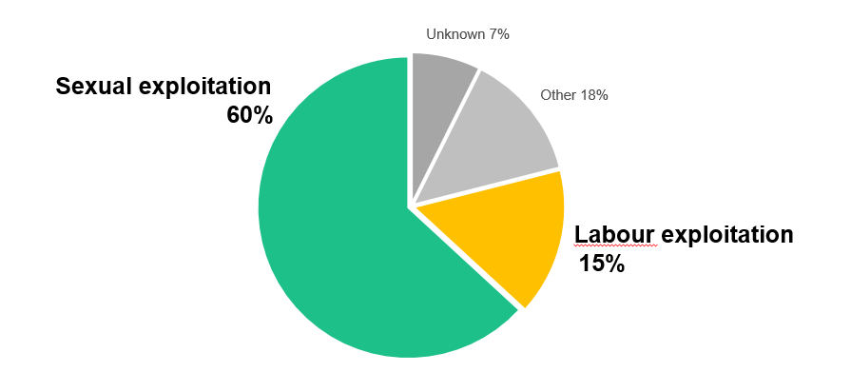
Figure 1 Repartition of registered victims by form of exploitation in the EU in 2017 and 2018
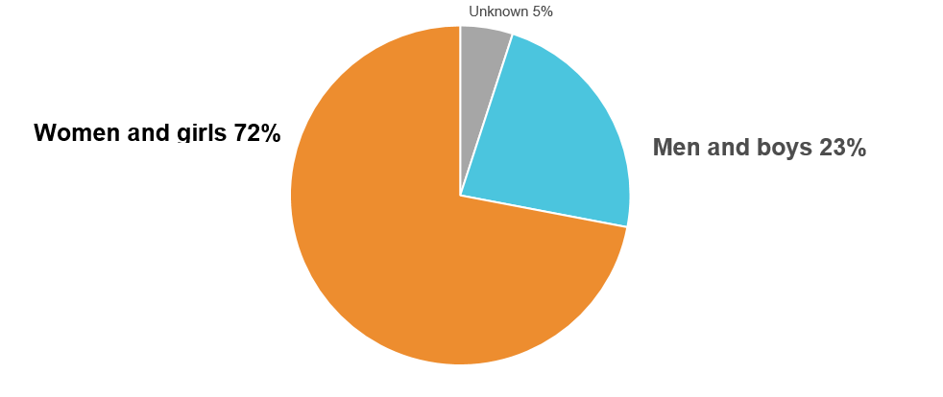
Figure 2 Repartition of registered victims by sex in the EU in 2017 and 2018
Combatting trafficking in human beings has long been a priority for the European Union. Over the years, progress has been made in many respects. Cooperation among key actors, including at political level, between law enforcement and judicial authorities, in both national and transnational contexts, led to prosecutions and convictions as well as improved identification, assistance and support to victims. Awareness raising campaigns, education programmes and training initiatives were carried out to reduce the risks of people becoming victims of trafficking. Studies and reports increased knowledge about the phenomenon, thus contributing to developing adequate response strategies.
Despite the progress achieved, trafficking in human beings remains a serious threat in the European Union, endangering thousands of individuals every year, particularly women and children. Traffickers prey on social inequalities as well as economic and social vulnerability of people, which have been exacerbated by the Covid-19 pandemic, making it easier for perpetrators to find victims. The pandemic also hindered victims’ access to justice, assistance and support, and hampered the criminal justice response to the crime. Moreover, traffickers moved to a new business model of online recruitment and exploitation of victims, making it more difficult for law enforcement and the judiciary to respond.
This strategy identifies key priorities with the objective of combatting trafficking in human beings more effectively. It proposes concrete actions, which will be developed in full respect of fundamental rights, to identify and stop trafficking early on, to go after criminals by turning trafficking from a low-risk and high-return crime to high-risk and low-return crime, and to protect the victims and help them rebuild their lives.
Since trafficking in human beings is a particularly serious form of organised crime, this strategy is closely interlinked with the EU Strategy to Tackle Organised Crime 2021-2025. While the holistic priorities and key actions of the strategy against organised crime apply to trafficking in human beings, this strategy responds to the specific aspects of the crime of human trafficking.
- Comprehensive response to combatting trafficking in human beings – from prevention through protection of victims to prosecution and conviction of traffickers
Trafficking in human beings is a complex criminal phenomenon. Traffickers abuse the vulnerable situation of individuals to gain profit. On the demand side, businesses, employers, users and consumers benefit from the exploitation of victims through services, labour and products. Throughout the trafficking chain, victims suffer severe short- and long-term harm that requires immediate assistance, support and protection as well as a re-integration perspective for a better life for them.
The complexity of the trafficking phenomenon calls for a comprehensive response. There is a need for overarching legal, policy, and operational initiatives to combat human trafficking in a coherent and wide-ranging manner – from prevention to conviction of criminals while emphasising the protection of victims at all stages, taking into account in particular women and child victims as well as trafficking for sexual exploitation.
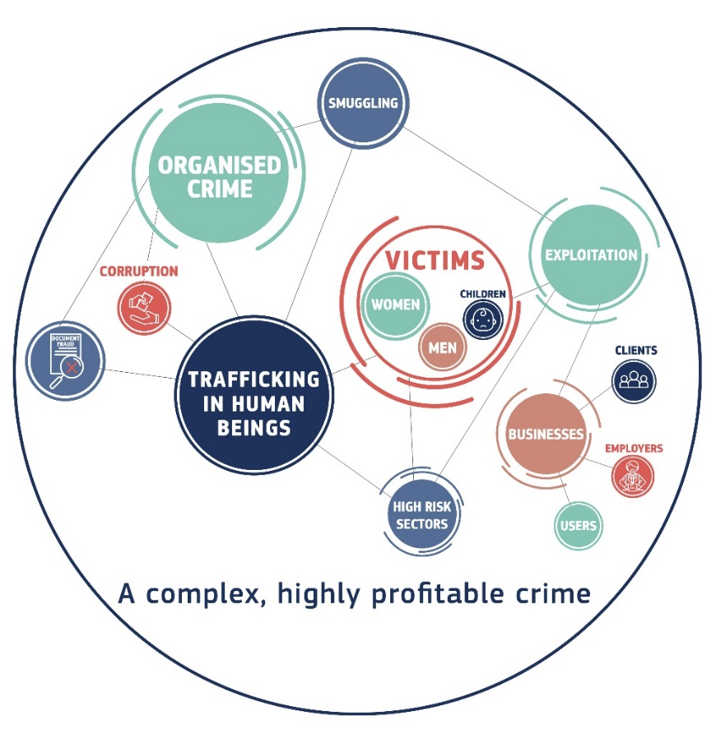
Legislation is one of the most powerful tools at our disposal because it allows to define the crime, set sanctions and common objectives to prosecute criminals, and protect the victims. The EU Anti-trafficking Directive has been the backbone of the EU’s efforts in combatting human trafficking. The European Commission has monitored and supported the transposition and implementation of the Directive in Member States bound by it. In its 2016 Transposition Report, the Commission found that while Member States made substantial efforts to transpose the Directive, there is still room for improvement as regards the prevention, protection, assistance and support measures to victims, including child victims. The Commission requested further information in 2019 from Member States with regard to the findings of its 2016 report. In parallel, the Commission has been supporting Member States to implement effectively the Directive. In this context, the Commission developed the knowledge base, provided guidance and funded dedicated actions, including for cross-border cooperation initiatives. The Commission’s work with the EU network of National rapporteurs and equivalent mechanisms and the EU Civil Society Platform against Trafficking in human beings has also supported the implementation of the Directive. The correct and complete transposition and full implementation of the Directive will remain the Commission’s priority to ensure that traffickers do not benefit from diverse approaches across Europe and that victims receive adequate protection within the EU regardless of where they are. The Commission will continue to support Member States in the implementation of the Directive and will use its powers conferred by the Treaties, including infringements as appropriate.
The monitoring of the implementation of the Directive in Member States, conducted by the Commission in inter alia two-yearly progress reports as well various stakeholders’ reports indicate that the decade old instrument may not be fit for purpose any longer. Despite prevention initiatives undertaken, the demand for using exploited victims’ services has not been reduced. The impunity of perpetrators in the EU persists, and the numbers of prosecutions and convictions of traffickers remain low. The minimum rules established for victims may not take sufficiently into account their actual needs. Therefore, there is a need to evaluate the implementation of the Directive and if necessary, based on the outcome of this evaluation, propose revising it to make it fit for purpose.
At policy and operational level, it is crucial to ensure cross-border, regional and international cooperation, including by developing and sharing knowledge and information, as well through interoperability of information systems. These practices make enforcement and judicial authorities better equipped to obstruct criminals and to support victims. While criminal networks move across borders – through countries of origin, transit and destination – investigating and prosecuting crimes is the competence of Member States within their jurisdiction. Cross-border cases of trafficking in human beings are difficult to investigate as they require resources, coordination and good communication between relevant authorities. Law enforcement also need capacity, tools and structured cooperation to tackle the digital modus operandi of traffickers. EU agencies, such as Europol and Eurojust, have been facilitating close cooperation and coordination between national authorities for successful operational actions to bring criminals to justice and to identify and protect victims.
When victims are repatriated or return voluntarily from the country where they were exploited to their countries of origin, timely cooperation between relevant actors for targeted assistance, support and integration measures are necessary both at the departure and at the arrival point. Such processes to enable victims’ access to their rights in cross-border cases can be facilitated by transnational referral mechanisms, i.e. platforms for cross-border cooperation of relevant public authorities and civil society involved in following up on the identification, assistance and protection of trafficked victims.
To better take into account these cross-border and transnational challenges, the Commission will fund and coordinate a set of actions to further improve the policy and operational work to combat trafficking in human beings. The actions will aim to enhance exchanges of best practices, including on cross-border cooperation between law enforcement and judicial bodies; to facilitate advisory services by practitioners to reinforce multi-agency cooperation and coordination at national and transnational level; to help further enhance support to victims and their referral in Europe and beyond; and to promote awareness-raising, research and data analysis by supporting cooperation between relevant national bodies, for example data institutes and observatories. This set of actions will de facto serve as a knowledge and expertise hub for Member States and other stakeholders.
Providing appropriate funding has facilitated joint investigations and prosecutions by national authorities, increased capacity of law enforcement and other authorities, created broad alliances across stakeholders for a multi-agency and multi-disciplinary approach to combatting the crime. It also enabled victim support and integration in Europe and in partner countries.
The priorities under this strategy will be supported by appropriate funding in order to achieve tangible impact and provide appropriate responses to different forms of exploitation. In addition to actions directly managed by the Commission, the Commission will advise Member States to prioritise their anti-trafficking actions in national programmes under the Asylum, Migration and Integration Fund, the Internal Security Fund, and the Border Management and Visa Instrument in line with the priorities of this Strategy, taking into account the national context and needs. Horizon Europe security research funding will contribute to the priorities of this strategy as well. The Technical Support Instrument could also be used to support the implementation of this Strategy by the Member States.
In order to tackle the situation in countries of origin and transit to Europe and outside, thematic and geographical EU funding will be mobilised along the priorities of this strategy, giving specific attention to (i) the gender dimension, (ii) donor coordination, (iii) local ownership and (iv) support to civil society organisations and local actors and activists; (v) addressing the special protection needs of children in migration.

Key actions:
The Commission will:
- Further support Member States in implementing of the Anti-trafficking Directive, including through dedicated funding, in particular as regard the gender specific and child sensitive aspects;
- Ensure the effective implementation of the Anti-trafficking Directive as a matter of priority by using its powers conferred by the Treaties, including infringements as appropriate;
- Launch a study for the evaluation of the Anti-trafficking Directive, and based on the outcome of the evaluation, consider reviewing the directive;
- Ensure appropriate funding to combat trafficking inside and outside the EU.

- Reducing demand that fosters trafficking
Ultimately, organised crime groups operate based on the basic economic principle of high demand driving their activities. Demand fosters all forms of exploitation of people in vulnerable situations, which traffickers take advantage of, in particular, in high risk sectors and high risk environments. This in return brings huge revenues to organised crime groups and to those who take advantage and profit from the exploitation of the bodies, services and labour of trafficked victims. The estimated global annual profit from trafficking in human beings amounted to EUR 29.4 billion in 2015. In the EU, in one single year, criminal revenues of trafficking for sexual exploitation, which is the most prevalent purpose of trafficking, are estimated at about EUR 14 billion. This amount does not take into account trafficking for labour and other forms of exploitation. Reducing demand in an effective way is therefore essential to deprive traffickers of their financial gain and thus ensuring that the crime does not pay.
Discouraging demand as part of prevention measures is addressed in the Anti-trafficking Directive, which invites Member States to consider criminalising the knowing use of services exploited from trafficked persons. However, the final decision is left to Member States. This has led to a diverse legal landscape across the EU where employers and users face different consequences where they employ or use the bodies, labour and services of trafficked people. The increasing number of victims indicate a worsening situation and calls for a stronger and harmonised response to reduce illicit demand for exploited services of trafficked victims. Given the serious and extensive nature of this crime across the EU and the differing legal landscapes, which hamper efforts to reduce demand, the criminalisation of the knowing use of exploited services and products from victims should be thoroughly analysed. As part of the evaluation of the Anti-trafficking Directive, the Commission will therefore carry out an assessment on the possibility having minimum EU rules that criminalise the use of exploited services of trafficking victims.
Awareness raising campaigns on the risks of trafficking are important means to detect and prevent the crime. They help make the public, employers and users of services of victims aware of trafficking. Such campaigns are best conducted in cooperation with relevant civil society organisations. The Commission will therefore organise a communication campaign, together with Member States and civil society, targeting high-risk sectors and high-risk environments, including for sexual exploitation.
Labour exploitation concerns 15% of all victims of trafficking within the European Union, with an increasing number of victims remaining undetected. To bring these numbers down, the criminal justice response to trafficking for labour exploitation should be strengthened. In this context, national authorities should be encouraged to intensify joining efforts with labour inspectors and/or social partners and EU agencies, in particular with Europol, and within its remit with the European Labour Authority, to carry out concerted and joint inspections in high risk sectors to identify victims and their exploiters. Enhanced cooperation between Member States’ relevant authorities and other actors through the European Platform tackling undeclared work, soon within the European Labour Authority, will help build know-how and showcase transferable practices, including to identify victims trafficked for labour exploitation. Fostering the development of public-private initiatives with businesses in high risk sectors and high risk environments, also by involving the regional and local level, will support efforts to increase the detection of trafficking victims and the reporting of the crime to authorities.
Employers can also contribute to reducing demand for serviced of exploited victims of trafficking. Finding employment in the EU without the required legal status is one of the main drivers for smuggling as well as trafficking to the EU. The Employers’ Sanctions Directive prohibits the employment of irregularly staying third-country nationals, including victims of trafficking in human beings. It lays down minimum standards on sanctions and other measures to be applied in the Member States against employers who infringe upon the Directive. This year, the Commission will assess how to strengthen the effectiveness of the Directive and evaluate the need for further action.
Businesses in certain sectors – such as hospitality, garment, fishing, agriculture and construction – may rely on the workforce of people who are in a vulnerable situation. They therefore have an important part to play and should take measures against human rights violations. This includes discouraging demand by ensuring that anti-trafficking objectives are incorporated in their policies, which can be achieved through responsible management of global supply chains of products and human rights due diligence. The Commission’s upcoming legislative initiative on sustainable corporate governance, providing for a duty of diligence by companies, is one of the key EU initiatives to promote respect for human rights. Public institutions also have a role to play in ensuring that public procurement incentivise transparency and due diligence in supply chains. The upcoming Commission guide on socially responsible public procurement will provide indications on how to pursue these objectives. In this context, the Council called on Member States for the effective implementation of the UN Guiding Principles on Business and Human Rights and the UN Sustainable Development Goals to overcome child and forced labour and human trafficking in global supply chains.
As part of the new EU trade policy, the Commission will promote sustainable and responsible value chains on mandatory due diligence, including effective action and enforcement mechanisms to ensure that forced labour does not find a place in the value chains of EU companies. The EU will also work to step up efforts to ensure EU companies’ supply chains are free from child labour. The Commission will provide guidance to raise awareness among EU business in taking the appropriate measures, based on risk, in line with international due diligence guidelines and principles.

Key actions:
The Commission will:
- Assess the possibility of modifying the provisions of the Anti-Trafficking directive on criminalising the use of exploited services from victims of trafficking;
- Assess how to strengthen the effectiveness of the Employers’ Sanctions Directive including when it comes to the protection of victims of trafficking;
- Put forward a legislative proposal on sustainable corporate governance to foster long-term sustainable and responsible corporate behaviour;
- Provide guidance on forced labour due diligence in line with international due diligence guidelines and principles;
- Organise a prevention campaign, conducted together with Member States and civil society organisations, targeting high-risk sectors and high-risk environments.
The Commission invites Member States to:
- Continue focussing in their criminal justice responses and prevention initiatives on all forms of exploitation, including on trafficking for sexual exploitation;
- Fully use the support of relevant EU agencies (such as Europol, Eurojust, Cepol and Frontex) and enhance capacity building of their operational actors, including to identify potential victims of trafficking;
- Improve the capacity of labour inspections and/or social partners and facilitate multi-agency cooperation for identifying trafficked victims for labour exploitation and for bringing perpetrators to justice;
- Cooperate with EU agencies, in particular with Europol, and within its remit with the European Labour Authority, to combat labour exploitation;
- Develop further public-private initiatives with businesses in high risk sectors and high risk environments;
- Promote initiatives on due diligence in the global supply chain of products.

- Breaking the criminal model to halt victims’ exploitation
Organised crime groups that traffic people are well-structured and professional criminal networks, operating also internationally. They work with specialised tasks, including recruitment, transport, provision of clients, guarding of victims, or organising accommodation and food for victims. Violence, threats, manipulation and deception are used to recruit and exploit victims. These groups are often involved in migrant smuggling, money laundering, corruption, document fraud, drugs and other serious crimes that support their core activities. Micro networks’ operate mainly in the field of sexual exploitation where pimping is carried out in small groups of up to five people or individually.
The European Commission’s data collection makes EU level data on trafficking available since 2008. Improving further data recording and data reporting across EU Member States on traffickers and on victims, their nationality, gender, age and forms of exploitation, will help better target and inform policies. Additional cooperation between national data institutes could facilitate and improve data reporting. It could involve other pieces of information such as trafficking-related criminal activities and information on trafficking routes.
4.1 Effective operational means against the criminal business model
Organised crime groups specialised in trafficking increasingly exploit legal businesses (such as hotels, nightclubs and massage parlours) in their operations, for example by recruiting workers, engaging in a contractual relationship in the country of origin and transferring them to the country of exploitation. To disrupt the criminal business model of trafficking, Member States are encouraged to employ the tools and approaches specified in relation to the priority of the EU Strategy to Tackle Organised Crime 2021-2025 on removing profits of organised crime and preventing infiltration into the legal economy and society. This includes the systematic use of financial investigations in law enforcement investigations as well as developing and implementing a robust framework to identify, seize and confiscate criminal assets. Moreover, recovered assets can be used for compensating victims and for victim support as well as for trans-border law enforcement counter-trafficking activities, which is already encouraged through the Anti-trafficking Directive.
Member States’ operational actions, with the support of EU agencies, bring concrete results within the framework of the European Multidisciplinary Platform against Crime Threat (EMPACT). Europol facilitates Member States’ intelligence-lead and financial investigations and supports effective cross-border operational cooperation, also through joint investigation teams and joint action days.
4.2 Tackling the culture of impunity by building capacity for a robust criminal justice response
The low numbers of prosecutions and convictions of traffickers still mean that trafficking is a low-risk and high-profit crime. To break the trafficking chain, a robust criminal justice response is crucial in order to carry out effective investigations, prosecution and convictions, taking into account, inter alia, the gender specific nature of the crime. This requires building expertise and assigning specialised experts and departments or units for trafficking in human beings among the competent authorities at national and local level.
Criminal activities are evolving fast. This calls for law enforcement and the judiciary to keep pace with skills, capabilities and knowledge about available tools, services and technologies. The EU Strategy to Tackle Organised Crime 2021-2025 defines the objectives, actions and actors for improving access to skills, knowledge and operational expertise. In this context, with a view to breaking the criminal model for trafficking victims for exploitation, capacity building efforts should be strengthened.
Systematic training of law enforcement and justice practitioners on specific elements of the crime as well as with multi-stakeholder, simulation-based practical exercises to test procedures in handling trafficking cases will increase professionalism and coordination in dealing with the cases and will ensure appropriate follow-up. Such training activities are encouraged to focus on the specific features of trafficking for different forms of exploitation (sexual, forced labour, forced criminality, forced begging, child trafficking), the complex dynamics between trafficking in human beings and other illicit activities, methods for detecting the crime and its financial aspects, the role and use of internet and social media, as well as on developing skills in managing investigations and moving them towards prosecutions (evidence gathering, interviewing victims, victim protection, transnational cooperation). In addition to specialised training for law enforcement working on trafficking cases, training other law enforcement officers working in other crime areas as well as training for the judiciary is necessary to increase the detection, reporting and to improve handling of trafficking cases.
To take into account victims’ perspective and needs, training should take place in a multi-stakeholder environment, including, among others, law enforcement, judicial authorities, civil society, social workers, child protection practitioners, education and health care providers. Specific attention should be dedicated to capacity building of police, labour inspectors, border guards, prosecutors and judges on how to work with victims during criminal proceedings, on detecting signs of being a victim of trafficking and on referring victims to support services, in line with applicable procedures. Cases involving child victims of trafficking require trained officials who are aware of the particular vulnerabilities of child victims and who are well trained on children rights and protection needs during criminal proceedings.
Training of justice professionals on the available instruments of judicial cooperation in criminal law will contribute to intensifying cooperation between law enforcement and judicial authorities as well as other relevant actors, such as labour inspectors or social partners.
The Commission will fund and coordinate capacity building measures for law enforcement in cross-border and transnational cooperation, such as simulation exercises. In addition, the Commission will facilitate, together with Eurojust, the creation of a focus group of specialised prosecutors against trafficking in human beings, with a view to intensify judicial cooperation. These actions will create opportunities for further law enforcement and judicial cooperation and will also lead to the development of guidance for their work.
4.3 Tackling the digital business model of traffickers
Organised crime groups swiftly adapt their modus operandi and business model to the changing patterns of demand. During the Covid-19 pandemic, traffickers increasingly moved online for every phase of trafficking. They use the digital space in the recruitment and exploitation of victims, organisation of their transport and accommodation, advertising victims online and reaching out to potential clients, controlling victims, communicating between perpetrators and hiding the criminal proceeds. Technology has broadened criminals’ ability to traffic human beings for different types of exploitation, particularly for sexual, but also for labour exploitation, the removal of organs, illegal adoption of children and forced marriages. Children are at particular risk of falling victim to traffickers online. While criminals have managed to take advantage of the latest capacities offered in the digital era, law enforcement faces major challenges keeping pace, including detecting signs of exploitation in the increasing magnitude of online advertisements and obtaining crucial digital evidence.
The challenges created by the digital age for law enforcement and judicial bodies in the fight against trafficking in human beings should be addressed in line with the horizontal priority of the EU Strategy to Tackle Organised Crime 2021-2025 related to the modern law enforcement response to technological developments. Europol can support stepping up the detection of internet content used by traffickers. Making the best use of technology and relying on digital evidence can alleviate the situation of victims in criminal proceedings. For example, there would be less need to rely on victims’ testimony if other types of evidence are found and victims would avoid the trauma of facing their traffickers in court.
Further to the already existing obligations for platforms to remove illegal content under the e-Commerce directive, as reinforced by the proposal for the Digital Services Act, the Commission will conduct a dialogue with relevant internet and technology companies to reduce the use of online platforms for the recruitment and exploitation of victims. The Commission will also accompany possible similar dialogues to be conducted by Member States at national level. Internet service providers and related companies are part of the solution to support anti-trafficking efforts with identification and removal of online material associated with exploitation and abuse of trafficked victims. Cooperation with the private sector is therefore encouraged to harness innovation and expertise for the development of technology-based solutions to support prevention and combatting of trafficking in human beings. Prevention and awareness-raising activities on the safe use of the internet and social media, among others, could further contribute to mitigating the risk of child trafficking.

Key actions:
The Commission will:
- Improve data recording and data collection on trafficking in human beings to ensure reliable and comparable information for tailor made policies;
- Facilitate the creation of a focus group of specialised prosecutors against trafficking in human beings;
- Enhance the coordination of law enforcement services in cross-border and international cases and support multi-stakeholders coordinated responses, including via funding of simulation exercises;
- Enhance law enforcement and judicial cooperation between Member States through concrete operational projects under the Internal Security Fund;
- Conduct a dialogue with the private sector and digital industries and promote the exchange of best practices with support from EU agencies.
Member States are invited to:
- Improve their national data recording and data collection on trafficking in human being;
- Make full use of existing instruments for operational cooperation, such as joint investigation teams, with support from Europol and pursue operational cooperation in the framework of EMPACT;
- Systematically exchange data on investigations on human trafficking with the support of Europol;
- Improve digital capabilities of law enforcement and expertise to keep up with technological developments.

- Protecting, supporting and empowering the victims, especially women and children
Trafficking in human beings is a grave violation of fundamental rights, which causes great suffering and long-lasting harm to the victims. In addition to the comprehensive actions of the EU Strategy on victims’ rights (2020-2025) and the comprehensive EU strategy on the Rights of the Child, this Strategy proposes measures to improve the situation of victims of trafficking in human beings. Trafficking for sexual exploitation – which is the most prevalent form of exploitation – is a form of gender-based violence, rooted in gender inequalities. Several factors increase the vulnerability of women and girls to trafficking, including gender inequality, poverty, social exclusion, ethnicity, and discrimination. The data at the EU level highlights the gender dimension of the crime. Nearly three quarters (72%) of all victims in the EU and 92% of the victims trafficked for sexual exploitation are women and girls. Nearly a quarter of all victims of trafficking are children. Most of the child victims are EU citizens and trafficked for sexual exploitation, Children in migration, and in particular unaccompanied migrant children, are also particularly vulnerable to traffickers. The proposed action takes these patterns into account and addresses the situation of other vulnerable groups, and the intersection between them, including LGBTIQ people, persons with disabilities and people from ethnic minority backgrounds, such as those belonging to marginalised Roma communities. Young women and minors from Roma communities are especially vulnerable to exploitation and trafficking due to several socio-economic factors such as multi-dimensional poverty, antigypsyism, low levels of education, precarious housing conditions, social exclusion and discrimination.
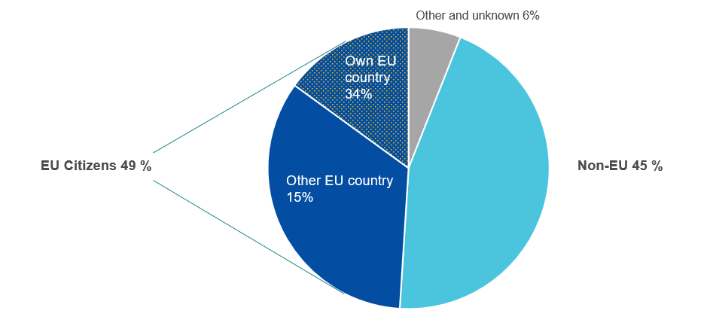
Figure 3 Repartition of registered victims of trafficking by EU and non-EU citizenship in the EU in 2017 and 2018
Early identification of victims is crucial to promptly assist, support and protect victims of trafficking in human beings and enables police and prosecution authorities to better investigate and punish traffickers. Frontline officers, such as border guards, police officers, social workers and inspector services are crucial in this respect. The involvement of civil society organisations in the identification of victims and their referral for support is a challenge, just as the lack of training of professionals in cross-border victims’ support cases.
To improve the current situation, the proactive early identification of victims must be followed by strong support in addressing victims’ need. However, ensuring assistance, support and protection to victims remains a challenge. Victims often encounter difficulties in accessing their rights. Their specific needs and circumstances, depending on the forms of exploitation they were subjected to, their sex and age, are not systematically taken into account. Accessing compensation for trafficking victims is hampered by many difficulties, including by the complexity of the proceedings. Victims should also not have to fear retaliation and secondary victimisation during criminal proceedings, when they report the crime. They should not be penalised for crimes they were compelled to commit during their exploitation. They should be treated as rights holders, without prejudice or bias. Furthermore, opportunities for the victims to rebuild their lives also remain limited as re-integration and rehabilitation programmes need to be further developed and opportunities for durable solutions, such as inclusion into the labour market, are scarce.
The Commission will support Member States’ efforts in improving the early identification of victims, as well as their referral to assistance, support and protection services, taking into account their special needs and the forms of exploitation to which they have been subjected. Special attention should be paid to child victims and children at risk of trafficking, with systematic reporting and alerts on missing children for an early identification, referral procedures tailored to child victims, speedy appointment of guardians and effective free legal aid. The Commission will promote activities such as gender-sensitive and child-rights based training for professionals likely to come into contact with victims (such as law enforcement, judiciary, labour inspectors, immigration and asylum officers, border guards, social workers, victims support or healthcare staff), developing guidelines, toolkits and exchanging best practices among practitioners to improve national structures and cooperation for the identification, assistance and support of victims, including national referral mechanisms.
In accordance with the Anti-trafficking Directive, Member States have taken measures to establish appropriate mechanisms aimed at the early identification, assistance to and support for victims, so called referral mechanisms. The European Commission carried out a study on national and transnational mechanisms in Member States. The study identified areas for further improvements: detecting potential victims; making available appropriate accommodation, notably for child victims; strengthening cooperation among all actors, including civil society organisations; and better monitoring of impact and results of measures in all phases of the referral. Taking into account existing national and transnational cooperation, the Commission will enhance actions to improve victims’ support and referral in the cross-border context, towards the objective of setting up a European referral cooperation mechanism, with the support of relevant EU agencies (such as the European Asylum Support Office, Fundamental Rights Agency, European Institute for Gender Equality and Cepol).
Support to Member States is also offered by the ten EU agencies who signed the joint statement of commitment to work together against trafficking in human beings in 2018. The Commission coordinates their cooperation, in line with their respective mandates, to address challenges related to victims of trafficking. They will jointly report on their respective roles and actions to make Member States more aware of the Agencies’ potential in helping the early identification and protection of victims and to encourage Member States to work closer with the agencies in this area.
To address trafficking at the local and regional and transnational levels and to benefit from available European funding instruments, the Commission will encourage cooperation between relevant national and local authorities and regions, cities and municipalities. The Commission will seek closer cooperation with the European Economic and Social Committee and the Committee of the Regions and respective partners to fight trafficking in human beings. The partnership on integration, signed by the Commission and the Committee of the Regions, will provide support for the integration of all migrants, including non-EU victims of trafficking.
Victims of trafficking should have access to appropriate and safe accommodation that allows them to escape from traffickers and that is adapted to their specific needs and circumstances. Safe shelters are needed for children, women and men. Same-sex shelters that also provide trauma-focussed support can effectively help victims’ recovery. In this respect, the Commission will enable targeted funding support for shelters for victims of trafficking – including specialised facilities for women and child victims of trafficking – via the Asylum, Migration and Integration Fund and Internal Security Fund, in accordance with the specific eligibility conditions and scope of each of the Funds.
Social, economic and educational measures are essential for victims to re-integrate into society. The Commission will facilitate and promote programmes supporting victims in their recovery and re-integration such as health, psychological or legal specialised services, and facilitating access to education and economic opportunities. The Commission will encourage Member States to put in place community-led and peer-mentoring programmes involving victims of trafficking, offering opportunities for education, employment and empowerment.
Victims who are not EU citizens face additional difficulties. The particular situation of victims of trafficking requires specific consideration when issuing residence permits. Under current EU rules, the granting of a residence permit can be conditional upon the victim’s cooperation in the criminal proceedings. In addition, there are inconsistencies across Member States in the application of reflection periods for victims who are not EU citizens, during which assistance to victims is ensured. Member States should pay particular attention to the specific situation of trafficked victims in the context of transferring non-EU citizens to the country where they first arrived. Victims can become accessible to traffickers and be exposed to risks of being re-trafficked. In addition, for children in migration, specific safeguards should be put in place to ensure that their rights are respected, throughout relevant procedures. The Action Plan on Integration and Inclusion 2021-2027 provides measures, including for victims of trafficking.
The EU Anti-trafficking Directive sets minimum requirements, including on the support and protection of victims. The Commission will assess how the above identified concerns related to the Anti-trafficking Directive can be better addressed, including through a strong gender dimension in supporting and protecting victims, the non-punishment of victims for crimes they were compelled to commit, and in relation to the 2004 Council Directive on residence permit for victims of trafficking.
Key actions:
The Commission will:
- Enhance capacity building and sharing of best practices for the identification of victims of trafficking, in particular among vulnerable groups, including through dedicated funding for training of police, social workers, inspector services, border guards;
- Facilitate re-integration and victim empowerment programmes and exchanges on best practices in this regard;
- Enhance cooperation towards a European referral mechanism;
- Enable targeted funding support to specialised shelters for victims of trafficking, including specialised facilities for trafficked women and children via the Asylum, Migration and Integration Fund and Internal Security Fund;
- Ensure funding in non-EU partner countries to non-governmental organisations, migrant resource centres for supporting victims, including their psychosocial, taking into account gender and child-specific needs;
- Develop close cooperation with the European Economic and Social Committee and the Committee of the Regions in order to multiply the impact of anti-trafficking actions with social and economic partners and on local and regional level;
- Enhance partnerships with non-EU countries to ensure that victims’ rights are guaranteed during all the steps of the return process and that they receive specific, tailor-made assistance and protection upon return, including specific safeguards for children.
The Commission invites Member States to:
- Promote gender sensitive and child rights based training for officers and all practitioners likely to come into contact with victims.
- Promote awareness-raising activities targeting frontline professionals in high-risk sectors and high-risk environments where victims of trafficking are exploited;
- Create safe environments for victims to report their crimes without a fear of being prosecuted for acts they were forced to commit by the traffickers, and without a fear to be exposed to secondary victimisation, intimidation or retaliation in the context of criminal proceedings;
- Improve the functioning of National Referral Mechanisms;
- Provide training to health care workers on diversity management and the needs of victims of trafficking in human beings who are migrants, under the EU health programmes;
- Enable funding for community-led and peer-mentoring empowerment programmes.

- International dimension
In 2020, 534 different trafficking flows were identified globally and more than 120 countries reported victims from more than 140 different countries of origin. Trafficking is a transnational crime, and half of the victims identified in the European Union are non-EU citizens, mainly from Africa, Western Balkans and Asia. In low income countries, half of the person victims of trafficking are children, the majority of them forced into child labour. The EU must therefore also step up its efforts to address economic grievances and help families and communities to become more resilient to negative coping mechanisms. The priorities of this strategy, including breaking the criminal business model of traffickers, reducing demand, and protecting and empowering victims should therefore fully apply in the context of the EU’s external policies.
Victims are also trafficked in mixed migration flows to the EU via all routes. Migrant smuggling is often intertwined with other forms of organised crime, such as trafficking in human beings. The current global and regional migration situation heightens the risks of trafficking, with traffickers abusing asylum procedures, including by legalising their own status and that of their victims. The EU Action Plan against Migrant Smuggling under the new Pact on Migration and Asylum will contribute to disrupting traffickers’ business in moving victims for exploitation to Europe and fight smuggling networks. Furthermore, a key strand of the Pact is establishing and deepening partnerships with countries of origin, transit and destination. It is therefore essential to advance international cooperation and partnerships by making best use of external policy instruments, cooperation tools and funding in order to share information and criminal intelligence on trafficking, related crimes and criminal networks. Closer cooperation of Member States with non-EU countries is facilitated and supported by a wide range of EU foreign policy instruments, including the Global Strategy for the EU Foreign and Security Policy, the Action Plan on Human Rights and Democracy 2020-2024, the EU Gender Action Plan for external action (2021-2025), the Joint Communication “Towards a comprehensive strategy with Africa”. In addition, for the EU’s enlargement process and neighbourhood policy, other instruments are relevant such as the EU Western Balkans Strategy, the Joint Communication “Eastern Partnership Policy beyond 2020 Reinforcing Resilience- an Eastern Partnership that delivers for all” and the Joint Communication “Renewed partnership with the Southern Neighbourhood-A new Agenda for the Mediterranean”. The EU’s approach to external security within the framework of the Common Foreign and Security and the Common Security and Defence Policy is essential. The civilian and military missions under the Common Security and Defence Policy lead efforts to disrupt organised criminal networks involved in smuggling of migrants and trafficking in human beings. Closer cooperation with justice and home affairs agencies in this field, as stipulated in the civilian Common Security and Defence Policy Compact, is also of crucial importance.
These instruments are key to promote closer cooperation between EU Member States and countries of origin and transit of victims. Systematic engagement of EU delegations in specific countries will be facilitated and close cooperation with Common Security and Defence Policy missions and operations will be sought, where relevant and applicable. The European External Action Service will continue to play a key role in enhancing strategic and operational cooperation with third countries and international organisations, by making full use of its external tools, such as the high level dialogues and the network of Counter-Terrorism/Security experts in EU delegations. The cooperation with UN agencies and international organisations, such as the United Nations Office on Drugs and Crime and the International Organization for Migration, reinforce actions at global level, particularly with countries of origin and transit.
The Commission supports Member States and non-EU partner countries in the implementation of the United Nations Convention against Transnational Organized Crime and the Trafficking in Persons Protocol, to which the EU and its Member States are parties. The EU and its Member States are also part of the recently launched review mechanism of the implementation of the UN Trafficking in Persons Protocol. The Commission will pursue closer cooperation with relevant actors in relation to the UN Protocol, including but not limited to the Inter-Agency Coordination Group against Trafficking in Persons of the United Nations. The Commission will also work closely with the Council of Europe and its Group of Experts on Action against Trafficking in Human Beings in line with the identified priorities of this strategy.
External actions should take into account the relevant Sustainable Development Goals of the United Nations focussing on trafficking in human beings. In this context, the EU’s trade policy promotes sustainable development goals, including human rights and employment standards. The Commission will consider whether current international standards against trafficking in human beings could be better reflected in the implementation of trade agreements and their enforcement notably via the more assertive use of the essential elements clause.
The Commission welcomes the recently adopted EU Global Human Rights Sanctions Regime, which allows the European Union to target individuals, entities and bodies responsible for, involved in, or associated with serious human rights violations and abuses worldwide. The sanctions regime enables the Council to impose travel bans, asset freezes and the prohibition to make funds or economic resources available to listed individuals and entities.

Key actions:
The Commission will:
- Adopt an EU Action Plan against Migrant Smuggling (2021-2025);
- Step up cooperation with non-EU countries of origin and transit of victims as well as with international and regional partners, including international organisations;
- Use the dedicated human rights and security dialogues in engaging with partner countries;
- Enhance cooperation with the Council of Europe and its Group of Experts on Action against Trafficking in human beings;
- Support the European External Action Service’s systematic engagement of EU delegations in specific countries by regular and targeted communication, action and exchange of information.
The Commission invites Member States to:
- Enhance information sharing and criminal intelligence on trafficking and related crimes and criminal networks; and facilitate cross-border and international operational and judicial cooperation in countries affected by trafficking notably in the Western Balkans, countries in the Neighbourhood, Africa, the Middle East, and South-East Asia, including with support from EU agencies, such as Europol and Eurojust.

- Conclusion
Trafficking in human beings is a serious and complex crime, which mostly affects women and children. It brings enormous revenues to criminals while causing tremendous suffering to victims and high costs to our society. Despite progress made over the last decade to reinforce the Union’s response against trafficking in human beings, the threat of being trafficked remains high for any vulnerable person. Trafficking in human beings impacts the fabric of society, rule of law and sustainable development in EU Member States and in our partner countries.
With this strategy, the Commission sets out a renewed commitment and a strong policy framework to protect vulnerable individuals from being trafficked, to empower victims, to bring perpetrators to justice, and to safeguard our communities. Women and children are at the centre of this commitment.
The priorities and actions set out in this strategy will be implemented in the period from 2021 to 2025. Meanwhile, the Commission will be ready to react swiftly to any new developments or trends based on continuous monitoring and analysis of how trafficking in human beings evolves – in the EU and beyond. Together, the EU and its Member States must stay ahead of criminals, users and exploiters of victims.
The Commission is committed to the timely and effective implementation of this strategy. As combatting trafficking in human beings needs the engagement of all, the Commission will work closely with all partners to maximise the impact of the foreseen actions. The EU anti-trafficking coordinator will help ensure coordination and coherence among EU institutions, EU agencies, Member States and international actors, in the implementation of this strategy. Joining forces in the fight against trafficking in human beings is essential for ensuring European security, protecting vulnerable people and the economy, and for the safeguarding of the rule of law and fundamental rights.
The Commission will also systematically monitor and report on the implementation of this Strategy, including to the European Parliament and the Council.

See Article 83(1) of the Treaty on the Functioning of the European Union and Article 5(3) of the Charter of Fundamental Rights of the European Union.
63.7% of identified victims and 36.3% of presumed victims.
All EU-27 level data on victims in the document concerns years 2017 and 2018. Source: Data Collection on Trafficking in Human beings in the EU (2020); COM(2020) 661 final, 20.10.2020.
COM(2020) 661 final, 20.10.2020 and SWD(2020) 226 final, 20.10.2020.
Article 2(6) of Directive 2011/36/EU defines the term ‘child’ meaning any person below 18 years of age.
Study on the economic, social and human costs of trafficking in human beings within the EU (2020); at: https://ec.europa.eu/anti-trafficking/sites/antitrafficking/files/study_on_the_economic_social_and_human_costs_of_trafficking_in_human_beings_within_the_eu.pdf.
See EU Strategy towards the Eradication of Trafficking in human beings 2012-2016 COM(2012) 286 final, 19.6.2012; and Reporting on the follow-up to the EU Strategy towards the Eradication of trafficking in human beings and identifying further concrete actions; COM(2017) 728 final, 4.12.2017.
Regular EU-wide data collection takes place with support from Eurostat on victims and their characteristics and on perpetrators, including prosecutions and convictions. All EU publications included are available at: https://ec.europa.eu/anti-trafficking/publications.
See for example: ICAT, COVID-19 pandemic and its impact for victims and survivors of trafficking in persons; UNODC, Impact of the Covid-19 Pandemic on Trafficking in Persons - Preliminary findings and messaging based on rapid stocktaking.
Directive 2011/36/EU of the European Parliament and of the Council of 5 April 2011 on preventing and combating trafficking in human beings and protecting its victims, and replacing Council Framework Decision 2002/629/JHA, OJ L 101, 15.4.2011.
Denmark is not bound by the Anti-trafficking Directive.
COM(2016) 722 final, 2.12.2016.
See on implementation: COM(2020) 661 final, 20.10.2020; SWD(2020) 226 final, 20.10.2020.
Through regular contributions to the European Commission’s progress reports adopted every second year and studies, for example: the Study on reviewing Member States’ national and transnational referral mechanism (2020), the Study on the economic, social and human costs of trafficking in human beings (2020); the Study on the gender dimension of Trafficking in human beings (2016).
For example: A guide to enhance child protection focusing on victims of trafficking (2019); Guidelines for the identification of victims (2013); Handbook on guardianship for children deprived of parental care (2014).
See regular calls for proposals under the Internal Security Police and the Asylum, Integration and Migration Fund; and the Study on the Comprehensive Policy review of anti-trafficking projects funded by the European Commission (2016).
https://ec.europa.eu/anti-trafficking/intensifying-coordinated-response/intensifying-coordinated-response
COM(2020) 661 final, 20.10.2020.
For example, European Parliament resolution of 10 February 2021 on the implementation of Directive 2011/36/EU on preventing and combatting trafficking in human beings and protecting its victims; 2020/2029(INI).
6 163 prosecutions and 2 426 convictions in EU-27 in 2017-2018.
European Parliament resolution of 10 February 2021 on the implementation of Directive 2011/36/EU on preventing and combatting trafficking in human beings and protecting its victims; 2020/2029(INI).
Eurojust Report on Trafficking in human beings, Best practices and issues in judicial cooperation (2021).
See examples in: Study on Reviewing the functioning of National and Transnational Referral Mechanism (2020), TACT project developed by the International Organisation for Migration (IOM). For the Baltic Sea States’ transnational referral mechanism: https://bsr-trm.com//.
These actions will be funded under the Internal Security Fund.
Study on the Comprehensive policy review on-trafficking projects funded by the European Commission (2016).
See reference to the particular vulnerability of children in migration to traffickers in the Commission Communication on the protection of children in migration, COM(2017) 211 final, 12.4.2017.
In the case of sexual exploitation, prostitution, escort services, massage parlours, bars and nightclubs are high risk environments. In the case of labour trafficking, such environments can include: agricultural sector, construction, hospitality, cleaning sector, domestic work, forestry, textile and garments, food manufacturing For more details: COM(2020) 661 final, 20.10.2020 and SWD(2020) 226 final, 20.10.2020; Fundamental Rights Agency, Severe labour exploitation: workers moving within or into the European Union (2015) and European Migrant Smuggling Centre, 4th Annual report, Europol 2020.
Europol (2015), The trafficking in human beings financial business model, at: https://www.europol.europa.eu/publications-documents/trafficking-in-human-beings-financial-business-model
Study on Mapping the risk of serious and organised crime infiltration in legitimate businesses, March 2021, DR0221244ENN, https://data.europa.eu/doi/10.2837/64101.
In EU-27: 13461 in 2015 and 2016 and 14 145 in 2017 and 2018.
https://ec.europa.eu/social/main.jsp?catId=1299&langId=en.
For definitions and inter-relation between trafficking and smuggling, see Report: Smuggling and trafficking: rights and intersections, https://ec.europa.eu/anti-trafficking/sites/antitrafficking/files/smuggling_and_trafficking._rights_and_intersections_1.pdf
Directive 2009/52/EC of the European Parliament and of the Council of 18 June 2009 providing for minimum standards on sanctions and measures against employers of illegally staying third-country nationals, OJ L 168, 30.6.2009.
See SWD(2017) 147 final, 24.4.2017; the Commission’s Guidelines on non-financial reporting enhance business transparency on social and environmental matters (C/2017/4234; OJ C 215, 5.7.2017, p. 1–20); European Parliament Motion for a Resolution on Sustainable corporate governance (2020/2137(INI); Council Conclusions on Human Rights and Decent Work in Global Supply Chains ,13512/20, 1 December 2020.
Commission Communication on Trade Policy Review - An Open, Sustainable and Assertive Trade Policy, COM(2021) 66 final, 18.2.2021.
SWD(2020) 226 final, 20.10.2020, EMSC Annual Activity Report (Europol, 2019), UNODC, Global Report on Trafficking in Persons, 2020 (2021), Study on Mapping the risk of serious and organised crime infiltration in legitimate businesses.
Study on Mapping the risk of serious and organised crime infiltration in legitimate businesses.
See Council conclusions on enhancing financial investigations to fight serious and organised crime, 8927/20, 17 June 2020.
For example in 2019, such actions resulted in 825 arrests, 8 824 suspects and 1307 potential victims, including 69 identified children, 94 identified or dismantled organized crime groups (OCGs) and EUR 1,5 million of assets frozen in bank accounts, companies and web domains, at: https://www.consilium.europa.eu/media/44281/information-note-empact.pdf; https://newsroom.consilium.europa.eu/videos/127612-empact-2019-results-20200602 and https://data.consilium.europa.eu/doc/document/ST-7623-2020-INIT/en/pdf.
Since 2010, trafficking in human beings has been an EU crime priority within the framework of the EU policy cycle on serious and organised crime.
There were 6 163 prosecutions and 2 426 convictions in the EU in 2017-2018 for the offences of trafficking in human beings. COM(2020) 661final, 20.10.2020.
Europol, ‘The challenges of countering human trafficking in the digital era’ (2020). See also COM(2020) 661final, 20.10.2020 and SWD(2020) 226final, 20.10.2020 and European Parliament resolution of 10 February 2021 on the implementation of Directive 2011/36/EU on preventing and combatting trafficking in human beings and protecting its victims, 2020/2029(INI)).).
Europol, 2021 EU Serious and Organised Threat Assessment Report (EU SOCTA),12 April 2021
https://ec.europa.eu/digital-single-market/en/digital-services-act-package.
COM(2020) 661 final, 20.10.2020.
Commission Communication on the EU Strategy on victims’ rights (2020-2025), COM(2020) 258 final, 24.6.2020.
Commission Communication on the EU Strategy on the rights of the child, COM(2021)142final, 24.3.2021.
In 2017-2018, 60% of all registered victims had been trafficked for sexual exploitation.
European Parliament resolution (2020/2029(INI)).
In 2017 and 2018: 78% of child victims were girls; 60 % of child victims were trafficked for sexual exploitation and three quarters (75%) of all child victims in the EU were EU citizens. Trafficking and exploitation of boys, especially for sexual exploitation, including children in migration, is recalled to be an under-reported phenomenon at EU level.
See Commission Communication on the protection of children in migration, COM(2017) 211 final, 12.4.2017.
As concerns persons with disabilities who are also particularly vulnerable to human trafficking, violence and abuse, the Strategy for the Rights of Persons with Disabilities 2021-2030, (COM(2021) 101 final), 3.3.2021 will pursue actions in the area of safety and protection.
‘Child Trafficking among Vulnerable Roma Communities’ (2015); https://csd.bg/fileadmin/user_upload/publications_library/files/22588.pdf.
The Commission adopted on 7 October 2020 the EU Roma strategic framework for equality, inclusion and participation to ensure effective equality, socioeconomic inclusion and promote participation of Europe’s largest ethnic minority; COM(2020) 620 final, 7.10.2020. It aims to combat poverty, antigypsyism and discrimination.
Study on Reviewing the functioning of National and Transnational Referral Mechanism (2020).
SWD(2020) 226 final, 20.10.2020.
See also the objectives of the EU Strategy on Victims Rights 2020-2025; COM(2020)258 final, 24.6.2020.
See European Court of Human Rights recently ruling related to the non-punishment of victims, V.C.L. and A.N. v the United Kingdom of 16 February 2021.
Study on Reviewing the functioning of National and Transnational Referral Mechanism (2020).
Ibid.
The Heads of the European Asylum Support Office (EASO), European Police Office (Europol), European Agency for the operational management of large-scale IT systems in the area of freedom, security and justice (eu-LISA), European Monitoring Centre for Drugs and Drug Addiction (EMCDDA), EU Judicial Cooperation Unit (Eurojust), European Institute for Gender Equality (EIGE), European Border and Coast Guard Agency (Frontex), EU Agency for Fundamental Rights (FRA), EU Agency for Law Enforcement Training (CEPOL), and the European Foundation for the Improvement of Living and Working Conditions (Eurofound) signed a Joint Statement of commitment to work together against trafficking in human beings.
https://ec.europa.eu/home-affairs/news/european-commission-committee-regions-partnership-integration_en
See Articles 6 and 8 of Council Directive 2004/81/EC of 29 April 2004 on the residence permit issued to third-country nationals who are victims of trafficking in human beings or who have been the subject of an action to facilitate illegal immigration, who cooperate with the competent authorities, OJ L 261, 6.8.2004. Civil society organisations have highlighted the gap between the numbers of victims who are not EU citizens and the number of residence permits issued under the Directive.
Under the 2004 Residence Permit Directive, third-country nationals concerned are granted a reflection period allowing them to recover and escape the influence of the perpetrators of the offences so that they can take an informed decision as to whether to cooperate with the competent authorities (reflection period).
Regulation (EU) No 604/2013 of the European Parliament and of the Council of 26 June 2013 establishing the criteria and mechanisms for determining the Member State responsible for examining an application for international protection lodged in one of the Member States by a third-country national or a stateless person, OJ L 180, 29.6.2013.
Commission Communication on “Enhancing cooperation on return and readmission as part of a fair, effective and comprehensive EU migration policy, COM(2021) 56 final, 10.2.2021.
Commission Communication on the Action plan on Integration and Inclusion 2021-2027, COM(2020) 758 final, 24.11.2020.
The Commission is following up on the commitments of the EU Gender Equality Strategy 2020-2025 COM(2020) 152 final, 5.3.2020 including by proposing a legislative initiative on combatting gender-based violence against women and domestic violence.
Council Directive 2004/81/EC, OJ L 261, 6.8.2004.
UNODC, Global Trafficking in Persons report, 2020 (2021). UNODC used the term “flow” as a combination of one origin country and one destination where at least 5 victims were detected during the period considered. For flows, the 2018 (or most recent) data was used as the reference year. For countries where 2018 data were not available, the most recent data from 2019, 2017 or 2016 were used.
Data collection on trafficking in human beings in the EU (2020).
Global Trafficking in Persons report, 2020.
European Migrant Smuggling Centre 4th Annual Activity report, Europol, 2020.
Commission Communication on a New Pact on Migration and Asylum, COM(2020)609 final, 23.9.2020.
For example through the Neighbourhood, Development and International Cooperation Instrument.
For example, the EUBAM Libya mission and the operation EUNAVFOR MED IRINI.
On 19 November 2018, the Council and the Member States adopted conclusions on the establishment of a civilian Common Security and Defence Policy (CSDP) compact. See Council Conclusions: https://www.consilium.europa.eu/en/press/press-releases/2018/11/19/civilian-common-security-and-defence-policy-eu-strengthens-its-capacities-to-act//.
Council Conclusions on EU priorities for cooperation with the Council of Europe 2020-2022, 9283/20. 13 July 2020.
SDG 5.2 (violence against all women and girls); SDG 8.7 (forced labour and human trafficking) and SDG 16.2 (violence against and torture of children).
Council Decision (CFSP) 2020/1999 of 7 December 2020 concerning restrictive measures against serious human rights violations and abuses; OJ L 410I , 7.12.2020; and Council Regulation (EU) 2020/1998 of 7 December 2020 concerning restrictive measures against serious human rights violations and abuses; O.J.L-410 I, 7.12.2020.

