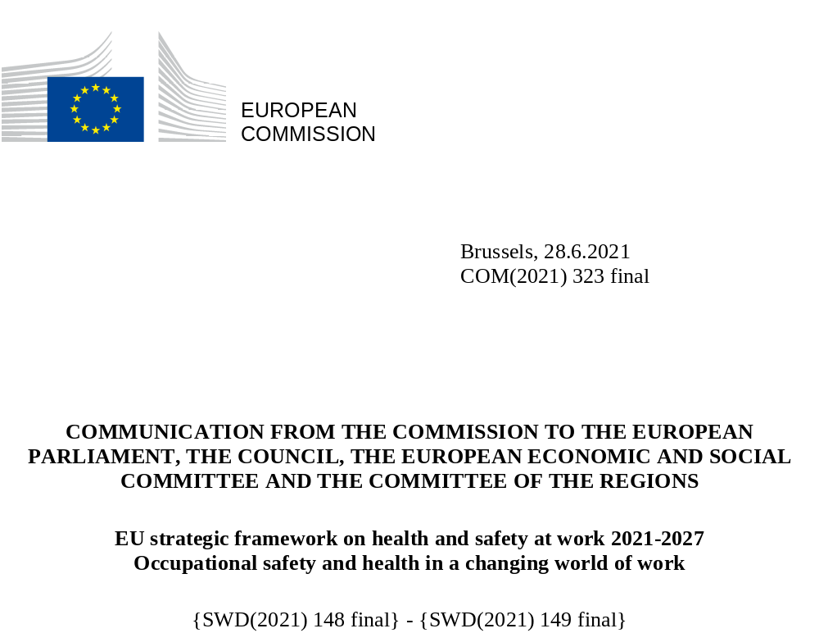

COMMUNICATION FROM THE COMMISSION TO THE EUROPEAN PARLIAMENT, THE COUNCIL, THE EUROPEAN ECONOMIC AND SOCIAL COMMITTEE AND THE COMMITTEE OF THE REGIONS
EU strategic framework on health and safety at work 2021-2027
Occupational safety and health in a changing world of work

Occupational safety and health in the EU

The value of health and safety at work
EU occupational safety and health (OSH) legislation is essential to protect the health and safety of the almost 170 million workers in the EU. Protecting people from health and safety hazards on the job is a key element of achieving sustained decent working conditions for all workers. It has allowed to reduce health risks at work and to improve OSH standards across the EU and across sectors. However, challenges remain and the Covid-19 pandemic has exacerbated risks that need to be addressed.
The protection of workers’ health and safety, enshrined in the Treaties and the Charter of Fundamental Rights, is one of the key elements of an EU economy that works for people. The right to a healthy and safe workplace is reflected in principle 10 of the European Pillar of Social Rights, and is fundamental for reaching the United Nations’ sustainable development goals. It is also a building block of the European Health Union under construction.
The new 2021-2027 OSH framework, announced in the European Pillar of Social Rights action plan, sets out the key priorities and actions necessary for improving workers’ health and safety over the coming years in the context of the post-pandemic world, marked with green and digital transitions, economic and demographic challenges and the changing notion of a traditional workplace environment.
Healthy and safe working conditions are a prerequisite for a healthy and productive workforce. Nobody should suffer from job related diseases or accidents. It is also an important aspect of both the sustainability and competitiveness of the EU economy.
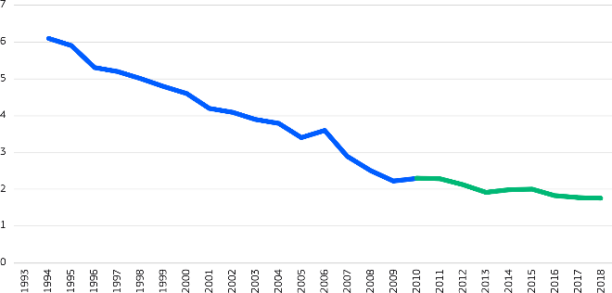
The last three decades have brought significant progress in OSH: fatal accidents at work in the EU decreased by about 70% between 1994 and 2018 (Figure 1). While factors such as de-industrialisation and better medical care have undoubtedly contributed to this decrease, the EU OSH system has also played a substantial role. Despite this progress, there were still over 3 300 fatal accidents and 3.1 million non-fatal accidents in the EU-27 in 2018, and over 200 000 workers die each year from work-related illnesses. This brings immense human suffering. Maintaining and improving protection standards for workers is therefore an ongoing challenge and necessity.
Figure 1: Fatal accidents at work in the EU –
1994-2018 (cases per 100,000 employed persons)
Source: Eurostat, data for common economic sectors in EU-15 (1994 - 2009), and for all economic sectors in EU-27 (2010 - 2018).
Besides health and wellbeing, there is a strong economic case for a high level of worker protection. Work-related accidents and illnesses cost the EU economy over 3.3% of GDP annually (ca. EUR 460 billion in 2019) (Figure 2). While the cost to wellbeing behind these numbers is unquantifiable, good practice in OSH helps make businesses more productive, competitive and sustainable. Estimates show that for every euro invested in OSH, the return for the employer is around twice as much. A solid OSH supportive structure catering for the specific needs of SMEs, the backbone of the EU economy, will provide a vital contribution to a sustainable economy and to the success of OSH in the EU at large. Good OSH also reduces healthcare costs and other societal burdens, in contrast, the costs of poor OSH are high for individuals, businesses and society.
Figure 2: Costs to society of work-related injury and illness, 2019 (billion €)
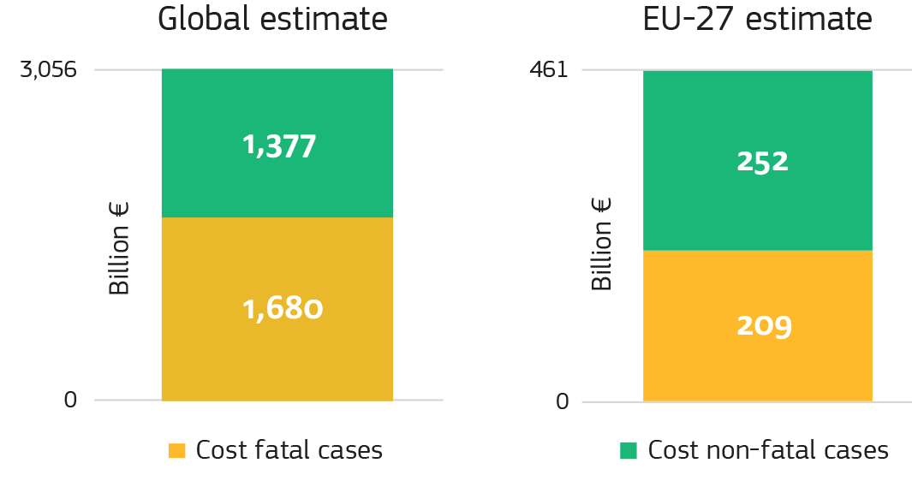
Source: “An international comparison of the cost of work-related accidents and illnesses” (EU-OSHA, 2017), estimation based on Eurostat and World Bank data.
The Covid-19 pandemic has shown how crucial OSH is for protecting workers’ health, for the functioning of our society, and for the continuity of critical economic and social activities. Therefore, the road to recovery and reactivation of productivity must also include the renewed commitment to keep occupational safety and health at the forefront and to improve the synergies between OSH and public health policies.

The EU system at work
Two factors help explain the achievements of the EU approach to OSH. Firstly, the EU and Member States have developed an advanced regulatory system to lay down the preventive and protective measures to address occupational risks. Secondly, it relies on the tripartite approach whereby workers, employers and governments are closely involved in the development and implementation of these OSH measures at EU and national level. Moreover, the continuous support provided in particular to micro enterprises and SMEs helps the correct application of the OSH rules.
The EU OSH legislative framework consists of a framework directive and 24 specific directives developed over time. The 1989 European Framework Directive on Safety and Health at Work is the basis for common principles and minimum standards across the EU. It focuses on a risk-prevention culture and lays down employers’ obligations on: (i) risk assessments; (ii) preventive measures; (iii) giving OSH information to workers; (iv) training; (v) consultation; and (vi) balanced participation. These obligations apply across all sectors and professions and to both public and private employers. Specific directives address particular risks, groups and settings.
EU OSH legislation is developed in close cooperation with the Advisory Committee on Safety and Health at Work (ACSH), a tripartite body composed of national government representatives, trade unions and employers’ organisations. The European Agency for Safety and Health at Work (EU-OSHA) provides guidelines and tools, which, together with similar, national, internet-based tools: (i) provide sector-specific information primarily targeted at small and medium-sized enterprises (SMEs) as they employ the majority of the workers in the EU, and often face higher obstacles to ensure occupational health and safety; and (ii) guide employers through all steps of the risk-assessment process. The Senior Labour Inspectors Committee (SLIC) provides opinions on the enforcement of EU OSH legislation and promotes knowledge sharing on labour-inspection practices.

Building on previous strategic frameworks and a broad consultation
For close to 20 years now, EU OSH strategic frameworks have played a pivotal role in the way national authorities and social partners decide on OSH objectives. These objectives include (i) increasing alignment on common priorities; (ii) facilitating cooperation; (iii) triggering investment in OSH; and (iv) promoting concrete actions at workplace level.
The key priorities of the 2014-2020 strategic framework, such as prevention of work-related diseases, addressing demographic change and implementation of legislation, were echoed throughout the national frameworks. Some of the key achievements at EU level under the previous strategic framework include: (i) 3 updates of the Carcinogens and Mutagens Directive and a proposal for a fourth update; (ii) modernisation updates of 4 directives including in the areas of exposure limit values and biological agents; (iii) a great number of widely used EU-OSHA guidelines and online tools for employers, including on COVID-19; and (iv) inspection guides and tools developed by the SLIC.
This strategic framework builds on a stocktaking exercise of the achievements in the implementation of the EU strategic framework on health and safety at work 2014-2020. The stocktaking exercise identified a number of challenges linked to shorter-term implementation of the strategic framework in light of: (i) resource constraints in Member States; (ii) the need to increase focus on occupational diseases, demographic change, psychosocial risks and musculoskeletal disorders; and (iii) the need to help both labour inspectorates and companies improve their OSH standards.
This strategic framework is also based on input from a broad range of stakeholders, mirroring the commitment of all actors in its implementation. The groundwork was laid by an EU-OSHA report on the national OSH strategies, a specific evaluation report, and advanced survey tools. Additional crucial input to the framework came from: (i) several Council conclusions; (ii) reports, recommendations, hearings and other exchanges with the European Parliament; (iii) exchanges with social partners, and independent experts; (iv) replies from an open public consultation; and (v) the opinion from the ACSH.
It also builds on the information provided by the assessment of the practical implementation of the Framework Directive 89/391/EEC on safety and health of workers at work and 23 related EU Directives for the period 2013-2017.
The staff working document and the synopsis report accompanying this communication summarise these outcomes.

An updated vision for OSH – Three Key Objectives
The priorities of the previous framework remain relevant today. However, further OSH action in the EU is needed to make the workplaces fit for the increasingly rapid changes in the economy, demography, work patterns, and society at large. For a certain part of the EU workers, the concept of workplace is becoming more fluid but also more complex as new organizational forms, business models and industries are emerging. The COVID-19 pandemic has accentuated these complexities and made OSH and public health policy more inter-related than ever before.
The strategic framework therefore focuses on three crosscutting key objectives for the coming years:
- anticipating and managing change in the new world of work brought about by the green, digital and demographic transitions;
- improving prevention of workplace accidents and illnesses;
- increasing preparedness for any potential future health crises.
To deliver on these objectives, action is needed at EU, national, sectoral, and company level.
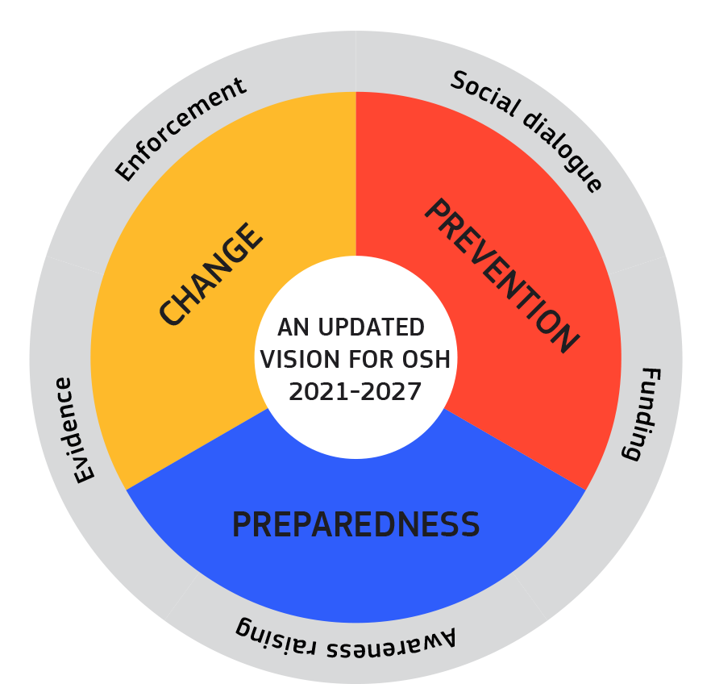
The implementation of these three objectives will be underpinned by: (i) social dialogue; (ii) strengthening of the evidence base; (iii) strengthening of enforcement; (iv) awareness raising; and (v) funding.

Anticipating and managing change
The nature of many tasks, work patterns, and workplaces is changing. Jobs that did not exist a decade ago have emerged, fuelled by the green and digital transitions. The European Green Deal, the EU digital strategy, and the new industrial strategy for Europe will together: (i) generate major investments; (ii) contribute to growth, innovation and job creation; and (iii) provide flexibility and opportunities for workers, businesses, and the self-employed. The EUR 1.8 trillion EU budget for 2021-2027, including NextGenerationEU, will support these initiatives and contribute to a sustainable recovery. At the same time, demographic change in the form of an ageing workforce in Europe requires continuous reflection and response. Occupational health and safety plays an essential role in this, as workers are getting older it is necessary to adapt the working environment and tasks to their specific needs and minimise risks. The Green Paper on Ageing has therefore launched a debate including on the conditions for labour market participation of older workers.
CHANGE
Advances in technology can provide new opportunities for workers at all stages of their life and career. Digital technologies can provide workers, including workers with disabilities or older workers, and their employers with digitally enabled solutions to support their health and wellbeing. These technological advances can offer increased opportunities to improve work-life balance for both women and men, and support OSH implementation through accessible tools, awareness raising and more efficient inspection. Robotisation, the use of artificial intelligence, and the greater prevalence of remote work reduce the risks of dangerous tasks, such as those in highly contaminated areas like wastewater systems, landfills, or agricultural-fumigation areas. However, new technologies also pose a number of challenges due to both: (i) the increased irregularity in when and where work is performed; and (ii) the risks related to new tools and machinery. Climate change can also affect workers’ safety and health, including through increased ambient temperature, air pollution and extreme weather.
- Modernising and simplifying EU OSH rules in the context of the green and digital transitions
EU OSH legislation already covers many of the risks that arise from changing industries, equipment, and workplaces. Four OSH directives have been modernised in recent years, covering personal protective equipment, medical treatment on board of vessels, biological agents at work, and exposure to chemical agents. The Commission has also proposed to revise the Machinery Directive, which addresses risks deriving from digitalisation and the use of machinery that are also relevant to workers’ health and safety. It is also proposing the first legal framework on AI, which addresses the risks of certain AI systems used in employment, worker management and access to self-employment. Nevertheless, significant technological developments, notably in display screen equipment and workplaces, and the developing needs and capacities of an ageing workforce, require further relevant legislative updates. Industry 5.0 proposes a vision how European industry could lead the green and digital transition by reconciling workers’ rights and needs, with technological advancement and planetary boundaries.
Changing forms of work, stemming among others from digitalisation, with an important increase of the population working remotely, will also require new and updated OSH solutions. The rapid deployment of wireless, mobile and other advanced technologies – and the increased use of such devices for work purposes – require further analysis of workers’ exposure to optical radiation and electromagnetic fields, and of possible adverse health effects in the case of more powerful appliances.
The Commission is following the overall developments of new forms of work and business models, especially those linked to the internet-enabled on-demand economy. It has launched a second phase consultation of social partners and, unless social partners are willing to negotiate among themselves, will put forward an initiative to improve the working conditions of people working through digital platforms at the end of 2021. One key aim of this initiative is to ensure adequate working conditions, including in terms of health and safety, of all people working through platforms. This will notably clarify the situation as regards to the OSH acquis that applies to people recognised as workers while it does not for people qualified as self-employed.
As implementation begins on several initiatives under the European Green Deal and EU chemicals strategy for sustainability, the current limit values of certain hazardous substances used in existing and emerging sectors need to be reviewed. This is relevant both to the question of green transitions and to the prevention of work related diseases, in particular cancer (see also Section 2.2). For lead and cobalt, two hazardous substances frequently used in renewable energy technologies and in battery production, new scientific data indicates that limit values should be reviewed or, in case of cobalt, established.
Another such substance is asbestos. Exposure to asbestos will be a health-risk factor in the renovation wave, which aims to make buildings fit for a climate-neutral future in the context of the European Green Deal. While it can no longer be produced or used in the EU, there is a legacy problem for workers with the renovation of buildings that often requires the removal of asbestos used many years ago. Exposure to asbestos claims about 88 000 lives in Europe annually, accounting for 55-85% of lung cancers developed at work, and mortality rates from this exposure are estimated to continue to increase until the late 2020s and 2030s. Strict obligations in terms of protection, planning and training already apply to employers. However, in light of the latest scientific evidence, the exposure limit value for asbestos needs to be lowered. To that end, the Commission is launching the second consultation with the social partners in parallel with this strategic framework.
- Focus on psychosocial risks
Already before the pandemic, mental health problems affected about 84 million people in the EU. Half of EU workers consider stress to be common in their workplace, and stress contributes to around half of all lost working days. Nearly 80% of managers are concerned about work-related stress.
As a result of the pandemic, close to 40% of workers began to work remotely full time. This blurs the traditional boundaries between work and private life and together with other remote-working trends, such as permanent connectivity, a lack of social interaction, and increased use of ICT, has given and additional rise to psychosocial and ergonomic risks.
Evidence suggests that tackling hazards to psychosocial wellbeing requires a process with different stages implying changes in the work environment. The European Commission is funding projects that address these challenges. The projects aim to develop and implement interventions to promote good mental health and prevent mental illness at work. In particular, the Horizon 2020 projects “Magnet4Europe” and “EMPOWER” are expected to deliver innovative results. For essential workers in the health or care sectors, the “RESPOND” project aims to address adverse mental health effects due to the COVID-19 pandemic.
The Commission will:
- Modernise the OSH legislative framework related to digitalisation by reviewing the Workplaces Directive and the Display Screen Equipment Directive by 2023;
- Propose protective limit values on:
  - asbestos in the Asbestos at Work Directive in 2022;
  - lead and diisocyanates in the Chemical Agents Directive in 2022;
  - cobalt in the Carcinogens and Mutagens Directive in Q1 2024.
- Launch an “EU-OSHA healthy workplaces campaign” 2023-2025 on creating a safe and healthy digital future covering psychosocial and ergonomic risks in particular.
- In cooperation with Member States and social partners, prepare a non-legislative EU-level initiative related to mental health at work that assesses emerging issues related to workers’ mental health and puts forward guidance for action before the end of 2022.
- Develop the analytical basis, e-tools and guidance for risk assessments related to green and digital jobs and processes, including in particular psychosocial and ergonomic risks.
- Ask the expert panel on effective ways of investing in health, to deliver an opinion on supporting the mental health of healthcare workers and other essential workers by the end of 2021.
- Ensure appropriate follow-up to the European Parliament Resolution on the right to disconnect.
The Commission calls on the Member States to:
- Update their national legal frameworks, in consultation with social partners, to address OSH risks and opportunities related to the green and digital transitions. Member States should focus on the use of digital tools to make labour inspection more efficient by both preventing and detecting breaches of legislation.
- Host ‘peer reviews’ addressing occupational psychosocial and ergonomic issues.
- Strengthen monitoring and data collection on the situation of mental and psychosocial risks across sectors.
The Commission invites the social partners to:
- Take action and update existing agreements at cross-industry and sectoral level to address new OSH issues related to the digital labour market, particularly psychosocial and ergonomic risks, by 2023.
- Find commonly agreed solutions to address the challenges raised by telework, digitalisation, and the right to disconnect, building on the European Social Partners Framework Agreement on digitalisation.

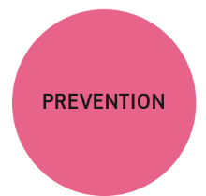
Improving prevention of work-related diseases and accidents
All efforts must be deployed to reduce work-related deaths as much as possible, in line with a Vision Zero approach to work-related deaths in the EU. To that end, this strategic framework strengthens prevention culture, both in organisations and among individual workers. Preventing work-related deaths will only be possible by: (i) thorough investigation of accidents and deaths at the workplace; (ii) identifying and addressing the causes of these accidents and deaths; (iii) increasing awareness of the risks related to work-related accidents, injuries and occupational diseases; and (iv) strengthening enforcement of existing rules and guidelines. Lessons learnt from ‘near misses’ and critical incidents – and exchange of information on these events will lead to improved analysis and prevention across the EU. For instance, in the agriculture and forestry sector in the EU, the number of accidents and fatalities remains unacceptably high. Reliable data on the number of accidents and deaths on farms in this regard is essential, as well as comprehensive awareness raising, including on the potential risks for other family members and children living on the farm.
Causes of work-related deaths
Cancer is the leading cause of work-related deaths in the EU (Figure 3). Carcinogens contribute to an estimated 100 000 occupational cancer deaths in the workplace every year. Actions to fight cancer at the workplace are key components of the Europe’s beating-cancer plan, which sets out a new EU approach to sustainable cancer prevention, treatment and care. The EU commitment to fight work-related cancer is also in line with the strategy of the roadmap on carcinogens 2020-2024, which brings together Member States and social partners to implement the limit values and other provisions adopted at EU level rapidly, limiting exposure to 26 hazardous substances and therefore improving working conditions for around 40 million workers.
Figure 3: Causes of work-related fatalities (%) in the EU
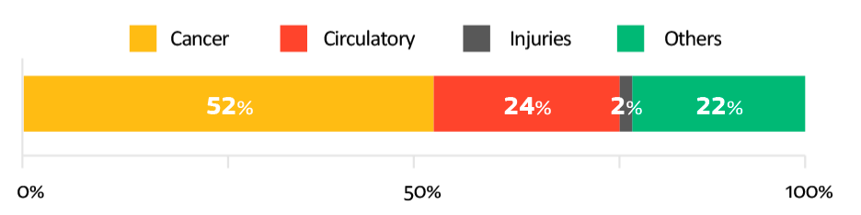
Source: “An international comparison of the cost of work-related accidents and illnesses”, EU-OSHA 2017
Another essential aspect of improving worker protection is addressing occupational circulatory diseases, such as heart disease or stroke. Although circulatory diseases are the second-largest cause of work-related deaths in the EU (Figure 3), little is known about their underlying causes and their links to work-related risks. This hampers the deployment of appropriate prevention measures at the workplace. Further research and data collection as well as health promotion at work both at EU and national level should be a priority. These actions should also cover musculoskeletal disorders (MSD), which affect millions of workers in the EU. Work-related MSDs can in the worst-case lead to disability and they are usually not linked to a single cause but to a combination of physical, psychosocial, organisational and individual factors.
- Hazardous substances
Hazardous substances can be found in nearly all workplaces, and millions of workers in the EU are exposed to these substances every day.
Overall, the process for addressing hazardous substances based on scientific assessment, consultation with the tripartite ACSH, and the close involvement of all stakeholders has proven to be successful, even though it is time and resource intensive. Under this strategic framework, the methodology for addressing hazardous substances will continue to be updated to identify further efficiencies in establishing OSH limit values in the decision making process. Moreover, the Commission will continue to streamline the interface between OSH and REACH regulation to ensure workers’ protection in line with the ‘one substance, one assessment’ approach and the updated Better Regulation approach.
The ongoing legislative procedure on limits for acrylonitrile, nickel compounds and benzene under the Carcinogens and Mutagens Directive (CMD) will help increase protection from carcinogenic and mutagenic substances for over 1 million workers. Furthermore, the ACSH is identifying the substances to be addressed in priority under the CMD and the Chemical Agents Directive, to ensure up-to-date limit values for hazardous chemicals.
Priority will be given to updating and expanding the protection of workers exposed to reprotoxic substances, in line with demands by the European Parliament. Reprotoxicants can have two groups of different effects: (i) effects on sexual function and fertility; and (ii) effects on the development of the foetus or offspring. These are serious health risks, and they can lead to spontaneous abortion, stillbirth, or impaired cognitive development of the conceived children. According to a worst-case-scenario estimate, reprotoxic substances may be the cause of up to 1 274 new cases of reproductive ill health each year, leading to an economic cost of EUR 381 million per year. Lead is the largest contributor to diseases from reprotoxic substances. The upcoming proposal for stricter binding limit values on lead will therefore be a major step forward in addressing reprotoxic substances. However, it will also be essential to map out a specific list for key reprotoxicants to be urgently addressed. In parallel, the ACSH Working Party on Chemicals will continue to discuss the need to add reprotoxic substances and hazardous medicinal products to the CMD as well as the methodology in establishing the limit values.
The European Parliament and stakeholders have also stressed the need to protect healthcare staff exposed to hazardous medicinal products as well as other risks. The European Commission and EU-OSHA have launched extensive studies and dialogues with experts and stakeholders on how to address these risks as part of efficient healthcare provision. This has revealed a great need for further training, instruction and guidance as well as the challenges of enacting binding legislation to address this issue.
Promoting health at work
A healthy workforce is the fundamental basis of a strong and resilient economy and society. Encouraging healthy lifestyle choices in the workplace can significantly reduce the incidence of absenteeism, illness and non-communicable diseases (such as cancer, obesity, cardiovascular disease and diabetes). For instance, through Europe’s Beating Cancer Plan, actions will be launched to improve health literacy on cancer risks and determinants to give people, including workers, the information and tools they need to make healthier choices.
Workplaces for all
Recognising diversity, including gender differences and inequalities, and fighting discrimination in the workforce is vital in ensuring the safety and health of both women and men workers, including when assessing risk at work. For example, the pandemic highlighted the risks of ill-adapted tools and equipment (e.g. women in the healthcare sector having to wear personal protective equipment designed for men) and the need to provide accurate, timely and easily understandable information to ensure that all workers, including those most disadvantaged, can fully understand the workplace rules and exercise their rights. Actions will be encouraged to avoid gender bias when assessing and prioritising risks for action by ensuring: (i) gender representation in consultations of workers; (ii) training adapted to employees’ personal situation; and (iii) the recognition of risks in occupations that have long been overlooked or considered as ‘light work’ (e.g. carers or cleaners).
In line with the Commission strategy for the rights of persons with disabilities 2021-2030, the Commission will present a package to improve the labour market outcomes of persons with disabilities. This package will include guidance and support for mutual learning on: securing health and safety at work; and on vocational rehabilitation schemes for people suffering from chronic diseases or people who have been the victims of accidents.
Workplace violence, harassment or discrimination, whether based on sex, age, disability, religion or belief, racial or ethnic origin and sexual orientation may affect the safety and health of workers, and therefore have negative consequences for those affected, their families, their co-workers, their organisations, and society at large. It can also lead to situations of labour exploitation. The Commission will assess how to strengthen the effectiveness of the Employers Sanctions Directive (2009/52/EC), including with regard to the labour inspections targeting particularly vulnerable groups of workers. The Commission has proposed a Council decision authorising Member States to ratify, in the interest of the EU, the Violence and Harassment Convention, 2019 (No. 190) of the International Labour Organization. The Convention also includes specific rules on gender-based violence and harassment at work, which will be strengthened through the forthcoming legislative proposal on preventing and combatting gender-based violence against women and domestic violence, as announced in the Gender Equality Strategy 2020-2025.
The Commission will:
- Promote a ‘Vision Zero’ approach to work-related deaths by:
  - improving data collection on accidents at work and occupational diseases, and analysing the root causes for each work-related death or injury;
  - setting up a dedicated Vision Zero ACSH tripartite working group, and developing targeted information actions and tools to increase awareness;
  - strengthening enforcement by supporting the SLIC in increasing awareness on reducing work-related deaths at company level, sharing good practices, and supporting increased training for labour inspectorates.
- Update the EU rules on hazardous substances to combat cancer, reproductive, and respiratory diseases by:
  - launching a social partner consultation on reduced limit values for welding fumes, polycyclic aromatic hydrocarbons, isoprene, and 1,4-dioxane under CMD in 2023;
  - identifying a priority list of reprotoxicants to be addressed through the relevant directives by the end of 2021.
- Provide updated guidelines, including on training, protocols, surveillance and monitoring, for protecting workers against exposure to hazardous medicinal products by 2022.
- Produce an OSH overview of the health and care sector, in cooperation with the EU-OSHA by Q1 2024.
- Support awareness raising on musculoskeletal disorders, cancer and mental health as well as workplace harassment and gender bias.
- Provide sector-specific information to SMEs in cooperation with the EU-OSHA.
- Propose a legislative initiative on preventing and combatting gender-based violence against women and domestic violence before the end of 2021.
The Commission calls on the Member States to:
- Work towards fulfilling the ‘vision zero’ approach to work-related deaths in the EU.
- Address occupational risks related to circulatory diseases.
- Promote the European Code against Cancer among workers to improve their health literacy and reduce cancer risks.
- Assess and address risks with a particular focus on groups most affected by the pandemic, such as persons with disabilities.
- Actively support reintegration, non-discrimination and the adaptation of working conditions of workers who are cancer patients or cancer survivors.
- Promote gender considerations in design, implementation and reporting.
- Actively address hazards in the healthcare sector by putting in place and implementing safe working procedures and providing appropriate training.
- Provide improved guidance and training for the risk-assessment and prevention measures, in particular to micro enterprises and SMEs.
Provide training to farmers via Farm Advisory Services to increase their skills and awareness on the health and safety rules on farms, including safe use of chemical substances, in particular plant protection products. The Commission invites the social partners to:
- Develop a guidance for the health care sector focusing, among other things, on workers protection from the exposure to hazardous medicinal products, paving the way for developing the online interactive risk assessment (OiRA) tool specifically for the health care sector in collaboration with the EU-OSHA.

Increasing preparedness – responding rapidly to threats
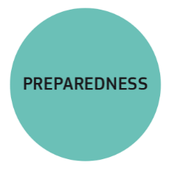
During times of crisis such as Covid-19, occupational safety and health has a crucial role in helping workers, businesses and governments to protect lives and manage wellbeing risks, business continuity and sustainability. It is therefore essential to draw the lessons of the COVID-19 pandemic and increase preparedness for potential future health crises but also post-pandemic resumption of work. Measures of increased hygiene, non-pharmaceutical interventions and mental health support should be given greater priority by improving the timeliness and effectiveness of the response to such crises, and synergies between OSH and public health should be further developed. The present framework therefore contributes to health policies and helps in increasing the preparedness for the future, in parallel with the Communication on the early lessons learn from the Covid-19 pandemic.
The COVID-19 pandemic revealed the importance of having an overall framework obligation of risk-assessment and preventive measures by the employer for addressing health risks to workers in case of health crisis. It has highlighted more than ever the need for workers to benefit from a working environment that reduces the risk of transmission of infectious diseases. Since the outbreak of the pandemic, the EU-OSHA has developed a series of guidance documents and tools in consultation with national authorities and social partners, which allowed employers, particularly SMEs, to know how to comply with OSH requirements through the different stages of the pandemic. These guidelines will be adapted to the gradual understanding of the risks by science and corresponding public health measures. In addition, the Commission will develop EU OSH emergency procedures and guidance to allow for measures to be rapidly deployed in potential health crises. This would include, among others, provisions for updated risk assessments, mechanisms for Member States to inform the Commission in a timely manner about the occurrence of health threats in different sectors and workplaces as well as the related national OSH plans.
In parallel, the SARS-CoV-2 virus was classified under the Biological Agents Directive under an urgency procedure. This decision helps to ensure the protection of workers in facilities in which the virus is being handled directly, such as vaccine production and distribution centres. The Commission will now monitor its implementation, as well as develop guidance for labour inspectors to help ensure the correct application of measures.
The pandemic also highlighted that, in some cases, mobile and cross-border workers, including EU and non-EU seasonal workers, can be more exposed to unhealthy or unsafe living and working conditions, such as poor or overcrowded accommodation or lack of information of their rights. The Commission developed guidelines on seasonal workers and transport workers in the EU in the context of the COVID-19 outbreak. These guidelines call on Member States and companies to ensure compliance with their obligations to protect indispensable and vulnerable workers, including by fulfilling their OSH obligations. The European Labour Authority (ELA), with the support of the European Commission, also launched in June 2021 the awareness-raising campaign ‘Rights for all seasons’, calling attention to the need to promote fair and safe working conditions for seasonal workers employed across EU countries. In addition, the EU-OSHA is carrying out, in cooperation with the SLIC, a survey on OSH labour inspectors’ views on high-risk occupations, including seasonal work, in all member States.
While the EU OSH approach is focused on prevention, it is also important to support workers infected by Covid-19 and families who have lost family members because of work exposure to SARS-CoV-2. To that end, most Member States have reported that they recognise COVID-19 as an occupational disease. Although occupational disease is a matter closely linked to social security, which is a national competence, the Commission Recommendation on occupational diseases promotes the recognition of occupational diseases listed by the Recommendation by Member States, with a view to encourage convergence.
The recognition of Covid-19 as an occupational disease or accident at work is already a reality in 25 Member States. France, for example, has introduced a government decree in September 2020, which allows for the automatic recognition of health care and similar workers and professionals in cases leading to severe respiratory infection. In addition, France allows for compensation of such cases. In Denmark, cases of COVID-19 can be recognised and compensated as both, occupational disease and accident at work in all professions, following an assessment of relevant authorities.
The Commission will:
- Immediately launch an in-depth assessment of the effects of the pandemic and the efficiency of the EU and national OSH frameworks to develop emergency procedures and guidance for the rapid deployment, implementation and monitoring of measures in potential future health crises, in close cooperation with public-health actors.
- Update of the Commission Recommendation on occupational diseases to include COVID-19 by 2022.
- Develop guidance for labour inspectors on assessing the quality of risk assessments and risk-management measures under the Biological Agents Directive by 2022.
The Commission calls on the Member States to:
- Draw up preparedness plans for future crises in the national OSH strategies, including implementation of EU guidelines and tools.
- Draw up coordination mechanisms between public health and OSH authorities by 2023.
- Increase monitoring and effective inspections of OSH obligations towards seasonal workers in high-risk professions.
- Strengthen cooperation and exchange of information between labour inspectorates and other relevant national authorities to improve health and safety standards in all employment sectors.

Implementing the updated strategic framework
This strategic framework will be underpinned by: (i) a strengthened evidence base; (ii) strong social dialogue; (iii) mobilised funding; (iv) improved enforcement; and (v) awareness raising.
Member States will need to address green and digital issues in national OSH strategies, and improve prevention and preparedness to ensure that updated measures and approaches reach the work floor.
At the enterprise level, this will translate into planning and anticipative measures by employers. Targeted and updated guidance as well as awareness raising and digital tools with a particular focus on SMEs are needed to support them in this transition to ensure a high level of workers’ protection and sustainable solutions, but also to preserve competitiveness.

Social dialogue
Social partners are particularly well placed to find solutions adapted to the circumstances of a specific activity or sector. The EU sectoral social dialogue makes a strong contribution to the effective implementation of EU OSH legislation. The Commission will engage with social partners to identify relevant areas and actions at the sectoral level to implement this strategic framework.

Evidence base
Research and data collection, both at EU and national level, are a pre-condition for the prevention of work-related diseases and accidents. Scientific advice and the latest technological developments feed into OSH legislation and policy. This allows the Commission to continue with evidence-informed policymaking, as set out in the 2021 Better Regulation Communication.
Surveys, data collection, and focused peer-reviews on specific subjects in the current framework, both at national and EU level, will be stepping-stones towards the objectives of addressing change, prevention, and preparedness in OSH. Measures must be gender aware and tailored to the circumstances of all workers, including: (i) the needs of young workers who are entering working life; (ii) the needs of people with disabilities; and (iii) the needs of an ageing workforce that need to keep up with the rapid evolution of modern technology an in which the prevalence of chronic diseases and disabling conditions has been growing.

Application and monitoring of the strategic framework
The success of this strategic framework depends largely on its implementation at national and local level. To achieve it, Member States are invited to: (i) update their current OSH strategies; (ii) reflect the updated approach to worker protection at the local level; and (iii) address the downward trend in the number of labour inspections in some Member States by strengthening field inspections.
A 2023 stocktaking OSH summit, gathering the EU institutions, Member States, social partners, the EU-OSHA and other relevant stakeholders, will draw on the first lessons learned and recommend any necessary redirection of this strategy. The summit will focus on the progress achieved on the ‘vision zero’ approach to work-related deaths, as well as on preparedness for potential future threats to workers’ health and safety.
In the European Pillar of Social Rights action plan, the Commission proposed a new indicator on fatal accidents at work in the revised social scoreboard. This new indicator will be a key element of monitoring the EU’s ‘vision zero’.
This strategic framework will also help to improve the application and enforcement of existing EU law, e.g. in the work of labour inspectors, supported by relevant actors (e.g. the ACSH, the EU-OSHA and the SLIC). Providing labour inspectors with EU-level and national guidance and training to promote cooperation and innovative inspection methods helps improve consistent enforcement across the Member States. Moreover, the Commission will work with the EU-OSHA to develop supporting tools and guidance for employers, in particular micro and small enterprises, to comply with OSH legislation.

Awareness raising and capacity building
There are two preconditions for fulfilling the ‘vision zero’ approach to work-related deaths: (i) increasing awareness of risks related to work-related accidents, injuries and occupational diseases; (ii) capacity building of employers, to ensure occupational safety thanks to training and education; and (iii) all actors accepting their responsibility to comply with rules and guidelines. Awareness raising will be a continuous focus of the EU-OSHA, notably through its OSH overview on digitalisation and Healthy Workplaces Campaign 2023-2025: OSH and Digitalisation. It will contribute to the deepening of the knowledge and increased awareness of the risks of these developments.

Funding
EU funds, notably the Recovery and Resilience Facility and the Cohesion policy funds, can be used to mobilise investments for OSH action. Over 50% of the new EU long-term budget and NextGenerationEU will support the modernisation of the EU, notably through investing in research and innovation, green and digital transitions, preparedness, recovery and resilience. The European Social Fund Plus (ESF+) is available to support measures aiming to promote sustainable, quality employment and social inclusion, with 25% earmarked for the latter. ESF+ can be used by Member States to invest in: (i) innovative and more productive work arrangements; (ii) training; (iii) information and awareness campaigns for healthy lifestyles; (iv) wellbeing at work; and (v) support for labour inspectors. The European Regional Development Fund (ERDF) can contribute with better-adapted work environments, digital solutions and equipment. The ERDF and the Cohesion Fund can support the connectivity of rural and remote areas. The new EU health programme – EU4Health 2021-2027 – will also provide significant support to the fight against cancer. In addition, EU4Health 2021-2027 will contribute to: (i) disease prevention and health promotion in an ageing population; and (ii) increased surveillance of health threats. The EU will also support Member States with health research through the Horizon Europe mission on cancer, which integrates innovative approaches to research and public health with an emphasis on cancer prevention, and with infrastructure needed for digital health tools through the Connecting Europe Facility. Several OSH related topics have been proposed in the first work programmes of Horizon Europe under the Health cluster. Furthermore, results from ongoing research funded under Horizon 2020 on occupational safety and health, will provide valuable input, for example on mental health at work. The new Technical Support Instrument is also available to help Member States design and implement OSH reforms.

Promoting effective OSH standards worldwide
In a globalised world, health and safety threats do not stop at borders. Countries around the world benefit from exchanging best practices and learning from each other’s experiences. It is crucial to strengthen engagement with the EU’s partner countries, regional and international organisations and other international fora to raise OSH standards globally.
The Commission will engage with the International Labour Organization (ILO) to implement and follow-up the 2019 Centenary Declaration for the Future of Work. This engagement will involve supporting the integration of the right to safe and healthy working conditions into the ILO framework of fundamental principles and rights at work. Cooperation with the ILO and WHO on data and knowledge will be especially relevant. This cooperation will include support, together with Member States, for the creation of a new indicator on mortality from diseases attributed to occupational risk factors as part of the United Nations’ sustainable development goals.
The Commission will foster OSH in global supply chains and companies operating in low- and middle-income countries. In particular, this will include continuing to engage in framework initiatives such as the G7 Vision Zero Fund, the G20 Safer Workplaces Agreement, and the OSH Experts Network.
It is essential to: (i) ensure that OSH standards are properly taken into account as part of binding commitments on labour and social standards; and (ii) promote the broader issue of decent work in future EU trade agreements. Effective implementation of EU trade agreements should support these commitments, following the recent example of the EU-Japan Economic Partnership Agreement.
The Commission will continue to develop bilateral cooperation with partner countries to promote better working conditions, thus tackling inequalities and advancing human development worldwide. In addition, the bilateral cooperation with the US will be resumed under a revisited and updated joint OSH agenda, and new cooperation will be launched, in particular with Canada.
Candidate countries and potential candidates will be supported in their efforts to align their legal frameworks and policies on OSH with the EU acquis. For the Western Balkans, this includes support through: (i) the Economic and Reform Programme process; (ii) subcommittee meetings; (iii) Chapter 19 negotiations where relevant; and (iv) financial assistance provided to EU-OSHA activities and in support of the OSH agencies.
Bilateral cooperation on OSH will also be developed with the EU’s Eastern and Southern Neighbourhood as well as by promoting regional cooperation, including through the Eastern Partnership and the Union for the Mediterranean.

Conclusion
This strategic framework aims at mobilising EU institutions, Member States, social partners and other relevant stakeholders around common priorities on workers’ health and safety protection. It applies to all relevant parties dealing with health and safety at work (national administrations including labour inspectorates, employers, workers, and other relevant OSH actors) and creates a framework for action, cooperation and exchange.
The Commission will work with Member States and social partners to: (i) address change in the new world of work; (ii) improve the prevention of workplace accidents and illnesses in line with the ‘vision zero’ approach; and (iii) increase preparedness for potential future health crises.
The Commission calls on Member States to update and draw up their national OSH strategies in line with this strategic framework – in cooperation with social partners – to ensure that the new measures are applied on the ground. The 2023 OSH summit will allow taking stock of progress on this ambitious framework as well as an assessment of adaptation in light of the rapidly changing context.

Eurostat, lfsa_eegan2, employees only (excluding family workers)
https://europa.eu/european-union/law/treaties_en
Charter of Fundamental Rights of the European Union, OJ C 326, 26.10.2012, p. 391
https://sdgs.un.org/goals
https://ec.europa.eu/info/strategy/priorities-2019-2024/economy-works-people/jobs-growth-and-investment/european-pillar-social-rights/european-pillar-social-rights-action-plan_en
This figure was calculated by using the percentage of disability adjusted life years (DALYs) in the total number of working years of the EU working population multiplied by the EU GDP. DALYs are calculated by summing up the years of life lost (YLL) and years lived with a disability (YLD), for fatal and non-fatal work-related accidents and illness.
European Commission, Directorate-General for Employment, Social Affairs and Inclusion, ‘Socio-economic costs of accidents at work and work-related ill health – final report’, 2011.
Tompa, E. “IWH economic analysis recommends a combination of methods to reduce silica dust exposure”, At Work, Issue 101, Summer 2020: Institute for Work & Health, Toronto.
Council Directive of 12 June 1989 on the introduction of measures to encourage improvements in the safety and health of workers at work (89/391/EEC).
The implementation of the Framework Directive and related EU OSH directives for the period 2013-2017 is presented in the accompanying staff working document SWD(2021) 148/2.
Council Decision of 22 July 2003 setting up an Advisory Committee on Safety and Health at Work (2003/C 218/01) OJ C 218 of 13.9.2003.
E.g. to date, 250 online interactive risk-assessment (OiRA) tools have been published, and over 70 more are under development. More than 173 000 risk assessments have been carried out with these tools.
Representing Member State labour inspection bodies.
Communication from the Commission to the European Parliament, the Council, the European Economic and Social Committee and the Committee of the Regions on an EU Strategic Framework on Health and Safety at Work 2014-2020, COM (2014) 332 final
National Strategies in the field of Occupational Safety and Health in the EU report. EU-OSHA 2019.
Directive 2004/37/EC of the European Parliament and of the Council of 29 April 2004 on the protection of workers from the risks related to exposure to carcinogens or mutagens at work.
Council Conclusions of 13 June 2019 ‘The changing world of work: reflections on new forms of work and implications for the safety and health of workers’ (Romanian presidency); Council Conclusions of 10 December 2019 ‘A New EU Strategic Framework on Health and Safety at Work: Enhancing the implementation of Occupational Safety and Health in the EU’ (Finnish presidency); Council Conclusions of 8 June 2020 ‘Enhancing Wellbeing at Work’ (Croatian presidency).
European Parliament resolution of 19 January 2017 on a European Pillar of Social Rights (2016/2095(INI)); European Parliament resolution of 17 December 2020 on a strong social Europe for Just Transitions (2020/2084(INI))
SWD(2021) 148/2.
SWD(2021) 149/2.
ESENER 2019.
https://ec.europa.eu/info/strategy/priorities-2019-2024/european-green-deal_en
https://ec.europa.eu/info/strategy/priorities-2019-2024/europe-fit-digital-age_en
https://eur-lex.europa.eu/legal-content/EN/TXT/?uri=CELEX:52020DC0102
https://ec.europa.eu/info/sites/default/files/1_en_act_part1_v8_0.pdf
Personal protective equipment (Council Directive 89/656/EEC); medical treatment on board vessels (Council Directive 92/29/EEC); biological agents at work (Directive 2000/54/EC of the European Parliament and of the Council); 5th list of Indicative Occupational Exposure Limit Values (Commission Directive 2019/1831).
https://ec.europa.eu/info/law/better-regulation/have-your-say/initiatives/2019-Revision-of-the-Machinery-Directive
https://digital-strategy.ec.europa.eu/en/library/proposal-regulation-laying-down-harmonised-rules-artificial-intelligence
https://ec.europa.eu/info/news/industry-50-towards-more-sustainable-resilient-and-human-centric-industry-2021-jan-07_en
https://ec.europa.eu/social/main.jsp?langId=en&catId=522&furtherNews=yes&newsId=10025
https://ec.europa.eu/environment/pdf/chemicals/2020/10/Strategy.pdf
https://echa.europa.eu/oels-activity-list/-/substance-rev/25140
Communication from the Commission to the European Parliament, the Council, the European Economic and Social Committee and the Committee of the Regions: A Renovation Wave for Europe - greening our buildings, creating jobs, improving lives, COM/2020/662 final
Working with asbestos in energy renovation (own-initiative opinion). https://www.eesc.europa.eu/en/news-media/news/workers-health-should-not-be-jeopardised-order-make-buildings-energy-efficient.
The consultation documents will be published here: https://ec.europa.eu/social/main.jsp?advSearchKey=consultationsocialpartners&mode=advancedSubmit&catId=22&doc_submit=&policyArea=0&policyAreaSub=0&country=0&year=0#navItem-1
https://ec.europa.eu/health/sites/default/files/state/docs/2018_healthatglance_rep_en.pdf
Eurofound and EU-OSHA (2014), Psychosocial risks in Europe: Prevalence and strategies for prevention, Publications Office of the European Union, Luxembourg.
As compared to the beginning of 2020 when 1 in 10 employed people in the EU were working remotely, full time, or occasionally, and generally in high-skilled occupations in the information-and-communications-technology (ICT) and knowledge-intensive sectors.
https://ec.europa.eu/jrc/sites/jrcsh/files/jrc120945_policy_brief_-_covid_and_telework_final.pdf
https://cordis.europa.eu/project/id/848031
https://cordis.europa.eu/project/id/848180
https://www.respond-project.eu
Council Directive 89/654/EEC of 30 November 1989 concerning the minimum safety and health requirements for the workplace.
Council Directive 90/270/EEC of 29 May 1990 on the minimum safety and health requirements for work with display screen equipment.
Directive 2009/148/EC of the European Parliament and of the Council of 30 November 2009 on the protection of workers from the risks related to exposure to asbestos at work.
Council Directive 98/24/EC of 7 April 1998 on the protection of the health and safety of workers from the risks related to chemical agents at work.
2021-2024 OSH overviews on digitalisation and psychosocial risks, in cooperation with EU-OSHA
https://ec.europa.eu/health/sites/health/files/expert_panel/docs/mandate_workforce_mental-health_en.pdf
https://www.europarl.europa.eu/doceo/document/TA-9-2021-0021_EN.html
https://www.etuc.org/system/files/document/file2020-06/Final%2022%2006%2020_Agreement%20on%20Digitalisation%202020.pdf
The European Parliament resolution of 17 December 2020 on a strong social Europe for Just Transitions (2020/2084(INI)) calls on the Member States to commit to eliminating work-related deaths and reducing work-related illnesses by 2030, and on the Commission to achieve this aim through a new OSH strategy.
https://ec.europa.eu/health/sites/health/files/non_communicable_diseases/docs/eu_cancer-plan_en.pdf
https://roadmaponcarcinogens.eu/
EU figures date from before 2021, thus including the UK.
https://healthy-workplaces.eu/en/about-topic/what-issue
Regulation for Registration, Evaluation, Authorisation and Restriction of Chemicals (https://ec.europa.eu/environment/chemicals/reach/reach_en.htm).
https://eur-lex.europa.eu/legal-content/EN/TXT/?uri=CELEX%3A52020PC0571
Study on reprotoxic chemicals. https://ec.europa.eu/social/.
https://ec.europa.eu/social/main.jsp?catId=738&langId=en&pubId=8376&furtherPubs=yes
https://eur-lex.europa.eu/legal-content/EN/TXT/?uri=CELEX%3A52020PC0024
https://eur-lex.europa.eu/legal-content/EN/TXT/?uri=CELEX:52020DC0152
Fifth revision of the CMD.
https://ec.europa.eu/info/files/communication-early-lessons-covid-19-pandemic_en
https://osha.europa.eu/en/themes/covid-19-resources-workplace
https://osha.europa.eu/en/publications/covid-19-back-workplace-adapting-workplaces-and-protecting-workers/view
Directive 2000/54/EC of the European Parliament and of the Council of 18 September 2000 on the protection of workers from risks related to exposure to biological agents at work.
https://www.ela.europa.eu/en/news/rights-all-seasons-european-labour-authority-supports-fair-work-seasonal-workers
Commission Recommendation of 19 September 2003 concerning the European schedule of occupational diseases.
https://ec.europa.eu/info/files/better-regulation-joining-forces-make-better-laws_en
The ageing workforce: implications for occupational safety and health. A research review. EU-OSHA, 2016.
European Commission (2021): ‘Study to support the evaluation of the EU Strategic Framework on health and safety at work 2014-2020 – Final Report’.
The Mission has the overall goal of “saving more than 3 million lives by 2030, and for those affected by cancer, to live longer and better”.
https://op.europa.eu/en/publication-detail/-/publication/03a2c022-9c01-11eb-b85c-01aa75ed71a1/language-en/format-PDF/source-199503195#document-info

