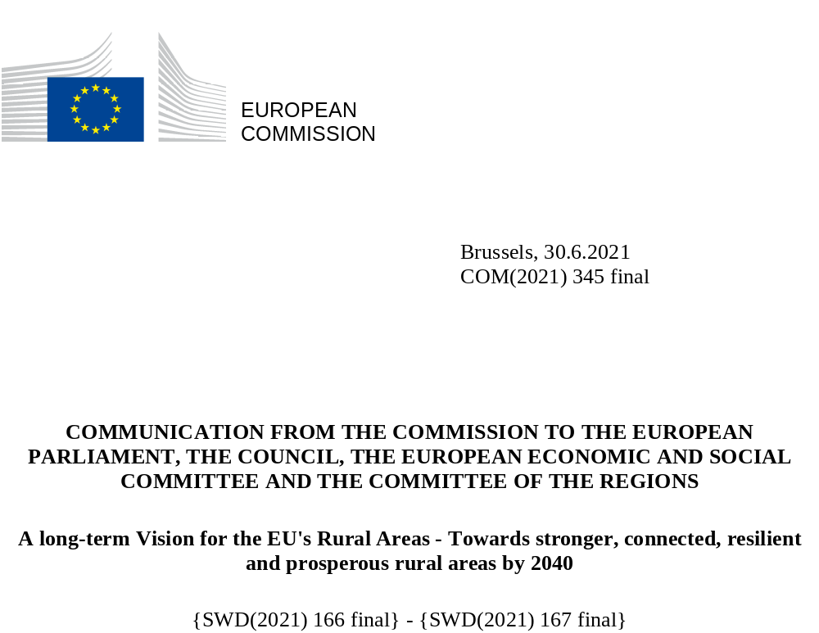

Introduction: the call for a long-term vision for the EU’s rural areas
‘Our rural areas are the fabric of our society and the heartbeat of our economy. The diversity of landscape, culture and heritage is one of Europe’s most defining and remarkable features. They are a core part of our identity and our economic potential.’
‘We will cherish and preserve our rural areas and invest in their future.’
President von der Leyen – July 2019
(Political guidelines for 2019-2024)
The EU’s rural areas are a core part of the European way of life. They are home to 137 million people representing almost 30% of its population and over 80% of its territory, considering all communes and municipalities of Europe with low population size or density. They are widely recognised and valued for food production, management of natural resources, protection of natural landscapes, as well as recreation and tourism. Many of our traditions, festivals and culture are rooted in Europe’s rural areas. As emphasised by the European Commission’s President, Ursula von der Leyen, ‘Europe would not be whole without its countryside’.
Yet social and economic changes of the last decades, including globalisation and urbanisation, are changing the role and nature of rural areas, which are also affected by population decline and ageing. Many Europeans are worried about the erosion of rural infrastructure and service provision, including access to healthcare, social services and education as well as to postal and banking services. Others express concerns about shrinking employment opportunities and possible drop in income in rural areas or limited transport and digital connectivity.
There is a growing understanding, that the role and importance of rural areas is under-appreciated and insufficiently rewarded. Almost 40% of those who replied to the public consultation organised in preparation of this Communication said they felt left behind by society and policy-makers. This perception and the factors driving it need to be addressed.
This Communication on a long-term Vision for the EU’s rural areas aims to address these challenges and concerns, by building on the emerging opportunities of the EU’s green and digital transitions and on the lessons learnt from the COVID 19 pandemic, and by identifying means to improve rural quality of life, achieve balanced territorial development and stimulate economic growth in rural areas along with the help of the newly launched Atlas of Demography. It builds on analysis, foresight activities, extensive consultations and contributions from communities. It sets out the vision as well as the policy tools, to achieve it, including best practices that can be replicated. The Communication promotes and helps to achieve the 2030 Agenda and its Sustainable Development Goals.
Rural areas are active players in the EU’s green and digital transitions. Through sustainable production of food, preservation of biodiversity and the fight against climate change, they play a key role in achieving the European Union’s Green Deal, Farm to Fork and biodiversity targets. In parallel, the roll-out of new technologies in rural areas will be indispensable to make Europe’s Digital Decade a reality. Reaching the targets of the EU’s digital ambitions for 2030 can also provide more opportunities for the sustainable development of rural areas beyond agriculture, farming and forestry. It can contribute to developing new perspectives for the growth and geographical distribution of manufacturing and especially services.
Europe’s rural areas are very diverse. Variations in natural and climatic conditions, geographic features, historic and cultural developments, demographic and social changes, national and regional specificities and economic prosperity mean that no two rural areas are alike. This diversity calls for locally designed responses and solutions corresponding to each territory’s specific needs and possibilities. It also means that territorial development strategies should address rural areas according to their individual characteristics and in relation to their environment. In this respect, actions need to focus particularly on remote and less developed rural regions.
Changes to society, including the latest ones caused by COVID-19, should be turned into opportunities for rural areas. We need to avoid an asymmetric recovery and ensure that all of the EU’s territories have the means to bounce back equally from the pandemic.
The European Commission, in line with its strong commitment to democracy and equality, and mindful of the impact of demographic change, is committed to leave no one and no place behind and to bring the EU closer to its citizens. With this Communication, it has the ambition to create a new momentum for rural areas by changing the way they are perceived and by building new opportunities, with a stronger voice for rural communities, which are an integral part of building the future of Europe. Rural communities also play a pivotal role in implementing the 20 principles of the European Pillar of Social Rights, contributing to a strong social Europe that is fair, inclusive and full of opportunity.
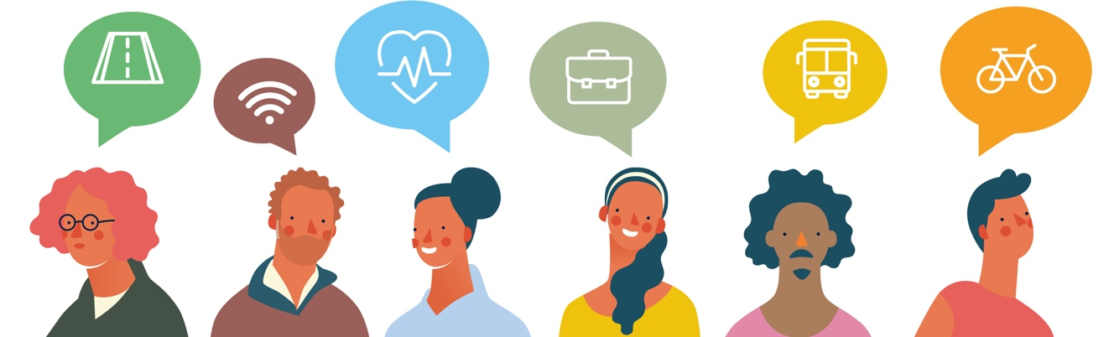
Balanced territorial development, anchored in place-based approaches and the involvement of all governance levels, as outlined in the recently adopted new Territorial Agenda of the EU, is necessary to make the most of the potential of rural areas.
The Commission is committed to reducing regional disparities and helping rural areas catch up. This commitment is enshrined in Article 174 TFEU which lays out that particular attention should be paid to ‘rural areas, areas affected by industrial transition, and regions which suffer from severe and permanent natural or demographic handicaps such as the northernmost regions with very low population density and island, cross-border and mountain regions’. The specific status of the outermost regions and their rural areas is recognised by Article 349 TFEU.
These Treaty principles need to be observed and embraced at all levels: no policy, action or measure should hamper regional convergence nor aggravate the regional divide.
Against this background, this Communication sets out a long-term Vision for the EU’s rural areas up to 2040. It identifies areas of action towards stronger, connected, resilient and prosperous rural areas and communities. A Rural Pact will mobilise public authorities, and stakeholders to act on the needs and aspirations of rural residents. The accompanying EU Rural Action Plan will pave the way to fostering territorial cohesion and create new opportunities to attract innovative businesses, provide access to quality jobs, promote new and improved skills, ensure better infrastructure and services, and leverage the role of sustainable agriculture as well as diversified economic activities.

EU’s rural areas today

1.1. Trends and challenges
The EU’s population is ageing and will slowly start to shrink in the coming decade. The population in rural areas is already older, on average, than the population in towns and suburbs and cities. Rural regions have, on average, seen a reduction in population in recent years mainly due to negative natural population change, not compensated by sufficient positive net migration. Certain eastern and southern Member States are even confronted with both challenges, as natural population change and net movement in their rural regions have been negative. Moreover, young women are more likely to leave rural regions than young men. These demographic trends, when coupled with a lack of connectivity, infrastructure and productivity challenges and low access to public services including education and care, can contribute to the lower attractiveness of rural areas as places to live and work.
For centuries, ‘rural’ meant ‘agricultural’ with millions of farmers nurturing European society. Life in many rural areas, especially in more remote and peripheral parts, remains intrinsically linked to agriculture – over 40% of land in rural areas is used for agriculture. Over time, the contribution of agriculture, forestry and fisheries to rural regions has decreased both in economic and employment terms to 12% of all jobs and 4% of gross value added, while crucially maintaining food security in the EU.
In parallel, the weight of services (e.g. tourism, recreation) increased and marked a structural change in many rural economies, while the share of the industry and construction sector remained constant.
While higher growth has enabled the gap to narrow since 2000, gross domestic product (GDP) per capita in rural regions was still considerably lower (at 75%) than the EU average in 2018. The economic catching-up did not reach remote rural regions (which remain at around 70% of EU GDP per capita). This overall economic context highlights the need to continue pursuing the economic diversification of rural areas, encompassing all dimensions and sectors, to make the most of their potential in relation to services and manufacturing.
The average employment rate in the EU’s rural areas increased between 2012 and 2020 (from 67.5% to 73.1%, i.e. higher than in cities), while the average unemployment rate dropped (from 10.4% to 5.9%, i.e. lower than in cities). These favourable overall dynamics mask different realities, notably a very diverse situation in the Member States and the fact that young people have a higher unemployment rate compared to the general working age population, also in rural areas. Moreover, in terms of share of population that is at risk of poverty or social exclusion, the figures in 2019 are higher in rural areas (22.4%), compared to cities (21.3%) and towns and suburbs (19.2%), and in ten Member States the percentage of the population at-risk-of-poverty in rural areas has risen since 2012..
There is a gap between male and female employment in rural areas of 13 percentage points (versus 10 percentage points in cities), rising to over 20 in certain Member States. This gap has remained fairly stable at EU level since 2012. In over half of the Member States, this gender gap is wider in rural areas than cities. Attention should be paid to the fact that many women have precarious contracts (e.g. seasonal workers) or play an ‘invisible role’ in rural societies (e.g. assisting spouses), which may leave them exposed to vulnerable situations (such as no access to social protection or maternity benefits, in some cases). At the same time, women represent a significant driving force for prosperity and social inclusion in rural areas, notably through entrepreneurship.
The share of population with higher education in rural areas remains low despite an increase from 18% in 2012 to 22% in 2019. The difference between rural areas and cities also increased from 17 percentage points in 2012 to 19 in 2019 (being stable or growing in most Member States). As regards basic skills (reading, mathematics and science), the performance gap between urban and rural areas is also wide in many countries, as indicated by the results of PISA 2018. In terms of at least basic digital skills the gap amounted to 14 percentage points (48% for rural areas vs 62% for cities) in 2019 and is stable since 2015. In addition, at EU level the rate of early leavers from education and training is higher in rural areas and towns than in cities. Schools in some rural areas often struggle to provide quality education due to their geographical isolation and small size. They are faced with insufficient infrastructure and educational support services, a limited educational offer and a lack of experienced teachers. This can limit the uptake of e-services and the potential to study and work remotely, which influences the availability of quality jobs in rural areas.
Life in rural areas crucially depends on access to quality public services and infrastructure. The public consultation identified infrastructure, access to facilities and amenities, digital connectivity and employment as the most urgent needs. In particular, essential services and related infrastructure - such as water, sanitation, energy, transport, financial services and digital communications - are key to guaranteeing social and economic inclusion. They complement and facilitate access to other services that fulfil an enabling function, such as childcare, education, long-term care, housing, labour market and social services and they can also be an important source of job creation.
Access to public services and infrastructure is influenced by the density and proximity of people, which differs between rural areas across Member States and between rural areas close to a city and remote rural areas. The less urbanised and the more remote an area is, the longer the average road distance to the nearest service is.
One third of the population of rural regions, lives in a border region. On average, these rural border regions have weaker road and rail performance and access to fewer passenger flights than other rural regions. People in rural border regions have to travel further to reach a primary or secondary school or a hospital compared to other rural regions.
Longer distances, lower population density and larger catchment areas make both delivery and access to services in rural areas more difficult. However, delivering services of general interest in rural areas with comparable quality to those in urban areas is key to maintaining equitable living standards for all citizens and across all territories, including in the most remote rural areas and in the outermost regions.
Rural communities are also potentially exposed to greater costs associated with the climate transition. Longer travelling distances to e.g. hospitals, schools and shops, coupled with greater dependency on private cars due to scarce public transport service leads to higher travel costs. Retail, doctors, pharmacies, banks, post offices, public transport, childcare facilities and schools are essential to rural life and jobs, as well as to ensure no-one and no place is left behind. The absence of these services can quickly lead to feelings of remoteness and social exclusion. Small cities and towns can act as driving forces for rural attractiveness and development and provide access to a number of services for their surrounding rural areas. It is important to reflect and try new ways to organise national and regional public services, taking advantage of digitalisation in the process.
Business models and approaches such as e-services, mobile service solutions, private-public partnerships, social enterprises, cultural and creative industries as well as cooperatives can help reach less populated areas and are more generally a key factor for rural socio-economic development. They crucially depend on the level of digital skills and the availability and affordability of adequate digital infrastructure, and the capacities to effectively deploy digital technologies, such as digital service platforms. The key prerequisite for the digital transformation is internet connectivity. Despite recent improvements in high-speed broadband connectivity, only 59% of households in rural regions have access to next generation access (NGA) broadband (>30Mbps), compared to 87% of the households in the EU.
Finally rural areas face specific challenges related to climate change and environmental degradation. For instance farming and forestry are more vulnerable than urban economic activities to more frequent adverse climate events such as storms, floods and droughts. These sectors are among the first to feel the consequences when biodiversity is lost posing a threat for the long-term economic perspectives of the rural communities that depend on them.

1.2. Opportunities in rural areas
New societal demands, the opportunities of the green economy, the possibilities opened up by digital technology together with the consequences of the COVID-19 pandemic and the expansion of teleworking have brought renewed attention to rural areas as places of well-being, security, eco-living and new possibilities for social and economic renewal.
The natural resources of rural areas are key defining assets on which to build a sustainable and prosperous future. When well-managed, rural landscapes covered by forests and natural areas help regulate water flows, capture carbon and air pollutants from the atmosphere, prevent soil erosion and provide ecosystem services. Sustainable farming and forestry management which encompasses environmental, economic and social sustainability, helps safeguard decent work and livelihoods, ecological systems and biodiversity and also enhances climate and risk resilience. Improving the quality of produced output and supporting farmers, foresters and rural entrepreneurs who are the enablers of the transition towards a greener society and economy is essential.
The increased focus on mitigating climate change, including through renewable energy production, is an opportunity for rural areas to combat energy poverty provided that ecosystem services are appropriately valued and business models retain value within rural communities.
In the context of the European Green Deal, Europe’s new growth strategy, rural areas will play an important role in making the EU the first climate neutral continent by 2050. The green transition will require the development of partnerships in all economic activities in rural areas, between businesses of all sectors, local authorities, researchers and services based on innovation, knowledge sharing and cooperation, including within smart specialisation processes.
The bioeconomy is one of the Union's largest sectors. It encompasses agriculture, forestry, fisheries, aquaculture, and the production of food, feed, bio-energy and bio-based products. It can help the EU accelerate progress towards a circular and low-carbon economy and will contribute to the modernisation and strengthening of its food sector as well as the industrial base of rural areas. Sustainable bio- and circular economy will create new, more diverse value chains and greener, more cost-effective processes, while protecting biodiversity and the environment. In 2017 the bioeconomy generated EUR 614 billion of value added and employed around 17.5 million people in the EU. Within rural areas, the bioeconomy can drive innovative business solutions and can be supported through initiatives such as Startup Villages and support to SME’s.
Alongside these new economic opportunities and to create employment in the affected areas, sustainable and innovative ways to use former mines and mineral extraction sites must also be identified, notably by restoring degraded ecosystems and the services they provide to local communities.
The evolving consumer demand for better quality, more sustainable and healthy food including organic products can generate new opportunities for farmers and the rural economy. The transition towards organic production methods, the development of short supply chains, local processing and innovative products, in line with the EU’s Farm to Fork Strategy and the Action Plan for the Development of Organic Production, can contribute to strengthening the role of farmers and increasing their income.
Sectors like tourism also benefit from a wider offer of quality touristic activities, including on-farm activities, the production of local quality products, the adequate management of landscapes and sea-land interactions in coastal rural areas. ‘Bio-districts’ - geographical areas where farmers, the public, tourist operators, associations and public authorities enter into an agreement for the sustainable management of local resources based on organic principles and practices - is a promising concept in this regard, in particular in combination with the Natura 2000 network. It is therefore important to account for the needs of small and medium sized farmers, attracting young, new and female farmers and preventing land abandonment as well as facilitating land access. This should also include agricultural workers, including seasonal workers and those with a migrant background. The development and management of tourist offers, making full use of technology and digital services should also be supported.
Digital connectivity is a key enabler for the diversification of economic activities in rural areas. It will make it easier for entrepreneurs and start-ups to set up and grow their businesses and thus creating new economic opportunities for rural areas. The development of innovation ecosystems will allow rural communities to create high quality jobs in rural areas in all sectors.
Another important set of opportunities for rural areas lies in the quality of life and the involvement of local communities in decision making. Possibilities for active participation in public and social life, including artistic and cultural activities, are also likely to influence the relative attractiveness of rural areas.

A vision for rural areas towards 2040
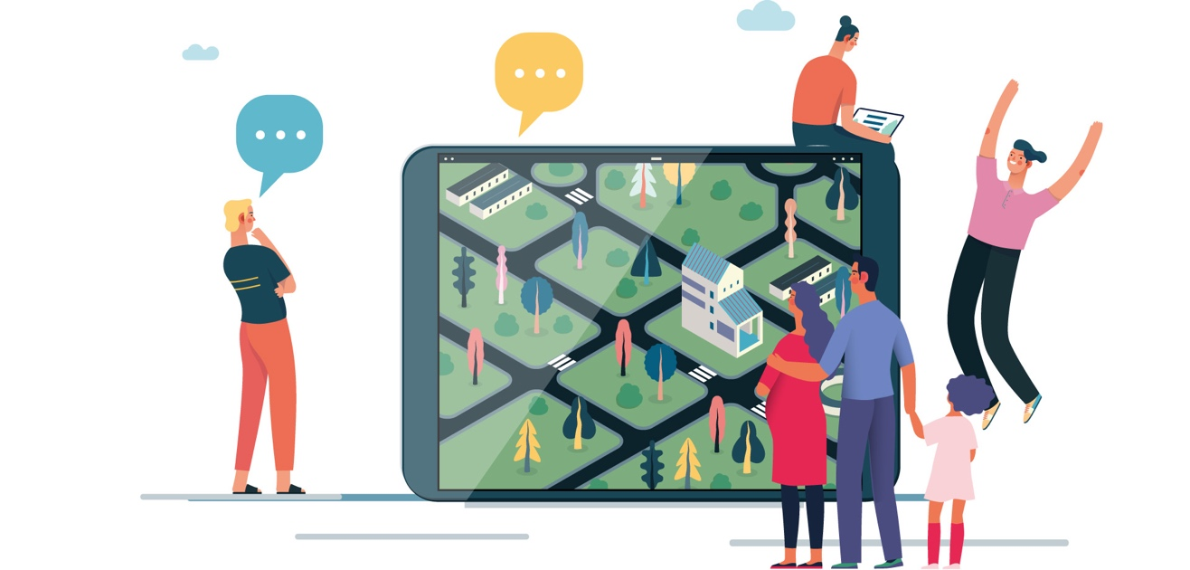
The challenges and opportunities rural areas face, several of which are likely to continue in the future, are the foundation for the exercise undertaken to define the Vision. Citizens and organisations from rural areas were strongly involved in designing this Vision depicting where rural areas want to be in 2040. In addition, a dedicated foresight exercise was conducted. It considered megatrends driving transformations to 2040 and identified key underlying factors of change, the so-called ‘drivers’, that are expected to shape the future of rural areas (see graph 1). Demography and governance were highlighted as the most impactful and uncertain drivers and were the axes along which four scenarios were developed. Each one illustrates a possible future for rural areas in 2040, depending on whether they attract new inhabitants or not, and on the quality of multi-level governance. The scenarios also address rural-urban interdependencies.
Drawing on the identified drivers, the scenarios and numerous consultation activities, four complementary areas of action emerged, embodying a long-term Vision from, by and for stronger, connected, resilient and prosperous rural areas by 2040.

Graph 1: Main drivers shaping the future of rural areas for 2040 and the four complementary areas for action
Stronger
- Empowered communities
- Access to services
- Social innovation
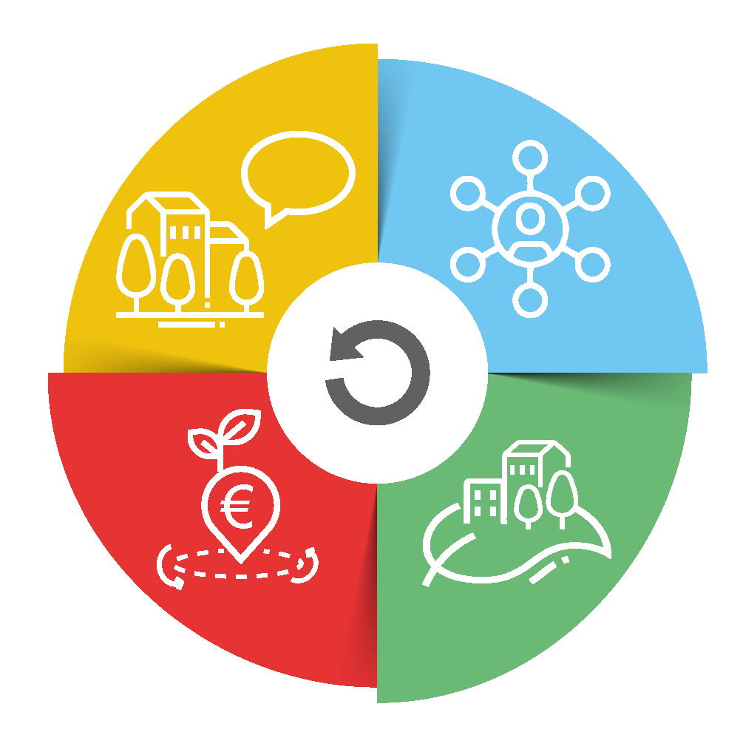
Connected
- Digital connectivity
- Transport links and
new mobilities

Prosperous
- Diversification of
economic activities
- Sustainable food production
Resilient
- Resilience to climate change
- Environmental resilience
- Social resilience

Source: European Commission

Stronger rural areas
‘Innovation in rural areas is not led by big corporates.
It is community-led.’
‘From ‘rural inhabitants’ to rural communities.
Everyone invited, everyone involved.’
(Consultation activities for the long-term Vision)
(Consultation activities for the long-term Vision)

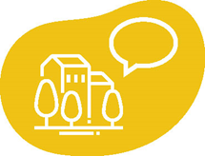
Rural areas should be home to empowered and vibrant local communities. Enabling all individuals to take active part in policy and decision-making processes, involving a broad range of stakeholders and networks as well as all levels of governance is key to developing tailor-made, place-based and integrated policy solutions and investments. New possibilities for active public participation such as consultations of rural constituencies or online voting can make rural areas, particularly remote and depopulating ones, more attractive by engaging people in decisions on their own future and in how to make the most of the cultural and economic strengths of their area.
While situations vary between Member States, the population of a number of the EU’s rural areas is mostly shrinking and growing older, which may put pressure on the provision of public and private services. Ensuring rural areas are attractive places to live and work is key. In this respect, the effective access to essential services of sufficient quality, such as water, sanitation, healthcare, energy, transport, financial services and digital communications, has to be guaranteed for all. Innovative solutions for the provisions of services should also be developed, making the best of the possibilities offered by digital tools and encouraging strongly social innovation.

Connected rural areas

‘The countryside is still struggling with numerous white spots in terms of infrastructure - roads, transport, sewage and water supply.’
‘Broadband needs to be an essential service. It is a means to an end, not the end itself.’
(Consultation activities for the long-term Vision)

(Consultation activities for the long-term Vision)

The further development of rural areas is dependent on them being well connected between each other and to peri-urban and urban areas. This makes them easier to access while improving access to a wider range of services for local communities.
In terms of transport, this means maintaining or improving affordable public transport services, and infrastructure such as railways, inland waterways, roads, charging and refuelling stations to support e-mobility solutions, cycling paths, multimodal connections including to active means of transport, as well as short-sea shipping and air transport links, which are often the only means of connecting islands and certain peripheral regions. The potential for rural areas to act as hubs for the development, testing and deployment of sustainable and innovative mobility solutions should also be further explored.
Digital infrastructure is an essential enabler for rural areas to contribute to and make the most of the digital transition. The development of digital capacities in rural areas will improve their attractiveness. Digital technologies will offer services such as multi-modal intelligent transport systems, rapid emergency assistance in case of accidents, more targeted waste management solutions, smart energy and lighting solutions, resource optimisation, and more.

Resilient rural areas that foster well-being
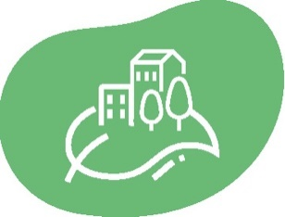
‘The vision must promote sustainable resilience and inclusive development, and enhance the well-being of inhabitants.’
(Consultation activities for the long-term Vision)

Rural areas can and should play a central role in the European Green Deal. The preservation of natural resources, the restoration of landscapes, including cultural ones, the greening of farming activities and shortening supply chains will make rural areas more resilient to climate change, natural hazards and economic crises. As providers of services that protect ecosystems and solutions for carbon neutrality, rural areas have an increasingly important role to play in climate change mitigation and the sustainable bio- and circular economy. Rural areas should build on sustainable farming, forestry, agri-food economic activities and a diversified range of greener economic activities promoting carbon-farming and local, community-based high-quality production.
For the benefit of rural areas, different sustainable activities should be able to coexist. Family agricultural activities should be carried out in harmony with other economic activities, all the while respecting and preserving the proper autonomy of economic sectors via appropriate land use planning and zoning. Likewise, agricultural production should be mindful of its impact on waters and marine ecosystems.
The green and digital transitions should be fair and take the needs of all rural community members into account, including those from disadvantaged groups to strengthen the social resilience of rural areas.
Making rural areas more socially resilient requires tapping into the full breadth of talents and diversity in our societies. Everyone should be able to access re- and upskilling, opening the possibility of good quality jobs and opportunities, and they should be equally represented in decision making, at the national, regional and local levels. Gender-based violence and gender stereotypes should be addressed. Particular attention should also be paid to young people as well as older persons, persons with disabilities, children, LGBTQI+ people, people with a migrant background and Roma communities that sometimes lack access to basic services, such as adequate social and educational services and health care.

Prosperous rural areas
‘Continue the commitment to support the diversification of activities and functions of rural areas, harnessing local strengths, knowledge and opportunities and providing greater support for small and micro scale projects, especially promoted by young people and unemployed, avoiding their leaving for the cities.’
(Consultation activities for the long-term Vision)
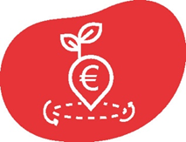

Rural areas can become more prosperous by diversifying economic activities to new sectors with positive effects on employment, and improving the value added of farming and agri-food activities.
The diversification of economic activities should be based on sustainable local economic strategies including measures that make their environment attractive to companies. Economic diversification also requires giving access to digital and hybrid education and training for communities to acquire new skills and support entrepreneurial mind-sets. Improved networking of smaller businesses can be an alternative to consolidation, which often leads to the transfer of power and profit away from rural areas.
The important economic role played by agriculture, forestry and fisheries should be preserved. Developing short supply chains, making use of labelling schemes acknowledging the quality and variety of local and traditional food products will have a positive impact on local economies. Producer organisations can contribute to promoting products and their regions through activities, such as advertising campaigns. This also plays a role in satisfying the increasing demand for local products - linked to the specific rural areas they are from - and contributes to preserving the self-sufficiency and sustainability of European food production.

The Rural Pact and the EU rural action plan


A Rural Pact and an EU Rural Action Plan with tangible flagship projects and new tools will help achieve the goals of the Vision (see point 3.1). They will drive the revitalisation of rural areas, mitigate the impact of negative trends and allow the monitoring and reporting on the achievements towards 2040.

The Rural Pact – strengthened governance for EU rural areas
‘Ensuring alignment and complementarity between International, National and Local policies which impact on rural development will maximise the positive effects of our collective efforts.’
(Consultation activities for the long-term Vision)
A Rural Pact will be developed with all levels of governance and stakeholders supporting the shared goals of the Vision which are proposed in this Communication (see below). The Pact will provide a common framework for the engagement and cooperation of a wide range of actors at the EU, national, regional and local level. It will contribute to increased synergies, complementarities and coherence between the EU, national, regional and territorial policies and interventions to achieve the objectives of this long-term Vision and respond to the common aspirations of rural communities. Interactions between all levels of governance and stakeholders on rural development will be encouraged through existing networks that will be mobilised to involve rural stakeholders.
The Commission will act as a facilitator for the Pact to be a successful framework. National authorities and stakeholders will be able to exchange ideas on the ways to reach the shared goals of the Vision. Sharing experiences and best practises in the development of strategies, action plans and concrete measures that have been taken will contribute to ensuring that all rural areas are stronger, connected, resilient and prosperous by 2040. Member States, regional and local governments that have not yet designed a strategy and an action plan to address the challenges faced by rural areas will be invited to do so. A particular focus will be placed on the management of structural transitions and multi-level and participatory governance to design and implement solutions that work best for rural areas.
The four strands – Stronger, Connected, Resilient and Prosperous – summarise common aspirations of rural communities and stakeholders for rural areas in 2040 to become:

- Attractive spaces, developed in harmonious territorial development, unlocking their specific potential, making them places of opportunity and providing local solutions to help tackle the local effects of global challenges.
- Engaged in multi-level and place-based governance, developing integrated strategies using collaborative and participatory approaches, benefitting from tailor-made policy mixes and interdependencies between urban and rural areas.
- Providers of food security, economic opportunities, goods and services for wider society, such as bio-based materials and energy but also local, community-based high-quality products, renewable energy, retaining a fair share of the value generated.
- Dynamic communities focusing on well-being, including livelihoods, fairness, prosperity and quality of life, where all people live and work well together, with adequate capacity for mutual support.
- Inclusive communities of inter-generational solidarity fairness and renewal, open to newcomers and fostering equal opportunities for all.
- Flourishing sources of nature, enhanced by and contributing to the objectives of the Green Deal, including climate neutrality, as well as sustainable management of natural resources.
- Fully benefiting from digital innovation with equal access to emerging technologies, widespread digital literacy and opportunities to acquire more advanced skills.
- Entrepreneurial, innovative and skilled people, co-creating technological, ecological and social progress.
- Lively places equipped with efficient, accessible and affordable public and private services, including cross border services, providing tailored solutions (such as transport, education, training, health and care, including long-term care, social life and retail business).
- Places of diversity, making the most out of their unique assets, talents and potential.
Beyond the diversity of rural areas, which is an asset for successful adaptation, these aspirations reflect common ground and possible EU added value and are therefore proposed as shared goals for endorsement for a long term Vision for EU’s rural areas.

EU Rural Action Plan
Testifying to the Commission’s renewed commitment to rural communities and the development of rural areas, this Communication proposes a Rural Action Plan articulated around flagship initiatives. Several EU policies already provide support to address rural challenges and opportunities and contribute to the balanced, fair, green and innovative development of rural areas.
The reformed Common Agricultural Policy (CAP), and in particular its European Agricultural Fund for Rural Development (EAFRD), is one of the key sources of EU funding for rural areas, by fostering a smart, resilient and diversified agricultural sector, bolstering environmental care and climate action and by strengthening the socio-economic fabric of rural areas.
Cohesion Policy is the other major source of support for rural areas, promoting and supporting the harmonious overall development of Member States, regions and territories. To reach these objectives the European Regional Development Fund (ERDF), the Cohesion Fund (CF) and the European Social Fund Plus (ESF+) mobilise significant investments in people and infrastructure in rural areas. It also allows the design of tailor made strategies to the needs of each territory through new policy objectives of the 2021-2027 Cohesion Policy the: ‘Europe closer to citizens and ‘a more social and inclusive Europe’. It provides a flexible and adaptable framework for Member States and regions to support integrated territorial development with multi-level governance. It also offers the possibility to support place based solutions developed in and by rural areas.
Member States should therefore seize the opportunities offered by the CAP Strategic Plans and the Cohesion policy programmes for the 2021-2027 period to prompt sustainable and integrated rural development. In addition they should use the very significant potential of the Recovery and Resilience Facility (RRF), InvestEU, and other EU programmes, as well as of the European Investment Bank to cover existing investments gaps in rural areas. Funding needs to be mobilised coherently, in complementarity with national and regional Member State interventions, which remain crucial to providing comprehensive support to rural areas.
Beyond these key funding opportunities, the EU Rural Action Plan underpinning this Vision will articulate tangible projects and initiatives, based on the four strands of actions and bringing different EU policy areas together to turn this Vision into a reality. To deliver on the Vision, a number of initiatives have been regrouped around flagships that launch the joint effort to deliver on the Vision’s shared goals and typically regroup a number of actions that work together. The flagships are actionable projects, reinforced by accompanying actions described in detail in Annex.

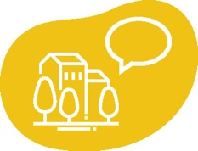
Flagship initiatives supporting stronger rural areas
‘The vital importance of rural territories to society as a whole must be recognised, its image and perception among urban populations and decision-makers must be improved, with a deconstruction of stereotypes.’
(Consultation activities for the long-term Vision)
Local communities are best placed to assess the relative strengths of their territories and build on them. Over the past 30 years, communities have been empowered to develop local strategies with CAP funding under the LEADER approach. There is also a well-established feature of Cohesion policy, through so-called Community-Led Local Development (CLLD), in particular in peri-urban and coastal areas as well on islands. Building on existing and future local development strategies, enhanced networking should help provide more advice to local communities, notably on access to funding and the conception of such strategies. The Smart Villages approach will also continue to be promoted in this context.
To foster the dynamism of rural areas, the following initiatives are proposed:
- Rural revitalisation platform
The Commission will set-up a one-stop shop platform for information on existing projects and funding possibilities for rural communities, rural project holders and local authorities alike to collaborate. It will provide an opportunity for rural citizens and communities to highlight how they have been able to leverage the specificities of their territory into new economic opportunities or provision of services for their population. This will in turn allow project holders or rural authorities to adapt these strategies to their own reality.
It will predominantly support rural areas affected by population loss, ageing and a lack of economic opportunities, who will be able to access information and best practices on tools and strategies.
- Research and innovation for rural communities
Strong innovation ecosystems that bring together public and private players are a key opportunity for rural communities to thrive again, for rural areas to be attractive places for innovators to work and live, and for Europe to mobilise the wealth of innovation pockets, talents and creative minds located outside of key knowledge hubs. Actions under this flagship will promote the strengthening of such ecosystems. Rural-focused R&I activities under Horizon Europe will support the development of innovations by and for rural communities, training, as well as knowledge exchange between the actors of rural innovation through yearly forum of Startup Villages to accelerate the spread and adoption of innovations.
These flagships will be complemented by accompanying actions. The Commission will assess how to best incentivise optimal land use planning and zoning to protect and promote sustainable farming and other economic activities and further enhance the networking around LEADER and Smart Villages. New programmes such as Erasmus+ and the European Solidarity Corps will also reach more people in rural areas through inclusion measures.


Flagship initiatives encouraging connected rural areas
‘No matter how much effort is spent on education, promotion of tourism, development of new economic initiatives, etc.: accessibility remains a key to success for any development initiative. The absence of a good accessibility and connectivity affects any development strategy implemented in rural territories.’
(Consultation activities for the long-term Vision)

The Commission calls on Member States and regions to develop sustainable rural mobility strategies. These should focus on specific rural mobility challenges, taking cross-border and macro-regional links into account to make the most of existing networks. They should draw on the European guidelines on sustainable urban mobility planning (SUMP). Urban areas are also encouraged to adopt sustainable mobility plans that pay attention to their surrounding peri-urban and rural areas.
Broadband coverage, including 5G, is key for businesses and people to work remotely and adapt to innovations and new economic activities. It also allows for innovative ways to acquire new skills and is a prerequisite for accessible e-services such as eHealth, retail, online banking, travel information and access to public administrations. A combination of terrestrial and space-based connectivity, ensuring high-speed broadband everywhere for resilient and cost-effective services will help achieve this. Developing widespread digital literacy is also crucial to ensure accessibility. Finally, data should be used to the benefit of rural areas. It can support improved and efficient service delivery, citizen involvement and innovation in sectors such as mobility, energy, food supply and health.

To encourage rural connectivity, the following initiatives are proposed:
- Sustainable multimodal mobility best practices for rural areas
It is imperative to improve existing transport connections. To this end, sustainable multimodal mobility solutions and connections should be optimised, making use of digitalisation. Building on its experience with urban mobility networks, the Commission will support rural municipalities in discussing and identifying mobility solutions. By showcasing local level initiatives, local authorities will be able to discuss rural mobility issues and adapt such initiative to address mobility in their territories, improving the sustainability of transport and the accessibility of rural areas.
- ‘Rural Digital Futures’
Rural areas and communities need to be at the core of digitalisation. ‘Rural Digital Futures’ proposes an integrated set of actions to boost the sustainable digital transformation of rural areas, raise their attractiveness for people and businesses to stay or return. It will address:
- Digital connectivity: closing the gap between rural and urban areas and enabling universal and affordable access to high speed connectivity. This will be achieved by mobilising private-sector investments.
- Digital technology: digital innovation and new technologies such as artificial intelligence, robotics, Internet of Things solutions and Digital Innovation Hubs contributing to the development of rural areas.
- People: boosting competencies needed for the digital transformation of rural areas, including access to and being part of a high-performing digital education ecosystem as per the strategic objectives of the Digital Education Action Plan 2021-2027, and promoting digital skills and entrepreneurship, so that everyone is able to benefit from the digital transition.
- Measuring progress towards closing the digital gap between urban and rural areas by re-arranging existing indicators, notably from the Digital Economy and Society Index, in a Rural Digital Index.
By 2030, the EU’s objective is to ensure that democratic life and public services will be fully accessible to everyone online. In line with the 2030 Digital Compass, 100% online provision of key public services would be available for European citizens and businesses; 100% of European citizens would have access to medical records (e-records); and 80% of citizens would use a digital ID solution by 2030.
European funding from the EAFRD, the ERDF, the ESF + and the Connecting Europe Facility (CEF), the RRF as well as national and private funding, should work together to invest in infrastructure, technology and people. These investments will contribute to reaching the goal of 100% fast broadband coverage in rural areas by 2025. It is to be noted that a minimum of 20% from the Recovery and Resilience Facility should support the digital transition. As mentioned in the Digital Decade Communication all European households should be covered by a Gigabit network and all populated areas covered by 5G by 2030.
Alongside these flagship actions, the Commission will also provide support to Broadband Competence Offices to facilitate the roll-out of broadband. CAP, Cohesion Policy, Horizon 2020 and Horizon Europe funding will allow for further digitalisation, notably of the agricultural sector. In terms of transport, urban-rural linkages will be addressed in the new EU Urban Mobility Framework and rural needs will be taken into account in the Drone Strategy 2.0.


Flagship initiatives supporting resilient rural areas
‘The idea of sustainability needs to build into every aspect of the development of rural areas.’ - ‘For farmers, climate-friendly production methods create new niches and opportunities for the future.’
‘COVID-19 has shown the various weaknesses and opportunities of different territories. For rural areas in particular, while risks of spreading the disease would seem lower than in densely urbanised areas, the population had to face the lack of proximity health institutions and services, with an overall older and therefore more vulnerable population’
(Consultation activities for the long-term Vision)
Actions under this block will contribute to increasing the environmental, climatic and social resilience of rural areas and focus on businesses and authorities, as they may bear a disproportionate share of the costs of the transition. They should ensure the inclusion of EU citizens at risk of being deprived of their rights, the promotion of gender equality, the equality and inclusion of people with a minority ethnic or racial background living in rural areas or seasonal workers, and give equal priority to economic and social advancement.
To contribute to resilient rural areas, the following initiatives are proposed:
- Support rural municipalities in energy transition and fighting climate change
The Covenant of Mayors for Energy and Climate Change is the world’s largest network of municipalities. A rural work stream will be created for rural signatories to exchange best practices, access funds, and increase awareness on the contribution they make to fighting climate change. European funds can finance the renovation of buildings in rural areas, supporting the EU’s recovery from the COVID-19 pandemic by providing jobs and contributing to the Green Deal objectives by increasing energy efficiency, local renewable energy production and reducing energy poverty in the EU. Rural areas will also be fully represented in the New European Bauhaus, which connects the European Green Deal to our living spaces, adapting buildings and public spaces.
- Climate action in peatland through carbon farming
Restoration, rewetting and conservation of wetlands and peatlands has great potential in terms of climate benefits as it can deliver immediately significant emission reductions in a relatively small area, while at the same time delivering several co-benefits related to water management and biodiversity.
This transition would be more effective with a territorial approach, in particular in those rural areas hosting extensive peatlands. These regions, could make benefit from support under the Just Transition Fund. Carbon farming initiatives could be a further source of income for their farmers and foresters, rewarding them for carbon sequestration. As set out in the Farm-to-Fork Strategy, a new EU carbon farming initiative will promote this new business model. CAP, the Cohesion Policy and the LIFE programme can provide support to develop pilot carbon-farming initiatives in their regions. Ensuring strong advisory support to farmers and foresters will be particularly relevant.
- The proposed EU Mission on soil health and food
The proposed mission in the area of ’Soil health and food’, under Horizon Europe, aims at implementing an ambitious research and innovation programme. The mission should contribute to tackle soil challenges in rural areas, but also in urban settings, building connections between rural and urban practices. The mission should also implement citizen engagement activities and seek to improve knowledge on soil.
- Social resilience and Women in rural areas
Support for women will be provided for entrepreneurship, participation in decision making and investments in work-life balance services, such as early childhood education and care, as well as services for older people. There can also be opportunities to increase women’s integration in the labour market.
As announced in the Gender Equality Strategy 2020-2025, the Commission will continue supporting Member States’ work on improving the availability, accessibility and affordability of quality education and care services for children and other dependents in rural areas through investments from the European Social Fund Plus, the European Regional Development Fund, the InvestEU programme and the European Agricultural Fund for Rural Development. Special attention will also be paid to people in vulnerable situations.
These four flagships will be complemented by other actions for demographic and social resilience. These will include, among others, actions supporting the analysis of the drivers of demographic decline in the rural areas that suffer from it in Europe, and inclusion and integration measures for people with a migrant background and other minorities.

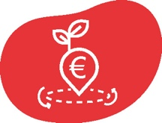

Flagship initiatives promoting prosperous rural areas
‘Diversify the economy, promote innovation of rural enterprises, especially micro enterprises, and, ultimately, increase the competitiveness of the business fabric in rural areas is vital for their future’
(Consultation activities for the long-term Vision)

Actions in this field should contribute to the economic diversification in rural areas around the green and digital transformation of society and lead to the strengthening of value chains in manufacturing and in cultural and creative industries. Relevant actions should be well articulated with regional smart specialisation strategies and should ensure that rural regions remain attractive for investments of industry and other economic activities.
The diversification of rural areas beyond the food and farming sector should also be supported. Synergies between tourism, farm marketing and processing, including the promotion of geographical indications, will contribute to the development of rural areas. This could cover the commercialisation of products with geographical indications which reflect a strong association between a product and its territorial origin. Goods produced in well managed Natura 2000 sites demonstrating the compatibility of their production with nature conservation may also benefit.
Regions will be supported in developing strategies that make the most of their intrinsic strengths, notably in areas linked to the Green Deal as well as in the manufacturing, service and creative sectors, while preserving self-sufficiency and sustainability of food production. The development and transition of the industrial and service sectors in rural areas is therefore key, along with value chains linked to the raw materials and energy sectors, but not detracting from agricultural production or encroaching on sustainable agricultural land use. The manufacturing energy and cultural and creative sectors have close connections to and support productivity and employment growth in other sectors in rural areas.
The European Pillar of Social Rights Action Plan sets the target of 78% of the population aged 20 to 64 in employment by 2030. To achieve this, the participation in the labour market of people living in rural areas (among others) need to be ensured. The Action Plan further sets out that by 2030, 60% of all adults should participate in training every year. Funding from the ESF+ will support the training of people in rural areas to ensure they have the tools required to be competitive on a changing job market. The initiatives planned under the European Education Area will contribute to foster the quality and inclusiveness of national education and training systems with an impact also on rural and remote areas.
The following broad action will be promoted:
- Entrepreneurship and social economy in rural areas.
The Commission will undertake a series of actions, including research and innovation funding activities, paying special attention to small and medium sized enterprises already settled or planning to settle in rural areas. This will enable entrepreneurs and small businesses to move to rural areas and contribute to their adaptation to the changing economic environment, provide opportunities to innovative business practices, cooperate and cluster as well as develop new sectors of the economy. This will be partly achieved through funding from Horizon Europe as well as the Commission’s Single Market Programme, which will specifically address the needs of small and medium rural businesses.
Social economy organisations hold significant potential to increase residential attractiveness and empower citizens and communities. The European Action Plan on Social Economy and the European Cluster Collaboration Platform will address challenges and opportunities by promoting social economy and social enterprises innovations and helping to pool business resources in rural areas, as well as to support social economy stakeholders in innovation, quality job creation and social inclusion. Networking between rural businesses will also be enhanced through the European Enterprise Networks, Europe’s largest network of small and medium sized enterprises, as well as through calls for inter-regional cooperation through the European Social Economy Missions. A specific focus will be placed on short supply chains of agri-food products, directly linking producers to consumers.
The flagship will be complemented by actions developing, among other things, employment and learning opportunities for young people and the sustainable development of the bioeconomy.

Implementation of the EU Rural Action Plan
The Commission will support and monitor the implementation of the EU Rural Action Plan and regularly update it to ensure its relevance and account for new EU policy actions. It will liaise with the Member States, stakeholders, bodies and institutions on a regular basis to offer a platform for exchanges on rural issues. It is envisaged that the current EU and national rural networks, the Cohesion Policy networks, the Inform EU network and the future CAP networks will play an active role in involving stakeholders, sharing good practices and taking actions forward across a wide range of the proposed topics and actions.

Rural proofing
Given the multidimensional nature of rural development and the fact the Treaties aim for economic, social and territorial cohesion, there is a need to review EU policies through a rural lens, considering their potential impacts and implications on rural jobs and growth as well as development prospects, social well-being and equal opportunities for all, and the environmental quality of rural areas.
As part of the Better Regulation Agenda, a rural proofing mechanism will be put in place, notably to assess the anticipated impact of major EU legislative initiatives on rural areas. Its purpose will be to ensure coherence, consistency and complementarity between policies to benefit rural areas and communities. Rural proofing policy initiatives will increase their impact on the ground. Putting in place such a mechanism was recommended in the Cork 2.0 Declaration ‘A better life for rural areas’, confirmed by the 2017 Commission Communication on the Future of Food and Farming as well as the recently adopted Communication on Better Regulation and stressed by local and regional authorities and rural stakeholders during consultation activities. It will draw – among other things – on territorial impact assessments and a better monitoring of the situation of rural areas. The way in which rural areas are integrated in the EU’s policies will be monitored, notably through regular reports on the implementation of relevant policies.
The Commission also invites Member States to consider implementing the rural proofing principle at the national, regional and local level.

EU Rural Observatory
More and better data are essential to understand the rural dimension of economic, social and demographic conditions and to act on them. A Rural Observatory will be set up within the Commission to further improve data collection and analysis on rural areas. This Observatory will also provide evidence to inform policy making in relation to rural development while supporting the overall implementation of the Rural Action Plan. It will be tasked with:
- Centralising and analysing data, ensuring a bridge between data sources through a rural data portal. Sex-disaggregated data will be used where available.
- Informing on relevant EU initiatives for rural areas.
- Analysing the achievements of the EU Rural Action Plan.
While the observatory’s scope will be rural, it will naturally contribute to the analysis of diverse territories (cross-border, outermost regions, mountains, islands, sparsely populated etc.) to reflect the multiple dimensions of rural areas and their links with other territories. In this respect it will work in synergy with Eurostat, the Joint Research Centre’s Knowledge Centre for Territorial Policies and ESPON. Rural-focused research and innovation activities funded under Horizon Europe will also support the rural observatory with strengthened evidence.
In this context, the Commission will establish a common approach for the use of Geospatial Information Systems. This will increase the publication of georeferenced statistics and geospatial information will be included in statistical production. As a result, the Commission will be able to produce more detailed regional, local and cross-border level statistics in areas such as demography, health, education, tourism and agriculture.

Toolkit on EU Funding opportunities for rural areas
To reach the goals of the Vision, existing EU policy support needs to be enhanced and further strengthened. A first step will be to improve synergies and complementarities between funds that contribute to rural development.
The Commission will develop a toolkit on access to, and optimal combination of EU funding opportunities for rural areas. It will aim to be a guide to the different funding opportunities, centralising information in one document which will be accessible to local authorities, stakeholders, project holders and managing authorities. The toolkit will support integrated territorial and local development strategies, providing inspirational solutions and examples to rural areas to trigger revitalisation by making full use of the new opportunities offered by the new 2021-2027 budget.


Next steps
This Communication, which also contributes to the work of the Conference on the Future of Europe, is only the first step of a process which, through the Rural Pact and the rolling EU Rural Action Plan, should ultimately fulfil the objectives of the long-term Vision for the EU’s rural areas in 2040. Delivering on the goals of the Vision and adapting to changing economic and social realities can only be done in cooperation with citizens living in rural areas, national and regional administrations, local authorities and all rural stakeholders.
By the end of 2021, the Commission will, together with the stakeholders, launch the Rural Pact, linking with the Committee of the Regions, to examine the path towards achieving the goals of the Vision. This process will discuss rural issues in dedicated events, including within networks under the CAP, and other existing networks under the Cohesion Policy Funds. The Commission will further engage the European Rural Parliament, which can act as forums of exchange on the implementation of the Vision.
By mid-2023, the Commission will take stock of what actions have been carried out and programmed in support schemes for rural areas financed by the EU and Member States in the 2021-2027 programming period for the CAP and Cohesion Policy Funds and will highlight gaps where necessary. A set of reflections on possible orientations for enhanced support action and financing for rural areas, as well as on the ways forward, will be included in a public report by the first quarter 2024, based on the implementation of the EU Rural Action Plan. The discussions around the report will feed the reflection on the preparation of the proposals for the 2028-2034 programming period.


According to the 2018 LAU (Local Administrative Unit) level modelling by the JRC Eurostat demography data. Atlas of demography: https://migration-demography-tools.jrc.ec.europa.eu/atlas-demography/
Webinar - A vision for rural Europe - Harnessing the potential of rural areas to contribute to a sustainable & prosperous Europe.
See Commission report on the impact of demographic change (COM(2020)241 final) and green paper on ageing (COM(2021) 50 final)
For further information see the accompanying Stakeholder consultation – Synopsis report (SWD(2021) 167 final)
Communication The European Green Deal (COM (2019) 640 final)
Communication A Farm to Fork Strategy (COM (2020) 381 final)
Communication EU Biodiversity Strategy for 2030 (COM (2020) 380 final)
https://ec.europa.eu/info/strategy/priorities-2019-2024/europe-fit-digital-age/europes-digital-decade-digital-targets-2030_en
https://ec.europa.eu/info/strategy/priorities-2019-2024/economy-works-people/jobs-growth-and-investment/european-pillar-social-rights_en
https://www.territorialagenda.eu/files/agenda_theme/agenda_data/Territorial%20Agenda%20documents/TerritorialAgenda2030_201201.pdf
For further evidence, see also the Staff Working Document (SWD (2021) 166 final) accompanying this Communication.
Different data sets make use of different definitions of ‘rural’. For this chapter the most important difference is between DEGURBA data (referring to ‘cities, towns and suburbs and rural areas’) and the NUTS urban-rural typology (referring to ‘urban, intermediate and rural regions’). For more information, please see the methodology chapter of the accompanying Staff Working Document.
This means that the number of deaths has exceeded the number of births.
Based on average annual rates of change between 2014 and 2019.
Youth unemployment rates are higher than general unemployment rates throughout the EU, and in all types of areas. See the accompanying Staff Working Document (SWD (2021) 166 final) pp. 58-59 and Figure 11) and File:Share of people at risk of poverty or social exclusion, analysed by degree of urbanisation, 2019 (%) LCIE20.png - Statistics Explained (europa.eu).
Share of total population in this context does include people of different age groups.
The right to access these services - and in particular the necessity to support people in need - is enshrined in Principle 20 of the European Pillar of Social Rights (EPSR).
The total number of people within a radius of 120 km.
This comprises among others retailer, primary school, pharmacy and bank.
OECD, Delivering Quality Education and Health Care to All: Preparing Regions for Demographic Change, OECD Rural Studies, OECD Publishing, Paris, 2021. https://doi.org/10.1787/83025c02-en
Maes J., et al., More green infrastructure is required to maintain ecosystem services under current trends in land-use change in Europe, Landsc Ecol 30:517–534, 2015.
https://ec.europa.eu/info/strategy/priorities-2019-2024/european-green-deal_en
https://s3platform.jrc.ec.europa.eu/what-is-smart-specialisation-
Ronzon, T., et al., Developments of Economic Growth and Employment in Bioeconomy Sectors across the EU, Sustainability 12, no.11:4507, 2020. https://doi.org/10.3390/su12114507
https://ec.europa.eu/commission/commissioners/2019-2024/suica/announcements/launch-global-eu-campaign-rural-50-strategy_en
Communication on an action plan for the development of the organic production, (COM (2021) 141 final)
Based on participatory approaches with ENRD-Thematic Group, see ENRD portal and Staff Working Document (SWD (2021) 166 final) accompanying this Communication
Foresight is the discipline of exploring, anticipating and shaping the future helping building and use collective intelligence in a structured and systematic way to anticipate developments and better prepare for change.
Megatrends are defined as long-term driving forces that are observable now and will most likely have a global impact. More information can be found in the European Commission’s Megatrends Hub
More explanations can be found in the foresight section of the SWD (2021) 166 final.
Action Plan Principle 20 – The European Pillar of Social Rights: https://ec.europa.eu/info/strategy/priorities-2019-2024/economy-works-people/jobs-growth-and-investment/european-pillar-social-rights/european-pillar-social-rights-20-principles_en
This includes ensuring accessibility of public transport and infrastructure in line with the United Nations Convention on the Rights of Persons with Disabilities.
Communication 2020 Strategic Foresight Report – Charting the course towards a more resilient Europe (COM(2020)493 final).
See Communication on an action plan for the development of the organic production, (COM (2021) 141 final)
Fritsche U., et al., Future transitions for the Bioeconomy towards Sustainable Development and a Climate-Neutral Economy - Knowledge Synthesis Final Report, Publications Office of the European Union, Luxembourg, 2020. https://op.europa.eu/en/publication-detail/-/publication/54a1e679-f634-11ea-991b-01aa75ed71a1/language-en
https://ec.europa.eu/info/food-farming-fisheries/key-policies/common-agricultural-policy/cap-glance_en#legalfoundations
https://ec.europa.eu/info/business-economy-euro/recovery-coronavirus/recovery-and-resilience-facility_en
See annex for complete list of accompanying actions.
This includes the specific challenges linked to the demography of rural areas, such as an ageing population calling for ensuring accessibility of transport fleet and infrastructure.
https://www.eltis.org/sites/default/files/sump_guidelines_2019_interactive_document_1.pdf
The findings of the SMARTA 1 project concluded that a network on rural transport can showcase local level initiatives which local authorities could replicate in their territory and provide a forum for discussion on rural mobility issues. See: https://ruralsharedmobility.eu/wp-content/uploads/2021/01/SMARTA-2nd-Brochure-EN.pdf
Communication Resetting education and training for the digital age (COM(2020)624 final)
Communication 2030 Digital Compass: the European way for the Digital Decade (COM(2021)118 final)
Including through measures recommended by the Commission as part of the Effective Active Support to Employment (EASE).
https://europa.eu/new-european-bauhaus/index_en
Communication A Union of Equality: Gender Equality Strategy 2020-2025 (COM(2020)152 final)
Communication: An EU Strategy on the Rights of the Child 2021-2024 (COM) (2021) 142 final)
The Covid-19 crisis has triggered behavioural changes in favour of sustainable tourism (https://publications.jrc.ec.europa.eu/repository/handle/JRC121262 ).
Cork 2.0 Declaration-A Better Life in Rural Areas. https://enrd.ec.europa.eu/sites/default/files/cork-declaration_en.pdf
Communication The Future of Food and Farming (COM(2017)713 final)
https://ec.europa.eu/commission/presscorner/detail/en/qanda_21_1902
https://knowledge4policy.ec.europa.eu/territorial_en
https://www.espon.eu/programme/espon/espon-2020-cooperation-programme

