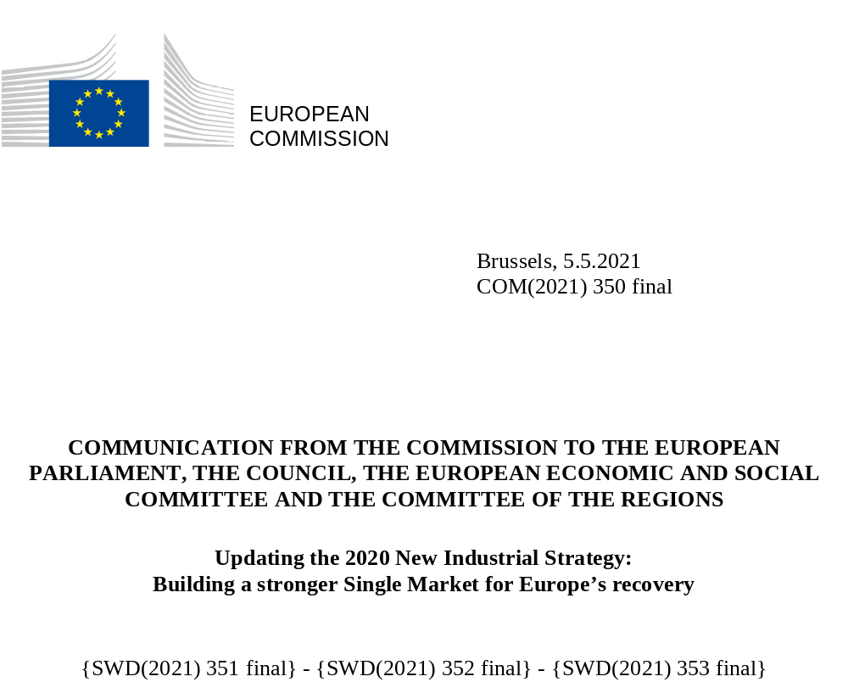

COMMUNICATION FROM THE COMMISSION TO THE EUROPEAN PARLIAMENT, THE COUNCIL, THE EUROPEAN ECONOMIC AND SOCIAL COMMITTEE AND THE COMMITTEE OF THE REGIONS
Updating the 2020 New Industrial Strategy:
Building a stronger Single Market for Europe’s recovery
- The need for an update: Emerging challenges, enduring priorities
On 10 March 2020, the European Commission presented ‘A New Industrial Strategy for Europe’. It laid out a plan for how the EU’s world-leading industry could lead the twin green and digital transitions, drawing on the strength of its traditions, its businesses and its people to enhance its competitiveness. It set in motion a new policy approach to deliver on this, focused on better connecting the needs and support provided to all players within each value chain or industrial ecosystem. To support this, it underlined the fundamentals of industry - innovation, competition and a strong and well-functioning single market - while strengthening our global competitiveness through open markets and a level playing field.
The day after the new industrial strategy was presented, the World Health Organization announced the COVID-19 as a pandemic. The lockdowns and economic slowdowns that ensued took their toll on the EU communities and economies, as well as its industries and companies. The Commission and others acted quickly to address the impacts on Europe’s businesses and to ensure the free flow of goods and movement of workers and services, notably through Green Lanes. Emergency measures on fiscal rules, state aid and short time work helped support the most affected sectors and workers and cushioned the impact for companies, including SMEs. The European Pillar of Social Rights has continued to be the EU and its Member States’ compass in cushioning the social impacts.
During this period, we witnessed the resilience, ingenuity and adaptability of the EU industry but we were also exposed to new vulnerabilities and older dependencies, as well as socio-economic and territorial inequalities that need to be addressed. The crisis revealed the interdependence of global value chains and the value of a globally integrated Single Market. It also illustrated the need for more speed in the transition towards a cleaner, more digital, and more resilient economic and industrial model, in order to maintain and enhance Europe’s drive towards sustainable competitiveness. This is why President von der Leyen announced in her State of the European Union address an update of the EU’s industrial strategy: to learn the lessons of the crisis, strengthen our economic resilience and accelerate the twin transition while preserving and creating jobs.
The starting point for this update is capturing the real impact of the last year on Europe’s economy and industry. A first analysis and needs assessment formed the basis for Europe’s recovery plan, NextGenerationEU, which – together with the Multi-annual Financial Framework 2021-2027 will provide unprecedented financial support to EU’s citizens and companies. Judged by any metric, the conclusions were stark: with a 6.3% contraction in the EU economy in 2020 accompanied by major turnover losses and a decline in jobs and investment.
A year on, there are some cautious signs of improvement and the EU economy is expected to strongly rebound in 2021 and 2022. Prospects for a quick recovery in world trade have also improved and making the most of these trading opportunities will be a key part of the recovery for companies across Europe. However, the continued fall in short-term private investment plans and the increasing number of strong firms facing significant liquidity issues point to the fact that the recovery will take time and continued support.
To best tailor that support, the Commission is building on the flexible ecosystem-based approach outlined in last year’s industry strategy. As part of the first Annual Single Market Report, fourteen industrial ecosystems have been identified at this stage and their different needs and challenges analysed. It shows that the impact of the crisis – and the prospects for recovery and renewed competitiveness - vary significantly. While tourism was hit hardest, and textile, mobility and cultural and creative companies face a slower and more uneven recovery, the digital ecosystem increased its turnover during the crisis. Smaller businesses also continue to be more vulnerable, with some 60% reporting a fall in turnover in the second half of 2020.
Women, youth and low-income workers were particularly affected by the crisis, partly due to the fact that they represent a large majority of employees in the sectors most affected. The Commission is paying a particular attention to equal rights and opportunities for an inclusive recovery across all sectors. Europe’s people are among its leading assets, and while addressing skills gaps and inequalities, the EU should build on all the strengths of its talented, well-educated and inventive workers and entrepreneurs as a force for innovation and competitiveness.
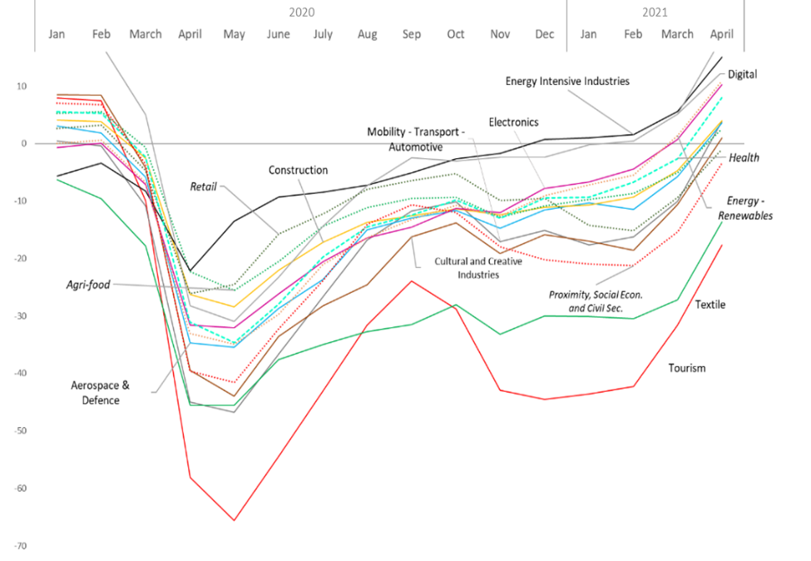 | Confidence Indicator by Ecosystem  Source: European Commission analysis based on the Joint Harmonised EU Programme of Business and Consumer Surveys.  Note: For “Retail”, “Agrifood”, “Proximity-Social Economy”, “Renewable Energies”, and “Health”, represented using dotted lines, data coverage is limited, so data have to be interpreted with caution.
Figure 1: Confidence indicator by ecosystem
This analysis and our experience during the crisis show that the principles, priorities and actions in Europe’s industrial strategy still hold. The need to strengthen Europe’s open strategic autonomy and the new partnership approach with industry and likeminded international partners are even more acute than a year ago. We must continue to focus on the fundamentals outlined a year ago and speed up implementation to enable industry to accelerate and lead the transitions.
This update neither replaces the 2020 Industrial Strategy nor completes the processes launched by it – much of that work is in progress, and requires dedicated efforts. This is a targeted update, which focuses on what more needs to be done and what lessons need to be learned. It assesses where our Single Market was tested and stretched and proposes measures to strengthen its resilience and functioning. It offers a tailored assessment of the needs of each industrial ecosystem and how all market players can best work together. And it identifies a set of strategic dependencies and capacities and proposes measures to address and reduce them. In doing so, this update answers calls from the European Council, the European Parliament, Member States and other stakeholders to analyse the impact of the crisis on our policies and offer solutions where necessary.
Three Staff Working Documents accompany the Communication. They reflect certain early deliverables of the 2020 Industrial Strategy and offer the analytical underpinning to address such requests:
- The first edition of the Annual Single Market Report sets out the impact of the crisis on the Single Market, reports on progress made on barriers and in delivering on actions identified in the 2020 Industrial Package; includes an analysis for all 14 industrial ecosystems; and presents a set of key performance indicators;
- An initial analysis of the EU’s strategic dependencies and capacities, with an in-depth review for a number of technological and industrial strategic areas;
- An illustrative analysis of one key industrial sector, focused on the challenges and opportunities for industry and the EU policy toolbox available Towards competitive and clean European steel in support of the twin transition.

- Learning the lessons and Accelerating the transitions
Europe has a lot to build on and a lot to learn from the testing time it continues to go through. Over the last year, we have seen the resilience of our Single Market and the best of industry. Drawing on the pool of excellence in life sciences, it has been at the forefront of global COVID-19 vaccine development and production, notably thanks to the EU Vaccine Strategy and the EU support to ramp up industrial capacity. We have seen companies switch production to help meet urgent needs, whether for personal protective equipment, hand sanitisers or vaccine production. Other companies made the shift to e-commerce overnight or used digital tools to find new suppliers or supply chains. Despite a significant fall in energy demand and impacts on critical energy operators, the internal energy market adjusted well, with no interruptions in energy supply.
However, this was not feasible for all. As lockdown forced many businesses to a halt, borders closed, supply chains were interrupted, demand was disrupted and workers and service providers found themselves unable to move across Europe. When lorries stopped at the internal borders, it quickly showed how integrated manufacturing and the economy are in Europe today. Blockages to the free flow of goods, services and people profoundly affected value chains and economic activity, undermined European solidarity and hampered a coordinated response to the crisis. Supplies were stuck at borders, air cargo prices soared because planes were grounded and imbalances in trade flows led to a shortage of maritime containers.
Important lessons can already be drawn:
First, the crisis highlighted the essential need to uphold the free movement of persons, goods, services, and capital in the Single Market and the need to work together to strengthen its resistance to disruptions. Border controls and closures and uncoordinated national or regional restrictions as well as containment measures restricting the free movement of persons, often subject to frequent adjustments exacerbated uncertainty and costs of compliance, causing serious delays and leading to major disruptions of supply chains in many industrial ecosystems. Green Lanes and other EU ad-hoc measures significantly alleviated the potential harmful impact of unilateral and uncoordinated national measures across the Single Market. The free movement of services was also affected strongly, including by forced temporary closures of non-essential businesses, travel restrictions, and a lack of clarity on applicable rules on movement across borders. This in turn led to difficulties for cross border workers and shortages of harvest workers, to name but a few examples. The Single Market in Europe relies on a highly mobile and available workforce.
Second, these situations triggered wider awareness of the need to analyse and address strategic dependencies, both technological and industrial. The EU and its trading partners gain resilience from world markets being open and integrated in global value chains, which help to absorb shocks and drive the recovery. The COVID-19 pandemic showed that disruptions in global value chains can affect specific essential products and inputs, such as medical supplies, that are particularly critical for society and the EU economy. One of the key lessons of the crisis is to get a better grasp of Europe’s current and possible future strategic dependencies. This will provide the basis for the development of facts-based, proportionate and targeted policy measures to address strategic dependencies while safeguarding the open, competitive and trade-based EU economy. The EU will continue to showcase its preference for international cooperation and dialogue, but also its readiness to combat unfair practices and foreign subsidies that undermine the level-playing field in the Single Market.

Finally, this unprecedented year showed that the business case for the green and digital transition is stronger than ever. In the medium-term, all business activity will need to become sustainable and the disruption of many traditional patterns caused by COVID-19 will shake up old habits and therefore will accelerate the green transition. Efforts to ensure secure and sufficient access to competitively priced clean energy throughout the single market will be central to ensuring that the EU bolsters its industrial strengths while making this transition. A skilled workforce is key in ensuring successful transitions, supporting the competitiveness of the European industry and quality job creation. Digitalisation has assumed a strategic role for the continuation of economic activities and has well and truly changed the way business is conducted. Economies, companies and their employees risk being left behind as the transition accelerates. Digital and green business models and technologies placed companies that had already embraced this transition at an advantage compared to those that had not and companies that drive the change will continue to enjoy a crucial first-mover advantage. The rising levels of consumer awareness of and demand for this transition is also an opportunity that needs to be leveraged.
The readiness for change is high. Competitive sustainability enabled by new, often digital technologies and services remain our goal. Businesses are the best placed to determine how to become competitive and leaders in their sector and at finding solutions to their challenges. Where necessary, our industrial policy should then benefit from agile forms of public-private partnership and new forms of cooperation between private and public sectors to accelerate the delivery of innovative solutions that would not be achieved otherwise. For an inclusive transition, a well-functioning social dialogue will be key.
Monitoring industrial trends and competitiveness
The Annual Single Market report defines a set of key performance indicators (KPI), based on publicly available data sources, to analyse economic developments and monitor the progress achieved, focussing on competitiveness, Single Market integration, SMEs, the twin transition, and economic resilience. The KPIs also provide a forward-looking view based on investment and a confidence indicator, and an overview of the performance of the EU economy, comparing it to international partners and analysing the specificity of industrial ecosystems. The analysis of these indicators, which will be performed regularly by the Commission, can help in taking a strategic stance on the EU economy, anticipate challenges, and inform policy and investment decisions.
Although the effect of the crisis will have long-lasting implications, the EU’s recovery has begun. For several industrial ecosystems, turnover has almost reached pre-COVID 19 levels, even if the dynamics remains slightly subdued. Positive signals also emerge from an analysis of economic sentiment, which in April 2021 shows improvements across all ecosystems (See Figure 1). However, it is essential to continue monitoring the recovery trajectory of all ecosystems. In fact, data show that although public interventions have been effective in limiting unemployment and bankruptcies, the risk of abrupt surges of layoffs and insolvencies is increased.
In full synergy with existing monitoring tools (e.g. Single Market Scoreboard), the Commission will monitor main indicators of the competitiveness of the EU economy as a whole, in particular:
- Single Market integration, based on indicators on intra-EU trade or price dispersion across Member States, to help assess policies fostering a favourable business and innovation environment.
- Productivity growth, based on labour productivity.
- International competitiveness, based on EU global market share or extra-EU trade, to support policies for open and fair access to export markets
- Public and private investment, based on data on net public and net private investment as % of GDP, to notably illustrate the potential transformation of the economy in line with the twin transition objectives.
- R&D investments, based on public and private R&D expenditure as % of GDP, to support innovation.

- Strengthening Single Market resilience

Making the Single Market better equipped for crises
The Single Market is the EU’s most important asset, offering certainty, scale and a global springboard for our companies, and wide availability of quality products for consumers. But this asset cannot be taken for granted. Particularly in the early days of the pandemic, businesses and citizens suffered from border closures, supply disruptions and a lack of predictability.
Despite the usefulness of existing Single Market tools, the crisis showed that they can be improved for emergency situations. As announced by President von der Leyen in February 2021, the Commission will propose a Single Market Emergency Instrument to provide a structural solution to ensure the availability and free movement of persons, goods and services in the context of possible future crises. This instrument should guarantee more information sharing, coordination and solidarity when Member States adopt crisis-related measures. It will help to mitigate the negative impacts on the Single Market, including by ensuring more effective governance. It should also build a mechanism through which Europe can address critical product shortages by speeding up product availability (e.g. standard setting and sharing, fast-track conformity assessment) and reinforcing public procurement cooperation. It will be aligned with relevant policy initiatives such as the forthcoming proposal to establish a European Health Emergency Preparedness and Response Authority (HERA), and the upcoming Contingency Plan for Transport and Mobility as well as relevant international practice aiming at addressing emergency situations or ensuring and speeding up the availability of essential products.
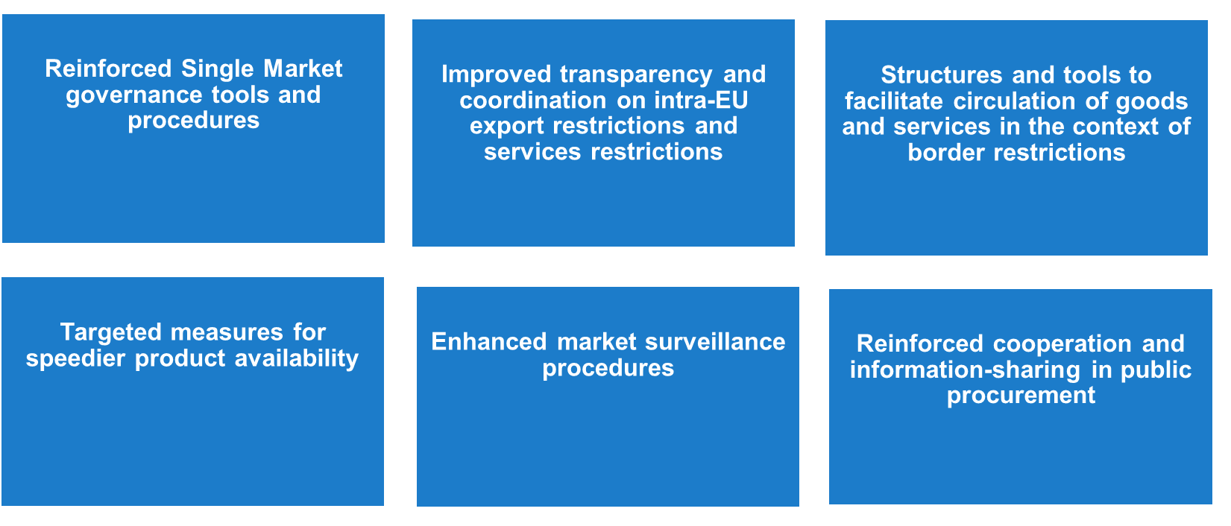
Figure 2 Key elements of the Single Market Emergency Instrument

A well-functioning Single Market to accelerate the recovery
The last year reaffirmed the need to bring down the persisting and significant barriers that hamper the good-functioning of the Single Market. The pursuit of a well-functioning Single Market calls for unrelenting efforts on numerous fronts:
- Permanent management of effective compliance with existing single market rules;
- Continuous investment in deepening integration in the fields which offer greatest opportunities;
- Adaptation of existing policy approaches where justified;
- New strategies where needed (e.g. to accompany the twin transitions).
While the Commission will carry out recurring assessments of the main barriers within each ecosystem as part of its Annual Single Market Report, the services sector deserves particular attention because of its size, the interplay with goods and its cross-ecosystems nature.
A new effort to address restrictions and barriers is under way notably through the Single Market Enforcement Task Force (SMET) and other relevant actions. Progress has been too slow over the past years in several key areas, in particular services. The full enforcement of the Services Directive will ensure that Member States comply with their existing obligations, including the notification obligation in order to identify and eliminate new potential regulatory barriers.
Business services such as engineering, architecture, IT and legal services, contribute up to 11% of EU GDP and are essential competitiveness factors for firms. Yet they are held back by restrictive national rules such as strict entry and exercise requirements. While European goods standards have delivered great benefits for companies and consumers, raising quality and safety, improving transparency, reducing costs and opening up markets for businesses, European service standards only account for roughly 2% of all standards. Service standards lay down technical requirements, e.g. levels of quality, performance, interoperability, environmental protection, protection of health or safety. They can increase consumer confidence and further integrate European service markets. They can help overcome barriers linked to multiple national certification requirements. The Commission will explore the merits of a legislative proposal for regulating key business services supported by harmonised standards, starting with an assessment of the most pertinent business service areas where harmonised standards could add value.
While EU legislation guarantees a set of mandatory rights and working conditions of employment to be applied to posted workers throughout the EU, feedback from stakeholders consistently highlights administrative difficulties with posting workers. Companies can find it cumbersome to send engineers or technical staff to businesses or end-users in another Member State, for instance in the construction sector. The Commission will continue working with Member States to ensure the Posting of Workers Enforcement Directive is properly transposed and implemented. Without compromising the legal framework and the workers’ protection it ensures, the Commission will work with Member States to devise a common form, in an electronic format, for the declaration of the posting of workers. This Single Digital Form could initially be introduced on a voluntary basis.
The crisis has also highlighted that effective market surveillance is key, with Member States’ authorities facing increased numbers of non-compliant and dangerous products. This was the case notably for some personal protective equipment and medical devices in high demand. Stepping up coordination, investment, resources and digitalisation of authorities –both within the Single Market and at the Union borders- is therefore a priority. The Commission will support and encourage market surveillance authorities to step up the digitalisation of product inspections and data collection and use of state-of-the-art technologies to trace non-compliant and dangerous products, as announced in the Single Market Enforcement Action Plan. Investing in the digitalisation of product safety and compliance information is also important to improve the traceability and control of traded products. Moreover, dedicated capacity building is needed to ensure effective and efficient checks.
As a primary vehicle of innovation in the various ecosystems, the SMEs need to be borne in mind in all actions under this Strategy. This is reflected in a horizontal manner by increased attention to regulatory burden under the Commission’s revised approach to Better Regulation: by introducing a ‘one in, one out’ approach adapted to the policymaking in the EU, it strengthens the attention of policymakers for the implications and costs of applying legislation, especially for SMEs.
In the SME Strategy, the Commission emphasised the need to enhance fairness in B2B relations to support SMEs which due to asymmetries in bargaining power with larger organisations face an increased risk of being subject to unfair business practices and conditions both online and offline. In particular, the crisis demonstrated the importance and necessity of e-Commerce. For the first time, the Digital Services Act proposes a common set of rules on intermediaries' obligations and accountability across the Single Market, which will open up opportunities for all business, including SMEs and ensure a high level of protection to all users. Similarly, the Digital Markets Act proposes harmonised rules defining and prohibiting certain practices by platforms acting as digital “gatekeepers” that could prevent or slow down valuable and innovative services from reaching the consumer, to ensure the proper functioning of the Single Market by promoting effective competition in digital markets and in particular a contestable and fair online platform environment. The Commission urges the co-legislators to accelerate work in view of swift adoption.
Late payment behaviour was compounded during the crisis, which puts additional burden on SMEs. The EU Observatory on late payments, which monitors unfair payment practices and analyses how late payments spread through the supply chain, will expand its current work on the construction ecosystem to others. To address unfair payment practices exacerbating payment delays and often leading to long disputes, the Commission will design and implement pilot Alternative Dispute Resolution schemes.
Financial pressure and insolvencies are likely to increase in 2021 as relief is phased-out. In particular, the risk of over-leverage and the need for recapitalisation can become pronounced for SMEs. A rise in bankruptcies could significantly impact entire supply chains. This requires coordination and design of measures that need to be proportionate to the challenges ahead. The Commission is determined to mobilise significant investment, and the SME window under InvestEU could trigger EUR 45 billion of investment in SMEs by the end of 2023.
To help address the solvency risk affecting SMEs, the Commission will facilitate an exchange of good practices on measures and incentives taken by several Member States to target support on viable companies. The Commission is working on dedicated capital support to SMEs through financial products of InvestEU, and invites Member States to contribute to EU-wide efforts. REACT-EU further provides targeted support to SMEs.
There are a number of possibilities for Member States to provide equity support under national support schemes to strengthen the solvency and growth of innovative SMEs and mid-caps in line with State aid rules, including the State aid Temporary Framework. For example, these include schemes to provide public guarantees on private investment funds based on the idea of the State providing a guarantee to crowd in private funding, rather than providing capital itself. Alternatively, Member States can decide to grant certain repayable instruments, which can later be converted into grants, depending on the recovery of the companies and their ability to repay.
The Commission will continue to make progress to deliver a single market for capital. For example, the Commission is accelerating work on the equity funding for SMEs, including expanding support for scale-up capital, strategic investments and for Initial Public Offerings (IPO). That work will trigger investments in green and digital technologies across all stages of an SME’s life, from start-ups to growth and expansion stage, and to exits to public markets. A new public private IPO Fund will support SMEs and midcaps through and beyond the listing process. The EIB group will publish calls for interested fund management teams in the second half of 2021.
Taxation also plays a critical role in ensuring fairness and growth: the upcoming Communication on “Business Taxation for the 21st century” will set out concrete plans to support both objectives, including concrete measures for SMEs.
EU competition policy has a key role to play in maintaining a level playing field and it is one of our biggest assets in ensuring a Single Market that supports companies to innovate and grow. Preserving competition in the Single Market contributes to the resilience and competitiveness of our companies on the global markets. The Commission will also continue to monitor the application of the State aid Temporary Framework (extended until end-2021) and the implementation of COVID-19 related State aid measures, with a review to progressively phasing out crisis support measures when the situation allows, while avoiding cliff-edge effects.
KEY ACTIONS | TIMING
Single Market Emergency Instrument | Q1 2022
Annual Single Market Report | Annual
Possible common form/template for the declaration of the posting of workers | Q1 2022
Strengthen Single Market surveillance of EU and imported products | Q4 2022
Under InvestEU, work on capital support and equity financing to support SMEs | ongoing
- Dealing with dependencies: open strategic autonomy in practice
Openness to trade and investment is a strength and source of growth and resilience for the EU, as a major importer and exporter. Nevertheless, COVID-19 impacted negatively global supply chains and led to shortages in Europe. As the 2020 Industrial Strategy underlined, the EU needs to improve its open strategic autonomy in key areas.
The crisis further emphasised the need to strengthen the EU’s ability to confront a crisis and act as necessary. The disruptions along the supply chain of the health ecosystem were particularly challenging, resulting from a combination of surging demand as well as supply and workforce shortages, despite the EU’s proactive response to ensure (global) transport routes and supply chains remain as open and secure as possible. More recent challenges, such as the semiconductors shortage faced by the automotive industry, highlight that Europe faces also other specific dependencies. The pandemic accelerated this awareness and pushed countries such as the United States to review their positions in global value chains.
The EU also has important strengths and capacities. While the EU faces certain dependencies, other countries also depend on the EU (“reverse dependencies”). Mutual dependencies may be an element of stability in global value chains. The EU also shares foreign dependencies with our partners (“common dependencies”). These provide opportunities for building up cooperation with likeminded partners to find mutually beneficial solutions.
Mapping our strategic dependencies and capacities
Some disruptions caught Europe by surprise, showing the need for a better grasp of where its strategic dependencies lie, how they may develop in the future and the extent to which they would lead to vulnerabilities for the EU. Such strategic dependencies affect the EU’s core interests, notably as regards health, security and safety and accessing key inputs and technologies necessary for the green and digital transitions.
In response to the European Council request, the Commission has carried out a “bottom-up analysis” based on trade data that provides first insights on the scope of the issues at stake. Out of 5,200 products imported into the EU, the analysis identifies 137 products (representing 6% of the EU’s total import value of goods) in sensitive ecosystems for which the EU is highly dependent – mainly in the energy intensive industries (such as raw materials) and health ecosystems (such as active pharmaceutical ingredients) as well as concerning other products relevant to support the green and digital transformation.
About half of imports for these dependent products originate in China, followed by Vietnam and Brazil. However, 34 products (representing 0,6% of the EU’s total import value of goods) are potentially more vulnerable given their possibly low potential for further diversification and substitution with EU production. About 20 of these products are raw materials and chemicals belonging to the energy intensive industries ecosystem, with the majority of the remaining products belonging to the health ecosystem (such as active pharmaceutical ingredients and other health related products). The analysis also shows challenges and dependencies in the area of advanced technologies such as for cloud and microelectronics, predominantly linked to the global market structure.
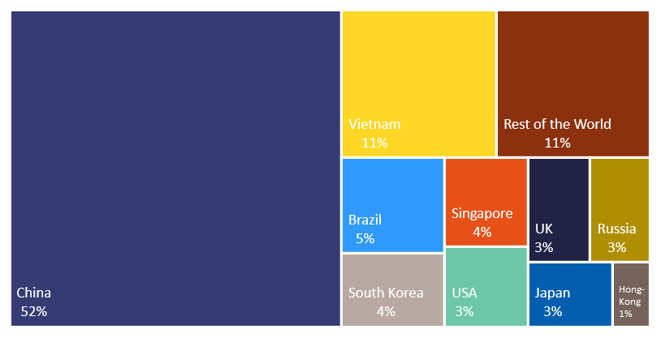
Share of EU import value by origin of the identified 137 products where the EU is dependent in sensitive ecosystems
Source: European Commission based on BACI database
The analysis also highlights the issue of possible internal dependencies within the Single Market, linked to a concentration of activities at the level of individual firms. In such instances, EU competition policy and enforcement can play a major role in addressing possible risks related to such internal dependencies, by ensuring that markets remain open and contestable.
The Staff Working Document accompanying this update presents six in-depth reviews of strategic areas, i.e. on raw materials, batteries, active pharmaceutical ingredients, hydrogen, semiconductors and cloud and edge technologies, providing further insights on the origin of strategic dependencies and their impact. The Commission will engage with Member States, industry and social partners, including with the support from the Industrial Forum or through the Structured Dialogue on the security of medicines supply and the pharmaceutical strategy, to deepen this analysis and further address the identified strategic dependencies.
The Commission will launch a second stage of in-depth reviews of potential dependencies in key areas, including products, services or technologies key to the twin transition, such as renewables, energy storage and cybersecurity. In addition, a monitoring system through the Commission’s Observatory of Critical Technologies and a periodic review process will cover both current dependencies and risks of future (technological) dependencies.
Building a toolbox to reduce and prevent strategic dependencies
In most cases, industry itself is best placed – through its corporate policies and decisions – to improve resilience and reduce any dependencies that may lead to vulnerabilities, including through diversification of suppliers, increased use of secondary raw materials and substitution with other input materials. There are however situations where concentration of production or sourcing in only one single geographical area results in the unavailability of alternative suppliers.
In areas of strategic importance, the Commission is identifying public policy measures that can support industry’s efforts to address these dependencies and to develop strategic capacity needs: diversifying supply and demand relying on different trading partners whenever possible, but also stockpiling and acting autonomously whenever necessary. Such measures should generally be based on a mix of actions, targeted and proportionate to ecosystems’ needs and identified risks. The Commission will work in close cooperation with the relevant stakeholders to identify measures to reinforce the EU position in global value chains, including by strengthening and diversifying external trade, creating new opportunities also for low- and middle-income countries. A more circular economy and improved resource efficiency also contribute to reducing dependencies and strengthening resilience. In addition, these measures should enable the EU to strengthen its own capacity, building on the strengths of a fully functioning Single Market with open and competitive markets. It will leverage its privileged relations with its closest neighbours - in particular the ones already engaged in regulatory convergence with the EU.
The Commission will, as outlined in its Trade Policy Review, work towards diversifying international supply chains and pursue international partnerships to increase preparedness.
In the areas of common dependencies with its partners, the EU may choose to pool resources and build stronger and more diverse alternative supply chains with our closest allies and partners. The transatlantic relationship and the enlargement and neighbourhood policy are cornerstones of such efforts as are Free Trade Agreements with other partners and trade blocs. On the former, the proposed EU-US Trade and Technology Council could provide a platform for cooperation.
The Commission will also examine further reverse dependencies and map areas where other countries depend on the EU. Deeper understanding of such interdependencies can better inform the EU’s policy response.
The Commission will continue to support industrial alliances, in strategic areas where such alliances are identified as the best tool to accelerate activities that would not develop otherwise, and where they help to attract private investors to discuss new business partnerships and models in a manner that is open, transparent and fully compliant with competition rules, and where they have a potential for innovation and high-value job creation. The Commission will pay particular attention to the inclusiveness of alliances, for start-ups and SMEs. Such alliances should complement public-private partnerships and provide a broad and open platform to establish strategic roadmaps and efficient coordination of research, development and innovation investment plans for technologies in particular ecosystems. In three of the six areas in which the Commission presents in-depth reviews with this Communication, the Commission has already launched industrial alliances: on raw materials, batteries and hydrogen.
Building on this positive experience, the Commission is preparing the launch of the two alliances that had already been announced in the New Industrial Strategy and in the Digital Decade Communication in the digital field: the Alliance on processors and semiconductor technologies and the Alliance for Industrial Data, Edge and Cloud. Bringing together a wide range of stakeholders, these alliances will help achieve key EU policy objectives in microelectronics and strengthen Europe’s industrial position in the global cloud and edge computing market, notably addressing the trend towards increasing distribution and decentralisation of data processing capacities and the need to enable federated and vendor-agnostic cloud ecosystem.
The Commission is also considering the preparation of: i/ an Alliance on Space Launchers to bring together all players, big and small, to work towards a globally competitive, cost-effective and autonomous EU access to space; and ii/ an Alliance on Zero Emission Aviation to ensure market readiness for disruptive aircraft configurations (e.g. hydrogen, electric), leveraging the existing investments under the Clean Sky initiative and contributing to Europe’s 2050 climate neutrality objective, working in full complementarity with the Renewable and Low-Carbon Fuels Alliance currently under consideration.
The Commission will continue to support Member States’ efforts to pool public resources via Important Projects of Common European Interest (IPCEIs) in areas where the market alone cannot deliver breakthrough innovation, as has been the case in the areas of batteries and microelectronics. Member States and companies have jointly expressed interest to engage in additional IPCEIs, such as next-generation cloud, hydrogen, low-carbon industry, pharmaceuticals and a second IPCEI on cutting-edge semi-conductors. The Commission will examine these project plans attentively and, where the criteria are met, will accompany them as they reach maturity. In appropriate cases, such as in the case of batteries, industrial alliances can help to prepare such IPCEIs.
The EU budget can also support investments in areas of strategic importance. For instance, the national recovery and resilience plans can include contributions to the Member State compartments under the InvestEU Programme and Member States could use parts of their national allocations to invest in such sectors.
Strategic dependencies can have a particular impact on SMEs, ranging from higher switching costs to a lack of vibrant start-up communities and innovative smaller providers. In 2021, with a combined budget of EUR 61 million under the Single Market Programme the European Cluster Collaboration Platform and Enterprise Europe Network will take reinforced actions to assist SMEs to address disruptions and vulnerabilities or diversify by connecting them to new local and cross-border partners, thereby increasing SME resilience. Digital solutions, such as industrial manufacturing data spaces, would also lead to more flexible supply chains.
Global leadership in technologies goes hand-in-hand with leadership in standard-setting and ensuring interoperability. Global convergence on the same international standards helps reduce adaptation costs and strengthens EU and global value chains. For the EU to retain its influence in setting global standards, its own standardisation system, a core of the Single Market, has to function in an agile and efficient way. Be it on hydrogen, batteries, offshore wind, safe chemicals, cybersecurity or space data, our industry needs European and international standards that underpin its twin transition in a timely manner. Establishing global leadership in these key priority standards is also a critical matter for the competitiveness and resilience of EU industries.
The Commission will present a strategy on standardisation. This will support a more assertive stance on European interests in standardisation (in the EU and globally)and in working openly with others on certain areas of mutual interests (e.g. US and Canada on lawful and ethical use of AI). In this context, the Commission will assess whether amendments to the Standardisation Regulation are required to achieve these objectives. A Joint Task Force between the Commission and European Standardisation Organisation (ESOs) will define agreed solutions to adopt in a fast manner those standards identified as crucial. The Commission will also pay particular attention to anticipating standardisation needs that support the twin transition of industrial ecosystems.
European companies need to benefit from a level playing field globally and in the Single Market. EU competition and trade policies have to remain assertive against unfair and coercive practices, while favouring international cooperation to solve global common problems. In conjunction with the present Communication, the Commission is proposing a legal instrument to address the potentially distortive effects of foreign subsidies in the Single Market. It will make sure that potentially distortive subsidies granted by foreign governments to undertakings wishing to acquire an EU company or bid in public procurement do no longer go unchecked. The Commission will continue to address with our trading partners distortive industrial subsidies.
Public spending through procurement amounts to 14% of EU GDP each year. The European public procurement framework can help strengthen companies’ competitiveness, including through the use of strategic criteria notably for green, social and innovation procurement, while ensuring transparency and competition. It is also important to increase innovation procurement of digital solutions and in R&D procurement. In addition, the Commission will develop guidance on how to use public procurement effectively to strengthen the resilience of key ecosystems, using a toolbox to help public buyers identify and address strategic supply risks and dependencies and diversify the supplier base.
KEY ACTIONS | TIMING
Adopt proposal to address the potentially distortive effects of foreign subsidies in the Single Market | May 2021
Periodic review of strategic dependencies and monitoring of risks associated with strategic dependencies | Starting in 2021
Explore international partnerships and cooperation to address strategic dependencies | Starting in 2021
Launch of alliances on processors and semiconductor technologies, on industrial data, edge and cloud | Q2 2021
Reinforced action on SME supply chain disruptions and vulnerabilities | Q4 2021
Adopt a standardisation strategy | Q3 2021
Guidance on identifying and addressing strategic dependencies through public procurement | Q1 2022
- Accelerating the twin transitions
The 2020 Industrial Strategy included a list of actions to support the green and digital transitions of EU industry, many of which are already implemented, but the pandemic has drastically affected the speed and scale of this transformation. It is now clearer than ever that companies pursuing sustainability and digitalisation are more likely to succeed than others. This is why the digital transformation of businesses is one of the four cardinal points of the Digital Compass.

Co-creating transition pathways across relevant industrial ecosystems
The Annual Single Market Report 2021 presents a first analysis of the challenges faced by 14 industrial ecosystems as they have been identified so far, but also of the transformative initiatives already undertaken to achieve the twin transition and increase resilience. As an illustrative example, the Staff Working Document on clean and competitive European steel looks in detail at what the green and digital transition means for this particular sector and explains how EU policy measures support the industry in leading the transition.
These analyses can serve to co-create, in partnership with industry, public authorities, social partners and other stakeholders, transition pathways for ecosystems, where needed. Such pathways will offer a better bottom-up understanding of the scale, cost, long term benefits and conditions of the required action to accompany the twin transition for the most relevant ecosystems, leading to an actionable plan in favour of sustainable competitiveness. Such plan should take into account relevant inputs such as industrial technology roadmaps announced in the Communication on the European Research Area and those developed under the Action Plan on Synergies between civil, defence and space industries.
Priority should be given to the ecosystems and sectors that face the most important challenges meeting climate and sustainability goals and embracing the digital transformation, and whose competitiveness depends on this, such as energy-intensive industries (including the chemical and steel sectors), and construction, as well as to sectors heavily affected by the crisis, which benefit from accelerating their twin transition in order to boost their recovery (such as tourism and mobility).

Supporting the business case for the green and digital transitions
EU industry has embraced the challenges and opportunities that the twin transition brings. It is ready to invest, but asks for predictability and a real business case, with a coherent and stable regulatory framework access to capacities and infrastructure, finance for innovation and deployment, raw materials and decarbonised energy, demand-side measures for climate neutral and circular products and the right skills. These are necessary for a competitive transition.
The EU’s immediate opportunity to support such business cases lies in its recovery efforts. The EU Budget and NextGenerationEU, and notably the Recovery and Resilience Facility, should be used as a springboard to speed up the recovery in Europe and reinforce the commitment to the green and digital transition. Based on their relevance across Member States, the very large investments required, and their potential to create jobs and growth and reap the benefits from the green and digital transitions, the Commission has strongly encouraged Member States to include in the national Recovery and Resilience Plans investment and reforms in a limited number of flagship areas. The Commission is now carefully assessing the national plans and will monitor their implementation to ensure in particular that at least 37% of funding is dedicated to green investments and at least 20% is dedicated to digitalisation. Many national recovery and resilience plans will channel funding to green and digital SME investments. The 2021-2027 Cohesion policy funds will have a strong focus on the twin transition, contributing to the green and digital transformation of the EU’s economy.
The Recovery and Resilience Plans offer an unprecedented opportunity to join forces in multi-country projects to build digital and green critical capacities. A number of Member States have signalled their intention to include in their draft national plans multi-country projects. These projects could accelerate much-needed investment in the field of hydrogen, 5G corridors, common data infrastructure and services, sustainable transport, blockchain or European Digital Innovation Hubs. The Commission is assessing options for an effective mechanism to accelerate the implementation of such multi-country projects, enabling notably possible combination of Member States and EU financing.
The enforcement of competition rules, in particular State aid rules, will ensure that public funds for the recovery do not replace but trigger additional private investments. The Commission is also conducting an extensive review of the EU competition rules to make sure that they are fit to support the green and digital transition to the benefit of Europeans, at a time when the global competitive landscape is also fundamentally changing. The revision of the environmental and energy State aid rules will better enable Member States to support business to de-carbonise their production processes and adopt greener technologies.in the context of the Green Deal and the New Industrial Strategy. State aid rules on IPCEIs help catalyse cross-border investment in ground-breaking innovations, where the market alone would not take the risk, and only where the positive effects of addressing a clear market failure outweighs the risk of market distortion in the Single Market. Whilst the recent evaluation of the current IPCEI Communication showed that the provisions work well, some targeted adjustments would be necessary, including to further enhance their openness and facilitate participation of SMEs and to provide guidance on the criteria to pool funds from national budgets and EU programmes. The new Regional State aid Guidelines will enable Member States to support the least favoured regions in catching up and reducing disparities, as well as regions facing transition or structural challenges, while ensuring a level playing field between Member States.
In its evaluation of the State aid Broadband Guidelines, the Commission is assessing whether those rules are fit-for-purpose and in line with recent technological and market developments, so that they can fully support the EU’s ambitions in respect of the deployment of broadband infrastructure in line with the policy objectives as set out inter alia in the Gigabit Society and the Digital Decade communications. Further, the on-going review of the antitrust rules applicable to horizontal agreements between companies will cover, amongst others, issues that are key to the green and digital transition, such as research and development agreements, and provide guidance on so-called “sustainability agreements” and procompetitive data-sharing and data-pooling agreements. Similarly, the ongoing review of the Vertical Block Exemption Regulation and the Vertical Guidelines aims at bringing the applicable rules closer to new market realities with growing e-commerce and online sales in particular and provide up to date guidance to businesses on these matters. The Notice on market definition is also under review, taking into account developments such as digitalisation and globalisation. With the Trade Policy Review, the Commission has set out a plan for trade policy to play its full role in the twin transition. As part of its focus on implementation of trade and investment agreements, the EU will use all in-built flexibilities in its existing trade agreements so that they are fit for purpose and respond to the new challenges relating to the green and digital transition.
To support the financing of a green recovery, the Commission is preparing its Renewed Sustainable Finance Strategy and a legislative initiative on sustainable corporate governance providing for due diligence by companies. In addition, the support to green investments will be paired with the development of new standards for green finance.
Before the summer break 2021, the Commission will come forward with the ‘fit-for-55’ package, presenting a coherent revision of the key instruments of the 2030 climate and energy package, in view of achieving a climate-neutral Europe by 2050. The Commission will present a Carbon Border Adjustment Mechanism for selected sectors, to better address the risk of carbon leakage, in full compliance with WTO rules. Existing tools to address the risks of carbon leakage of globally exposed energy-intensive industries should continue to be used until fully effective alternative arrangements are in place. Given the diversity of approaches to carbon pricing worldwide, the Commission will continue to reach out to the EU’s international partners to find grounds for cooperation in this area.
The Horizon Europe Programme, with all its tools - partnerships, the European Innovation Council and the Institute of Innovation and Technology - will support next generation pan-European innovation ecosystem for green and digital transition. The Innovation Fund will continue providing critical support for the commercial demonstration of innovative low-carbon technologies in multiple sectors. As part of the proposal for a revised ETS Directive, the Commission is considering proposing a European approach to carbon contracts for difference, using ETS revenues and complementing other forms of support under the Innovation Fund.
Current investments into renewable energy sources, energy storage, grids, interconnections and industrial transformation in the EU are too slow. For the green transition to bring genuinely sustainable competitiveness, industry needs access to abundant, affordable and decarbonised electricity, and additional efforts are required in this regard. The Commission will work with Member States to increase their ambition on renewable energies and streamline permit procedures. The Energy and Industry Geography Lab, a tool under development by the Commission’s Joint Research Centre in collaboration with industrial stakeholders, will provide geospatial information for companies and energy infrastructure planners. Industrial consumers, SMEs and communities can also work together for long-term price security to renewable power projects and improved environmental footprint. The Commission will consider measures, as part of the revised Renewable Energy Directive in June 2021, to support the uptake of corporate renewable Power Purchase Agreements, and remove any unjustified barriers.
The market expansion and global growth in demand for wind turbines, solar PV panels, and smart energy technologies is a key opportunity, as greater scale should bring lower energy costs for industry as well as society at large. The Commission welcomes efforts to scale up manufacturing of these technologies in the EU, such as the industry-led European Solar Initiative. The Commission is also working on ecodesign measures for solar panels, including possible requirements on carbon footprint.
The European Raw Materials Alliance (ERMA) is establishing a project pipeline for both the rare earths and magnets value chains and on energy storage and conversion materials. If all the projects identified by the ERMA were to be implemented, these could allow as much as 60% of the EU annually installed wind energy capacity to rely on rare earths magnets made in the EU by 2030 and for EU supply to cover 20% of projected nickel demand by 2030.
Continued efforts towards sustainable product design, a circular economy and increased collection and recycling of raw materials, as well as a functioning market for secondary raw materials, will be key. The Commission’s proposal for a Batteries Regulation provides an innovative regulatory framework for batteries covering their entire lifecycle.
SMEs can profit from the green transition but need advice and financial support to make the most out of it. The Enterprise Europe Network is already putting in place Sustainability Advisors to provide dedicated advice to SMEs and these will be fully in place as of 2022. They will promote both SME innovation in decarbonised electricity generation, including the use of solar panels and on energy efficiency. Digitalisation is also essential for SMEs so all relevant platforms will act together to support SMEs in their ecosystems in e.g. adopting data-driven business models, and solutions against cyber threats. By 2023, the Digital Europe Programme will inject EUR 310 million into the European Digital Innovation Hubs that will offer SMEs local support in digital transformation and access to technology testing. In 2021, the European Innovation Council will also channel EUR 1.1 billion in grants and equity funding, mostly to start-ups and innovative SMEs.
The Commission will work to reinforce the synergies between the sustainable and digital transitions. Digital solutions, such as digital twins in advanced manufacturing, can help optimise processes in all ecosystems. The industry-led European Green Digital Coalition will measure the impact and speed up the deployment of digital solutions to green key sectors. To deliver on the commitments made in the Digital Compass, the Commission is going to identify additional measures to reach the carbon neutrality target of ICT technologies and to increase the uptake of digital technologies to lower the environmental footprint of other ecosystems.
The green and digital transitions cannot be realised without more and fair data sharing, in particular to optimise sustainability, and to develop innovative products and services. To help unleash the potential of data by companies and the public sector, the Commission will propose a Data Act in 2021 and will continue to support the establishment of sectoral ‘Common European data spaces’, in full compliance with fundamental rights, via the upcoming Digital Europe Programme. At international level, the EU is engaging in the WTO Joint Statement initiative negotiations on e-commerce to shape the global rules on digital trade. To promote the development of safe and trustworthy Artificial Intelligence, the Commission presented a proposal for a regulatory framework on AI and a revised coordinated plan on AI on 21 April 2021.
Investment in skills is an important component of investing in people, and will be essential to support the twin transition and to contribute to a fair recovery. The European Skills Agenda supports the green and digital transitions with initiatives like the Pact for Skills. It helps mobilise the private sector and other stakeholders to upskill and reskill Europe’s workforce. The Pact supports large-scale skills partnerships per ecosystem, some of which already put forward skilling commitments (automotive, microelectronics, and aerospace and defence industries). The Skills Roundtables, organised by the Commission with relevant stakeholders from each ecosystem, will have covered all ecosystems by mid-2021, and will contribute to the design and implementation of the pathways. The EU budget for 2021-2027 includes a number of instruments that can support upskilling and reskilling. The national recovery and resilience plans can also contribute, as well as effective active support to employment.
KEY ACTIONS | TIMING
Co-creation of green and digital transition pathways for relevant ecosystems, starting with tourism and energy intensive industries | As of Q2 2021
Actions to promote renewable Power Purchase Agreements in the proposal for a revised Renewable Energy Directive | Q2 2021
Consider European approach for carbon contracts for difference in the proposal for a revised ETS Directive | Q2 2021
Energy and Industry Geography Lab | As of Q4 2021

- Conclusion: coming back stronger in partnership
The new Industrial Strategy 2020 strategy laid the foundations for an industrial policy that would support the twin transitions, make EU industry more competitive globally and enhance Europe’s strategic autonomy. It set out a new industrial way for Europe, fit for the ambitions of today and the realities of tomorrow. It is still work in progress, building on Europe’s assets as the home of industry – our diversity and the talent of our people, our innovators and creators, our values and social market traditions. This new industrial strategy is entrepreneurial in spirit and action, and as valid as ever.
The EU, its Member States and industry are now drawing the lessons from the crisis and are ready to put Europe’s industry on a new sustainably competitive footing. This means implementing and building on the measures announced on industry, SMEs and the Single Market in the March 2020 Industrial package. It also means securing Europe’s central asset, its Single Market, ensuring open strategic autonomy and accelerating the green and digital transitions across the EU territory. Legislation, co-creation, investment, partnerships and international cooperation all have a role to play. This update to the Industrial Policy Package will help achieve those goals.
To be effective, these efforts must be supported by strong partnerships between the EU, Member States, social partners, industrial and other relevant stakeholders, between and within industrial ecosystems, building on the EU’s open and inclusive Industrial Forum. For the most relevant ecosystems and together with other relevant stakeholders, the Forum will support the development of transition pathways and the analysis of strategic dependencies. It will promote best practices and solutions across ecosystems and identify cross-border and cross-ecosystem investment needs and cooperation opportunities.
The Commission will continue promoting political ownership of the industrial strategy, continuing regular dialogues with the European Parliament and the Council.
The EU will seek international cooperation wherever possible to build a strong global economy, based on EU principles including a level playing field, leadership on standard setting and other regulatory priorities, and strengthening the resilience of global supply chains.

COM(2020) 102 final, https://ec.europa.eu/info/sites/info/files/communication-eu-industrial-strategy-march-2020_en.pdf. ‘The 2020 Industrial Policy package’ includes also a dedicated Strategy for small and medium-sized enterprises (SMEs; COM(2020) 103 final) and Specific actions to address barriers to a well-functioning the Single Market and improve enforcement of commonly agreed rules, COM(2020) 93 final and COM(2020) 94 final.
SWD(2021) 351, Annual Single Market Report 2021 identifies the following 14 industrial ecosystems: 1. Aerospace & Defence, 2. Agri-food, 3. Construction, 4. Cultural and Creative Industries, 5. Digital, 6. Electronics, 7. Energy Intensive Industries, 8. Energy-Renewables, 9. Health, 10. Mobility-Transport-Automotive, 11. Proximity, Social Economy and Civil Security, 12. Retail, 13. Textiles, 14. Tourism. Further ecosystems may be identified and their delineation adapted based on stakeholders dialogues and changing realities.
Activation of the General Escape Clause under the Stability and Growth Pace, Temporary framework for State aid measures supporting the economy during the Covid-19 pandemic, European instrument for temporary support to mitigate unemployment risks in an emergency (SURE), or the Coronavirus Response Investment Initiative.
COM(2020) 456 final.
SWD(2021) 351, Annual Single Market Report 2021.
SWD(2021) 351, Annual Single Market Report 2021.
European Commission/European Central Bank (November 2020), “Survey on the access to finance of enterprises (SAFE)”.
Conclusions of the European Council, 1 and 2 October 2020, EUCO 13/20.
European Parliament resolution of 25 November 2020 on a New Industrial Strategy for Europe, 2020/2076(INI).
Competitiveness Council Conclusions, 11 September 2020, 16 November 2020.
SWD(2021) 351, Annual Single Market Report 2021.
As a response to the European Council request of 2 October 2020 to identify strategic dependencies, particularly in the most sensitive industrial ecosystems and to propose measures to reduce these dependencies.
SWD(2020) 104, Energy security: good practices to address pandemic risks.
Commission and Council recommendations on common coordinated approach as regard travel restrictions.
OECD analytical work has confirmed that global value chains not only maximize economic efficiency, but that resilient, supply chains are essential in times of crisis to absorb shocks, to offer options to adjust and to speed up recovery. Cf. Shocks, risks and global value chains: insights from the OECD METRO model, June 2020.
https://ec.europa.eu/commission/presscorner/detail/en/speech_21_745.
See SWD(2020) 54 final and SWD(2021) 351, Annual Single Market Report 2021.
It represents 70% of the EU’s GDP and an equivalent share of employment.
SMET is the high-level forum where the Commission and Member States collaboratively seek solutions for addressing Single Market obstacles rooted in enforcement or implementation deficiencies. In this first year, it played an important role in assessing Member States’ measures on borders and measures on travel restrictions that restrict the free movement within the EU.
SWD(2021) 351, Annual Single Market Report 2021, Annex I.
SWD(2021) 351, Annual Single Market Report 2021 and COM(2020) 93.
A thorough analysis to the potential of harmonised standards to facilitate cross-border activities, market potential and opening and overall economic benefit, including for SMEs and women entrepreneurs, would be carried out to identify priority areas. Impacts on working conditions and workers’ rights will be subject to thorough considerations.
COM(2019) 426 final.
Regulation (EU) 2019/1020 of the European Parliament and of the Council of 20 June 2019 on market surveillance and compliance of products and amending Directive 2004/42/EC and Regulations (EC) No 765/2008 and (EU) No 305/2011.
COM(2021) 219 Better Regulation: Joining forces to make better laws, https://ec.europa.eu/info/sites/default/files/better_regulation_joining_forces_to_make_better_laws_en_0.pdf
One of the root causes of payment delays.
According to the Observatory, the EU construction ecosystem has the longest disputes duration in the world (average 20 months to solve a dispute).
Estimates suggest that 11.4% of all companies are likely to exit as support dries up if they fail to get access to fresh sources of credit. SWD(2021) 351, Annual Single Market Report 2021.
That, in accordance with Article 3(1)(g) of the InvestEU Regulation, were negatively affected by the COVID-19 crisis and were not already in difficulty in State aid terms at the end of 2019.
“A Public-Private Fund to Support the EU IPO Market for SMEs” – European Commission’s study available at: https://ec.europa.eu/info/evaluation-reports-economic-and-financial-affairs-policies-and-spending-activities_en suggests a public-private IPO fund with a public investment of about 740 million EUR could increase IPOs of SMEs and midcaps in Europe by 10%.
A long-term and cross-cutting perspective on strengthening Europe’s open strategic autonomy will also be provided by the Commission’s 2021 Strategic Foresight Report.
“Executive Order on America’s Supply Chains”
The Pharmaceutical Strategy for Europe provides for actions to address these issues as regards the supply of medicines (COM/2020/761)
The Commission will release an additional detailed analysis on critical supply chains for the energy sector by summer 2021. This analysis highlights that critical raw and processed materials are essential to ensure energy security and the success of the clean energy transition.
SWD on Strategic dependencies and capacities, SWD(2021) 352.
https://ec.europa.eu/health/human-use/strategy/dialogue_medicines-supply_en.
COM(2021) 70, Action Plan on synergies between civil, defence and space industries.
COM(2021) 66.
E.g. an analysis of sensitive ecosystems identifies about 20 products imported from China on which both the EU and the US are highly dependent (including in the health, energy intensive industries, renewables and digital/electronics ecosystems). The same holds true for other close EU trading partners.
Including the Strategic Research and Innovation Agendas of Horizon Europe partnerships supported by industry and Member States, which build the basis for ERA Industrial technology roadmaps (COM(2020) 628), page 10. There are 49 proposed public private partnerships in the Horizon Europe Programme and nearly EUR 25 billion of EU contribution, aiming at mobilising at least the same amount from private partners and Member States.
COM(2020) 789 Sustainable and Smart Mobility Strategy
https://ec.europa.eu/commission/presscorner/detail/en/IP_21_226.
https://ec.europa.eu/commission/presscorner/detail/et/ip_18_6862.
The level of underinvestment in innovation procurement in Europe compared to its major trading partners is the largest in digital solutions and in R&D procurement (respectively a factor 3 and factor 5 underinvestment). https://digital-strategy.ec.europa.eu/en/news/final-report-available-benchmarking-innovation-procurement-investments-and-policy-frameworks-across
SWD(2021) 351, Annual Single Market Report 2021, section 3 and Annex II.
COM(2021) 118 final.
SWD(2021) 351, Annual Single Market Report 2021, Annex III.
SWD(2021) 353, Toward Competitive and Clean European Steel.
COM(2020) 628 final, A new ERA for Research and Innovation.
COM(2021) 70 final, Action Plan on synergies between civil, defence and space industries.
Synergies should be developed between the transition pathways and the indicative voluntary roadmaps, as envisaged under the European Climate Law Regulation.
Taking into account the Sustainable and Smart Mobility Strategy (COM(2020) 789 final).
Annual Sustainable Growth Strategy 2021, COM (2020) 575 final. The flagships are titled: Power Up; Renovate; Recharge & refuel; Connect; Modernise; Scale-up; Reskill & upskill.
As announced in the Communication “2030 Digital Compass”, COM (2021) 118 final.
Covering clean steel, process industries, hydrogen, batteries, zero-emission road transport, clean aviation, zero emission waterborne transport, sustainable built environment and advanced manufacturing, among others.
SWD(2020) 176 final, Impact Assessment accompanying the 2030 Climate Target Plan (table 12); Agora-Energiewende & EMBER (2021): The European Power Sector in 2020. The latest National Energy and Climate Plans indicate a 72 TWh/year increase of wind and solar power generation between 2020 and 2030, but 93-100 TWh/year would be required to achieve the 55% climate goal.
See chapter 5.1 of SWD(2021) 352, Strategic Dependencies and Capacities for the underlying calculations.
European Digital Innovation Hub (EDIH) network, ECCP, EEN, and Startup Europe.
COM(2021) 118 final, 2030 Digital Compass: the European way for the Digital Decade.
Such as the European Social Fund, Erasmus or the Digital Europe Programme.
Commission Recommendation for Effective Active Support to Employment (C(2021) 1372 final).

