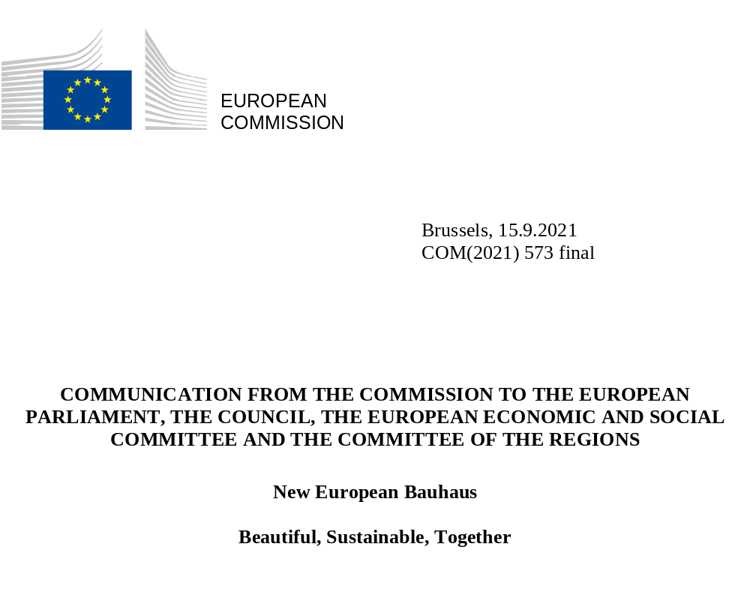

Table of Contents
1. Introduction 2
2. Building on co-design: A transformational project by all of us for all of us 3
3. The shape of the New European Bauhaus 4
3.1. From the historical movement to the New European Bauhaus 4
3.2. Three key principles 5
3.2.1. A multilevel approach: from global to local 5
3.2.2. A participatory approach 5
3.2.3. A transdisciplinary approach 5
3.3. Thematic axes of the transformative path 6
3.3.1. Reconnecting with nature 6
3.3.2. Regaining a sense of belonging 7
3.3.3. Prioritising the places and people that need it the most 7
3.3.4. The need for long-term, life-cycle thinking in the industrial ecosystem. 8
4. Delivering the New European Bauhaus 9
4.1. Working with the New European Bauhaus Community: the NEB Lab 10
4.2. A threefold transformation 11
4.2.1. Transformation of places on the ground 12
4.2.2. Transformation of the enabling environment for innovation 13
4.2.3. Diffusion of new meanings 15
5. Next steps 16

Introduction

The New European Bauhaus expresses the EU’s ambition of creating beautiful, sustainable, and inclusive places, products and ways of living. It promotes a new lifestyle where sustainability matches style, thus accelerating the green transition in various sectors of our economy such as construction, furniture, fashion and in our societies as well as other areas of our daily life.
The aim is to provide all citizens with access to goods that are circular and less carbon-intensive, that support the regeneration of nature and protect biodiversity.
The New European Bauhaus (NEB) is a project of hope and perspectives. It brings a cultural and creative dimension to the European Green Deal to enhance sustainable innovation, technology and economy. It brings out the benefits of the environmental transition through tangible experiences at the local level. It improves our daily life.
This can only happen if people from different backgrounds and areas think and work together in a participatory way. That is why the Commission started the project with a six month co-design phase where everybody could contribute with ideas, visions, examples and challenges for the New European Bauhaus.
This Communication presents the concept of the New European Bauhaus based on the findings from the co-design phase and lays out the next steps. More details on the co-design process can be found in Annex 1.
To achieve the New European Bauhaus goals, the Commission will continue to build a movement of interested people and organisations. For the implementation, the Commission combines relevant EU initiatives and proposes a set of new actions and funding possibilities that are summarised in Chapter 5 of this Communication. They cover for example:
- The creation of the NEB Lab to grow the community and prepare policy actions
- Seed funding for transformative NEB projects in the EU Member States
- Funding for social housing projects that follow the New European Bauhaus values
- A new approach to the Commission’s own building strategy
- The co-creation of green transition pathways for the construction and the textiles ecosystems
- Calls for Start Ups and citizen initiatives
- A yearly New European Bauhaus Festival and Prize
- eTwinning and DiscoverEU 2022 on the topic of the New European Bauhaus
Change will not happen from one day to another. The New European Bauhaus will create the space to explore and test policy, funding and other tools for designing and building a better everyday life for all generations.

Building on co-design: A transformational project by all of us for all of us
As a first step of this participatory project, the Commission reached out to civil society and stakeholders as part of the co-design phase. After the announcement of the project by President Ursula von der Leyen in September 2020, this co-design phase was an open invitation for anyone to say what the New European Bauhaus should be about, to share the challenges it should address and ideas and expertise on how this can be done. The concept of the New European Bauhaus is based on the various inputs received during this phase.
The co-design process relied on interested people, organisations, political institutions and companies to organise events, conversations and workshops. The official Partners of the New European Bauhaus have contributed to multiply the messages and activities. Eighteen thinkers and practitioners formed a New European Bauhaus high-level roundtable to act as a sounding board for the initiative and to give their input on a regular basis. The first ever Conference on the New European Bauhaus in April 2021 was the culmination of this global conversation, with some 8,000 online participants from around the world, highlighting the need for the movement to connect globally.
Most of the activities took place in EU countries, but there is also a growing interest in other parts of the world; whether in the close neighbourhood or in South and North America. To underline the global dimension of the project, the Commission also invited explicitly contributions from beyond the EU .
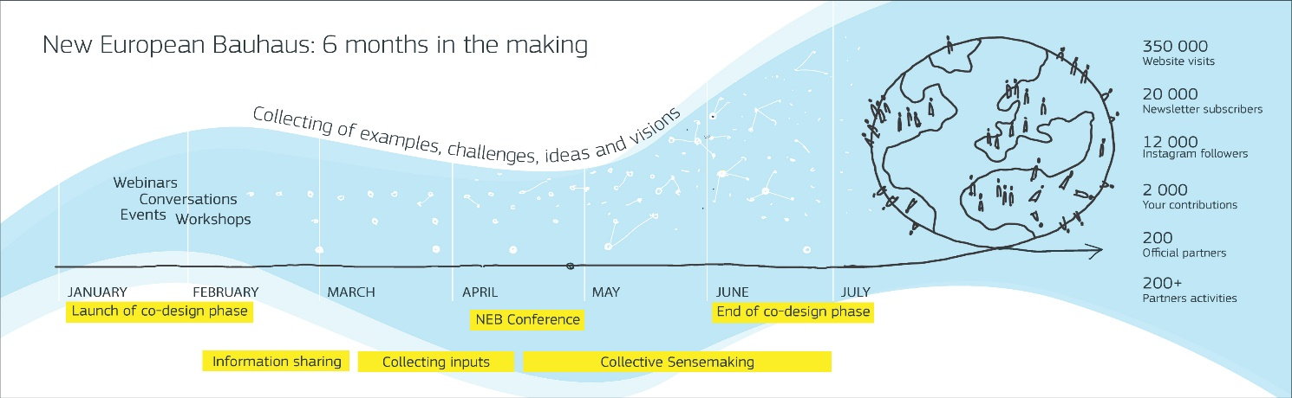
The New European Bauhaus is growing on fertile ground, where buildings, public spaces, businesses and social practices, cultural activities and education programmes are beacons of the initiative and inspire new ideas. The first New European Bauhaus prize was launched as part of the co-design phase to put the spotlight on those inspirational examples and ideas by young talents.

The shape of the New European Bauhaus

From the historical movement to the New European Bauhaus
Several features of the historical Bauhaus served as a basis for the vision of the New European Bauhaus.
The historical Bauhaus, created in 1919, emerged at a moment of deep transformation – towards the modern societal and industrial era. The founders addressed this transformation in their work and searched for solutions of the new challenges. It quickly became a global cultural movement. It brought together artists, designers, architects and craftspeople. This transdisciplinary approach is also very much needed for the challenges of our times where we are once more facing profound transformation.
Like one hundred years ago, the question of innovative materials remains key. While at that time, the solution was cement and steel, we now need to explore more nature-based materials that are produced sustainably, and to develop low-carbon production solutions for all materials. This goes for construction as well as for fashion, design, furniture, transport or energy. A triangle of values
A triangle of three core inseparable values guides the New European Bauhaus:
- sustainability, from climate goals, to circularity, zero pollution, and biodiversity,
- aesthetics, quality of experience and style, beyond functionality,
- inclusion, valorising diversity, equality for all, accessibility and affordability
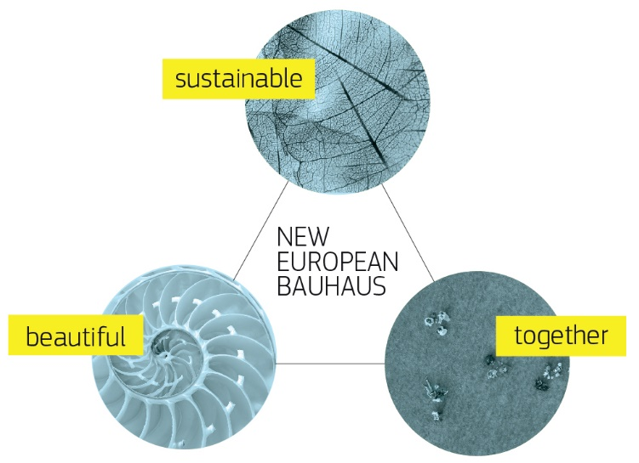
The challenge is to address all three values simultaneously to develop the creative solutions that best address people’s needs at a lower overall cost.

Three key principles
Three key principles, emerging from the co-creation process were taken up by the Commission and should guide the New European Bauhaus:
- Combination of global and local dimension
- Participation
- Transdisciplinarity

A multilevel approach: from global to local
The New European Bauhaus endorses a multilevel approach to transformation – from global to local. Climate change and the green transition bring challenges that should be addressed globally. At the same time, it is at the local level that change is happening and makes sense for people. The New European Bauhaus therefore addresses different levels of the transformation, from the global to the neighbourhoods, village and city.
Delivering on the New European Bauhaus means reaching out to local areas, following a place-based approach. Successful small-scale projects show that transformative initiatives, no matter their size, are doable for everyone, everywhere. The New European Bauhaus will explore ways to support small-scale initiatives by individuals, neighbourhoods and local communities.
This cannot be limited to the European Union. The New European Bauhaus will reach out further beyond European borders over time with the aim of spreading its principles of sustainability, inclusion and aesthetics globally.

A participatory approach
The European Commission is a strong advocate of a participatory approach, as evidenced by the on-going Conference on the Future of Europe, which has the vocation to deepen and sustain engagement with citizens. The Commission will continue to listen to and work together with those on the ground and explore together where policy, funding and other tools are really making a difference. This will mainly happen in the NEB Lab. The participatory approach involves civil society and people of all ages and in all their diversity, including women (under-represented in certain key sectors) and disadvantaged groups. This necessary focus on inclusion aims at leaving no one behind and acknowledges that the most creative solutions are born from collective thinking. New solutions should solve everyday problems and improve the quality of life for all.

A transdisciplinary approach
The New European Bauhaus is about bridging silos between viewpoints and professions. Culture and technology, innovation and design, engineering, craft, the arts and science working hand in hand have the power to create a better tomorrow.
The coronavirus pandemic has demonstrated that, more than ever, integrated approaches are needed to tackle the complex problems our planet and our society face. Meaningful transformation requires bringing in many different competences and knowledge. Working and learning across disciplines facilitates a cross-fertilisation of ideas, knowledge, skills and methods.

Thematic axes of the transformative path
Creating a movement means working with people and their interests, needs and motivations. The analysis of the input received during the co-design phase identified four thematic axes that the Commission decided to follow during the implementation of the New European Bauhaus.
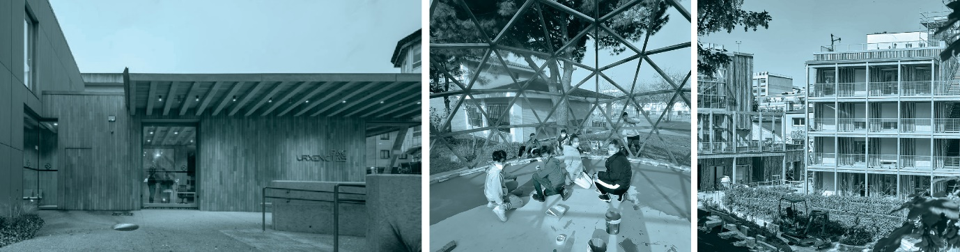

Reconnecting with nature
Contributions have pointed out to more awareness and more willingness to address climate change (mitigation and adaptation) and to reduce exposure to pollution.
What people feel as a need to reconnect with nature, including for health and well-being, is supported by research: greater opportunities for contact with green public spaces translate into better health indices for the population and reduce income-related health inequalities. Nature-based solutions in cities can help addressing floods and other extreme weather events while making the built environment more attractive.
Climate action is no longer seen as an abstract fight, but as an integral part of our daily lives that can improve air, water and soil quality and overall living conditions. This experience has been reinforced during the pandemic where our living spaces got limited and where people rediscovered their cities, villages, green spaces. The pandemic underlined the direct link between nature protection and physical and mental health for all of us.
There is a need to go beyond a human-centred to a life-centred perspective, getting inspired by nature and learning from it. The ways are manifold: from making cities greener and using sustainably sourced nature-based materials to innovative solutions based on “mimicking” elements found in nature; from taking care of the soil to re-using or recycling waste; from building urban green corridors for active mobility to rethinking transport infrastructure.
The reconnection to nature starts at a young age. Millions of young people have called for more action for a better planet and woken up our environmental consciousness. The contributions of the co-design phase highlight the crucial role education and culture play in the shift of paradigm towards new behaviour and values. Educating and empowering children and young people in a participatory way to understand, experience and embrace sustainability and inclusion will create strong connections to nature for the future generations.
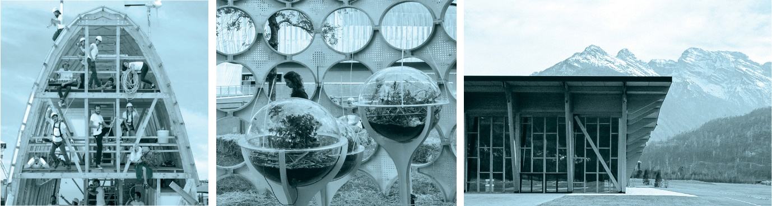

Regaining a sense of belonging
The New European Bauhaus movement is about our collective and private experiences. Building bridges between people is a strong aspiration expressed by contributors.
It implies encouraging intergenerational solidarity, developing links between education and the arts in local environments, improving our common spaces and places to meet. The proximity economy, with concepts like the “15 minute cities” for citizens to access key services and amenities within walking distance, is also a way to strengthen connections and foster healthy, sustainable, active mobility.
Cultural assets (heritage, arts, local craft, know how, etc.), natural assets (landscapes, natural resources, etc.) as well as social assets (social economy enterprises, local organisations and associations etc.) make a place unique. Cultural life, arts events, concerts are opportunities for connection and social interaction, the binding element that creates a sense of belonging.
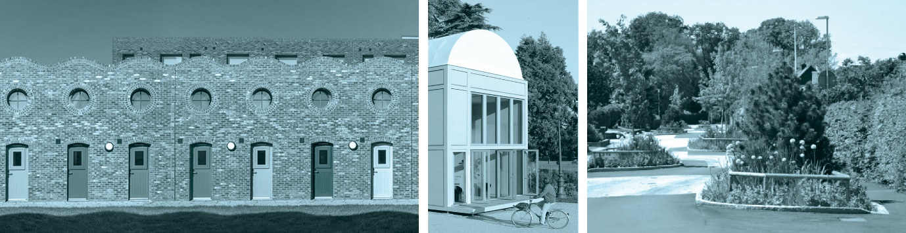

Prioritising the places and people that need it the most
The co-design phase showed that the New European Bauhaus must be inclusive. This does not relate only to people but also to the places where they live.
Beautiful and sustainable solutions have to be affordable and accessible for all. Due consideration should be given to the specific situation of groups and individuals who are the most vulnerable, for instance, at risk of exclusion or poverty or experiencing homelessness. For example, 800 000 social housing units (5% of the total social housing stock) require renovation per year, and 450 000 new social homes are needed annually in the EU. Disadvantaged groups are at greater risk of energy poverty and air pollution and have less access to public transport.
Inclusion also implies pursuing a Design for All approach to remove accessibility barriers to the built and virtual environments and to goods and services.
The New European Bauhaus clearly goes beyond large city centres and encompasses places in all their diversity, including small villages, rural areas, shrinking cities, degenerated city districts and de-industrialised areas. This calls for territorial development avoiding spatial segregation of social groups to create a sense of togetherness. The various parts of a city, a village or neighbourhood should be connected. Missing connections between rural and urban areas should be addressed. Digitally connecting people is an essential enabler for independent living, access to information, or attending cultural events as we experienced during the COVID-19 pandemic.
Delivering access to digital connectivity to all people is an essential enabler for independent living and being actively involved in the green transition, access to information, or attending cultural events as we experienced during the COVID-19 pandemic.
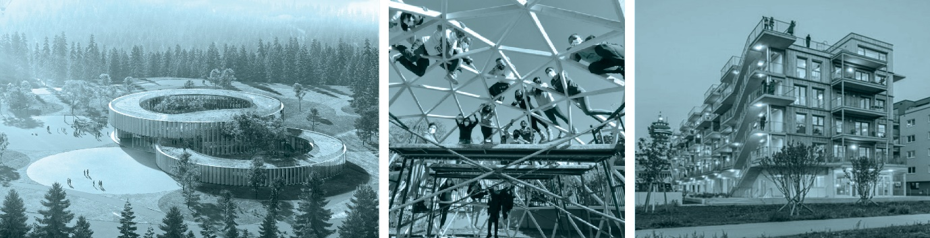

The need for long-term, life-cycle thinking in the industrial ecosystem.
Respondents in the co-design phase identified a clear need for more circularity to tackle unsustainable use of resources and waste, including uses for obsolete buildings or infrastructures. Addressing these challenges concerns the entire industrial ecosystem, from production to delivery and consumption, with a circular economy mind-set.
For example, re-use, regeneration, life extension and transformation of existing buildings should be prioritised over the construction of new buildings whenever feasible. . Circular, sustainable design and architecture should become the new normal.
Recovered and renewable materials should be better recognised by all relevant disciplines and become part of design paradigms. The use of sustainably produced and procured nature-based building materials, such as wood, bamboo, straw, cork or stone should be improved. New production technologies should help reduce the carbon footprint of steel or cement, recycle otherwise wasted textiles and accelerate the green transition of energy intensive industries.
New business models, bioeconomy, social economy approaches and Design for Sustainability can support the transformation of sectors such as textiles, tourism, waste management or energy production. The digital transition will play a systemic role in the development and implementation of the New European Bauhaus. Digital tools e.g. 5G, Artificial Intelligence, data-based tools, robotics and 3-Dimensional printing technologies or digital twins in the construction industry, can improve the sustainability performance of materials, products and buildings.

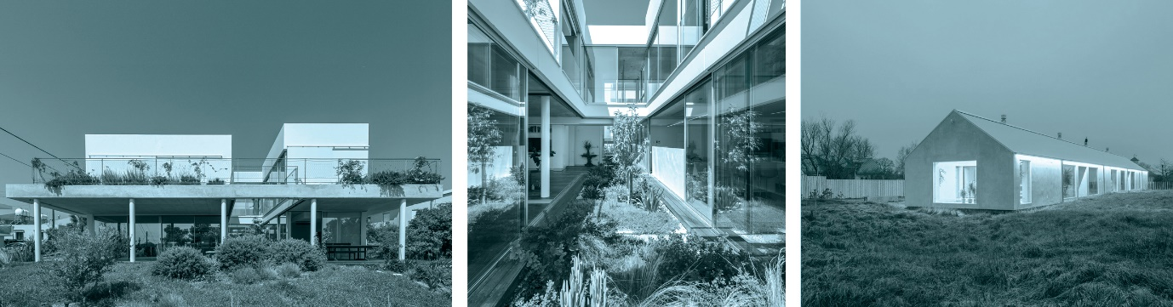

Delivering the New European Bauhaus
The Commission, in cooperation with the European Parliament and the other EU institutions as well as with the Member States, wants to create an enabling framework of the New European Bauhaus, integrated with the sustainable development goals (SDGs) and with relevant EU policies and initiatives. This enabling framework is designed to create a space to develop and test policy and funding instruments for the transformation of our societies and economy.
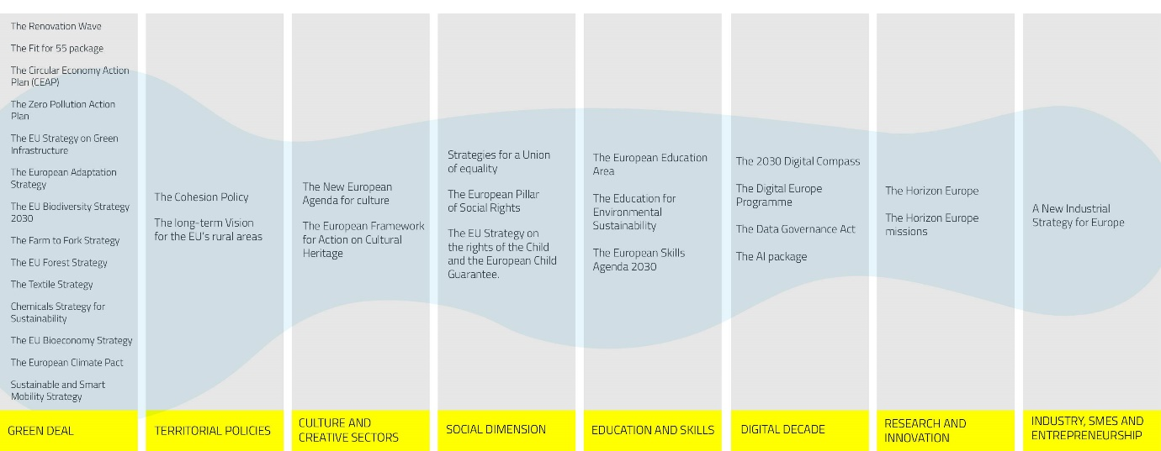
This framework is first of all about achieving more with the policies and funding instruments that we have already. Synergies among existing and planned EU policies or programmes should be intensified so that they can support the New European Bauhaus objectives. They can all contribute to a cultural project bringing together sustainability, inclusion and aesthetics in the places where people live and in the way they live.
The New European Bauhaus triggers issues that cannot be adequately addressed by a single instrument and which often “fall between the cracks”.
In addition, the New European Bauhaus puts in place specific and dedicated actions that will help make the transformation happen.
This first delivery framework will evolve in the light of the results, through iterative assessments and reviews.

Working with the New European Bauhaus Community: the NEB Lab
In order to support the implementation of the New European Bauhaus, the Commission will establish the NEB Lab, the “think and do tank” to co-create, prototype and test the tools, solutions and policy actions that will facilitate transformation on the ground. The Lab will function as an “accelerator and connector”.
Starting with the High Level Round Table and the official partners, the Lab will pursue its community-building journey to embrace the concrete projects inspired by the New European Bauhaus - whether supported by EU funds or by other initiatives – and connect them for mutual support and learning. It will also link up with established communities already working on relevant topics and reach out to politics, industry and society to bridge silos and experiment how they can work together.
While setting up the enabling infrastructure, including a digital platform, the Commission will invite the New European Bauhaus community to cooperate on the following topics and develop concrete recommendations:
- Labelling strategy: How to characterise and recognise concrete initiatives to match the ambition of the New European Bauhaus? What makes a project a New European Bauhaus project? How can an EU New European Bauhaus label be integrated with access to funding for projects?

- Innovative funding: Can crowdfunding be usefully combined with public financing to reach out to grassroots initiatives and improve project selection? What approach could best mobilise private funding, including from philanthropists, to support New European Bauhaus projects? How to incentivise investors in various sectors such as real estate, tourism infrastructures, etc. to embrace the ambition of the New European Bauhaus? How can the social economy support the New European Bauhaus?

- Regulatory analysis and experimentation: How can the regulatory framework support the development of New European Bauhaus projects in construction, energy intensive industries, mobility, proximity and social economy, cultural and creative industries, tourism, textiles? How can the NEB make a full use of new technological development including the digital transformation? What are the remaining obstacles and regulatory bottlenecks? How can public procurement and regulatory simplification promote New European Bauhaus priorities at the European, national and regional level? Can regulatory experimental settings be envisaged in cooperation with Member States and local authorities to test new regulatory approaches driving more ambition along the New European Bauhaus axis?

- Key performance indicators How can the success of the New European can be measured both in 2024 and 2030? What are the deliverables that we want to see at the different stages of the project? How can we evaluate the results in a meaningful way?
The Commission will follow up on the results of the work in the NEB Lab with further action as well as initiatives involving the Member States, the European Parliament, the Committee of the Regions and other partners. It will monitor and analyse developments, facilitate connections between stakeholders, collect and validate positive results and findings. It will identify new topics to explore through the Lab and contribute to the adaptation of the EU support framework over time.

A threefold transformation
Considering the many stories, conversations and essays collected during the co-design phase, three leverage points have been identified, where specific actions should be implemented: (i) making change happen in specific places on the ground, (ii) the need for doing things differently in making innovation happen, including by improving our skills and methods and (iii) the need for adapting the intentions and the way of thinking that is behind our actions. The support and funding instruments are designed around these three points.
Creating a sense of community and showcasing innovation is key for the New European Bauhaus. In order to allow visibility for the change makers, to share and debate progresses and results, and to foster the engagement of citizens, the Commission will convene a ‘New European Bauhaus Festival’ for the first time in spring 2022.
It will be a gathering – both physical and virtual - for the entire community to meet, debate, share, learn and celebrate.
The Festival will include three components:
- A Forum with debates to shape the project. It will gather thinkers, policy makers and practitioners in a global conversation from science and technology to culture and education, from regional and local development to international perspectives;
- A Fair to showcase projects, prototypes and outputs contributing to the New European Bauhaus and award the New European Bauhaus prize;
- A Fest with a cultural programme combining physical and virtual exhibitions, performances and art works.
The first edition of the festival will take place in Brussels and will be organised and financed by the European Commission. From 2023 onwards, based on the experience from the first edition, the Commission will envisage a concept for a yearly event that should ideally include places in- and outside the EU

Transformation of places on the ground
Changes should happen in specific places and in as many places as possible, at the levels of homes, neighbourhoods, urban and rural areas, physical and virtual meeting spaces. The successful deployment of the New European Bauhaus will require an effective learning and sharing from innovative and emblematic projects. Putting such “pilot demonstrators” in the spotlight spurs enthusiasm to engage and repeat. At the same time, initiative often comes from the grassroots actors, and support for small-scale projects will also be needed.
The Commission’s building strategy
The Commission has started integrating all three dimensions of the New European Bauhaus in the development of its presence and actions in the places where it services are established. In Brussels, those values will be implemented in the renovation of the Commission Visitors’ Centre, and the Commission will propose a partnership in the design of the new European Quarter Urban planning to the relevant authorities of the Brussels region. Consultations are to be launched in autumn 2021 and will ensure a citizens dialogue around the European neighbourhood. The New European Bauhaus values will also be implemented in the new construction and refurbishment projects proposed by the Commission for the Joint Research Centre sites’ in Sevilla and Geel.

The European Commission will
- launch calls for proposals, starting in September 2021 to select innovative pilot projects that are emblematic of the New European Bauhaus values, including dedicated calls under Horizon Europe on lighthouse demonstrators and on social, affordable and sustainable housing districts demonstrators. In 2022, additional New European Bauhaus demonstrators will be supported by cohesion policy’s European Urban initiative. Beyond 2022, the approach will be pursued through synergies with the activities launched under the Horizon Europe Missions;
- provide technical assistance to support interested stakeholders, such as regional and local administrations, to develop and deliver New European Bauhaus projects, with a first focus on citizen engagement and interdisciplinary methods for project incubation and co-design;
- introduce a dedicated urban development financial instrument leveraging EU and private investment to support New European Bauhaus projects in Member States. Beyond project financing, it will also grant support for training and project implementation;
- explore how to best support small scale projects building on the work of the European Institute for Innovation and technology.
- establish a New European Bauhaus Seal of Excellence to highlight projects of high quality that could not be financed by EU programmes because of budgetary constraints. The Seal of Excellence can be seen as a first step towards a New European Bauhaus label. Selected projects will be integrated in the New European Bauhaus community and promoted towards other potential funders.
Beyond Commission-led initiatives, the funding of transformative New European Bauhaus projects will require strong cooperation with Member States. The place-based and community-led local development approaches of cohesion policy can promote New European Bauhaus projects at the regional and local level with the participation of local communities.
The European Commission will invite Member States to:
- introduce the New European Bauhaus in their socio-economic and territorial development strategies and to reflect their commitment to support and mainstream the New European Bauhaus in the implementation of cohesion policy 2021-2027 as part of the Partnership Agreements and relevant operational programmes;
- take up the New European Bauhaus financial instrument to finance projects on the ground
- mobilise the relevant parts of their recovery and resilience plans (e.g. on renovation or infrastructures) on New European Bauhaus transformative projects.

Transformation of the enabling environment for innovation
New European Bauhaus transformation depends on the industrial ecosystems, from construction to lifestyle and creative industries, from materials to business models, from digital to farming, to provide tailored and affordable solutions. As the design phase has shown, innovation plays a key role. This is not only innovation in the sense of new technologies, but can also be a combination of new and traditional technics or a new adaptation of local crafts and knowledge.
The diversity and complexity of relevant legislation and the length of administrative processes can become a challenge for transformation projects and even an obstacle to innovation. Innovative approaches should be tested and implemented in experimental settings in close cooperation with Member States national, regional and local authorities.
The effective use of new materials, production process and other tools, will require (re-)skilling, also through Vocational Education and Training, in several sectors and on different levels.
The Commission will:
- co-create, by 2022, transition pathways towards (i) a green, digital and resilient construction ecosystem through the High Level Forum on Construction, (ii) a green, digital and resilient ecosystem on proximity and social economy, to complement the EU Action Plan on social economy, and (iii) a green, digital and resilient textiles ecosystem, to complement the EU strategy on textiles;
- develop a self-assessment tool to measure to what extent a project is sustainable, inclusive and aesthetic and help to identify where improvement is possible. This would combine all existing standards, rules and guidance in the relevant areas. In addition, develop digital tools for e-learning and assessment to support the use of the Level(s) framework that promotes life-cycle and whole life carbon assessment for the environmental performance of buildings
- mobilise further the Horizon Europe programme to support the New European Bauhaus through research and innovation. The Commission will organise a high-level workshop on “research and innovation for the New European Bauhaus’ to bring together leading experts to provide a forward-looking research and innovation agenda supporting the New European Bauhaus and feed into the co-creation process of future Horizon Europe Work Programmes;
- mobilise the European Institute of Innovation and Technology (EIT) and the European Innovation Council (EIC) capacities to launch a first set of coordinated calls for proposals to address the key innovation challenges that will emerge from the transformation projects on the ground;
- integrate the New European Bauhaus among the priorities of the LIFE Programme to support in particular projects promoting circularity, zero pollution and biodiversity;
- mobilise the Single Market Programme and its COSME pillar to support business partnerships in the lifestyle sector (fashion, design, furniture etc.) between designers, manufacturers, craftsmen and -women and technology providers (Worth Partnership Project) and to support partnerships on Social Economy and Local Green Deals;
- foster trans-disciplinary innovation for sustainability, inclusion and well-being among the cultural and creative sectors under the Creative Europe Programme, notably through Creative Innovation Labs;
- mobilise Digital Innovation Hubs in the relevant sectors (including the construction sector) to develop real and virtual environments and experiences involving deep digital technologies (AI, High Performance computing, big data) to support the New European Bauhaus;
- propose, as from 2021, topics and priorities contributing to the New European Bauhaus initiative in the Digital Europe Work Programmes;
- promote innovative procurement in the context of the New European Bauhaus to foster an approach based on quality, sustainability, inclusion rather than just cost, including through the ”Big Buyers” initiative;

Diffusion of new meanings
Inspiring a movement starts with values. It is essential to work with those who reflect on, study and convey our values, such as artists, social scientists, educators and education institutions and youth organisations.
Artists and creative professionals from all fields have long contributed to raise awareness of the socio-economic and environmental challenges of our times. Their critical stance and challenging works on contemporary society can act as eye-openers and help reshape our future world. This is also true for the notions of aesthetics and beauty, for which there are no universal standards or canons any more.
In close collaboration with the Education for Climate Coalition (*), the Commission will launch a call for expression of interest for places of education and knowledge (from public libraries to schools and universities) to develop their own New European Bauhaus projects. The Commission will connect these projects and provide them visibility. A dedicated New European Bauhaus prize in 2023 will allow the best projects to shine. (* https://education-for-climate.ec.europa.eu/_en )

Together with education, training and youth organisations, cultural and creative industries and sectors are new sources of smart, sustainable and inclusive growth and jobs. Their contribution to innovation is increasingly driven by non-technological factors such as creativity, design and new organisational processes or business models and cooperation. This is why sustainability is a major focus for EU youth and education policy, including higher education and support framework, allowing many synergies with the New European Bauhaus initiative.
The Commission will:
- propose to include under Erasmus + a dedicated priority on the New European Bauhaus in the 2022 call for Alliances for innovation, targeting both higher education and vocational education and training sectors and propose a priority for the New European Bauhaus in the Erasmus+ European Youth Together 2022 call for projects supporting transnational partnerships for youth organisations
- propose to support through Creative Europe ‘artists’ residencies and other types of place-bound cultural activities in spaces identified or labelled by the New European Bauhaus;
- organise the New European Bauhaus prize annually, highlighting different dimensions of the New European Bauhaus each year;
- develop a peer learning action to help local authorities to integrate and implement quality principles in the built environment as developed by the Davos process and the Member States’ expert group established under the New European Agenda for Culture. ;
- focus the eTwinning 2022annual theme on topics related to the New European Bauhaus
- propose topics related to the New European Bauhaus as part of the thematic priorities for the European Innovative Teaching Award 2022
- link the annual theme of the 2022 DiscoverEU action to the New European Bauhaus;
- for the European Solidarity Corps 2022 annual call, propose projects that can contribute to the New European Bauhaus initiative.

Next steps
The New European Bauhaus will build on the strength of its growing community. Over the past six months, the initiative gathered enthusiasm and thousands of ideas, which this communication builds upon. The mobilisation of interested actors will continue and the conversation will widen both across Europe and beyond, in cooperation with the European External Action Service, European Union Delegations as well as the interested international organisations and networks. In this respect, synergies with relevant policy and cooperation frameworks will be identified in particular in the EU’s neighbourhood.
The European Commission will count on the cooperation of the European Parliament, the Council, the Committee of the Regions and the European Economic and Social Committee to raise awareness and promote the debate in their constituencies, mobilise citizens and private sector actors and share available resources to support the New European Bauhaus.
The cooperation of Member States and of the public authorities at international, national, regional and local levels, including participation of civil society and representatives of diverse communities, will be crucial. From the promotion of participatory co-design processes to the ability to support the financing of local transformation projects, the New European Bauhaus will require strong cooperation across this multilevel governance framework.
As a starting point, Member States will be invited to entrust an entity as a contact point for the New European Bauhaus initiative to connect and coordinate efforts in their respective country and participate in an EU wide informal network for exchange of information and experience.
The European Commission will report on the progress of the initiative in 2022.

Annexes:
1. Report on the co-design phase
2. Mobilising EU programmes
3. New European Bauhaus policy ecosystem

Credits
COVER:
- Tree-House School © Valentino Gareri
- Architecture © Adobe Stock – lilymary
- Top view of people are resting on the lawn in the park © Adobe Stock – Watman

Internal pages
- Nautilus shell © Adobe Stock – Dean Pennala
- Green foliage texture © Adobe Stock – Vera Kuttelvaserova
- Top view of people are resting on the lawn in the park © Adobe Stock – Watman
- Laracha Health Centre © H. Santos-Díez
- Domo - sustainable architecture education in secondary school © Dolores Victoria
- La Ferme du Rail © Myr Muratet.
- The Arch © O.S.T. & Constructlab
- Wunderbugs © Francesco Lipari
- Palaluxottica © Simone Bossi
- Holmes Road Studios © Peter Barber Architects
- Proto-Habitat © Flavien Menu
- Rain gardens at Rundelsgatan in Vellinge © Source: edge​s
- Tree-House School © Valentino Gareri
- Domo - sustainable architecture education in secondary school © Dolores Victoria
- Gleis 21 © H. Hurnaus
- Garden house © C. Pavlou
- Garden house © C. Pavlou
- The Salt House © R. Hofmanis

New European Bauhaus: Commission launches design phase (europa.eu)
Co-designing the New European Bauhaus (europa.eu)
Partners (europa.eu)
High-level roundtable (europa.eu)
2021 Prizes (europa.eu)
For the purpose of the New European Bauhaus initiative, “sustainability” is understood as “environmental sustainability”.
This local context has multiple facets which, once combined, may determine the quality of life in the place: proximity to a rewarding job market, access to various types of infrastructures and facilities, affordability of housing, etc.
This includes persons at a higher risk of poverty, marginalisation and/or discrimination, such as young and older people, people with disabilities, lesbian, gay, bisexual, trans, non-binary, intersex and queer (LGBTIQ) people and people with a minority racial or ethnic background, like the Roma, and religious minorities.
See EEA Report No 21/2019, Chapter 3 on “Healthy environment, healthy lives: how the environment influences health and well-being in Europe”
15-Minute City (15minutecity.com)
Boosting investment in social infrastructure in Europe - Publications Office of the EU (europa.eu) https://op.europa.eu/en/publication-detail/-/publication/d3129b80-6f7c-11e8-9483-01aa75ed71a1/language-en/format-PDF
https://digital-strategy.ec.europa.eu/en/policies/digital-compass
https://www.routledge.com/Design-for-Sustainability-A-Multi-level-Framework-from-Products-to-Socio-technical/Gaziulusoy/p/book/9781032089959
http://revistas.unisinos.br/index.php/sdrj/article/view/sdrj.2021.141.02
Explanatory MEMO: European Urban Initiative- POST 2020 (Europa.Eu)
Missions in Horizon Europe | European Commission (europa.eu)
The European Institute of Innovation and technology has launched a Call for Proposals for Citizens engagement aligned with New European Bauhaus initiative. The aim is to work on activities where citizens are not only asked to identify relevant challenges of their city, but also empowered to co-create together potential solutions in an ideation process (https://www.eiturbanmobility.eu/launch-of-cross-kic-new-european-bauhaus-call-for-proposals-for-citizen-engagement /)
European Institute of Innovation & Technology (EIT) (europa.eu)
European Innovation Council (europa.eu)
The LIFE Nature and Biodiversity and LIFE Circular Economy and Quality of Life sub-programmes LIFE (europa.eu)
Single Market Programme | European Commission (europa.eu)
COSME. Europe’s programme for small and medium-sized enterprises. | Internal Market, Industry, Entrepreneurship and SMEs (europa.eu)
WORTH Partnership Project (worthproject.eu)
Add link to the call if ready to launch by 14 September
https://bigbuyers.eu/
It targets cooperation between a wider range of stakeholders: students, universities, companies, NGOs, civil society, etc.)
See Davos Baukultur Quality System - Davos Declaration 2018
The final report of the expert group on high- quality architecture and built environment for everyone will be published in the second half of September 2021
eTwinning - Homepage
DiscoverEU | European Youth Portal (europa.eu)

