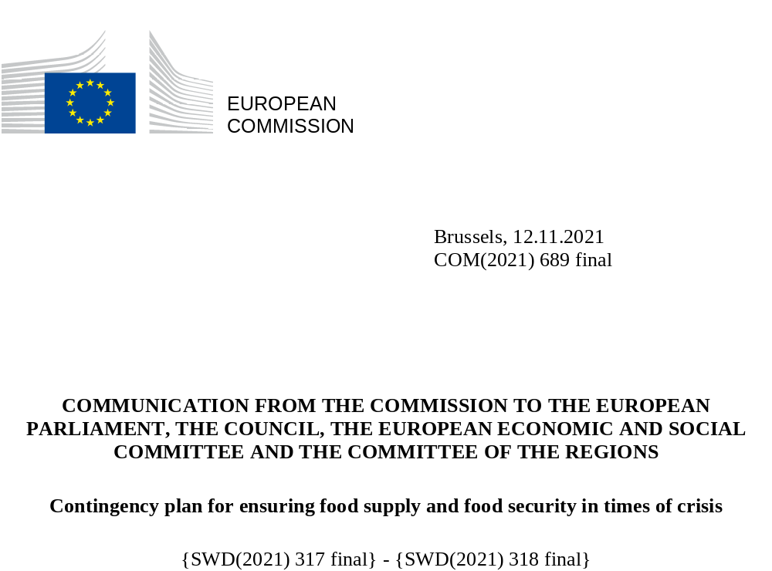

Contents
1. Introduction 2
2. The lessons from the COVID-19 crisis 3
3. Building on existing EU policies to respond to future crises 5
3.1. Existing policy frameworks are operational and reliable 5
3.2. Ongoing initiatives to improve preparedness in the EU 6
4. A new risk landscape for EU food supply and food security, with vulnerabilities and dependencies 7
5. An EU contingency plan for food security 8
5.1. Principles to be followed in times of crises 9
5.2. A European Food Security Crisis preparedness and response Mechanism (EFSCM) 10
5.3. Actions of the European Food Security Crisis preparedness and response Mechanism (EFSCM) 11
5.3.1. Foresight, risk assessment and monitoring 11
5.3.2. Coordination, cooperation and communication 12
6. Conclusions 13

Introduction
Every day the EU food supply chain provides Europeans with a wide variety of high-quality food. This is thanks to the experience and competitiveness of its agricultural, fisheries, aquaculture and food sectors. These sectors under different climates, territories and economic structures benefits from the common agricultural and fisheries policies (respectively CAP and CFP), include more than 11 million EU farms and 81 000 fishing vessels. Consumers have access to both shorter food supply chains, which should be supported, as recommended to Member States for their CAP strategic plans, and longer food supply chains involving more complex processes. The EU single market for goods and services enables safe food to be distributed efficiently between Member States. Thanks to the EU trade policy, the EU is also a major global food trader. In 2020 the net trade surplus for agri-food products amounted to EUR 62 billion. Seafood products however have registered a trade deficit for a long time, growing by 33% since 2010.
Ensuring food supply and food security is an objective set out in Article 39 of the Treaty on the Functioning of the European Unionand its achievement should not be taken for granted. The COVID-19 crisis was a wake-up call for those who thought that severe supply challenges for specific food in shops in the EU were inconceivable. Difficulties in the food supply chain resulted, in some cases, in empty shelves - although only a few products were temporarily unavailable to consumers.
The purpose of this Communication is to identify EU actions to address the shortcomings and to provide a better response to future crises. To do this, the EU will ‘step up its coordination of a common European response to crises affecting food,’ as stated in the Farm to Fork strategy. Both European Parliament and the Council welcomed the Commission’s intention to develop a contingency plan,.
The Commission’s 2020 annual Strategic Foresight report focused on resilience. The Group of Chief Scientific Advisers has been asked by the Commission to provide a scientific opinion on the matter.
The Commission is therefore actively improving crisis management in the EU, including on preparedness. Contingency planning requires defining procedures for the coordination, cooperation and exchange of information between key actors.
While moving forward with contingency planning arrangements, the Commission will continue to promote more resilient and sustainable EU food systems, in line with the Farm to Fork and the Biodiversity strategies, with the support of the reformed CAP, the new Organic action plan, the Strategic guidelines for aquaculture and the planned proposal for framework legislation on sustainable food systems, planned for 2023.

The lessons from the COVID-19 crisis
The resilience of the EU’s food system ensured that the health crisis triggered by the COVID-19 pandemic did not lead to a food crisis. On the production side, prices remained relatively stable throughout the crisis. However, in some markets like fisheries and aquaculture, potatoes, meat and wine, the closure of food servicesled to a sharp fall in demand. On the consumption side, food prices rose moderately (up to +5%) in April-May 2020, but the situation quickly normalised. As the supply of food was deemed to be an essential activity from the earliest policy response, the food sector was overall less affected than other economic sectors. This enabled a remarkable and fast recovery. The positive performance of agri-food trade in 2020 (+1.4% compared to 2019) further illustrates this situation and proves the importance of keeping trade open also in times of crisis.
As the agriculture, fisheries and aquaculture, and food sectors are often confronted with shocks - related to weather, trade or sanitary issues - regulatory tools to support these sectors are provided for by the CAP and the CFP. During the COVID-19 crisis, these tools enabled the EU to react swiftly: the risks of market imbalances were countervailed by private storage aid, and cash flow issues faced by producers were addressed through compensation payments. The measures taken had direct effects, provided reassuring signals and influenced behaviour in markets. Professional organisations, such as producer and interbranch organisations, played a crucial role by adapting their production and marketing strategies. The Commission also provided the necessary flexibility to ensure the functioning of EU policies. The early adoption, in mid-March 2020, of the temporary framework on State aid allowed Member States to provide decisive support to operators. The fisheries sector benefited from amendments to the European Maritime and Fisheries Fund (EMFF).
Other underpinning policies paramount for the well-functioning of the food supply chain, such as e.g. on the mobility of goods and people, required extraordinary action. The Commission published guidelines on Green Lanes in mid-March 2020, to ensure the movement of goods within the single market. In the Communication concerning the exercise of the free movement of workers during COVID-19 outbreak the Commission also recognised cross-border and seasonal workers in the food sector, as well as transport workers, as essential workers. Respondents to a targeted questionnaire on this initiative ranked the guidelines on Green Lanes as the most useful measure taken. (54% ‘very useful’). Stakeholders also appreciated the information and guidance provided by the Commission, as well as trade facilitation measures such as those allowing for electronic certificates.
Despite the resilience shown by the EU’s food system, several areas for improvement have been identified.
A lack of coordination between public authorities in the EU was reported. Some Member States adopted unilateral measures that put the single market at risk, by limiting or restricting the free movement of food or by favouring national products. Such measures may appear to provide a temporary protection to national operators, but can quickly affect operators’ access to necessary inputs from abroad. These measures further complicated crisis management in the initial stages and added to an already tense situation in the food system.
In the absence of structured coordination channels, the specific policy needs of the food supply chain were not always conspicuous, having to compete with many other emergencies, in particular those related to public health.
Similar tensions were noted at international level. Some countries imposed food trade restrictions (essentially export bans), although to a much lesser extent than in previous crises. The Agricultural Market Information System (AMIS) played a major role in ensuring international coordination.
It has become clearer that there is a need for an integrated food systems’ approach which recognises interdependencies and includes not only the actors of the food supply chain itself such as farmers and fishers, food processors, traders, retailers, food services, including their workers. It should also take into account actors that support the functioning of the chain such as the transport and logistics sector as well as industries providing necessary inputs and packaging material.
The crisis also showed that appropriate communication is key for policy makers and stakeholders to take informed decisions and follow business continuity plans, and for the general public to be objectively informed about the crisis and avoid irrational stockpiling behaviour.

Building on existing EU policies to respond to future crises

Existing policy frameworks are operational and reliable
The existing policy frameworks that apply to the food supply chain include a wide range of measures and instruments to address crises.
In agriculture, direct payments provide an income safety-net that supports the resilience of EU farms. Rural development policy supports risk management, knowledge-building and supply chain organisation. A specific objective of the recently agreed CAP reform is to foster a smart, resilient and diversified agricultural sector ensuring food security. The amended Regulation (EU) No 1308/2013 for agricultural markets and the improved rules on the agricultural reserve, will strengthen the EU’s ability to be more flexible when responding to crises.
In fisheries and aquaculture, the CFP aims to ensure that fishing and aquaculture activities are environmentally sustainable in the long-term and achieve economic, social and employment benefits. The 2021-2027 European Maritime Fisheries and Aquaculture Fund includes a mechanism to provide financial compensation in case of exceptional events causing a significant disruption to the markets, upon recognition of the occurrence of such events by the Commission.
Food safety requirements and official control rules allow the Commission to bring forward the measures needed to contain risks for animal and plant health and animal welfare. A crisis management framework in case of foodborne incidents is also established.
Member States have a fundamental role in responding to crises. State aid rules allow compensation for the damage caused by natural disasters, including in cases of a ‘serious disturbance in the economy of a Member State’.
The Fund for European Aid to the Most Deprived (FEAD) supports actions in Member States to provide food aid to those most in need. Food banks state that there was a sharp increase in demand for food aid in 2020. FEAD rules were amended among others to take these needs into account. Member States have developed different instruments to ensure better access to food, such as direct food aid or support to food banks, and launched initiatives to find alternative destinations for surplus food to avoid food waste.
Meanwhile, the Union Civil Protection Mechanism (UCPM) can be used by Member States to request and provide various forms of financial and operational support, in the event of any type of disaster, including requesting food from other Member States in a food crisis. The Emergency Response Coordination Centre (ERCC) acts as 24/7 crisis coordination hub and facilitates rapid coordination with and among Member States authorities in the response to emergency situations. Coordination with ERCC and UCPM is key in case of large scale multifaceted disasters involving food components.
Several other EU policies strengthen the resilience of EU food systems, such as those supporting the circular economy and the EU’s research and innovation policy.

Ongoing initiatives to improve preparedness in the EU
The EU is protecting critical infrastructure to reduce vulnerabilities and ensure the functioning of its society and economy. The Foreign Direct Investment Screening Regulation established an EU-wide framework to coordinate actions in relation to foreign investments. This includes risks to food security when dealing with agricultural land or infrastructure. The update of the EU’s Industrial strategy includes a Single Market Emergency Instrument (SMEI) to ensure the free movement of people and the availability of goods and services. The strategy also addresses the risks of disruption to global supply chains that affect the availability of essential products, by monitoring strategic dependencies. Similarly, in the mobility sector, the Commission’s Sustainable and Smart Mobility strategy, announces a crisis contingency plan for transport. In the health sector, the Commission drew lessons from the COVID-19 pandemic and has set up a new Health Emergency Preparedness and Response Authority (HERA), to better anticipate public health risks and improve contingency planning. Considering the exposure to cyber threats, the Commission proposed a new Directive on measures for a high common level of cybersecurity across the Union, repealing Directive (EU) 2016/1148, included food production, processing and distribution in its scope.
Most Member States have provisions in place for contingency planning in the food sector. They provide for monitoring and data collection, transparency of information through market reports, and regular contacts with stakeholders. The contingency planning landscape in the Member States varies. Responsibilities are shared between several institutions, and food is covered by general contingency planning activities. Most Member States are reviewing their arrangements following the COVID-19 crisis.
Strategic reserves are maintained in at least seven Member States, and managed either by public authorities or by private operators. The reserves include mainly staple grains, but other goods, such as inputs, are on occasion covered. Some Member States have published recommendations to their citizens to keep precautionary stocks at home on a permanent basis.
Stocks can play a role in mitigating food security crises, as a complement to trade, particularly in developing countries. However, to a large extent due to the perishability of commodities and food products, stockholding policies entail significant costs. When managed directly by public authorities, stockholding discourages similar efforts by the private sector. The release of stocks can also interfere with the functioning of markets.

A new risk landscape for EU food supply and food security, with vulnerabilities and dependencies
Increasing uncertainty as well as price and supply volatility are affecting production capacity and distribution through the food supply chain. Some risks affect all these aspects.
During the last decades, the EU has largely been spared from crises that resulted in food security issues associated with crop failures or political conflicts. That said, weather events related to climate change and environmental degradation are on the increase, and are the main perceived risk related to food insecurity (60% of respondents to the targeted questionnaire).
More frequent extreme weather events - recent cold spells and flooding, increased frequency and intensity of droughts, such as those in 2018 and 2019, or heatwaves resulting in large-scale forest fires - show that climate change increasingly affects agricultural and seafood production in the EU, for instance with failure of fodder crops due to drought. The increased probability of simultaneous extreme events affecting several areas of production may result in tensions on markets and food stocks. Other pressures on food production relate to the degradation of the environment, resource scarcity and biodiversity loss, as well as plant and animal health issues. These climate and environmental risks have the potential to have a much greater impact on the EU food supply than the COVID-19 crisis. The Farm to Fork strategy lays down actions to make the food systems more resilient and ensure lasting food security in the face of climate change and biodiversity loss.
Other risks may threaten the functioning of the food supply chain e.g. those related to public health, technology, migration, geopolitical shifts and industrial or other accidents, including nuclear incidents that have the potential to irradiate large tracts of agricultural land. Risks affecting the availability and affordability of key inputs (i.e. fertilisers, energy, etc.) and factors of productions such as labour in the food sector or the transport sector also need to be considered. Digitisation of food systems brings major benefits but carries the risk of cyber-attacks and failures having greater impact. Cyber-attacks against large companies in the food sector have recently resulted in disruptions of the food chain. Risks related to geopolitical shifts encompass foreign direct investment in critical infrastructures in the EU, bio-terrorism or competition to access essential inputs and commodities.
Within this new risk landscape, the EU food supply chain has to cope with some dependencies and vulnerabilities. For example, 76% of the EU oilseeds meals for feed is imported. The fish sector has a high degree of import-dependency, the EU self-sufficiency being at 14% for the top five species consumed.
For some imported products, the EU relies on a limited number of sources. Soya bean production is largely concentrated in three countries which represent 85% of the EU imports, and maize imports come predominantly from two non-EU countries. Inputs, like fertilisers or chemicals, originate from few neighbour countries. Many feed and food additives such as amino acids, vitamins and veterinary products are predominantly imported, in some cases from a single supplying country.
The complexity of food supply chains, intertwined with other industrial ecosystems such as transport and energy, is complicating the ability to react to crisis situations. Due to these interdependencies a disruption in another economic sector can result in disturbances in the food chain. That way, packaging material shortages threatened the supply of eggs during the COVID-19 crisis. Specialised intensive production systems, potentially more efficient economically, may not be the most resilient in times of crises.

An EU contingency plan for food security
The recent crisis has shown that there is need to step up coordination and improve contingency planning so to be prepared to deal with risks that may threaten EU food supply and food security. The objective is to avoid repeating the COVID-19 experience where coordination measures at EU level had to be taken on an ad hoc basis and developed on the spot.
The disaster cycle used in crisis management includes four main phases: (i) prevention, (ii) preparedness, (iii) response and (iv) recovery. Contingency planning is a part of preparedness which requires identifying the hazards to which the community is vulnerable and the nature of potential impacts. Therefore, the focus is on the preparedness phase and on the support to actors in charge of responding to the crisis. The contingency plan will cover the whole food system starting from inputs up to the delivery of food to consumers through retail or food services.

Figure 1: Scope of the contingency plan for ensuring food supply and food security in times of crises
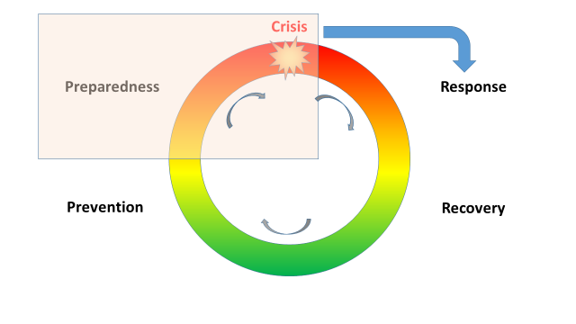
Contingency planning is not meant to duplicate or interfere with the relevant decision-making processes that apply to crisis response decisions, as provided for in existing policies such as the CAP, the CFP and the General Food Law. It should take them into account and focus on the ways to support coordination of public and private actors involved in the response.
As announced in the Farm to Fork strategy, in case of a transnational crisis, a dedicated mechanism involving Member States will be coordinated by the Commission. Actions that may need to be adopted at national and EU-level can and should provide significant added value in terms of coordination.

Principles to be followed in times of crises
Lessons learnt from the pandemic provide the basis for the approach to be followed to ensure food supply and food security in times of crises. These principles will facilitate a structured coordination between Member States and the Commission, taking into account that crises of the future may not look like those of the past.
A collaborative approach between all public and private parties being part of the food supply chain is crucial to enhance preparedness, to quickly identify the signs of an upcoming crisis and to coordinate the response at all levels. This will foster EU food supply chain resilience.
Given the interdependencies between economic sectors, due horizontal coordination across political and administrative competences and consistency with other crisis instruments are needed, in particular when the crisis originates from factors exogenous to the food supply chain, as was the case in the COVID-19 crisis or would be the case in crises where for example energy supply is no longer ensured. The contingency planning should therefore be sufficiently flexible to adapt and interact in complementarity with these instruments. Resilience initiatives and new measures under the contingency planning should be sustainable and green in line with the European Green Deal.
Market imbalances should be monitored and when necessary quickly addressed, making full use of the available tools, notably under the CAP and CFP, as well as of relevant stakeholder exchange and coordination networks.
Supply chains need to remain operational and trade flows smooth, including for the sectors that are essential to the functioning of the food chain. The role of transport and transport workers is for instance essential to the smooth functioning of the food supply chain. The circulation of goods within the single market must therefore be guaranteed by applying the Commission guidelines on Green Lanes. Unilateral measures restricting exports to other Member States should not be adopted as these may exacerbate the crisis. To avoid export bans by non-EU countries and maintain international trade flows, early coordination with AMIS and international trade partners will be ensured.
Food supply should also be sustained by facilitating free and fair movement of cross-border and seasonal workers in the food sector.
Communication in a crisis is paramount. Notably in times of disinformation campaigns and fake news, there is a danger to exacerbate a crisis through inappropriate information. To avoid rash decisions and panic movements, early, regular and transparent communication to the stakeholders and the public is necessary.

A European Food Security Crisis preparedness and response Mechanism (EFSCM)
To implement such principles, the Commission will establish the Food Security Crisis preparedness and response Mechanism, which will rely on a (new) dedicated group of experts, composed of Member States’ representatives and a set of rules of procedures governing its functioning.
As the institutional settings differ among Member States, several national authorities may be involved in the mechanism on behalf of Member States . For coordination purposes, a single authority should be identified as a contact point. Member States are responsible to ensure that this focal point is competent for all the sectors of activity of their national food chain. Non-EU countries whose food supply chain is highly integrated with the EU will be involved in the EFSCM.
Stakeholders’ organisations that have a role in the EU food supply chain will be invited to contribute to improving the cooperation and partnership between public and private sector. This is one of the key lessons learnt from the COVID-19 crisis. It will help to identify the early signs of a crisis, closely monitor its development, and reduce uncertainties as the crisis unfolds. This will enable to swiftly identify response priorities, and to provide proper advice to decision makers. All stages of the food chain should be represented.
The Commission will convene the group of experts periodically to improve the EU level of preparedness. It will dedicate the meetings to analysing the risk landscape and the vulnerabilities and the structural issues to be addressed to enhance the preparedness. This will also build trust between food chain actors. Trust is essential to manage a crisis and avoid unilateral decisions that lead to sub-optimal collective outcomes.
The group of experts may be convened in case of emergency or crisis without delay and as often as needed when discussions or coordinated actions would benefit the actors responsible for the crisis response. The mechanism will be triggered in case of exceptional, unpredictable and large-scale events or risks – whether endogenous or exogenous to the food supply chain - that have the potential to threaten the EU food supply or food security, unfolding in more than one Member State and requiring EU-level coordination. The group of experts will meet at this occasion. Most of the recent market disturbances would not have warranted such an emergency meeting, as they did not represent a significant threat to the availability of and access to safe food in the EU. For example, the consequences of the recent localised extreme weather events (droughts, frost) resulted in market tensions, but did not threaten the overall EU food supply or security.
The functioning of the mechanism provided for in this communication will not duplicate other existing preparedness or response structures. The need for complementary interaction with other mechanisms, in particular the ARGUS general rapid alert system, the general plan for crisis management in safety of food and feed, the UCPM and ERCC, the SMEI and the Council Integrated Political Crisis Response mechanism will be ensured.

Actions of the European Food Security Crisis preparedness and response Mechanism (EFSCM)

Foresight, risk assessment and monitoring
Foresight, risk assessment or vulnerability analysis are useful to improve preparedness, prepare for what the future might bring and to understand uncertainties and potential bottlenecks. Several Member States, and the Commission regularly carry out such analyses. Within the EFSCM the implications of various approaches will be discussed and analysed.
The existing vulnerabilities and dependencies, including those of structural nature will be mapped out within the EFSCM. The vulnerability of the food chain may be assessed at sector and EU level through stress tests of the different value chains to be organised and coordinated by the Commission, with the active involvement of stakeholder organisations. The identification of where food production takes place, with potential high concentration in specific regions, may be done, in cooperation with Member States. The Commission will conduct a study to further review the vulnerabilities and critical infrastructure of the food supply chain. Its findings will be discussed in the group of experts.
Several early warning systems are of relevance to strengthen preparedness and inform response. Some early warning systems monitor drivers of production related to climate and weather, like for example the MARS system monitoring crop development which showed its importance when drought impacted fodder crops in 2018 and 2019 at the time of elaborating the policy response to such extreme weather event. Market observatories for agricultural and fisheries markets provide information on non-climate related factors, including short- and medium- term projections. Specific dashboards for monitoring food supply and food security complementing those already existing will be considered.
The role of digitisation is potentially decisive in providing timely information and further improving market transparency. Important information, like the size of commercial and public stocks are not always known with accuracy. Technology and big data could also be mobilised to improve the flow of information during crises. The Commission will reflect on the potential of new technologies in improving preparedness for food security crises.
One of the main difficulties in crisis situations is the high degree of uncertainty and rapidly evolving conditions. A pro-active network of correspondents from national authorities and private sector organisations can ensure a better flow of information.

Coordination, cooperation and communication
Sharing information and best practice on national and European initiatives through digital platforms will be beneficial for all concerned. Member States will be encouraged to continue to have or develop their own contingency plans at national level and share them. Such plans will boost cooperation between national authorities at EU level and at all levels down to regional and local governments, as well as favour partnerships with private actors along the food chain including food banks and other NGOs.
On any matter of interest, including on the possible measures to be drawn up in case of crisis, the development of recommendations to address the crises will be coordinated within the EFSCM, in order to assist the Commission in preparing policy initiatives. Cooperation with private sector actors in the EFSCM will facilitate a coordinated response by both the public and the private sectors, involving for example voluntary agreements. Recommendations will for instance be developed on the ways to ensure a diversity of supply sources between shorter and longer food supply chains.
Coordination and cooperation with the international community will be ensured through supporting and participating in relevant global and regional initiatives, in particular AMIS. This is crucial to minimising national or regional policies that could undermine the common good, particularly since events affecting EU food supply and food security are likely to have a global dimension.
Learning together from previous crises is crucial to improving prevention and preparedness. Ex post analyses of crises will be shared and discussed. The key conclusions, including structural changes to improve the crisis response, will be communicated to the group of experts.
Good communication practice is essential. It relies on transparent and evidence-based information, obtained from trusted networks. Data gathering and analysis activities mentioned above will strengthen credibility. Exchanges on contingency planning at different levels will help economic actors and officials to plan responses and to know what is expected of them individually. Appropriate reporting of the EFSCM’s actions will be made available to stakeholders and the public. The general objectives and principles of crisis communication in food safety as set out in Articles 8a and 8b of Regulation (EC) No 178/2002 will be applied.
Specific guidelines for crisis communication will be elaborated and discussed in the group of experts, covering principles to be followed in a context of high uncertainty or to ensure a coordinated approach of all private and public actors.

Conclusions
The EU benefits from diversified food systems, a supportive policy framework, a single market connecting close to 450 million consumers and an economy open to the rest of the world. However, in a changing risk landscape, following the wake-up call of the COVID-19 crisis, the level of preparedness can and should be stepped up. There is no ready-made solution to address a future, unpredictable, crisis. The best solution is to enhance the knowledge of and mitigate to the extent possible the vulnerabilities and risks and to create and maintain the procedural capability to respond in a swift, coordinated and cooperative way relying on a mix of EU policies that support the resilience of the system and provide crisis management tools.
This is the purpose of the contingency planning and of the EFSCM that will be bringing together the Commission, Member States, relevant non-EU countries and stakeholders’ organisations. Within the EFSCM, the Commission and other actors will develop a set of accompanying actions summarised in the Annex to this Communication.

COM(2020)381.
Council Conclusions on the Farm to Fork Strategy.
European Parliament resolution of 20 October 2021 on a farm to fork strategy for a fair, healthy and environmentally-friendly food system (2020/2260(INI)).
2020 strategic foresight report.
Strategic crisis management in the EU.
Including the support for resilient food systems in CAP Strategic Plans of individual Member States.
COM(2021)141.
COM(2021)236.
Annex I to the Staff Working Document includes a thorough analysis of the impact of COVID-19 on EU food supply. The European Parliament published a study assessing the preliminary impacts of COVID-19 on European agriculture.
https://eur-lex.europa.eu/legal-content/GA/TXT/?uri=CELEX:52020XC0330(03).
The results of the targeted stakeholder questionnaire are described in more detail in a separate synopsis report.
Agricultural Market Information System.
OJ L 347, 20.12.2013, p. 671.
An agricultural reserve will ‘provide additional support (...) to respond promptly in the case of crises affecting the agricultural production or distribution’.
Article 107(3)(b) of the Treaty on the Functioning of the European Union (TFEU).
COM(2020) 829.
Screening of foreign direct investment.
COM(2021) 350.
COM(2020) 789.
COM(2021) 380.
COM(2020) 823.
IPCC 6th Assessment report, August 2021.
Commission Decision 2006/25/EC.
Commission Implementing Decision (EU) 2019/300 C/2019/1064.

