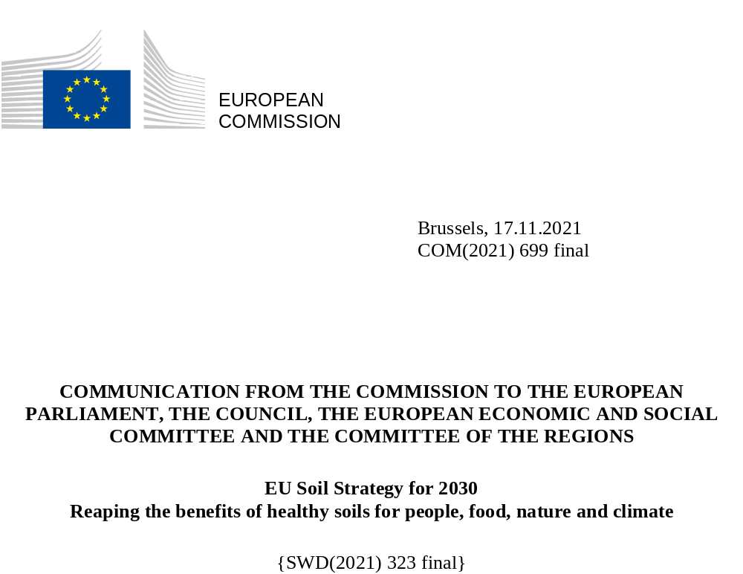

- Introduction
Too few know that the thin layer that lies below our feet holds our future. Soil and the multitude of organisms that live in it provide us with food, biomass and fibres, raw materials, regulate the water, carbon and nutrient cycles and make life on land possible. It takes thousands of years to produce a few centimetres of this magic carpet.
Soil hosts more than 25% of all biodiversity on the planet and is the foundation of the food chains nourishing humanity and above ground biodiversity. This fragile layer will be expected to feed and filter drinking water fit for consumption to a global population of nearly 10 billion people by 2050.
Healthy soils are also the largest terrestrial carbon pool on the planet. This feature, coupled with their sponge-like function to absorb water and reduce the risk of flooding and drought, makes soil an indispensable ally for climate change mitigation and adaptation. Healthy soils therefore integrate part of the Union’s climate, biodiversity and also long-term economic objectives.
The EU’s rich soil patrimony features a myriad soil types (covering 24 of the world’s 32 major soil groups), each with its own identity and specific characteristics. Such richness is an asset that needs to be protected and preserved for future generations. Yet, our soils are suffering. It has been estimated that about 60 to 70% of soils in the EU are not healthy. Land and soil continue to be subject to severe degradation processes such as erosion, compaction, organic matter decline, pollution, loss of biodiversity, salinisation and sealing. This damage is the result of unsustainable land use and management, overexploitation and emissions of pollutants. For example, every year, about 1 billion tonnes of soil are washed away by erosion in Europe. Between 2012 and 2018 more than 400 km² of land was taken per year in the EU on a net basis.
Cropland and grasslands in the EU provide EUR 76 billion worth of ecosystem services per year: less than one third come from crop production, the rest from other ecosystem services. However, while the benefits of healthy soils and the costs of soil degradation together with the depletion of its ecosystem services are shared by the public and the land users, the latter have most of the prerogative on its use and management. Furthermore, the value of the soil capital must be properly reflected in natural capital accounts so that our dependence on it becomes more visible. To avoid the risks and impacts that continued soil degradation has on the economy and people’s wellbeing, soils deserve the utmost and urgent attention of governments, parliaments, public authorities at all levels as well economic operators, soil users, local communities and citizens.
Investing in prevention and restoration of soil degradation makes sound economic sense. As the EU’s largest terrestrial ecosystem, healthy soils sustain many sectors of the economy while soil degradation is costing the EU several tens of billion euros per year. Management practices that sustain and enhance soil health and biodiversity improve cost efficiency and limit the inputs (e.g. pesticides, fertilisers) needed to maintain yields. Halting and reversing current trends of soil degradation could generate up to EUR 1.2 trillion per year in economic benefits globally. The cost of inaction on soil degradation, which outweighs the cost of action by a factor of 6 in Europe, goes beyond the economic calculation; it would not only lead to fertility loss comprising global food security, but also impact on the quality of products and their nutritional value.
To reap the benefits of healthy soils for people, food, nature and climate, the EU needs a renewed Soil Strategy that sets out a framework and concrete measures for protecting, restoring and sustainably using soils and that mobilises the necessary societal engagement and financial resources, shared knowledge, sustainable practices and monitoring to reach common objectives. The strategy is closely linked and works in synergy with the other EU policies stemming from the European Green Deal and will underpin our ambition for global action on soil at international level. This will only be achieved through a combination of new voluntary and legally binding measures, presented here below, developed in full respect of subsidiarity and building on existing national soil policies.
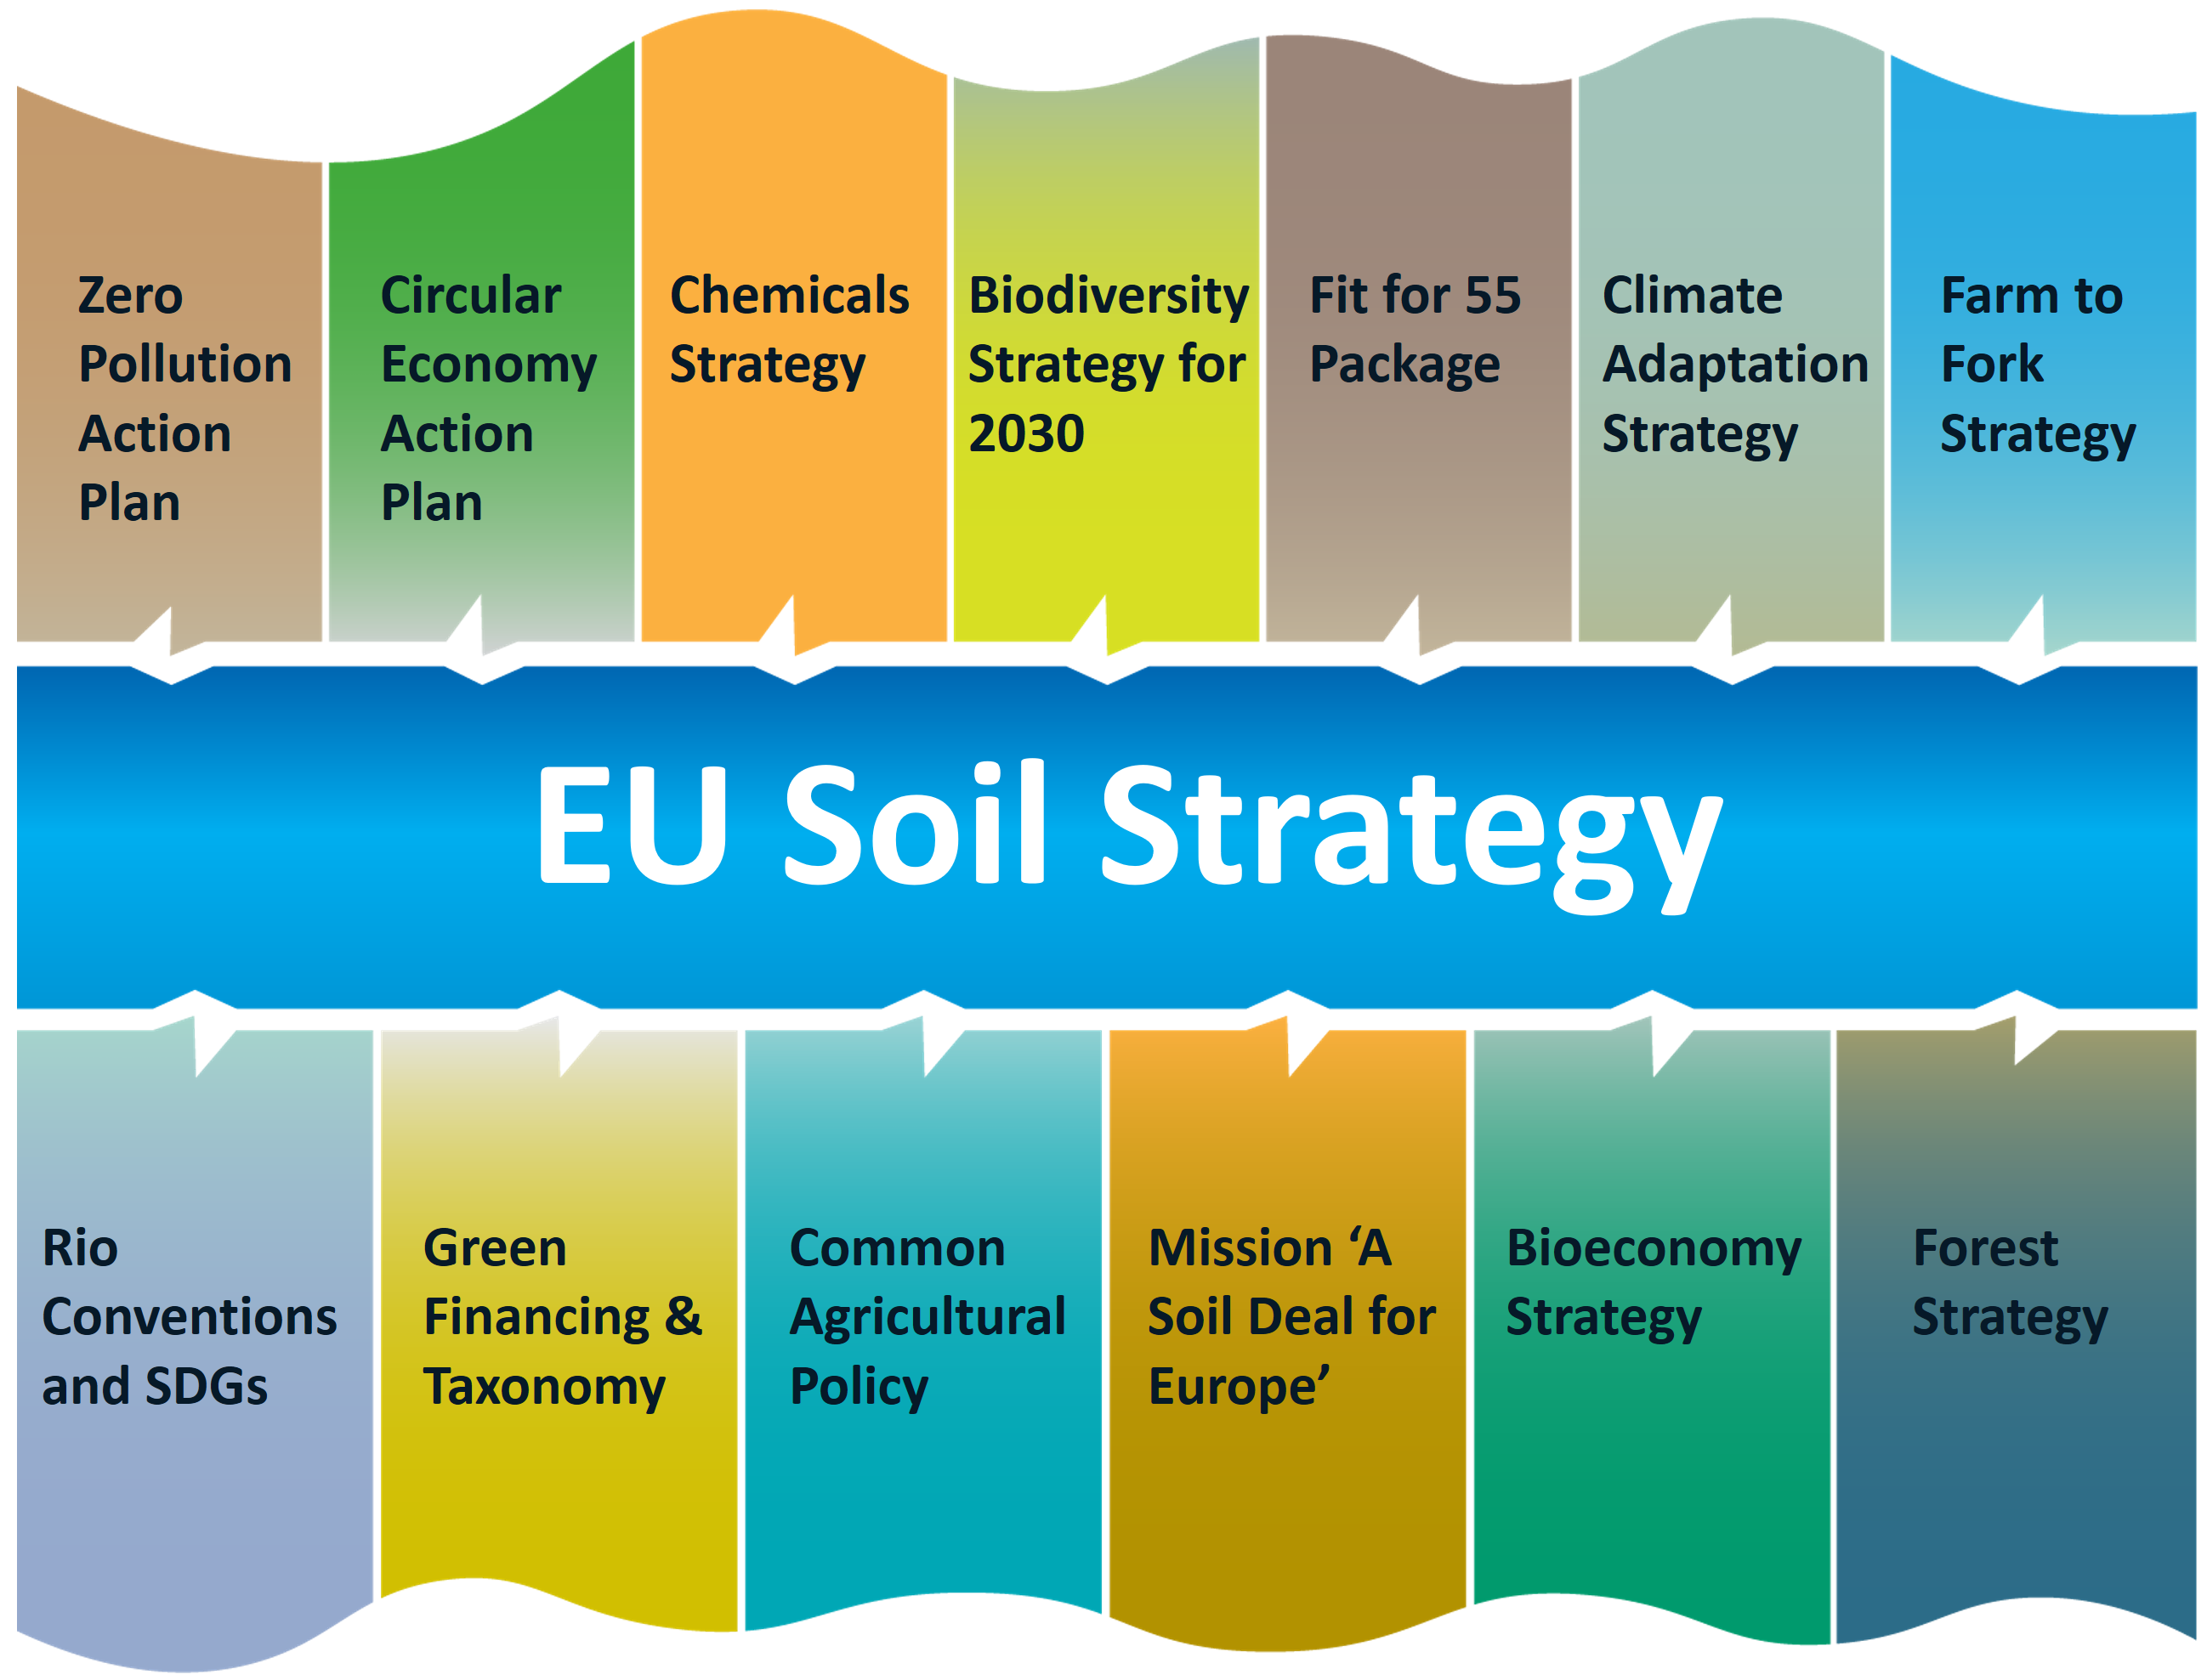
Figure 1: links between the EU Soil Strategy and other EU initiatives
- Vision and objectives: achieving good soil health by 2050
The vision for soil
By 2050, all EU soil ecosystems are in healthy condition and are thus more resilient, which will require very decisive changes in this decade.
By then, protection, sustainable use and restoration of soil has become the norm. As a key solution, healthy soils contribute to address our big challenges of achieving climate neutrality and becoming resilient to climate change, developing a clean and circular (bio)economy, reversing biodiversity loss, safeguarding human health, halting desertification and reversing land degradation.
This new vision for soil is anchored in the EU biodiversity strategy for 2030 and the Climate Adaptation Strategy. This Soil Strategy therefore builds on and will significantly contribute to several of the objectives of the Green Deal and objectives prior to that:
Medium-term objectives by 2030
- Combat desertification, restore degraded land and soil, including land affected by desertification, drought and floods, and strive to achieve a land degradation-neutral world (Sustainable Development Goal 15.3).
- Significant areas of degraded and carbon-rich ecosystems, including soils, are restored.
- Achieve an EU net greenhouse gas removal of 310 million tonnes CO₂ equivalent per year for the land use, land use change and forestry (LULUCF) sector.
- Reach good ecological and chemical status in surface waters and good chemical and quantitative status in groundwater by 2027.
- Reduce nutrient losses by at least 50%, the overall use and risk of chemical pesticides by 50% and the use of more hazardous pesticides by 50% by 2030.
- Significant progress has been made in the remediation of contaminated sites.
Long-term objectives by 2050
- Reach no net land take .
- Soil pollution should be reduced to levels no longer considered harmful to human health and natural ecosystems and respect the boundaries our planet can cope with, thus creating a toxic-free environment.
- Achieve a climate-neutral Europe and, as the first step, aim to achieve land-based climate neutrality in the EU by 2035.
- Achieve for EU a climate-resilient society, fully adapted to the unavoidable impacts of climate change by 2050.
Aside from some existing EU legal provisions relevant to soil protection and actions undertaken under the 2006 Soil Thematic Strategy, the EU has so far not been able to equip itself with an adequate legal framework granting soil the same level of protection as water, marine environment and air. Yet, the need has become more pressing, and the knowledge about soils and the recognition of their value has advanced significantly over the past years. The pressures, expectations and claims on soil have intensified, while the climate and biodiversity crises are aggravating the situation. We need healthy soils now more than ever.
What is a healthy soil?
Soils are healthy when they are in good chemical, biological and physical condition, and thus able to continuously provide as many of the following ecosystem services as possible:
- provide food and biomass production, including in agriculture and forestry;
- absorb, store and filter water and transform nutrients and substances, thus protecting groundwater bodies;
- provide the basis for life and biodiversity, including habitats, species and genes;
- act as a carbon reservoir;
- provide a physical platform and cultural services for humans and their activities;
- act as a source of raw materials;
- constitute an archive of geological, geomorphological and archaeological heritage.
The upcoming Commission proposal for a Nature Restoration Law aims at restoring ecosystems to good condition by 2050. Yet to achieve that objective for soil ecosystems, given the lack of EU soil policy, a number of important policy gaps will remain and would need to be filled. This Communication addresses these gaps through several strands.
The lack of dedicated EU legislation has been singled out by many as a major cause for the alarming state of our soils. Indeed, soil degradation has impacts that go beyond national borders (see accompanying staff working document), and lack of action in one Member State may lead to environmental degradation in another one. Equally, soil degradation, and an uneven and fragmented response by Member States to tackle it, has led to an uneven playing field for economic operators who have to go by different rules on soil protection while competing on the same market.
To address transboundary impacts of soil degradation, secure equal market conditions, promote policy coherence at EU and national level and thus be able to achieve our goals on climate change, biodiversity, food security and water protection, the Commission will table a dedicated legislative proposal on soil health by 2023 which will enable the objectives of this strategy to be met and good soil health to be achieved across the EU by 2050. Such a legislative initiative will fulfil better regulation requirements, be based on a thorough impact assessment, including a subsidiarity check, and fully respect the competences of Member States in this matter. To determine the scope and content of this proportionate and risk-based framework, the Commission will engage in a broad and inclusive consultation with Member States, the European Parliament and all relevant stakeholders.

While there is a big variety in the EU, soils also present a set of common characteristics. This makes it possible to define common ranges or thresholds beyond which soils cannot be considered healthy anymore. Such indicators for soil health and their range of values that should be achieved by 2050 to ensure good soil health will need to be developed and agreed, and they should be considered at EU level in the context of the Soil Health Law to ensure a level playing field and a high level of environmental and health protection. The Commission will mandate the new enlarged Expert Group on Soil Protection to develop them, building on the Soil Mission’s work. The membership of the current Commission Expert Group will be complemented in a balanced manner in order to provide additional advice. The Mission Board had advocated to aim for 75% of the soils of the European Union (EU) to be healthy or improving by 2030.
Knowing the health of a soil is very relevant for farmers, foresters, landowners, but also for banks, public authorities and many other stakeholders. There is an increasing interest for a refined soil quality index, e.g. in the financial and industrial sector. Some Member States have developed certificates of soil health to be provided during land transactions to adequately inform the buyer. In parallel, both the public and private sectors have been developing and investing in outcome-oriented approaches fostering effective practices for soil health, biodiversity, carbon storage capacity, etc.
- Soil as a key solution for our big challenges
  - Soil for climate change mitigation and adaptation

Net removals from the LULUCF sector are on a worrying trend. Between 2013 and 2018, the yearly net carbon removals were reduced by 20%. Achieving net-zero greenhouse gas emissions by 2050 relies also on carbon removals through the restoration and better management of soils to absorb the emissions that will remain at the end of an ambitious decarbonisation pathway. Targeted and continued sustainable soil management practices can significantly help in achieving climate neutrality by eliminating the anthropogenic emissions from organic soils and by increasing the carbon stocked in mineral soils.
Healthy soils will make the EU more resilient and reduce its vulnerability to climate change. Given the crucial role of soil in the water cycle, it is also an indispensable ally for climate adaptation. A high water retention capacity in soils reduces the effects of floods and decreases the negative impact of droughts.
The revision of the LULUCF Regulation that the Commission is proposing within the Fit for 55 legislative package aims to stop and reverse this trend and simplify the accounting rules.
In relation to climate change, these two main types of soils play an important role:
- Organic soils (including peatlands) have a high carbon content of more than 20% in dry weight and cover 8% of the EU. Peatlands are terrestrial wetlands in which waterlogged conditions prevent plant material from fully decomposing. Peatland drainage across all land categories in Europe alone emits around 5% of total EU greenhouse gas emissions. Emissions from cultivated organic soils have still not decreased significantly due to the continuation of harmful cropping practices. Yet restoring drained organic soils alone could significantly reduce CO₂ emissions from land, which comes with numerous co-benefits, for nature, biodiversity and water protection.
- Mineral soils feature a carbon content below 20%, although more generally it is below 5%. Every year mineral soils under cropland are losing around 7.4 million tonnes of carbon, caused i.a. by unsustainable farming practices. Yet, that carbon pool is the ‘bank account’ of farmers and foresters in terms of natural capital. It is essential not to deplete it, as the carbon content is the basis for soil’s biodiversity, health and fertility. Furthermore, carbon sequestration in mineral soils, while depending on soil type and climatic conditions, is a cost-effective emission mitigation method with significant potential to sequester between 11 to 38 MtCO₂eq annually in Europe if a range of management practices which have already been identified are applied on a larger scale in arable land. Many of these practices are cost-effective. Foresters as well have significant opportunities for measures which simultaneously improve forest productivity, carbon sink function and healthy soil properties.. The banking and financial sector is increasingly interested in investing in those farmers who apply sustainable practices and increase soil carbon, as well as creating market-based incentives for carbon storing. There is evidence that carbon farming can contribute significantly to the EU’s efforts to tackle climate change but also brings other co-benefits such as increased biodiversity and the preservation of ecosystems.
Actions
For soils to help meet the climate neutrality objective and contribute to climate adaptation, the Commission will, in line with the Fit for 55 package:
For organic soils:
- Based on the results of the impact assessment, consider proposing legally binding objectives in the context of the Nature Restoration Law, to limit drainage of wetlands and organic soils and to restore managed and drained peatlands, in order to maintain and increase soil carbon stocks, minimise flooding and drought risks, and enhance biodiversity, taking into account the implications of these objectives for future carbon farming initiatives and agricultural and forestry production systems. Furthermore, the EU is committed to the protection of wetlands and peatlands in line with the provisions of the CAP strategic plan regulation.
- Contribute to the assessment of the state of peatlands in the context of the Global Peatlands Initiative hosted by FAO and UNEP.
For mineral soils:
- The Commission will consider measures, possibly in the context of the Nature Restoration Law, to enhance biodiversity in agricultural land that would contribute to conserving and increasing soil organic carbon (SOC),
- Join the international initiative ‘4 per 1000’ to increase the soil carbon in agricultural land.
- Develop a long-term vision for sustainable carbon cycles (including capture, storage, and use of CO₂) in a climate-neutral EU economy. As part of this, the Commission will deliver a communication on restoring sustainable carbon cycles, in 2021 and present the EU carbon farming initiative and a legislative proposal on carbon removal certification in 2022 to promote a new green business model rewarding land managers, such as farmers and foresters, for climate–friendly practices.
  - Soil and the circular economy
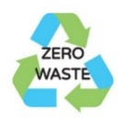
Soil is a major partner in a resource-efficient and circular economy, since it is arguably the planet’s biggest recycling machine: it recycles water, carbon and nutrients, and can break down and filter pollutants. In addition, soil deposits are used as raw material by many economic sectors, e.g. sand, gravel or clay for the construction industry. Yet, soil formation is so slow that prudent use is necessary. Prioritising the circular use of land over greenfield development will limit the acute pressure from soil sealing and land take.
    - A safe, sustainable and circular use of excavated soil
Most excavated soils are clean, fertile and healthy and should be reused in the same or another appropriate location. If it is not possible to reuse excavated soils, e.g. due to unacceptable levels of pollution, such soils should be prioritised for recycling or some other form of recovery rather than landfilling, in line with the waste hierarchy. A sustainable use of raw material is necessary. In 2018, more than 530 million tonnes of excavated soils were generated and reported as waste, with two thirds of such waste being recovered in operations bringing that soil back into the economy. To separate contaminated soil from clean soil, these streams have to be monitored more closely throughout the value chain, with traceability and quality control from the excavation site up to the receiving end.
Actions
The Commission will:
- Investigate the streams of excavated soils generated, treated and reused in the EU, and benchmark the market situation in Member States by 2023. This should give a complete picture of the situation in the EU.
- As part of the development of the Soil Health Law, assess the need and potential for legally binding provisions for a ‘passport for excavated soil’, and provide guidance, based on Member States’ experiences, to put in place such a system. The passport should reflect the quantity and quality of the excavated soil to ensure that it is transported, treated or reused safely elsewhere.
    - Limiting land take and soil sealing with a circular use of land
Soils provide the foundation for buildings and infrastructure. However, when we seal soil to build on top, we are losing irreversibly all its key ecosystem services, exposing cities to higher flood peaks and more intense heat island effects. Land and soil degradation are intertwined because ‘land’ indicates the surface, while ‘soil’ is the natural resource below it. Land and soils are fragile and limited resources subject to an ever growing hunger for space: urban sprawl and soil sealing consume nature and transform valuable ecosystems into concrete deserts. This often affects the most fertile soils and reduces the potential for farmers and foresters to make a decent living .
Having suffered from increased vulnerability to extreme weather events and other externalities, some Member States have set targets to reduce land take, however with uneven results. Land recycling, namely constructing in or rehabilitating already previously built-up areas , accounted for only 13.5% of urban developments in the EU (between 2006 and 2012), so there is room for improvement. In fact, some Member States have achieved rates higher than 50%, and up to 80%, showing that sustained land recycling is possible. This spares natural areas for the benefit of biodiversity, forests and green spaces, land for food and biomass production, water and rainfall regulation. Hence, there is a need to apply a hierarchy in land planning.

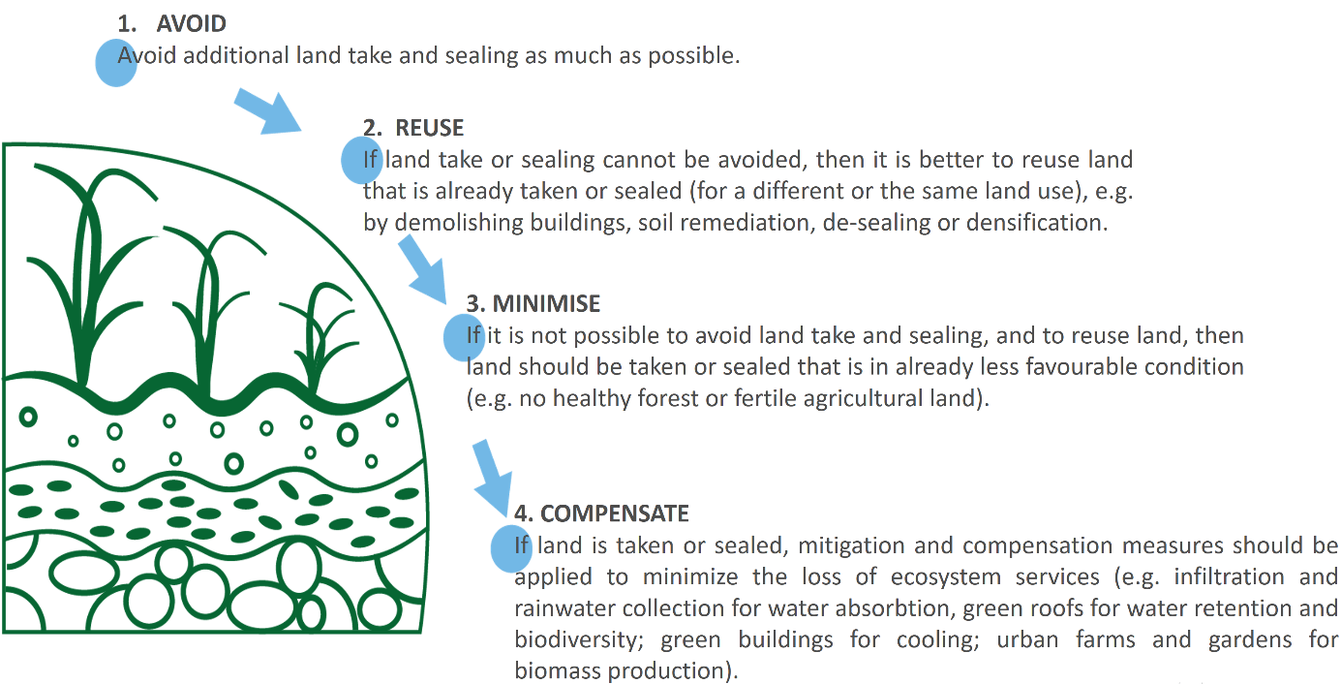
Figure 2: Land take hierarchy
Actions
The EU should achieve no net land take by 2050, which will contribute to the net removals target of 2030. To do so, notably
Member States should:
- Set by 2023 their own ambitious national, regional and local targets to reduce net land take by 2030 in order to make a measurable contribution to the EU target of 2050, and report on progress.
- Integrate the ‘land take hierarchy’ into their Urban Greening Plans, and give priority to reusing and recycling land and to quality urban soils at national, regional and local level, through appropriate regulatory initiatives and by phasing out financial incentives that would go against this hierarchy, such as local fiscal benefits for converting agricultural or natural land into built environment.
The Commission will also:
- Provide a definition of net land take in the Soil Health Law.
- As part of the impact assessment for the Soil Health Law, consider provisions for Member States to report on progress in achieving their land take targets
- As part of the impact assessment of the Soil Health Law, consider options for monitoring and reporting on progress towards the no net land take targets and the implementation of the land take hierarchy on the basis of the data reported by Member States.
- Provide guidance to public authorities and private companies on how to reduce soil sealing, including best practices for locally-driven initiatives for desealing artificial surfaces to let soil breathe, with a revision of the EU Soil Sealing Guidelines by 2024. Foster an exchange of best practices, building on experiences from Member States or regions that have spatial planning systems which successfully address the challenge of land take with a view to developing a common methodology.
    - Closing the nutrient and carbon circle
Leaves, biomass and roots are broken down by soil organisms to simpler compounds that provide soil fertility and are suitable to be taken up again by plants. Recycling organic matter such as compost, digestate, sewage sludge, processed manure and other agricultural residues has many advantages: the material after appropriate treatment serves as organic fertiliser, helps to replenish depleted soil carbon pools, and improves water retention capacity and soil structure, and thus enables closing of the nutrient and carbon cycle. However, this should always be carried out in a safe and sustainable way to prevent soil pollution. For that reason, the Commission will by 2022 revise the Urban Wastewater Treatment Directive and the list of surface water and groundwater pollutants, evaluate the Sewage Sludge Directive and adopt an Integrated Nutrient Management Action for a safer use of nutrients on soil. In the impact assessment for the Soil Health Law, the Commission will assess measures that can contribute to achieving the objective of the reduction of nutrient losses by at least 50% (resulting in the reduction of use of fertilisers by at least 20%), including the option of making this target legally binding. Building on the obligation to collect organic waste separately, the Commission will seek to finance a new LIFE project that addresses as an ad hoc priority the use of high quality compost from biowaste on soil. The Commission will also continue funding research to address the environmentally sound recovery of organic fertilisers from bio-waste.
  - Soil biodiversity for human, animal and plant health

Beneath our fields and our feet, an eclectic community of soil organisms toil day and night in a remarkable, coordinated effort that sustains life on Earth. One handful of healthy soil can contain up to a billion bacteria, more than one kilometre of fungi essential to plant and animal life. Yet we only know a little percentage of them. Moreover, soil hosts the first stages of life of many insects and pollinators.
Soil biodiversity greatly contributes to human health. Since the discovery of penicillin from a soil fungus, antibiotics produced by soil microbes have saved millions of lives. Recently, certain soil bacteria have been instrumental in a breakthrough in the development of much needed new antibiotics. Several cholesterol-lowering drugs were developed from soil fungi. It has been shown that children often playing in healthy forest soils have a stronger immune system. The ‘One Health’ principle clearly recognises that the health of the planet is closely linked with human and animal health. If one group is affected, this influences the health of the rest: for instance, the more balanced nutrients and trace elements are in soil the more nutritious food is. Many soil microorganisms are powerful allies against pollution, since they are capable of breaking complex contaminants, performing bioremediation for free. Equally, the healthier and cleaner the soil, the cleaner our water resources and the air we breathe. The soil fungal network has been shown to be key in maintaining healthy forests by enabling trees to share nutrients, water or defence signals.
Yet, soil biodiversity, just as the above-ground organisms, is threatened by land-use change, overexploitation, pollution, climate change and invasive alien species such as the New Zealand flatworm, a predator that can lead to the decline of earthworms and have dramatic effects on soil productivity. There is a need to increase the knowledge on the impact of land use change, overexploitation and other stressors on soil biodiversity, also by using synergies between the FSDN (Farm Sustainability Data Network) and LUCAS (Land Use and Coverage Area frame Survey) Soil. Achieving many of the targets of the EU biodiversity strategy and farm to fork strategy will also benefit soil biodiversity. To protect and preserve soil organisms, we need to monitor and know more about them and cooperate at international level.
Actions
The Commission will:
- Show its global leading role in building knowledge on soil biodiversity by publishing by 2022 the first assessment of EU soil biodiversity and antimicrobial resistance genes in agricultural soils under different management regimes (through the LUCAS Soil).
- Assess the risk of further alien flatworm species for their potential inclusion in the list of ‘invasive alien species of Union concern’, in line with the Invasive Alien Species Regulation.
- Strive for better coherence and stronger synergies between the Rio Conventions and strive for a post-2020 global biodiversity framework that recognises the importance of soil biodiversity, strengthens the use of sustainable soil management practices to safeguard ecosystem services (namely by promoting agro-ecology and other biodiversity-friendly practices) and integrates soil preservation and restoration in different targets and indicators.
- Actively contribute to the adoption by the 15th Conference of the Parties to the Convention on Biological Diversity of the plan of action 2020-2030 for the International Initiative for the Conservation and Sustainable Use of Soil Biodiversity and the updated plan of action and to its subsequent implementation.
- Step up efforts in mapping, assessing, protecting and restoring soil biodiversity and support the establishment of the Global Soil Biodiversity Observatory as proposed by the Food and Agricultural Organisation’s (FAO) Global Soil Partnership.
  - Soil for healthy water resources
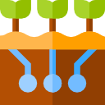
Soils, sediments and water are intimately connected. Soils filter, absorb and buffer water, but can also get eroded and polluted. When soil is sealed, water is transported differently across surfaces. Methods that allow floodwaters to infiltrate soils in order to reduce disasters and pollution to water bodies are important for water management. The restoration of the sponge-like function of soils can boost the supply of clean, fresh water and reduce the risk of flooding and drought. Also, some highly fertile and carbon-rich soils are eroded and deposited downstream in river basins, dams and the sea, where often this sediment is dredged for nautical reasons. These sediments could be reused again, provided they are clean.
Hence, coordinating water and soil policies is essential to achieving healthy soils and aquatic ecosystems through better soil and water management, including across borders, and reducing the impact of floods on people and the economy. There is a comprehensive body of EU water law in place, and the new EU strategy on adaptation to climate change highlights the importance of healthy soils in minimising climate change related risks, such as floods and droughts. The Commission will consider addressing the adequate integration and coordination of soil and water management, including in the impact assessment for a Soil Health Law. It will also facilitate exchange of practices among the Member States on the nexus between soil, water and sediment and publish a guidance on the sustainable management of sediment. Member States should better integrate soil and land use management in their river basin and flood risk management plans where possible by deploying nature-based solutions such as protective natural features, landscape features, river restoration, floodplains, etc.
- Preventing soil and land degradation and restoring healthy soils
  - Making sustainable soil management the new normal

Soils are generally healthy in unmanaged and natural ecosystems, and can be maintained healthy also in managed ecosystems through the application of sustainable soil management (SSM). This is a set of practices that is able to maintain the soil in, or restore it to, a healthy condition yielding multiple benefits, including for water and air. These practices increase soil biodiversity, fertility and resilience which are needed for the vitality of rural areas.
There is no magic recipe for SSM that applies to all soil types and climatic conditions or to all types of land use. An increasing amount of knowledge, including empirical knowledge, can be applied in agriculture and forestry. On the principles to be followed, there are international reference documents such as the FAO Voluntary Guidelines for Sustainable Soil Management. However, there is no agreed common definition at EU level of SSM that is concrete and complete to be enforceable.
These practices are also part of broader agro-ecological principles which are at the heart of the farm to fork and biodiversity strategies and their targets to bring back at least 10% of agricultural area under high-diversity landscape features, to reduce nutrient losses and risk and use of chemical pesticides, to increase the proportion of agricultural land under organic farming and to increase soil organic matter. There is evidence that soil carbon levels are likely to improve if organic farming is applied to agricultural production systems. Equally, agroforestry provides many benefits for soil health and climate adaptation. Other sustainable practices include cover cropping, crop rotation, the incorporation of crop residues, contour farming in slopes, avoid heavy machinery, the safe and compost, preventing conversion to arable land, conversion to grassland, continuous soil cover, reduced tillage and chemical inputs.
Making sustainable soil management the new normal requires coordination and working together at local, regional, national, EU and global level to promote and implement such practices. Playing its role, the Commission will integrate the sustainable use of soils in the relevant EU policies.
The role of advisory services both in agriculture and forestry is absolutely essential in assisting land users. For agricultural soils, local action must be closely nurtured and fostered with sufficient support from the farm advisory services and the Agricultural Knowledge and Innovation Systems (AKIS) of the CAP strategic plans.
The new CAP has introduced an enhanced conditionality for environmental protection. Conditionality sets the baseline for more ambitious and sustainable agricultural commitments through environment- and climate-friendly farming practices under eco-schemes and rural development interventions.
Maintaining healthy soils is particularly important, including in forests, as there is a strong interdependence between trees and the soil on which they grow, with mutual benefits and losses. In line with the new Forest Strategy, forest management needs to avoid unsustainable practices that degrade the soil, for example through compaction, erosion or loss of soil organic carbon.
To make it happen on the ground, and inspired by the French national soil sampling scheme BDAT , a ‘TEST YOUR SOIL FOR FREE’ initiative is proposed below. Knowing more about soil characteristics (pH, bulk density, soil organic matter, nutrient balance, etc.) will help land users to adopt the best management practices. For that reason, building on years of experience surveying soils in the LUCAS survey, the Commission will assist Member States in setting up, with their own funds, a system to test soil for free for those land users that so wish, and who will receive the results of the tests. This will complement existing obligations in Member States for soil sampling. In order to maximise consistency in approaches to sampling techniques, and to ensure appropriate advice, the involvement of AKIS advisors is crucial. An estimate of the costs involved in such an initiative are included in the staff working document accompanying this strategy.
Along the food value chain, many businesses are increasingly committing to agro-food and forestry production practices that respect and increase the health of soils. This helps raise consumer awareness and addresses expectations by citizens and stakeholders of concrete results on soil health.
Actions
To promote sustainable soil management, the Commission will:
- As part of the Soil Health law, and in the context of an impact assessment, assess requirements for the sustainable use of soil so that its capacity to deliver ecosystem services is not hampered, including the option of setting legal requirements.
- Prepare, in consultation with Member States and stakeholders, a set of ‘sustainable soil management’ practices, including regenerative farming in line with agro-ecological principles, adapted to the wide variability of soil ecosystems and types, and identify unsustainable soil management practices.
- Provide assistance to Member States to put in place through national funds the ‘TEST YOUR SOIL FOR FREE’.
- Create with the Member States a network of excellence of practitioners, and an inclusive network of SSM ambassadors, including on regenerative and organic agriculture, connecting stakeholders beyond academia and agricultural actors. For this they will build on the work of Living Labs and Lighthouses of the Mission ’A Soil Deal for Europe’ (see Section 5.3).
- In the context of the CAP and in close cooperation with the Member States, continue the dissemination of successful sustainable soil and nutrient management solutions, including through the national rural networks of the rural development programme, farm advisory services and AKIS, and the European Innovation Partnership for Agricultural Productivity and Sustainability (EIP-AGRI).
- Promote SSM through voluntary commitments between actors in the food system under the EU Code of Conduct on Responsible Food Businesses and Marketing practices.
- Value outstanding achievements and innovative initiatives on sustainable soil management by strengthening cooperation with the farming community such as though the European Land Owners Soil Award.
- Continue to support the Global Soil Partnership in promoting sustainable soil management worldwide.
- Propose by 2023 a legislative framework for an EU sustainable food system, as indicated in the Farm to Fork Strategy.
Member States should:
- Duly include in their programmes under EU cohesion policy the conservation, restoration and sustainable use of soil, making full use of the EU guidance on integrating ecosystems and their services into decision-making.
- Ensure the CAP’s strong contribution to maintaining and enhancing soil health, in line with the CAP Strategic Plans analysis and needs assessment. This is to be achieved, among others, by adopting ambitious CAP strategic plans containing sufficient interventions under the green architecture, following the Commission’s CAP recommendations. The Commission will continue providing necessary guidance and assess the contribution and consistency of these plans towards the Green Deal targets.
- Set up at the appropriate level the ‘TEST YOUR SOIL FOR FREE’ initiative.
  - Preventing desertification
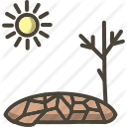
The United Nations Convention to Combat Desertification (UNCCD) has recognised the link between desertification, land degradation and drought, and the need to take urgent action by reversing land degradation. It set the target of land-degradation-neutrality (LDN), later taken up as one of the UN Sustainable Development Goals in 2015. All Parties of the Convention have been encouraged to publicly report on land degradation every 4 years, and several EU Member States have submitted the 2018 report.
Europe will be affected by a rise in drought conditions (as well as heavy precipitation events), thus enhancing the risk of future desertification processes and already affecting agricultural production in Europe.
Already in 2008, extensive processes resulting in desertification were observed both in Mediterranean and Central and Eastern European countries, and a study from 2017 confirmed this trend. Whilst thirteen Member States have declared themselves as ‘affected party’ under the UNCCD, the EU has not yet done so. While the risk of desertification in the EU relates to specific regions, the environmental, social and economic impact concerns the whole EU. Not only does the loss of soil fertility put food security at risk, desertification also reduces both above-ground and below-ground biodiversity, further contributes to climate change through loss of soil carbon and feedback effects on the atmosphere, brings poverty and health problems and leads to migration within and from outside the EU.
The European Court of Auditors concluded that the steps taken by the Commission and Member States to combat desertification lack coherence and that there is no shared vision in the EU on how land degradation neutrality will be achieved by 2030.
Despite some progress, much more must be done to transition the agricultural sector to adapt to the weather extremes, especially at farm level. A wide number of soil protection measures are available that help retain water and reduce water needs, avoid salinisation and increase resilience to droughts. Therefore, applying specific sustainable soil management practices that retain moisture, planting bushes and trees that generate shade, and cultivating plants and crop species and variants adapted to dry climatic conditions can reverse the trend towards desertification and restore soils already affected by it. Member States have already been encouraged to develop drought management plans and monitor drought events and their severity with specific indicators.
Actions
The Commission will:
- Establish a methodology and relevant indicators, starting with the UNCCD’s three indicators, to assess the extent of desertification and land degradation in the EU.
- Propose to Member States to declare the EU affected by desertification under UNCCD and continue to encourage Member States to participate in the United Nation’s Land Degradation Neutrality (LDN) Target Setting Programme.
- Supported by the European Environment Agency (EEA) and the Joint Research Centre (JRC), publish information every five years about the state of land degradation and desertification in the EU.
- Continue support to key initiatives such as the Great Green Wall initiative, Regreening Africa, and aid on land/soil issues in development cooperation.
Member States should:
- Adopt, in line with the actions envisaged in the EU climate adaptation strategy, appropriate long-term measures to prevent and mitigate degradation, notably by reducing water use and adapting crops to the local water availability, coupled with wider use of drought management plans and application of sustainable soil management.
  - Preventing soil pollution
Preventing diffuse and point-source soil pollution remains the most effective and cheapest way to ensure clean and healthy soils in the long term. As a priority, contamination should be prevented at the source. This can be done, for example, by having clean industry, sustainable product design, improved recycling, waste management and nutrient recovery, more efficient fertiliser application or reduced pesticide use and risk, as well as implementing the Strategic Approach to Pharmaceuticals in the Environment and reducing the use of antimicrobials. This should be complemented by reduced emissions and a safer production and use of chemicals.
The EU has legislation to prevent the release of emissions of hazardous substances into the environment, including soil. To prevent soil contamination, it is important that the risks of chemicals for soil quality and biodiversity are properly considered in risk assessments. Yet, the necessary data on the hazard and environmental fate of and exposure to such chemicals and the resulting risk they pose for soil quality and organisms are often lacking.
Actions
Building on the Farm to Fork, Biodiversity and Chemicals Strategies and the Zero Pollution Action Plan, the Commission will:
- Revise the Directive on the Sustainable Use of Pesticides and evaluate the Sewage Sludge Directive by 2022.
- Improve and harmonise the consideration of soil quality and soil biodiversity in EU risk assessments for chemicals, food and feed additives, pesticides, fertilisers, etc. It will do this under the ‘one substance one assessment’ initiative and in collaboration with the European Chemicals Agency (ECHA), the European Food Safety Authority (EFSA), the EEA, JRC and the Member States.
- Restrict intentionally used micro-plastics under the Registration, Evaluation, Authorisation and Restriction of Chemicals (REACH) Regulation and develop measures on the unintentional release of microplastics by 2022. Following the initiation of the restriction process by some Member States, the Commission will prepare a restriction under REACH on all non-essential uses of the per- and polyfluoroalkyl substances (PFAS), preventing their emission to the environment including soil, and also develop a policy framework on bio-based, biodegradable and compostable plastics by 2022.
- By July 2024, adopt biodegradability criteria for certain polymers, such as coating agents and agricultural mulch films under the EU Fertilising Products Regulation. The contaminant limits for EU fertilising products will be reviewed by July 2026 as part of the general review of that regulation.
  - Restoring degraded soils and remediating contaminated sites

A degraded soil has lost partially or completely its capacity to provide its multiple functions and services. In some cases, resorting to sustainable soil management allows soil to re-establish a healthy condition, leading to full recovery after some years (e.g. in case of loss of carbon and biodiversity or compaction and erosion of the top fertile layer). In other cases, active restoration measures are needed for sometimes only partial recovery (e.g. for sealed, desertified, salinised or acidified soils). In the EU Biodiversity Strategy for 2030, the Commission announced a proposal for legally binding EU nature restoration targets in 2021 to restore degraded ecosystems, in particular those with the most potential to capture and store carbon and to prevent and reduce the impact of natural disasters. Sometimes, alas, degradation is irreversible.
Contaminated sites require remediation with often complex and costly techniques, although in certain cases low-cost, bioremediation techniques have been shown to be effective. Nonetheless, in some cases soils have been degraded to such an extent that they cannot be fully restored to a healthy condition at a reasonable cost. In such cases, appropriate measures are needed to confine or manage the risk of the contaminated site in order to prevent any further harm to the environment and human health.
By 2050, soil pollution should be reduced to levels which are no longer expected to pose risks and which respect the boundaries our planet can cope with, thus creating a toxic-free environment. Recently, in the case of mercury-contaminated soil, one Member State with a well-maintained register (Belgium) identified more than 1 600 contaminated sites while several other Member States reported none. Some Member States have very comprehensive legislation in place at national or regional level, while others do not. This latter group has no specific soil contamination and remediation laws, applies more of an ad hoc approach and does not have a register for (potentially) contaminated sites. Reporting on progress in managing soil contamination is currently voluntary, irregular and based on a changing methodology, different national definitions, screening values and risk assessment methodologies. In light of this lack of level playing field, the Commission will therefore explore the need for legal provisions to make such reporting mandatory and uniform across the EU in the context of the Soil Health Law.
When efforts to prevent and control the source of pollution have failed and contaminants reach the soil and pose risks for the environment and human health, the soil must be remediated and the polluter should pay for it. The Environmental Liability Directive obliges certain operators to remediate contaminated land that poses risks for human health if pollution occurred as the consequence of activities carried out after 30 April 2007 or, if carried out before, not yet finished at that date. The Industrial Emissions Directive requests operators of certain installations to establish the state of soil and groundwater contamination at the start of operations, apply for a permit that includes conditions to prevent soil pollution through application of the best available techniques and to take necessary action upon definitive cessation to return the site to its initial status. The Commission is also working on a revision of the Environmental Crime Directive, which will propose an ambitious instrument to tackle environmental crime and introduce effective tools for law enforcement authorities across the Union to enforce its environmental policy (including soil pollution offences), with the support of Eurojust in cross-border cases.
However, for historical or orphan contaminated sites, a common approach is lacking in the EU, which is a very important legal gap. It is crucial that all Member States identify and maintain a register for contaminated sites, assess the risks and finally remediate these sites in case of unacceptable risks. This is required to honour the several commitments made at global level on the management of contaminated sites.
All Member States face the same challenges and independently have to develop national methodologies for assessing the risks of soil contamination. In 2018, there were more than 21 000 registered chemicals on the EU market. The PFAS group alone consists of more than 4 700 chemicals highly persistent in the soil and in humans. Only a very small fraction of all chemicals is screened in the standard soil analysis, and even fewer substances are regulated under national legislation with contaminant thresholds. This means that most chemicals remain undetected in the soil. The fate, behaviour and (eco)toxicological effects of contaminants of emerging concern are not yet well understood, especially for lower orders of soil biota. There is a need to assess the risks of these substances already present in soils, sediments and water bodies, and take appropriate remedial action if required. This is a shared challenge that requires increased knowledge and data exchange and collaboration between Member States.
Actions
As part of the impact assessment for a Soil Health Law, the Commission will:
- consider options for proposing legally binding provisions to:
i) identify contaminated sites, ii) set up an inventory and register of those sites and iii) remediate the sites that pose a significant risk to human health and the environment by 2050.
- assess the feasibility of the introduction of a soil health certificate for land transaction to provide land buyers with information on the key characteristics and health of the soils in the site they intend to purchase.
In addition to these legal provisions, the Commission will:
- In cooperation with Member States and stakeholders, facilitate a dialogue and knowledge exchange on the risk assessment methodologies for soil contamination and identify best practices.
- By 2024, develop an EU priority list for contaminants of major and/or emerging concern that pose significant risks for European soil quality, and for which vigilance and priority action at European and national level is needed.
- By 2022, revise the Industrial Emissions Directive and by 2023 evaluate the Environmental Liability Directive, including with regard to the definition of land damage and the role of financial security.
Member States should:
- Establish a system of soil health certificates for land transactions, with support by the EU research programme and mission ‘A Soil Deal for Europe’, if this is not included in the Soil Health Law.
- We need to know more about soils
It is essential to make more and better knowledge and data about soils available and to use this knowledge and data. Access to soil research data will be made easier through the creation of a Green Deal dataspace and the implementation of the Horizon Europe Mission ‘A Soil Deal for Europe’. Building on the INSPIRE Directive, open standards for data should improve the interoperability of national, EU and global soil monitoring frameworks.
  - Soil and the digital agenda

Digital technologies present new and untapped opportunities for monitoring the pressures and condition of soils and land. Our knowledge on soil in the last decade has gained enormously from, Earth observation, in particular RADAR systems and hyperspectral sensors, remote sensing, new techniques such as DNA analysis for soil organisms. The target of the Farm to Fork Strategy on availability of fast broadband internet, also in rural areas, will help data transfer and smart use as well as real-time monitoring with sensors. Examples of digital solutions for addressing soil pollution, including FaST, have been highlighted in the Zero Pollution Action Plan. Copernicus, the European Union's Earth observation programme and its land monitoring service will continue to provide data on bio-geophysical variables, land cover and land use in the EU and beyond. These activities will radically contribute to innovative soil research and use. Through these activities, it will also be possible to increasingly use machine learning techniques and use more artificial intelligence solutions from sensing systems (such as those provided by precision agriculture) and field-based measuring systems (e.g. hand-held spectrometers, portable DNA extraction, on-site chemical analysis).
Actions
The Commission will:
- Enhance the use of digital tools and Copernicus and rely on the JRC to further develop the European Soil Observatory (EUSO) and the EEA to develop the Land Information System for Europe (LISE), supported by geospatial analytical products.
- Encourage and support Member States to set-up farm sustainability tools for nutrients (FaST), as part of the farm advisory services under the new CAP. Such tools will provide to farmers recommendations about the use of fertilisers, compliant with existing legislation and based on available data and knowledge.
- Improve the modelling capacity of soil-related processes under the Commission’s Destination Earth in collaboration with the Horizon Europe Mission ’A Soil Deal for Europe’.
  - Soil data and monitoring
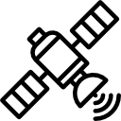
Several soil monitoring systems are present at Member State level. However, overall, they are fragmented, incomplete and in general not harmonised across the EU. Data are often not yet publicly shared in accordance with the mechanism of the INSPIRE Directive. There is currently no systematic comprehensive monitoring of policy-relevant issues in many countries due to a lack of capacity or resources. The Commission’s LUCAS soil initiative is the only monitoring system that provides harmonised and systematic on-the-field measurements for all Member States. But it needs to be better integrated with activities in Member States and other data flows. Also the EEA provides indicators such as on soil sealing and land take, yet our knowledge on soil will greatly profit from better data resolution, more frequent measurements and harmonisation of approaches between Member States. An integrated soil indicator system is needed to serve as an umbrella for further monitoring and reporting. The EUSO was launched recently to help set up an EU-wide soil monitoring system pursuant to the INSPIRE Directive and in connection with national reporting under the NEC Directive and LULUCF Regulation.
Actions
To fill the monitoring gap for soil, the Commission will:
- Following an impact assessment, and as part of the Soil Health Law, consider provisions on monitoring soil and soil biodiversity and reporting on the condition of soil, building on existing national and EU schemes, including LUCAS soil module; consider, as part of the impact assessment, providing a legal basis for the LUCAS soil survey to legally anchor the objectives, conditions, funding, access to land, use of data and privacy issues.
- Provide through the LUCAS soil surveys EU-wide harmonised monitoring of the evolution in soil organic carbon content and carbon stocks, complementing Member States’ reporting under the LULUCF Regulation.
- Work towards integrating a pollution module in the future LUCAS in 2022 soil survey to better understand and map the issue of diffuse soil contamination in the EU, and produce a clean soil outlook as part of the integrated zero pollution monitoring and outlook framework.
- In implementing the EUSO:
  - Identify, with the contribution of the European joint programme on agricultural soil management, soil monitoring gaps, in dialogue with Member States and other key stakeholders
  - Develop a soil dashboard with a set of reliable soil indicators integrating trends and foresight.
  - Develop an EU inventory of soil biota in order to monitor and better understand soil biodiversity.
  - Soil research and innovation

The Horizon Europe framework programme for research and innovation will facilitate knowledge creation, collaboration and thereby accelerate the transition to healthy soils. In this context, there are relevant instruments available through Cluster 6, Food2030 priorities, and the Horizon Europe Partnerships (Food System, Biodiversity, Agroecology, Agriculture of Data, etc.). In addition, the Horizon Europe Mission ’A Soil Deal for Europe’ provides a comprehensive framework for research and innovation and contributes to creating a harmonised EU framework for soil monitoring and reporting and effective research-policy and research-practice interfaces to achieve healthy soils. In addition to addressing gaps in our knowledge, the mission will test, demonstrate and deploy solutions for soil health for their widespread uptake through a network of ‘living labs’ (experiments and innovation in a laboratory on the ground) and ‘lighthouses’ (places showcasing good practices).
Actions
Through Horizon Europe and in particular the Mission ’A Soil Deal for Europe’, the Commission will:
- Implement ambitious roadmaps for research and innovation to expand the knowledge base for soil stewardship and widen the access to and use of results from research activities.
- Continue providing substantial funding to i) research solutions to increase soil biodiversity; ii) address soil degradation; iii) pilot innovative technologies for decontamination.
- Promote the development and use of digital and remote sensors, apps and handheld samplers to assess soil quality.
- Enabling the transition to healthy soils
  - Private finance and EU funding

Entire value and supply chains and economic sectors depend on healthy soils. Yet, many of the actors in these value chains are unaware of the vulnerability of their assets to soil degradation. Investors and banks are becoming increasingly aware of the financial risks of soil degradation and the returns of prevention and restoration. Some banks offer farmers a lower interest rate when their soil is healthy, because the land value is higher and the loans can be resold to sustainable pension funds and asset managers that want to have a positive impact on people and the planet. Farmers are more and more financially rewarded for the carbon that their soils capture and the application of sustainable soil management practices through carbon payment schemes. Companies are increasingly offsetting carbon emissions by buying carbon credits from farmers, investing in soil health by applying sustainable farming practices or focusing on the niche of sustainable land redevelopment and remediation. As for funding, the current EU budget provides sources of funding to support the sustainable use and restoration of degraded soils, such as the CAP, the LIFE programme, Horizon Europe, Cohesion Policy. In the Recovery and Resilience Facility, there is as well a number of national Recovery and Resilience Plans that have included measures on soil protection. Particularly relevant in this context is the Commission’s ‘do no significant harm’ technical guidance to help Member States prepare their Recovery and Resilience Plans.
The Commission will set up a dialogue with the public, private and financial sector to see how financing the prevention of soil degradation and the restoration of soil health can be improved.
Actions
The Commission will:
- Publish a guide in 2022 with an overview of EU funding opportunities available for the protection, sustainable management and restoration of soils, once all priorities and focus areas for 2021-2027 have been clearly defined.
- Promote investments in projects that sustainably manage and do not significantly harm soils under the EU Taxonomy Regulation and its delegated acts.
  - Soil literacy and societal engagement

Soil is probably the most undervalued element of nature. Increasingly urbanised populations often see it just as ‘dirt’ and as an unlimited natural resource, often unaware of its relevance in their daily lives and of its key role in the sustainable and circular bioeconomy. This reflects a lack of emphasis in education of the importance of soil and highlights the need to increase public awareness and societal engagement. Soil literacy combines broad awareness with specialised understanding across a range of disciplines through communication and educational activities that bring soil closer to people’s lives. To achieve this, all stakeholders must have access to both general education on soil and targeted training for specialist needs. Formal soil education should be complemented with active hands on learning and messaging on the sharing of best practices and shared knowledge. The recently adopted implementation plan of the Mission ‘A Soil Deal for Europe’ outlines the significant contribution of the mission to increase soil literacy through wide engagement with citizens and actors involved along the entire food production chain, including farmers, food companies and retailers.
Actions
The Commission, together with Member States and stakeholders, will:
- Launch a soil literacy engagement and awareness initiative, building on the successful example of the “ocean literacy”.
- Facilitate and encourage the sharing of best practices in communication and engagement on soil, building an EUSO portal and setting up outreach networks aiming at healthy soils.
- Integrate the issue of soil degradation under the European common reference framework of sustainability competences, to develop the concept of soil literacy with European citizens.
- Run a comprehensive portfolio of actions for communication, education, and citizen engagement to promote soil health at various levels and bring soils closer to citizen’s values, building on the Mission ‘A Soil Deal for Europe’ and the EU Soil Observatory.
- Conclusions

Bestowing on soil the same level of protection as air and water and marine environment and granting the same attention to soil inhabitants as we do for above-ground biodiversity is a major challenge. To succeed, the vision and the commitments set out in this strategy pave the way for ambitious and necessary changes. Successful implementation of this soil strategy requires inclusive and broad governance arrangements at national, EU and global level.
We need all stakeholders around the table to discuss and collaborate. Therefore, a new governance model based on a ‘network of networks’ and inspired by the Coalition4Oceans will be created: the EU Coalition4HealthySoils (C4HS). At its core, the EU Soil Expert Group will be enlarged to include a balanced representation of stakeholders. Policy action will continue to be based on data and knowledge from the EU Soil Observatory and the EIONET National Reference Centre on Soil and the Mission ’A Soil Deal for Europe’. C4HS will interact with other relevant EU expert groups, the Global Soil Partnership and its European Soil Partnership. The EU has always strongly supported the Global Soil Partnership of the FAO and its regional branches and will continue to do so to improve governance on sustainable soil management, including at global level.

Our soils need to be healed. It is a matter of our own survival. This Strategy sets therefore ambitious and necessary objectives, on which we need to urgently deliver. It is backed by scientific evidence and puts forward a set of actions which will help us to get there. By launching this Strategy, the Commission is going to engage in discussions with the European Parliament, the Council, the European Economic and Social Committee, the Committee of Regions, as well as with civil society, economic operators and other stakeholders to make this Strategy and its actions a common success.

FAO (2020), State of knowledge of soil biodiversity - Status, challenges and potentialities.
World Resources Institute (2019), Creating a sustainable food future.
European Commission (2021), EU Strategy on Adaptation to Climate Change – Impact assessment
European Commission (2005), Soil Atlas of Europe.
European Commission (2020), Caring for soil is caring for life.
EEA (2019), The European Environment: State and Outlook 2020.
Panagos P. et al (2015), The new assessment of soil loss by water erosion in Europe.
https://www.eea.europa.eu/data-and-maps/dashboards/land-take-statistics#tab-based-on-data
European Commission (2021), Accounting for ecosystems and their services in the EU (INCA)
World Business Council for Sustainable Development (2018), The business case for investing in soil health.
Estimated at EUR 50 billion in the report of the Mission board for Soil health and food (2020), “Caring for soil is caring for life”, https://op.europa.eu/en/publication-detail/-/publication/4ebd2586-fc85-11ea-b44f-01aa75ed71a1/
IPBES (2018), The assessment report on land degradation and restoration.
Nkonya et al. (2016), Economics of Land Degradation and Improvement - A Global Assessment for Sustainable Development.
EU Biodiversity Strategy for 2030, COM(2020)380.
EU Climate Adaptation Strategy, COM/2021/82.
United Nations (2015), Transforming our world: the 2030 Agenda for Sustainable Development.
EU Biodiversity Strategy for 2030, COM(2020)380.
Proposal for a revision of the LULUCF Regulation, COM(2021) 554.
Water Framework Directive 2000/60/EC
EU Farm to Fork Strategy, COM(2020) 381.
EU Biodiversity Strategy for 2030, COM(2020)380.
Roadmap to a Resource Efficient Europe, COM/2011/0571.
7th EU Environment Action Programme, Decision No 1386/2013/EU.
Pathway to a Healthy Planet for All, EU Action Plan: ‘Towards Zero Pollution for Air, Water and Soil’, COM(2021)400.
Climate Law Regulation (EU) 2021/1119.
Proposal for a revision of the LULUCF Regulation, COM(2021) 554.
EU Climate Adaptation Strategy, COM/2021/82.
Requirements related to specific aspects of soil protection within, for example, Sewage Sludge Directive, Industrial Emissions Directive, Common Agricultural Policy, Environmental Liability Directive, Waste Framework Directive, LULUCF Regulation.
Thematic Strategy for Soil Protection, COM(2006)231.
The European Parliament, the European Court of Auditors, the Committee of the Regions, the EEA in its State and Outlook of the Environment Report 2020, citizens and stakeholders answering the public consultation; see SWD(2021)323 for details.
Such as expertise from business and professional organisations, academia and scientific organisations, and the civil society.
Proposal for amending Regulations (EU) 2018/841 and (EU) 2018/1999, COM/2021/554
Delivering the European Green Deal: Fit for 55 package
Calculated from data derived from the national submissions to the UNFCCC.
European Commission (2021), Technical guidance handbook: Setting up and implementing result-based carbon farming mechanisms in the EU. Data are from 2016, including UK.
European Commission (2018), In-depth analysis in support of this in COM(2018) 773: A Clean Planet for all - European strategic long-term vision a prosperous, modern, competitive and climate neutral economy
Lugato et al. (2014), Potential carbon sequestration of European arable soils estimated by modelling a comprehensive set of management practices.
European Commission (2021), Technical guidance handbook: Setting up and implementing result-based carbon farming mechanisms in the EU
European Commission (2021), Technical guidance handbook: Setting up and implementing result-based carbon farming mechanisms in the EU
www.globalpeatlands.org
www.4p1000.org
European Commission carbon farming initiative, ‘Climate change – restoring sustainable carbon cycles’
EU principles for sustainable raw materials
In accordance with Article 2, 1(c) of Waste Framework Directive 2008/98/EC, uncontaminated soil and other naturally occurring material excavated in the course of construction activities where it is certain that the material will be used for the purposes of construction in its natural state on the site from which it was excavated, is excluded from the scope of this Directive. Reused excavated soil is also not reported as waste.
European Commission (2020), Study to support the preparation of Commission guidelines on the definition of backfilling.
Pistocchi A. et al (2015), Soil sealing and flood risks in the plains of Emilia-Romagna, Italy.
European Commission (2012), In depth report: soil sealing.
The loss of agricultural land from 1990 to 2006 through sealing in EU countries had the productive capacity equivalent to 6 million tonnes per year of wheat (Gardi et al. (2014)).
European Academies Science Advisory Council (2018), Opportunities for soil sustainability in Europe.
The impact of overall EU consumption is estimated at over 9 million hectares deforested between 1990 and 2008 to meet the EU’s imports of crops and livestock. Source: Consumption Impact Study - Forests - Environment
Germany aims to seal less than 30 hectares per day until 2030; Austria had set 2.5 ha per day until 2010; two Belgian regions (Flanders and Wallonia respectively) set targets for reducing land take to zero by 2040/2050 respectively.
Land recycling and densification — EEA
See EU Biodiversity Strategy for 2030, key commitment 11 of the Nature restoration plan: “Cities with at least 20,000 inhabitants have an ambitious Urban Greening Plan.” by 2030.
Guidelines on best practice to limit, mitigate or compensate soil sealing, Commission Staff Working Document (2012) 101.
Czechia has divided agricultural land into five protection classes to protect the most valuable and fertile soils from land take.
EEA (2019), Land and soil in Europe.
Pathway to a Healthy Planet for All, EU Action Plan: ‘Towards Zero Pollution for Air, Water and Soil’, COM(2021)400.
For example: Horizon 2020 (Closing nutrients cycle) and Horizon Europe (Environmental impacts and trade-offs of alternative fertilising products at global/local scale)
Fortuna, A. (2012), The Soil Biota. Nature Education Knowledge.
Brevik et al. (2020), Soil and human health: current status and future needs
Yu Imai et al. (2019), A new antibiotic selectively kills Gram-negative pathogens
One Health (who.int)
Wall and Six (2015), Give soils their due
Pickles et al. (2017), Mycorrhizal Networks and Forest Resilience to Drought. Mycorrhizal Mediation of Soil, pp. 319-339
Joint Research Centre (2021), Baseline distribution of invasive alien species added to the Union list in 2019
EU Regulation 1143/2014 on the prevention and management of the introduction of invasive alien species.
https://www.cbd.int/meetings/COP-15
FAO (2020), State of knowledge of soil biodiversity – Status, challenges and potentialities.
European Innovation Partnership for Agriculture
IUCN (2020), Common ground: restoring land health for sustainable agriculture
Good Agricultural and Environmental Practices (GAEC) under CAP; https://ec.europa.eu/info/food-farming-fisheries/key-policies/common-agricultural-policy/income-support/cross-compliance_en#gaec
Pro Silva Principles, https://www.prosilva.org/close-to-nature-forestry/pro-silva-principles/
FAO (2017), Voluntary Guidelines for Sustainable Soil Management.
Gattinger A. et al (2012), Enhanced top soil carbon stocks under organic farming.
https://ec.europa.eu/info/food-farming-fisheries/key-policies/common-agricultural-policy/cap-glance_en - thenewcap
New EU Forest Strategy for 2030, COM(2021)572 final.
https://www.gissol.fr/le-gis/programmes/base-de-donnees-danalyses-des-terres-bdat-62
See the EU Code of Conduct on Responsible Food Business and Marketing Practices, https://ec.europa.eu/food/horizontal-topics/farm-fork-strategy/sustainable-food-processing/code-conduct_en
Soil and Land Award (europeanlandowners.org)
SWD(2019)305 on EU guidance on integrating ecosystems and their services into decision making.
Eco-schemes and rural development as well as ambitious ‘good agricultural and environmental conditions’.
See, for example, https://indicators.report/targets/15-3/
See UNCCD reporting platform: https://prais.unccd.int/unccd/reports
EEA (2019), Climate change adaptation in the agriculture sector in Europe
Bulgaria, Croatia, Cyprus, Greece, Hungary, Italy, Latvia, Malta, Portugal, Romania, Slovakia, Slovenia and Spain. Source: European Court of Auditors (2018) Background Paper. Desertification in the EU
ECA Special Report 33/2018: Combating desertification in the EU: a growing threat in need of more action
EEA (2019), Climate change adaptation in the agriculture sector in Europe,
See recommendations from the assessment of the 2nd River Basin Management Plans.
https://www.greatgreenwall.org/
https://regreeningafrica.org/
Forging a climate-resilient Europe - the new EU Strategy on Adaptation to Climate Change, COM(2021)82.
Pathway to a Healthy Planet for All, EU Action Plan: ‘Towards Zero Pollution for Air, Water and Soil’, COM(2021)400.
European Environment Agency (2021), Land and soil pollution — widespread, harmful and growing
Directive 2009/128/EC.
Pathway to a Healthy Planet for All, EU Action Plan: ‘Towards Zero Pollution for Air, Water and Soil’, COM(2021)400.
https://ec.europa.eu/environment/chemicals/mercury/regulation_en.htm
Directive 2004/35/CE on environmental liability with regards to the prevention and remedying of environmental damage
Judgment in Joined Cases C-379/08 and C-380/08, ERG aos.
Directive 2010/75/EU on industrial emissions
Historical contamination was caused before the entry into force of national or EU legislation. On orphan sites, the polluter cannot be identified, no longer exists or cannot bear the remediation cost, e.g. due to bankruptcy.
UNEA-3 resolutions 3/4 on environment and health and 3/6 on managing soil pollution, the 2030 Agenda for Sustainable Development (SDG 3.9 and 15.3), the Minamata Convention (Article 12), the Stockholm Convention (Article 6), the Ostrava declaration of the 6th Ministerial Conference on Environment and Health.
https://echa.europa.eu/-/21-551-chemicals-on-eu-market-now-registered
SWD(2020)249 on Poly- and perfluoroalkyl substances (PFAS) accompanying the Chemicals Strategy
Industrial Emissions Directive 2010/75/EU
Environmental Liability Directive 2004/35/CE
A European Strategy for Data, COM(2020)66.
INSPIRE Directive 2007/2/EC.
Farm to Fork Strategy, COM(2020)381.
Farm sustainability tool, see https://fastplatform.eu
SWD(2021) 140
Copernicus Land Monitoring Service (CLMS)
https://ec.europa.eu/jrc/en/eu-soil-observatory
See https://digital-strategy.ec.europa.eu/en/policies/destination-earth
https://webgate.ec.europa.eu/fpfis/wikis/display/SOIL/National+monitoring+systems
INSPIRE Directive 2007/2/EC.
See also EEA (2021), Soil monitoring in Europe - Indicators and thresholds for soil quality assessments https://www.eea.europa.eu/publications/soil-monitoring-in-europe-indicators-and-thresholds/
National Emissions Reduction Commitments Directive 2016/2284, Article 9.
Land Use Land Use Change and Forestry Regulation 2018/841.
LUCAS - ESDAC - European Commission
This is being developed in coherence with other monitoring initiatives such as the EU groundwater watch list process.
EJP SOIL - Towards climate-smart sustainable management of agricultural soils
https://ec.europa.eu/info/research-and-innovation/research-area/environment/bioeconomy/food-systems/food-2030_en
Soil health for stronger farms? We can measure that (rabobank.com)
E.g. Soil Capital
Microsoft uses blockchain modern technology to purchase soil carbon credit in Australia
Living Soils initiative: Nestlé, McCain and Lidl address soil health in France
Revive
European Commission C(2021) 1054
Regulation (EU) 2020/852 on the establishment of a framework to facilitate sustainable investment, and amending Regulation (EU) 2019/2088.
https://oceanliteracy.unesco.org/
https://ec.europa.eu/info/law/better-regulation/have-your-say/initiatives/12985-Environmental-sustainability-education-and-training_en
https://www.eionet.europa.eu/countries/national-reference-centres/nrc-on-soil
https://ec.europa.eu/info/research-and-innovation/funding/funding-opportunities/funding-programmes-and-open-calls/horizon-europe/missions-horizon-europe/soil-health-and-food_en
http://www.fao.org/global-soil-partnership/regional-partnerships/europe/en/

