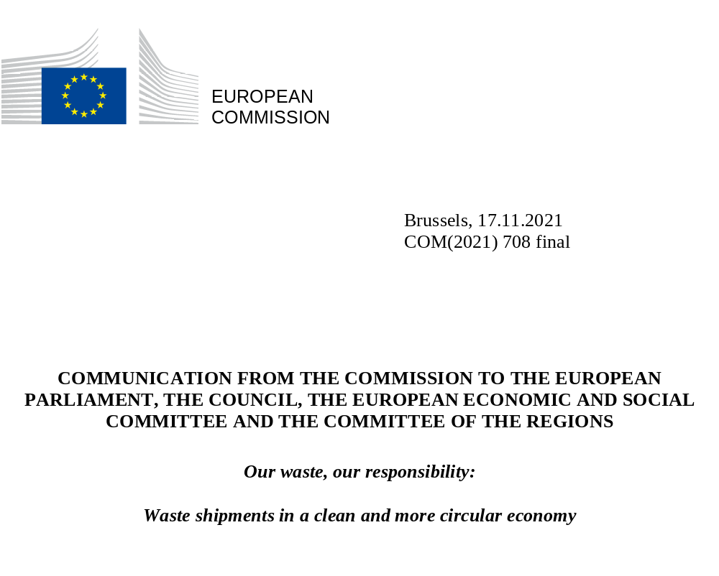

- INTRODUCTION

A robust and integrated market for secondary raw materials is a cornerstone of a well-functioning circular economy. Treating waste as a resource requires facilitating its circulation so that it can provide valuable flows of materials in support of more sustainable and resilient production, remanufacturing and reuse. This will contribute to fulfilling the EU climate objectives laid down in the Climate Law and the EU's “Fit for 55” package of legislative proposals to reduce greenhouse gas (GHG) emissions by 55% by 2030, as compared to 1990 levels.
Today only 12% of raw materials used in EU industry come from recycling. While shipments of waste for recovery in the EU have steadily increased in the last decade, too many waste materials are still not prepared for reuse or recycled in new products in the EU, representing a considerable loss in its transition to a circular economy. Every year, the EU exports around 33 million tonnes of waste. This represents around 16% of the total of global trade in waste, making the EU one of the top exporters of waste worldwide. The EU also imports 16 million tonnes of waste, while 70 million tonnes of waste is traded within the EU. The EU relies heavily on exports for a number of waste streams, in particular ferrous and non-ferrous metal scrap, paper waste, plastic waste, textile waste and glass waste.
EU exports of waste have increased by 75% since 2004, with almost half of it destined for non-OECD countries. This has generated increased pollution linked to the unsound treatment of some of this waste in many destination countries. Large volumes of waste exported from the EU end up in open dumpsites or are burnt in open air, where they contaminate air and water, harm public health and emit substantial amounts of greenhouse gas. This is particularly problematic in developing and emerging countries, which already face important challenges in dealing with their domestic waste and are expected to experience the highest growth in waste generation in the future. The leakage into the ocean of plastic waste exported abroad has also become a major source of marine pollution. An increasing number of countries have introduced restrictions or bans on the imports of waste, notably China, which used to be the largest importer of plastic and paper waste from the EU, followed by other major importers of EU waste in Southeast Asia.
Furthermore, waste trafficking is one of the most serious forms of environmental crime and an area in which organised crime networks are active, both for intra-EU and extra-EU shipments of waste. Coordinated enforcement campaigns indicate that between 15% and 30% of waste shipments might be illegal, amounting to EUR 9.5 billion annual revenues from the illicit waste market in the EU. In addition to environmental harm, waste trafficking also poses security threats, particularly in situations when criminal groups, involved in such shipments, are spread across several countries. It is therefore paramount that the the EU and the Member States make the fight against waste trafficking a higher priority among enforcement agencies, improve cooperation between all relevant authorities and ensure that sanctions against criminal activities in the waste sector are truly deterrent.
These developments have exposed the fragility of a business model where the export of waste has become a common way of dealing with some waste streams generated in the EU. It is essential for the EU to take greater responsibility for its own waste, ensure that a high level of environmental protection is preserved and that the polluter pays.
Modernising the EU policy and legislation on waste shipments and a shift to digital solutions will encourage more shipments of waste to be sent for preparation for re-use and recycling in the EU and will provide incentives to reduce waste generation. This will result in improved security of supply for the industrial ecosystems in the EU, reducing their dependence on the use of primary raw materials including critical raw materials, encourage their full integration in circular models and lower their carbon footprint. A good example in this regard is the steel industry, identified in the Commission’s new industrial strategy for Europe as a priority among the energy intensive industries for the transition to a circular and climate neutral European economy. Higher uptakes of scrap are key to decarbonise the steel sector, as using 1 tonne of steel scrap saves around 1.5 tonne of greenhouse gas (GHG) emissions compared to using iron ore. The use of scrap for the production of aluminium or copper results also in less GHG emissions, pollution and energy use.
The European Green Deal, the new Circular Economy Action Plan and the Zero Pollution Action Plan have called on the European Commission to propose a new approach to EU shipments of waste. Citizens are also explicitly requesting the EU to combat the waste problem and to foster recycling - a demand that is clearly expressed in the context of the Conference on the Future of Europe. This Communication, which accompanies the Commission proposal for new rules on the shipment of waste, sets out the EU’s priority actions designed to ensure that:
- Shipments of waste for preparation for reuse and recycling in the EU are facilitated;
- The EU does not export its waste challenges to third countries; and
- Illegal shipments of waste are more effectively addressed.

- NEW EU RULES ON WASTE SHIPMENTS: TOWARDS VIRTUOUS CIRCLES IN THE EU AND BEYOND
  - Unlocking the potential of the EU internal market
The EU has comprehensive legislation and an ambitious agenda to reduce waste generation and transform waste into resources. The guiding principle for the revision of the EU rules on waste shipments proposed by the Commission is to build a strong and resilient circular economy by reducing unnecessary barriers and burdens that currently hinder a smooth circulation of reusable products and secondary raw materials in the EU. The Commission proposes to facilitate waste shipments in the internal market of the EU by:
- A closer alignment of waste shipment rules with the waste hierarchy. The Commission proposes to set much stricter rules for shipments of waste destined for landfilling or incineration in another Member State. It also proposes to strengthen the links between the rules on waste shipments and the waste management plans set up by Member States to achieve their prevention and waste management targets under EU law. This should incentivize shipments of waste for preparation for re-use and recycling and support growth, jobs and innovation in these sectors.
- A shift to digital solutions for issuing and exchanging the information and documents required for shipping waste between EU Member States. All actors involved in waste shipment, both public and private, will be able to submit and access information through online tools. This will speed up the exchange of documents and replace the current, mostly outdated paper-based procedures and allow for better monitoring and control of transboundary waste flows.
- The improvement of the fast-track procedure for shipments of waste. Harmonised conditions would be set up to facilitate shipments to recovery facilities, which are subject to pre-consents by the competent authorities, and to ensure that they are mutually recognised by all Member States. This will speed up shipments to waste recovery facilities which operate according to high-quality standards.
- A more harmonised classification of waste shipped within the EU. The Commission proposes that criteria used to classify some waste streams, such as contamination thresholds, are agreed at the EU level. This will address the current fragmentation of the EU’s internal market where Member States have diverging views on whether specific waste streams should be subject to the EU’s notification regime, and consequently apply different rules for their shipment.
These measures will facilitate improving the circularity of products and materials and provide incentives for investments, as well as for the development and deployment of new technologies across the value chains. They will encourage the waste sector to accelerate its modernisation, extend its capacity to deal with additional waste, notably plastics and textile waste, and engage in high-quality recycling, while the manufacturing industry will benefit from increased availability of recycled materials for their production.
The unprecedented level of public financial support for investments to help businesses and industries recover from the crisis linked to the COVID-19 pandemic put in place by the EU provides considerable opportunities for all actors in the waste sector, mostly SMEs, and the industries processing waste to accelerate the transition to the circular economy.

  - Stopping the export of waste challenges outside the EU
The current EU legislation, in addition to banning the export of hazardous waste to non-OECD countries, sets out that waste can only be exported outside the EU if they are managed sustainably in the countries of destination, under conditions that are broadly equivalent to those in the EU. The lack of clear provisions and mechanisms to implement this key principle has led to its weak enforcement. In practice, since the current Waste Shipment Regulation was adopted in 2006, exports of waste outside the EU have surged, with few or no controls on whether they are treated sustainably in the countries of destination. This is in particular the case for non-hazardous waste (‘green-listed’ waste), the exports of which are not subject to any prior authorization from the relevant authorities.
The Commission proposes to introduce a strong regime governing the export of waste outside the EU, based on the following measures:
- Restricting the export of all waste to non-OECD countries. The EU exports of ‘green-listed’ waste should be authorized only for those non-OECD countries that explicitly notify the EU of their willingness to receive EU waste exports and demonstrate their ability to treat this waste in an environmentally sustainable manner. These third countries will be included in a list of countries to which export of green-listed waste would be authorized. The list will be drawn up by the Commission and export will not be possible for countries and waste not included therein.
- Step up the monitoring of EU waste exported to OECD countries. Countries adhering to the OECD have to undergo a screening process with respect to their waste management systems. OECD countries generally have laws and practices designed to ensure that waste is sustainably managed and shipments of waste between OECD countries are subject to a specific international legal regime. Therefore, the measures to ensure that EU waste exports do not cause environmental harm in third countries which are OECD members should be proportionate and cannot foresee general restrictions such as those for non-OECD countries. The Commission proposes that such exports should be monitored and if there are concerns that certain exports are likely to cause environmental damage in the country of destination, it will engage in a dialogue with this country and, ultimately, suspend such exports of waste if this waste is not managed in an environmentally sustainable manner.
- Require EU exporting companies to show that their exports are sustainable. It is also essential that exporting companies assume responsibility for their exports. The Commission proposes that all companies exporting waste outside the EU conduct independent audits in the facilities to where they ship waste in order to ensure that those facilities are operating in line with criteria showing that they manage waste in an environmentally sound manner. If the audits show that this is not the case, the companies should stop exporting their waste to the facility concerned.
- Establish clear criteria to prevent waste from being falsely exported as ‘used goods’. This would allow the Commission, working with relevant stakeholders and Member States, to adopt criteria for specific problematic wastes in order to differentiate between used goods and waste. This will ensure that items, such as end-of-life vehicles, waste batteries or textile waste, which are often labelled as used commodities, are not exported outside the OECD, where they are likely to create sizeable environmental and health damage.

  - Addressing illegal shipments of waste more effectively
The Commission proposes to include the following provisions in the EU rules to address illegal shipments of waste:
- Establishing an EU ‘waste shipment enforcement group’, to increase cooperation and coordination against illegal shipments of waste. This group will comprise environmental, customs, police and other relevant national inspection authorities, as well as European and international law enforcement networks. It will focus on illegal shipments of waste within the EU as well as outside the EU, and serve as a forum to share best practices and intelligence, identify EU priorities for waste shipment enforcement and facilitate joint action between EU Member States.
- Empowering the Commission to support transnational investigations by EU Member States on waste trafficking. The European Anti-Fraud Office (OLAF) possesses relevant expertise in that regard and can support Member States’ authorities either through inspections directly carried out by OLAF, or through coordinating investigations carried out by different Member States. This will strengthen the overall enforcement capacity of the EU and its Member States and ensure more efficient use of the often limited resources for enforcement. Similarly, Eurojust can offer its assistance and expertise to facilitate Member States’ transnational investigations when tackling waste management and support the exchange of best practices and mutual approaches in order to promote effectiveness in prosecution and strengthen cross-border investigations.
- Strengthening the existing rules on administrative penalties against illegal shipment of waste. Common criteria for determining the types and levels of penalties to be imposed for infringements will make penalties more deterrent and consistently applied across the EU. These criteria would include the nature and gravity of the infringement and other factors such as the economic benefits derived from and the environmental damage caused by the infringement, insofar as these can be determined. Member States should take these criteria into consideration when establishing penalties for offenders.
In addition, the Commission will propose a revision of the Environmental Crime Directive, which will look at the possibility to set out new rules on criminal sanctions (including their levels) and other tools to help EU environmental law be more effectively applied. The revised Environmental Crime Directive will aim to, among others, improve the operational effectiveness of national enforcement chains to foster investigations, prosecutions and sanctioning. It will respond to the low rates of sanctioned environmental crimes through dissuasive and proportionate sanction types and levels, facilitating the work of national judicial authorities.

- INTERNATIONAL COOPERATION FOR MORE SUSTAINABLE WASTE MANAGEMENT
Waste management remains one of the most critical environmental challenges for our planet. This is particularly the case for emerging and developing countries, where rapid urbanisation and improved living standards are expected to lead to a sharp increase in waste generation. In many of them, policies, legislation and infrastructure are lacking or insufficient to deal with a surge in household and industrial waste generation. The large quantities of waste exported legally or illegally from the EU risk compounding the problems that these countries already face in managing their own waste. The EU should therefore make it a priority with its international partners to better harness global trade in waste, improve waste management in third countries and tackle waste trafficking.

  - Better harnessing global trade in waste
The EU has been at the forefront in promoting multilateral initiatives to improve waste management and better monitor international shipments of waste.
The exposure to negative environmental impacts linked to the growing volume of plastic waste exported to developing countries led the 187 Parties to the Basel Convention on the control of transboundary movements of hazardous wastes and their disposal to adopt new global rules governing the trade in plastic waste in 2019. Going beyond the Basel Convention, since 2021 EU rules have banned the export of unsorted plastic waste from the EU to non-OECD countries.
Ongoing work on plastic waste will remain a high priority and the Commission will scrutinise export of plastic waste to ensure that the new rules in the Basel Convention are properly implemented. The Commission will also pay particular attention that plastic waste which used to be exported outside the EU is not re-routed to EU Member States which do not have sufficient capacity to treat it in a sustainable manner. The Commission will provide a report on shipments of plastic waste in 2023.
Building on the recent decisions in the Basel Convention on trade in plastic waste, the EU will continue to support multilateral institutions taking a leading role in addressing global challenges linked to the shipment of waste, notably through the United Nations Environment Programme (UNEP) and the Basel Convention. The Commission will take a particularly active role in defining further adequate global rules and requirements on trade in waste which poses particular challenges to the environment and public health, in particular as regards:
- Strengthening the control of international trade in e-waste in the context of discussion of a proposal to clarify its status and better monitor its international trade at the Basel Convention in 2022;
- Supporting global action on the export of used vehicles, to prevent polluting and non-roadworthy used vehicles from being shipped to developing countries, building on the initiatives taken by African countries on importing second-hand cars;
- Increasing transparency and sustainability in global trade in textile waste and used textiles;
- Examining the possibilities to place additional waste under the control of the Basel Convention, once there is evidence that the current trade patterns of these waste streams are unsustainable;
- Continuing its efforts to modernise the Basel Convention, notably by ensuring better functioning of the notification procedure, encouraging the uptake by the Parties of digital solutions to exchange information, and working further on the classification of waste treatment operations and the hazardous characteristics of waste.
The EU will also promote the improvement of the OECD legal framework on the shipments of waste. This should be done by including clear provisions that reflect the need for each OECD country to put in place waste treatment operations which are in line with environmentally sound management criteria, as well as to ensure appropriate control and inspection on waste shipments.
At the bilateral level, the EU will be intensifying its cooperation on issues of common interest related to waste shipments. It will do this through its dialogues on the environment with third countries and regions, as well as in the context of the sustainable development chapters of the EU bilateral and region-to-region trade agreements, in line with the overall EU objectives to increase the sustainability dimension of its trade policy.
The EU will continue to engage closely with citizens, who explicitly insist that the EU tackles the waste problems and fosters recycling, as well as work with and support the actions of civil society organisations. These organisations are instrumental in raising awareness of the challenges facing the environment and public health linked to the waste shipments to third countries, and in attempting to address these challenges.

  - Improving waste management and the circular economy in third countries
The EU will continue to pursue its ‘Green Deal diplomacy’, effectively using its influence at global level to promote better waste management and the uptake of circular economy models worldwide. This includes providing expertise and financial resources to scale up international partnerships and action in and with third countries. This is a top priority in the EU’s multilateral environmental agenda, especially in the United Nations Environment Assembly (UNEA), G20, G7, and the OECD, in multilateral environmental agreements like the Basel, Rotterdam, Stockholm and Minamata Conventions, as well as the International Resources Panel. The EU has been instrumental in putting together the Global Alliance on Circular Economy and Resource Efficiency (GACERE), supported by the EU’s Partnership Instrument, which is also encouraging cooperation with different regions to fight plastic pollution and promote the transition to circular economy models. The EU is actively promoting the adoption of a global agreement on plastics in the context of UNEA. The EU is also engaging with regional alliances and coalitions on the circular economy that have been established in other regions, notably Africa and Latin America.
The EU is supporting specific work carried out in the Basel Convention to improve the management of a series of waste streams, especially household waste, plastic waste, e-waste, waste batteries or waste containing persistent organic pollutants, either through developing specific technical guidelines or through global partnerships bringing together stakeholders and countries to devise concrete solutions to waste management issues. Addressing marine litter will also remain a strong priority in multilateral fora like the Food and Agricultural Organization and International Maritime Organization.
At the regional and bilateral levels, these priorities will be pursued with a particular focus on the Balkan region, the Mediterranean basin (notably Turkey, which is by far the largest destination of waste exported from the EU), the African continent, Southeast Asian countries and the Small Island Developing States in the Caribbean and the Pacific.
These diplomatic activities will be underpinned by the inclusion of waste management and the circular economy in the multiannual programmes of many third countries in 2021-2027 under the Instrument for Pre-Accession Assistance and the Neighbourhood, Development and International Cooperation Instrument –– Global Europe (NDICI). The Commission will continue to support multilateral initiatives that aim at promoting the circular economy and at improving the sustainable and safe management of waste, especially in the context of the Basel and Stockholm Conventions. The UNEP Special Programme on chemicals and waste has also been instrumental in addressing pollution in developing countries.
  - Mobilising all actors against transnational waste crime
The Commission will increase its involvement against illegal shipments of waste and its support to all those involved in this field, so that it can become a higher priority for enforcement agencies across the EU. This is in line with the recently adopted EU strategy against organised crime, as well as the priority given to waste trafficking in the EU policy against organised crime for 2022-2025 as part of the European Multidisciplinary Platform Against Criminal Threats (EMPACT) process.
The Commission intends to intensify its cooperation with IMPEL, which plays a key role in enforcement cooperation between European countries against illegal waste shipments, and continue to assist Member States through a wide array of programmes and initiatives, namely, the Environmental Compliance and Governance Forum, the TAIEX-EIR PEER-2-PEER programme, and the EU Environmental Law Training Package. The Commission will in particular encourage enforcement authorities in their efforts to better address waste trafficking, through training and exchanges of best practices on the specific features of this type of crime, as well as on its links with organised crime, corruption and money laundering, on the use of specific investigative tools and prosecution, including on the added value of setting up specialised enforcement and prosecution offices for environmental offences.
The Commission is committed to providing significant financial support to operational projects that directly target waste trafficking, focusing on particular waste streams like plastic or e-waste, and will ensure that such projects continue to be eligible under EU financial programmes like LIFE or the Internal Security Fund – Police.
To scale up actions globally against illegal waste shipments, the EU will further engage with key partners and support global and regional cooperation, for instance through the EU’s external funding instruments combined with actions taken in the formats of Basel Convention, Interpol, the UN Office on Drugs and Crime (UNODC), the WCO and the Financial Action Task Force (FATF), which is the global money laundering and terrorist financing watchdog. For example, the EU provides EUR 3 million to support cooperation between the EU and Association of Southeast Asian Nations (ASEAN) against waste trafficking. This is of key importance because of the high volume of waste shipments (both legal and illegal) between the two regions, and the challenges encountered in the past with the identification of illegal trade routes, the operators involved and the implementation of ‘take-back’ measures, i.e. taking back illegal waste from Asia to EU Member States.
The Commission will continue to work closely with civil society organisations, which are often at the forefront in the battle against illegal shipments of waste and the environmental damage that they cause in third countries.

COM(2020) 80 final
COM(2020) 474 final.
COM(2021) 350 final.
SWD(2021) 353 final.
COM(2019) 640 final.
COM(2020) 98 final.
COM(2021) 400 final.
COM(2021) XXX final
Decision of the OECD Council on the Control of Transboundary Movements of Wastes Destined for Recovery Operations (OECD/LEGAL/0266)
This includes the European Union Network for the Implementation and Enforcement of Environmental Law (IMPEL), Europol, Eurojust, the European Network of Prosecutors for the Environment (ENPE), the European Union Forum of Judges for the Environment (EUFJE), the Basel Convention, Interpol and the World Customs Organization (WCO).
OJ L 328, 6.12.2008, p. 28–37.
OJ L 433, 22.12.2020, p. 11–19.
OECD/LEGAL/0266.
COM(2021) 66 final.
https://ec.europa.eu/environment/international_issues/gacere.html
https://pimap.eu/
https://www.aceaafrica.org/
https://www.coalicioneconomiacircular.org/en/elementor-7/inicio-english/
Council document 8665/21.
For example https://www.wasteforceproject.eu, http://www.lifesmartwaste.com, https://opfawaste-project.eu or https://www.sweap.eu/
INTERPOL’s Environmental Security Programme works with agencies in MSs to prevent, detect and disrupt pollution crimes, including waste crimes, and dismantle the groups behind them, https://www.interpol.int/en/Crimes/Environmental-crime/Pollution-crime

