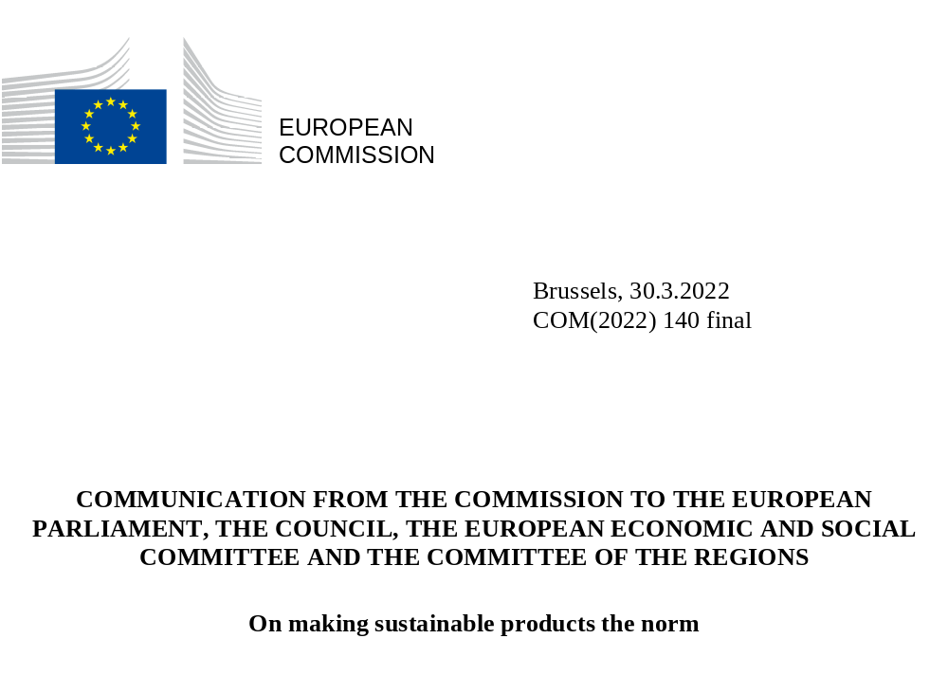

Introduction
The collision of major crises and economic shocks in recent years has impacted every part of the EU’s economy and society. The latest and starkest in this series – the ruthless and unprovoked invasion of Ukraine by Russia – is different in nature to the pandemic and recovery or the evermore urgent need to respond to the climate and biodiversity crises. The geopolitical situation it has led to puts a renewed strain on people and businesses in Europe and beyond, at times when the European Union, Ukraine and the world at large were looking forward to building back better.
But these crises also have much in common, and force us to question assumptions, to rethink our economic model and to work on redesigning our energy system. We have again been confronted with our own dependencies and with the vulnerabilities these can lead to in terms of security of supply, financial strain on households and shocks for businesses whose daily operations and long-term survival are at risk.
This points to the need to look at how we can increase the well-being of our citizens and ensure sustainable growth through using better the resources and the materials that make up the products we use every day, as well as improving the products themselves. By making products consume less energy, by using them more efficiently and for longer, by relying on recycled materials instead of primary raw materials, and by spreading front-runner circular economic models we can decouple our economic growth from natural resource use and environmental degradation. By promoting a harmonised approach at EU level, we can boost competitiveness, create new business opportunities and jobs, foster the greening of the single market in line with the sustainable growth agenda of the European Green Deal, enable consumers to save on costs, and make the EU economy more resilient to disruptions in integrated global value chains. Moreover, it will make a decisive contribution to achieving climate neutrality by 2050, to halting biodiversity loss and to achieving our zero-pollution ambition.
While progress has been made in recent years, the environmental impacts of consumption are still pushing us outside the safe operating space for humanity, as we exceed planetary boundaries in several ways in the EU. Globally, half of all greenhouse gas emissions and 90% of biodiversity loss are caused by extracting and processing primary raw materials, while the still prevailing linear take → make → dispose model of our economy leads to significant waste of resources. For the EU to succeed in the transition to a resource-efficient, climate-neutral and pollution-free circular economy and reduce its energy and resource dependencies, we urgently need a new approach to the way we design, make and use products. The EU will promote this approach also internationally, thus strengthening the sustainability and resilience of global value chains.
Today’s package of interlinked initiatives on sustainable products, presented in this Communication, aims to bring this new approach significantly closer to reality, building on what has already been done. The EU already sets minimum environmental requirements for certain products or sectors, such as energy-related products, packaging and chemicals. These requirements have helped to substantially reduce the EU’s environmental and climate footprint, including energy consumption. For instance, the cumulative effect of current EU rules on ecodesign and energy labelling means a 10% lower annual energy consumption by the products in scope, comparable to the energy consumption of Poland, reducing our dependence on fossil fuels, including from Russia. However, the existing rules cover only a limited share of the goods marketed in the EU and do not systematically encourage circularity, nor tackle many of the ways in which products impact the climate and the environment throughout their lifecycle. Also, there is still significant potential to lower the energy use of energy-related products.
This is why the proposal for a Regulation on Ecodesign for Sustainable Products is at the heart of today’s package. As product design dictates up to 80% of its life-cycle environmental impact, the proposal extends the scope of the Ecodesign framework to cover the broadest possible range of products. It foresees setting minimum criteria not only for energy efficiency but also for circularity and an overall reduction of the environmental and climate footprint of products. Until the new framework enters into force, the existing Ecodesign Directive will continue to drive improvements in energy efficiency and circularity. To that end, the Commission is adopting together with the new proposal an Ecodesign and Energy Labelling Working Plan 2022-2024 to cover new energy-related products and update and increase the ambition for products that are already regulated.
To support this, targeted sectoral initiatives -- the EU Strategy for Sustainable and Circular Textiles and the revision of the Construction Products Regulation -- are presented as part of the package to address these two priority product groups that have a significant impact on the environment and climate. To ensure that consumers remain active proponents of the transition, the Commission is also tabling a legislative proposal to Empower Consumers in the Green Transition that introduces targeted amendments to ensure the necessary ‘greening’ of horizontal EU consumer law.
By bringing a common approach to products in the EU, our proposals will help to create a level playing field for companies operating in the single market and make the EU a standard-setter in the area of sustainable products. In order to ensure that the shift to more sustainable products rolls out in a way that alleviates the costs and challenges of the transition, the selection of product groups and the setting of product-specific rules will be subject to long-term planning in an inclusive co-creation process, as well as to rigorous impact assessments, including as regards affordability for consumers, impacts on competitiveness and administrative burden.
Several Member States have already started to set environmental sustainability requirements on products on their own and citizens are increasingly asking them to go further and faster. This risks fragmenting the single market through diverging national rules, complicating and increasing the costs of doing business. Harmonised EU rules will avoid such market distortions, considerably scale the market for environmentally sustainable products and ultimately reduce compliance costs and administrative burden for businesses operating across the EU.
There are also many other cost saving opportunities for businesses, given the increasing scarcity of primary natural resources, challenges in the supply of raw materials and their price volatility. By re-designing business models, production processes and products, by making products last longer or optimising their use, and by participating in a well-functioning market for secondary raw materials, businesses can significantly reduce their costs for materials, energy and waste management and improve their resilience. Social economy organisations have played a pioneering role in shaping and expanding circular economy activities, such as electronics and textile recycling, reusable consumer goods, repair and remanufacturing activities. New digital solutions, too, open up huge opportunities to re-design business models for energy efficiency, circularity and broader environmental sustainability.
Front-runner companies in several industrial ecosystems have already embraced this transition.
A clear and harmonised regulatory framework on product environmental sustainability will provide the conditions for this approach to become mainstream and drive companies that buy and sell on EU markets to innovate and invest in circular business models and the products of tomorrow.
All this would significantly extend the range of environmentally sustainable products available to EU consumers and make these the mainstream option. Today the market share of such products is still limited, also affecting their availability and affordability to consumers. But the EU’s experience has already shown that ecodesign, when scaled up, does bring notable cost savings. In 2021 alone, existing ecodesign requirements for energy-related products saved consumers EUR 120 billion, even if counting in the acquisition costs. Many more savings could be unlocked if we remedy the problem that consumers are confronted with products that have a short lifespan and cannot be repaired, or have insufficient access to circular business models. Combining this with the right consumer information and ensuring protection against green-washing, the EU would meaningfully empower its consumers for the green transition and make sustainable products the norm, inspiring the rest of the world to follow.
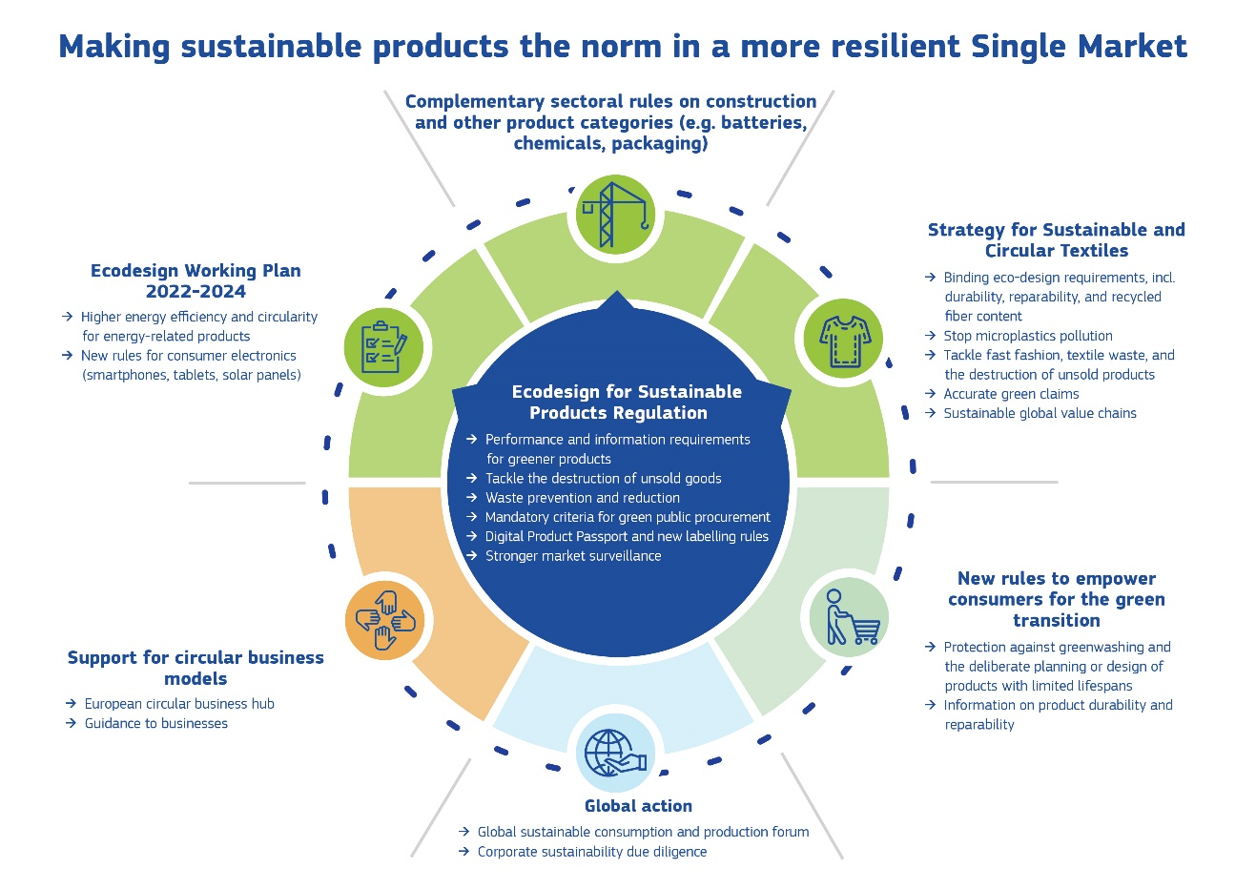
Overview of initiatives in the Circular Economy package

Our ambition: making sustainable products the norm

Designing more sustainable, circular and energy performing products
The proposed Ecodesign for Sustainable Products Regulation (ESPR) is the cornerstone of the Commission’s approach to more environmentally sustainable and circular products. It establishes the framework for setting ecodesign requirements for specific product categories to significantly improve their circularity, energy performance and other environmental sustainability aspects. It builds on the proven effectiveness of the Ecodesign Directive in relation to energy-related products and will enable minimum ecodesign and information requirements to be set for almost all categories of physical goods placed on the EU market. For groups of products that share sufficient common characteristics, horizontal rules can be set.
These ecodesign requirements will be tailored to the particular characteristics of the product groups concerned. Their identification and development will factor-in the potential for improvement and relative effectiveness in delivering increased resource and energy efficiency, enabling longer product life and maximising the value embedded in materials, reducing pollution and the overall impact of products on climate and the environment. The ecodesign requirements will, as appropriate for the product categories to be regulated, cover:
- product durability, reliability, reusability, upgradability, reparability, ease of maintenance and refurbishment;
- restrictions on the presence of substances that inhibit the circularity of products and materials;
- energy use or energy efficiency of products;
- resource use or resource efficiency of products;
- minimum recycled content in products;
- ease of disassembly, remanufacturing and recycling of products and materials;
- life-cycle environmental impact of products, including their carbon and environmental footprints;
- preventing and reducing waste, including packaging waste.

Helping businesses and consumers to make more informed choices
In addition to setting requirements on how products should be made, the Ecodesign for Sustainable Products Regulation (ESPR) is also a framework to set requirements to provide information on the environmental sustainability of products. Depending on the product concerned, this can include information on energy use, recycled content, presence of substances of concern, durability, reparability, including a reparability score, spare part availability and recyclability.
Digital product passports will be the norm for all products regulated under the ESPR, enabling products to be tagged, identified and linked to data relevant to their circularity and sustainability. Pioneering this approach for environmental sustainability data can also pave the way for wider voluntary data sharing, going beyond the products and requirements regulated under the ESPR. Moreover, product passports may be used for information on other sustainability aspects applicable to the relevant product group pursuant to other Union legislation.
Structuring information on the environmental sustainability of products and transmitting it by means of digital product passports will help businesses along the value chain, from manufacturers, importers and distributors to dealers, repairers, remanufacturers and recyclers, to access information that is valuable in their work to improve environmental performance, prolong product lifetime, boost efficiency and the use of secondary raw materials, thus lowering the need for primary natural resources, saving costs and reducing strategic dependencies. This will also help track the presence of substances of concern throughout the life cycle of materials and products, following through on commitments made in the Chemicals Strategy for Sustainability and contributing to the EU’s aim to achieve zero pollution. Digital product passports can also enable consumers to make more informed choices, improve transparency for public interest organisations and help national authorities in their enforcement and surveillance work.
The ESPR will also enable the EU to set labelling requirements, for example on the reparability of products. The new EU Energy Labels will incorporate circularity aspects, such as a repair score, by means of supplementary information. For other products, the new ESPR label will provide such information. Some products may bear both the EU Energy Label and an ESPR label, in case there is evidence that this will be more effective for consumers and less burdensome for industries. As demonstrated by the EU Energy Label, mandatory provision of key information at the moment of purchase can be an effective way to inform about relevant aspects of the environmental performance of products, particularly when it allows an easy comparison of products in a given category.
In parallel to and in synergy with developing product-specific rules under the ESPR, the Commission will work on reviewing or setting new product-specific criteria under the EU Ecolabel. This is a well-known and trusted label that has recognised and certified products with a high environmental performance for 30 years across the EU.

Putting a stop to the destruction of unsold consumer goods
The proposed ESPR includes measures to prevent and stop the destruction of unsold consumer goods. As a first step, large businesses that discard unsold products will have to disclose the amount of products they discard per year, provide reasons for the discarded volumes and information on the volume of discarded products sent out for reuse, remanufacturing, recycling, energy recovery and disposal operations, in line with the waste hierarchy. The regulation will also provide the possibility to ban the destruction of unsold products entirely, depending on the product categories to be regulated.

Promoting and procuring more sustainable products
While the performance and information requirements on product ecodesign will enable businesses and consumers to choose more environmentally sustainable products, there is a greater role that Member State’s incentives and public procurement can play. The Commission has already developed several green public procurement criteria, but their impact remains limited as their use is currently voluntary. Therefore, the ESPR aims to leverage the weight of public spending to boost demand for more environmentally sustainable products by setting mandatory criteria for the public procurement of these products, drawing where appropriate on existing voluntary criteria. This means that contracting authorities would be required to use green procurement criteria to purchase specific groups of products. In addition, incentives provided by Member States can be leveraged through environmental sustainability requirements on the products those incentives concern.

A cross-sectoral approach to sustainable products
The ESPR is designed to be coherent and aligned with existing and future sectoral legislation and policies. Once its framework is in place, the product requirements will be rolled out following multiannual working plans. This will enable the Commission to make a careful assessment of where regulatory action is most needed.
Where environmental sustainability requirements are already set at a satisfactory level in EU legislation, the ESPR will not come into play. Conversely, where these requirements are lacking, but the circularity, energy and resource efficiency potential, as well as the potential to reduce overall climate and environmental impacts are high and warrant action, the ESPR would step in. Measures under the ESPR will be accompanied by dedicated impact assessments, to ensure proportionality, due consideration of the international dimension and the impact on third countries, as well as consistency with other EU legislation.
Three different situations can illustrate how the proposed ESPR is designed to work with sectoral legislative and policy initiatives to accelerate the green transition.

Creating new EU product-specific rules: the example of textiles
For products where there is no specific EU law setting mandatory requirements on environmental sustainability, the ESPR will be the legal framework under which to set EU rules. This is the case for textiles and footwear. While these products are currently subject to certain product requirements, for instance concerning chemicals and labelling, there are no specific requirements governing circularity, e.g. durability, reparability, recyclability and recycled content.
Following the adoption and entry into force of the ESPR, and subject to impact assessment, this regulatory gap will be filled through secondary legislation setting ecodesign performance requirements for textile products, information requirements and a Digital Product Passport. Targeted changes to textiles labelling will also be considered under the Textiles Labelling Regulation. Beyond textiles and following the same logic, other priority products will be identified in the first ESPR working plan (see Section 4).
In addition, the EU strategy for sustainable and circular textiles that the Commission is adopting as part of this package presents a comprehensive set of actions that go beyond the ESPR. The aim is to transform this sector and change not only textile design but also boost circular business models and reduce textile waste, in line with and in full consideration of the need to ensure consumer affordability and business competitiveness. It also marks the launch of the co-creation process of the transition pathway of the textiles industrial ecosystem.

Complementing existing product-specific EU rules: the example of construction products, batteries, packaging and chemicals
Given the wide scope of the ESPR, some products covered by it will also be subject to separate product-specific legislation. For these products, as a general principle the ESPR will only intervene when the environmental sustainability dimensions of those products cannot be fully and appropriately addressed by other instruments. This would make EU rules on specific products more coherent and avoid placing an administrative burden on businesses to meet requirements laid down in different EU pieces of legislation. However, following the necessary consultations and impact assessments, specific circumstances may justify taking targeted action also under the ESPR. This may make sense when the product is part of another product (e.g. batteries), closely linked to it (e.g. packaging), or when environmental sustainability requirements for a group of products are laid down.
Although construction products are in the scope of the ESPR, given the need to manage the close links between their environmental and structural performance, including health and safety, it is justified to lay down environmental sustainability requirements under the revised Construction Products Regulation that is adopted as part of this sustainable products package. However, in the case of energy-related construction products, sustainability aspects will be primarily dealt with under the ESPR, as they are already regulated under the existing Ecodesign Directive. Still, the revised Construction Products Regulation may intervene in a complementary manner, where needed. The two proposed Regulations include provisions to maintain close legal alignment as the rules are developed and implemented.
The sustainability requirements for batteries will primarily be dealt with under the proposed batteries regulation. If the need arises to set additional specific sustainability requirements, for instance for specific applications of batteries in other products, the ESPR could cover complementary aspects.
Concerning packaging, the essential requirements for packaging allowed on the EU market are laid down in the Packaging and Packaging Waste Directive (PPWD), currently under revision. However, as packaging varies greatly depending on the product category, it should be one of the key aspects to cover when developing product-specific ESPR rules. This must complement, with more targeted rules, the essential requirements laid down in the PPWD.
Regarding chemicals, the ESPR’s area of competence is clearly defined: it will be able to take action to restrict the presence of chemicals in products for reasons linked to improving the product’s environmental performance along its life cycle. This can complement existing law governing chemicals, such as REACH, the primary focus of which is ensuring chemical safety, or RoHS, which covers only electrical and electronic equipment.

New EU rules under the current Ecodesign Directive: the example of consumer electronics
Electronics is our fastest growing waste stream. Users are frustrated at how quickly their devices break, become obsolete, cannot be updated or repaired. Moreover, in the EU we recover only few of the components or materials, including critical ones, that could be used again for making new products. In this context, the Commission is working on new ecodesign measures for smartphones, tablets and laptops, to be adopted as identified in the working plan under the existing Ecodesign Directive. In addition to energy efficiency and already before the new ESPR will replace the existing framework, the measures will cover other key aspects of ecodesign for circularity, notably durability, reparability and recyclability. In the same context, the ecodesign rules for external power supplies are being revised, mainly in view of interoperability and circular economy requirements to complement the recent Common Charger initiative adopted as a revision of the Radio Equipment Directive.
In addition to developing ecodesign requirements, the Commission has also launched a review of EU rules restricting the use of hazardous substances in electrical and electronic equipment, i.e. the RoHS Directive with the aim of ensuring that it meets its objectives in the most effective and efficient way. The Commission is also exploring options to incentivise the take-back and return of small electronics such as old mobile phones, tablets and chargers stored at home. The objective is to extend lifetimes and improve collection of those products, thereby also boosting circular business models.

The ecodesign method: planning, consultation, co-creation
The EU’s ecodesign and energy labelling policies are already highly effective in delivering energy efficiency. They generate savings for consumers lower our dependency on fossil energy imports and reduce emissions reductions. Over the last decade, rules have been set for around 30 energy-related product groups. Careful targeting through the adoption of multiannual working plans has been central to ensuring clear prioritisation, effectiveness and efficiency under the Ecodesign Directive. This will continue under the ESPR, based on a sound and robust approach for identifying priority products.
In order to ensure a smooth transition to the ESPR framework, the new ecodesign and energy labelling working plan for 2022-2024 is adopted as part of this package. It ensures that, until the new ESPR framework enters into force, work under the current Ecodesign Directive can continue at pace, bringing further reductions in energy use as well as material consumption from energy-related products. Additional products identified, such as low temperature emitters, offer energy-saving potential representing billions of euro in reduced consumer expenditure. Importantly, the new working plan ensures that circularity aspects are increasingly addressed to the extent feasible under the current legal framework.
In parallel, the Commission intends to start work under the proposed ESPR to cover new products and new parameters. It aims to propose product-specific measures without delay, as soon as the new framework is in place. To ensure the right priorities are set in a transparent and inclusive way, it will launch a public consultation on the categories of products to be selected under the first Ecodesign for Sustainable Products Regulation working plan by the end of 2022. A preliminary assessment made by the Commission has identified that product categories such as textiles, furniture, mattresses, tyres, detergents, paints, lubricants, as well as iron, steel and aluminium have high environmental impact and potential for improvement, and are thus suitable candidates for the first working plan.
The success of the Ecodesign Directive to date owes much to the input from all key players, contributing in an inclusive, open and transparent way. The ESPR will build on this co-creation approach, from drawing up a working plan and prioritising products, to assessing and developing all new product requirements. The Ecodesign Forum, building on the existing Consultation Forum under the Ecodesign Directive, will remain the platform for targeted exchanges across stakeholder groups and at all key phases of the process, and thus bring industry, national-level and enforcement authorities to the table. Consultation processes and thorough impact assessments will precede and underpin the development and adoption of product requirements.
New ESPR rules must be underpinned by sound methodological approaches, so that environmental and climate impacts of products can be effectively addressed through requirements on the key aspects laid down in the ESPR. Given the potential range of products under the future framework, it will be essential to choose and adapt the most suitable methodology, depending on the product or group of products in question and the environmental or circularity aspect targeted. This approach will build on the experience gained under the current Ecodesign Directive, which will continue to be upgraded, and on the Product Environmental Footprint method where appropriate. As a priority, the Commission will develop new methodologies to underpin the additional circularity aspects brought under the ESPR, including e.g. durability, reparability and recycled content related methodologies, also taking into account research results of projects funded by the Horizon Europe Programme.

Circular business models
In addition to making sustainable products the norm, we must also increasingly invest in and incentivise the uptake of circular business models. These include product-as-a-service models, peer-to-peer sharing and reverse logistics, on-demand manufacturing, reuse and repair services, to name a few. This is necessary to decrease overall demand for energy and resources, and decouple growth from primary resource use.
Circular business models are designed to create and capture value while helping optimise and limit resource use. This means not only regulatory product-specific requirements but also the right market signals for circular business models to give producers an incentive to design products better, extend products’ lifetime and retain their value during and after use. For instance, by selling products as a service (illustrated by the well-known example of selling light, not light bulbs) the economic logic shifts and profits are no longer dependent on the volume of products sold. Instead, it becomes profitable to ensure that the products provided as a service are durable and repairable, as the ownership remains with the business and the need to buy new products is a business cost.
Today, it is still challenging for circular business models to take off and scale up. Product requirements under the ESPR will stimulate the uptake of such models, as developing circular activities depends to a large extent on the physical design features of products, and on access to relevant data. Also digital product passports and smart use of digitally enabled innovation constitute critical enablers to move to circular business models. However, better product design and information alone will not be enough to trigger a full shift in business approaches. There is a clear need to identify bottlenecks, identify effective means to boost the uptake of circular business models, ensure their profitability, make them increasingly attractive to consumers, exchange best practices, and provide tailored advice for new and existing businesses to switch to circular business models.
To that end, the Commission wants to bring different stakeholders together in the new European Circular Business Hub. The Hub will support the uptake of circular business models, channel information and services including awareness raising, cooperation, training and exchanges of best practices. It will build upon the expertise and service offer of existing EU actions, notably the European Circular Economy Stakeholder Platform, Enterprise Europe Network Sustainability Advisors and the network of European green tech clusters.
In addition, the Commission will prepare guidance on boosting circular business models to help businesses, Member States and regions take action. This will include guidance on directing investment and funding and optimising local resource stocks and flows, with a view to creating circular value and jobs. The Commission will also issue guidance on how to support uptake and partnerships for the circular economy between social enterprises and other actors, including mainstream businesses.
Moreover, through the European Skills Agenda, the Commission is supporting investments in skills indispensable for the development of a circular economy. Under the Pact for Skills, the Commission is setting up large-scale partnerships bringing together industry representatives, social partners and vocational education and training providers.

Empowering and protecting consumers
Most consumers want to play an active part in the green transition. The ESPR will support consumers in the green transition. It will ensure products meet minimum requirements for environmental performance, and provide better information, labelling and greater access to spare parts, upgrades and repairs, while taking into account affordability, boosting consumer convenience and giving consumers access to higher quality products.
But it is also necessary to ensure better information at the point of sale and build consumer confidence in the claims that producers make on the environmental benefits of their products on their own accord. The proposal on empowering consumers for the green transition enables consumers to take informed purchasing decisions.
The proposal will introduce targeted amendments to horizontal EU consumer law to ensure that consumers are provided with information at the point of sale about a commercial guarantee of product durability, as well as information relevant for repair (including a reparability score, whenever this is available). It will also prohibit traders from making certain types of environmental claims deemed to be misleading. This includes vague environmental claims (e.g. “green”, “eco-friendly”, “good for the environment”) that are not adequately justified and verified in line with the rules. Moreover, the proposal will ban several practices associated with early obsolescence, including planned obsolescence practices.
In addition, the Commission is working on proposing more specific rules on green claims to boost reliability, comparability and verifiability, relying on the Product and Organisation Environmental Footprint methods and is developing an initiative for encouraging repairs of consumer goods (‘right to repair’), with adoption planned in autumn 2022. This initiative will complement ESPR and will contribute to its practical effects by giving consumers the possibility to use their purchased products longer by giving them a right to have these products repaired.

Leading the sustainable and circular products and business models agenda at global level
The EU has a track record of advocating for sustainability worldwide. Producers already meet EU rules on hazardous substances, ecodesign and energy labelling when placing products on the EU market. The proposals in the package of initiatives on sustainable products will contribute to accelerating implementation of the UN 2030 Agenda for Sustainable Development. By expanding markets for environmentally sustainable products, the EU seeks to strengthen the sustainability of global value chains and contribute to positive change in the partner countries, which will help in meeting several UN Sustainable Development Goals.
However, EU action alone is not enough and cannot deliver alone the transition to more environmental sustainability and circularity the world needs. We need to work together with our partners by strengthening international cooperation and promoting our ambition worldwide. The EU will step up its engagement with non-EU countries, at global, regional and bilateral level, to support the sustainability transition, and to facilitate compliance with the new rules, especially with low- and middle-income countries. Bilaterally, the EU will work in partnership with non-EU countries on capacity building, enhanced dialogue, technical cooperation, access to business support networks, access to finance for circular economy investments, and exchanging best practices to identify potential technical barriers and to promote joint initiatives.
At global level, the EU will continue to pursue the circular economy agenda in multilateral fora, in the G7 and G20, and in the context of the Global Alliance for Circular Economy and Resource Efficiency. The Commission will advocate creating a global Sustainable Consumption and Production Forum to facilitate a broad discussion between countries and stakeholders on meeting the UN Environment Assembly’s recent call on Member States ‘to take measures, in cooperation with the private sector to enhance the design of products taking into account lifecycle assessments, to favour product lifetime extension, repair, re-use, and easier recycling in the context of circular economy with the view to contributing to achieving resource efficiency’. The EU will continue supporting the UN and other relevant global and multilateral initiatives promoting sustainable production and consumption. It will also support and help disseminate the findings of the work carried out by the International Resource Panel. The EU will cooperate with its trading partners in the World Trade Organisation, by sharing and discussing best practices on how to increase circularity in global value chains, in line with domestic and international law.
Finally, the recent Commission proposal on corporate sustainability due diligence will contribute to driving sustainable business models at global level. The proposal fosters the sustainability transition of companies across industry sectors by requiring that companies address and account for adverse impacts on the environment in their global value chains. Based on the proposed rules larger companies also need to have a plan to ensure that their business strategy is compatible with limiting global warming to 1.5 °C in line with the Paris Agreement.

Conclusion
The initiatives on sustainable products aim to ensure that by 2030 a significant part of products available to EU consumers will be designed to be durable and energy- and resource efficient, reparable, recyclable, and with preference for recycled materials. Companies from all over the world will be able to compete without being undercut by companies that pass on costs to society and the environment. Consumers will also have access to the information they need to make more sustainable choices, will be better protected against practices harmful to the green transition, and will be able to keep their products functioning for as long as possible, while companies will be able to access the data they need to ensure environmental sustainability and circularity of their products and business models. These actions are explicitly recommended by European citizens in the framework of the Conference on the Future of Europe, who have called for stronger circular economy policies, including on combatting planned obsolescence and providing information on how to re-use and repair products.
The impact of today’s package of initiatives will be felt gradually. The rules of some measures will be applicable upon entry into force; others will take time due to the legal framework and the type of systemic changes they will instigate. The Ecodesign for Sustainable Products Regulation will allow for a multi-pronged approach to product regulation – a real game changer, whose momentum will build over time. By setting a comprehensive cross-sectoral framework and by taking key steps such as the adoption of working plans, the general direction and objectives will be clear well in advance. This will give time for companies to make the necessary organisational and systemic preparations, even before detailed product rules are laid down.
The proposals in this package are central to the European Green Deal. They will make a considerable contribution to the European Union’s environmental and climate goals, in particular to achieving climate neutrality by 2050, to doubling the circularity rate of material use by 2030 and to achieving the European Union’s ambitious energy efficiency targets. They will also contribute to and benefit from the objectives of the 2030 Digital Decade, the New Industrial Strategy, the European Pillar of Social Rights Action Plan and the New European Bauhaus.
The proposals in this package have the potential to bring the EU significantly closer to reaching the UN’s 2030 Sustainable Development Goals, provided that their level of ambition is maintained and they are swiftly and effectively implemented.
The Commission therefore calls on the European Parliament, the Council and all other stakeholders to endorse the approach and ambitions of these proposals and to work towards their rapid adoption and implementation.

COM(2019) 640 final
Sala, S et al. (2020). Environmental sustainability of European production and consumption assessed against planetary boundaries. Journal of environmental management, 269, 110686
UN International Resources Panel Global Outlook 2019 – Natural Resources for the Future we Want. https://www.resourcepanel.org/reports/global-resources-outlook
Compared to ‘business as usual scenario’, where no ecodesign rules would be in place. Ecodesign Impact Accounting Overview Report 2020
COM(2022) 142
https://op.europa.eu/en/publication-detail/-/publication/4d42d597-4f92-4498-8e1d-857cc157e6db
COM(2022) 141
COM(2022) 144
COM(2022) 143
Please see Annex 7 of SWD(2022) 82
OECD policy brief on Making the most of the social economy’s contribution to the circular economy (2022), https://op.europa.eu/en/publication-detail/-/publication/be4e83a2-735a-11ec-9136-01aa75ed71a1/language-en
Ecodesign and Energy Labelling Working Plan 2022-2024
With some notable exceptions, such as food and feed as defined in the General Food Law (Regulation EC No 178/2002).
COM(2020) 667 final
Regulation (EU) 2017/1369
Regulation on Registration, Evaluation, Authorisation and Restriction of Chemicals (REACH), 1907/2006 of 18 December 2006 and Directive on the Restriction of Hazardous Substances in Electrical and Electronic Equipment (RoHS) 2011/65/EU of 8 June 2011.
Regulation (EU) No 1007/2011
Regulation (EU) No 1007/2011
COM(2020) 798 final
Directive 94/62/EC
Regulation 1907/2006 and Directive 2011/65/EU.
Directive 2011/65/EU
Critical Raw Materials (CRMs) are those of high importance to the EU economy and with high risk associated with their supply. See also: https://op.europa.eu/en/publication-detail/-/publication/d1be1b43-e18f-11e8-b690-01aa75ed71a1
COM(2021) 547 final
Directive 2011/65/EU
European Green Deal: Commission seeks views on reviewing rules on hazardous substances in electrical and electronic equipment, https://ec.europa.eu/environment/news/european-green-deal-commission-seeks-views-reviewing-rules-hazardous-substances-electrical-and-2022-03-10_en
In 2020, it is estimated that some 3 billion products subject to Ecodesign and/or Energy Labelling measures were sold in the EU. This includes some 1.5 billion light sources, 880 million electronics, 350 million tyres and 240 million other products.
https://ec.europa.eu/transparency/expert-groups-register/screen/expert-groups/consult?do=groupDetail.groupDetail&groupID=3609
https://ellenmacarthurfoundation.org/circular-examples/why-buy-light-bulbs-when-you-can-buy-light-signify
https://circulareconomy.europa.eu/platform/
https://een.ec.europa.eu/
https://resourceefficient.eu/en
As announced in the Social Economy Action Plan COM(2021) 778
COM(2020) 274 final
Pact for Skills - Employment, Social Affairs & Inclusion - European Commission (europa.eu)
Pacts for Skills have already been established in industrial ecosystems such as Construction, Microelectronics, and Textile, Clothing, Leather and Footwear.
94% of Europeans say protecting the environment is important to them personally, and 68% regard their own consumption habits as adversely affecting the environment. Attitudes of Europeans towards the Environment - March 2020 - - Eurobarometer survey (europa.eu)
COM(2022) 143
Unfair commercial practices Directive 2005/29/EC and Consumer rights Directive 2011/83/EU
Commission Recommendation (EU) 2021/2279 of 15 December 2021 on the use of the Environmental Footprint methods to measure and communicate the life cycle environmental performance of products and organisations, OJ L471/1
UNEA 5 resolution on Enhancing Circular Economy as a contribution to achieving sustainable consumption and production, adopted 5 March 2022, UNEP/EA5/L17/REV.1
COM(2022) 71 final

