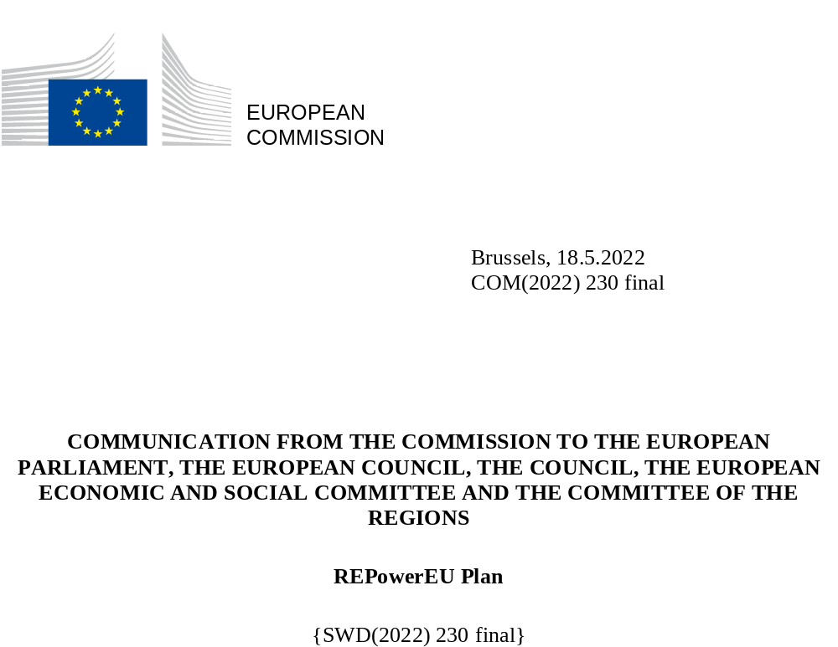

Introduction
Russia’s unprovoked and unjustified military aggression against Ukraine, has massively disrupted the world’s energy system. It has caused hardship as a result of high energy prices and it has heightened energy security concerns, bringing to the fore the EU’s over-dependence on gas, oil and coal imports from Russia. High amounts paid for Russia’s fossil fuels are helping Russia sustain its war against Ukraine.
In March 2022, EU leaders agreed in the European Council to phase out Europe’s dependency on Russian energy imports as soon as possible. Drawing on the Commission’s communication, they invited the Commission to swiftly put forward a detailed REPowerEU plan. Coal and oil imports are now to be covered by the sanctions regime. The recent gas supply interruptions to Bulgaria and Poland demonstrate the urgency to address the lack of reliability of Russian energy supplies.
REPowerEU is about rapidly reducing our dependence on Russian fossil fuels by fast forwarding the clean transition and joining forces to achieve a more resilient energy system and a true Energy Union.
We can significantly reduce our dependency on Russian fossil fuels already this year, and accelerate the energy transition. Building on the Fit for 55 package of proposals and completing the actions on energy security of supply and storage, this REPowerEU plan puts forward an additional set of actions to:
- save energy;
- diversify supplies;
- quickly substitute fossil fuels by accelerating Europe’s clean energy transition;
- smartly combine investments and reforms.

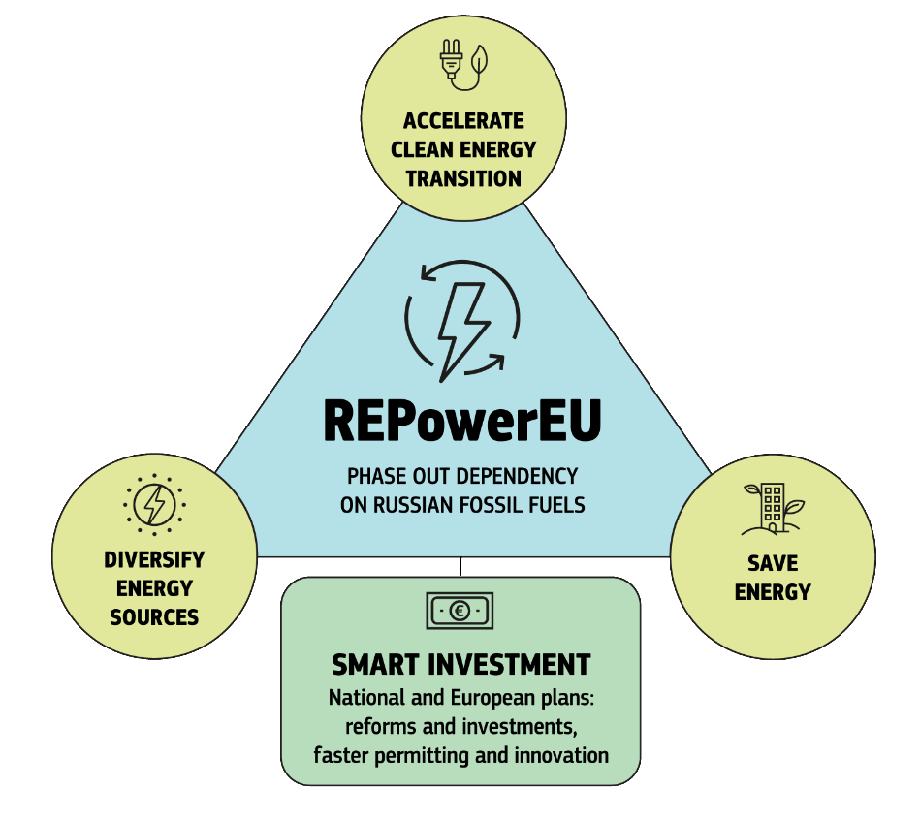
Taken together, these actions will structurally transform EU’s energy system. They require effective coordination between European regulatory and infrastructure measures, as well as national investment and reforms and joined-up energy diplomacy. They also require coordination between action on the demand side, to reduce energy consumption and transform industrial processes to replace gas, oil and coal with renewable electricity and fossil-free hydrogen, with action on the supply side to create the capacity and framework to roll out and produce renewable.
Fairness and solidarity are defining principles of the European Green Deal. Our joint action to accelerate the clean energy transition therefore reinforces the need for effective employment, skills and social policies, in line with the European Pillar of Social Rights.Dependence amongst Member States on Russian energy sources differs as the energy situationand energy mixes differ from one country to the other. The approach taken in this REPowerEU plan reflects these differences and proposes a variety of balanced responses corresponding to the specific Member States needs whilst moving the EU as a whole towards climate neutrality by 2050.
REPowerEU builds on the full implementation of the Fit for 55 proposals tabled last year without modifying the ambition of achieving at least -55 % net GHG emissions by 2030 and climate neutrality by 2050 in line with the European Green Deal. It will have a positive impact on EU’s emission reduction over the decade. However, the fast phasing out of fossil fuel imports from Russia will affect the transition trajectory, or how we reach our climate target, compared to that under previous assumptions.
The REPowerEU plan cannot work without a fast implementation of all Fit for 55 proposals and higher targets for renewables and energy efficiency. In the new reality, the EU’s gas consumption will reduce at a faster pace, limiting the role of gas as a transitional fuel. However, shifting away from Russian fossil fuels will also require targeted investments for security of supply in gas infrastructure and very limited changes to oil infrastructure alongside large-scale investments in the electricity grid and an EU-wide hydrogen backbone. In parallel, some of the existing coal capacities might also be used longer than initially expected, with a role for nuclear power and domestic gas resources too.
The public expects the EU and its Member States to follow through on the commitments made to reduce our dependence on Russian fossil fuels. 85% of people polled believe that the EU should reduce its dependency on Russian gas and oil as soon as possible. 84% agree that Russia’s aggression against Ukraine makes it more urgent for EU Member States to invest in renewable energy.
While some Member States have already announced their intention to end fossil fuel imports from Russia, no Member State can tackle this challenge on its own. By carrying out joint needs assessments and planning, joint purchases and greater coordination, we will ensure that the phasing out of our dependency on Russian fossil fuels is both achievable and affordable for all Member States. Legislation on renewable and energy efficiency will help realise ambitious targets. A truly interconnected and resilient EU energy network will provide energy security for all. These actions constitute our plan to repower the EU.

Energy savings

Savings are the quickest and cheapest way to address the current energy crisis. Reducing energy consumption cuts households’ and companies’ high energy bills in the short and long term, and decreases imports of Russian fossil fuels. Reducing energy consumption through higher efficiency is a vital component of the clean energy transition which increases the resilience of the EU economy and shields its competitiveness against high fossil fuel prices.
Saving energy will help our supplies go further in the critical months ahead, while investments are being rolled out. The accompanying EU Save Energy Communication presents a two-pronged approach: strengthening structural change with mid- to long-term energy efficiency measures and achieving immediate energy savings through behavioural changes.
Fit for 55 would lower our gas consumption by 30% by 2030, with more than a third of such savings coming from meeting the EU energy efficiency target. Updated modelling assesses the impact of the phase out of Russian fossil fuel dependence in terms of higher energy prices and lower use of natural gas. A further reduction of energy consumption compared to the previous Energy Efficiency Directive proposal and higher renewable energy targets would enable the EU to fully meet the REPowerEU objectives, with other parts of the Fit for 55 package unchanged.
- The Commission therefore proposes to increase to 13% the binding target in the Energy Efficiency Directive.
In addition, the Commission invites the Parliament and Council to enable additional savings and energy efficiency gains in buildings through the Energy Performance of Buildings Directive, and to uphold the ambition of the Commission proposal for a Regulation on Ecodesign for Sustainable Products, the rapid deployment of which will lead to further energy savings through improved energy and resource efficiency of a broad range of products.
Pending agreement on the legislative measures, immediate energy savings can be made by changing our behaviour. The European Commission has launched, in cooperation with the International Energy Agency (IEA), a nine-point plan “Playing my part” for reducing energy use in the EU. Based on input from stakeholders, the IEA estimates that these types of short-term energy saving measures could achieve a 5% reduction in the demand for gas (around 13 bcm) and in that for oil (around 16 mtoe).
Member States should also make full use of supporting measures such as reduced VAT rates for high efficiency heating systems and for insulation in buildings and other energy pricing measures, which encourage switching to heat pumps and purchase of more efficient appliances. Such measures should cushion social and distributional impacts, e.g. focusing on vulnerable households struggling to pay their energy bills and to manage the potential impact of the accelerated energy transition on the labour market, with immediate upskilling and reskilling needs.
Stepped up implementation and ambitious updating of National Energy and Climate Plans (NECPs) are key in delivering the REPowerEU objectives. NECPs have a crucial role in enhancing investor confidence and investment predictability. They provide a good framework for planning and encouraging the reduction of use of fossil fuels.
- The Commission intends to publish guidance later this year for the Member States’ update of their NECPs in 2024 and will report progress on REPowerEU, among others, through the State of the Energy Union and Climate Action reports.
Regions and cities are playing a leading role in developing energy saving measures tailored to their local context. They should launch awareness and information and support schemes, energy audits and energy management plans, pledging savings targets, and ensure citizens’ engagement such as through the European Mission on climate-neutral and smart cities or the European Urban Initiative under cohesion policy.

Diversifying energy imports

The EU has been working intensively with international partners for several months to diversify supplies and mitigate the rise in energy prices.
Following the mandate by the European Council in March, the Commission and Member States have set up an EU Energy Platform for the voluntary common purchase of gas, LNG and hydrogen. On 5 May, the Commission and Bulgaria set up a first regional taskforce, as part of the EU's Energy Purchase Platform, in coordination with neighbours in the south east of Europe.
The EU Energy Platform will fulfil three functions supporting common purchase of gas:
- Demand aggregation and structuring: The demand pool will identify and aggregate contestable volumes based on expiring long-term contracts as well as flexible volumes under existing long-term gas contracts which could lead to roughly 30-70 bcm of demand in the short term. In addition, the Commission will encourage diversification of supply and will consider legislative measures to require such diversification over time. Demand pooling will be supported by electronic tools, which will make the process secure, automated and user friendly.
- Optimised and transparent use of the import, storage and transmission gas infrastructure maximising security of supply and replenishment of storage.
A mechanism and an IT tool will be put in place to improve the transparency in infrastructure bookings i.e. remaining availability, secondary markets, rerouting and existing bottlenecks. The exchange of information will be in line with antitrust rules.
- International outreach: Joined up international outreach will focus on concluding long-term cooperation frameworks with trusted partners via binding or non-binding agreements that support the purchasing of gas and hydrogen and clean energy project development, while fully using the collective strength of the Union.
As a next step, the Commission will consider developing a voluntary operational ‘joint purchasing mechanism’ responsible for negotiating and contracting on behalf of participating Member States of the aggregated gas demand and competitive release to the market. Such mechanism could take the form of a Joint Venture or a business-owned entity, leveraging the power of the European market. Such a construct will be subject to review of its impact on competition.
The Platform will also work through Regional Task Forces, which will identify needs and diversification of supply options and coordinate on contractual issues. The Platform will set up a dedicated work stream with Member States on joint purchasing of hydrogen.
Industry expertise on the global energy market will be important for the success of the Platform. An Advisory Group will inform the Platform on issues such as LNG trade, financing, hedging and other elements along the value chain. The exchange of information will have to be compliant with antitrust rules.
In line with the conclusions of the European Council the EU Energy Platform is open for the Energy Community Contracting Parties (Western Balkans, Ukraine, Moldova, Georgia). The Platform should also benefit EU’s partners in its close neighbourhood, partners who are committed to the EU’s internal market rules and joint security of supply. The Platform will work closely with the Energy Community Secretariat to assist the Contracting Parties to make the most of the Platform.
The emergency synchronisation of the electricity grids of Ukraine and Moldova with Europe’s grid mid-March shows the commitment to ensure Ukraine’s and Moldova’s interconnection with the EU’s power grid. As soon as the necessary technical improvements are completed, it will allow Member States in the region to purchase excess electricity from Ukraine, thus compensating for some of the reduced gas imports.
With a full implementation of the REPowerEU plan, high prices, gas alternatives (sustainable biomethane, renewable hydrogen), further deployment of renewables, and structural demand measures such as energy efficiency, EU gas demand is expected to decrease at a faster rate than foreseen under Fit for 55. The EU will provide its international partners with long-term perspectives for mutually beneficial cooperation by integrating hydrogen and renewable energy development and trade, as well as cooperation on methane emission reduction strategies in the gas diversification efforts, as described in the External Energy Engagement Strategy.
Diversification options are also important for Member States currently dependent on Russia for nuclear fuel for their reactors serving either power generation or non-power uses. This requires working within the EU and with international partners to secure alternative sources of uranium and boosting the conversion, enrichment and fuel fabrication capacities available in Europe or in EU’s global partners. In addition to diversifying external suppliers, continuing domestic natural gas production for Member States where this is possible can contribute to strengthen security of supply.

3. Substituting fossil fuels and accelerating Europe’s clean energy transition

A massive speed-up and scale-up in renewable energy in power generation, industry, buildings and transport will accelerate our phasing out of Russian fossil fuels. It will also, over time, lower electricity prices and reduce fossil fuel imports.
Boosting renewable energy
- Based on its modelling of impacts and feasibility, the Commission is proposing to increase the target in the Renewable Energy Directive to 45% by 2030, up from 40% in last year’s proposal. This would bring the total renewable energy generation capacities to 1236 GW by 2030, in comparison to 1067 GW by 2030 envisaged under Fit for 55 for 2030.
- Solar photovoltaics (PV) is one of the fastest technologies to roll out. That is why the Commission sets the REPowerEU target of over 320 GW of solar photovoltaic newly installed by 2025, over twice today’s level, and almost 600 GW by 2030. As part of the increased ambition for solar, the Commission:
- presents the EU solar strategy ;
- introduces the European Solar Rooftop Initiative anchored around a legally binding EU solar rooftop obligation for certain categories of buildings.
Wind energy, in particular offshore wind represents a significant future opportunity: resources are stable, abundant and public acceptance is higher. Europe is the global leader in offshore wind. To further strengthen the EU wind sector’s global competitiveness, and achieve the REPowerEU ambition with fast wind energy deployment, supply chains need to be strengthened and permitting drastically accelerated.

The European Union should aim at doubling the current deployment rate of individual heat pumps, resulting in a cumulative 10 million units over the next 5 years. Member States can accelerate the deployment and integration of large-scale heat pumps, geothermal and solar thermal energy in a cost-effective way by:
- developing and modernising district heating systems which can replace fossil fuels in individual heating;
- clean communal heating, especially in densely populated areas and cities;
- exploiting industrial heat whenever available.
To strengthen the supply chains for solar, wind and heat pump technologies and make them more sustainable, the Commission will:
- enhance the regulatory framework and ensure life-cycle sustainability, by tabling, in the first quarter of 2023, ecodesign and energy labelling requirements for solar PVs, and by revising existing requirements for heat pumps.
- support efforts from Member States to pool their public resources via potential Important Projects of Common European Interest (IPCEI) focused on breakthrough technologies and innovation along the solar and wind energy and heat pumps value chains.
To promote the development of electricity storage capacities, the Commission proposes to consider storage assets as being in the overriding public interest and facilitate permitting for their deployment.
Accelerating hydrogen
Renewable hydrogen will be key to replace natural gas, coal and oil in hard-to-decarbonise industries and transport. REPowerEU sets a target of 10 million tonnes of domestic renewable hydrogen production and 10 million tonnes of renewable hydrogen imports by 2030. The Commission:
- calls upon the European Parliament and the Council to align the sub-targets for renewable fuels of non-biological origin under the Renewable Energy Directive for industry and transport with the REPowerEU ambition (75% for industry and 5% for transport) and to rapidly conclude the revision of the Hydrogen and Gas Market package;
- will top-up Horizon Europe investments on the Hydrogen Joint Undertaking (EUR 200 million) to double the number of Hydrogen Valleys;
- publishes for public feedback two Delegated Acts on the definition and production of renewable hydrogen;
- intends to complete the assessment of the first Important Projects of Common European Interest on hydrogen by the summer;
- calls on industry to accelerate the work on missing hydrogen standards, in particular for hydrogen production, infrastructure and end-use appliances;
- will regularly report, in close cooperation with the Member States, starting in 2025, on hydrogen uptake, and the use of renewable hydrogen in hard-to-abate appliances in industry and transport.
Accelerated efforts are needed to deploy hydrogen infrastructure for producing, importing and transporting 20 million tonnes of hydrogen by 2030. Cross-border hydrogen infrastructure is still in its infancy, but the basis for planning and development has already been set by the inclusion of hydrogen infrastructure in the revised trans-European networks for energy. Total investment needs for key hydrogen infrastructure categories are estimated to be in the range of EUR 28 – 38 billion for EU-internal pipelines and 6 - 11 billion for storage.
To facilitate the import of up to 10 million tonnes of renewable hydrogen, the Commission will support the development of three major hydrogen import corridors via the Mediterranean, the North Sea area and, as soon as conditions allow, with Ukraine. Green Hydrogen Partnerships will facilitate the imports of green hydrogen while supporting the decarbonisation in the partner countries. Other forms of fossil-free hydrogen, notably nuclear-based, also play a role in substituting natural gas (see map).
To help achieve these targets, the Commission will:
- map preliminary hydrogen infrastructure needs by March 2023, based on the TEN-E Regulation, in a process involving Member States, national regulatory authorities, ACER, ENTSOG, project promoters and other stakeholder;
- mobilise EU funding under CEF, Cohesion Policy and RRF;
- set up a dedicated work stream on joint renewable hydrogen purchasing under the EU Energy Platform.
Scaling up biomethane
Boosting sustainable biomethane production to 35 bcm by 2030 is a cost-efficient path to achieve our ambition to reduce imports of natural gas from Russia. To increase the capacity of biogas production in the EU and promote its conversion into biomethane, the estimated investment needs amount to EUR 37 billon euro over the period.

As outlined in the Biomethane Action Plan in the accompanying staff working document, the Commission proposes to address the main barriers to increased sustainable biomethane production and use and facilitation of its integration into the EU internal gas market by:

- establishing an industrial biogas and bio-methane partnership to stimulate the renewable gases value chain;
- taking additional measures to encourage biogas producers to create energy communities;
- providing incentives for biogas upgrading into bio-methane;
- promoting the adaptation and adjustment of existing and the deployment of new infrastructure for the transport of more bio-methane through the EU gas grid;
- addressing gaps in research, development and innovation;
- facilitating access to finance, and mobilise EU funding under CEF, Cohesion Policy, RRF and the Common Agricultural Policy.

The focus should be on sustainable production, ensuring that biomethane is produced from organic waste and forest and agricultural residues, to avoid impacts on land use and food security.
Bioenergy makes up 60% of the renewable energy in the EU. It is a domestically available and stable energy source but sustainable sourcing is key. Current estimates show a moderate but steady increase of biomass use until 2030. Prioritizing use of non-recyclable biomass waste and agricultural and forest residues will ensure a sustainable energy production that can contribute to the REPowerEU objectives.
Reducing fossil consumption in hard-to-abate industrial and transport sectors
Replacing coal, oil and natural gas in industrial processes will not only reduce carbon emissions, it will also strengthen industrial competitiveness by shielding industrial production from volatile fossil fuel markets and support international technology leadership.
Energy efficiency, fuel substitution, electrification, and an enhanced uptake of renewable hydrogen, biogas and biomethane by industry could save up to 35 bcm of natural gas by 2030 on top of what is foreseen under the Fit for 55 proposals. Production of non-metallic minerals, cement, glass and ceramics, production of chemicals and refineries provide the biggest opportunities for reducing fossil gas demand – almost 22 bcm.
There is also great potential for electrification of industry. Current technologies already enable industrial companies to reduce their reliance on fossil fuels. Opportunities to adopt electric technology will continue to expand as technologies improve and renewables are rolled out.
To support hydrogen uptake and electrification in industrial sectors, the Commission:
- will roll out carbon contracts for difference and dedicated REPowerEU windows under the Innovation Fund to support a full switch of the existing hydrogen production in industrial processes from natural gas to renewables and the transition to hydrogen-based production processes in new industrial sectors, such as steel production;
- publishes guidance to Member States on renewable energy and power purchase agreements (PPAs);
- will, in cooperation with the EIB, develop a technical advisory facility under the InvestEU Advisory Hub to support PPA-financed renewable energy projects. To unlock industrial investment, the Commission will double the funding available for the 2022 Large Scale Call of the Innovation Fund this autumn to around EUR 3 billion. A specific REPowerEU window will support (1) innovative electrification and hydrogen applications in industry, (2) innovative clean tech manufacturing (such as electrolysers and fuel cells, innovative renewable equipment, energy storage or heat pumps for industrial uses), and (3) mid-sized pilot projects for validating, testing and optimising highly innovative solutions.
In transport, electrification can be combined with of the use of fossil-free hydrogen to replace fossil fuels. To enhance energy savings and efficiencies in the transport sector and accelerate the transition towards zero-emission vehicles, the Commission:
- will consider a legislative initiative to increase the share of zero emission vehicles in public and corporate car fleets above a certain size;
- calls on the co-legislators to swiftly adopt the pending proposals on alternative fuels and other transport related files supporting green mobility;
- will adopt in 2023 a legislative package on greening freight transport;
Delivering REPowerEU – with skilled people, raw materials and a complete regulatory framework
Achieving the REPowerEU goals will require diversifying the supply of renewable energy equipment and of critical raw materials, reducing sectoral dependencies, overcoming supply chain bottlenecks and expanding the EU’s clean energy technology manufacturing capacity. While the EU is a global leader in electrolyser, wind and heat pump technologies, the EU solar panels and heat pumps market has seen increasing imports from Asia over the last years.
For heat pumps, a doubling of the deployment rate should be matched by a fast ramp up of the production of the necessary equipment, including, where necessary through facilitated access to finance.
Beyond ensuring suppliers diversification, strengthening circular economy models must be a priority. Support for research and innovation, including through Horizon Europe, will be provided to reduce materials consumption, enhance recyclability of renewable energy equipment and substitute critical raw materials.
To enhance industry’s contribution to REPowerEU and reinforce its competitiveness, the Commission:
- will set up an EU Solar Industry Alliance;
- will work with industry to scale up electrolyser manufacturing capacities, as laid out in the Electrolyser Declaration;
- will intensify work on the supply of critical raw materials and prepare a legislative proposal. The Commission will step up ongoing EU policies and actions (e.g. implementation and negotiation of Free Trade Agreements, cooperation with like-minded partners, etc.) and reinforce the EU’s monitoring capacity and help secure the supply of diverse critical raw materials. This initiative will aim to strengthen the European value chain through the identification of mineral resources and of critical raw materials projects in the European strategic interest, while ensuring a high level of environmental protection, including projects that promote a circular economy and resource efficiency
Accelerating and amplifying the deployment of renewables and increasing energy efficiency relies on a skilled workforce and strong supply chains to meet the increased demand for clean technology and roll-out in the construction sector. The clean energy transition offers ample job market opportunities and helps ensure reskilled jobs for transition sectors.
To address the skills shortages, the Commission:
- encourages stakeholders in renewable energy production (solar, wind, geothermal, biomass, heat pumps etc.) and permitting authorities to establish a large-scale skills partnership under the Pact for Skills;
- will support skills through ERASMUS + and the Joint Undertaking on Clean Hydrogen, with the launch of a large project to develop skills for the hydrogen economy.
Speeding up permitting and innovation
Slow and complex permitting processes are a key obstacle to unleashing the renewables revolution and for the competitiveness of the renewable energy industry. Obtaining a permit can take up to 9 years for wind projects, and up to 4.5 years for ground-mounted solar projects. Varying permitting times between Member States demonstrate that national rules and administrative capacities complicate and slow down permitting.
- To help Member States exploit all possibilities for acceleration that exist within the legislative framework, the Commission presents a Recommendation on permitting.
It proposes measures to streamline procedures at national level, addresses ambiguities in the application of EU legislation and sets out good practices in Member States. It recommends participatory approaches that involve local and regional authorities and providing authorities with the necessary resources so as to facilitate the timely realisation of locally adapted investments.
- To kick-start the implementation of the Recommendation, the Commission will convene renewable energy experts with environmental assessment experts from Member States on 13 June.
High Level Summits hosted by Member States, such as the North Sea Summit in Denmark, will enhance the case for investment in cross-border wind parks and renewable projects.
Member States should as a matter of priority implement the permitting-related Country Specific Recommendations in the European Semester and already adopted Recovery and Resilience Plans. Equally, the full and rapid transposition by all Member States of the Renewable Energy Directive is a matter of urgency to simplify permitting procedures.
- In order to support an acceleration of permitting procedures for renewable energy projects and related infrastructure, the Commission is amending its proposal on the Renewable Energy Directive and asks the European Parliament and Council to ensure a swift agreement as part of the Fit for 55 package.
The revised proposal operationalises the principle of renewable energy as an overriding public interest, introduces the designation of ‘go-to’ areas and other ways to shorten and simplify permitting while also minimising potential risks and negative impacts on the environment. It also provides for the possibility to create regulatory sandboxes to foster innovation in the sector.
The Commission also calls on the Member States to speed up the transposition of the Electricity Directive to effectively allow consumers to participate in energy markets (individually or via energy communities or collective self-consumption schemes) to produce, self-consume, sell or share renewable energy.

4. Smart investment

The Commission’s analysis indicates that REPowerEU entails additional investment of 210 billion euro between now and 2027, on top of what is needed to realise the objectives of the Fit for 55 proposals. Such investment will pay off. Implementation of the Fit for 55 framework and the REPowerEU plan will save the EU EUR 80 billion in gas import expenditures, EUR 12 bn in oil import expenditures and EUR 1.7 bn in coal import expenditures per year by 2030.
During the transition, the fast decoupling from Russian energy imports can lead to higher and more volatile energy prices. Targeted measures are needed to minimize volatility, keep prices in check and protect the individuals in or at risk of (energy) poverty in order to ensure a fair transition for all. The Commission calls upon the European Parliament and the Council to adopt its proposal for a Social Climate Fund to support vulnerable households and small business in the transition.
4.1 European interconnection and infrastructure needs
The REPowerEU plan brings a significant change to the energy system in terms of quantities and directions of energy flows. This is the time to implement many long pending projects, with a particular focus on cross-border connections to build an integrated energy market that secures supply in a spirit of solidarity.
The Trans-European energy networks (TEN-E) framework has helped establish a more resilient European gas infrastructure based that enables more diversified supplies. Once the ongoing Projects of common interest and Projects of mutual interests are implemented, all Member States and Neighbouring countries will have access to at least three gas sources or to the global liquefied natural gas (LNG) market. In 2022 alone, gas PCIs with a total additional gas transmission capacity of 20 bcm/year have been or will be commissioned. Very recently, a number of key projects co-financed by the EU were completed or launched, such as the Gas Interconnector Poland-Lithuania (GIPL) of key importance to the Baltic region and a new liquefied natural gas terminal in Northern Greece that will help Europe and the Balkans become less reliant on Russian supplies .
The maps and project lists shown here are the result of analysis by the regional groups of the additional needs strictly linked to REPowerEU. They complement the existing list of projects of common interest, some of which, such as the Iberian interconnectors and connections for island Member States, have been under preparation for many years. These projects should now also be accelerated to complete the European infrastructure. The gas projects to be included in the REPowerEU chapters of the Recovery and Resilience Plans should build on the analysis of the needs currently represented on the maps below.
The regional assessment of additional gas infrastructure needs for REPowerEU shows that it will be possible to fully compensate the equivalent of Russian gas imports by a combination of demand reduction, a ramp up of domestic production of biogas/biomethane and hydrogen, and limited additions of gas infrastructure. The most important needs are linked to meet demand in Central and Eastern Europe, and in the northern part of Germany, as well as the reinforcement of the Southern gas corridor. This limited additional infrastructure, as described in annex 3, should solve the needs for the forthcoming decade, without leading to a lock-in of fossil fuels and stranded assets that inhibit the long-term transition to a climate-neutral economy.
Storage is key for enhancing the security of supply. Appropriate support, including financial, should be provided to those projects that aim at increasing the storage and withdrawal capacities in order to ensure an increased level of preparedness and response to risks in the security of gas supply. To import sufficient LNG and pipeline gas from other suppliers, investments estimated at EUR 10bn by 2030 will be required for a sufficient level of gas infrastructure, including LNG import terminals, pipelines, to connect underutilised LNG import terminals and the EU network, and reverse flow capacities. Additional investments to connect LNG import terminals in the Iberian Peninsula and the EU network through hydrogen-ready infrastructure may further contribute to diversify gas supply in the internal market and help tap into the long-term potential for renewable hydrogen. Also, a very limited investment will be needed to ensure security of supply in Member States almost fully dependant on pipeline oil from Russia.
Dependence on Russian fossil fuels also extends to crude oil and petroleum products. While for the majority of cases the world market allows for quick effective replacement, some Member States are more reliant on Russian pipe oil. The stop of supply from the Druzhba pipeline, which delivers crude oil to Europe directly from central Russia, will increase pressure on alternative supply routes, namely ports (such as Gdansk, Rostock, Trieste or Omisalj) and alternative pipeline infrastructure, currently not prepared to handle such additional pressure, that serves the same regions.
In this context, very limited and targeted investments to ensure the security of oil is needed. Projects building on and expanding the capacity of the existing infrastructure and tackling existing bottlenecks (namely in the Transalpine (TAL), Adria or SPSE oil pipelines) are key to ensure viable alternatives to the most affected Member States. The establishment of alternative supply routes must also be accompanied by targeted investments in the reconfiguration and upgrading of petroleum product refineries, as replacing Urals crude oil by alternative oil grades entails technological changes. The total investment needs to ensure the security of oil supply is expected to amount to up to EUR 1.5 -2bn.

An additional EUR 29 billion of additional investments are needed in the power grid by 2030, to make it fit for increased use and production of electricity. All relevant projects are already included in the 5th PCI list. The accelerated implementation of electricity PCIs is crucial for an interconnected system with an increased share of renewable energy sources. The current high electricity prices in the Iberian Peninsula highlight the importance of improving cross-border electricity interconnections as a cost-effective way to ensure secure and affordable electricity supplies. The Commission will continue to support and encourage the Spanish and French authorities for accelerating the implementation of the three existing projects of common interest through the High Level Group South West Europe aiming at increasing the interconnection capacity between the Iberian Peninsula and France. The EU has already taken action for the synchronisation of the Baltic States' electricity networks with the continental European network. Once completed, no later than 2025, neither the electricity trade nor system operation can be used to threaten the energy security of the region.
Energy storage plays a significant role in ensuring flexibility and security of supply in the energy system by facilitating the integration of renewable generation, supporting the grid, and shifting energy to the time when it is most needed. Ultimately, energy storage reduces the use of gas power plants in the energy system.
The Commission will also encourage the swift development of crucial offshore grids and cross-border hydrogen infrastructure.

European map of infrastructure for gas – PCIs and additional projects identified through REPowerEU, including hydrogen corridors

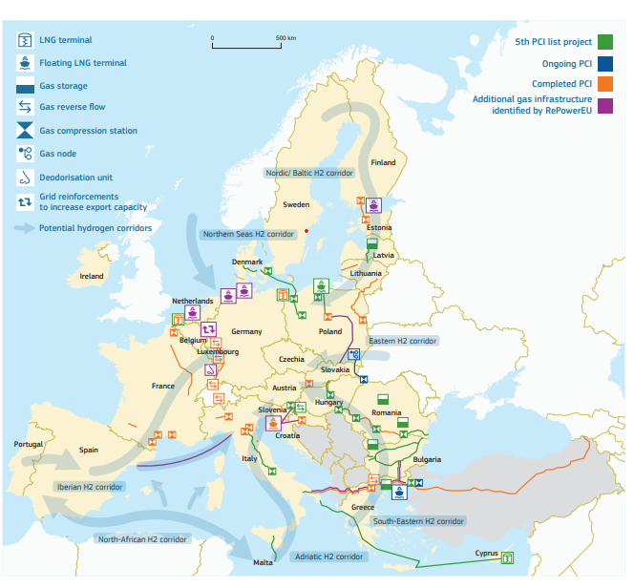
European infrastructure map for electricity
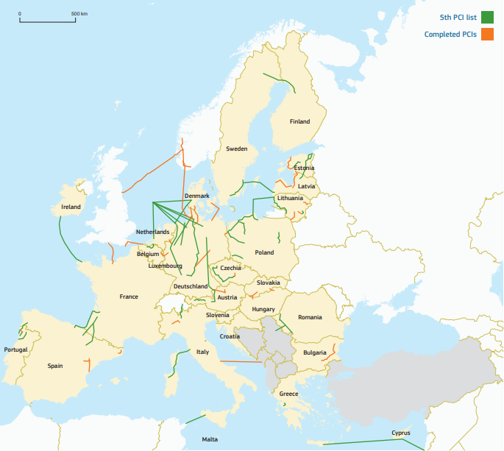
4.2 National reforms and investments
While most of the targets and objectives are European and require a strong coordination, implementation of many of the measures remain with Member States and require targeted reforms and investments.
The Recovery and Resilience Plans (RRPs) have proven highly suitable to implement urgent priorities in a joint EU framework, based on needs by Member States and with a strong results orientation. They are already providing a set of ambitious reforms and investments to deliver on the twin transition. Their milestones and targets are more valid than ever.
The Commission invites Member States to add to their existing RRPs a dedicated chapter with new actions to deliver on the REPowerEU objectives of diversifying energy supplies and reducing dependence on fossil fuels. Technical support to Member States is available under the Technical Support Instrument for that purpose. Cross-border investments are essential to strengthen interconnection and ensure the security of energy of supply for the Single Market. When assessing the dedicated RepowerEU chapters, the Commission will take its contribution towards the security of supply for the Union as a whole into account. The 2022 country-specific recommendations will guide the new RRP chapters. The Commission issued together with this communication tailored recommendations for all Member States on energy policy in line with the REPowerEU objectives.
The RRPs should ensure complementarity between measures funded under the RRF and actions supported via other national or EU funds. In particular, synergies must be increased between cohesion policy, in particular the European Regional Development Fund (ERDF), the European Social Fund+ (ESF+), the second pillar of the Common Agriculture Policy (CAP), Connecting Europe Facility (CEF) and the REPowerEU chapters in the RRPs. For example for gas, mature projects for grids, storage or LNG located in one Member State but having European importance can be included in the RRF REPowerEU chapter. RRPs could also for example support energy infrastructure projects selected in TEN-E regional groups for their common interest because they link Member States' energy networks, connect regions currently isolated from European energy markets, strengthen existing cross-border interconnections, help integrate renewable energy, and respond to market integration, competitiveness and security of supply objectives. This allows freeing CEF energy funds for interconnectors in electricity, off-shore, hydrogen and other infrastructure projects of common interest that require cross-border planning and regional cooperation for their implementation as provided under the TEN-E policy.
The RRPs provide for a fast and effective way to frontload investments focused on REPowerEU needs, combined with accompanying reforms to maximise their impact. As the REPowerEU chapter and cohesion policy funds both support the green energy transition, in energy efficiency and renewable energy investments can be supported under both. In view of enhancing synergies between these policies, Member States have the possibility to plan their investments over the lifetime of the programming period in a coordinated manner, taking into account the available funding and implementation timelines.
4.3 Financing
To mobilise finance for covering the short term REPowerEU investment needs, the Commission proposes a targeted and swift amendment of the Recovery and Facility Regulation. The amendment foresees allocating additional funding from the auctioning of allowances of the Emissions Trading System (‘ETS’), in a limited amount. It also proposes that Member States benefit from a higher flexibility to transfer resources allocated to them both under the Common Provisions Regulation (EU) 2021/1060) and the Regulation on CAP strategic plans (EU) 2021/2115). These grants will complement the remaining EUR 225 billion of loans under the RRF, resulting in a total amount close to EUR 300 billion. It is proposed that if part of the remaining EUR 225 billion of loans under the RRF is not requested by the member States currently entitled to them within 30 days after the entry into force of the amended RRF Regulation, these resources will be made available to other MS.
Member States will have the possibility to transfer up to 12.5% of their allocation under the cohesion policy to the RRF by adding a 7.5% transfer possibility for REPowerEU objectives based on demonstrable needs and provided that Member States have used the already available 5% transfer possibility. This new transfer possibility will allow Member States to include in their RRPs new investments and reforms for that contribute to a rapid reduction of fossil fuel imports from Russia. Such a transfer possibility is justified by the urgent timeline and nature of some the investments needed.
In addition, Member States will have the possibility to transfer up to 12.5% of their allocation under the European Agricultural Fund for Rural Development to the Recovery and Resilience Facility. Delivering part of the Common Agricultural Policy financing under the Recovery and Resilience Facility speed up implementation of relevant projects, allowing farmers to receive the necessary financial support to reduce the use of synthetic fertilizers and increase the production of sustainable biomethane or renewable energy.
The process for undertaking voluntary transfers by Member States of cohesion policy funds and CAP funds to the REPowerEU chapters of the recovery and resilience plans has been designed to ensure a swift adoption process, and should not delay the adoption and implementation of the strategic plans and programmes.
Above all, it is important that Member States engage in a wide consultation process during the preparation of their REPowerEU chapters, in particular with local and regional authorities, social partners as well as stakeholders from the agricultural sector, to ensure broad ownership that will be key for the successful implementation of the measures.
Cohesion policy funds with their strong record of supporting energy-related investments will continue to complement and strengthen the REPowerEU and European Green Deal objectives. Under the current MFF, cohesion policy will support decarbonisation and green transition projects with up to EUR 100 billion. To ensure swift disbursement, the Commission will put forward a flexible instrument to help member States mobilise private resources and intends to adopt by the end of 2022 a delegated act to speed up the design and reimbursements of energy efficiency projects and renewables projects through standard reimbursement schemes in cohesion policy. The Commission will also work with Member States in promoting the development of regional and local energy agencies as single entry point for energy projects.
State aid rules fully apply to the reforms and investments included into the REPowerEU chapters. It is the responsibility of each Member State to ensure that such measures comply with the EU State aid rules and follow the applicable State aid procedures. In light of the unprecedented urgency to reduce dependence on Russian fossil fuels, the Commission will look into ways to facilitate State aid control for REPowerEU measures while limiting distortions to competition. In particular, the Commission will provide guidance on how measures can be designed in line with State aid rules and fast track decisions once it has complete information. The Commission will also assist Member States in designing measures which can be exempted from notification under the General Block Exemption Regulation. Finally, it will keep the Temporary Crisis Framework for State aid under constant review to ensure that it is apt for enabling Member States to address the effects of the current geopolitical situation, including in the field of energy, and it will continue ensuring that the State aid framework is generally fit-for-purpose.
The Connecting Europe Facility –Energy (CEF-E) will support projects of common interest (PCIs) not implemented by the market or not implemented otherwise within the timeframe needed to deliver on the REPowerEU objectives. The Commission launches together with this communication a new CEF Energy call for proposals for Projects of Common Interest (PCIs) with a total estimated budget of around EUR 800 million. Successful projects will be selected in the second half of 2022 to support the most urgent infrastructure projects needed for realising the REPowerEU priorities. In early 2023, the Commission will launch another CEF Energy call for proposals for PCIs for projects to apply that may not be ready for this year’s call.
Member States can consider taxation measures to support REPowerEU objectives so as to incentivise energy savings and reduce fossil fuels consumption. Member States are encouraged to consider additional tax measures such as reductions and exemptions from vehicle taxation for both the purchase and use of electric and hydrogen vehicles, tax deductions linked to energy savings and the phase-out of environmentally harmful subsidies. The Commission’s pending proposal for a revision of the Energy Taxation Directive (ETD), contributes to the objectives of REPowerEU by setting price signals to reduce consumption of fossil fuels and save energy and the Commission calls on Member States to swiftly reach an agreement.
The InvestEU Programme will mobilize private finance to support a wide range of investments that contribute to achieving the REPowerEU’s policy goals, by sharing risks with implementing partners. The Commission will work closely and in a Team Europe approach with the EIB Group, other implementing partners of the InvestEU Programme and EU Member States to accelerate lending, blending and advisory products for renewables, energy efficiency and electricity networks.
To enable the Innovation Fund to cover 100% of the relevant costs in the case of competitive bidding, the European Parliament and the Council should swiftly examine the proposed amendment to the ETS Directive for the Innovation Fund, after which the Commission will swiftly adopt the necessary amendment to the Delegated Act establishing the Innovation Fund.

5. Reinforcing preparedness

Europe must be ready and prepared for a severe supply disruption. While the risk for unserved gas demand for this summer will be limited, there could be a risk that, without further action in the coming months, storages will not be sufficiently filled for next winter.

Together with the swift adoption of the storage regulation in view of starting implementation of refilling storage levels this summer, the Commission calls on Member States to:
- pre-emptively implement the EU Save Energy Communication. The gas saved in the short term can be used notably to refill underground storage ahead of the next winter;
- update their contingency plans, taking into account the recommendations contained in the Commission’s preparedness review. The updated contingency plans should identify the essential customers which play a key role for critical supply chains in the Union;
- ask transmission system operators to accelerate the technical measures, which can increase the reverse flow capacities from west to east by the next winter, including regarding the technical requirement concerning the composition of gas;
- conclude the outstanding bilateral solidarity arrangements between neighbouring countries.
The existing EU legal framework already foresees that in case of extreme crisis Member States can request their neighbouring Member States solidarity measures. Solidarity measures are meant as last resort in the event of an extreme gas shortage to ensure supply to households, district heating systems and basic social facilities in the affected country.
The Commission will issue guidance on the prioritisation criteria of non-protected customers, in particular of industry. The guidance will focus, on the one hand, on the identification of national and cross-border value chains of key and critical importance which, if disrupted, could negatively impact on security, food, health and safety at European and global level. It should also assess the impact on the competitiveness of the different territories. The Commission will also facilitate setting up a coordinated EU demand reduction plan with pre-emptive voluntary curtailment measures which should be ready for activation before an actual emergency arises. This plan would include voluntary market-based measures to reduce the consumption of undertakings and thus guarantee that supplies to protected customers are prioritised. In addition, the Commission is reviewing Member States’ Risk Preparedness Plans in the electricity sector to minimize the impact of potential gas disruptions on electricity generation.
Conclusions
The time to reduce Europe’s strategic energy dependence is now. REPowerEU accelerates diversification and more renewable gases, frontloads energy savings and electrification with the potential to deliver as soon as possible the equivalent of the fossil fuels Europe currently imports from Russia every year. It does this with coordinated planning, in the joint interest and with strong European solidarity.
There is a double urgency to reduce Europe’s energy dependence: the climate crisis, severely compounded by Russia’s aggression against Ukraine, and EU’s dependence on fossil fuels, which Russia uses as an economic and political weapon.
The green transformation of Europe’s energy system will strengthen economic growth, reinforce its industrial leadership, and put Europe on a path towards climate neutrality by 2050.
The European Commission calls on leaders, Member States, regional and local authorities, and indeed every citizen and business, to reduce Europe’s energy dependence from Russia through the implementation of this REPowerEU plan.

European Council Conclusions (24 and 25 March 2022)
Communication on REPowerEU: Joint European Action for more affordable, secure and sustainable energy, COM(2022) 108 final, (8.3.2022)
See the complete list of actions in Annex 1
Flash Eurobarometer 506: EU's response to the war in Ukraine, 5 May 2022.
REPowerEU scenario in the staff working document Implementing the REPowerEU Action Plan: Investment Needs, Hydrogen Accelerator and Achieving the Bio-methane Targets, accompanying this communication.
COM(2021) 558 final, 14.7.2021
COM(2022) 142 final, 30.03.2022
EU-US_LNG_2022_2.pdf (europa.eu)
On 5 May, the Commission and Bulgaria set up a first regional taskforce, as part of the EU's Energy Platform, in coordination with neighbours in the South East of Europe. Further Regional Task Forces, covering Central Eastern Europe, North-West and the Baltics will be proposed soon. In this context, it is important that the biggest energy markets of the EU, with access to diversification infrastructure such as LNG terminals, are active participants in the diversification and security of supply efforts of the Platform.
This dedicated hydrogen purchasing work stream will operationalise the European Global Hydrogen Facility, drawing on the experience of H2Global and of the Euratom Supply Agency, to be established under the EU Energy Platform.
EU external energy engagement in a changing world, JOIN(2022) 23, (18.05.2022)
Five Member States (Bulgaria, Czechia, Finland, Hungary, Slovakia) currently have VVER reactors operated on their territory, all fully reliant at present on fuel supplied by a Russian provider.
Medium Power Research Reactors (MPRRs), which include reactors in Czechia, Hungary, Poland, are characterised by their original Soviet design and are still dependent for fuel on the monopoly Russian manufacturer.
Commission Staff Working Document Implementing the REPowerEU Action Plan: Investment needs, Hydrogen Accelerator and Biomethane Targets, accompanying this communication.
EU solar energy strategy, COM(2022) 221, (18.05.2022)
Commission Staff Working Document Implementing the REPowerEU Action Plan: Investment needs, Hydrogen Accelerator and Achieving the Bio-methane Targets, accompanying this communication.
Based on REPowerEU, the Commission expects that around 30% of EU primary steel production will be decarbonized with renewable hydrogen by 2030, [requiring 1.4 million tonnes of renewable hydrogen and investments of EUR [18-20] bn to replace blast furnaces with direct reduced iron (DRI) processes fueled by renewable hydrogen.]
Commission Recommendation on speeding up permit-granting procedures for renewable energy projects and facilitate Power Purchase Agreements, C(2022) 3219, SWD(2022) 149, (18.05.2022).
Electrolyser Summit Joint Declaration. Electrolyser manufacturers in Europe committed to a tenfold increase of their capacity to manufacture electrolysers to 17.5 GW by 2025.
The Pact for Skills supports large-scale skills partnerships in different industrial ecosystems, including Energy Intensive Industries, Construction and Renewable Energy. The Pact gathers and inspires commitments from individual companies, training providers and social partners to upskill or reskill people of working age, such as developing skilled professionals and the reskilling of gas boiler installers in new technologies such as heat pumps, solar panels, etc.
Commission Recommendation on speeding up permit-granting procedures for renewable energy projects and facilitate Power Purchase Agreements, C(2022) 3219, SWD(2022) 149, (18.05.2022).
Directive (EU) 2018/2001 of the European Parliament and of the Council of 11 December 2018 on the promotion of the use of energy from renewable sources (recast).
Proposal for a Directive of the European Parliament and of the Council amending Directive (EU) 2018/2001 of the European Parliament and of the Council as regards the promotion of energy from renewable sources, COM (2022)222, (18.5.2022)
Renewables go-to area’ means a specific location, whether on land or sea, which has been designated by a Member State as particularly suitable for the installation of plants for the production of energy from renewable sources, other than biomass combustion plants.
See for example the proposal for a Council Recommendation on ensuring a fair transition towards climate neutrality (COM(2021) 801 final).
In 2022 alone, PCIs with a total additional gas transmission capacity of 20 bcm/year have been or will be commissioned, e.g. the gas interconnector between Poland and Lithuania (the GIPL pipeline), the Poland-Slovakia interconnector, the Baltic Pipe between Poland and Denmark, the Greece-Bulgaria pipeline (IGB). LNG terminals in Cyprus (2 bcm/year) and Alexandroupolis Greece (5 bcm/year) are due to be operational in 2023. Moreover, several gas PCIs are expected to be completed in the coming years which include several storage projects in South Eastern Europe (Greece, Romania, Bulgaria) as well the LNG Gdansk in Poland (at least 6 bcm/year). Besides, the support of the expansion of the Southern Gas Corridor to 20 bcm per year will play a major role to secure gas supply for South Eastern Europe (Greece and Italy at the beginning) and the Western Balkans.
Opened on 5 May, GIPL is a major EU project developed under the Baltic Energy Market Interconnection Plan (BEMIP). The 508-km-long pipeline connected Estonia, Finland, Latvia, and Lithuania to the gas market of the EU. Of some EUR 500 million spent on the project, the EU contributed ca. EUR 300 million.
The LNG facility in Alexandropoulis (a floating storage and regasification unit) is set to be completed in the end of 2023 and will have a capacity of 153,500 cubic metres, with a yearly potential throughput of 5.5 billion; the budget is ca EUR 364 mn with EUR 167 mn from the 2014-2020 cohesion policy.
Of great importance for the security of supply in Central and Eastern Europe are two gas corridors: the Trans-Balkan Corridor (Turkey-Bulgaria-Romania) and the Vertical Corridor (Greece-Bulgaria interconnector, Romania-Bulgaria interconnector and BRUA) which will facilitate the supply of gas from third countries in the region.
See indicative projects in Annex 3.
https://ec.europa.eu/energy/sites/default/files/fifth_pci_list_19_november_2021_annex.pdf
Technical Support Instrument: 2022 country factsheets | European Commission (europa.eu)

