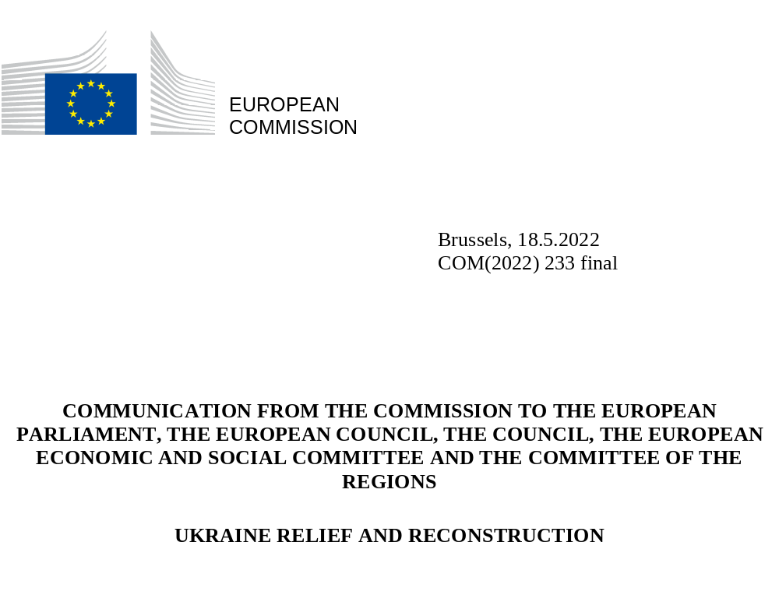

- INTRODUCTION
The unprovoked and unjustified Russian invasion of Ukraine has caused terrible human suffering and massive destruction of towns and communities. Lives and livelihoods are being lost, with more than twelve million people forced from their homes – and nearly six million from their country, half of them being children – in search of safety.
Confronted with the Russian aggression, the European Union and its Member States have shown unwavering solidarity with people fleeing the war in Ukraine and immediately mobilised support to the Ukrainian government to maintain its functions. The Union has provided emergency assistance to support resilience, humanitarian assistance, military aid and other support. The Commission is coordinating its largest ever operation under the EU Civil Protection Mechanism for a wide array of support measures, including in the health, energy, food and agriculture sectors, and providing shelters, machinery as well as medical equipment and evacuations. To support Ukraine, the Commission has also put forward measures to facilitate trade, notably the suspension of import duties on Ukrainian exports, and to establish solidarity lanes to help Ukraine export agricultural goods. The EU's welcome has been exemplified by the activation of the Temporary Protection Directive, granting access to jobs, housing, education and healthcare across the EU. The Commission will continue to support Ukraine and its people, working together with Member States in a Team Europe approach.
With hostilities taking place across the whole country, the economic situation has deteriorated rapidly. GDP is expected to fall by 30 to 50% this year and tax revenues dropped by around 50 to 80%. Ukrainian Azov and Black Sea ports remain blocked by Russian military action, depriving Ukraine of much-needed export revenues. The estimated overall damage runs already in the hundreds of billions of euros, with more than EUR 100 billion in damage to physical infrastructure alone.
A major global financial effort is required to support Ukraine during this war, as well as to rebuild the country and provide new opportunities to its citizens. This is why it is important to design the main building blocks of this international effort already now, even while Russia’s aggression continues. In its conclusions of March 2022, the European Council agreed to develop a Ukraine Solidarity Fund, inviting international partners to participate. The European Council called on the Commission to continue developing technical assistance to help Ukraine to implement necessary reforms.
A reconstruction of this scale on the European continent requires strong leadership from the European Union, working proactively with international partners. Ukraine is closely tied with the European Union through the Association Agreement and its Deep and Comprehensive Free Trade Area. On 28 February 2022, Ukraine applied for EU membership, and it has expressed a strong will to link reconstruction with reforms on its European path.
This Communication sets out the Union’s response to address Ukraine’s immediate financing gap and the longer-term reconstruction framework.
- IMMEDIATE RELIEF
The short-term response covers the immediate period when reconstruction efforts on a significant scale cannot yet be envisaged. Assistance in this period is mainly focused on necessary operational support to the Ukrainian government, complemented by providing emergency assistance and humanitarian aid.
Support already provided
The EU’s commitment to supporting Ukraine is long-standing and has delivered results. The EU has provided significant financial assistance to Ukraine, which over the years from 2014 to 2021 amounted to EUR 1.7 billion in grants under the European Neighbourhood Instrument, EUR 5.6 billion under five macro-financial assistance programmes in the form of loans, EUR 194 million in humanitarian aid and EUR 355 million from foreign policy instruments. The EU provides its support to Ukraine for policy development and comprehensive reforms, with strong involvement from Member States in a Team Europe approach. Among the flagship programmes are those on decentralisation, public administration reform and anti-corruption.
Since the Russian aggression started, the EU has stepped up its support, mobilising around EUR 4.1 billion for Ukraine’s overall economic, social and financial resilience in the form of macro-financial assistance, budget support, emergency assistance, crisis response and humanitarian aid. Military assistance measures under the European Peace Facility, amounting to EUR 1.5 billion, have also been provided to Ukraine and the mobilisation of an additional EUR 500 million is under way.
Before and during the war, the EU has worked closely with European financial institutions to support Ukraine. Since 2014, the European Investment Bank and the European Bank for Reconstruction and Development have mobilised over EUR 10 billion in loans to Ukraine. In recent weeks, the European Investment Bank has disbursed EUR 668 million to the Ukrainian budget. The EU is also working in close cooperation with the World Bank and the International Monetary Fund, which have been key partners in the Ukrainian efforts since 2014.
Short-term relief
The war resulted in a collapse of tax, export and other revenues, compounded by large scale illegal appropriation of assets and export goods including in the agricultural sector, while essential expenditure skyrocketed. Ukraine will need significant short-term financial relief to sustain basic services, to address humanitarian needs and to fix the most essential infrastructure that is now destroyed. The International Monetary Fund has estimated Ukraine’s financing gap until June at roughly EUR 14.3 billion (USD 15 billion).
The Ukrainian government’s financing needs continue to be substantial in the short term, to sustain the country, help maintain macro-financial stability and reduce the stress on human and physical capital. Addressing these needs will require a joint international effort, in which the Union will be ready to play its part.
For its part, the Commission therefore envisages to propose granting Ukraine new exceptional macro-financial assistance in 2022 in the form of loans of up to EUR 9 billion, to be complemented by support from other bilateral and multilateral international partners, including in G7 format. This would be paid in tranches with long maturities and concessional interest rates thanks to the guarantee from the Union budget.
To make this possible, Member States should agree on making available guarantees to complement the provisioning set aside for this purpose in the relevant compartment of the Common Provisioning Fund of the Union. Together with grant support from the EU budget for subsidising the related interest payments, this will ensure well-coordinated and highly concessionary relief for Ukraine.
- RECONSTRUCTION OF UKRAINE
The overall reconstruction of Ukraine will require comprehensive support to rebuild the country after the war damage, to create the foundations of a free and prosperous country, anchored in European values, well integrated into the European and global economy, and to support it on its European path.
The reconstruction effort will need to build on Ukraine’s ownership, close cooperation and coordination with supporting countries and organisations, and Ukraine’s strategic partnership with the Union. Reconstruction will also require mobilising resources at regional and local level. Peer-to-peer cooperation and programmes embedded in partnerships between cities and regions in the European Union and those in Ukraine will enrich and accelerate reconstruction.
Four major pillars of reconstruction can already be envisaged:
- Rebuilding the country, in particular infrastructure, health services, housing and schools, as well as digital and energy resilience in line with the most recent European policies and standards;
- Continue modernising the state and its institutions to ensure good governance and respect for the rule of law, by providing administrative capacity support and technical assistance, including at regional and local level;
- Implementing a structural and regulatory agenda with the aim of deepening the economic and societal integration of Ukraine and its people with the EU in line with its European path;
- Support the recovery of Ukraine’s economy and society by promoting sustainable and inclusive economic competitiveness, sustainable trade, and private sector development, while contributing to the green and digital transition of the country.
Establishing a clear link with the broad reform agenda will be vital for the success of the reconstruction effort. Ukraine has made significant reform progress over the years. It will be important to consolidate and accelerate these reforms once the full reconstruction effort starts. The reconstruction should be in line with the European green and digital agenda; it should strengthen resilience and respect fundamental principles of the rule of law, including on anti-corruption, judiciary, public administration and good governance.
Given the extent of the war damage so far, the financial needs for reconstruction are expected to be substantial and the reconstruction effort would potentially span more than a decade. The Commission will work in close cooperation with Ukraine, international partners and international financial institutions to assess the reconstruction needs, looking at how best to meet them.
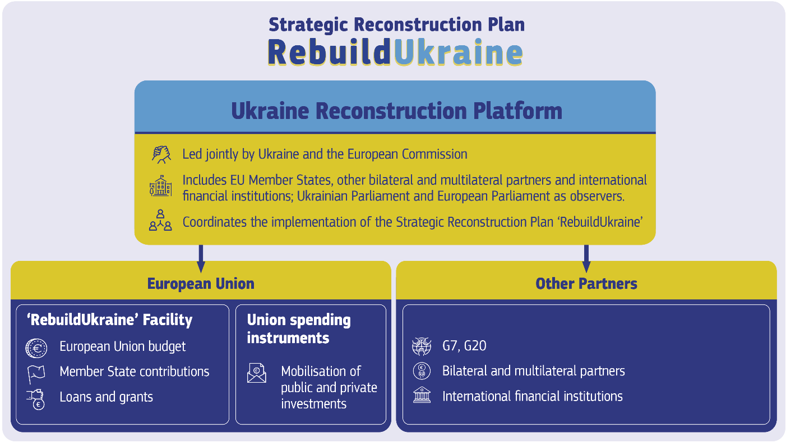
A Ukraine-led reconstruction effort embedded in its European path
The reconstruction effort should be framed in a high-level strategic reconstruction plan (ʻRebuildUkraineʼ), for which Ukrainian authorities have full ownership and which is endorsed by the Union and other international partners. The ‘RebuildUkraine’ reconstruction plan would outline key reforms and investments necessary to build a prosperous and sustainable future for Ukraine.
The Ukrainian Government has clearly expressed its intention to embed the ‘RebuildUkraine’ reconstruction plan in a strategic partnership with the European Union. This reflects the close political and economic relations based on the Association Agreement with its Deep and Comprehensive Free Trade Area and Ukraine's recent application for EU membership. Establishing a clear link to the broad reform agenda will be vital for the success of the reconstruction process, and the alignment with the EU acquis.
The Ukraine reconstruction platform
The reconstruction effort should be led by the Ukrainian authorities in close partnership with the European Union and other key partners, such as G7 and G20 partners and other third countries, as well as international financial institutions and international organisations.
The ‘Ukraine reconstruction platform’, an international coordination platform, co-led by the Commission, representing the European Union and the Ukrainian government would be established. The platform would bring together the supporting partners and organisations, including EU Member States, other bilateral and multilateral partners, and international financial institutions. The Ukrainian Parliament and the European Parliament would participate as observers. In this way, it would act as an overarching and single-entry point for all actions on the reconstruction of Ukraine.
Whereas ownership of this reconstruction plan should rest with Ukraine, the platform should be the strategic governance body endorsing the high-level strategic ‘RebuildUkraine’ reconstruction plan and ensuring that the support provided is in line with the plan. Based on that plan, the platform would determine the priority areas selected for financing and the specific projects implementing those priorities, coordinate the financing sources and their destination to optimise their use, including budgetary support to the Ukrainian state, investment support, guarantees for private sector investments, focus on specific sectors and monitor progress in the implementation of the plan. Administrative capacity support and provision of technical assistance would need to be provided to Ukraine to effectively draw up and implement the ‘RebuildUkraine’ reconstruction plan.
The platform should bring together under one roof the EU support as well as other initiatives set up by other partners such as the World Bank Trust Fund or the International Monetary Fund administered account ensuring a smooth division of labour between different partners, avoiding duplication and promoting synergies, including through joint co-financing of specific projects.
The Unionʼs support
The Union is ready to provide a major part of the overall efforts from the international community in the rebuilding of Ukraine. A joint EU approach to the Ukraine reconstruction would be in the interest of Member States and Ukraine, helping to create the conditions for a free, democratic, prosperous and sustainable Ukraine as part of the European family. EU financial mechanisms moreover provide the best safeguards for the proper use of funds.
The framework for the EU’s contribution to the reconstruction of Ukraine would consist of the following strands:
- The ‘RebuildUkraine’ Facility, a new EU-funded instrument specifically dedicated to finance the reconstruction effort and the alignment of Ukraine’s economy to the EU;
- Support from existing Union programmes, including blending and guarantees under the Neighbourhood, Development and International Cooperation Instrument.
Reconstruction and resilience support – including humanitarian aid, which will need to be reinforced and implemented in line with humanitarian principles, – will have to go hand in hand for a number of years, to take care of the most vulnerable parts of the population, such as internally displaced persons, children, victims of war including victims of sexual violence, minorities, persons with disabilities, people in need of protection and those who cannot be reached by public social services.
‘RebuildUkraine’ Facility at the heart of Unionʼs support
The ‘RebuildUkraine’ Facility would be the main legal instrument for the European Union’s support, through a mix of grants and loans, to the ‘RebuildUkraine’ reconstruction plan. It would be embedded in the EU budget, thereby ensuring the transparency, accountability and sound financial management of this initiative. The Facility would follow Ukraine’s EU-driven reform agenda and its implementation should therefore be carried out with a view to helping Ukraine rebuild its economy, with a clear link to investments and reforms. It would build on the experience with financing investments and reforms under the Recovery and Resilience Facility inside the EU, adapted to the unprecedented challenges of reconstructing Ukraine and accompanying it on its European path.
The Facility itself would have a specific governance structure ensuring full ownership by Ukraine. It would ensure that investments – including in strategic digital, transport and energy infrastructure – are brought in line with climate and environmental EU policies and standards. Its reforms would help to further integrate the Ukrainian economy into the single market improve the business environment to attract necessary foreign direct investments, support the creation of jobs and facilitate the gradual alignment and compliance with EU law. It would put significant emphasis on good governance, the rule of law, sound financial management as well as anti-corruption and anti-fraud proofing.
Mobilising resources for the Unionʼs support
With the war ongoing, the overall needs for the reconstruction of Ukraine are not yet known. They will extend beyond rebuilding of physical assets, including infrastructure, and will need to comprise budgetary support to the Ukrainian state. The duration of such support cannot now be estimated in precise terms; however, it will have to have a medium- to long-term horizon.
Even if combined with contributions from other international partners, the European Union has a strategic interest in leading the reconstruction effort of Ukraine. This implies a major share in the total international financial effort. At the same time, the large-scale and the comprehensive nature of the reconstruction of a country damaged by war, combined with support to its European path, imply important outlays at the beginning and predictability of such support over time.
These unforeseen needs created by war in Europe are well beyond the means available in the current multiannual financial framework. Therefore, new financing sources will have to be identified.
The architecture described above is sufficiently flexible to accommodate such new financing sources. The additional grants to be made available to Ukraine could be financed either by additional contributions from Member States (and by third countries should they wish to do so) to the Facility and existing Union programmes, thus benefitting from the Union’s financial mechanisms and safeguards for the proper use of funds, or through a targeted revision of the multiannual financial framework. These sources could also finance the loans to be granted to Ukraine under the Facility. However, given the scale of the loans that are likely to be required, options include raising the funds for the loans on behalf of the EU or with Member States’ national guarantees.

In this context, it can be considered whether it is possible to use frozen Russian assets as financing source in line with national and EU law, for instance following potential criminal proceedings on criminal activities related to EU-listed Russian or Belarusian individuals and companies.

- CONCLUSION
While international efforts to provide short-term relief and to bring the Russian aggression to an end continue, it is also time to look ahead and prepare for the massive reconstruction effort that will follow. This effort must be led by Ukraine, with strong and sustained support from the European Union and international partners.
This communication outlines a comprehensive framework for these efforts, fully reflecting the needs identified by Ukraine and firmly anchored in the green and digital transitions and fundamental European values. These investments will help Ukraine to emerge stronger and more resilient from the devastation of the Russian invasion. In time, they will support Ukraine in pursuing its European path.
The Commission invites the European Parliament, the European Council, and the Council to endorse the ideas put forward in this communication. Through ‘Rebuild Ukraine’, the European Union will send another clear signal of its unwavering commitment to stand with Ukraine through the war and its aftermath, and to help rebuild a stronger Ukraine for the next generation.

For example, the Cohesion’s Action for Refugees in Europe provides Member States with immediate liquidity and additional flexibility in the use of EU funds to welcome people fleeing Ukraine.
There is a high degree of uncertainty surrounding any financing gap, but the International Monetary Fund has worked closely with the Ukrainian authorities to establish a robust estimate of their needs, e.g., referred to by the International Monetary Fund’s Managing Director Kristalina Georgieva at the Spring Meetings on 21 April 2022.
The Ukrainian government has set up a National Council for Recovery, which has been tasked with preparing a plan for the post-war recovery and development of Ukraine. The establishment of the plan will build on remarkable cooperation and institutional capacity demonstrated by the Ukrainian authorities at all levels, municipalities as well as civil society (Regulation on the National Council for Recovery of Ukraine from Consequences of War, approved by Decree of the President of Ukraine dated 21 April 2022, № 266/2022). On the EU side, the European Commission established in 2014 a dedicated Support Group for Ukraine to support reforms in the country.

