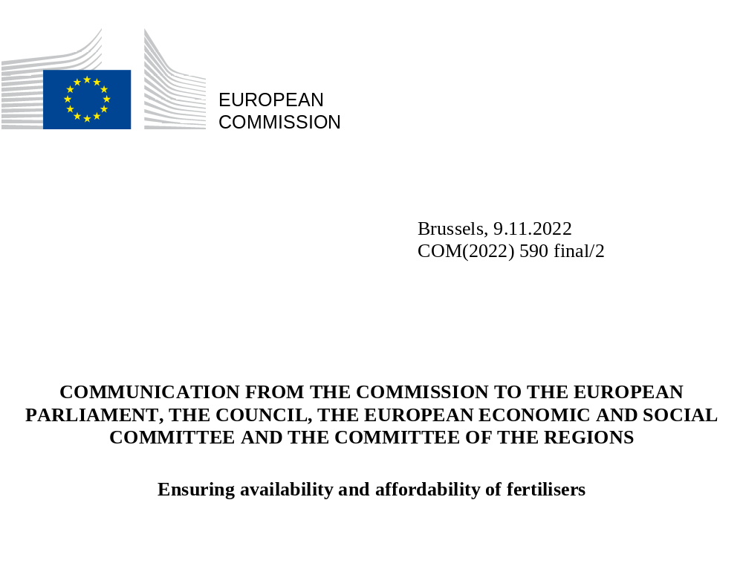

Introduction
A global mineral fertiliser crisis, of a severity unseen since the 1970s, is currently unfolding. The COVID-19 pandemic with its supply chain disruptions, followed by the energy crisis, have resulted in record high fertiliser prices.
Fertilisers play a significant role for food security.
Russia’s illegal and unjustified invasion of Ukraine has had significant negative effects on what had already been very tight global fertiliser markets. It has exposed weaknesses due to the world’s reliance on a few global suppliers. Russia, which accounted in 2020 for about 15% of global fertilisers’ exports, has imposed restrictions on its own exports of food and fertilisers lowering global supply and driving up prices. Scarcity and high prices for fertilisers compound the food security crisis in the world and a concerted effort is needed to address the global fertiliser crunch. The EU has stepped up its efforts to address global food insecurity and mitigate the effects of the food crisis in vulnerable countries, through a swift and comprehensive Team Europe Response to Global Food Insecurity.
Moreover, the EU’s Solidarity Lanes and the Black Sea Grains Initiative have been effective in alleviating the food crisis by allowing Ukraine to continue to export its grains and contributing to stabilising the markets and lowering food prices. The EU-Ukraine Solidarity Lanes have become a major trade link between Ukraine, the EU and the rest of the world and have so far facilitated the export of over 14 million tonnes of Ukrainian agricultural goods (grain, oilseeds and related products, including fertilisers), thus helping to alleviate the global food crisis. The EU has been supporting the facilitating role of the UN and Turkey calling for the renewal of the Black Sea Grains Initiative beyond 19 November. A discontinuation of the scheme would have severe consequences on worldwide food security.
Low- and middle-income countries in particular bear the brunt of the tight fertiliser markets. In 2022, a record high of 222 million people in 53 countries are acutely affected by food insecurity and in need of urgent assistance. Countries most affected include Somalia, Afghanistan, Ethiopia, Nigeria, South Sudan and Yemen, but also the region of South America.
While viable food production depends on more than just fertilisers, what makes the current situation particularly critical is the short-term effect that fertiliser shortages can have on agricultural yields. Lower yields mean less food. The UN has warned of a global fertiliser crisis, indicating that it might jeopardise food production in the coming years, affecting countries that do not have the fiscal space to run support programmes to sustain fertiliser affordability.
Figure 1: Net trade of fertilisers expressed in million tonnes of nutrients
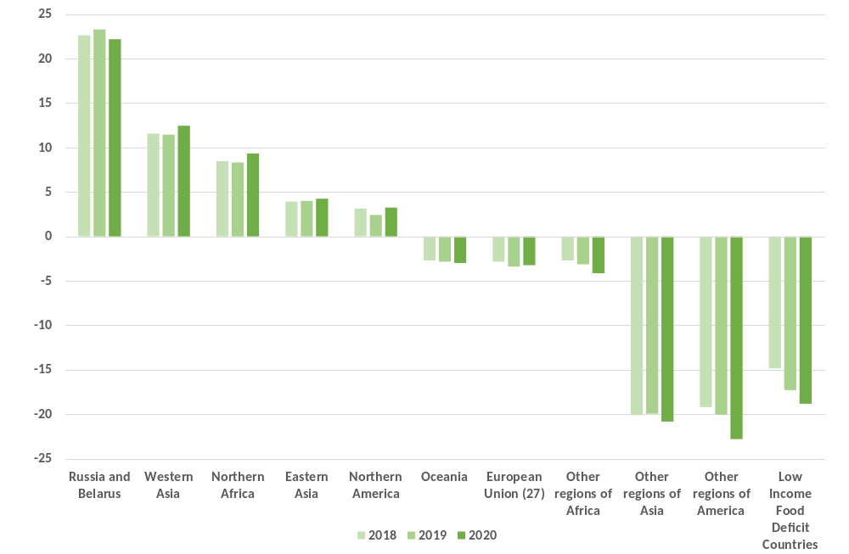
Source FAOSTAT
The global scarcity of fertilisers is primarily caused by the high price of natural gas which is necessary for the production of nitrogen fertilisers. Europe has an important fertiliser industry but is dependent on imports of natural gas as well as on imports of phosphates and potash. In summer 2022, gas accounted for up to 90% of the variable production cost of the ammonia production in the EU (ammonia is an intermediate product for nitrogen fertilisers). In August 2022 when gas prices peaked, the industry closed down 70% of its ammonia production capacity as production had become unprofitable. Indications are that the current capacity usage is at 50%. Should gas prices fall further, usage can be expected to increase further. The reduced production in the EU also means less EU exports to non-EU countries. Exports of nitrogen intermediates and fertilisers have dropped by 9% while imports have increased by 19% in the first eight months of this year.
While fertilisers remain available in the EU, their affordability constitutes a challenge for farmers (149% price rise in September 2022 on a year-to-year basis for nitrogen fertilisers), in particular as other input prices (energy) have significantly increased as well. High fertiliser prices affect farmers’ purchasing and planting decisions and this, in turn, might affect the next season’s harvest and the EU’s contribution to global food availability and affordability.
The measures that the EU is rolling out to mitigate high energy prices will improve conditions for the fertiliser industry. But more immediate and targeted action is required. The short-term actions proposed here should alleviate the difficulties EU farmers and fertiliser producers face and advance the EU’s strategic goal of reducing the dependence on imports from Russia by diversifying the production and securing reliable supply chains. Globally, the EU’s engagement in fighting food insecurity must further be strengthened.
Figure 2: Global fertilisers and food commodities price index (Index 100=2010)
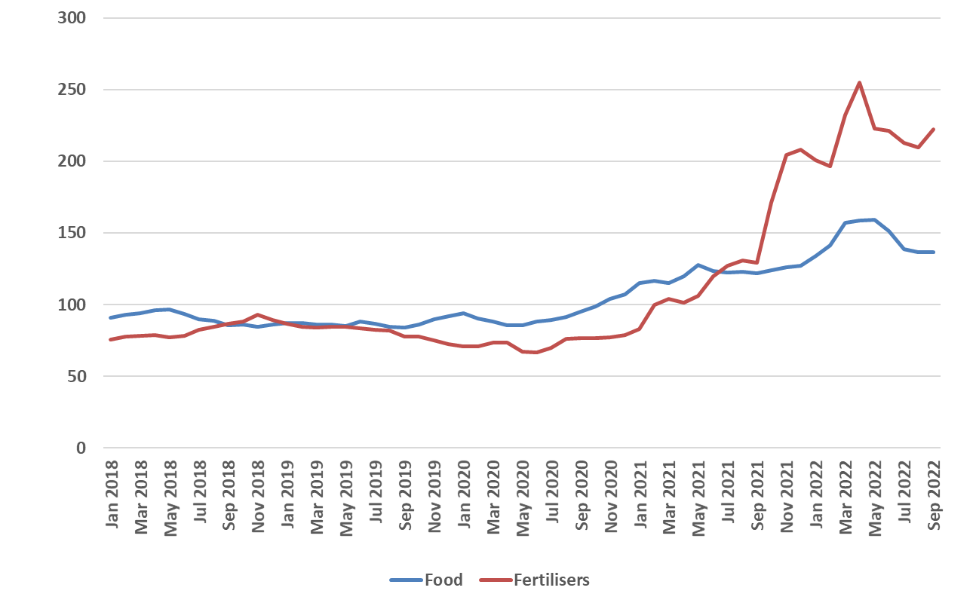
Source: The World Bank
The EU’s overall strategic objective remains defined by the targets laid down in the Farm to Fork Strategy. Evidence shows that fertilisers are not always properly applied. Nutrient losses account for up to 50-60% of the applied amount on fields in certain regions and are indicative of excess fertiliser use per hectare of cropland in many parts of the EU, with little obvious yield gain. The Farm to Fork Strategy’s target to reduce nutrient losses by 50% by 2030 while preserving soil fertility is therefore reachable.
In the short term, however, and against the backdrop of the geopolitical uncertainties, every reasonable effort should be made to avoid compromising EU’s continued contribution to food availability and affordability. We must ensure that the EU sanctions on Russia are implemented as intended, allowing the transit and flow of fertilisers for use by farmers in the EU and beyond. An acceleration of the transition to sustainable food production and innovative technologies constitutes the Union’s structural solution to ensuring food availability and affordability and protecting the health of our environment and planet.
By way of this Communication, the Commission presents the following domestic actions:
- The Commission points out that Member States may prioritise the continued and uninterrupted access to natural gas for fertiliser producers in their national emergency plans in the event of gas rationing, in line with the Commission Communication “Save gas for a safe winter”.
- The amended Temporary Crisis Framework for State aid enables a specific support to farmers and fertiliser producers. By way of the second amendment of the framework on 28 October 2022, the Commission has increased the ceilings set out for limited amounts of aid for farmers and has increased flexibility and support possibilities for companies affected by rising energy costs, such as fertiliser producers, subject to safeguards. There is potential for expanding such targeted aid over and above the currently low share of aid approved for the sector. Public authorities could for instance purchase fertilisers and offer them at lower prices to farmers.
- Funds generated by measures such as the cap on the market revenues of certain electricity generators and the solidarity contribution provided for under Union legislation can also be used, subject to the applicable conditions, for purposes of national support schemes.
- The Commission will together with Member States examine the expediency of making use of the agricultural reserve worth EUR 450 million for the financial year 2023 for farmers affected by high input costs.

- The Commission will examine and discuss with Member States how to best use the CAP Strategic Plans to address the fertiliser situation. Sustainable fertilisation measures should be implemented in an accelerated manner. The Commission encourages Member States to ensure that revisions of their plans - where insufficiently programmed as of now - help farmers use fertilisers more efficiently and sustainably. The Commission will welcome and support such amendments and ensure that these interventions reduce and prevent environmentally harmful nutrient losses.
- The Commission will take steps to improve market transparency in the EU’s fertiliser market by way of a new market observatory, to be established in 2023, and the organisation of regular stakeholder consultations in the framework of the expert group of the European Food Security and Crisis Mechanism (EFSCM).
- In an effort to promote the EU’s open strategic autonomy as an opportunity for the EU to ensure the security of its food supply and to set high sustainability standards, the Commission will promote the following measures as regards fertilisers:
  - better access to organic fertilisers and nutrients from recycled waste-streams, especially in regions with a low usage of organic fertilisers.
  - support for the conversion of the European nitrogen fertiliser industry to one based on ammonia produced using renewable and fossil-free hydrogen.
  - ensure that there is a stable and workable regulatory environment governing the production of renewable and low-carbon hydrogen, thereby ensuring that a market for renewable and low-carbon hydrogen-based fertilisers can rapidly develop.
  - support for import diversification to reduce dependence on Russia.

  - launch in 2023 a new European Innovation Council challenge on resilient agriculture.

- The Commission will adopt an Integrated Nutrient Management Action Plan in the first quarter of 2023 aiming at action at EU and national level to promote more efficient use of nutrients, taking into account Member States’ starting points and a zero-pollution ambition.
In the international area, the Commission will:
- continue to work with its Member States and European Financial Institutions, in a Team Europe approach towards the contribution to the four strands of the Response to Global Food Insecurity (Solidarity, Production, Trade and Multilateralism).
- continue to work with its Member States, Ukraine, Moldova and relevant stakeholders to increase the capacity of the EU-Ukraine Solidarity Lanes.
- cooperate with selected EU partner countries, including through the Global Fertilisers Challenge, to reduce their dependence and consumption on imported mineral fertilisers through the use of effective and sustainable farming practices, and alternatives based on sustainable soil fertility management.
- improve global market transparency in fertilisers, by contributing to relevant international initiatives concerning fertilisers, in particular the G20’s Agricultural Market Information System (AMIS).
- continue to work with UN agencies and International Financial Institutions to address in bilateral and multilateral forums the issues of availability and affordability of fertilisers and to contribute to sustainable multilateral solutions.
- step-up the support to address balance of payments needs including through the IMF Poverty reduction and Growth Trust, and reinforce cooperation with independent financial institutions under Global Gateway to develop innovative and sustainable investments.
- initiate discussions on transparency improvements, including the avoidance of export restrictions on fertiliser trade in the WTO, with the view to delivering on the commitments taken under the declaration on food insecurity agreed at the last Ministerial Conference.
- continue to work with the Member States to ensure that global trade in agri-food products, including fertilisers, is able to proceed smoothly.
- step-up its work concerning joint communication and diplomatic outreach to highlight and consolidate the Team Europe response to food insecurity and to to counter Russian disinformation. The EU will continue monitoring and countering Russia’s information manipulation, including through the EU public channels, such as EUvsDisinfo, while continuing working with like-minded partners, in particular within the G7 and NATO.

Ensuring availability and affordability of fertilisers in the EU

Market monitoring
Since the rise in agricultural input prices in 2021, the fertiliser market has been on the agenda of Commission meetings with stakeholders and Member States, including in the European Food Security Crisis Preparedness and Response Mechanism (EFSCM) and in the expert group meetings on fertilising products.
Data on stocks held by fertilisers industry and/or farmers and their producer organisations does not exist. The Commission will improve market transparency via an observatory for fertiliser markets in the EU and examine ways in which to obtain more real-time data from Member States and from stakeholders.

Common Agricultural Policy (CAP) and Member States’ CAP Strategic Plans
Under the new CAP, financial support is widely available to farmers with a view to optimising their fertiliser use, thereby enabling them to achieve environmental, climate and economic benefits. Best practices in Member States show that, with greater nitrogen use efficiency fertiliser use can be reduced while maintaining or even increasing yields as well as having a positive impact on overall soil-fertility. At the same time, increased efficiency in the EU will reduce the need for fertilisers, reducing tension in the global market.
The new green architecture combines enhanced conditionality (GAECs and SMRs) to protect and improve soil health and fertility with voluntary measures designed by Member States to support farmers beyond the minimum requirements, including in the area of nutrient management. Voluntary measures for farmers include interventions such as eco-schemes, agro-environmental and climate management commitments. All CAP Strategic Plans address nutrient use efficiency through different actions:
- Interventions incentivise crop diversification and enhanced rotation with inclusion of protein crops. CAP plans also support ‘catch crops’ that increase green fertilisation and soil organic matter or commitments to increase the soil cover beyond the minimum requirements.
- CAP Strategic Plans support the wider adoption of nutrient management plans, beyond the areas where they are already compulsory under the Nitrates Directive - that increase use efficiency.
- Precision agriculture, organic farming and agro-ecology are supported under the plans in the form of management commitments and investments in new machinery, practices requiring less use of fertilisers and greater access to advice and training.
- CAP Strategic Plans support partial replacements of mineral fertilisers by organic fertilisers like manure, sewage sludge and biowaste, from methanisation processes or biological and thermal treatments, while ensuring that this does not result in higher nutrient losses.
In the negotiations leading to the adoption of the CAP Strategic Plans, the Commission has urged Member States to include measures in their plans in relation to practices optimising the efficient use of fertilisers. Once all the plans are adopted, it will ensure that planned interventions are followed up and implemented. It will encourage Member States to promote a wider adoption of these measures by farmers. The Commission will invite Member States to look into further prioritisation and to increase the ambition of such interventions in future revisions of their CAP Strategic Plans. In particular, the Commission calls on Member States to accelerate the rollout of Farm Sustainability Tool for Nutrients (FAsT) and its adoption by farmers.

Exceptional measures and the agricultural reserve
In March 2022, the Commission adopted an exceptional support package worth EUR 500 million to support the producers most affected by the serious consequences of the war in Ukraine. Funds under the crisis reserve of the CAP were used for this purpose. On this basis, Member States have provided EUR 492 million of financial support prioritising farmers engaged in sustainable practices and hardest hit by the crisis.
Under the agricultural reserve of the reformed CAP, EUR 450 million will be available in 2023 for public intervention and storage measures to stabilise agricultural markets or for exceptional measures that would respond to threats of market disturbance, health risks, or other emergencies as laid down in the Common Market Organisation Regulation. The Commission will, together with Member States, look into the expediency of deploying exceptional measures under the agricultural reserve to prevent market disturbances that would stem from the impact of the tight fertiliser market on EU farmers’ production.

Temporary Crisis State Aid Framework as a conduit for financial assistance
The Temporary Crisis State Aid Framework (‘Framework‘) enables Member States to use the flexibility foreseen under State aid rules and allows them to support among others primary agricultural producers, including as regards their purchases of fertilisers, and fertiliser producers. Member States may grant aid to cover part of the recent increase in gas and electricity costs for companies, including for example primary agriculture and manufacturers of fertilisers, subject to safeguards.
Between March and September 2022, the Commission approved 18 agriculture specific aid schemes with a total budget of about EUR 3.5 billion under the Framework. Three of the schemes are dedicated to farmers’ purchases of fertilisers (total budget of EUR 855 million). Most Member States opted for umbrella schemes open to all sectors of the economy (EUR 455 billion in September 2022). Some Member States opted for dedicated State aid schemes to support energy intensive companies.
On 28 October 2022, the Framework was adjusted to the needs of Member States to support energy intensive companies most affected by the crisis, including fertiliser producers. Fertiliser producers as a particularly affected sector may, if they meet the eligibility criteria, benefit from higher aid intensities and aid amounts of up to EUR 150 million. For companies receiving larger aid amounts, the Temporary Crisis Framework foresees commitments to set a path towards reducing the carbon footprint of energy consumption and implementing energy efficiency measures. Also the ceiling for maximum aid for primary agriculture (farmers) has been increased, which allows Member States to support farmers’ purchases of fertilisers if necessary.
State support can take different forms beyond State aid measures. It is, for example, possible for public authorities to purchase fertilisers at more competitive market prices (given their bargaining power) and to offer them at lower prices (there would be an element of State aid in this) to farmers, subject to the applicable limits of the Framework. Member States could also ensure that fertilisers are distributed among farmers in a reasonable and non-discriminatory manner, in particular in the case of necessary gas rationing.

Other EU funding
By virtue of a cap on the market revenues of certain electricity generators and the solidarity contribution, Member States may have funds at their disposal that they can inter alia re-direct via the Framework towards intensive energy users such as farmers or fertiliser producers (up to an estimated EUR 140 billion) to support companies in energy intensive industries provided that these funds are used for investments in renewable energies, energy efficiency or other decarbonisation technologies. The recently proposed targeted and exceptional measures (SAFE - Supporting Affordable Energy) under the 2014-2020 Cohesion Policy rules would allow national authorities to choose to redirect up to EUR 40 billion to support SMEs, workers and vulnerable households to cope with the increasing energy prices. In addition, the Commission encourages Member States to prioritise measures that target fertiliser affordability and thereby bolster food security.
In light of the current energy crisis, the Commission has proposed to make targeted amendments to the Recovery and Resilience Facility (RRF) Regulation to integrate dedicated REPowerEU chapters, which Member States can add to their existing recovery and resilience plans (RRPs). The Commission has issued guidance for Member States on how to modify and complement their RRPs with dedicated REPowerEU chapters, which should aim at energy savings, diversification of energy supplies, and the accelerated roll-out of renewable energy to replace fossil fuels in homes, industry and power generation. Member States, in their revision of their plans, could integrate support for a sustainable production of fertilisers as part of this diversification, in full respect of the ‘do no significant harm’ principle .
Under Horizon Europe, targeted investments with a volume of around EUR 9 billion are mobilised for the period of the current Multiannual Financial Framework 2021-2027, dedicated to the work programmes, partnerships, and missions of Cluster 6 related to Food, Bioeconomy, Natural Resources, Agriculture and Environment. In the first two years of Horizon Europe, more than 35 projects with a budget of around EUR 180 million are estimated to relate to fertilisers in agriculture, including projects on optimisation of nutrient budget, alternative fertilising products, and nature-based and agro-ecological solutions for nutrient management. Funding is also granted under the Mission ‘A Soil Deal for Europe’. One of its specific objectives is reducing soil pollution, targeting action that reduces fertiliser use and nutrient losses.
In 2023, the Commission will launch a new European Innovation Council challenge on resilient agriculture with a budget of EUR 65 million to support AgTech start-ups for the fast development of deep-tech innovations to maintain and improve crop yield with environmentally friendly technologies, notably in the area of fertilisation.
The Emissions Trading System (ETS) Innovation Fund also provides financing for innovative demonstration projects that contribute to circular economy objectives linked to the recovery of materials from waste and waste-water such as, inter alia, nutrients.

Organic fertilisers
The substitution of mineral fertilisers by organic fertilisers is part of the solution to reduce the EU’s dependence on gas and is also promoted via the EU’s organic target (25% of agricultural land by 2030). It will help reduce the carbon footprint of fertilisers.
Since July 2022, the Fertilising Products Regulation (FPR) has opened the single market in particular to fertilisers made from recovered waste and by-products available in the EU. It promotes green and circular alternatives to natural gas and mined raw materials for fertiliser production. Specialty EU fertilising products such as inhibited fertilisers, controlled release fertilisers and plant biostimulants will increase use efficiency and therefore reduce the amounts of fertilisers needed for optimised yields. The forthcoming definition of end-points in the manufacturing chain under the Animal by-products Regulation - a pre-condition for the market access granted by FPR - will constitute important further progress.
Developing methods to extend efficient nutrient recycling of organic waste (e.g. livestock manure, anaerobic digestion, sludge and other organic waste streams) into renewable bio-based fertilising products contributes to the objectives of the Farm to Fork Strategy. An important element in this is the separation and collection of bio-waste. Better local use of organic waste not only has environmental benefits, it also has economic benefits for livestock farmers and farmers producing arable crops and will reduce the dependence of European agriculture on mineral fertilisers from outside the EU. On 26 October 2022, the Commission adopted a revision of the urban waste-water treatment Directive including stricter obligations to recover nutrients from wastewater, which can then be reused in agriculture.
The use of manure and processed manure, in compliance with the Nitrates Directive, can play a role in helping farmers to reduce their exposure to volatile mineral fertiliser prices and close nutrient cycles. The circular use of biowaste as fertiliser will be discussed in the Commission’s Integrated Nutrient Management Action Plan which will be adopted at the beginning of 2023. In that context, the Commission will also assess further regulatory and non-regulatory steps to allow for wider use of recovered nutrients from livestock manure.

Alternative supply sources for imports and suspension of import duties for ammonia and urea
Diversifying the supply sources of imported fertilisers and intermediate products to ensure fertiliser availability constitutes a pragmatic reaction to curtailments of production in the EU, especially in regions where appropriate links to ports exist. In this regard, the EU’s free trade agreements (FTAs) promote access to fertilisers from key trade partners. This does not detract from the EU’s strategic interest in a viable fertiliser production sector in the EU.
The Commission has reached out to alternative suppliers of fertilisers to compensate for shortfalls from Russia and Belarus. Oman, Turkmenistan and Qatar have been identified as alternative sources of nitrogen fertilisers. The economies of these non-EU countries will benefit from such imports through increased growth and employment. Imports from Egypt and Algeria are up substantially (by almost 20% and 40%, respectively), with the realistic prospect of Egypt replacing Russia as the EU’s main source of imports in 2022.
Most Favoured Nation duties of 6.5% apply to imports of nitrogen fertilisers into the EU. The Commission has proposed suspending these tariffs for two key intermediate goods used in the production of nitrogen fertilisers, i.e. ammonia and urea, until the end of 2024. This would address availability and affordability concerns relating to the supply of ammonia and urea and promote import diversification. The proposal is currently under discussion in the Council. In 2019, following an investigation concerning dumping causing injury to the EU’s industry, the Commission imposed anti-dumping duties against imports of urea ammonium nitrate (UAN) from Russia, Trinidad and Tobago and the United States. On 26 October 2022, the Commission decided not to suspend them.

Measures to ensure security of supply and affordability of gas
Over the past year, the Commission has taken decisive steps to ensure security of gas supply and stabilise gas markets. On 13 October 2021, the Commission published guidance to Member States (‘Energy Price Toolbox’) to address the immediate impact of price increases, and further strengthen resilience against future shocks.
The REPower EU Plan of 18 May 2022 introduced measures to decarbonise gas markets and promote renewable gas as well as energy savings, diversification of energy supplies, and the accelerated rollout of renewable energy to limit the impact of supply disruption and keep energy prices in check.
In its July 2022 ‘Save gas for a safe winter’ Communication, the Commission reinforced the EU’s preparedness for this winter. The demand reduction measures, along with the efforts made under the Gas Storage Regulation to reach and even exceed the Union’s gas storage targets, have attained their objective. Prices, although still at historically very high levels, have decreased compared to the peak level they reached in August 2022. The Commission provided guidance to Member States concerning the industries considered critical or strategic from a societal perspective for purposes of prioritisation. The food sector is identified as a critical sector and the fertiliser sector as supplying the socially critical agricultural sector across the whole EU. The Commission points out that Member States may prioritise the continued and uninterrupted access to natural gas for fertiliser producers in the case of rationing of gas by means of their national emergency plans.
More recently, on 18 October 2022, the Commission has proposed a new emergency regulation to address high gas prices in the EU and ensure security of supply this winter. This will be done through joint gas purchasing, price-limiting mechanisms, new measures on transparent infrastructure use and solidarity between Member States, and continuous efforts to reduce gas demand. These new measures will help to further mitigate the price pressure felt by European citizens and industry, while ensuring security of supply and a functioning internal market.

Promoting green ammonia and biomethane production
As regards nitrogen fertilisers, ammonia produced using renewable, low carbon and other fossil-free hydrogen is a technology that promises to greatly reduce the greenhouse gas emissions from the fertiliser production process. The use of renewable hydrogen would furthermore eliminate the EU’s dependence on natural gas for producing fertilisers. Although many large-scale projects are underway, these will only start to produce significant quantities of fertilisers from 2025.
Challenges remain in upscaling ammonia production based on renewable hydrogen, including a lack of infrastructure, speeding up permitting procedures and a regulatory framework that is still under development. The REPowerEU Plan presents a number of actions to address these challenges. As gas prices rise, these projects are becoming commercially viable compared to ammonia based on natural gas, accelerating the former’s deployment. To help scale up the EU’s renewable hydrogen economy, a new European Hydrogen Bank will be created to invest EUR 3 billion into kick-starting a hydrogen market in EU, including through matching supply with demand.
Apart from the Temporary State Aid Crisis Framework, the Commission has recently revised and modernised its State Aid toolbox, which Member States can use to support the conversion of the European nitrogen fertiliser industry to renewable electricity or renewable hydrogen, in combination with local circular nutrients recuperation projects, if the relevant conditions are fulfilled.
The Commission will aim at ensuring that there is a stable and workable regulatory environment governing the production of renewable and low carbon hydrogen, thereby ensuring that a market for renewable and low carbon hydrogen-based fertilisers can rapidly develop. The Commission will soon publish two delegated acts under Directive (EU) 2018/2001 establishing a regulatory framework for renewable fuels of non-biological origin.
Biomethane has a promising substitution potential in relation to gas, especially for the zones where renewable hydrogen would be less competitive. As indicated in REPowerEU, boosting sustainable biomethane production to 35 bcm by 2030 is a cost-efficient path to achieving the EU’s ambition to reduce imports of natural gas from Russia. Not only will this supply renewable energy and boost farmers’ income, but it will also create a new supply stream of organic fertilisers. The European Biomethane Industrial Partnership was launched on 28 September 2022, with a target of annual production and use of biomethane of 35 bcm by 2030.
The Commission will furthermore look into measures that can help make green fertilisers competitive in the market during the transition to a fully decarbonised economy.

Ensuring availability and affordability of fertilisers in the world

EU support to multilateral and bilateral initiatives
The European Union has swiftly reacted to the systemic shock generated by the Russian aggression against Ukraine through its four-pronged Team Europe Response to Global Food Insecurity: (1) Solidarity, (2) Production, (3) Trade and (4) Multilateralism. In total, the European Union is estimated to provide EUR 7.7 billion until 2024 to support global food security and sustainable food systems. The EU supports, inter alia, measures that seek to improve soil health as well as more optimal and sustainable use of fertilisers.
The Commission recognises the work of the UN-led Global Crisis Response Group on Food, Energy and Finance as well as other international initiatives such as the G7 Global Alliance on Food Security, the Call to Action and FARM. These initiatives include measures to address fertiliser shortages, notably by keeping markets open and avoiding export restrictions, temporarily increasing fertiliser production to compensate shortages, supporting fertiliser innovation and promoting methods to maximise fertiliser efficiency.
The Commission reinforces the multilateral approach in its bilateral talks with strategic partners. For example, by way of the Collaboration Platform on Agriculture set up with the United States in November 2021, key issues such as the lack of reliable information on supply and demand in international markets, the need to improve crop production efficiency and the use of nutrients, and refining production practices using data and precision application are addressed. The Commission and Canada will hold a joint event on the sustainable use of fertilisers, focusing on optimisation of use and the development of new products.
The Commission will join the Global Fertiliser Challenge (GFC) launched at the Major Economies Forum in June 2022. The initiative aims to strengthen global food security and reduce agriculture greenhouse gas emissions by helping alleviate fertiliser supply shortages notably through better nutrient management, increased fertiliser use efficiency, alternative farming practices and alternatives to mineral fertilisers is in the process of identifying concrete actions that contribute to the objectives of GFC.
In addition to the impact of the Russian invasion, global fertiliser markets have been strongly affected by market disruptions. Key producing countries, like Russia and China, have imposed export restrictions, which have impacted 20% of the global fertiliser trade expressed in nutrients. The EU put all its efforts in cooperating with its partners and international organisations, with the aim to avoid such restrictions to trade.

Support for partner countries: sustainable soil fertility management and farmers’ productive capacities
Global levels of mineral fertiliser consumption per hectare of arable land vary considerably. Diversified agricultural practices, access to water, adapted training and rural advisory services, secured land rights, fair access to quality seeds and access to credit are among the major levers to support farmers’ production and resilience strategies. These factors are key, especially in areas where land degradation leads to a low fertiliser response.
Against this backdrop and in line with its Farm to Fork and Biodiversity strategies, the Commission is committed to globally pave the way for innovative approaches in support of integrated soil fertility management, applying a diverse set of site-specific soil fertility solutions conducive to sustainable yield gains. Diversified agro-ecosystems, higher soil organic matter content and better nutrient cycle management (i) increase the resilience to climate change, (ii) contribute to climate mitigation by an increased storage of carbon in the soil, and (iii) enhance biodiversity preservation.
Although not all farmers are impacted in the same way and at the same scale in each country, the EU helps its partners to reduce their reliance on imported fertilisers and dependence on mineral fertilisers by investing in alternatives, including organic fertilisers, and also sustainable agriculture and soil fertility management. This is a key component of the rollout of the country driven national food systems transformation pathways, following the 2021 UN Food Systems Summit. A number of interventions funded from the NDICI-Global Europe instrument, including from the 225 million EUR new Food and Resilience Facility for the North Africa and Middle East countries, as well as from the development envelope of the recently announced 600 million EUR support from the EDF reserves for ACP countries and the Food and resilience facility, will be designed for this purpose. In particular, the EU will:
- facilitate dialogue and sharing of experiences, support research and innovation activities, notably in countries with high fertiliser use and/or low nutrient use efficiency;
- work closely with farmers’ organisations across specific agri-value chains and link them systematically to agricultural research organisations and private sector, building among others on the DeSIRA and GCCA+ portfolios;
- promote agro-ecological approaches, including concerning concrete value chains and crops, and sustainable agricultural practices that are essential to improve and sustain soil fertility (legumes and plant proteins, cover crops, agroforestry, polyculture-livestock, etc.). For instance, such actions will be adopted in Morocco, Tunisia, Egypt, Jordan, Lebanon and Syria under the regional ‘Food and Resilience Facility’ worth EUR 225 million;
- improve access to and efficient use of fertilisers for smallholders through transparent and well-targeted tools (e.g. e-vouchers, co-payment schemes, use of micro-doses for more efficiency), efficient advisory services (calculation of nutrient balances, mobilisation of different sources of nutrients) and improved public input subsidy programmes for mineral and organic fertilisers;
- foster ongoing strategic partnerships, notably with CGIAR, the International Fund for Agricultural Development (IFAD) and FAO, to strengthen sustainable soil fertility management and facilitate agro-ecological approaches.
In parallel, the EU aims to further strengthen its humanitarian food assistance, which is already over EUR 900 million so far in 2022. This is around 55% more than last year, and almost 80% more than in 2020. Funds will be used to strengthen vulnerable populations’ food security and nutrition status through modalities that would vary depending on the country and regional contexts (direct food assistance in kind/cash including multi-purpose cash, nutrition).

Market transparency and G20’s Agricultural Market Information System (AMIS)
The EU will continue to promote market transparency to ensure stability of the markets and to avoid market disturbances and prices spikes. The Commission welcomes the extension of the coverage of the G20’s AMIS to the fertiliser market and is committed to providing all necessary data and support to the AMIS Secretariat. In this regard, the Commission is exploring with Member States the possibilities for increased funding of AMIS.

Facilitating the global trade in fertilisers
The EU will continue to advocate against measures restricting or banning the export of fertilisers as reflected in the Commission‘s Communication of 23 March. The EU will continue to work closely with other countries in international fora (in particular in the WTO, G7, FAO) against trade restrictions or export bans on fertilisers and ensure an open, transparent and predictable trade environment. In that sense, the EU will promote actions to increase transparency concerning exports restrictions including on fertilisers as a way to implement the commitments taken under the declaration on food insecurity agreed at the last WTO ministerial.
The new and expanded logistics routes set up by the EU-Ukraine Solidarity Lanes have become essential corridors for Ukraine’s exports, both in agricultural and other sectors. Since August, the UN-brokered Black Sea Grains Initiative has helped relaunch grain shipments from Ukraine’s Black Sea ports. Together, both initiatives have allowed the export of more than 22 million tonnes of Ukrainian grain, oilseeds and related products between May and October. A significant share of these agricultural goods has been reaching partner countries in need.
At the same time, the EU has essentially exempted the agri-food sector and fertilisers from its restrictive measures against Russia. Since these sanctions are not extraterritorial, they do not apply to non-EU companies or individuals that conduct business entirely outside the EU. Moreover, they allow the transfer of potash fertilisers, originating or exported from Russia to non-EU countries, to be carried out by EU operators or via EU territory. The financing or financial assistance associated with such transfers is allowed, as is the provision of insurance. In addition, EU sanctions also contain specific provisions to ensure that transactions for Russian agricultural products, including fertilisers, are able to proceed smoothly. The Commission has issued guidance to this effect, in order to assist Member States in the effective and uniform implementation of EU sanctions, which is paramount for the agri-food sector. Further, the Commission continues to work closely with Member States and international organisations to ensure that guidance and implementation by competent authorities are transparent and consistent, enabling industry to maintain functional supply chains in full compliance with EU sanctions, and contributing to the availability of fertilisers for farmers. EU sanctions have a clear objective: to deter and respond to the Russian war of aggression in Ukraine. For this reason, EU sanctions place restrictions on some key sectors of the economy in order to prevent significant revenues funding the Russian war machine, and freeze the assets of individuals and entities who support the war. However, contrary to the Russian propaganda, these aims are not incompatible with food security.

Address affordability through enhanced fiscal space
Higher import prices for food and fertiliser and disruptions of supply chains for food importers as well as a loss of revenue for some food exporters add to urgent balance-of-payments needs of certain Non-EU countries. The EU’s EUR 100 million contribution to the IMF’s Poverty Reduction and Growth Trust (PRGT) and its leverage effect will support vulnerable countries that have seen their import bills increase. The IMF recently launched a Food Shock Window. The EU supports this window by way of its contribution to the PRGT as it helps ACP countries (mostly Low Income Countries) access concessional lending to mitigate the consequences of the food crisis. Furthermore, through the new EUR 225 million Food security and resilience facility the EU will support, inter alia, the balance of payment stabilisation in countries in the Southern neighbourhood, and this support should be further extended in 2023.

Strengthen partnerships with International Financial Institutions
The EU will seek ways to strengthen partnerships and develop innovative and sustainable investments in the agricultural sector by reinforcing cooperation with International Financial Institutions under the Global Gateway as part of a comprehensive Team Europe response including through the European Fund for Sustainable Development (EFSD+) Open Architecture agriculture investment window. EFSD+ supports climate-smart agriculture systems and value chains. The EBRD’s portfolio already covers significant investments in the agribusiness private sector. The European Investment Bank will provide the International Fund for Agricultural Development (IFAD) with a EUR 500 million concessional loan to finance investments that boost sustainable agricultural production and generate resilience.

Strategic communication and fight against disinformation
The Commission will intensify the joint communication on its fertiliser efforts at multilateral, regional and country level, including through EU Delegations to address perceptions and concerns in partner countries. In parallel, the EU will continue monitoring and countering Russia’s information manipulation and interference activities aimed at diverting the responsibility for the food security crisis away from its war of aggression against Ukraine, including through the EU public channels, such as EUvsDisinfo and with like-minded partners as in G7 and NATO.

Conclusion
Fertilisers are important for ensuring the continuous production of food and feed in the EU and globally. High gas prices and Russia’s war of aggression against Ukraine, on top of the dependence on a limited number of suppliers - including Russia - have jeopardised the availability and affordability of fertilisers, thus putting food security at risk, especially in the most vulnerable countries in the world.
In this context, short-term actions are needed to support farmers and fertiliser producers. Those consist in better market transparency, assistance measures benefitting fertiliser producers and farmers through State aids and EU funding such as the CAP Strategic Plans and market measures under the agricultural reserve, diversification of the import sources of fertilisers and gas-securing and gas-price limiting measures while supporting sustainable agricultural practices for better use of fertilisers and less dependence on fertilisers. Such actions should remain consistent with the long-term objectives of the EU Green Deal and its related strategies.
The EU will continue to work with the Member States, European Development Banks, international organisations, partner countries and other key actors to mitigate the impact of fertilisers’ impaired affordability on global food security and to improve their efficient use. The EU has joined new international initiatives like the Global Fertiliser Challenges, is stepping up its partnership with International Financial Institutions and will continue to promote measures to ensure global market transparency and avoid export restrictions.
In the medium and long term, an important part of the solution to the challenges concerning the supply of fertiliser as well as the environment and the climate lies in supporting the transition to the sustainable use of fertilisers and the deployment of sustainable alternatives to mineral fertilisers. Support for the recycling of nutrients from waste-streams and the scaling up of the production of green ammonia will be key flanking actions. This will generate benefits for farmers, the environment and the climate and at the same time lessen the EU’s dependence on fertilisers based on fossil fuels. This should go hand in hand with the continuation of actions such as better market transparency, the diversification of import sources, the prevention of market restrictions and actions aiming at an affordable and secure energy supply.
This approach offers opportunities for the EU’s partner countries too. The EU will support them in promoting alternatives to mineral fertilisers based on a sustainable soil fertility management.
The current crisis is an opportunity to accelerate the transition to a sustainable agriculture and a sustainable food system, away from an undue dependence on synthetic fertilisers, while ensuring an adequate and affordable fertiliser supply to farmers in the EU and in the world.

See Annex 1 of this Communication for a brief explanation of the biological and chemical processes underlying the working and impact of fertilisers.
See 23 March 2022, Commission Communication, ‘Safeguarding food security and reinforcing the resilience of food systems’, COM(2022) 133 final.
Geographical aggregates are those or constructed from FAOSTAT’s aggregates.
The state and mechanics of the fertiliser market in the EU and in the world are briefly explained in the Annex 2 to this Communication.
The key macro-nutrients used in fertiliser production are nitrogen, phosphorus and potassium.
In this context, the proposal for the Soil Health Law in 2023 will provide further targeted medium/long-term responses to the issue of fertile soil for food security in the EU.
GAECs (Good Agricultural and Environmental Conditions) and SMRs (Statutory Management Requirements) relevant in the area of nutrients are compliance with the obligations derived from the Nitrates Directive (SMR 2), establishment of buffer strips along water courses (GAEC 4), measures to avoid soil erosion and to ensure minimum soil cover (GAECs 5 and 6) and crop rotation (GAEC 7).
Catch crops take up surplus nitrogen remaining from fertilisation of the previous crop, preventing it from being lost through leaching.
Investments in relation to precision farming are explicitly included in 24 draft plans.
The Farm Sustainability Tool for Nutrients enables farmers to optimise their use of fertilisers as regards timing, amounts and placement.
Commission Communication, ‘Temporary Crisis Framework for State Aid measures to support the economy following the aggression against Ukraine by Russia’, C(2022) 7945 final.
Council Regulation (EU) 2022/1854 of 6 October 2022 on an emergency intervention to address high energy prices.
12 February 2021, Commission Notice, ‘Do No Significant Harm Technical Guidance’, (2021/C58/01).
Regulation (EU) No 2021/695 of the European Parliament and of the Council of 28 April 2021 establishing Horizon Europe – the Framework Programme for Research and Innovation, laying down its rules for participation and dissemination, and repealing Regulations (EU) No 1290/2013 and (EU) No 1291/2013.
Organic farming does not authorise the use of synthetic fertilisers.
Regulation (EU) 2019/1009 of the European Parliament and of the Council of 5 June 2019 laying down rules on the making available on the market of EU fertilising products.
Council Directive 91/271/EEC of 21 May 1991 concerning urban waste-water treatment.
JRC 2020, ‘REcovered Nitrogen from manURE’ - Technical proposals for the safe use of processed manure above the threshold established for Nitrate Vulnerable Zones by the Nitrates Directive A 2020 Joint Research Centre report (called ‘RENURE’) concludes that considerable progress has been made regarding the development of technologies that reduce leaching in processed manure. However, the available technologies are likely to yield products with higher ammonia emissions than certain mineral fertilisers such as calcium ammonium nitrate (CAN) and ammonium nitrate (AN) - although better than manure and similar or lower than urea. Therefore, the use of RENURE products would need to be subject to strict requirements concerning application practices, fully in line with the criteria of the Nitrates Directive.
Council Directive of 12 December 1991 concerning the protection of waters against pollution caused by nitrates from agricultural sources. In nitrate vulnerable zones, manure but also processed manure can be used to replace mineral fertilisers only up to the limits set by the Nitrates Directive (170kg/ha/year) to avoid further pollution.
A number of fertiliser exporting countries such as Morocco, Egypt, Algeria, Tunisia, Trinidad and Tobago enjoy duty-free access to the EU under free trade agreements.
19 July 2022, Proposal for a Council Regulation amending Annex I to Regulation (EEC) No 2658/87 on the tariff and statistical nomenclature and on the Common Customs Tariff, COM(2022) 359.
Commission Implementing Decision (EU) 2022/2070 of 26 October 2022, C/2022/7826.
13 October 2021, Commission Communication, ‘Tackling rising energy prices: a toolbox for action and support’, COM(2021) 660 final.
17 July 2022, Commission Communication, ‘Save gas for a safe winter’, COM(2022) 360 final.
Proposal for a Council Regulation, Enhancing solidarity ordination of gas purchases, exchanges of gas across borders and reliable price benchmarks, COM(2022) 549 final.
18 February 2022, ‘Guidelines on State aid for climate, environmental protection and energy’, C/2022/481; 19 October 2022, ‘Framework for State aid for research and development and innovation’, C(2022) 7388 final.
IFPRI food trade policy tracker, https://www.ifpri.org/project/covid-19-food-trade-policy-tracker
From 20 kg/ha in Sub-Saharan region, to 77 kg in North Africa, 125 kg/h in North America, 155 kg/ha in Europe, 171 kg/ha in Latin America to 294 kg/ha in East Asia (2018, World Bank).
Neighbourhood, Development and International Cooperation Instrument.
DeSIRA: Development of Smart Innovation through Research in Agriculture. GCCA+: Global Climate Change Alliance+.
Consultative Group for International Agricultural Research.
The only restriction currently in place on Russia concerns imports into the EU of certain potash fertilisers, for which, however, a large quota is in place based on past consumption. Sanctions pertaining to named individuals are also relevant.
This is without prejudice to the ability of Member States to take the necessary measures to protect their national security interests.

