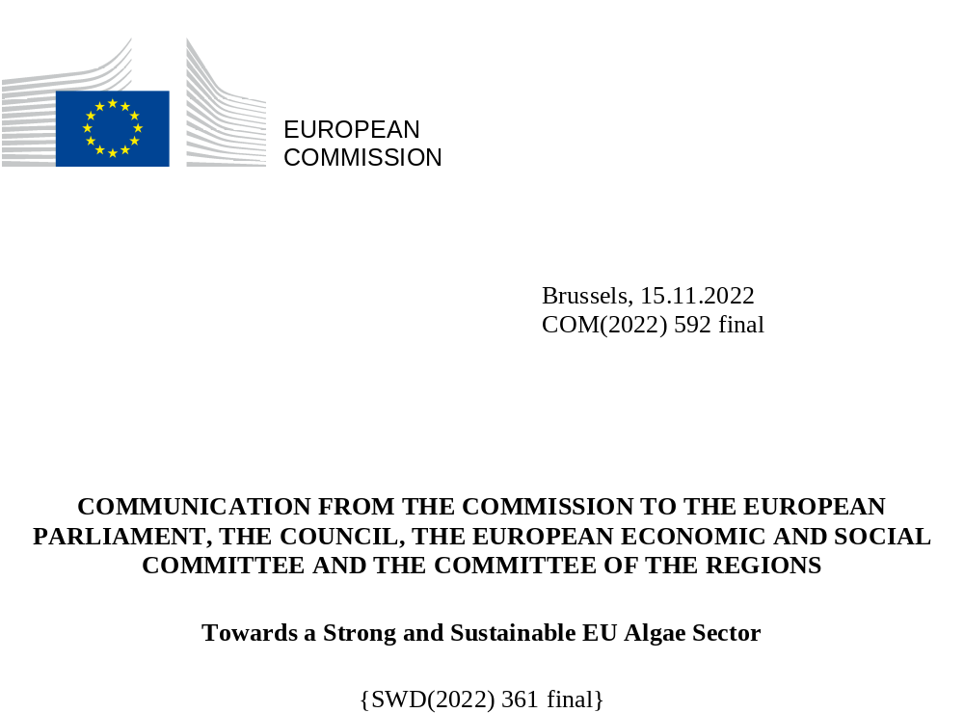

Introduction
Now is the time to fully harness the potential of algae as a renewable resource in Europe. The need to ensure the security of supply of raw materials and energy has become all the more pressing with the unjustified and unprovoked Russian military aggression against Ukraine, which affects the availability of fertilisers, animal feed ingredients and energy. This is ‘fuelling high global energy, commodity and food prices and increasing uncertainty, factors that are dampening growth and exacerbating inflationary pressures globally’.
A growing global population, the depletion of resources, environmental pressures, and climate change require a different approach to be taken to food and economic systems. For this to happen, it is essential to develop new and sustainable ways of feeding a rapidly growing global population. How? By, for one, making use of the vast and too little used resource that is the seas and the ocean – currently the source of only up to 2% of human food, despite covering over 70% of the Earth’s surface.
The European Green Deal, the Farm to Fork Strategy and the Sustainable Blue Economy Communication identify the potential of farmed seafood as a source of protein for food and feed with a low-carbon footprint. The Farm to Fork Strategy highlights the role of algae as an important source of alternative protein for a sustainable food system and global food security.
Strategic guidelines for a more sustainable and competitive EU aquaculture for the period 2021 to 2030 (Strategic guidelines for EU aquaculture) stress the need to promote the farming of algae – both macroalgae (seaweed) and microalgae – as a way of contributing to achieving several objectives of the European Green Deal. The farming of algae can contribute to achieving the EU’s objectives in terms of decarbonisation, zero pollution, circularity, the preservation and restoration of biodiversity, the protection of ecosystems and the development of environmental services. Algae can replace fossil-based products, and serve as raw material for plant biostimulants, bio-based chemicals and other materials, and biofuels. The Sustainable Carbon Cycles Communication recognises the potential of algae for the blue carbon economy.
The ‘Food from the Oceans’ report prepared by the European Commission’s (the Commission) High-Level Scientific Advice Mechanism identifies seaweed as having the potential to satisfy the projected more than 100 million tonnes of additional biomass demand for human food in the next 20 years. The production and processing of algae and other new marine resources (biomass) can help to provide sustainable food and feed products as well as pharmaceuticals, nutraceuticals, plant biostimulants, bio-based packaging, cosmetics and other non-food products (see Figure 1).
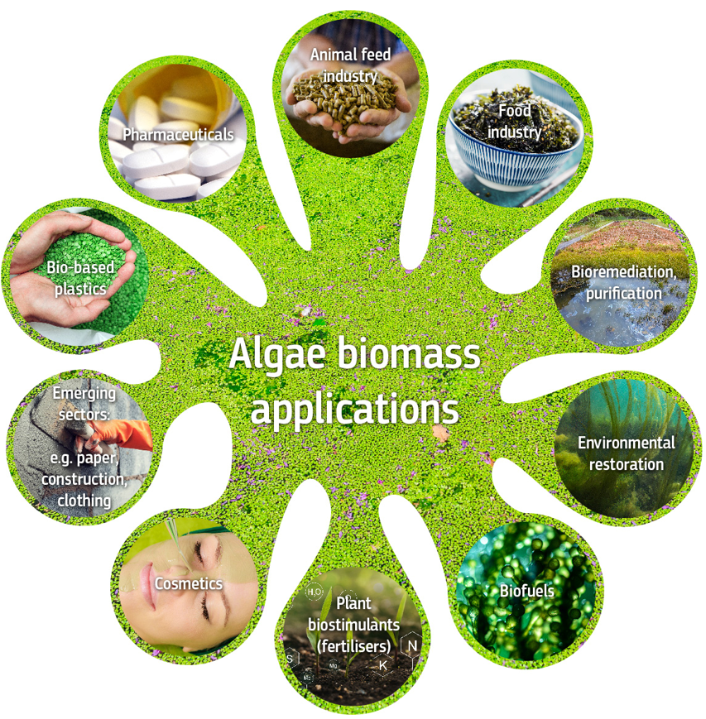
Figure 1: Algae biomass applications
But expansion of seaweed cultivation at sea should not affect the equilibrium of marine ecosystems and should avoid reproducing in oceans the same environmental mistakes historically done on land.
Although currently small, the European algae sector has the potential to become a significant part of the EU blue bioeconomy. A combination of research and innovation in the EU and enthusiastic entrepreneurship has created the momentum the EU algae sector needed to develop and expand – the UN Global Compact even call it a Seaweed Revolution – while contributing to the achievement of the European Green Deal objectives. This puts Europe in a very good position to harness its algae potential over the next decade.
The Seaweed for Europe coalition estimates that European demand for seaweed could increase from around 270 000 tonnes in 2019 to 8 million tonnes in 2030 and reach EUR 9 billion in value in 2030 across all sectors, with feed, food and plant biostimulants (fertilising products) being the largest. Such an increase in production could create around 85 000 jobs, remove thousands of tonnes of phosphorus and nitrogen from the European Seas annually, mitigate up to 5.4 million tonnes of CO₂ emissions a year and relieve pressure on the land¹⁶.
A thriving EU algae industry could become a flagship and source of inspiration for other industries to become more regenerative, innovative and socially exemplary, creating thousands of jobs in the process, especially in coastal communities. As announced in the Communication on the Commission’s new approach for a sustainable blue economy⁵, this Communication looks at the potential of algae in the EU and sets out a coherent approach, including targeted actions, to support the upscaling of regenerative algae cultivation and production throughout the EU, and to develop and mainstream the markets for food and non-food algae applications.

Why algae are considered an untapped resource in Europe
Low in fat and rich in dietary fibres, micronutrients and bioactive compounds, algae are often presented as a healthy and low-calorie food, with some species known for having a particularly high protein content. Their biochemical compounds and properties make algae a valuable material for a growing number of other commercial applications, e.g. animal/fish feed and feed additives; pharmaceuticals; nutraceuticals; plant biostimulants; bio-based packaging; cosmetics or biofuels and services provider for wastewater treatment; for example, carbon and nutrients fixation etc. Algae also remove nutrients from aquatic ecosystems, thereby reducing eutrophication. Seaweed, when being cultivated at sea, removes carbon, thereby reducing ocean acidification. All these potential benefits will of course have to be considered in light of the existing EU legislation, and balanced with the potential health risks, when relevant (e.g. considering the high content of heavy metals in certain algae species).
The seaweed industry in Europe, currently focused more on the harvesting of seaweed from the wild rather than cultivation in aquaculture facilities as in Asia, is still very much at an embryonic stage. While the Asian market^{,14} has grown significantly over the past decade (where seaweed accounts for around a half of global aquaculture production), European seaweed production is so far negligible (see Figure 2 below).
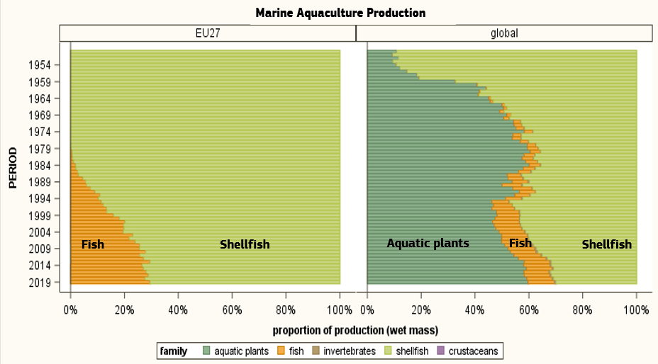
Figure 2: Marine aquaculture production in the EU and globally.
Despite its current marginal share in the global seaweed market, given the favourable business prospects, Europe can develop a strong algae industry centred on aquaculture production and innovative seaweed mariculture (marine permaculture). Such an industry may harness the potential of vast European seas while creating jobs for local communities, producing healthy low-carbon products, regenerating coastal ecosystems (e.g. fixing CO₂ and nutrients and generating oxygen) and providing ecosystem services.
The EU is a top global importer of seaweed products in terms of value (EUR 554 million in 2016), so there is clearly a strong demand for seaweed products in Europe. This demand is set to increase in line with health and sustainability trends. A growing human population worldwide and consumption patterns will further boost demand for algae and algae-based products. EU demand for algae and algae-based products is equally expected to increase in the years to come (see Figure 3). With regard to microalgae, which can also be produced on land and far from the sea, market demand for chlorella and the cyanobacteria spirulina is also growing in the EU.
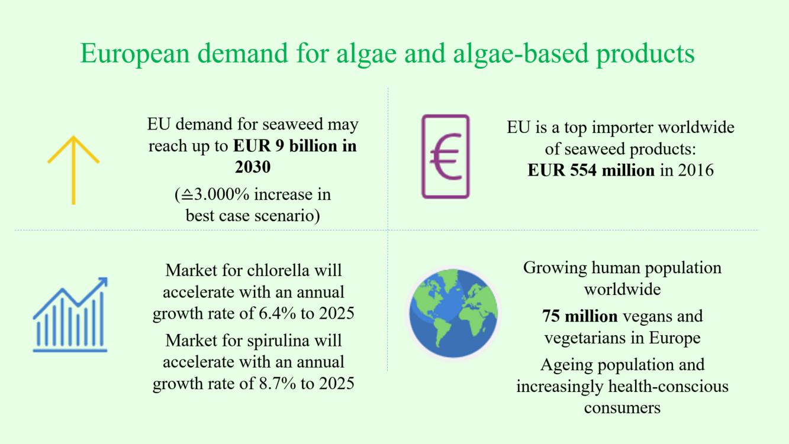
Figure 3: Expected increase in demand for algae-based products^{16,}.
It is expected that the European market will grow at an annual growth rate for chlorella and spirulina of 6.4% and 8.7% respectively by 2025³⁰. The demand for food and drink products containing seaweed in Europe increased by a factor of 2.5 between 2011 and 2015. The EU’s growing vegetarian and vegan population, currently estimated at around 75 million, and increasingly environmental and health-conscious consumers will also increase the demand for plant-based food and non-food products, including algae.
All EU maritime regions have also been recognised as fertile ground and areas where considerable environmental and socioeconomic benefits could be derived from the development of the algae industry. For example, the Atlantic Ocean and the North Sea provide ideal natural conditions for seaweed cultivation due to their cold, nutrient-rich waters, and researchers believe that Europe has vast areas suitable for seaweed cultivation.

What has been done so far and why is it not enough?
The Roadmap for the Blue Bioeconomy published by the Blue Bioeconomy Forum at the end of 2019, after consulting around 300 relevant stakeholders, identified bottlenecks and made recommendations in four main areas: (1) policy, environment and regulations; (2) finance and business development; (3) consumers and value chains and (4) science, technology and innovation. On the current EU algae sector and the potential for its sustainable growth, it concluded that the development of algae cultivation has been hindered by factors such as high production costs, low-scale production, limited knowledge of the markets, consumers’ needs and the risks and environmental impacts of algae cultivation, as well as a fragmented governance framework. Figure 4 below summarises the biggest problems and identifies general and specific ways of addressing these problems.
In recent years, the Commission has initiated and supported a number of algae-related initiatives currently in an implementation or planning phase (2021-2023). These include the EU4Algae project (creation of a collaborative European Algae Stakeholder Platform), EU research and innovation funds’ calls for applications (Horizon 2020, Horizon Europe), the Bio-Based Europe Joint Undertaking, investments in the algae sector made possible by the European Maritime and Fisheries Fund and the European Regional Development Fund, blue economy-related business support mechanisms (Blue Invest, the Aquaculture Assistance Mechanism).
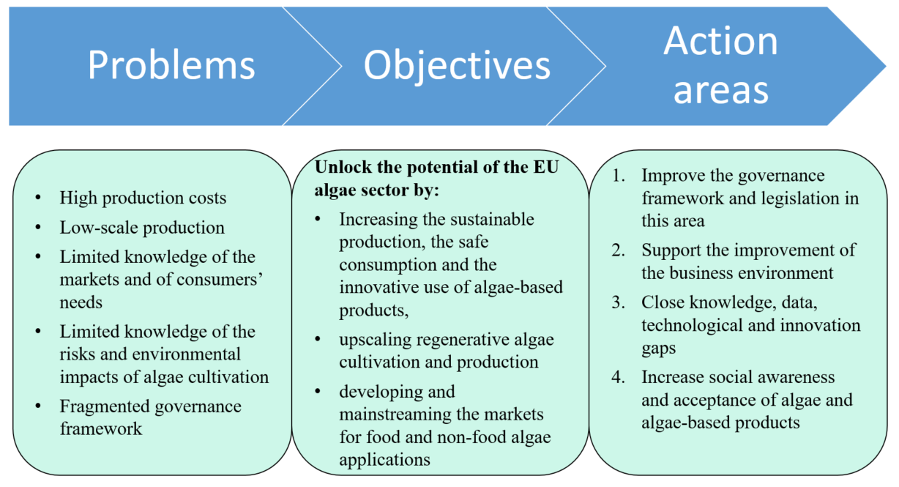
Figure 4: Problems, objectives and proposed action areas for EU algae-related initiatives.
There are also initiatives in place to help increase knowledge of algae, such as the European Marine Data and Observation Network (mapping algae companies), the Commission’s Knowledge Centre for the Bioeconomy, the Joint Research Centre’s (JRC) Biomass study, algae-related studies looking at how algae could help to achieve climate-related goals and its relationship with nutrients, ocean literacy and awareness-raising initiatives, smart specialisation strategies, etc. The EU Mission Restore our Ocean and Waters by 2030 Board states in its recent report that regenerating the ocean and waters is vital for human existence, wellbeing and the livelihoods of EU citizens. The Food 2030 initiative being deployed via Horizon Europe has convened and fostered a systems approach to R&I policy that connects land and sea, producers to consumers, from ‘farm to fork to gut and back’. It is calling for a transformation of the food systems to respect planetary boundaries, provide healthy safe and nutritious food and diets for all, and sustain a diverse fair and inclusive thriving food economy. One of the ten Food 2030 pathways for action is aimed at developing solutions for food from the ocean and freshwater resources, where the role of algae farming is central.
The European Blue Forum of sea users will further enable discussions between blue economy sectors (e.g. the algae sector as a major part of the EU’s blue bioeconomy), stakeholders and scientists to develop synergies and reconcile competing uses of the sea in the interests of climate neutrality, zero pollution and the protection and conservation of the marine environment.
Currently, algae, specifically seaweed aquaculture, are subject to a multitude of both EU and national regulatory texts (Figure 5). Instead of the fragmentation this occasions, the algae sector could benefit from a more coherent approach.
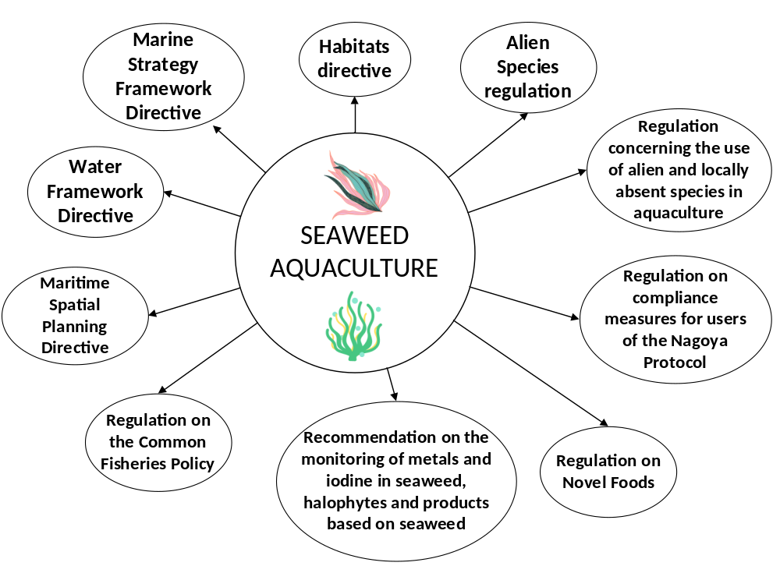
Figure 5: EU legal acts relevant to seaweed aquaculture
Every action listed in Section 4 contributes individually to the development of the EU algae sector. However, a more coordinated and systemic approach is needed, supplementing the existing framework with additional policy actions, e.g. simultaneously using different levers to boost the development of a regenerative EU algae sector.
The Commission has a central role to play in creating the conditions that make it possible to do something about the impediments the EU algae sector currently faces. It should also address the potential concerns of EU citizens about the environmental sustainability of large-scale seaweed cultivation and the safety of algae-based products placed on the EU market.

What does the EU need to do?
To unlock the potential of the EU algae sector, regenerative algae cultivation and production need to be upscaled throughout the EU, and the markets for food and non-food algae applications need to be developed and mainstreamed. Once this has been done, the EU’s potential to ensure a continuous supply of algae biomass, strategic autonomy from imports and the smooth functioning of the algae sector would be unlocked.
To harness the full potential of the EU algae sector, specific actions have been identified on the basis of an extensive preliminary analysis of the sector and wide-ranging stakeholder consultations. The actions identified build on existing initiatives (see Section 3 above), the best available science, knowledge and data and the best business practices.
The Communication identifies 23 actions aimed at:
- improving the governance framework and legislation,
- improving the business environment,
- closing knowledge, research, technological and innovation gaps, and
- increasing social awareness and market acceptance of algae and algae-based products in the EU.
The actions outlined in this Communication are meant to be piloted in a coordinated way. They will be implemented in close collaboration with Member States and relevant stakeholders.
To implement the actions envisaged in this Communication, certain funding has been earmarked and some algae-related actions in Horizon Europe have already been closed or are ongoing. The Commission will continue to look into opportunities to incorporate algae-related actions into the above and other funding calls

Improving the governance framework and legislation
Currently, certain EU legislation applies to seaweed cultivation at sea or algae cultivation on land, e.g. legislation on food safety or fertilising products (Figure 5). However, there is considerable fragmentation in areas where there is no EU-level regulatory framework and different national regulations, depending on an EU Member State sector’s specific circumstances, are in place, (e.g. on licensing, access to marine space, species to be farmed).
The EU algae sector therefore needs coherent and streamlined governance throughout the EU, including simplified procedures and a monitoring and quality framework, with the ultimate aim of placing on the market sustainably sourced and safe biomass algae-based products. Actions to this end could include developing a new algae farmers’ toolkit for algae cultivation in the Member States, tailored to the cultivation conditions in different sea basins, and promoting the integration of algae-related provisions into national governance frameworks (e.g. maritime spatial plans) and strategies (e.g. bioeconomy strategies). A specific action should focus on ways for algae farmers to facilitate access to marine space for algae cultivation and to facilitate the obtention of algae farming licenses (e.g. building on the guidance document for access to space envisaged in the Strategic guidelines for EU aquaculture, sharing good practices using the open method of coordination for aquaculture, etc.).
The Commission will also encourage Member States to include algae cultivation in their national/regional spatial plans under the Maritime Spatial Planning Directive promoting sustainable development and encouraging the coexistence of different sectors in the marine area. Better governance also entails developing new or improved industry standards for algae products and considering making necessary legal changes.
The Commission will:
- starting in 2023 and in close collaboration with relevant stakeholders, develop a new algae farmers’ toolkit;
- work with Member States to facilitate access to marine space, identify optimal sites for seaweed farming and include seaweed farming and sea multi-use in maritime spatial plans;
- by the end of 2026, together with the European Committee for Standardization (CEN), develop standard testing, quantification and extraction methods for algae ingredients and contaminants;
- by the end of 2026, together with CEN, develop algae biofuel standards and a certification methodology for algae-biofuel products to be used in various transport sectors, particularly heavy road, aviation and maritime transport;
- starting in 2023, assess the market potential, efficiency and safety of algae-based materials when used in fertilising products and the need to amend Regulation (EU) 2019/1009 on EU fertilising products to include algae-based materials.
The Commission calls on the Member States to simplify national licensing procedures and governance for algae cultivation.

Support the improvement of the business environment
A smoothly functioning and thriving business landscape and healthy marine environment are crucial for the effective growth of a regenerative algae sector. The improved business environment will scale up EU industry’s collaboration within the EU and with the algae industries of countries bordering the EU in order to prepare novel food applications, where appropriate and discover species that are used as traditional food in the Member States. It should also result in new algae species being brought onto the EU market, increasing the variety in that market of algae species to be used as food or feed or for other purposes.
Algae production should be promoted through different funding mechanisms as a way of diversifying economic activity and sources of income for communities in coastal and rural areas. In particular, the Commission will encourage and support the reorientation of fishers’ careers to regenerative ocean farming through pilot projects.
Targeted support should be provided for innovative small and medium-sized enterprises (SMEs) making the best use of market intelligence and strengthening investors’ capacities to mobilise capital for high-potential businesses/technologies, preparing new sustainability coaching packages for SMEs, and providing technical assistance to accelerate business-to-business (B2B) cooperation. The possible use and extraction of nutrients derived from algae-based products, and the inclusion of algae-based products in green labelling and green procurement frameworks, should also be assessed.
The Commission will:
- starting in 2023 and together with the algae industry, examine the algae market and propose market-stimulating mechanisms to support and promote the transfer of technology from research to market;
- by the end of 2024, based on the good practices, feed indicators and other relevant information develop specific guidance to promote replacing fish-based feed with algae-based feed;
- work with the algae industry and Member States to:
- identify valid and safe alternatives to the use of nutrients and CO₂ from various sources for microalgae cultivation and organic certification;
- promote the extraction of nutrients from algae biomass
- support the life cycle assessment of the environmental and climate impact of algae cultivation and production by considering the development of monitoring methodologies and indicators to measure the environmental impact and sustainability of seaweed cultivation;
- fund, in 2023/2024, pilot project(s) supporting the reorientation of fishers’ careers from fishing to regenerative ocean farming;
- enhance targeted support for innovative SMEs and projects in the algae sector through the scaled-up activities of the BlueInvest Platform;
- starting in 2023, facilitate sea basin and macroregional cooperation by promoting innovative interregional partnerships (e.g. the blue bioeconomy, focusing on algae), through smart specialisation strategies and the 3S Sustainable Blue Economy Platform.

Close knowledge, data, technological and innovation gaps
Technological developments, innovation and better knowledge are crucial for boosting regenerative algae cultivation and production in the EU. The availability of reliable information on the EU algae sector, including socioeconomic and environmental data, is currently limited. This slows down the development and mainstreaming of algae production markets. Determining the potential of algae to contribute to achieving the European Green Deal goals requires a targeted collaborative research effort that can be provided by the EU Horizon Europe programme, including through dedicated calls of Sustainable Blue Economy Partnership and the EU Mission: Restore Our Ocean and Waters by 2030.
The main algae production methods are in the process of being developed (see Figure 6), but there is a need to develop innovative equipment to increase productivity in the algae sector and the quality of algae-based products. Such equipment could include large-scale (possibly automated) cultivation and processing systems, monitoring probes with control-command systems, etc. that can reduce unpredictable biomass loss and labour costs. Innovative equipment can also play a crucial role in improving downstream processes, such as biorefineries for the treatment of the entire biomass of macroalgae and microalgae, not just a small volume of active components while the rest of the biomass is wasted. There is also a need to remove systemic innovation barriers and accelerate market access to algae-based products.
Better knowledge of environmental impacts of wild seaweed harvesting and the amounts of seaweed washed up on EU coasts should also be acquired, to assess what amount of this type of biomass can provide sustainable business opportunities for EU companies. The algae cultivation sector would certainly benefit from an EU-wide centralised approach of maintaining European seaweed strains. This approach would also help conserve seaweed biodiversity.
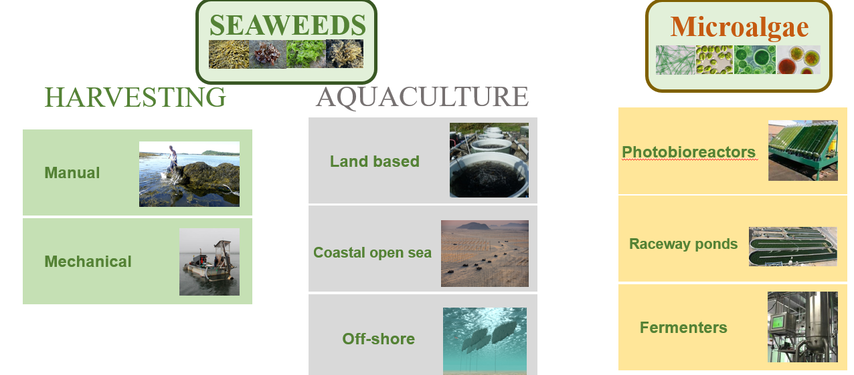
Figure 6: Main algae production methods in Europe
Despite its capacity to remove carbon and reduce ocean acidification, until now seaweed has been mostly neglected in blue carbon assessments. But studies suggest that macroalgae may be displaced by currents and deposited in carbon sinks beyond macroalgae habitats. Carbon may also be sequestered by converting algae into durable products such as algae-based circular materials (including packaging). Clarifying and quantifying these processes could enable aquaculture producers to obtain additional incentives (e.g. blue carbon credits) for their activities such as regenerative seaweed farming and integrated algae production.
But more knowledge is needed of viable options for improving policy and legal arrangements to incorporate blue carbon as a natural climate solution; to investigate financial approaches and accounting tools for greenhouse gas emissions and carbon removal and sequestration using algae and how this is affected by cultivation and use; to clarify property rights; to compile a list of developing technologies (e.g. sensors) and computational tools (e.g. artificial intelligence, block-chain) for measuring and monetising blue carbon sequestration at low cost and improving our understanding of lesser-known aspects of the blue carbon cycle (e.g. seaweed contributions). Better understanding is also required of the feasibility of and perspectives for developing the blue carbon economy, particularly blue carbon farming and the certification of carbon removals. Through innovative seaweed mariculture approaches (such as marine permaculture), seaweed cultivation could also be facilitated in the Mediterranean and Atlantic offshore waters of the southern EU where the water depth is suitable for such operations.
Knowledge
The Commission will:
- by the end of 2023, integrate algae sector knowledge into the EU aquaculture assistance mechanism;
- by the end of 2025 and in collaboration with relevant stakeholders, do a study to gain better knowledge of seaweed climate change mitigation opportunities and the role of seaweed as blue carbon sinks;
- by the end of 2025 and in collaboration with researchers and academics, assess the options for an EU-wide approach to conserving seaweed biodiversity by maintaining and documenting European seaweed strains in a centralised biobank network or databank;
- starting 2023 and subject to European Food Safety Authority advice start discussions on the establishment of maximum levels of contaminants and iodine in algae and/or the adoption of a new monitoring Recommendation for algae species for which insufficient occurrence data for contaminants are available, in order to allow the establishment of maximum levels.
- starting in 2023 and in collaboration with Member States, study existing monitoring schemes and available data on seaweed harvesting from the wild and from beachcast on EU coasts.
Technology developments and innovation
The Commission will:
- support, through Horizon Europe and other EU research programmes, the development of new and improved algae processing systems and novel production methods for high-value compounds traditionally sourced from algae (e.g. biorefineries, precision fermentation, cell-free systems), processing algae to make circular bio-based products for multiple applications;
- together with Member States, support, through Horizon Europe and other EU research programmes, the development of better and scalable algae cultivation systems (e.g. integrated multi-tropic aquaculture (IMTA), sea multi-use, offshore cultivation, photobioreactors and algaeponics) or methods (e.g. cellular mariculture and macroalgae in tanks) for dealing with the current technical constraints of macroalgae and microalgae production systems;
- address algae biofuel-specific technological and systemic challenges and identify market take-up measures in the context of Horizon Europe.
Data
The Commission will:
- starting in 2023, prepare an overview of the availability of algae-related data (e.g. production, employment, turnover and other socioeconomic data) and issue a recommendation on centralising the sources of such data.

Increase social awareness and market acceptance of algae and algae-based products
EU consumers and citizens are often not aware of the many benefits of algae cultivation and algae-based products, ranging from regenerating marine ecosystems to creating low-carbon products and generating blue economy jobs. Increasing social awareness of algae and algae-based products can boost the demand for them, spurring the EU algae sector’s development.
Knowledge of the blue bioeconomy sector can be increased through educational programmes in schools, seaweed cooking shows, leaflets and press articles on the topic, and social media campaigns. Targeted analysis of consumer behaviour and preferences for algae-based products would also help to get an idea of where knowledge is lacking and where it is therefore necessary to organise awareness-raising initiatives and in what direction to take algae business development.
The Commission will:
- starting in 2023, support the raising of consumer awareness by:
- doing a consumer behaviour and preference analysis of the perceptions of algae-based products;
- launching a fact-based EU-wide and/or, where relevant, regional or local communication campaign(s) to promote the variety of applications and benefits of algae-based products;
- raise the sustainability profile of algae-based products in the EU sustainable food labelling framework, including in marketing standards for fisheries and aquaculture products and green public procurement initiatives envisaged as part of the Farm to Fork Strategy.
- starting in 2023, together with the EU4Ocean platform and Member States, promote awareness-raising actions for schools and universities on the blue bioeconomy and innovative solutions for regenerative aquaculture.

Conclusions
By acting now, the EU can seize the opportunity to address potential glitches, and not only respond to the increasing interest in considering algae as an alternative raw material in various economies, but also provide the impetus for developing an economically, socially and environmentally safe, renewable and competitive resource for the growing EU and international algae-based products market. As the Horizon Europe’s Mission Restore our Ocean and Waters by 2030 states, regenerating the ocean and waters is vital for human existence, wellbeing and the livelihoods of EU citizens, in particular coastal communities. Algae can play a significant role in this.
In the context of the European Green Deal, this initiative plays an important role in turning the current environmental and climate-related challenges into business opportunities. It provides an integrated and systemic approach to creating synergies between actions that are already underway and proposing new actions, described in this Communication. Such integration and coordination are crucial for ensuring the effective implementation and smart economic application of the EU budget by ensuring synergies and maximising knowledge sharing.
The EU algae sector is a young and dynamic one, with a fast-changing industry, ever-increasing knowledge and an ever-increasing number of research projects. The Commission will prepare a report assessing progress in implementing this Communication by the end of 2027.

European Council Conclusions, 23-24 June 2022
EU marine territory (5.7 million km²) is bigger than land territory (4 million km²). At the same time, the total amount of biomass is 1 billion (dry) tonnes, 69% of which comes from the agriculture sector, and 31% of which comes from forestry, while fisheries and aquaculture account for less than 1% (JRC Biomass report).
COM/2019/640 final.
COM/2020/381 final.
COM(2021) 240 final of 17.5.2021.
The Commission Strategic Guidelines for a more sustainable and competitive EU aquaculture
European standard EN 17399:2020 defines algae as a functional group of organisms consisting of microalgae, macroalgae, cyanobacteria and labyrinthulomycetes. Algae also refer to plant-like aquatic organisms ranging in size from single-celled organisms (microalgae and cyanobacteria) to giant multicellular forms such as seaweed (macroalgae).
Sustainable Carbon Cycles Commission Communication
Food from the Oceans
Studies show that substituting algae or seaweed as a protein and Omega-3 fatty-acids source for fish nutrition have positive effects on fish growth rates and survival percentages of fish, reduces feed costs and be a more sustainable source of fish nutrition Review on use of macro algae (seaweed) in fish nutrition., Saleh, H. 2020
Images © Adobe Stock: Drimafilm (duckweed background); Dewald (animal feed); valya82 (seaweed bowl); Atelopus (bioremediation pit); Viktor (algae on lake bottom); chokniti (biofuel algae); Miha Creative (fertilisers); Voyagerix (facial); lovelyday12 (cement); Arsenii (bioplastic granules); sharky1 (pills).
The UN Global Compact is uniquely positioned to support companies as they align their practices with what is required for a sustainable and inclusive future. With the support of all 193 countries participating in the UN General Assembly, the UN Global Compact remains the global normative authority and reference point for action and leadership within a global corporate sustainability movement.
Seaweed Revolution: a Manifesto for a Sustainable Future, Lloyd’s Register Foundation, UN Global Compact, 2020
Seaweed for Europe is a business organisation aiming to support systematic innovation and the sharing of best practices, to mobilise investments and to raise the profile of seaweed. It is composed of 56 algae sector stakeholders.
Seaweeds and microalgae: an overview for unlocking their potential in global aquaculture development, Food and Agriculture Organization of the United Nations (FAO), 2021 https://doi.org/10.4060/cb5670en.
Best case scenario, source: Seaweed for Europe.
Hidden Champion of the Ocean: Seaweed as a Growth Engine for a Sustainable European Future, Seaweed for Europe, 2021.
Regeneration is the ability of an ecosystem – specifically, the environment and its living population – to renew itself and recover from damage. Regeneration refers to ecosystems replenishing what is being eaten, disturbed or harvested. Its greatest force is photosynthesis, the transformation of solar energy and nutrients into plant biomass. Seaweed cultivation can deliver valuable ecosystem goods and services, including providing new habitats for fish and mobile invertebrate species (according to this Report).
Mainstream marketing means marketing aimed at the masses. It indicates that a marketing campaign’s target audience is very large and that the products and services being marketed can be used by almost everybody.
Blue carbon: The potential of coastal and oceanic climate action, Claes, J., Hopman, D., Jaeger, G., Rogers, M., 2022.
Brief on algae biomass production, Araujo, R., Lusser, M., Sanchez Lopez, J. and Avraamides, M. (editor(s)), Publications Office of the European Union, Luxembourg, 2019; Sustainable Seaweed Aquaculture Full Recommendations, Barbier, M. et al., 2019.
Of the 35.8 million tonnes of algae produced globally in 2019, 34.8 million tonnes (97% of global production) were produced in Asia, while EU production was 0.085 million tonnes (0.2% of global production), of which only around 0.4% was cultivated, while the rest was harvested from wild stocks. Source: FAO, 2019 (Footnote 13).
Data source: FAO.
0.3 million tonnes/year of algae production in Europe (99% wild harvesting) against almost 36 million tonnes/year of production globally (99% algae aquaculture) (FAO, 2019 data).
Marine permaculture is a form of marine farming that reflects the principles of permaculture (an approach to land management and settlement design that takes its lead from patterns observed in flourishing natural ecosystems), by recreating seaweed forest habitats and other ecosystems in nearshore and offshore ocean environments. Doing so enables a regenerative long-term harvest of seaweeds and seafood, while regenerating life in the ocean. Marine permaculture uses deep-water irrigation technology to access cold and nutrient-rich deep water. In the EU, seaweed cultivation in marine permaculture could be facilitated in the Mediterranean and Atlantic waters of the southern part of the EU.
Seaweed aquaculture has the potential to provide many ecosystem services, including climate change mitigation, coastal protection, the preservation of biodiversity and the improvement of water quality (EKLIPSE expert report).
‘Summary for policymakers of the thematic assessment of the sustainable use of wild species of the Intergovernmental Science-Policy Platform on Biodiversity and Ecosystem Services (IPBES)’, July 2022.
Chlorella is a common single-celled green alga of both terrestrial and aquatic habitats that is cultivated to be used as food or food ingredient on the EU market, It is rich in nutrients, it’s a good source of several vitamins, minerals and antioxidants.
Spirulina is a microscopic filamentous aquatic cyanobacterium (genus Spirulina) that is cultivated for use as a food supplement. It is among the most popular algae-based food supplements . Spirulina has a high protein content, rich in vitamins (B1, B2; and B3), microelements (copper, iron, magnesium etc.), and contains essential fatty acids Omega-3 and Omega-6. Spirulina platensis, a super food?, Jung, F., Kruger-Gengte, A., 2019, Journal of Cellular Biotechnology.
In the broader context, projected EU biomass demand is 40-100% higher than the available supply (Report EU Biomass in a net zero economy (climate-kic.org)).
The European Market Potential for Seaweed of Marine Algae. CBI. 2021.
Mintel 2016.
A global spatial analysis reveals where marine aquaculture can benefit nature and people, Theuerkauf, S. J., Morris, J. A., Waters, T. J., Wickliffe, L. C., Alleway, H. K., Jones, R. C., 2019.
Global Potential of Offshore and Shallow Waters Macroalgal Biorefineries to Provide for Food, Chemicals and Energy: Feasibility and Sustainability, Lehahn, Y., Nivrutti, I., Golberg, A., 2016.
Data show that China, with 13 000 km of coastline with an actual area that can be cultivated of 136 223 ha (1362 km²), cultivated 20.1 million tonnes of algae in 2019. By contrast, the EU-27, with its 66 000 km of coastline and 5.7 million km² of marine area (141 000 km² of which are near-shore waters (0-1 nautical mile from the coastline) and 715 000 km² are territorial waters (0-12 nautical miles from the coastline)) cultivates less than 1000 tonnes of seaweed a year. If the EU’s algae potential were unlocked by 2030, EU suppliers could produce one third of the market’s requirements.¹⁶
Blue Bioeconomy Forum Roadmap
The Commission launched the Blue Bioeconomy Forum (BBF) in 2018 to bring together industry, public authorities, academia, finance and civil society in order to strengthen the EU’s competitive position, harness the potential of renewable resources and ensure the sustainable use of the resources of the emerging blue bioeconomy. The BBF’s aim is to develop a common understanding of the current state of the blue bioeconomy in the EU and to formulate recommendations on strategic developments, market opportunities, appropriate financial assistance, regulatory actions and research priorities.
The EU4Algae project
Horizon 2020
Horizon Europe
Bio-Based Europe Joint Undertaking (BBI-JU)
European Maritime and Fisheries Fund (EMFF)
European Regional Development Fund (ERDF)
Blue Invest
Information based on the work of DG for Maritime Affairs and Fisheries (DG MARE) (public consultations, targeted stakeholder consultations etc) for the drafting of this document.
Emodnet human activities
Commission’s Knowledge Centre for Bioeconomy
JRC Biomass study
Algae and Climate Study
Algae, shellfish and nutrients study
EU4Ocean Coalition for Ocean Literacy
EU Mission: restore our ocean and waters
‘Regenerating our ocean and waters by 2030: interim report of the mission board healthy oceans, seas, coastal and inland waters’, European Commission, Directorate-General for Research and Innovation, Publications Office, 2020, https://data.europa.eu/doi/10.2777/885438.
https://research-and-innovation.ec.europa.eu/research-area/environment/bioeconomy/food-systems/food-2030_en
Announced by the Commission in its Communication on a new approach for a Sustainable Blue Economy, to be set up in the coming months following a call for proposals: https://ted.europa.eu/udl?uri=TED:NOTICE:351341-2022:TEXT:EN:HTML&tabId=1.
Commission guidance documents such as Commission staff working document on the application of the Water Framework Directive and the Marine Strategy Framework Directive to aquaculture (Link) and Guidance on aquaculture and NATURA 2000 clarify the application of EU environmental legislation to the aquaculture sector.
Summary of the Open Public Consultation
Such as two projects included in the DG MARE Work Programme 2023 (to support the setting up of a regenerative EU algae industry and to pilot regenerative ocean farms).
Unlocking the potential of algae for a thriving European blue bioeconomy, HORIZON-CL6-2021-CIRCBIO-01-09, closed 6.10.2021.
Lighthouse in the Baltic and the North Sea basins – bringing sustainable algae-based products and solutions to the market, HORIZON-MISS-2022-OCEAN-01-06 (application deadline 27.9.2022); Towards local community-driven business models: regenerative ocean farming, HORIZON-MISS-2022-OCEAN-01-10, (application deadline 27.9.2022).
Such as European Maritime, Fisheries and Aquaculture Fund, EU LIFE programme, Interreg Europe programme, European Institute for Innovation and Technology (EIT Food) etc).
E.g. through the Marine Spatial Plan Assistance Mechanism and Member States expert group, as well as the open method of coordination for aquaculture.
E.g. access to space, the selection of species to be cultivated, national health-related aspects (e.g. iodine levels) etc.
The Commission will support this process by developing a guidance document on good practices for administrative procedures, and enabling the exchange of good licensing and governance practices for algae cultivation in the context of the open method of coordination for aquaculture.
Before 15 May 1997 (date of entering into force the novel food regulation)
This includes using secondary nutrients (from wastewater) or excess nutrients from eutrophic surface waters for microalgae and cyanobacteria cultivation in closed circles.
E.g. to produce nutrients for plant biostimulants (biofertilisers), with the focus on processed biomass (e.g. remaining biomass after the extraction of active ingredients or biomass derived from wastewater treatment plants or washed ashore (beachcast)).
This may include the delivery of market intelligence and strengthening the capacities of investors to mobilise capital for high-potential businesses/technologies, new coaching packages on sustainability for SMEs, and technical assistance to close deals more quickly.
Smart Specialization Platform
Report on the Community of Practice Workshop: Algae production in Europe: status, challenges and future developments, the European Commission’s Knowledge Centre for the Bioeconomy.
The European Partnership for a climate neutral, sustainable and productive Blue Economy is a public-public partnership between the EC and the MS established under Horizon Europe.
EU Mission: Restore Our Ocean and Waters has set a target to develop solutions for zero-carbon and low-impact aquaculture.
For example, to further advance and move to the market algae powered batteries thanks to the discovery that blue-green algae perform photosynthesis and generate a small electrical current that “interacts with an aluminum electrode and is used to power a microprocessor,” Bombelli, P et al: ‘Powering a Microprocessor by Photosynthesis.’ Energy & Environmental Science, May 2022. DOI: 10.1039/D2EE00233G
‘The future of Blue Carbon science’, Macreadie, P.I., Anton, A., Raven, J.A. et al, Nat Commun 10, 3998 (2019).
In view of the health risks related to the possible occurrence of high concentrations of heavy metals in certain algae species, the discussions on maximum levels and monitoring will also be linked to discussions on the need for consumption advice regarding the consumption of certain seaweed species
From various sources such as European Market observatory for Fisheries and Aquaculture products (EUMOFA), Eurostat, the Data Collection Framework, industry etc.
E.g. using the Eurobarometer - a collection of cross-country public opinion surveys conducted regularly on behalf of the EU Institutions since 1974.
Could be combined with targeted awareness-raising actions, such as setting up an algae cooking contest to increase consumers’ engagement and awareness.

