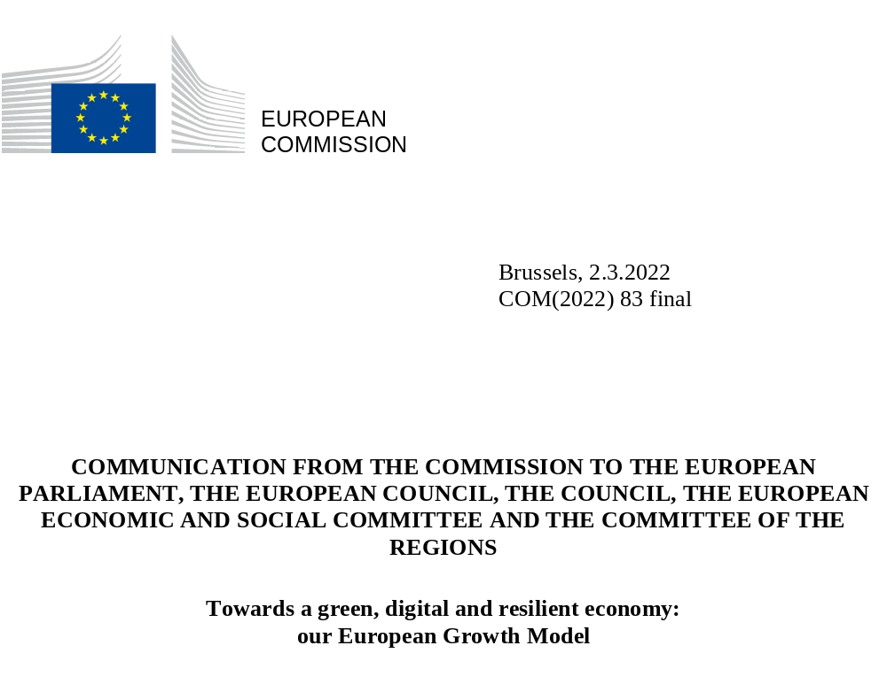

- Introduction
The European economy is undergoing unprecedented transformations towards a fair green and digital future in a context of massive uncertainties linked to the global and security outlook. Since spring 2021, the economy has seen a strong economic rebound from the COVID-19 pandemic. The output levels have fully recovered, also thanks to the exceptional support measures taken at EU and national levels. The pandemic and the EU policy response have accelerated the twin transition of the EU economy and highlighted the need to strengthen the resilience of the EU economy. In addition, the Russian invasion of Ukraine undermines the European and global security and stability and confronts the EU with some immediate challenges.
The rapidly worsening geopolitical context underscores the need to work closely with our international partners and to reinforce our long-term sustainable growth agenda. Now more than ever, the Union should leverage its international partnerships to join forces on common challenges and promote peace and stability, as well as a rule-based international order and effective multilateralism. The coordinated response by the Union and its international partners to the invasion of Ukraine shows how the Union can work to achieve those objectives. At the same time, new sources of risks and uncertainty have emerged and need to be addressed. While most companies and supply chains showed a high degree of resilience and adaptability during the pandemic, the recovery and the recent developments linked to Ukraine’s invasion have revealed a number of vulnerabilities, including in the energy sector, which must be tackled to protect our European way of life, maintain growth and improve resilience in the longer run. The events of the past few weeks and the rapidly worsening geopolitical context should not divert our focus. Instead, they confirm the need to accelerate the ongoing economic transformation.
There is a broad consensus on the priorities for the European economic growth model, including the green and digital transitions, and the need to enhance the Union’s economic and social resilience. These priorities jointly contribute to the objective of competitive sustainability. Achieving our objectives implies structural changes to the EU economy, including at national and regional level. The shift towards a sustainable, resilient and inclusive economic model, enabled by a broader diffusion and uptake of digital and green technologies and skills, will help address key challenges Europe faces, improve its position as a global leader and strengthen its open strategic autonomy. This is all the more important in the current context. At the same time, we must ensure the fairness of our economic model and protect those that are most affected by the transition, including those who lack the means or the skills to fully benefit from it. The transformation of the European economy will only succeed if it is fair and inclusive and if everybody can gain from the opportunities the twin transition brings.
The transformation of our economy relies on two equally important pillars: investments and reforms. The implementation of ambitious and mutually reinforcing investments and reforms will be instrumental in delivering the transition. On the one hand, investment is pivotal for sustained and sustainable growth and a prerequisite for an accelerated green and digital transition. On the other hand, our economic structures and the regulatory framework should support the economic transformation and be conducive to investment. Reforms are required at all levels, to remove specific investment barriers, improve product and labour market functioning, modify production and consumption patterns and strengthen socio-economic resilience.
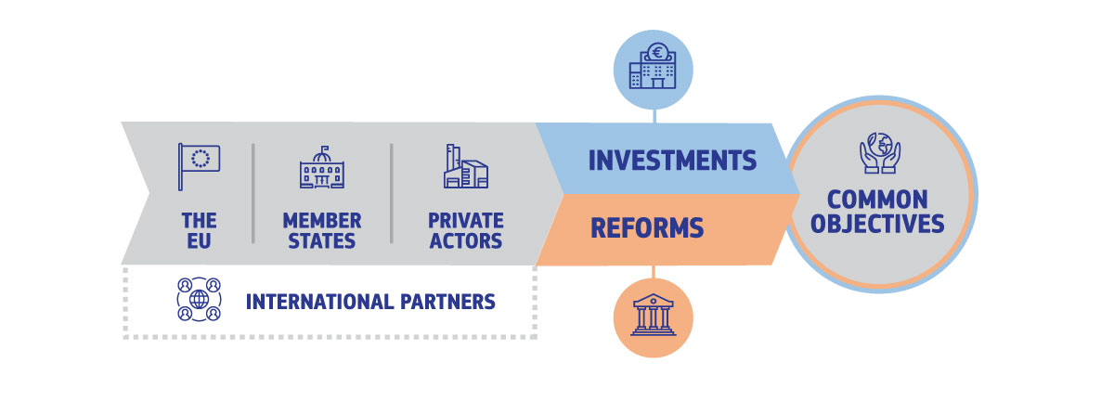
In order to deliver on these objectives, all existing tools will need to be mobilised in a coherent manner. Our ambitions of achieving climate neutrality by 2050 and seizing the opportunities of the digital decade, while enhancing economic, territorial and social resilience, require immediate action. Entire sectors and regions will undergo a major transformation, leading to reallocation of the labour force and changing skills requirements. Consumption patterns will change too. The scale of the investment needs will require the involvement of both the public and the private sector, with most of the investments having to come from the private sector.
NextGenerationEU, including the Recovery and Resilience Facility (RRF), and the EU budget, provide a much-needed boost to the recovery. The swift deployment of new EU instruments, including the European instrument for temporary Support to mitigate Unemployment Risks in an Emergency (SURE) and the Coronavirus Recovery Investment Initiative (CRII), softened the impacts of the crisis. The RRF contributes to the recovery by supporting reforms and investments in the Member States through grants and loans. While the RRF is a temporary instrument, thanks to its focus on sustainable and growth-enhancing reforms and investments, its impacts will be long-lasting. Private and public investments, at national and EU level, will need to be sustained over time. As the major share of investments to finance the twin transition and enhance resilience will come from the private sector, public investments should be well targeted and crowd in private investments. There is an ongoing reflection on how to best achieve these objectives while ensuring a growth-friendly reduction of high public debt.
Our framework and rules should support the EU objectives and create the right incentives for households and businesses. In this context, it will be important to make progress on the reform agenda at EU level and to swiftly adopt and implement the Commission’s proposals under the ‘Fit for 55’ package, as well as the proposals underpinning the EU’s digital agenda. These are key in achieving the objectives of the Paris Agreement and the Sustainable Development Goals.
The Single Market is Europe’s most valuable economic asset and its main source of resilience. It offers certainty, scale and a global springboard for European companies, and a wide availability of quality products for consumers. The pandemic has shown that when the Single Market does not work, everyone pays the price: consumers, industry and services, large companies but also the many SMEs in the supply chain. That is why the Commission continues to work to unlock the full potential of the Single Market, remove existing barriers and increase its resilience by reflecting on how to be better equipped in case of future crises, also with a view to ensure free movement of goods. We need to ensure resilient supply chains, including to safeguard logistics and security of supply for some key sectors of the economy, by diversifying supply, and investing in innovation and new capacities. It is also important to address labour and skills shortages and cyber threats. To mobilise private investments more efficiently, decisive action will be required to complete the Banking Union and make swift progress on the Capital Markets Union, including the actions on sustainable finance. Furthermore, it is vital to operationalise the European Skills Agenda. Other policies will also contribute to the broader objectives, including taxation, trade policy, and the economic governance framework.
This Communication aims to contribute to the leaders’ informal discussions on the European economic growth model. It underlines the importance of full implementation of measures agreed at EU level, coordinated action by all relevant actors, including the EU, Member States and the private sector, as well as of promoting the key investments and reforms required for long-term sustainable growth and wellbeing for all EU citizens. Given the global nature of the challenges ahead, action at EU and international level will be essential. It will also be important that not only Member States but also private actors pull in the same direction.
- Investing in Europe’s future
Investment spending in the EU suffered in the aftermath of the financial crisis. Following the financial crisis, real investment in the EU dropped by 15% compared with the 2007 level and stayed well below its historical trend for several years. As a share of GDP, private investment started to recover gradually as of 2014. Public investment started to recover only slowly as of 2016 and could scarcely keep up with depreciation levels. If sustained, these low public investment levels would result in a gradual deterioration of the public capital stock.
Graph 1: Gross public and private investment in the EU (% of GDP) – left panel; and net public investment for the Union and other international partners (% of GDP) – right panel
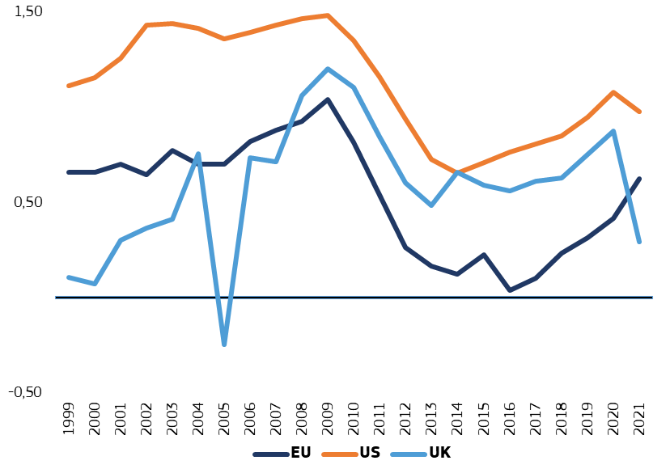
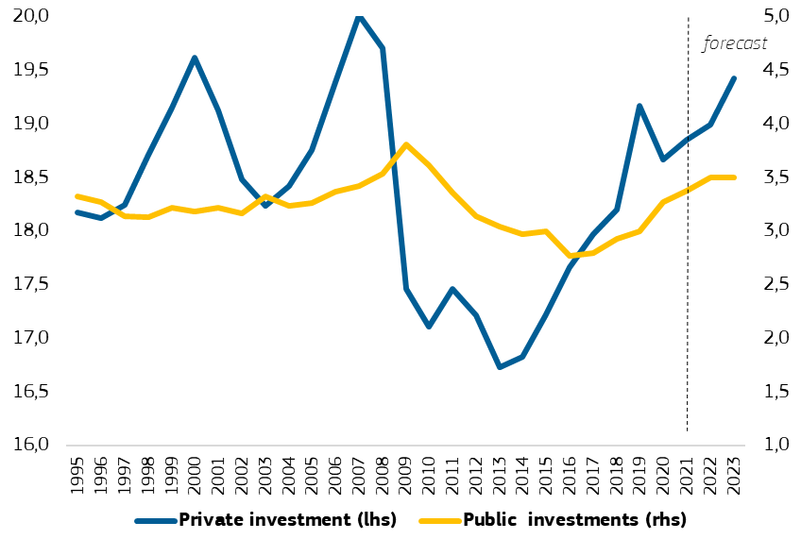

Source: Commission services. Investment is defined as fixed capital formation.
While investment dropped in the first half of 2020 as economic activity collapsed, policy support is set to lift it above pre-pandemic levels. Thanks to monetary and fiscal policy support, the shared commitment to avoid a premature return to fiscal consolidation, and the investment boost from NextGenerationEU and the EU budget, both private and public investments are set to surpass pre-pandemic levels in 2022, confirming that we are on the right path. Nevertheless, additional high quality investment remains necessary to meet the 2030 targets of the twin transition. Moreover, the crises of the past decade have demonstrated the importance of accompanying the investments with reforms.
  - Delivering on the European Green Deal
The green transition is an opportunity to put Europe on a new path of a sustainable and inclusive growth. It is urgent to act and the current decade is a make or break moment. The green transition will also help reduce energy bills and dependence on fossil fuel imports, thus improving energy and resource security of the Union. The geopolitical situation and recent developments in energy prices have highlighted the need to accelerate this change. The transition will also entail transformations of our industry and food system, require building renovations, accelerate the shift to sustainable and smart mobility, and create new jobs and business opportunities in a circular economy.
The transition will also bring challenges. For the green transition to succeed, it must put people first and care for those who will be most affected. To this end, the Commission has put fairness at the heart of its policies under the European Green Deal, including the ‘Fit for 55’ package. In addition, the proposal for a Council Recommendation on ensuring a fair transition provides specific guidance to help Member States devise and implement policy packages, addressing the employment and social aspects linked to the transition in a comprehensive manner.
The European Green Deal sets out the roadmap for making the Union’s economy sustainable in a fair and inclusive manner, tackling climate and environmental-related challenges. In line with the Paris Agreement, the Union has committed to reducing greenhouse gas (‘GHG’) emissions by at least 55% in 2030, compared to levels in 1990. In an effort to mobilise all policies and align current rules with the European Green Deal objectives, the Commission has proposed the ‘Fit for 55’ package at EU level, which aims at revising all relevant policy instruments. The Commission has also identified a number of additional actions needed in order to meet the environmental objectives of the European Green Deal, including the protection of biodiversity and ecosystems, tackling pollution and decoupling economic growth from resource use.
To deliver on the Green Deal objectives, we will need to increase the annual investments by around EUR 520 billion in the coming decade (2021-2030), compared to the previous decade. Such investments have high benefits to society and the costs of non-action are far higher. From those additional investments, EUR 390 billion per year correspond to the decarbonisation of the economy and in particular the energy sector, including energy-related investments in the buildings and transport sectors. The additional investment needed to deliver on the other environmental objectives of the green transition (beyond climate and energy) is estimated to be about EUR 130 billion per year. We will also need to invest in climate change adaptation and key technologies that will enable the green transformation and EU’s future growth, such as batteries, solar panels, and hydrogen, as well as in upskilling and reskilling of the workforce and training. This investment effort will also help to fully unlock the potential of EU regions and their different competitive advantages.
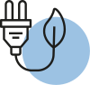
This increase of more than 50% of the energy investment needs compared to the historical trend is mostly driven by the need to decarbonise the economy and will support our efforts to ensure security of supply. The table below provides a breakdown of the sectors where those energy-related investments will be needed. On the energy supply side, investments will be needed in new infrastructure, including renewable energy, energy storage, upgrades of existing power grids, gas and electricity interconnections and the development of new fuels, such as synthetic fuels. On the energy demand side, investments will be needed in relation to the industrial, residential, tertiary, and transport sectors.
Table 1: Additional annual investments needs for the climate and energy policy (EUR bn)
Supply side | Power grid | 31
Supply side | Power plants, incl. boilers and new fuels | 25
 | Industrial sector | 14
Demand side | Residential | 92
Demand side | Tertiary | 54
 | Transport sector | 175
Total | 392
Source: Commission services, based on data from table 7 of SWD(2021) 621 final. Additional annual investments calculated as the difference between the average total annual investments 2011-2020, and the average total annual investments 2021-2030 (MIX scenario). Numbers have been rounded.

As stated above, additional investments will also be needed to deliver on the environmental objectives of the European Green Deal, amounting to EUR 130 billion annually. Those objectives notably concern the protection and restoration of biodiversity and ecosystems, the transition to a circular economy, the sustainable use and protection of water and marine resources, and pollution prevention and control. The table below provides a breakdown of the additional investments needed for each of those objectives, including research and development activities.
Table 2: Additional annual investment needs for environmental objectives (EUR bn)
Protection of biodiversity and ecosystems | Biodiversity landscapes/nature restoration | 4
Protection of biodiversity and ecosystems | Management of forest resources | 2
Protection of biodiversity and ecosystems | Management of wild flora and fauna | 1
Circular Economy and Resource Efficiency | Management of materials and efficiencies | 10
Circular Economy and Resource Efficiency | Waste management | 10
Circular Economy and Resource Efficiency | Additional potential in 3 sectors  (food, mobility and built environment) | 15
Pollution prevention and control | Protection of ambient air and climate | 40
Pollution prevention and control | Noise and vibration abatement | 1
Pollution prevention and control | Protection against radiation | 5
Water protection and management | Management of waters | 21
Water protection and management | Wastewater management | 15
Research and Development | Resource management R&D | 5
Research and Development | Environmental R&D | 2
Total | 130
Source: Commission services, based on data from table 1 of SWD(2020) 98 final. Numbers have been rounded.
The required total investment levels will remain high also in the period after 2030. Hence, it is important that a proper policy framework that incentivises and enables investment is in place to sustain the level of investment needed for the green transition up until 2050.
The impacts of climate change on our economy, including direct physical impacts and their consequences in Europe and beyond, will intensify and we need to be better prepared. This may entail, for instance, the disruption of regular trade and travel, but also social and geopolitical developments that may be spurred by the climate crisis or the green transition and that could affect our economy. The Strategy on Adaptation to Climate Change outlines measures to strengthen Europe’s resilience in that regard, from climate-proofing infrastructure to limiting the effects of climate change on human health.
The digital transition will contribute to the green objectives, with synergies in many areas of a smart circular economy. The uptake of innovative digital solutions can help achieve sustainability objectives in various sectors of the economy (e.g. smart buildings, smart and sustainable mobility systems, digital ‘product passports’, precision farming). Moreover, digital technologies can also support innovative data solutions that can contribute to the Green Deal objectives (e.g. European Green Deal data space, Destination Earth initiative). At the same time, the digital sector should foster the uptake of technologies with lower environmental footprint and higher energy and material efficiency, for instance by promoting technological excellence through energy efficient semiconductors.
  - Seizing the opportunities of Europe’s digital decade
The COVID-19 pandemic has accelerated the digital transformation of our societies and further highlighted the importance of digital technologies for Europe’s future economic growth. Digitalisation is transforming the way people study, work and connect with each other. At the same time, it allows entrepreneurs to set up and grow their business wherever they live, opening markets and investments across Europe and globally, and creating new jobs. We need to make sure that everyone can actively participate and gain from this transformation. A fair digital transformation has the potential to increase the innovation and productivity of the EU economy, offering new opportunities for people and businesses.
The Digital Compass proposed by the Commission sets out the Union’s digital ambitions for 2030. They cover four broad areas: the development of digital education, skills and competences, secure and sustainable digital and connectivity infrastructures, digital transformation of businesses, and the digitalisation of public services and education systems. In order to achieve these goals, we will need to step up investments in key digital technologies, including cyber security, cloud computing, artificial intelligence, data spaces, blockchain and quantum, and semiconductors, as well as in the relevant skills. A recent proposal for a Path to the Digital Decade confirms the 2030 digital targets and sets out the way to reach them.
In order to deliver on the digital transformation of the Union, a 2020 estimate considered the additional investment needs to be around EUR 125 billion per year. This includes investments in digital infrastructure, digital skills and advanced technologies, but leaves out other dimensions such as digital public services. Table 3 below provides a breakdown of that investment gap until 2030 as analysed at the time for each area.

Table 3: Additional annual investment needs for the digital transformation (EUR bn)
Communication networks | 42
Digital Skills | 9
AI | 20
Cloud | 11
Semiconductors/Photonics | 17
Cybersecuriy | 3
Digital Green Technologies | 6
HPC, Graphene and Quantum | 6
Blockchain | 3
Common European data spaces | 3
Digital Innovations/Data and Next Generation Internet | 5
Total | 125
Source: Commission services, based on data from table 2 of SWD(2020) 98 final. Numbers have been rounded.

While the bulk of the investment for the digital transformation will come from the private sector, public intervention will as well be needed to crowd in private investments and help correct market failures. The programme of policy reforms at EU level aims at creating a digital Single Market which protects the fundamental rights of users, offers a level playing field for businesses, and facilitates the uptake and deployment of digital technologies by the business sector and in particular SMEs. This is the objective, for instance, of the EU’s Cybersecurity Strategy, the European Digital Identity, the European Democracy Action Plan, the Platform to Business Regulation, and the Geo-blocking Regulation. Moreover, the Commission adopted horizontal and sectoral strategies to promote the creation of a Single Market for data. The recently launched Structural Dialogue on digital education and skills aims to increase Member States’ commitments and to improve investments, reforms and deliverables in this area, as well as to inform future EU actions.
Europe aspires to be a frontrunner in setting global standards that put people at the centre of the digital transition. The digital technologies and services people use must be compliant with the applicable legal framework and respect the rights and values intrinsic to the Union. The Union has pioneered regulation of the digital space, for instance, through the Digital Services Act and Digital Markets Act, and more recently Artificial Intelligence, by proposing a Directive on improving working conditions in platform work and a Declaration on digital rights and principles. By leading the way, Europe also promotes its values worldwide. In the same vein, the EU is having a central role in the negotiations carried out within the World Trade Organisation to set the multilateral international framework for digital trade.
  - Enhancing resilience and crisis preparedness
The Single Market is our main source of resilience, even if recent events demonstrated that it is not immune to shocks. While the economy showed considerable resilience during the pandemic, the rebound has left some companies struggling to keep up with surging demand as they rebuild their supply chains and search for input materials as well as available and qualified staff. The resulting price pressures, coupled with high energy prices, have led to higher than expected inflation, which weighs on households’ purchasing power.
Most supply chains proved strong and adapted to the unprecedented shock to the economy. However, a few industrial ecosystems have been strongly affected by shortages and supply disruptions, with a significant effect on the overall economy. The updated industrial strategy has helped identify areas in which we have strategic dependencies that need to be addressed. The second Report on EU strategic dependencies and capacities deepens the assessment related to raw materials of strategic importance and chemicals. It also assesses additional areas, namely cybersecurity, IT software and photovoltaic panels. It confirms the progress made to address the strategic dependencies identified in the first review, thanks to international partnerships, industrial alliances, important public and private investments and fit-for-purpose regulatory proposals.
Diversification and openness are key ingredients of a resilient European economy. The current geopolitical instability and accelerating climate change demonstrate that Member States and regions that rely heavily on a limited set of economic activities or providers are more exposed to shocks and more limited in their ability to react. To support diversification and competitiveness, the EU needs to remain open to trade, strengthen the multilateral trading system and make active use of the trade policy tools at its disposal, including Free Trade Agreements and measures to ensure undistorted trade. The EU’s credibility and interests hinge on its ability to negotiate and conclude agreements, and effectively implement and enforce them. Meanwhile, businesses need to diversify their supply chains to manage risks to raw material prices, quality and supplies. Competition policy and its enforcement plays an instrumental role in this respect.
The transition towards a greener, more digital and more resilient economy and business models is taking root in Europe. Important investment pipelines are emerging that can promote Europe’s industrial leadership in the technologies of the future. The 2022 Annual Single Market Report takes stock of investment volumes for certain products and technologies playing a key enabling role of most industrial ecosystems and the competitiveness of tomorrow’s industry. It covers investment volumes in raw materials, solar PV, batteries, clean hydrogen, green steel, cement, chemicals, clouds services and cybersecurity projects.
Industrial alliances can play an important role in mobilising actors and investment in strategic areas, identifying regulatory barriers and enablers and building a suitable project pipeline. Existing industrial alliances, as shown in the graph below, have proved instrumental to strengthening European capacities (e.g. batteries). They are bringing tangible results by aligning European, national and private sector reform and investment priorities.
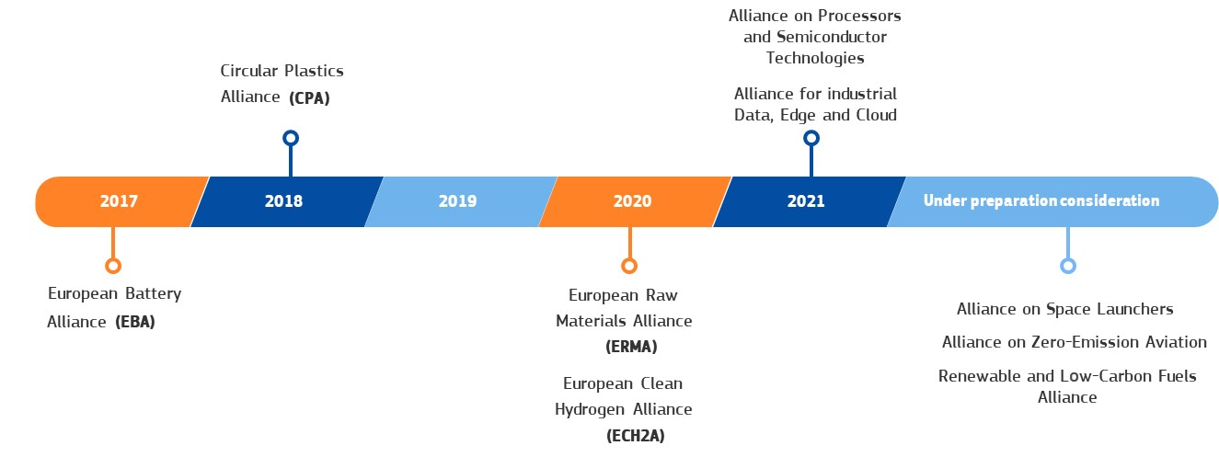
Graph 2: Overview of industrial alliances Source: Commission services, figure 11 of SWD(2022) 40 final.
Important Projects of Common European Interest (IPCEI) can help stimulate public and private investments by supporting research, innovation and first industrial deployment across the Union. Possible new IPCEIs on cloud, hydrogen and additional ones on microelectronics and connectivity as well as health are in preparation by Member States, in addition to the existing IPCEI on batteries and the first IPCEI on microelectronics.
In the area of semiconductors, the recently proposed European Chips Act comprises a comprehensive set of measures to strengthen the EU's security of supply, resilience and technological leadership. To achieve these objectives, it aims to mobilise more than EUR 43 billion of public and private investments and set measures to prevent, prepare and swiftly respond to any future supply chains disruption, together with Member States and the Union’s international partners.
To further enhance Europe's technological edge and support its industrial base, the EU and its Member States will also have to considerably increase investment in European defence and space industries, including in cyber defence. The invasion of Ukraine highlights that in order for the Union to retain the ability to act and take responsibility for its own security, it must strengthen its resilience and develop strategic capacities, such as in energy, defence and cyber. Regarding cyber resilience, the EU needs to enhance its collective preparedness, coordinate joint situational awareness, and strengthen its operational assistance capacity, including through the proposed Joint Cyber Unit and launch a European infrastructure of SOCs (Security Operations Centres). The recently adopted space and defence packages aim to set out concrete measures to support the Union’s ambitions in space and defence policies. These initiatives will also promote synergies between the civil and defence industries in view of maximising spin-offs and cross-fertilisation.
Additional targeted investment has been mobilised to strengthen our risk management and emergency response capabilities. The European Health Emergency preparedness and Response Authority (HERA) was designed for this purpose. It will help anticipate potential health crises, through intelligence gathering and building the necessary response capacities. When an emergency does arise, HERA will help ensure the production and distribution of medicines, vaccines and medical equipment. Moreover, through the EU4Health Programme, the Union is also investing in actions to complement Member States’ action in the area of disease prevention, health promotion, cross-border health cooperation, health systems resilience and resource efficiency. The Union is also investing in the development of the rescEU strategic reserve of response capacities under the Union Civil Protection Mechanism to improve our preparedness for future large-scale crises, including health and disaster scenarios with transboundary effect, triggered by climate change-induced disasters and new and emerging threats.
Latest developments have confirmed the importance of an integrated and well-functioning Single Market for products, workers, services and capital, which is essential for our resilience. It is estimated that further improvements of the Single Market for manufactured products could generate gains in GDP between 183 and 269 billion EUR annually, while further integration of the services markets could amount to gains in GDP of 297 billion EUR per year. These increases alone could raise the economic benefits of the Single Market from 8-9% to around 12% of additional GDP. To that end, the Commission is actively promoting the removal of existing barriers and unjustified obstacles, notably through coordinated work and dialogue with Member States in the context of the Single Market Enforcement Task Force. The Commission also works to prevent the creation of new barriers, for example through the existing notification mechanisms, and takes enforcement action if needed.
To bolster the resilience of its Single Market, Europe must increase its capacity to ensure security of supply in case of an emergency. To guarantee more information sharing, coordination and solidarity when Member States adopt crisis-related measures, the Commission is working on a proposal for a Single Market Emergency Instrument. The instrument will put in place a mechanism for crisis preparedness and action through which the Union can address critical product shortages by speeding up product availability (e.g. standard setting and sharing, fast-track conformity assessment) and reinforcing public procurement cooperation.
- Ensuring a fair and inclusive economic transformation
The green and digital economic transformation can only succeed if it is fair and inclusive. The welfare effects of digitalisation and decarbonisation are likely to be unequally distributed. As lower- and middle-income households often spend a larger share of their disposable income on food and essential services, such as housing, energy and transport, they are likely to be more affected as the cost of emissions is internalised, driving up the price of certain economic activities relative to others.
Labour reallocation within and between sectors will require reforms and large-scale investment in reskilling and upskilling. Similarly, the digital transformation is likely to create new employment opportunities in advanced technologies while other jobs will most likely be fully or partially automated. New forms of work organisation create both opportunities and challenges for policy makers, especially when it comes to ensuring broad access to social protection and high-quality working conditions. To facilitate restructuring and adjustment, Member States should follow granular approaches, focusing on the individual regions and sectors concerned. The approach for comprehensive and coherent policy packages set out in the Commission Recommendation for Effective Active Support to Employment (EASE) can guide this process.
A strong policy response at all levels will be needed to effectively address the social and cohesion challenges ahead of us. At EU level, the European Pillar of Social Rights and the associated Action Plan provide a coherent framework for action, including three ambitious EU headline targets for 2030 in the areas of employment, skills and poverty reduction. Member States and regional and local governments will also have to play their part, involving the relevant actors on the ground, including social partners and civil society, in the design and implementation of effective enabling policies and flanking measures. The EU budget will continue providing support to reduce regional and social disparities, in particular through cohesion policy.
As emphasised in the Porto Declaration, education and skills must be at the centre of our political action. Existing systems will have to adjust to support the transition towards newly created jobs. The Communication on the European Education Area formulates a shared vision to improve access to quality education and training and to equip EU citizens with the right knowledge and skills to reap the benefits of the green and digital transitions. In addition, the Digital Education Action Plan proposes a set of initiatives to foster the development of a digital education ecosystem with enhanced digital competences for the digital transformation.
The European Skills Agenda, including the Pact for Skills, provides a comprehensive framework of future action and a set of ambitious objectives to steer investment in adult learning across the EU. It notably includes proposals linked to vocational education and training, micro-credentials and individual learning accounts. To implement the initiatives and meet the objectives of the Skills Agenda, the EU will need additional public and private investments in skills of approximately EUR 48 billion annually. NextGenerationEU and the EU budget provide significant resources which contribute to meeting these needs.
Flanking measures will be required to mitigate the distributional impacts of the twin transition. Measures will have to be carefully designed to provide the right incentives and support the shift to climate neutrality. At EU level, financing for supporting policies is available from cohesion policy, the Just Transition Mechanism, the RRF and, in the future, from the proposed Social Climate Fund linked to the introduction of emissions trading in buildings and road transport. By ensuring a balanced territorial development and creating quality job opportunities for everyone while taking measures to mitigate the negative impact on the most vulnerable, including those at risk of energy poverty, and strengthening access to social protection, the economic transformation can help address pre-existing socio-economic inequalities, improve health and promote equality. The fairness of the twin transitions will also require measures to promote adequate working conditions, including as regards minimum wage.
- Mobilising coordinated action at all levels
In order to master such a massive transformation of the European economy, an enabling policy framework must support innovation and accompany change. Tackling the challenges in the post-pandemic world will require innovative products and services as well as new business models and a well-prepared and adaptable workforce.
The investments needed in order to complete the twin transition and to enhance resilience will need to come primarily from the private sector. Hence, the need to fully seize the business opportunities offered by the Single Market, to start-up and scale up, and top tap the potential for the Capital Markets Union to improve the efficiency of funds allocation within the Union. Member States have a key role to play when it comes to lifting barriers linked to the transposition, implementation and application of EU legislation, lengthy and complex administrative procedures, regulatory uncertainty, fragmentation, complex tax systems and a weak business environment. Moreover, cross-cutting policies, such as taxation, trade, and competition policy, also support Union’s favourable business environment and help attract investment.
Strong and efficient Capital Markets Union and Banking Union are needed, to mobilise the flow of private money necessary to support the twin transition. The scale of investments needed for the recovery and the twin transition can only be provided by a strong and competitive banking sector and well-functioning, deep and integrated capital markets. They support the twin transition by making companies, including SMEs, more visible to investors, supporting access to public markets and encouraging more long-term and equity financing, also through InvestEU. Access to finance for companies in general and SMEs in particular can be improved by completing the Banking Union and by developing capital markets so as to diversify sources of funding, as well as by removing barriers to financial services provided across borders. In order to reap the benefits of integrated capital markets, it is important to complete the Capital Markets Union by swiftly adopting and implementing the measures put forward by the Commission last year and the upcoming proposals to be presented this year. In particular, the Commission intends to put forward proposals to cut red tape for companies wanting to raise funds on EU public markets and to harmonise certain aspects of insolvency frameworks and procedures.
The sustainable finance framework will increase private investments in sustainable economic activities, businesses and projects. The new sustainable finance strategy lists a set of measures to ensure that the financial system fully supports the transition towards sustainability. It strongly relies on the EU Taxonomy, which provides companies, investors and policymakers with criteria on which economic activities substantially contribute to climate and environmental objectives, including transition activities. It also comprises measures to promote the transparency of sustainable investments, empower retail investors and SMEs, and better integrate sustainability risks in the financial system. In addition and as a result of its strategy review, the European Central Bank has agreed on an ambitious roadmap on how to integrate climate change considerations into its work. Moreover, to finance sustainable projects under the RRF, the Commission is issuing green bonds under NextGenerationEU, thereby further strengthening the market for sustainable finance.
While private funds will account for the major share of investments, public intervention may be needed in certain cases to create the right incentives and remove obstacles to innovation. Carbon pricing through the EU Emissions Trading System (EU ETS) and environmental taxation are essential to send the right price signals for households and businesses. Regulatory action can also create a level playing field (e.g. the proposal for a Batteries Regulation). Standards can foster transparency and reduce market risks while intellectual property policy protects innovation and supports investment.
Public investment can be a catalyst for private investment. It can do so, in particular, by improving access to finance and risk capital for SMEs, guiding and crowding in private investments, de-risking innovative projects, overcoming market failures, and fostering closer links between research institutions and businesses. For example, in the production of microprocessors, there are high entry barriers and substantial fixed costs. This may justify the deployment of public support in critical areas subject to strong safeguards. However, public support needs to be well targeted to projects with clear added-value in order to avoid crowding out private investment and preserve sound public finances.
EU competition policy has a key role to play in this respect, as well as in maintaining a level playing field and supporting companies to innovate and grow. Preserving competition contributes to the resilience and competitiveness of our companies on the global markets. During the pandemic, the State aid Temporary Framework provided the required flexibility for Member States to support the economy during these challenging times. The new State aid guidelines on climate, energy and environment aim at supporting Member States in achieving the objectives of the European Green Deal. Moreover, the Commission is undertaking an unprecedented review of competition rules to ensure that they are fit for purpose. In this context, it updated guidelines on the public financing of Important Projects of Common European Interest (IPCEIs). To stimulate innovation and risk taking, the revised Risk Finance Guidelines clarified the rules under which Member States can support access to finance by start-ups, SMEs and companies with a medium capitalization.

Public investment needs to go hand in hand with the need to safeguard the sustainability of public finances. This is particularly relevant in light of the need to ensure debt sustainability through a gradual and high-quality fiscal adjustment and economic growth. Promotion of investment and reforms should be an integral part of a credible medium-term fiscal strategy that ensures fiscal sustainability. In this context, it will be important to foster coherence between fiscal, investment and reform policies in the Member States and at the EU level. These issues are discussed as part of the ongoing review of the European economic governance.
Supporting recovery and the economic transformation of EU economy in line with the twin transitions is also a key objective of Union’s trade policy. In parallel to opening access to markets, trade policy must protect EU companies and citizens from unfair trading practices, including with the help of trade defence instruments and other innovative instruments such as the anti-coercion instrument.
EU investments have an important signalling effect. The EU budget, together with the temporary recovery instrument NextGenerationEU, with the RRF as its centrepiece, amount to EUR 2.018 trillion, a substantial firepower in support of long-term growth. Through the discussions on the national Plans, the Recovery and Resilience Facility has been instrumental in aligning the EU and national priorities for reforms and investment around a set of common goals. NextGenerationEU will help mitigate the impacts of the pandemic while supporting the transformation of the economy and the twin transition. At the same time, borrowing for NextGenerationEU bolsters the international role of the euro and strengthens the EU capital markets.
The RRF provides incentives for reforms and support for funding to the key priority areas of the green and digital transitions until 2026. The RRF Regulation requires each Member State to dedicate at least 37% of its recovery and resilience plan total allocation to climate objectives and 20% to digitalisation objectives. Besides the green and digital investments, the RRF is also providing crucial support to social policies, to promote an inclusive growth, social and territorial cohesion, and support health as well as policies for the next generation. The visual below shows the allocation to each of the six pillars of the RRF. Member States’ commitment to reforms is unique to the design of the RRF and the reforms represent almost a third of all the measures included in the recovery and resilience plans of the Member States. They are crucial to create the right framework conditions to enable investments and to generate faster and larger impacts, including cross-border growth effects. At present, large amounts of RRF loans remain available, offering the possibility of further support to Member States wishing to make use of them.
Graph 3: Share of Recovery and Resilience funds contributing to each policy pillar

Source: Commission services. The amounts refer to the 22 Recovery and Resilience Plans adopted in 2021.
Legend: The darker-coloured parts of the columns represent those measures which have been tagged and assigned to the pillar as primary policy area, while the lighter-coloured parts represent measures tagged as secondary policy area.

The EU’s 2021-2027 long-term budget and other instruments provide substantial support for the transition. As indicated in the European Green Deal Investment Plan, the Union aims at mobilising at least EUR 1 trillion over the next decade to support sustainable investments through the EU budget and associated instruments. This amount takes into account the public and private funding obtained through leveraging the EU’s budget guarantee under the InvestEU Programme. 30% of the 2021-2027 budget will be spent on the green transition, for example through Cohesion Policy and the Common Agricultural Policy but also through specific programmes such as the LIFE programme, the Just Transition Mechanism, and the innovation and modernisation funds. The InvestEU programme supports investments in digital infrastructures, technologies, and skills, in particular through its window on Research, Innovation and Digitisation. In addition, the digital transition will be supported by various EU funds, notably through Cohesion Policy, Horizon Europe, the Digital Europe Programme and the Connecting Europe Facility.
- Conclusions
The global challenges Europe is facing provide an opportunity to renew our resolve and commitment to the economic transformation and reinforce the cooperation with our international partners. The transformation of EU economy is taking place in a context of geopolitical instability and rising global challenges, such as the COVID-19 pandemic, the invasion of Ukraine, the climate crisis, and the spike in energy prices. Those developments highlight the need to double down on the green and digital transition in an inclusive manner, as well as to increase our resilience and crisis preparedness. The Single Market, as Union’s main source of resilience, will be instrumental in achieving those goals and absorbing possible shocks.
There is a strong consensus on what we want to achieve. Getting there will require investment and reforms in all Member States. Investment, which needs to be substantially increased, should be accompanied by ambitious reforms to generate the intended returns, in financial terms as well as in terms of their broader societal goals. Both investment and reforms are equally important and must be fully aligned and strongly coordinated at EU level to become mutually reinforcing, prevent divergence across Member States and to strengthen the Single Market.
Public authorities at regional, national and EU level should focus on creating an investment-friendly business environment, enhancing private investment with targeted financial support and promoting public investment, while preserving sound public finances. As the private sector will account for the major share of investment, it is important that the conditions are in place to effectively channel private financing towards economic activities that contribute to the decarbonisation, digitalisation and resilience of our economies. Public investment and reforms contribute positively to debt sustainability to the extent that they are of high quality and support growth. Successful debt reduction strategies should focus on fiscal consolidation, the quality and composition of public finances and promoting growth. The ongoing review of the European economic governance framework provides an opportunity to improve the effectiveness of the EU’s fiscal rules and to ensure that they play an appropriate role in incentivising the Member States’ investment and reform policies, in line with our common priorities, while safeguarding sound public finances. In this context, it will be important to ensure coherence between fiscal surveillance and economic policy coordination and to align investment and reform policies in the Member States as well as national and EU objectives.
To safeguard the prosperity and wellbeing of its citizens, the EU needs to accomplish a fair and inclusive transition towards a greener and more digital future while strengthening socio-economic resilience in an unstable world. Coordinated and complementary action, including between national fiscal policies and the EU budget, will have a greater impact and foster investments in areas of strategic importance and with strong cross-border component to deliver European added value. The ambitious targets we have set can only be achieved by a sustained effort involving all actors at European, national and regional level. Reaching our common goals requires a long-term vision and a coordinated approach which calls for a thorough reflection to identify concrete priorities that are common to the EU and its Member States, and at the global level. Public authorities at EU level and in the Member States need to work together in a consistent manner with private industry actors across all sectors to bolster competitive sustainability.

Proposal for a Council Recommendation on ensuring a fair transition towards climate neutrality, COM(2021) 801 final.
Communication on The European Green Deal, COM(2019) 640 final. See also European Parliament resolution of 15 January 2020, and European Council conclusions of 11 December 2020.
In addition, the Union has committed to climate neutrality by 2050. See Regulation 2021/1119 establishing the framework for achieving climate neutrality (OJ L 243, 9.7.2021, p. 1).
Communication on ‘Fit for 55’: delivering the EU’s 2030 Climate Target, COM(2021) 550 final.
For instance: Communications on EU Soil Strategy for 2030, COM(2021) 699 final; Communication on New EU Forest Strategy for 2030, COM(2021) 572 final; Communication on EU Biodiversity Strategy for 2030, COM(2020) 380 final; Communication on A new Circular Economy Action Plan, COM(2020) 98 final; and Communication on EU Action Plan: towards zero pollution for air, water, and soil, COM(2021) 400 final.
Communication on The EU economy after COVID-19: implications for economic governance, COM(2021) 662 final, p.17.
These estimates include investments in the power grid, power plants, industrial boilers and new fuels production and distribution, investments in building insulation, energy renovation, and transport-related infrastructure such as recharging and refuelling stations. However, they do not include investments in rail, road, airports or ports infrastructure, nor future climate adaptation needs such as investments dedicated to making existing assets more resilient to climate change or increased costs due to more frequent extreme weather events. See SWD(2020) 98 final, p.17. See COM(2020) 789 final and SWD(2020) 331 final for estimates on the investment gap regarding transport infrastructure.
Communication on the new EU Strategy on Adaptation to Climate Change, COM(2021) 82 final.
Communication on the 2030 Digital compass: the European way for the Digital Decade, COM(2021) 118 final.
Proposal for a decision of the European Parliament and of the Council establishing the 2030 Policy Programme ‘Path to the Digital Decade’, COM(2021) 574 final.
COM(2021) 662 final, p.17.
Commission services are reviewing these numbers.
Joint Communication on the EU’s Cybersecurity Strategy for the Digital Decade, JOIN(2020) 18 final.
Proposal for a Regulation as regards establishing a framework for a European Digital Identity, COM(2021) 281 final.
Communication on the European democracy Action Plan, COM(2020) 790 final.
Regulation 2019/1150 on promoting fairness and transparency for business users of online intermediation services (OJ L 186, 11.7.2019, p. 57).
Regulation 2018/302 on addressing unjustified geo-blocking and other forms of discrimination based on customers' nationality, place of residence or place of establishment within the internal market (OJ L 60I, 2.3.2018, p. 1).
Proposal for a Regulation on a Single Market for Digital Services (Digital Services Act), COM(2020) 825 final; and proposal for a Regulation on contestable and fair markets in the digital sector (Digital Markets Act), COM(2020) 842 final.
Communication on a Digital Finance Strategy for the EU, COM(2020) 591 final; Communication on a European strategy for data, COM(2020) 66 final; Communication on Fostering a European approach to Artificial Intelligence, COM(2021) 205 final.
Proposal for a Directive on improving working conditions in platform work, COM(2021)762 final.
Communication on Establishing a European Declaration on Digital rights and principles for the Digital Decade, COM(2022) 27 final.
Communication on updating the 2020 New Industrial Strategy, COM(2021) 350 final.
These areas include for example active pharmaceutical ingredients and other health related products.
SWD ‘Strategic dependencies and capacities: second stage of in-depth reviews’, SWD(2022) 41 final.
As part of the critical raw materials action plan, the Commission is accelarating the work with Member States to address strategic dependencies for the EU’s raw material supplies by a) diversified sourcing outside the Union (e.g. partnerships with Canada); b) recycling; and c) sustainable extraction and processing of raw materials in the EU. The Commission is identifying how to tailor this approach per critical raw materials for the green and digital transition (e.g. critical raw materials needed for batteries, solar panels, semiconductors or hydrogen).
Communication ‘2021 Strategic Foresight Report: The EU’s capacity and freedom to act’, COM(2021) 750 final.
Annual Single Market Report 2022, SWD(2022) 40 final.
Proposal for a Regulation establishing a framework of measures for strengthening Europe's semiconductor ecosystem (Chips Act), COM(2022) 46 final.
As regards the space package, see in particular the Joint Communication on EU approach for Space Traffic Management and an EU contribution addressing a global challenge, JOIN(2022) 4 final; and proposal for a Regulation establishing the Union Secure Connectivity Programme for the period 2023-2027, COM(2022) 57 final. Concerning the defence package, see in particular the Communication on Commission contribution to European defence, COM(2022) 60 final; and Communication on roadmap on critical technologies for security and defence, COM(2022) 61 final.
Communication on Long term action plan for better implementation and enforcement of Single Market rules, COM(2020) 94 final.
Communication on identifying and addressing barriers to the Single Market, COM(2020) 93 final.
Communication on the European Pillar of Social Rights Action Plan, COM(2021) 102 final.
At least 78% of the population aged 20 to 64 should be in employment by 2030; at least 60% of all adults should participate in training every year; the number of people at risk of poverty or social exclusion should be reduced by at least 15 million by 2030.
See https://www.consilium.europa.eu/en/press/press-releases/2021/05/08/the-porto-declaration/
Communication on achieving the European Education Area by 2025, COM(2020) 625 final.
Communication on European Skills Agenda for sustainable competitiveness, social fairness and resilience, COM(2020) 274 final, p.20
These include cohesion policy funding under the ESF+ and ERDF, Erasmus+, Horizon Europe, the dedicated Digital Europe Programme, InvestEU, the Just Transition Fund, the European Globalisation Adjustment Fund and the Modernisation Fund.
In this context, the Commission’s proposal for a Directive on Minimum Wages provides a framework for ensuring that workers in the Union are protected by adequate minimum wages, allowing for a decent living wherever they work.
Communication on A Capital Markets Union for people and businesses, COM(2020) 590 final.
Communication on a strategy for financing the transition to a sustainable economy, COM(2021) 390 final.
For more information, see https://ec.europa.eu/info/business-economy-euro/banking-and-finance/sustainable-finance/eu-taxonomy-sustainable-activities_en.
Communication on an EU Strategy on Standardisation - Setting global standards in support of a resilient, green and digital EU single market, COM(2022) 31.
Communication on Criteria for the analysis of the compatibility with the internal market of State aid to promote the execution of important projects of common European interest (IPCEIs), (OJ C 528, 30.12.2021, p. 10).
The European Investment Bank has also pointed out the need to catalyse private investment through risk-sharing instruments to mitigate ongoing macroeconomic uncertainty. See European Investment Bank, Investment Report 2021/2022: Recovery as a springboard for change, 2022, p.124.
Communication on Guidelines on State aid to promote risk finance investments (OJ C 508, 16.12.2021, p. 1).
This amount is made up of EUR 1.211 trillion (long-term budget) and EUR 806.9 billion (NextGenerationEU). The majority of funds from NextGenerationEU will be spent through the RRF (EUR 723.8 billion), which provides support in the form of grants (EUR 338 billion) and loans (EUR 385.8 billion). For more information, see https://ec.europa.eu/info/strategy/eu-budget/long-term-eu-budget/2021-2027/whats-new_en.
Regulation (EU) 2021/241 of the European Parliament and of the Council of 12 February 2021 establishing the Recovery and Resilience Facility (OJ L 57, 18.2.2021, p. 17).
The six policy pillars are set out in Article 3 of the RRF Regulation.
Communication on European Green Deal Investment Plan, COM(2020) 21 final.

