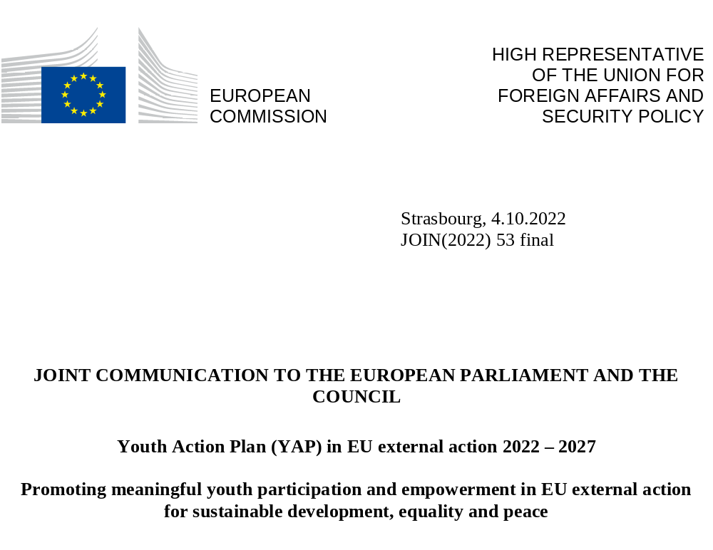

‘We deserve to be heard, empowered, protected and also given the opportunity to lead’, Alda Soraya (23 years old), Indonesia.

Introduction
At a time marked by multiple challenges and rapidly shifting paradigms, including the ongoing Russian war of aggression against Ukraine, there is a clear need to strengthen our partnership with young people across the globe to achieve positive transformative change.
The world’s youth population is larger than ever before, with 1.8 billion young people between the ages of 10 to 24. Close to 90 per cent of young people live in low- and middle- income countries. In the context of the global demographic transition, these numbers are expected to grow further.
Worldwide, young people are powerful agents of change. They play a crucial role in addressing global challenges, contributing to sustainable development and driving innovations. They often stand at the forefront in the fight against climate change, poverty and corruption, and for peace and reconciliation in conflict areas. Many of them champion civil, political, economic, social, and cultural human rights.
However, their prospects and capacity to act are often limited by lack of access to education, decent jobs, health care and social protection and, in many countries, by shrinking democratic and civic spaces. Legal, cultural and economic barriers restrict young people’s civic and political participation, which is not conducive to building trust in institutions and political systems.
Young people and children bear the brunt of crises and instability caused by armed conflicts, rising inequalities, climate change and environmental degradation. Around 600 million young people live in conflict or fragile situations, 71 million young people are unemployed and about 264 million children and youth are out of school. Girls and young women are particularly affected.
The COVID-19 pandemic has taken a heavy toll on young people’s education, employment, mental well-being, and their right to participate in public life. While many young people have shown great engagement to protect older and vulnerable persons during the pandemic, it has also highlighted the need for greater intergenerational solidarity to build more equal, sustainable and resilient societies in the interest of the future of the young generations.
In such a context, young people must be given a real voice in shaping the solutions that will have an impact on their futures and the future of the planet.
The Youth Action Plan (YAP) responds to this imperative and provides a policy framework for a strategic partnership with young people in EU external action, as also called for by the 2020 Council conclusions. The YAP aims at promoting the engagement of young people as strategic partners, supporting their empowerment and harnessing the demographic dividend, to build more resilient and inclusive societies and make progress towards global commitments such as the United Nations Sustainable Development Goals (SDGs) of the 2030 Agenda and the Paris Climate Agreement.
The EU response to the multiple challenges is based on the fundamental values laid down in Article 2 of the Treaty of the European Union. It is geared towards building strong partnerships for the present, securing the future of next generations and contributing to intergenerational equity and justice.
With a focus on the transition from childhood to adulthood, and as a deliverable of the European Year of Youth, the YAP strengthens the international dimension of the EU Youth strategy, and builds on the EU strategy on the rights of the child that promotes meaningful participation and empowerment from the early years of life.
It draws on the EU Action Plan on Human Rights and Democracy that stresses the need for equal, full and meaningful participation of young people in public and political life, and the European Pillar of Social Rights. Finally, it implements the EU Gender Action Plan (GAP) III, by focusing on the empowerment of girls and young women.
The YAP will support as well the implementation of the UN Youth, Peace and Security Agenda and the role of young people in building lasting peace, contributing to justice and reconciliation and countering violent extremism.The Youth Action Plan is global in nature, but will also be implemented through tailor-made approaches adapted to the needs and circumstances of youth in specific regions, e.g. in the EU’s enlargement and neighbourhood countries, Africa, the Middle East, Latin America and the Caribbean and Asia and the Pacific.

Young people have a say
The Youth Action Plan has been drawn up after extensive consultations with over 220 stakeholders across the world, in particular youth and children’s rights organisations. It responds to the legitimate demand by young people, also reflected in the outcomes of the Conference on the Future of Europe, to be involved in a more structured way in EU policy- and decision-making processes.
As pointed out by the Youth Sounding Board for International Partnerships, ‘young people cannot be considered as “add-ons” to adult-led initiatives. Young people are a constituency who hold uniquely critical perspectives and skills, necessary for informing and driving policy, service delivery, and research. Barriers to meaningful youth participation can only be addressed by an action plan that has been created through processes that, in themselves, have tried to transcend such barriers’.

Towards a strategic EU partnership with young people in external action
The EU will be guided by four principles in building a strategic partnership with young people:
- A human rights-based approach and gender equality
The EU aims at promoting the participation of young people and children as a right, ensuring no one is left behind, by addressing inequalities and structural barriers, mainstreaming gender equality and non-discrimination and applying an intersectional approach.
- A participatory approach for transformative change
Young people will be involved at country, regional and global level throughout the external EU policy and programme cycles, thus contributing to youth ownership and sustainability of actions.
- Youth inclusion
The participation of young people in civic, economic, social, cultural and political life will be promoted by specific actions targeting youth and by mainstreaming their perspectives and needs in programming, policy and political dialogues across all areas.
For example, the humanitarian gender-age marker ensures that different gender and age groups, including youth, are adequately involved and targeted by EU-funded humanitarian aid.
- Evidence-based policy-making and accountability
The YAP aims to increase the availability and quality of data on youth bridging thematic and geographic gaps, focussing on young people between 15 and 29 years. The EU monitoring and evaluation framework of the external action will be strengthened, by integrating more age-disaggregated data, adopting youth-specific indicators and promoting data collection and youth-oriented and -led research.

How to deliver: the three pillars of an action-oriented agenda
The YAP identifies priorities and main objectives along the three pillars ENGAGE, EMPOWER and CONNECT, which mirror the three core areas of action of the EU Youth Strategy.
The EU will promote a Team Europe approach in the implementation of the YAP, while working with key partners and stakeholders at country, regional and multilateral levels.

3.1 Partnership to ENGAGE
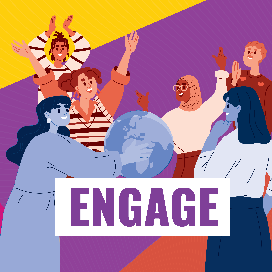
Young people demand and deserve a comprehensive approach to ensure meaningful, inclusive and effective youth participation. To this aim, a conducive environment to participation requires the creation of safe youth- and child-friendly spaces and opportunities, while enabling young people from diverse backgrounds to engage in democratic decision-making, raising the awareness and strengthening the capacity of policy-makers to work with young people.
The EU is committed to increasing the voice and leadership of young people, in particular young women and girls, youth activists and organisations, at all levels of governance, from domestic politics to multilateral forums, and within EU processes. The European Citizens’ Panels of the Conference on the Future of Europe, which were composed in one third of young people (age 16-25), provided a lead example for creating a space for intergenerational dialogue.

3.1.1 Meaningful youth engagement in EU external action
The EU will enhance institutional youth engagement to:
- Promote young people’s involvement in the design, implementation and monitoring of EU external policies and actions;
- Ensure further accountability on youth issues through a strategic, inclusive and participatory communication to reach out to young people, including children, in all their diversity.
EU institutional youth engagement will be achieved through:

- An EU platform for regular dialogue with youth organisations, as a new element of the Policy Forum on Development. Its main features will be defined in partnership with youth organisations by 2023.
- The Youth Sounding Board for International Partnerships, set up in 2021, to advise the European Commission on youth participation in external action.
- Mandatory consultations of youth organisations in the Neighbourhood, Development and International Cooperation Instrument - Global Europe (NDICI-Global Europe) programming process.
- The country roadmaps for EU engagement with civil society, integrating a youth perspective and ensuring that youth organisations participate in a meaningful way.
- Youth advisory structures providing advice to EU Delegations (EUDs) on country-specific priorities. By 2027, these will be in place in most partner countries.
- Enhanced institutional capacity and expertise of EU staff on how to work with and for young people and on child protection through training, guidelines and sharing of good practices. By 2024, 80% of EUDs will have youth focal points.

3.1.2 Improving youth engagement at regional and multilateral level
In recent years, young people have increasingly championed multilateral solutions to global issues.
- Promote meaningful youth participation in multilateral policy-making, by following up on the UN Secretary General’s report on Our Common Agenda and supporting the establishment of a UN Youth Office.
- Involve young people in discussions on regional partnerships and cooperation, for instance in the EU relations with Africa, Asia, Latin America and the Caribbean, the Neighbourhood countries, the Mediterranean region and the Gulf countries.
To achieve these objectives, the EU will launch:
- The EU@UN youth delegates programme, which will support gender-balanced and diverse youth participation in multilateral fora and strengthen their capacity to effectively contribute to multilateral policy-making. The EU will advocate for a formal youth dialogue as a permanent feature of the Commission on the Status of Women and the Conference of State Parties to the UN Convention on the Rights of Persons with Disabilities, and facilitate coordination among the EU youth delegates in the United Nations Framework Convention on Climate Change, the United Nations Environment Assembly and other multilateral processes.
- The AU-EU Youth Lab, which will enhance dialogue with youth on the Africa-EU Partnership by supporting young people and youth organisations from Africa, Europe and the diaspora to co-create solutions to global challenges.
The EU will also contribute further to youth engagement at regional and multilateral level through the following existing initiatives:
- The Young Mediterranean Voices, supporting cooperation between young people on both sides of the Mediterranean in public affairs and in local and regional transformative initiatives. Erasmus+ will also support capacity-building in the field of youth in the Western Balkans and the Southern Mediterranean.
- The EU4Youth programme, fostering youth participation and leadership in policy-making in the Eastern Partnership, especially in Ukraine.
- The network of Young European Ambassadors in the Western Balkans and Eastern Partnership and the Goodwill Ambassadors in the Southern Neighborhood.
- The promotion of youth engagement in the framework of the new Agenda for the Mediterranean, notably by building on the Union for the Mediterranean Youth Strategy 2030, and EU-Gulf Strategic Partnership.
- The involvement of young people in upcoming regional processes in Asia, Latin America and the Caribbean, or other regions, such as the EU-ASEAN Young Leaders Forum.
- The EU Macro Regional Strategies, involving young people in their governance and political dialogues and Interreg programmes supporting youth engagement in their decision-making, funding youth actions and promoting the Volunteer Youth Initiative.
- Co-leading the youth participation cohort of the 2023 Summit for Democracy.

3.1.3 An enabling environment for young people’s civic and political participation
Youth and child participation in formal political processes remains low across the globe, due to structural barriers, cultural biases, and the erosion of trust in democratic institutions. Demanding the full recognition and protection of young people’s human rights, including freedom of expression and association, participation in public and political life, and notably in fair, inclusive, accessible, transparent and peaceful elections, is an essential part of the EU’s action on good governance, democracy, rule of law and human rights in partner countries.
EU action aims to:
- Foster political dialogue with partner countries, on youth and child engagement and participation;
- Promote the inclusion of young people in political and policy dialogues with national authorities;
- Ensure girls’ meaningful inclusion, participation and leadership in decision-making;
- Strengthen national capacities to work for and with young people and to support relevant national youth policy frameworks, considering the principle of intergenerational justice and dialogue;
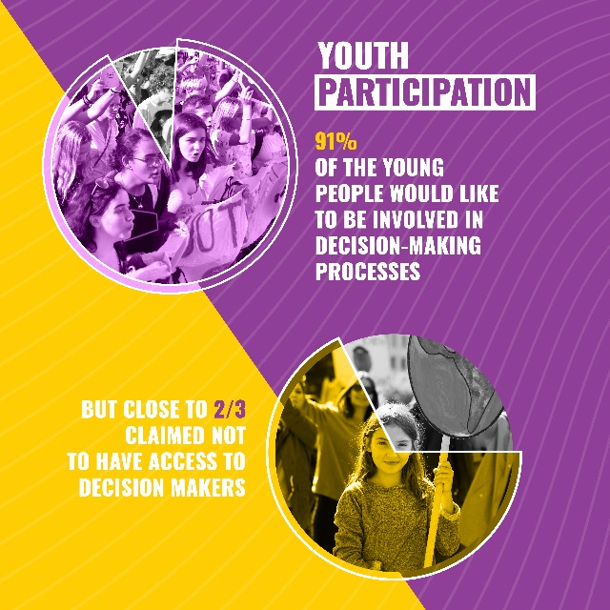
- Support youth civic engagement, volunteering and leadership;
- Advocate for the inclusion of young people on political parties’ lists for winnable seats and for boosting their capacity to stand as candidates;
- Increase access to national identity documents and voter registration, to ensure the right to vote;
- Strengthen the protection of young activists and human rights defenders, including LGBTIQ advocates, as well as countering racist narratives, hate speech and disinformation online while defending freedom of expression.

To achieve these objectives, the EU will launch:
- The Youth and Women in Democracy Initiative, which will promote political pluralism and inclusiveness of democratic processes by improving participation of youth and women in all aspects of public life. Young people’s role in political parties and parliaments will be strengthened through capacity building, networking, peer-learning and mentoring. This initiative will support grassroots organisations and young activists in institutional oversight, anti-corruption, citizen election observation, democratic reform advocacy, civic education, promotion of the right to vote, freedom of association and assembly and human rights.

The EU will also promote further young people’s civic and political participation in partner countries through the following existing initiatives:
- The new EU human rights defenders mechanism, to address specific threats faced by young human rights defenders and activists.
- The Global Campus on Human Rights as a major global hub for human rights education.
- The Youth Policy Labs in the Neighbourhood region, the Western Balkans and non-EU Western European countries, to promote innovative ways to involve young people in policy dialogues, to co-create and monitor the implementation of youth-relevant policies and strengthen youth participation mechanisms.
- Erasmus+, to back youth-led initiatives in Turkey, the Western Balkans and Neighbourhood countries.
- The human development initiatives, building on the EUROsocial+ programme, to support policy efforts in Latin America and the Caribbean involving youth to improve inclusive access to health, education, labour market, good governance and political participation.

3.1.4 Contributing to the implementation of the Youth, Peace and Security agenda
The EU and its Member States fully support the three successive UN Security Council (UNSC) Resolutions on the Youth, Peace and Security (YPS) agenda and their global implementation. In the June 2020 Council conclusions on youth in external action, EU Member States stressed the need to actively and inclusively engage young people in efforts to build lasting peace, contribute to justice and reconciliation and counter violent extremism. The EU is committed to follow the areas of work outlined by the UNSC Resolution 2250: participation, protection, prevention, partnerships and disarmament, demobilisation and reintegration. This is increasingly important in conflict situations around the world, not least in Africa and the Middle East, and in the wake of the ongoing Russian war of aggression against Ukraine.
EU action aims to:
- Support inclusive and meaningful participation of youth in national and international mechanisms for the promotion of lasting peace and resolution of conflict;
- Promote inclusive partnerships with and among young peacebuilders and support youth participation and leadership in peacebuilding;
- Increase support for young women and girls in fragile and conflict-affected countries in line with the Women, Peace and Security Agenda;
- Enhance the youth dimension in peace mediation, including by developing concrete guidance and capacity building;
- Strengthen cooperation on Youth Peace and Security with international organisations, and integration in dialogues on conflict prevention, mediation or security sector reform;
- Develop initiatives to counter violent extremism, in particular online radicalisation.
- Protect children in armed conflict, prevent and end violence (including sexual), promote compliance with International Humanitarian Law, offer psycho-social support and access to child-friendly justice and help for unaccompanied and separated children, also in the context of the Russian war of aggression against Ukraine

To implement the Youth, Peace and Security agenda, the EU will:
- Use appropriate multilateral fora, including the UN, to promote the inclusion of youth and the implementation of the YPS agenda.
- Improve youth-sensitivity of the EU conflict Early Warning System and in conflict analysis, paying attention to intergenerational dynamics and to concrete preventive actions incorporating the youth angle.
- Integrate the YPS agenda into the EU’s political dialogues.
- Develop concrete guidance on youth in the EU peace mediation.
- Review and update the EU’s Guidelines on Children and Armed Conflict to strengthen EU action to protect children affected by armed conflict.
- Build capacity of EU staff on the Youth Peace and Security agenda, for example in conflict prevention and mediation trainings in the European External Action Service.
- Incorporate the Youth Peace and Security dimension into conflict prevention and crisis management efforts.
- Engage with relevant local communities and civil society organisations in developing strategies that endorse the positive role of youth and children in promoting peace.
- In the framework of the Strategic Partnership with the Gulf, support initiatives on research and education, contributing to regional security and stability.
- In Africa, support the implementation of the “Extremely together” initiative on antiradicalisation, as well as the ongoing cooperation between youth networks and the Executive Secretariat of the G5 Sahel.

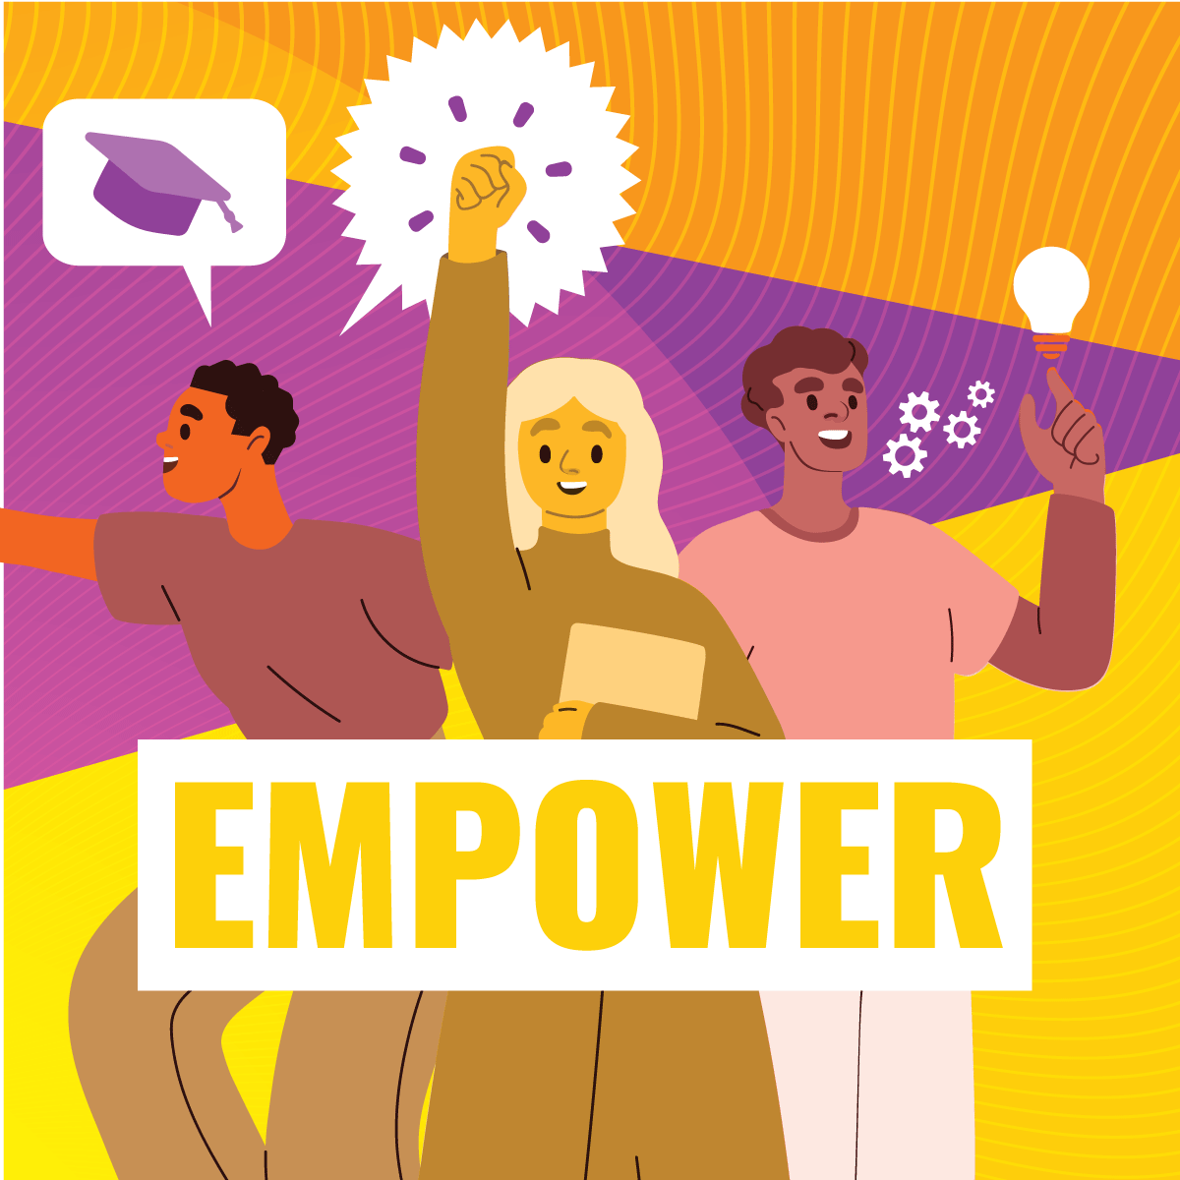

3.2 Partnership to EMPOWER

Young people are empowered when their voices are heard and the inequalities that affect their lives are tackled.

3.2.1 Transforming education
Quality education and lifelong learning are basic human rights and enable equality, active citizenship and sustainable livelihoods.
Too many children and young people are still deprived of equitable access to free and quality education, in particular girls and those affected by crisis. Gender-based discrimination, conflicts, humanitarian emergencies, violence, poverty and lack of teachers and schools are the main factors pushing millions out of school at an early age. Many of them are subjected to child labour, modern slavery including forced labour or forced child marriage, pregnancies or recruitment as child soldiers. Vulnerable young people, the displaced, minorities and those with disabilities are often excluded from education.

The COVID-19 pandemic has worsened the severe shortcomings and fragility of education systems, including the digital divide. There is a real risk that an entire generation will be trapped in a downward spiral of diminishing opportunities.

The EU is working to reverse the learning crisis and to promote equitable access to free and quality education from primary to tertiary levels. It aims to invest in education at least 10% of the overall funding under Global Europe for Sub-Saharan Africa, Latin America and the Caribbean, Asia and the Pacific including through Global Gateway investments.
In addition, the EU allocates 10% of its humanitarian aid funding to education in emergencies and protracted crises to reach the most marginalised children and young people, including those in areas of armed conflict and refugee sites.
EU action aims to:
- Support evidence-based education reforms in partner countries with a focus on access, equity, quality, inclusion, governance, gender-transformative programmes and financing, also following up on the 2022 UN Transforming Education Summit;
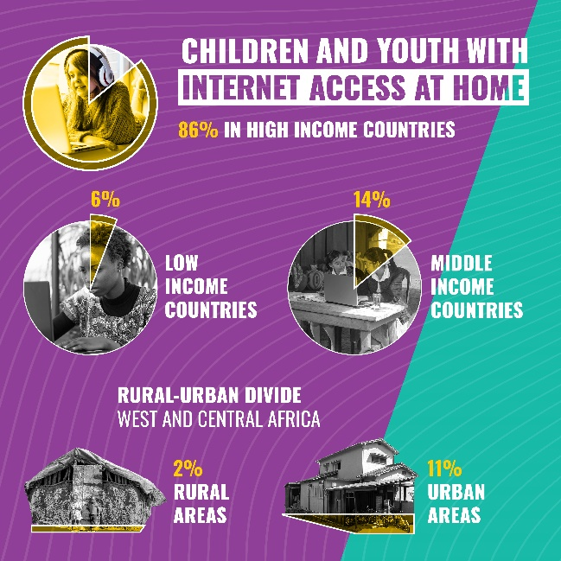
- Promote girls’ education to achieve equal access to all forms of education and training;
- Support comprehensive sexuality education for all young people, in particular marginalised adolescents, LGBTIQ young people and young people with disabilities;
- End child labour, applying the Commission zero-tolerance approach, through legislation, remediation and prevention measures, including reintegrating child labourers back into education and training, in line with the Durban Call to Action;
- Ensure access to safe and quality education during humanitarian crises, minimise the impact on the right to education and support authorities in resuming education services during or after a crisis;
- Invest in teachers to improve learning outcomes and the socio-emotional development of children and young people;
- Promote 21st century life and work skills, including on civics, climate change, environment, media and cultural literacy;
- Invest in high-quality and inclusive digital education to ensure young people and teachers have basic digital skills and the opportunity to acquire specialised digital skills in line with their professional aspirations and to strengthen resilience against disinformation. This also includes improving access to affordable, stable and high-speed internet;
To achieve these objectives, the EU will:
- Increase funding, policy dialogue and technical assistance to support partner countries’ efforts to achieve SDG 4 on quality education.
The EU will also further support the transformation of education by:
- Launching the new Regional Teachers Programme in Africa, which aims to make teaching an attractive career for young people.
- Leading the support to the Global Partnership for Education and Education Cannot Wait initiatives, which empower girls, adolescents and vulnerable groups through quality education.
- Investing in formal and non-formal learning opportunities in humanitarian emergencies. EU programmes mitigate the disruption of education and children’s psycho-social development in crisis contexts, for instance in Sahel, Ethiopia, Afghanistan, Bangladesh, Syria or Yemen.
- Contributing to the rehabilitation of damaged schools in Ukraine.
- Building on long-standing EU efforts supporting education in conflict contexts and learning from the recent experience in response to the Russian invasion of Ukraine, working with partner countries and humanitarian organisations to facilitate the access of children and young refugees to education and to relevant EU programmes in the host country.

3.2.2 Improving young people’s access to economic opportunities
Youth empowerment is closely linked to creating quality jobs, fighting precarious and volatile incomes, and having self-employment and entrepreneurship opportunities, while promoting gender equality and non-discrimination, also with a view to limiting brain drain.
EU action aims to:
- Support young people’s participation in economic decision-making and social dialogue to contribute to a more youth-friendly investment and business environments;
- Promote the decent work agenda, which educates young people about their basic labour rights and supports partner countries in developing social security and active labour market measures;
- Foster youth employability, by supporting partner countries’ efforts to improve vocational education and training (VET) and better align education systems to labour market opportunities;
- Support youth entrepreneurship, youth-led micro, small and medium-sized enterprises, with a focus on young women;
- Equip young people with green skills and support decent youth employment and entrepreneurship in the green economy, including in regenerative farming and the sustainable agri-food sector;
- Promote inter-generational learning between older and younger employees;
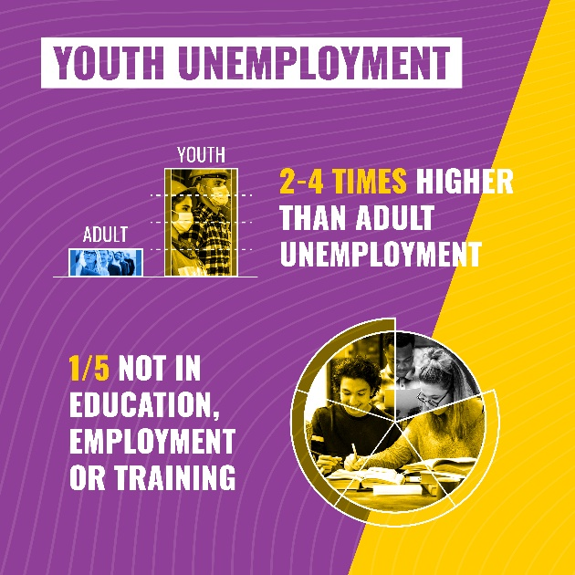
- Foster sustainable, gender-sensitive and responsible corporate behaviour and governance, ensuring environmental and human rights are fully respected;
- Facilitate the transition of young people to the formal economy and extend social protection to informally employed young people;
- Support the Worst Forms of Child Labour Convention, by helping non-EU countries to deliver action plans against child labour;
- Integrate youth employment impact assessments in programmes supporting the agri-ecology, green and digital transitions, including for Global Gateway investments.
To achieve these objectives, the EU will launch:
- The regional Team Europe Initiative on Opportunity-driven skills and VET in Africa to promote exchanges on public-private partnerships, enabling young people to find jobs.

- The implementation of the Youth Guarantee following the EU model to improve transitions from school to work in the Western Balkans and explore the activation of similar schemes in the Eastern Partnership region and North Africa.
The EU will also support further youth employment and entrepreneurship through the following existing initiatives:
- Erasmus+ capacity-building projects to foster accessibility and responsiveness of VET in Enlargement and Neighbourhood countries, Sub-Saharan Africa, and Latin America and the Caribbean.

- Support to national authorities in the Middle East and North Africa to reengage young people, particularly women, who are not in education, employment or training (NEETs) into education and the labour market. The Union for the Mediterranean Regional Platform on Employment and Labour and its 2022-2025 Roadmap for Action will focus on young NEETs and develop the use of “Communities of Practice”.

- The EU initiatives for youth entrepreneurship and improved access to finance for youth-led businesses, such as the recently launched Investing in Young Businesses in Africa Team Europe Initiative, the African European Digital Innovation Bridge, the New Deal for Youth in the Eastern Partnership, and the EU4Youth Employment and Entrepreneurship mechanism.

- Innovative investment schemes set-up under the European Fund for Sustainable Development+ with international financial institutions to cater for young people’s specific needs, such as the NASIRA Risk-Sharing Facility.

- The EU Global Action to End Child Labour to strengthen labour inspection systems to monitor and enforce child labour laws.

- The work of the European Training Foundation supporting partner countries to strengthen human capital and improve the quality of VET systems. Programmes such as DARYA, in Central Asia, contributes to better and more inclusive education, training and employment systems.

- The European Alliance for Apprenticeships to strengthen the quality of apprenticeships and the Erasmus for Young Entrepreneurs programme, offering peer-to-peer exchange of entrepreneurial knowledge in the Enlargement region.

3.2.3 Strengthening young people’s capacity to contribute to sustainable development and drive the green and digital transitions
Young people are often the engine behind innovative solutions, behavioural change and accelerators of their take-up at grassroots level. However, to transform their ideas into change-making initiatives, they need to improve their skills and networks, be able to make informed choices, participate in a safe digital environment and access funding opportunities.
EU action aims to:
- Increase capacity building and funding for youth organisations;
- Provide the resources to develop and scale up youth-led innovative and sustainable solutions;
- Support youth social entrepreneurship as a business model to reconcile economic progress and sustainability;
- Enable the participation of young people in decision-making and policy dialogues on climate, environment and disaster risk reduction;
- Promote girls and women’s participation and leadership to ensure gender responsive strategies on environment, climate mitigation and adaptation, including water;
- Strengthen the participation of young people, including girls, in the digital transition, and support positive and safe digital environments by promoting the European Declaration on Digital Rights and Principles for the Digital Decade and the Better internet for kids strategy (BIK+), including youth participation activities and support for capacity building;
- Promote the use of youth-friendly digital tools to raise awareness about the nature crisis, with initiatives such as the Pollinator Park.

To achieve these objectives, the EU will launch:
- The Youth Empowerment Fund, a new pilot initiative that will support grassroots youth organisations and youth-led initiatives. The overall objective of the Fund is to foster the contribution of young people to the SDGs in their communities. It will include two dedicated thematic components to promote youth actions on environment and climate change and the inclusion of vulnerable and marginalised youth. In a more flexible and accessible way, it will provide youth-friendly, small-scale funding arrangements and accelerator-type support to scale-up impactful initiatives (e.g. trainings, peer-learning, mentoring, networking, advocacy). Young people will be included in the governance of the programme, including in monitoring and reporting.

The EU will also provide funding and capacity building for youth organisations through:
- the Thematic Programme for Civil Society Organisations under the NDICI-Global Europe.
- the Erasmus+ Programme
- the EU4Youth programme

3.2.4 Supporting health, mental and physical well-being and access to sexual and reproductive health and rights
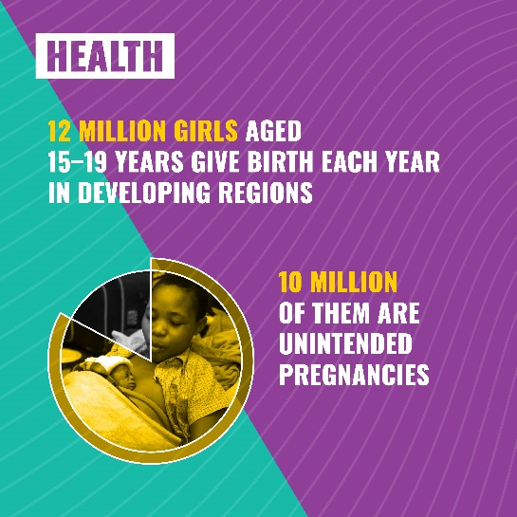
Health and well-being is a prerequisite for young people to realise their full potential and actively participate in society. They face huge challenges in accessing health services and information, including on sexual and reproductive health and rights (SRHR) and mental health. COVID-19 pandemic and conflicts have further deteriorated the situation. Mental health is also affected by a loss of perspective linked to climate change, protracted wars, forced displacement, racism or disinformation.
EU action aims to:
- Strengthen health systems, tackle inequalities and advance towards universal health coverage, starting from maternal and perinatal health;
- Support comprehensive, safe, inclusive and child and youth-friendly health services, including mental health and digital health services;
- Promote universal access to youth-friendly SRHR, with quality and affordable services and information, including comprehensive sexuality education, HIV and AIDS prevention and treatment, focusing on adolescent girls, marginalised and LGBTIQ young people;
- Protect young people from the harmful effects of tobacco and related products, supporting the full implementation of the WHO Framework Convention on Tobacco Control and its Protocol to Eliminate Illicit Trade in Tobacco Products.
To achieve these objectives, the EU will help to promote young people’s health and well-being through:

- A youth-friendly approach to the new EU global health strategy.

- A new regional Team Europe Initiative on Enabled Environment for SRHR to contribute to reaching universal coverage for SRHR in Africa.

- The Spotlight Initiative, which contributes to eliminate gender-based violence in Africa, Latin America and the Caribbean, Asia and the Pacific, by preventing and eradicating female genital mutilation and ending forced and early marriage.

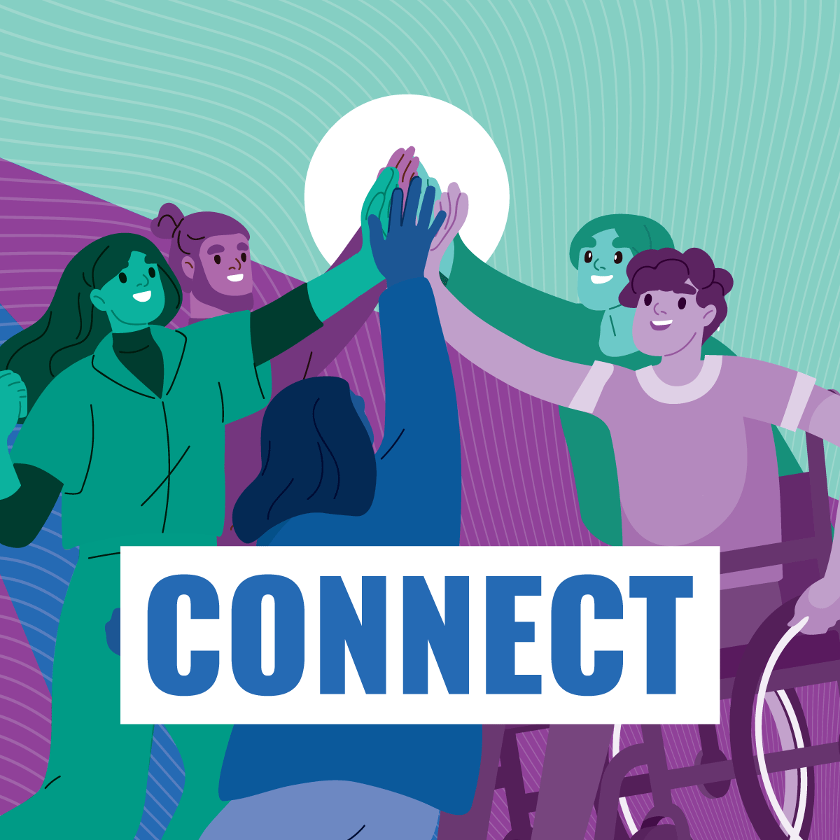
3.3 Partnership to CONNECT
The EU aims to promote youth mobility, exchanges and networking as an essential aspect of the people-to-people dimension of the Global Gateway strategy. The goal is to ensure diversity and inclusiveness, while paying special attention to social and economic barriers, the digital divide and risks related to disinformation.

3.3.1 Increasing opportunities for mobility in education, training and work
Going abroad to study, train or work drives young people’s educational, professional and personal achievements, as well as intercultural understanding and innovation.
EU action aims to:
- Promote inclusive learning mobility and increasing learning opportunities;
- Foster exchanges for the professional and personal development of young people.

To achieve these objectives, the EU will support youth mobility through:

- Several initiatives under the EU-Africa Global Gateway Investment Package, such as the Intra-African Academic Mobility Scheme, the Harmonisation of African Higher Education Quality Assurance and Accreditation initiative, and the African Continental Qualifications Framework, to (i) boost youth mobility within Africa, and with the EU, (ii) strengthen continental integration, (iii) increase attractiveness of Africa as a study destination and (iv) improve employability of young people.

- The Erasmus+ Programme and Marie Skłodowska-Curie Actions, which support the professional and personal development of students, staff and researchers.

- The EU-ASEAN SHARE programme, promoting harmonisation of higher education and scholarships.

- The EU Regional Trust Fund in Response to the Syrian Crisis and the Facility for Refugees in Turkey with scholarships for young refugees to access education, acquire skills and become self-reliant.

- The Western Balkans School Exchange Scheme ‘Superschools’, which increases skills and knowledge, promoting reconciliation and intercultural dialogue among schools, students and communities.

- The Study in Europe Team Europe Initiative, providing young people around the world with information about study, research and scholarship opportunities in the EU.

- Opportunities for young people to travel, study, work or train in the EU under the envisaged Talent Partnerships with identified partner countries in Africa and Asia, as well as potentially under an EU Youth Mobility Scheme whose feasibility is being explored.

3.3.2 Promoting contacts among young people
Young people are eager to connect and exchange ideas with their peers all over the world.
EU action aims to:
- Promote young people’s participation in global citizenship education for a common understanding of global challenges and encourage them to jointly take action;
- Increase networking opportunities for young people, including peer-to-peer learning and exchanges;
- Encourage participation by young people, including indigenous people, in the field of culture, and in intercultural and inter-faith dialogues, countering discrimination and racism;
- Increase the quality and relevance of information for young people, and improve child- and youth-friendly communication.

To foster mutual learning and understanding, the EU will launch:

- The Africa-Europe Youth Academy, which will provide opportunities to young leaders in their respective fields and communities to connect, exchange, improve their leadership skills and create a network of change-makers.

The EU will also contribute further to promoting young people-to-people contacts through the following existing initiatives:

- The EU Alumni Initiative and public diplomacy actions to enable young participants in EU programmes to foster global and local networks and inform their peers, in particular disadvantaged young people, about opportunities offered by the EU and its Member States.

- The European Youth Portal, with improved access to quality information on initiatives and opportunities for young people in partner countries.

- The Development Education and Awareness Raising programme (DEAR) which will increase its focus on youth participation and encourage the involvement of young people worldwide.

- The Global Erasmus+ Alumni Mentoring Scheme, connecting Erasmus+ Alumni with Erasmus+ potential participants, also outside the EU.

- The new programme Youth Europe Sahel to support youth participation and promote intercultural dialogue, human cohesion and human rights and create a platform to inform youth in the region about personal and professional development opportunities.

- The Global Cultural Relations programme and actions for African and European artists, to promote inter-cultural dialogue, mobility and co-creation between young artists and cultural practitioners from partner countries and the EU.

- The Regional Youth Cooperation Office in the Western Balkans, promoting the spirit of reconciliation and understanding between young people through intra-regional youth exchanges and cooperation.

- The European Solidarity Corps, encouraging the participation of young people in volunteering and solidarity projects.

- The EU Policy and Outreach Partnerships, to improve mutual understanding and trust through public diplomacy activities.

- Campaigns that connect young people worldwide to advocate for the green transition, such as the Green Track or the upcoming #ReFashionNow to empower young consumers on sustainable textiles.

Monitoring and reporting
The Commission, in cooperation with the European External Action Service, will monitor progress on the Youth Action Plan (YAP) at mid- and end-term through the regular reports on implementation of EU assistance, and in line with other policy frameworks and commitments on human rights, gender equality and youth, peace and security.
The implementation reports will track institutional change towards strengthening youth engagement in EU policy-making, and progress towards YAP objectives in thematic priorities. A monitoring framework will be developed within the first year of implementation, in cooperation with experts and youth partners, based on age-disaggregated data and youth-specific indicators.
An evaluation on YAP implementation will be launched in time to feed into the next programming cycle.

Conclusion
With the Youth Action Plan in EU external action, the EU recognises the essential role of young people ‘as dreamers and makers’ to address complex global challenges and sets the framework for a strong partnership between them and the EU.
Through its implementation, the EU will support youth engagement in its external action, offer an enabling environment and opportunities for child and youth empowerment and participation, and promote building bridges among young people across the globe.
The Youth Action Plan embodies at the same time a genuine political commitment to the voice of children and young people in the world and an operational roadmap to contribute to building more democratic, equal, sustainable and peaceful societies for present and future generations.

Youth Activist and member of the Youth Sounding Board for EU International Partnerships of the European Commission
UN Youth World Report
Global survey on youth and Covid-19
Council conclusions on youth in external action
European Year of Youth 2022
EU Youth Strategy
EU Strategy on the rights of the child and the supporting Council Conclusions of 9 June 2022
EU Action Plan on Human Rights and Democracy
European Pillar of Social Rights
GAP III
UN Security Council Resolutions 2250 (2015), 2419 (2018) and 2535 (2020)
Conference on the Future of Europe
Meaningful Inclusion of Youth: A Promising Future
In line with the UN Convention on the Rights of the Child and the EU human rights-based approach.
Intersectional approach, in line with relevant EU policy frameworks: GAP III, LGBTIQ Equality Strategy, EU Anti-racism Action Plan, Strategy for the Rights of Persons with Disabilities.
Gender and age marker
Patchwork: Mapping international data on youth, JRC
Team Europe consists of the European Union, the EU Member States - including their implementing agencies and public development banks-, as well as the European Investment Bank (EIB) and the European Bank for Reconstruction and Development (EBRD).
Policy Forum on Development
Synergies and exchanges of best practices could be ensured with the future EU Children’s Participation Platform
Youth Sounding Board
Neighbourhood, Development and International Cooperation Instrument – Global Europe
UN Our Common-Agenda
UN Resolution A/RES/76/306
EU Neighbourhood and Enlargement
Africa-EU Partnership and 6th EU-AU Summit
EU Eastern Partnership
A new agenda for the Mediterranean and Union for the Mediterranean Youth Strategy 2030
A strategic partnership with the Gulf
EU Macro Regional Strategies, Youth Manifesto, Interreg Volunteer Youth
Summit for Democracy
Youth and satisfaction with democracy
For example, the EU-Arctic Policy promotes dialogue of policy-makers with the Arctic youth, to create awareness of the current challenges of the Arctic, involve youth in the implementation of the EU strategy and ensure its sustainability.
EU engagement with Western Balkans
Erasmus+ funded under external action instruments
Council conclusions on preventing and countering terrorism and violent extremism
160 million children aged 5 to 17 are in child labour. Half of them perform hazardous work, ILO/UNICEF
Modern slavery is defined by ILO through two principal components: forced labour and forced marriage. According to ILO/IOM 2022 Forced Labour Estimate, there are more than 3,3 million children in forced labour.
127 million girls of primary and secondary school age are out of school, UNESCO
Children and young people with internet access at home, UNICEF
Global Gateway
Communication on Education in Emergencies and Protracted Crisis
2022 UN Transforming Education Summit
Proposal for a regulation on prohibiting products made with forced labour on the Union market
Durban Call to Action
The model of the European schools also provides relevant examples that could be used globally
European Digital Competence Framework for Citizens
Digital Education Action Plan
Education is a priority in 80 EU Multi-Annual Indicative programmes in partner countries
Global Partnership for Education
Education Cannot Wait
Communication Decent Work Worldwide
Proposal for a Directive on corporate sustainability due diligence
Convention 182/1999
Youth Guarantee
European Training Foundation
Erasmus for Young Entrepreneurs
An action plan for the social economy
European Declaration on European Digital Rights and Principles
The new EU strategy for a better internet for kids (BIK+)
Pollinator Park
Spotlight Initiative
Talent Partnerships were launched in 2021 as one of the key aspects of the external dimension of the New Pact on Migration and Asylum and will underpin a comprehensive policy framework and financial support to engage key partner countries strategically in all areas of migration management. They aim to strengthen cooperation between the EU, Member States and partners and to boost international labour mobility and development of talent in a mutually beneficial way.
Policy and Outreach Partnerships
2022 State of the Union Address by President of the European Commission, Ursula von der Leyen

