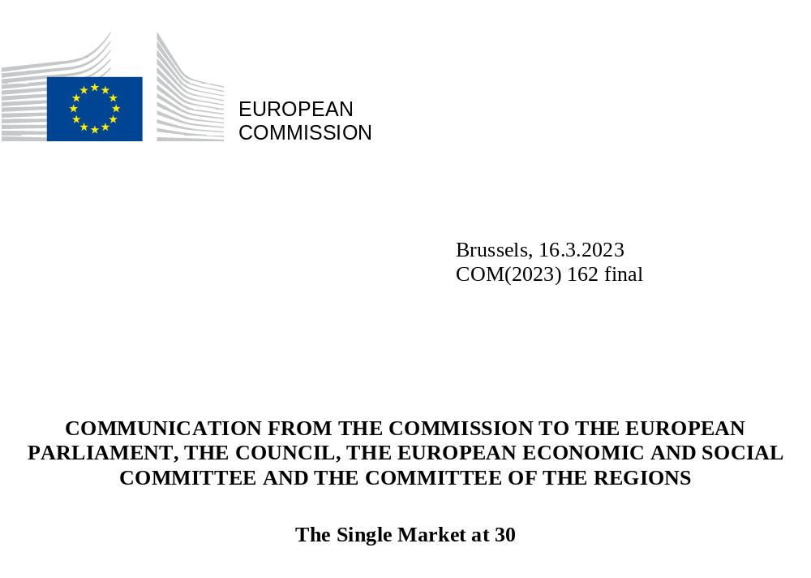

INTRODUCTION

This year the Single Market celebrates its 30th anniversary. The Single Market is one of the greatest achievements of the EU. Since its creation in 1993, citizens and businesses have benefitted from the free movement of people, services, goods and capital to an extent that exceeds even the most visionary expectations of three decades ago.
Originally conceived as an area of free trade without tariff or non-tariff barriers among its members, the Single Market has developed into much more than that. It has successfully become the world’s largest integrated single market area, while remaining one of the most outward oriented. Yet the Single Market is much more than a legal framework or indeed a market: it is an area of freedom, progress, opportunity, growth, shared prosperity, resilience and a means of geopolitical projection.
In addition to looking back at the many achievements that we have come to take for granted in our everyday lives, it is important to acknowledge that the Single Market is a valuable living asset that we must continuously preserve and improve.
The Single Market must continue to adapt to new challenges, as recognised, among others, by the European Parliament in its Resolution on the 30th anniversary of the Single Market. A collective effort is required to continue maintaining it, deepening it, harnessing its full potential, preserving a level playing field both internally and globally, and ensuring it underpins the EU’s prosperity through long-term competitiveness and productivity, as requested by the European Council. The Single Market is a common space which attracts investments within the EU and from outside the EU by having a predictable and simple regulatory framework.
Joint efforts are required to enforce existing rules, remove barriers and explore areas for further integration of the Single Market. The potential benefits are very significant: it has been estimated that removing Member State-level barriers to the Single Market for goods and services alone could add EUR 713 billion to the economy by the end of 2029.

THE SINGLE MARKET AT THE HEART OF THE EUROPEAN PROJECT FOR 30 YEARS

  - Improving lives of citizens and businesses, accompanying the green and digital transitions
The free movement of people, goods, services and capital gives Europeans access to the widest possible choice of products, services, experiences, ideas, cultures and languages. Everyday this benefits more than 440 million citizens across the continent. The Single Market is, above all, a means to enhance people’s well-being.
The abolition of roaming surcharges lets us stay in touch with family and friends when we travel around Europe. Consumer products and food circulating in the Single Market, whether bought online or offline, have become safer, and dangerous products are recalled from the market. The common charger for electronic devices will reduce e-waste and consumer inconvenience and bring savings of EUR 250 million to consumers each year. The Single European Transport Area allows travel and goods to be transported affordably within the EU. Strong passenger rights mean we are compensated when our travel plans are disrupted. Businesses and citizens can make payments across borders just as easily as they do domestically. Consumers applying for credit can count on improved protection.
The Single Market also makes it easier to live, study, work and retire in another Member State. The Erasmus programme has enabled nearly 13 million young people to study and work abroad. The Single Market has expanded the horizons and opportunities of European professionals who have their professional qualifications recognised more easily. Thanks to the coordination of social security rules, millions of Europeans can continue to enjoy their rights to pensions and healthcare when they live abroad, and rules on health and safety at work ensure fair competition and high standards for all, wherever they work.
The Single Market is a powerful engine to accelerate the green transition, in line with the European Green Deal. Product standards set uniformly at EU level ensure environmental and safety compliance, as well as respecting energy efficiency requirements. The market-based approach of the EU Emissions Trading System (ETS) is bringing down emissions in a cost-effective way, while the revenues it generates can support the transition to cleaner production and to stimulate innovation.
An integrated EU energy market is the most cost-effective way to ensure sustainable, secure and affordable energy supplies to EU citizens. Over the last decade, the major efforts undertaken to further integrate electricity markets in Europe have delivered significant benefits, estimated to amount to around EUR 34 billion a year, for consumers, by enabling cross-border trade between Member States and improving security of supply across a larger geographical area. In the context of frequent supply disruptions, the Single Market has helped ensure that energy, notably gas, flows to where it is most needed. Regional cooperation and solidarity have been essential to guaranteeing the resilience of the EU energy system. The TEN-E Regulation has contributed significantly to this robust security of supply by interconnecting Member States’ energy systems through Projects of Common Interest (PCIs). At the same time, the recent energy crisis has highlighted a number of shortcomings to which the EU has had to respond.
In the next years, the Single Market must evolve to meet citizens’ expectations for a human-centric digital transition and for markets that make sustainable choices affordable and attractive”. The Digital Services Act will ensure that online businesses can operate across Europe on the basis of a single set of directly applicable rules, and that citizens can safely use online platforms and e-commerce services no matter where they are in the EU, protected from illegal content, disinformation and cyberbullying. The Digital Markets Act will ensure fair and contestable markets in the digital sector so that platforms cannot misuse their gatekeeper power in the Single Market. Harmonised rules, in areas such as audio-visual media and copyright, support cultural diversity and media pluralism in the digital context. With the Data Governance Act, already adopted, and the Data Act, in advanced negotiations, the EU is building a genuine Single Market for data, opening up opportunities for all economic players and making Europe a global leader in the data-agile economy. And we are creating a Single Market of cybersecurity, including cybersecurity requirements for any connectable product, software or hardware.
The EU has developed digital tools to make the Single Market run more smoothly. During the pandemic, the Commission quickly developed a Digital COVID Certificate to facilitate freedom of movement, by enabling EU citizens and residents to easily provide digital proof that they had either been vaccinated against COVID-19, received a negative test result or recovered.
Digital tools reduce administrative burdens and create transparency for citizens and businesses. When they want to know more about their rights and opportunities, they can turn to the Your Europe portal, a one-stop shop for information. Those seeking advice when Single Market problems arise can make use of Your Europe Advice and SOLVIT, which helps businesses or individuals affected by breaches of EU law to resolve disputes and obtain out-of-court redress, enabling them to overcome barriers. To improve the business environment, SOLVIT will focus its efforts on helping small and medium-sized enterprises (SMEs) to make the best use of the opportunities of the Single Market. The Internal Market Information system (IMI), which connects thousands of public administrations, facilitates cross-border administrative exchanges between them and solves problems. It has been constantly growing over the years, now covering 19 policy areas. Taken together, this creates a true ‘Single Market back office’, for the benefit of businesses and administrations alike.

The once-only technical system (OOTS) will ensure that when a business or citizen has submitted a document once to a public administration, the document can be safely transferred to other public administrations, so that the business or individual can complete other procedures without needing to re-submit it. All of these tools are accessible through the EU’s Single Digital Gateway. Furthermore, the European Digital Identity Wallet will provide citizens and businesses with standardised documents they can use safely to identify themselves and key information across the EU, for example diplomas attesting professional qualifications or documents relating to healthcare and social security. Moreover, in pursuit of the EU Digital Decade ambition, the EU aims to provide all key public services online by 2030.

Graph 1: Single Market tools
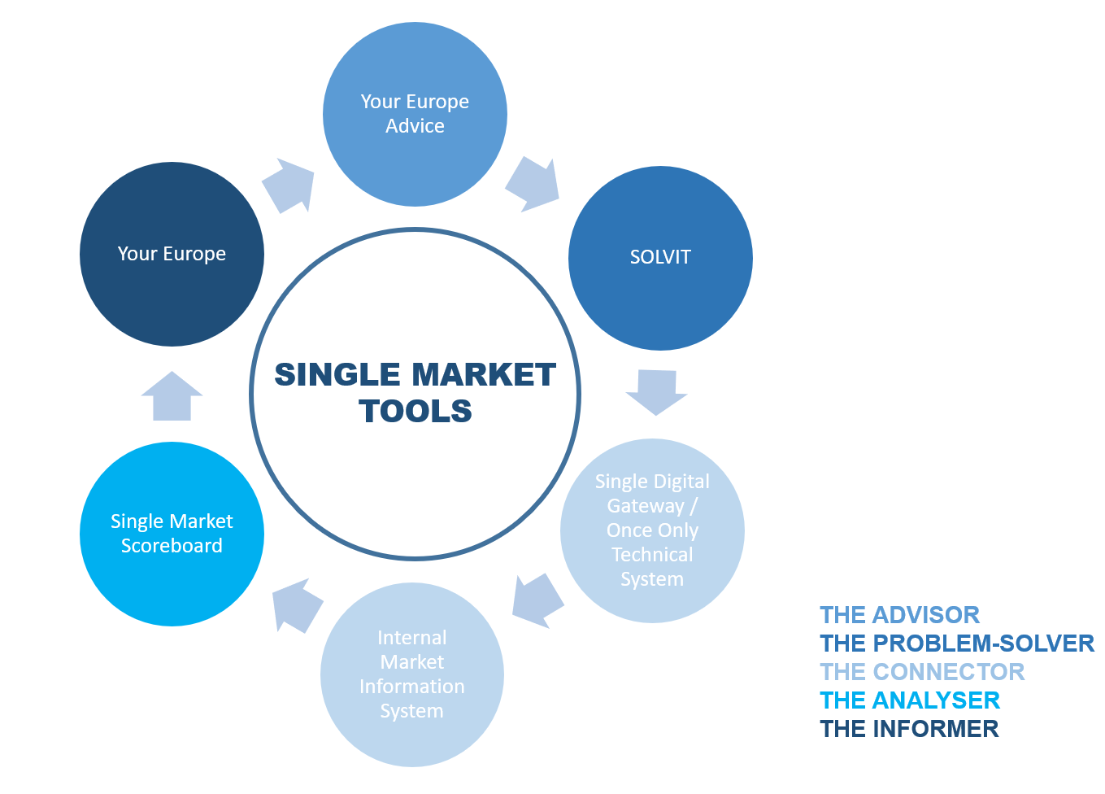

Source: European Commission

  - Boosting the economy
As the world’s largest integrated market, the Single Market has exceeded all expectations in macro-economic terms. Accounting for 18% of global GDP, it is a springboard for businesses to offer their goods and services to more than 440 million EU citizens across the continent. It is home to 23 million businesses which employ nearly 128 million people. The Single Market has brought very significant economic benefits, delivering to the EU a GDP that is up to 9% higher in the long run, than would have been the case without the Single Market. This integration has been, and continues to be, a fundamental source of growth and job creation. Whereas total employment in the EU increased by 5.5% in 2000-2014, the number of jobs reliant on cross-border services almost doubled in the same period (from 5.6 to 10.9 million). The level of trade between Member States in goods and services in comparison to the size of the EU economy has approximately doubled over the last 30 years. Researchers suggest that economic integration in Europe is more advanced from a regulatory standpoint than, for example, in the United States.

Graph 2: Trade in goods and services within the Single Market (1993-2021)
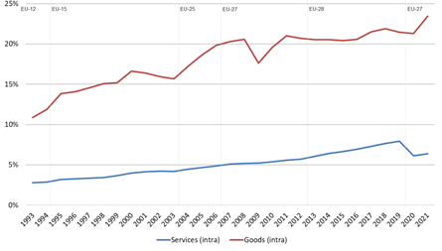

Source: Commission services, based on Eurostat. Note: the graph shows intra-EU trade flows in goods and services as a share of EU GDP. The vertical dotted lines in the graph highlight changes in the scope of data on trade and GDP being considered, in light of the number of Member States (e.g. the period 2007-2012 considers trade and GDP for EU-27, whereas the period 2013-2019 considers trade and GDP for EU-28). Trade is measured by the average of imports and exports.

Moreover, the Single Market is an important vehicle for financial integration in Europe and essential for the economic and monetary union. It makes it easier for businesses to raise money and makes Europe a more attractive place to invest. Intra-EU holdings of foreign direct investments and portfolio investments kept increasing in the last decades, were almost 5 times higher, and 4 times higher, respectively, in the second quarter of 2021 compared to the beginning of 2002. As part of the Capital Markets Union Action Plan, several initiatives are underway to complete the Single market for Capital. Most recently, in December 2022, as part of the Capital Markets Union, the Commission put forward a proposal to cut red tape for companies, in particular SMEs, aiming to raise funds on stock exchanges and a proposal to address structural barriers by harmonising key aspects of corporate insolvency laws. Nevertheless, much more remains to be done to integrate national capital markets. Integrated and trusted payment systems support the functioning of the Single Market and thus contribute to the EU’s competitiveness.
The social benefits of the Single Market on employment are also significant, with up to 56 million jobs in the EU depending on intra-EU trade. The number of mobile EU workers has increased steadily in the last 30 years thanks also to programmes such as EURES and to policies aimed at improving qualifications and skills recognition. The EU model of a social market economy relies on high social standards as promoted by the European Pillar of Social Rights. It promotes equal opportunities and access to the labour market, fair working conditions and social protection, inclusion and diversity (for instance on posting of workers, work-life balance, adequate minimum wages and pay transparency). In return, this social framework contributes to a level playing field in the Single Market.
The Single Market has also allowed for the further development of the social economy, with about 2.8 million social economy entities in Europe employing around 13.6 million people. The Commission adopted an action plan for the social economy in December 2021, proposing concrete actions to be implemented by 2030. A Social Economy Package will be adopted this year, including a legislative initiative on cross-border activities of associations in the Single Market.
The Single Market has played a major role in enabling progressive upward economic convergence within the EU following successive enlargements. This is because the Single Market has created a level playing field for businesses across the EU, making it easier for companies to operate across borders and compete on an equal footing. This has encouraged greater cross-border trade and investment, which in turn has helped to boost economic growth and create jobs. Social and economic cohesion are vital for the functioning of the Single Market, as recognised in its founding act 30 years ago. Cohesion policy supports a harmonious development of European regions, allowing them to contribute to, and reap the benefits of their participation in, the Single Market. By increasing opportunities for economic activity, the Single Market has allowed lower-income countries to converge towards higher-income ones and has contributed to creating more jobs, therefore reducing unemployment. The Single Market has underpinned the competitiveness of European businesses, which has resulted in better products and lower prices for consumers. It has also made value chains in the EU highly integrated and interconnected. The mobility and automotive ecosystem, for example, is not only made up of large, world-renowned corporations, but most importantly component suppliers, sales and repair networks, and represents a total of 1.8 million companies, 99.7% of which are SMEs.
Competition policy plays a central role for preserving well-functioning markets and in addressing relevant market failures in Europe. Since the creation of the Union, competition policy has helped industries become stronger and globally competitive and has ensured that EU citizens are the ultimate beneficiaries of a highly competitive social market economy. Rules-based competition law enforcement also provides legal certainty and predictability to all businesses striving to make the best of Europe’s Single Market.

  - Building resistance and resilience against crises
The recent succession of crises has demonstrated the critical importance of a smoothly functioning Single Market. Essential services such as energy, water and health provision, transport and telecommunications are key to ensuring the well-being of people, as well as to the emergency response itself. These services need to remain operational during and after a disaster or crisis.
When Member States act individually, by closing their borders or introducing intra-EU export bans on medical equipment, grain or raw materials, the whole functioning of the Single Market is put under pressure, threatening industry, services and professionals alike, and ultimately citizens. While the COVID-19 pandemic led to initial shortages of essential products and huge traffic jams at frontiers preventing free movement of essential workers, the Single Market prevailed. When the global demand for masks and vaccines skyrocketed, the Single Market helped us overcome the lack of diverse sources of supply and capacity to produce what had become vitally important goods.
After an initial period in which national authorities raised barriers to the free flow of goods, services and people in a unilateral and uncoordinated way, which affected economic activity profoundly, the Commission stepped in – with the support of Member States – to remove these with initiatives such as “green lanes”. And the EU maintained fully open supply chains with the world, building on a thriving industry that has benefitted from the Single Market for decades, and joining forces and capacities all over Europe from large companies to highly innovative and competitive SMEs.
We have drawn the necessary policy lessons from these crises, building on these achievements. The Commission established the Health Emergency Preparedness and Response Authority (HERA) to better detect, prevent and respond to future cross-border health emergencies. The Commission has also proposed a new Single Market Emergency Instrument to make sure that, in a future crisis situation, the Single Market remains open and fair, and continues to ensure the availability of goods and services that people and businesses most need. More generally, the EU has stepped up its emergency readiness at all levels through the Union Civil Protection Mechanism. Finally, ensuring the resilience of Single Market requires a coordinated approach at EU level against growing cross-border threats, notably to critical sectors and infrastructure that is being developed and implemented under the Security Union umbrella.
Resilience is also improved with better preparedness. The Commission has designed an early warning system (SCAN Monitoring System) with the goal of providing evidence for policy. It uses quasi-real-time customs data and examines anomalous variations in quantities and prices to reveal premature signs of supply chain disruption. Other possible drivers include the excessive concentration of certain imports from limited foreign sources, the existence of global single points of failure for critical inputs propelled by strategic dependencies, or indications of limited EU industrial production capacity. The Chips Act proposed in 2022 and the proposal for a European Critical Raw Materials Act adopted in parallel to this Communication will, respectively, help turn the EU’s world-class research into industrial leadership, by investing in European industry and promoting international partnerships, and set a framework to improve access to raw materials within the Single Market, increase European capacity and diversify external sources of raw materials.
The Green Deal Industrial Plan for the Net-Zero Age sets out the challenges that European industry is currently facing and therefore proposes further measures to promote the net-zero industry. As part of this plan, the Commission has proposed a Net Zero Industry Act, and has adopted a State Aid Temporary Crisis and Transition Framework, setting out targeted, temporary, and proportionate measures to accelerate Europe’s competitive transition to a net-zero economy while avoiding fragmentation of the Single Market. In addition, as announced in the Green Deal Industrial Plan, the Commission intends to propose a European Sovereignty Fund before summer 2023 to preserve a European edge on critical and emerging technologies relevant to the Green and digital transition, as well as to safeguard cohesion and preserve the integrity of the Single Market.

  - The Single Market as a pull factor and geopolitical asset on the global stage
The benefits the Single Market brings are a major component of the EU’s overall attractiveness as a pole of security, stability and open values. The EU accounts for around 14% of the world’s trade in goods. In addition to successive enlargements between 1973 and 2007, in the 1990s EFTA members Iceland, Liechtenstein and Norway decided to establish the European Economic Area jointly with the EU, thus extending the four freedoms of the Single Market to their countries. Many countries in the Western Balkans and Eastern neighbourhood wish to pursue a future as members of the Union and its Single Market. The EU is strongly committed to supporting the Western Balkans on their path towards the EU.
The EU is also seizing every opportunity to integrate Ukraine further into the Single Market, e.g. by connecting it to the EU’s electricity grid, suspending import duties on Ukrainian exports to the EU, creating Solidarity Lanes to improve movement of goods and persons and bringing Ukraine into the European roam-like-at-home area. The Commission will focus with Ukraine on agreed priority actions, including in the area of public procurement, standardisation, industrial cooperation, Technical Barriers to Trade and conformity assessment, in order to better integrate Ukraine into the Single Market. Similar efforts are underway to similarly integrate Moldova. The EU is also including Ukraine and other Eastern Partnership countries in a number of key EU programmes such as the Single Market Programme.
The Single Market is also a force of projection, a geopolitical lever that boosts the EU’s standing and influence in the world. It is the economic backbone of the EU’s international diplomacy. This global influence is crucial in light of the geopolitical developments over the last 30 years and the intensified global competition with other continent-size economies. For example, during the pandemic, the fast development and authorisation of vaccines under the EU’s rigorous medicines regime gave the EU a powerful platform to help address COVID-19 on a global scale.
The size and attractiveness of the EU Single Market often results in companies choosing to apply EU legislation and standards to their global operations. This has enabled the EU to contribute to global prosperity and to the Sustainable Development Goals – with sustainable growth, a high level of social protection, respect for privacy and fundamental rights, and strong environmental and human rights protection.
The European standardisation system is a particular success story in this regard, with the special role of harmonised European standards that allow economic operators to demonstrate compliance with EU law with one standard across the Single Market. As underpinned by the recent EU Standardisation Strategy, standards play an important role for the digital and green transition and can give the EU a global leadership role, especially when it comes to strategic technologies. Standards can also contribute to a more inclusive society by ensuring accessibility of a range of everyday products and services. International standards also play an important role not only for tackling technical barriers to trade, but also for facilitating international market access for EU companies. With the increasing geopolitical role of standards, enhanced EU engagement in international standards-development processes is also key to preserve EU values and interests. For this, the Commission is undertaking strategic dialogues with key trading partners, like the US, Japan or India.
The Single Market has enabled the EU to become a trading power, creating opportunities for the EU’s businesses abroad, projecting our rules and values, connecting the EU to growth poles around the world, securing the inputs we need and supporting others in achieving sustainability objectives. The EU is the number one trading partner for 53 countries around the world that together represent 48% of world GDP. The Single Market provides leverage to ensure that the EU’s openness goes hand in hand with respect of the EU’s rules, for instance by addressing distortions caused by foreign subsidies, preventing goods made with forced labour or environmentally/socially unsustainable practices. Furthermore, the ability of the EU to use economic tools, such as sanctions and restrictive measures, to uphold the international rules-based order, is predicated on a well-functioning Single Market with a central role in the global economy.

THE WAY FORWARD – TOWARDS FURTHER INTEGRATION OF THE SINGLE MARKET

Anniversaries are an opportunity not only to look back at past achievements, but to set the expectations and objectives for the future. In a rapidly changing environment, efforts to improve enforcement of Single Market rules and to instil joint ownership of the Single Market at EU and national level need to continue. Rules must also, where necessary, continue to be adapted to new products, services and business models that will help fuel the green and digital transitions.
A fully functioning Single Market is the essential foundation of the EU’s long-term competitiveness. The Commission’s Communication on competitiveness, published alongside this Communication, sets out actions to ensure a predictable, coherent and simplified regulatory framework that is favourable to long-term competitiveness, as well as to ensure the availability of skills needed for the green and digital transitions and for economic growth, and to speed up and improve access to finance.
Going forward, the Commission will work with all levels of governance and all stakeholders to fully harness the potential of the Single Market so that it provides a firm foundation for long-term sustainable competitiveness. In this context, this Communication focuses on two key areas for further action:
- enforcing existing Single Market rules and removing Member State-level barriers, in particular barriers to the cross-border provision of services, and in the industrial ecosystems with the greatest economic integration potential (retail, construction, tourism, business services and renewable energy sector),
- continuing to foster the green and digital dimensions of the Single Market as a source of innovation, growth and competitiveness.

  - Enforcing Single Market rules and removing Member State-level barriers
Citizens and businesses can fully benefit from the Single Market only when EU rules are correctly implemented and enforced. Ensuring the correct day-today implementation of single market rules is the collective responsibility of the Commission and the Member States. In particular, a correct application of regulations relies on the work of national authorities to give full effect to them.
Correct and timely transposition of EU law is of critical importance to ensure that Single Market legislation achieves its intended effects. The average transposition deficit of Single Market directives now exceeds the 1% threshold set by the European Council in March 2007. Only five Member States have met the agreed target (see graph 3). Directives also need to be correctly transposed and applied on the ground, paying particular attention to issues of unjustified "gold plating". Here, Member States need to improve the situation considerably (see graph 4).

Graph 3: Transposition deficit of Member States as at 10 December 2021
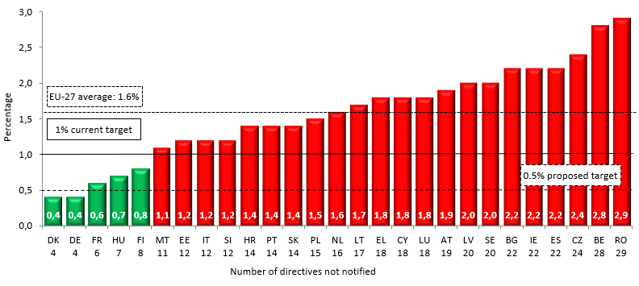

Source : Single Market Scoreboard
Graph 4: Conformity deficit of Member States as at 10 December 2021
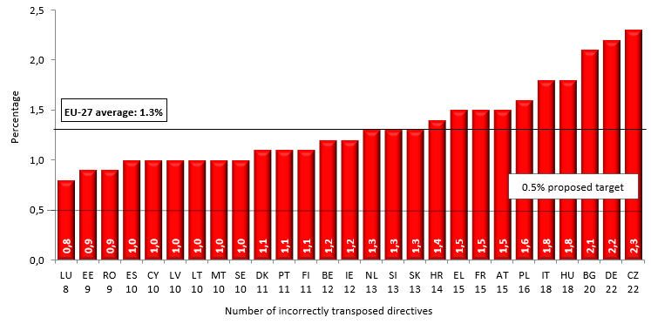
Source: Single Market Scoreboard
There is no one-size-fits-all approach to making Single Market rules achieve their full potential, but in all cases, a strong culture of compliance and the spirit of partnership are needed to successfully manage the Single Market. The Commission is committed to working together with the Member States at the appropriate level within their administration to support and promote the ambitious implementation of Single Market rules. Complementing cooperation, the Commission will continue to pursue a rigorous enforcement policy to ensure that jointly agreed EU rules are also correctly applied collectively by all Member States.
The Commission pursues a strategic approach to enforcement and is successfully implementing its 2020 Single Market Enforcement Action Plan, focusing on critical issues. This includes ensuring the freedom of establishment, the free circulation of goods and services, including mobility of professionals to bridge skills gaps, ensuring public procurement rules enable companies to compete across the Single Market and public funds to be used efficiently, addressing unfair payment practices and delays in payments, and enforcing European standards for the benefit of citizens and companies.
In February 2023, the Commission adopted 24 infringement decisions to bring down barriers in the Single Market in services and make it easier for companies in the EU to operate. At the same time, robust enforcement action by the Commission meant that it was possible to close 18 infringement cases due to real improvements in the Single Market for services.
Unjustified barriers arise when national law conflicts with Single Market rules or when those rules are incompletely or insufficiently implemented or applied at national level, including due to administrative practices of national authorities. They hinder the capacity of businesses to flourish, remain competitive and to harness the green and digital transition.
Some types of barriers have proven to be persistent: 60% of the barriers that businesses report facing today are of the same type as were reported 20 years ago. Many of these relate to national regulation as well as administrative practices, which, in the first instance, have to be addressed directly by Member States. Barriers confirmed by stakeholders include the complexity of national procedures and lack of information on them, disproportionate national requirements in the area of services, including mobility of professionals, burdensome administrative requirements for posting workers and difficulties related to taxation in a cross-border context. Many such barriers are not amenable to legislative harmonisation and hence reducing obstacles at national level remains the major objective. Technical Support Instrument helps Member States to improve public administration and create an enabling business environment.
Services are particularly crucial to the EU economy. They account for around 70% of the EU's GDP and 73% of total employment. Services cover a broad range of sectors and many different activities. In some sectors, the free movement of services works well, facilitated by digital technologies and harmonised rules. Others are still mainly domestic markets, sometimes due to intrinsic factors of the specific service (e.g. regional or national market preferences). Where there is scope for more integration in services, barriers typically linked to national regulation in the area of business services, restrictive authorisation requirements in the area of retail, regulatory and administrative requirements complicating the cross-border provision of construction services, and restrictions in tourism both for cross-border service provision and as regards requirements for accommodation services.
Strengthened collaboration between Member States and with the Commission and exchanges of information, as well as exchanges of views especially in the Competitiveness Council, play an important role in effective implementation of Single Market rules, preventing breaches of EU law from the outset and avoiding infringements of EU law.
The work of the Single Market Enforcement Taskforce (SMET), set up in 2020, has shown the significant value of collaboration between Member States and the Commission in tackling the concrete barriers that EU businesses experience in the Single Market. The joint and intensive work in this innovative forum focuses on simplifying the regulatory framework and reducing administrative barriers in specific areas. For example, within SMET Member States have agreed to simplify the constraints for professionals and businesses that provide temporary cross-border services and, based on good practices, to remove prior qualification checks for 247 professions and to review and reduce administrative and document requirements.
SMET also identified more than 80 of the most pressing barriers to the smooth and rapid granting of permits for the deployment of wind and solar energy installations. Bearing in mind there are 50 000 SMEs active in the production of renewable energy, removing these barriers will facilitate sustainable growth. This will also make the EU more attractive as an investment location, and complement well the proposal for a Net Zero Industry Act , which aims to facilitate and speed up investments into net-zero technology manufacturing projects so as to significantly scale up the production of solar panels, wind turbines and other clean energy technologies in Europe. The existing legal framework on permitting for the deployment of renewable energy installations (based on the Renewable Energy Directive), will soon be complemented through this legislation as regards a harmonised legal framework to also streamline permitting for new industrial facilities that produce such technologies, including gigafactory-sized projects. The Commission reiterates the significant value of SMET as a cooperative tool with the Member States to address Single Market barriers, and therefore relies on continued joint efforts aiming at concrete deliverables within this framework.
Continuing the existing structured engagement with business stakeholders, including in the context of the Industrial Forum, the Enterprise Europe Network (EEN), the network of national SME Envoys and the clusters network, is also crucial to better understand barriers that they face. This work will be fed by analytical work such as the Annual Single Market Report and the SMET Annual Report. The Single Market Scoreboard is a helpful tool for all stakeholders to understand the remaining barriers and to design actions to remove them. The Commission will carefully monitor selected indicators from the Single Market Scoreboard and other relevant sources related to enforcement and the business environment, such as transposition and conformity deficits, public procurement, payment delays by public authorities and availability of digital public services as well as those indicators developed in the Reform Recommendations for professional services.
The existing collaboration instruments should be fully exploited to improve further the proactive and practical resolution of Single Market problems for citizens and businesses, including urgent action by Member States to ensure that national SOLVIT centres have sufficient and adequate human resources. Scrutinising national measures before they are adopted has shown to be particularly effective to prevent conflicts with the Single Market rules. SOLVIT has managed to solve more than 2000 cases in 2021 with the average resolution rate of 87%.
The notification mechanism under the Single Market Transparency Directive (SMTD notification system) has developed into a genuinely preventive tool, reinforcing dialogue and cooperation between Member States and the Commission at an early stage, for instance with respect to low-emission transport or recycling and reducing waste.
In order to improve compliance with Single Market rules, the Commission intends to simplify the notification obligations of Member States by setting up a single notification entry point for Single Market notifications. Whereas Member States currently have to use a variety of notification tools, set up under different pieces of Single Market legislation, a Single Notification Window will enable Member States to finalise all notifications in one place.
In the area of services, the Commission is also launching a priority process of addressing jointly with Member States barriers to free movement of services in industrial ecosystems with a high services content which have not reached their potential of cross-border trade. These ecosystems are in particular construction, retail, tourism and business services.
Many barriers are not intended as such – they are often simply the outcome of different ways of doing things, devised at different times in different Member States, focused on national or local considerations. They may not be clearly contrary to the Treaty or to harmonised rules. However, they can still significantly impede cross-border business. Moreover, despite the benefits we can all derive from smoother exchanges, powerful vested interests, other more politically visible priorities and/or the simple force of inertia may stand in the way of practical solutions. The Commission cannot be the sole voice of the interest of the Single Market, acting through its enforcement and convening powers. The Single Market also needs a dedicated voice within national administrations. The Commission therefore proposes to each Member State to establish a dedicated Single Market Office to address Single Market barriers. Such office should have a senior leadership and appropriate resources, and a standing brief to proactively raise issues and propose solutions within the national decision-making system. This work would be complementary to collaborative tools such as SOLVIT and SMET and could contribute in particular to addressing remaining barriers for services.
Preventing new trade barriers from emerging is extremely important and is especially relevant in the services sector, where the diversity of national regulation and strong vested interests have limited the ability to achieve greater integration in the Single Market. The Services Directive requires Member States to ensure that new regulations which they introduce are justified and proportionate, namely as regards restrictions such as territorial limitations, company ownership rules or fixed tariffs. The Services Directive also obliges Member States to notify such new requirements to the Commission and the other Member States.
Moreover, since 2020, the Proportionality Test Directive has provided a framework for Member States to assess and explain why any new national rules are non-discriminatory and proportionate before they enter into force. However, it only applies to part of the services economy, namely regulated professional services. The Commission intends to explore together with Member States how to make best use of this framework for services at large and not just professions. It will do so by adapting the Services Directive notification tool and providing additional targeted guidance to Member States for applying these proportionality criteria. This will contribute significantly to better and less restrictive regulation and avoid recourse to costly and unnecessarily confrontational ex-post enforcement.
A large group of Member States has started working together with the Commission with a view to voluntarily introducing a common e-declaration for posted workers. The Commission urges all Member States to work towards finalising their work by end of 2023.
A renewed political commitment at all levels is needed to enhance application and enforcement of Single Market rules and to deliver on previous commitments. The Commission will regularly bring the results of the Single Market Scoreboard to the attention of national authorities responsible for the Single Market, notably in the Competitiveness Council. The discussion should assess progress on achieving the targets, identify potential additional action in order to improve Member States’ performance in enforcing Single Market rules and reducing unnecessary and disproportionate barriers.
The Commission refers to its previous call on the Member States to commit to limiting the transposition deficit to 0.5% for all directives and to 0% in the case of directives whose implementation is more than two years overdue. Likewise, the Commission refers to its previous proposal to limit the conformity deficit to 0.5% for all directives. Furthermore, for cases concerning the non-communication of transposition measures, the Commission has proposed the target of 12 months from the sending of the letter of formal notice to the resolution of the case or to refer infringement cases to the Court of Justice.
Based on the above elements, the Commission proposes to set concrete targets on enforcement with the aim of limiting both the transposition as well as conformity deficit to 0.5%. It also proposes to set a benchmark on SOLVIT with the aim of solving a minimum of 90% of the cases within 12 months in each Member State. The Commission will also communicate on its observations on progress in solving Single Market barriers in the context of cooperative tools such as SMET.

  - Continuing to foster the green and digital dimensions of the Single Market
The Single Market will be crucial for the EU’s green transition and the circular economy. The EU needs to maintain its leadership on clean technologies and its competitive edge on decarbonisation to be able to deliver a zero-emissions economy. We need to use materials and other resources more efficiently and shift to a circular economy that retains the value of materials in products and minimises waste. The Circular Economy Action Plan is being rolled out with ambitious goals to promote green and digital transition.
Common rules applicable throughout the EU will make it easier for businesses to rise to the challenge, and thus to achieve our objectives – also potentially at the global level. Ecodesign rules for Sustainable Products facilitate and increase the recuperation and recycling of materials from products at the end of their life cycle, minimising waste production. The Product Passport Initiative will allow consumers and operators to easily access information on compliance of products, as well as recycled and recyclable content in products.
The EU sustainable finance framework offers tools that help private capital invest into green activities and finance the transition. The EU Taxonomy offers a list of sustainable economic activities tailored for investors looking for clean-tech and sustainable investments.
Whilst the current design of the EU electricity market has over many years delivered an efficient, well integrated market, which incentivised deployment of renewable and low-carbon energy and clean flexible technologies, the recent energy crisis has highlighted a number of shortcomings, which have exposed households and companies to significant price spikes with effects on their electricity bills. To respond to the crisis, the EU adopted an energy prices toolbox with measures to address high prices (including income support, tax breaks, and gas-saving and storage measures), as well as the REPowerEU plan with further measures and funding to boost energy efficiency and renewable energy in order to reduce dependence on Russian fossil fuels. The Commission has proposed a reform of the Electricity Market Design.
Digitalisation is pervasive and part of our everyday life. It is a key driver of the Union’s competitiveness, prosperity and well-being of our societies. The Digital Services Act and the Digital Markets Act entrust the Commission with new direct, investigatory and enforcement powers that are already known in some other areas, such as competition law or financial regulation. The Commission is committed to taking all necessary investigatory and enforcement measures and using its supervisory powers against very large online platforms and very large online search engines as well as gatekeepers, where they do not comply with their DSA or DMA obligations.
Europeans across the Single Market need access to reliable, fast and secure connectivity throughout the Union, ensuring that all critical infrastructures in the EU, including electronic communications and digital infrastructures, are highly secure. In parallel to the proposal for a Gigabit Infrastructure Act, adopted on 23 February, the Commission has launched a broad exploratory consultation on the future of the connectivity sector. The consultation also explores how we can move towards a true Single Market for electronic communications. This would ultimately benefit citizens by providing them with better and more affordable telecommunication services.
The 2020 European Data Strategy aims to create a genuine Single Market for data where European rules on privacy and data protection are fully respected and there is legal clarity on who can access and use the data and under which conditions. The Commission proposed the Data Act in February 2022 in order to set the basic framework to ensure fairness in the digital environment, stimulate a competitive data market, open opportunities for data-driven innovation and make data more accessible for all. The general framework will be supported by the creation and interconnection of common European data spaces in strategic sectors and domains of public interest.
Alongside the publication of this Communication, the Commission is launching a Public Procurement Data Space, which will ensure more accessible and better quality data for public contracts, which account for around EUR 2 trillion (almost 13.6% of EU GDP). This data space will create a level playing field for businesses making bids for public procurement projects anywhere in the EU. It will be a particularly helpful tool for SMEs. It will help public buyers and businesses improve their investment and bidding strategies, and to give all stakeholders greater transparency and better value for money.
The proposed European Health Data Space will not only empower individual patients, it will also enable health-related research and innovations at European scale. Excessive fragmentation of the Single Market for pharmaceuticals must also be tackled, to facilitate the circulation of medicinal products for the benefit of EU patients.
After decades of discussion, the Unitary Patent will finally become reality in June 2023. This marks a long-overdue deepening of the Single Market in technology. Patents are the most potent of intellectual property rights, critical for investment in the digital transition. Simulations suggest that the Unitary Patent could generate a EUR 1.8 billion increase in annual foreign direct investment into the EU. The Unitary Patent will be accompanied by a reform of Standard Essential Patents setting out the global licensing standards in a way that maximises R&D investment of holders and implementers alike of EU Standard Essential Patents.
Digitalisation is increasingly making it easier for citizens to exercise their social security rights across borders. The Commission will, in the course of 2023, present an initiative on digitalising social security coordination, in connection with the work on a pilot project for the European Social Security Pass. The initiative will present how digitalisation in this area facilitates the exercise of citizens’ social security rights across Europe and thus supports free movement of persons and labour mobility. It will describe the progress in digitalisation of social security, the main challenges and opportunities, links to other digital initiatives and will set clear milestones until 2030, supporting the Commission’s longer-term vision of more interoperable and interconnected social security systems.
The EU plays an active role also in the field of tax policies to address distortions and ensure the good functioning of the Single Market. For example, the VAT in the Digital Age proposal will greatly contribute to the strengthening of the Single Market by further simplifying the VAT obligations of traders, especially SMEs, and by proposing a digital reporting requirement which will prevent further fragmentation in the EU. The Business in Europe: Framework for Income Taxation (BEFIT), currently under preparation, will introduce a single corporate tax rulebook for the EU, creating a coherent approach to business taxation throughout the EU.
Moreover, the Commission is preparing an ambitious reform of the Customs Union, which will further strengthen the cooperation between customs and market surveillance authorities, by including centralised risk management data analytics, and a more comprehensive and structured exchange of data from multiple sources. For EU businesses to prosper in the face of new geo-political challenges and to keep their production facilities within the Single Market, preserving its integrity and a level-playing field with third-country producers is of utmost importance. A key objective of the Customs reform is thus to more efficiently and effectively enforce EU rules at external borders, including prohibitions and restrictions.
Successful transition to a green and digital economy requires a workforce with the necessary education skills. Already today, 77% of companies declare that they struggle to find employees with the required skills. A key tool for ensuring companies have access to the skills when and where they need them is the EU’s professional mobility system, which has already enabled 800 000 people to practise their profession in another Member State since 1997. Since 2013, the introduction of the European Professional Card and a Common Training Test has made mobility easier, but only in a limited number of professions. To tap this potential and make the recognition of professional qualifications in other Member States faster and easier for more people, the Commission will explore with Member States the possibility of using these and similar tools more widely. The Commission will moreover present in 2023 a proposal to facilitate the recognition of qualifications of third country nationals in order to make the Single Market more attractive for talent and skilled workers from outside the EU. The Commission will also pilot the European Digital Skills Certificate to ensure a minimum level of quality of digital skilling and upskilling and its recognition across the EU. In parallel, we will complete the European Education Area by 2025, further enriching the digital and green dimension of Member States’ education systems, facilitating learners and teachers to work across the Single Market and making it easier for researchers and universities to collaborate.

* * *

Conclusions

The Single Market has benefitted citizens, businesses and the EU as a whole in economic, social and geopolitical terms. While these benefits are undisputed, further joint efforts remain to be continued in order to explore and find solutions in order to benefit further from the potential which is still untapped. The Single Market will also have to continue to adapt to the new realities of the geopolitical environment, technological developments, the green and digital transitions and the need to boost the EU’s long-term competitiveness and productivity.
The creation of the Single Market thirty years ago was the fruit of common endeavour. As we look forward, we need to continue maximising the Single Market’s benefits in the context of those new realities. First, a renewed focus is needed on tackling barriers in areas most relevant for the whole economy, such as services, capital markets, energy markets, digital and data markets. Second, enforcement activities need to focus on areas with the highest untapped potential, such as business services, retail, construction and tourism. Third, clear benchmarks are needed to address the deficits related to transposition and implementation of EU rules, reducing administrative barriers and improving the business environment.
The Commission will monitor progress based on the Single Market Scoreboard and other relevant sources related to enforcement and the business environment as well as progress in the framework of SOLVIT and cooperative tools such as SMET.
Based on the elements presented above, the Commission’s reporting on progress with enforcement and implementation of the Single Market rules and on addressing barriers to the Single Market will inform discussions in the Council and the European Council. Heads of State and Government are invited to discuss the respective developments on an annual basis in the context of the Spring European Council.
All of this will require a common endeavour, jointly with all actors – the European Parliament, Member States, the Commission, as well as businesses, SMEs and civil society organisations – each playing their part.
The Commission calls on leaders, governments, lawmakers and social partners to take this year’s celebration of the Single Market as an opportunity to redouble efforts to keep the Single Market delivering, and delivering better, for people and businesses. A continued reflection is necessary on how to take the Single Market forward over the next 30 years.

Measured in purchasing power parity, IMF World Economic Outlook.
Including demographic ones.
European Parliament resolution of 18.1.2023 on the 30th anniversary of the Single Market: celebrating achievements and looking towards future developments, P9_TA(2023)0007.
European Council conclusions, 9 February 2023.
Mapping the Cost of Non-Europe 2019-24, Study of the European Parliamentary Research Service, 2019.
This holistic role of the Single Market is acknowledged by the EP Resolution (see point 9).
Agency for Cooperation of Energy Regulators: https://www.acer.europa.eu/events-and-engagement/news/press-release-acer-publishes-its-final-assessment-eu-wholesale.
Internal Market Information System https://ec.europa.eu/internal_market/imi-net/index_en.htm.
Single Market Scoreboard 2022, IMI overall performance.
For more information, see European Digital Identity (europa.eu).
For more information, see Decision on the 2030 policy Programme “Path to the Digital Decade”.
GDP at current prices.
Excluding financial sector.
Celebrating 30 years of EU Single Market 1993-2023, Eurostat : https://ec.europa.eu/eurostat/web/products-eurostat-news/w/edn-20221206-1. This figure covers the 'non-financial business economy' (NACE Rev. 2 sections B to N and division 95 except section K) which includes: industry, construction, distributive trades, non-financial services.
Discussion Paper 094: Quantifying the Economic Effects of the Single Market in a Structural Macromodel (europa.eu), Jan in’t Veld, 2019.
Source: Danish Ministry of Industry, Business and Financial Affairs: The Single Market accounts for 56 million jobs across the EU.
Employees in companies which export services or provide the exporting sector with intermediate goods and services.
Source: “Cross border services in the internal market: an important contribution to economic and social cohesion“, Study by Manuel Fritsch and Dr. Roman Bertenrath (2019); https://www.eesc.europa.eu/en/our-work/publications-other-work/publications/cross-border-services-internal-market-important-contribution-economic-and-social-cohesion.
Source: Parson, C. and Smith, A. (2022) “The 'completeness' of the EU Single Market in comparison to the United States”, Single Market Economy Papers, WP7, Publication Office of the European Commission. See also Section 2.4 on how non-regulatory barriers are addressed in the EU through administrative cooperation and digital tools.
Source: European Central Bank (2022), Financial Integration and Structure in the Euro Area, Technical report, European Central Bank, Frankfurt. European Commission (2022), European Financial Stability and Integration Review, Staff Working Document, SWD(2022) 93 final, European Commission, Brussels.
EURES is a European cooperation network of employment services, designed to facilitate the free movement of workers EURES (europa.eu).
Directive (EU) 2018/957 of the European Parliament and of the Council of 28 June 2018 amending Directive 96/71/EC concerning the posting of workers in the framework of the provision of services (Text with EEA relevance).
Directive (EU) 2019/1158 of the European Parliament and of the Council of 20 June 2019 on work-life balance for parents and carers and repealing Council Directive 2010/18/EU.
Directive (EU) 2022/2041 of the European Parliament and of the Council of 19 October 2022 on adequate minimum wages in the European Union.
Figure covering the EU 28. See European Economic and Social Committee, Recent evolutions of the Social Economy in the European Union, by Monzon J. L. and Chaves R., 2017.
Communication from the Commission ‘Building an economy that works for people: an action plan for the social economy’, COM(2021)778.
Source: Parson, C. and Smith, A. (2022) “The 'completeness' of the EU single market in comparison to the United States”, Single Market Economy Papers, WP7, Publication Office of the European Commission. See also Section 2.4 on how such non-regulatory barriers are addressed in the EU through administrative cooperation and digital tools.
Over the past decade, research and innovation in the wide sense contributed to two thirds of EU productivity growth. Horizon Europe and its predecessor programmes have helped creating and better diffusing excellent knowledge and technologies throughout the Single Market. See Science, Research and Innovation Performance of the EU (SRIP) Report 2020. The October 2022 Eurobarometer survey on competition policy, focussing on citizens and SMEs shows that a vast majority of respondents believe that competition encourages innovation and allows for more choice and better prices. See https://ec.europa.eu/commission/presscorner/detail/en/ip_22_6374.
In specific terms, it is estimated that interventions concerning mergers, cartels and antitrust generated direct customer savings in the range of EUR 12-21 billion per year in the period 2012-2021 (Annual Single Market Report 2023, page 18).
To strengthen the resilience of EU transport in times of crisis, the Commission adopted a Communication on Contingency Plan for Transport (COM/2022/211 final). See also the Action Plan on Military Mobility 2.0: https://defence-industry-space.ec.europa.eu/action-plan-military-mobility-20_en
https://civil-protection-humanitarian-aid.ec.europa.eu/what/civil-protection/eu-civil-protection-mechanism_en.
For example, the Directive on the resilience of critical entities (Directive (EU) 2022/2557).
See SCAN” (Supply Chain Alert Notification) Monitoring System, which introduces this approach accompanied by a pilot application to Solar PVs: https://single-market-economy.ec.europa.eu/publications/scan-supply-chain-alert-notification-monitoring-system_en”.
Proposal for a Regulation of the European Parliament and of the Council establishing a framework of measures for strengthening Europe's semiconductor ecosystem (Chips Act), COM(2022) 46 final.
COM(2023)160
COM(2023) 62
COM(2023) 161
Temporary Crisis and Transition Framework (europa.eu).
https://european-union.europa.eu/principles-countries-history/key-facts-and-figures/economy_en.
Priority Action Plan for enhanced implementation of the EU-Ukraine Deep and Comprehensive Free Trade Agreement.
The Commission is preparing the ground for an Agreement on Conformity Assessment and Acceptance of Industrial Products (ACAA) with Ukraine. The Commission is engaged in preparatory work with Moldova as well, with the intention of starting negotiations for an ACAA.
In order to strengthen the Single Market on the ground, a significant funding package of EUR 4.2 billion – the Single Market Programme – was adopted to support a variety of actions from improving market surveillance to providing citizens and businesses with problem-solving support, supporting SMEs’ competitiveness and improving food safety.
COVID-19 vaccines | European Medicines Agency (europa.eu).
Regulation (EU) 2016/679 of the European Parliament and of the Council of 27 April 2016 on the protection of natural persons with regard to the processing of personal data and on the free movement of such data, and repealing Directive 95/46/EC (General Data Protection Regulation, GDPR).
An EU Strategy on Standardisation - Setting global standards in support of a resilient, green and digital EU single market, COM(2022)31.
Regulation (EU) 2022/2560 of the European Parliament and of the Council of 14 December 2022 on foreign subsidies distorting the internal market.
Proposal for a Regulation of the European Parliament and of the Council on prohibiting products made with forced labour on the Union market, COM(2022) 453 final.
COM(2023)168
See also recent Commission Communication on Enforcing EU law for a Europe that delivers (COM(2022)518 final).
Single Market Scoreboard 2022. This analysis considers 997 directives and 5669 regulations to ensure the functioning of the Single Market, in force on 1 December 2021.
See footnotes 65 to 68 for details on enforcement deficit targets.
Single Market Scoreboard 2022.
Single Market Scoreboard 2022.
As described in the Annex 1 : Stocktaking of the implementation of the 2020 Single Market Enforcement Action Plan, Annual Single Market Report 2023. All actions of the long term Action Plan for better implementation and enforcement of single market rules have been implemented or launched.
Free movement of services: Commission takes action (europa.eu).
See “30 years of single market – taking stock and looking ahead”, European Commission 2022.
https://single-market-economy.ec.europa.eu/news/single-market-task-force-continues-tackle-barriers-single-market-2022-11-29_en.
The Industrial Forum brings together Member States, businesses of all sizes, trade unions and civil society and it acts as a sounding board for stakeholders and showcases the state of the European competitiveness. The Forum also counts on a dedicated taskforce that is tasked with assessing the state of the Single Market. It also actively contributes to Transition Pathways, which also take into account regulatory challenges for the twin transitions and resilience of Europe’s industry. It acts as a sounding board but also as a source of information on issues that industry is facing and how to address them. The Forum meets in plenary 2-3 times a year, most recently 7 March 2023.
According to the Single Market Scoreboard, the latest score on the provision of digital public services for businesses was very high (around 80 or more) for two thirds of Member States. By contrast, in 2022, 19 out of 27 Member States showed higher public payment delays by public authorities than in 2019. Overall, the public procurement indicators suggest a stable situation, with slight improvement. However, there is scope for the further progress in several Member States, in areas such as the share of public procurement tenders with a single bidder and the share of direct awards. On professional services, the scoreboard shows little if any progress between 2007 and 2021 with respect to reducing regulatory barriers for entry to and the exercise of professions. Legal services remain the most protected profession in the Single Market.
National SOLVIT centres - European Commission (europa.eu).
SOLVIT’s Helping Hand in the Single Market: celebrating 20 years https://ec.europa.eu/solvit/_docs/2022/anniversary_report_web_en.pdf.
Single market transparency directive – EUR-Lex (europa.eu).
Its role should be adapted to different governance systems, e.g. in federal systems, or where there is significant decentralisation.
By early 2023 and following consultations and a feasibility study, 20 Member States agreed to work towards a common form as announced in the Industrial Strategy Update 2021.
1% transposition deficit (percentage of Single Market directives not yet completely notified to the Commission) target established by the European Council, Brussels 8-9 March 2007, and 0% transposition target for directives whose implementation is more than two years overdue established by the European Council, Barcelona 15-16 March 2002.
0.5% transposition deficit target proposed by the Commission in the Single Market Act COM/2011/0206
0% transposition target for directives whose implementation is more than two years overdue established by the European Council, Barcelona 15-16 March 2002
0.5 conformity deficit targets proposed by the Commission in the Single Market Act COM/2011/0206
Communication from the Commission — EU law: Better results through better application C/2016/8600
COM(2023) 148 final
C(2023) 1696
To date, only a small fraction of data, from only 20% of all tenders, is available and searchable for analysis in one place, the EU database Tenders Electronic Daily (TED). 80% of the data, on the other hand, is spread in different formats and multiple systems across the Member States.
European Health Data Space (europa.eu).
https://www.epo.org/service-support/publications.html?pubid=162#tab3.
This pass complements the Electronic Exchange of Social Security Information system (EESSI), which enables exchanges between authorities, by facilitating the interactions and exchanges between mobile citizens, social security institutions and other relevant public administrations (e.g. labour inspectorates and health care providers), making real-time verification of social security entitlements possible, including by those actors that do not have access to the EESSI system.
See (COM(2022)701 final). https://taxation-customs.ec.europa.eu/taxation-1/value-added-tax-vat/vat-digital-age_en.
Another example of strengthened cooperation of customs and market surveillance authorities is the recently adopted EU Single Window Environment for Customs Regulation, which ensures national customs systems interconnection: Regulation (EU) 2022/2399 of the European Parliament and of the Council of 23 November 2022 establishing the European Union Single Window Environment for Customs and amending Regulation (EU) No 952/2013, OJ L 317, 9.12.2022, p. 1.
Annual Single Market Report 2023, p. 23.

