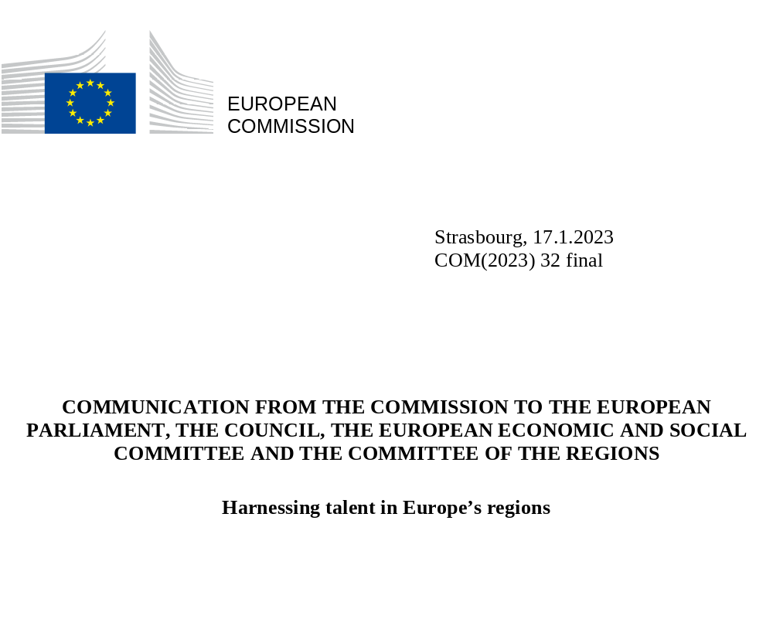

COMMUNICATION FROM THE COMMISSION TO THE EUROPEAN PARLIAMENT, THE COUNCIL, THE EUROPEAN ECONOMIC AND SOCIAL COMMITTEE AND THE COMMITTEE OF THE REGIONS
Harnessing talent in Europe’s regions

Introduction
Acute demographic transformations are taking place in our societies and our economies. Overall, the population in the EU is ageing and birth rates have been steadily declining since the 1960s. Several regions in the EU face the problem of intense departure of their young and skilled workforce.
The combination of these demographic trends has led to a shrinking working age population. Following a decrease by 3.5 million people between 2015 and 2020, the EU working age population is expected to shrink still further over the next years and decades, with the loss of an additional 35 million persons by 2050.
Most Member States are affected, but some regions are more acutely impacted than others. Indeed, in parallel to the disruption caused by the COVID-19 pandemic, regions that are often already disadvantaged, suffer a second blow when they lose their best and brightest, who leave to seek their fortune elsewhere, while at the same time failing to attract from outside the region.
If left unaddressed, this process will trigger new and growing territorial disparities as regions age and fall behind in terms of size and skills of their workforces. The change in Europe’s demographic landscape will hamper the resilience and competitiveness of the EU as a whole and compromise Cohesion. This is taking place in the context of a fierce global race for talent and against the backdrop of other structural transformations, such as the transition to a climate neutral and resilient economy and technological change, that may also exacerbate disparities between regions.
A shrinking workforce is thus simultaneously a demographic, economic and social phenomenon. In some regions, the resulting challenges are compounded by a low and stagnating share of persons with a tertiary education. This diminishes regional capacity to address the economic consequences of a shrinking workforce. It particularly affects rural areas, but peripheral, outermost and industrial transition regions are also affected by depopulation, departure to wealthier regions, particularly of younger and qualified workers and difficulties in promoting, retaining and attracting talent.
This Communication focuses on regions that are facing a related set of challenges: a sharp working age population decline in combination with a low and stagnating share of people with a tertiary education, as well as regions experiencing a significant departure of young people.
These regions are or risk falling into a talent development trap. An ageing and shrinking working age population, as well as lack of economic dynamism lead to a decrease of highly skilled and younger workers. In addition, such regions face significant socio-economic challenges, such as the lack of economic diversification possibilities, over-reliance on declining sectors, and low innovation capacity. This is closely linked to under performing labour markets, lower adult learning rates, poorer social outcomes and a more limited access to essential services. This combination of challenges limits the capacity of these regions to build sustainable, competitive and knowledge-based economies.
Increased territorial disparities, resulting from such talent development traps, would result in a growing number of people and communities feeling left behind, which could further fuel current trends in political discontent. It would reduce confidence in our democratic values and decrease public support for reforms, including those related to the green and digital transition.
To avoid the risk of growing talent development traps, it is imperative to boost both the demand for talent notably by stimulating more dynamic and diverse economic opportunities, and the talent supply. This requires a set of investments and reforms, supported inter alia by the new generation of Cohesion policy programmes and the Recovery and Resilience plans. The policy response should encompass a comprehensive set of measures, elaborated and implemented through place-based approaches, tailored to local circumstances, steered by Cohesion policy and complemented by sectoral strategies. The regions concerned should also improve the business environment and the quality of life to become more attractive places to live and work. This can help nurture the talent needed for their economic development, which is becoming increasingly dependent on knowledge and innovation, and, therefore highly skilled people. In parallel, the European Semester will play an active role in fostering the reforms needed, notably in the labour market or education system to stimulate the development of talent.
This Communication is the first key deliverable of the European Year of Skills as proposed by the Commission, which aims to further promote reskilling and upskilling and to ensure that nobody is left behind in the twin, green and digital, transitions and the economic recovery. The territorial dimension will be critical in this endeavour as disadvantaged and remote regions, including the outermost, face more acute challenges.
This Communication outlines targeted measures to promote, retain and attract talent to transform all regions into dynamic talent-driven locations. Such measures require first and foremost the mobilisation of the national and regional levels, building on key regional assets such as small and medium sized towns, universities, vocational education and training (VET) institutions, adult learning providers, research facilities as well as companies and small business clusters that can ensure long-term regional development. Such objectives are also aligned with the 2030 Agenda for Sustainable Development.
The actions proposed in this Communication will be underpinned by a dedicated EU mechanism to support the design and implementation of targeted regional and territorial strategies that are based on regions’ specific situation and assets, and by the ambitious implementation of the European Pillar of Social Rights and the long-term vision for the EU’s rural areas, together with targeted use of existing EU funds, aiming to adapt their deployment to the demographic trends experienced in the EU.

Many EU regions are ill-equipped to harness the talent needed for their development

Many EU regions are experiencing an accelerated decrease in their working age population and lag behind in developing, attracting and/or retaining skilled workers
Whereas the decrease of working age population is widespread, with more than half of the EU’s population living in regions where it is shrinking, this decline is combined in some regions with further structural challenges. Compared to the EU average, some regions have a significantly lower share of tertiary-level educated people, with young adults (aged 20-24) comparatively less likely to be enrolled in tertiary education. Moreover, while at the EU level the proportion of people with a tertiary education in the 25-64 age range is growing, because younger age cohorts are more educated than older ones, this share grew more slowly in these regions, and this trend is projected to continue. With a declining or stagnated share oftertiary-level educated workers, these regions will not be able to compensate for a decreasing labour force with highly skilled workers. If left unaddressed, this will increase the talent and economic gap with more dynamic EU regions.
Regions facing a talent development trap also have a higher share of early leavers from education and training. The rate of young people neither in employment nor in education or training (NEET) is significantly higher in these regions (at 19%, compared to the EU average of 13%). Too many young people in these regions do not complete upper secondary education and are left with poor employment prospects.
Adult participation in learning is significantly lower in regions facing a talent development trap (with a rate of 5.6%, compared to the EU average of 10%): fewer people are updating their skills or learning new skills, including those needed for the twin transition, with a risk of higher mismatch with rapidly evolving labour market needs. Within Member States, the performance in terms of adult learning varies considerably, with much higher rates in urban areas than in rural areas.
Physical accessibility to education infrastructure is also lower in these regions. Although each of these regions host one or more universities, fewer people live within a 45-minute drive from the nearest university compared to other regions.
Large differences exist within Member States, notably between capital regions and other regions, sometimes with territorial disparities within regions. In most Member States, the capital region, with its universities, a concentration of highly skilled jobs, economic opportunities, vibrant cultural and social prospects, serves as an attraction for many young people. They move there to study or to find a job shortly after their studies. When they get older, they may move out from the capital region. This talent circulation is a win-win situation, but can only be a reality if all regions are equally well equipped to attract talent.

Regions facing departure of young talent are at risk of falling into a talent development trap
Tertiary education can make an important contribution to regional dynamism and attractiveness. However, it is equally important, on the one hand, to create economic opportunities so that talent stays and moves in, and, on the other hand, to match labour supply with current and future market needs. The lack of career perspectives may discourage young people from investing in tertiary education and lead some to seek career opportunities elsewhere. The rate of unemployment of young people (15-34) is 14.6% in regions in or at risk of falling in a development trap, significantly higher than in the EU (11.1%). Furthermore, while the departure of young people brings new opportunities for the individual, it equally may result in creating further tensions in the labour market and exacerbating job shortages in some sectors.
The mobility of people is influenced by various factors: job opportunities, wages, working conditions, equal opportunities, location and services available in their surroundings and trust in institutions.
In this regard, wages, income and economic development in the regions facing a talent development trap are substantially lower than in the rest of the EU (with a compensation per employee (PPS) at 82% of the EU average). The quality of institutions is also lower, as the European Quality of Government Index of these regions is currently only around 60% of the EU average.
Without an integrated strategy to boost talent and create new development opportunities, regions affected by high rates of departure of young people could find themselves in a similar structural situation as regions facing a slow but accelerating decline in their working-age population and a stagnant share of tertiary-level graduated.

Regions in a talent development trap or at risk of falling into one
The talent development trap is multidimensional and poses a significant risk to the long-term prosperity of regions.
The map highlights 46 regions (in red) that are in a talent development trap. These regions face an accelerating decline of their working-age population, and a low and stagnant number of people with a tertiary education between 2015 and 2020. This group of regions accounts for 16% of the EU’s population. Most of these regions are less developed, with an average GDP/capita of 64% of the EU average. This group of regions is more rural than the rest of the EU, with 31% of its population living in rural areas, compared to 21% on average in the EU.
The map also identifies a second group of 36 regions (in yellow) that are at risk of falling into a talent development trap in the future, because they are sharply affected by the departure of their population aged 15-39 (a reduction of more than -2 per thousand per year compared to 5.3 per thousand on average in the EU). This group accounts for 13% of the EU’s population.
Together, the two categories of regions represent 30% of the EU population.

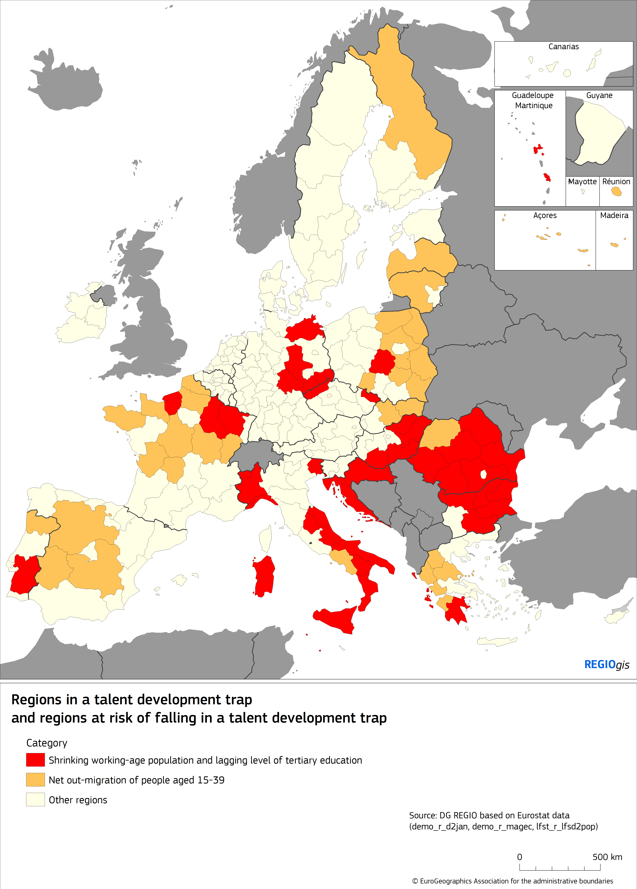
The combination of the different above mentioned factors in these regions results in creating a downward spiral that hampers and stunts long term growth. By contrast, a comprehensive resources and incentives strategy is necessary to break the vicious circle and generate greater economic dynamism.

Boosting demand for and supply of talent to avoid development traps
In order to avoid falling into or remaining in a talent development trap, they must find ways to stimulate both the supply of and demand for talent and at the same time match them to the changing needs of their economies. This includes addressing inefficiencies in their labour market, education, training and adult learning systems, improving innovation and public governance performances, the business environment and increasing the level of and access to services. All EU regions and territories confronted with a decrease in their working-age population and willing to boost their attractiveness and better develop, attract and retain talent will benefit from a new dedicated EU initiative: the Talent Booster Mechanism. Moreover, regions in, or at risk of falling in a talent development trap will also benefit from dedicated support under certain components of this mechanism (see point 3.5).

Untapping talent development with the support of place-based policies

Supporting economic revitalisation and better access to services
The revitalisation of regions requires a diversification of their economic fabric together with an upgraded accessibility to services in the framework of place based strategies. EU Cohesion policy, as a catalyst for place-based policies, in synergy with the rural development dimension of the Common Agricultural Policy, provides these regions with an integrated strategic framework for planning long-term investments, through efficient governance and involvement of local actors. Given sub-national demographic disparities, the involvement of regional and local authorities in the definition and implementation of funding priorities under the 2021-2027 Cohesion programmes is essential for the success of these strategies.
These place-based strategies to support the economic revitalisation of regions facing a talent development trap can also help to address rapid industrial transformation driven by climate change mitigation objectives. Without economic dynamism and the right skills base to attract high-potential activities, the growth opportunities and benefits of the green and digital transitions for the development of these regions will not be fully exploited. Given that these transitions require innovation and new technologies and that workers adjust their skills and change jobs or occupations, the ability to maintain a good skills base and training opportunities will be particularly relevant.
The different pillars of the Just Transition Mechanism, complementing other instruments under Cohesion policy, support the development and implementation of comprehensive strategies in the impacted territories, enabling the diversification of their economic fabric, the upskilling and reskilling of their labour force, thus stimulating their dynamism and attractiveness.
At local level, the specific bottom-up and place-based approach developed by Local Action Groups (LAGs) initiated under the Common Agricultural Policy with LEADER, and now supported with the EAFRD, the EMFAF and Cohesion policy funds, empowers local communities for shaping strategies and projects that have the potential to revitalise territories. For instance, in areas where fishing and aquaculture are important activities, LAGs, supported by the EMFAF, prepare and implement integrated strategies addressing the decline in income and employment of fisheries communities.
Finland: In Lapland, LAGs have financed from 2017 to 2020 a fisheries recruitment and training project to rejuvenate the ageing fisheries sector in the area around the Lokka and Porttipahta reservoirs. As a result, a number of young people have taken up this activity and begun to operate in the region. Thanks to the project, new investments in the port and processing infrastructure (as well as other development funding) were made, with even more expected in this area. These new fishers have revitalised the local fisheries sector bringing their new ideas and energy for development.
Among the economic sectors that can improve the socio-economic conditions of regions facing a talent development trap is the silver economy.
Spain: Castilla and León as a rapidly ageing region, has promoted a model “Atención en Red” (“Network Care”), offering an alternative to institutionalisation, resting on new technologies applicable to the social and health care of people. It notably aims at allowing the elderly to develop their life projects, with the highest level of autonomy and quality of life, wherever they decide to live. This model contributes to favouring social cohesion, promoting local employment, revitalising the territory and maintaining population, in particular by attracting healthcare professionals with favourable work conditions.
Tourism is another important economic sector for many of these regions. The transition pathway for tourism highlights the need for well-planned strategies that take account of the environmental, economic, and social impacts of tourism and involve local communities. These strategies can help create new opportunities and help local communities’ well-being. The EU Tourism Dashboard which monitors the green and digital transitions and socio-economic resilience factors of tourism activities in Europe, demonstrates how those can vary greatly between regions.
Equal access to quality services and infrastructure, such as early childhood education and care, education and training, health- and long-term-care, affordable housing and cultural services, transport, energy supply and access to the internet, plays a crucial role in the global competition to develop, attract and retain talent.
The COVID-19 pandemic has had an impact on where some people choose to live. It has also changed the size and location of offices and work-spaces. This may increase the appeal of regions where real estate costs are lower and offering better quality of life, raising opportunities for these regions, who will nevertheless be required to offer the right infrastructure and access to services, which is a key factor in people’s motivation to stay or move to another region.
In this regard, in a tight budgetary context, regions facing a talent development trap, particularly those which are less developed, are obliged to take difficult decisions. Their fiscal revenues decreases in proportion to the decline in their population and economic activity, whereas they are expected to face increasing expenditure for services to support an ageing population.
The improvement of the digital connectivity of regions caught in a talent development trap is essential, in order to reap the full benefits offered by the digital transition. So far, households in these regions are less likely to have a broadband connection at home and the share of population with high-speed broadband is much lower than in other regions.
A better broadband connection in these regions creates more economic opportunities for companies and for teleworking. It also creates more opportunities for remote education and training which could help to reduce the skills gap.
Several EU funding instruments, notably Cohesion policy, the rural development policy, the RRF can support investments needed in order to speed up the deployment of very high-speed and 5G networks, especially in rural and remote areas, where a lower population density may create a market gap justifying public intervention.
Romania: the “RO-NET” project supported by the ERDF has expanded broadband coverage by building infrastructure to provide internet access for people in so-called ‘white areas’ where there is no access to electronic communication networks and no development plan of private investors. By reducing the digital gap between urban and rural areas affected by depopulation, these investments contribute to improving the quality of life of inhabitants and the attractiveness of the regions.
Public investments can be completed by appropriate regulatory measures, aiming at ensuring an adequate access to essential services for all.
In France, the opening of new pharmacies is regulated through authorisation procedures. New pharmacies can be opened in deprived territories (revitalisation of rural areas and priority urban districts) or based on demographic criteria (population increase). This policy aims at ensuring equitable access to pharmacies throughout all territories and notably in those facing social and economic difficulties.
Cross-border cooperation, supported by the Interreg programmes, contributes to encourage the attractiveness of border regions facing a talent development trap. The pooling of human resources, equipment and infrastructure, and the availability of digital public services working cross-border, can improve accessibility to public services and provide more job opportunities in a cross-border labour market.
In addition to overcoming legal and administrative obstacles deriving from the existence of borders, technical obstacles may be tackled by ensuring interoperability of digital public services. This would enhance interactions between stakeholders from neighbouring regions and, thus increase job prospects on the other side of the border, allowing cross border regions to retain more talent.
Germany/Poland: the Interreg V-A Poland-Germany/Saxony cooperation programme has developed a cross-border educational curricula tailored to the needs of the common labour market, by strengthening cooperation between higher education institutions and improving access to VET institutes, particularly in the fields that are most in demand among local and regional businesses.

Stimulating dynamic innovation ecosystems through smart specialisation strategies and technological and social innovation
The structure of the regional economy is one of the reasons for the lower share of high-skilled jobs in regions facing a talent development trap. Creating new economic perspectives and corresponding high skilled job opportunities is a precondition for tertiary-level educated people to remain in these territories.
In addition, enhanced productivity is needed to mitigate the impact of a shrinking working-age population, and innovation is crucial in this respect. The innovation performance of regions facing or at risk of facing a talent development trap is much lower than the EU average.
Significant gaps and disparities exist in innovation capacity between capital regions and other regions.
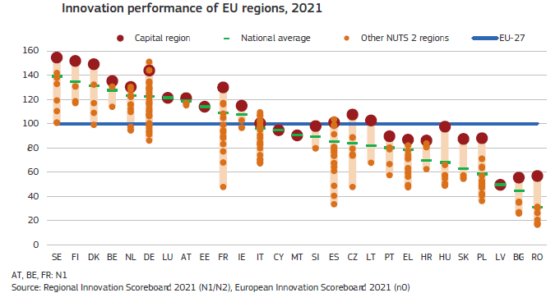
Addressing weaknesses in the diffusion and adoption of new ideas and technologies and encouraging broad-based innovation, as well as recognition and encouragement of excellence, will ensure that these regions become more productive, offer better job opportunities and reap the benefits of an increasingly knowledge-intensive economy.
These regions should accordingly implement place-based innovation strategies and optimise the impact of resources available under Cohesion policy and the Recovery and Resilience Facility (RRF) of their Member States. Innovation should be understood in a broad sense, including production processes, marketing, including digital marketing and digitalisation of services. It can boost business and job opportunities in new and growing sectors, but also in traditional sectors such as agriculture or tourism. These strategies contribute directly to the upgrade of regional economic systems, stimulating entrepreneurship and the creation of highly skilled and attractive jobs, tackling skill mismatches and eventually foster talent gain for such regions, through new hubs of competitiveness and attractiveness.
A number of tools at EU level can be activated to boost innovation in regions facing a talent development trap.
Smart specialisation strategies (S3) steered under Cohesion policy prioritise investment based on local assets, encourage the transition to a knowledge and innovation-based economy, and strengthen cooperation between the different innovation ecosystems stakeholders (administrations, universities, enterprises, VET institutions) at all levels of governance.
The European Institute of Innovation and Technology (EIT) implements a place-based innovation approach through its Knowledge and Innovation Communities (KICs), integrating S3 by engaging local actors representing education, business, and research sectors. The EIT Regional Innovation Scheme (EIT RIS) supports in particular the innovation performance of regions with moderate or modest innovation scores. To date, more than 90 regional EIT Hubs in 18 EIT RIS countries are largely located in regions in a talent development trap and facilitate the engagement of local partners to support local innovators, and raise awareness to local, regional and national authorities, as well as to talent development.
A recent study on mobility flows of researchers in the context of the Marie Skłodowska-Curie Actions (MSCA) shows that the mobility of excellent researchers is primarily driven by factors that directly contribute to their ability to carry out quality research and develop their skills, namely the opportunity to work with leading scientists, the quality of research infrastructure and training offered.
The new European Innovation Agenda sets out the Deep Tech Talent Initiative, a specific flagship to respond to the talent gap in deep tech sectors, integrating all regions in Europe. Coordinated by the EIT, it will target deep tech talents over a three-year period in all Member States and launch an innovation internship scheme in 2023, so that over 600 researchers and graduates, including from regions facing a talent development trap, can gain an experience in innovation in EIC and EIT partner companies. Specialists in fields such as data science, artificial intelligence, cybersecurity and quantum will be trained through the Digital Europe programme. This initiative will bring together less and more innovative regions to facilitate cooperation in building new EU value chains by leveraging each region’s particular assets. The creation of interconnected regional deep tech innovation valleys in the EU will allow to retain and nurture talent. The initiative recognises the importance of the role of VET on innovation and regional development, notably through the Centres of Vocational Excellence supported by Erasmus+ in complementarity with RRF or the Cohesion policy funds.
Western Greece: the ‘ReBrain’ initiative supported by Cohesion policy aims to foster the digital transformation of the economic system, focusing on the reskilling and upskilling of the region’s scientific potential and promoting innovation-led growth. A regional mechanism for diagnosing labour market needs aims at improving employment policies and reduce skills mismatches.
The Erasmus+ Alliances for Innovation will support the development of entrepreneurial skills, with a particular focus on deep tech skills, in order to help student entrepreneurs coming from regions facing a talent development trap turn their ideas into businesses, as announced in the European strategy for universities.
In Horizon Europe, under the MSCA, the ERA fellowships enable excellent researchers who could not be funded under the MSCA to undertake a fellowship in a widening country, to promote a more balanced brain circulation to these countries. The Widening Fellowships, their predecessor under Horizon 2020, had a significant positive impact on talent mobility towards these countries, and helped those to attract back experienced researchers and to retain talent.
In addition, the Policy Support Facility of Horizon Europe, a demand driven tool at the disposal of Member States, should help implementing some of the already identified recommendations to improve the functioning of the R&I system in several Member States. It is particularly relevant in regions faced with a talent development trap, in particular in Romania, Greece and Croatia.
Germany: in Saxony, Simul+ Innovation Hub is a platform for innovative regional development which gathers citizens and actors from research, business, and regional and local governments. It brings together knowledge, skills and resources to address demographic change, the skills gap and territorial disparities. The Hub rests on three pillars: knowledge transfer, competition for innovative ideas, and support for pilot projects. Under Simul+, people from all over Saxony come together and develop and exchange ideas to make their region attractive for talents and worth living in.
SMEs and businesses in these regions can benefit from Digital Innovation Hubs’ support for innovation and digitisation.

Revitalising rural areas
Rural regions are particularly exposed to the twin impact of demographic decline and insufficient talent development.
A comprehensive set of actions have been launched in the follow up of the long-term vision for the EU’s rural areas. An EU Rural Action Plan identified concrete areas for action in relation to human capital that are expected to make these territories and corresponding communities stronger, more connected, resilient and prosperous by 2040. Its implementation will contribute to make rural areas more attractive for talent, creating new opportunities to attract innovative businesses, providing access to high-quality jobs, promoting new and improved skills, better infrastructure and services, and harness the benefits flowing from the diversification of their economic activities.
- The Rural Revitalisation Platform provides rural authorities in areas affected by population loss, ageing and a lack of economic opportunities, with information and best practices on tools and strategies to address the loss of talent.
- Dedicated calls for projects in rural areas will be launched under Horizon Europe (Research and innovation for rural communities) and support will be provided for training and knowledge exchange to accelerate the spread and adoption of innovations, such as the “expertise and training centre on rural innovation” created through the RURALITIES project. A European forum for start-up villages was also launched under the flagship to help better understand the needs of rural start-ups.
- Rural digital futures, with a prominent human capital dimension, target skills needed for the digital transformation of rural areas, including digital skills and entrepreneurship.
- Entrepreneurship and social economy in rural areas support innovative environments in rural areas by encouraging and empowering entrepreneurs.
In addition to the rural vision, under the Territorial Agenda 2030 project, multilevel governance cooperation will support the vital role of small towns and villages in the development of integrated territorial development, and strengthen cooperation between territories. It will aim at maintaining and developing small places as attractive places to live and work for young people.
Moreover, integrated development policies that are promoted by Cohesion policy at local level, will contribute to the development of rural areas and stimulate urban-rural linkages. They can attract new economic activities, close the digital gap, provide more education opportunities, improve access to infrastructures, services and cultural amenities and raise the quality of life, thus attracting and retaining talent in rural areas.

Improving the quality of public administrations and public governance
The quality and effectiveness of public administration and public governance is one of the key factors driving the regions’ attractiveness for investment.
Low quality of governance, notably corruption, as well as the non respect of rule of law, undermine growth potential but also the confidence of investors and economic operators and are well-known to be one of the factors influencing the decision to move out of the region. By contrast, regions investing in the quality of governance are more likely to implement strategies for boosting development in an efficient and effective manner.
Therefore, regions facing a talent development trap should further improve the quality of their administration, and public governance, using, inter alia, the possibilities offered by the Technical Support Instrument.
In Bulgaria, the Severoiztochen region has developed and implemented a regional development plan, delivering concrete social and economic improvements. In particular, this region has outperformed the EU average for business establishment. It has also steadily improved its quality of governance. As a result, the employment rate has increased by 10.6% over the last decade, compared to a 4.4% increase at EU level.

Upgrading the effectiveness of education and labour market
Regions caught in a talent development trap are underperforming as regards developing and attracting the talent they need for their sustainable development, notably in terms of education and training systems, skills, labour market integration and working conditions. This requires integrating more people into the labour market while creating new economic opportunities and boosting productivity.
The implementation of the European Pillar of Social Rights and its Action Plan is not only key for reaching the EU 2030 employment, skills and poverty headline targets, but also for social and economic convergence among and within regions Pursuing implementation of the Union of Equality strategies remains crucial to achieve social and economic resilience The active involvement of regional and local authorities in implementing the twenty principles of the Pillar according to their specificities will be essential for its success.
The European Semester is the main tool to monitor the implementation of the Pillar at national and regional level. In the last European Semester exercises, the Commission issued country-specific recommendations in the area of education, skills, and, VET, equal opportunities and labour market participation to almost all Member States. The Semester thereby steered the programming of Cohesion policy funding (ERDF, ESF+, Cohesion Fund and Just Transition Fund) for the 2021-2027 programming period with a view to reducing regional disparities.
In particular, the ESF+, will support people at all stages of life, and intervene on all skills aspects, from anticipation of future needs, notably due to green and digital transitions, to the elimination of skills mismatches. It will also support the management of these transitions by modernising employment services, helping to improve the resilience of education and training systems.

Enhancing the effectiveness of education and training systems
Promoting education and adult participation in life-long learning results in improving productivity and thus contributing to the competitiveness of these regions, particularly in relation to the green and digital transitions.
Participation in adult learning is a strong driver of talent supply (with the EU aiming for 60% of all adults participating in training every year by 2030) particularly in the context of a rapidly changing technological environment, digitisation and green transition, where employees’ skills need to be kept up to date.
VET can equally contribute decisively to this and the 2020 Council Recommendation on VET defines key principles to ensure that VET adapts swiftly to labour market needs and provides quality learning opportunities for young people and adults alike. It places a strong focus on the increased flexibility of VET, reinforced opportunities for work-based learning, apprenticeships and improved quality assurance. The Council has also identified the objective of “Making lifelong learning and mobility a reality for all” as a strategic priority. To close the learning gap, Member States are implementing a considerable number of reforms and investments on skills and adult learning through the RRF and the ESF+.
The priorities highlighted above need to be implemented particularly efficiently in regions facing a talent development trap.

Improving integration into the labour market
Whereas regional employment rates at the EU level have been converging for a decade, regions facing a talent development trap have lower employment rates and higher unemployment rates than the rest of the EU and have not been able to reduce these gaps over the last decade, except for a few regions. Increasing the employment of underrepresented groups, notably women, young and older people and persons with disabilities, would help reduce this gap. In regions where Roma are a significant part of young population it is also important to encourage their employment.
An important untapped potential to increase employment rates in these regions is to boost female employment (with an employment rate of 59% in the affected regions, below the EU average of 66%) given that working-age women are more likely to move out of these regions than men are. The EU is committed to at least having the gender employment gap by 2030 under the European Pillar of Social Right Action Plan. To this end, granting paid family and care leave, providing quality early childhood education and care, and reducing the gender pay gap, are key ways in which these regions can increase labour-market participation by women.
Several initiatives promote women’s employment, in particular in technology areas, where their underrepresentation is more pronounced:
- A Women Entrepreneurship and Leadership scheme will continue to support early-stage women-led tech start-ups through an enhanced ‘WomenTech EU’ call. Other related EU initiatives such as ‘Women4Cyber’, and potentially national acceleration programmes will contribute to speed up the growth of women-led companies in regions facing a talent development trap.
- The Erasmus+ funded E-STEAM project supported tertiary education and labour-market participation, especially in the science, technology, engineering and maths (STEM) fields and can help create synergies in such regions between schools and the labour market with a view to promoting the creative and meaningful engagement of girls in STEM education (through a mentoring programme).
- In addition, the Girls Go Circular action, implemented by the EIT and KICs under the Digital Education Action Plan 2021-2027, boosts the digital and entrepreneurial skills for girls to empower them and to have a positive attitude towards choosing a career in this field.
Encouraging the employment of older people, whose employment rate is 54% in the affected regions, below the EU average of 59%, is also important to mitigate skills and job shortages. In regions facing a talent development trap in particular, it is crucial to provide motivating job opportunities for older people, including through flexible part-time work, life-long learning opportunities and mentoring partnerships. Older people are a source of knowledge and skilling for younger people. In addition, the contribution of older members of the society to the volunteering sector is also a key aspect in this regard.
Moreover, creating quality employment and learning opportunities for young people is also critical to retain talent in regions in or at risk of falling into a talent development trap. At EU level, the Reinforced Youth Guarantee provides the policy framework and is supported by initiatives such as the European Alliance for Apprenticeships (EAfA) and the ALMA initiative. The ESF+ and the RRF contribute to these objectives with investments into youth employment and integration of young jobseekers close to EUR 22 billion for the period 2021-2027.

Investing in reskilling and upskilling to address skills mismatches and labour shortages
The EU labour market as a whole has been confronted with increasing labour shortages for several years now, and they could increase in the context of accelerating transition to climate neutrality unless skills are appropriately aligned with evolving labour market demands. However, shortages are not evenly distributed across the EU, with some sectors and regions being confronted with particularly severe challenges in this respect.
Regions suffering from severe labour and skills shortages may face competitiveness challenges and become unattractive locations for investment. Hence, there is a particular need to boost reskilling and upskilling in these regions.
However, investments in education, training and lifelong learning are only effective if they focus on those skills that match the current and future needs of the local labour market. This underlines the importance of good skills intelligence and close cooperation between regional and local authorities, social partner organisations, public and private employment services, local businesses and education and training providers, to ensure that the jointly deployed education, training and lifelong learning efforts focus on the right skills needed in a particular region.
Regional and local authorities and other administrative bodies in areas facing a talent development trap can play a major role in providing career guidance services, training opportunities and outreach. The Council Recommendation on Upskilling Pathways invites national and regional authorities to ensure that adults with low levels of skills and qualifications have access to ‘upskilling pathways’ to develop their skills and potentially progress towards a qualification. Such pathways should offer support through skills assessment, tailor-made learning offerings and adequate skills validation and recognition accompanied by outreach, guidance and education staff training.
Under the European Pact for Skills the Commission currently supports 14 large-scale partnerships in various European industrial ecosystems helping them to equip the workforce with the skills they need to successfully navigate the transition pathway towards a climate-neutral and digital economy. Over 1 000 members have meanwhile signed up including large multinational companies, SMEs, local training providers, and chambers of commerce. Together, they have pledged to help upskilling 6 million people. Around 50 regional or local authorities working together under the Pact are already designing solutions for the upskilling and reskilling in cooperation with industry, social partners and education and training providers and the Commission encourages all regions and especially those in the development trap to sign up to the Pact and form regional Skills Partnerships with the help of a dedicated support service.
The Commission’s proposal to make 2023 the European Year of Skills will promote concrete actions to boost the competitiveness of European companies and to realise the full potential of the digital and green transitions in a socially fair and just manner. The Year will promote skills policies and investments to address labour shortages for a better skilled and adaptable workforce in the EU. This is a good opportunity for regions facing a talent development trap to identify the obstacles that prevent their businesses and workforce to shift towards more productive and future-fit sectors. It will be an important step, particularly in lagging regions where low GDP per capita is driven by high shares of employment in low-productivity sectors.
The EU is particularly facing a significant digital skills gap, which - if left unaddressed - will continue growing. Already now, 90% of jobs require some level of digital skills whereas millions of companies struggle to find digitally skilled workers, particularly ICT specialists. In order to address these challenges, the Digital Decade Policy Programme sets two important targets. The first is to increase the number of adults with basic digital skills from the current 54% to 80% by 2030. The second is to increase the amount of employed ICT specialists to 20 million by 2030 while promoting the access of women to this field and increasing the number of ICT graduates. Member States capitalised on the RRF to reform the adult education system and deploy significant resources to improve quality and access to up/re-skilling.
Cyprus: in order to cope with high skills mismatches, Cyprus developed a national plan to up-skill and re-skill at least 25 600 persons in labour-market relevant programmes for digital skills, skills related to the blue and green economy, and entrepreneurship skills for unemployed and inactive people.
Higher education institutions have a key role to play in preventing skills mismatches and bottlenecks. A Council Recommendation on a European approach to micro-credentials for lifelong learning and employability was adopted in June 2022. Its swift follow-up will mobilise higher education and VET organisations in support of lifelong learning and contribute to professional reskilling and upskilling to meet new and emerging needs in society and labour market.
The European Universities alliances and Centres of Vocational Excellence selected under Erasmus+ will also act as hubs for training and retraining adults, including active professionals, with high-level and forward-looking competencies, helping businesses with a skilled workforce shortage.
Spain: In order to develop the economic opportunities in the agri-food industry in the region of Andalusia, one of the promising areas of development of the regional S3, the University of Córdoba created and launched a Master's Degree in Digital Transformation of the Agricultural and Forestry sector. This responds to the identified bottlenecks in encouraging innovation and digitalisation in the agri-food value chain, as evidence arose concerning the lack of adequate professional agri-tech profiles. This Master trained a large number of professionals who are now capable of facilitating, supporting and promoting digital transformation in rural areas and encouraging the use of technologies such as sensors, the internet of things, big data, Cloud computing, the food industry 4.0, artificial intelligence or precision agriculture. After the successful implementation of this Master, this model was copied by the University of Seville.

Ensuring fair working conditions for talent to flourish
The attractiveness of regions in or at risk of falling into a talent development trap will ultimately depend on their ability to recognise and reward talent.
Adequate minimum wages are essential to ensure that competition is based on high social standards in the Single Market, stimulating productivity improvements and promoting economic and social convergence in these regions. The new directive on adequate minimum wages is of particular relevance in this context, because it sets up a framework to ensure the adequacy of statutory minimum wages that promotes collective bargaining on wage-setting and enhances the workers’access to minimum wage protection.
Enhancing the involvement of social partners in the regions facing a talent development trap is particularly valuable in creating better working conditions, adequate wages, and in tackling skill and labour shortages.
This convergence is supported by Cohesion policy and appropriate reforms, helping to close the wage gap and to increase the attractiveness of regions facing a talent development trap.

Enhancing talent mobility and encouraging return of workers to their regions of origin
Growing labour market needs cannot be fulfilled in the long term by mobilising the domestic workforce alone. Regions in or at risk of facing a talent development trap should capitalise on intra-EU mobility and attract young people coming from other EU regions and Member States. While the focus is often on the outflows of young people, too few regions are focused on ensuring a attractive opportunities for the incoming returning workers.
Among the strategies to attract talent from other Member States, some regions seek to capitalise on the diaspora and encourage the return to their place of origin of the skilled labour force which had emigrated, in order for them to support their regions of origin. For instance, Member States like Bulgaria, Portugal and Greece set up specific programmes to strengthen the connections with researchers from their international scientific diaspora, both to increase their overall attractiveness and attract back their own nationals.
Romania: The Diaspora Start-up programme co-financed by the ESF provides grants to support urban small-scale businesses registered by Romanians returning in their country of origin.
However, long term strategies for re-attracting talent should primarily build on structural attractiveness drivers, focussing on entrepreneurship and skills, as well as diplomas most in demand on the labour market. Regions should therefore develop a comprehensive, long-term strategy to promote economic diversification and innovation involving local and regional authorities, the private sector, job and training centres, research and higher education institutions, as well as VET institutions.

Supporting legal migration and integration in the EU
The Commission promotes an ambitious and sustainable policy on legal migration to the EU. To remain globally competitive, the Students and Researchers Directive and the recast EU Blue Card Directive contributes to improving the attractiveness of the EU regions for high-skilled workers from non-EU countries and facilitate their mobility within the EU through simplified procedures.
The Commission also proposed to step-up cooperation with targeted partner countries, including through the launch of Talent Partnerships announced in the 2020 Pact on Migration and Asylum. These tailor-made Partnerships with third countries enhance legal pathways to the EU, while engaging partner countries strategically on migration management. The Talent Partnerships aim to provide a comprehensive policy framework, as well as funding support to boost mutually beneficial international mobility based on better matching of labour market needs and skills between the EU and partner countries whilst remaining mindful of the risks of brain drain. An EU Talent Pool will also be designed to match skilled workers from outside the EU with potential jobs across EU Member States.
The efforts made in terms of legal migration to the EU need to be complemented by effective integration policies to achieve effective and sustainable results. As underlined in the Action plan on integration and inclusion, the local level is essential for effective migrants’ integration policies, including through cooperation with local and regional authorities and civil society organisations.
Efforts from all stakeholders (Member States, local and regional authorities, social partners, NGOs, the private sector and the host society) should be comprehensive to help boost the ability of regions to attract new talents and integrate third-country nationals in their territory.

Supporting regions through a new dedicated EU mechanism: the Talent Booster Mechanism
In addition to these existing or announced EU initiatives and policies, the Commission will set up during 2023 a new dedicated eight pillar-mechanism to boost talent in regions facing or at risk of facing a talent development trap. Under the mechanism, a dedicated portal will be set-up, to provide a comprehensive access to all pillars to regions and stakeholders.
- A new pilot to help regions facing a talent development trap elaborate, consolidate, develop and implement tailored and comprehensive strategies to train, attract and retain talents. This will take the form of dedicated technical support to selected regions coupled with broader awareness and capacity building actions.
- A new initiative “Smart adaptation of regions to demographic transition” to help regions at risk of a talent development trap elaborate new approaches to demographic transition and talent development through tailored place-based policies focusing on necessary investments and reforms.
- The Technical Support Instrument (TSI) will continue to offer the possibility for Member States to design and implement reforms at national and regional level. Under the TSI 2023 call, the Commission will continue its efforts to support regional authorities overcome barriers to regional development.
- Direct financial assistance will be provided under existing instruments.
In order to stimulate innovation and opportunities for high skills jobs, regions facing difficulties in retaining and attracting talent will be taken into account under the calls for proposals of the Interregional Innovation Investments instrument (I3). This EU instrument funded by the ERDF, aims at stimulating innovation ecosystems involving several EU regions by providing advisory and financial support to innovation projects in joint smart specialisation areas. Under its new strand ‘capacity building’, it will in particular contribute to test new approaches and stimulate the ability of regions in a talent development trap to attract highly skilled persons.
Furthermore, greater attention will be paid to the regions facing a talent development trap by EU and national policies and instruments. The mid-term review of the 2021-2027 Cohesion policy programmes, scheduled for early 2025 and steered by the country specific recommendations adopted in 2024, will provide an opportunity to assess the situation of these regions and, where appropriate, align the programming of Cohesion policy funds.
- In addition, as part of the European Urban Initiative - a comprehensive tool funded by the ERDF supporting cities of all sizes to build capacity and knowledge, to support innovation and develop transferable and scalable innovative solutions to urban challenges of EU relevance - the Commission will address challenges faced by shrinking cities, including difficulties in developing, retaining and attracting talents, in the 2023 call for innovative actions to test place-based solutions led by cities.
- Signposting to EU initiatives that can support the development of talent. The mechanism will provide information to interested regions about EU policies in the areas of research and innovation, training, education and youth mobility, cluster policies and digital innovation that can help to improve regional attractiveness and raise skills levels.
- Exchange of experiences and dissemination of good practices: A variety of practices already in place in some regions could inspire others. Regions will be able to set up thematic and regional working groups to address, in a more tailored manner, specific professional or territorial challenges. The dissemination of good practices will also build on the outcome of existing platforms, such as the Territorial Just Transition Platform or the rural revitalisation platform, addressing regions and territories facing common challenges.
- Increase analytical knowledge in order to support evidence-based policies on regional development and migration and facilitate policy making. The work carried out by the Joint Research Centre on the Regional Social Scoreboard will be continued. The Commission (Eurostat) will also invite Member States to provide more comprehensive statistical data on population movements within the EU, in particular regional migration flows, broken down by age and gender. Furthermore, data on the location of essential services within the EU, such as education and healthcare, within the EU will be collected to provide valuable research and information to stakeholders on how to address the key challenges for social cohesion and just transition.

CONCLUSION
Ensuring that regions facing a talent development trap, or at risk of falling into one, become more resilient and attractive is crucial in the Union’s commitment of leaving nobody and no place behind. The trap is not inevitable and challenges can be effectively addressed, as corroborated by the successful experiences in various regions and which are highlighted in this Communication.
A comprehensive, strategic, and targeted approach is crucial to address all factors and mobilise the relevant actors and layers of governance. While action at these different levels is key, it is increasingly clear that capacity needs to be developed at European level to gather and assess data and expertise, in order to provide guidance on the appropriate solutions.
As the situation of regions in a talent development trap is heterogeneous, the solutions which need to be promoted differ. Tailored place-based strategies and policies need to be designed and implemented, enabling a differentiated approach, addressing their specific weaknesses and promoting their respective comparative advantages, in order to enhance economic dynamism and quality of life.
As the first key deliverable of the European Year of Skills as proposed by the Commission, through the new Talent booster mechanism, the Commission will provide targeted assistance and knowledge to regions caught in a talent development trap, supporting them in developing and successfully implementing these tailored strategies. It will provide them a unique opportunity to unlock their development potential by harnessing the talent they need and thus contribute to overcome their structural handicaps. As knowledge and skills are the true engines of the future economic growth and development, these regions will then be able to stay in the game, attract investment, and flourish as prosperous, innovative, and desirable places to live and work in.

European Commission Report on the impact of demographic change, 2020 and 2023.
This is in particular the case of Martinique, Guadeloupe, continental Croatia and the Vidurio ir vakarų Lietuvos region.
This is defined for the purpose of this Communication as those aged 25-64.
The EU outermost regions are located in the Atlantic and Indian Oceans, in the Caribbean basin and in Latin America. In line with Article 349 TFEU, and with a dedicated strategy of May 2022 (COM(2022) 198 final), specific measures help these regions address their permanent constraints.
This is captured in the regional dimension of the Social Scoreboard. The Social Scoreboard is used to monitor the implementation of the European Pillar of Social Rights at national and regional level.
“The Geography of EU discontent”, 2020, https://ec.europa.eu/regional_policy/information-sources/publications/working-papers/2018/the-geography-of-eu-discontent_en
Some regions with a shrinking working age population and lagging level of tertiary educated people can also experience net departure of people aged 15-39.
Territories in other regions could also be faced with these challenges, although they cannot be captured because of the lack of sufficient granularity of available regional statistics.
One of the five policy objectives of Cohesion policy 2021-2027 is to make Europe closer to citizens by fostering the sustainable and integrated development of all types of territories and local initiatives. A dedicated set of territorial instruments can be set up at local level to implemented integrated development strategies.
See European Commission (2019) – Employment and Social Developments in Europe review, Chapter 5.
https://ec.europa.eu/docsroom/documents/49498/attachments/1/translations/en/renditions/native
https://tourism-dashboard.ec.europa.eu/?lng=en&ctx=tourism
See Interoperable Europe Act Proposal (COM(2022) 720 final) and accompanying Communication (COM(2022) 710 final).
See Interoperable Europe Act Proposal (COM(2022) 720 final) and accompanying Communication (COM(2022) 710 final).
Regional Innovation Scoreboard, 2021.
Smart Specialisation is a place-based approach characterised by the identification of strategic areas for intervention based both on the analysis of the strengths and potential of the economy.
As defined by the European Innovation Scoreboard.
COM(2022) 332 final.
Centres of Vocational Excellence are transnational collaborative networks aimed at driving innovation and excellence in vocational education and training.
Bulgaria, Croatia, Cyprus, Czechia, Estonia, Greece, Hungary, Latvia, Lithuania, Malta, Poland, Portugal, Romania, Slovakia and Slovenia.
See Chapter 7 of the 8th Cohesion report – COM(2022) 34 final.
The Gender Equality Strategy 2020-2025, the EU Anti-racism Action Plan 2020-2025, the EU Roma strategic framework for equality, inclusion and participation for 2020-2030, the LGBTIQ Equality Strategy, the Strategy for the Rights of Persons with Disabilities 2021-2030 and the EU Strategy on combating antisemitism.
https://eur-lex.europa.eu/legal-content/EN/TXT/?uri=CELEX%3A32020H1202%2801%29
Council Resolution on a strategic framework for European cooperation in education and training towards the European Education Area and beyond (2021-2030) (OJ C 66, 26.2.2021, p. 1) - https://eur-lex.europa.eu/legal-content/EN/TXT/?uri=CELEX:32021G0226(01).
People between 55 and 64 years old.
European Alliance for Apprenticeships - Employment, Social Affairs & Inclusion - European Commission (europa.eu).
ALMA (Aim, Learn, Master, Achieve) - Employment, Social Affairs & Inclusion - European Commission (europa.eu).
The Automotive skills alliance - the Skills partnership for microelectronics - the Aerospace & defence skills partnership - the Pact for skills for offshore renewable energy - Upskilling shipbuilding and maritime technology workers in Europe - the Textile, clothing, leather and footwear industries - the Skills partnership for the tourism ecosystem - the Pact for skills in construction - the Skills partnership for the agri-food ecosystem - the Skills partnership for the cultural and creative industries - the Skills partnership for the proximity & social economy ecosystem - the Skills Partnership for the digital ecosystem - the Skills Partnership for the retail ecosystem - the Skills Partnership for the health ecosystem.
Pact for Skills - Employment, Social Affairs & Inclusion - European Commission (europa.eu).
The Year will also give a concrete boost to the European Pillar of Social Rights Action Plan targets of 78% employment rate and 60% of adults participating in up- and reskilling each year by 2030.
Directive (EU) 2016/801 of the European Parliament and of the Council of 11 May 2016 on the conditions of entry and residence of third-country nationals for the purposes of research, studies, training, voluntary service, pupil exchange schemes or educational projects and au pairing.
Directive (EU) 2021/1883 of the European Parliament and of the Council of 20 October 2021 on the conditions of entry and residence of third-country nationals for the purpose of highly qualified employment, and repealing Council Directive 2009/50/EC.
COM(2020) 758 final, 24.11.2020.

