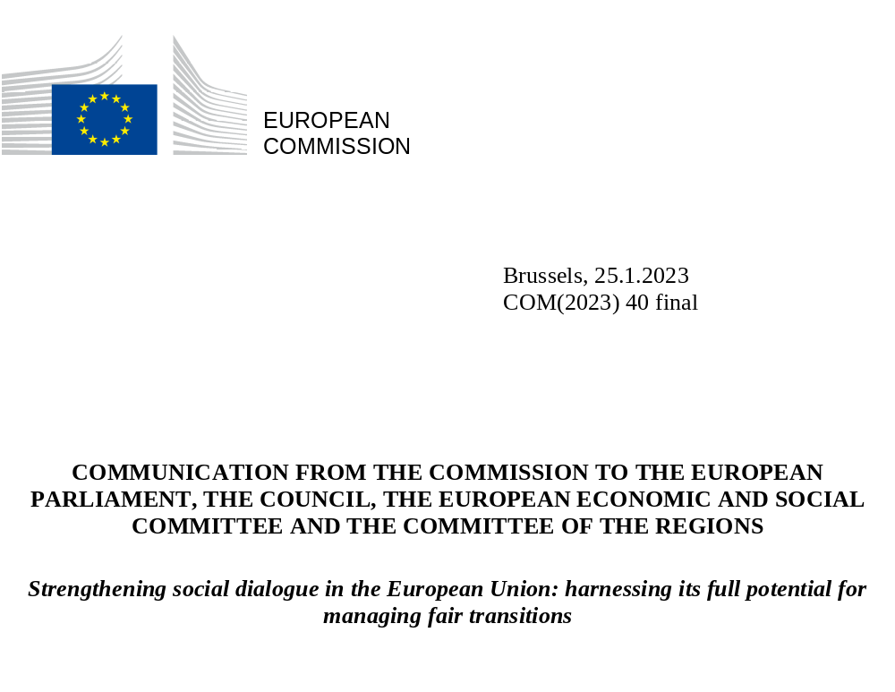

INTRODUCTION
Social dialogue is a cornerstone of the European social model. One of the EU’s key objectives is to improve living and working conditions. Social dialogue and collective bargaining are fundamental ways of doing this, contributing to higher productivity while also ensuring social fairness, a quality working environment and democracy at work. A strong social Europe requires strong social partners. Social dialogue is therefore one of the key principles of the European Pillar for Social Rights.
Strong social partners are essential for effective and balanced change management. Climate change, digitalisation and demographic trends are rapidly changing the world, including the world of work. COVID-19 has accelerated some of these changes. Social dialogue is fundamental for finding balanced ways of dealing with the changes in the world of work. Across the EU, social dialogue was at the forefront of the design and implementation of policies limiting the impacts of the pandemic. At the level of sectors and companies, social partners quickly established new occupational health and safety (OSH) protocols or implemented training. At national level, they supported authorities in financially assisting workers and companies. Social partners also play a key role in tackling the far-reaching impacts of the Russian war of aggression against Ukraine, by facilitating labour market integration of displaced people from Ukraine, as well as other refugees and migrants, and finding sustainable solutions to adjusting wages and collective agreements in response to the cost of living crisis and high levels of inflation.
Social partners’ involvement improves policy-making and law-making. Social partners have unrivalled knowledge and experience of the employment and social situation ‘on the ground’. Their input can strike the right balance between workers’ and employers’ interests and improve the acceptability and effectiveness of policy and legislation. Social partners have a unique role compared to other stakeholders. The Treaty (Article 154 TFEU) obliges the Commission to consult social partners on proposals in the social policy field (i.e. falling under Article 153 TFEU), so as to allow social partners to negotiate agreements, if they so wish. Agreements of social partners can be implemented by means of EU law (Article 155 TFEU). Structured dialogues at EU level are regularly organised with the social partners in the context of the European Semester of economic and employment policy coordination at all key moments in the cycle.
The EU promotes the role of social partners and urges better social dialogue. Promoting social dialogue is a common objective of the EU and its Member States, taking into account the diversity of national systems and respecting the autonomy of social partners. More needs to be done both nationally and at EU level to support collective bargaining coverage and build the capacity of, encourage the involvement of and safeguard the autonomy of social partners. The Commission announced in the European Pillar of Social Rights Action Plan of March 2021 that it would present an initiative to support national and EU social dialogue following consultations with the social partners. Strengthened social dialogue at all levels was also urged at the highest political level with the Porto Social Commitment signed by the Portuguese Presidency of the Council of the EU, the European Parliament, the European Commission, social partners, and the Social Platform. The social dialogue initiative, also mentioned in the Commission Communication “Conference on the Future of Europe, Putting Vision into Concrete Action” of June 2022, makes a significant contribution to the follow-up to the Conference.
This Commission Communication sets out a number of concrete measures to further strengthen EU social dialogue and is accompanied by a proposal for a Council Recommendation on how to strengthen national social dialogue and collective bargaining. The Commission has prepared this initiative with the close involvement of the social partners and has also held exchanges with the European Parliament, the European Economic and Social Committee and the Committee of the Regions.

NATIONAL SOCIAL DIALOGUE
Social dialogue arrangements and processes vary across Member States: in terms of collective labour relations, the role of collective bargaining in determining working conditions, organisations’ capacity and membership, the formal structures for the involvement of social partners in policy-making and implementation, as well as their political importance. Member States’ collective bargaining systems also vary in their degree of centralisation or decentralisation.
Most Member States have one or more formal national social dialogue structures in place where representatives of employers, trade unions and the government can discuss general economic and social matters. The role and powers of these bodies vary widely, but they usually play an advisory and consultative role on draft legislation and policies, especially in employment-related areas, and can sometimes provide a forum for the negotiation of agreements. Many Member States also have tripartite bodies that deal with specific issues, such as social security, employment, training, and health and safety at work. Productive tripartite social dialogue, involving public authorities, is contingent on strong bipartite social dialogue.
Social dialogue is under pressure to deliver in the changing world of work. While employer density (share of employers who are members of employers’ organisations) has remained relatively stable, trade union density has diminished (on average) across all Member States. The shift of economic activity from manufacturing to private sector services and the changing world of work make it difficult for trade unions and employers’ organisations to recruit new members. Many workers active in most of the newer forms of employment, including a rising number of self-employed people, are not represented. The same applies to workers on fixed term contracts who are increasing in numbers but less likely to unionise. The flexibility in terms of the time at which the work is done, and where it’s done, makes it difficult for workers’ representatives to organise such a fragmented workforce. In recent years, social partners’ organisations have taken initiatives to attract new members or to give more of a say to certain underrepresented groups (notably, youth and platform workers) through targeted strategies and recruitment efforts and by creating specific structures within the organisations. In terms of gender equality, the proportion of women in trade unions varies strongly across the EU, with a general trend of a growing number of women members, despite the reduction in trade union membership overall. Women remain underrepresented in leadership positions.
The share of workers covered by collective agreements has declined significantly in the past 30 years. It decreased from an estimated EU average of about 66% in 2000 to about 56% in 2019 with particularly big drops in central and eastern Europe [Graph 1]. Across Member States, a broad move towards the decentralisation of bargaining towards company level has been observed. According to the Organisation for Economic Co-operation and Development (OECD), collective bargaining coverage is high (above 50%) only in countries with at least some form of sectoral bargaining. In countries where bargaining takes place predominantly at company level, collective bargaining coverage is typically low. Coordination across sectors and bargaining units as well as the level of coordination are particularly important dimensions of collective bargaining.
The degree and quality of involvement of social partners in policy-making vary considerably among Member States. Although the quality of the involvement of social partners has remained stable over the past few years in most Member States, their timely and meaningful involvement varies greatly from country to country. Part of the reasons for this is the different institutional settings, procedures and practices. In particular, the quality and effectiveness of social dialogue in Member States is assessed by the Employment Committee in its annual “Social Dialogue review”. The latest conclusions endorsed by the Council in June 2022 stress, amongst other, the importance of allocating sufficient time for consultations throughout the policymaking process, ensuring adequate institutional frameworks, and addressing issues related to capacity building and the declining coverage of collective bargaining. The European Parliament also stressed that strong collective bargaining systems increase the resilience of the Member States in times of economic crisis and that Member States should take measures to promote high trade union density and reverse the decline in collective bargaining coverage.

Graph 1: Collective bargaining coverage in the EU, 2000-2019
Number of employees covered by the collective agreement, divided by the total number of wage and salary-earners (in %, 2000 and 2019).
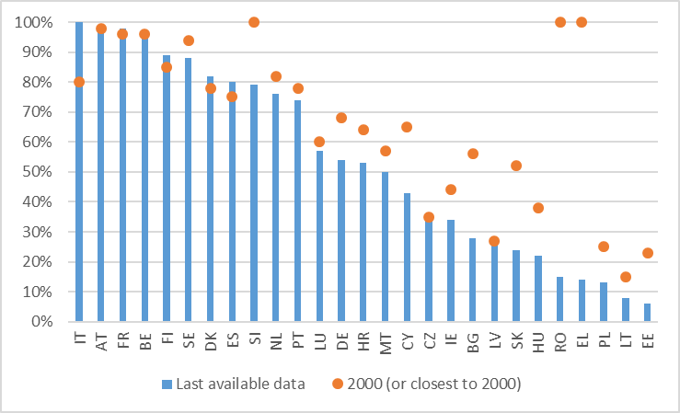
Note: (1) Latest available data is from: 2019 (AT, BE, CZ, HU, IT, LT, NL, PL, PT), 2018 (BG, DE, DK, ES, FR, LU, LV, SE), 2017 (EL, FI, IE, SI, RO), 2016 (CY, MT), 2015 (SK) and 2014 (HR). (2) For IT the coverage has been revised to 100% reflecting the fact that the base wages fixed in collective agreements are used by labour courts as a reference for the application of the constitutional principle of commensurate and sufficient remuneration. The 100% level of collective bargaining coverage in RO and EL in 2000 are explained by the existence of mechanisms extending collective agreements to all companies while the drop results mainly as a consequence of abolishing those extension mechanisms and other changes leading to decentralisation of collective bargaining.
Source: For 2000 or closest - ICTWSS database, Version 6.1, University of Amsterdam. Variable AdjCov (# 111). For latest available data - OECD/AIAS database (2021)
The EU has a number of instruments aiming at strengthening national social dialogue. The Minimum Wage Directive requires Member States to take action to help social partners to develop their capacity to engage in collective bargaining on wage setting, and to encourage constructive, meaningful and informed wage negotiations. The Directive also asks Member States where collective bargaining coverage does not reach at least 80% of workers, to put in place an enabling framework for collective bargaining and an action plan to promote it. Ongoing technological shifts and increasing automation are fast manifesting themselves as restructuring throughout the economy. In this context, the 2013 EU quality framework for restructuring helps companies anticipate change and mitigate the employment and social effects of restructuring. A comprehensive framework of Directives on the information and consultation of workers, at both national and transnational levels, also establishes rules to protect the rights of workers at company level, in particular at times of restructuring. The European Parliament is considering a resolution with recommendations to the Commission on the revision of the European Works Councils Directive. The EU public procurement Directives require Member States to respect the right to organise and collective bargaining following the ILO Convention 87 on Freedom of Association and the Protection of the Right to Organise and ILO Convention 98 on the Right to Organise and Collective Bargaining.
The Commission proposal for a Directive on improving the working conditions of platform workers strives for strengthening social dialogue in the platform economy, including by granting new information and consultation rights on algorithmic management and requiring digital labour platforms to create the possibility for people doing platform work to contact and communicate with each other and their representatives. The recent guidelines on the application of EU competition law to collective agreements by solo self-employed persons clarify the circumstances in which certain solo self-employed people can negotiate collectively to improve their working conditions without breaching EU competition rules. The involvement of social partners in designing and implementing social and employment policies and reforms has also been acknowledged and further encouraged in the employment guidelines.
Over the past few years, social dialogue has become more important in the European Semester with the result that a number country specific recommendations have been issued in relation to the involvement of national social partners in policy-making. In the 2023 Annual Sustainable Growth Survey, the Commission reiterates the importance of an inclusive process and the timely involvement of social partners in economic and employment policy coordination and implementation at European and national level, including at all the relevant stages of the European Semester, many of which are also relevant for the implementation of the Recovery and Resilience Facility (RRF). The 2023 Commission proposal for a Joint Employment Report underlines how predictable, meaningful and timely involvement of social partners plays an important role to ensure that reforms and investment are designed and implemented effectively. The Commission regularly stresses the importance of stakeholder involvement in its dealings with all Member States. The Commission will use the existing European Semester forums to keep social partners informed of and involved in the RRF implementation.
The EU has been supporting social partners improve their membership basis and administrative capacities. In a number of Member States, social partners lack capacity preventing them from effectively participating in social dialogue. Social partners’ capacity was highlighted as a challenge for 10 countries in the 2019 European Semester country reports and for additional four countries in 2020. Capacity building is first and foremost a task for social partners themselves to accomplish. However, public authorities have a key role to play by providing technical, financial and other support.
The European Social Fund Plus (ESF+) requires Member States to whom a country specific recommendation on social dialogue has been addressed to spend at least 0.25% of the funds on supporting the capacity-building of social partners and/or NGOs, while all other Member States must allocate an appropriate amount of ESF+ resources to this area. The Commission is facilitating the programming of ESF+ for the capacity building of national social partners. It is also promoting mutual learning and the sharing of good practices across Member States including through the prerogative budget lines for social dialogue.
The efforts to address the challenges outlined above need to be redoubled at national level to harness all the benefits of social dialogue. EU action can help Member States promote social dialogue and support social partners, but it is not enough on its own. The challenges social partners are facing, including the declining trends in collective agreements and the varying quality of social dialogue from one Member States to another, can only be tackled through action at national level. In addition to the instruments presented above, the Commission will support Member States in implementing Principle 8 of the European Pillar of Social Rights by presenting a Council Recommendation on social dialogue. This proposed Recommendation, once adopted, will provide Member States with guidance on how best to promote social dialogue and strengthen collective bargaining. The promotion of social dialogue and collective bargaining is also important in the context of the ongoing enlargement negotiations as candidate countries need to strengthen their social dialogue structures and processes to meet the challenges the changing world of work gives rise to.
Commission proposal for a Council Recommendation
- The Commission proposes a Council Recommendation to support the continued implementation of Principle 8 of the European Pillar of Social Rights by Member States. The proposal recommends that Member States ensure there is an enabling environment for tripartite and bipartite social dialogue, including collective bargaining that respects the fundamental rights of freedom of association and collective bargaining; promotes strong, independent workers’ and employers’ organisations, includes measures to strengthen their capacity ; ensures access to the relevant information needed in order to participate in social dialogue; promotes engagement in social dialogue on the part of all parties; adapts to the digital age, promotes collective bargaining in the new world of work and a fair and just transition towards climate neutrality; and ensures appropriate institutional support.
- The Commission will regularly take stock of the implementation of the Recommendation by Member States in consultation with the relevant social partners and the Member States, to assess progress immediately following its implementation date. This will complement the regular and well-established consultation and involvement of social partners as part of the yearly European Semester process.

SOCIAL DIALOGUE AT EU LEVEL
The Treaty on the Functioning of the European Union (TFEU) fully recognises the key role of social partners in a social market economy, conferring on them a specific role in EU law-making in the social policy field. The possibility the Treaty provides to put social partner agreements into practice in EU law confirms the importance of EU social dialogue and the special status of representative social partners. In applying these provisions, it is essential to respect the autonomy and roles of social partners and the EU institutions. Their role is also recognised through the tripartite nature of three EU Agencies (Eurofound, the European Centre for the Development of Vocational Training and the European Agency for Safety and Health at Work) and through the tripartite Advisory Committees in the area of safety and health at work, on free movement of workers, social security coordination and vocational training.
In 2015, the Commission launched a New Start for Social Dialogue together with the European social partners. The European social partners, the Commission and the Council subsequently signed a Joint Statement on the New Start for Social Dialogue. As part of the follow up, the Commission strengthened the role of European social partners in the European Semester by consulting them at key points in the process, getting them more involved in policy-making and law-making by introducing new forms of social partner consultations. It is also giving more emphasis to the capacity-building of national social partners, including through increased funding, as social dialogue at EU level cannot deliver without a well-functioning and effective national social dialogue.
The framework for EU social dialogue has become a strong framework for both bilateral and tripartite negotiations and consultations. However, it is crucial that the framework is regularly updated to ensure that social partners can fully contribute to rising to economic and social challenges. It is time to take stock of the progress made following the New Start for Social Dialogue and look at ways of better harnessing the potential of European social dialogue. The Commission, based on its consultations with the social partners, proposes a set of measures to strengthen European social dialogue by modernising its structures, encouraging and supporting social partner agreements, strengthening the involvement of social partners in EU policymaking and making the Commission’s financial and technical support more effective.

Social dialogue structures
Cross-industry level
European social dialogue has well-established cross-industry structures in place. The Tripartite Social Summit for Growth and Employment ensures a biannual concertation between the Council, the Commission, and European-level social partners. The Macroeconomic Dialogue provides a forum for the Council, the Commission, the European Central Bank and the Eurogroup to exchange views on monetary and budgetary policies and wage developments with European social partners. In recent years, the Employment Committee (EMCO) has also organised several seminars with European and relevant national social partners to discuss topics of particular importance to them (for example skills, COVID-19 related measures or job transitions) on top of the traditional yearly Social Dialogue review. The Social Protection Committee (SPC) regularly involves social partners in its discussions (for example on pensions, long-term care or access to social protection). The Social Dialogue Committee, organised by the Commission, is the main forum for cross-industry social dialogue among European cross-industry social partner organisations.
While these fora enable a comprehensive bipartite and tripartite EU dialogue, recent experience of developing better tools to deal with rapid labour market and social changes has brought into focus a complementary need for more in-depth tripartite dialogue on employment and social matters. This need has been strongly emphasised by social partners in the consultation process.
The Commission will:
- invite the Employment Committee and Social Protection Committee to organise regular tripartite exchanges on relevant topics with the participation of European and national social partners.
- In the context of the Social Dialogue Committee meetings and in agreement with social partners, organise on relevant topics (for example on labour and skills shortages or just transition) ad-hoc/extraordinary tripartite discussions involving European and national social partners and Member State representatives.

Sectoral level
EU sectoral social dialogue covers more than 80% of the EU workforce. The 43 Sectoral Social Dialogue Committees consist of 65 European employers’ organisations and 15 European trade union federations and represent approximately 185 million workers and over 6 million firms across the EU. They discuss and agree on how to improve working conditions and industrial relations in their respective sectors and are consulted on developments at EU level with social and employment implications. Besides agreements, each year European sectoral social partners adopt between 30 and 50 joint outcome positions on a wide range of topics, such as health and safety at work, working conditions, the impacts of the transition to climate neutrality, digitalisation, skills, labour mobility or gender equality. High coverage of workers and companies gives the committees legitimacy and ensures that joint outcomes such as autonomous agreements have a real impact in terms of implementation. Despite big differences among sectors, the committees have provided a common social dialogue framework at EU level.
This framework has developed over time in response to the need for the social partners to influence and contribute to greater EU integration. Social partners may however appear or disappear in any given sector. For example, new operators such as low-cost companies in civil aviation, new companies in postal services or private social services providers have appeared in recent years. To better react to sectoral developments and the changing world of work, committees should strive to be inclusive, maintain and increase representativeness. They should also increase the relevance of sectoral social dialogue, including by getting national social partner organisations involved and co-operating with sectors/segments not yet represented or covered in European sectoral social dialogue.
The Commission, together with sectoral social partners, will engage in the modernisation of the framework for EU sectoral social dialogue to enhance its relevance and effectiveness and examine whether a revision of the Commission Decision 98/500/EC on the establishment of Sectoral Dialogue Committees promoting dialogue between the social partners at European level is necessary.
Environmental commitments affect the organisation of meetings. In line with the recent Commission Communication on “Greening the Commission”, the Commission has already started to organise a number of meetings in online or hybrid format. The Commission will continue to support the organisation of sectoral social dialogue meetings. It doing so, it will, in cooperation with the social partners, develop a new and greener approach to organising them.
The Commission will, in close cooperation with social partners:
- modernise the legal framework for Sectoral Social Dialogue Committees through a possible revision of the relevant Commission Decision;
- within the current structure of the Sectoral Social Dialogue Committees, facilitate synergies between existing committees, promote the inclusion of new segments of economic sectors in them subject to the fulfilment of the relevant criteria, and adjust the approach for conducting representativeness studies in cooperation with Eurofound;
- launch a process to review how Sectoral Social Dialogue Committee meetings are organised;
- continue to explore the modalities for the setting up of a new sectoral social dialogue for social services at EU level.
The Commission calls on social partners to:
- continue efforts and assess the need for further actions in their respective social dialogues to make contact with affiliates in Member States not yet covered in the respective Sectoral Social Dialogue Committees, to improve the membership and representativeness of both trade unions and employers’ organisations;
- Promote the inclusion of all relevant representative European social partner organisations in the existing and new committees.

Supporting social partner agreements
Social partner agreements are one of the most important outcomes of EU social dialogue. To date, social partners have concluded six autonomous cross-industry agreements. Aside the autonomous agreements, between 1995 and 2010, four cross-industry social partner agreements were implemented through EU law. However, in the last decade the European cross-industry social partners have not negotiated any new agreements to be implemented through EU law. The Commission welcomes the new 2022-2024 work programme of the European cross-industry social partners and the on-going negotiation of a new agreement on telework and the right to disconnect intended to be implemented through EU law. At sectoral level, eight social partner agreements were turned into EU law between 1999 and 2018 and five autonomous agreements were developed by national social partners between 1999 and 2021.
The recent judgements of the European Court of Justice (ECJ) clarify the framework for implementing social partner agreement through EU law. The judgements entail that, following a joint request of social partners for their agreement to be implemented at EU level, the Commission determines on a case-by-case basis whether it is appropriate to submit a proposal to the Council, implementing that agreement at EU level as a Directive. While an agreement is being negotiated, social partners may act freely and the Commission must refrain from any conduct aimed at influencing the course of the negotiations or the content of the envisaged agreement.
The Commission will, as a priority, continue to promote social partner agreements. To this end, the Commission services will support the negotiation of social partner agreements by providing, at social partners’ request, administrative support and legal advice, notably on matters that could have a negative impact on the implementation of an agreement by means of EU law (for example any possible misalignment with the scope of the Treaty or overlaps with existing legislation). This legal advice, provided on a best-effort basis, will not prejudge the final Commission position on whether to submit the agreement to Council.
As confirmed by the judgement of the Court of 21 September 2021 (Case C-928/19 P), on receiving a request from social partners to implement a social partner agreement through EU law, the Commission will assess the agreement’s legality and the signatory parties’ representativeness, as well as the appropriateness of implementing the agreement through EU law, by looking at economic, social and political aspects among other considerations. An impact assessment may be conducted in this context. The Commission recognises social partners’ knowledge on the possible impacts their agreement could have on businesses and workers.
The Commission services will inform the respective social partners within 3 months of their preliminary considerations, possibly including whether or not there will be an impact assessment. The Commission will take a final decision depending on the complexity of the assessment of the proposed agreement taking into account the requirements of the recent jurisprudence of the Court of Justice.
The Commission will also continue to promote other joint social partner outcomes such as framework of actions, mutual learning or guidance documents and to encourage European social partners to continuously develop and follow up on new ones in response to emerging challenges.
The Commission will:
- provide European social partners, at their request and during their negotiations on social partner agreements whose implementation through EU law is envisaged, with administrative support and legal advice;
- strengthen the emphasis for projects that support the implementation of autonomous social partner agreements in future social dialogue calls for project proposals.
The Commission calls on European social partners to:
- negotiate and conclude more social partner agreements;
- ensure that they have a mandate from their national affiliates allowing them to enter into negotiations on social partner agreements;
- continue to involve their respective members in joint and separate capacity building actions and projects aimed at ensuring the implementation of their autonomous framework agreements in all Member States.

Strengthening social partners’ involvement in EU policy-making
The Commission consults all 87 recognised European social partners on possible EU legislative action in the social policy area covered by Article 153 TFEU (for example working conditions, occupational safety and health, information and consultation of workers, workers’ social security and social protection, gender equality in employment). These two-stage consultations have kept a steady pace over the past 10 years and have all been conducted in writing. In some areas, such as the setting of occupational limit values for carcinogens, mutagens and reprotoxins, social partners are extensively consulted using specific structures such as the Tripartite Advisory Committee on Safety and Health at Work. In such cases, and in agreement with European social partners, the two-stage consultation could be done through meetings with all social partners concerned, in fulfilment of all Treaty obligations.
Since the New Start for Social Dialogue, the Commission has introduced dedicated hearings as a new way of consulting European social partners on initiatives for which the Treaty does not require a two-stage consultation. The dedicated hearings have demonstrated their usefulness and are important forums for both the Commission and social partners to exchange views on upcoming policy initiatives. The number of dedicated hearings has increased over time with their coverage extending to policy areas other than employment and social matters under Article 153 TFEU (for example sustainable corporate governance, pay transparency, the European care strategy, the sustainable and smart mobility strategy and prohibiting products made by forced labour on the EU market). Moreover, the Sectoral Social Dialogue Committees are consulted on EU developments that have social implications for their respective sectors.
Ensuring the proper format and timing of such consultations is important to avoid lost opportunities in getting quality input into consultations for the Commission. This is why there is a need for a better understanding of social dialogue across the Commission and a more coherent approach to involving and consulting social partners. A better overview of the planning of upcoming proposals in the Commission work programme would help the social partners to prepare their input and activities.
Moreover, the Commission cooperates with social partners on specific topics on a regular basis. Through the European Partnership for Integration, for example, the Commission and European social and economic partners aim to promote a multi-stakeholder approach to the labour market integration of refugees and other migrants. Social partners also contribute to deliberations on legal migration in the new Labour Migration Platform.

The Commission will:
- assign the role of Social Dialogue Coordinator in each Commission service;
- through the responsible Members of the College, gather the views of the European cross-industry social partners on policy priorities ahead of the Commission Work Programme, as part of the regular dialogue.
The Commission calls on social partners to:
- provide more joint outcome positions ahead of the relevant Commission proposals.

Making financial and technical support more effective
The special role of social partners and the Treaty-based character of European social dialogue is recognised in the EU’s budget. Through this budget, the Commission supports European and national social partners’ projects, as well as research on industrial relations. The Commission also finances and organises the meetings of the Social Dialogue Committee, the 43 Sectoral Social Dialogue Committees and well as the consultation hearings.
The EU is supporting important research on social dialogue and collective bargaining. Industrial relations and social dialogue are among the strategic priorities of Eurofound 2021-2024 multiannual work programme. Eurofound provides comparative information on national social dialogue and collective bargaining processes and outcomes; reports on the functioning of tripartite social dialogue and social partners’ involvement in national policymaking; provides data on working time and wage setting and analyses the role of social dialogue in the context of restructuring, the impacts of the transition to climate neutrality and digitalisation. The Commission is also running a joint project with the OECD to support the development of the OECD/AIAS database on the Institutional Characteristics of Trade Unions, Wage Setting, State Intervention and Social Pacts. The project provides comprehensive, comparable information on the evolving nature and scope of collective bargaining in OECD and EU countries. Furthermore, the Commission is co-financing every year a number of European research projects on collective bargaining under its call for proposals to improve the expertise in the field of industrial relations.
There is a need for better information sharing and nurturing of the social dialogue culture. The Commission maintains a publicly available database on the outcomes jointly agreed by the European social partners and provides online information on the 40-50 social dialogue projects funded every year. Despite this, there is limited information about the impact of European social dialogue at national level and about the follow-up by national social partners to outcomes agreed at European level. Most EU social dialogue outcomes do not contain implementation provisions. Their implementation is not monitored, followed up or analysed. Furthermore, in some Member States, the social dialogue culture is comparatively weak due to national and local traditions that have affected how social dialogue has developed. Awareness of EU policies and labour market institutions among national social partners also varies across Member States and social partner organisations, and could be strengthened through targeted information actions with a capacity-building purpose. This could include a pilot information and visiting programme targeted to young social partners leaders.
The Commission will:
- set up, in cooperation with social partners, a research network for analysing and promoting EU social dialogue and to following its implementation;
- support European social partners to improve awareness of EU policies and labour market institutions among their member organisations.
The Commission calls on social partners:
- to give greater visibility to the outcomes of European social dialogue and the results of EU projects and ensure that the results are widely disseminated to their members and beyond.

PROMOTING SOCIAL DIALOGUE INTERNATIONALLY
The EU is leading by example promoting social dialogue internationally. It does so through regular collaboration meetings with the International Labour Organization, the OECD or other international organisations or bodies both at political and at technical levels. The EU and its Member States actively support global partnerships that promote social dialogue, including through the Global Deal initiative. In the context of the EU enlargement policy, the Commission also supports projects aimed at improving social dialogue in candidate countries or potential candidates and participates in exchanges of best practice at various levels. In the context of the European Neighbourhood policy, the Commission is funding regional programmes aimed at enhancing social dialogue and is organising the Union for the Mediterranean Social Dialogue Forum with social partners from both sides of the Mediterranean. Through international partnerships and with the EU’s value-based offer for partner countries, the Global Gateway, the EU upholds high standards of human, social, and workers’ rights, and the promotion of social dialogue supports ensuring that this cooperation benefits the whole of society.
In February 2022, the Commission adopted its Communication on Decent Work Worldwide reaffirming the EU’s commitment to striving to ensure decent work in the EU and around the world. The EU supports the universal concept of decent work as developed by the ILO and as reflected in the UN Sustainable Development Goals. Social dialogue and tripartism are one of the four elements of the universal concept of decent work. Freedom of association and the effective recognition of the right to collective bargaining are among the core labour standards set out in the 1998 ILO Declaration on Fundamental Principles and Rights at Work, and are part of the commitments in EU Free Trade Agreements and in the EU Generalised Scheme of Preferences Plus.
All Member States have ratified the core international standards of the ILO relevant to social dialogue. The Council, supported by the Commission, encourages Member States to continue to ratify and effectively implement ILO Conventions. It also calls on the Member States and the Commission to improve social dialogue at all levels and in all its forms, including through cross-border cooperation and by promoting international framework agreements to ensure the active participation of social partners in shaping the future of work and helping to bring about social progress, particularly through the effective recognition of the right to collective bargaining.
The Commission will:
- continue to call on Member States to ratify and effectively implement ILO Conventions, and promoting them internationally;
- in cooperation with the ILO launch a project to support social partners in EU Sectoral Social Dialogue Committees, at their request, in conducting activities on responsible supply chains, including respect for labour rights.
The Commission calls on social partners:
- to continue to promote social dialogue internationally at all levels.

See also the Report on strengthening EU social dialogue of special advisor Andrea Nahles, available online.
COM (2021) 102 final, available online.
Porto Social Commitment of 7 May 2022, available online.
COM(2022) 404 final, Annex, available online
Eurofound (2021), available online.
Available online.
European Parliament resolution of 11 March 2021 on the ‘European Semester for economic policy coordination: Employment and Social Aspects in the Annual Sustainable Growth Strategy 2021’, available online.
Directive (EU) 2022/2041, available online.
COM/2013/0882 final, available online.
Directive 1998/59/EC, Directive 2001/23/EC, Directive 2002/14/EC and Directive 2009/38/EC.
Directive 2014/24/EU , Directive 2014/25/EU and Directive 2014/23/EU.
COM(2021) 762 final, available online.
C/2022/6846 available online.
Eurofound (2020), available online.
Regulation (EU) 2021/1057, available online
Joint Statement on the New Start for Social Dialogue (2016), available online.
Article 152 TFEU and Council Decision 2016/1859, available online.
Outcomes available online.
See Eurofound (2019), available online
Commission Decision 98/500/EC, available online.
See C(2022)2230 final
Directives 96/34/EC, 97/81/EC, 1999/70/EC and 2010/18/EU.
Directives 1999/63/EC, 2000/79/EC, 2005/47/EC, 2009/13/EC, 2010/32/EU, 2014/112/EU, 2017/159/EU and 2018/131/EU.
Judgment of the Court of 14 October 2019, C-928/19, and Judgement of the General Court of 21 September 2021, C‑928/19 P.
Directive 2004/37/EC on the protection of workers from the risks related to the exposure to carcinogens, mutagens or reprotoxic substances at work, available online
Information available online.
COM(2022) 66 final, available online.
Council Conclusions of 24 October 2019, on “The future of work: the EU promoting the ILO Centenary Declaration”

