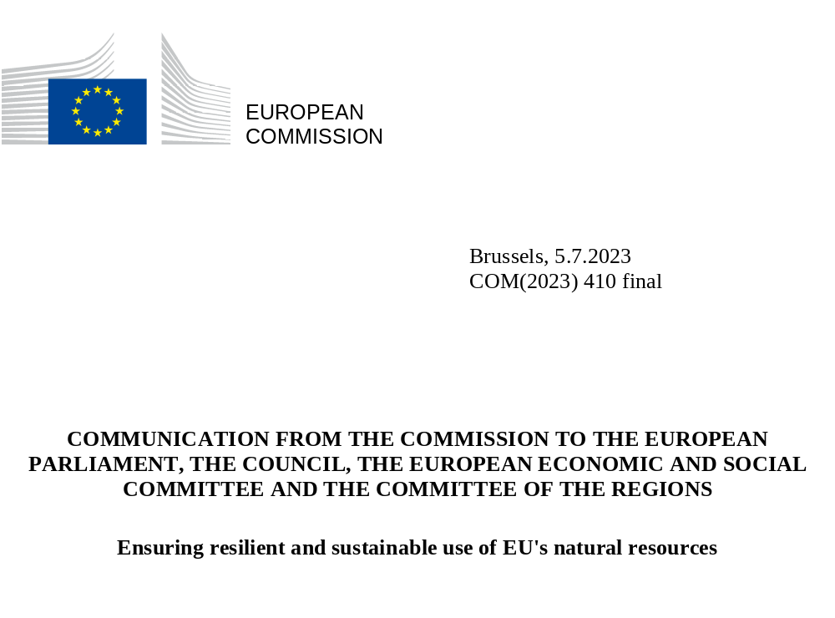

- Introduction
The European Green Deal is a must for the health of our people and planet. Since its presentation in December 2019, it has set in motion a deep and holistic transformation of our society and our economy. The already agreed and completed Fit for 55 initiatives and progress achieved on circular economy and zero pollution proposals pave the way towards meeting the European Union’s climate targets for 2030 and 2050.
These initiatives and their targets rely on solutions provided by nature, our best ally in the fight against climate change, as much as on new technologies and innovation. To uphold the European Union’s international commitments under both the Paris Agreement and the Kunming-Montreal Biodiversity Framework as well as in view of the 2030 Agenda for Sustainable Development, to ensure a transition to a sustainable economy and deliver on climate neutrality and adaptation, in particular to enhance carbon removals by natural sinks, and to deliver on the EU Climate Law, we must urgently restore and strengthen the resilience of natural ecosystems across the EU. We must increase their ability to help us adapt to climate change, improve preservation of water resources, and enhance their productive capacity to ensure lasting food and material security.
With droughts, wildfires water scarcity and flood risks rapidly increasing, and already tragically affecting three quarters of European countries, more progress is therefore needed on another pillar of the Green Deal: ensuring the sustainable use of the EU’s natural resources. This will also strengthen the resilience of European food and farming.
Unsustainable use of natural resources is one of the major drivers of the climate and biodiversity crises which, in turn, already costs thousands of lives and billions of euros in the EU alone. To secure a liveable and sustainable future for ourselves and for next generations, and to strengthen the EU’s resilience against disasters, healthy ecosystems are essential. The degradation and pollution of soils and weakened ecosystem resilience come at a cost for many sectors, especially agriculture, fisheries and the related value chains. In turn, loss of yields due to degraded environment, pollution, droughts, heatwaves, floods and new pests come at a cost to farmers, fishers and consequently to citizens in increased food prices.
With this package, the EU continues to respect its international commitments by paving the way for healthy soils in Europe by setting out a soil monitoring and resilience proposal which will allow us to monitor the health of soils and offer a range of support measures to bring them progressively to a healthy condition. As set out in the Farm to Fork Strategy, it also proposes a new regulatory framework for plant and forest reproductive material that will boost innovation and sustainable practices, leveraging technological progress in new genomic techniques to develop resilient plants and further enable the reduction of the use and the risk of chemical pesticides. Measures to prevent and reduce food and textiles waste will also contribute to a more efficient use of natural resources and further reduction of greenhouse gas emissions, as also set out in the Circular Economy Action Plan.
This package completes the previous Green Deal proposals already adopted, such as the Climate Law and the revised LULUCF Regulation, or those still in the co-decision process, such as the Nature Restoration Law, which is the flagship proposal of the Green Deal’s natural resource pillar and key to deliver on agreed international targets on biodiversity. This package is also tightly knit with proposals on the carbon removal certification, or the sustainable use of pesticides and those linked to zero pollution. Together, these proposals will enable the EU to steer and speed up the transition to a sustainable economy and society.
Taken together, these measures will bring long-term economic, social, health and environmental benefits to everyone. They will benefit in particular those living directly from land and nature, in the form of more resilient natural assets. This contributes to prosperous rural areas, food security, a resilient and thriving bioeconomy and protects against the consequences of climate change and biodiversity loss. By increasing the resilience and health of soils, these proposals can provide additional income opportunities for farmers and land managers, who can be rewarded for carbon farming, receive payments for ecosystem services or for increasing the value of healthy soils and food produced on them.

- Leveraging natural resources and improving soil health
Today’s reality is that the condition of EU soils is extremely worrying. 60 to 70% of soils in the EU are currently unhealthy. In addition, a billion tonnes of soil is washed away every year due to erosion, which means that the remaining fertile top layer is continuously reducing. Land take and soil sealing are also leading to an irreversible loss of the most fertile soils. The overall costs associated with soil degradation are estimated to exceed EUR 50 billion per year. Without proper action, these costs will only increase.
Droughts, floods, pest outbreaks, wildfires, and other climate-induced extreme weather events (including storms) have further degraded the health and resilience of our soils. Their frequency has increased over the last years. The extent of intense drought impacts is increasing in the EU indicating worsening ecosystem condition. Since 2000, eight years were above the long-term average in terms of drought impact, out of which five years were in the last decade. A tenth of Europe’s urban population is currently living in areas potentially at risk of flooding.
The last two wildfire seasons (2021 and 2022) have shown a worrying trend of higher-than-expected number of wildfires as well as larger areas of land burnt. The wildfire seasons are also starting earlier and ending later in the year. The last years have therefore seen more Member States having asked for support from other Member States through the Union Civil Protection Mechanism (UCPM) to extinguish fires, as they have deemed their own response resources insufficient.
Strengthening response capacities on fires, floods, soil erosion and droughts is however not sufficient. Improving soil health is an essential way forward to strengthen disaster prevention and management.
Managing droughts and water scarcity requires innovative approaches combining more traditional water and drought risk management responses with a focus on building larger ecosystem resilience. Healthy soils retain up to 25% of their mass in water, contributing to disaster risk prevention and acting as long-term reservoirs to refill groundwater bodies. The natural capacity of resilient soils, wetlands and forests to store water is higher than what could be achieved through costly new artificial reservoirs. Improved water retention can mitigate floods as well as droughts and make the environment more resilient to landslides and soil erosion. Overall, nature-based solutions for flood prevention, for instance, have high benefit-cost ratios. Healthy soils with a high-water infiltration rate also support the establishment of wildfire-preventing and -resistant vegetation cover.
In addition to helping prepare for the increasing effects of climate change, healthy soils are also the pre-condition for our own health, as well as for the health of many ecosystems. They form the basis for agricultural food production and for a sustainable bioeconomy. Since 95% of our food is directly or indirectly produced on soils, soil degradation has a direct impact on food security. Soils are also an essential source of raw materials indispensable to our green and digital transitions. Natural resources and the services provided by healthy ecosystems, including food production, are crucial to the viability of our economy and society. As degraded and polluted soils have a strongly reduced capacity to store carbon and to make nutrients naturally available to plants, further degradation of European soils would also make the achievement of European climate targets and Member States’ legal obligations under LULUCF more challenging. In parallel, degraded soils reduce the business case for carbon farming while healthy soils secure farmers’ incomes from food production, carbon farming as well as from the farm’s assets.
This is why it is so important that Member States authorities, farmers and other landowners develop and put into place the right soil management and regeneration measures in the right place. For this purpose the Soil Proposal puts in place a solid and coherent soil monitoring framework for all soils across the EU and to continuously improve soil health in the Union with the view to achieve healthy soils by 2050. The proposal builds on practices already supported by the Common Agricultural Policy and does not introduce any new obligations on farmers. The monitoring framework brings several sources of soil data under one roof, combining soil sampling data from the Land Use and Coverage Area frame Survey (LUCAS) with satellite data from Copernicus, data generated under the EU Mission ‘A Soil Deal for Europe’, as well as with national and private data.
This will facilitate Member States’ efforts in monitoring their commitments under LULUCF and national energy and climate plans, the Common Agricultural Policy as well as under the proposed Nature Restoration Law. It will contribute to the regular Zero Pollution Monitoring and Outlook and the Biodiversity Monitoring where, so far, soil data are not included at the same level as air and water data. At the same time, an accurate diagnosis across the EU will help Member States authorities, farmers and other landowners to develop and put into place the appropriate soil management and regeneration measures.
Soil data will also feed into the development and deployment of innovation, technological and organisational solutions in farming practices including crop diversification, precision farming, plant development, digitised soil management tools or the use of artificial intelligence solutions from sensing systems and field-based measuring systems. This will enable farmers to implement the most appropriate treatment method and assist them in maintaining and increasing soil fertility and yields, while minimising water and nutrient consumption. In addition, soil data allows an enhanced analysis of trends on droughts, water retention and erosion, contributing to disaster prevention and management.
The proposal also lays down sustainable management principles applicable to managed soils in Europe, including soils used in agriculture. It helps Member States to develop and define regenerative practices in an inclusive manner with farmers and other land managers.
Access to soil data is also crucial for foresters to maintain and enhance the ecological, socio-economic value of their forests. Forests and other wooded land cover close to half of the EU’s land surface and play a key role in supporting a strong forest-based bioeconomy, mitigating and adapting to climate change and preserving and restoring biodiversity. Forested land is the main contributor to the EU’s carbon sink. The importance of forests and their multiple functions is set to increase in the future, also as provider of raw material for the bioeconomy, with the extended forest-based value chains currently supporting 4.5 million jobs in the EU. However, climate change has caused significant tree dieback and temporary forest loss in many EU Member States in recent years. Economic impacts from forest fires have reached around 1.5 billion annually, while increasing temperatures are predicted to reduce the value of forest land by several hundred billion euros by the end of the century due to changes in species composition.
The uptake, large-scale development and success of new sustainable business models such as carbon farming based on carbon removal certification and payments for ecosystem services requires high-quality data, especially on soils. The voluntary certification of healthy soil is expected to increase the value of the carbon removal certificate and to provide further social and market recognition for sustainable soil management and related food products.
The benefits of fertile soils and recognition of measures to achieve this will also help boost private financing, as food industry and other business have already started putting in place programmes aimed at paying for ecosystem services and supporting sustainable practices related to soil health. Diversification of agricultural and forestry production systems, accompanied by a greater variety of marketable products, also provide opportunities for new jobs in the EU. Carbon farming initiatives can be financed via the Common Agricultural Policy, other EU funding instruments such as LIFE, and Horizon Europe, public funding such as State aid, private initiatives linked to carbon markets, or through a combination of these funding options.
Box 1. Reaping benefits from improved data and knowledge

- The soil proposal will enable farmers and foresters access independent and impartial advice on how to bring their soils to good health.
- All land managers will have (voluntary) access to soil health certification. This will have an impact on the value of land. It can be expected that healthy soils will hold a higher value, as they will be proven as more resilient to the effects of the climate change and volatility of weather. This is crucial for the land market, as well as for young and new farmers. Healthy soils produce healthy food, store more carbon regulate water and nutrient flows and support biodiversity. This can also be reflected by the market, for example in sustainable labelling or via carbon credits in the context of carbon removal certification.
- Soil data will enable farmers to account for the variety of soil conditions and therefore allowing them to implement the most appropriate treatment method: this will lead to increased fertility and yields, while minimising water, pesticide and fertilizer consumption.
- Soil pollution data are increasingly demanded by land property owners and affect the value of land in particular in cases where remediation is needed (e.g. from former industrial sites) before the land can be reused for other purposes (e.g. housing).
- Access to data will also facilitate technological development and innovation in agricultural areas such as precision farming, crop management and diversification, digitised soil management tools or the use of artificial intelligence solutions from sensing systems and field-based measuring systems.
- In addition, soil data could be used by Member States and the EU for an enhanced analysis of trends in droughts and floods, so contributing to a better disaster management and resilience.
- The EU Mission A Soil Deal for Europe is testing and scaling-up solutions for sustainable land and soil management in agriculture, forestry and other land uses to progress towards healthier soils and help to advance harmonised soil monitoring and reporting in Europe. Food is also one of the key systems addressed in the EU Mission on adaptation to climate change which ambitions to have at least 150 regions or local entities resilient to climate change by 2030.
- The European Biodiversity Partnership, the European Partnership Water Security for the Planet, the Sustainable Food Systems Partnership, the Partnership for Agroecology are concerted research and innovation initiatives, delivering concrete solutions to stakeholders that have to take action on food, water and biodiversity.

3. Supporting resilient and sustainable food systems
The double crisis of climate change and biodiversity loss has put the focus on long-term resilience and the need for a transition to sustainable agriculture and food systems. Scientific analysis shows clearly that climate change and biodiversity loss are among the biggest threats to food security globally. To ensure lasting food security, we need to make use of all solutions available.
As defined in the proposal for a Nature Restoration Law, restoring and enhancing biodiversity in agricultural ecosystems is urgent in order to ensure the transition to sustainable food systems and their long-term resilience. More than 75% of global food crops and almost €5 billion of the EU’s agricultural output rely on animal pollination. Scientific evidence indicates that, over the past 30 years, we have already lost more than three quarters of flying insects. Currently, one in three bee and butterfly species in the EU are in decline. Biodiverse and sustainably managed agricultural ecosystems are more resilient to climate change. To support the resilience of our agricultural ecosystems, we need to rely on a sustainable food production system. This requires healthy ecosystems that support soil fertility, nutrient cycling, climate and water regulation, pollination, and natural pest control.
Healthy biodiversity and functioning ecosystems make food systems, livelihoods and the society at large more resilient to shocks and stress. Ecosystems and habitats that facilitate biodiversity benefit the overall stability of crop production. A more sustainable agricultural production that it less dependent on fertilisers and chemicals/pesticides will make the sector less dependent on external inputs and more resilient in general, including to the inevitable impacts of climate change. This also applies to forestry, fishery and other sectors that depend on nature. Restored, more biodiverse ecosystems will be more resilient to external threats and to the impacts of climate change and natural disasters.
The CAP through eco-schemes, agri-environment-climate measures and green investment aid provide support for rolling out sustainable practices, such as agro-ecology and organic farming (EUR 97.6 billion for the period 2023-2027). In addition, the CAP provides for obligations and support for advisory services to be made available to farmers, and which are essential when undertaking major changes in the farming systems or implanting innovative or complex practices. In parallel, companies within and outside the food chain provide a fast-emerging variety of private funding for regenerative agriculture.
As a part of the necessary efforts towards greater sustainability, farmers need access to state of the art innovation. New technologies can help in boosting resilience for both agriculture and forested land and provide means to protect harvests from the effects of climate change, biodiversity loss and environmental degradation. As a consequence, there is significant demand by breeders and farmers in the EU and globally for better adapted varieties making best use of all types of breeding approaches including new genomic techniques.
New Genomic Techniques (NGT) have been developing rapidly in the last two decades. These innovative techniques can improve crops. Examples include plants with improved tolerance or resistance to plant diseases and pests, plants with improved tolerance or resistance to climate change effects, including extreme temperatures or droughts, improved nutrient and water-use efficiency in plants, and plants with higher yields. In most cases, applying these new techniques to plant breeding means that plants can be developed faster (e.g., whereas it may take a few years for a plant developed through New Genomic Techniques to reach the market, it may take 10-15 years for the same plant, bred by conventional breeding methods), cheaper and, especially, that the changes be more targeted and precise than by using conventional breeding or established genomic techniques. A modern set of rules can increase the competitiveness of EU agriculture, unlock EU research potential and deliver wider variety of food to consumers, while increasing global food security Plants based on New Genomic Techniques can also contribute to reducing the use and risk of pesticides, which is the aim of the proposal for a regulation on the sustainable use of plant protection products.
The proposal on New Genomic Techniques combines a high standard of protection for both human and animal health and the environment with a contribution to a resilient and sustainable food system through innovative plant products. The Commission’s proposal provides for requirements for the marketing of plants based on New Genomic Techniques and products which -to avoid unnecessary burden- take into account that, in some cases, New Genomic Techniques lead to plants and products that are comparable to those of conventional breeding, and in other cases they entail more complex modifications. It also puts forward clear rules to ensure transparency about plants and products obtained by New Genomic Techniques, including the labelling of seeds. This will provide farmers with a clear and informed choice. At the same time, this proposal is complementary to other sustainable farming methods, such as organic farming, which will not use New Genomic Techniques.
The proposed enabling framework will support the competitiveness of the European research, and diverse plant breeding and farming sectors. The European seed sector is the largest exporter in the global seed market (20% of the global market with an estimated value of EUR 7-10 billion with about 7000 SMEs, their long-term innovation capacity, competitiveness and production in the EU being crucial for the EU food security) and the ability to use innovative technologies is a prerequisite formaintaining the EU’s competitiveness and its continued contribution to global food security. Innovation will put the EU at the forefront of technological developments and global economic, social and environmental benefits generated by these new technologies. The proposal introduces a swift process for businesses that will either have to show that the plants based on New Genomic Techniques are equivalent to conventionally-bred plants, or undergo a proportionate and risk-based environmental and safety assessment, thus speeding up the availability of plants and products obtained from them, including food and feed, to the benefit of farmers and consumers.
Box 2. New genomic techniques – safe and sustainable food

Disease resistant potatoes

Fungal resistant potato varieties are difficult to breed because fungal diseases are severe and can overcome resistance. Due to the low availability of varieties with resistance, potatoes are among the crops that use most pesticides. New Genomic Techniques can support and speed up the breeding process to allow for a faster access to fungal resistant varieties.

Varieties with durable resistance to these diseases could reduce fungicide use without affecting yields. In potatoes, a 50-80% reduction of fungicide use may be reached, representing cost savings for farmers as well as an important environmental benefit. For instance, potatoes which are resistant to late blight disease are estimated to lead to 4 to 15% cost savings per hectare.

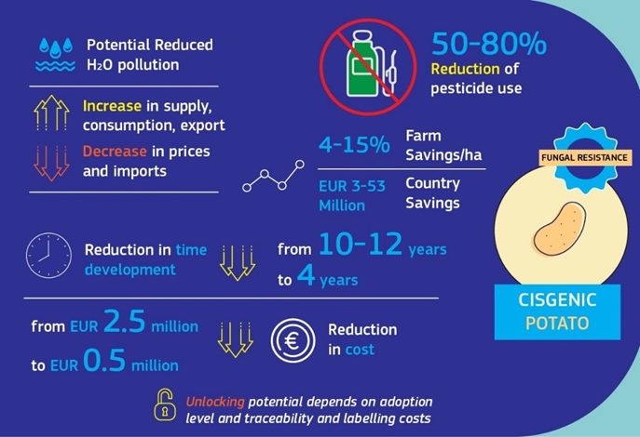

It is important for the legislative framework to be balanced and calibrated, ensuring farmers and breeders access to patented techniques and material, so as to promote seed diversity at affordable prices, and safeguard breeding and cultivation of unpatented conventional and organic crops, while also strongly supporting innovation in plant breeding by preserving investment incentives, such as patents. The Commission will assess, as part of a broader market analysis, the impact that the patenting of plants and related licensing and transparency practices may have on innovation in plant breeding, on breeders’ access to genetic material and techniques and on availability of seeds to farmers as well as the overall competitiveness of the EU biotech industry. The Commission will report on its findings by 2026. It will identify possible challenges in the sector and serve as basis to decide on any possible follow-up actions.
Together with today’s package, the Commission also addresses the Council’s request to submit a study complementing the impact assessment of the proposal for a Regulation on the sustainable use of plant protection products. The additional input shows that the proposal will help guarantee the EU’s long-term food and feed security. Building on the Commission’s 2022 non-paper, the reduced scope of restrictions in sensitive areas can help protect human health and the environment, whilst having a limited impact on agriculture. The additional input also suggests possible ways for the co-legislators to consider how to further reduce the administrative burden, particularly for very small farms, and stresses the importance of the availability of sufficient alternatives to chemical pesticides. Therefore, the Commission outlines possible options that co-legislators could consider, notably on setting shorter timelines for Member States to deliver draft assessment reports for new biocontrol active substances, allowing provisional authorisations at Member State level for biocontrol products and allowing approvals to be granted for an unlimited period of time at EU level for biocontrol active substances. This would mean that the current lengthy approval procedure would be substantially reduced and new biological alternatives could be deployed almost immediately, when Member States have completed the first assessment.
The proposed Regulation on the production and marketing of plant reproductive material will consolidate, update and simplify the existing legal framework regarding all sectors of seed by replacing the 10 existing Directives. It will give farmers access to diverse, high-quality seeds and other plant reproductive material that guarantee stable yields, resilience and other traits by resilient plant varieties through reinforced sustainability requirements in variety testing (e.g. disease resistance) for all regulated crop groups. Seeds derived from such varieties will be better adapted to the pressures of climate change and help ensure food security. The proposal will contribute to reaching 25% of agricultural land under organic farming by facilitating the registration of organic varieties through rules adjusted to the principles of organic farming. The proposal will help conserve and enhance the genetic diversity of cultivated crops by introducing lighter rules on conservation varieties, seed conservation networks and exchange in kinds of seeds between farmers and support the development of mixtures of seeds. It will also increase efficiency and efficacy of the registration/certification systems by providing more flexibility to the operators and enabling the use of bio-molecular techniques and digitalisation.
The proposal for a Regulation on the production and marketing of forest reproductive material will help ensure that the right tree is planted in the right place for forests to thrive under current and projected future climatic conditions. Assessment of sustainability characteristics of parent trees allows speeding up climate change adaptation of forests, thus ensuring their continued productivity in the future. Rules to facilitate the conservation of endangered forest genetic resources will enhance the genetic diversity of trees. National contingency plans will help ensure sufficient supply of forest reproductive material to reforest areas affected by extreme weather events, fires, pest outbreaks and other disasters. The regulation provides flexibility to apply specific approaches and actions in different types of forests and forest ecosystems and contributes to creating resilient forests, conserve biodiversity and restore forest ecosystems. It also supports the conservation and sustainable use of forest genetic resources.
4. Ensuring efficient use of produce by tackling food and textile waste
Food waste is one of the largest sources of inefficiency and puts an unnecessary burden on limited natural resources, such as land and water use. Nearly 59 million tonnes of food (131 kg/inhabitant) are wasted in the EU each year with estimated market value of EUR 132 billion. Over half of food waste (53%) is generated by households, followed by the processing and manufacturing sector (20%). It is also simply unacceptable to waste food at this scale while hunger is on the rise globally and 32.6 million EU citizens cannot afford a proper meal every second day.
Fighting food waste is a triple win: it saves food for human consumption and thereby contributes to food security. It helps companies and consumers to save money, and it lowers the environmental impact of food production and consumption.
Despite the growing awareness of the negative consequences of food waste, the full potential of food waste reduction is not yet realised. The proposed food waste reduction targets for EU Member States support their commitment as part of the global UN Sustainable Development Goals to move towards halving food waste at the retail and consumer levels by 2030. The targets will galvanise efforts towards the development of increasingly sustainable food system. In order to ensure common and shared responsibility across the EU, the proposal for food waste reduction sets the same target for each Member State whilst leaving to each of them to take the most effective measures, tailored to its specific national situation, supported by initiatives to share best practices and results achieved such as the EU Platform on Food Losses and Food Waste. Further to the legislative proposal, the Commission is publishing today a compendium of solutions to help all actors prevent food waste at consumer level . The compendium responds to recommendations from the recently convened citizens’ panels organised to support consumer behavioural change. Food waste reduction targets are expected to deliver significant environmental benefits and financial savings for consumers (ca. €400/household/year).
To address the hotspots of food waste generation in the EU and to accelerate Member States’ progress towards the global ambition, the specific food waste reduction targets are differentiated across the food chain and based on the latest scientific evidence. Continuous data collection will allow to track and review progress and to make any necessary adjustments, taking into account Member States’ progress over time. This will support a robust EU contribution towards SDG Target 12.3 by 2030 and will inform the ambition for further progress beyond that date.
Textile waste also puts an unnecessary burden on limited natural resources. Around 78% of the textiles waste is not separately collected by consumers and ends up in mixed household waste, destined to be incinerated or landfilled. This resource-inefficient waste management is not in line with the circular economy objectives and leads to environmental harm in the EU and in third countries, including in developing countries and among vulnerable populations, through excessive levels of GHG emissions, water consumption, pollution and land use. The proposed rules on the introduction of extended producer responsibility for textiles, and on ensuring the proper management of textile waste aim to implement the polluter-pays principle, promote the circular economy for textiles and boost value-creating activities with the important potential to create local jobs. These rules will enhance the market for second-hand textiles, supporting the many social economy enterprises active in it, and stimulate innovation in textiles recycling. Increasing the availability of used clothes will create cost-saving opportunities for citizens in the EU and beyond, while also saving on natural resources. Harmonised rules on extended producer responsibility will also facilitate the proper functioning of the single market and support Member States in implementing the obligation to collect textiles separately as of 2025 in a coherent way, so as to ensure a level playing field for economic operators.

- Conclusions
The consequences of the climate and biodiversity crises are becoming increasingly visible, also in the European Union. They already affect nearly every citizen and every sector of the economy. As they are closely linked, action is needed on both - climate change and biodiversity loss are two sides of the same coin. While important progress has been made on climate legislation, the same is necessary on the Commission’s legislative proposals on the sustainable use of the EU’s natural resources, which has benefits at the same time for climate mitigation, adaptation and for biodiversity.
The legislative proposals presented today are necessary to uphold the EU’s commitment to climate neutrality, as the climate and natural resources pillars of the European Green Deal are complementary to each other. They also constitute an important building block to ensure long-term food security for European citizens. Today’s proposal on soil, for instance, will help to deliver on the commitment to increase natural carbon sinks’ absorption capacity under LULUCF as well as on the targets set by the Nature Restoration Law and the European Climate Law, both flagship proposals under the climate and natural resources pillar of the Green Deal. Only healthy soils can store carbon and provide thriving terrestrial ecosystems that are more resilient to droughts, floods, heatwaves, and other climate-related weather extremes, thus contributing to the EU overall resilience. Only healthy natural resources have the capacity to ensure our path towards climate neutrality. The proposed monitoring framework and the relevant data are essential to tailor consequent restoration measures according to local needs. At the same time, this proposal is key to facilitating the monitoring requitements under LULUCF and the CAP. It also complements the proposal for carbon removal certification. Healthy soils will increase the amount of stored carbon and therefore the value of the related carbon credits, boosting farmers’ incomes.
Altogether, the proposals already made under the European Green Deal’s natural resources pillar, as completed by today’s package, are necessary to deliver on the EU’s legal obligations under already adopted climate legislation, as well as on the EU’s multilateral commitments within the Kunming-Montreal Biodiversity Framework as the EU continues to work in cooperation with its partner countries towards a sustainable future. The Commission therefore calls on the European Parliament and the Council for the swift adoption of the initiatives under this pillar of the Green Deal.

Joint Research Centre – European Drought Observatory
Between 1980 and 2021, weather- and climate-related damages amounted to an estimated EUR 560 billion (2021 values). It is of concern that over the last ten years, weather- and climate related damages have continued to increase steadily. A single event like the 2021 flooding in Germany and Belgium can cause almost EUR 50 billion in damages.
Drivers of Food Security, Commission Staff Working Document SWD (2023) 4
https://www.eea.europa.eu/ims/drought-impact-on-ecosystems-in-europe
“What the future has in Store: A new Paradigm for Water Storage”, The World Bank, 2023.
“Economics for Prevention and Preparedness: Investment in Disaster Risk management in Europe makes Economic Sense”, The World Bank report, 2021, Summary report, p. 14.
Overview - Land cover/use statistics - Eurostat (europa.eu)
Soil health and food (europa.eu)
Zero pollution targets (europa.eu)
Proposal for a Regulation of the European Parliament and of the Council on the sustainable use of plant protection products and amending Regulation (EU) 2021/2115, COM (2022)305 final, 2022/0196 (COD)
Ragonnaud G., 2013. The EU seed and Plant Reproductive Material Market in Perspective: A Focus on Companies and Market Shares. Policy Department B: Structural and Cohesion Policies. European Parliament Committee on Agriculture and Rural Development.
Schneider, K., Barreiro-Hurle, J., Kessel, G. et al., 2023. Economic and environmental impacts of disease resistant crops developed with cisgenesis. EUR 31355, Publication office of the European Union, Luxembourg. https://doi.org/10.2760/715646
Food waste and food waste prevention - estimates - Statistics Explained (europa.eu)
European Consumer Food Waste Forum | Knowledge for policy (europa.eu)
ECP1_Citizens Recommendations_EN_final.pdf (europa.eu).

