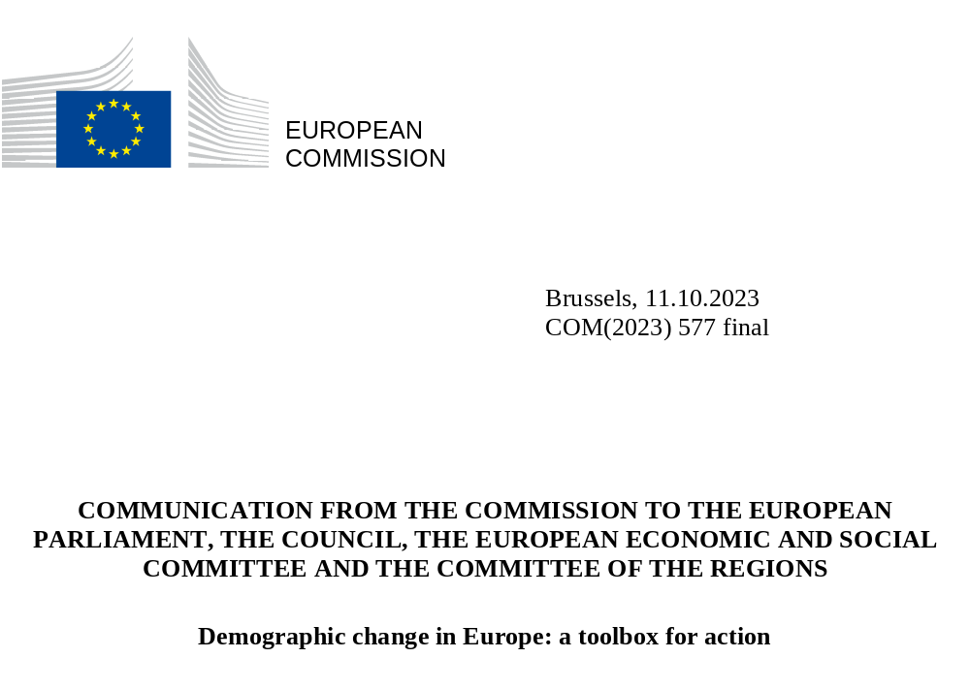

INTRODUCTION
People across Europe live longer, healthier lives. Life expectancy has risen thanks to Europe’s broad-based social and economic progress over the past decades, including improved living standards, access to education and training, and advances in healthcare and medicine. As life expectancy increases, Europe needs to build a ‘longevity society’ that values the longer lifetime spent in older age, empowers older citizens, and nurtures the welfare and well-being of present and future generations alike.
However, demographic change has a direct impact on the EU’s human capital and its competitiveness. Population ageing and a shrinking working-age population are expected to exacerbate labour shortages and increase pressure on public budgets. Population ageing is also likely to have a profound impact on investment, productivity and entrepreneurial activity. In addition, demographic change affects the social, territorial, and inter-generational cohesion of our democratic societies as some Member States and regions are more affected than others.
In its conclusions of June 2023, the European Council called for a toolbox to address demographic challenges and notably their impact on Europe’s competitive edge. Citizens expect joint action by the EU and their national governments to manage demographic change and its impacts. Relevant policies should be guided by the principles of gender equality and intergenerational fairness, be grounded in local realities accounting for rural and remote regions, and embrace other global mega-trends, such as the green and digital transitions. The scale of the task calls for a coordinated whole-of-government approach involving all actors in the economy and society in a democratic and inclusive manner. Tackled in this way, demographic trends can be managed to strengthen Europe’s resilience overall, as highlighted by EU citizens in the context of the Conference on the Future of Europe.
Demographic change is primarily determined by life choices that individuals and families make. However, EU and national policies should help ensure that people in Europe can fulfil their aspirations. To this end, public policies and support at the relevant level should be adjusted with a view to:
- better reconciling family aspirations and paid work, notably by ensuring access to quality childcare and work-life balance, with a view to fostering gender equality;
- supporting and empowering younger generations to thrive, develop their skills, facilitate their access to the labour market and to affordable housing;
- empowering older generations and sustaining their welfare, through reforms combined with appropriate labour market and workplace policies;
- where necessary, helping to fill labour shortages through managed legal migration in full complementarity to harnessing talents from within the Union.
EU tools - regulatory instruments, policy frameworks and funding - should be effectively combined with national and regional policies to empower and support all generations, to realise their life choices and their potential in the economy and society at large.

DEMOGRAPHIC CHANGE IS RESHAPING OUR ECONOMIES AND SOCIETIES
In the coming years, the shrinking and continued ageing of the EU population risks negatively impacting the EU’s long-term competitiveness. Globally, the world population is projected to grow throughout the 21st century and ageing will be an increasingly important demographic trend worldwide. The direction and pace of demographic change varies across countries and a large share of global population growth is projected to take place in low-income countries. Within the EU, due to ageing and declining birth rates, the population will peak around 2026 and gradually shrink over the coming decades. The EU’s working-age population is projected to decline (by 57.4 million until 2100) and the old-age dependency ratio to increase (from 33% to 60% by 2100). As a result of these trends, the EU’s share in the world’s population will continue to fall (from 6% today to below 4% in 2070), potentially scaling down the relative weight of the Single Market in the global economy and diminishing the EU’s geopolitical clout.
  - Estimated and projected share of world population BY CONTINENT, 1960-2100 (in %)
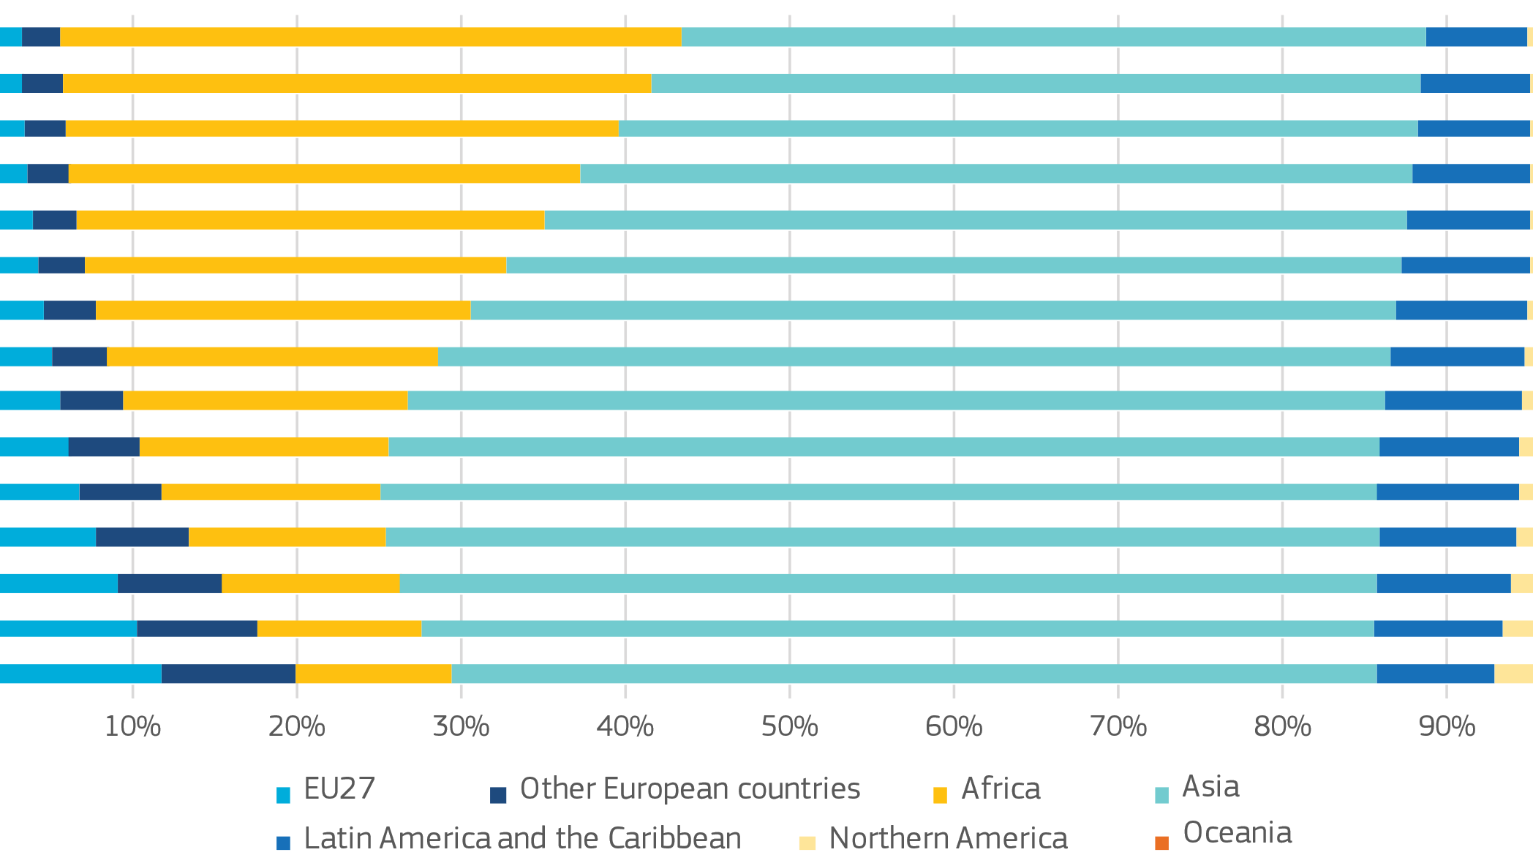
Demographic change - if left unaddressed - may further exacerbate labour shortages, creating bottlenecks in the economy. Already at present, labour shortages in the EU are at record levels, with the declining working-age population being one of several diverse factors. There is notably high demand for professionals in STEM (science, technology, engineering, mathematics), ICT (information and communications technology), construction and care, and transportation (notably truck and coach drivers) in several Member States and regions. As the ‘baby boomers’ (those born between the mid-1940s to the mid-1960s) retire until the mid-2030s, shortages in both high- and low- skilled occupations are projected to rise considerably in the absence of offsetting trends. Labour activation and wage increases in occupations particularly affected may dampen labour shortages. However, if not supported by productivity increases, rising labour costs may also impact EU firms’ competitiveness vis-à-vis competitors in other major economies.
Demographic change can create new opportunities in various sectors, but also adds to certain risks of strategic dependencies. Europe’s ageing population raises the potential of the ‘silver economy’ to a projected 28.1% of EU GDP in 2025. In a ‘longevity society’, opportunities emerge in diverse sectors and areas, such as technology, health and care, medicine, nutrition and well-being, education and lifelong learning, transport and financial services, and the social economy. Demographic changes are also having an impact on access to certain critical medicines, by raising demand for medicines tailored to age-related conditions and geriatric care, thus influencing pharmaceutical R&D priorities. In addition, labour shortages may hamper ambitions to increase local production.
Demographic change aggravates the productivity challenge. Higher productivity, partly driven by innovation and automation (e.g. the use of robotics, artificial intelligence), as well as accumulating wages linked to those developments may offer a ‘longevity dividend’ that helps counterbalance the decline of the working-age population. However, continuous productivity increases may prove challenging, in particular as older generations’ lower savings rates channel resources towards consumption rather than productive investment. Older workers are also potentially more concerned by a need to update their skills. Moreover, population ageing reduces entrepreneurial activity as the older age cohorts are less likely to start a new business and the intergenerational transfer of business becomes more complex and less frequent.
How do Europeans see demographic change and its consequences?
According to new survey results from Eurobarometer, 7 in 10 Europeans agree that demographic trends put at risk the EU’s long-term economic prosperity and competitiveness.
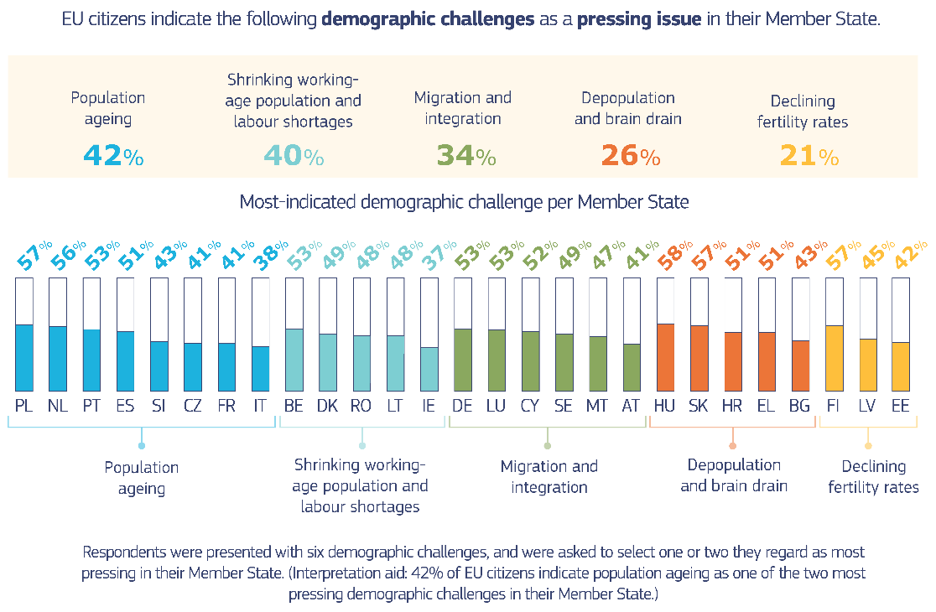
The majority of Europeans (51%) think that managing demographic change should remain a political priority, both for the EU and Member States, and a large majority – 85% – agrees that this requires close cooperation between all levels of government.
Asked about policy solutions, citizens’ preferred measures addressing population ageing are to ensure adequate pensions that remain affordable for future generations (49%), as well as providing high-quality and affordable health care services (49%). In the labour market, citizens consider actions addressing youth unemployment as most effective (61%), followed by work-life balance policies (48%).
An ageing population puts more pressure on public budgets. The decline in the working-age population exerts downward pressure on revenues from personal income taxes and social security contributions. Conversely, as the population grows older, expenditure on healthcare, long-term care and pensions is projected to rise from 24.6% of GDP in 2019 to almost 27% in 2040. As a consequence, the pressure on public budgets may reduce the fiscal space available for investment in other policy priorities, such as the green and digital transitions. In addition, an ageing society needs investment in adapted mobility and infrastructure solutions which can benefit the whole population and be carried out in a green and digital-friendly manner.
The EU’s demographic transformation interacts with other global mega-trends, such as the green and digital transitions. Carbon emissions are closely linked to the level of income, but also to the age profile of consumers. While consuming less in absolute terms, older people tend to live in smaller households and have higher energy consumption needs, resulting in more emissions per capita. They are also more represented in rural areas where dependence on car use is higher. As the share of older people in the population is increasing, it is estimated that by 2060 up to 39% of emissions will be generated by people above 65 years of age. At the same time, climate change and air pollution have detrimental impacts on mortality and morbidity of the population, particularly affecting more vulnerable groups including older persons. The climate crisis and degradation of the environment can also play a role in choices whether or not to have children. In the context of the digital transition, technology can make health and long-term care more cost-effective and improve access to and quality of services, including in rural and remote regions and for people with a disability or reduced mobility. Yet, poor digital infrastructure and low levels of digital skills can exacerbate divides between regions, groups and generations.
  - Population developments, 2021-2050
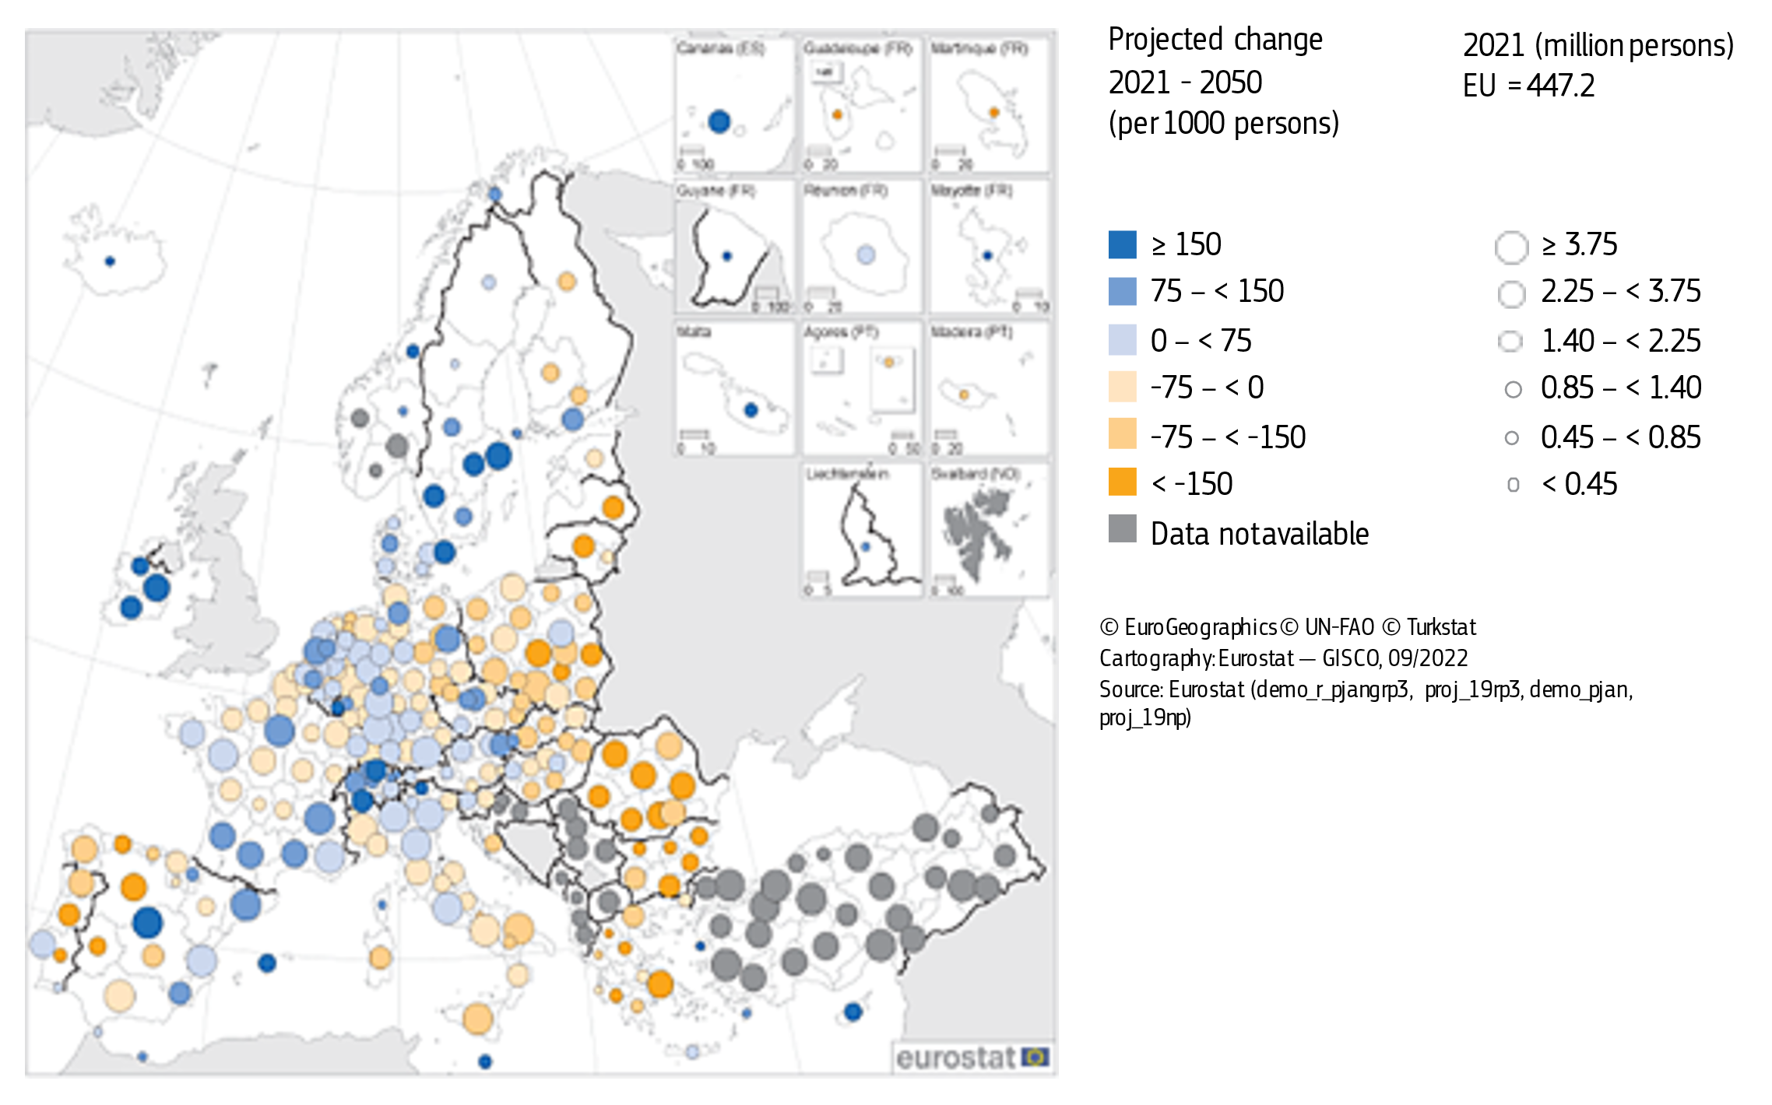
Territorial disparities are at risk of increasing within and between Member States. Some regions are faced with the combined challenges of population ageing, a low and stagnant share of people with tertiary education, and outward migration of the young and educated. This risks putting them in a talent development trap, limiting their capacity to build sustainable, competitive and knowledge-based economies. As a result of demographic shifts and structural transformations, many less developed and rural regions increasingly face labour and skills shortages as well as low regional competitiveness and ability to attract investment, with urban-rural divides in some countries. Such territorial disparities also undermine social cohesion and trust in democratic institutions and processes in Europe.

POLICY TOOLS: ADDRESSING AND MANAGING DEMOGRAPHIC CHANGE
Policy makers at all levels need to create an environment that enables people across the Union to realise their life choices and to reconcile family and professional lives. Complementing these efforts, legal migration and the effective integration of third country nationals legally residing in the EU can help alleviate labour market pressures and provide an additional boost to innovation and entrepreneurship. A comprehensive set of EU policy tools is already available to support Member States in managing demographic change and its impacts. The ‘toolbox’ presented in this Communication builds on best and promising practices from across the Union and complements national-level action. It recognises the need to take on board the territorial dimension of demographic shifts, specifically in regions that experience the phenomenon of population decline and a significant outward mobility of young workers (‘brain drain’).
  - A comprehensive approach to demographic change
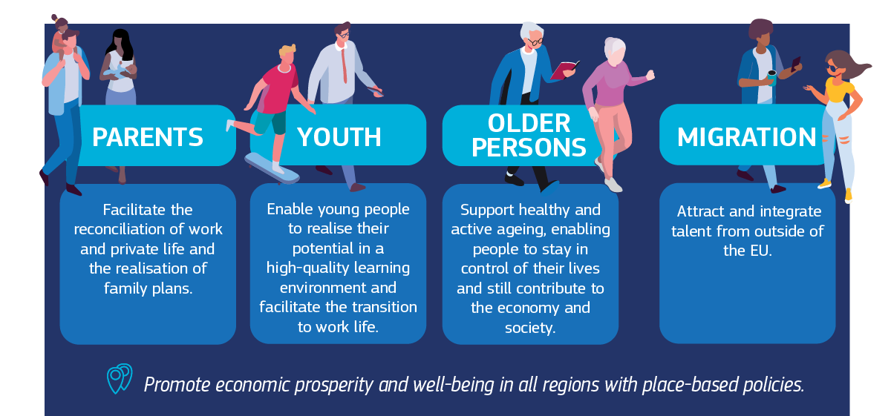

Reconciling family aspirations and paid work
Everyone should be supported to be able to choose both a career and a family. The choice to have children is a personal one. However, quality of life, availability of care and housing, as well as work opportunities and adequate income may shape these choices. There is a growing trend of young people to postpone the decision to start a family or limit its size. Yet, when asked, many of them, particularly highly educated women, indicate they would want to have more children than they actually do. Key elements explaining the gap between actual and desired family size include the difficulty to reconcile work and care responsibilities and persistent gender inequalities, as well as economic and social insecurity linked to employment prospects, the cost of living and housing.
  - Women’s Employment rates & Fertility Rates in the EU

To achieve the EU’s employment rate target for 2030, we must strive to at least halve the gender employment gap compared to 2019. Increasing women’s labour participation could be one of the most effective remedies to the negative consequences of population ageing. Despite improvements in the last decades, women’s participation in the labour market still falls short of that of men. In the EU, the employment rate of women remains 10.7 percentage points below that of men and shows significant variations across Member States (ranging from 20.1 percentage points in Romania to 1.4 pp in Lithuania). Some Member States – such as Sweden and Denmark – manage to have relatively high employment rates above 75% among women (together with below-average gender employment gaps), while their fertility rates also rank relatively high in EU comparison. However, women in almost all Member States, including the ones mentioned above, work part-time more often than men, and the gender pay gap remains sizeable, in particular for women with children, with considerable differences between Member States.
Unpaid care responsibilities keep an estimated 7.7 million women in the EU from joining the labour market. By comparison, only 450 000 men are estimated to be concerned in this regard. The labour market participation of mothers with infants has even deteriorated over the past two decades, often impacting their career and incomes for years. The intensity of care matters too: only 35% of informal carers who provide more than 40 hours of care per week are employed (vs 71% of those providing less than 10 hours). Women remain strongly under-represented in many shortage occupations, such as ICT. This exacerbates labour shortages and the old-age dependency ratio, with fewer people economically active both today and tomorrow. Further increases in the need for care due to ageing may affect women disproportionately as the burden of informal care is still distributed unequally.
Affordable, accessible and good quality childcare enables parents to reconcile paid work and family life. The EU Strategy on the rights of the child stressed that access to inclusive, non-segregated, quality education should be guaranteed. In 2022, only over one third of children under the age of three (35.7%) in the EU received formal early childhood education and care (ECEC), with significant differences within and between countries, and considerably lower participation rates for children in disadvantaged situations. Only nine Member States have reached the revised 2030 Barcelona target of 45% participation rate in ECEC. Only in Denmark is near full-time childcare a reality for a majority of all children aged less than three. Expanding affordable and good quality care services, as for instance done significantly in the RRP of Portugal, can have a positive effect on women’s employment, especially in countries with currently low labour market participation rates of women and low shares of formal care provision. Rural and remote regions with a low availability of care services would benefit substantially from an expansion of social infrastructure. In turn, accessible, affordable and good quality childcare enables parents to raise a family while remaining active to make an independent income and pursue their careers.
Croatia in its Recovery and Resilience Plan aims to expand ECEC by investing about EUR 215 million. It aims to guarantee all children older than four a place in ECEC while also creating 22,500 new places through investments in construction and renovations, thus reducing regional inequalities.
  - Chidren in formal childcare
(% share of children aged less than three years)
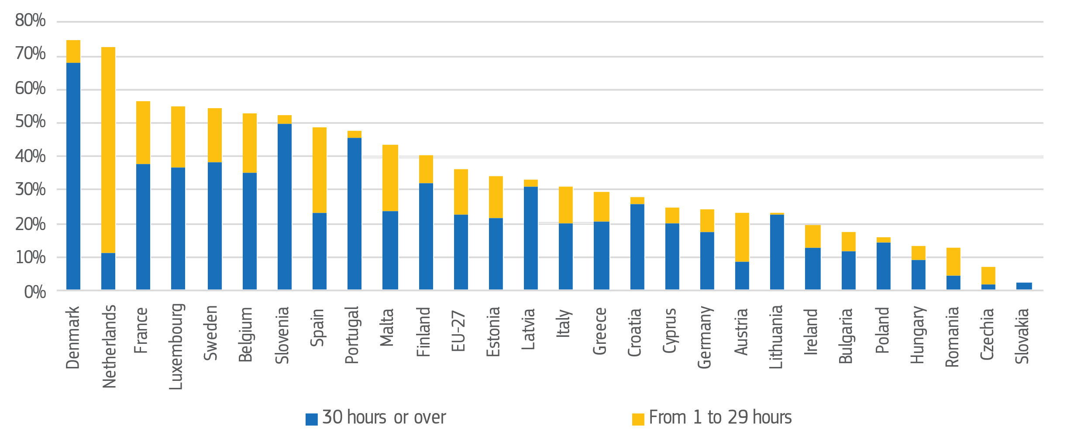
Flexible working arrangements and work-life balance policies can lighten the care burden for women. Experiences gained across Member States shows that various measures can have long-lasting effects on rebalancing the burden of care between parents, including flexible work patterns, adequate leave rights, in particular paternity leave and non-transferable well-compensated parental leave, in combination with measures raising their uptake. Fathers in the EU are entitled to at least 10 days of compensated paternity leave and four months of compensated parental leave, but these rights have been transposed in different ways so far. For instance, Spain and Finland offer comparatively high durations of paternity leave. Yet, the uptake of parental leave by fathers remains generally low. Carers’ leave, as provided generously in the Netherlands for example, can also help those with caring responsibilities for other dependent relatives to stay in the labour market. Flexible work arrangements can help align working time with family responsibilities, including with part-time work balanced well between genders. Capitalising on telework, where possible and under the right conditions, can also contribute to better reconciling family with working life.
Targeted tax and benefit reforms can make sure that work pays off. On average, a low-paid single mother who takes up a job in the EU loses about two-thirds of her gross employment earnings, due to a combination of childcare costs, withdrawn benefits and taxes. Well-designed tax-benefit systems ensure that both individuals and families are financially better off when taking up paid work, for instance by removing tax disincentives for second earners. Cutting personal income taxation or introducing/extending income tax credits for those on low incomes can contribute to bringing people into paid employment, while preserving progressivity of direct taxation to safeguard the financing of social protection and public investment. Child benefits may temporarily support family formation. It is however important to ensure that their design is targeted and does not disincentivise the uptake of paid work by women, as for instance addressed by Finland’s ‘flexible care allowance’.
Key EU-level tools:
- The Work-Life Balance Directive introduced the right to compensated paternity leave, compensated parental leave, a right to carers’ leave, and a right to request flexible working arrangements for all working parents (of children up to at least 8 years).
- Further legal protections include, notably, the Pregnant Workers Directive (right to minimum maternity leave and protection against dismissal during leave) and the Directive on equal opportunities and equal treatment of men and women in matters of employment and occupation (protection against dismissal during paternity and adoption leave).
- The Council Recommendation on early childhood education and care encourages Member States to increase participation in these services by establishing ambitious targets and supports the delivery of quality, affordable and accessible services, with specific attention to the inclusion of children from disadvantaged backgrounds.
- The ‘Women in Digital’ Declaration commits Member States to boost participation of women in the digital landscape, working with the public and private sectors and civil society to achieve equality in tech.
Key next steps:
- The review of the Work-Life Balance Directive in 2027 will provide an opportunity to assess whether the rules still fit the evolving working practices.
- In the context of its Gender Equality Strategy, the Commission will organise a Work-life balance rights campaign to raise awareness of working parents and carers about their rights and launch a call under the Citizenship, Equality, Rights and Values programme on projects aimed at promoting family-friendly working time arrangements and recognising the value of care.
- By June 2024, Member States are expected to inform the Commission of the measures implemented or planned under the Council Recommendation on early childhood education and care to meet the 2030 targets agreed.

Supporting and empowering younger generations to thrive
The potential of young people in Europe is yet to be fully realised. In 2022, more than one in ten young people aged 15 to 29 in the EU were neither in employment nor education or training (NEET), including 13.1 % of young women, 20% of those born outside the EU and 56% of young Roma aged 16-24. This issue displays significant territorial disparities across the EU, with particularly high NEET rates found in southern and eastern EU regions, as well as in the outermost regions of France. In some of these regions, over one quarter of all young people were NEET. Young people from families with disadvantaged backgrounds, such as parents with low education levels, tend to perform worse in class and are at a greater risk of dropping out of school early. Being out of school and out of employment prevents young people from gaining experience and learning on-the-job, potentially affecting their long-term employment prospects. This deteriorates dependency ratios of the active, employed population relative to those outside of the labour force.
  - Young people (aged 15-29) neither in employment
nor in education and training, 2022
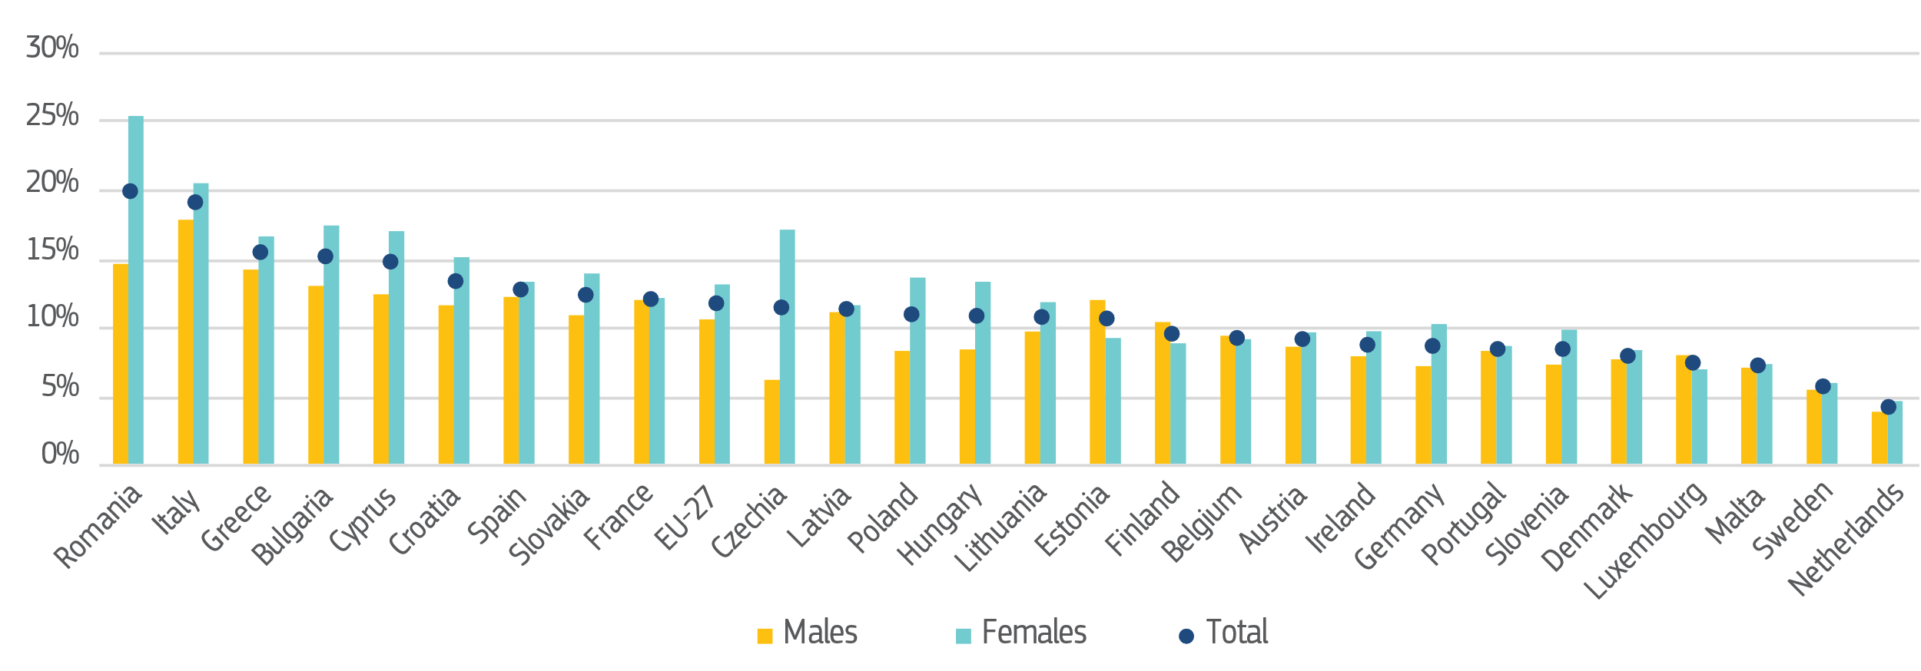Empowering youth starts by fostering a nurturing environment for all children. Children must be protected, supported and empowered. This is epecially important during the formative years of a child’s life. Together with supporting parents’ income, key policy solutions include guaranteeing access to inclusive, quality services for children, in particular early childhood education and care, basic education (including school-based activities), healthcare and nutrition. For instance, Bulgaria invests EUR 245 million from the Recovery and Resilience Facility (RRF) to modernise teaching tools and enhance the learning of STEM in schools through the establishment of a national and three regional STEM centres, as well as of more than 2 200 STEM laboratories and high-tech classrooms. Young people with diverse or multiple vulnerabilities, such as early school leavers or youth with disabilities or health problems, should receive tailored support.
Promoting young people’s access to quality jobs, affordable housing and decent living standards is crucial for their long-term prospects. Investments in education and training are essential for mobilising young people and equipping them with basic skills as well as future-proof skills, such as those needed for the green and digital transitions, as done in Italy with the ‘School 4.0’ initiative to transform 100,000 classrooms into innovative learning spaces. As underlined in the 2023 Strategic Foresight Report, to manage demographic change, the EU needs robust tools for granular forecasting of skills and workforce needs in key sectors. In addition, to smooth school-to-work transitions, an important role is played by outreach to youth, as done for instance by Slovenia with its local youth ‘ambassadors’ who inform their peers about possibilites under the Youth Guarantee, as well as quality traineeships and vocational education and training, including apprenticeships. Temporary learning mobility across regions and countries can enhance opportunities for young people. In addition to improving labour market integration, access to basic services (including to mental health services) and to affordable, energy-efficient housing determines the possibilities for young people to start a family. In Hungary, the Family Housing Subsidy is a non-refundable state subsidy for families raising at least one child, including same sex partnership couples, for buying or enlarging a flat or house. Families in smaller settlements are eligible for the Rural Family Housing Subsidy, to retain the population of rural areas. Regions in a ‘talent development trap’ (or at risk thereof) need targeted, place-based support for economic revitalisation, educational opportunities and better access to services and housing.
Key EU-level tools:
- In the context of the EU Strategy on the Rights of the Child, the European Child Guarantee aims to address social exclusion by guaranteeing children in need effective access to key services, including free early childhood education and care.
- The European Education Area sets seven targets for 2025 and 2030, including on ECEC participation, early school leaving, and underperformance of students.
- The Youth Employment Support package reinforces the Youth Guarantee, improving the labour market integration of young people, including by strengthening skills for the digital and green transitions.
- The Council Recommendation on vocational education and training (VET) aims at modernising VET and giving a renewed impetus for apprenticeships and the European Framework for Quality and Effective Apprenticeships.
- The ALMA (Aim, Learn, Master, Achieve) initiative is a cross-border youth mobility scheme to support young people and NEETs in integrating into the job market.
- The Digital Europe Programme supports specialised education programmes in the area of advanced digital skills as well as the build-up of digital skills for young people, particularly girls, for example through the EU Code Week.
- The Sustainable and Smart Mobility Strategy supports the development of smart mobility solutions that help prevent depopulation and allow young people to have access to basic services (health, education) and work opportunities.
- The Renovation Wave Strategy aims to double the annual energy renovation rates in the next 10 years. The Affordable Housing Initiative aims to improve access to affordable housing through local projects’ access to technical and innovation capacity.
- The Talent Booster Mechanism supports EU regions to train, retain and attract people and to address the impact of the demographic transition.
- The EU-OECD/INFE Financial Competence Framework for children and youth in the European Union aims to help improve their financial literacy to allow them to take decisions around money that are in their best interest, including later on in life.
Key next steps:
- In early 2024, the Commission will update the Quality Framework for Traineeships, which supports the transition of young people from education and unemployment into employment through quality traineeships.
- Under the European Child Guarantee, 24 Member States have submitted national action plans. Member States will report on their implementation progress every 2 years (starting in March 2024) and the Commission will review overall progress in 2026.
- In 2023, the European Education Area is undergoing a mid-term review reflection process to support implementation. In 2025, the Commission will publish a final report on the EEA.
- The Commission monitors progress towards the 2025 targets set in the European Skills Agenda.
- Recent Commission proposals for Council Recommendations, if agreed by Member States, will support national authorities and the education and training sector in providing high-quality, inclusive and accessible digital education and training to develop the digital skills of European citizens.

Empowering older generations and sustaining their welfare
In an ageing society, it is crucial to empower older workers to remain active for longer. The average employment rate of workers between 55 and 64 years of age has increased from 45% in 2011 to 60.5% in 2021. However, disparities between Member States in this area remain considerable, indicating that there is still room for improvement. Longer working lives can allow people to update skills on the job and remain active, helping employers to retain staff, while promoting knowledge transfers in multi-generational workforces. More flexible working time arrangements support the retention of older workers, for instance with flexible or reduced working hours, and enable people to remain longer in employment if they choose to. A workers’ right to request flexible work (as granted e.g. in Belgium, France, Germany, Netherlands) can contribute to a cultural change towards more inclusive working practices and workplaces.
  - Employment rates by age group (%)
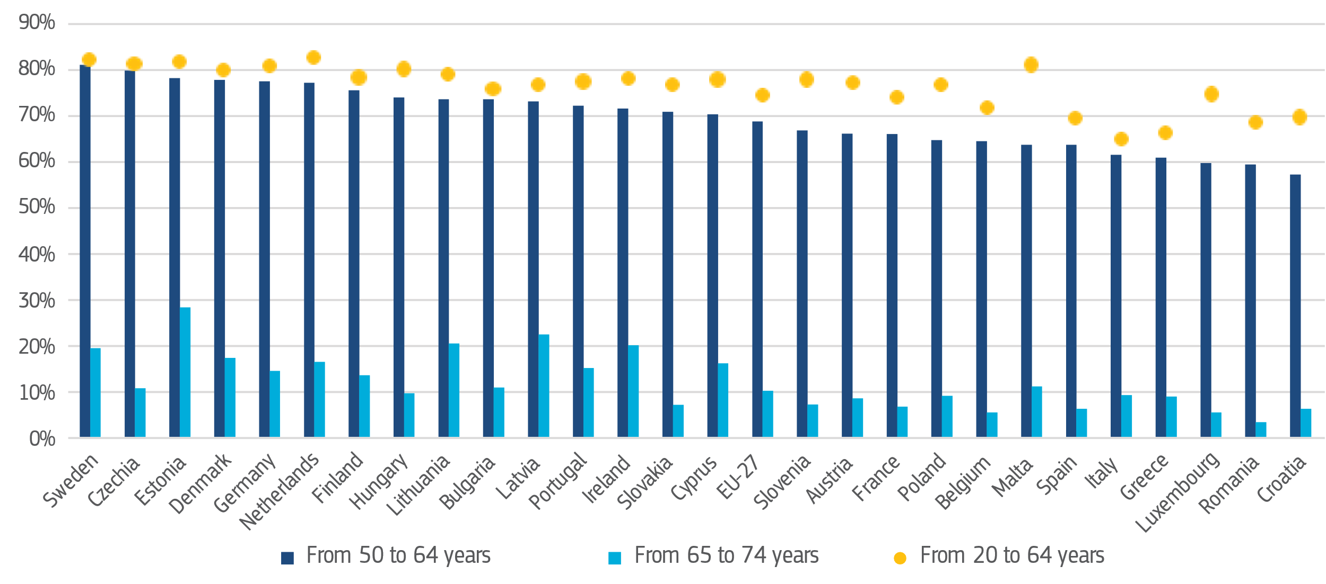

Businesses and workers need to work together to adapt work practices and to change preconceived notions and stereotypes about generations. Respect for older citizens and their well-being is a cornerstone of a thriving ‘longevity society’ at large. The Union of Equality strategies adopted by the Commission in 2020 and 2021 stress the need to combat stereotypes, fight age-based discrimination within their respective remit, to promote diversity and inclusion in the workplace, and give everyone equal chances to contribute and thrive. The potential of technology to create a workspace adapted to changing needs over the lifetime should be fully exploited (e.g. increased availability of ergonomic workstations, use of so-called ‘cobots’ or hybrid man-machine assembly systems to reduce the risk of strain injuries).
Population ageing will increase demand for financial lifecyle planning. Enhanced participation in supplementary occupational and personal pension schemes can complement retirement incomes, including through structures aimed at increasing enrolment in occupational pension schemes or the pan-European private pension product. Achieving better outcomes for citizens who invest to prepare future events (such as retirement, children education or access to housing) is a key objective of the Capital Markets Union. The cross-border integration of financial services can also enhance the supply of relevant financial instruments, such as insurance for long-term care. Better financial education can empower citizens in this regard. In parallel, efforts to promote inclusive access to payments and banking services can ensure that no one is left behind, in particular older people.
Health promotion and disease prevention are key enablers for healthy longevity. As life expectancy increases, the burden of non-communicable diseases is growing, including for cancer which disproportionally affects older people. This requires improved availability of and access to disease prevention services, diagnosis and treatment of non-communicable diseases. Healthy lifestyle requires an overarching person-centred approach to care and support services, which promotes a shift from treatment to health promotion and disease prevention; integration and coordination of services along the continuum of care, autonomy and independent living; and fostering, for all generations, an active and healthy lifestyle combined with good mental health and wellbeing, which can include community services and volunteering activities. For instance, in Romania with the help of the RRF, the development of the eHealth and telemedicine system helps improve access to a broad range of health care services, in particular in rural areas and small towns.
Health care and long-term care must be strengthened and become more cost-effective, while mitigating old-age poverty, which particularly affects women. In particular, affordable and high-quality care services can reduce caring responsibilities on the approximately 53 million informal carers in the EU, of whom only 65% work full-time. Investing in care is important to attract and retain talent in the sector. Formal carers must benefit from better wages and working conditions and adequate training and the relevant professions must become more attractive, as for instance reflected in France’s roadmap to support the ageing of French citizens at home. The healthcare workforce is also subject to imbalances linked to the ageing of workers, lack of replacement from medical schools and strong international competition for doctors and nurses. These imbalances are exacerbated at territorial level given the necessity to rationalise the provision of health services in regions with declining population. Provided that the users, as well as health and care professionals have the relevant digital skills, digital technologies can facilitate cost-effective and better-quality services, through digital health tools and assistive technologies. In addition, they can facilitate social contact to reduce loneliness, which also affects mental health.
To ensure adequate and sustainable pensions, pension reforms need to be accompanied by supporting labour market policies. Many Member States have implemented pension reforms in the past two decades, raising the statutory pension age and adjusting conditions. Some Member States are still lagging behind, however, and pension reforms require accompanying measures to bear fruit. These include labour market reforms to provide tailored assistance and lifelong learning opportunities, incentivise job search behaviour, and offer employment subsidies for older workers, as used in Austria’s targeted ‘Employment Initiative 50+’. Such active labour market policies are essential for helping the long-term unemployed remain in the labour force while respecting their diverse needs. Older people who want to work beyond the retirement age should be supported to do so. Policy adjustments should provide for attractive options to postpone retirement and remove earning limits and other obstacles.
Italy’s Employability Guarantee for Workers aims to help people integrate into the labour market, with a particular focus on women, long-term unemployed, workers with disabilities, young people as well as older workers. A budget of EUR 4.4 billion from NextGeneration EU is allocated to the Initiative.
Fiscal sustainability and adequacy can be enhanced by improving the composition of public finances and the revenue base of social protection systems. While revenues generated by labour income will continue to play a role in financing the welfare state, a more holistic reflection is needed on the optimal tax mix in view of demographic trends, including by assessing the scope for enhanced capital taxation to compensate for a decreasing share of labour taxes. In addition, the composition of public finances can be made more growth-, employment- and environment-friendly by shifting the tax burden away from labour towards energy and environmental taxation. Since 2022, the Commission organises an annual Tax Symposium gathering policy makers, academics, businesses and civil society to reflect on how to adapt our tax mix in view of 2050. Finally, cutting low-priority or ineffective expenditure can help prioritise and improve the efficiency of public budgets.
Key EU-level tools:
- The EU Framework Directive on occupational safety and health aims to ensure people’s safety and health at work.
- The Employment Equality Directive protects against age-based discrimination at work.
- The Council Recommendation on the integration of the long-term unemployed into the labour market offers policy guidance for activation measures at the national level.
- Under the European Care Strategy, the Council Recommendation on access to affordable and high-quality long-term care provides guidance to Member States to strengthen the adequacy, availability and quality of long-term care for all who need it and to improve working conditions of carers.
- The Council Recommendation on adequate minimum income ensuring active inclusion helps Member States reform their social safety nets by promoting adequate income support, coverage and uptake, access to services, and labour market integration.
- The European Accessibility Act makes key products and services more accessible for older people and people with disabilities, including e-services and certain elements of transport services.
- The ‘Healthier Together’ initiative supports EU countries in reducing the burden of major diseases and improving the citizens’ health and well-being, contributing to healthy ageing.
- The comprehensive approach on mental health puts forward 20 flagship initiatives and identifies EUR 1.23 billion of EU support to activities promoting good mental health across generations, focusing on vulnerable groups.
- Europe’s Beating Cancer Plan supports, coordinates and complements Member States’ actions to reduce the burden of cancer across the entire disease pathway, including with the Council Recommendation on a new EU approach to cancer screening.
- The Pan-European Personal Pension Product is a voluntary personal pension scheme to be offered by financial institutions to offer citizens a new option to save for retirement.
- The EU-OECD/INFE Financial Competence Framework for adults in the European Union promotes adults’ financial skills by supporting inter alia financial literacy programmes and good practice exchanges.
- The consumer footprint calculator allows citizens to estimate their environmental footprint and offers tips to shift behaviour towards more sustainable patterns.
Key next steps:
- The Commission calls on the co-legislators to work towards a swift agreement on its proposals for standards for equality bodies.
- The High-level group on non-discrimination, equality and diversity promotes exchanges of practices on age equality and combating ageism, and will publish an output paper in spring 2024.
- By June 2024, Member States are recommended to inform the Commission of the measures implemented or planned under the Council Recommendation on access to affordable and high-quality long-term care, complementing continuous monitoring and support for national reforms.
- The 2024 Access City Award winners will be announced during the conference marking the International Day of Persons with Disabilities in December 2023.
- In 2024, the Commission will publish the Pension Adequacy Report (jointly with the Social Protection Committee) and the Ageing Report (jointly with the Ageing Group).
- By December 2025, Member States are recommended to report on the implementation of the Council Recommendation on a new EU approach to cancer screening.

Labour shortages and managed legal migration
In 2022, labour shortages were at a historical high in the EU. While the employment rate in the EU reached a new record high, about 30% of all firms reported labour shortages and 74% of SMEs report they face a lack of skilled workers. Labour shortages exist in various sectors and occupations across all skills levels and are set to increase. Although activation of people of working age, in particular women, young and older people, reducing skills shortages, improving working conditions in certain sectors, and intra-EU mobility are vital for mitigating labour shortages, it will not suffice to meet needs in all shortage occupations. Legal migration from non-EU countries can also help employers fill vacancies in all skills levels, for instance for occupations with a critical role for the EU economy and its green and digital transition in the context of the Green Deal Industrial Plan. Given the size of its labour market, labour migration to the EU remains low in international comparison.
  - SMEs facing skills shortages (%)
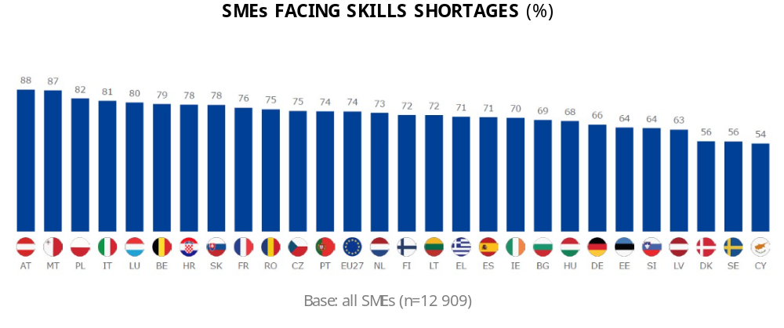
Enhanced legal migration pathways to the EU can help fill vacancies while also benefitting origin countries. The need to make Europe a more attractive destination for talent from third countries is a consistent call from EU industry. This calls both for proactive steps to help match employers and employees. This is recognised by several Member States, as demonstrated by the increasing number of work permits issued to non-EU nationals for employment purposes. The EU strives to support countries of origin with Talent partnerships in strengthening their economic base and human capital. Attracting talent globally requires targeted labour migration initiatives to address shortages that cannot be met through the domestic workforce while factoring in the aspirations of the third country nationals themselves and the priorities of countries of origin. The Talent Partnerships between the EU and third countries combine direct support for mobility schemes for work or training with capacity building and investment in human capital to ensure an equal win for Member States, partner countries, business communities on both sides and the benefitting individuals. According to the OECD, only four EU Member States feature in the top 10 countries most able to attract highly educated talent and entrepreneurs from abroad, including Sweden with its favourable visa conditions for entrepreneurs as well as its inclusive, family-friendly environment. Policies also need to facilitate the successful integration of third country nationals into European societies, ,with integration and the respect for the EU’s core values and principles are both a right and a duty.
Sweden attracts and retains international talent through a new residence permit for highly skilled third-country nationals and reinforced control measures to tackle abuse of migration routes.
Job matching and navigating legal migration pathways is often cumbersome and costly for both migrants and employers. Labour market access should be facilitated by assuring legal migrants of fair working conditions, through swift recognition of foreign qualifications and support to overcome administrative and language barriers. For instance, Czechia has established a dedicated IT tool for the assessment of labour needs that could be filled through migration and Greece has a user-friendly online platform to better match supply and demand for skills. A more coordinated approach to matching the needs of employers looking for workers in the EU and of those looking for jobs should be fostered. Migrants are often in jobs that do not match their skills, with almost 40% of them being overqualified for the jobs they are in (compared to 20% of EU citizens). Non-EU citizens and people from migrant backgrounds also often suffer from discrimination, poor working conditions and can lack relevant language skills. As a result, non-EU citizens have a lower employment rate than nationals or other EU citizens in Member States, including among youth. This further justifies the need for well organised and orderly channels for labour migration to the EU.
Key EU-level tools:
- The revised EU Blue Card Directive, which will apply as from 19 November 2023, will facilitate the recruitment of highly qualified workers in the EU.
- The Single Permit Directive establishes one single permit for both the right to work and provides for a set of rights for third-country workers while the Long-Term Residents Directive sets out the rules for acquiring the EU long-term resident status. Both Directives are under revision with the view to streamline and facilitate the integration of third country nationals and strengthen their rights.
- Talent Partnerships with selected third countries (currently Morocco, Tunisia, Egypt, Bangladesh, Pakistan) enhance legal pathways for international labour mobility and develop talent in a mutually beneficial way, which respects possible concerns of partner countries.
- The Action Plan on Integration and Inclusion 2021-2027 proposes support to Member States through actions including to improve employment opportunities and recognition of qualifications of migrants or developing inclusive education and training.
- Free Trade Agreements with third countries, including those under negotiation with Australia, Indonesia, India and Thailand, should include provisions to support the movement of skilled professionals.
Key next steps:
- The Commission will put forward a package on Talent Mobility in November 2023, including a proposal for an EU Talent Pool as an IT platform to facilitate labour matching between EU employers and jobseekers from third countries, a Commission Recommendation on the recognition of qualifications of third country nationals, and a proposal for a Council Recommendation on a learning mobility framework.
- Through the Labour Migration Platform, Member States and the Commission will further strengthen cooperation on facilitating migration so that regional labour shortages in all Member States can be filled.

IMPLEMENTING THE DEMOGRAPHY TOOLBOX
The demography toolbox can help mobilise policies at EU and national levels. The Commission calls on Member States to put in place and implement integrated policies addressing demographic change and mainstream demography concerns across all policies. Member States are encouraged to make use of the available tools at EU level in combination with national policies. Through the European Semester process, Member States received country-specific recommendations on relevant areas such as pensions, healthcare and long-term care (including their adequacy and sustainability), childcare, taxation, social housing, skills, adult learning and employment policies. Actions addressing demographic change and its impacts also contribute to broader societal progress in line with the Sustainable Development Goals.
Gender equality, non-discrimination and intergenerational fairness must be at the heart of policy choices. It is imperative that the chosen policy mixes at all times safeguard and contribute to gender equality and equal opportunities, notably by enhancing women’s effective access to the labour market and enabling people in Europe to make their personal aspirations and choices a reality. In this respect, the broad formal provision for affordable, high-quality childcare and long-term care is a key policy solution. At the same time, policy solutions that mutually benefit several or all generations are being implemented and should be supported across various policy areas such as education and training (e.g. intergenerational learning fostering knowledge and jointly build skills), housing and care (e.g. intergenerational living and community-based care, including adult day services) and in the workplace (e.g. multigenerational workforces which accommodate diverse needs and invest in two-way knowledge and skills transfers between generations).
Since 2006, Germany set up more than 540 multi-generational houses as ‘central meeting places’ to promote social cohesion between generations. These centres support their surrounding communities in addressing challenges of demographic change at the local level.
Member States’ policies to address demographic change should be grounded in the local realities. As the challenges differ between Member States and regions, policy responses should be designed and implemented as a concerted effort with the active involvement of regional and local authorities. Public employment services, social partners and civil society organisations also have a role to play. The Commission stands ready to support the Member States in this exercise, including by facilitating mutual learning and the exchange of best practices at all levels, for instance in the framework of the Talent Booster Mechanism which supports EU regions in addressing the impact of the demographic transition. The Commission will also pay particular attention to the specific challenges linked to the demography of rural areas in its forthcoming report on the implementation of the long-term vision for rural areas, scheduled for publication in early 2024.
  - Demography Toolbox:
  - key EU-level tools available to Member States 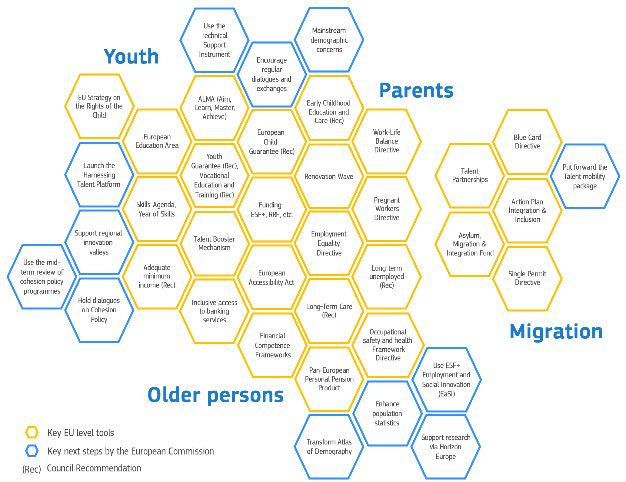
Digital technologies can boost Europe’s competitive edge and help offset the impacts of demographic change. Artificial intelligence and automation are already reshaping the economy and labour markets in Europe. If well designed and implemented, policy action promoting innovation and the scaled-up application of technologies can contribute to offsetting the impacts of demographic change on productivity and fiscal sustainability. Technology can also make health and long-term care more cost-effective and improve access to and quality in this area, including in rural and remote regions, for older people and for people with disabilities or reduced mobility. In addition, digital tools can contribute to the well-being of an aging population, promoting healthier and more active lives. They can also facilitate social engagement, mitigating social isolation among older individuals, especially when digital tools are used as a means of facilitating real interpersonal interactions.
On top of the regulatory instruments and policy frameworks listed above, a range of financing instruments are available at the EU level to support Member States. The Recovery and Resilience Facility stimulates reforms and investments across the four pillars of the Toolbox, notably with around EUR 8 billion channeled towards early childhood education and care, about EUR 43.2 billion towards education, around EUR 41.7 billion towards up-skilling and re-skilling, around EUR 48.2 billion supporting health care and long-term care, and around EUR 15.1 billion for social housing and social infrastructure. In the partnership agreements 2021-2027, 26 Member States have identified demography as a major challenge for their territories to be addressed with the support of Cohesion Policy funds. The European Social Fund Plus (ESF+), the EU’s main instrument to invest in people, steers together with Member States almost EUR 7 billion to promote a gender-balanced world of work, equal working conditions and a better work-life balance, and EUR 427 million to support workers’ active and healthy ageing. The upcoming mid-term review of Cohesion policy programmes, to be finalised by mid-2025 and steered by the country-specific recommendations adopted in 2024, will provide an opportunity to assess the situation of these regions and, where appropriate, align the programming of Cohesion Policy funds. In addition, Horizon Europe funds research to reduce skills shortages and mismatches with EUR 43 million, as well as to address the socio-economic impacts of demographic change with EUR 27 million.
Effectively managing demographic change requires comprehensive, high-quality and granular data and capacity at EU and national levels to gather and assess data and expertise in order to provide analysis and guidance on the appropriate solutions. Coordinating efforts is also key. At the national level, Member States have conducted or are launching assessments of demographic change and its impacts, for instance in the Netherlands through the new ‘State Committee on Demographic Developments 2050’. Complementing these activities, the European statistics on population and migration and the EU-level ‘Atlas of Demography’ already provide an unprecedented body of data, interactive maps and charts in this area, in addition to other tools, such as the Rural Observatory. Nevertheless, greater attention will need to be given to building the evidence base and gathering capacities to assessing and further anticipate demographic trends and their implications, including how policies can be better designed to cater for the changing cohort of seniors in our societies. A major step in this direction is the proposal for a Regulation on European statistics on population and housing that aims at modernising and integrating demography, international migration and population and housing census statistics.

With a view to enhancing the available tools, the Commission will:
Reinforce the data and evidence base
- Transform the Atlas of Demography into a dynamic platform for the creation and dissemination of knowledge about demography at EU level, facilitating the exchange between Member States.
- Support, in the framework of the European Statistical System, Member States in enhancing their population and housing statistics and implementing innovative actions, based on the future regulatory framework for European statistics on population and housing (ESOP).
- Support analytical activities under the ESF+ employment and social innovation (EaSI) strand in 2024, addressing key aspects of demographic developments, in particular relating to longevity, ageing and long-term care.
- Support research through Horizon Europe on policy responses to demography challenges, including a study on the implications of the rising need for long-term care (‘care wave’) to be published by 2025.
Support the review and upgrading of demography-related policies at all levels
- Encourage, in cooperation with the Presidency, regular dialogues and exchanges with Member States on all dimensions of demography through dedicated structures and resources.
- Make use of the Technical Support Instrument to provide assistance to national authorities, upon their request, for developing or updating national strategies aimed at addressing demographic change, notably in the context of the flagships ‘Youth First’, ‘Skills’, ‘Overcoming barriers to regional development’, and ‘Migrant integration and talent attraction’.
- Release, in early 2024, the 9th cohesion report which will offer an opportunity to reflect on how cohesion policy helps Member States address demographic challenges.
- Mainstream demographic concerns in relevant policy proposals at the EU level and their accompanying impact assessments where appropriate.
- Organise a thematic conference in the first half of 2024 to reflect on how systems and policies can sustain longevity in Europe, building on the key findings of the Pension Adequacy and Ageing Reports.
Ensure that no region in the EU is left behind
- Launch the Harnessing Talent Platform officially on 23-24 November 2023 and proceed with further calls under the Talent Booster Mechanism.
- Pay particular attention to the specific challenges linked to the demography of rural areas in the forthcoming report on the implementation of the long-term vision for rural areas.
- Support the creation of 100 regional innovation valleys involving EU regions with lower innovation performances, with funding of EUR 100 million from Horizon Europe and EUR 70 million from the Interregional Innovation Investments (I3) instrument under the ERDF.
- Hold a regular dialogue in the relevant Commission expert group covering Cohesion Policy funds on demographic challenges and support by relevant funds, in view of ensuring that demographic challenges are adequately addressed throughout their programming and implementation.
- Invite Member States to make use of the upcoming mid-term review of Cohesion Policy programmes to adjust, where necessary, the programmes to the needs generated by demographic challenges.

CONCLUSION
Demographic change has a profound impact on our lives and the competitiveness of our economy. While the ‘longevity society’ can help us adapt and reap new opportunities, population ageing and a shrinking working-age population may exacerbate existing challenges related to the shortage of labour, productivity and public budgets, adversely affecting the economy and society at large. Demographic trends can also contribute to widening disparities between regions and countries, potentially undermining social cohesion and trust in our democratic institutions to deliver broad-based prosperity and well-being.
Europe must pursue a comprehensive approach that empowers all generations to realise their talents and aspirations. EU leaders expressed in Granada their determination to invest in the skills of the future and address demographic challenges. To build a resilient, sustainable economy that works for people and a society where individuals can fulfil their potential, it is crucial to carefully balance different policy objectives. EU and national polices should enable people across Europe to reconcile family aspirations and paid work. Gender equality, non-discrimination, respect of fundamental rights and intergenerational fairness must guide our efforts at all time. With acute labour shortages straining businesses across the EU, legal migration and third country nationals’ effective integration are vital too, in complement to harnessing talents from within the Union. The planned Social Partner Summit at Val Duchesse in the first half of 2024 will be an opportunity to further tackle the pressing issue of labour and skills shortages. To address the issue of competitiveness overall, the Commission President has tasked Mario Draghi, former ECB President and Head of Government of Italy, to prepare a report on the future of EU competitiveness by summer 2024.
By working together, we can progress towards a strong, dynamic, competitive and cohesive Europe. This Communication points to key reforms and investments needed to address and manage demographic change in Europe. As set out above, policy-makers in the Member States should apply them in their national and regional contexts in a whole-of-government approach. The Commission is committed to support Member States in effectively using the tools at hand and, to this end, continue to develop them further. In their efforts, policy-makers should also promote citizens’ active participation and involve all players – social partners, civil society organisations, and others, grounding their policies in local realities. This way, we can help individuals and communities thrive, fostering the welfare and well-being of present and future generations alike.

Intergenerational fairness is the idea of fairness or justice between different generations. It can be applied to fairness in dynamics between children, youth, adults, and seniors, as well as between generations currently living and future generations. It relates to several fields and includes topics such as economic or social fairness, standards of living or climate change.
Conference on the Future of Europe, Report on the Final Outcome, May 2022 (15. Proposal: Demographic transition).
United Nations, Department of Economic and Social Affairs, Population Division, World Population Prospects 2022.
Employment and Social Developments in Europe Annual Review, SWD(2023) 248 final.
See Report on the impact of demographic change, COM(2020) 241 final. The impact of demographic change – in a changing environment, SWD(2023) 21 final.
Employment and Social Developments in Europe Annual Review, SWD(2023) 248 final.
In a ‘silver economy’, economic activity serves the needs of people aged 50 and over, for instance via products and services purchased and the further economic activity their spending generates. European Commission (2018), The silver economy – Final report, Publications Office of the European Union, Luxembourg.
Flash Eurobarometer 534, Demographic change in Europe (Fieldwork: 1/9 – 14/9/2023).
European Commission (2021), The 2021 Ageing Report, Economic & Budgetary Projections for the EU Member States.
See Final Report of the High-Level Group the Future of Social Protection and of the Welfare State in the EU (2023).
Communication from the Commission to the European Parliament, the Council, the European Economic and Social Committee, and the Committee of the Regions on Harnessing talent in Europe’s regions, COM(2023) 32 final.
Cohesion in Europe towards 2050, 8th report on economic, social, and territorial cohesion, SWD(2022) 24 final.
European Commission (2021), The Demographic Landscape of EU Territories, Publications Office of the European Union, Luxembourg.
At the Porto Social Summit in 2021, the Heads of State and Government of the EU i.a. backed the 2030 employment headline target of the European Pillar of Social Rights action plan, striving to have at least 78% of the population aged 20 to 64 in employment by 2030.
European Commission (2019), Demographic Scenarios for the EU: Migration, population and education. Publications Office of the European Union, Luxembourg.
See Social Scoreboard for the European Pillar of Social Rights.
In 2021, women's gross hourly earnings were on average 12.7 % below those of men in the EU; the highest gender pay gap in the EU was recorded in Estonia (20.5 %) and the lowest in Luxembourg (-0.2 %).
European Institute for Gender Equality (2020), Gender inequalities in care and consequences for the labour market.
Employment and Social Developments in Europe Annual Review, SWD(2023) 248 final.
Van der Ende, M. et al. (2021), Study on exploring the incidence and costs of informal long-term care in the EU, Publications Office of the European Union, Luxembourg.
Communication from the Commission to the European Parliament, the Council, the European Economic and Social Committee, and the Committee of the Regions, EU strategy on the rights of the child, COM(2021) 142 final.
European Commission (2022), The transposition of the Work-Life Balance Directive in EU Member States: A long way ahead, Publications Office of the European Union, Luxembourg.
OECD (2022), Net childcare costs in EU countries, 2021.
Directive (EU) 2019/1158 of the European Parliament and of the Council of 20 June 2019 on work-life balance for parents and carers and repealing Council Directive 2010/18/EU.
Council Directive 92/85/EEC of 19 October 1992 on the introduction of measures to encourage improvements in the safety and health at work of pregnant workers and workers who have recently given birth or are breastfeeding.
Directive 2006/54/EC of the European Parliament and of the Council of 5 July 2006 on the implementation of the principle of equal opportunities and equal treatment of men and women in matters of employment and occupation (recast).
Council Recommendation of 8 December 2022 on early childhood education and care: the Barcelona targets for 2030 (2022/C 484/01).
See Social Scoreboard for the European Pillar of Social Rights.
Council Recommendation (EU) 2021/1004 of 14 June 2021 establishing a European Child Guarantee.
For more information, see the Council Resolution on a strategic framework for European cooperation in education and training towards the European Education Area and beyond (2021-2030), 2021/C 66/01.
Communication from the Commission to the European Parliament, the Council, the European Economic and Social Committee and the Committee of the Regions, Youth Employment Support: a Bridge to Jobs for the Next Generation, COM(2020) 276 final.
Council Recommendation of 30 October 2020 on A Bridge to Jobs – Reinforcing the Youth Guarantee and replacing the Council Recommendation of 22 April 2013 on establishing a Youth Guarantee (2020/C 372/01).
Communication from the Commission to the European Parliament, the Council, the European Economic and Social Committee and the Committee of the Regions, A Renovation Wave for Europe – greening our buildings, creating jobs, improving lives, COM(2020) 662 final).
Gender Equality Strategy 2020-2025; LGBTIQ Equality Strategy 2020-2025; EU Roma Strategic Framework 2020-2030; EU Anti-racism Action Plan 2020-2025; Strategy for the rights of persons with disabilities 2021-2030.
See also Final Report of the High-Level Group of Experts on Pensions (2019).
Proposal for a Directive of the European Parliament and of the Council amending Directives (EU) 2009/65/EC, 2009/138/EC, 2011/61/EU, 2014/65/EU and (EU) 2016/97 as regards the Union retail investor protection rules and Proposal for a Regulation of the European Parliament and of the Council amending Regulation (EU) No 1286/2014 as regards the modernisation of the key information document, COM(2023) 279 final.
Communication from the Commission to the European Parliament, the Council, the European Economic and Social Committee and the Committee of the Regions on the European Care Strategy, COM(2022) 440 final.
In 2023, 5 Member States received Country-Specific Recommendations concerning the long-term sustainability of their pension systems and active ageing (Czechia, Germany, Ireland, Luxembourg, Poland).
Labour taxes accounted for 51.4% of total tax revenues in the EU in 2021.
In particular by reducing the tax wedge for lower- and middle-income earners, in order to incentivize paid work.
Council Directive 89/391/EEC of 12 June 1989 on the introduction of measures to encourage improvements in the safety and health of workers at work.
Council Directive 2000/78/EC of 27 November 2000 establishing a general framework for equal treatment in employment and occupation.
Council Recommendation of 15 February 2016 on the integration of the long-term unemployed into the labour market (2016/C 67/01).
Council Recommendation of 8 December 2022 on access to affordable high-quality long-term care (2022/C 476/01).
Council Recommendation of 30 January 2023 on adequate minimum income ensuring active inclusion (2023/C 41/01).
Directive (EU) 2019/882 of 17 April 2019 on the accessibility requirements for products and services.
Council Recommendation of 9 December 2022 on strengthening prevention through early detection: A new EU approach on cancer screening replacing Council Recommendation (2022/C 473/01).
https://knowsdgs.jrc.ec.europa.eu/cfc
Proposal for a Council Directive on standards for equality bodies in the field of equal treatment between persons irrespective of their racial or ethnic origin, equal treatment in the field of employment and occupation between persons irrespective of their religion or belief, disability, age or sexual orientation, equal treatment between women and men in matters of social security and in the access to and supply of goods and services, and deleting Article 13 of Directive 2000/43/EC and Article 12 of Directive 2004/113/EC, COM/2022/689 final; and Proposal for a Directive of the European Parliament and of the Council on standards for equality bodies in the field of equal treatment and equal opportunities between women and men in matters of employment and occupation, and deleting Article 20 of Directive 2006/54/EC and Article 11 of Directive 2010/41/EU, COM(2022) 688 final.
Business and Consumer Survey (BCS), European Commission.
Flash Eurobarometer 529 (2023).
European Commission (2023), Annual Report on Intra-EU Labour Mobility 2022, Publications Office of the European Union, Luxembourg.
For instance, relative to Australia, Canada, and the United States. OECD (2019), Building an EU Talent Pool: A New Approach to Migration Management‎ for Europe, OECD Publishing, Paris.
In 2022, an estimated 1.6 million residence permits were issued for employment-related reasons.
Including skills development, vocational education and training and operationalisation of work-based exchange schemes.
Netherlands, Sweden, Luxembourg, Denmark.
OECD Indicators of Talent Attractiveness.
European Migration Network (2019), Report on Labour market integration of third country nationals in EU member states.
Directive (EU) 2021/1883 of the European Parliament and of the Council of 20 October 2021 on the conditions of entry and residence of third-country nationals for the purpose of highly qualified employment, and repealing Council Directive 2009/50/EC.
Directive 2011/98/EU of the European Parliament and of the Council of 13 December 2011 on a single application procedure for a single permit for third-country nationals to reside and work in the territory of a Member State and on a common set of rights for third-country workers legally residing in a Member State.
Council Directive 2003/109/EC of 25 November 2003 concerning the status of third-country nationals who are long-term residents.
Talent Partnerships are also being discussed with Nigeria and Senegal.
Communication from the Commission to the European Parliament, the Council, the European Economic and Social Committee and the Committee of the Regions, Action plan on Integration and Inclusion 2021-2027, COM(2020) 758 final.
Figures as of 28 September 2023. Data are based on the pillar tagging methodology for the Recovery and Resilience Scoreboard and correspond to the measures allocated to the policy area ‘early childhood education and care’ as primary or secondary policy area. For more recent information and figures on the RRF, please also refer to the Report from the Commission to the European Parliament and the Council on the implementation of the Recovery and Resilience Facility: Moving forward, COM (2023) 545 final/2.
Ibid. Data correspond to the measures allocated to the policy area ‘General, vocational and higher education’ as primary or secondary policy area.
Ibid. Data correspond to the measures allocated to the policy area ‘Adult learning’, ‘Green skills and jobs’, and/or ‘Human capital in digitalisation’ as primary or secondary policy areas.
Ibid. Data correspond to the measures allocated to the policy area ‘Healthcare’, and/or ‘Long-term care’ as primary or secondary policy areas.
Figure as of 5 October 2023. Data correspond to the measures allocated to the policy area ‘Social housing and other social infrastructure’ as primary or secondary policy area.
European Regional Development Fund, European Social Fund Plus, Cohesion Fund and Just Transition Fund.
Proposal for a Regulation of the European Parliament and of the Council on European statistics on population and housing, amending Regulation (EC) No 862/2007 and repealing Regulations (EC) No 763/2008 and (EU) No 1260/2013, COM(2023) 31 final.
Expert group on the Common Provisions Regulation Funds (CPR Expert Group), see C(2021) 7888 final.

