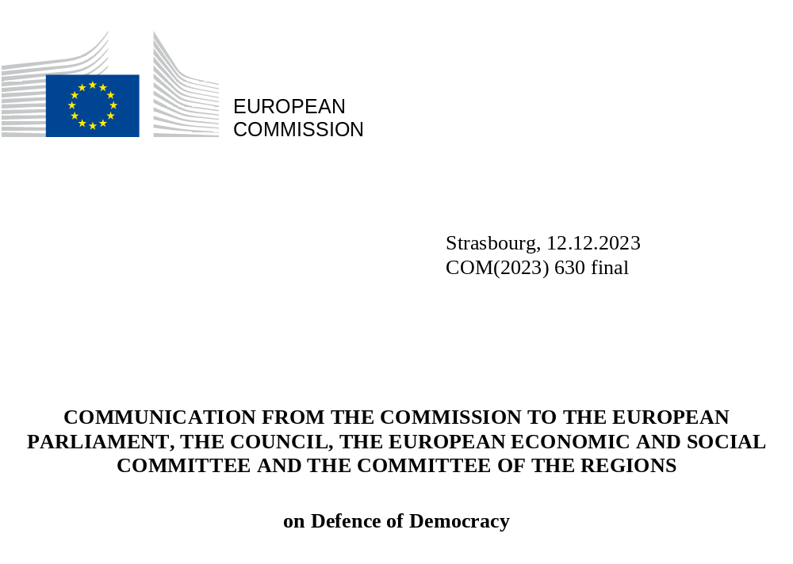

- INTRODUCTION
Democracy, the rule of law and fundamental rights are founding values of the European Union. They underpin all the EU’s achievements in fostering peace, prosperity, economic competitiveness, social cohesion and stability across the continent and around the world. The essence of democracy is that citizens can freely express their views and participate in democratic life, choose their political representatives, and have a say in their future. Citizens should be able to form their own opinions in a public space where different views can be expressed, where they have a right to disagree and to change governments through elections, free from interference, either foreign or domestic. With the wealth of local, regional, national and European elections, the EU and its Member States represent one of the deepest democratic experiences in the world. European democracy and the rights and freedoms associated with it are at the core of our open and transparent societies.
But democracy also has its challenges and its enemies. Authoritarian regimes see it as a threat, whether at home or abroad. This has resulted in some such regimes adopting a conscious policy to undermine the democratic process in the EU. They aim at undermining democratic institutions, put pressure on the media and reduce the space for civil society. This can range from attempts to exploit societal division and stoke mistrust of, and disillusionment with, established institutions, to weakening the democratic voice of citizens and civil society, engaging in information manipulation and disinformation, and direct distortion of election campaigns. Recent experience shows how quickly those wishing to foment hatred in our society can seize on new opportunities, and the need for the EU to be in the vanguard of countering such destructive forces.
Interference from outside the EU in our democratic process, including by the use of proxies, has received increasing political attention, at both national level and in the EU institutions. The Commission shares many of the concerns expressed by the European Parliament, including on the need for a coordinated EU strategy against foreign interference and information manipulation. Free and fair elections are a cornerstone of democracy, and independent and transparent electoral processes are vital to a competitive electoral environment to ensure citizens’ trust in the integrity of elections and their results. There is increasing evidence of cases such as lawmakers hacked ahead of elections, covert lobbying via proxies, fake research issued to whitewash human rights records, and websites purporting to be independent media platforms while covertly facilitating political interference campaigns. The Russian war of aggression against Ukraine, which is also a war on democracy and on all the values for which the EU stands, has further intensified the risk of outside interference. A recent Eurobarometer survey shows that 81% of people surveyed in the EU believe that foreign interference in our democratic systems is a serious problem that needs to be addressed.
The EU has increasingly acknowledged the need to be proactive in safeguarding democracy, and in strengthening the rule of law and protecting fundamental rights and freedoms. Work on the measures put forward by the Commission in 2020 in the European Democracy Action Plan is well under way, helping to strengthen democratic resilience by promoting election integrity, protecting media freedom and pluralism, and strengthening the fight against disinformation, foreign information manipulation and interference. This Communication sets out how the Commission, in close cooperation with the High Representative, has worked on all these fronts through key legislation and other political initiatives, bolstering societal resilience from within and the direct engagement of citizens.
At the same time, the EU has responded to the different risks of foreign interference in a variety of ways. This includes addressing risks affecting economic security, due to the involvement in the internal market of actors associated with third countries not primarily motivated by market rationales. Steps have included a proposal for a new tool to counter the use of economic coercion by third countries, rules on screening foreign direct investments where security or public order might be at risk, as well as measures in the field of cybersecurity, research security and countering hybrid threats. In particularly serious circumstances, to respond to threats or risk of threats to the fundamental interests of the Union and the objectives of the common foreign and security policy, the EU has imposed restrictive measures under EU sanctions regimes.
This Communication introduces the defence of democracy package announced in the 2022 State of the Union address. The package centres on a legislative proposal aiming to enhance transparency and democratic accountability by shedding light on covert foreign influence, as well as to improve the functioning of the internal market through common standards for interest representation activities carried out on behalf of third countries. The proposal has been developed through an extensive public and stakeholder consultation and a fully-fledged impact assessment.
The upcoming European elections will be a crucial test case for the resilience of our democratic processes. The package includes a targeted recommendation to promote free, fair and resilient elections, and to protect them from cyberattacks and other efforts to distort or manipulate our democratic and electoral environment.
The Commission also works with Member States to promote and protect a civic space where an active and independent civil society and citizens are provided with the enabling conditions and tools to become more engaged. This can contribute to making our democracies more resilient. This builds on investment already made and using new avenues for citizen participation in the public sphere as boosted by the Conference on the Future of Europe and its follow up. A dedicated recommendation sets out ways to promote the engagement and effective participation of citizens and civil society organisations in public policy-making processes.
The defence of democracy package is part of a set of initiatives which represent a proactive approach to uphold EU values. Since 2020, the Commission has examined the situation in Member States in its annual Rule of Law Reports. The anti-corruption and ethics initiatives put forward in early 2023 also seek to protect democracy from the corrosive impact of corruption, including from foreign actors. The recent Joint Communication on combating hatred aims to step up the EU action against hatred and promote an inclusive, diverse and democratic Europe. The Commission has been implementing strategies to combat discrimination, which also promote equal opportunities for inclusive participation and engagement. The 2022 report on the application of the Charter of Fundamental Rights focused on the civic space and its role in protecting and promoting fundamental rights. Putting people and their rights at the centre of the digital transformation are also core principles in the EU approach to digitalisation and technological advancement. This approach is also at the heart of the EU’s enlargement policy, and guide the EU’s work worldwide to support and promote democracy and the universal values of human rights and the rule of law in line with the EU Action Plan on Human Rights and Democracy (2020-2024). In all its actions, the EU commits to engage with organisations which respect democratic values and fundamental rights, as enshrined in Article 2 of TEU and in the Charter.

2. ENSURING TRANSPARENCY OF FOREIGN INTEREST REPRESENTATION in THE EU democratic sphere through harmonised requirements
The EU is open to the world and actively engaged with partners across the globe. Transparent and open exchanges across countries and cultures and access to information are part of our identity and are mutually beneficial at all levels. Governments, public authorities and political actors from outside the EU have the possibility to present their views and may try to have these views reflected in the democratic debate and influence policies on various issues. When they do this via entities that represent their interests, the legitimacy of such interest representation rests on its transparency and accountability.
There is however a growing concern in the EU that the openness of our societies can be exploited: interference by foreign governments seeking to manipulate public opinion and distort the democratic debate poses a threat to the EU’s democracies. This risk has increased due to a dynamic threat landscape, and third country governments can make use of public resources to carry out wide-ranging and sustained influence campaigns, sometimes covertly, and to promote their political and geopolitical interests at the expense of domestic constituencies. Comparable data about this phenomenon in the EU is scarce. This also results in limited accountability and oversight. Instilling transparency and openness in the way that foreign interests are represented is the best way to protect the integrity of our democratic space and to prevent foreign interference. More broadly, a political and institutional system based on integrity, transparency and accountability in public life is the best guarantee against corruption, and public bodies should seek the highest standards of transparency as an important part of broader efforts to tackle corruption.
Interest representation activities are increasingly used by third country governments alongside formal diplomatic channels and processes to promote their policy objectives. The transparency and reporting requirements for interest representation activities are currently regulated in different ways, and to different extents, in Member States. Some national laws make it compulsory to register while others rely on self-regulation. In substance, the rules may differ, for instance in terms of the types of activities and entities caught by obligations. Given that interest representation is an increasingly cross-border activity, an EU response is necessary to prevent the emergence of additional obstacles in the internal market and the risk of a patchwork of regulatory landscapes. Fragmentation imposes additional costs and creates legal uncertainty, with providers required to invest in separate compliance steps and adapt to the various requirements of the different EU jurisdictions. Without EU action, Member States address the identified risks and threats to democracy unilaterally, undermining the internal market, and facilitating attempts by third countries to use diverging rules to their advantage when they seek to covertly influence our democratic process.
The Commission is therefore putting forward a proposal for a harmonised approach to remove obstacles in the internal market and equip the EU with transparency tools that will enable it to defend democracy, remain an open society and protect fundamental rights, in particular freedom of expression and access to information. It aims to ensure a common high level of transparency and democratic accountability across the EU in relation to lobbying campaigns provided as a service, as well as similar activities performed by entities on behalf of a third country government that are attempting to influence the development, formulation or implementation of public policy or legislation, or of public decision-making processes. As such it will also contribute in the medium term to a better understanding and public awareness of the magnitude, trends and actors involved in such activities. This would allow EU citizens and public authorities to understand the motivation behind them and to see which third countries invest in influencing democratic debate and the decision-making processes in the EU.
The Commission proposal would enhance the integrity and openness of public debate by ensuring that when third countries seek to influence EU democratic processes through intermediaries, this is done in a transparent manner. Freedom of expression and association, as well as academic freedom and the freedom of scientific research, are paramount to the democratic debate and should not be significantly affected by the limited and proportionate transparency requirements foreseen. It is up to service providers to decide which services they want to offer. Funding received by civil society organisations or others from a third country government that is unrelated to an interest representation activity would not be covered by the requirements. The proposal also includes comprehensive safeguards to ensure that entities subject to the transparency requirements would not be stigmatised, nor incur consequences for the mere fact of being registered.
The proposed Directive focuses on interest representation activities, i.e. activities carried out with a view to influencing democratic processes, that are of an economic nature and which are carried out on behalf of third countries. It would cover all entities engaging in an activity seeking to influence the development, formulation or implementation of policy or legislation, or public decision-making processes, in the EU. This could include lobbying and public relations companies, think tanks, civil society organisations, private research institutes, and public research institutes offering research services, as well as consultants and in-house lobbyists, carried out on behalf of third countries with a view to influence public life and the democratic process in the EU. When this happens, the fact that a foreign government is behind the activity needs to be transparent. The proposal specifically excludes activities such as diplomatic representation or legal representation in a trial.
The Directive would apply in a fair, and non-discriminatory manner, with minimal administrative formalities. It would subject the entities within its scope to mandatory, but limited and proportionate, registration requirements. Member States would be asked to establish, or adapt existing, national registers to ensure the transparency of interest representation activities. Such registers should have simple and clear access requirements to facilitate registration and enforcement. To limit administrative burden, Member States would be invited to ensure that entities having to register can re-use data already submitted in other national registers ('Once Only' principle), where possible. Information on the registration obligations and formalities established by this Directive should be available via the Single Digital Gateway which sets up a one-stop shop to give businesses and citizens information about rules and procedures in the Single Market. The most important elements of the registered data would be publicly available, allowing for transparency and enhanced public scrutiny, in full compliance with EU data protection rules.
In line with the Court of Justice’s case law and guidelines from the Venice Commission of the Council of Europe, the Directive would also include safeguards to avoid registration requirements being misused to limit fundamental rights and freedoms, such as the freedoms of expression or of association, academic or artistic freedom, or to unduly restrict the civic space. First, independent supervisory authorities would be empowered to request limited records in duly justified cases only, and in a proportionate manner. The supervisory authority should have clearly defined and circumscribed powers, and should be competent for supervision and enforcement activities, including to ensure that no adverse consequences arise from registration. Secondly, there should be proportionate administrative fines for non-compliance, subject to judicial review and effective remedies, to avoid potential chiling effects. The proposal would also create a cooperation framework for the exchange of information between supervisory authorities.
Full harmonisation for matters falling within the scope of the proposed directive would prevent Member States from maintaining or introducing additional requirements within the framework of the harmonised rules. This would further limit the risk of divergent and potentially disproportionate and repressive national rules and practices. At the same time, in line with the principle of subsidiarity, Member States would remain free to establish rules for areas not covered by the Directive, for example rules on contacts between their public officials and interest representatives.
This proposal would be a key first step in tackling foreign interference based on a framework that will harmonise transparency requirements in the internal market and allow an overview of third countries’ interests represented in the EU. It is a targeted and proportionate response to current concerns. Its implementation, and in particular the effectiveness and proportionality of the rules, would need to be kept under review and a timely assessment made as to whether revisions or further steps are needed, including as regards the scope of intervention and as well as a reflexion on the possibility of creating a Union level portal connecting national registers. In parallel, the Commission will continue to monitor and support reforms in Member States to ensure the transparency of lobbying. The Rule of Law reports recognise this to be key element of fostering integrity, transparency and accountability in public life. The Commission will also organise regular stakeholder group meetings to touch base on the application of the rules.
At EU level, the EU Transparency Register covers activities carried out by interest representatives with the objective of influencing the formulation or implementation of policy or legislation, or the decision-making processes of the EU institutions. Citizens and interest groups can use it to look at the potential influence of interest representatives towards decision-makers, thereby promoting ethical and transparent interest representation. It is supplemented by a code of conduct, as well as by internal transparency measures in the EU institutions concerning meetings and other interactions with lobbyists. Although it has a different scope compared to the proposed Directive, the EU Transparency Register already covers activities of foreign influence when carried out by foreign entities without diplomatic status, or any entitites that lobby the EU institutions on behalf of third countries. Once the outcome of the discussions between the European Parliament and the Council on the proposed Directive is clear, the Commission will consider how to best address issues such as double registration and whether to develop possible links between national registers under the Directive and the Transparency Register.
The proposed Directive would complement the rules that apply to digital services under the Digital Services Act and to advertising service providers and publishers under the proposal on political advertising, both of which have a different scope. Concrete preventive measures proposed in the European Research Area to create awareness about foreign interference and build resilience across the sector, building on the Toolkit on Tackling Research and Innovation Foreign Interference, are also complementary. It is also in line with standards at international level. The Commission will also support actions such as the exchange of best practice in relation to informing citizens, building resilience and engaging actively with the topic of interference in the European democratic sphere, including training, media literacy, awareness-raising and critical thinking. The Commission has also put in place a set of actions to support Member States’ administrations preparing reforms, anticipating future trends and strengthening administrative cooperation which support democractic structures. There is also support for efforts at national level to further reforms that reinforce democractic structures and processes.
With this proposal, the Commission seeks to contribute to setting standards, not only in the EU, but also on a global scale, on how to address covert foreign influence in a coherent, balanced and proportionate way, fully respecting fundamental rights. By focusing on transparency and democratic accountability and by introducing targeted rules accompanied by strong safeguards, the approach strikes a balance between the exercise of fundamental rights and the public interest.
Understanding and taking action to tackle the phenomenon of foreign interference has been gaining ground globally. Some jurisdictions outside the EU – such as Australia, the United States, Canada and the United Kingdom – have introduced or are preparing frameworks to regulate the transparency of foreign government influence by means of specific disclosure and registration requirements applicable to lobbying on behalf of foreign governments.
Other jurisdictions have adopted ‘foreign agent’ laws which go beyond transparency requirements and have been found to be in violation of fundamental rights and freedoms. The aim of such laws has been to restrict the civic space by stigmatising and intimidating certain civil society organisations and human rights defenders – which often rely on funding from abroad, including from the EU – and curtailing their activities. For example, the Russian ‘foreign agent’ law effectively empowers authorities to hinder the work of independent civil society organisations through intrusive inspections, direct oversight over programmes and events, and the threat of dissolution and of taking criminal proceedings against non-compliant organisations and their members – even when foreign support is fully transparent. The label of ‘foreign agent’ under such laws undermines the financial stability of an organisation, due to the heavy fines imposed on those who do not abide by its rules. It also harms its credibility, as it carries with it connotations of spying, which can in turn incite violence against members of targeted civil society organisations online and offline. Such ‘foreign agent’ laws are profoundly undemocratic and have been found to violate international laws and standards.
Not all risks of foreign interference are associated with state actors. Some non-state entities may also use similar tactics to promote actions that directly contravene EU values, such as actions designed to amplify polarisation and incite hatred. This is particularly true online, as evidenced recently in an explosion of violent extremist, hateful and divisive content.
The Commission strongly encourages Member States to remain vigilant and share information with one another and at EU level on such non-state entities, even if they are not linked to, or dependent on, a foreign government. In line with this, the Commission’s proposed recast of the Financial Regulation includes adding a new ground of exclusion from EU funding for ‘incitement to discrimination, hatred or violence.’ The new ground would be applicable for funds disbursed in direct and indirect management, even in the absence of a final judgment at national level. In addition, the Commission is introducing internal awareness-raising measures and developing internal working methods to ensure increased scrutiny in the selection of projects.
- TAKING THE EUROPEAN DEMOCRACY ACTION PLAN FORWARD
The European Democracy Action Plan (EDAP) adopted in December 2020 aims to strengthen the resilience of EU democracies, identifying key actions to address the areas where our systems and citizens are most vulnerable. These actions seek to better protect the integrity of elections, safeguard media freedom and media pluralism, and fight disinformation. The Action Plan also recognised that a healthy democracy relies on meaningful and inclusive citizen engagement exercises and an active civil society, not only at election time, but on an ongoing basis, and that engaged, informed and empowered citizens and a vibrant civil society are vital to guarantee the resilience of our democracies, including resilience to foreign interference.
Taking stock of the state of implementation of the actions under EDAP, this section highlights areas where the EU can be proactive in the face of existing and evolving challenges.

3.1 Protecting election integrity and promoting democratic participation ahead of and beyond the 2024 European elections
Free and fair elections are at the very core of our democracy. If left unaddressed, risks to the electoral process can both distort the process itself and undermine citizens’ trust in the fairness and integrity of elections.
Together with this Communication, the Commission is putting forward a Recommendation on inclusive and resilient electoral processes in the European Union and enhancing the European nature and efficient conduct of the elections to the European Parliament. It is addressed to Member States, European and national political parties, foundations and campaign organisations in the context of the preparation of elections in general and with regard to the upcoming European elections in particular. It aims to promote high democratic standards for elections in the EU, supporting high turnout, inclusive participation, easy and equal exercise of electoral rights and resilient electoral processes. To this end, it includes specific recommendations to support voter turnout and inclusive participation, with a particular focus on gender equality and addressing the needs of specific groups.
There is a constant need to step up the cybersecurity of election technology. The Recommendation sets out specific proposals to ensure the security, integrity and resilience of elections and election-related entities and infrastructure, in light of the requirements established by the revised Directive on security of network and information systems (NIS2 Directive) and the Directive on the resilience of critical entities. Building on a first experience from 2019, a new EU tabletop exercise took place on 21 November 2023 with the participation of the Commission, European Parliament, the EU Agency for Cybersecurity and Member States. The NIS Cooperation Group should also continue the review of the Compendium on Cybersecurity of Election Technology, to ensure it keeps pace with the evolving threat landscape.
In addition to the direct risk posed to election infrastructure, the intentional and coordinated manipulation of the information environment by foreign state actors likewise poses a threat to democracy and security. There are numerous reports of large-scale coordinated efforts combining different tactics, techniques and procedures, such as the use of fake social media accounts to ‘like’, comment on or share information to artificially boost its visibility, the spread of disinformation including through manipulated audio-visual content such as deepfakes, or opaquely targeting voters to influence them and manipulate the outcome of elections. Additionally, information manipulation can occur in concert with activity in other domains, such as cyber threats in the case of hack-and-leak operations. To this end, and building on the Eurobarometer data, the Recommendation puts forward a series of measures to protect election-related information from manipulation and disinformation.
A free and fair democratic debate relies on legality and fair play. Surveillance tools may be used by public authorities, under certain conditions, for reasons of national security, but the use of spyware to gain political advantage is very different. The recommendation stresses that surveillance tools should never be used to interfere with the democratic debate and deploying such tools to target political actors and journalists for political gain is unacceptable. The Commission has always made clear that the notion of national security should be interpreted in accordance with the criteria laid down by EU case law. The country chapters of the Rule of Law report cover this issue insofar as the functioning of institutional checks and balances is concerned. There are also strong safeguards against the use of spyware against media, journalists, and their families in the proposal for a European Media Freedom Act. The European Parliament has set up an important strand of work on spyware with a Committee of Inquiry to investigate the use of Pegasus and equivalent surveillance spyware (PEGA Committee). In its resolution of June 2023 the Parliament strongly condemned the illegal use of spyware, calling on action at both national and EU level. The Commission is preparing a non-legislative initiative clarifying the boundaries and the interplay between EU law, in particular the data protection and privacy acquis, and national security.
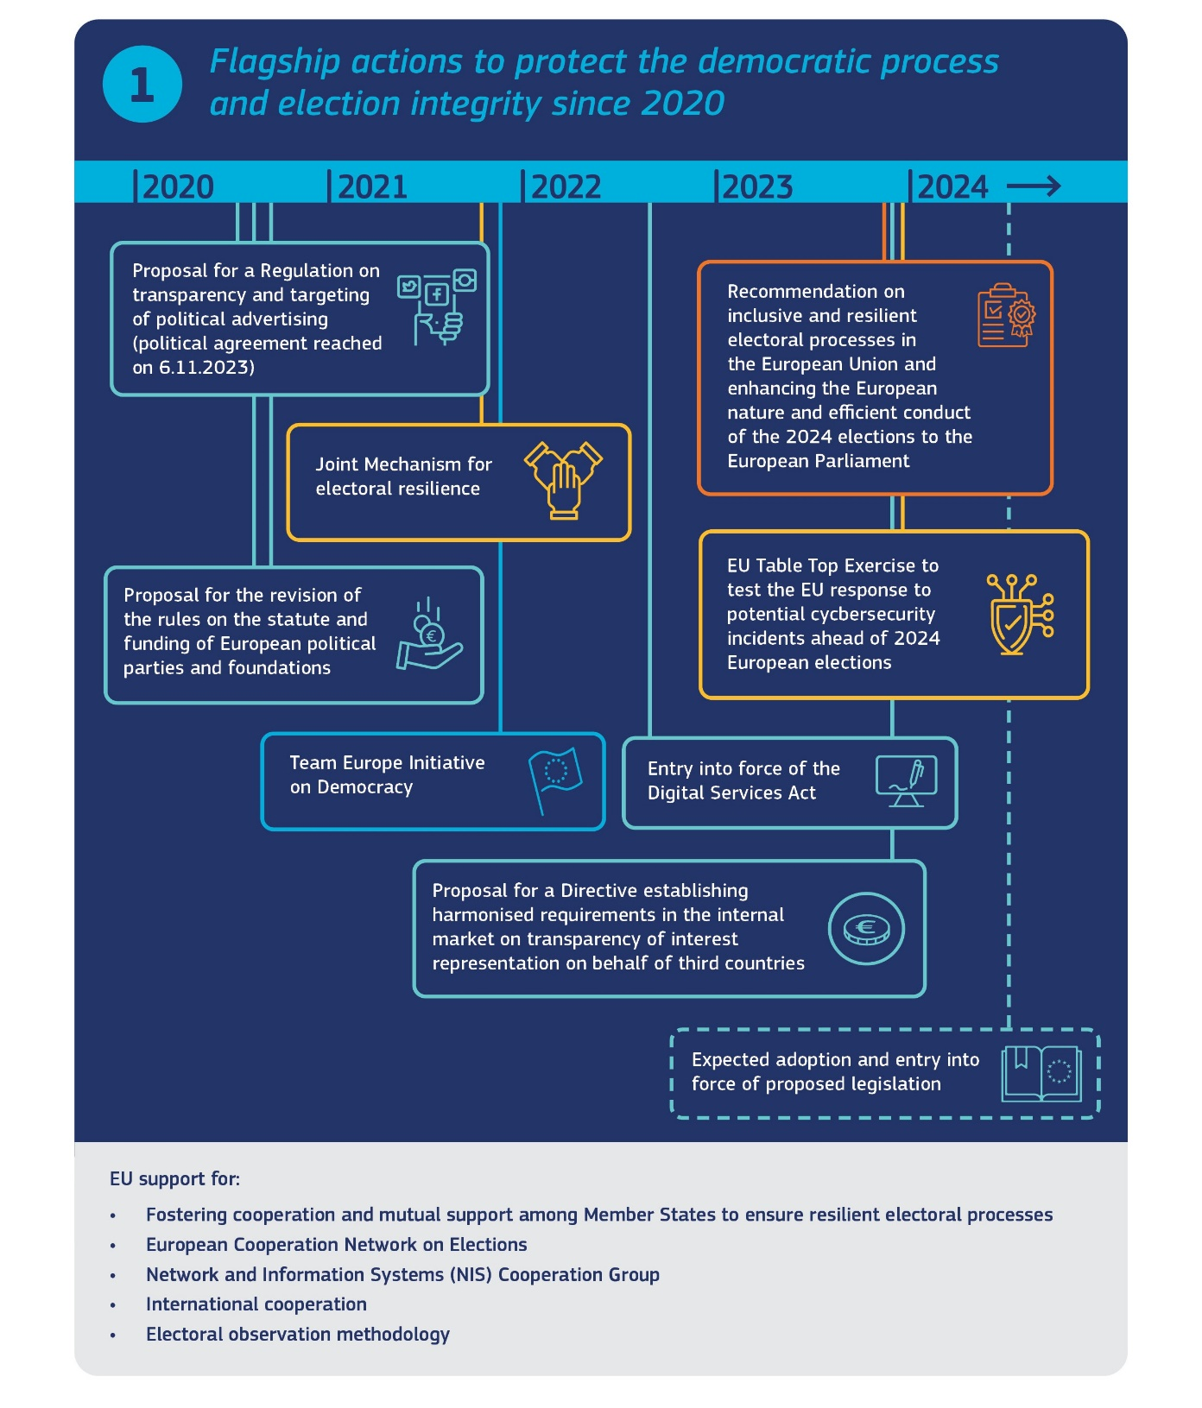

Other recommendations include the use of campaign pledges and codes of conduct by political parties to encourage election integrity and fair campaigning; efforts to ensure the transparency of political advertising; and promoting the observation of elections as an efficient means of encouraging citizens to actively engage with the electoral process and improve public trust in elections. It also touches upon the funding of political parties and foundations, with a view to limiting any risk of covert foreign influence, including by means of covert donations, to distort the level playing field in the electoral process.
The recommendation builds on the decisive steps taken by the Commission since 2020 to address identified loopholes and to ensure citizens can form their own judgments and make electoral choices in a public space where a plurality of views can be expressed, free from interference, be it domestic or foreign.
When it comes to the digital sphere, the rules under the Digital Services Act set out the responsibilities of online platforms and search engines in addressing the risks related to civic discourse and electoral processes stemming from the functioning, design or use of their services, including through disinformation, inauthentic use or tactics involving artificially generated content. The rules also provide for more transparency and support people to take informed decisions about the information they see online. In addition, the regulation on transparency and targeting of political advertising will allow for better public scrutiny and accountability in relation to political advertising services, including through a European public repository for online political ads, and introduce stricter conditions around the use of personal data for the targeting and delivery of political adverts. To address the risk of foreign interference, it will also prohibit sponsoring political advertising by non-EU actors three months before elections or referenda. The role of European political parties and political groups in the European elections is also recognised. In 2021, the Commission also proposed a revision of the rules on the statute and funding of European political parties and foundations. The proposal aims at giving European political parties more possibilities to fulfil their role in building and nurturing a truly European political sphere, while at the same time protecting their action from foreign interference. The enforcement of these rules is a top priority for the Commission. When it comes to the Digital Services Act, the Commission is supervising and enforcing the application of the rules by very large online platforms and search engines.
Although the organisation of national elections is a Member State competence, it is informed by international standards, and governed by this broader framework of EU law. Reinforced mutual support and cooperation among Member States is now well established, centred on the work of bodies such as the European Cooperation Network on Elections, also drawing on the EU’s structures to promote information security and tackle disinformation. In preparation of the European Parliament elections, the Commission organised a high-level event on elections in October 2023 bringing together Member States, EU institutions, NGOs, and academia to put forward ideas on supporting voter turnout, the resilience of the electoral systems and fair and inclusive elections across the Union.
A Joint mechanism for electoral resilience was launched in January 2022, aiming to build capacity in Member States to address risks to elections, through expert exchanges, in particular on disinformation and cyber-related threats. The mechanism has also been used to support the preparation of the compendium on e-Voting and other ICT Practices, in addition to targeted exchanges on how to ensure parity of treatment and balanced media coverage during elections. Exchanges between national parliaments could also be a valuable way to share experience and the Commission will support such exchanges.
The EU has refined its external electoral observation methodology in recent years, including through common guidelines based on international standards, that consolidate its capacity to tackle the use of new technologies in the electoral process. Good practices are regularly discussed within the European Cooperation Network on Elections and in the context of the Declaration of Principles for International Election Observation.
The EU does not act in isolation. Under EDAP, the Commission has continued its efforts to help build resilience in third countries, with a view to better equipping societies and public authorities with the means to respond to common external threats to the democratic process. Such efforts are a priority in EU enlargement policy. The EU also facilitates international cooperation on electoral matters between EU networks, partner countries and international organisations such as the Council of Europe, UNESCO and the OSCE. The European External Action Service conducts election observation missions in close coordination with other international and regional observation organisations. It complements these activities with dedicated support to governments, civil society and independent media to help build resilience against and prevent, deter and respond to foreign information manipulation and interference (FIMI), including through insights into how FIMI has been used in electoral contexts. EU action has also included participation in the two Summits for Democracy and financial support for capacity-building and electoral reform, including in the countries in the EU’s immediate neighbourhood.
  - Strengthening media freedom and pluralism
Russia’s war of aggression against Ukraine has also dramatically highlighted the essential role journalists play in informing citizens about the reality on the ground. The Russian authorities have engaged in a systematic crackdown on and censorship of independent media, which remains essential to fight propaganda.
Under EDAP, the EU’s efforts to protect media freedom and counter disinformation are two sides of the same coin. As part of this vision, the Commission proposed key new initiatives to improve the safety of journalists and to protect journalists and human rights defenders and others from abusive lawsuits against public participation (SLAPPs). The anti-SLAPP directive brings a system of powerful procedural safeguards for cross-border SLAPP cases, which equip courts to deal with abusive litigation and act as a deterrent to potential new SLAPP cases. The directive includes rules that allow the early dismisal of such cases and provide effective remedies for SLAPP victims. Together with the related recommendation, the rules form a strong package of measures to fight SLAPP and protect public participation and the freedom of expression in the EU. The Commission also proposed to harmonise certain aspects of national rules related to media services under the European Media Freedom Act. The proposal aims to address fragmented national regulatory approaches related to media freedom and pluralism and editorial independence and to ensure the free provision of media services within the internal market. It also puts a focus on the independence and stable funding of public service media as well as on the transparency of media ownership and of the allocation of state advertising, two key objectives under the EDAP. Under the new provisions, Member States would also have to look at the impact of national measures and media concentrations on media freedom and pluralism. When it comes to the dissemination of media content in the online environment, the European Media Freedom Act proposal builds on the horizontal framework established by the Digital Services Act.
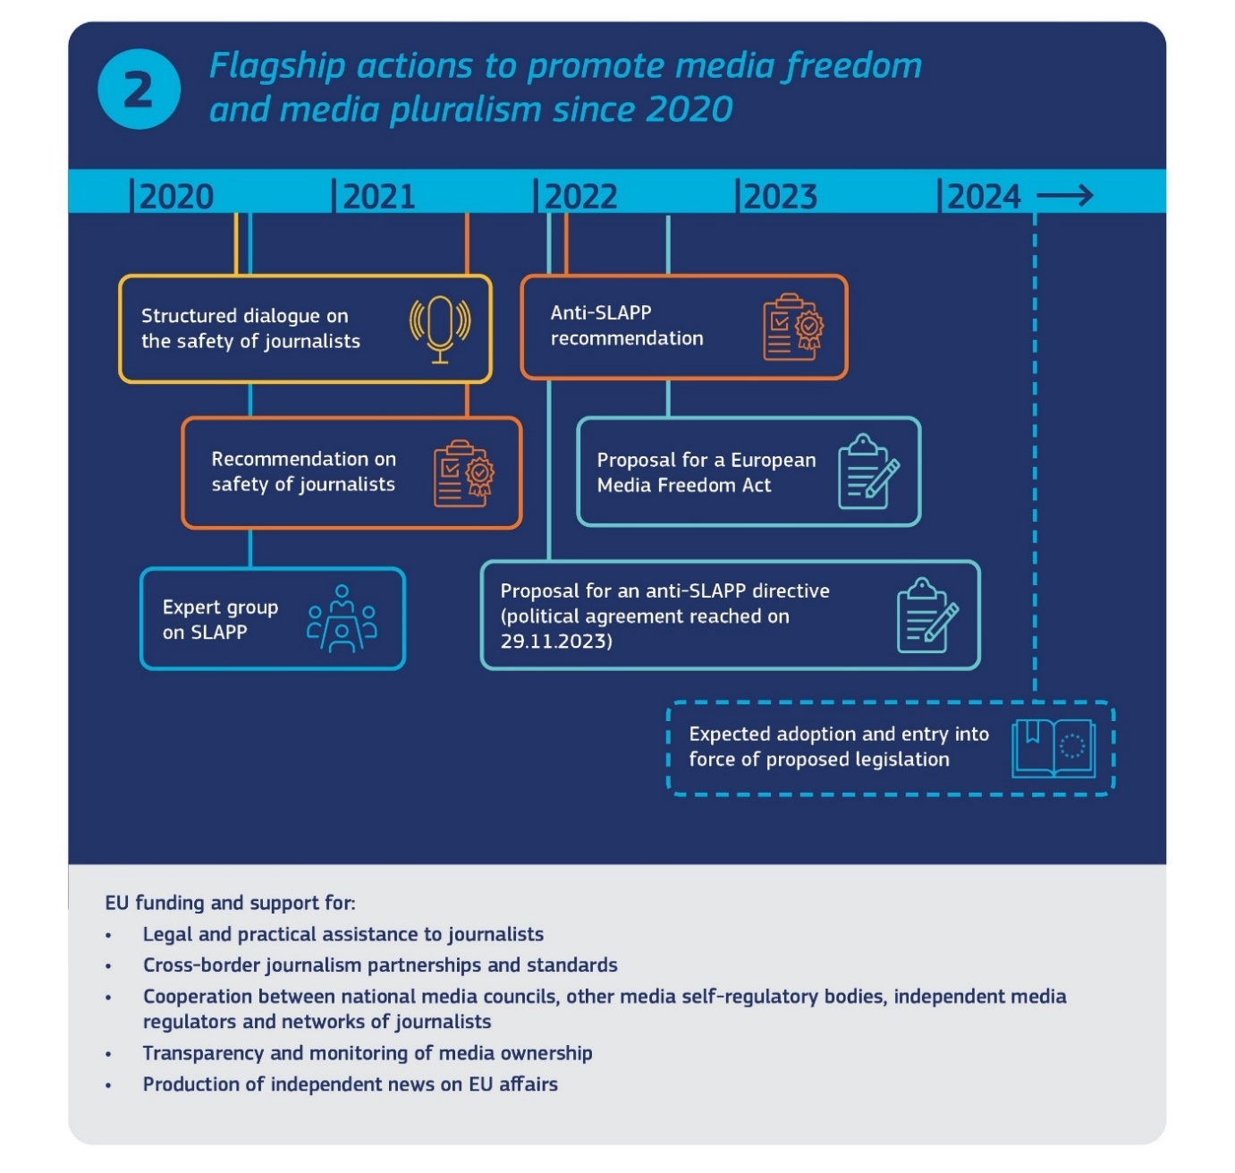
The Commission also assesses media freedom and pluralism in its annual rule of law report. The report covers in detail developments in Member States as regards topics such as the independence of national media regulatory authorities, the transparency of media ownership, the fairness and transparency of state advertising, the governance of public service media, and the frameworks in place to ensure the safety of journalists. This exercise is based on constant dialogue with the relevant Member State authorities and stakeholders and has resulted in a number of reforms being initiated at national level.
The media’s financial sustainability is a key driver of editorial integrity and media independence. The Commission has stepped up its support for media resilience since the adoption of the Media and Audiovisual Action Plan (MAAP) in December 2020, in particular with measures boosting private investments in news media. The MAAP called to bundle actions and support to the news media sector by offering better access to loans, enhancing media collaborations and proposing the setup and implementation of a data space for media.
The Commission has also strengthened funding to news media organisations. The Creative Europe programme 2021-2027 has devoted around EUR 75 million for projects and initiatives supporting media pluralism, journalism and media literacy. Actions include monitoring of media pluralism, support to media councils, to a media freedom rapid response mechanism and to specific sectors such as investigative journalism or local reporting. As the demand for financing exceeds the available resources under Creative Europe, the Commission will continue seeking ways to support these sectors.
As the EU strengthens support and protection for media freedom within the EU, it does so also abroad, with a particular attention to the neighbourhood. In the context of Russia’s war of aggression against Ukraine, the EU has allocated funding to supporting journalists and the media in Ukraine to a value of EUR 30 million. Support for Russian independent media has also been increased and needs to be sustained in the long term.
A provisional political agreement was reached between the European Parliament and the Council on the proposed anti-SLAPP directive. Co-legislators are also shortly expected to reach agreement on the European Media Freedom Act. The implementation and enforcement of the new rules will be key next steps. Member States should also continue working for the full implementation of the recommendation on the safety of journalists and the anti-SLAPP recommendation. Several cases of abusive lawsuits launched by, or on behalf of, third countries also underscore the importance of strong EU-wide rules to curb SLAPPs and protect the democratic space.
  - Countering disinformation and foreign information manipulation and interference
Protecting Europe’s democracies from the threats and harmful effects of disinformation, information manipulation and interference, in particular from foreign actors, has been a priority of the EU in recent years.
Such manipulative influence operations and disinformation campaigns seek to undermine democratic debate and exacerbate societal division. Such operations are often well-funded, state-sponsored and carried out by hostile actors and, as such, constitute a security threat to EU democracies. The Russian war of aggression against Ukraine highlighted and heightened the risk to the European information space, with the Kremlin increasingly engaging in disinformation campaigns and foreign interference operations and using them as a strategic and coordinated instrument to threaten security, democracy and support its war of aggression. The conflict in the Middle East following the Hamas terrorist attacks in Israel has also triggered widespread disinformation and hate campaigns. This is exacerbated by digitisation, including design features of online platforms that allow to disseminate disinformation with unprecedented speed and efficiency, as well as new tools powered by artificial intelligence able to be used by malicious actors.
When asked how often they believed they were exposed to disinformation, 35% of respondents in a recent Eurobarometer survey answered ‘often’ or ‘very often’, and 33% answered ‘sometimes’. The respondents perceived online social networks to be the primary medium via which they were most frequently targeted (64%), followed by television (36%), online newspapers and news magazines (22%) and video-sharing websites (21%).
Under the EDAP, the EU has stepped up efforts to improve its capacity to react to this new and evolving threat landscape – both domestically and internationally. Existing cooperation has been strengthened within the Commission, between the EU institutions and services and beyond, involving relevant stakeholders in civil society, academia and private industry, as well as international partners. The EU has stepped up its strategic communication response to disinformation through the Commission’s Network against Disinformation (NaD). The EEAS-managed Rapid Alert System (RAS) has continued to provide common situational awareness and share effective approaches to responding to the threat of FIMI with Member States, EU institutions and international partners. Initiatives include detection, active pre- and debunking, and targeted campaigns addressing the COVID-19 pandemic, as well as a comprehensive and constant reaction to Russian state-sponsored disinformation around its war of aggression against Ukraine. The results have been shown in the ability to be effective in addressing challenges more rapidly and in a more coordinated manner. This has also made a broader contribution to democratic resilience.
International cooperation has been strengthened with support to the G7 Rapid Response Mechanism and close cooperation with NATO has continued, with FIMI highlighted as one of the key security threats for EU-NATO cooperation. The EU-US Trade and Technology Council and the EU-US Summit statement of October 2023 gave further impetus to close transatlantic cooperation on the threat, in particular to advance on the strategic cooperation and enhancing interoperability of approaches to tackle FIMI. The EU has also made effective use of its diplomatic tools to counter FIMI and foreign interference, most notably through the adoption of restrictive measures imposed on individuals and media outlets involved in information manipulation and interference following the war of aggression against Ukraine. This has been complemented by the development of a reinforced EU Toolbox to counter foreign information manipulation and interference (FIMI) which offers a common analytical framework and methodology to collect systematic evidence of FIMI incidents to help improve the understanding of tactics, techniques and procedures used to manipulate and interfere. This complements the work of the EEAS StratCom Task Forces to raise awareness and build capacity, support EU Delegations and conduct outreach to civil society. The objective is to make it harder for FIMI actors like Russia and China to manipulate the EU’s and neighbouring information environments.
A centrepiece of the Commission’s approach to fighting disinformation has been its work to ensure more accountability for online platforms. 52% of Europeans think that online platforms should do more to prevent the spread of false and misleading information. The Digital Services Act obliges providers of very large online platforms and of very large online search engines to regularly assess the systemic risks their services may present to society, including to the freedom of expression, or the risk of their services being used as a tool for disinformation campaigns, not least in view of protecting electoral processes. As a key way to mitigate such risks, they are invited to participate in establishing voluntary codes of conduct and crisis protocols. An example is the ambitious new Code of Practice on Disinformation signed in June 2022 by a wide range of signatories. Importantly, the Code also comes with a solid monitoring framework and a Transparency Centre to ensure transparency and accountability. In January and September 2023, the Code’s signatories, including online platforms, reported on progress, providing an unprecedented level of information on the way they implement their commitments to fight disinformation.
In the run-up to the 2024 European elections, the Commission is carrying out a pre-election dialogue and collaboration with online platforms and other signatories of the Code. In addition, the work within the Code is also focusing on addressing harmful potential of the new AI-powered tools that could be used in disinformation and foreign interference campaigns. Concluding the negotiations on the proposed AI Act is a priority in this context, as it would put in place the necessary guardrails and transparency on the use of AI.
In order to empower citizens to make informed decisions, the Commission supports a broad range of innovative projects to fight disinformation under various EU programmes, in particular by civil society organisations and education and training institutions, or with the involvement of journalists, with a view to promoting media and digital literacy and helping citizens identify disinformation, both within the EU and beyond. As part of the Digital Education Action Plan (2021-2027), the Commission published Guidelines for Teachers and educators on tackling disinformation and promoting digital literacy through education and training. Likewise, both Erasmus+ and the European Solidarity Corps have dedicated funding for grassroots projects promoting media literacy.
In parallel, the EU has supported community-led initiatives to fight disinformation through reinforced fact-checking, such as the European Digital Media Observatory (EDMO) and the development of the European Code of Standards for Independent Fact-Checking Organisations. This has proven to be instrumental in fighting disinformation related to the war of aggression against Ukraine. As part of its broader mission to fight disinformation, EDMO has set up a special European elections task force dedicated to detect early signs of potentially dangerous disinformation campaigns that might spread across the EU and coordinate dedicated media literacy activities. The task force will also provide its expertise to European institutions in the framework of the preparation to the European elections.

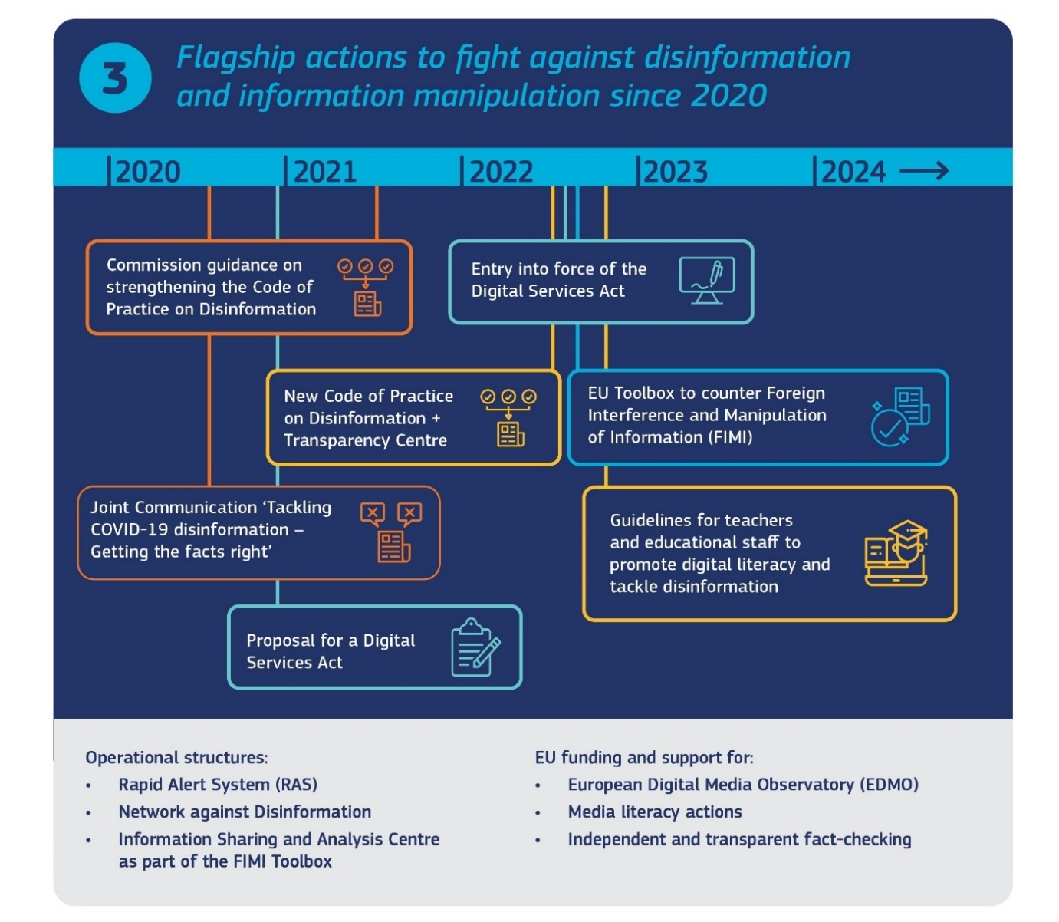
In parallel, the High Representative is advancing work on further strengthening the ‘whole-of-society’ approach for information sharing in the form of an Information Sharing and Analysis Center on FIMI . This is an integral part of the FIMI Toolbox to enable a stronger common situational awareness and further develop the common methodology for collecting systematic evidence on FIMI and putting in place a trusted framework for exchanging information between the relevant stakeholders, also bringing the defender community together to systematically collect and share information on FIMI incidents. It also follows up on the Strategic Compass on Security and Defence’s call for a FIMI Data Space. The Commission will also continue to strengthen its own capacity to detect, monitor, analyse and tackle disinformation activities, carried out both at EU and national level. Under Horizon Europe, more than a third of the over EUR 300 million support for research on democracy was mobilised for funding research and innovation to better detect and understand foreign information manipulation and interference, and other undue influences on political decision-making. In future, it would be important to maintain this level of ambition and capitalise on the lessons learned.
Civil society actors are at the forefront of the fight against disinformation and uncovering foreign interference, including through grassroots initiatives and the expert community working to analyse and counter FIMI and disinformation. A strong involvement of civil society is key for assessing quickly and efficiently the constantly evolving threat landscape, the actors and tools they use. The Commission will continue to support the work of the EDMO hubs’ independent community. Research and awareness-raising focused on disinformation and foreign interference inside the EU, notably using the data generated by Code of Practice on Disinformation and its transparency and access to data provisions. To support the work of fact-checking in the implementation of the Code of Practice and to ensure high professional standards and independence of fact-checkers, the Commission will also continue to fund training activities to back up the Code of Professional Integrity of the European Fact-Checking Standards Network (EFCSN).
  - Inclusive civic engagement and participation for European democratic resilience
Strengthening the links between people and the democratic institutions that serve and represent them is the bedrock for democratic resilience. A strong, safe and enabling civic space and engaged, informed and empowered citizens are an essential guarantee for the resilience of our democracies, whether at election time or beyond. In the recent Eurobarometer, almost nine in ten respondents (87%) saw civil society (associations, NGOs) as important in promoting and protecting democracy and common values, including in terms of fostering a well-informed and pluralistic democratic debate. The data also shows that more than half of respondents think there is a need to increase the engagement of civil society organisations in the decision-making process at the national level (56%) and the European level (54%). Around two-thirds of respondents are in favour of an increased engagement of citizens in the policy-making process at the national (68%) and European level (66%).
Empowering citizens and civil society organisations, and providing them with appropriate tools for civic engagement, are cross-cutting priorities across the different pillars of the EDAP, as well as in the Charter and the Rule of Law Reports. A wide range of funding opportunities has also been made available to boost citizen participation, civic engagement and trust in democracy, most notably under EU programmes such as the Citizens, Equality, Rights and Values programme; Creative Europe; Erasmus+; and Horizon Europe. Technical assistance for administrative reform in the Member States under the Technical Support Instrument has also been deployed to build capacity in public administrations and public authorities for participatory practices. Incorporating citizen engagement into policy design and implementation had also been a priority under the partnership principle of EU cohesion policy. The Conference on the Future of Europe provided valuable experience on how to strengthen citizen engagement in policy-making by implementing deliberative processes. It also contributed to boosting democratic resilience, leading to the implementation of a new phase of citizen engagement with European Citizens Panels now embedded in the European Commission’s policy-making process.
In parallel, increasing support and funding under EU programmes has also been dedicated to promoting media and digital literacy, equipping people of all ages with the tools to navigate today’s information and media environment, identify different types of media and how they work, and have a critical understanding of different types of media, including social networks, so that they are able to make informed decisions. As the possibilities to engage online are widening and becoming more commonplace, online hate speech can deter people from expressing their views and participating in online discussions. Fostering a respectful, enabling a safer environment in which to express their views is a priority. To this end the Commission has proposed an initiative to extend the list of EU crimes to hate speech and hate crime. This will complement the regulatory framework under the Digital Services Act, the Framework Decision on combating certain forms and expressions of racism and xenophobia by means of criminal law and the efforts under the Code of conduct on tackling illegal hate speech.
New and meaningful methods of citizen participation, deliberation and engagement, across all generations, can reinforce representative democracies. These forms of participation offer complementary ways for citizens to actively participate in the democratic debate and contribute to policy-making, taking into account the Member State’s constitutional traditions and specificities. Experiences with participatory and deliberative democracy, whether at the local, national and pan-European levels, demonstrate that these practices can help to bridge existing gaps between citizens and decision-makers and bring together diverse groups of people to develop collective recommendations. Building on the Conference on the Future of Europe, new ways to ensure citizens are given this closer role in EU policy-making have been set up. These forms of engagement complement established practices of involving citizens in policy-making processes at EU level, such as public and stakeholder consultations, regular dialogues with stakeholders, or transparency and access to information and documents rules. To strengthen the participation of stakeholders in different stages of policy-making processes, the Commission has adopted Better Regulation Guidelines setting out the principles it follows when preparing new initiatives and proposals and when evaluating and monitoring the implementation of existing legislation.
Education plays a major role in forging appetite for citizen engagement and participation and the attachment to democratic values. Promoting and protecting European democratic values is a central dimension of the European Strategy for Universities adopted in 2022, as higher education institutions contribute to promoting active citizenship, tolerance, equality and diversity, openness and critical thinking. Erasmus+ (2021-2027) promotes participation and civic engagement in Europe’s democratic life through multiple funding streams, in the EU Member States and beyond. The promotion of inclusive participatory democracy is one of the guiding principles of the EU Youth Strategy (2019-2027). The 2023 Citizenship Package recognises the importance of citizenship education, including awareness of EU citizens’ rights , and voter education for promoting political participation, as well as building resilience to disinformation among citizens.
Civil society organisations are one of the main pillars of a functioning democracy. They act as watchdogs for democratic foundations and institutions. They hold governments to account and help protect and promote fundamental rights and the rule of law by assisting individual people and communities and helping to promote their interests. They also empower individuals to take part in matters of public interest and overall help in growing meaningful public participation.
The Commission engages with civil society organisations in policy-making on many fronts. Consultation and dialogue enable civil society organisations and human rights defenders to present their views on EU legislation and policy. The ‘Have Your Say’ portal is the entry point for consultation and makes it possible for all interested parties to contribute to initiatives before and after adoption. Civil society organisations are part of the partnership with regional and local authorities and economic and social partners, which allows them to be involved throughout the preparation, implementation, and evaluation of EU-funded Cohesion policy programmes.
The Commission has also established regular dialogues with civil society actors in different policy areas providing for more effective communication and involvement in policy-making. Structural civil society dialogue takes place through forums and platforms, covering a broad range of policy areas. Representations of the Commission in the Member States are important local actors for citizen engagement. They have organised thousands of events, ranging from citizens’ dialogues to ad-hoc participatory events, notably during the Conference on the Future of Europe, where more than 6000 events were organised in the Member States gathering more than 700 000 participants in total. This can be expanded and complemented by other initiatives to connect to the local level.
Protecting, supporting, and empowering civil society organisations and human rights defenders is at the core of the EU’s work on ensuring a thriving civic space as underlined in the 2022 Report on the application of the Charter of Fundamental Rights. The report highlights the importance of ensuring that civil society organisations and human rights defenders work in an enabling, safe and supportive environment. The 2022 Rule of Law Report set out how the operation of civil society organisations without unjustified interference is based on EU case law and European standards, and the reports provide an overview of the steps taken in Member States to improve the situation for civil society organisations. Examples include simplifying registration procedures, setting up structures to assist civil society organisations, and revising rules on the operation and access to funding of civil society organisations. The 2022 and 2023 Rule of Law Report made specific recommendations to a number of Member States. In addition, in September 2023 the Commission put forward a proposal for a legislative initiative on cross-border activities of associations, which will aim to remove barriers in the single market to enable associations to thrive in the single market, will complement action taken in the current package.
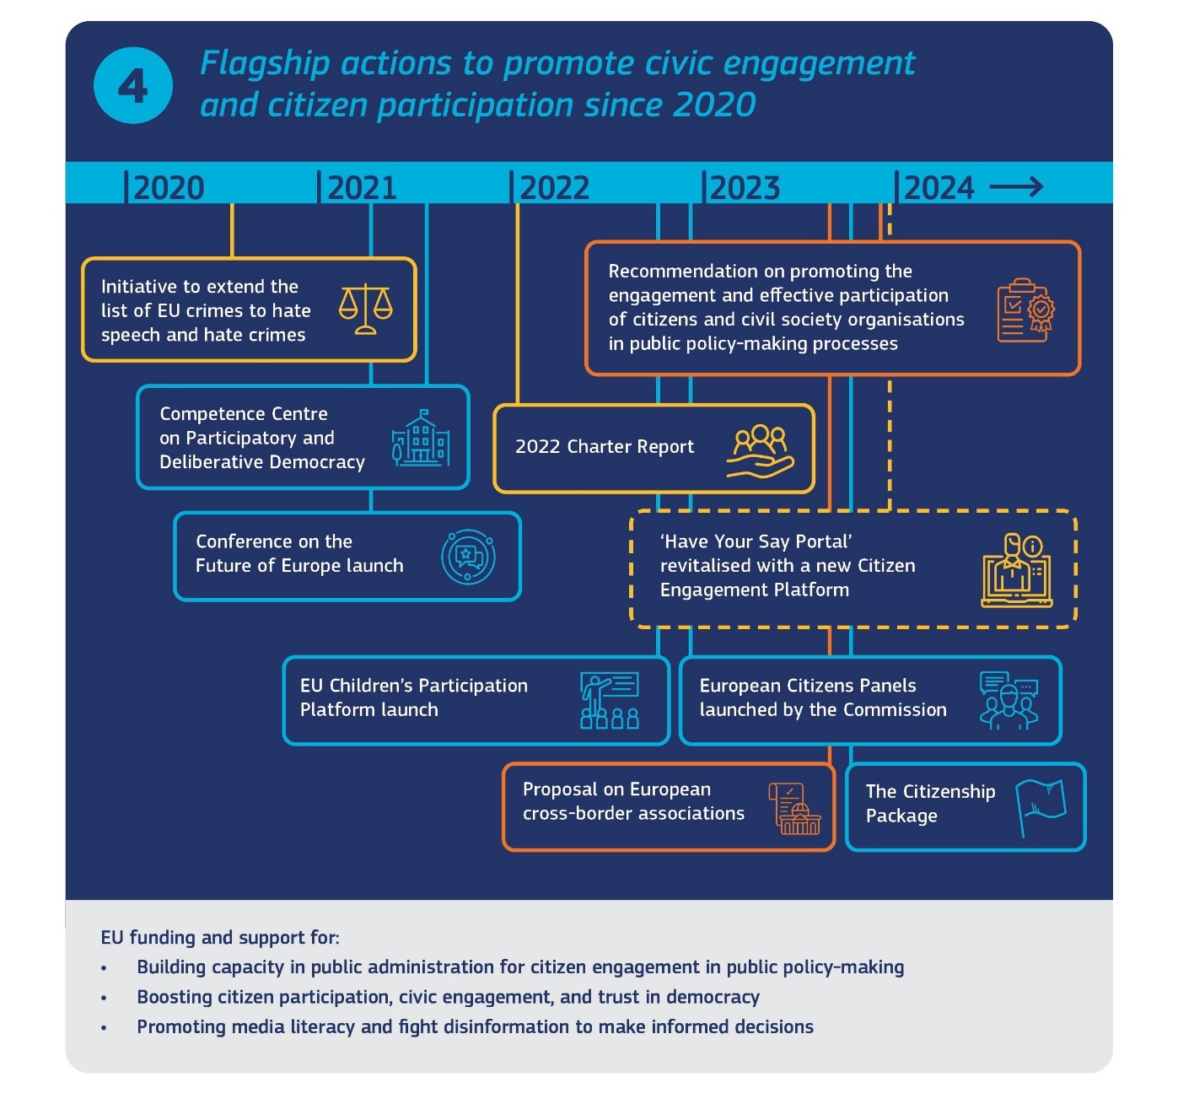
To further foster citizen participation and empower civil society organisations and human rights defenders to participate in policy-making and complement other actions taken at EU level, the Commission is putting forward a Recommendation on promoting the engagement and effective participation of citizens and civil society organisations in public policy-making processes. The Recommendation aims to promote the participation of citizens and civil society organisations in public policy-making and to help build democratic resilience in the Union. The Recommendation also aims to facilitate the promotion of civic engagement and the protection of democracies and respect for fundamental rights in Member States. It encourages Member States to ensure effective and inclusive participation of citizens and civil society organisations in policy-making processes, with a wide representation of the different groups and instances in society, thus reducing exclusion, marginalisation and discrimination, and to support capacity-building of citizens, civil society organisations and public administrations, in both traditional and emerging public spaces. The Recommendation also draws on the lessons of the Conference on the Future of Europe and the ongoing work of the Competence Centre on Participatory and Deliberative Democracy, in line with the established standards and good practices of co-creation and deliberative democracy. Acknowledging the need to ensure a common level of protection and engagement of civil society organisations across the Union (and beyond), it encourages Member States to create and maintain an enabling environment for civil society organisations and human rights defenders, allowing them to effectively engage in such policy-making processes. The Recommendation also proposes a list of measures Member States should take to protect and support civil society organisations and human rights defenders to safeguard a thriving civic space.
Financial support is essential for a thriving civil society. The EU already provides ample funding opportunities for civil society organisations to build their capacity and to implement projects that help foster EU values. One fundamental requirement for EU funding is respect for EU values. Respect for EU values already features as part of the grant agreement every beneficiary of EU funding must sign and the Commission has worked on guidelines to set out more clearly the consequences breaches of EU values have for beneficiaries. The Commission is also rolling out pilot projects on reinforcing checks and verification procedures for budgetary programmes in relevant spending areas that entail higher risk of abuse and disrespect of EU values. Member States should put in place effective mechanisms to apply the same approach when managing EU funds. The Citizens Equality Rights and Values programme (CERV) is focused heavily on supporting civil society organisations to protect and promote EU values and rights. The Commission will continue to ensure a targeted allocation of funding to priorities under the EDAP and mobilise dedicated funding from a range of the available EU Programmes to support the goals of today’s package in terms of countering disinformation, as well as promoting election integrity and media pluralism. To make it easier to navigate through the different programmes, the Commission will further improve and promote the tool it has put in place on available funding with simple search functionalities so that relevant information about funds on democracy can be accessed easily and quickly. The Commission and the EEAS will continue to pro-actively engage with citizens and civil society organisations on the ground via the Commission Representations in Member State capitals and EU Delegations around the world to increase awareness and improve information sharing on the available opportunities under the various EU programmes. Figure 5 provides a brief overview of possibilities offered under EU Programmes, and other possibilities are available under EU structural funds and the Technical Support Instrument (for example to fund civil society and build capacity and institutional/administrative infrastructure for deliberative civic engagement and political participation).
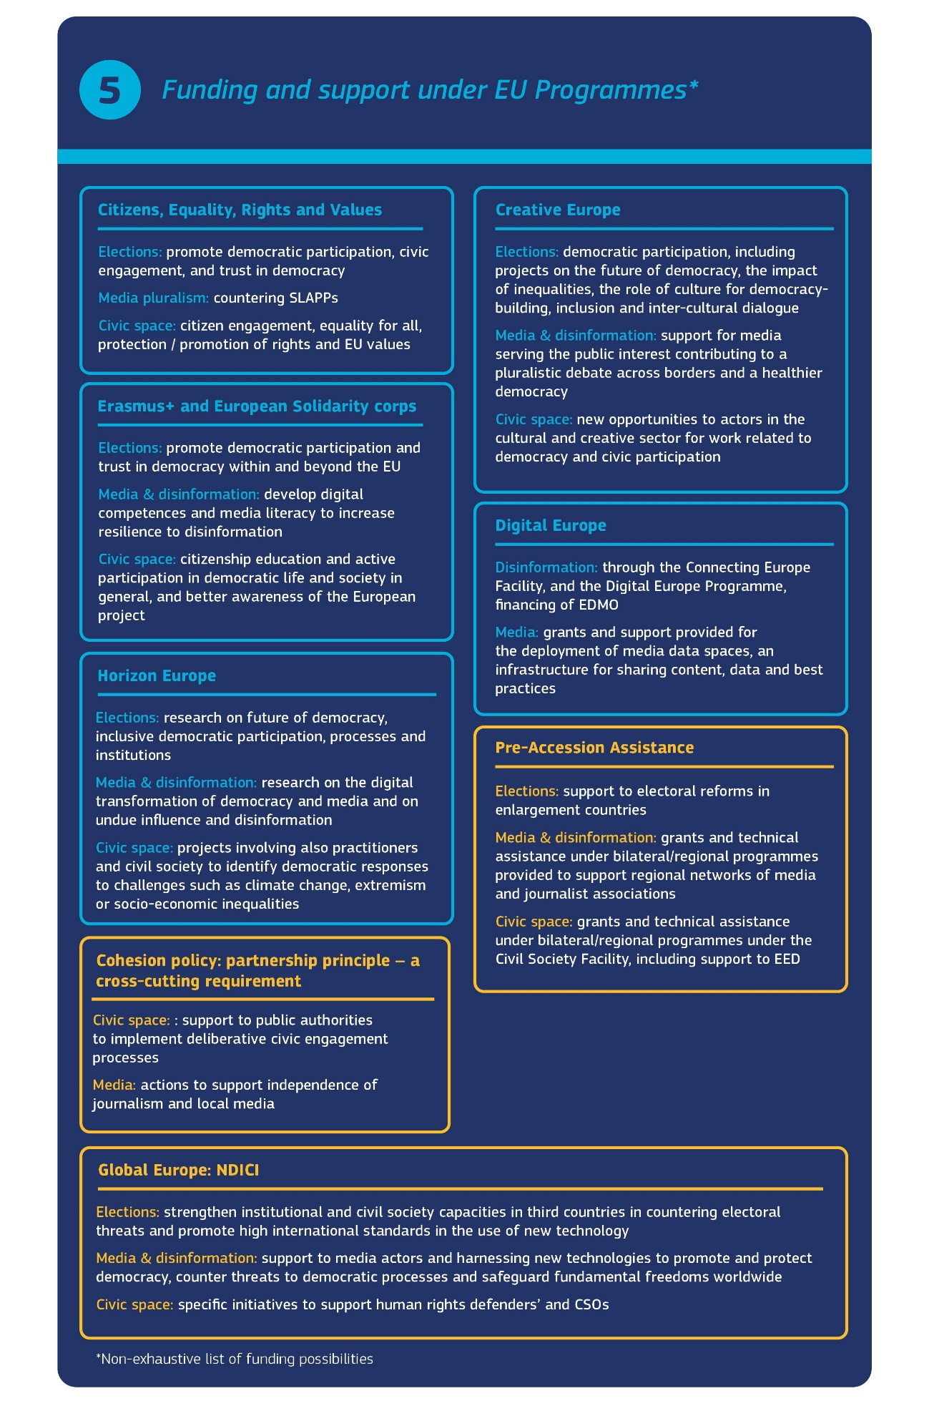

4 CONCLUSION
In July 2019, President von der Leyen called for a new push for European democracy, with a greater say for Europeans and a greater effort from the EU to nurture, protect and strengthen our democracy. This translated in the December 2020 European Democracy Action Plan, which made a major contribution to fight against disinformation and information manipulation and to protect fair elections and media freedom and pluralism.
Since the beginning of this Commission’s mandate, the EU has had to face a succession of major geopolitical, economic, climate and health crises. The way the EU has managed to respond to these crises has shown that it can rely on its strong liberal democracy, trust in its institutions, and respect for our common principles and values. However, these crises have also shown the threat of foreign interference and the risks from a highly volatile international context: some actors have devoted huge resources to the goal of undermining democracy and trust in our institutions.
This Defence of Democracy package aims to reinforce this action ahead of the elections to the European Parliament. This package answers these challenges, in full respect of our fundamental rights and values, also building on the lessons learned from the Conference on the Future of Europe. The Commission looks forward to the full engagement of the European Parliament and the Council to make decisive progress on all legislative proposals in the democracy area before the European parliamentary elections; and for the wide circle of national actors involved, public and private, to ensure the implementation of the European Democracy Action Plan and of this new Defence of Democracy package.

Article 2 TEU.
Article 8 TEU, Article 21 TEU.
Civil society organisations are frequently referred to as non-State, not-for-profit, non-partisan and non-violent structure, through which people organise to pursue shared objectives and ideals. Operating from the local to the national, regional and international levels, they can comprise urban and rural, formal and informal organisations.
Key trends identified are attempts to undermine trust in or attachment to democratic institutions and representative democracy, attempts to remove democratic checks and balances, destabilisation of electoral campaigns, pressure on free media and the civic space, and the illegal use of spyware against democratic actors.
COM(2023) 772 final.
On 1 June 2023 the European Parliament adopted a resolution on foreign interference in all democratic processes in the European Union, including disinformation (2022/2075(INI).
See: Commission response to European Parliament resolution on foreign interference in all democratic processes in the EU, including disinformation.
Flash Eurobarometer 528 (2023) on “Citizenship and Democracy”.
COM(2020) 790.
COM(2022) 404.
COM(2021) 775 final. The aim of this legal instrument is to deter third countries from restricting or threatening to restrict trade or investment to bring about a change of policy in the EU in areas such as climate change, taxation or food safety.
Regulation (EU) 2019/452 of 19 March 2019 establishing a framework for the screening of foreign direct investments into the Union.
The Cybersecurity Strategy | Shaping Europe’s digital future (europa.eu).
An EU approach to enhance economic security (europa.eu).
JOIN/2016/018 final; JOIN/2018/16 final; 2020 EU Security Union Strategy. Council conclusions on a Framework for a coordinated EU response to hybrid campaigns” (June 2022)
See for example the media-related restrictions in Regulation (EU) 2022/350 of 1 March 2022 amending Regulation (EU) No 833/2014 concerning restrictive measures in view of Russia's actions destabilising the situation in Ukraine.
The Conference on the Future of Europe was itself a bold statement on deliberative democracy by the European institutions: a broad and deep grass-roots consultation with citizens, including the highly innovative randomly selected European Citizens’ Panels and the Conference Plenary, which reaffirmed citizens’ desire for an active European civic space which can bring value-added to our representative democracy and which amplifies the role available to civil society to play an active part in our democracy. See also the Commission’s follow-up communication: COM(2022) 404 final.
Communication on the fight against corruption, JOIN (2023) 12 final, with accompanying proposals COM (2023) 234, HR(2023)108 and JOIN(2023)13.
Communication on a Proposal for an interinstitutional ethics body COM(2023) 311 final.
Communication to the European Parliament and the Council No place for hate: Europe united against hatred, COM(2023)772 final.
The Gender Equality Strategy 2020-2025, the EU Anti-racism Action Plan 2020-2025, the EU Roma strategic framework for equality, inclusion and participation for 2020-2030, the LGBTIQ Equality Strategy, the Strategy for the Rights of Persons with Disabilities 2021-2030.
A thriving civic space for upholding fundamental rights in the EU, COM(2022) 716 final.
See European Declaration on Digital Rights and Principles.
EU Action Plan on Human Rights and Democracy (2020-2024).
In Flash Eurobarometer 522 (2023) on “Democracy”, 43% of Europeans referred to propaganda and/or false or misleading information from a non-democratic foreign source and covert foreign interference in the policy and economy of their country as amongst the most serious threats to democracy.
Estimating the amounts effectively spent by third countries in Member States and across the EU with the purpose of interfering with democratic processes is difficult due to the nature of those activities, which are by definition covert. A clearer overview on amounts spent by third countries on interest representation in the EU should be available once this Directive is implemented.
Flash Eurobarometer 528 (2023) on “Citizenship and Democracy”.
COM (2023) 800 final.
OECD (2021) Lobbying in the 21st Century which shows that ‘the increasing complexity of domestic policy-making processes and negotiations at the international level is blurring the lines between lobbying and diplomacy.
Some Member States are looking into introducing national rules of various types. See SWD(2023) 661.
The proposed directive would cover all interest representation activities on behalf of third countries, irrespective of the entity involved. Inclusion in the register should therefore not result in any negative labelling or questions of the credibility or legitimacy of the entity concerned, thereby significantly reducing the risk of stigmatisation.
COM(2023) 637.
While the provision of media services would not fall within the scope of application of the proposed Directive, interest representation activities carried out on behalf of third country entities by media service providers would be covered.
This is without prejudice to restrictive measures imposed under an EU sanctions regime.
Established under Regulation (EU) No 2018/1724.
To further limit administrative burden, administrative cooperation and exchanges of information between the national authorities, as well as the supervisory authorities and the Commission, should take place through the Internal Market Information (IMI) system established under Regulation (EU) No 1024/2012for administrative cooperation between EU countries’ competent authorities in Single Market related policy areas. A targeted revision of this Regulation is also part of this package.
Registered entities may request that all or part of the information provided is not made publicly available where there are overriding interests that justify withholding publication, including fundamental right considerations, where for instance, the publication of such information would endanger the entity or its employees or partner associations.
Judgment of 18 June 2020, Commission v Hungary (Transparency of associations), C-78/18, EU:C:2020:476.
Venice Commission Report on Funding of Associations CDL-AD(2019)002.
For example, Member States would be prevented from requiring the entities fall within the scope of the initiative to register ‘as an organisation in receipt of support from abroad’ or indicate on their internet site and in their publications and other press material the information that they are organisations in receipt of support from abroad.
Broadening the scope of this proposal to all interest representation on behalf of any entity would affect an estimate of 3.5 million entities.
The Commission addressed recommendations in this area to a number of Member States in its annual Rule of Law reports in 2022 and 2023.
Interinstitutional Agreement of 20 May 2021 between the European Parliament, the Council of the European Union and the European Commission on a mandatory transparency register.
Transparency Register (europa.eu).
The Transparency Register is a general lobby register that covers interest representation activities directed at the EU institutions. It makes no differentiation for interest representation on behalf of third countries. The register does not apply to lobbying activities directed at public authorities of Member States. Its legal architecture is also different: contrary to the mandatory national registers envisaged by the proposal, the Transparency Register is generally voluntary, even though the EU institutions do require prior registration for certain types of activities.
This would include law firms, professional consultancies or standalone lobbyists hired by third country governments or public authorities to lobby the Union institutions, as well as any entities such as foreign agencies, investment funds and public-private structures without diplomatic status. Those actors would be expected to register and provide information in relation to their activities and, in the case of intermediaries, declare on the register their clients, and provide an indication of the annual amounts generated by the activities.
See section 3.1 below.
Staff Working Document on “Tackling R&I Foreign Interference” (SWD(2022)12).
Notably the Principles for Transparency and Integrity in Lobbying developed by the Organisation for Economic Cooperation and Development (OECD, 2009) and Council of Europe Recommendation on the legal regulation of lobbying activities in the context of public decision-making (CM/Rec(2017)2, 22 March 2017).
COM(2023) 667 final, Enhancing the European Administrative Space (ComPAct)
Technical Support Instrument / Reform Support (europa.eu).
In June 2022, the European Court of Human Rights issued a judgement in the case Ecodefence and Others v Russia, in which the Court said the law violated the freedom of assembly and association guaranteed in the European Convention on Human Rights. The Venice Commission has also issued related opinions: https://www.venice.coe.int/webforms/events/?id=3271. The UN High Commissioner for Human Rights and the Special Procedures of the Human Rights Council have also on several occasions expressed similar concerns over the legislation, calling on Russia to stop the harassment, criminalisation and imprisonment of human rights defenders, the forced dissolution of human rights organisations, and lift the severe restrictions on the freedoms of expression, peaceful assembly and association. The EU and its Delegations has also strongly condemned this law, see: EU-27 Declaration on the 10th anniversary of the Law on Foreign Agents, July 2022.
See Fifth Progress Report on the implementation of the EU Security Union Strategy (COM(2022) 745, 13.12.2022).
This also includes foreign information manipulation and interference.
See also Annex for a detailed overview and more information.
C(2023) 8626.
The Recommendation takes into account specific groups including persons with disabilities, younger voters and mobile citizens and those susceptible to marginalisation. In addition, as announced in the Strategy for the Rights of Persons with Disabilities 2021-2030 (COM(2021) 101, 3.3.2021), the Commission has prepared a Guide of good electoral practice addressing the participation of citizens with disabilities.
Directive (EU) 2022/2555 of 14 December 2022 on measures for a high common level of cybersecurity across the Union.
Directive (EU) 2022/2557 of 14 December 2022 on the resilience of critical entities.
A first EU tabletop exercise was organised in April 2019 to test how effective Member States and the EU’s response practices and crisis plans were and to identify ways to prevent, detect and mitigate cybersecurity incidents that may affect the European elections.
Deep fakes are understood to be images, audio or video content generated or manipulated by artificial intelligence systems that appreciably resemble existing persons, places or events and would falsely appear to a person to be authentic. The AI Act proposal - COM(2021)206 - would ensure the labelling of AI content and the disclosure of its origin.
In a Eurobarometer survey in which respondents were asked to rate the most important aspects of free and fair electoral campaigns, the strongest responses concerned (i) debates and campaigns avoiding hate speech, manipulation and lies; (ii) the need for candidates and political parties to have equal opportunity to access the media and (iii) voters knowing who finances candidates and political parties. See Flash Eurobarometer 522 (2023) on “Democracy” and, respectively, Flash Eurobarometer 528 (2023) on “Citizenship and Democracy”
COM(2022) 457 final.
P9_TA(2023)0244 Investigation of the use of Pegasus and equivalent surveillance spyware (Recommendation).
See: Commission response to the European Parliament Recommendation following the investigation of alleged contraventions and maladministration in the application of Union law in relation to the use of Pegasus and equivalent surveillance spyware.
EUR-Lex – 32022R2065 – EN – EUR-Lex (europa.eu).
COM(2021) 731 final. A provisional agreement between the European Parliament and the Council was reached on 6 November 2023. Formal adoption is expected for early 2024. While the full set of rules will apply 18 months after entry into force, provisions such as the non-discrimination clause and the definitions will apply immediately, ahead of the European elections.
COM(2021) 734 final.
Compendium on e-Voting and other ICT Practices.
In the EU’s revised enlargement methodology, progress made on reforms related to upholding fundamental values such as democracy, human rights and the rule of law are key for determining the overall pace of the accession process.
The EU has funded electoral assistance projects of over EUR 380 million over the last ten years. These country actions are supported by global democracy programmes, including the Team Europe Democracy Initiative (TED), launched in December 2021, which coordinates action by the EU and Member States. The programme for Women and Youth in Democracy Initiative supports civic and political participation around the world, notably in areas like election observations and democratic reforms.
The EU participation in the Summits for Democracy in 2021 and 2023 provided the occasion to reinforce alliances for democracy and to showcase the work done by the EU to support democracy globally. For more information see Annex.
Examples include a project to support electoral reform in the Western Balkans, running until mid-2024 (budget of EUR 1.715 million), implemented by ODIHR.
C(2021) 6650, 16 September 2021.
COM/2022/177 final and C/2022/2428 of 27 April 2022. On 30 November, the European Parliament and the Council reached a provisional political agreement on the anti-SLAPP directive. The Commission is working closely with Member States to support them in implementing the anti-SLAPP Recommendation.
See COM(2023) 800 final.
Commission Recommendation (EU) 2022/1634 of 16 September 2022 on internal safeguards for editorial independence and ownership transparency in the media sector (C/2022/6536). See also the Communication on European Media Industry Outlook COM(2020) 784 final.
COM(2020) 784 final.
See Annex for more details and examples of financing.
Under the Global Europe Human Rights and Democracy programme 2021-2027, an estimated EUR 185 million are earmarked for support to independent media and harnessing digitalisation worldwide. The new Financial Framework Partnership Agreement on Protecting Independent Media was launched in October 2023 to provide sustainable support to NGOs that work to protect independent journalistm and fight disinformation across the world.. In the context of enlargement, numerous regional programmes support media freedom and pluralism, such as the Western Balkan media programme with a budget EUR 40.5 million. See annex for further information.
The Commission launched this year a call for proposals for a pilot project supporting exiled independent media and journalists from Ukraine, Belarus and Russia that have relocated and are working from the Member States so that they can continue producing content and distributing it to their audiences without editorial interference.
As well as the EDAP itself, see the work of the European Parliament Special Committee on Foreign Interference in all Democratic Processes; and Council conclusions on Foreign Information Manipulation and Interference (18 July 2022); Complementary efforts to enhance resilience and counter hybrid threats (10 December 2019); and strengthening resilience and countering hybrid threats, including disinformation in the context of the COVID-19 pandemic (15 December 2020).
https://www.eeas.europa.eu/countering-disinformation/tackling-disinformation-information-work-eeas-strategic-communication_en?s=2803
Allegations that EU sanctions are the reason for food shortages and attempts to abuse the UN Security Council to engage in information manipulation are only two examples that illustrate how such activity can target the international community and international cooperation.
The Commission is currently negotiating a new a new Code of conduct on countering illegal hate speech online, with a view to establish it as a code of conduct under the DSA in early 2024. It should help improve prevention and anticipate a rising threat of hate speech before content has gone viral.
Flash Eurobarometer 522 (2023) on “Democracy”.
For an overview of the Rapid Alert System, see: Rapid Alert System | EEAS (europa.eu). For an overview on the Network against Disinformation, please consult: DG COMM Management Plan 2022 .
This includes social media communication and campaigns to de-bunk Russian disinformation on sanctions, food and energy security with a total of more than 10 million impressions in 2022. In the Member States, Commission Representations have been tailoring responses to local contexts with flagship initiatives like the “Decodeurs d’Europe” initiative in France. The Representation in Sofia launched an anti-disinformation network and led a successful de-bunking campaign in collaboration with Bulgarian fact checkers, while in Vilnius the Representation teamed up with independent journalists to produce inspiring videos about Ukrainian refugees successfully integrating into Lithuanian society. See also: EUvsDisinfo.
http://www.g8.utoronto.ca/summit/2022elmau/2022-05-06-rrm-data.pdf.
https://www.consilium.europa.eu/en/press/press-releases/2023/01/10/eu-nato-joint-declaration-10-january-2023.
US-EU-statement-final.pdf (europa.eu)
Set out in EDAP, this was based on the tasking in the Strategic Compass, see: https://www.eeas.europa.eu/eeas/strategic-compass-security-and-defence-1_en.
https://www.eeas.europa.eu/eeas/1st-eeas-report-foreign-information-manipulation-and-interference-threats_en.
The EEAS also provides insights into how FIMI targets specific groups, and underlines the harmful impact of such manipulation to society: https://www.eeas.europa.eu/eeas/fimi-targeting-lgbtiq-people_en.
Flash Eurobarometer 522 (2023) on “Democracy”.
The Commission reinforced efforts to tackle harmful and illegal content online, specifically in the context of unprecedented period of conflict and instability. See Commission Recommendation of 20.10.2023 on coordinating responses to incidents in particular arising from the dissemination of illegal content, ahead of the full entry into application of Regulation (EU) 2022/2065 (the ‘Digital Services Act’).
Under the DSA, services need to adopt all necessary mitigation measures and are subject to public scrutiny and independent audits.
This followed Commission Guidance on Strengthening the Code of Practice on Disinformation of 26 May 2021 (COM(2021) 262 final): https://disinfocode.eu/. To date there are over 40 signatories.
In this context, the Commission is planning to launch an Artificial Intelligence (AI) Pact seeking the voluntary commitment of industry to anticipate the AI Act and start implementing its requirements ahead of the legal deadline, see: https://digital-strategy.ec.europa.eu/en/policies/ai-pact.
See Annex for details.
COM/2020/624 final.
See also section 3.4 and more details and examples under Annex.
https://edmo.eu/.
https://eufactcheckingproject.com/ by the European Fact-Checking Standards Network (EFCSN).
EDMO established a dedicated Task Force, fostering collaboration among practitioners and leading to the identification of more than 2 000 disinformation instances related to the Ukraine war through fact-checks and the publication of reports and investigations on emerging and trending narratives.
EDMO Task Force on 2024 European Elections.
Horizon Europe call “Standing up for democracy” (2023), includes EUR18 M to finance up to 6 projects to address research gaps concerning FIMI. Overall, between 2021 and 2024 Horizon Europe has mobilised over EUR 100 M for research on foreign interference or very related issues like undue influence on political decision making, disinformation, digital literacy.
A recent working paper highlights that civic engagement at local levels can contribute not only to economic and social development but also to good functioning of democracy by increasing people’s trust in public institutions. See REGIO working paper, “The geography of EU discontent and the regional development trap in Europe.” Horizon Europe has also continued to support research to develop a better understanding of people’s dissatisfaction with democracy and how it can be addressed through democratic innovation, including civic engagement and deliberative democracy initiatives.
Flash Eurobarometer 528 (2023) on “Citizenship and Democracy”.
The total allocations under this instrument amounts to EUR 864 m for the period 2021-2027.
The partnership principle makes cohesion policy close and recognisable to EU citizens. Engagement of partners is essential for ensuring transparency and democratic accountability of public investments. The Commission and the OECD ran a pilot project to explore how to apply innovative citizen participation methods to cohesion policy, focusing on five authorities across Europe. Follow-up projects were launched in July 2022 in six Member States. See Annex for further examples of actions.
COM(2021) 777 final.
Council Framework Decision 2008/913/JHA of 28 November 2008 on combating certain forms and expressions of racism and xenophobia by means of criminal law.
Code of conduct on tackling illegal hate speech online.
COM(2022) 404.
Better Regulation Guidelines.
See Annex for more details.
A “Guide to EU citizenship” presented by the Commission with the Citizenship Package on 6 December 2023, is a useful tool in this context intended to further advance awareness of EU citizenship.
Have your say (europa.eu)
By providing general feedback or sharing views or knowledge during an Open Public Consultation or Call for Evidence via the ‘Have your Say’ portal. This can be complemented by targeted consultations. There are also opportunities to place formal complaints before the Commission if a breach of EU law is suspected, while the European Ombudsman can investigate complaints from individuals and organisations about maladministration by the institutions, bodies and agencies of the EU.
Some such examples include the Permanent Anti-racism Civil Society Forum, the Disability Platform, and the European Migration Forum. The Victims’ Rights Platform launched in 2020 was put in place to facilitate dialogue and the exchange of best practices and information among its members, two thirds of which are civil society. See COM(2022) 716 final, p. 31.
One example is the Building Europe with Local Councillors initiative. https://building-europe-with-local-councillors.europa.eu/index_en.
COM(2022) 716 final.
Judgment of 18 June 2020, Commission v Hungary, C-78/18.
See in particular Recommendation Rec(2007)14 of the Committee of Ministers of the Council of Europe on the legal status of non-governmental organisations in Europe.
Single market – Proposal for a legislative initiative on cross-border activities of associations (europa.eu) COM(2023) 516 final.
C(2023) 8627.
Generally understood as non-State, not-for-profit, non-partisan and non-violent structures, through which people organise to pursue shared objectives and ideals. Operating from the local to the national, regional and international levels, they comprise urban and rural, formal and informal organisations, in line with established EU definitions. This also includes ‘human rights defenders’.
The Commission is also drawing up internal guidelines establishing principles and providing a toolbox for participatory and deliberative formats and practices. This will include a Charter of Principles for successful citizen engagement. See also: Competence Centre on Participatory and Deliberative Democracy.
Funding & tenders (europa.eu).

