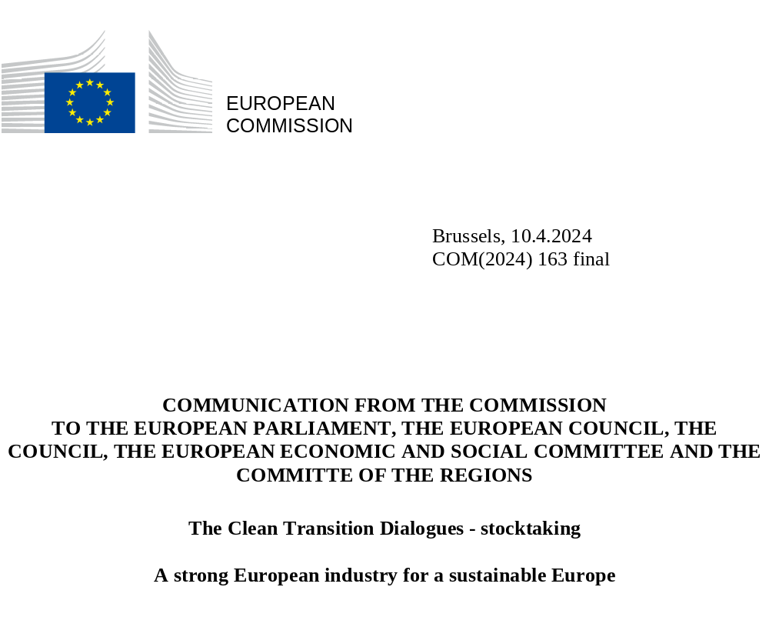

- INTRODUCTION

Transforming Europe into a clean, resource-efficient, fair and competitive economy was one of the key priorities set out by the Commission at the beginning of the mandate. To reach this goal and turn Europe into the first climate-neutral continent in the world, the Commission presented, in 2019, the European Green Deal. This initiative has been followed by a range of concrete proposals, the majority of which have now been enshrined in law. In 2023, the Commission followed up with the publication of a Green Deal Industrial Plan. The focus must now shift to shaping a tailor-made implementation.
In this context, the European Commission is also strongly committed to strengthen Europe as a business location and destination, with a strong domestic manufacturing base built on diversified supply chains for the strategic commodities and inputs it requires. With the right accompanying policies, Europe’s transition to climate neutrality and a circular economy creates clean growth, new business models and markets, high quality jobs and technological development. Total net greenhouse gas (GHG) emissions were 32.5% lower in 2022 than in 1990 while the economy has grown by 67% and – thanks to the European ETS - over EUR 175 billion in revenues has been generated over the last decade alone. Moving forward, the EU will need to mobilise investments and generate significant economic growth. To this end, preserving and fostering the EU single market remains essential.
Recent geopolitical developments have strengthened the case for a clean, resource-efficient and competitive economy. Russia’s aggression against Ukraine has underlined our need to achieve resilience and reduce dependencies from unreliable partners.
The global call at COP28 to transition away from fossil fuels, and the global pledge to triple renewable energy capacity and double energy efficiency improvements by 2030, have shown the international commitment to the clean transition and the need for Europe to stay the course. With the right set of policies, Europe will benefit from the global uptake of clean energies and technologies. While leading international efforts in the development of renewable energy and other clean technologies, the EU will continue to contribute to green and clean transition globally, including through the Global Gateway investment strategy and trade relations.
2. THE CLEAN TRANSITION DIALOGUES
Europe’s industry has a key role to play in the transition of Europe’s economy. At the same time, it is coming under pressure because of the worsening security, geopolitical, and economic context. This is aggravated by actions undertaken by some third countries such as massive foreign subsidies and local content requirements abroad, which can lead to unfair competition and trade distortions. A clear example is the deployment of net-zero technologies which are the focus of strong geostrategic interests and a global technological race, where the right policy and investment mix is key for Europe’s future. In addition, high energy costs in the EU, insufficient access to finance and diffusion of new technologies, low tolerance for failure among companies, as well as undue regulatory burdens and red-tape present serious risks for the competitive sustainability of European industry.
To address these concerns and to strengthen the Commission’s engagement with industry and social partners, President von der Leyen announced in the 2023 State of the Union a series of Clean Transition Dialogues. Their core aim is to support industry in building its business model fit for a decarbonised economy. This Communication takes stock of these Dialogues and gives input for building blocks that can contribute to a reinforced industrial approach for a sustainable Europe.
The Dialogues, just like the Val Duchesse Social Partner Summit and the discussions at the Antwerp Industrial Summit, showed that industry and social partners are strongly committed to the climate goals and engage in shaping and implementing the European Green Deal. They also showed our industry’s steadfast commitment to prosper in Europe while creating growth by accessing global markets and through diversified value chains.
At the same time, stakeholders voiced growing concerns about the lack of a level playing field globally, the risks of carbon leakage and insufficient access to finance. The Dialogues showed that policy instruments should be modelled to address those concerns. Dialogue participants also highlighted the need to strengthen the business case for a resource-efficient and competitive economy, and the importance of the Single Market and market incentives, in addition to targets and regulation. Social partners highlighted the importance of ensuring the social fairness of the transition, to create good quality jobs and anticipate its effects on people, consumers and the workforce, as well as the need for reinforced structured social dialogue, including in industrial policy making.
These insights confirm the need for a reinforced industrial approach, building on the EU’s industrial strategy and the Green Deal Industrial Plan, allowing Europe to reach three objectives at the same time: climate neutrality by 2050, increased competitiveness and resilience of our industry, and a transition that is socially fair and inclusive.
The Dialogues emphasised a few building blocks that will contribute to that reinforced industrial approach: (1) an effective and simplified regulatory framework for businesses to deliver on the transition; (2) action on energy prices; (3) modern infrastructure; (4) easier access to finance; and (5) a stronger Single Market in a globally competitive environment.

- DELIVERY THROUGH EFFECTIVE IMPLEMENTATION AND SIMPLIFICATION

The EU has delivered the policy and regulatory framework to achieve the 2030 targets and to keep Europe on track towards climate neutrality and a sustainable economy by 2050. A clear regulatory framework creates stability and predictability, which are key for driving investments, especially in net zero technologies. As the clean transition enters its implementation phase, the focus must now be on a swift and uniform application of the agreed framework across all EU Member States, also by updating and monitoring the National Energy and Climate Plans.
What gets measured gets done. Building on its various Single Market and Competitiveness Reports and Scoreboards, and without creating any new reporting obligations for industry, the Commission will publish on a dedicated platform a limited set of key indicators to monitor, measure and present in a clear way the competitiveness of the Single Market and the progress of the clean industrial transition. It will cover areas such as GHG emission reductions, and enabling factors such as job creation and a skilled workforce, especially in energy-intensive industries, energy costs, energy efficiency, deployment of zero and low carbon energy and fuel sources, as well as infrastructure development and circularity. It could also rely on information regarding progress in achieving benchmarks on domestic manufacturing capacity and reuse in the sectors covered by the Net Zero Industry Act (NZIA), and the Critical Raw Materials Act (CRMA), mobilisation of investments to finance the clean transition, as well as diversifying supply chains in the strategic sectors. Such an overview will help policymakers to decide on actions needed to improve and speed up the application of the agreed framework, thereby supporting industry in leading the transition.
Given the comprehensive legislative framework adopted under this mandate, the Commission will provide guidance to facilitate the application of EU legislation in support of industry, third countries and Member States, especially those with weaker administrative capacity, or with specific challenges on spatial planning, to reach the European Green Deal targets.
Ease of doing business in our Single Market strengthens delivery on the transition. The Commission will build, under the Single Market Obstacle Tool and the Single Digital Gateway, a dedicated digital platform to identify obstacles in the Single Market, more clearly, especially those to deployment of clean technologies across our continent. Industrial actors, social partners and other stakeholders can use this information to suggest possible improvements to the existing regulatory framework, to remove obstacles that slow down investments and hamper the business case for their projects, or point to regulatory inconsistencies. The platform would operate on a voluntary basis and would not create new reporting requirements for industry.
At the same time, the Commission will continue enforcing European legislation to create a Single Market with simplicity for businesses, also by taking corrective actions followed by infringement procedures when necessary.
Simplification of the framework by removing undue regulatory burdens should be Europe’s rolling commitment. This Commission will further focus on burden reduction and its ongoing actions, such as reducing burden from reporting requirements by 25% without undermining its policy objectives. The Commission has made progress with 41 initiatives to rationalise reporting requirements, that were presented in the 2024 Commission Work Programme. To sustain this effort and prepare the ground for future action, the Commission prepared targeted rationalisation plans, which will be reported upon in the upcoming Commission’s Annual Burden Survey. The Commission will also explore making better use of digitalization and new technologies, such as AI and geospatial data, to see where reporting by businesses can be replaced by data obtained through other means, thus cutting burdens for businesses.
In addition, the Commission will support industry to address the skills gap, which has become a serious bottleneck for the industry’s clean transition. This requires a strong focus by Member States to identify the skills gap and work with industry and social partners to mobilise actions to address them in accordance with the Action Plan to reduce skills and labour shortage .
An effective and simplified enabling framework for a competitive sustainable economy often starts at local and regional level. Cities are key players in delivering the objectives of the Green Deal on the ground, as demonstrated by the Covenant of Mayors and the EU Mission on ‘Climate-Neutral and Smart Cities’, which involves 100 EU cities committed to reach climate neutrality by 2030, representing 12% of the EU’s population. To speed up the implementation of the Green Deal and to foster our industrial strength, the Commission will further work on identifying key value chains, lead markets, and demand aggregation opportunities with a strong anchor on the regional and local level, leveraging Cohesion Policy decarbonisation investments in EU Member States and regions.
This collaborative approach will continue to be supported through industrial alliances.

- ABUNDANT AND AFFORDABLE CLEAN ENERGY

Participants in the Dialogues stressed that securing the supply of abundant and affordable zero and low-carbon energy is a key condition to accelerate the decarbonisation of the EU economy and preserve the competitiveness of the European industry. To get there, and in full respect of Member States’ right to decide on their energy mix, Europe will need all zero and low-carbon energy sources and flexibility technologies as well as efficient and integrated energy markets. Energy efficiency improvements, and the uptake of sustainable and efficient products can continue to lower the energy costs, and guarantee a cost-effective transition.
Thanks to the unprecedented efforts of citizens, industry, Member States and the EU, the situation on the EU energy market has stabilised. However, energy prices continue to affect the competitiveness of the EU industry. EU electricity industrial retail prices are 2 to 3 times more expensive than in the US (2021 to 2023) while historically they were 1.5 - 2 times the US prices. Gas prices are 3 to 6 times higher than those in the U.S, compared to 2-3 times historically. This requires a thorough discussion involving all EU institutions, Member States and stakeholders on how Europe can achieve the phase-in of clean energy and phase-out of fossil fuels in an affordable and competitive manner for Europe, notably by rewarding early movers towards clean energy and energy efficiency whilst bridging the potential funding gap when there is a market failure.
The Dialogues reconfirmed that this is of particular importance for energy intensive industries but also for the clean tech and transport sectors, both being critical for stimulating growth and creating jobs in Europe. Indeed, certain industrial and transport sectors have called for additional innovative, transitory measures that secure energy at lower prices, while providing certainty to energy producers through long-term off-take. Furthermore, participants also noted that a reduction of network fees paid by energy intensive industries that are pursuing decarbonisation strategies could lower their energy costs. Going forward, this may warrant a discussion at European level on network tariff setting methodologies with a specific focus on energy intensive industries, in line with the EU acquis. Additionally, participants underlined the importance of taking additional actions at EU level to faciliate the production and uptake of sustainable alternative fuels.
The full benefits of the energy transition will only materialise when zero- and low-carbon technologies will more permanently replace fossil fuels, and when major investments in grids, storage and flexibility are completed. The roll-out of zero and low carbon energy sources must accelerate. Member States should make full use of the potential provided by the new rules, including by rapidly transposing the Renewable Energy Directive, removing barriers to the conclusion of power purchase agreements and accelerating permit-granting for renewables, their connection to the grid, and their manufacturing. Making use of this potential may require strengthening administrative capacity, including by ensuring appropriate staffing and financing of permitting authorities. The Technical Support Instrument stands ready to support Member States in improving permitting systems. At the same time, in relation to wood-based bioenergy, it would be important to implement the new sustainability criteria for the use of woody biomass and avoid support schemes that create distortive effects on the rapidly expanding bioeconomy sector.
To master the transition, industry called for the creation of industrial clusters, that connect the largest manufacturing facilities and hubs with zero and low carbon generation plants, hydrogen and renewable- and low-carbon fuels producing facilities, or carbon capture, storage, transport and utilisation infrastructure. Clustering industrial activity, in line with EU competition rules, could help suppliers of net-zero technologies and renewable energy to scale up their operations and improve their commercial viability by supplying several industrial off-takers within a cluster, while manufacturing industry could decarbonise their operations at a lower cost by securing access to clean technologies and sharing costs, overall building a strong business case. Moreover, in line with recent COP conclusions and the Commission’s proposal to review the Energy Taxation Directive, Member States need to take measures eliminating subsidies for using fossil fuels, including in the form of tax exemptions or reduced rates. Fossil fuel subsidies amounted to EUR 56 billion in the EU in 2021 and to EUR 123 billion in 2022. More than half of fossil fuel subsidies do not have a fixed end date in 19 Member States.
Graph 1: Fossil fuel subsidies as share of GDP and their planned end date
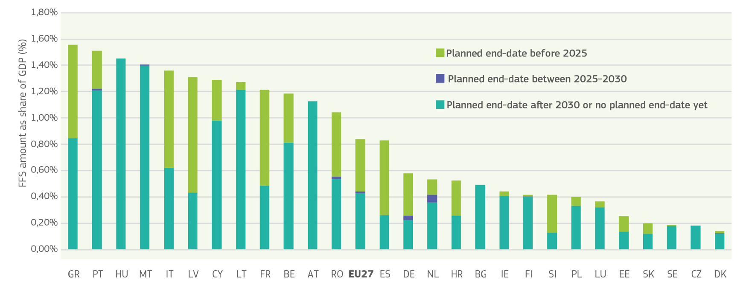
Source: European Commission.

Participants in the Dialogues called on Member States to reconsider the level of taxes and levies on energy, including electricity. Reducing them would have the potential to bring electricity prices down by around EUR 10-20 per MWh for industrial customers on average in the EU, with significant additional potential in Member States with a high level of taxes. At the same time, energy taxation plays a direct role in supporting the green transition by sending the right price signals and providing the right incentives for sustainable consumption and production. Changes to their level should be designed in full consistency with decarbonisation objectives, and taking into account any distributional and fiscal impacts.
Graph 2: Electricity prices – share of taxes and levies
Average of taxes/levies in the electricity price in the first half of 2023
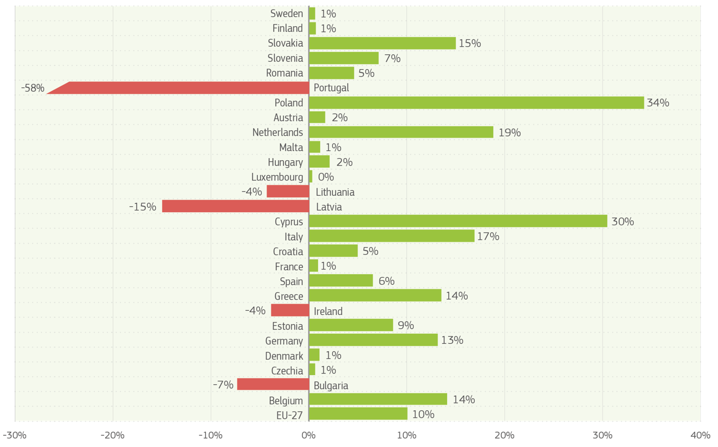
Source: EUROSTAT (nrg_pc_205) - Electricity prices for non-household consumers Band IC

- MODERN INFRASTRUCTURE AS A BACKBONE FOR INDUSTRY

Energy, digital and transport infrastructure is critical for Europe’s economic security and the long-term competitiveness of our industry. The scale of the challenge, however, is unprecedented. In this decade alone, the cross-border electricity transmission capacity should double. To serve the growing zero-emission vehicle fleet, a four-fold increase in publicly accessible electric recharging infrastructure and additional hydrogen refuelling infrastructure is needed by 2025, compared to 2020. Connecting this electromobility infrastructure and other network users requires a substantial modernization and expansion of electricity infrastructure, particularly at distribution level. 40% of distribution grids in the EU are more than 40 years old, a clear sign that urgent investment in smartening and flexibility solutions as well as grid expansion are needed. The length of planning, tendering, and permitting for these investments needs to be reduced. Delays in developing the infrastructure come with a hefty price tag of billions of euros, notably in the form of curtailed renewables generation and higher energy prices.
The EU already supports the development of the infrastructure needed for the clean transition. But to ensure a more European approach and timely completion of the necessary investments, including for security, with better integrated long-term planning between energy, transport and data. Closer coordination is urgently needed between the Commission, Member States, local and regional authorities, network operators, industrial actors, regulators and financial institutions. The Commission will analyse and where needed adjust the existing formats to provide a platform for a regular and direct engagement with all key actors, with a focus on concrete infrastructure projects, including cross-sectoral projects
Dialogue participants also raised the important mismatch between the significant upfront investment costs of infrastructure development, and available funds. Private investment has not been sufficiently mobilised. Given the limited resources of public funding instruments such as the Connecting Europe Facility, public support should be well targeted and designed to unlock private investments. For energy the Commission will intensify discussions with industry, national regulators and system operators as well as social partners on how flexibility solution and demand response can effectively complement investments in infrastructure and reduce capital expenditure, as well as how grid users, and notably power generators could contribute to the funding of required investments, while avoiding additional pressure on energy prices. For transport, the blending of grants and loans under the Alternative Fuels Infrastructure Facility of the Connecting Europe Facility are relevant to trigger investments while limiting competition distortions in the internal market. Synergies between energy and transport investments could be further explored to facilitate infrastructure financing.
As part of an ambitious clean infrastructure agenda, the EU should also remain a global leader in the manufacturing of cables, pipes, turbines, electrolysers, transformers, and technologies for vehicle recharging and refuelling, and other key components. The swift implementation of the Grid Action Plan, including long-term visibility of projects and common product specifications will be instrumental. The Commission will therefore consider supporting industry in developing demand standardisation for cables, pipelines and technologies necessary for the development of the energy grid. Resilience requirements applicable to procurement and auctions will help create demand for EU-made equipment and components that meet high standards set for use in infrastructure development.

- UNLOCKING FINANCE FOR THE TRANSITION

The Communication on the EU's 2040 climate target and the accompanying impact assessment estimate the total cost of investment associated to the economic sectors needed for the clean transition, as a whole, at around EUR 1.5 trillion per year between 2031 and 2050. Given that the important share of this cost would occur even without clean transition the additional investment would be lower, and is estimated at some 660 billion per year.
The private sector will continue to play a leading role in deploying investment in the clean transition and scaling up of innovative companies. Strengthening the capital markets union and mobilising venture capital, pension funds, private equity, and sovereign funds are necessary for injecting more financing into the Europe’s clean economy. Less than 30 percent of European firms’ funding comes from tradable equity and debt, compared to nearly 70 percent for US firms. Achieving a deep and integrated Capital Markets Union may, according to some estimates, generate 470 billion euros per year in investment, including in the clean transition. The Commission will also continue enhancing the usability of the sustainable finance framework, with a view to maximising its impact. Instruments like carbon removal certification or biodiversity credits can promote new business models and reward stakeholders for nature-based solutions. Participants in the Dialogues also stressed the need to reduce the cost of raising capital, diversify funding options for businesses, propose new innovative financial tools, and facilitate cross-border investing.
Wider availability of risk sharing tools is and will continue to be needed, an area where the European Investment Bank (EIB) has an important role to play given its firepower and ability to pull private banks and investors. At the national level, National Promotional Banks should be leveraged. The Commission will also consider how risk-sharing tools, guarantees, credits and insurances provided by Member States, for instance via export credit agencies could serve as cost-effective way to support the industry’s clean transition, addressing market failures and securing additional access to private funding.
The Commission should strengthen the political engagement and dialogue with the institutional actors, including the EIB, the European Bank for Reconstruction and Development (EBRD), international financial institutions and private banks to ensure the enabling conditions, including investment guarantees, for the rapid mobilisation of private finance and ensuring inflow of new capital urgently needed for the clean transition.
Even with the stronger engagement of private markets, market failures are likely to remain in certain areas, requiring a discussion on stronger, targeted and innovative public financial support. This can provide bridge financing and effectively share investment risk, in order to crowd in private finance and trigger strategic make-or-break investments in key decarbonisation technologies.
Around 35% of the greenhouse gas emissions reduction that must be achieved by 2050 are deemed to be dependent on solutions that are currently only at the demonstration or prototype stage, underlining the importance of funding for research and innovation (R&I), including through Horizon Europe, as well as for the scale-up and deployment of existing solutions.
The Commission has pledged to mobilise unprecedented support of EUR 1 trillion for the clean transition for the 2021-2030 period. This includes EUR 578 billion for climate mainstreaming by the EU Budget and NextGenerationEU. Under the Recovery and Resilience Facility, over EUR 202 billion are dedicated to the climate transition, with EUR 110 billion targeted to the decarbonisation of industry and clean tech (incl. EUR 23 billion for R&D initiatives) and more than EUR 2 billion for developing green skills and jobs for the clean economy. Cohesion Policy supports Member States’ transition to a climate-neutral and clean economy with EUR 93 billion in 2021-2027. The Just Transition Fund (JTF) focuses EUR 19 billion of investment specifically for the transformation of the regions with coal and carbon-intensive industry most affected by the green transition. The InvestEU Programme has also been instrumental in mobilising private financing in green priority areas in cooperation with public partner institutions, although its capacity is falling short compared to the high demand for its products.
Important financing is provided from auctioning of allowances under the Emissions Trading System (ETS). Over the last decade, the revenues from the European ETS amounted to over EUR 175 billion. From 2024 to 2030, depending on the carbon price and other factors, the EU ETS may generate around EUR 220 billion, with an additional EUR 113 billion over 2027-2030 coming from the newly created emissions trading system on buildings, road transport and additional sectors. The Commission proposed in June 2023 that 30% of revenues generated by EU emissions trading would accrue to the EU budget, contributing to the financing of the EU budget with its focus on sustainable investments. A strong EU budget is needed to deliver higher quality investments and in this context the Commission urges swift progress on both the issue of innovative ways to use public funds to crowd in private investment, as well as the proposed ETS own resource.
More specifically, around 10% of the ETS allowances issued in 2021-2030 are dedicated to the EU’s two flagship financing programmes, i.e. the Innovation Fund and the Modernisation Fund. Calls organised under the Innovation Fund have an oversubscription rate of up to 20 times the available funds. Industrial actors have flagged the need to increase the budget of the Innovation Fund and further simplification of the rules, including to support green scale ups and start ups across industry, transport, circular economy and energy sectors.
Furthermore, a greater share of ETS revenues could flow back to support decarbonisation. Member States currently spend on average around 75% of their revenues on climate and energy purposes, which under the revised ETS Directive will need to increase to 100%. This offers vast opportunities to scale up support to industry .
Graph 3: ETS revenues spent on climate and energy purposes by Member States
Based on reported usage, in million euro

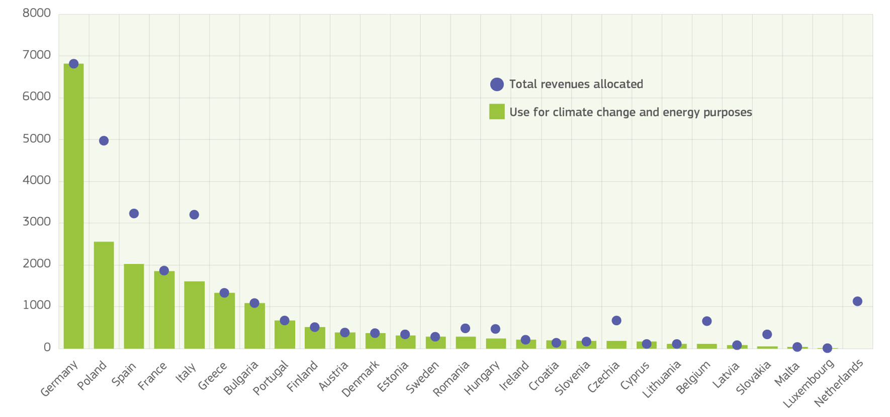Source: European Environmental Agency, https://www.eea.europa.eu/en/analysis/indicators/use-of-auctioning-revenues-generated#:~:text=Total%20auctioning%20revenues%20generated%20under,and%20the%20Modernisation%20Fund%20(EUR3

Also for access to public funds, simplicity means better delivery. Dialogue participants considered access to EU funds to be complex and lengthy due to different eligibility criteria, application procedures, and red tape. They underlined the challenge of navigating the different EU and national funds, especially for SMEs. They called on the EU to make access to public funding simpler and faster and to explore ways to link EU funding with available local and regional finance, building on the updated Funding & Tenders Portal.
The Strategic Technologies for Europe Platform (STEP) is a crucial initiative to boost investments in Europe’s critical technologies across digital, deep tech, clean tech, and biotech for an estimated investment potential of up to EUR 50 billion. The Commission will as a matter of priority launch the STEP Sovereignty Portal in the second quarter of 2024 and will enhance its functionalities over time. It will consolidate information on EU funding options for STEP investment areas and support project promoters in identifying the best EU funding opportunities for their business needs. The next MFF represents an opportunity to further streamline the EU financial landscape and strengthen synergies across programmes to better support the clean transition.
As part of this workstream, the Commission will also assess how EU funding and financing could be accelerated. The average level of commitments and spending on climate mainstreaming under the EU funds amounts to some 30% of the available budgets for the 2021-2027 period. This is especially relevant for clean tech and decarbonisation projects as their long lead times require early financing and funding to ensure these investments can still effectively contribute to meeting the 2030 target.
According to the participants, to simplify access to national funding and create economies of scale, Member States should, in line with State aid rules, make more use of auctions-as-a-service schemes, as pioneered under the 2023 pilot auction of the European Hydrogen Bank to which Germany allocated EUR 350 million for renewable hydrogen. These schemes are an innovative way to accelerate market deployment throughout the EU, and reduce the administrative burden, including by facilitating important synergies for swift State aid clearance of the schemes. The Commission will assess how the concepts of auctions-as-a-service and grants-as-a-service can be expanded to other policy fields, while ensuring that auctions remain sufficiently competitive, starting for example with the Commission’s announced support to European manufacturers of the most sustainable batteries of EUR 3 billion tfor three years.
On State aid, participants in the Dialogues frequently mentioned the example of the Temporary Crisis and Transition Framework (TCTF), including the provisions enabling Member States in exceptional cases to provide support to companies, where there is a real risk of investments being diverted away from Europe, up to the amount of support the beneficiary could receive for an equivalent investment in that alternative location (‘matching aid'), or the amount needed to incentivise the company to locate the investment in the EEA (‘funding gap'), whichever is the lowest. Some of the participants have also noted that the existing State aid framework should to a larger extent take due account of the external dimension including the existing and possible future multilateral commitments and rules on subsidies and the changing global security, economic and trade context. The Commission will continue to ensure that State aid rules are fit for purpose in light of all relevant factors and in consultation with all relevant stakeholders.
Overall, there is an urgent need to coordinate funding more at EU level, to create economies of scale, to enhance the efficient allocation of resources, and make use of the single market, while taking into account cohesion policy objectives for a fair and inclusive transition.

- LEVERAGING THE CLEAN SINGLE MARKET IN A GLOBALLY COMPETITIVE ENVIRONMENT

The global clean transition represents a major geostrategic and geoeconomic challenge. It is at the same time an unprecedented opportunity for the EU to be one of the leaders shaping the global market for mass-manufactured clean technologies and become the world’s largest sustainable marketplace. With the clean tech market projected to triple to an annual worth of around EUR 600 billion globally by 2030, it provides ample business opportunities. The EU’s international partnerships can support the EU clean tech industry, including SMEs, to unlock new business opportunities worldwide. By leveraging its single market, the EU can pool demand, and build long-lasting strategic international partnerships to secure diversified supply of clean technologies.
The Single Market is the EU’s greatest strength, as it provides scale and promotes a high level of standards also outside Europe. Further efforts are taking place to support standardisation as part of the EU standardisation strategy.
Given that approximately EUR 2 trillion of public funds, representing 14% of GDP, is spent every year through the public procurement process, strategic public procurement is a key tool to create markets for net zero, circular and clean technologies and business solutions and to reward companies that invest in innovative and sustainable technologies and manufacturing with the best sustainability footprint, while creating quality jobs. Resilience and sustainability provisions under European legislation already allow such opportunities, which should be followed by a thorough discussion on how public procurement can, in practice, be deployed more strategically to unlock investment to cement competitive sustainability in Europe.
Another useful tool is the joint purchase of strategic commodities on the global markets. Based on the positive result of demand aggregation and joint purchase of medical countermeasures in the health sector and gas in the energy sector, the Commission will consider developing demand aggregation and joint purchasing for other strategic commodities, while implementing the pilot for hydrogen under the Hydrogen Bank and organising the joint purchasing of critical raw materials. This would help European buyers to secure supply of these strategic commodities at affordable prices on a global market, thereby supporting efforts by European manufacturers and suppliers to scale up their production capacity and reduce the time lag for rolling out key clean technologies. The Commission will explore further ways for industrial actors willing to engage in various cooperation models, including by forming consortia, to jointly negotiate better conditions from global producers, with important safeguards for encouraging the transfer of benefits to end users and the involvement of smaller companies in line with competition rules.
The Net Zero Industry Act establishes a benchmark for EU manufacturing capacity for net-zero technologies to reach at least 40% of expected EU demand by 2030. Member States should therefore make full use of the new provisions on permitting, non-price criteria in public procurement, resilience auctions, and renewable energy auctions. Regulatory measures, including market access rules based on carbon footprint, such as in the Batteries Regulation, or on a well-functioning Single Market for the collection and reuse of secondary materials, also have an important role to play to ensure that sustainably produced products gain a larger market-share.
The EU will require substantial additional amounts of critical raw materials to meet the needs of the clean and digital transitions. Further reducing the EU’s dependence on critical raw materials requires the swift and full implementation of the Critical Raw Materials Act and the agreed strategic partnerships and overall strengthening the circular economy, making the maximum use of secondary materials and resources. As such, the EU supports industry in developing domestic and international critical raw material value chains with partners in third countries. This includes using the opportunities under the Global Gateway strategy and Team Europe's approach in creating sustainable investments value added in partner countries. The Commission, with the support of the European Raw Materials Alliance, will also strengthen its engagement with the EIB, the EBRD, dedicated national funds, commercial banks and financial institutions in view of stepping up financing for the strategic projects.
Trade is one of the key drivers of the EU’s competitiveness. The EU draws economic and political strength from its position as the largest trader and investor: it is the world’s largest exporter, accounting for 16% of global exports. The EU is a promoter of, and thrives on, open and rules-based trade. EU trade policy is key both to protect the single market against unfair trade as well as to open markets for EU products and ensure access to inputs. It can also play a key role in enabling investment in raw materials and green energy in third countries and in ensuring that those products can be exported to the EU, without restrictions imposed by third countries. The European industry is under growing pressure, as the playing field is increasingly distorted by unfair competition from certain third countries, and due to excessive dependencies in strategic sectors. In particular, unprecedented incentive schemes and wide-spread use of subsidies favouring domestic industries provide significant advantages to businesses based in those countries.
The Commission and Member States should make full use of policy instruments against unfair global competition, to ensure a level playing field on the internal market. This includes the possibility for the Commission, under the Foreign Subsidies Regulation, to investigate subsidies granted by non-EU countries to companies engaging in any economic activity in the EU and redress, if needed, the distortive effects of these foreign subsidies. Similarly, the Foreign Direct Investment (FDI) Screening Regulation allows for the assessment of security risks of FDIs. EU trade agreements also aim to promote renewable energy investments, including through access to energy grids, with a view to diversify sourcing and enable market access in third countries while preserving security of supply.
In addition, actions, including trade measures should be considered and taken to protect the EU economy from unfair competition on international markets. In this context, early notification to the Commission by industry and Member States of potential distortions of the level playing field by third countries is of primary importance.
Progress in global carbon pricing, remains essential. The EU and Member States should focus their collaborative efforts on convincing other economies to put a price on carbon. To this end, the Commission has created a Task Force, in February 2024, to deploy a more systematic global carbon pricing diplomacy.
Participants of the dialogues have stressed the necessity of ensuring the proper implementation of the Carbon Border Adjustment Mechanism, which aims to support the EU to reach its environmental objectives. Before the end of the transitional period, the Commission will carry out a broad review of CBAM, including an assessment of the risks of carbon leakage for goods produced in the Union intended for export to non-EU countries. This review will also include downstream products and other sectors, including international transport which compete globally and are exposed to the risk of carbon leakage.

- CONCLUSION

Climate protection, green growth and competitive sustainability go hand in hand. Clean technology and sustainable production are and have to remain the EU’s competitive advantage. Now is the time to deliver and step up investment in a fair transition and in clean technology and sustainable production.
This requires a reinforced industrial approach that ensures predictability for investors in an effective and simplified regulatory environment, allows movers to clean energy and fuels to benefit from competitive costs, delivers the necessary infrastructure, unlocks private and public investment, strengthens the Single Market and ultimately improves the competitiveness of European businesses and their ability to deliver on the European Green Deal. This will require a more collaborative approach through intensive dialogue with Member States, regional and local authorities, as well as industry and stakeholders.
The Commission will continue its engagement with industry and social partners through the Clean Transition Dialogues, and it stands ready to engage in a thorough debate with Council and Parliament on the key factors that need to be addressed, and to work together on these with all stakeholders.

Climate Action Progress Report 2023.
Estimate from AMECO database (European Commission, DG ECFIN), real GDP.
The following Clean Transition Dialogues took place: 10 October 2023: Hydrogen; 30 November 2023: Energy-intensive; 22 February 2024: Clean-tech; 23 February 2024: Critical raw materials; 26 February 2024: Grean Deal infrastructure; 14 March 2024: Forest and Forestry owners; 15 March 2024: Cities; 22 March 2024: Steel industry; 8 April 2024: Clean mobility.
https://commission.europa.eu/news/val-duchesse-summit-eu-and-social-partners-commit-strengthening-social-dialogue-2024-01-31_en
https://antwerp-declaration.eu/
It is noted that the findings of the European Monitor of Industrial Ecosystems (SWD(2024)77 final), can also provide an additional basis for evidence-based policy action.
In this transition, the Single Digital Gateway will continue to facilitate the reduction of administrative burden for companies, providing a centralized platform to access information, administrative procedures, and assistance across all Member States.
Under the European Pact for Skills, 3,5 million workers have already been trained to make sure the green and digital transition creates quality jobs in Europe.
The EU has already made available EUR 5.8 billion for substantial investments in green skills and green jobs.
COM(2024) 131 final of 20 March 2024
Gas and electricity prices are gradually approaching their level from summer 2021, while the EU dependency on Russian gas fell from 45% in 2021 to 15% in 2023. The EU has diversified its gas supplies and has successfully reduced energy demand.
The successful transition to sustainable mobility depends on access to clean energy and access to feedstocks. In particular, the maritime and aviation sectors will need considerable amounts of renewable and low-carbon fuels, as supported by the Renewable and Low-Carbon Fuels Value Chain Industrial Alliance. Developing production of those fuels will diversify our energy supply while improving our industrial competitiveness. The EU will ensure continued regulatory predictability to incentivize investments in the production of the necessary feedstocks to scale-up such innovative fuels on the European market in the next decade.
Such as hydrogen valleys and net-zero acceleration valleys.
https://www.eea.europa.eu/en/analysis/indicators/fossil-fuel-subsidies#:~:text=Fossil%20fuel%20subsidies%20remained%20relatively,and%20Russia's%20invasion%20of%20Ukraine.
Austria, Belgium, Bulgaria, Cyprus, Czechia, Denmark, Estonia, Finland, Greece, Hungary, Ireland, Lithuania, Luxembourg, Malta, the Netherlands, Poland, Portugal, Slovakia, Sweden.
Negative values indicate that the electricity price after taxes and levies is lower than before as a result of Member States’ subsidies via tax alleviation and/or the tax accounting methodologies in Member States.
Commission Communication: A strategic rollout plan to outline a set of supplementary actions to support the rapid deployment of alternative fuels infrastructure, https://eur-lex.europa.eu/legal-content/en/TXT/?uri=CELEX%3A52021DC0560
Commission Communication: Grids, the missing link – An EU Action Plan for Grids, https://eur-lex.europa.eu/legal-content/EN/TXT/?uri=CELEX:52023DC0757
COM(2024) 63 final
Indeed, an important share of these costs would have to be born even without the clean transition, but the structure of the expenses would be different. For example, investments in the energy system will be aimed at scaling up decentralised domestic renewable energy production instead of paying a bill for imported fossil fuels.
The Impact Assessment accompanying the 2040 Climate Target Communication, combining the additional investments into the energy system (production and users of energy) and additional investments into transport.
Haver Analytics and IMF staff calculations. https://www.imf.org/-/media/Files/News/Speech/2023/imf-background-note-on-cmu-for-eurogroup.ashx
New Financial: Driving growth: how EU capital markets can support a post-Covid recovery, https://newfinancial.org/report-eu-capital-markets-a-post-covid-recovery/
‘Net Zero Roadmap; a global pathway to keep the 1.5°C goal in reach’, IEA, 2023 update.
COM/2020/21 final
This excludes the revenues for the innovation fund and revenues related to the initial endowment for the Modernisation Fund and the allowances used for REPowerEU.
https://ec.europa.eu/info/funding-tenders/opportunities/portal/screen/home
https://eur-lex.europa.eu/legal-content/EN/TXT/HTML/?uri=CELEX:52023PC0161
For instance, the NZIA, the Ecodesign for Sustainable Products regulation or the Construction Products Regulation.
Materials represent 40–60 percent of the total input costs for EU manufacturing companies and widespread resource scarcity has led to increased costs for 37% of companies, as well as supply chain disruption for 27%, and slowdowns in production capacity for a quarter of industrial firms surveyed.
Regulation (EU) 2019/452 establishing a framework for the screening of foreign direct investments into the Union

