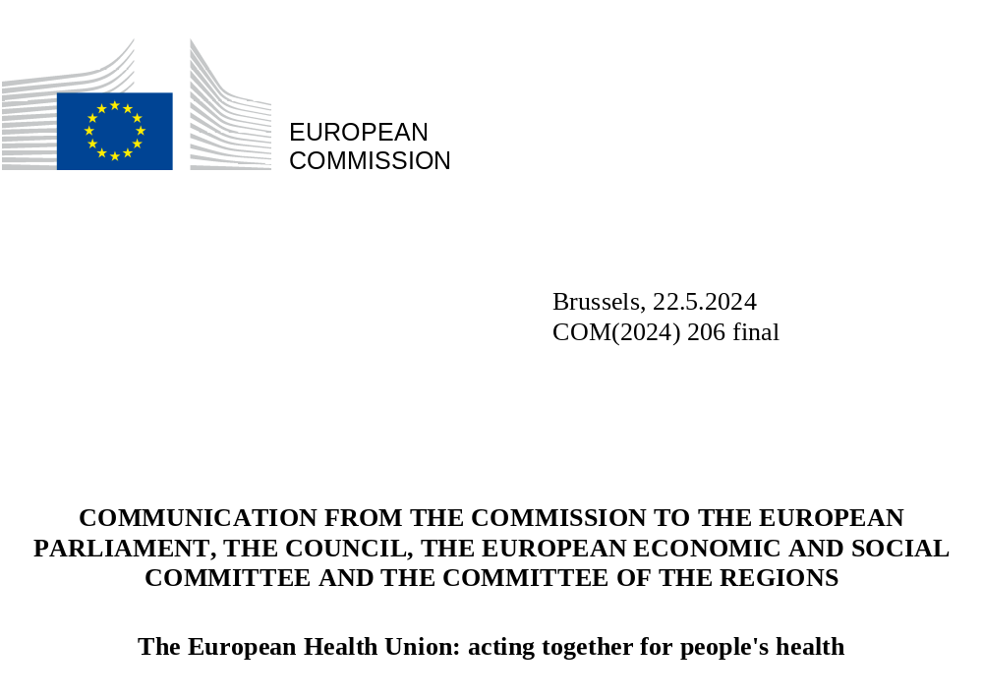

The European Health Union: acting together for people’s health

Introduction
Almost five years ago, the Von der Leyen Commission began its mandate with ambitious plans for EU action in health. It committed to supporting Member States in constantly improving the quality and sustainability of their health systems, addressing major societal challenges such as cancer prevention and care, ensuring that Europe has a sustainable supply of affordable medicines, and maximising the potential of digital health. These initiatives would become central pillars of the vision we know today as the European Health Union.
Less than one month after taking office, the COVID-19 pandemic struck, causing millions of deaths and unprecedented health and socioeconomic damage. The pandemic caught the world by surprise, revealed strategic dependencies and exposed gaps in preparedness. After early challenges, the EU responded with concrete and decisive action, showing the power of solidarity in addressing an unprecedented health threat, restoring economic and social life, and highlighting the need for more structural, far-reaching solutions.
The EU Vaccines Strategy presented in June 2020 was a European success story that helped the EU to deliver vaccines saving at least 1.4 million lives in Europe. The speed of the industrial ramp up was unprecedented, from development, evaluation, authorisation, production, and rollout; making vaccines available to all citizens at the same time, and with the same conditions, regardless of where in the EU they lived. 4.6 billion doses were secured for Europeans and partner countries. During the most acute phase, over 80% of the EU adult population were vaccinated against COVID-19, with at least a primary course in a historic, pan-European drive to protect our citizens. The subsequent creation of the EU Digital COVID Certificate helped to reopen Europe’s societies, restore business, and allowed people to resume travel safely – moving the EU closer to normal life.
European cooperation and solidarity extended far beyond our borders, with the EU and Member States becoming the world´s largest vaccine supplier when the availability of vaccines was a question of top necessity. Over 530 million doses were donated to low- and middle-income countries. The Union also ensured the delivery of over 190 million medical and personal protective equipment, such as masks or gloves, to partner countries. These achievements would not have been possible without the close collaboration between European Parliament, Member States, Commission, European External Action Service, EU Agencies, and international actors. EU’s core role in the international scene allowed access to vaccination for all populations, including the most vulnerable ones, living in humanitarian, fragile or conflict affected environments. The EU Digital COVID Certificate became the global standard for mobility at international level and supported the re-opening of economic activity at global level.
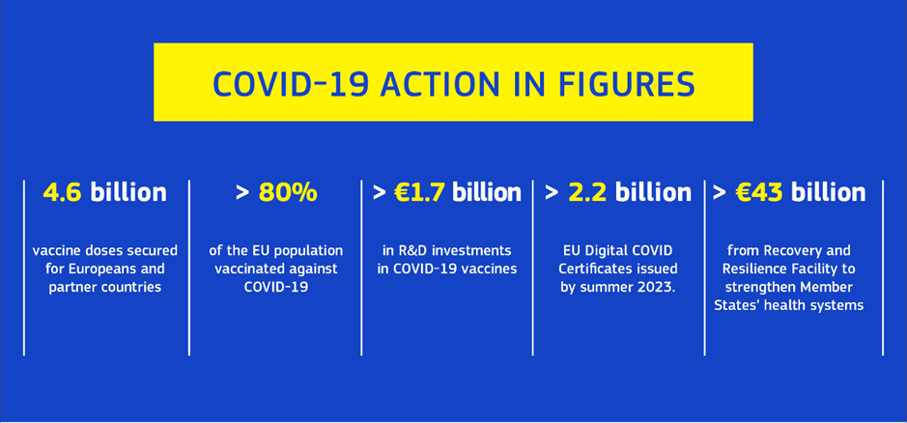
Europe’s determination and coordinated approach allowed to manage the COVID-19 pandemic as swiftly and effectively as possible. Still, this traumatic experience provided harsh yet important lessons. It revealed weak points in European health systems and highlighted the need for a stronger One Health approach, based on seamless links between human, animal, and plant health on one side, and the environment on the other. It also amplified the connections between health and the Union’s economic resilience and open strategic autonomy. It also emphasised the need for greater EU leadership in global health recognising the importance of health as a geopolitical factor.
Perhaps most of all, the pandemic underlined the salience of public health at the top of the political agenda, and showed the very tangible ways the Union can complement and add value to national policies in improving citizens’ everyday lives and welfare. This approach delivers on clear expectations from citizens when it comes to protecting and promoting their health. The latest Eurobarometer and Public Opinion, surveys have shown that health ranks among European citizens’ top priorities. The European Health Union has been created to deliver on their expectations.
Investing in health always delivers. The pandemic showed how public health is a prerequisite for societies and economies to function. A health crisis primarily costs lives, can disrupt the free movement of people and goods which EU is committed to protecting, halt economic growth and disrupt essential social functions, from education, health services to the functioning of our democracies.
The last five years were marked not only by the COVID-19 pandemic, but also by severe geopolitical challenges, notably Russia´s unjustified war of aggression against Ukraine, the Middle East crisis and the growing impacts of climate change and the digital transformation, all of which had and continue to have profound impacts on the health of EU citizens and beyond.
The European Health Union is our answer to this rapidly evolving global landscape. It is based on the principles that equity in access is a fundamental human right and that health policy can no longer be limited to its pre-pandemic boundaries – joint action at European level is crucial to Europe’s societal wellbeing, our strategic autonomy and our geopolitical stability.
Under this new approach, Member States prepare for, prevent and protect their citizens by acting together, where joint European action is necessary. It is based on a set of key pillars:
- A new health crisis framework: with effective rules to deal with health threats and a new Health Emergency Preparedness and Response Authority allowing the EU and Member States to better prepare for and respond to emerging crises together;
- Security of medical supply: with affordable, accessible and innovative treatments and medicinal products for all;
- Modern and innovative health policies: better protecting the health of our citizens and drawing on the potential of new technologies.
Crucially, it was backed by the most ambitious EU health funding programme in history, EU4Health.
Every action under the European Health Union has been designed and delivered to make citizens safer and healthier. And through these actions, the European Union has taken groundbreaking steps to protect and promote health and to strengthen health systems across Europe.

Strengthening health security for EU citizens

Tackling serious cross-border health threats
In today’s increasingly mobile and interconnected world, EU citizens expect their governments to protect them from health threats, which can easily spill across national borders. The experience of the last five years has profoundly shown the necessity of Member States responding to health crises together, and in a coordinated way.
New EU rules on serious cross-border threats to health respond to this need and are the backbone of the EU’s health security framework. These strengthened rules, in force since December 2022, allow the EU to anticipate, prepare for, and respond to major health threats – not only infectious diseases but also environmental, climate-related, or chemical risks. For example, the Commission, with the Health Security Committee (HSC), can now swiftly adopt guidance on response measures to address emerging threats or declare a public health emergency at Union level, which would trigger increased coordination and could activate emergency funding for medical countermeasures. The Commission, working closely with Member States and the relevant Union agencies, is also developing a comprehensive Union Prevention, Preparedness, and Response Plan.
Today, the EU is better able to help Member States and partner countries to prepare for health shocks, and to respond when a crisis strikes. A strengthened EU HSC ensures better cooperation and coordination between Member States. The HSC played an important role in the Commission’s coordination of the EU response to the COVID-19 pandemic, as well as in 2022 in the context of the Mpox and Ebola outbreaks. Today, it is actively addressing avian influenza among animals and humans and other potential threats. When an emergency overwhelms the response capabilities of a country in Europe or beyond, it can request assistance through the Union Civil Protection Mechanism (UCPM), which can include emergency medical support.
Surveillance plays a crucial role when it comes to protecting health, and the sharing of data means the EU is better able to monitor communicable disease trends, detect outbreaks and evaluate the effectiveness of public health measures. The Commission is helping Member States to strengthen their national surveillance systems, including wastewater surveillance, and is connecting the EU’s Early Warning and Response System (EWRS) with other EU alert systems.
Science guided the world out of the pandemic, and scientific cooperation also offers the surest path towards a more secure, healthier future. The EU Framework Programmes for Research and Innovation, which belong to the largest funding programmes for R&D&I in the world, have supported projects in various fields, including long-term research on mRNA that contributed to the development of COVID-19 vaccines. As a response to the pandemic, the Commission pledged EUR 1 billion for coronavirus research, including for the conduct of large-scale EU-wide clinical trials. With a financial support of EUR 100 million, the European Investment Bank was instrumental in helping the European company BioNTech to use the mRNA technology for the development of a COVID-19 vaccine candidate. The Commission has established a network of world class public health laboratories (DURABLE) and designated the first six EU reference laboratories for public health in March 2024, helping to increase laboratory capacities across the EU and to promote good practices. Furthermore, the EU and Member States agreed to streamline and leverage research efforts through a European Partnership on Pandemic Preparedness.
The COVID-19 pandemic underscored the vital need for robust manufacturing capacities and resilient supply chains, exposing significant vulnerabilities that impact global health and economic stability. In response, the European Commission established the Task Force for Industrial Scale-up of COVID-19 Vaccines. This Task Force worked closely with industry stakeholders to alleviate vaccine production bottlenecks, effectively map supply chains, and secure long-term manufacturing capacity in Europe, thereby catalysing further measures for critical medicines beyond just COVID-19 vaccines.
The last five years and the experience of managing the pandemic showed the critical value of these initiatives in protecting the health of citizens, particularly the most exposed and vulnerable ones such as children, older people and persons with disabilities, and overcoming an unprecedented health crisis.
  - The creation of a Health Emergency Preparedness and Response Authority (HERA)
The COVID-19 pandemic highlighted the vital importance of medical countermeasures during health emergencies, including diagnostics, vaccines, therapeutics, and personal protective equipment. It has also shown that EU and Member States funding were instrumental in securing access to messenger mRNA technologies for COVID-19 vaccines. EU support was crucial to the development of lifesaving vaccines in record time.
In 2021, the Commission created the Health Emergency Preparedness and Response Authority (HERA). HERA is designed, in close coordination with Member States, industry and civil society, to strengthen the development, manufacturing, procurement, and equitable distribution of critical medical countermeasures to protect Europeans in case of a public health emergency. In a health crisis, joint procurement can be a crucial tool to leverage Member States’ purchasing power and secure the same products for all citizens, no matter where they live. Indicatively, HERA procured vaccines two weeks after the first signs of the 2022 Mpox outbreak in the EU. HERA is also securing access to pandemic and pre-pandemic vaccines to protect Europeans from avian influenza.
HERA is steering industrial, research and innovation efforts to create the next generation of tools to tackle serious cross-border health threats. To ensure maximum flexibility, it has a dual working mode: one focusing on preparedness and a second one only activated during emergencies. Once a public health emergency has been declared, the EU emergency framework of measures for ensuring the supply of crisis relevant medical countermeasures can be activated by the Council. The Health Crisis Board, together with the ongoing work of the HERA Board, ensures coordinated actions between Member States on issues related to the development, production, procurement, and distribution of medical countermeasures in crisis and preparedness time. In public health emergencies, the Health Crisis Board and the Health Security Committee work in close coordination.
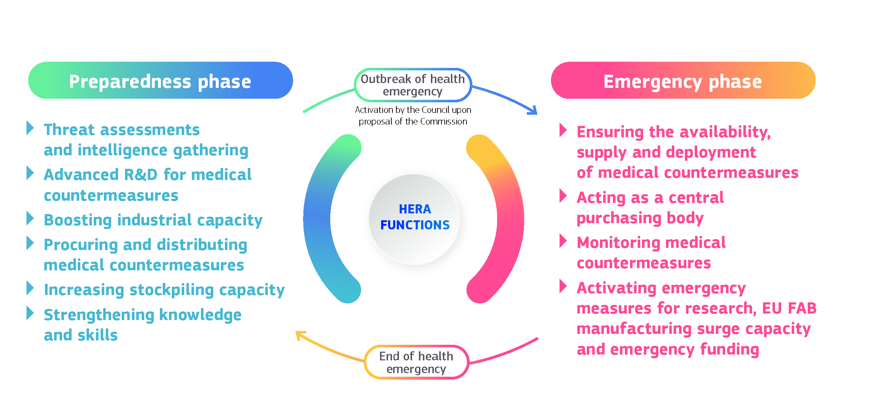
To strengthen health preparedness, HERA has launched the Global wastewater surveillance system, which has the potential to become an international lookout system for the early detection and real- time monitoring of epidemic threats and outbreaks. By identifying threats and evaluating how to best address them with medical countermeasures, HERA is establishing a broad portfolio of initiatives that would allow the EU to rapidly respond to disease X. The Commission and the European Investment Bank also created HERA Invest, a EUR 100 million top-up to the InvestEU programme, to support R&D in the most pressing cross-border health threats, financed by the EU4Health programme.
Through these actions, HERA is ensuring that the EU has the capacity to develop and produce countermeasures quickly and at the necessary scale in times of crisis. Emergency research funding can be mobilised, and EU clinical trial networks can be activated for timely and robust data generation. In times of crisis, EU FAB, a network of ever-warm production sites around the EU, could produce 325 million vaccine doses per year. In addition, backed by an investment of EUR 1.65 billion, the Commission has established strategic stockpiles of medical countermeasures and is working on response equipment to Chemical Biological Radiological Nuclear (CBRN) threats under the UCPM - rescEU, to increase preparedness and as a safety net in case Member States stocks are insufficient.

Stronger mandates for the ECDC and the EMA
Bolstered by the experience of the pandemic, the mandate of the European Medicines Agency (EMA) was broadened to prepare for, prevent, coordinate, and manage the impact of public health emergencies and major events on medicinal products and on medical devices. Under its extended mandate, the EMA will also facilitate a coordinated EU-level response to public health emergencies by providing scientific advice and reviewing available scientific evidence on medicines.
The European Centre for Disease Prevention and Control (ECDC) has played a fundamental role in the EU’s response to the COVID-19 pandemic. Now, after assessing the state of implementation of Member States' national prevention, preparedness and response plans and their relation with the Union's prevention, preparedness and response plan as foreseen by the Serious Cross Border Health Threats Regulation, the ECDC can issue recommendations for actions and milestones to be set, both to the Member States and the Commission. The agency is strengthening integrated surveillance systems and is coordinating the new network of EU reference laboratories (EURLs). The ECDC is establishing an EU Health Task Force for rapid health interventions in case of a major outbreak, complementing the Union Civil Protection Mechanism.

Improving the safety, availability and access to medicines, medical devices, and substances of human origin

Access for all to safe, affordable, and innovative medicines
Across Europe, patients and healthcare systems are faced with unequal access to medicines, shortages of medicines and even no medicines at all for certain diseases. In order to address these challenges, in November 2020, the Commission presented a new Pharmaceutical Strategy for Europe and in April 2023, proposed the most significant reform of the EU’s pharmaceutical rules in over two decades.
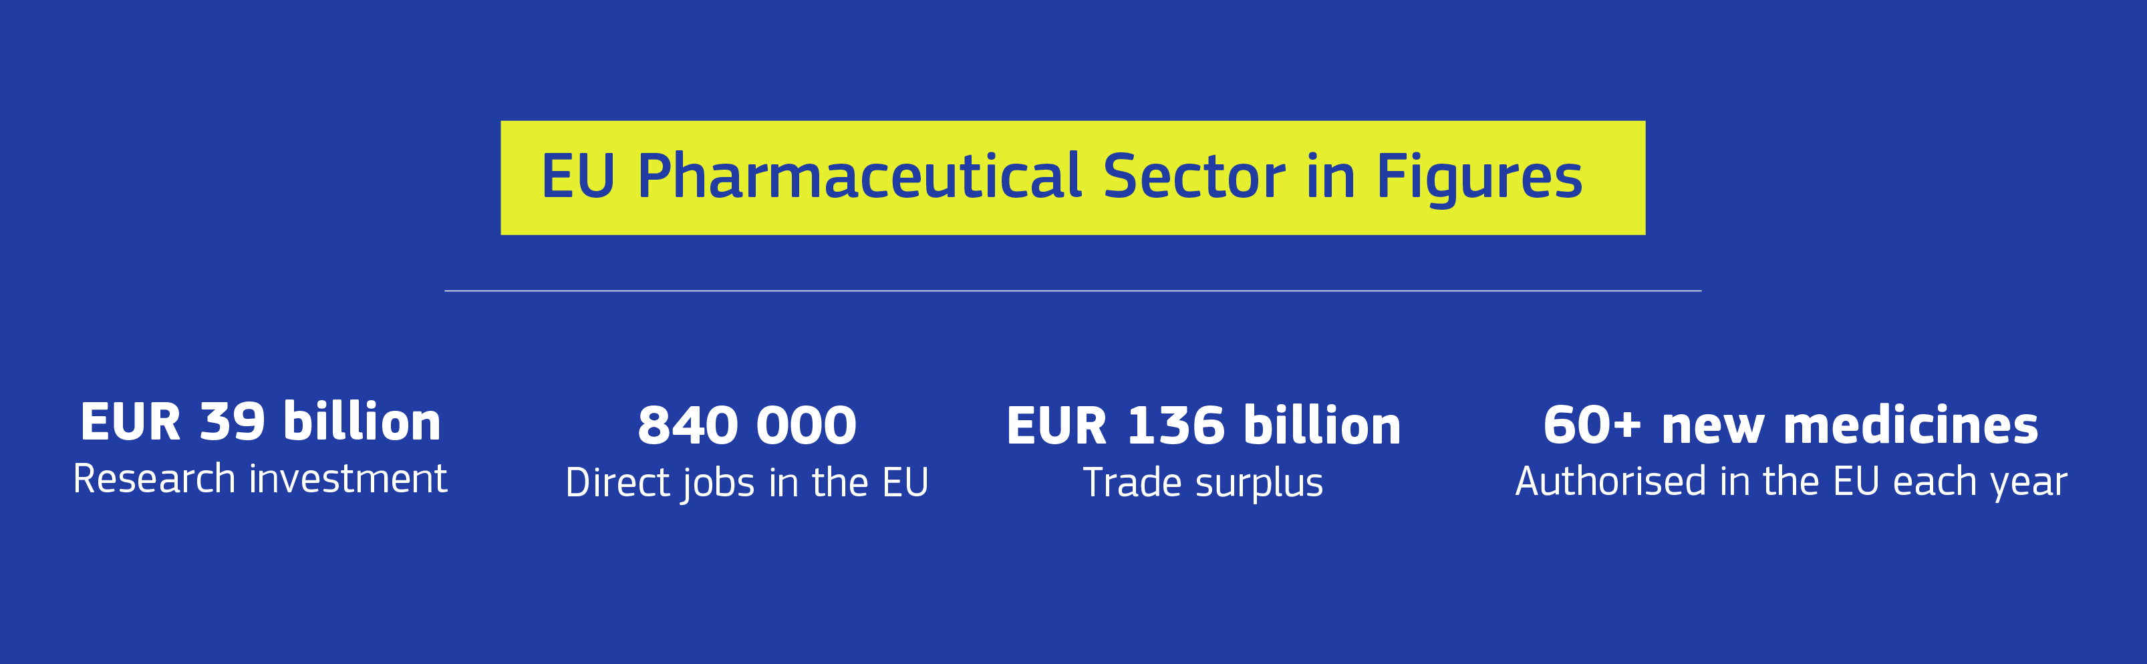
The proposed reform includes a redesigned system of incentives, to encourage companies to deliver on public health objectives, namely on more timely and equal access to medicines in all 27 Member States and the unmet medical needs of EU patients, particularly the most vulnerable ones such as children, older people and persons with disabilities. That is why, the reform proposes several measures to facilitate access, in particular in smaller Member States, that are often neglected by companies, due to their small, commercially not attractive market. Equally important, these more targeted incentives and the broader simplifications proposed will support the European pharmaceutical industry in remaining an innovator and world leader.
Once adopted by the co-legislators, the proposed reform will allow European patients, in particular those living in smaller countries, to receive medicines more quickly. Medicine developers will receive greater scientific and regulatory support from the EMA, while SMEs and not-for-profit developers will receive additional facilitation. Companies will benefit from accelerated and simplified procedures for the evaluation and authorisation of medicines, while digitalisation will reduce their administrative burden. The use of regulatory sandboxes, will support innovation in forefront technologies, including health biotechnology, and ensure the legislative system is future-proof, while maintaining the highest standards of quality and safety. By enabling generic and biosimilar medicines to reach the market more quickly and simplifying market authorisation procedures, the reform is designed to also give patients quicker access to products that are cheaper, yet of high quality.
Complementing these legislative measures, the European Commission supports cooperation projects to exchange on pricing, payment and procurement policies, in order to improve the affordability and cost-effectiveness of medicines and health system sustainability. The Commission is currently evaluating proposals to enable public financing by several Member States to support breakthrough innovation in pharmaceuticals, through a first health Important Project of Common European Interest (Med4Cure). This project aims to support the development, and first industrial deployment of innovative treatments and new technologies such as mRNA platforms to tackle antimicrobial resistance, rare diseases, and cancer.

Ensuring the availability of critical medicines and medical devices
The risk of medicine shortages is a major healthcare concern in both the EU and globally. The European Health Union is addressing this challenge with both regulatory and industrial measures.
The pharmaceutical reform proposes measures to strengthen the security of supply of the most critical medicinal products and gives the EMA a stronger role in coordinating measures to mitigate shortages. In October 2023 the Commission put forward additional short and mid-term measures to ensure more systemic and coordinated action on medicine shortages. This included the publication of a first version of the Union list of critical medicines in December 2023, with over 200 active substances for which continuity of supply is a priority. Moreover, the Strategic Technologies for Europe Platform (STEP) will aim to leverage EU funds to further support the development and manufacturing of biotechnologies and critical medicines.
The Commission launched the Critical Medicines Alliance in April 2024, as a cooperation platform to address the industrial dimension of shortages. The Alliance brings together public and private actors from the European health and industrial ecosystem, to propose recommendations to reinforce security of supply and strengthen global supply chains of critical medicines. Building on the vulnerability assessment of critical medicines, the Alliance will look at possible ways to mitigate structural risks, and reinforce supply by encouraging diversification as well as modernising and boosting manufacturing capacity at EU level where needed. The work of the Alliance will also feed into a possible legislative initiative for an EU “Critical Medicines Act” in the future.
In 2017, the Medical Devices Regulation (MDR) and the Regulation on in vitro Diagnostics (IVDR) established a new, stricter EU legislative framework to ensure better protection of public health and patient safety following safety concerns, especially in relation to breast and hip implants. Under the new rules, the EUDAMED database will be progressively rolled out from the end of 2025 and provide an EU-wide overview of the lifecycle of all products on the medical device market, enhancing transparency in the overall system and the ability of market surveillance authorities to adequately monitor the market. Legislative amendments to the MDR and IVDR in 2023 and 2024 extend the transition periods and ensure continuity of supply of critical devices. In addition, the Commission has put in place non-legislative actions to support the sector and mitigate risks of shortages. The Commission will launch, later this year, a targeted evaluation of the EU medical device legislation including a structural assessment of the impact on the availability of medical devices and on the innovation and competitiveness of the medical device system in the EU, as a first step towards identifying sustainable solutions for the future.

Fighting Antimicrobial resistance
Anti-microbial resistance (AMR) is one of the greatest health threats of our time. Currently, more than 35 000 people die in the EU every year from drug resistant infections, and without decisive action, this figure will rise within a generation. AMR has a huge impact on the economy and healthcare systems, bringing an estimated EUR 1.5 billion per year in healthcare costs and productivity losses.
As recognised in the EU Strategic Approach to Pharmaceutical in the Environment, the environment is a reservoir of antimicrobial resistance that needs further understanding and action, as several residues of pharmaceuticals (such as antibiotics or antifungals) may enter the environment during their use by humans and animals. To address these challenges, in 2023, the Commission proposed the most ambitious EU actions to date against AMR, in a Recommendation that sets targets to be achieved by 2030 – including a 20% reduction in antibiotic consumption in humans by 2030 in the EU, advocating for stronger global commitments on AMR.
The review of the pharmaceutical legislation includes additional and innovative incentives for pharmaceutical companies to develop new anti-microbials.
A new joint action is helping EU Member States, as well as Norway, Iceland and Ukraine, to carry out the recommended actions with EUR 50 million in EU funding. The Commission is supporting research and development of new antibiotics and alternative treatments to address AMR. In this context, the future European partnership on One Health Antimicrobial Resistance will be instrumental. It is also enhancing access to newly developed antimicrobials, including via future joint procurement for antimicrobials and is launching a pull incentive pilot project, taking the form of a revenue guarantee.
Globally, the Commission is joining forces with the WHO to update the list of priority bacterial and fungal pathogens, carry out pipeline analyses for antimicrobial and diagnostics and design target product profiles. The United Nations High-Level meeting on AMR in September 2024 is an important avenue for concrete deliverables at global level.

Safe and widely accessible Substances of Human Origin
To ensure the highest possible level of protection for those donating or receiving substances such as blood, tissues, and cells the Commission proposed new rules in July 2022. A new Regulation updating the rules on safety and quality of substances of human origin (SoHO) will be formally adopted in the coming months to strengthen the protection of all patients treated by transfusion, transplantation, or medically assisted reproduction. It improves access to safe and proven SoHO therapies and creates more opportunities for patients across the EU to access the treatment they need, regardless of where they live. At the same time, the new SoHO rules will support innovation.
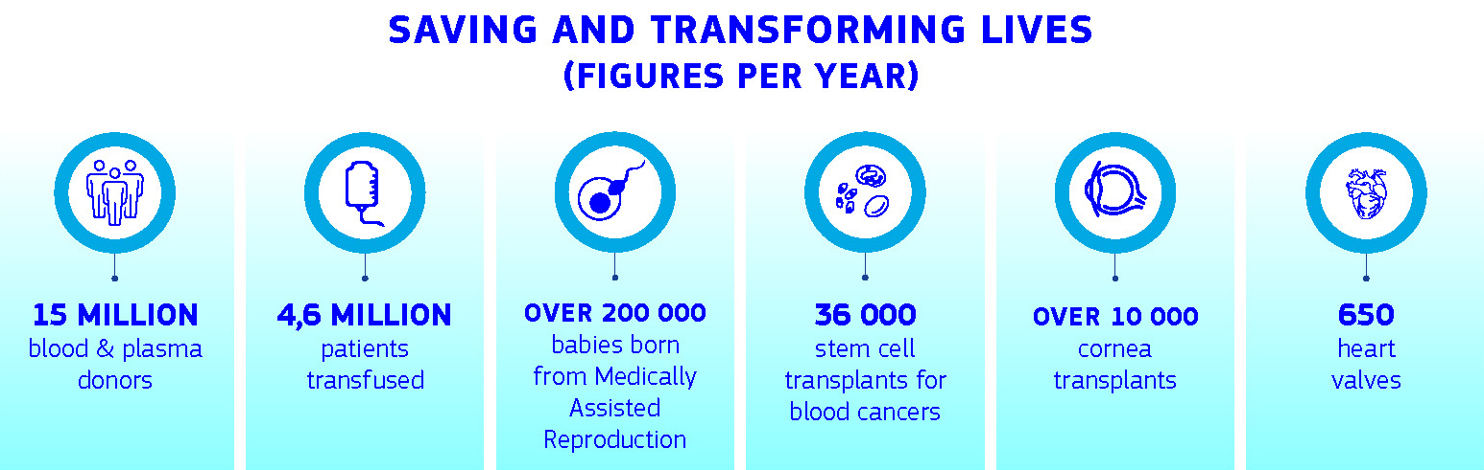

Resilient, accessible, and inclusive health systems

Making health systems more resilient
European health systems must be strengthened to meet current and future challenges head on, including an ageing population, the growing prevalence of non-communicable diseases, climate change, and increased risk of infectious diseases. Resilient health systems need sustainable investment and a skilled workforce, the European Health Union supports Member States in their national efforts.
The Commission proposed the EU4Health programme in May 2020 with this objective, its budget of EUR 4.7 billion (post MFF mid-term revision) for the 2021-27 financing period is the highest amount ever allocated to health policy at EU level.
The EU4Health programme funds initiatives to enhance healthcare access, support the health workforce, and integrate national health systems, laying the groundwork for resilient, patient-centred systems. It has also allowed us to respond quickly to health emergencies, such as the COVID-19 pandemic and the Mpox outbreak in 2022. It is ready to support actions under the European Health Data Space and strengthens efforts to tackle cancer and rare diseases. Synergy with the EU Horizon Europe framework programme has boosted research and innovation in many different areas of health. For instance, a European Partnership on Transforming Health and Care Systems was launched in 2023.
Through the Recovery and Resilience Facility EUR 43 billion were allocated by Member States to healthcare-related measures in their national Recovery and Resilience Plans. Those measures aim at addressing infrastructure gaps, workforce shortages, digitalisation needs and deficiencies in primary care, among other areas. The Commission provides policy guidance and health-related recommendations to Member States through the European Semester. Cohesion Policy Funds, including the European Regional Development Fund and the European Social Fund Plus, help Member States to improve their health systems’ resilience, accessibility and effectiveness. Through the Coronavirus Response Investment Initiatives (CRII and CRII+) and the Recovery Assistance for Cohesion and the Territories of Europe (REACT-EU), adopted in 2020, EU support to healthcare systems under the 2014-2020 Cohesion Policy programmes has been increased by EUR 16.7 billion to a total of more than EUR 32 billion. Around EUR 12.6 billion is planned for health under the 2021-2027 programming period of the Cohesion Policy funds, of which around EUR 1.3 billion is allocated for healthcare digitalisation and e-Health.
The Technical Support Instrument complements these EU funding instruments by providing expertise to Member States, upon their request, to implement reforms aiming to improve the resilience, accessibility and inclusiveness of their health systems.
In the face of the pandemic, the European instrument for Temporary Support to mitigate Unemployment Risks in an Emergency (SURE) also supported Member States to finance health-related measures up to nearly EUR 5 billion. Of this, 22% concerned measures taken in the workplace to ensure a safe return to work.
A robust health workforce is at the core of resilient health systems. However, the EU is currently facing significant shortages of health professionals, driven by high job strain and inadequate health and safety conditions. Furthermore, the health workforce, is ageing. To help tackle labour and skills shortages, the Commission has a adopted an Action Plan with targeted commitments to help improve working conditions for health professionals.
In addition, the evolving healthcare landscape calls for providing more for training and development opportunities to the health workforce for harnessing the potential of artificial intelligence and digital tools, to meet specific challenges such as multi-disciplinary geriatric care and climate change-induced health impacts. The Commission supports Member States for health workforce planning for retaining health workers and for up- and reskilling the European health workforce. Under the Pact for Skills, the Commission launched a skills partnership for the health ecosystem, as well as a large-scale skills partnership for the European Health Industry.

Preventing non-communicable diseases
Non-communicable diseases (NCDs) make up 80% of all diseases affecting EU citizens. These include cardiovascular diseases, cancer, diabetes, and neurological diseases, including mental health issues. Today, more than 90% of deaths in the EU can be attributed to such diseases. In June 2022, the Commission presented the Healthier Together – EU Non-Communicable Diseases Initiative, which was created with stakeholders and Member States to reduce the burden of major NCDs. Its five strands cover cardiovascular diseases, diabetes, chronic respiratory diseases, mental health and neurological disorders, and cross-cutting health determinants, including environmental, commercial, and lifestyle-related risk factors. It identifies priorities, best practices, and areas where action is needed.
Environmental pollution and climate change are worsening all NCDs. Through initiatives under the European Green Deal and in particular under the Zero Pollution Action Plan, the Commission has taken further action to tackle air, water and soil pollution. Despite significant improvements in air quality during the past few decades, air pollution continues to be the largest environment-related health risk, with significant associated mortality (with estimated more than 250.000 premature deaths in the European Union each year) and morbidity. The Zero Pollution Action Plan also puts forward a target that by 2030 the EU should reduce by more than 55% the health impacts (premature deaths) of air pollution (compared to the year 2005).
Launched in 2021 under the EU Strategy on Adaptation to Climate Change, the European Climate and Health Observatory gathers evidence and expertise to guide policymaking on climate change's health impacts. At the climate COP28 in November 2023, the Commission endorsed for EU Member States the first-ever Declaration on Climate and Health. This Declaration outlined vital actions to strengthen health systems, promote research, and adapt behaviours to mitigate climate-related health risks.

Europe’s Beating Cancer Plan
In 2022, 2.7 million people in the EU were diagnosed with cancer. Cancer will directly affect more and more EU citizens over time and take a major toll on European health systems and economies, constituting it one of the greatest health challenges of our times. This demands urgent, concrete, and collective action at EU level to prevent and treat cancer. This is a holistic plan bringing together scientists, patients, researchers for the first time.
In February 2021, in the most acute phase of the pandemic, the Commission presented Europe’s Beating Cancer Plan, reinforcing its political commitment to turn the tide against cancer. The EU Mission on Cancer was launched in September 2021, generating crucial knowledge and evidence to help Member States implement effective cancer control strategies. Europe’s Beating Cancer Plan, backed by EUR 4 billion in funding, a record number of projects, actions and initiatives have been launched addressing the four key pillars of the Cancer Plan, always with a people-first approach: prevention, early detection, equal access to treatment and quality of life. Together with all actors and with combined efforts at national and EU level, the Europe’s Beating Cancer Plan brings together sizeable resources, coordinates actions, reduces fragmentation and inequalities between countries and delivers a more effective and more equal response to cancer with the patient at the centre.
Prevention is more effective than any cure. It is estimated that about 40% of cancer cases in the EU are preventable. One of the goals of the Cancer Plan is to eliminate cervical cancer and other cancers caused by viruses. In 2024, the Commission presented a proposal for a Council Recommendation on vaccine-preventable cancers to help EU Member States to increase the uptake of vaccination against Human Papillomaviruses (HPV) and Hepatitis B virus (HBV).
When it comes to prevention, knowledge is power, and the Commission is working to update and expand the evidence-based recommendations of the European Code against Cancer and is developing a Mobile App for Cancer Prevention to communicate clear and accessible information on the risk factors of cancer.
Tobacco continues to be the leading cause of preventable cancers. The Commission is also in the process of conducting a comprehensive evaluation of the overall legal framework on tobacco control, to support Member States in achieving a Tobacco Free Generation. The Commission also remains committed to the ambition set in the Cancer Plan when it comes to reducing harmful alcohol consumption, which remains a public health concern in the EU. Early detection improves chances of curing cancer and saving lives. In 2022, and for the first time in almost 20 years, the EU introduced modern and science-based cancer screening guidelines to improve early detection, covering cancer types that together account for over half of all new cases diagnosed every year. The aim is to ensure that 90% of people who should be screened for breast, cervical and colorectal cancer are offered screenings by 2025 and expand population-based cancer screening to include other cancers, like lung and prostate cancer.
Protecting the workforce from cancer is paramount for promoting occupational health and ensuring a sustainable workforce. Exposure to carcinogens in the workplace poses serious health risks to workers and can lead to long-term health complications, including various forms of cancer. In the EU, significant strides have been made in this regard through comprehensive legislation and workplace safety measures aimed at minimizing exposure to carcinogens. During this mandate, as part of the EU Cancer Plan, the EU continued setting limits on occupational exposure to cancer-causing substances.
To improve access to high-quality care, the first EU Network of Comprehensive Cancer Centres will be established by 2025 with the aim to ensure that 90% of all eligible patients have access to these centres thus reducing cancer care disparities. The first ever EU Cancer Inequalities Registry provides vital information on cancer trends and services, helping policymakers to better understand and address inequalities. In addition, the Plan calls for work on delivering better access to medicines and training for the cancer workforce. In the area of quality of life, the Network of Youth Cancer Survivors, launched in February 2022, offers help to young patients through peer support and the EU Cancer Mission has launched a dialogue with young cancer survivors, resulting in complementary funding opportunities under EU4Health and Horizon Europe. Quality of life for those whose lives have been touched by cancer is a priority of the Plan and work is ongoing to end discrimination in access to financial services.
By establishing guidelines for cancer prevention, screening, diagnosis, treatment and post-cancer care, the Cancer Plan enables a high level of care across all Member States and prevents disparities in access to quality treatment thus bridging the gaps and providing all cancer patients and their families with hope. The Plan shows how effective EU-level coordination can be in improving the health and wellbeing of EU citizens.

Tackling rare diseases
Rare diseases, which affect 8% of the EU population, or 36 million Europeans, are another important example where cooperation at EU level is essential. There are thousands of rare diseases, including cancers, but each disease only affects a relatively small number of patients. This necessitates pooling data, expertise, and resources at EU level, where joint action is most effective.
The European Reference Networks (ERNs), connect specialised healthcare providers across borders, and facilitate cooperation, research, and treatment development. Given that the average diagnosis time for rare diseases is 5 years, the 24 ERNs have facilitated virtual consultations for over 3,800 patient cases helping expertise travel and giving diagnoses, treatment plans and answers to patients and their families. ERNs have produced more than 400+ clinical guidelines, established patient registries with data for over 50,000 patients, and are effectively improving care for rare disease patients across Europe. Work is ongoing to embed ERNs in national healthcare systems, by developing referral pathways for rare disease patients.
Moreover, recent research funded by Horizon Europe demonstrated that genomics offers important potential to tackle many unsolved rare disease cases. Therefore, the EU continues investing into the 1+ Million Genomes initiative to achieve the necessary critical mass of data by enabling secure access to genomics across the continent without transferring the highly sensitive data.

Safeguarding mental health
When any crisis occurs, it is usually the most vulnerable who suffer most. Even before the COVID-19 pandemic, mental health problems affected about one in every six citizens in the EU (84 million people) – at an estimated cost of over EUR 600 billion (more than 4% of GDP). The launch for the first time of the Comprehensive Approach to Mental Health in June 2023 opened an ambitious new chapter for EU action in this area. Based on three guiding principles: prevention, fighting stigma, access to quality care and treatment, and reintegration, putting mental health on a par with physical health, supporting mental health in all policy areas, from education to digitalisation and urban planning, and recognising the positive role of nature and a clean environment for both mental and physical health.
EU programmes offer EUR 1.23 billion in funding opportunities for 20 flagship initiatives to support Member States and EU stakeholders. For instance, the EU Best Practices Portal showcases leading and promising mental health practices, which can inspire others to act. Awareness campaigns run by the European Agency for Safety and Health at Work (EU-OSHA) help tackle work-related mental health issues. The EU is also working with the World Health Organization to assist Member States to developing prevention-focused mental health approaches. Across these efforts, special focus is given to the most vulnerable, particularly children and young people. Initiatives include a project with UNICEF on “promoting a comprehensive, prevention-oriented approach to children’s health”, and the development of a child-and-youth mental health network. One of the key policy areas of the 2022 European Year of Youth was to boost young people’s personal, social, and professional development. This included for a special focus on mental health. A number of mental health-related initiatives were launched under the European Year of Youth such as the 2022 Council Recommendation on Pathways to School Success and the Expert Group for supporting wellbeing at school. This Expert Group developed concrete guidelines for policy makers and educators on addressing wellbeing and mental health at school, published in May 2024. The EU and Member States are also preparing a European partnership on Brain Health (under Horizon Europe), which will also cover research on mental health and develop an ecosystem to facilitate and coordinate research and innovation activities.
Through EU4Health, the Commission is funding projects to support improving mental health and psychosocial wellbeing in migrant and refugee populations, with a particular focus on people from Ukraine. Over EUR 34 million from the EU4Health programme to help people fleeing Ukraine in urgent need of mental health and trauma support, including through a project with the International Federation of Red Cross and Red Crescent Societies providing psychological first aid support for Ukraine’s displaced and affected people. Additional projects are also on-going with non-governmental organisations for best practices to improve mental health and psychological well-being in the migrant and refugee populations.

Harnessing the power of digitalisation in health
The European Health Data Space (EHDS) is a flagship European Health Union initiative, and a game changing approach aiming to harness the power of digitalisation and to empower patients to better control and share their health data. It was proposed by the Commission in May 2022 and political agreement was reached by the co-legislators in March 2024, leading to adoption by the European Parliament in April 2024. The EHDS will introduce clear rules for the use of electronic health data, and will facilitate better healthcare delivery, research, innovation, and policymaking, in full compliance with the EU's data protection standards.
Patients will have immediate, free and easy access to their data in electronic form and will be able to share these data with healthcare professionals across Member States. Healthcare documents, such as patient summaries, e-prescriptions laboratory results, images, image reports, and discharge reports, will be exchanged in a common European format. This will improve the healthcare that patients receive, wherever they are in the EU. It will also reduce needless and costly repetitions of what are at times invasive medical procedures and tests.
In parallel, the EHDS will empower the use of health data for research, innovation, policy-making and regulatory activities, under very strict conditions protecting those personal data. This will advance research and innovation, support the development of important new treatments, identifying side effects of medicines and help to fortify health systems. 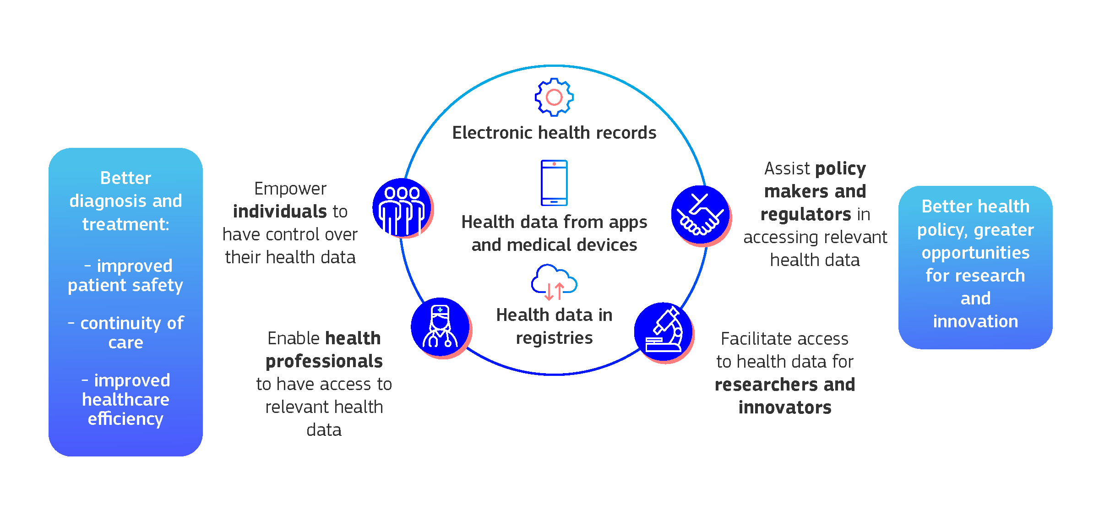
The EU invests in novel technologies, including artificial intelligence combining multiple types and sources of health data. To this end the power of data leveraged through the European Health Data Space and specialised data infrastructures (such as 1+Million Genomes, Cancer Image Europe or EOSC- Life), combined with high-performance computing will enhance early detection, prediction and prevention, further improving diagnosis and treatments.

Global Health
The COVID-19 pandemic highlighted how, in our interconnected world, health is a global policy area and with a clear geopolitical dimension. The pandemic underscored the urgent need for a more coordinated EU approach to global health, and for greater global cooperation in the face of interlinked health threats like pandemics, the triple planetary crisis (climate change, environmental pollution and biodiversity loss) and antimicrobial resistance. These threats are likely to grow, and the EU – and the world – need to be ready to respond.
The EU played a central role in the rapid development, scale-up and equitable distribution of COVID- 19 vaccines, therapeutics, and diagnostics. Around two-thirds of vaccine doses produced in the EU –
3.1 billion doses – have been exported to the rest of the world saving millions of lives. The EU was a founding member and strong supporter of the Access to Covid Tools Accelerator (ACT-A) and the largest donor to COVAX – the multilateral initiative for global equitable access to COVID-19 vaccine. The EU is determined to continue this path and is committed to preventing and combatting health threats globally, applying a One Health approach.
The EU also seeks to reduce supply chain vulnerabilities resulting from dependencies by promoting diversification. Given the complexity of pharmaceutical products, EU industry needs to have access to a broad range of essential inputs. Trade policy and partnerships aim at opening new markets and diversifying sources of supply and complement enhanced efforts to reduce excessive dependencies for critical supply chains by thorough implementation of preferential trade agreements, as well as of the work within international fora such as the G20, the G7 and the WTO.
The EU Digital COVID Certificate set a global standard for international travel and has been the most widespread system in operation at international level. 51 non-EU countries and territories across four continents have benefited from this system. On 1 July 2023, the EU handed over the system of digital COVID-19 certification to the WHO, in order to develop a system for global verification of health documents to deliver better health for all and protect citizens across the world from health threats.
The EU is continuously working multilaterally to shape a new global health order through a more strategic, and effective engagement. This includes building a robust global governance, prioritising international partnerships and dialogue at multilateral, regional and bilateral level, addressing disinformation, and providing more effective funding. The EU has become increasingly active in multilateral fora, including the G7, G20, the UN General Assembly as well as the WHO, and under its Neighbourhood, Development and International Cooperation Instrument is a major donor to global funds (e.g. the Pandemic Fund, GAVI, Global Fund).
In the current geopolitical context, with the ongoing Russian war of aggression on Ukraine and the conflict in Gaza, the EU has supported the medical evacuation (Medevac) of patients. Since Russia’s war against Ukraine, over 3100 medical evacuation operations were conducted through the Union Civil Protection Mechanism (UCPM). The Commission has been closely cooperating with the WHO, notably in the establishment of the EU Medevac hub in Poland to support Ukraine, and in the deployment of Member States’ medical experts to support WHO operations in Gaza.
The EU is playing a leading role in the negotiations of the Pandemic Agreement, which aims to strengthen international rules on pandemic preparedness and response.
The Commission published a new EU Global Health Strategy in November 2022 to ensure a coherent, effective, and focussed approach worldwide. First and foremost, the Strategy indicates the EU’s determination to reassert its responsibility and leadership in global health, based on fundamental values like solidarity, equity, and respect for human rights. It positions global health as an essential pillar of EU external policy representing the external dimension of the European Health Union. and a key component of Global Gateway which builds partnerships of equals with partner countries based on joint responsibility and co-ownership. Under the Global Gateway the EU and Member States are helping to tackle inequalities, improve health security and increase health systems’ resilience globally, engage with global partners to ensure equitable worldwide access to diagnostics, vaccines and treatments, pandemic preparedness, prevention, and early detection of health emergencies. The Team Europe initiative on manufacturing and access of vaccines, medicines and health technologies in Africa (MAV+) has mobilised more than EUR 1.3 billion in funding from the EU, Member States and European financing institutions to implement actions through 89 projects at continental, regional and local level. In Rwanda for instance, Global Gateway provides over €103 million support to local manufacturing and access to vaccines, medicines and health technologies including a local plant for manufacturing of vaccines with mRNA technology. The EU is also working to deepen cooperation on manufacturing vaccines, medicine and health technologies, and strengthen health systems in the context of the EU- Latin America and the Caribbean (LAC) Health Partnership. Strengthening global health is an investment in global health security, in the Sustainable Development Goals, and in the protection of the health of all people, wherever they are.

Looking ahead
Overall, and thanks to the cooperation between the Commission and the Member States, the EU is in the area of health now in a much stronger position than five years ago. But complacency is not an option. Much work remains to be done to further improve our health policies. Health therefore needs to remain a political priority.
New threats will continue to emerge, and particular attention should be paid to AMR, climate change- induced health threats and CBRN threats. Cooperation is required at multiple levels – European, national, regional, and global to continue to bolster our health security.
The EU faces a multitude of health challenges beyond disease outbreaks. Shortages of medicines across Europe are disrupting treatment plans for chronic illnesses, like cancer and diabetes. Adopting the proposed reform of the EU’s pharmaceutical legislation will be vital to improve access to and availability of medicines, together with other actions addressing shortages of critical medicines such as the work carried out by the European Medicines Agency and the Critical Medicines Alliance. To support Member States in accessing medicines in the area of rare diseases and orphan medicines, instruments such as Joint Procurement could be further explored.
Similarly, Europe would benefit from strengthened medical research, and a boost to biotechnologies and biomanufacturing, in line with the recent Communication “Building the future with nature: Boosting Biotechnology and Biomanufacturing in the EU”. The slow development of new medicines, diagnostics, and therapies leave everyone vulnerable to future diseases and makes it harder to manage existing ones. AMR is a prime example. Investing in research for new antimicrobials, alternatives to antimicrobials, and rapid diagnostics, while tracking the spread of resistant bacteria and identifying emerging threats, is essential. This requires a close cooperation across multiple sectors, according to a One Health approach, promoting research and further advocating a prudent and responsible use of antibiotics. To accelerate research and development for antimicrobials and medical countermeasures for future pandemics, together with Member States, we should continue working to make clinical trials in the EU attractive, efficient, and fast. Strengthening pan-European clinical trials should continue.
At the same time, learning from the experience of the COVID-19 pandemic and conscious of the challenges ahead, health systems should continue to be strengthened, with a resilient, well-trained health workforce at the heart. The Commission will keep up its support to reforming national health systems, by providing advice and financing with EU funds.
Europe’s population is ageing and that comes with consequences for health policy – including on healthy longevity, non-communicable diseases, including neurodegenerative diseases. This requires exploring how to deal with longevity so that our societies stay healthy, even as they age. Finding effective treatments and ultimately cures for debilitating conditions like Alzheimer's and Parkinson's disease requires significant research investment and international cooperation. The future of healthcare will also depend on personalised medicine approaches. Advances in genomics and data technologies, such as artificial intelligence, can enable the tailoring of treatments, improving their effectiveness and reducing side effects.
Non communicable diseases remain a top priority. The EU has shown its commitment to tackling NCDs, with a focus on prevention across a person’s lifetime, promoting healthy lifestyles and policy coordination across sectors, using Europe’s Beating Cancer Plan as a template, and strengthening existing initiatives such as the ‘Healthier Together Initiative’ to tackle key challenges such as cardiovascular diseases. Through the 2023 Mental Health Communication, the Commission will continue to prioritise the most vulnerable groups in our societies, with a focus particularly on children and youth. The European Health Union is already preparing for these challenges. The EHDS has the potential to revolutionise healthcare in the EU by maximising the immense potential of digital health. The current multiannual financial framework which runs until 2027 will continue to provide financial and technical support to Member States and stakeholders in this area, including through EU4Health Programme and the Digital Europe Programme. It is essential to also explore how to integrate artificial intelligence into healthcare and the digital upskilling of healthcare professionals for improved efficiency, accessibility, and sustainability.
Serious health risks – from rising pandemic or epidemic threats to the health impacts of climate change and NCDs – are interlinked and driven by the triple planetary crisis. A strong, innovative, and inclusive European Health Union requires cooperation at all levels in a One Health approach.
Moreover, in the coming years, preparing for a larger Union will require ensuring that a future enlarged EU is resilient to health challenges and that the public health policies are well-coordinated among the Member States, and with countries in the accession process.

Conclusion
The COVID-19 pandemic was a global health crisis that turned our world upside down. It challenged, our societies, our economies, and our very own European way of life. It also highlighted the weak points in our health systems and left us with some clear lessons. The innovative working methods used during and after the COVID-19 pandemic show that the EU can deliver in a strong and united way, applying creatively the rules, for the benefit of its citizens. The most powerful lesson was also the simplest – we are stronger and more resilient when the Commission and all EU Member States collaborate in solidarity, and when with like-minded international partners we bring together our strengths for a better global response.
During this mandate, the Commission and the Member States came together to deliver a comprehensive response to the greatest health threat in a century. In parallel, they took unprecedented steps to go beyond merely firefighting the pandemic. Drawing on the solidarity and resolve shown during the crisis, the EU has built a strong and resilient European Health Union for all its citizens. The European Health Union seeks to ensure that all Member States are better prepared and respond together to future health crises. To promote European innovation and competitiveness in the healthcare sector, so that the needs of patients can be addressed with the support of all necessary actors. Solidarity and cooperation go hand in hand with resilience, with hope, with security, with meeting citizen expectations across all territories, including rural and remote ones, when it comes to delivering optimal health care. This is the European Health Union in action, answering to the needs of citizens, putting equity in access and care at the heart of the European Union.
Over the coming years, the European Health Union will continue to evolve and grow to further promote the health and wellbeing of people across the EU and beyond.
The world has changed irrevocably since 2019. And it will continue to change. Thanks to a robust European Health Union, the EU is now better prepared for what tomorrow brings for our citizens’ health.

mission-letter-stella-kyriakides_en.pdf (europa.eu)
EU Vaccines Strategy (europa.eu)
https://www.who.int/europe/news/item/16-01-2024-covid-19-vaccinations-have-saved-more-than-1.4-million-lives-in-the-who-european-region--a-new-study-finds
EP Autumn 2021 Survey: Defending Democracy | Empowering Citizens - February 2022 - - Eurobarometer survey (europa.eu)
Public opinion in the EU in time of coronavirus crisis 2 (europa.eu)
Opinion of the Health Security Committee on zoonotic avian influenza - European Commission (europa.eu)
Antimicrobial resistance (AMR) in bacteria; vector borne viral pathogens; emerging, rodent-borne and zoonotic viral pathogens; high-risk, emerging and zoonotic bacterial pathogens; Legionella; and diphtheria and pertussis.
https://single-market-economy.ec.europa.eu/coronavirus-response/task-force-industrial-scale-covid-19-vaccines_en
https://ec.europa.eu/commission/presscorner/detail/en/ip_22_4363
https://eur-lex.europa.eu/legal-content/EN/TXT/?uri=CELEX%3A52021PC0577
Launching GLOWACON: A global initiative for wastewater surveillance for public health - European Commission (europa.eu)
Disease X represents the knowledge that a serious international epidemic could be caused by a pathogen currently unknown to cause human disease. Disease X is part of the WHO list of priority pathogens (World Health Organization definition).
https://health.ec.europa.eu/medicinal-products/pharmaceutical-strategy-europe_en
In the group of National Competent Authorities on Pricing and Reimbursement and Public Healthcare Payers (NCAPR)
https://ec.europa.eu/commission/presscorner/detail/en/IP_23_5190
https://ec.europa.eu/commission/presscorner/detail/en/ip_23_6377
https://health.ec.europa.eu/health-emergency-preparedness-and-response-hera/overview/critical-medicines-alliance_en
eur-lex.europa.eu/legal-content/EN/TXT/PDF/?uri=CELEX:52019DC0128
https://research-and-innovation.ec.europa.eu/funding/funding-opportunities/funding-programmes-and-open-calls/horizon-europe/european-partnerships-horizon-europe/health_en
A political agreement was reached in December 2023
https://www.thcspartnership.eu/
Figure as of 28 February 2024. Data are based on the pillar tagging methodology for the Recovery and Resilience Scoreboard and correspond to the measures allocated to the policy area ”Healthcare: Resilience, Sustainability, Adequacy, Availability, Accessibility and Quality, including digitalisation and infrastructure”.
https://ec.europa.eu/social/BlobServlet?docId=27472&langId=en
The project – JA HEROES | Health Workforce Planning Project
BeWell – Blueprint alliance for a future health workforce strategy on digital and green skills (bewell-project.eu)
https://pact-for-skills.ec.europa.eu/about/industrial-ecosystems-and-partnerships/health_en
https://knowledge4policy.ec.europa.eu/health-promotion-knowledge-gateway/eu-burden-non-communicable-diseases-key-risk-factors_en
https://commission.europa.eu/strategy-and-policy/priorities-2019-2024/european-green-deal_en
https://environment.ec.europa.eu/strategy/zero-pollution-action-plan_en
See, for example, https://www.eea.europa.eu/publications/harm-to-human-health-from-air-pollution/
https://research-and-innovation.ec.europa.eu/funding/funding-opportunities/funding-programmes-and-open-calls/horizon-europe/eu-missions-horizon-europe/eu-mission-cancer_en
Council Recommendation of 9 December 2022 on strengthening p... - EUR-Lex (europa.eu)
https://ec.europa.eu/commission/presscorner/detail/en/ip_22_7153
https://ec.europa.eu/commission/presscorner/detail/en/ip_24_1570

