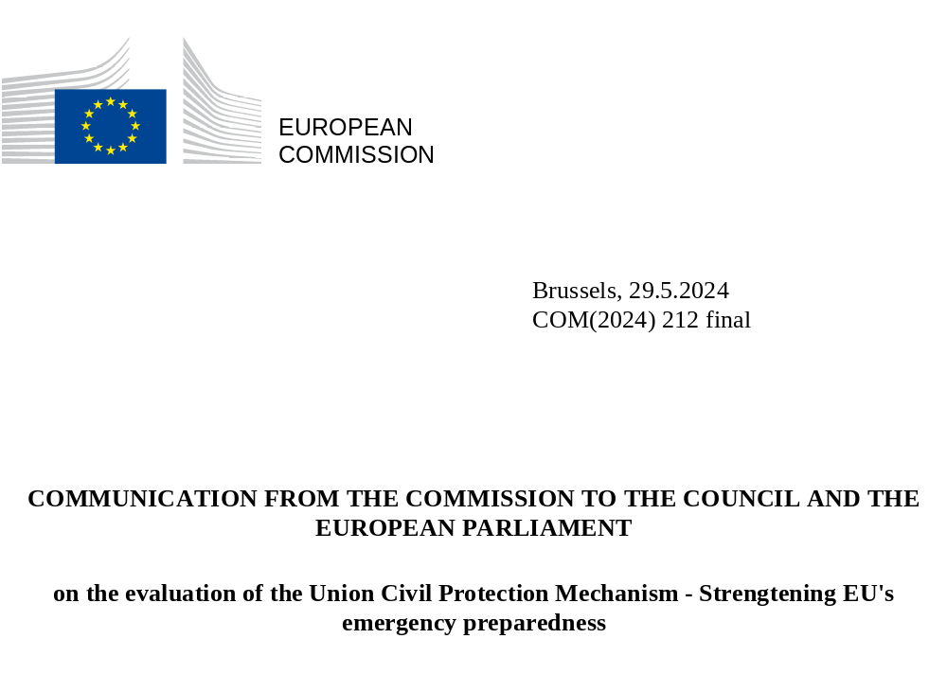

Table of content

1. Introduction – the UCPM, bolstering the EU’s readiness 2
2. Delivering despite challenges. Emerging threats on the horizon 2
3. Evaluation findings – the UCPM operating in a changing risk landscape 5
4. Looking ahead – Learning from the past to strengthen the EU’s ability to face crises 7
5. Conclusion 10

Introduction – the UCPM, bolstering the EU’s readiness
In the wake of a disaster, civil protection is the lifeline for affected populations. When a crisis overwhelms the capacity of a single country, the Union Civil Protection Mechanism (‘UCPM’) stands as the operational backbone, facilitating Europe’s collective response, both within and beyond its borders.

While more than 500 activations of the UCPM were triggered in the evaluated period 2017-2022, the UCPM was called into action on over 320 occasions in the period between 2020 and 2022 alone, marking a five-time increase compared to the previous decade’s average. This uptrend underscores the growing importance of the UCPM in bolstering the Union’s emergency readiness at all levels.

In 2021, the European Ombudsman Award for Good Administration recognized the exceptional contributions of DG ECHO and the EEAS, whose extraordinary efforts facilitated the repatriation of over a half million EU citizens stranded worldwide during the Covid-19 pandemic.

This exemplifies the pivotal role played by EU institutions and agencies within the UCPM in supporting and complementing the action of Member States in times of crisis. In essence, safeguarding our society, nature, and cultural heritage hinges on our ability to prevent and prepare for future disasters. Civil protection does not operate in isolation; it demands collaborative efforts, breaking down silos, and working together as a cohesive Union to fortify our collective resilience and readiness.

This Communication outlines the evolving needs and challenges confronting the civil protection landscape in Europe and formulates recommendations to enhance the effectiveness across the UCPM prevention-preparedness-response contiguum in diaster management.

Delivering despite challenges. Emerging threats on the horizon
Europe’s risk landscape is evolving dramatically. Today, the EU is confronted with multiple, simultaneous challenges and threats of varying nature and growing complexity. The rise in the number of conflicts, man-made and natural disasters – including extreme weather events – and the changing nature of security risks increasingly challenge the disaster risk management structure of the EU and the ability of the UCPM to operate effectively. The steady increase in the number of activations of the UCPM in recent years indicates that this trend will continue further.
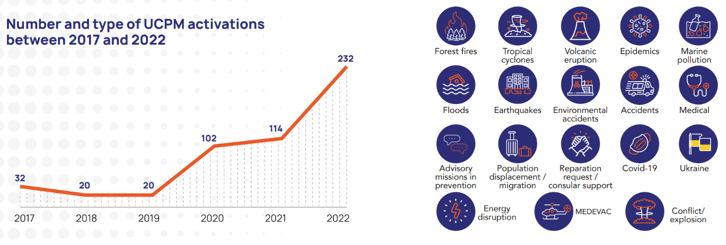
Figure 1 - number and types of UCPM activations
The graph (left) shows the increasing number of UCPM activations from 2017 to 2022. The bubbles (right) illustrate the types of crises the UCPM addressed in the same period of time.
The five key dimensions outlined below exemplify this evolving risk landscape and demonstrate how the UCPM already utilizes its ability to adapt and its entire set of instruments to address risks across these dimensions. However, the evolving risks are expected to have a more significant impact on Europe in the future, likely widening gaps in the way Europe addresses risks.

Navigating Complexity: Coordinated Responses to Emerging Crises
The Evaluation underscored the UCPM’s remarkable flexibility in adapting to evolving challenges. The swift adjustments made in EU legislation to accommodate DG ECHO’s tools were cited as prime examples of this flexibility. In this regard, in the wake of the Covid-19 pandemic, the significant upscaling of the medical stockpiling capacity under rescEU was considered as a notable achievement by the striking majority of stakeholders, both at national and EU level.
Throughout the evaluation period, it became evident that the ERCC played a pivotal coordination role between civil protection and health authorities, and also between the ministries of Foreign Affairs in Member States and Participating States together with EEAS and EU Delegations. Additionally, together with the Secretary General, it facilitated coordination between European Commission Directorates, the EEAS, and the Council. This cross-sectoral cooperation proved key to addressing the consequences of Covid-19, including the provision of medical supplies and logistical support for consular assistance for the repatriation of EU citizens stranded in third countries. In this context, innovative approaches and adaptability to new situations were key success factors.

Dynamic Challenges: Adapting Risk Mapping and Early Warning Systems
The dedicated focus group of scientist contributing to the Evaluation of the UCPM identified areas for improvement to enhance the effectiveness of Early Warning Systems (EWS) in increasing preparedness at national and EU level. In particular, EWS could be revised to:
1. Ensure that information is less fragmented across EU and domestic EWS: several stakeholders highlighted the challenge of managing a vast amount of information from various systems, making it difficult to promptly conduct expert assessments during major events. In addition, EU-level EWS could influence national EWS more systematically;
2. Cover more hazards: the hazards most effectively covered by early warning and monitoring systems are wildfires, floods, and droughts, thanks to near real-time monitoring. However, the monitoring of floods, health emergencies, and other human-induced or anthropogenic disasters could be improved and made more effective.

Urgent Responses: Mobilizing Resources for Severe and Cross-Border natural Disasters
The Summer of 2023 has seen Europe battered by heatwaves, record-breaking wildfires, and catastrophic floods. These often happened simultaneously, fitting into a broader pattern of extreme climatology. In July and August 2023, global temperatures reached record highs, surpassing the 1.5°C threshold set in the Paris Agreement. This serves as a preview of the potential average summer conditions in the future if climate action is not taken.
The Evaluation findings showed that the pre-positioning of firefighters in 2021 had a positive impact on facilitating knowledge sharing among firefighters in regions affected by forest fires. This approach was also well received as a tool to enhance the effectiveness of responses. In 2021, firefighters were pre-positioned in Greece to assist with the summer forest fire season. Following positive feedback from Member and Participating State, this initiative has been renewed, with 11 Member States committed to send almost 450 firefighters to France, Greece, and Portugal in preparation for the upcoming forest fire season.
Moreover, the Evaluation underscored that a large majority of stakeholders valued the flexibility of the UCPM and, more crucially, its capacity to swiftly adapt and respond to new situations. The introduction of the rescEU reserve, along with the recent, prompt decision to increase the rescEU aerial fleet, was heralded as a notable demonstration of the flexibility and innovation capabilities of the UCPM to stay relevant. The adaptability of the UCPM training programme and EU MODEX has also been commended and regarded as evidence of the flexibility of the UCPM.

Evolving risks and security threats requiring enhanced response capabilities
The response to Russia’s war of aggression against Ukraine triggered the largest UCPM activation to date, including complex logistic operations. On 15 February 2022, Ukraine activated the UCPM in preparation for a large-scale emergency and updated its initial request consecutively. Requests included - among others - medical supplies, food, shelter items, fire-fighting equipment, IT and communications equipment, cultural heritage protection apparatus, CBRN countermeasures, and agricultural supplies.
The ERCC supported Poland, Romania, and Slovakia in establishing UCPM logistics hubs where incoming assistance was received, consolidated, and subsequently dispatched to Ukraine. Additionally, in response to the significant volume of inquiries from private companies following the “Stand for Ukraine” campaign by the Commission, a pilot project was established in Belgium to channel private sector donations under rescEU.
In response to the increasing demand for medical treatment, the European Commission (DG ECHO and DG SANTE) set up a standard operating procedure for the medical evacuation (MEDEVAC) of displaced people from Ukraine. Poland, Moldova, Slovakia, and Ukraine requested support for medical evacuation operations from their respective countries to other European countries with available hospital capacity.
Furtermore, the scenario building initiative aims to provide comprehensive evidence for further improvements under the UCPM to address the challenges anticipated in Europe’s evolving risk landscape, including cascading effects of security threats, which may lead to an increased likelihood of high-impact, cross-sectoral, and multi-country disasters. In essence, the scenarios reinforce the case for additional resources, adaptations to the UCPM’s existing functioning across the entire emergency management cycle, and related modifications to the UCPM’s legal framework.

Protecting the Vulnerable: Addressing the Impact of Disasters on Vulnerable Groups
Climate risks disproportionately affect vulnerable populations due to socio-economic factors such as income, gender, age, disability, health, and social exclusion, with pre-existing disadvantages further hampering the ability of vulnerable groups to recover from disasters. Gender-based and sexual violence, hate speech, and xenophobia have been documented since the inception of Russia’s war of aggression against Ukraine.
Against this backdrop and in the context of the Commission’s Recommendation and Communication on ‘Union Disaster Resilience Goals’, the Commission advocated for the systematic consideration of the specific needs of people in vulnerable situations, including individuals with disabilities and children, within national early warning systems.

Evaluation findings – the UCPM operating in a changing risk landscape
The new emergency management reality described above has provided numerous opportunities for the UCPM to demonstrate its efficiency and effectiveness as an emergency instrument that can further strengthen European resilience to complex, long-lasting and occasionally concurrent crises. The main findings of the performance of the UCPM in the period 2017-2022 underscore this assessment.
Main findings of the UCPM performance from the 2017-2022 Evaluation
- The UCPM adapted to changing pressures and demands and successfully maintained a high response rate despite increasing activations;
- The UCPM has shown flexibility to adapt to evolving needs on the grounds and unanticipated events. Innovative answers to new dimensions of crises were a key success factor.
- The UCPM reinforced its prevention and preparedness dimensions, enhancing cost-effectiveness;
- The UCPM contributed to enhancing disaster preparedness at national and EU level;
- The UCPM helped enhance cooperation between civil protection actors and non-traditional disaster management actors;
- The UCPM contributed to raising awareness of disasters within the civil protection community;
- Risk mapping through the EU-level overview of risks contributed to strengthening disaster prevention although challenges remain in the comparability and availability of data;
- The UCPM facilitated cross-border cooperation between the EU, Member and Participating States on disaster preparedness and response;
- DG ECHO and national civil protection authorities face resource constraints and significant workload.
Additionally, the Evaluation has shown that the evolving risk and threat landscape also tested the limits of the UCPM. This assessment is shared by the European Council for the broader European crisis management system. Several Council Conclusions of the years 2023 and 2024 acknowledge the challenges posed by cross-sectoral and cross border crises and natural and human-made disasters, which are additionally exacerbated by the projected increase in climatic hazards.
Overall, emphasis is placed on strengthening European resilience in strategic areas through an all-hazards approach to preparedness and response by utilizing relevant mechanisms, including the UCPM. Further, the ability to maintain societal functions depends on Member States to systematically embed the all-hazard approach in all relevant policies, thus ensuring resilience by design. The first line of defence in risk management lies in policies that can reduce vulnerabilities and limit human exposure. Against this backdrop, climate adaptation and mitigation efforts are pivotal in enhancing the EU’s resilience and crisis response capacity.Considering the aforementioned political steering, safeguarding the sustainable operation of the UCPM’s existing emergency management model has become a key concern. At the same time, there is a recognised need to further equip the UCPM for new hazards and risks within a more inclusive all-hazard approach in Europe’s broader crisis management architecture.
In a similar vein, the independent scientific advice on strategic crisis management in the EU issued by the Group of Chief Scientific Advisors to the EU concluded that efficient crisis management entails strengthening EU governance, enhancing infrastructure resilience, optimising financial resources, fostering societal collaboration, and ensuring accessible data for effective communication.
Strategic crisis management in the EU: Improving EU crisis prevention, preparedness, response and resilience
The independent scientific advice on strategic crisis management in the EU issued by the Group of Chief Scientific Advisors to the College of European Commissioners found that the EU should:
- Develop a roadmap to create synergies between existing legislation and instruments;
- Respond to cascading and transboundary crises by strengthening European governance for strategic crisis management;
- Make critical infrastructures more resilient to cascading effects;
- Make existing EU financial instruments and resources more scalable, rapidly deployable, and efficient;
- Collaborate closely with society to manage crises effectively; and
- Provide interoperable, high-quality data, and easy to communicate information for crisis management.
In addition to the recognized need to strengthen European resilience against shocks at the political level, nine in ten Europeans feel that it is important for the EU to assist in coordinating the response to disasters in the EU and other countries. Further, 94% of European citizens believe that when a disaster occurs in a EU country that is too overwhelming for them to handle alone, other EU countries should provide assistance.

Looking ahead – Learning from the past to strengthen the EU’s ability to face crises
Damage from catastrophic events is massively rising whereas the overall capacity to absorb and recover from such shocks is limited. Therefore, the EU faces the challenge of ensuring that the European approach to crisis management is “future proofed”. This demands a strong UCPM that can adapt to the constantly changing risk landscape. In response to this, the Commission developed five strategic reccommendations.
Recommendation 1: Strengthen the operational response capabilities of the UCPM
The success of the UCPM relies fundamentally on the capabilities of Member States. This foundation needs further strengthening while promoting deeper engagement within both the European Civil Protection Pool (‘ECPP’) and rescEU. It is crucial to equip both the ECPP and rescEU to effectively address the transboundary, large-scale risks of the future.

The UCPM’s capabilities should be strengthened based on gaps identified through common scenario analysis and a comprehensive assessment of needs at the European level, while considering the civil protection – security nexus and its future needs for interoperability as important strategic guidance for the future. In sectors where common needs and risks are identified, a further expansion of rescEU is the most cost-effective alternative as well as a vibrant demonstration of European solidarity and of the EU’s commitment to collective resilience and response.

Furthermore, the UCPM must be able to continuously adapt to evolving technologies and play a leading role in the development and promotion of effective and efficient tools and instruments in disaster response.
Recommendation 2 – Enhance EU prevention and preparedness through cross-sectoral coordination, an all-hazards approach, and a strong Emergency Response Coordination Centre
The active engagement of all relevant stakeholders in all stages of disaster prevention, preparedness, and response in an all-of society/ all-hazards approach is imperative. The ERCC has proven its ability to work in close coordination with different services during complex emergencies and crises (especially in areas such as CBRN, civil-mil, cyber, hybrid, health, logistical support for consular assistance, and climate change). Fragmenting into further, sectoral response structures is ill-suited for tackling complex scenarios and should thus be sidestepped. Elevating the ERCC as the Commission’s cross-sectoral crisis hub would bring together sectoral expertise from various policy areas, ensuring comprehensive operational coherence and effectiveness within a better integrated EU crisis response system.
Consequentially, it is important to ensure that all EU and national processes are aligned to ensure resilience by design. The UCPM prevention pillar needs to be better articulated with other EU policies and programmes that have the capacity to impact societal resilience.
Moreover, addressing civilian disasters with security or defence components necessitates systematic coordination among civil, security, and defence authorities throughout all phases of the disaster management cycle. Civilian and military preparedness should be complementary and involve the whole of society. The ERCC should intensify its cooperation with NATO, the EEAS, and the UN (OCHA), facilitating a smooth response in climate related emergencies or conflict scenarios. The same applies to the exchange with selected International Organisations and countries which possess specialised knowledge and capacities crucial for managing major disasters.
Furthermore, efforts should be intensified to enhance private sector involvement at the EU level in specialised civil protection tasks related to prevention, preparedness, and response. This entails establishing arrangements for strategic cooperation with relevant private entities within a clearly defined scope.
Recommendation 3 – Streamline knowledge and expertise sharing on risk identification and early warning
Union-wide, cross-border, multi-country, and cross-sectoral disasters must assume a more prominent position in relevant European and national risk assessments. This can be achieved by expanding the analysis of underlying drivers of risks and emerging threats, leveraging existing resources across sectors at both EU and national levels, and using the knowledge and expertise available from third parties. This could be reflected in a more comprehensive EU overview of risks, bridging all sectors.
Furthermore, there should be an increase in knowledge sharing by national civil protection authorities, particularly on highly specialised expertise related to low-probability high-impact disasters. Therefore, it is essential to reinforce the information sharing and interoperability of early warning systems across Member States with an all-hazard approach. The UCPM/ERCC is well positioned to coordinate this effort.
Moreover, a flexible and comprehensive European disaster management structure necessitates a more systematic knowledge exchange at all levels. The UCPM should be further strengthened to link scientific institutions and Member States and make scientific knowledge available to all relevant stakeholders.
The role of the Commission in disaster risk and crisis communication efforts should be comprehensively integrated across services to deliver added value for Member States and European citizens.
Recommendation 4 – Consider and address the needs of vulnerable groups in existing prevention, preparedness, and response arrangements
Recent events such as floods, forest fires, and Russia’s war of aggression against Ukraine have shown that vulnerable groups suffer disproportionately during major disasters. It is crucial to enhance consideration and address the needs of these vulnerable groups, – particularly individuals with disabilities, the elderly, and marginalised communities - within existing prevention, preparedness, and response arrangements.
This can be achieved through various measures, including adapted early warning systems and alert mechanisms, ensuring warning messages are accessible, clear, and actionable, and provided in multiple languages to reach all segments of the population, implementing tailored preparedness and response actions, systematically integrating vulnerable groups into risk assessments, and empowering their representation in disaster risk management planning.
Recommendation 5 – Reinforced budget and increased synergies and integration into relevant EU instruments to ensure long-lasting European disaster management across sectors and borders
It is crucial to ensure that the EU’s investments under the UCPM are both effective and efficient, with a focus on sustainability to yield long-term positive impacts on the European resilience and the lives of European citizens. Additionally, reinforcing the budget is essential where investments at the European level prove to be cost-effective and bring added value.
Furthermore, European disaster risk management must be integrated into all relevant EU funding instruments. Given the increasing disaster risk and its impacts on economic, social and environmental development in the EU, it is important to ensure that disaster risk management is mainstreamed as an investment priority across all the relevant EU funding programmes. Every Euro spent in this area saves substantial amounts in response costs, particularly evident in the context of wildfires (approximately € 2 billion per year).
Moreover, to complement its existing framework, the UCPM requires greater flexibility to adapt its response and financing arrangements to address exceptional needs in complex or prolonged crises scenarios, possibly through specific emergency funding mechanisms. Civil protection authorities, Member States, and the Commission would benefit from simplified co-financing rates and more flexible direct procurement processes. These measures would ultimately enhance the UCPM’s agility and ability to deliver a tailored response to crises in a timely manner.

Conclusion
To address Europe’s new reality, it is now time for the Commission to further develop an integrated crisis management approach capable of bringing all relevant Commission services together to work in a coordinated manner, effectively supporting and complementing the efforts of Member States across the prevention, preparedness, and response contiguum. Consequentially, this enhanced approach should foster prevention, bolster preparedness, and facilitate rapid and efficient response to disasters both at Member State and Union levels.
At the Commission level, a horizontal approach is needed in order to improve coherence, avoid duplication and overlap while exploiting potential synergies.,. The ERCC is the natural and most competent coordinating body to understand, analyse, coordinate, and mobilise actions across all relevant sectors and dimensions of disaster management. A fragmentation into a multitude of instruments across different services would lead to inefficiencies and potential duplication, thus hampering the integrated, resilient, and effective European crisis management that European citizens expect.
Moreover, to tackle the main challenges for crisis management over the next decade, namely climate change and evolving security threats, the Commission and Member States must upscale their strategic preparedness, in close cooperation with its key stakeholders and partners. Strengthening rescEU, the most effective and efficient tool at the EU level, would bolster the Union’s resilience against threats that could impact the fundamental fabric of European society.

Civil protection consists of emergency assistance provided under the auspices of government authorities in preparation for, or immediate aftermath of, a disaster in Europe and worldwide.
The 27 Member States and 10 third countries (Albania, Bosnia and Herzegovina, Iceland, Montenegro, North Macedonia, Moldova, Norway, Serbia, Türkiye, and Ukraine) are part of the Union Civil Protection Mechanism.
While the activation from Ukraine in 2022 related to the war was counted only once, this includes more than 120 updated requests for assistance.
The majority of respondents in the survey with Member State authorities (ICF, independent support study of the UCPM 2017-2022).
Survey with Member State authorities and EU Institutions (ICF, independent support study of the UCPM 2017-2022).
In this context, one national authority remarked that some countries have better alignment between their national systems and the EU EWS. It emphasized a notable instance during the 2021 flash floods in Germany, where early warning information was available at European level, but local and regional authorities were unaware of the system and the extent of the anticipated floods.
A recent example of the UCPM operating in this domain is the co-funding of a new all-hazard early warning system for the State Fire and Rescue Service of Latvia. The key outcomes of the project included a feasibility study comparing the various solutions that telecom companies could provide, a survey among the population to understand the disaster-alert awareness level of the Latvian population, and a draft of the architecture of the proposed system, including the required infrastructure and interoperability.
Funding-support of goods channelled through hubs.
Implemented under Article 10.1 of Decision No. 1313/2013/EU.
European Commission, Communication from the Commission to the European Parliament, the Council, the European Economic and Social Committee and the Committee of the Regions: Managing climate risks – protecting people and prosperity, COM/2024/91 final, <b04a5ed8-83da-4007-9c25-1323ca4f3c92_en (europa.eu)>.
Commission Recommendation of 8 February 2023 on Union disaster resilience goals, 2023/C 56/0, <EUR-Lex - 32023H0215(01) - EN - EUR-Lex (europa.eu)>; European Commission, Communication on European Union Disaster Resilience Goals: Acting together to deal with future emergencies, COM/2023/61 final, < EUR-Lex - 52023DC0061 - EN - EUR-Lex (europa.eu)>.
European Council meeting on 29/ 30 June 2023 and on 26/ 27 October 2023.
European Council meeting on 21/ 22 March 2024.
Structural decisions, such as decisions on spatial planning, should consider all relevant risks and be approved by the national authorities responsible for the resilience of critical infrastructure and entities.
COM(2024) 91 final
European Commission, Directorate-General for Research and Innovation, Strategic crisis management in the EU – Improving EU crisis prevention, preparedness, response and resilience, Publications Office of the European Union, 2022, <https://data.europa.eu/doi/10.2777/517560>.
European Commission, Civil Protection – Eurobarometer (February 2024), 2977 / SP541, <EU civil protection - February 2024 - - Eurobarometer survey (europa.eu)>.
Including by making use of the Technical Support Instrument (TSI) and the Horizon Europe programme of the European Commission.
The role of Copernicus Emergency Management Service at EU and national levels should be reinforced. Once launched, the new Galileo Emergency Warning Satellite Service (EWSS) will constitute an important complement to existing early warning systems.

