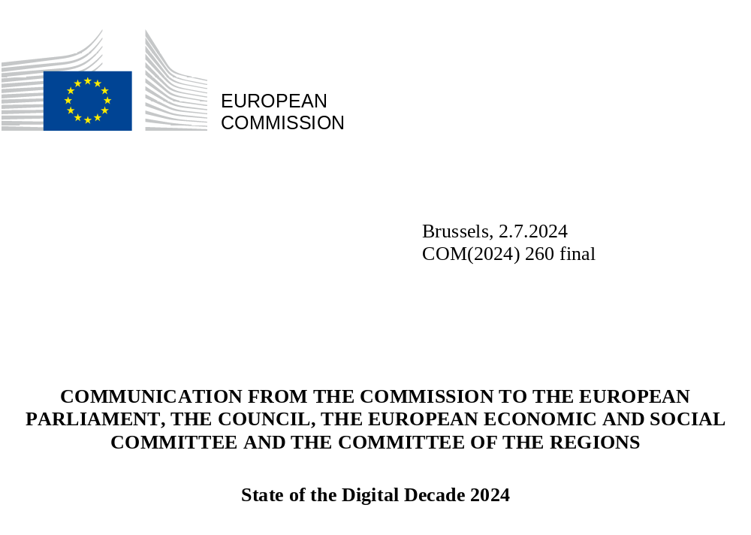

Table of content
1. Introduction: delivering the Digital Decade 2
2. EU established as the global policy innovator 4
3. A stronger EU digital industrial basis accelerating progress in the Digital Decade 6
4. State of the Digital Decade: Progress in 2024 11
4.1 A wake-up call 11
4.1.1. Progress towards a competitive, sovereign and resilient EU based on technological leadership 11
4.1.2. Progress towards the protection and empowerment of EU people and society 12
4.1.3 Leveraging digital transformation for a smart greening 14
4.2 The strategic Digital Decade national roadmaps and their role in achieving the EU’s ambition 14
4.3 Recommendations on the way forward 16
5. International dimension 19
6. Conclusions 20

1. Introduction: delivering the Digital Decade
This Communication contains the 2024 State of the Digital Decade report. It examines digital policy developments since the 2023 report and presents the EU’s progress towards achieving the agreed objectives and targets for a successful digital transformation for people, businesses, and the environment, as set out in the Decision establishing the Digital Decade policy programme 2030. A snapshot of this analysis per each Digital Decade target is provided in Figure 1 below.
Figure 1. Taking stock of the progress towards Digital Decade targets set for 2030
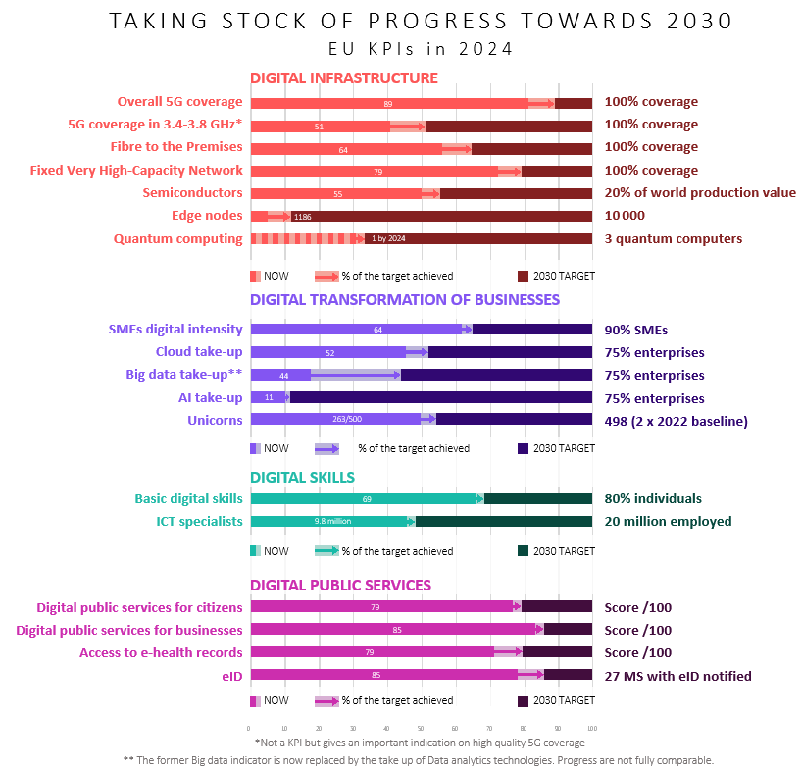
For the first time, this report includes an assessment of national Digital Decade strategic roadmaps. On this basis it outlines Member States’ individual contribution to collectively achieving the Digital Decade’s objectives and targets and, overall, it confirms the findings of the 2023 State of the Digital Decade report:
- Over the past years, the EU has considerably upgraded its action through regulatory and non-regulatory measures to equip itself with a governance framework and a clear vision of the future, based on specific targets and objectives and the means to achieve them. The Digital Decade policy programme has been designed as main instrument to coordinate this effort: it relies on close cooperation with Member States and stakeholders at European, national, regional and local levels to ensure collective progress.
- Thanks to this enabling framework and joint action, some progress has already been achieved. Notably, the implementation of the Recovery and Resilience Facility (RRF) has given an important contribution to the achievement of the Digital Decade policy programme. These instruments and governance framework are complementary to each other and to the European Semester of economic and social policy coordination.
- Yet, as shown by Figure 2 below, at the current rate of Member State’s intervention, the remaining time projected to meet the targets is sometimes well beyond the agreed 2030 timeframe. It is therefore critical that Member States follow suit and step up their contribution to the achievement of the Digital Decade objectives and targets with concrete measures and policies, starting with the adjustment of their roadmaps.
Figure 2. Projected time to target based on last annual average progress for each KPI
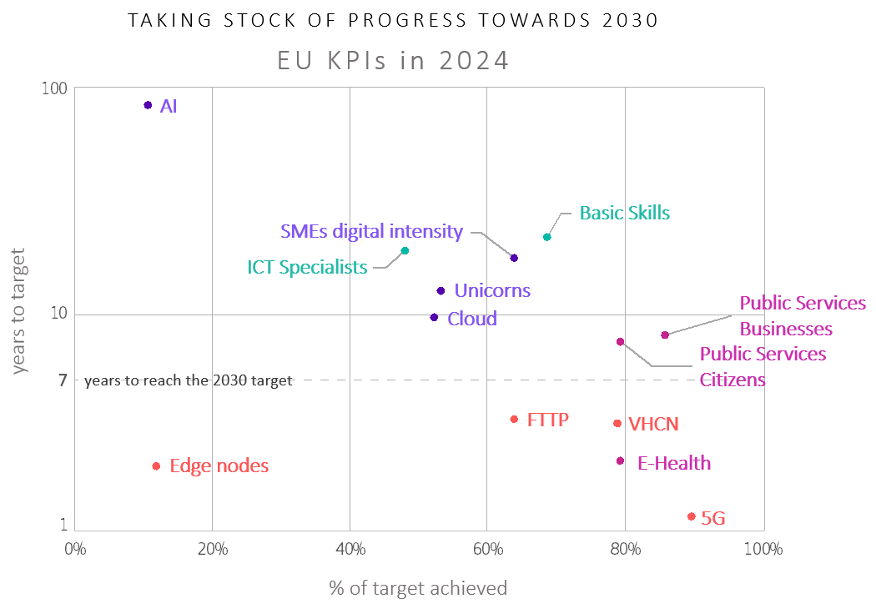
This Communication outlines the main findings of the analysis and it is accompanied by three Annexes: Annex 1 provides an extensive analysis of the progress made towards the Digital Decade objectives and targets and contains horizontal recommendations addressed to all Member States; based on most recent data available, Annex 2 updates the trajectories for the EU to timely reach each Digital Decade target and key performance indicator (KPI); Annex 3 provides a summary of the analysis made for each Member State and includes country specific recommendations. Both the horizontal and the country recommendations aim to accelerate the EU’s collective progress and propose adjustments to national strategic roadmaps.

2. EU established as the global policy innovator
Over the last 5 years, the EU has strategically pivoted toward a more assertive digital policy framework, recognising the urgent need to shape the digital space with targeted investments and robust regulatory mechanisms when necessary. This approach marks a significant disruption, propelling the EU to the forefront of global digital governance and policy innovation. With its state-of-the-art digital rulebook, the EU should contribute, by levelling the playing field across the Member States, to the future achievement of Digital Decade objectives and targets.
2023 and 2024 have been watershed years for the EU’s leadership in the digital age, and its role as a bolder global-class regulator, inspiring other regions of the world to act. The European Commission’s five-year mandate of 2019-2024, has overhauled the digital policy landscape, by proposing and negotiating 23 legislative files which have contributed to reinforce EU’s position in the Digital Decade.
New EU-wide rules have contributed to the Digital Decade objectives of competitiveness and of the development of a human-centred digital space, strengthening the protection of people, facilitated the growth of enterprises with the deepening of the single market and shaping the digital economy far beyond its borders. Among the important legislation delivered in this mandate is notably the Artificial Intelligence Act (AI Act), the world’s first initiative regulating specific uses of artificial intelligence based on the level of potential risk. It seeks to address societal challenges, rights and safety including ethical considerations while establishing effective yet light-touch requirements for AI systems operating within the EU. Other initiatives such as the Data Governance Act, the Data Act or the European Health Data Space Regulation, the Once-Only Technical System (OOTS) under the Single Digital Gateway (SDG) Regulation and the Interoperable Europe Act have built the foundations of our data-driven economy. The EU is strengthening the protection against online harms and disinformation for a safer, more transparent digital space, with the initiation of investigations and information requests being launched to enforce the Digital Services Act (DSA). Large online platforms have already made changes to comply with the Digital Markets Act (DMA), giving more choice to EU users and ensuring fair and contestable digital markets where our enterprises can grow. Finally, during this mandate, essential steps have also been taken to steer the implementation of major legislative building blocks of the Digital Single Market, such as the 2018 European Electronic Communications Code, the 2019 Copyright Directive and the revised Audiovisual Media Services Directive.
The Digital Decade objectives of resilience and cybersecurity were also strengthened through upgraded frameworks, such as with the update of the Network and Information Systems Security Directive (NIS2), the Cyber Solidarity Act and the Cyber Resilience Act. Through the European Digital Identity (EUDI) Regulation, the EU is facilitating access to and use of trusted online services with the EU Digital Identity Wallet (EDIW). The EU has driven more economic and social development by accelerating the deployment of high-speed networks with the Gigabit Infrastructure Act. The EU is reinforcing European energy security by adopting the cybersecurity network code for cross-border electricity flows.
After this wave of strong regulatory efforts, the EU will now need to deliver on implementation and enforcement, with more consistency and coherence and better synergies across regulatory authorities to govern EU digital policies efficiently. This will be essential to strike a balance between innovation and regulatory burden and contribute to the achievement of the EU’s digital decade objectives and targets.

3. A stronger EU digital industrial basis accelerating progress in the Digital Decade
The past 5 years have seen significant advancements in digital innovation and industrial policy, which have fostered a unique and dynamic European ecosystem. This ecosystem, based on connectivity, edge nodes, high performance computing (HPC), quantum, chips and start-ups, supports the EU’s green transition and digital transformation, thereby enhancing its competitiveness. Strengthening the EU’s technological leadership is crucial for accelerating its progress towards the Digital Decade’s objectives and targets.
As shown in Table 1, with an estimated global effort amounting to EUR 205 billion over the past few years, the EU has made full use of its funding capacity to support the Digital Decade. Being one of the main political priorities of the Commission to enhance the EU’s prosperity, economic recovery, and resilience, the digital transformation receives substantial coordinated support from EU funding across the board. An initial stocktaking exercise demonstrated that EUR 131.9 billion of the 2021 and 2022 EU budgets (including NextGenerationEU) was allocated to the digital transition, representing almost 17.4% of the total EU budget. In particular, the Recovery and Resilience Plans, combining investments and reforms worth EUR 651.7 billion, serve as a key source of funding for the digital transformation at national level for many Member States and complete the large scale strategic European projects funded under the Digital Europe Programme (DIGITAL), Horizon Europe and the Connecting Europe Facility (CEF).
Table 1. EU relevant budget for the Digital Decade targets (2021-2027 MFF, incl. RRF 2020-26, EUR million)
Fund |  | Total | RRF  (2020-2026) | Cohesion  (2021-2027) | DIGITAL  (2021-2027) | Horizon  (2021-2024) | CEF  Digital  (2021-2027)
Total funding |  | 957 422 | 651 670 | 260 896 | 7 948 | 35 199 | 1 709
Digital funding |  | 204 583 | 150 037 | 31 063 | 7 948 | 13 826 | 1 709
Digital funding % |  | 21% | 23% | 12% | 100% | 39% | 100%
Funding DD general objectives |  | 27 488 | 14 129 | 4 392 | 1 275 | 7 320 | 373
Funding Digital Decade targets | Total target budget | 177 096 | 135 909 | 26 672 | 6 673 | 6 506 | 1 336
Funding Digital Decade targets | Basic digital skills | 15 405 | 14 294 | 950 | 128 | 34 | 0
Funding Digital Decade targets | ICT specialists* | 10 881 | 9 506 | 633 | 661 | 73 | 8
Funding Digital Decade targets | Gigabit networks | 14 003 | 11 628 | 2 164 | 4 | 0 | 206
Funding Digital Decade targets | 5G* | 3 362 | 1 967 | 115 | 4 | 396 | 879
Funding Digital Decade targets | Semiconductors* | 18 200 | 14 801 | 0 | 1 396 | 2 004 | 0
Funding Digital Decade targets | Edge nodes* | 609 | 0 | 0 | 220 | 355 | 35
Funding Digital Decade targets | Quantum computing* | 1 918 | 866 | 0 | 293 | 669 | 90
Funding Digital Decade targets | Cloud computing* | 8 373 | 6 019 | 1 584 | 370 | 337 | 63
Funding Digital Decade targets | Data analytics* | 7 552 | 4 718 | 1 584 | 546 | 678 | 26
Funding Digital Decade targets | Artificial intelligence* | 9 386 | 5 278 | 1 584 | 1 227 | 1 266 | 30
Funding Digital Decade targets | Digital late adopters* | 19 885 | 14 154 | 4 753 | 674 | 304 | 0
Funding Digital Decade targets | Unicorns | 19 257 | 14 158 | 4 753 | 159 | 187 | 0
Funding Digital Decade targets | Online provision of key public services | 32 343 | 24 449 | 7 271 | 616 | 6 | 0
Funding Digital Decade targets | e-health | 15 233 | 13 604 | 1 280 | 163 | 187 | 0
Funding Digital Decade targets | e-ID | 688 | 466 | 0 | 212 | 9 | 0
In more detail, the Recovery and Resilience Facility represents an unprecedented and, in many cases, the largest source of funding for digital transformation in Member States. Despite major revisions of the Plans, including the incorporation of REPowerEU to address new challenges, the total RRF budget dedicated to digital reforms and investments increased by early 2024 to about EUR 150 billion, representing 26% of the total RRF funding.
RRF has had already significant impact on the Digital Decade across the board. A significant part of the RRF funding directly contributes to Digital Decade objectives and targets, particularly by supporting governments and public bodies in digitising their services and key sectors such as health systems, and by supporting the digitalisation of businesses and improvement of digital skills (cf. table above). Just to make a few examples, to date, 14.7 million additional dwellings have been provided with very high-capacity internet access via Very High-Capacity Networks (VHCN), 728 475 enterprises (mainly SMEs) have been supported in developing digital products, services and processes and 2.1 million people have participated in education or training focused on digital skills.
With a budget of EUR 1.7 billion, the Connecting Europe Facility (CEF 2) Digital supports investment in key European digital infrastructure projects contributing to the Digital Decade’s targets of more resilient and sovereign infrastructures.
CEF2 has had an important impact on the Digital Decade’s targets on connectivity, resilience and sovereignty: so far 158 projects have been awarded, including in the EU Outermost Regions. Projects of strategic importance have benefitted from CEF funding, notably cross border sections of 5G corridors, submarine cables, 5G-based systems enabling use cases functioning as early socio-economic drivers via 5G smart communities in public administrations, healthcare centres, schools and other education and training institutions, as well as quantum communication infrastructure connections.
With a budget of EUR 40,5 million, CEF Digital co-finances a 6-fibre smart submarine cable between continental Portugal Azores Madeira, thus guaranteeing the connection of the two islands for the next 30 years and enabling data gathering as regards seismic detection, environmental monitoring, underwater nautical activity detection and data transmission for scientific purposes, with local, regional, national and worldwide impact. With more than EUR 29 million, CEF2 also finances the 2.145 km long branch extension of the flagship European project Ellalink cable linking Portugal to Brazil towards French Guiana. This branch will not only connect this outermost region of the EU directly to continental Europe with no dependency on any third-party territory but will also lay the foundation for the extension of the cable to European territory in the Caribbean. Another impactful example is the EUR 29 million financing of the first cable linking Ireland directly to the continental EU (France with future extensions to Portugal and Spain).
The CEF2 is also ensuring the development of 5G corridors, granting close to EUR 6 million to the financing of the deployment and upgrade of 5G RAN, Core and transport elements along the Greek (GR) and Bulgarian (BG) highways of the Orient/East-Med (OEM) TEN-T corridor. It also provides over EUR 6.3 million financing covering the motorway section from Frisange (Luxembourg) to Saarbrucken (Germany) at the border crossing near Schengen which will include also connected and automated mobility testing by a major EU car manufacturer.
With a budget of EUR 7.9 billion, the DIGITAL Europe programme is the main programme to fund strategic investments that create digital ecosystems, ensuring the EU’s digital autonomy and global competitiveness. It has already achieved several important results related to the deployment of innovative new digital solutions, capabilities and related services. Among others, the EuroHPC Joint Undertaking awarded the procurement of JUPITER, the first system in Europe to achieve exascale performance, i.e., the ability to execute over one billion calculations per second. Data space initiatives in key sectors are currently being set up, most recently the European Cancer Imaging Initiative and the European Genomic Data Infrastructure. DIGITAL has funded numerous testing and experimentation facilities.
DIGITAL Europe programme has played a critical role in enabling the EU to progress toward infrastructures objectives and targets (notably HPC, quantum, cybersecurity, semiconductors, AI, e-government services) and the financing of cooperation activities such as European Digital Infrastructure Consortia (EDICs) as well as European Digital Innovation Hubs (EDIHs). Operational since 2023, the EDIHs emerged from DIGITAL to support SMEs, mid-caps and public sector organisations in their digital transformation. Offering a comprehensive range of services to their clients – including digital maturity assessments, test before investing platforms, support for investment, training, networking etc. – the network’s strength lies in its extensive reach. It now comprises over 200 hubs, present in 90% of the European regions but covering 100% of the EU, bringing together public and private entities, including research organizations, universities, industry associations, regional development agencies, and private sector companies. DIGITAL contributes to creating more connected public administrations on a cross-border basis, e.g., connecting Member States’ business registers including with other EU level systems. The programme is also supporting bridging the digital divide across regions and has funded various hubs in the EU Outermost Regions.
Horizon Europe is expected to dedicate 35% of its EUR 95 billion budget to the digital transition through the entire 2021-2027 period, with the legal obligation to earmark at least EUR 13 billion for core digital (general-purpose) technologies.
Horizon Europe has fostered EU leadership in several areas underpinning the Digital Decade vision and targets. With the ‘Digital, industry and space’ cluster it supports research and high-end innovation in enabling technologies, such as AI and robotics, next generation internet, microelectronics, the internet of things and cloud computing, high performance computing and data analytics, 6G, extended reality, quantum and other emerging technologies, and several European partnerships.
The InvestEU programme significantly strengthens investments in digital infrastructures and technologies, including media content and skills.
10% of the total investment and financing operations already approved contribute to Digital Decade transformation objectives. EUR 5.24 billion is expected to support digitisation and mobilise up to EUR 74 billion of public and private investments. This funding will provide access to VHCN networks to an additional 1 420 000 households, enterprises or public buildings and will create a significant number of Wi-Fi-hotspots.
Finally, the Technical Support Instrument provides on-demand tailor-made technical expertise to design and implement structural reforms in EU Member States with a budget of EUR 864 million.
The Technical Support Instrument is contributing to building capacity of Member states to participate in the Digital Decade. It is supporting over 240 projects directly linked to the digital economy, including digital transformation governance, AI, business process re-engineering, data-informed decision making and digital skills development. In 2023 more than half of the projects were linked (directly or indirectly) to support Member States’ RRF implementation. The flagship initiative ‘AI-ready public administration’ has particularly supported the deployment of AI in public administration. This year’s call includes a dedicated priority to enhance public administrations’ capacities for Europe's Digital Decade. It aims to strengthen their ability to effectively implement EU legislation in the digital realm and achieve the targets related to the digitalisation of public services.
The EU has also started to reduce its strategic dependencies in critical sectors thanks to key initiatives adopted during this mandate. The Chips Act has triggered a wave of new investments in semiconductor manufacturing in Europe. The EU’s Important Projects of Common European Interest (IPCEIs) are progressing, with notable recent approvals of the second IPCEI on Micro-electronics and Communication Technologies and of the IPCEI on Next Generation Cloud Infrastructure and Services. Several industrial alliances were launched in the areas of batteries, data, edge and cloud computing, processors and semiconductor technologies, and cyber technologies. Thanks to the EU’s investment over the past few years, Europe has become a leader in supercomputing, with 3 of the 10 most powerful supercomputers in the world. In January 2024, the EU adopted the AI innovation package to support AI start-ups and SMEs.These initiatives are supported by considerable investments in advanced digital skills development in key strategic digital areas.
With the Economic Security Strategy adopted in June 2023, the Commission is coordinating assessments of four categories of risks: (1) risks to the resilience of supply chains; (2) risks to the physical and cyber-security of critical infrastructure; (3) risks to technology security and security-relevant technology leakage; and (4) risks of weaponisation of economic dependencies or economic coercion. These assessments are enabling the EU to understand the evolving, new and emerging risks in this challenging geopolitical context and to find ways to mitigate them, by taking measures to promote EU's competitiveness and protect EU’s economic security, including by partnering with the broadest possible range of partners. In particular, the adoption of the Strategy has kickstarted the risk assessments to evaluate the technology security and technology leakage risks in four technology areas that are extremely critical for the EU (out of the 10 areas identified in the Commission Recommendation of 3 October), i.e., advanced semiconductor technologies, quantum technologies, AI technologies and biotechnologies.
To further enhance the EU’s strategic sovereignty and support its technological leadership, the Commission proposed the establishment of the Strategic Technologies for Europe Platform (STEP) in June 2023, an instrument to develop critical emerging technologies that are relevant to the green and digital transitions and to the strategic sovereignty of the EU. The Platform aims to boost the manufacturing capacity in digital technologies and deep tech innovation, clean and resource-efficient technologies and biotechnologies, and to strengthen value chains as well as address labour and skill shortages in these sectors.
Last but not least, concrete cooperation is advancing quickly to develop large-scale projects that a single Member State cannot tackle alone. Three European Digital Infrastructure Consortia (EDICs) have been established by the end of May 2024: the Alliance for Language Technologies EDIC, the Local Digital Twins towards the CitiVERSE EDIC and the EDIC for European Blockchain Partnership and European Blockchain Service Infrastructure (EUROPEUM-EDIC). Eight more are in preparation, and a few additional initiatives are under consideration.
As shown in this chapter, joint and coordinated investment in digital technologies is crucial for accelerating progress toward the Digital Decade objectives and targets, thus driving innovation and economic growth, particularly in an era where digital transformation is reshaping industries and societies. Public investments, when combined with private sector efforts, create a synergistic effect that accelerates technological advancements and broadens their impact. For the European Union to remain competitive on the global stage, it is imperative that funding priorities maintain a strong focus on continuing to leverage the stimulating effect of public and private investment enhancing digital infrastructure, fostering digital skills, and supporting digital innovation across all sectors. By prioritizing digital investment, the EU can secure its position as a leader in the digital age, ensuring sustainable growth and a robust, future-proof economy.

4. State of the Digital Decade: Progress in 2024

4.1 A wake-up call
Despite the significant initiatives undertaken at EU level, the detailed analysis of progress on objectives and targets presented in Annexes 1 and 3 reveals two significant concerns: insufficient progress in reaching the objectives and targets and significant fragmentation across Member States. This highlights the need for more significant efforts by Member States to ensure the EU’s control over its future.

4.1.1. Progress towards a competitive, sovereign and resilient EU based on technological leadership
First of all, the 2024 analysis of progress on objectives and targets confirms the findings of the 2023 report and outlines the need to continue working towards maintaining a leadership position in digital technologies: this is essential for the EU’s future prosperity as it could unlock over EUR 3.4 trillion in economic value, which represents a significant 21% of the EU’s current economy and would greatly contribute to achieve the Digital Decade targets and objectives.
The full potential of the (Digital) Single Market remains untapped: intra-EU trade in services represent a mere 8% of GDP, in stark contrast to its trade of goods, which exceeds 25%. Capitalising on the single market is essential to address major imbalances in the production of digital services. Currently, 80% of the technologies and services needed for Europe’s digital transformation are designed and manufactured in third countries and European platforms have struggled to capture more than 5% of global market value for a decade. More generally, the presence of European firms among the world’s leading ICT companies is minimal, with only 3 Europeans in the top 50 ICT companies by market capitalisation.
Tracking progress against the targets based on 2023 data, the report highlights the EU’s strong position in HPC and quantum as well as limited progress in connectivity coverage, especially in terms of quality. Only 64% of households have access to fiber and the rate of progress (13,5%) is far lower than what we need to reach the gigabit target by 2030. Moreover, there is an extremely low uptake of Gigabit connections of just 18,5%. Coverage of high quality 5G extends only to merely 50% of the EU territory (based on main pioneer band), with the large majority of the deployment of 5G not being stand alone. The investment needed to reach connectivity targets is still significant, amounting to EUR 200 billion. Moreover, the deployment of an estimated 1186 edge nodes is insufficient and predominantly utilised for testing and research, rather than being fully operational and available for general use.
In the semiconductor industry, EU revenues declined by 3% between 2022 and 2023 (dropping from EUR 90 billion to 87 billion), while global revenues decreased by 14% (from EUR 918 billion to 791 billion), indicating however a relatively greater resilience in the EU market.
In the realm of quantum technologies, the first milestone of the Digital Decade target – having the first quantum accelerated computer by 2025 – is expected to be reached this year. However, the level of private investment is still low, representing a mere 5% of total funding.
With limited annual progress, businesses’ uptake of digital technologies remains a key challenge. Cloud adoption has increased by only 7%, falling short of the 9% needed to meet the target. There has been no noticeable improvement in AI take-up, and merely 32% of European companies have adopted data analytics. The digitalisation of SMEs is also progressing too slowly and unevenly across the EU, with an annual increase of only 2,5%, which is half of the growth rate required to achieve the target. The startup ecosystem, despite some progress – 5,6% growth in the number of unicorns – remains underdeveloped. The EU is home only to 263 unicorns (13% of the total), compared to 387 in China, and 1 539 in the USA, partly due to a lack of private capital.

4.1.2. Progress towards the protection and empowerment of EU people and society
Key Findings from the Eurobarometer 2024 Report:
- 3 out of 4 Europeans consider that the digitalisation of daily services makes their lives easier.
-46% European citizens think that misuse of personal data is one of the online issues that have major personal impact on them and 45% think the same about fake news and disinformation, while non-justified removal of content and non-transparent content moderation practices were the two least mentioned issues.
- 82% of respondents consider it important for public authorities to ensure that European companies can grow and become European Champions able to compete globally, while 86% believe equally in the importance of increasing research and innovation for more secure and strong digital technologies.
- 9 out of 10 Europeans think it is important for public authorities to provide proper human support to help individuals navigate digital transformation and digital services.
- The insufficient protection of minors on online platforms is one of the most impactful concerns for one-third of respondents, with this concern increasing by 10 percentage points since last year.
- An increasing majority of Europeans is aware that their rights that apply offline should also be respected online (62%), but less than a half of them (45%) feel that their digital rights are well protected.
While the European population increasingly recognizes the importance of digital transformation, it is increasingly sensitive to the effect of the rapid pace of change in their lives. For the digital transformation to be successful, it is essential for people to remain engaged and supportive. According to 88% of the EU population, public authorities are expected to provide adequate support to help citizens navigate the effects of digital transformation in their lives. The promotion and implementation of the Declaration on Digital Rights and Principles, which aims to give citizens a clear reference point about the type of digital transformation the EU wants, should be stepped up in this context.
Very significant work remains to be done to reach the 2030 targets on digital skills: only 55.6% of EU’s population has at least basic digital skills and, at the current pace, the number of ICT specialists will reach just 12 million by 2030 – well below the EUR 20 million target and amid growing competition for digitally skilled talent. The annual progress achieved in 2023 is alarmingly insufficient, falling between 2.5 and 3 times less than the rate needed to reach the targets by 2030.
The availability of eID schemes, digital public services and access to e-Health records is increasing, but there are still significant differences among countries, as the adoption of eID varies. Significant gaps exist in the provision of fully user-centric, accessible, and sovereign digital public services.
Online risks are on the rise and disinformation has been identified as one of the most destabilising factors for our societies, requiring comprehensive, coordinated action across borders and actors. The EU cybersecurity landscape continues to be strongly impacted by geopolitical events, with cyberattacks on the rise: ENISA recorded more than 2 500 cyber incidents from July 2022 to June 2023, with 220 incidents specifically targeting two or more EU countries. In 2023, 33.5% of individuals surveyed in the EU reported encountering hostile or degrading online messages, targeting specific groups due to their political and social views, racial or ethnic origin, or sexual orientation, highlighting the prevalence of online hate speech. Moreover, a 10 percentage points increase in public support for better protecting children online, highlights a growing focus on safeguarding children in the digital space. The combination of the significant amount of time spent online by children and the sophisticated, invasive digital techniques used by advertisers, poses new and serious challenges for the protection of children in the online space including risks for their mental health, or abuse of unhealthy food, tobacco, or alcohol. Furthermore, the health dimension of digitalisation has recently attracted attention due to the negative impacts that particularly certain online interface designs, can have on health in general, and in particular on mental health.
One of the major challenges faced in the EU’s digital transformation, as seen from monitoring the objectives and targets of the Digital Decade, is the limited spread of digital technologies beyond large cities, linked to increasing digital divides and to the slow digitalisation of businesses, especially SMEs. Convergence is still lagging as major population centres often concentrate investments, human capital and digital infrastructures while small cities, remote and rural areas struggle to stimulate economic activity and face demographic challenges. A successful Digital Decade will therefore not be possible without greater focus on inclusiveness and the participation of all actors at all levels including regions and cities. To this end the Digital Decade policy programme offers a framework for cooperation among actors with new opportunities of collaboration.

4.1.3 Leveraging digital transformation for a smart greening
The digital sector currently accounts for 7-9% of global electricity consumption, which is projected to rise to 13% by 2030 due to the growing demand for Internet services and AI at global level. Efforts to reduce energy consumption of digital services will be crucial, with a focus on energy-efficient semiconductors and climate-neutral edge nodes. Despite its importance for achieving a circular economy, the recycling of digital devices remains limited, with only 10.4% of people reporting to have recycled their mobile/smart phones and another 9.7% and 12.8% their laptops/tablets and desktop computers respectively.
The increasing role of digital transformation and technology adoption in reducing the ICT environmental footprint, driving productivity growth and efficiency gains for companies, as well as advancing breakthroughs in energy, net-zero and clean technologies, is becoming more evident. This sector has indeed the potential to reduce total greenhouse emissions by 15%-20% before 2030, across the whole economy. A significant achievement in 2023 is the development and implementation of a science-based methodology for measuring the net environmental impact of digital solutions, facilitated through the European Green Digital Coalition.
Finally, the RRF is instrumental in supporting the twin, digital and green transition, including Smart Mobility and Smart Energy Systems (such as smart grids and ICT systems).

4.2 The strategic Digital Decade national roadmaps and their role in achieving the EU’s ambition
As mentioned, for the first time, the analysis of EU progress towards the Digital Decade benefits from an analysis of the combined national ambitions as presented in national roadmaps of all Member States. This initial set of national roadmaps represents a successful starting point demonstrating a unified effort by Member States to contribute to the Digital Decade.
In their national roadmaps, Member States propose 1 623 measures aimed at achieving the Digital Decade targets and objectives, amounting to EUR 251.9 billion investments (including EUR 168 billion from the public budget which amounts to 1% of the EU’s GDP). The proposed measures focus mainly on semiconductors (public budget EUR 40 billion, 24%), connectivity (EUR 29 billion, 17%), and basic digital skills (EUR 25 billion, 15%). While references to general objectives in national roadmaps are less developed than the specific targets, they still encompass 414 measures addressing competitiveness (public budget EUR 56.8 billion), technological leadership (EUR 22.3 billion), and cybersecurity (EUR 5.9 billion).
The roadmaps contain also national targets corresponding to the Digital Decade targets and ambitions as illustrated in Figure 3 below. However, only 70% of the expected targets were included in national roadmaps, with 52% of targets being aligned with the EU-level targets. The level of ambition of the Member States is only comparable to the EU’s Digital Decade in the case of basic digital skills, VHCN, basic 5G and Digital Intensity Index while being much lower for FTTP, ICT specialists, data analytics, cloud and AI.
Figure 3. National 2030 targets compared to EU targets
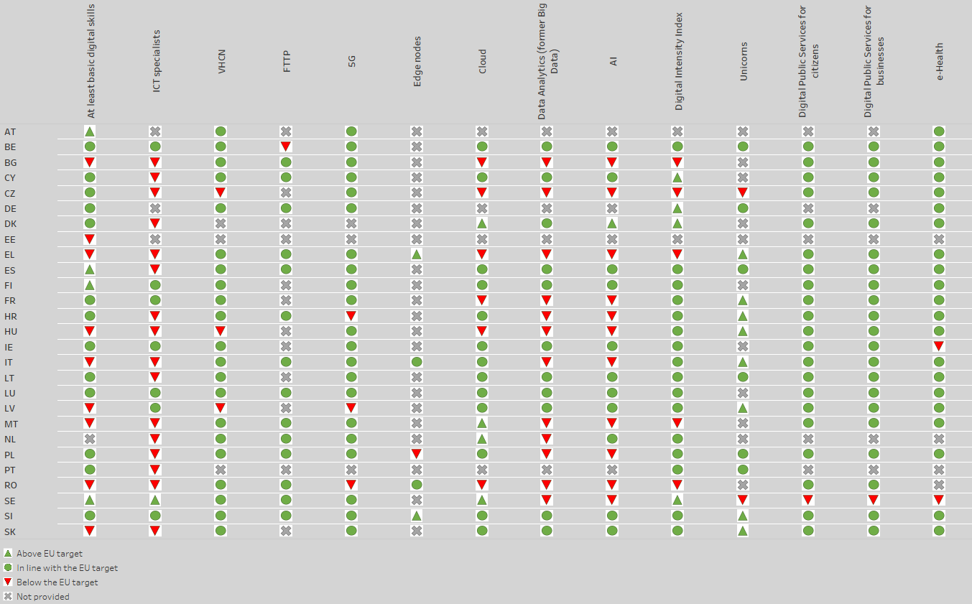
An analysis of the collective effort based on roadmaps against the achievement of targets (cf. Table 2) shows that in the current scenario, the collective efforts of the Member States fall short of the EU’s level of ambition for at least 8 out of 12 KPIs.
Table 2. Aggregation of the national roadmaps’ commitments
KPI | Basic digital skills | ICT Specia-lists | VHCN | FTTP | 5G | Cloud | Data Ana- lytics | AI | DII | Digital Public Services |  | e-Health
 |  |  |  |  |  |  |  |  |  | Citi-zens | Busi-ness | e-Health
% EU target achieved | 98% | 62% | 97% | 69% | 94% | 63% | 51% | 48% | 95% | 77% | 77% | 76%
A more thorough assessment demonstrates that substantial improvements and adjustments of the national roadmaps are needed to align them with the ambition and benchmarks of the Digital Decade policy programme, as per the Commission’s 2023 Guidance. In particular, all targets should be covered by national targets and trajectories that reflect the EU’s level of ambition, as defined by the co-legislators, and should be translated into more ambitious measures, including budgetary considerations. To ensure a more sustained progress towards these targets Member States should also present an analysis of the impact that these measures will have. Greater attention is required on the challenges faced by each Member State and the general objectives (i.e., human centred digital space, competitiveness, fairness, resilience, sovereignty, inclusiveness, sustainability and greening, coherence of the action) linked with the European Declaration on Digital Rights and Principles. These objectives also emphasise the promotion of cultural and linguistic diversity. The monitoring of the Declaration indeed shows that increasing the profile of the Declaration at national level could also help improve outcomes in the years to come. This will ensure coherence and efficiency in collective action. Finally, stakeholder consultation is a key element of the Digital Decade, and it should be conducted and appropriately reflected in the national roadmaps.

4.3 Recommendations on the way forward
All the advancements made by the EU, supported by vigorous policy action, already start delivering significant progress towards Digital Decade objectives and targets with concrete effects on basic connectivity coverage, semiconductors, and super-computing, as further highlighted in Annex 1.
However, considering the limited progress made in 2023 and the important needs identified by the Digital Decade monitoring in most areas, there is still a critical need for action and investment at EU and national level regarding notably Digital Skills, ICT experts, high-quality connectivity, dissemination of AI and data analytics, start-up ecosystems, whilst efforts in semiconductors should be continued. Among all critical areas, the fostering of collaborative connectivity and computing networks will require at least EUR 280 billion of investment by 2030.
Considering this comprehensive analysis, the Annexes 1 and 3 of this report provide concrete recommendations to Member States on the way forward, addressing the whole possible scope of action: mobilising investments, completing the single market, disseminating technologies, and fostering cooperation between Member States. In a nutshell the recommendations revolve around the following main pillars.
First, in order to swiftly implement and enforce the regulatory frameworks established to drive the digital transformation (including the DSA, the DMA, the AI act, the EU Digital Identity Regulation, the OOTS, the Cybersecurity and Data legislations and the EU toolbox for 5G cybersecurity), the EU and Member States should engage in more coordination and cohesion across the board, synergies among governance entities and funding programmes, and the mitigation of unnecessary administrative burden.
In particular, the reduction of the administrative burden, both in the implementation and enforcement of existing legislative acts, entails promoting synergies, avoiding duplication and adopting a coordinated approach to managing the existing governance structures, with a coherence between digital and cybersecurity policy. In this context, the Digital Decade Board can serve as a central point for Member States, with a broad mandate covering various aspects of digital transformation, such as governance, reporting obligations, and multi-country projects. By leveraging this board, efforts can be further streamlined and harmonised across different entities, across various Member States, ultimately resulting in an adoption the ‘whole-of-government' approach underpinning the Digital Decade. Such approach can break down boundaries between government agencies enabling smooth data and information sharing across their systems. This approach can also foster collaboration in mapping reporting obligations, consolidating, or codifying the digital legal framework, ultimately streamlining processes for businesses and citizens.
Secondly, the Member States should intensify their efforts to strengthen their competitiveness, encompassing productivity, resilience, greening and sovereignty. This requires increased measures and investments, as well as a step change in addressing obstacles to the single market. The EU should be ready to ensure the availability of reliable, fast and secure collaborative connectivity and computing networks throughout the EU, fostering the digitalisation of both business and public services, for the benefit of national and cross-border users. The EU should also equip itself with a more coherent and strategic framework of investment, governance, and capacity-building for an effective and inclusive skills and talent development for the digital age, notably through a swift adaptation of EU education and training systems.
Significant mobilisation of further public and private investments will be critical to foster research, innovation, and digital infrastructure development. These investments are also essential to bridge the digital divide across regions. This includes the cultivation of start-up ecosystems, the creation of software and chips that meet sustainability and security standards and the leveraging of synergies between civil and defence sectors. Progress toward a true capital markets union is also essential for driving growth and innovation.
The report also highlights the need to extend the scope of public policy interventions, particularly in public procurement. This will help accelerate the development of the EU’s digital industrial and services base, including for sovereign AI and cloud technologies and services.
Thirdly, there is still untapped potential to foster the dissemination of digital technologies across society and regions, particularly by developing cooperation and collaboration between European actors at the local level. Building on EDICs, EDIHs and partnerships such as EuroHPC JU, the EU and Member States should establish closer links with local actors, including SMEs, start-ups, universities, etc. This collaboration should also extend to cities and local development banks to fully harness the potential of the European society. The experience and capacities of regions and cities are of paramount importance for a successful Digital Decade. With their practical experience, knowledge, and innovative solutions based on daily contacts with citizens and businesses, regions and cities can help better promote and monitor implementation of the Declaration on Digital Rights and Principles, tackling digital divides and ensuring that the benefits of digitalisation can reach all actors including SMEs.
Fourthly, building on citizens’ growing perception of the potential of the digital transformation to foster a smart green transition, Member States can capitalise on the significant achievements made in 2023 in better understanding the synergies between the twin transitions and possible leverages. The priority is to transition from small scale pilots and initiatives to large scale projects based on cooperation between public and private actors. To achieve this goal, it is notably essential to establish a quantitative target on greening in the Digital Decade, to accelerate the work on identifying best practices as well as to intensify the coordination between national Digital Decade strategic roadmaps and National Energy and Climate Plans (NECPs).
Fifth, a common effort is required to ensure that people and their rights, as committed to in the Declaration on Digital Rights and Principles, are at the centre of the digital transformation, ensuring that they have the adequate digital skills and keeping them on board. To achieve this objective, the EU and Member States will need to better monitor societal and economic risks stemming from digitalisation, addressing issues such as inequality, poverty, online discrimination, and social exclusion and foster direct human support to those who are facing difficulties. Member States should also intensify action against threats to public health and democracy, while at the same time ensuring that the online space becomes a genuinely safe, healthy and secure environment for children. These actions to address inequalities, online discrimination, divides and social exclusion linked to the growing centrality of online interfaces in daily lives are critical to prevent a growing digital disconnect from evolving into digital discontent.
Finally, the identification and sharing of best practices is a key driver of a successful digital transformation and was identified as a priority for both the Commission and Member States. The goal is to foster increased cooperation, mutual inspiration and the sharing of success stories and solutions to systemic challenges. Such collaboration is essential for advancing towards the EU’s 2030 goals and the broader digital transformation. As agreed by the Digital Decade Board and based on the interest of Member States, the process of sharing best practices is scheduled to intensify in 2024, initially focusing on three pilot areas: (i) advancement of digital skills; (ii) uptake of advanced digital technologies, especially AI; and (iii) monitoring of the green footprint of digital technologies. The process will be led by Member States with the Commission acting as an accelerator to identify, select and monitor best practices and their dissemination.

5. International dimension
International cooperation efforts on digital policies focus on (i) promoting the EU human-centric model and regulatory framework, (ii) protecting the EU’s strategic interests including EU economic security and (iii) reinforcing the global role of the EU in the digital world.
The Declaration on Digital Rights and Principles has influenced international texts, including the OECD Declaration on a Trusted, Sustainable and Inclusive Digital Future and discussions for a United Nations Global Digital Compact. The EU has laid down foundations for Digital Diplomacy through Council Conclusions and aims for a stronger, more strategic approach in global digital affairs. The importance of the international dimension of EU digital policies was further emphasised by the European Council in its Conclusions of 18 April 2024, which underlined the need to strengthen the EU’s leadership in global digital affairs and invited the Commission and the High Representative to prepare a joint communication on the subject.
The Commission has continued to develop its network of Trade and Technology Councils (TTC) and Digital Partnerships with like-minded partners like the US, India, Japan, South Korea, Singapore and Canada, developing cooperation on investments and technical support, policy and legislation as well as standardisation. Through the EU-US TTC, the EU has advanced cooperation in key areas such as emerging technologies, secure and resilient connectivity and protection of human rights and values online. The TTC with India and the Digital Partnerships with Japan, the Republic of Korea and Singapore showcase the EU’s strategic engagement in the digital field with the Indo-Pacific.
In the Latin America and Caribbean (LAC) region, bilateral digital policy dialogues have been set up with Brazil and Argentina and a dialogue is planned with Mexico, in complement to the bi-regional dialogue established under the EU-LAC Digital Alliance. In Asia, the EU held a second High Level Dialogue on Digital with China in September 2023 as well as the High- Level Economic Dialogue. The dialogue notably discussed problems EU companies encounter in China such as access to ICT standardisation bodies or cross-border data.
The Global Gateway initiative focuses on digital infrastructure investments to bridge the global digital divide and enhance secure digital connections, notably the deployment of secure 5G networks provided by trusted vendors and the security and resilience of submarine cables, supporting the EU’s digital resilience and reducing dependencies. The Commission has continued to support digital transformation efforts in enlargement countries and the EU neighbourhood, including a long-term roaming arrangement with Ukraine through the EU-Ukraine Association Agreement. The Commission has also engaged in multilateral fora notably on artificial intelligence (G7 Hiroshima AI Process, Council of Europe Convention). To safeguard economic interests, the EU has implemented measures such as the EU Economic Security Strategy, promoting cooperation with key partners in emerging technologies. These measures aim to balance economic openness with strategic interests and enhance the EU's resilience in critical sectors.
Trade policy and agreements also play a vital role in this regard by setting the global and bilateral rules for digital trade in an open but assertive manner, based on European values. The Commission negotiated ambitious commitments on digital trade in recent trade agreements with New Zealand, Chile and Japan. Trade rules allow EU businesses and consumers throughout the economy to have access to the most innovative and best performing goods and services and EU businesses to access to a wider customer base in a global market. As the geopolitical environment is expected to remain tense, agreeing binding digital trade rules with like-minded countries is important to ensure that EU companies can secure access to third country markets and trusted cross-border flows of data, to allow EU companies to scale up and thrive in the digital economy at global level. The EU has also been a driving force in the WTO plurilateral negotiations on e-commerce amongst 90 WTO members, accounting for over 90% of global trade. Most recently, in 2023, the Commission opened negotiations for modern self-standing digital trade agreements with Singapore and with Korea.

6. Conclusions
Over the past 5 years, the EU has forged an unprecedented digital legacy by developing a vision, the Digital Decade objectives and targets, and the tools to shape its digital transformation towards the achievement of such vision. Its unique digital regulatory framework remains unparalleled, while innovation and industrial policy continue to grow increasingly assertive.
The state of play presented in this report calls for leveraging the acquis to intensify joint action on the EU’s digital transformation. Member States are invited to take note of the analysis in this State of the Digital Decade report and review the horizontal and Member State-specific recommendations provided in the annexes. It is critical that Member States respond to this call for action and adjust their national roadmaps to align with the ambition of the Digital Decade policy programme, before November 2024 as requested by the Digital Decade decision.
Considering the evidence presented in this report, the Commission will continue its discussions with Member States, the European Parliament, and stakeholders on how to progress together, leveraging the Digital Decade’s governance mechanism, notably the Digital Decade Board. The report will also inform the co-operation with stakeholders and partners outside the EU.
As set out in the Digital Decade policy programme, the Commission will monitor and assess the implementation of these recommendations and report on the progress made in the State of the Digital Decade 2025 report.
The Commission will also start preparing the review of the Digital Decade policy programme, foreseen for June 2026.

https://digital-strategy.ec.europa.eu/en/library/2023-report-state-digital-decade.
Decision (EU) 2022/2481 of the European Parliament and of the Council of 14 December 2022 establishing the Digital Decade policy programme 2030, OJ L 323, 19.12.2022, p. 4–26.
Commission analysis, SWD ‘Digital Decade in 2024: Implementation and perspective’ with annexes, SWD(2024)260: https://digital-strategy.ec.europa.eu/en/news-redirect/833325.
The report was drafted following a series of workshops and fact-finding missions which encompassed over 100 meetings held across all Member States. These meetings engaged authorities, regulators and civil society representatives.
In Figure 2 the ‘time to target’ is calculated by projecting the most recent observed average annual growth (as of 2023). It does not foresee any acceleration neither takes into account very recent actions that may have a positive impact. The current KPI for the 5G target does not take into account quality of service, and therefore most of the current 5G deployment can be categorised as “basic 5G”. "Stand-alone" 5G, which ensures high reliability, low latency and is crucial for enabling advanced features, is still not deployed on any meaningful scale, except in very few cases of private networks. Meanwhile, 5G coverage in the 3.4-3.8 GHz band, considered the primary pioneer band for 5G in the Union and the only available mid-band on a large scale offering a good balance between coverage and capacity, stands at only 51% in 2023. Since 2023, the European Commission together with the Member States is working on an update of the 5G indicator, which entails the development of a methodology to map quality of service (QoS).
This report is complemented by the Staff Working Document ‘Digital Decade in 2024: Implementation and perspective’ with annexes, SWD(2024)260, including horizontal and individual detailed analysis of the Digital Decade strategic roadmaps submitted by the Member States and reporting on the implementation of the European Declaration on Digital Rights and Principles (2023/C 23/01, OJ C 23, 23.1.2023, p. 1–7), which translates the EU’s vision of digital transformation into principles and commitments and provides a clear reference for people, policymakers and companies regarding the desired type of digital transformation in the EU.
See SWD ‘Digital Decade in 2024: Implementation and perspective’ with annexes, SWD(2024)260: https://digital-strategy.ec.europa.eu/en/news-redirect/833325, Annex 1 List of relevant policy initiatives.
The regulation is expected to be published in the Official Journal in summer 2024 (AI Act webpage: https://digital-strategy.ec.europa.eu/en/policies/regulatory-framework-ai).
Regulation (EU) 2022/868 of the European Parliament and of the Council of 30 May 2022 on European data governance and amending Regulation (EU) 2018/1724 (Data Governance Act)., OJ L 152, 3.6.2022, p. 1–44, http://data.europa.eu/eli/reg/2022/868/oj.
Regulation (EU) 2023/2854 of the European Parliament and of the Council of 13 December 2023 on harmonised rules on fair access to and use of data and amending Regulation (EU) 2017/2394 and Directive (EU) 2020/1828 (Data Act), OJ L 2023/2854, 22.12.2023, http://data.europa.eu/eli/reg/2023/2854/oj.
The regulation is expected to be published in the Official Journal in autumn 2024 (EHDS webpage: https://health.ec.europa.eu/ehealth-digital-health-and-care/european-health-data-space_en).
https://commission.europa.eu/news/once-only-technical-system-key-creation-first-european-data-space-2022-07-20_en.
Regulation (EU) 2018/1724 of the European Parliament and of the Council of 2 October 2018 establishing a single digital gateway to provide access to information, to procedures and to assistance and problem-solving services and amending Regulation (EU) No 1024/2012, OJ L 295, 21.11.2018, p. 1–38, https://eur-lex.europa.eu/legal-content/EN/TXT/?uri=uriserv:OJ.L_.2018.295.01.0001.01.ENG.
Regulation (EU) 2024/903 of the European Parliament and of the Council of 13 March 2024 laying down measures for a high level of public sector interoperability across the Union (Interoperable Europe Act) OJ L, 2024/903, 22.3.2024, https://eur-lex.europa.eu/legal-content/EN/TXT/?uri=CELEX%3A32024R0903.
Regulation (EU) 2022/2065 of the European Parliament and of the Council of 19 October 2022 on a Single Market For Digital Services and amending Directive 2000/31/EC (Digital Services Act), OJ L 277, 27.10.2022, p. 1–102, https://eur-lex.europa.eu/eli/reg/2022/2065/oj 1–102, https://eur-lex.europa.eu/eli/reg/2022/2065/oj; https://digital-strategy.ec.europa.eu/en/policies/list-designated-vlops-and-vloses; https://digital-strategy.ec.europa.eu/en/policies/dsa-enforcement. .
Regulation (EU) 2022/1925 of the European Parliament and of the Council of 14 September 2022 on contestable and fair markets in the digital sector and amending Directives (EU) 2019/1937 and (EU) 2020/1828 (Digital Markets Act), OJ L 265, 12.10.2022, p. 1–66, http://data.europa.eu/eli/reg/2022/1925/oj; DMA designated Gatekeepers (europa.eu) .
Directive (EU) 2018/1972 of the European Parliament and of the Council of 11 December 2018 establishing the European Electronic Communications Code, OJ L 321, 17/12/2018, p. 36-214, http://data.europa.eu/eli/dir/2018/1972/oj.
Commission guidelines on video sharing platforms, on European works and on the scope of MS media literacy reports (https://digital-strategy.ec.europa.eu/en/policies/audiovisual-and-media-services).
Directive (EU) 2022/2555 of the European Parliament and of the Council of 14 December 2022 on measures for a high common level of cybersecurity across the Union, amending Regulation (EU) No 910/2014 and Directive (EU) 2018/1972, and repealing Directive (EU) 2016/1148, OJ L 333, 27.12.2022, p. 80–152, http://data.europa.eu/eli/dir/2022/2555/2022-12-27 (consolidated text).
The regulation is expected to be published in the Official Journal in 2024 (Cyber Solidarity Act webpage: https://digital-strategy.ec.europa.eu/en/policies/cyber-solidarity).
The regulation is expected to be published in the Official Journal in 2024 (Cyber Resilience Act webpage: https://digital-strategy.ec.europa.eu/en/policies/cyber-resilience-act).
Regulation (EU) 2024/1183 of the European Parliament and of the Council of 11 April 2024 amending Regulation (EU) No 910/2014 as regards establishing the European Digital Identity Framework, OJ L, 2024/1183, 30.4.2024, http://data.europa.eu/eli/reg/2024/1183/oj.
Regulation (EU) 2024/1309 of the European Parliament and of the Council of 29 April 2024 on measures to reduce the cost of deploying gigabit electronic communications networks, amending Regulation (EU) 2015/2120 and repealing Directive 2014/61/EU (Gigabit Infrastructure Act), OJ L, 2024/1309, 8.5.2024, http://data.europa.eu/eli/reg/2024/1309/oj.
https://commission.europa.eu/strategy-and-policy/eu-budget/performance-and-reporting/horizontal-priorities/digital-tracking_en.
This amount represents the total estimated costs of measures included in the Recovery and Resilience Plans, including REpowerEU measures.
Source: Joint Research Centre report ‘Mapping EU level funding instruments to Digital Decade targets - 2024 update’ (Signorelli et al., 2024).
The Digital Decade targets indicated in the table with an asterisk (*) benefit from HPC funding. This funding not only supports computing research and infrastructures (e.g., quantum, cloud, AI etc.) but also the training of specialists, the development of hyper-connectivity (5G, edge nodes), and the adoption of HPC by SMEs. In total HPC funding amounts to EUR 3 267 million, mainly channelled through DIGITAL (EUR 1 967.2 million), Horizon Europe (EUR 900 million), CEF (EUR 200 million), and the RRF (EUR 168 million).
Including measures in the REpowerEU chapters contributing to the digital transition. It should be noted that those measures are considered in the analysis in this report but do not contribute to the achievement of the 20% digital target set by the Regulation establishing the Recovery and Resilience Facility (see also the Guidance on Recovery and Resilience Plans in the context of REPowerEU). Excluding measures under the REpowerEU chapter, the amount of the RRF that contributes to the digital transition is about EUR 149.7 billion, which represents about 26% of the total RRF funds.
While the overall Cohesion Policy funds total is EUR 392 billion, only the following funds are included in the mapping. and subsequent estimations: the European Regional Development Fund (ERDF), the Cohesion Fund (CF), and the European Territorial Cooperation Fund (Interreg), Including the digitalization investments from the REPowerEU chapters.
Excluding measures under the REpowerEU chapter. The share is calculated using Annex VII to the Recovery and Resilience Facility (RRF) Regulation.
https://ec.europa.eu/economy_finance/recovery-and-resilience-scoreboard/common_indicators.html?lang=en..
The outermost regions (Art. 349 TFEU) are an integral part of the EU and are located in the Atlantic Ocean, the Caribbean basin, South America and the Indian Ocean. CEF Digital provides higher co-financing rates to projects involving the outermost regions and has funded submarine cable infrastructure in these regions worth over EUR 125 million.
5G Seagul, 5G DeLux, 5G NETC, MEDCOR, 5G Balkans, BaltCor5G.
Continent-Azores-Madeira ring, Pisces project, ViaTunisia project, as well as various Arctic connectivity projects.
https://digital-strategy.ec.europa.eu/en/library/second-staff-working-document-data-spaces.
Namely the EU Beneficial Ownership Registers Interconnection System (BORIS) and with the EU Insolvency Registers Interconnection system (IRI).
For example, the hub CIDIHUB in the Canary Islands focuses on digitalisation of businesses while EDIH of Réunion specialises in cybersecurity with funding from DIGITAL.
https://www.statista.com/statistics/732308/worldwide-research-and-development-information-communication-technology/.
https://www.statista.com/statistics/732308/worldwide-research-and-development-information-communication-technology/.
With Joint Undertakings for Chips, EuroHPC, Smart Networks and Services and other partnerships in AI, Data and Robotics partnership, Photonics or Made in Europe and the Virtual Words and Advanced Materials Partnership).
https://commission.europa.eu/funding-tenders/find-funding/eu-funding-programmes/technical-support-instrument/technical-support-instrument-tsi_en.
https://reform-support.ec.europa.eu/tsi-2024-flagship-ai-ready-public-administration_en.
https://reform-support.ec.europa.eu/our-projects/flagship-technical-support-projects/tsi-2025-flagship-compact-pillar-ii-capacity-europes-digital-decade_en.
https://single-market-economy.ec.europa.eu/industry/strategy/industrial-alliances_en.
https://www.top500.org/lists/top500/list/2024/06/.
https://digital-strategy.ec.europa.eu/en/news/commission-launches-ai-innovation-package-support-artificial-intelligence-startups-and-smes.
JOIN/2023/20 final – Joint Communication to the EP and the Council on “European economic security strategy”.
C(2023) 6689 final – Commission Recommendation on critical technology areas for the EU's economic security for further risk assessment with Member States.
For a comprehensive description of the ongoing EDICs: SWD ‘Digital Decade in 2024: Implementation and perspective’ with annexes, SWD(2024)260: https://digital-strategy.ec.europa.eu/en/news-redirect/833325 Annex 2 Update on MCPs / EDICs.
Cf. Communication ‘State of the Digital Decade 2024’ with annexes, COM(2024) 260: https://digital-strategy.ec.europa.eu/en/news-redirect/833324.
Since last year, there has been a marginal 0.5 percentage point increase in EU’s share (https://www.statista.com/statistics/263801/global-market-share-held-by-selected-countries-in-the-ict-market/). It may be early to interpret this as a shift in trend, but this could be an encouraging sign.
https://cerre.eu/wp-content/uploads/2022/12/Digital-Industrial-Policy-for-Europe.pdf.
https://companiesmarketcap.com/tech/largest-tech-companies-by-market-cap/.
Special Eurobarometer 551 ‘The Digital Decade’ 2024: https://digital-strategy.ec.europa.eu/en/news-redirect/833351.
https://digital-strategy.ec.europa.eu/en/policies/digital-principles.
Cross- border availability remains limited for digital public services for citizens and for businesses, both reaching a score of around 70 points out of 100 (Source: eGovernment Benchmark, Capgemini).
https://www.enisa.europa.eu/publications/enisa-threat-landscape-2023.
Special Eurobarometer 551 ‘The Digital Decade’ 2024: https://digital-strategy.ec.europa.eu/en/news-redirect/833351.
https://digital-strategy.ec.europa.eu/en/policies/national-strategic-roadmaps.
Very high capacity networks (VHCN) include both fibre to the premises (FTTP) and DOCSIS 3.1 technologies.
See footnote 5. The current KPI for the 5G target does not take into account quality of service, and therefore most of the current 5G deployment as well as the corresponding national 5G targets can be categorised as “basic 5G”.
Cf. footnote above.
The most recent figures available on AI take-up by enterprises were collected in 2023 and cannot take into account the possible effect of the innovation package to support Artificial Intelligence startups and SMEs that was launched by the European Commission in January 2024 (https://ec.europa.eu/commission/presscorner/detail/en/ip_24_383).
SWD ‘Digital Decade in 2024: Implementation and perspective’ with annexes, SWD(2024)260: https://digital-strategy.ec.europa.eu/en/news-redirect/833325.
https://digital-strategy.ec.europa.eu/en/library/guidance-member-states-preparation-national-digital-decade-strategic-roadmaps.
European Declaration on Digital Rights and Principles for the Digital Decade 2023/C23/01: https://eur-lex.europa.eu/legal-content/EN/TXT/?uri=OJ:JOC_2023_023_R_0001.
See SWD ‘Digital Decade in 2024: Implementation and perspective’ with annexes, SWD(2024)260: https://digital-strategy.ec.europa.eu/en/news-redirect/833325 Annex 4 Monitoring of the European Declaration on Digital Rights and Principles.
An ecosystem that spans semiconductors, computational capacity in all kinds of edge and cloud environments, radio technologies, to connectivity infrastructure, data management, and applications.
European Commission, White Paper - On options for enhancing support for research and development involving technologies with dual-use potential, 2024: https://research-and-innovation.ec.europa.eu/document/download/7ae11ca9-9ff5-4d0f-a097-86a719ed6892_en; Key Note Speech by President Ursula von der Leyen at the EDA Annual Conference 2023: Powering up European Defence, 30 November 2023: https://ec.europa.eu/commission/presscorner/detail/en/SPEECH_23_6207.
European Declaration on Digital Rights and Principles for the Digital Decade 2023/C23/01: https://eur-lex.europa.eu/legal-content/EN/TXT/?uri=OJ:JOC_2023_023_R_0001.
OECD, Declaration on a Trusted, Sustainable and Inclusive Digital Future: https://legalinstruments.oecd.org/en/instruments/OECD-LEGAL-0488.
EU- Latin America and Caribbean Digital Alliance: https://international-partnerships.ec.europa.eu/policies/global-gateway/eu-latin-america-and-caribbean-digital-alliance_en.
Association Agreement between the European Union and its Member States, of the one part and Ukraine of the other part: http://data.europa.eu/eli/agree_internation/2014/295/2023-12-01.
DECISION (EU) 2022/2481, Article 8.3.

