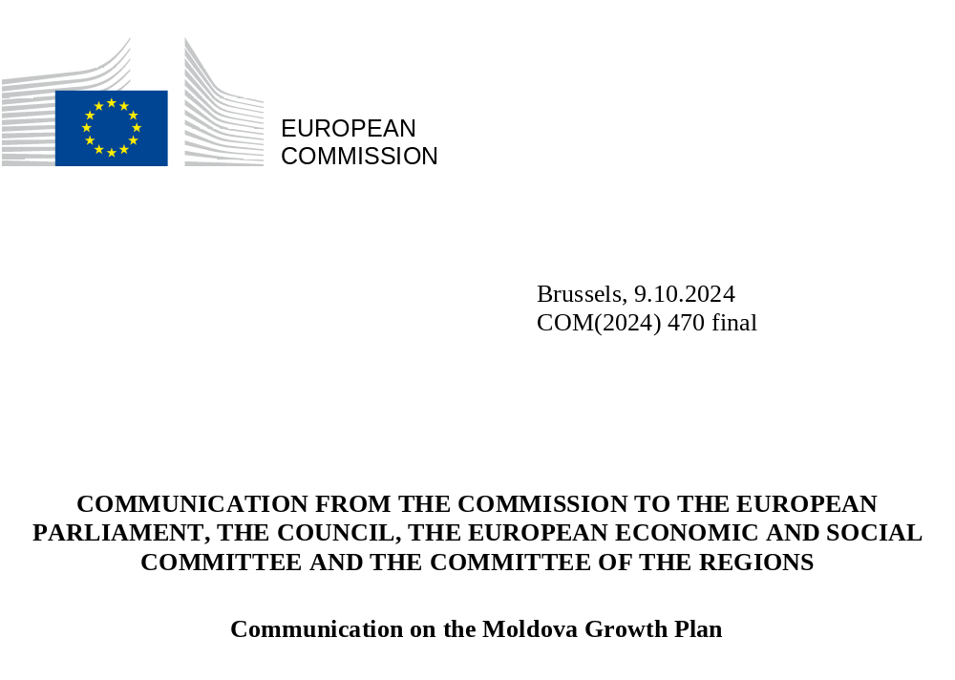

INTRODUCTION
The European Union’s (EU) enlargement policy remains of central importance to safeguard and promote a peaceful, stable, strong and united Europe. Russia’s war of aggression against Ukraine illustrates once again the need for a determined geostrategic investment in this policy. The Republic of Moldova’s (henceforth Moldova) full membership is in the EU’s political, economic and security interest. It is a direct response to the European aspirations of Moldovans, helping to bolster a stable and thriving democracy, improving their economic and social livelihood, and ultimately, a safer, peaceful and more prosperous future. The EU now needs to provide the necessary support for Moldova to accelerate its sustainable and inclusive economic growth and its accession process, based on EU-related reforms, through a new Growth Plan for Moldova.
Moldova’s convergence with the EU single market started in 2014 with the provisional entry into force of the EU-Moldova Association Agreement, which included a Deep and Comprehensive Free Trade Area (DCFTA). Through the Economic and Investment Plan (EIP) for the Eastern Partnership, the EU, in cooperation with international financial institutions, has already mobilised EUR 1.6 billion of public and private investments in flagship projects for Moldova. The EIP has been pivotal in spearheading investments in critical sectors such as connectivity, energy efficiency, business development, and competitiveness. The COVID-19 pandemic and the heavy economic and social burden borne by Moldova as a consequence of Russia’s war of aggression against Ukraine and of Russia’s attempts to destabilise the country through disinformation campaigns, as well as energy and economic coercion, have slowed down the recovery. Moldova’s gross domestic product (GDP) per capita was 29% of the EU average in 2023, indicating a significant socio-economic convergence gap with the EU.
Against this difficult background, and since its application to join the EU in March 2022, Moldova has demonstrated resilience and steadily implemented reforms essential to its advancement on the accession path. As a result of reform commitments, Moldova was granted EU candidate status in June 2022 and accession negotiations opened in June 2024. Yet, at the current rate of economic growth and the slow rate of convergence, the country will be held back from rapidly progressing on its EU track without further decisive political and economic support.
The EU has recognised the importance of supporting the Western Balkan partners with the new Growth Plan for the Western Balkans put forward in 2023. The Moldova Growth Plan aims to tackle similar challenges to those of the Western Balkan countries, boosting socio-economic convergence with the EU and supporting the accession process, based on the implementation of EU-related reforms. The Moldova Growth Plan will provide a new and comparable impetus to Moldova’s economy and society. The Plan, built on three pillars, will accelerate socio-economic and fundamental reforms (Pillar 1), enhance access to the EU single market (Pillar 2) and increase financial assistance through a dedicated Reform and Growth Facility for Moldova (Pillar 3). Together, the plan and facility will enable and incentivise reforms and the investments needed to accelerate the accession process as well as sustainable growth and decarbonisation of Moldova’s economy to the benefit of its people.
The Moldova Growth Plan will address the underlying structural deficiencies holding back Moldova’s growth potential by strengthening the country’s competitiveness, supporting substantial investments in the private sector and in infrastructure, improving economic governance, developing its social capital, supporting the green and digital transition, and promoting the rule of law and anti-corruption efforts. The Plan will assist Moldova in developing a functioning and open market economy able to cope with the competitive pressures and market forces within the EU. The accelerated alignment with EU laws and standards will also facilitate the progressive integration of Moldova in the EU single market, unlocking some of the benefits of EU membership before accession, which in turn will drive sustainable economic growth and create jobs.
- Moldova’s current socio-economic Situation
While the current government has capably managed the overlapping crises, Moldova’s economy has struggled over recent years to improve its economic convergence with the EU. The country’s GDP per capita has reached 29% of the EU average in 2023, behind most of the Western Balkan countries. The country’s economy is only slowly recovering from recent external shocks and recessions triggered by the COVID-19 pandemic, and exacerbated by Russia’s war of aggression against Ukraine, its weaponisation of energy, and the ensuing energy and refugee crises. The economic recovery is expected to continue in 2024 and 2025, though the annual GDP growth is projected to remain below the levels needed to ensure a rapid convergence with the EU average.

Source: Eurostat and World Bank
* This designation is without prejudice to positions on status, and is in line with UNSCR 1244(1999) and ICJ Opinion on the Kosovo Declaration of Independence.

Moldova’s economy has also suffered from years of under-investment while economic diversification remains low. The country’s exports consist predominantly of low value-added agricultural and industrial products, such as cereals and oilseeds, electrical equipment, and textiles. With the lack of a qualified labour force, low productivity, and one of the highest emigration rates in Europe, Moldova struggles to maintain the skilled human capital needed to grow its economy. Public investments have remained limited as a percentage of GDP, reducing its ability to upgrade vital energy, digital, and transport infrastructure. Russia’s war of aggression against Ukraine has further aggravated the difficulties to attract foreign direct investments (FDI). The assets of state-owned enterprises, amounting to approximately one-fifth of Moldova’s GDP, represent a fiscal burden for the economy and contribute to lack of market competition and inefficiencies.
Combined with a generally weak business environment and dependence on energy imports, these impediments constitute significant barriers to Moldova’s ability to significantly unlock the opportunities offered by the DCFTA with the EU. The DCFTA contains a wealth of untapped potential requiring Moldova to increase not only the volume but also the added value across its exports in the agricultural, manufacturing, information, communication technologies, and other service sectors.
An ambitious reform and investment strategy could be the catalyst allowing these objectives to be reached.

- The Moldova Growth Plan and its main Pillars
As Moldova recovers from the recent external shocks, it is necessary to provide substantial support for the country to capitalise on its economic opportunities, accelerate convergence, and promote inclusive and sustainable economic growth for its citizens. To ensure timely progress, the proposed Growth Plan for Moldova – like for Ukraine and the Western Balkans – will be centred around three pillars:
- Accelerate socio-economic and fundamental reforms, through the support of a dedicated Reform Agenda closely interlinked with Moldova’s EU accession process.
- Enhance access to the EU single market, based on the opportunities offered by the Deep and Comprehensive Free Trade Area and participation in EU programmes and policies, subject to Moldova’s alignment with the relevant EU single market rules.
- Increase financial assistance to support the implementation of socio-economic and fundamental reforms, and contribute to triggering investments, through a dedicated Reform and Growth Facility for Moldova with disbursements conditional on reform progress.
Mutually reinforcing and building on the reform process in line with the Association Agreement/DCFTA and the results of the EIP, these three pillars address the underlying structural problems holding the country back on its growth path and could help Moldova double its economy over the coming decade. In line with the existing enlargement methodology it will also accelerate the adoption and implementation of the acquis and deliver socio-economic benefits of integration ahead of EU accession. In this regard, fundamental reforms, including to strengthen the rule of law and fundamental rights, are indispensable to unleash the benefits of integration and to create a favourable environment to attract private investments and generate sustainable economic growth while reducing emissions.
Pillar 1: Accelerating socio-economic and fundamental reforms, through a dedicated Reform Agenda

To accelerate Moldova’s sustainable and inclusive socio-economic convergence with the EU ahead of accession, the Moldova Growth Plan will be centred on a Reform Agenda. The Reform Agenda will help to structure and secure Moldova’s ambitious reform initiatives, incentivising their implementation and enabling accompanying investments. It will be based on its national development strategy, the National Strategy of Economic Development 2030, national sectoral strategies, the EU-Moldova Association Agenda for the period 2021-2027, existing recommendations from the annual enlargement packages, conclusions of the Economic and Financial Dialogue, and the Economic Reform Programme (ERP) as well as the Priority Action Plan 2023-2024. The Reform Agenda developed by Moldova will be assessed and approved by the European Commission.

The Reform Agenda will outline priority reforms for socio-economic development, building on key economic growth drivers: economic competitiveness; economic resilience, including infrastructure and energy; economic governance; social capital; and the green and digital transitions.
To promote economic competitiveness, the Reform Agenda will feature actions improving the business environment and SME support, including from a regulatory perspective; implementing the new industrial policy; and promoting exports and investments to help the integration of local companies in global value chains. Strengthening economic resilience will require structural reforms to close Moldova’s connectivity gap, in particular by aligning transport, energy and digital policies, and ensuring substantially higher investments in these key sectors. In addition, improvements in economic governance will be required, including by strengthening public finance management through audit and control systems, addressing the inefficiencies of state-owned enterprises, and reducing their dominance in productive sectors.
As regards social capital, measures will be needed to support reforms in the areas of education, skills, inclusive employment and labour market opportunities with a particular attention on youth, gender equality and women’s economic empowerment, social protection and health.
Finally, in line with Moldova’s commitment to reaching climate-neutrality by 2050, the green transition as a horizontal priority will help Moldova decarbonise its economy and infrastructure and curb environmental degradation and pollution. It will address resource productivity and circular economy, biodiversity, low carbon environment and strengthening of environmental institutions.
The Reform Agenda will outline key reforms across all fundamentals of the EU accession process due to their cross-cutting nature, centrality to the accession process and importance for a thriving economy and a healthy business environment and investors’ confidence. Reforms will strengthen the rule of law the fight against corruption and organised crime, as well as the management of home affairs, including visa alignment with the EU. Furthermore, reforms will safeguard fundamental rights, including freedom of expression and the functioning of democratic institutions, and enhance the reform of Moldova’s public administration.
The successful implementation of the Reform Agenda will set the pace for the implementation of the Moldova Growth Plan: disbursements of EU funding under the Reform and Growth Facility will be conditional on the progress achieved and will contribute to accelerating the pace of accession negotiations.

Pillar 2: Enhance access to the EU single market for Moldova
Providing the country with more opportunities to achieve deeper links to the EU single market is one of the key rationales for the Growth Plan. It will both gradually strengthen Moldova’s capacity to cope with competitive market pressures, and provide market access for higher-value goods and services across export-oriented sectors, driving sustainable and inclusive growth and creating jobs. It aims to create a level playing field for Moldovan and EU exporters by applying EU norms and standards to Moldovan products.
The Growth Plan proposes targeted actions in five priority areas in which Moldova can take immediate steps to scale up the benefits of the single market: (i) free movement of goods and integration in supply chains; (ii) facilitation of trade and transport connection; (iii) integration in the EU energy market; (iv) integration in the Digital Market; and (v) access the Single Euro Payments Area (SEPA).
Immediate actions will focus on the free movement of goods, targeting standardisation, certification, conformity assessment and market surveillance, which will help increase Moldovan exports to the single market. As the country achieves the necessary level of preparedness, additional access will become possible. Border crossing processes, including customs, can be facilitated and overall supply chain security improved, through Moldova acceding to the Common Transit Convention and taking advantage of the Trade Control and Expert System (TRACES) in trade and transport connections. Furthermore, the streamlining of border procedures will be explored to improve trade flows. Moldova's access to the Single Euro Payments Area (SEPA), subject to the fulfilment of the necessary criteria and a decision by the European Payments Council, will stimulate cross-border trade and investments. Looking ahead to the Digital Single Market integration, opportunities to join the EU roaming area, as well as association to EU flagship initiatives, will be supported, including the EU Digital Identity Wallet and the EU Cybersecurity Reserve.
Further possible areas of cooperation include critical medicines, e-commerce and skills recognition. Through access to the Critical Medicines Alliance, Moldova could develop strategic partnerships to secure the supply of critical medicines. E-commerce related services including parcel delivery and tourism services could be developed. Cooperation in the area of skills and recognition of qualifications would support better access for Moldovan citizens to the EU labour market (see Annex).
Moldova already enjoys close trade relations with its EU neighbours, which doubled over the past ten years. Further opportunities should be explored to support the increase in volume and added value, and the potential gains for Moldova including by further strengthening trade relations with Ukraine. Moldova’s enhanced access to the EU single market is also supported by its participation in the Central European Free Trade Area (CEFTA). In this context, Moldova is expected to continue to constructively support the work of this regional organisation. Assistance will be further provided to enhance its regional development policies and smart specialisation, taking into account inter-regional collaboration in the EU, including in the Danube and the Black Sea Regions.
Pillar 3: Increasing financial assistance to support socio-economic and fundamental reforms and attract investments
The EU has played a central role in providing the necessary financial assistance to strengthen Moldova’s resilience over the past years and offered targeted support. Since 2021, the EU has strongly reaffirmed its support for, and solidarity with, Moldova by making available EUR 2.2 billion in loans and non-repayable support. Moldova currently benefits from EU support under the Neighbourhood, Development and International Cooperation Instrument (NDICI). Funding has been channelled through multiple forms of support, such as direct budget support, macro-financial assistance, participation to EU programmes, and projects with international financial institutions guaranteed by the EU budget.
In view of the country’s accession path, the Reform and Growth Facility for Moldova (the Facility) aims to provide increased financial support to the implementation of the comprehensive Reform Agenda. The investments will assist Moldova to achieve its full potential in terms of sustainable economic, and social development compared to EU Member States, improving living standards and accelerating Moldova’s accession.
The Facility, presented separately as a legislative proposal to the European Parliament and Council, will disburse support of up to EUR 1.8 billion and is closely modelled on the Reform and Growth Facility for the Western Balkans. It will be financed from the EUR 420 million of bilateral allocations foreseen for Moldova under NDICI and cover the period 2025-2027. Part of this amount will be used to mobilise loans, directly disbursed to Moldova’s national budget, to accelerate the reforms specified in the Reform Agenda and enable required investments. These loans will be highly concessional, with long repayment time and advantageous interest rates. Non-repayable financial support will continue to be provided from the bilateral envelope, including technical assistance to accompany the implementation of the Growth Plan priorities and provide support to civil society Moldova will continue to benefit from regional initiatives as well as participating in EU programmes.
Disbursements under the Facility will be conditional on the implementation of specific reforms and investments identified in the Reform Agenda, which will serve as payment conditions, i.e. upon achievement, they will trigger the release of funds under the new Reform and Growth Facility according to a pre-determined timeline.
By linking the increased financial support under Pillar 3 and the Reform Agenda under Pillar 1, together with opportunities offered by Pillar 2 (access to the EU single market), the Growth Plan will support Moldova’s socio-economic convergence with the EU, as well as its accession process by accelerating alignment with EU values, laws and standards.
The Facility is expected to mobilise around EUR 2.5 billion of new investments from international financial institutions and the private sector. This substantial increase in public and private investment will go hand in hand with the implementation of the Reform Agenda to deliver the energy, transport and digital connectivity infrastructure necessary for businesses and trade to thrive. The Facility will also leverage investments to accompany Moldova on its path to decarbonisation. The Neighbourhood Investment Platform (NIP), will be the main vehicle for the implementation of these investments. It will build on the work already done through the EIP for Moldova, which spearheaded investments in critical sectors such as connectivity, energy efficiency, business development, and competitiveness.
The Growth Plan, with its focus on the Reform Agenda and aligned investments, will serve as a strong strategic framework and could support Moldova’s efforts for donor coordination in particular in the context of the Moldova Partnership Platform which gathers the EU Member States, G7 countries, international partners, and like-minded partners.

CONCLUSION
Moldova is engaged on the EU accession path. In light of the impact of Russia’s war of aggression against Ukraine and Russia’s hybrid warfare against Moldova, it continues to face significant challenges in reinvigorating its economic growth and advancing socio-economic reforms at an adequate pace. Following-up on the Growth Plan for the Western Balkans, the Moldova Growth Plan is a timely extension of the EU’s offer to help Moldova boost its sustainable economic development perspectives and accelerate fundamental reforms necessary to reduce the economic convergence gap.
Through its three interlinked pillars, the Plan will support Moldova’s integration into the EU and its single market. It aims to overcome structural challenges, advance fundamental reforms on the rule of law and the fight against corruption and organised crime. The Plan will close important investment gaps in infrastructure and businesses, promote the green and digital transition and increase productivity by focusing on core sectors with high growth potential. Ultimately, this will allow Moldova’s economy to potentially double over the next decade and attract new capital investments. It will help facilitate the creation of 5 000 new businesses and help 100 000 Moldovan citizens to find a job.
To fully benefit from the Growth Plan, Moldova must implement reforms and ensure a comprehensive approach that involves all segments of society. This should, in turn, lead to faster alignment with the EU laws and standards, as well as reforms in the fundamental areas of the enlargement process. Effective implementation will require a robust mechanism with strong interinstitutional coordination within the country.
The Growth Plan will serve as a strategic roadmap for investment over the coming years and provide a platform for better donor coordination, or to secure broad and targeted support for essential reforms and investments.
By fostering a strong and resilient economy, the Moldova Growth Plan will bring tangible benefits to all citizens and lay the foundation for Moldova's sustainable, prosperous and peaceful future, reflecting its ambition to accelerate integration with the EU.

Association Agreement between the European Union and the European Atomic Energy Community and their Member States, of the one part, and the Republic of Moldova, of the other part; https://eur-lex.europa.eu/legal-content/EN/TXT/?uri=CELEX:22014A0830(01)
SWD(2021) 186 final
On 4 December 2023, Russia introduced a complete ban on the import of vegetables and fruits from Moldova.
COM(2023) 691 final
After an 8% drop in GDP in 2020, due to the COVID-19 pandemic, followed by a strong rebound of 14% in 2021, the Moldovan economy contracted again by 5% in 2022, following the start of Russia’s war of aggression against Ukraine. The economy also went through an energy crisis related to its dependence on Russian gas and severe droughts that impacted the agricultural harvests, critical for Moldova’s economic performance. The Moldovan economy gradually entered a recovery phase, albeit at a slow pace, with the real GDP growth attaining 0.7% for 2023.
The fundamentals cluster includes: chapter 23 – Judiciary and fundamental rights, chapter 24 – Justice, Freedom and Security, the economic criteria, the functioning of democratic institutions, public administration reform, chapter 5 – Public procurement, chapter 18 – Statistics and chapter 32 – Financial control.
COM (2020) 57 final
LP315/2022 (legis.md)
Priority Action Plan for enhanced implementation of the DCFTA component of the Association Agreement between the Republic of Moldova and the European Union in 2023-2024: EU trade relations with Moldova (europa.eu)
The Central European Free Trade Agreement (CEFTA) 2006 brings together the Western Balkans countries and Moldova in a regional trading area with the aim of liberalising trade in goods and services within the region. The work of CEFTA was incorporated into the CRM action plan in 2020.
Notably through the EU Strategy for the Danube Region and the Common Maritime Agenda for the Black Sea
Regulation (EU) 2024/1449 of the European Parliament and of the Council of 14 May 2024 on establishing the Reform and Growth Facility for the Western Balkans
The NIP is a mechanism aimed at mobilising additional funding to finance infrastructure projects in the EU’s Eastern and Southern neighbourhood. It pools grants from the EU and its Member States and using them to leverage loans from European Financial Institutions and contributions from partner countries themselves.
The EIP has already mobilised EUR 1.6 billion in public and private investments, demonstrating its effectiveness in attracting resources and bolstering economic resilience.

