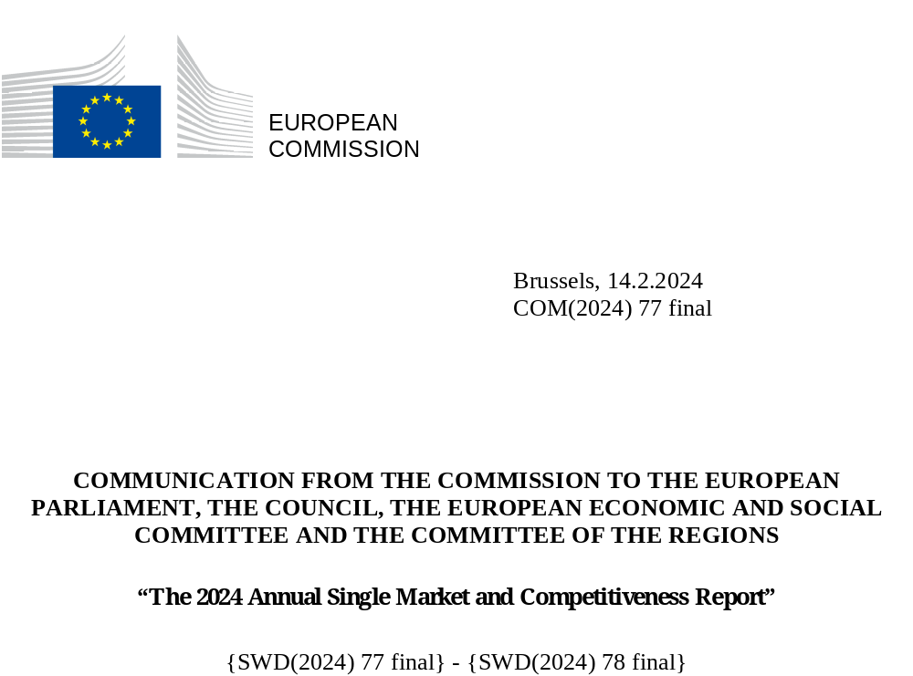

Introduction
The EU’s Single Market, one of the world’s largest integrated market areas, is at the core of our competitiveness. With more than 440 million consumers and large economies of scale, it has made it possible for the EU to become the world’s largest trading bloc – with its businesses accounting for one fourth of global exports in services and one fifth in high-tech goods – and a desirable destination for foreign investment. Its stable macroeconomic framework and high-quality infrastructure support an investment-friendly business environment and are rooted in and support a strong social market economy model.
The succession of recent crises has highlighted the importance of strengthening the resilience of the Single Market. The Commission has taken major initiatives to preserve the integrity of the Single Market and strengthen the EU’s industrial base during the COVID-19 pandemic as well as following Russia’s war of aggression against Ukraine. In this challenging context and in light of growing global competition, the Commission strives to combine the twin green and digital transition with a competitive and sustainable Single Market, leaving no one behind. A well- functioning Single Market benefits consumers through lower prices, diversified choices and common well-protected rights.
The EU has very strong assets to build on: highly qualified engineers, excellence in research, quality infrastructure, a solid manufacturing base, a strong services sector, a competitive edge in the development of clean technologies, high-performance computers, quantum, and transformative digital technologies – and, of course, the Single Market as a springboard.
Nonetheless, the European economy faces challenges – both long-standing and more recent – related to climate change, geopolitical shifts, technological acceleration, high energy prices, demography, labour and skills shortages, strategic dependencies, and unfair international competition.
In 2023, the Single Market at 30 Communication discussed the way forward on how the Single Market could be further deepened to harness its full potential. In parallel, the Communication on Long-term competitiveness provided an overview of competitiveness challenges and assessed them through the lens of nine competitiveness drivers (see Figure 1). This Communication provides an analysis of the Single Market and its competitiveness, structured along these nine competitiveness drivers and the related Key Performance Indicators (KPIs). It also identifies future priorities and recommends actions where appropriate.
The Commission thus contributes to a first annual cycle where the Council, the European Council and the European Parliament discuss progress and necessary measures regarding the future of the Single Market and competitiveness.

Figure 1: Definition of competitiveness based on nine drivers
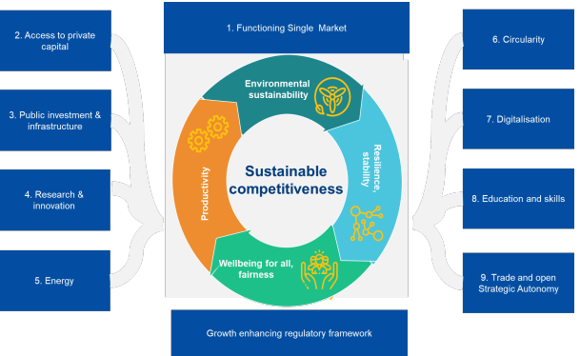
Source: Long-term competitiveness Communication (COM(2023)168)

- A functioning Single Market

KPI | Description | Target | Latest EU value
KPI 1: Integration in the Single Market | Integration in the Single Market: trade over GDP | Up | 26.3% for goods (2022)  23.5% for goods (2021)  7.5% for services (2022)  6.6% for services (2021)
KPI 2: Conformity deficit (incorrectly transposed directives) | It measures the number of directives transposed for which infringement proceedings for incorrect transposition have been launched by the Commission | 0.5% | 1.2% (2023)  1.3% (2022)
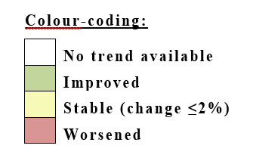

The Single Market is a prerequisite for long-term competitiveness. A well-functioning Single Market has provided the EU with a strong economic base in the last 30 years: a large demand pool, diversified supply sources and opportunities for innovation and scaling up of production, while supporting strong social rights and fair working conditions. It has proven to be a powerful tool for building resilient supply chains, providing a geopolitical lever when required.
The Commission and Member States have addressed obstacles to the Single Market functioning. In 2023, through the Single Market Enforcement Taskforce (SMET), Member States committed to removing 301 prior checks for professions where not proportionate. SMET also screened over 170 process-related barriers for wind and solar energy projects, committing to removing half of them. This objective has already been exceeded, with 60% of the confirmed barriers having been addressed. Based on evidence from the SOLVIT network, a project tackling IBAN related discrimination in the Single Market in the public sector and in telecoms was launched in 2023.
Over this mandate, the Commission took prompt enforcement action when the core principles of the free access to markets were at stake or discriminatory practices emerged against non-national operators. The Commission worked in particular to tackle violations of EU rules on public procurement and late payments, to ensure transparency and efficiency in markets supported by public procurement, and to defend SMEs’ interests. Preventive tools such as Single Market Transparency Directive and the ex-ante assessment of new restrictions in national regulation of professional services were reinforced.
The Communication Single Market at 30 sets out concrete targets and initiatives for cooperation between the Commission and Member States in enforcing existing rules and removing national barriers, for instance in the services sector. The Commission set a target of reducing the conformity deficit to 0.5% (i.e. the maximum percentage of incorrectly transposed Directives). The actual rate improved in 2023 reaching 1.2% (see KPI 2), and the Commission will continue to work with Member States to reach this objective, as substantial additional growth could be realised by addressing national barriers, notably through a better implementation of agreed rules.

Regulatory burden and simplification
KPI | Description | Target | Latest EU value
KPI 17: Ease of regulatory compliance (Burden of government regulation) | Business perception by replying to the question: “In your country, how easy is it for companies to comply with government regulation and administrative requirements (e.g. permits, reporting, legislation)? (1 = Overly-complex; 7 = Extremely easy)” in the survey for the Global Competitiveness Index of the World Economic Forum. | Up | 3.80 (2022)  - (2021)

Regulatory burdens have started to decrease in the EU (see KPI 17), notably due to efforts at EU level. In 2022, the Commission’s proposals yielded EUR 7.3 billion more administrative savings than costs. In March 2023, the Commission proposed to simplify formalities for companies operating in multiple Member States and further expand and upgrade the use of digital tools and processes in company law.
The Commission has also extended the implementation of the Single Digital Gateway, the EU’s flagship eGovernment initiative. Specifically, since December 2023, Member States are obliged to provide online access, for national and cross-border users, to 21 types of important procedures. The Internal Market Information (IMI) system connects 12 000 authorities and facilitates exchanges for 35 000 registered users on 20 policy areas and in all EU languages. The Road Transport Posting Declaration portal, linked to the IMI system, allows the road transport sector to digitally submit a single uniform driver posting declaration. From February 2022 to December 2023 33 million posting declarations were submitted via the portal. The Commission recently agreed on a voluntary electronic template for declarations of posting of workers with a significant number of Member States and is working on a multi-lingual portal for such submissions. The Interoperable Europe Act establishes a structured cooperation mechanism between Member States and EU Institutions reducing barriers to cross-border and cross-sectoral digital public services.
The Commission has implemented the ‘one in, one out’ approach, as well as introduced a mandatory competitiveness check and strengthened the SME test for the scrutiny of new proposals. It is also making progress towards the target of reducing the burden from reporting requirements by 25%. A first set of 41 initiatives to cut such burdens was presented in the 2024 Commission work programme. For example, the reform of the Union Customs Code is expected to bring around EUR 2 billion in cost savings. The revision of the Regulation on European statistics will further save EUR 450 million.
Moreover, a call for evidence was launched on 17 October 2023 and the input from stakeholders will feed into the preparation of rationalisation plans by all departments of the Commission. Further input will come in 2024 from the Fit for Future Platform, with recommendations from Member States and stakeholders for simplification and burden reduction, including on reporting obligations. The upcoming Annual Burden Survey will report on the progress.
More generally, efforts at EU and Member State level are required to further simplify the implementation of agreed legislation, paying particular attention to unjustified "gold plating" and addressing the cumulative impacts and timing of implementing legislation. This would help to reduce compliance costs and ensure greater visibility for investment decisions.
A modernised Single Market
The EU has adopted several measures to help consumers benefit from the Single Market. For instance, the common charger initiative is already simplifying the life of millions of Europeans. Efforts to address illegitimate green claims or initiatives on the right to repair also contribute to ease constraints for citizens and promote a greener economy.
Decisive regulatory steps have been taken to develop a Single Market in the digital sector, providing a uniform set of rules for businesses to operate across the EU: the Digital Markets Act to prevent gatekeeper platforms from imposing unfair conditions on businesses and consumers; the Digital Services Act to ensure that what is illegal offline is also illegal online, the Data Governance Act to increase data availability and trust in data sharing and overcome technical obstacles to the reuse of data; the Data Act to harmonise rules on fair access to data; and the AI Act to provide legal certainty and open the way for innovation in trustworthy AI.
In addition, as a reaction to the disruption of the Single Market caused by anti-COVID 19 measures, the Single Market Emergency Instrument (SMEI) renamed Internal Market Emergency and Resilience Act (IMERA) will ensure that the Single Market continues to function and support citizens and businesses in critical situations.

SMEs and small mid-caps
The goal of the SME Relief Package is to allow SMEs to compete and grow. As shown by a recent Commission study, the companies outgrowing the SME definition – the so-called small mid-cap enterprises (SMCs) – play a vital role in the EU economy, constituting 6% of overall employment. They are prominently present in industrial ecosystems that are key to the EU’s competitiveness and technological sovereignty, such as electronics, aerospace and defence, energy, energy-intensive industries and health. Around 20% of all SMCs were SMEs three years earlier. Compared to SMEs, SMCs tend to demonstrate a higher pace of growth, level of innovation and digitisation, but they still face certain similar challenges such as administrative burden, including the need for more proportionality in new legislation and for targeted support. To enable the smooth transition of SMEs into SMCs, it is important to address these challenges in a coherent manner.
A definition for SMCs is already used under the General Block Exemption Regulation and the Guidance on Risk Finance. On the basis of this definition, the Commission will monitor outcomes for both SMEs and small mid-caps under relevant financial programmes and take action to enhance the engagement of these companies, where relevant. Furthermore, it will develop a broader dataset on SMCs and deepen its evaluation of barriers impeding the growth and transition of medium-sized enterprises into SMCs, taking into account the views of the SME network and other stakeholders. This will inform future decisions on how best to establish a harmonised SMC definition for horizontal purposes, and to identify fields where it is relevant to frame proportionate regulatory, funding or policy measures.
Enlargement
In December 2023, the European Council paved the way for an enlargement of the European Union and thus of the Single Market. The Commission is already acting to integrate candidate countries into the Single Market by checking their progress in alignment with EU law, helping them make the necessary (and often substantial) political and economic reforms, and by preparing them for the rights and obligations that come with EU membership. Most candidate countries are now associated to the Single Market Programme and the Digital Europe Programme. Roadmaps for the enhanced implementation of the Deep and Comprehensive Free Trade Areas with Ukraine and Moldova have been agreed for 2023-2024 in view of providing those countries with further access to the EU Single Market.
The Single Market requires political ownership and should constitute a common endeavour, jointly with all players and across all policy areas.
Drawing on the progress achieved under this mandate, the Commission and Member States should continue to complete and modernise the Single market in particular by stepping up correct implementation and robust enforcement of Union law at national level, including in relation to issues linked to "gold-plating". To achieve these goals, the Commission continues to advocate establishment of dedicated national Single Market Offices, with Member States ensuring senior leadership and necessary resources. These offices, which would be complementary to other collaborative tools, could contribute in particular to addressing the remaining barriers for services.
The implementation of Single Market rules should be streamlined, combining preventive, collaborative and remedial tools. Member States should achieve the concrete targets with respect to conformity and transposition of Directives. The SOLVIT-network, work within the SMET and dedicated Single Market Offices can help resolve more obstacles to the Single Market, including for services. To do so, sufficient resources should be allocated to this work.
Regulatory burden reduction should remain a priority at all levels. Regulatory reforms and support instruments should target in particular SMEs and small mid-cap enterprises.
In parallel, the necessary groundwork and reforms for enlargement should continue to ensure a mutually beneficial integration of enlargement countries in European supply chains.
- Access to private capital and investment
KPI | Description | Target | Latest EU value
KPI 3: Private investment as a share of GDP | Private investment is directly linked to the ease of access to private capital. | Up | 19.3% (2022)  18.7% (2021)
KPI 4: Venture capital investments as share of GDP | Progress in this field is a good indicator of progress in access to private capital in general. | Up | 0.09% (2022)  0.11% (2021)

Private investment in the EU has held up well since the financial crisis compared to other international players. Deepening the Capital Markets Union (CMU) is essential to unlock private investment and increase the EU’s competitiveness. Investments needed to accelerate the green and digital transitions, enhance resilience and boost the Union’s competitiveness will have to primarily come from the private sector.
In this mandate, of the 16 actions of the 2020 CMU action plan proposed by the Commission, almost all have been adopted or politically agreed. However, despite improved EU capital markets conditions, these measures alone will not complete the CMU and the availability of risk capital, such as venture capital, remains insufficient for the scaling up of innovative companies and to finance future growth.
The EU Taxonomy regulation will enhance financing of environmentally sustainable economic activities and boost the green transition.
Financing conditions tightened significantly in 2023, creating a more challenging investment environment. Interest rates in the euro area increased sharply, while lending standards for new loans or credit lines became more stringent and diverged across the euro area. The EIB reports availability of finance as an investment impediment for 44% of EU businesses.
The current size and depth of the EU capital markets remain insufficient to support the EU’s future growth. A deeper CMU will help mobilise more savings and investment capacity to finance the real economy, reduce the costs of borrowing and facilitate investments in the Single Market, all of which are indispensable for a successful twin transition.
Availability of risk capital (in particular for scaling up businesses) continues to be subdued. The EU’s stock market capitalisation, in percentage of GDP, is less than half of that of the USA (despite higher savings in the EU) and lower than that of Japan, China or the UK. Private equity and venture capital investment in digital and green tech firms have continuously increased since 2016. Venture capital was at 0.09% of GDP in 2022 (see KPI 4), double the level of 2018 (0.04%), but lower year-on-year and still a fraction of the level in the USA (0.75%) and China (0.58%).
The number of EU scale-ups is 38% of that in the US, though this gap is narrowing. To keep improving the situation, the EIB group and five Member States launched the European Tech Champions Initiative (ETCI), a fund of funds structure making investments in large scale venture capital funds for innovative EU companies. This action complements the InvestEU originated funding opportunities for later stage VC fund managers such as EU-SCALe up Action for Risk capital, the EUIPO fund initiative.
Deeper and more integrated capital markets are crucial to finance EU companies and support the transition towards a digital and sustainable economy. The implementation of the 2020 Capital Markets Union action plan measures will have a positive impact on the growth of EU capital markets, improve access to market-based sources of funding for EU companies and make it easier and more attractive to invest in EU companies.
It is vital for Member States, private stakeholders and the EU institutions to keep working together on the CMU, including by ensuring larger pools of private capital, such as pension funds. In particular, the Commission and Member States should promote further efforts to increase direct access of corporates and others to capital markets, facilitating the supply in the EU of risk and venture capital, to support start-ups and enable the scaling-up of companies in Europe.

- Public investment and infrastructure
KPI | Description | Target | Latest EU value
KPI 5: Public investment as share of GDP | Public investment plays a key role in developing and maintaining business supporting infrastructures like energy, transport or digital connectivity. | Up | 3.2% (2022)  3.2% (2021)

Public investment has recovered from the low levels after the financial crisis. EU Cohesion Policy funds, the Recovery and Resilience Facility (RRF) and other programmes have helped finance the green and digital transition while maintaining a level playing field and promoting convergence across the Single Market. However, increased and more strategic public investment, including through more innovative instruments that help de-risk private investments, is needed to leverage private funding and deliver the EUR 650 billion required annually for the twin transition and for Europe’s economic resilience.
Public investments, at 3.3% of GDP, are just ahead of those in the UK (3.3%) and somewhat behind those in the USA (3.6%). While most of the investment needs for the twin transition will be financed by private funds, the role of public investments remains central, for instance with targeted use of financial products and blending of financial sources to catalyse and de-risk private investments, unlock the investments in infrastructure as well as to support projects in areas of economic security interests where private investments might be lacking. EU funding remains necessary to address financing needs while avoiding fragmentation of the Single Market due to varying levels of national (temporary) State aid support, and to reduce regional disparities.
Figure 2: Public investment
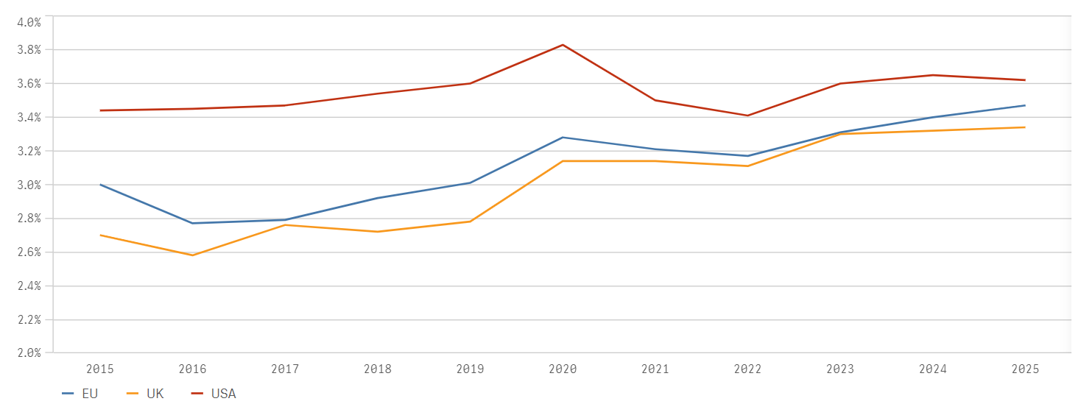
Source: European Commission, annual macroeconomic (AMECO) database
Since 2021, the RRF has paid out over EUR 222 billion, and the Cohesion Policy funds disbursed EUR 192 billion in the period 2021 - 2024. InvestEU provided EUR 13.44 billion in EU guarantees and Horizon Europe mobilised over EUR 24 billion for science and innovation.
More targeted instruments also play an essential role for key sectors through a mix of regulatory action and, when available, use of EU or national funds. The Net-Zero Industry Act, the Chips Act and the Critical Raw Materials Act strengthen the EU’s domestic manufacturing capacity and encourage businesses to exploit the potential of the Single Market. The European Chips Act will support, through EUR 3.3 billion from the EU budget, close to EUR 43 billion worth of investment. Over 100 billion EUR of public and private investment have been announced along the Chips supply chain. Industrial alliances, such as the recently launched Critical Medicines Alliance, facilitate stronger cooperation along supply chains in key technologies, contributing to EU’s competitiveness.
The New European Innovation Agenda (NEIA) delivers critical guidance and support measures to facilitate access to finance, promote innovation through regulatory testbeds and sandboxes, innovative procurement and talent development.
The Important Projects of Common European Interest (IPCEIs) support breakthrough innovations or infrastructure projects in critical technologies areas. To date seven integrated IPCEIs have been approved, for a value of EUR 27.9 billion of national public support, unlocking more than EUR 50 billion of private investments.
The “Innovation Fund”, financed through the revenues of the EU Emissions Trading System, supports and scales up innovation in net-zero technologies towards full technological and commercial maturity and is becoming a key public instrument to deploy the EU green deal industrial strategy. Given its success and over-subscription of large-scale calls for proposals, the Commission will seek to maximise the budget under the Innovation Fund by frontloading the commitment of available funds.
The “Strategic Technologies for Europe Platform” (STEP) will support investments for the development and manufacturing of critical technologies, in the sectors of clean tech, digital tech, deep tech innovation, and biotech. STEP will channel funding under existing programmes and support project promoters through an upcoming Sovereignty Portal. The investment potential of this initiative could reach dozens of billions of euros, depending upon Member States’ reprogramming decisions.
More can also be done via strategic public procurement, amounting to around 14% of EU GDP. Currently, environmental, social and innovative aspects are insufficiently considered in public tenders. New initiatives, such as the Net-Zero Industry Act introduce environmental and social sustainability, as well as resilience criteria in public procurement. This should inspire a greater reliance on non-price aspects for the procurement of goods and services in general.
The further deepening of the Single Market should be accompanied by continued public investment in key priority areas in all Member States, including at the regional level through Cohesion Policy, to ensure cohesive growth, competitiveness and resilience, while avoiding fragmentation of the Single Market.
Financing the green and digital transition requires a strategic combination of tools. This requires an increased and more innovative use of funding sources at European level, to catalyse and de-risk private investments. Public procurement should be used to encourage and reward sustainability, resilience, innovation, and socially responsible practices.

- Research and Innovation
KPI | Description |  | Target | Latest EU value
KPI 6: R&D expenditure as a percentage of GDP |  | The total R&D expenditure (public and private). | >3%  beyond 2030 | 2.2% (2021)  2.3% (2020)
KPI 7: Number of patent applications per million inhabitants |  | Patents reflect the capacity of an economy to exploit knowledge and indicate the competitiveness edge that can be obtained through innovation. | Up | EPO-EU:  151.1 (2022)  151.75 (2021)
Europe is a scientific powerhouse that produces one fifth of the top 10% most cited scientific publications. However, this does not always translate into commercial leadership (see KPI 7), often because of the difficulties to scale up business activities in the EU. More efforts are required to support Europe’s efforts from lab to fab, such as is being done for semiconductors through the European Chips Act, facilitating research collaboration and providing support through Horizon Europe or the Digital Europe Programme.
Innovation is at the heart of a thriving and competitive economy and the European Innovation Scoreboard 2023 highlights an improvement in the EU’s innovation performance throughout Europe.
The EU’s R&I investments have increased from 1.8% of GDP to 2.2% in twenty years (see KPI 6) but slipped year on year and remain below the target of 3%, and unevenly distributed across regions and Member States. R&I investments remain below those in the USA (3.4% of GDP) and China (2.4%), especially due to the gap in business sector R&I and stagnant public R&D investment. Moreover, the efficiency and impact of these investments are hampered by persistent structural challenges in several R&I systems, such as weak science-business linkages.
The EU is a global leader in the development of technologies that combine digital and green innovations, with a large share of EU patenting activities concentrated in climate change technology. In the digital domain only, the EU share was 20% in 2020, similar to that of the USA.
To help bridging Europe’s market gap in scale-up finance, the European Innovation Council (EIC), combines grants and equity to support promising deep tech start-ups and scale-ups. Over EUR 1 billion of investments in nearly 200 deep tech scale ups have already been approved. Additionally, the European Institute of Innovation and Technology has helped mobilise an additional EUR 7.3 billion of private investment in start-ups in strategic sectors such as batteries, hydrogen or health.
Under the Recovery and Resilience Facility, Member States are mobilising over EUR 47 billion in R&I investments and will introduce reforms in their R&I systems in addition to EUR 35 billion under Cohesion Policy.
Despite all of this, total factor productivity growth in the EU has been less than half of that in the USA over the past 30 years. This calls for even more focus on strategic technologies (e.g. clean technologies, critical raw materials substitutions, digital technologies, advanced materials, advanced and clean production technologies) including those with dual-use potential.
In addition to increasing EU investments in research and innovation, steps are required to further prioritise research efforts around the EU’s long-term competitiveness needs and strengthen the translation of research results into practical business applications.
Reforms are needed to modernise R&I systems to increase the impact of R&I investments. For instance, strengthening linkages between businesses and research entities and improving support structures for the uptake of research and innovation results by industry, can make for an attractive business case.

At EU level, the Commission will continue to develop and implement policies that target the promotion of deep tech and green tech innovative start-ups and scale-ups, including by building up the capabilities of the European Innovation Council.
- Energy

KPI | Description |  | Target | Latest EU value
KPI 8: Share of energy from renewable sources |  | Renewable energy generation (as proposed for the Renewable Energy Directive). | 45% in  2030 | 23.02 (2022)  21.77% (2021)
KPI 9: Electricity prices for non- household consumers |  | Electricity price for industrial consumers gives a good indication of energy affordability. | Down and then steady | EU IC band:  EUR 0.21 per kWh (Semester 1 2023)  EUR 0.18 per kWh (Semester 1 2022)

The EU leads the global transition to a decarbonised energy system. In 2022, greenhouse gas emissions were 32.5% lower than in 1990, while EU GDP increased by 67%. At the same time, Russia’s war in Ukraine sparked an energy crisis significantly affecting households and the competitiveness of European industry. Though energy prices have now fallen, they remain well above previous long-term trends, and persistently higher than in competing regions. More interconnected and integrated internal energy markets will help to ensure access to affordable, abundant, reliable and decarbonised energy.
From 2010 to 2021, emissions from the EU industrial ecosystems fell overall by 3%. Over the same period emissions from the energy supply sector fell by 35%.
EU electricity prices for large-sized industries were slightly lower than in Japan and the UK until 2021, albeit twice as high as in the USA. Since 2021, and beyond the shock triggered by Russian’s war of agression in Ukraine, the price differential with the USA has increased, to the detriment of EU’s competitiveness.
The reform of the EU electricity market design is expected to accelerate clean energy deployment by facilitating long-term contracts that provide both price predictability and investment certainty, thus helping to contain energy generation costs in the medium term. SMEs’ expenditure in energy-savings technologies has been increasing over the last five years across all industrial eco-systems, most notably in agri-food, textile, tourism and aerospace and defence³⁴. Advanced manufacturing technologies, such as industrial robotics and additive manufacturing, can further help achieving savings.
The EU will need to electrify massively its energy demand. This requires major investments in decarbonised technologies. Intra-EU investments in renewables have grown by 18.7 % a year from 2015 to 2022 reaching EUR 38 billion per annum. The even bigger (EUR 92 billion) Foreign Direct Investment outflow confirms the leadership of EU industry in this area³⁴. The impact assessment of the Communication on Europe’s 2040 climate target shows that renewable energy in majority, complemented by nuclear energy, will generate over 90% of the electricity consumption in the EU in 2040. The Commission also launched the European Industrial Alliance on Small Modular Reactors.
It will also be essential to connect new production centres of decarbonised energy to new consumption centres. The European action plan on grids is the first step setting out several actions to accelerate grids deployment and faster integration of renewable energy. It should be the basis for future comprehensive actions for accelerating the development of European integrated energy infrastructure. Digitalisation is also at the core of the new grid system. Digitalisation, data access and automation are required to integrate all (new) energy sources and stabilise the system.
Beyond deployment, the Net-Zero Industry Act will strengthen the manufacturing of net-zero technologies in the EU. The European Wind Power Action Plan sets out recommendations and commitments to support wind power manufacturing capacity in Europe.
The RRF and REPowerEU also play a key role with respect to the enhancement of the resilience, security and sustainability of the EU´s energy system, notably through investments in energy efficiency and in renewable energy and networks, while contributing to combatting energy poverty.

Over the last five years, the EU has massively updated its energy policy toolbox to meet the European Green Deal objectives, including in terms of its industrial plan.
But more will be required to facilitate the deployment of decarbonised electricity, its integration into energy grids and increased manufacturing of net-zero technologies. All of this is indispensable to reduce energy prices, reinforce Europe’s competitiveness.
Member States should contribute to these areas for instance via the implementation of the Grid and Wind Power Action Plans, Renewable Energy Directive and SMET work on permitting and rapid implementation of the Net-Zero Industry Act. Member States should make use of the STEP initiative to leverage the potential of all EU instruments, including EU Cohesion Policy Funds, and support the development and manufacturing of key strategic clean energy technologies.

- Circularity
KPI | Description | Target | Latest EU value
KPI 10: Circular material use rate | The circular material use rate measures the share of material recovered and fed back into the economy in overall material use. Target set up in the Circular Economy Action Plan: Doubling compared to 2020. | 23.4% by  2030 | 11.5% (2022)  11.7% (2021)

Europe is slowly progressing towards a more circular economy. Since 2000, the EU industry’s resource productivity has increased by 37%, indicating a more efficient use of materials in EU production, but the EU materials footprint remained stable in the last decade. Recently agreed legislation, once implemented, will improve the business case for circularity.
More circularity in the economy means lower consumption of primary materials, less waste and reduced dependencies. It also comes with a significant potential for quality job creation, notably in the social economy. The bioeconomy has the potential to contribute to more circularity, for instance in the area of battery materials.
At 11.5%, the rate of use of secondary raw materials in 2022 is less than half of the target agreed for 2030, showing significant untapped potential (see figure 3 and KPI 10). At the same time, the resource productivity of EU industry increased by 37% in twenty years, being now comparable to that of the USA and three times higher than that of China.
Unsustainable consumption and related production are key bottlenecks to circularity. Only 20% of SMEs use recycled materials and only 11% adopt circular materials business models.
Recently adopted or politically agreed legislation creates a strong business case for more circularity in the EU. Upstream, the Critical Raw Materials Act provides that Union recycling capacity should cover 25% of the Union’s annual consumption of strategic raw materials by 2030. At product level, the Ecodesign for Sustainable Products Regulation will allow to design specific circularity criteria for product categories placed on the EU market. This will help address Single Market fragmentation due to diverging national rules on product sustainability. The digital product passport will facilitate the sharing of information along the supply chains. Market surveillance will be enhanced to address the enforcement deficit of applicable ecodesign requirements, notably from imported products. Already now, the EU regulatory framework for batteries contributes to circular value chains for battery production. In parallel, some barriers remain to be addressed to favour more circularity, for instance in relation to waste definition. At consumer level, the Empowering Consumers for the Green Transition Directive and the Green Claims Directive help consumers identify trustworthy and sustainable products.
Figure 3: Circular material use rate (secondary materials use as % of overall material use)
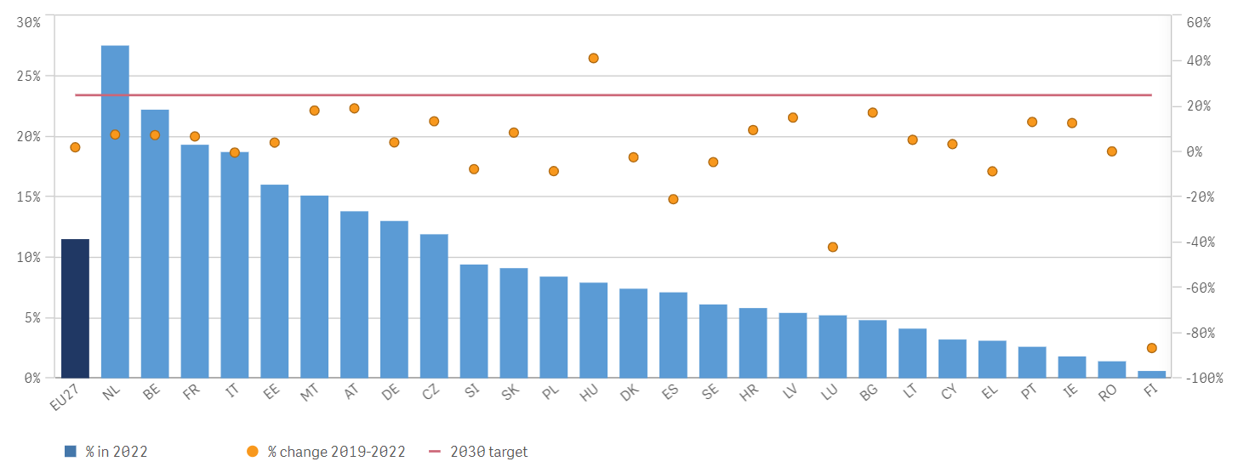
Source: Eurostat
Recently adopted legislation will increase circularity in the EU. But to ensure its effectiveness, Member States need to work to strengthen the market surveillance of product regulatory requirements linked to circularity. In addition, Member States could promote sustainable material consumption by supporting the industrial use of secondary materials (industrial symbiosis among businesses) and platforms for the sharing economy were supply and demand of recyclable/reusable waste could meet. Furthermore, it is important to mainstream the circular economy by boosting research and innovation, up- and re-skilling the workforce, and targeting the use of financing instruments.

- Digitalisation
KPI | Description | Target | Latest EU value
KPI 11: Digital intensity in SMEs | Share of EU enterprises with at least a basic level of digital intensity. A basic level entails the use of at least four of twelve selected digital technologies (such as using any AI technology; having e-commerce sales account for at least 1% of total turnover; etc.) as defined in the Digital Decade policy programme. | 90% by  2030 | 69.30% (2022)  61.36% (2021)
KPI 12: Digital technologies adoption by companies | Share of European enterprises that have taken up cloud computing services, big data and/or Artificial Intelligence. Target set in the Digital Decade policy programme. | 75% by  2030 | Cloud computing services: 34% (2021)  Big data: 14% (2020)  Artificial Intelligence 8% (2021)

The rollout and uptake of digital technologies and the overall digitalisation of the economy are essential drivers for competitiveness and sovereignty. Several funding instruments and legislative initiatives are now in place to enhance the digitalisation of businesses and the competitiveness of the EU information and communication technology sector. The continuation and enhancement of collective efforts will be necessary to accelerate digital transformation, to address the investment gaps and to strengthen digital capacities in line with the Digital Decade Policy Programme.
Despite the EU’s strengths in specific digital technology areas, such as advanced manufacturing technologies and semiconductor manufacturing equipment, the EU share in the global information and communication technology (ICT) market has drastically decreased in the past decade, from 21.8% (2013) to 11.3% (2022), while the US’s share increased from 26.8% to 36%.
The Digital Decade Policy Programme is a system of collaborative governance between the EU and national authorities to support the achievement of concrete 2030 objectives and targets. They focus on four areas: digital skills; digital infrastructure; digitalisation of businesses, including through the uptake of advanced technologies such as Artificial Intelligence (AI), Cloud services and Big Data analytics; and digitalisation of public services. The first State of the Digital Decade report highlights the need to accelerate and deepen the collective efforts to fulfil our ambitions in the field of semiconductors, advanced digital skills and to foster the digital transformation of European businesses.
Several EU funding instruments sustain the strengthening of digital capacities, infrastructure and the skills needed for digital transition. For instance, DIGITAL has contributed (with Horizon Europe) have contributed to making the EU a world-class level leader in High Performance Computing and provides strategic funding to support projects in artificial intelligence, advanced digital skills, cybersecurity and for the rollout of digital solutions for public administrations and businesses.
The disruptive emergence of generative AI creates a unique opportunity in a market that is expected to grow over 24.4% per annum from 2023 to 2030. To boost innovation in the field of AI, the AI Act provides a stable, predictable and proportionate legal framework for AI developers, fostering trust among citizens and businesses in AI applications and thereby boosting their uptake in the EU.
Besides, complementing the regulatory framework, the AI Start-up and Innovation package, will make Europe an innovative powerhouse for trustworthy AI. Building on Europe’s world-leading high-performance computing infrastructure (EuroHPC), it creates “AI Factories” that bring together the key ingredients of AI – data, computing, algorithms, and talent – and serve as a one-stop-shop for AI startups to train and develop large AI models. In addition, it connects AI startups and researchers with industrial users, boosting innovative applications of generative AI across Europe’s 14 industrial ecosystems.
Other EU policy measures have started already to build up domestic capacity for other transversal digital technologies and focused on reducing strategic dependencies concerning chips and cloud services. The Chips Act will increase the EU’s manufacturing capacity, with the objective of ensuring that at least 20% of world production in value of cutting-edge semiconductors are produced in Europe by 2030. The IPCEIs on microelectronics and on Next Generation Cloud Infrastructure and Services mobilise large companies and start-ups to invest in major, innovative industrial capacities and to develop an interoperable and openly accessible European data processing ecosystem,
The adoption of digital technologies by EU companies can substantially increase labour productivity across the economy. In 2022, 69% of EU SMEs had at least a basic level of digital intensity, as compared to the 2030 Digital Decade target of 90% (see KPI 11). The share of EU enterprises with 10 employees or more that have adopted digital technologies was 14% for Big Data in 2020, 34% for Cloud and 8% for AI in 2021, as compared to the 2030 target that 75% of companies use at least one of these technologies (see KPI 12). Digital tech start-ups are very active in most industrial ecosystems, with health, mobility, and cultural and creative industries attracting the highest share³⁴. Many of these start-ups offer basic digital solutions such as online marketplaces or software services, which contribute to the transformation of the ecosystems.
The digitalisation of EU businesses, in particular SMEs, and public services is progressing but remains in some areas far below the 2030 Digital Decade targets and objectives. The EU and Member States should fully implement the Digital Decade Policy Programme to address this.
The EU has already taken various policy measures to reduce strategic dependencies and promote competitiveness by stepping up investments in strategic technologies, such as semiconductors, cloud services, AI and High-Performance Computing. To be more effective, these policies require Member States to align strategies to build industrial capacity in the relevant areas.

- Education and skills
KPI | Description | Target | Latest EU value
KPI 13: Adult participation in education and training every year (average of male and female) | An increased participation in training will indicate good progress in the development of skills for sustainable competitiveness (target set in Porto Summit Targets, Social Pillar). | 60% by  2030 | 37.4% (2016)  Based on the adult education survey, which was carried out in the past once every 6 years.
KPI 14: Adult employment rate | An increased employment rate contributes to socially sustainable competitiveness (target set in Porto Summit Targets, Social Pillar). | 78% by  2030 | 74.6% (2022)  73% (2021)
KPI 15: ICT specialists (average of female and male, % of employment) | This indicator, one of the targets of the Digital Decade policy programme, measures progress towards a well dimensioned workforce specialised in the development and deployment of digital technologies. | 20 Million by 2030 (i.e. ca. 10% of total employment) | 9.4 million (2022)  8.9 million (2021)  Percentage of total employment:  4.6% (2022)  4.5% (2021)
Candidate KPI 15a: Average test scores for 15 year olds (PISA) | PISA is the OECD's Programme for International Student Assessment. PISA measures 15-year-olds’ ability to use their reading, mathematics and science knowledge and skills to meet real-life challenges. | Up | Mathematics:  474 (2022)  492(2018)  Reading:  475 (2022)  488(2018)  Science:  484 (2022)  488(2018)

At 74.6% in 2022, the EU is on track to reach its 2030 employment rate target of 78%. And yet, three quarters of SMEs currently face labour and skills shortages, which the Pact for Skills and measures facilitating labour mobility have started to tackle. Availability of quality jobs, addressing gender gaps and promoting equal opportunities for all are key for attracting and retaining the workforce. A skilled workforce is a key factor for competitiveness, in a context of ongoing demographic change.
The green and digital transitions create demand for new skills, which requires up- and re-skilling of the workforce. For instance, between 35% and 45% of the workforce in the building renovations sector will need training in energy efficiency. ICT skills are highly demanded, although specific needs vary substantially across ecosystems (see Figure 4). The number of ICT specialists has reached 9.4 million in 2022, representing 4.6% of total employment and progressing towards the 2030 goal of 20 million people (see KPI 15). On the other hand, in the EU only about one adult in three participates in learning activities every year (see KPI 13). In addition, the average scores for 15-year olds have fallen for the EU in 2022 compared to 2018 in all disciplines, where the EU is out-performed by its main competitors. This suggests that Europe is facing a problem in terms of equipping young people with basic skills
Figure 4: % of online job advertisements requiring at least moderate or advanced digital skills, EU-27.
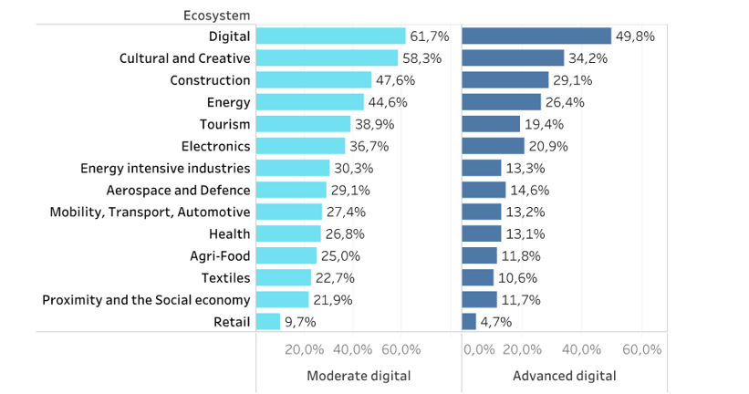Source: Technopolis Group analysis based on Cedefop Skillovate data, for the European Monitor of Industrial Ecosystems (EMI) project 2023.
The EU disposes of policy tools to adress these challenges. Cohesion funding and in particular the European Social Fund Plus (ESF+) supports national investments in human capital. Through the Pact for Skills, and through the specific partnerships set out in each of the 14 industrial ecosystems, the EU is contributing to the required up- and reskilling of millions of workers across the industrial ecosystems. 1 500 economic and social partners pledged to up- and reskill 10 million workers by 2030, with over 15 000 training programmes already developed. Besides, under the Net-Zero Industry Act, the Commission is supporting the launch of skills academies to scale-up the manufacturing and installation of net-zero technologies and the raw materials required for them. The Technical Support Instrument is further helping Member States in designing and implementing structural reforms to promote up- and reskilling of the population and to improve young persons’ skills. The Talent Booster Mechanism supports EU regions affected by the accelerated decline of their working age population.
Mobility of workers in the Single Market can help alleviate skills shortages. However, so far it concerns relatively few EU workers (3.8%) and is far more widespread among the high-skilled. Only 14% of EU SMEs (compared to 30% of large firms) have tried to recruit staff from other EU Member States. Regulatory or administrative requirements often impede labour mobility and simplification is needed. When moving for work, EU citizens face differences in registration practices with local authorities and access to the national IT systems. The rate of recognition of professional qualifications for accessing a regulated profession in another Member State is reasonably high in a large majority of Member States, but in certain professions and countries restrictive qualifications requirements and lengthy procedures remain. To facilitate the attraction of workers from third countries, the Commission’ ‘skills and talent mobility package’ includes recommendations to Member States on how to ease the recognition of qualifications of third country nationals and a proposal for a Regulation on the establishment of an EU Talent Pool.
As a follow-up to the Val Duchesse Social Partners Summit, which took place on 31 January 2024, the Commission, in cooperation with social partners, will come forward with an Action Plan to address labour and skills shortages, by spring 2024.

A more effective and targeted use of EU funds for investment in education and skills at national level, for instance in order to support actions under the Pact for Skills and net-zero skills academies, can help achieving progress in aligning education and training with skills demand.
Further, workers’ and service providers’ mobility could be facilitated through proportionate access requirements for regulated professions, smoother recognition of professional qualifications and simpler and more digital registration practices for citizens moving to another Member State.

- Trade and open strategic autonomy
KPI | Description | Target | Latest EU value
KPI 16: Trade with the rest of the world (as share of GDP) | Trade with the rest of the world (as share of GDP) | Up | 17.6% for goods (2022)  14.8% for goods (2021)  7.7% for services (2022)  6.9% for services (2021)
Candidate KPI 16a: Exports of goods and services as a share of the rest of the world imports | Exports of goods and services of the EU, UK, USA, Japan, and China as respective shares of the rest of the world’s imports. | Stable or Up | 16.2% for goods (2022)  16.4% for goods (2021)  33.1% for services (2022)  35.2% for services (2021)

Trade is key to the EU’s long-term competitiveness. It fosters efficiency and innovation, and opens up markets for EU operators. The EU draws economic and political strength from its position as the largest trader and investor: it is the world’s largest exporter, accounting for 16% of global exports. The EU is a promoter of and thrives on open and rules-based trade. At the same time, new risks arising from increased geopolitical tensions, unfair trade practices and asymmetric dependencies have led the EU to take new steps, encouraging supply diversification, by reinforcing trade and investment links as well as strengthening manufacturing capacity in critical areas. The EU is also using its trade defence tools and adding to its toolbox to defend a level playing field for EU businesses.
Trade is key to the EU’s long-term competitiveness. Extra-EU trade in goods and services amounted to 18% and 8% of EU GDP in 2022, respectively. The EU is the largest exporter globally (16% of imports of all countries, similar to China and significantly ahead of the USA). The EU has a particularly strong performance in services (see Figure 5 ) and in high-tech exports (23%) although that share has gradually fallen over the last decade. The EU also dominates global exports in several manufacturing sectors, such as chemicals and automotive markets (see Figure 6), where however the latest developments, notably the energy crisis and China's fast growth in clean tech markets, have resulted in market share losses. In fact, a combination of ‘push’ (higher energy costs in the EU) and ‘pull’ (very attractive investment conditions in third countries) factors could negatively affect the investment required in Europe for a successful green and digital transition.
Figure 5 : Share of world exports: total (left); services (right)
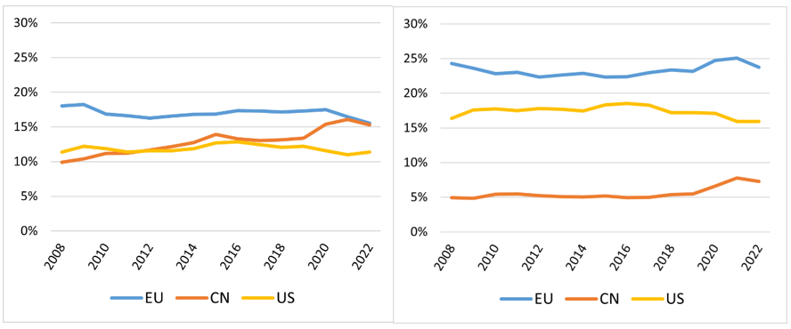
Source: European Commission based on WTO (World Trade Organization)
Figure 6: Share of world exports: EU, China, USA (%): chemicals (left); automotive (right)
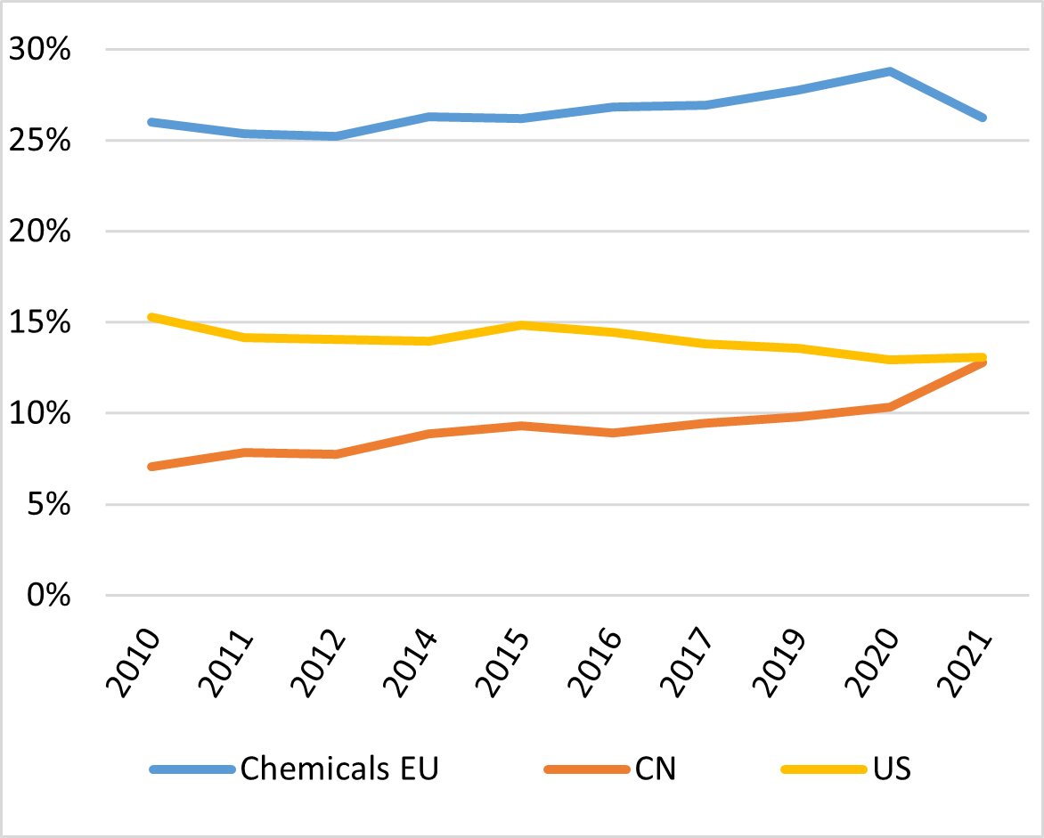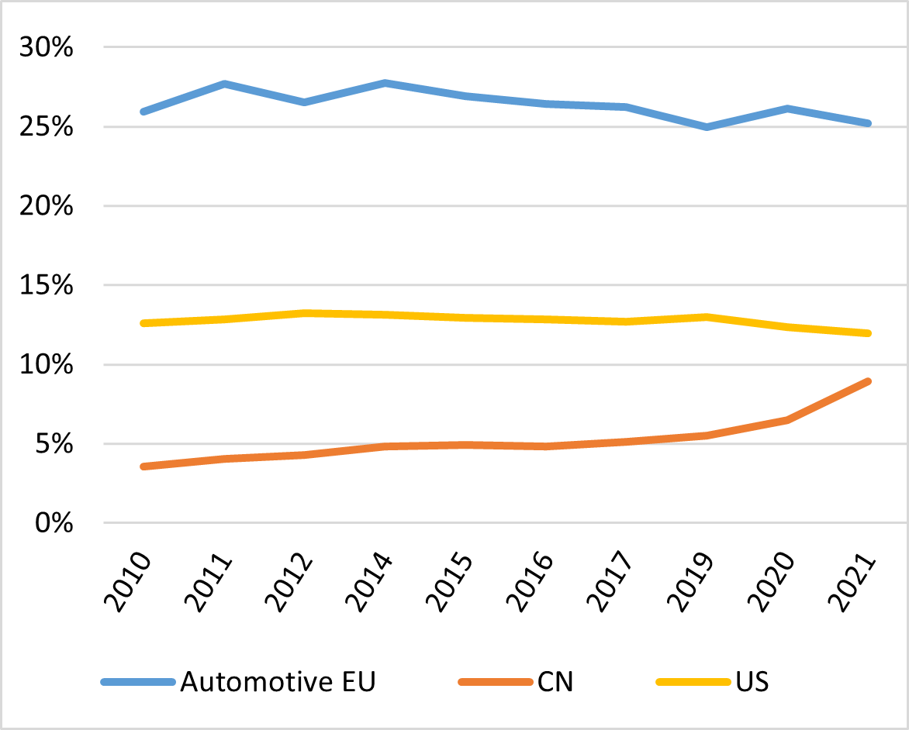
Source: European Commission based on WTO
The COVID-19 pandemic crisis and Russia’s invasion of Ukraine have revealed the Single Market’s vulnerability to supply chain disruptions, which required bold action, including reciprocity measures, joint purchasing, and diversified supply. The EU Energy Platform has been key to pooling demand of the European buyers and securing supplies of gas to Europe from the international producers and suppliers. It could be used as blueprint for organising the joint purchase of strategic commodities including hydrogen and critical raw materials.
The EU’s exposure to China has increased over the last two decades. Recent export controls that China put on gallium, germanium and artificial graphite products show the inherent risks in far-reaching economic dependence on imports from one non-EU supplier. In this context, the Commission is developing and implementing its de-risking strategy with regard to China.
In response to the request of the European Council of October 2020, the Commission identified and started to address the strategic dependencies of the EU. Strategic dependencies represent around 9.2% of total extra-EU imports, with single points of failure (SPOFs) in 40% of the identified cases. Key sectors like space and defence are also exposed to foreign dependencies that call for an increase of intra-EU integration of these markets.
Several non-EU countries have taken measures to reduce their own dependencies and boost credit and investment into strategic sectors. Aided by its state subsidies favouring state-owned enterprises, support programmes, government guidance funds and trade practices, China is now at the forefront of the clean tech market. China’s pipeline of announced investments exceeds USD 280 billion, leading to overcapacities and price pressure that could jeopardise the business case for industries elsewhere. With the Inflation Reduction Act (IRA), the USA has stepped up its efforts to fight climate change. The US approach is based on subsidies to create a domestic manufacturing base of net-zero technologies. Some elements of the IRA, notably with respect to discriminatory content, assembly requirements, and production subsidies, have raised concerns for the EU and other international partners. For example, the IRA tax credits increase the cost advantage for the domestic production of battery packs by 25-30% of total production costs.
To address such challenges, the EU has developed its own toolbox, combining efforts to diversify supply and boost domestic capacity.
The Commission continues to be actively engaged to safeguard and reform the WTO to address competitive distortions more effectively, with the upcoming 13th Ministerial Conference marking an important opportunity. It has also concluded Free-Trade Agreements and Economic Partnership Agreements, such as with New Zealand, Kenya and Chile, and is negotiating others. In parallel, to accelerate industrial cooperation, the EU has concluded Strategic Raw Materials Partnerships with Canada, Ukraine, Kazakhstan, Namibia, Argentina, Chile, the Democratic Republic of Congo, Zambia and Greenland. These partnerships facilitate industrial projects on raw materials in non-EU countries with EU off-takers and support the development of sustainable value chains and quality local jobs. The partnerships with developing countries are underpinned by the broader EU's Global Gateway strategy. The EU has also concluded four Digital Partnerships, with Japan, Korea, Singapore, and Canada, that focus in particular on secure 5G, cybersecurity, quantum computing and the resilience of the semiconductor industry. The EU is also working towards binding digital trade rules with key partners.
The EU has also adopted a series of new instruments alongside its trade defence instruments to defend competition on an equal footing. The Commission has launched in particular a formal investigation against distortive subsidies of imported battery electric vehicles from China.
Furthermore, the EU has also adopted the European Economic Security Strategy. The Commission responds to identified risks by proposing measures to promote the EU’s competitiveness, to protect the EU’s economic security and to further strengthen cooperation by partnering with a wide range of countries. The Commission adopted in January 2024 a package of proposals to implement this Strategy.
The EU should build a more modern network of trade agreements, partnerships and alliances, while continuing to work on reinforcing multilateral cooperation and open trade.
At the same time, our improved arsenal of trade protection tools can enhance economic security and resilience. The EU should deploy trade defence to protect the Single Market when necessary and continuously work to assess and address economic security risks in a complex environment.
The Commission and Member States should: (1) actively monitor the resilience of strategic supply chains and engage in the risk assessments foreseen under the Economic Security Strategy; (2) align strategies on supply chains and build industrial capacity in areas of strategic importance, exploiting the synergies of coordinated action, notably via the Semiconductors Board, the Critical Raw Materials Board and the Net-Zero Europe Platform; and (3) promote diversification through cooperation between European and partner countries’ industrial players in projects linked to the raw materials and digital partnerships established by the EU.

Conclusion
In a fast-changing and challenging global geopolitical context, the Single Market remains the EU’s strongest asset. This Communication reminds us that the Single Market is not a static achievement. Its health and the competitiveness of our economies depend on our joint and continuous efforts to tend to it and ensure that it remains aligned with economic realities.
Over the past few years, the EU has modernised the Single Market by organising its digital space, providing a uniform set of rules for businesses to operate online across the EU. The EU is also engaged in promoting a more circular economy, providing business opportunities for companies and savings for consumers.
In addition, the EU has made efforts to remove hurdles to investment. The Commission has initiated a decisive drive to reduce reporting burden. EU instruments support investments in the green and digital transition. The Pact for Skills and measures facilitating labour mobility aim to respond to skills shortages. New measures, such as the Chips Act, the Net-Zero Industry Act or the Critical Raw Materials Act will accelerate manufacturing projects in the technologies of the future and address supply chain vulnerabilities.
This Communication identifies areas for maintaining and improving the EU’s global competitiveness, notably:
- Dedicated efforts to improve and simplify the implementation of agreed rules, including by avoiding “gold plating”, to facilitate doing business and entrepreneurship in Europe.
- The Commission and Member States should accelerate efforts to address energy costs, through accelerated deployment of decarbonised energy and investment in infrastructure, including grids and cross-border interconnections.
- The Commission and Member States should continue to prioritise the deployment of a true and deep Capital Markets Union, to facilitate access to private funding, not least to risk and venture capital, and to enable the scaling-up of companies in Europe.
- Continued public investment is needed to ensure Europe’s competitive edge in key priority areas, in the light of the success of Next Generation EU and REPowerEU. Timely implementation of Union funds such as Cohesion policy instruments can contribute to the level playing field and enhance regional convergence in the Single Market, including through increased investments in strategic technology fields covered by STEP.
- Steps are required to further prioritise research efforts and strengthen the translation of research results into practical business applications.
- Not least to ensure that EU undertakings can continue to thrive in digital, clean tech and other strategic sectors, the EU should continue to promote fair and open trade and employ trade defence instruments to protect the Single Market when necessary.
- The skills and labour gaps should receive increased attention in the context of wider demographic trends, notably via efforts on education and training, but also by easing skills and talent mobility within and to the EU.
Against this background, this Communication lays out areas and directions to succeed in the drivers agreed in the Long-Term Competitiveness Strategy and to work towards the objectives set there and in the Communication “Single Market at 30”.
This discussion will continue and will see crucial contributions with the publication of Enrico Letta’s upcoming High-Level Report on the future of the Single Market and Mario Draghi’s Report on the future of European competitiveness.
Pending these contributions, the Commission invites the Council, the European Council and the European Parliament to discuss the current situation and prospects for progress in the Single Market and competitiveness in light of the present Report.

See the Single Market Scoreboard (Economic resilience | Single Market Scoreboard (europa.eu), trade section).
The Single Market at 30, of 16 March 2023, https://eur-lex.europa.eu/legal-content/EN/TXT/PDF/?uri=CELEX:52023DC0162.
Long-term competitiveness of the EU : looking beyond 2030, 16 March 2023,https://commission.europa.eu/system/files/2023-03/Communication_Long-term-competitiveness.pdf.
Data are those available in December 2023. Annex 1 “Overview of Key Performance Indicators (KPIs) on long-term competitiveness” in SWD(2024) 78 provides information on longer trends.
Mapping the Cost of Non-Europe 2019-24, Study of the European Parliamentary Research Service, 2019 (also cited in the Single Market at 30 Communication). https://www.europarl.europa.eu/thinktank/en/document/EPRS_STU(2019)631745
Data are those available in December 2023. Annex 1 “Overview of Key Performance Indicators (KPIs) on long-term competitiveness” in SWD(2024) 78 provides information on longer trends
Annual Burden Survey 2022, https://commission.europa.eu/system/files/2023-09/ABS_20230912_0.pdf
Proposal for a Directive to further expand and upgrade the use of digital tools and processes in company law - all documents - European Commission (europa.eu)
COM (2023) 534
https://single-market-economy.ec.europa.eu/single-market/single-digital-gateway_en
Annex II of Regulation (EU) 2018/1724.
https://www.postingdeclaration.eu/landing.
https://ec.europa.eu/commission/presscorner/detail/en/IP_23_5730
https://commission.europa.eu/document/download/7ad24728-71d5-4148-a6a6-2af7551726fe_en?filename=Communication Interoperable Europe Act
2024 Commission work programme - European Commission (europa.eu)
https://commission.europa.eu/system/files/2023-10/Factsheet_CWP_Burdens_10.pdf
Three out of the eight opinions planned for 2024 are related to reporting obligations, covering automating sustainability reporting; actions and methodology to avoid the build-up of unnecessary reporting obligations; and on the Sustainable Finance Disclosures Regulation.
Regulation (EU) 2022/1925
Regulation (EU) 2022/2065
Regulation (EU) 2022/868
Data Act | Shaping Europe’s digital future (europa.eu)
https://digital-strategy.ec.europa.eu/en/policies/regulatory-framework-ai
Single market emergency instrument - European Commission (europa.eu) Co-legislators have found agreement on 1 February 2024, and SMEI is expected to be adopted during this legislature.
SMEI / IMERA: Council and Parliament strike a provisional deal on crisis preparedness - Consilium (europa.eu)
SME Relief Package (europa.eu). See also annex 3A to this report SME relief package policy tracker.
Study to map, measure and portray the EU mid-cap landscape - https://op.europa.eu/en/publication-detail/-/publication/ad5fdad5-6a33-11ed-b14f-01aa75ed71a1/language-en/format-PDF/source-277396461
https://www.esri.ie/system/files/publications/BKMNEXT429.pdf
https://eur-lex.europa.eu/EN/legal-content/summary/general-block-exemption-regulation.html
https://eur-lex.europa.eu/legal-content/EN/TXT/?uri=uriserv%3AOJ.C_.2021.508.01.0001.01.ENG&toc=OJ%3AC%3A2021%3A508%3ATOC
The European Council decided to open negotiations with Ukraine and the Republic of Moldova, open accession negotiations with Bosnia and Herzegovina once the necessary degree of compliance is achieved, and to grant candidate country status to Georgia: europeancouncilconclusions-14-15-12-2023-en.pdf (europa.eu).
Data are those available in December 2023. Annex 1 “Overview of Key Performance Indicators (KPIs) on long-term competitiveness” in SWD(2024) 78 provides information on longer trends.
See for instance the Council Recommendation on the economic policy of the euro area, COM(2023) 903 final.
EIB Investment Survey 2023: European Union overview.
European Monitor of Industrial Ecosystems (EMI) SWD(2024) 77.
On 13 February 2023, initially by the EIB Group with contributions from Germany, France, Spain, Italy, and Belgium.
Data are those available in December 2023. Annex 1 “Overview of Key Performance Indicators (KPIs) on long-term competitiveness” in SWD(2024) 78 provides information on longer trends.
The overall additional investment needs to meet the objectives of the twin transitions have been estimated at around EUR 650 billion annually for 2022 to 2030. https://commission.europa.eu/strategy-and-policy/strategic-planning/strategic-foresight/2022-strategic-foresight-report_en#:~:text=It%20is%20estimated%2C%20at%20lower,regions%20in%20Europe%20and%20beyond. https://ec.europa.eu/commission/presscorner/detail/en/qanda_23_3194
Open Data Portal for the European Structural Investment Funds - European Commission | Data | European Structural and Investment Funds (europa.eu)
Net-Zero Industry Act (europa.eu).
Industrial alliances - European Commission (europa.eu)
https://research-and-innovation.ec.europa.eu/strategy/support-policy-making/shaping-eu-research-and-innovation-policy/new-european-innovation-agenda_en
Two in batteries, two in semiconductors, two in hydrogen ecosystems and one in cloud and edge computing technologies. See also Annex 2 in SWD(2024) 78.
COM(2023) 335 final.
https://www.eca.europa.eu/en/publications/SR-2023-28. The 2021 ‘Buying Social’ guidance issued by the European Commission can support public administrations implementing such criteria, https://ec.europa.eu/docsroom/documents/45767
https://single-market-economy.ec.europa.eu/industry/sustainability/net-zero-industry-act_en.
Data are those available in December 2023. Annex 1 “Overview of Key Performance Indicators (KPIs) on long-term competitiveness” in SWD(2024) 78 provides information on longer trends.
https://op.europa.eu/en/web/eu-law-and-publications/publication-detail/-/publication/04797497-25de-11ee-a2d3-01aa75ed71a1
Long-term competitiveness of the EU looking beyond 2030 | European Commission (europa.eu)
Total R&D spending (as a percentage of GDP) and total patent filings (PCT, per million inhabitants) have both been around 25%-40% below the USA in recent decades
One reason for the lower rate of R&D investment of the EU business sector as opposed to US is due to structural differences in R&D business investment sector profile. Both the USA and China exhibit particularly high R&D investment in high growth areas such as the IT/ICT and related services and in health-related areas (particularly the US). In comparison, the EU leads in R&D investments of the automotive sector and has a broader industrial portfolio investing in R&D, including in industries developing and applying green technologies, for decarbonisation as well as the circular economy. For additional details, see the 2023 EU Industrial R&D Investment Scoreboard, European Commission, Joint Research Centre, Publications Office of the European Union, 2023, https://data.europa.eu/doi/10.2760/506189.
EIB Investment Survey 2023: European Union overview.
Data are those available in December 2023. Annex 1 “Overview of Key Performance Indicators (KPIs) on long-term competitiveness” in SWD(2024) 77-78 provides information on longer trends.
The IC consumption band refers to medium-sized consumers with annual consumption between 500 MWh and 2000 MWh and provides for a proxy on affordability.
Climate Action Progress Report (2023) - COM/2023/650 final.
Eurostat, Air emissions accounts, greenhouse gases by NACE Rev. 2 activity, quarterly data.
See for instance Orgalim’s Autumn 2023 Economic Outlook.
Reform of the EU electricity market design (europa.eu)
Moreover, the Member States’ alliance of nuclear energy has announced the intention to reach 150 GW capacity of nuclear energy by 2050.
COM(2023)757.
COM(2022)552.
COM(2023)669.
Data are those available in December 2023. Annex 1 “Overview of Key Performance Indicators (KPIs) on long-term competitiveness” in SWD(2024) 78 provides information on longer trends.
This is the relationship between the size of the domestic economy and the use of domestic natural resources.
This is the total amount of raw materials consumed by residents: it includes materials used in EU production, adding materials embedded in imports and deducting materials embedded in exports.
Europe’s material footprint (europa.eu).
Eurostat: Material flow accounts and resource productivity – Statistic Explained (europa.eu).
Conditions and pathways for sustainable and circular consumption in Europe — European Environment Agency (europa.eu).
See survey on industrial ecosystems in Annex 6.
Eco-design for Sustainable Products Regulation (COM/2022/142).
Regulation (EU) 2023/1542.
Data are those available in December 2023. Annex 1 “Overview of Key Performance Indicators (KPIs) on long-term competitiveness” in SWD(2024) 78 provides information on longer trends.
ICT global market share worldwide 2023 | Statista.
Decision (EU) 2022/2481 of the European Parliament and of the Council of 14 December 2022.
https://digital-strategy.ec.europa.eu/en/library/2023-report-state-digital-decade. It is a comprehensive framework that guide and coordinate all actions related to digital with an industrial policy approach. Notably, it sets and monitors the achievement of Digital Decade targets, as measurable goals for connectivity, digital skills, digital business and digital public services.
Association for Computing Machinery, TechBriefs, summer 2023/ issue 8 -3626110 (acm.org).
Commission launches AI innovation package to support Artificial Intelligence start-ups and SMEs | Shaping Europe’s digital future (europa.eu).
SWD(2021)352 Strategic dependencies and capacities, accompanying the update to the 2020 New Industrial Strategy: Building a stronger Single Market for Europe's recovery.
Already 14 new fabs are planned to go online and become operational by 2030.
Including critical raw materials, equipment, wafers, research, pre-production and design.
Data are those available in December 2023. Annex 1 “Overview of Key Performance Indicators (KPIs) on long-term competitiveness” in SWD(2024) 78 provides information on longer trends.
Communication on Demographic change in Europe: a toolbox for action, COM(2023) 577 final
ETUC, “Skills and Quality Jobs in Construction”: 230630_-_jtc_study_report_may_2023.pdf (ituc-csi.org).
For example, the Learning Lab on Investing in Quality Education and Training helps Member States identify policies which are particularly effective in boosting basic and advanced skills.
For the 2021-2017 programming period, ESF+ investments in education and skills should amount to over EUR 42 billion (total budget), with over EUR 15 million dedicated to adult learning. National plans to use the resources of the ESF+ or the Recovery and Resilience Facility include many activities to re-skill the workforce; for about half Member States, they also include action towards schemes of individual learning accounts, implementing a Council Recommendation of June 2022.
Skills academies develop learning programmes offered to education and training providers in the Member States. Based on the existing model in the batteries sector, the academies aim to train 100 000 learners each within 3 years from their establishment. In addition, the Cyber Skills Academy will bring together existing initiatives on cyber skills and improve their coordination, in view of closing the cybersecurity talent gap Cyber Skills Academy | Digital Skills and Jobs Platform (europa.eu).
harnessing-talents-regions_en.pdf (europa.eu)
European Commission (2023), Employment and Social Developments in Europe.
Labour mobility and matching across borders | Single Market Scoreboard (europa.eu). In addition only 17% of EU citizens appear to have ever lived or worked in a country other than their own (see European Commission (2022), Eurobarometer 528 “Intra-EU mobility after pandemic”).
European Commission (2023), Flash Eurobarometer 537 ”SMEs and skills shortages”.
Flash Eurobarometer 529 European Year of Skills: Skills shortages, recruitment and retention strategies in small and medium-sized enterprises Report.
Access to Services and Services Markets | Single Market Scoreboard (europa.eu).
Communication on Skills and Talent Mobility, COM(2023) 715.
C(2023) 7700 final.
COM(2023) 716 final.
Data are those available in December 2023. Annex 1 “Overview of Key Performance Indicators (KPIs) on long-term competitiveness” in SWD(2024) 78 provides information on longer trends.
Economic resilience | Single Market Scoreboard (europa.eu).
REPowerEU (europa.eu).
Directorate-General for Internal Market, Industry, Entrepreneurship and SMEs, European Commission; SWD(2021)352 “Strategic dependencies and capacities”; SWD(2022) 40 final “EU strategic dependencies and capacities: second stage of in-depth review”; Single Market Economic Papers, n. 14 “An enhanced methodology to monitor the EU’s strategic dependencies and vulnerabilities - European Commission (europa.eu).
The risk of SPOFs depends on two product features: (1) the existence of a central node in world trade networks for that product, and (2) a high concentration of world exports in one country. The calculated risk of global SPOF is obtained by combining these two indicators. For further details, please see p. 18 in Single Market Economic Papers, n. 14 (reference above).
Annex 5 to this Communication provides an overview of resilience measures of key international partners (SWD(2024) 78).
https://ec.europa.eu/commission/presscorner/detail/en/ip_23_5245.
Deloitte (2023), “Sustainability & Climate IRA and the net-zero race – How EU industrial policy should respond”, p11.
This includes, among others, efforts undertaken as part of the Green Deal Industrial Plan, including the Net-Zero Industry Act, the Temporary Crisis and Transition Framework.
For instance, in relation to the strategic partnership with Kazakhstan, EU and Kazak companies have established cooperation for the recovery of rare earth elements from uranium mining waste, in airborne geophysical exploration and sustainable processing of two tungsten deposits in Kazakhstan, sometimes with the involvement of EU and EBRD financing.
Digital Partnerships | Shaping Europe’s digital future (europa.eu).
Negotiations with Japan have been concluded and are on-going with South Korea and Singapore.
For instance, the EU has adopted the EU Foreign Subsidies Regulation, Regulation on the screening of Foreign Direct Investment, the Anti-Coercion instrument, the International Procurement Instrument.
https://ec.europa.eu/commission/presscorner/detail/en/ip_23_4752.
New tools to reinforce the EU’s economic security - European Commission (europa.eu)..

