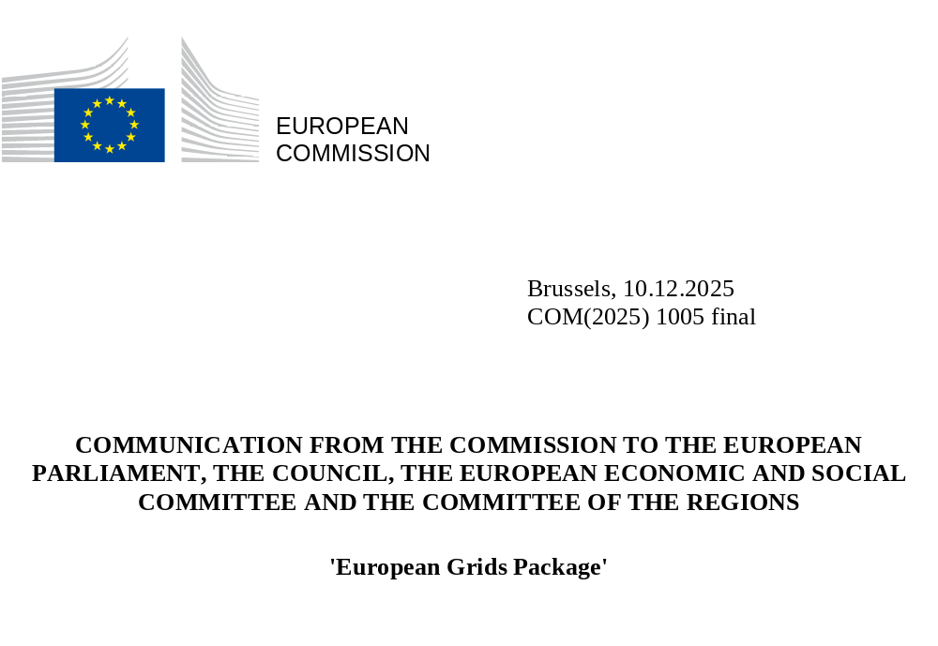

- Introduction
In recent years, the European Union has found itself at a critical crossroads due to unprecedented global geopolitical shifts and trade fluctuations. Russia’s continued war of aggression against Ukraine underscored the paramount importance of energy security and competitiveness in shaping our collective destiny. It is essential that we ensure that our companies and citizens, regardless of the Member State they are located in, have access to abundant clean, and affordable energy produced in Europe.
This, however, can be realised only by strengthening our energy infrastructure, the backbone not just of our energy system but of Europe itself. Grids are central to this effort. By enabling energy to flow efficiently across Member States, integrating cheaper clean energy and accelerating electrification, they help lower energy prices and support affordable living for all Europeans as highlighted in the Commission’s Action Plan for Affordable Energy. At the same time, they ensure a secure and reliable supply and allow countries to support one another in times of need, in line with the REPowerEU objectives and enabling the phase-out of Russian energy imports.
Despite the progress achieved within the current EU legal framework, we still have too little homegrown energy and have not reached the level of interconnectivity among Member States that would enable a genuine Energy Union, as several Member States are not on track in meeting the 15% interconnection target by 2030. The cost of inaction is staggering: in 2022, fossil fuels had the largest share of EU gross available energy use (70%) in the EU, with 98% of all oil and gas used in Member States being imported. This exposes the EU to price volatility and geopolitical risks. In 2024, Europe spent circa EUR 375 billion on imports of fossil fuels. In stark contrast, investment in renewable power and grids remains comparatively low: Europe spent USD 117 billion in 2025, when China spent USD 327 billion.
The insufficient integration and underinvestment in our energy infrastructure has a direct impact on energy bills of European citizens and the development of strategic sectors across the EU, such as net-zero industries or digital. The Draghi and Letta reports emphasise that our electricity prices remain 2-3 times higher than those in the US; EU electricity retail prices for industry were in Q2 2024 2.2 times those in the US, twice those in China and 1.2 times higher than in Japan (historically lower). In the first half of 2025, the average electricity price for EU consumers varied from €0.3835 per kWh in Germany to €0.1040 per kWh in Hungary, while non-household electricity prices ranged from €0.2726 per kWh in Ireland to €0.0804 per kWh in Finland. A key reason for this disparity is the insufficient level of investment in and integration of our infrastructure. If we fail to act, 45% of cross-border electricity capacity needs (equal to 41 GW) will remain unaddressed by 2030 and unused renewable energy may reach up to 310 TWh by 2040, nearly half of electricity consumption in 2023.
On the other hand, the benefits of action are clear: enhanced market integration could lead to annual cost savings of EUR 40 billion, while boosting cross-border electricity trade by 50% could raise annual EU GDP growth by around EUR 18 billion by 2030 (or 0.1%). Until 2030, we are lacking 88 GW of cross-border electricity transmission capacity. Investing EUR 5 billion would reduce system costs by EUR 8 billion, creating a net economic gain of EUR 3 billion and highlighting how grid development can deliver real added value and cost savings for Europeans.
It is therefore imperative that we collectively take decisive action to resolve structural issues in EU energy infrastructure planning and implementation to successfully deliver a genuine Energy Union that enables energy independence, strengthens our competitiveness, drives decarbonization, and fosters our energy security. The European Grids Package put forward by the Commission today aims to do exactly that. Complementing these measures, the Energy Highways initiative, launched in the 2025 by President von der Leyen in her State of the Union address, seeks to accelerate progress on critical and urgently needed energy infrastructure projects through immediate action, ensuring that we can harness the full potential of our energy system to power a more resilient, competitive and sustainable Europe.
2. Tackling structural bottlenecks through the European Grids Package
- Building a unified energy future: strengthening EU-wide cross-border infrastructure planning and maximising the use of existing infrastructure
The current grid planning framework under the TEN-E Regulation has significantly advanced the coordination and development of cross-border energy infrastructure projects. Since 2014, 124 Projects of Common Interests (PCIs) and Projects of Mutual Interests (PMIs) have been backed by EUR 8.4 billion from CEF, unlocking at least EUR 15.8 billion in private investments. However, further action is imperative to ensure a seamless coordination across national, regional and EU governance levels and across sectors, to ensure a fully optimised and interconnected grid.
To advance this, building on existing structures, the experience gained so far and strengthened regional cooperation, we must move to an EU cross-border energy infrastructure planning framework that enables a more coordinated and robust identification of needs, thereby ensuring projects align with current and future European objectives. The Package also supports a better-connected European energy network, reinforcing Europe’s strategic autonomy, security, and resilience, while fostering enhanced cooperation with neighboring partners from the European Economic Area (EEA), the Energy Community and the Eastern Partnership and the Southern neighbourhood.
Following today’s proposed package, within 2 years from its enactment, the Commission will develop a comprehensive central EU scenario consistent with EU energy and climate targets and delivering a cost-efficient, competitive and secure system at EU level. The central scenario will be based on input from Member States and all relevant stakeholders considering synergies across sectors. Based on this, ENTSOs and ENNOH will then identify the infrastructure needs.
Additionally, strengthened European intervention is necessary when a cross-border capacity need has been identified but relevant project proposals for addressing this have not been put forward. The Commission should be able to initiate a “gap filling” process, based on strong regional cooperation, inviting system operators, and eventually project promoters, to propose projects to address unmatched needs.
To achieve an integrated system, stronger coordination between national and European planning is essential, as internal network elements significantly influence cross-border infrastructure development, which in turn affects cross-border trade. The planning of distribution grids must therefore be well coordinated with transmission-level planning and should closely involve both the public and industry, so that future grids are prepared to accommodate increasing electricity generation and demand. In cooperation with all relevant stakeholders, the Commission will continue advancing this work under the 2023 Grids Action Plan.
In the meantime, maximising the use of existing infrastructure before investing in new capacity is key for achieving an affordable and sustainable energy transition and ensuring energy security. In line with the ‘energy efficiency first’ principle, greater uptake of smart electricity grids, innovative and digital technologies and network efficiency measures need to be further incentivised at both network and users’ level, while ensuring sufficient grid capacity to meet additional demand in a timely manner. As an example, the use of grid-enhancing technologies can increase overall network capacity in Europe by 20% to 40% by 2040 and cost reductions by 35% compared to traditional network expansion by 2040. The European Grids Package proposes to firmly anchor these principles in network planning and to promote related projects alongside the extension of physical infrastructure. The just launched Technopedia platform showcases best practices in grid-enhancing and innovative technologies. Next year, the Commission will also present a Strategic Roadmap for Digitalisation and AI in the energy sector, helping to scale up smart solutions across European grids. Digital tools can help address increased volatility notably from renewable energy integration. Moreover, large data and cloud infrastructure can contribute to reinforce grid stability and therefore will be taken into account during the planning procedure.
Furthermore, as access to grids starts being a challenge in some Member States, creative solutions can help free up capacity and manage queues in an efficient way. The Guidance on efficient grid connections adopted today provides recommendations and shares good practices Member States and national regulatory authorities can apply to address these challenges immediately and make the most efficient use of existing grids. These include applying the “first-ready first-serve” principle, transparent maturity criteria for all connection requests, establishing clear project-development milestones with associated penalties for non-compliance, and conducting regular monitoring and cleaning of the connection queues.
The Grids Package, therefore, plays a key role in ensuring our electricity market remains robust and effective. It strengthens the efficient use of existing infrastructure, thereby contributing to making 70% transmission capacity available for cross-zonal electricity trade. Additionally, it supports our commitment on delivering on the electricity interconnection target of 15% by 2030, while preparing the work for the revision of the Governance Regulation to align with our climate and energy ambition for the decade ahead.
- Turning plans into action: accelerating the delivery of energy infrastructure projects on the ground
Identifying infrastructure needs and projects is only half of the journey. Even when projects are defined, construction often stalls due to lengthy permitting procedures, lack of public acceptance, financing hurdles, or difficulties in sharing costs between Member States. All these must be addressed while enhancing the security and resilience of our infrastructure against both deliberate and accidental disruptions.
First, slow permitting remains one of the most significant barriers to timely deployment of energy infrastructure and generation in the EU. In 2023, 26% of electricity PCIs were delayed by an average of 12 months according to ACER, with permitting alone accounting for more than half of the total implementation timeline of electricity infrastructure. Similarly, permitting timelines vary widely across Member States, with transmission grids taking on average 5 years, PCIs on average 4.3 years, renewable energy projects taking up to 9 years, storage installations 1 to 7 years and recharging stations up to 2 years.
In 2022 and 2023, the EU took notable steps to speed up permitting for renewable energy and infrastructure projects, including via the Emergency Regulation (applicable until June 2025) and the revision of Renewable Energy Directive (RED). However, delays continue to persist, particularly in integrating standalone storage and charging stations. Additionally, while the environmental assessment is necessary to ensure both the protection of biodiversity and the social acceptance of projects, its present modalities do not effectively capture the specificity of projects with minimal environmental impact and can cause unnecessary delays.
Against this backdrop, the European Grids Package, in coordination with the EU regulatory framework on environmental protection, establishes an EU level framework to simplify and accelerate permitting procedures for all grid infrastructure, renewable energy projects, storage projects and recharging stations, and further strengthens the provisions for PCI/PMIs. Decarbonisation is the first action that can help safeguard nature and reduce air pollution. These streamlined permitting procedures target the cases where, based on the extensive experience with implementing the current legal framework, environmental impacts are limited; the proposed changes help attain the balance between protection of biodiversity and swift deployment of a clean energy system. This aims at reaching the goal of limiting the permitting process to, depending on the type of project, up to two years in most cases, with a maximum of three years for the most complex projects.
Public participation in project planning, and operation is also essential for building trust and achieving EU targets, thereby minimising lengthy judicial challenges. The Grids Package requires that renewable energy projects over 10MW redistribute benefits to the local population, beyond energy communities. It also allows for independent facilitators to support early dialogue and mediation, further reducing the risk of judicial challenges and fostering cooperative development. To address public acceptance concerns, the Commission will also offer a practical toolbox on public inclusion in Q1 2026 which will facilitate the sharing of good practices and capacity building on how to involve citizens and local authorities and promote benefit sharing of renewable energy projects.
A second challenge comes from rising demand for energy infrastructure, which is putting significant pressure on supply chains, labour availability, and skills, while manufacturing bottlenecks are increasingly constraining our electricity system expansion and modernisation. Although Europe is home to leading grid technology manufacturers, the current production capacity in some segments is insufficient to meet demand, and the sector must scale up to keep pace.
As highlighted in the guidance on efficient grid connections, demand visibility is essential to guide industry investment decisions. To help address this, the Commission will work together with the EU DSO Entity to establish, by the 2026 Energy Infrastructure Forum, a platform for EU distribution network planning that will provide visibility at distribution level on future plans and related-manufacturing needs across Member States. The Commission is actively advancing a series of measures to ease supply chain pressures, notably by reinforcing its work, initiated under the Grid Action Plan Action 13, to streamline and harmonise common technology specifications and technical requirements and improve interoperability of HVDC systems. The modernisation of the European Public Procurement framework, announced for next year, will also be crucial in further promoting the objective of supporting our manufacturing base, including grids technologies that are “Made in Europe”.
Third, mobilising private investment is needed to ensure an affordable grid roll-out. As grid infrastructure is largely financed through tariffs, meeting the substantial investments needed (EUR 1.2 trillion by 2040 for electricity grids, including EUR 730 billion for distribution grids alone, and EUR 240 billion for hydrogen networks) poses a challenge. Relying on the current framework could lead to higher prices for consumers, making EU action in this area necessary.
We therefore need to ensure future-proof network charges, exploring additional ways of financing infrastructure where needed, including by requiring the use of part of congestion income for investments in interconnectors on the PCI/PMI list. Furthermore, as cross-border energy infrastructure increasingly integrates, more projects deliver benefits beyond the territories where they are built. This makes fair and transparent cost-sharing essential to avoid disproportionate burdens on local consumers. To tackle this, the European Grids Package aims to provide more transparency, certainty and fairness in the way costs and benefits are assessed and shared and to enable the bundling of PCIs or PMIs in order to facilitate cost-sharing discussions. Bundling can also make financing easier, for example through the establishment of special purpose vehicles, thereby attracting additional investment.
Europe is scaling up financial support for energy infrastructure. The recently adopted legislation on the mid-term review of Cohesion policy enables national and regional authorities to reallocate 2021-2027 funding to key priorities, such as the energy transition. Furthermore, the Commission’s proposal for the next Multiannual Financial Framework, includes a significantly reinforced Connecting Europe Facility. However, EU funding alone cannot meet our massive investment needs. The EU budget must play a stronger role in de-risking private investment and unlocking financing by institutional investors. The upcoming Clean Energy Investment Strategy will propose concrete actions to crowd in and ensure enhanced support from private sector investment, including with support from the EIB, a key partner in accelerating the grid roll-out.
For hydrogen, project development remains slow due to limited bankability and high risks across the value chain. To address this, the Commission will assess and, where relevant, support the implementation of possible solutions, such as contracts for difference or cross-border coordination of regulatory tools, including as part of the regional High-level groups, to ensure coordinated progress and help bridge financing gaps.
Fourth, strengthening the security and resilience of our energy infrastructure is critical in today’s geopolitical context and in light of increasing climate-related risks. Recent incidents in the Baltic Sea, including damages to the Balticconnector and Estlink 2, highlight the vulnerabilities of cross-border energy assets, while climate-related events and accidental disruptions remain significant risks to our security of supply.
To safeguard the EU's energy independence, the Grids Package integrates physical and cyber security considerations into cross-border project planning from the start, promoting resilience and security by design for new infrastructure, enhances transparency in ownership to avoid dependency on high-risk foreign entities, and ensures existing infrastructure physical and cyber security and resilience enhancements are eligible for CEF financing while preventing overlaps with other EU financing support. In addition, building on the Cable Security Action plan, the Commission will continue its work through Regional Cable Hubs and strengthen the application of the Cable Security Toolbox.

3. Eight priorities for Europe’s energy backbone: the Energy Highways Initiative

In her State of the Union address on 10 September 2025, President von der Leyen announced eight “Energy Highways”. Building on existing PCIs and PMIs under the TEN-E framework, as well as flagship projects referred to in the Affordable Energy Action Plan, the Energy Highways address the most urgent energy infrastructure needs that require particular additional short-term support and commitment for implementation to address bottlenecks that hinder progress.
The Energy Highways will enhance energy security, reduce reliance on fossil fuels, integrate more renewables into the grid, promote electrification, decrease energy prices, accelerate the implementation of REPowerEU and help Member States adapt to the phase-out of Russian fossil fuel imports. Many of the Energy Highways hold PCI or PMI status in the second Union list of PCIs and PMIs published on 1 December 2025, which features 235 cross-border energy infrastructure projects within the EU and with third-country partners such as the Celtic Interconnector, the Black Sea Interconnection Cable, Estlink 3. Under the TEN-E framework, all PCIs and PMIs in the Union list benefit from several advantages, including priority status and streamlined permit granting procedures as well as eligibility to apply for financial assistance under the Connecting Europe Facility.
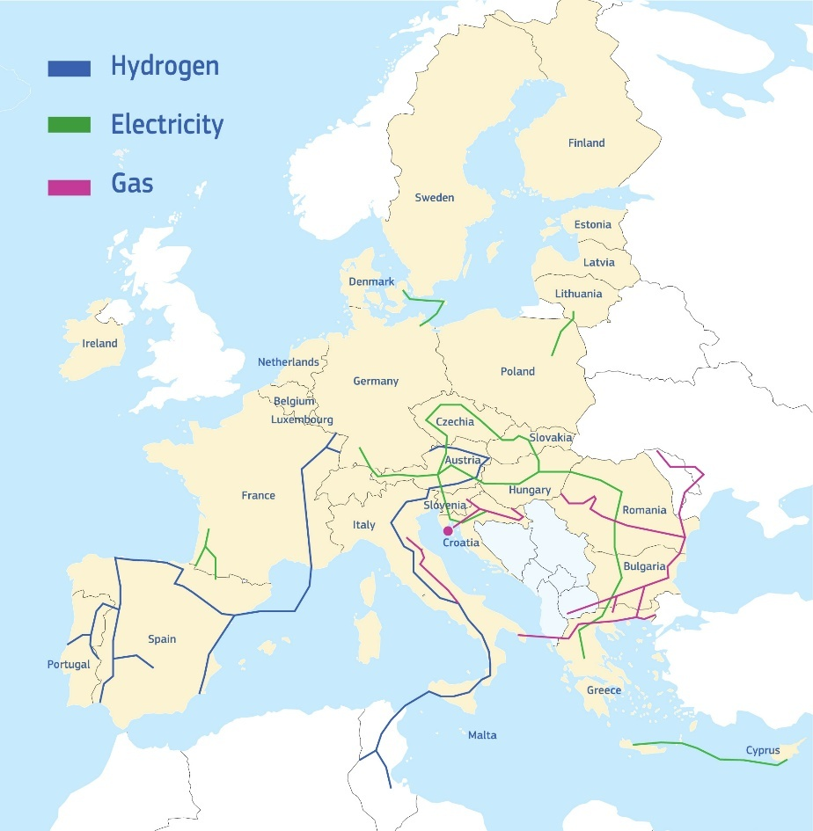
Figure 1: Map of the Eight Energy Highways
1. Pyrenean crossing 1 and Pyrenean crossing 2 [Better integrate the Iberian Peninsula with power interconnectors across the Pyrenees to France]
2. Great Sea Interconnector [Connect Cyprus with continental Europe to end its electricity isolation]
3. Harmony Link [Strengthen power links with the Baltic states]
4. TransBalkan Pipeline (TBP) reverse flow [Improve energy supplies in the Balkan region and eastern neighboring states]
5. Bornholm Energy Island [Turn the Baltic Sea into an offshore interconnector hub]
6. Improve price stability and energy security in southeastern Europe
7. SoutH2 Corridor [The South hydrogen corridor]
8. Southwest hydrogen corridor from Portugal to Germany

The Commission is committed to immediately fast-tracking the Energy Highways through enhanced political coordination, drawing on the Regional High-Level Groups, mobilizing support of European coordinators where relevant and working closely with the Energy Union Task Force, extending outreach beyond EU Member States where necessary. Each project will be prioritised at EU level, and the Commission will support Member States in giving them the same priority nationally.
To ensure effective cross-border cooperation on permitting, the Commission will focus on identified interconnector priority projects, strengthening its support to Member States in identifying joint procedures for an effective and efficient permitting process with the support of a European Coordinator, where appropriate. Drawing on this experience with the closer coordination of permit granting procedures, the Commission may consider further action. Moreover, to strengthen the administrative capacity of permitting authorities and the digitalisation of renewable energy permit granting procedures, the Commission will provide support to Member States through dedicated actions that will complement the permitting regulatory framework. This will include leveraging tools like the Technical Support Instrument and exploring the creation of a pilot facility on permitting through existing advisory facilities to enhance capacity building and access to financing for investments and reforms on permitting. The Commission will also promote knowledge-sharing about funding possibilities and the development of new digital platforms for permitting through the Permitting Expert group.
Some projects are already recognised as Important Projects of Common European Interest (IPCEIs), bringing additional benefits in terms of funding and coordination. Likewise, the Pyrenean crossing 1 and Pyrenean crossing 2 highways, the southwest hydrogen corridor and the South-Eastern Europe highway will be designated as pilots under the Competitiveness Coordination Tool allowing them to benefit from the tool’s whole-of-government approach and specific capacity to address horizontal issues. The priority actions that will be established under the CCT will be carried out in conjunction with the efforts of the respective High-level groups or fora and will reflect the respective needs of each highway, such as improving energy system flexibility, addressing supply-chain issues or financing challenges.
Moreover, the Baltic and Central- and South-East European region Highways have recently been assigned European Coordinators under the TEN-E framework, to facilitate the timely implementation of projects by promoting cross-border dialogue, supporting permitting and financing, ensuring Member State backing, and reporting on progress and obstacles. The Commission will also strengthen existing structures and ensure dedicated resources to achieve an increased and continuous focus on the delivery of the eight Energy Highways, in close cooperation with the European Coordinators, where appropriate.
The Commission will actively collaborate with all concerned Member States making full use of the above toolkit to ensure the successful implementation of the Energy Highways. Regular progress updates will be provided to the European Council to ensure political commitment while ensuring transparency and accountability.

Annex: Additional short-term targeted action for each of the Energy Highways
In addition to the horizontal support presented above, the Commission will provide targeted short-term actions to address specific challenges for each of the Highways, to ensure concrete progress and deliverables can be achieved within the next 6-9 months.
1. Pyrenean crossing 1 and Pyrenean crossing 2 [Electricity interconnections across the Pyreneans to better integrate the Iberian Peninsula]
The Iberian Peninsula remains insufficiently connected to the rest of the EU energy market, with current cross-border capacity between France and Spain limited to 2.5 GW. This hampers market integration, drives persistent price differentials, and constrains renewable integration. In addition to the Biscay Bay interconnection project that is under construction, the objective of these two additional Pyrenean projects is to raise total interconnection capacity to 8 GW by 2040, strengthen system resilience, and reducing renewable curtailment. The two Pyrenean interconnection projects have been reconfirmed in the current PCI/PMI list as priority projects to address this bottleneck. In May 2025, the Navarra (ES) - Landes (FR) project received a EUR 11.1 million Connecting Europe Facility (CEF) grant for preparatory studies. Despite their strategic importance, progress has been relatively slow, with further work needed on internal reinforcements and on clarifying the financing approach.
Short-term actions: The Commission will work to facilitate a joint political declaration at the next Ministerial meeting of the High-Level Group South-West Europe (Q1 2026), with the objective of confirming the start of implementation for at least one of the projects and addressing the necessary internal grid reinforcements.
2. Great Sea Interconnector [Electricity interconnection of Cyprus with continental Europe to end electricity isolation]
Cyprus is the last EU Member State not connected to the European electricity grid, limiting its integration into the internal energy market and constraining opportunities for renewable integration. The planned Great Sea Interconnector between Greece and Cyprus will address this gap, ending Cyprus’ electricity isolation, supporting Cyprus’s decarbonization and strengthening the resilience of the European energy system. It will also facilitate greater integration of renewable energy in the wider Mediterranean region.
The project, reconfirmed in the current PCI/PMI list, will be the world’s longest submarine power cable, with a length of nearly 900 km. It has been supported by CEF grants, including EUR 2.3 million for feasibility studies and EUR 658 million for works to construct the section between Greece and Cyprus. In May 2025, work was completed on the undersea cable linking the Greek mainland to Crete, a key step towards the full interconnection.
Progress on the project has been hampered by a complex geopolitical context, with potential implications for timelines and costs. The strategic value of this interconnection highlights the importance of strong coordination between Member States to address these challenges and ensure completion of the project.
Short-term actions: The Commission will continue to give strong political and technical support to the project of highest strategic importance in close cooperation with the upcoming Cyprus Council Presidency in 2026, including through dedicated events and high-level discussions, and with additional engagement to addressing geopolitical aspects.
3. Harmony Link [Strengthening the Electricity interconnection of the Baltic States to boost security benefits of their independence from Russia]
On 9 February 2025, the three Baltic States successfully synchronised their electricity systems with continental Europe, a landmark achievement for European energy security. A key remaining investment under the Baltic Synchronisation PCI is the Harmony Link interconnector between Lithuania and Poland, which will complete the full integration of the Baltic electricity markets. The recent appointment of a European coordination for the completion of this project should support swift delivery.
Once completed, the Harmony Link will enhance market integration, enabling electricity trade through Poland and fostering competition that can lower prices for consumers and businesses in the region. It will also facilitate the integration of renewable energy. Harmony Link will also significantly strengthen energy security in the Baltic States. Today, the LitPol Link interconnector is the only connection between the Baltics and continental Europe, and outage would carry serious consequences for the Baltic energy system.
Short-term actions: The Commission will support the timely delivery of this project through enhanced regional cooperation and take stock at Ministerial level during the next BEMIP High-Level meeting in 2026, following the signature of the updated BEMIP Memorandum of Understanding last year, and ensure that the adoption of the new BEMIP High-Level Group Action Plan prioritises delivery of this highway.
4. TransBalkan Pipeline (TBP) reverse flow [Resilience of energy supplies in the Balkan region and our eastern neighbourhood]
The Trans-Balkan Pipeline (TBP) reverse flow is not a capacity expansion project, but a coordinated effort in the Central- and South-East European region to enable the maximized use of existing natural gas transmission capacity in the reverse direction, from South to North. This functionality is key to diversifying natural gas supplies in South-East Europe and to ending Russian imports.
With significant transport capacity, the TBP can play a central role in regional diversification and in delivering on the REPowerEU objectives. This potential will grow further from 2027, when the Neptun Deep gas field in Romania is expected to come online. Full South-North operation of the TBP, combined with source diversification, would foster greater trade, competition, and market liquidity in the region without the need for costly new infrastructure.
Despite this potential, current regulatory and market obstacles in several Member States along the pipeline create obstacles to the TBP’s use and commercial viability. The recent appointment of a European Coordinator for the CESEC region will strengthen EU’s support the resolution of these barriers.
Short-term actions: The Commission will intensify coordination under the CESEC High-Level Group, with all concerned countries including Moldova and Ukraine, with a view to increasing the commercial attractiveness of the pipeline as soon as possible, while ensuring long-term compliance with the EU energy acquis. In this context, the Commission will further support the work of the CESEC High-level Group on gas quality harmonisation, and the removal of obstacles to the maximized utilization of the Trans-Balkan Pipeline.
5. Bornholm Energy Island [Turning the Baltic Sea into an offshore interconnector hub]
As a first-of-its kind project, the Bornholm Energy Island (BEI) is a hybrid offshore project, located southwest of Bornholm, in the Exclusive Economic Zone of Denmark. The project is planned as a future energy hub, with potential to expand and connect to more interconnectors with other countries. It is reconfirmed in the 2nd PCI/PMI list and received a CEF grant for works (EUR 645.2 million) in September 2025. BEI is a blueprint for future EU offshore initiatives; it will increase market integration, enhance security of supply at EU level and benefit Denmark and Germany and Member States beyond the region. By linking offshore generation with the Danish and German national grids, offshore wind energy is transformed from a national resource into a shared European asset for further electrification, strengthening our collective resilience and energy independence. Remaining challenges relate to an agreement between Denmark and Germany on how to share the additional support costs for the offshore wind farm in Denmark and completion of the regulatory framework in Denmark, particularly on cross-border liability.
Short-term actions: : Following the signature of the CEF grant agreement worth EUR 645 million to support the Danish side of the Bornholm Energy Island (BEI) on 4 September 2025 in Copenhagen, for the construction of two new converter stations and the installation of an submarine cable system, the Commission will continue supporting Denmark and Germany in reaching a political agreement on the cost sharing for the offshore generation located in Danish waters, as well as in finalizing their regulatory framework on cross-border liability. Furthermore, the Commission will continue to support work on the interoperability of offshore networks to ensure that the BEI can in the future develop into a true offshore hub for the Baltic region.
6. Improve price stability and energy security in southeastern Europe, including through storage

The South-Eastern European region suffers from structural high price differentials, as evidenced by 2024 price spikes, causing average price disparities of more than 10 EUR/MWh between respective countries.
The South-Eastern Europe electricity interconnections Energy Highway addresses critical electricity infrastructure gaps in the region, with the aim of improving price stability, enhancing security of supply, and fostering regional market integration. It involves making better use of existing interconnections and addressing future cross-border needs to eliminate current price disparities. According to ENTSO-E 2024 TYNDP system needs assessment, infrastructure reinforcements are needed on most of the borders in the region. Swift implementation of existing projects of common interest and priority electricity infrastructure projects of the Central and South-Eastern Europe Energy Connectivity High-Level Group (CESEC) will be crucial to fulfil those needs. Accelerating storage in the region will also improve system flexibility.
Short-term actions: Strong coordination and support from the CESEC High-Level Group, together with the CESEC Coordinator, will be essential to accelerate progress. The Commission will ensure that dedicated high-level discussions are held next year at all levels to maintain momentum and support implementation.
7. SouthH2 Corridor [The South hydrogen corridor (Tunisia, Italy, Austria and Germany)]

The South hydrogen corridor will be key to advancing a just and sustainable energy transition across the Mediterranean, particularly in North Africa, while enabling the decarbonization of industrial hubs along its route. It offers significant potential to scale up renewable hydrogen production, infrastructure and offtake markets, foster market integration, and establish a supportive regulatory and investment framework aligned with the EU’s hydrogen strategy and regulatory framework.
This corridor includes four Projects of Common Interest (PCI), some having already benefit from CEF grants for studies, and [one Project of Mutual Interest with Tunisia], all reconfirmed in the 2nd PCI/PMI list. Going ahead and given the early stages of hydrogen market development, further conceptual work will be needed, in particular to further derisk related investments while maintaining a mutually beneficial partnership with North Africa.
Short-term actions: In the short term, the Commission will reinforce coordination and implementation efforts of the SoutH2 Secretariat, under the joint leadership of DG MENA and DG ENER. Regional dialogues will also be intensified through meetings of the Southern Hydrogen Corridor Trilateral EU Joint Working Group (Italy, Austria and Germany) and the Penta-lateral group (Algeria, Tunisia, Italy, Austria, and Germany) in early 2026, to advance the initiative. The Trans-Mediterranean Renewable Energy and Clean Tech (T-Med) flagship initiative, launched under the Pact for the Mediterranean, will also contribute to the realisation of this Energy Highway.
8. Southwest hydrogen corridor from Portugal to Germany

The Southwest hydrogen corridor will transport decarbonised hydrogen from production sites in Southwest Europe to industrial demand centres, accelerating the decarbonization of hard-to-abate sectors and enabling efficient integration of renewable energy. The initiative encompasses key PCI projects between Portugal, Spain, and France, as well as internal links extending towards Germany. Together, these projects aim to deliver up to 2 million tonnes of renewable hydrogen annually by 2030, strengthening energy security and flexibility across the region.
However, progress has been limited, and several challenges persist, including the lack of uptake, delays in regulatory implementation, difficulties in securing financing and coordinating de-risking measures along the corridor, and strategic priorities across Member States to ensure the corridor delivers shared benefits for all participants.
Short-term actions: Strong coordination and renewed political support through the South-West High-Level Group will be essential to accelerate progress. The upcoming Ministerial Meeting of the High-Level Group on South-West Europe in Q1 2026 will help step up efforts and facilitate exchanges among Member States on key technical, financial, and de-risking aspects of the corridor’s development.

EUR-Lex - 52025DC0079 - EN - EUR-Lex
REPowerEU
Renewables, electrification and flexibility - For a competitive EU energy system transformation by 2030 | Publications | European Environment Agency (EEA), p. 6 and 16.
Imports of energy products to the EU down in 2024 - News articles - Eurostat
China’s energy dominance in three charts | MIT Technology Review
European Commission, Affordable Energy Action Plan (COM(2025) 79), p. 1.
Electricity price statistics - Statistics Explained - Eurostat
TYNDP 2024 / Infrastructure Gaps Report / Opportunities for a more efficient European power system by 2050
Electricity and heat statistics - Statistics Explained - Eurostat
IMF Staff Background note on EU Energy Market Integration, 17 January 2025, https://data.consilium.europa.eu/doc/document/ST-5438-2025-INIT/en/pdf, p. 5.
TYNDP 2024 / Infrastructure Gaps Report / Opportunities for a more efficient European power system by 2050
CINEA Project Portfolio - Welcome | Sheet - Qlik Sense
Grids, the missing link - An EU Action Plan for Grids, COM (2023) 757 final
2024 ACER monitoring report on electricity infrastructure, ACER_2024_Monitoring_Electricity_Infrastructure.pdf
TSO DSO Technopedia - Home
As foreseen under 15(2) of Regulation (EU) 2019/943 on the internal market for electricity, that minimum capacity shall be reached by 31 December 2025.
2023_ACER_PCI_Report.pdf .
ACER Monitoring Report 2024, Electricity infrastructure development to support a competitive and sustainable energy system, p. 18.
https://www.acer.europa.eu/media/charts/PCIs-and-PMIs-monitoring-2025.
Final report to be found here: Technical support for RES policy development and implementation – simplification of permission and administrative procedures for RES installations (RES Simplify) - Publications Office of the EU.
Fraunhofer Institute for Systems and Innovation Research ISI, et al., Study on energy storage, 2023.
Information collected by EV charging organisations, notably ChargeUp Europe, Ionity and Milence.
Relevant good practice examples can be found in SWD (2024) 124 final - Guidance to Member States on good practices to speed up permit-granting procedures for renewable energy and related infrastructure projects.
Such as the Covenant of Mayors, the Pact for Engagement and the Fast & Fair Renewables and Grids initiative.
For example, prices and lead times for new transformers and cables nearly doubled in 2025 compared with 2021–2022 (Source: Building the future transmission grid – Strategies to navigate supply chain challenges; IEA, February 2025).
Artelys, LBST, Trinomics, Finesso, A. et al., Investment needs of European energy infrastructure to enable a decarbonised economy, 2025.
https://energy.ec.europa.eu/publications/communication-future-proof-network-charges-reduced-energy-system-costs_en
Support could go towards developing cross-border energy interconnectors, expanding renewable energy sources like solar and wind, the deployment of recharging infrastructure and upgrading energy distribution networks to manage efficiently fluctuations in supply.
The EU currently provides substantial support through the Connecting Europe Facility, European Regional Development Funds, Cohesion Funds or Recovery and Resilience Plans, amongst others. Under the Commission’s proposal for the next Multiannual Financial Framework, the budget of the Connecting Europe Facility for Energy (CEF-E) would rise significantly, from EUR 5.84 billion for 2021–2027 to EUR 29.91 billion for 2028–2034. The European Competitiveness Fund will provide a consolidated funding stream (EUR 234.3 billion) with dedicated funding (EUR 26.2 billion) for scaling up and deploying decarbonisation and clean transition technologies, including infrastructure. The National and Regional Partnership Plans (EUR 865 billion) will bring together clean energy investments and reforms and support the implementation of National Energy and Climate Plans.
EU Action Plan on Cable Security, JOIN(2025) 9 final, eur-lex.europa.eu/legal-content/EN/TXT/PDF/?uri=CELEX:52025JC0009
Delegated Regulation on the second Union list of Projects of Common and Mutual Interest and its annex - Energy.
New European coordinator appointed to oversee completion of Baltic synchronisation energy project - European Commission New European coordinator appointed for the Central and South-East European energy interconnectivity
Ireland will be directly connected to EU electricity grid through the on-going Celtic Interconnector project between Ireland and France.
Joint communication on the Pact for the Mediterranean - Middle East, North Africa and the Gulf

