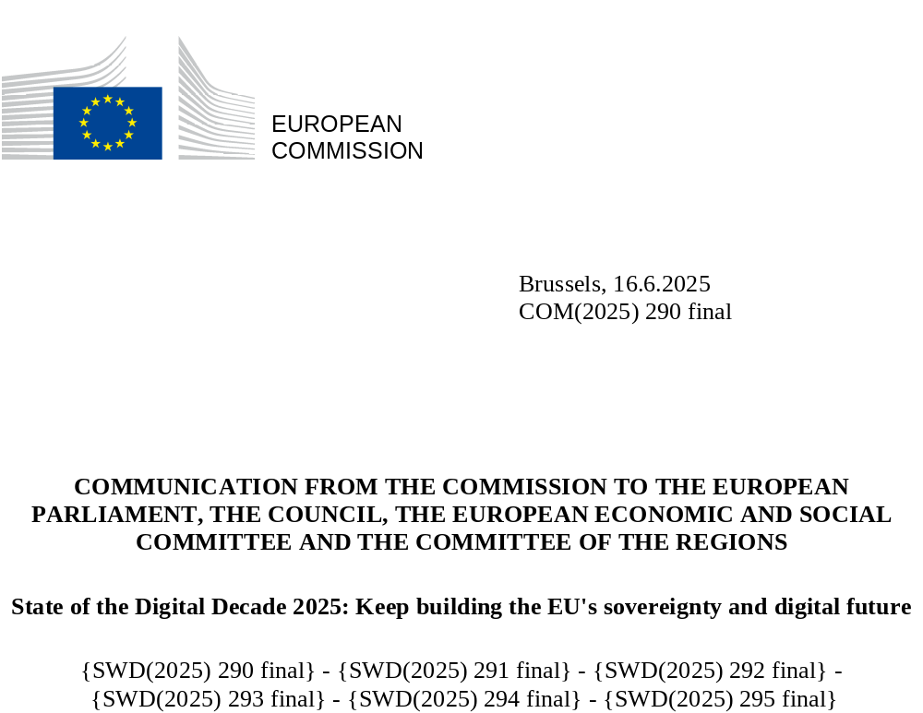

State of the Digital Decade 2025:
Keep building the
EU's sovereignty
and digital future

Introduction
The EU’s digital transformation is a central driver for ensuring that Europe remains competitive, resilient, reduces its excessive dependencies and enhance its technological sovereignty, while reinforcing its strategic autonomy. To this effect, the Digital Decade Policy Programme (DDPP), adopted in 2021, has provided the EU with a structured, strategic and legally binding governance framework, enabling it to navigate an increasingly volatile geopolitical, economic, and technological landscape. This demonstrates the EU’s determination and commitment to decisive, long-term action, driving forward its vision for a digitally transformed Europe.
In the face of today’s geopolitical challenges, the DDPP has become more vital than ever. Strengthening Europe’s technological sovereignty and resilience is key to protecting strategic interests and reinforcing the EU’s global leadership and competitiveness. The DDPP plays a crucial role in this context, fostering coordination among Member States, aligning their efforts, and addressing the urgent need for an accelerated digital transformation.
Through the Digital Decade, the EU sets and monitors digital objectives and targets, aligns initiatives through national roadmaps, and enhances joint investment. This demonstrates the EU’s determination and commitment to decisive, long-term action, driving forward its vision for a digitally transformed Europe. Furthermore, the Digital Decade fosters cooperation across EU, Member State, regional and city levels, accelerating digital transformation and supporting the implementation of the Competitiveness Compass. By adopting a broader, integrated perspective, the Digital Decade connects competitiveness, sovereignty, sustainability and democratic values. It underlines how the digital transformation is not only a matter of fuelling innovation and growth but also of fostering the most important strategic assets for Europe’s sovereignty, stability, and global influence, as illustrated in Figure 1.
This Communication describes the State of the Digital Decade in 2025, examining relevant digital policy developments and progress with the EU’s digital transformation since the last report published in 2024. It also lays the groundwork for the review of the DDPP in 2026, with possible changes to targets, objectives and governance in view of technological and EU policy developments.
More detailed analyses, including EU level recommendations, are presented in the Annexes to the Communication and in supporting documents, specifically Staff Working Documents, Eurobarometer and studies which, all together, constitute the 2025 State of the Digital Decade report.
In particular, this Communication is accompanied by 28 Annexes:
- Annex 1, an extensive analysis of the progress made towards the Digital Decade objectives and targets, and includes horizontal recommendations addressed to all Member States;
- Annexes 2-28, summaries of the analysis made for each of the 27 Member States, including country-specific recommendations.
Figure 1: The Digital Decade and EU digital priorities
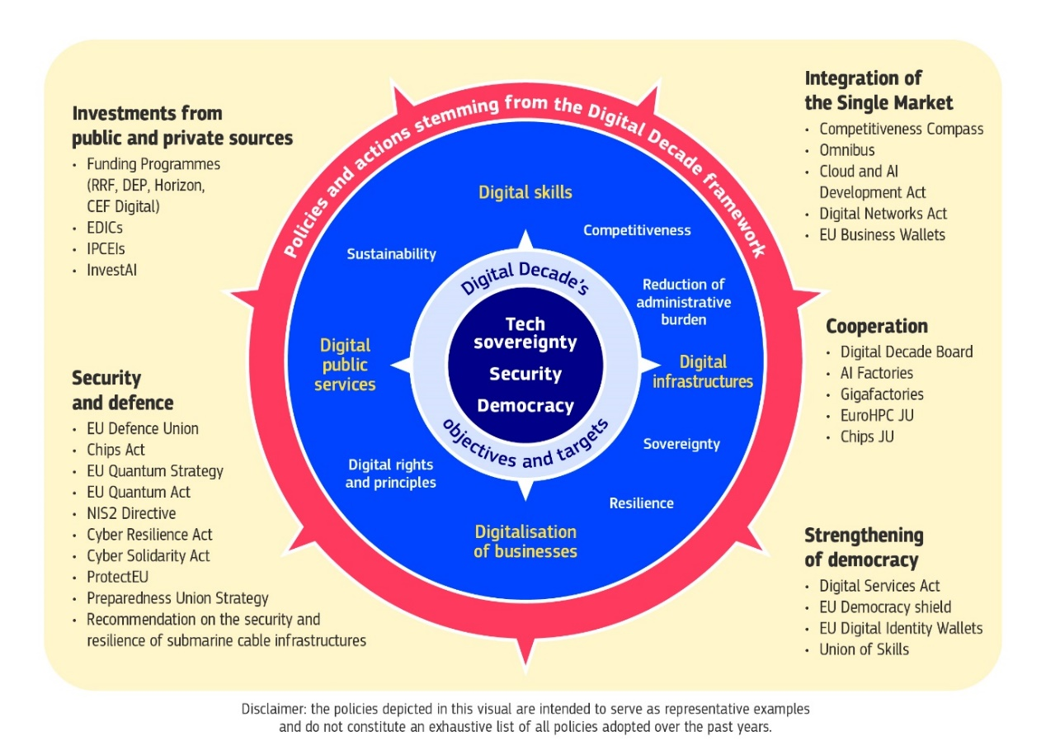

Tracking the EU’s Digital Decade overall progress

2025: a defining year for the EU’s future
In 2025, the global Artificial Intelligence (AI) revolution is gaining further momentum with breakthroughs in foundational technologies, which are reshaping innovation frontiers, redefining competitiveness, and changing people’s everyday lives. Workers now use AI tools to boost productivity – from factory-floor assistants in manufacturing to AI office software development – streamlining tasks and supporting decision-making. Meanwhile, autonomous car fleets are starting to scale, notably in the US and Asia, with self-driving taxis and delivery services setting new standards for urban mobility and economic efficiency. Furthermore, AI is revolutionising healthcare, making it more effective, accessible, and economically sustainable. AI is also a game changer for the green transition. enabling real time environmental monitoring, underpinning circular economy, streamlining industrial processes, and supporting smarter resource management across sectors such as water, energy, transport, and agriculture. Amid these rapid advances, a key emerging issue is how to harness the power of AI through effective policy and democratic governance to advance societal progress—promoting broad-based prosperity, inclusive growth, and public benefits.
Establishing EU leadership and positioning Europe as a true AI continent is a paramount priority, requiring a comprehensive set of assets, capabilities, and infrastructures — from advanced skills to robust ethical frameworks — as illustrated in Figure 2. It includes notably highly efficient digital infrastructure – from connectivity to quantum computing – to support the current surge in AI innovation. A major boost in computing power, data storage, and fast, secure, low-latency connectivity is also essential to train foundation models and develop vertically integrated AI applications.
Figure 2: The seven pillars for becoming an AI leader and the role of the Digital Decade
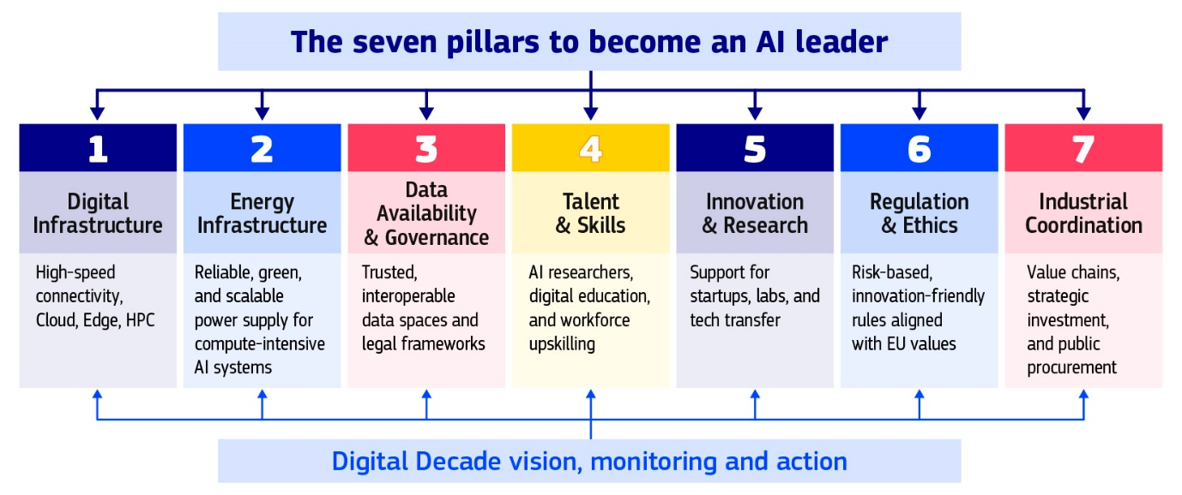
These foundational technologies are crucial for defence and cybersecurity, enabling real-time data analysis, battlefield situational awareness, autonomous decision-making, cryptanalysis, secure communications and next-generation cybersecurity solutions.
This has spinoff value, as 10% of the EU’s defence spending is expected to be channelled into European deep tech, potentially generating an annual market impact of EUR 245 billion, as a powerful catalyst for innovation and industrial renewal. Meanwhile, geopolitical shifts are turning the EU's digital supply chain dependencies into strategic vulnerabilities. As supply chains are increasingly weaponised through overreliance on high-risk-vendors or restrictions and tariffs, technological sovereignty has moved to the forefront of the EU agenda, driving the need for a more coordinated industrial policy, deeper public-private partnerships, and targeted investments with the objective of positioning the EU not as a mere passive consumer of global technology, but as a proactive, competitive force, spearheaded by its digital and industrial transformation. Excessive dependence on foreign entities is also exposing the EU’s financial system’s resilience, including in critical areas such as payment systems and crypto assets, which is becoming increasingly vulnerable to external influence and disruptions, sometimes beyond the reach of European regulation. The prospect of a digital euro is becoming a cornerstone of Europe’s digital finance strategy and economic security, strengthening Europe’s financial ecosystem, innovation capacity and strategic autonomy.
The growing sophistication of the threats we face – including disinformation, cyberattacks, deepfakes, and algorithmic manipulation – requires widespread digital literacy and a skilled ICT workforce. These threats, whose creation and dissemination are amplified by AI and online platforms, also have the potential to distort electoral outcomes, deepen societal polarisation, erode public trust in democratic institutions and compromise critical infrastructure. They also challenge the rule of law by undermining the integrity of democratic processes, weakening institutional accountability, and disrupting the enforcement of legal norms online — particularly when harmful or illegal content spreads unchecked across platforms. Additional risks are emerging from complex use patterns of algorithms and digital tools, such as online platforms, and their impact on children’s safety and wellbeing. If left unchecked, these online threats could put the very foundations of democracy at risk – undermining the rule of law and disrupting evidence-based public debate and policymaking.
The 2025 Digital Decade Eurobarometer.:
- A significant majority of European citizens (88%) believe that combating fake news and online disinformation should be a priority.
- Nine out of ten consider protecting children online to be an urgent concern.
- Three out of four Europeans consider that the digitalisation of daily services makes their lives easier. However, conversely this still indicates that about 100 million people find it makes their lives more complicated.
- 85% of respondents consider it important for public authorities to ensure that European companies can grow and become European champions able to compete globally, while 89% believe equally in the importance of increasing research and innovation for more secure and strong digital technologies.
Events in 2025 have thus underscored the urgent need for Europe to innovate, compete and grow while assuming greater responsibility for its strategic autonomy, resilience, security and defence, developing its own sovereign technologies not just as a matter of competitiveness, but as a strategic imperative.

From metrics to meaning: what 2024 reveals about the EU’s digital trajectory
Since July 2024, the EU has shown uneven progress across DDPP targets and objectives. Certain areas, such as the deployment of edge nodes, the availability of e-Health services, and ‘basic’ 5G radio coverage, are demonstrating comparatively high levels of target achievement. In contrast, several key domains – particularly foundational digital technologies such as AI, cloud services, data analytics, along with ICT specialists and basic digital skills – are showing deeply unsatisfactory progress. While improving at a slow pace, the digitalisation of public services and the roll out of Very High-Capacity Networks (VHCN) are showing signs of increased maturity, while deployment of Fibre to the premises is progressing but not enough to reach 100% by 2030.
More generally, the monitoring of general objectives shows that the EU is still facing major challenges to harnessing the digital transformation for its productivity and competitiveness. The deployment and integration of these technologies across the EU economy are still too limited, while regulatory fragmentation and administrative complexity continue to pose significant challenges for start-ups, SMEs, and innovators. The EU still lacks sovereign, pan-European digital connectivity and cloud computing infrastructure, as well as integrated management systems needed to support its development and a good level of security. With the increase in cyberattacks, which surged by 150% in 2024, security has become paramount. This need closely aligns with the priorities of most European citizens: around four out of five Europeans think that improved cybersecurity and stronger protection of online data and safety would significantly facilitate their daily use of digital technologies. A widespread lack of digital skills remains a systemic barrier to the EU’s digital transformation. In particular, persistent shortages of ICT specialists are slowing progress towards the Digital Decade targets in key areas like AI, cybersecurity, and semiconductors. This shortage is compounded by the continuous gender imbalance among ICT specialists.
Figure 3: Taking stock of KPIs progress toward 2030
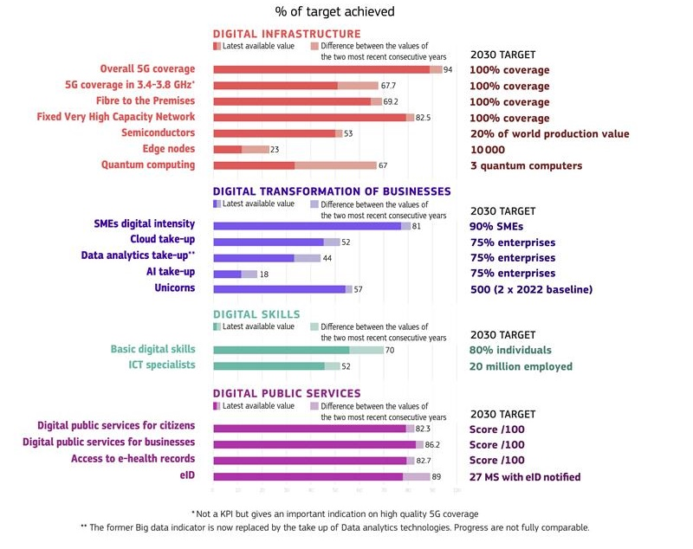
Meanwhile, the EU’s digital future is becoming increasingly dependent on stable energy production. In 2024, global electricity demand grew by more than twice the annual average increase over the past decade. Global Data centre electricity consumption is set to more than double to around 945 TWh by 2030, equivalent to Japan’s current total electricity consumption. The data centre industry must grow and evolve to accommodate inter alia the explosive growth and evolution of AI, generative AI and future AI iterations already in the making. This trend alone is set to represent 40% of the total energy demand in 2030 for data centre capacity. Exponentially rising energy demands are rapidly outpacing the development of clean and reliable energy supply and grid capacity across the EU. This discrepancy is emerging as a potential significant barrier to the scaling of key digital technologies and delaying the EU’s ability to fully leverage AI and data-driven innovation for economic competitiveness. These trends further underscore the imperative to strengthen the alignment between the green and digital transitions, as a key driver of the EU’s long-term competitiveness and security .
In order to see current perspective of achieving the 2030 targets, Figure 4 below tracks the progress of KPIs toward their EU targets, benchmarking achievement levels against projected timelines. The horizontal axis displays the target year for each KPI (based on the baseline trajectories where available), while the vertical axis shows the percentage of the target already attained as of 2024. The chart categorises KPIs into three groups: those ahead of schedule, on track (approaching targets), or delayed (falling below expected progress).
Figure 4: Tracking KPIs progress and expected timeline
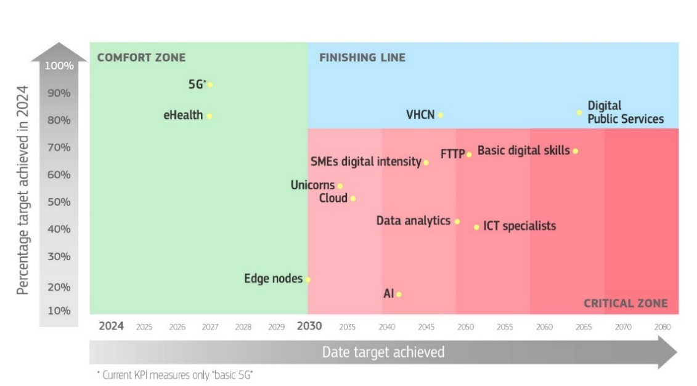

c. Halfway through the Decade: momentum is building among Member States and EU institutions, with some early signs of concrete progress
Two years after its entry into force, the DDPP is now in full implementation mode with concrete and ambitious action taken by the EU and Member States.
Collective ownership by all Member States of the Digital Decade targets and objectives is essential to achieving them and ensuring a consistent, impactful, and inclusive digital transformation across the EU. Member States are proactively implementing the DDPP, which is first and foremost a collaborative framework for Member States to work together, align and pool resources on digital policy.
All Member States have developed National Digital Decade strategic roadmaps (National Roadmaps), outlining the policies, measures and actions being taken from 2024 onwards to drive the EU’s digital transformation from 2024 on. The adoption of the roadmaps represents a significant milestone, as Member States are collectively committing to a total of 1 910 measures with a total investment of EUR 288.6 billion, comprising EUR 205.1 billion from public budgets (equivalent to 1.14% of the EU’s GDP).
Figure 5: Public budget intensity in Member States Roadmaps
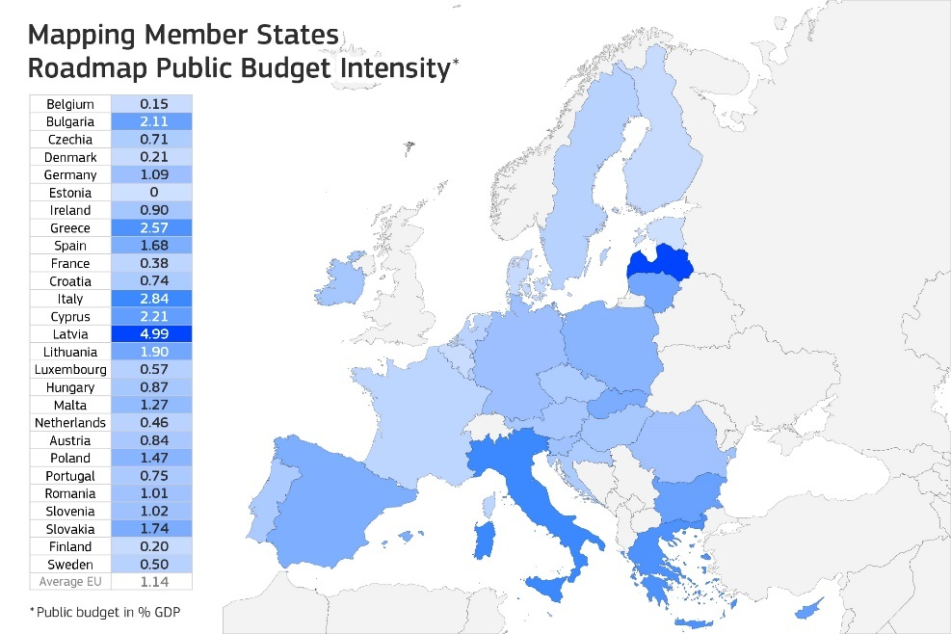
Following the 2024 State of the Digital Decade report recommendations, 21 Member States have updated their National Roadmaps and added roughly 20% of new measures. Over half of the measures indicating a timespan are planned to end in 2026, likely reflecting national budget cycles and the conclusion of the Recovery and Resilience Facility (RRF) plans and investments, suggesting a potential decline in support starting in 2027.
Member States are demonstrating their commitment to collective action through the implementation of annual recommendations. Member States addressed 57% of the 306 country-level recommendations issued by the Commission in 2024, either by implementing significant policy changes (12%) or making some changes (45%) through new measures. 19 Member States have addressed at least half of their recommendations through new measures. Among the EU-level recommendations, over 45% show either notable (35%) or significant progress (10%), with strong results in the areas related to the development of human-centred AI and safeguarding of digital rights and principles. On the other hand, 48% of the EU-level recommendations issued in 2024 have only seen limited progress, and 7% show no progress. This mixed picture highlights that, while there is clear momentum toward achieving some of the Digital Decade targets and objectives, there remains a continued need for structured and bolder policy action to accelerate and improve EU’s trajectory in the Decade.
Figure 6: National Roadmaps: budget breakdown per target and general objective
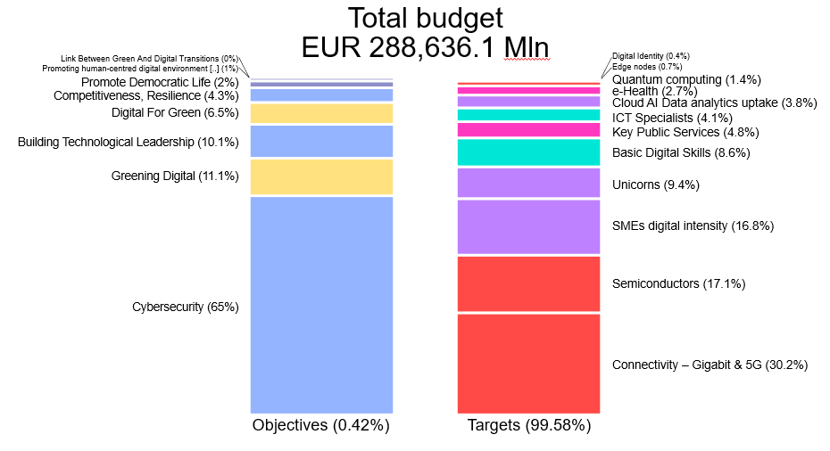Through the European Digital Infrastructure Consortia (EDICs), concrete multi-country cooperation is advancing to develop large-scale projects that a single Member State cannot tackle alone, covering key strategic areas such as AI, smart cities, health, mobility, and agri-food. Three EDICs have been established in 2024: the Alliance for Language Technologies EDIC, the Local Digital Twins towards the CitiVERSE EDIC and the EDIC for European Blockchain Partnership and European Blockchain Service Infrastructure (EUROPEUM-EDIC).
Member States are also supporting Important Projects of Common European Interest (IPCEIs) in the digital field. In 2024, IPCEI on Cloud Infrastructure and Services (CIS) was launched, with the participating companies advancing on their projects and the IPCEI ecosystem extending to include new indirect partners. In 2024, several Member States decided to enter into the design phase of three potential IPCEI candidates in the area of digital: one focusing on innovative AI services, one on advanced semiconductor technology applications and one on deploying computing infrastructure. Work is ongoing between the interested Member States and the Commission to shape those IPCEI candidates.
The Digital Decade Board (DDB), which brings together national representatives, has emerged as a key platform for coordination and exchange on issues related to digital transformation. It is well positioned to take on a growing role in advancing the EU’s digital transformation by strengthening cooperation, facilitating the implementation of digital policies, and supporting the development and adoption of solutions that simplify processes and reduce administrative burden, as well as advising on how to better link the targets and objectives with financing possibilities.
Furthermore, the Digital Decade Best Practice Accelerator, launched in July 2024, has been instrumental in further fostering collaboration among Member States through a combination of regular workshops and a dedicated online platform. This platform serves as a central hub for the exchange of information, challenges, and best practices related to achieving the goals of the Digital Decade. It features a repository that has compiled 52 best practices and organised eight workshops focusing on thematic clusters (Digital skills, Green IT, Tech Uptake, led respectively by Slovenia, France and Finland, Belgium), which enable in-depth exploration of specific areas crucial for the digital transformation of the EU. Additionally, discussions are ongoing for the launch of three new clusters in 2025, focusing on reducing administrative burden, digital rights and principles, and digital sovereignty.
The monitoring the Declaration on Digital Rights and Principles shows increasing commitment among Member States to take action, with over 2000 initiatives – 80% of them led by government organisations – identified across the EU. Member States are most active in the area of digital education, training and skills, as well as in working towards a better protected, safe and secure digital environment.
Finally, cities are vital enablers of the EU’s Digital Decade, serving as key implementation hubs that bring digital transformation directly to citizens, public services, and businesses—especially SMEs—through their proximity, innovation ecosystems, and local leadership. The report shows that there is still further potential to be unlocked through deeper cooperation with cities as part of EU’s digital governance, investment in local digital capacity, and alignment of local strategies, leveraging tools such as local observatories, and multi-country projects such as LDT-CitiVERSE.

d. Despite recent efforts, public and private investment levels are not yet fully aligned with the Digital Decade’s ambition and scale
In recent years, the EU has achieved some progress in strengthening its digital infrastructure and technological capabilities. Significant investments have been made in strategic areas, notably through initiatives like the Digital Europe Programme. Some examples of these achievements include:
- Over the past eight years, eight supercomputers have been acquired, three of which ranked among the world’s top 10 fastest supercomputers and were also recognised as being among the greenest and most energy-efficient.
- More than 150 European Digital Innovation Hubs are currently operational across the EU, covering nearly 90% of European regions, providing important support to both public and private organisations, in particular SMEs.
- The European Digital Identity Wallet, which is currently being piloted across the EU, will provide a secure and user-controlled tool enabling citizens to prove their identity, share documents, and sign digitally.
- In the semiconductor sector, four state-of-the-art pilot lines have been launched to test and validate advanced chip technologies.
In line with the priorities outlined in the Competitiveness Compass, on 9 April 2025 the Commission adopted the AI Continent Action Plan, outlining a set of actions relating to computing infrastructure, data, the development of AI algorithms and adoption, skills, and regulatory simplification. The action plan signals the EU’s ambition to become more competitive on the global stage by harnessing the potential of AI technologies and fostering strategic investments such as the AI Gigafactories, as well as launching targeted initiatives like Invest AI to scale public and private financing and Apply AI to accelerate the deployment of trustworthy AI across key sectors of the economy and public services.
Despite those achievements it is clear that continued and reinforced effort is essential to meet the scale of the digital transition and secure Europe’s technological sovereignty.
As the EU reaches the midpoint of its Digital Decade, this report—together with recent estimates from institutions including the EPRS, ECB, and the Draghi report using different scopes and methodologies show that the EU’s digital objectives will not be achieved without a transformative shift in its investment landscape. The Draghi report sets out that the additional effort of the EU should amount to EUR 150 billion a year for digital technologies. Similarly, the European Central Bank (ECB) stresses the importance of focusing EU finances on future-oriented investments, warning that failure to scale digital capabilities could compromise the EU’s long-term competitiveness and financial stability.
According to estimates by the European Parliamentary Research Service, only advancing high-tech digital innovation (HTDI) alone across Europe will require between EUR 212 and 380 billion annually, more than triple the EU’s current yearly total investment in digital technologies and infrastructure. A large part of the investment needs will have to come from private investments, mobilised through a deepened Capital Markets Union, increased risk financing, and industrial partnerships (see below). A quarter of that estimate will need to come from public channels, including national budgets, EU programmes, at a time when fiscal space is constrained across many Member States and medium-term budgetary pressures remain elevated, despite the increased flexibility of the new EU fiscal framework.
Strategic public procurement, notably thanks to the forthcoming revision of the Public Procurement Directives, will be crucial to achieve the EU’s objectives on resilience, innovation, simplification, and EU preference through public investment. When combined with measures outlined in the AI Continent Action Plan and the upcoming Cloud and AI Development Act and the support of GovTech, this revision will ensure that highly critical public sector develops highly secure, EU-based cloud capacity. Another unexplored opportunity is to make digitalisation eligible for sustainable (climate) financing demonstrating the energy and material efficiency gains of digitalisation in major industries, building notably on the recent work of the European Green Digital Coalition.
Analyses also converge on the critical areas where investment needs to be channelled to, from the roll-out of advanced connectivity infrastructure in fibre, 5G – in particular stand-alone and mid-band, including full coverage of transport corridors – to the development of next-generation semiconductors, including AI-specific chips, the scaling of secure and sovereign cloud and data infrastructure, the advancement of trustworthy AI and quantum computing technologies, and the development of robust cybersecurity capacities. Equally important is the sustained investment in training more digital technology specialists, digital literacy and upskilling, without which the benefits of innovation will remain inaccessible to many regions and sectors.
The cloud computing capacity gap between Europe and competitors like the US and China is expected to widen, unless significantly more capital is directed towards expanding edge and cloud computing capabilities. This report also identifies more precise mismatches between digital priorities and the funding allocated through EU public instruments (cf. figure 7), showing notably that insufficient attention is paid to the general objectives and the digital principles, skills development, foundational technologies, gigabit connectivity infrastructure deployment and digitalisation of SMEs. In this context, it is crucial to focus and align public spending as much as possible with strategic priorities and maximise its impact and efficiency.
Structural obstacles remain to foster the financing of the EU’s digital transformation. On the public side, persistent fragmentation of national strategies, limited coordination at EU level, and slow absorption of EU funds impede the effective deployment of available resources. There is also a need to better coordinate action, in order to channel more public funding into sovereign digital assets, including trusted clouds, AI models, chips and cybersecurity while fostering joint projects between Member States.
Mobilising private capital at scale will be critical to bridge the gap—through a deeper Capital Markets Union, better-aligned public-private instruments, and stronger mechanisms for de-risking and blended finance. Recent analysis by the ECB also highlights the need to focus not only on headline investment targets but also on improving delivery conditions, investment absorption, and project quality.
The fragmentation and underdevelopment of the EU’s financial markets, along with the tendency in the EU to avoid high-risk endeavours, still limit the flow of investment into high-growth and innovative sectors, with a large share of household savings not channelled towards productive investment. The EU also lacks a mature venture capital ecosystem, which limits access to finance for high-growth and innovative companies. The EU accounts for only 5% of global Venture Capital (VC) fundraising in innovation, compared to 52% for the US and 40% for China. European AI startups raised about EUR 11 billion in venture capital funding in 2024, more than six times less than in the US (about EUR 71 billion). These gaps are particularly critical for high-risk, high-impact investment in deep tech, where traditional bank financing is often insufficient. For cybersecurity, EU venture capital totalled just EUR 814 million concentrated in a few Member States, compared to EUR 15 billion in the US. Leveraging public resources to crowd in private investment – particularly through risk-sharing mechanisms and financial instruments – is therefore essential to scale innovation across the continent.
Figure 7: Comparison between gaps identified and EU funding from selected programmes in 2020-2027 (JRC estimates)
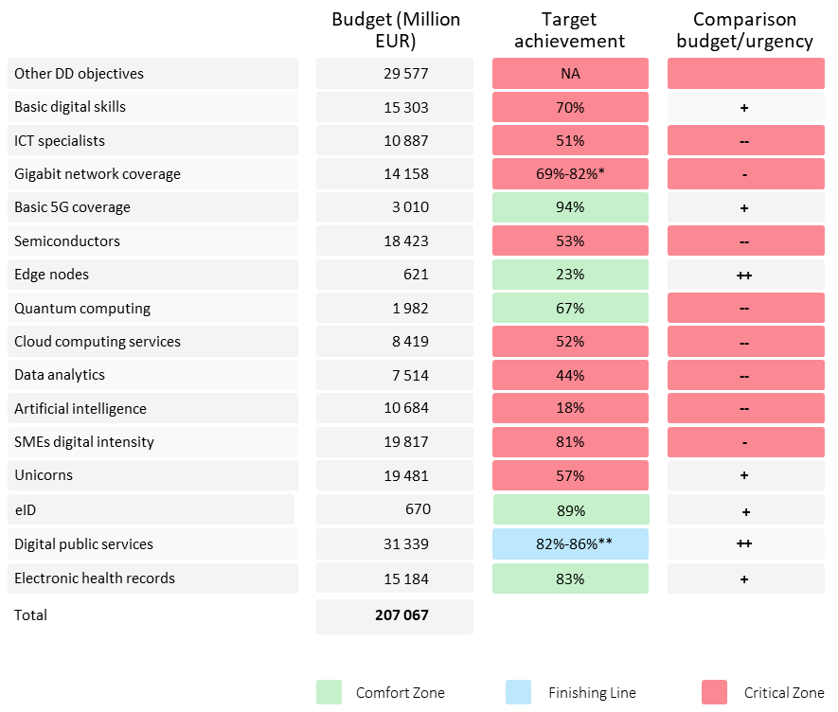
* 69% is referred to FTTP coverage; 82% to VHCN coverage.
** 82% is referred to digital public services for citizens; 86% to digital public services for businesses.

The report’s findings also underscore the need to establish a larger pool of public capital to leverage private investment in the European economy and reduce financing costs for European businesses. Decisive action is needed to significantly increase the funding opportunities for all EU businesses, from the start-up phase right through to more mature companies building on the recently adopted EU Startup and Scaleup Strategy. The main challenges to be addressed include the reinforcement and deployment of blended finance tools to de-risk private investment (e.g. InvestEU, expected to mobilise more than €372 billion of public and private investment through an EU budget guarantee of €26.2 billion), as well as the establishment of a Savings and Investments Union to scale private investment across borders, including through the simplification of Initial Public Offering (IPO) pathways and the unlocking of pension fund capital for digital investments, to accelerate scale-up trajectories.
Next to investments, reforms play a crucial role for the advancement towards the digital transition. The Recovery and Resilience Facility (RRF) was designed with this dual focus, supporting not only investments but also structural reforms, in connection with the European Semester. In the digital domain, on a total of about 2 500 milestones and targets, about 600 (24%) qualify as reforms. They include, for instance, reforms to facilitate network deployment, strengthen cybersecurity, to modernise labour market policies and education systems, or implement the once-only-principle.
In their national roadmaps, Member States were invited to also include 'regulatory and reform-oriented measures', but so far, they have provided little information on which roadmap measures qualify as reforms. As a first step, the relevance of reforms is reflected in the recommendations issued in this report at both horizontal (please see Annex 1) and Member State level, such as establishing enabling framework conditions and ecosystems that support commercialisation and technology transfer, in the area of digitalising SMEs and start-ups as well as the uptake of advanced technologies.
Finally, the Technical Support Instrument (TSI) has provided targeted expertise and capacity-building assistance to Member States in designing and implementing reforms, including in the area of digital. For instance, with the 2025 flagship ‘ComPAct - Capacity for Europe’s Digital Decade’, public administrations in the Member States get support in creating the technological foundations for data-driven policies that integrate interoperability and AI technologies.
3. Addressing digital weaknesses and excessive dependencies
While global access to innovative and affordable technology, infrastructure and services is vital for EU competitiveness, the EU’s reliance on foreign digital technologies, infrastructure and services exposes it to several risks. While digitalisation is a driver of innovation, productivity and global competitiveness, persistent strategic dependencies threaten the EU’s economic security and technological sovereignty. Excessive dependencies are particularly acute in the areas of semiconductors, cloud and data infrastructure and cybersecurity technologies.
The EU still lacks a significant domestic semiconductor manufacturing capacity. It lacks capacity to manufacture advanced node fabrication (below 10nm), essential for both civilian and military applications. This capacity is mainly concentrated in East Asia and in the US: 80% of the EU companies’ suppliers are headquartered outside the EU, with 35% located in the US, 12.4% in Taiwan, 11.7% in China or Hong Kong and 10% in South Korea. In the event of geopolitical turmoil in East Asia affecting Taiwan – currently producing over 90% of the world’s most advanced chips – particularly with the intention of controlling its semiconductor industry (most notably TSMC, the world’s most advanced chipmaker), the consequences would be severe. Most European industries – from automotive to aerospace, from medical equipment to defence – would face critical production deadlocks.
Foundational AI model development is also dominated by the US, notably because of the US access to vast computing power through US hyperscalers who are also devolving much of their capital investments into cloud development. This situation presents several risks for the EU, starting with the lock-in of users to proprietary ecosystems, as well as the critical risk of EU user companies and citizens being exposed to the application of US laws such as the US Cloud Act. Currently, the largest EU cloud operator holds a mere 2% share of the EU market. This trend is expected to persist, with US hyperscalers projected to drive 65% of data centre demand in Europe by 2028. Cybersecurity technologies taken up in Europe often originate from outside the EU, potentially exposing European networks to foreign influence or backdoor vulnerabilities.
Risks have also been identified in quantum technologies, particularly regarding the potential transfer of expertise through unmonitored foreign direct investment, talent poaching and collaborations lacking proper safeguards. On the other hand, it is also to be considered that the EU possesses significant strengths and leads in quantum science and research excellence, has a highly skilled workforce as well as one of the world's most dynamic startup ecosystems in quantum technologies. Initiatives such as Quantum Flagship, the Chips Joint Undertaking, and the new Quantum Pilot Lines also build on these strengths. Safeguarding these assets while fostering innovation remains a priority for sustaining Europe's competitiveness in this critical domain.
Europe is not yet harnessing the full power of open source - a public good that can be freely used, modified, and redistributed allowing all to use the technology at will - and the vibrant community of European open source developers, which could be an important avenue for tech sovereignty to reduce Europe’s dependencies from third countries. Digital dependencies and vulnerabilities relating to research security intersect with broader economic security concerns, especially in the current geopolitical context. Key risks include the weaponisation of dependencies and economic coercion for political leverage.
In addition to this, no pan-EU digital platform is today among the most visited in Europe and ‘European citizens are served mostly by non-EU commercial platforms’. These large platforms are often a gateway for a large number of business users to reach end users everywhere in the Union and control important ecosystems in the digital economy. Their position and the rules they set on their platforms can lead to unfair practices conditions for businesses using them, and harm users, as well as limit contestability and create an uneven playing field for other companies. Another concern in the digital landscape is the trade and exchange of illegal goods, services and content online, as well as the misuse of online services to amplify the spread of disinformation and for other harmful purposes. Modern connectivity is no longer a collection of separate technologies – satellites, submarine cables, mobile and fixed networks – but a deeply interconnected ecosystem. To respond to the growing demand for critical, low-latency applications - such as autonomous vehicles and remote surgery, increasingly higher amounts of data need to flow seamlessly across all these domains, as disruptions in one can affect the entire network’s performance and security. This will require in the near future a global approach ranging from orbital assets to terrestrial infrastructure, linking together in a unified, resilient, and globally optimised system. And for that we need to build the basis now, with full coverage of fibre and accelerated development of stand-alone 5G. The resilience and security of Europe’s connectivity infrastructure is increasingly challenged by the geopolitical and technological complexities of today’s digital landscape. The full implementation of the EU 5G Toolbox and the promotion of standalone 5G networks are essential for mitigating security risks associated with mobile connectivity. Furthermore, core infrastructures like submarine data cables remain vulnerable to physical sabotage, risks and challenges that are addressed by Cable Security Action Plan. In parallel, the EU’s autonomy in the field of communications is undermined by the EU’s heavy reliance on non-European satellite systems, a critical dependency starkly revealed during the war in Ukraine, when SpaceX threatened multiple time to interrupt the delivery of Starlink satellite services.
Finally, the risk of digital dependency is also critical in systemic sectors such as the financial sector. Today, the EU lacks a unified payment system, and while only seven countries of the Euro area have their own national payment systems, the EU as a whole relies heavily on international card schemes, representing over 64% of all card-initiated transactions in the euro area. In addition, mobile app payments, dominated by non-European tech firms (such as Apple Pay, Google Pay and PayPal), now account for nearly a tenth of retail transactions and are showing double-digit annual growth. These developments are exposing the EU to geopolitical and cybersecurity risks. The Commission’s legislative proposal on the digital euro, adopted in June 2023, continued its path of interinstitutional negotiations in 2024. The final decision on its issuance rests with the European Central Bank, following the conclusion of the legislative process.
4. Harnessing digitalisation for the EU’s defence capacity
Digital technologies are a cornerstone of the EU efforts to reinforce its security, strategic autonomy, and defence capabilities. By harnessing the potential of synergies between civilian and defence AI applications, the EU can unlock new opportunities for innovation, enhance Europe’s competitiveness and reinforce its strategic autonomy in this critical domain.
Robust and secure communication networks are essential for modern defence operations. Sovereign satellite communication infrastructure is vital for independent defence and crisis response. Integration of 5G and 6G technologies will further enhance secure, real-time operational capabilities across domains. In parallel, sovereign cloudified networks are critical to ensure that sensitive defence data is securely stored, processed, and protected within the EU jurisdiction. AI represents a transformative force in both civilian and military contexts as AI-enabled systems are key to accelerating threat detection, improving decision-making, and supporting autonomous operations.
Semiconductors underpin nearly all modern defence capabilities. As global supply chains remain vulnerable to geopolitical tensions, the Commission is committed to supporting a secure and sovereign European semiconductor ecosystem building on new five pilot lines with a total investment of EUR 3.7 billion, now able to also serve defence applications.

Figure 8: The increasing overlap between digital and defence policy areas
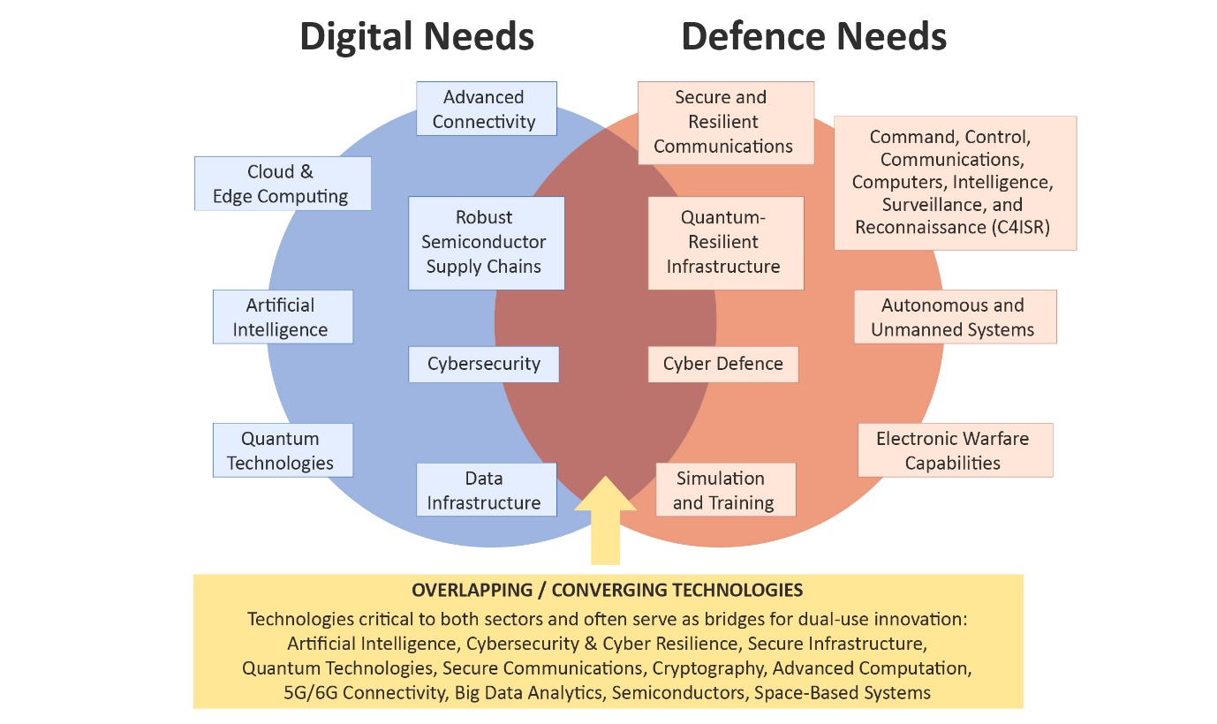
Quantum technologies will increasingly shape the future of secure communications, sensing, and computing. Through initiatives such as EuroQCS, EuroQCI, and the Quantum Flagship, the EU is investing in quantum computing for complex problem solving, ultra-secure communications, gravimetry sensors, and precise positioning, navigation and timing -to mention just a few that serve both defence and civilian applications and critical infrastructures.
The development and scale-up of dual-use start-ups and unicorns are essential to ensuring Europe’s long-term strategic competitiveness. However, a EUR 1.25 trillion defence investment gap since 2006 is indicative of chronic underinvestment, particularly for deep tech startups which includes an EUR 4 billion shortfall for SMEs, hindering innovation. Bridging this gap requires sustained investment, better integration of digital and defence strategies and targeted support for dual-use technologies and innovation ecosystems. Persistent barriers to private investment, including outdated exclusion policies, constraints related to Environmental, Social and Governance (ESG) standards, and a lack of defence-focused financial instruments have hindered the growth of digitally intensive SMEs and start-ups developing defence or dual solutions. About 40% of defence SMEs still face difficulties in accessing sources of financing, especially during the growth phase.
In conclusion, amid an evolving geopolitical landscape and the changing nature of warfare, the Commission’s efforts to integrate digital technologies into the defence ecosystem—and vice versa—are essential to strengthening the EU’s security, resilience, and technological leadership. Civilian-focused initiatives have laid important groundwork for harnessing advanced digital technologies such as AI, quantum computing, and semiconductors in support of defence capabilities. Nonetheless, key challenges persist, including the need for deeper policy integration, addressing digital infrastructure gaps, and accelerating innovation through targeted investment in dual-use technologies and enhanced coordination between digital and defence strategies.
5. International aspects of the Digital Decade
The digital transformation is reshaping economies and societies across Europe and globally, reinforcing the EU’s strategic interest in securing technological competitiveness as the foundation of long-term political sovereignty. Building on the EU’s strengths and internal policies and actions, the International Digital Strategy for the European Union seeks to (i) boost the EU’s tech competitiveness through economic and business cooperation with trusted partners (ii) promote a high level of security for the EU and its partners and (iii) shape global digital governance and standards in line with the EU values-based approach.
The Commission has continued to develop its network of Trade and Technology Councils (TTC) and Digital Partnerships. The EU has also expanded its growing portfolio of free trade agreements and digital trade agreements, which set high-standard digital trade rules and provide a platform for cooperation on digital trade issues. The Global Gateway strategy is playing a key role in promoting digital infrastructure investment, notably of secure 5G networks provided by trusted vendors and secure and resilient submarine cables. More broadly, the Global Gateway strategy is strengthening Europe’s role as a trusted partner in global connectivity. Additionally, the Commission is supporting digital transformation efforts in enlargement countries and the EU’s neighbourhood, while also engaging in multilateral forums to drive progress on key issues, such as the governance of AI (including the G7 Hiroshima AI Process and the Council of Europe Convention), Council of Europe Convention) or the promotion of secure and data protection compliant Digital Public Infrastructures (notably in the G20).
Finally, the Declaration on Digital Rights and Principles has had a significant impact on international discussions, serving as inspiration for several international declarations and contributing to the first comprehensive framework for global digital governance. By promoting its values and standards globally, the EU is helping to shape the future of the digital economy and ensure it is aligned with its strategic interests and values.
6. Conclusion
Amid intensifying geopolitical pressures, rapid technological change, and rising global competition, the Digital Decade anchors the EU’s resolve to shape a digital future rooted in technological sovereignty, competitiveness, innovation, sustainability and resilience.
As the EU reaches the pivotal midpoint of the Digital Decade, 2025 can be the moment when ambition turns into lasting impact. The choices made now will determine whether Europe completes its shift from a regulatory pioneer to a global leader in sovereign, secure, and ethical digital technologies. The report underlines the importance of responding with unity, determination, and sustained effort.
While the EU has sharpened its strategic focus and made real progress, major challenges continue to undermine the pace and resilience of its digital transformation. Skills shortages, infrastructure gaps – especially in connectivity and foundational technologies – and increased security and sovereignty concerns all demand urgent attention. Fragmented markets, overly complex regulations, possible tensions on energy capacity, and insufficient societal resilience and safeguards are also limiting the EU’s ability to scale innovation and unlock the full potential of its private capital.
The findings of this report highlight the importance of acting more consistently, focusing on these internal barriers and prioritising the acceleration of innovation cycles, the scaling of strategic technologies across the Single Market, and investment into the sovereignty and security of its digital ecosystem. In this regard, the National Roadmaps adopted by Member States mark a crucial turning point. Their success depends not only on ambition, but on coherent, long-term execution and alignment across all levels of governance. This also means making full use of the enabling instruments – from EDICs and the coming AI and Cloud Development Act, the EU Wallet, the GDPR, the DSA, DMA and AI Act – to the upcoming ‘28th Regime’ proposal – as well as better aligning investments with actual needs.
The stakes are high. Without decisive and further coordinated action, the EU risks missing out on substantial gains. According the EPRS study, an ambitious, coordinated policy could potentially increase the EU GDP by 1.84% compared to the baseline, based on increased productivity, more efficient public services, and a thriving innovation ecosystem. By turning its collective strengths into strategic advantage and sustaining coordinated action over time, Europe can not only meet the goals of the Digital Decade but lead the way in shaping a digital future grounded in resilience, trust, and shared prosperity.
Achieving this vision requires strong, collective ownership from all Member States, and cooperation with all parties involved, including cities, local and regional groups, to deliver digital policies that have tangible impact for citizens, businesses, and public services.
Considering the evidence presented in this report, the Commission will continue discussing with Member States, the European Parliament, and stakeholders on how to progress together, leveraging the Digital Decade’s governance mechanism, notably the Digital Decade Board. The report will also inform the co-operation with stakeholders and partners outside the EU.
As set out in the DDPP, the Commission will monitor and assess the implementation of these recommendations and report on the progress made in the State of the Digital Decade 2026. The Commission will also start preparing the review of the DDPP, planned by June 2026. This will provide an opportunity for a strategic reflection on the Digital Decade’s framework, objectives, and governance, to better address shifting geopolitical, technological, and societal realities.

See notably COM(2025) 30 final A Competitiveness Compass for the EU, as well as the 2024 Progress Report on the Implementation of the Strategic Compass for Security and Defence.
DECISION (EU) 2022/2481
A Competitiveness Compass for the EU, COM(2025) 30 final.
Please see the following page: https://digital-strategy.ec.europa.eu/en/policies/2025-state-digital-decade-package.
Daron Acemoglu and Simon Johnson, Power and Progress: Our Thousand-Year Struggle Over Technology and Prosperity (2023)
Dealroom.co. The 2025 European deep tech report, March 2025.
See Annex 1 to the Communication, related recommendations and Staff Working Document.
Eurobarometer Digital Decade 2025.
A Competitiveness Compass for the EU, COM(2025) 30 final.
Eurobarometer Digital Decade 2025.
The current KPI for the 5G target does not reflect the actual quality of service experienced by users. It monitors areas where a 5G signal is available, regardless of the network performance. Therefore, the current stage of 5G deployment can be considered only as ‘basic 5G’. Regarding quantum, data is based on: Strategic Advisory Board of the European Quantum Flagship, Key Performance Indicators for Quantum Technologies in Europe, , March 2025. Note that it is expected that six additional quantum computers will be deployed until the end of 2025 as several procurement procedures are currently ongoing.
No 2024 data is available for Cloud take-up, Data analytics take-up and Basic digital skills. The 2024 value of SMEs digital intensity is compared with the 2022 value. Full details on the KPIs in DESI 2025 Methodological note at https://digital-strategy.ec.europa.eu/en/policies/2025-state-digital-decade-package
Estimates at global level, on annual basis. Source: International Energy Agency, AI and Energy, April 2025.
McKinsey, AI power: Expanding data center capacity to meet growing demand, October 2024.
Digitalisation, environmental sustainability and resilience are mutually reinforcing transformations, as digital solutions could cut 15–20% of global greenhouse gas emissions by 2030 across sectors, notably through improved efficiency in buildings, energy, transport, and manufacturing sectors. Digitalisation can also help resource optimisation, water resilience, pollution and waste reduction as well as create new market opportunities for example through products meeting high eco-design standards or in boosting circularity.
When referring to national roadmaps, data used in this report are those declared by the Member States in their national roadmaps, on the basis of the Commission's guidance (C(2023) 4025 final). Data might reflect possible variations in reporting practices and methodological choices across Member States. No systematic assessment was made of the extent to which Member States followed the guidance.
Roadmap adjustments submitted by 31/03/2025 are taken into account. In accordance with Article 8 of the Decision (EU) 2022/2481, which establishes the Digital Decade Policy Programme 2030, Member States are required to submit adjustments to their national roadmaps to the Commission every two years, starting within 5 months of the publication of the second Report on the Digital Decade. If a Member State believes that no updates are necessary, it must provide a justification for this to the Commission.
Number of measures and budgets as reported by the Member States. The budget in the graph is split between targets and objectives, most of the budget (99.58%) is allocated towards the targets which are often related to some of the objectives. The budget breakdown shown for objectives (0.42%) only shows the breakdown of the budget allocated towards objectives that are not associated to the targets.
See SWD ‘Monitoring of the European Declaration on Digital Rights and Principles’.
See De Nigris, S., Kalpaka, A. and Nepelski, D., Characteristics and regional coverage of the European Digital Innovation Hubs network, Publications Office of the European Union, Luxembourg, 2023, doi:10.2760/590526, JRC134620, and European Commission: Joint Research Centre, Carpentier, E., D’Adda, D., Nepelski, D. and Stake, J., European Digital Innovation Hubs Network’s activities and customers, Publications Office of the European Union, Luxembourg, 2025, https://data.europa.eu/doi/10.2760/7784020, JRC140547.
A Competitiveness Compass for the EU, COM(2025) 30 final.
See European Parliamentary Research Service, Cost of Non-Europe in High-Tech Digital Innovation: Investment Needs and Economic Benefits, July 2024; European Central Bank, Mind the gap: Europe’s strategic investment needs and how to support them, ECB Blog by Othman Bouabdallah, Ettore Dorrucci, Lucia Hoendervangers and Carolin Nerlich, 27 June 2024; Draghi, M., The future of European competitiveness, 2024; World Economic Forum, Europe’s Digital Transformation: Time for Bold Action, July 2024.
European Parliamentary Research Service, Cost of Non-Europe in High-Tech Digital Innovation: Investment Needs and Economic Benefits, July 2024, pages 56-57 and 60-61.
What is the capital markets union? - European Commission.
EPRS (2024) estimates that around one fourth of the required HTDI investment would need to come from public sources. The study also provides an overview of other estimates for the public-private split from comparable analyses.
Other estimates concur, for example estimating that creation of sovereign, interoperable, and secure digital infrastructure stack alone would represent a total investment of EUR 300 billion over ten years (Bria, Timmers, Gernone, EuroStack – A European Alternative for Digital Sovereignty. Bertelsmann Stiftung, 2025EuroStack – A European Alternative for Digital Sovereignty, February 2025).
Public sector engagement with start-ups and SMEs to procure innovative solutions.
European Green Digital Coalition’s Net Climate Impact Assessment of digital solutions– www.greendigitalcoalition.eu
For connectivity infrastructure, the EU requires over EUR 200 billion by 2030 for gigabit connectivity and ‘full 5G’. White Paper, how to master Europe's digital infrastructure needs, COM(2024) 81 final.
These priorities are central in the context of the Competitiveness Compass (COM (2025) 30 final) and the Communication ‘Road to the next multi-annual financial framework’ (COM(2025) 46 final). Moreover, higher alignment between funding and key digital needs was advocated by a recent ECA report on the Recovery and Resilience Facility (ECA Special report 13/2025).
European Central Bank, Mind the gap: Europe’s strategic investment needs and how to support them, ECB Blog by Othman Bouabdallah, Ettore Dorrucci, Lucia Hoendervangers and Carolin Nerlich, 27 June 2024.
EIB, Investment Report 2024/2025: Innovation, integration and simplification in Europe, 2025.
Competitiveness Compass (COM (2025) 30 final).
Dealroom.co, Opening moves in global AI - AI, startups & venture capital, AI Action Summit, Paris, February 2025.
European Commission, European industrial technology roadmap for the next generation cloud-edge offering, 2021.
Data on budget in the first column are based on estimates by the Joint Research Centre (JRC) based on the mapping of five major programmes—RRF, CEF Digital, Horizon Europe, DIGITAL, and Cohesion Policy—and their contribution to the Digital Decade targets. Estimates are referred to the multi-annual financial framework 2021-2027, with the Recovery and Resilience Facility covering the period 2020-2026. Amounts should be regarded as broad estimates. See also Annex 1 to this Communication (section 5.b), and SWD ‘Digital Decade in 2025: progress and outlook’ (section 4.2.2). Source: European Commission: Joint Research Centre, Nepelski, D. and Torrecillas, J. Mapping EU level funding instruments 2021-2027 to Digital Decade targets – 2025 update, Publications Office of the European Union, Luxembourg, 2025, JRC141966.
COM(2025) 270 final Choose Europe to start and scale.
Savings and Investments Union A Strategy to Foster Citizens’ Wealth and Economic Competitiveness in the EU, COM(2025) 124 final.
The RRF regulation required that he recovery and resilience plan ‘contributes to effectively address all or a significant subset of challenges identified in the relevant country-specific recommendations’ (REGULATION (EU) 2021/241 establishing the Recovery and Resilience Facility, article 18.4).
Recovery and Resilience Facility Scoreboard.
Guidance to the Member States on the preparation of the national Digital Decade strategic roadmaps, C(2023) 4025 final.
IC Insights, McClean Report, May 2Q Update of The McClean Report 2022.
Ciani, A., Nardo, M., The position of the EU in the semiconductor value chain: evidence on trade, foreign acquisitions, and ownership, European Commission, Ispra, 2022, JRC129035.
McKinsey. The role of power in unlocking the European AI revolution, 2024.
According to Open Forum Europe, open-source software is estimated to contribute between EUR 65 to EUR 95 billion to the European Union’s GDP. Open-source software is today the basis for most software solutions, as open-source represents about 70% of all codes. But whilst Europe annually spends between EUR 10 and EUR 24 billion of public funds on software, only a minor fraction directly supports the European open-source industry, which comprises primarily of small and medium-sized enterprises (SMEs), start-ups, and individual developers (Blind, K.; Böhm, M., Grzegorzewska, P., Katz, A., Muto, S., Pätsch, S., Schubert, T. (2021). The impact of Open Source Software and Hardware on technological independence, competitiveness and innovation in the EU economy, Final Study Report. Brussels).
Draghi, M., The future of European competitiveness, 2024.
Statista, 2025 (Volume of data/information created, captured, copied, and consumed worldwide from 2010 to 2023, with forecasts from 2024 to 2028).
EU Action Plan on Cable Security, JOIN(2025) 9 final.
The digital euro: maintaining the autonomy of the monetary system, Keynote speech by Philip R. Lane, 2025.
Volume share of international card schemes in total electronically initiated card payments with cards issued in the euro area and transactions acquired worldwide for the first half of 2023. Based on data collected under Regulation (EU) No 1409/2013 of the European Central Bank on payments statistics (ECB/2013/43), as amended.
European Commission, Defence Investment Gaps Analysis and Way Forward, 2024.
Dealroom.co & NATO Innovation Fund, Defence, Security and Resilience in Europe: The state of startups and venture capital, February 2025.
European Commission, Report on “Access to equity financing for European defence SMEs”, November 2023.
An International Digital Strategy for the European Union, JOIN(2025) 140 final.
European Declaration on Digital Rights and Principles for the Digital Decade (2023/C 23/01).
The OECD Declaration on a Trusted, Sustainable and Inclusive Digital Future and discussions for a United Nations Global Digital Compact (GDC).
EPRS, Benefit of an EU strategic innovation agenda, Cost of Non Europe, 2025.

