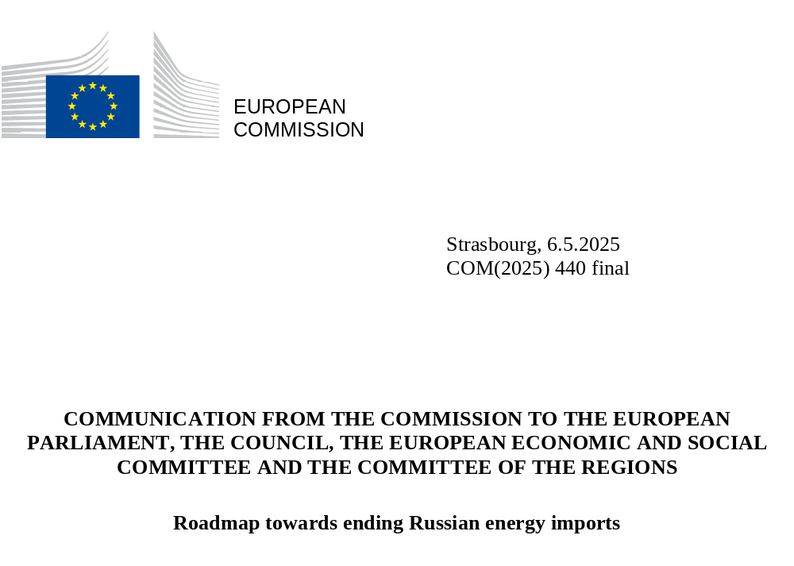

Introduction
In response to Russia’s aggression against Ukraine in February 2022 and in line with the Versailles Declaration of Heads of State and Government, the Commission launched the REPowerEU Plan in May 2022. The plan called for ending Europe’s dependency on Russian energy by enhancing energy efficiency and accelerating the deployment of renewable energy and diversifying supplies. Since then, additional renewable energy deployment and energy savings have enabled a reduction of more than 60 billion cubic meters (bcm) annually in gas imports between 2022 and 2024, which contributes to moving away from Russian gas.

Despite these efforts, in 2024, the EU still imported 52 bcm of Russian gas (32 bcm via pipeline and 20 bcm via liquified natural gas (LNG) or around 19% of total EU gas imports), as well as 13 million tonnes (MMt) of crude oil and more than 2800 tonnes of uranium in enriched or fuel form. Ten Member States imported Russian gas in 2024, three Member States still imported Russian oil and seven Member States imported enriched uranium or uranium services from Russia.

The dependency on Russian energy imports leads to serious security and economic risks for the Union and its Member States, as Russia has continuously used existing energy supply as a weapon to threaten the stability and prosperity of the Union.

This Roadmap outlines the EU’s strategy to phase out remaining Russian energy imports. It also sets out a common vision of Europe working together in solidarity to ensure alternative and affordable energy supplies for all Member States, while undertaking joint action to reduce Russian revenues, which fuel its war machine and endangers stability of the continent. Reducing dependency on fossil fuels will further strengthen EU energy security and sovereignty in line with EU climate neutrality objective.

The Roadmap is embedded in our strategy to boost the EU’s competitiveness, resilience and accelerate the clean energy transition. With the adoption of the Competitiveness Compass on 29 January 2025 the Commission set out a comprehensive and ambitious pathway to regain Europe's industrial edge. The Clean Industrial Deal, the Action Plan for Affordable Energy and Preparedness Union Strategy further reinforce this commitment. These initiatives recognise the negative impact of Russian energy imports on European economic security and competitiveness.

When combined with accelerated renewables deployment, including renewable gases, further electrification, energy efficiency and alternative supplies, the phasing out of Russian fuels will contribute to the objectives of the Clean Industrial Deal and the Action Plan for Affordable Energy. This Roadmap is without prejudice to possible future EU sanctions.

Actions undertaken to reduce dependency from Russian energy

The EU has already significantly reduced dependencies and energy imports from Russia, thanks to 16 sanction packages. Sanctions have effectively banned Russian coal and oil imports to the EU and prohibited the reloading of cargoes in EU ports carrying LNG from Russia. Particular attention should be brought to the issue of circumventing the EU oil sanctions by using “shadow fleets”.

The implementation of the REPowerEU Plan has also significantly contributed to reducing gas demand. The full implementation of the energy transition and the recent Action Plan for Affordable Energy are expected to replace up to 100 bcm of natural gas by 2030. This corresponds to saving the EU more than 15 bcm of gas per year, or a further reduction in gas demand by 40-50 bcm by 2027, which will also facilitate the phase out of Russian gas imports.

As a result of coordinated action between the Commission and Member States, and the enhanced EU energy diplomacy with international partners, gas imports (both LNG and pipeline) from Russia have decreased from 45% in 2021 to 19% in 2024. These imports have been replaced by supplies from more reliable sources, domestically produced energy and were possible through reduced consumption. Projections point to a further fall to 13% in 2025 with the end of the Ukraine transit. The share of Russian oil imports has also shrunk from 27% at the beginning of 2022 to 3% now. Despite significant progress, Russian gas, oil, and nuclear supplies remain part of the EU’s energy mix, posing risks to our economic security and allowing financial support to Russian war economy.

Building on the recent achievement of the Baltic States' synchronisation and the end of the Ukraine gas transit agreement, this Roadmap aims to further advance on the EU's independence from Russian energy by phasing out imports of gas, nuclear, and oil to reduce risks of weaponisation of energy supplies and prevent income to Russia’s budget from the EU.

The Commission and Member States worked closely together to ensure that security of supply would not be affected by the end of the Russian gas transit through Ukraine in December 2024. Although the impact has varied in different regions, overall security of supply and prices were not affected significantly EU wide. This shows that coordinated EU-wide preparatory actions, diversification efforts and a gradual approach in phasing out Russian imports are essential to preserve price stability, market predictability and security of supply in the EU.

Actions presented in this Roadmap should be implemented at EU level and in a coordinated manner, so they minimise the impact on energy prices, stabilise energy markets through secure and predictable alternative supplies and strive to provide legal certainty.

Need for action

2.1 Dependencies on Russian gas imports

Russia has repeatedly threatened the EU’s security of supply by unilaterally cutting gas flows to its European customers in 2006, 2009, 2014 and more recently in 2022 after its aggression against Ukraine, as well as in the run-up to the invasion. Phasing out Russian gas imports is therefore critical to bolster the EU’s energy security against weaponisation of energy imports. It would also reduce Russia’s revenues used to finance the unjustified war against Ukraine and to continue its military build-up.

Between 2021 and 2023, the EU reduced Russian gas imports by over 70%, from 150 bcm to 43 bcm. In 2024 this downward trend stopped and imports from Russia increased. LNG imports grew by 12% compared to 2023, from 18 bcm to 20 bcm and pipeline by 26% from 25 bcm to 32 bcm.

Several Member States have taken early actions to reduce or even ban Russian gas imports, including by terminating existing contracts with Russian gas suppliers. However, even after the end of Russian gas transit through Ukraine in 2025, Russian gas still represents around 13% of the EU’s overall gas imports. Currently, around two thirds of Russian gas imports are supplied based on long-term contracts, with EU destination, while around one third is provided on spot (short-term) basis. Remaining volumes are not expected to be eliminated without further European action given the absence of commercial incentives and ongoing long-term contracts.

Action at EU level is needed to phase out those gas supplies and at the same time ensure alternative supplies from international partners via LNG or pipeline gas, without creating new dependencies. In this context it will be important that infrastructure capacity booked on a long-term basis for Russian imports is made available to imports of gas from alternative sources. The EU has already significantly supported diversification efforts with EUR 184.7 billion to energy-related initiatives under the national Recovery and Resilience Plans and Connecting Europe Facility-Energy (CEF) with EUR 5.84 billion (2021-2027) financing cross-border infrastructure and EUR 55 billion with budget from EU cohesion policy.

Despite advancing the energy transition, gas will remain part of the EU’s energy mix for the coming decades. To ensure stable supplies, measures aimed at phasing out Russian gas should be accompanied by efforts to diversify the EU’s supply portfolio. This could be achieved through joint actions including demand aggregation at the EU level and by engaging in competitively priced long-term supply arrangements with alternative suppliers, where appropriate. The upcoming New Pact for the Mediterranean and the Trans-Mediterranean Energy Initiative in particular will provide concrete opportunities to further strengthen diversification of energy supplies.

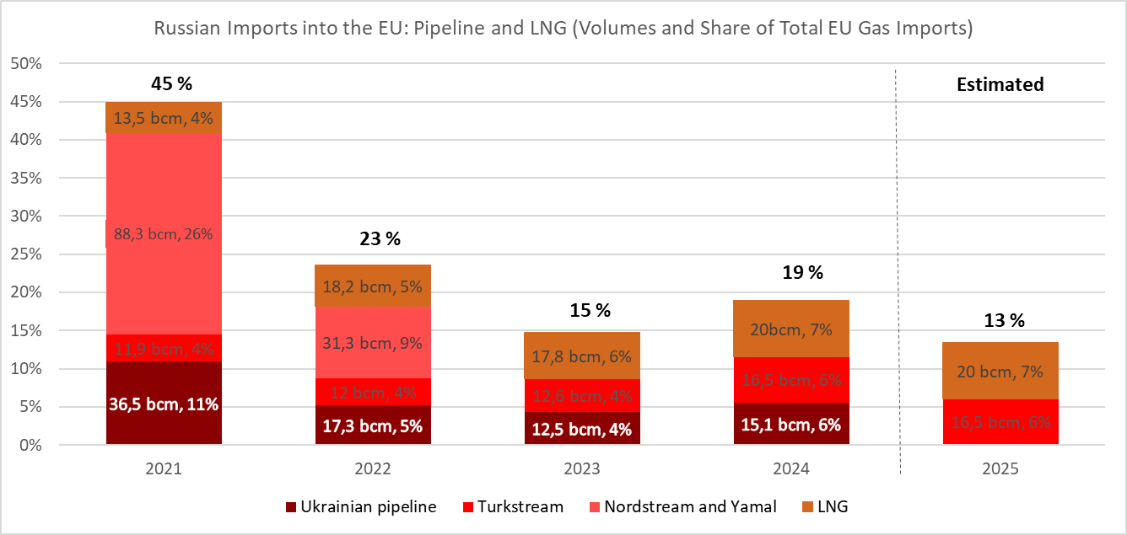
Diversification efforts should not be compromised by arrangements involving swaps, i.e. purchases of de facto Russian gas from third parties. These practices would contradict the objectives of REPowerEU, as they would maintain the revenue flows to Russia and keep the EU’s vulnerability to price manipulation.
2.2 Dependencies on Russia in the nuclear sector

In contrast to dependencies in the gas sector, dependencies in the nuclear sector are multi-facetted. Russia supplies products and services to EU customers across the whole nuclear fuel cycle. The dependency is most significant in the five Member States with Russian-designed reactors, also known as VVER, reliant traditionally on fuel from a Russian supplier. Likewise, other Member States have been relying on Russia for nuclear materials, spare parts or nuclear fuel cycle services. Russia also holds a strong position in the supply of certain radioisotopes for medical procedures.

2.2.1 Replacing Russian nuclear fuels with alternative suppliers in five Member States with Russian-designed nuclear reactors

Progress has been made in replacing Russian nuclear fuel with fuel from other producers in the five Member States with Russian-designed VVER reactors. Utilities in four out of five Member States concerned have since 2022 signed supply contracts for alternative fuel. Still, alternative fuel needs to be tested and licensed in each Member State before it can replace Russian fuel. In 2024, first test fuel assemblies were loaded in reactors in Bulgaria and Finland. The EU is also financially supporting the development of alternative fuels through its SAVE and APIS projects. A security of supply risks may arise in the short to medium term in the case of sudden policy changes.

The development of alternative nuclear fuels for VVER reactors and their licensing need to be accelerated and contracting with alternative suppliers should progress quickly towards a complete replacement of Russian supplies. Important lessons can be drawn from the experience in Ukraine where progress is also being made in using non-Russian alternative fuels including their experience with nuclear safety related licencing and fuel testing.

2.2.2 Diversifying supplies and building alternative capacity in nuclear fuel cycle for all Member States with nuclear installations

While more than 14% of uranium was sourced in the EU from Russia in 2024, the global market in natural and processed uranium is rather diversified. A major hurdle is the concentration of uranium conversion and enrichment services – needed to transform processed uranium into the material for nuclear fuel manufacturing – in a limited number of companies. Those located in the EU or other Western countries are currently not able to meet overall demand due to limited capacity of conversion and enrichment plants in operation. In 2024, around 23% of the whole EU demand for uranium conversion services was satisfied from Russia and in uranium enrichment services Russia covered almost 24% of EU needs.

While European enrichment companies have announced plans to extend their current enrichment capacity, the first new enrichment installation is not expected earlier than 2027. Moreover, the global uranium conversion industry is facing obstacles in ramping up production due to technological complexity and market uncertainties, and new conversion capacities are currently announced only for early 2030s. The EU’s nuclear sector also continues to rely on Russia for some spare parts and maintenance services. Continued international cooperation such as that in the G7 context is essential for ensuring sufficient enrichment and conversion capacity as well as spare parts and services in the years to come. The Commission’s review of the approach to enriched uranium supplies will also support strengthening security of supply and openness to reliable suppliers.

Finally, there is significant dependence on Russia for certain stable radioisotopes used to produce medical radioisotopes for cancer treatment and the EU needs to increase efforts to develop EU production of such medical radioisotopes for the benefit of all Member States. In particular, it will be important to strengthen the radioisotopes supply chain by securing access to source materials, enhance the industrial-scale production of radioisotopes, and support research and innovation into novel nuclear medicine therapies.

2.3 Dependencies on Russia in the oil sector

In 2022, Russian crude oil accounted for 27% of EU crude oil imports while now it only accounts for 3%. This is a direct consequence of the introduction and effective enforcement of EU sanctions, which banned Russian seaborne imports of crude oil from December 2022 and refined petroleum products from February 2023.

Nevertheless, Russian pipeline oil accounted for an important share of the total imports for Czechia, Slovakia and Hungary at the end of 2024, which currently have temporary exemptions from the EU sanctions regime.

With the completion of the TAL-PLUS project in April 2025, Czechia is now able to replace its Russian oil supplies with alternative sources. For Slovakia and Hungary on the other hand, Russian oil represents over 80% of their total oil imports. This high dependency can pose a risk for their security of supply. The Commission continues supporting these Member States to progressively replace Russian oil and ensure alternative suppliers through the Adria pipeline.

Russia has relied on a shadow fleet of tankers to maintain its oil exports and circumvent sanctions. These vessels are often old, in bad shape, with obscure ownership and insurance. They therefore present a tangible risk for the environment due to the risk of oil spills and other ship source pollution, which can cause environmental disasters. The EU has sanctioned specific ships, carried out extensive diplomatic outreach to flag and port states, and reinforced maritime safety obligations, in particular, through joint action by the Nordic-Baltic 8++ countries.

Further work and actions would be necessary to disrupt and deter Russia’s shadow fleet while enhancing environmental protection, maritime safety and security, and reduce funding for Russia’s war economy.

Actions to phase out energy imports from Russia

3.1 Pipeline gas and LNG

Action 1: Transparency, monitoring and traceability

Transparency, monitoring and traceability are the necessary starting point for action to effectively phase out Russian gas and to ensure enforcement. Existing EU legislation already contributed to more transparency and traceability of gas imports to the EU, but the information is not granular enough:

- EU rules require Member States to report certain gas contract details to the Commission, such as long-term contracts covering gas of Russian origin. These are shared per Member State without disclosing the identity of the counterparts of individual contracts. Whole contracts can only be requested in specific circumstances.

- In line with EU legislation, some information on imported gas is communicated to customs authorities when entering the Union Customs Territory. However, there is no obligation to report to national authorities responsible for energy policy.

While some Member States have national rules regarding traceability of Russian gas in place, there is no coherent EU framework on transparency, monitoring and traceability of Russian gas imports to the EU.

Therefore, the Commission will propose measures necessary for more effective monitoring and traceability. One measure would require companies to provide information on Russian gas contracts (e.g. volumes, duration) to Member States’ relevant authorities and to the Commission. Another action would ensure that information on actual imports of Russian gas is shared among customs, national energy and security authorities, and the Commission.

These measures would give governments and the Commission access to relevant information on Russian gas entering their energy systems, allowing the implementation of EU-wide targeted and effective measures and prepare alternative supplies. With this information the Commission would also be better equipped to coordinate EU-wide actions for a phase out across the European Union and prepare for alternative supplies.

To achieve this, the Commission intends to present by next month a legislative proposal on rules for increased transparency, monitoring and traceability of Russian gas. With a view to enhance security of supply and preparedness, the Commission aims to include similar transparency requirements, for all gas imports to the EU in the future revision of the energy security architecture in 2026.

Action 2: National plans to support EU action to phase out Russian gas

A well prepared, orderly and secure phase out of Russian gas in the EU minimises the impact on prices, markets and security of supply. The Commission intends to propose legislation requiring Member States to plan and monitor the EU-wide phase out of Russian gas.

National plans should, inter alia, lay out:

- the volume of Russian gas imports under existing contracts, including for contracts with take-or-pay clauses;
- a timeline, including milestones supporting EU measures to achieve the objective of phasing out Russian gas;
- diversification options and technical capabilities to replace Russian gas, including through cooperation in existing regional groups.

The Commission will support Member States in the preparation of the plans, through established working and coordination groups, such as the Gas Coordination Group, or a dedicated subgroup as well as regional groups.

The Commission intends to present a legislative proposal next month on national plans for the phase out of Russian gas, and recommends that Member States already submit their first national plans by the end of 2025 to allow for a secure, coordinated and well-prepared phase out.

Action 3: Stepwise prohibition of Russian gas imports

Building on joint European preparations, the assessment of the impact of the measures carried out by the Commission since the Versailles Declaration, including effects on gas security of supply, market, prices and legal aspects (including contracts), the Commission intends to propose legal measures for the effective phase out of gas imports from Russia.

Provided the phase out is gradual and alternative supplies are ensured, the prohibition of Russian gas imports is expected to have a limited impact on prices and on security of supply in Member States for the following reasons:

- The implementation of EU energy targets and supportive regulatory frameworks will accelerate the deployment of renewable energy and energy efficiency across the EU. It is estimated that the EU can save more than 15 bcm of gas per year, reducing the EU overall gas demand by 40-50 bcm by 2027.

- Additional global LNG supply is expected to become available in the coming years improving the global market balance, according to the International Energy Agency (IEA). While global LNG markets will remain tight in 2025, new LNG capacities of 85-90 bcm are forecast for end 2026, in particular from the US, Canada, Qatar and African countries. This is expected to outweigh the projected increase in the global demand. By 2030, global LNG export capacity is set to grow by about 250 bcm, an increase of almost 50% compared to the existing LNG supply.

- Member States are well equipped to receive LNG supplies from global partners due to coordinated efforts and investments at the onset of the energy crisis. Between 2022 and 2024 a record of twelve new LNG terminals and six expansion projects were commissioned, adding 70 bcm of LNG import capacity to the EU. These include LNG terminals in Alexandroupolis (Greece), Ravenna (Italy), Krk (Croatia), Swinoujscie (Poland) and Wilhelmshaven 2, Mukran, Stade and Lubmin (Germany). As a result, the EU’s total LNG import capacity amounts to approximately 250 bcm per year, more than twice the current LNG imports.

- More gas volumes will also become available in the coming years in Central and South-East Europe, a region traditionally dependent on Russian pipeline supplies. As of 2027 the Neptun Deep offshore gas field in Romania is expected to produce 8 bcm of natural gas per year in the first 10 years of its operation. From 2026, the capacity of the Trans Adriatic Pipeline will be expanded by 1.2 bcm allowing increased gas imports from Azerbaijan.

- The gas infrastructure in the EU is sufficiently flexible, with alternative routes and cross-border interconnection points enabling all Member States to access LNG and pipeline imports from non-Russian sources. Since 2022, Member States have developed key infrastructure, and additional ones will be finalised by the end of 2028.

Around two thirds of the Russian LNG and pipeline gas imports are based on existing long-term contracts with EU destination. The remaining volumes are supplied on short-term (spot) basis, with importers deciding on purchases based on their needs and prevailing market conditions. With longer contract duration and higher volumes in the existing long-term contacts than the volumes typically purchased in spot supply contracts, it is appropriate to organise the phase out of Russian gas imports in two steps, starting immediately with all new contracts and existing spot (short-term) contracts.

A phased approach to eliminating Russian gas imports would allow markets to better adjust and minimise market impact and potential implications for security of supply.

The Commission will ensure that the measures to eliminate Russian gas imports will be designed in a manner that minimises economic impact on market actors and is in full compliance with EU law and obligations under international law.

  - Prohibition of imports under new contracts and existing spot contracts on Russian gas
Since spot contracts concern a less significant part of the overall Russian volumes and involve short-term deliveries, phasing out the corresponding volumes is possible within a relatively shorter timeframe. The Commission intends to present a legal proposal next month to ban all imports under new Russian gas contracts and existing spot contracts. Such prohibition should take effect by the end of 2025 at the latest.

- Prohibition of imports of Russian gas under existing long-term contracts
The Commission intends to propose next month measures to ban the remaining imports of Russian gas, both pipeline and LNG, i.e. the volumes imported under existing long-term contracts. The necessary phase out of these imports requires a longer transition time due to the larger volumes for affected importers. Such prohibition should take effect no later than the end of 2027.
The Commission will involve concerned Member States and ensure that the proposal will be based on an adequate assessment of legal and economic impacts.

Impact of phase out of Russian gas

Since the beginning of the crisis the EU has been increasingly reliant on LNG, which played a fundamental role in replacing Russian gas imports and currently accounts for about 40% of the EU imports. As a result, the EU gas prices are now more exposed to the dynamics of LNG markets which are global in scope.
As of 2025, the LNG global supply is set to grow at increasingly high pace, with 25-30 bcm of additional capacity in 2025, around 60 bcm in 2026, around 80 bcm in 2027, and around 40 bcm in 2028.This will increase the total LNG capacity by about 200 bcm by 2028, five times more than the EU imports of Russian gas (IEA (January 2025) “Gas Market Report, Q1-2025). According to the IEA (IEA (October 2024) ‘World Energy Outlook 2024’), this will determine a surplus of at least 130 bcm of LNG by 2030 (see graph below) and this is set to ‘depress international gas prices’.
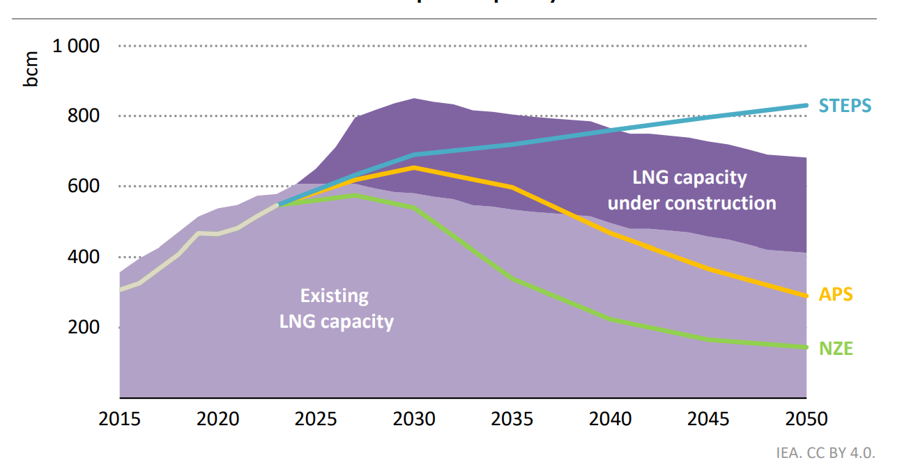

Source: Figure 4.7 – World Energy Outlook 2024
Note: STEPS, APS and NZE reflect demand projections under different scenarios.

While some uncertainty remains about the timing for the new LNG projects to become operational, if implemented in alignment with global market developments and reliable suppliers, the phase out of Russian gas imports is expected to have limited impact on European energy prices and security of supply.
In view of the expected deployment of new liquefaction capacity, it is sensible to start with spot supplies (around one third of overall Russian imports). The additional expected export capacity available globally by 2026 (+85-90 bcm/y) should be largely sufficient to compensate for the spot volume that the EU would no longer source from Russia. Moreover, large part of the EU’s Russian spot supply is LNG and its removal would likely lead to a reshuffling of LNG trades between regions with no significant alteration of the supply available globally.

As the global balance improves (+165-170 bcm/y of new liquefaction capacity by 2027) and more domestic production becomes available in the EU (Neptun Deep field), the EU could safely complete the phase out of the remaining Russian gas currently under long-term contracts (20-25 bcm/y). A longer lead-time would also enable European buyers to rearrange existing contracts and, if required, to sign new contracts for alternative supplies.

Action 4: Supporting diversification by demand aggregation and better use of infrastructure

Securing alternative supplies from reliable partners is critical to limiting any market or security of supply impact. For example, Norway, the EU’s largest gas supplier, as well as Romania and Greece, can help diversification in Central and Eastern Europe, traditionally dominated by Russian gas, through the Baltic Pipe and the Trans-Balkan pipeline respectively. The Commission will continue its discussions with reliable suppliers and will substantially step up its energy cooperation with partner countries in the Middle East, Northern Africa, around the Black Sea, and through the Global Gateway.

In parallel, alternatives to natural gas imports should continue to be developed where possible, notably via electrification or boosting the production of biogas and biomethane and clean hydrogen in line with REPowerEU.

During the crisis, AggregateEU has proven to be an effective tool contributing to the REPowerEU objectives by supporting European consumers and companies in procuring non-Russian gas. The second mid-term round of demand aggregation and matching under AggregateEU was completed on 26 March 2025 and gathered significant interest on both the demand and the supply side, with 29 bcm of demand, 31 bcm of supply offers and almost 20 bcm of matched supply-demand interests. It covered gas demand between 2025 and 2030 and allowed buyers to indicate a preferred terminal in the EU or deliveries free-on-board, providing buyers with additional flexibility.

Looking forward, options going beyond demand aggregation should be also explored in view of harnessing EU purchasing power to support its diversification efforts.

Based on the experience of AggregateEU, the Commission is evaluating the feasibility of a platform to support the scale-up and trade of gaseous molecules of non-fossil origin, including biomethane.

In addition, the Commission is working with the industry and other stakeholders to advance the deployment of sustainable biogas and biomethane. Considerable progress has been made since the adoption of the Biomethane Action Plan in 2022, including through the Biomethane Industrial Partnership. Building on the successful conclusion of the Biomethane Industrial Partnership, the Commission will set up a new biogas network of Member States as part of a tripartite contract to better address the diverging needs in different areas of the EU and include national and local stakeholders.

Given the specific challenges in Member States and Energy Community Contracting Parties in Central and South-East Europe (CESEC) in cross-border trade, the Commission will work under the CESEC High-Level Group, with the Energy Community Secretariat and with enlargement countries to maximise the use of existing infrastructure, aiming at removing regulatory and market barriers and to enhance diversification and assist candidate countries in shedding their dependencies on Russian energy imports.

3.2. Nuclear

Action 5: New restrictions to phase out Russian imports of uranium, enriched uranium and other nuclear materials

In contrast to dependencies in the gas sector, dependencies in the nuclear sector are multi-facetted and security of supply risks may still arise in the short to medium term in the case of sudden policy changes. Therefore, the purpose of this action is to support a gradual phasing out of the supply from Russia of uranium, enriched uranium and other nuclear materials, which are used for the manufacturing of fuel for European nuclear reactors, including by the Russian supplier of the fuel for Russian-designed VVER reactors.

- Measures on enriched uranium

The Commission will seek to make Russian imports of enriched uranium economically less viable by presenting, next month, trade measures on the import of enriched uranium. This will level the playing field and encourage political and business decisions in the relevant Member States to accelerate investment and capacity-building, develop an EU value chain and diversify away from Russia in a gradual manner, while allowing for supplies from other international partners.

- Restrictions on contracts co-signed by the Euratom Supply Agency

Next month the Commission intends also to restrict new supply contracts co-signed by the Euratom Supply Agency for uranium, enriched uranium and other nuclear materials with Russian suppliers as of a certain date. Deliveries based on existing contracts will continue but prolongations as well as new supply contracts would no longer be approved by the Euratom Supply Agency. This measure will strengthen long-term security of supply and predictability, and support European industrial and economic actors involved in nuclear fuel cycle activities by providing reassurance and predictability for investment decisions.

Action 6: Diversification obligation and transparency: national plans to phase out Russian nuclear supplies
The Commission will seek systematic action from Member States to phase out supplies of nuclear fuel, fuel services and spare parts from Russia and to replace them including, over time, with fully European alternatives. Member States will be required to develop national plans with concrete actions and timelines, and recommends that Member States already submit their first national plans by the end of 2025, aiming to provide reassurance and predictability to economic actors when taking investment decisions to make available sufficient uranium conversion and enrichment capacity.
Concretely, the Commission intends to propose, next month, a legislative proposal with specific targets for Member States to:
- Replace Russian nuclear fuels with alternative fuels by accelerating the contracting and licensing of such fuels and developing further fully European alternatives.
- Phase out reliance on Russia for uranium, enriched uranium and other nuclear materials.
- Increase transparency on dependencies and encourage diversification of Russian supplies of spare parts and maintenance services.

The Commission and the Euratom Supply Agency will continue their engagement and dialogue with the five affected Member States and stakeholders in the nuclear sector to ensure good coordination and monitoring of progress of diversification efforts.

Action 7: Ramping-up EU production: Proposal for a European Radioisotopes Valley Initiative (ERVI)

The Commission intends to propose the creation of an EU structure - a European Radioisotopes Valley - to secure EU supply of medical radioisotopes through increased own production, reduce EU dependency on foreign suppliers, in particular Russia, and increase the resilience of the European supply chain, taking into account different needs of Member States.
Impact of phase out of Russian nuclear imports
While diversification efforts might create uranium and fuel price volatility over access to uranium supply on global markets, major impacts on electricity prices are unlikely as the price of nuclear fuel and related services represent only a small portion of the final cost of electricity from nuclear power plants.
In the short term, certain security of supply risks related to nuclear supplies from Russia remain. However, the following factors are expected to mitigate these risks:
- the Member States operating VVER nuclear reactors have stockpiles of nuclear fuel covering their needs for the next few years;
- fuels from alternative suppliers can be both available and licensed in the near term, before the stockpiles are used up;
- additional nuclear fuel cycle services capacity is being built and should become available in the short- to medium term.
In addition to mitigate security of supply risks, the measures proposed will be carefully calibrated and gradually phased in to provide predictability to economic actors, create a nudging effect and avoid distortions in the market.

3.3 Oil

Action 8: National plans to phase out Russian oil and ensure alternative supplies

In line with the proposal for the preparation of national plans to phase out Russian gas, the Commission recommends that the two concerned Member States plan and monitor the phase out of oil imports from Russia. Sufficient infrastructure is available to replace such oil imports with non-Russian supply. Therefore, the Commission intends to propose an obligation requiring those Member States to establish such plan and its monitoring.

Member States concerned would be required to draft and submit to the Commission national plans outlining their strategies for replacing Russian oil imports by the end of 2027 with:

- a timeline, including milestones with corresponding measures, to achieve the objective of phasing out Russian oil;
- diversification options and technical capabilities to replace Russian oil;
- the volume of Russian oil imports under existing contracts, and their expiry.

Such plans could be included as a chapter in the national plans to phase out Russian gas.

Existing working and coordination groups, such as the Oil Coordination Group or dedicated subgroups, and regional groups will ensure coordination and support. The Commission encourages affected Member States to prioritise alternative supply infrastructure when available.

The Commission intends to present the legislative proposal next month on national plans to phase out remaining Russian oil imports and recommends that concerned Member States already submit their first national plans in by the end of 2025.

Action 9: Continue imposing and enforcing sanctions on entities and vessels suspected of illicit activities

To address the problem of circumvention of EU oil sanctions by using “shadow fleets”, the following actions are envisaged:
- Continue outreach and dialogue with concerned third countries.
- Work with international partners, including with the International Maritime Organization (IMO) to establish and uphold stringent maritime safety and security standards.
- Encourage Member States to enhance maritime surveillance, building on the integrated services hosted in the European Maritime Safety Agency, enabling:
  - Continuous monitoring and information sharing regarding vessels of interest to identify suspicious activity or behaviour;
  - enhanced deterrence of illegal maritime activities and enforcement international maritime law.
- High Representative will explore with the Member States the deployment of an EU Common Security and Defence Policy mission with a view to:
  - Conducting surveillance, continuous monitoring of maritime activities to identify suspicious vessels or behaviours;
  - Deterring illegal maritime activities;
- Enforcing international maritime law, including through requesting the Flag State of a suspicious vessel, or its master, that the vessel enters the territorial sea of a State, where that coastal State may take all necessary measures in accordance with UNCLOS and its domestic law.
- Boarding and inspecting vessels of interest in the high seas or in the exclusive economic zones of the EU Member States, where allowed under UNCLOS or after obtaining the consent of the Flag State to that effect.
- Conclude agreements with concerned Flag States to secure their consent for pre-authorized boarding operations on the high seas or in the exclusive economic zones of EU Member States.

Conclusions
This Roadmap towards ending Russian energy imports aims at ensuring the EU's independence from Russian energy by gradual phasing out imports of gas, nuclear, and oil in an orderly, secure and well-prepared manner in line with EU climate neutrality objective.

It complements the EU’s strategic goals, as set out in the Competitiveness Compass for the EU, the Clean Industrial Deal and the Action Plan for Affordable Energy by reducing imports of fossil fuels from suppliers that create economic security concerns and accelerating the clean transition, moving away from fossil fuels.

The nine proposed measures in this Roadmap will effectively remove Russian energy from EU markets, without jeopardising security of supply while minimising the impact on prices and markets.

Delivering on the Roadmap will require strong commitment, solidarity, engagement and cooperation of all Member States, EU institutions and energy market actors.

The Commission will assess the impact of and closely monitor progress in the phase out of Russian energy imports and provide necessary support to all Member States in addressing any challenges they may face. These regular exchanges of information in existing coordination groups and regional cooperation groups will ensure that the EU stays on track to meet its objectives, while making any necessary adjustments in a timely and effective manner in light of security of supply and dynamic market developments.

COM(2022) 230 final
Eurostat natural gas statistics. Europe imported 273 bcm in 2024, compared to 334 bcm in 2022.
Natural uranium equivalent contained in the imported products.
Since April 2025 Czechia does not import Russian oil.
In 2024, the EU paid for Russian energy a total of EUR 23 billion, including EUR 1 billion on nuclear fuels. Source: COMEX.
Share of energy from renewable sources in the EU gross final consumption of energy target of at least 42.5% by 2030 but aiming at 45%.
16th sanction package adopted on 24 February, which includes a ban to temporary storage of Russian oil and targets the shadow fleet. EU adopts 16th sanctions package against Russia. Russian natural gas is not included in the sanctions packages; see also Timeline - EU sanctions against Russia - Consilium.
18% between August 2022 and January 2025.
Estimates based on the Commission's long-term CETO projections, adjusted for the recent developments in gas demand. The projections reflect the information and expectations currently available and as such they are subject to uncertainties related to unforeseeable developments of, for example, energy prices, geopolitical situation and technological advancements in clean technologies.
Transit agreement between Naftogaz and Gazprom.
Estonia, Lithuania, Latvia, Denmark, Finland, Sweden, Germany, Poland, Croatia, Malta, Ireland, Luxembourg, Austria and Czechia have prohibited or stopped gas supplies from Russia. Some Member States could, however, be indirectly supplied with gas of Russian origin through wholesale market purchases.
The Cohesion policy mid-term review proposal will broaden the possibilities to invest in energy transition, COM(2025) 123 final.
See projections Europe’s 2040 climate target SWD (2024) 63 final. By 2040, fossil fuel supply for energy use will decrease by more than 70% compared to today. More than half of all fossil fuels used in the EU in 2050 are used in the non-energy sector as feedstock for chemical processes (plastic, fertilisers, etc.). The phase out of fossil natural gas imports from Russia accelerates the transition trajectory. The consumption of natural gas, biomethane and biogas is estimated to approximately 105 – 155 Mtoe by 2040 (4.5 – 6.5 EJ). In 2050, the consumption of those gaseous fuels in the EU is still between 70 and 80 Mtoe for all scenarios (3.0 – 3.5 EJ).
For example: European or international hub prices, indices and benchmarks (TTF, Henri Hub, etc).
Bulgaria, Czechia, Finland, Hungary and Slovakia.
The EU is financially supporting the development of alternative fuels for VVER reactors by Westinghouse (APIS project) and Framatome (SAVE project) with grants amounting to 10 Mio EUR for each project (total of 20 Mio EUR) via the Euratom Research and Training Programme.
While more than 85% of uranium is produced in six countries (Kazakhstan, Canada, Australia, Namibia, Niger, and Russia), uranium mines currently operate in many countries and unmined deposits exist also in some EU Member States.
Market shares based on 2024 provisional data.
According to COMEXT information from 2024 and 2023.
The Nordic-Baltic 8 ++ countries include Denmark, Estonia, Finland, Germany, Iceland, Latvia, Lithuania, the Netherlands, Norway, Poland, Sweden and the United Kingdom.
Article 14 of Regulation (EU) 2017/1938.
Union Customs Code
E.g. in Spain, www.enagas.es
See for the proposed rules on the phase out under Action 3 below.
A take-or-pay contract is a type of agreement commonly used in the energy industry, particularly in gas sales. This contract stipulates that the buyer must either take delivery of a specified amount of gas or pay a predetermined penalty if they do not take the delivery.
Including the existing Renewable Energy Directive, the Hydrogen and Decarbonised Gas Market package, Energy Efficiency Directive, Electricity Market Design, Grids Action Plan, the Action Plan for Affordable Energy and the planned Electrification Action Plan.
Source: World Energy Outlook 2024 (IEA) and gas-market-report-q1-2025 (IEA).
See on Global Gateway: Global Gateway - European Commission
AggregateEU - European Commission
Central and South-Eastern Europe Energy Connectivity.
Energy Community.
See Article 52 in connection with Article 197 of the Euratom Treaty.

