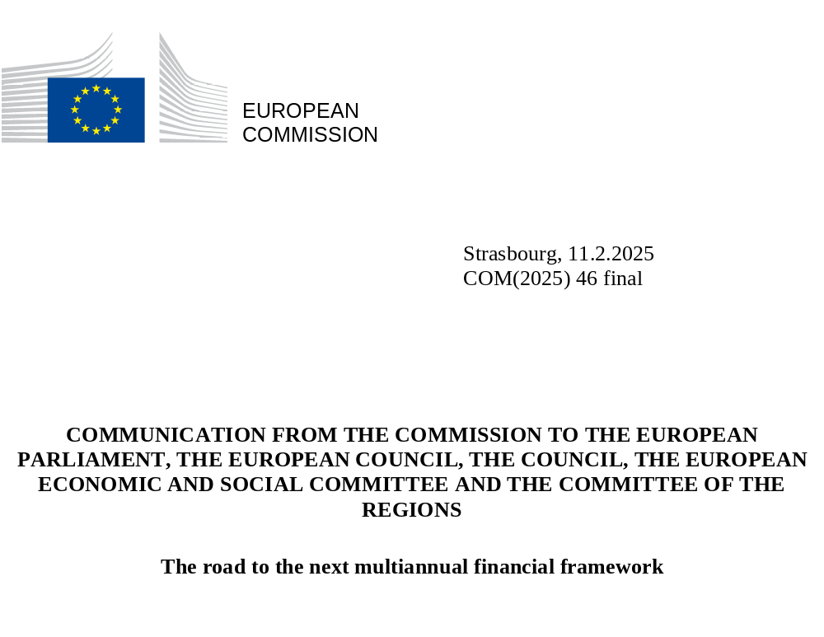

- INTRODUCTION: THE EU BUDGET AT THE CORE OF EU POLICY PRIORITIES
The EU budget is at the centre of the Union policy action. Over decades, it has contributed to improving the quality of life and the livelihoods of citizens, farmers, researchers, businesses and regions across Europe and beyond. It has shown its true worth in helping overcome a pandemic and energy crisis, saving millions of jobs during lockdowns, and investing in our clean and digital future. Looking back, when faced with one of the most significant crises of the past years, the COVID-19 pandemic and its fallout, the EU responded with NextGenerationEU and the 2021-27 multiannual financial framework. This paved the way for quick economic recovery, all while making Europe greener, more digital, and future-proof. As Russia’s war of aggression on the European borders called for quick action, to support Ukraine and address rising energy costs, the EU budget further proved its effectiveness.
The scale of the challenges faced in recent years required a commensurate and common EU response. Emerging political priorities were supported by sizeable spending, with expenditure dedicated to research, migration, defence and external action reaching the highest levels compared to previous multiannual budgets. For the first time, financing was provided at scale for reforms alongside investments – further increasing the impact of NextGenerationEU. Similarly, rule of law was brought to the forefront, through the general regime of conditionality protecting EU funds from breaches of the principles of the rule of law in the Member States.
However, the rise of new needs and emergencies and the increased calls for action at EU level, stretched the EU budget to its limits, requiring a mid-term revision in 2024. Strong and predictable support for Ukraine, reinforcement of migration and border management programmes, support for EU neighbouring partners and enlargement countries were geopolitical necessities; critical technologies required increased support. Volatile interest rates and rising financing costs required ad hoc solutions and increased flexibilities. The first-ever revision of the multiannual financial framework’s expenditure ceilings came with substantial redeployments and the creation of new special instruments.
Increasing expectations for EU action reflect the need to rethink the EU budget. The objective of a free, democratic, strong, secure, prosperous and competitive Europe outlined in the political guidelines of the new Commission and in the Strategic Agenda of the European Council for 2024-2029 need to be achieved in a very challenging geopolitical context. This will require a reformed and reinforced EU budget. Furthermore, the repayment of NextGenerationEU borrowing, which played a crucial role for the unified fiscal response to the crisis, will start in 2028. Such repayment will add to the financial needs of the next financial framework.
Europe needs to square the circle: there cannot be an EU budget fit for our ambitions and notably ensuring the reimbursement of NextGenerationEU, and, at the same time, stable national financial contributions without introducing new own resources. Choices need to be made.
This Communication outlines some of the key policy and budgetary challenges for the next financial framework, to launch a broad dialogue to help prepare the proposal for the next multiannual financial framework.

- POLICY CHALLENGES FOR THE NEXT MULTIANNUAL FINANCIAL FRAMEWORK
The future EU budget should focus on common challenges where spending at European level brings the highest added value. A broad agreement on ‘what’ to finance – that is, on the investment needs for the coming years – is a fundamental prerequisite to agree on ‘how’ to finance it – by mobilising private investments, through national budgets or through our common EU budget, and which tools to use in the latter.
European competitiveness is hindered by remaining barriers within the single market, unfair international competition, high energy prices, skills and labour shortage and difficulties for businesses in accessing the capital they need. The European economy has important strengths – an open economy, high market competition, a strong welfare model with low levels of inequality and high standards of governance, health, education and environmental protection, and a unique cultural richness. Some weaknesses are, however, becoming apparent. Public spending on research and innovation in Europe lacks scale – as only one tenth of it takes place at European level, and it is spread across many fields – and is insufficiently focused on breakthrough innovation. In 2023, expenditure for research and development in the EU stood at EUR 381 billion, or 2.22% of EU GDP, falling short of the 3% target. Likewise, EU companies spent around EUR 270 billion less in research and development than their US counterparts in 2021. The industrial structure is static: no EU company with a market capitalisation over EUR 100 billion has been set up in the last fifty years, while all six US companies with a valuation above EUR 1 trillion have been created in this period. The persistent gap in private financing for late-stage growth investment hinders the ability of EU companies to scale up. Europe is also suffering from skills gaps across the economy, reinforced by a declining labour force. Overall, Europe’s future competitiveness will depend on our ability to start a new age of invention and ingenuity, putting research and innovation, science and technology, at the centre of our economy.
The EU is facing rising security threats amid growing geopolitical tensions. The European Defence Technological and Industrial Base suffers from decades of underinvestment: between 1999 and 2021, EU combined defence spending has increased by 22%, against 66% in the US, 289% in Russia and 579% in China. Member States that are NATO members have committed to spending at least 2% of their GDP on defence, but not all have reached that target, while there are reflections on a higher target. Collaboration is also limited: Member States are still far from achieving the benchmark they set for themselves over 15 years ago to invest 35% together on European collaborative projects. Fragmentation along national borders, with limited cooperation and the associated duplications, harms competitive European defence companies and creates strategic dependencies. Stronger defence readiness, including through space assets, and military mobility is necessary both as a deterrent against future aggression and to support Ukraine towards peace. All this requires increasing and optimising financing for defence across the EU. As part of a true European Defence Union, Europe will need to spend more, spend better, and spend together. The Commission is going to present the White Paper on the Future of European Defence in March.
War, insecurity, poverty and a lack of opportunities contribute to displacement within, and irregular migration from, the EU’s Southern Neighbourhood to Europe. Europe has made a lot of progress in establishing a united approach to migration, asylum and borders, but migration will continue to be a challenge and delivering on it remains a priority for Europeans. Smuggling of migrants and trafficking of human beings yield criminal profits. The weaponisation of migration at the EU borders has illustrated new, hybrid forms of threats sowing discord and mistrust in European societies. The next long-term budget should therefore help address challenges related to migration, including effective protection of the EU external borders and comprehensive partnerships with countries of origin and transit. It should also support Member States to ensure they have the expertise, operational and financial capacity they need for the implementation of the new Pact on Migration and Asylum.
The success of the single market also hinges on its ability to benefit all European citizens and businesses. While regional and territorial disparities have been substantially reduced, including by EU cohesion policies, 29% of EU citizens still live in regions with a GDP per capita below 75% of the EU average and about 135 million people live in places which, in the last two decades, have slowly fallen behind. Small and medium-sized enterprises employ almost two thirds of the EU workforce and account for a bit more than half of its value-added, but many of them face barriers in accessing the Single Market, including complex bureaucratic procedures, high administrative burdens, and a lack of information and support services. Unlocking investment is necessary to ensure economic development across Europe, but reforms are also needed to remove obstacles to regional development, e.g. investment barriers, regulatory obstacles and weaknesses in the labour market and the business environment. We must reunite our society through education and investing in people.These challenges need to be addressed through a strengthened, modernised cohesion and growth policy, working in partnership with national, regional and local authorities.
Food security and nature protection sustain Europe’s quality of life but are facing specific difficulties. Farmers, fishers and rural areas are increasingly affected by unfair global competition, higher energy prices, a lack of younger farmers and fishers and difficulties in accessing capital. Despite the substantial support from the Common Agricultural Policy, the agricultural income per worker remains volatile and significantly below the average wage in the EU economy (60% in 2023). For small-scale coastal fisheries, the average wage in 2021 was about half of the economy average wage. With only 6.5% of farmers under the age of 35 in 2020, EU agriculture is ageing. Around EUR 62 billion would be required to close the investment gap in the agricultural sector and deliver on its digital, green and energy transitions. Moreover, climate change is increasing the food system’s exposure to risks. Building on the recommendations from the Strategic Dialogue on the Future of Agriculture and the forthcoming Vision for Agriculture and Food, a Common Agricultural Policy that is fit for purpose must provide targeted support to farmers who need it most, promote positive environmental and social outcomes through rewards and incentives for ecosystem services and support the right enabling conditions for thriving rural areas. It must become simpler, targeted and find the right balance between incentives, investment and regulation, and ensure that farmers have a fair and sufficient income.
More frequent and dramatic climate-related disasters come with a heavy social and economic toll. The average cost of natural disasters doubled from EUR 8 billion annually in the 1980s to EUR 16 billion in the last decade. In 2021 and 2022, the costs exceeded EUR 50 billion each year and they reached EUR 40 billion in 2023, the hottest year on record worldwide. According to the 2024 European Climate Risk Assessment Report, cumulated economic losses could reach EUR 175 billion (i.e. about 1.4% of EU GDP) under a 3°C warming scenario. Also, in light of these risks, the European Court of Auditors has recommended future-proofing EU funding for climate adaptation. This will require stepping up work on climate and water resilience and preparedness: while pursuing our Green Deal objectives as part of our economic growth strategy, preparing for growing climate risks will need to be an overarching objective for EU action, both internally and externally.
The global political and economic landscape poses challenges of unprecedented magnitude. Russia’s war of aggression against Ukraine has brought war back to the European continent. Europe’s financial, political and military support for Ukraine must be sustained for as long as it takes and is an investment in European security. The situation in the Middle East is leading to instability across the region and further humanitarian needs. Growing unfair competition and more aggressive economic and geopolitical stance have undermined the global multilateral system reflecting a shift from cooperation to competition and rising conflicts. Less than 20% of the Sustainable Development Goals targets are on track, with a persistent investment gap in developing countries. Humanitarian needs continue to rise: in 2024, EUR 45 billion are needed globally for humanitarian assistance, more than double compared to 2019. A European foreign policy with more targeted and impactful financing for our partners and better alignment with the EU’s strategic interests is required for mutually beneficial partnerships.
Enlargement is a political and geostrategic imperative. Accession to the EU will always be a merit-based process – and each candidate will be assessed on its own progress towards meeting all criteria. The EU will need to step up support to prepare candidate countries, through investment and reforms, to their perspective membership. GDP per capita of the Western Balkans, Ukraine, Moldova and Georgia remains around or below 50% of that of the EU, and the pace of achieving convergence is slow. Ukraine will need the support of the EU and its allies to withstand Russia’s brutal aggression and weather its economic fallout. There are significant socio-economic, political and security advantages of a bigger and stronger Union.
The scale of the challenges ahead thus calls for an ambitious budget, both in size and design.

- ‘EUROPE’S CHOICE’ FOR A SIMPLER, MORE FOCUSED AND MORE IMPACTFUL BUDGET
A more focused EU budget
The ongoing implementation of the current financial framework provides some lessons on how to increase the EU budget’s agility and better align it with our priorities and objectives. Flexibility is key in guaranteeing the budget’s ability to respond to a changing reality. However, this is not possible if EU funds are nearly all pre-programmed from the startmore than 90% of the 2021-2027 multiannual financial framework and NextGenerationEU are pre-allocated for specific purposes, programmes or national envelopes. As a result, evolving needs and crises since 2021 have been addressed by repurposing and reallocating existing funds, in sometimes lengthy procedures, as well as creating new ad hoc funds, programmes, or measures, further compounding the issue of scattering of EU funding. Greater focus and simplification are needed from the start to maximise the impact of EU funding, at a time of reflection on the future financial framework.
The EU’s response to the economic fallout of Russia’s war of aggression against Ukraine provides an example of how a framework aligning our policy objectives with our spending priorities strengthens the impact of common EU action. When Russia’s war of aggression against Ukraine led to a sharp increase in energy prices, the need to further reduce reliance on fossil fuels and accelerate deployment of renewable energy heightened. Through the European Semester framework, a dedicated recommendation was addressed to all Member States, which they were then able to implement through new REPowerEU chapters in the Recovery and Resilience Plans, including with additional EU funds. Our joint action allowed to reduce gas consumption by 18% between August 2022 and March 2024, overcome our dependency on Russian fossil fuels, ensured access to affordable energy and increased the production of energy from renewable sources.
Further efforts are needed to achieve a true policy-based budget to ensure synergies between our policies and the financial action of the Union. The EU budget remains too much driven by the structures of spending programmes rather than by policies. As a result, financing of the current EU policy priorities is often scattered across sometimes overlapping programmes. There is room to reinforce the link between overall policy coordination and the EU budget, through a new steering mechanism linking EU priorities with the EU budget. Concerning competitiveness, the Competitiveness Coordination Tool, together with a streamlined European Semester focused on reforms and investments at national level, will form part of a coherent and lean steering mechanism to inform decisions on investments and reforms at EU and national level. More broadly, the way EU policies inform and support the budgetary priorities could be improved, to ensure that the EU budget supports European public goods, notably cross-border projects.
Greater coherence in the financing of internal and external policies is crucial to better promote the Union’s strategic interests. The complementarity with Member States’ external action requires coordination to maximise the effectiveness and visibility of European global investment and cooperation. For this reason, when the COVID-19 pandemic hit, ‘Team Europe’ was put in place to ensure a co-ordinated and comprehensive global response by the EU, its Member States and European public financial institutions. Since then, the ‘Team Europe’ approach has become the backbone of EU financing for international cooperation. The Global Gateway initiative follows this approach, joining forces to identify common interests and lead a new wave of infrastructural investment around the world. At the same time, external action financing also covers a wide range of areas with significant internal and external policy interlinkages - from overall trade policy to materials, energy, climate, migration. Reviewing and scaling up best practices and the most efficient tools will help deliver on EU strategic and economic security interests and strengthen mutually beneficial partnerships, in Europe’s neighbourhood and beyond.
A simpler EU budget
Access to EU funding is hampered by the existing complexity. While the number of spending programmes has to some extent already been reduced at the beginning of the current period, there are still over 50 spending programmes in the budget and other programmes outside of it While this illustrates the large scope of EU funding, it increases the risk of overlaps and reduces the impact and transparency while possibly leaving gaps due to the lack of comprehensive and coordinated funding approaches for cross-cutting priorities such as competitiveness. In the EU, ‘weaknesses along the “innovation lifecycle” (…) prevent new sectors and challengers from emerging, [and] begin with obstacles in the pipeline from innovation to commercialisation’. This includes gaps in the support from the EU budget, as it does not provide seamless financing from research to innovation through development and deployment. This fragmentation, coupled with complexity and rigidities, weighs on the effectiveness of EU funding.
Beneficiaries have difficulties in navigating the multiplicity of rules and criteria, despite the simplification measures introduced in the current financial framework. Different eligibility rules, application processes, co-financing rates, as well as multiple entry points for potential applicants put at risk the speed and quality of implementation and stakeholder involvement. They may also undermine the achievement of EU objectives, if they are inconsistent. Responding to a call for proposals to access EU funds can be complex, and particularly burdensome for Small and Medium Enterprises. There are today more than 30 tools providing technical assistance and support options, with scope for simplification and eliminating overlaps. Moreover, the more complex the rules are, the higher the risk of spending errors. A true single point of entry for beneficiaries to all EU funding and advisory services in the next financial framework could facilitate access for beneficiaries.
The fragmentation of the financial landscape also translates into too many programming documents, which are resource-intensive for all administrations involved and cause delays. The current financial framework includes over 10 pre-allocated funds that require a separate planning and programming efforts. This creates a heavy administrative burden for managing authorities and project promoters at the start of each financial period and leads to a substantial lag between the preparation of the financial framework and implementation on the ground. This has been the case also in the 2021-2027 programming period, where the late adoption of the sectoral legislation and the lengthy process to adopt programming documents led to delays in implementation. For instance, the operational programmes of Cohesion policy funds were only adopted by mid-2022.
Due to the late adoption of operational programmes and the coexistence of several funds like the Just Transition Fund and the Recovery and Resilience Facility, with the latter having a tighter timeframe, and the fact that national authorities focused first on completing the implementation of the funds under the 2014-2020 multiannual framework under the ‘n+3’ rule, less than 7% of the 2021-27 allocation had been paid out, of which more than half is pre-financing.
Programming under external action financing, in particular for NDICI - Global Europe, also lasted up to three years.
The slow implementation of some programmes on the ground results in higher outstanding commitments or “Reste à liquider” (Figure 1) and higher risk of decommitments, and may result in inefficiencies, as the policy priorities have shifted when there is a significant lag of several years between the priority setting, the programming and the actual implementation of the investments.

Figure 1. Outstanding commitments of the EU budget
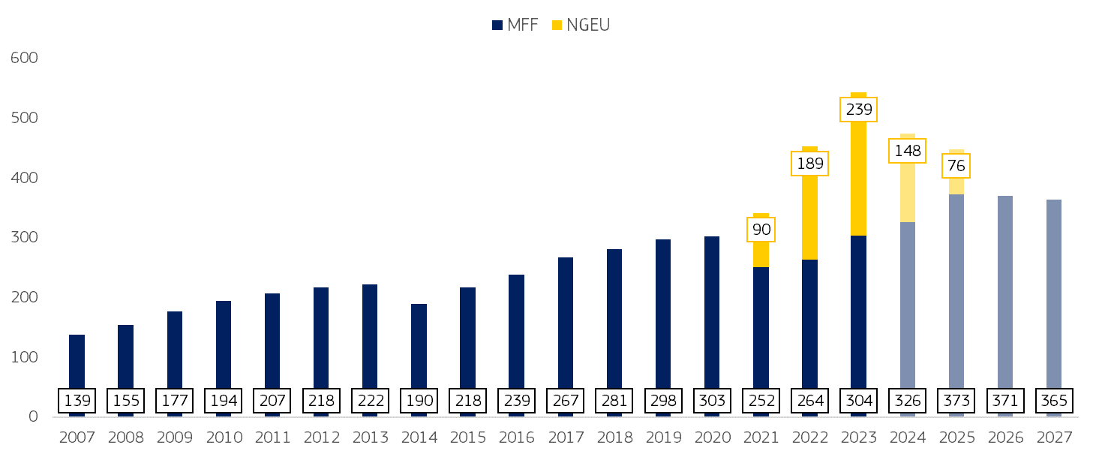
Note: EUR, current prices, rounded to the nearest billion. Years 2024-2027 correspond to the long-term payments forecast.

An EU budget with greater impact
The EU budget leverages the overall financial capacity of the Union. The broader financial architecture of EU spending programmes includes loans, guarantees and financial instruments backed by the EU budget, and mobilises co-financing from Member States and beneficiaries. Through InvestEU and the European Innovation Council, the EU budget de-risks innovative projects and crowds in private sector investments. 95% of project promoters reported that their projects would have either not proceeded at all or not as planned without InvestEU financing. Moreover, 58% of project promoters felt that the InvestEU guaranteed financing had impacted other financiers or investors’ decisions to commit to the project.
However, unlocking private investments is still proving challenging in the current long-term budget. There is room to optimise the risk-absorbing capacity of the EU budget to maximise the impact of public resources. For instance, higher provisioning is necessary to support sectors that face more difficulties in accessing market financing, e.g. high-risk sectors, or niche ones like biodiversity or social products. This could be counterbalanced by other lower provisioning products. The capacity of the EU budget to mobilise private investment through risk-sharing instruments is hampered by limited appetite for risk as implementing partners remain mostly focused on relatively low-risk investment. It has proven challenging to support defence-related projects with InvestEU in the current multiannual budget due to the internal rules of the implementing partners. Moreover, the InvestEU budget had a substantial top-up from NextGenerationEU. Due to the NextGenerationEU tighter deadlines, approvals were heavily frontloaded, exhausting the availabilities for many financial products. As a result, new approvals for some financial products notably in high-risk areas will cease after 2025. The use of funding sources different from bank financing is still below potential: for instance, EU venture capital is underdeveloped, with funds raising just 5% of global venture capital versus 52% in the US. Completing the Capital Markets Union will be crucial to attract private investments. At the same time, the EU budget can complement and mobilise private investments thus making it easier for commercial banks, investors and venture capital to finance fast-growing companies and address barriers that restrict the amount of European capital available to finance innovation. The EU needs to make better use of its budget to de-risk and leverage further national, private and institutional financing.
Financing the green, digital and social transition will require maximising public investment and leveraging private capital. Investing to achieve the EU’s decarbonisation goals and removing barriers to our Energy Union offers the opportunity for Europe to lower energy prices, increase its energy security and take the lead in clean technologies. Reaching this goal will require streamlining EU financing for clean technologies, concentrating on the technologies where the EU has an advantage and strong potential for growth. In addition, EU financial support currently excludes operating costs, where cost gaps are greatest. Fragmentation of the Single Market and of financing opportunities hinders the possibility for innovative companies to scale up, and this is especially the case for young, innovative tech companies. The failure to capitalise on the digital revolution is one of the factors hampering our competitiveness and will require substantial investments to keep pace with Europe’s main competitors: achieving sufficient scale in the support strategic projects will thus be crucial to fill Europe’s innovation gap. In this respect, the European Investment Fund can step in to further finance high-potential and fast-growing European companies. Overall, there is further scope for increasing the additionality of EU spending to ensure that the EU budget focuses on investments which would not have materialised otherwise.
A stronger focus on performance has helped aligning EU policy objectives and EU spending. Some programmes have moved from payments based on the reimbursement of costs to delivery models that are more focused on objectives and results to be achieved. This is not only the case for the Recovery and Resilience Facility – a large-scale programme where payments depend on the satisfactory fulfilment of pre-defined objectives – but also for other programmes such as the Ukraine Facility and the Western Balkans Growth Facility. Other mechanisms have been used to improve the performance of EU spending, such as financing not linked to costs, and strategic planning. For example, a stronger performance orientation in the Common Agricultural Policy was achieved through national Strategic Plans shaped around national needs and capabilities, which also link all interventions with indicators allowing to assess the progress of Member States in reaching their objectives. However, this has not yet removed excessive complexity at the level of individual farmers. Concerning cohesion, the Council underlined the need to reflect on how to make cohesion policy more performance-based with a view to enhancing its efficiency, building on its own experiences as well as lessons learned from other EU instruments, and on its strengths – shared management, multi-level governance, place-based approach and partnership principle. The Fit-for-Future Platform opinions on the evaluation of the cohesion funds resulting from a consultation of the Committee of the Regions network of regional hubs have also called for more focus on performance.
A stronger focus on performance needs to come together with simplification and accountability. Performance-based approaches have important positive features related to efficiency and speed of implementation. At the same time, they have created entry costs for Member State administrations, with room for further administrative simplification. Moreover, important factors of accountability and traceability of the EU funds must be equally taken into consideration. In this regard, the European Court of Auditors has identified areas with scope for improvement,.
While the EU budget has contributed to promoting horizontal priorities such as climate action, biodiversity, and gender equality, and to developing a stronger performance framework, there is room for improvement. Despite the progress made to support horizontal priorities, there is scope to improve the consistency of how programmes integrate those priorities in their design. Moreover, the revised Financial Regulation requires that EU programmes take into account, wherever relevant and possible, the Do No Significant Harm Principle, working and employment conditions, and the principle of gender equality. Our performance framework is robust and ensures that programmes have meaningful indicators allowing to monitor EU spending and its results. However, the monitoring and reporting rules remain complex, with different methodologies and sets of indicators depending on the programmes.
A more flexible EU budget
The EU budget needs to balance predictability for long-term investments and flexibility to respond to crises. The EU budget is different from national budgets insofar as it is predominantly an investment budget subject to multiannual planning. At the same time, it requires flexibility to respond to unforeseen needs (e.g. large economic crises or natural disasters) or to finance new priorities in line with the rapidly evolving global landscape.
The inherent rigidities of the multiannual financial framework need to be smoothened. It has historically revolved above 1% of EU GNI, and currently, together with NextGenerationEU – 1.7% of EU GNI (Figure 2). Expenditure is locked for a period of 7 years in the current financial framework, which means a longtime lag between the moment of policy design and its implementation. Furthermore, expenditures are bound within annual overall limits as well as limits per main area of activity (headings and sub-headings) which are set at the beginning of the period and constrain the transfer of resources. With seven headings and two sub-headings, the current multiannual financial framework has the highest number of headings compared to the past.
Figure 2. The EU budget as a percentage of GNI
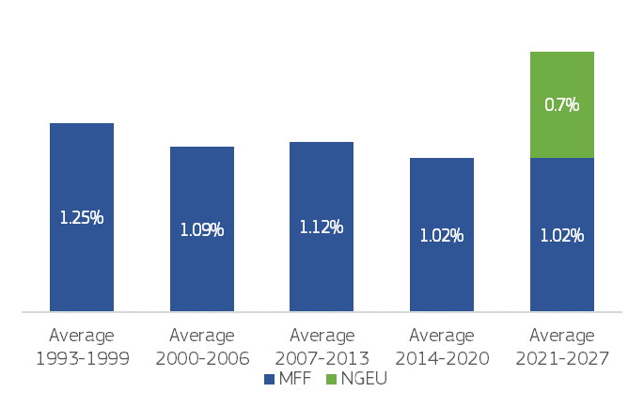

The current budget also has some in-built financial flexibilities, but these are limited in size and are often rigid in their use. Special instruments over and above the expenditure ceilings can help cater for unexpected needs. A few programmes have in-built flexibilities or cushions. Altogether, available flexibilities amounted to 3.65% of the overall ceilings at time of adoption of the multiannual financial framework. By the time of the mid-term revision of the financial framework, flexibilities in the EU budget were already depleted due to the size of the shocks they had to address, first and foremost the fallout of Russia’s war against Ukraine, but also natural disasters in the EU and beyond: the annual allocation of the Flexibility Instrument and the Solidarity and Emergency Aid Reserve had been fully mobilised in 2021-2022; 79% of the emerging challenges and priorities cushion and 75% of the unallocated margins for the whole period had been allocated. As a result, the Flexibility Instrument and the Solidarity and Emergency Aid Reserve had to be reinforced, and two new instruments, the EURI Instrument and the Ukraine Reserve, have been created to respond to unforeseen needs.
At the same time, the EU budget has been increasingly called to respond to unexpected needs, as the crises Europe faced have become larger, more complex and more frequent. Through its built-in flexibilities and re-programming, the EU has been able to provide liquidity to Member States in major recent crises, but it required ad hoc solutions. Cohesion policy, given its ability to deploy substantial means at regional and local level, was an important vehicle of EU’s response to the COVID-19 pandemic. It was then called again to respond to the fallout from Russia’s war of aggression in Ukraine (with the Cohesion’s Action for Refugees in Europe – CARE and FAST-CARE, as well as SAFE to support SMEs and vulnerable households facing high energy costs). When floods swept across Europe, increasing in intensity and size, current instruments and the current cohesion set-up was insufficient to address these urgent needs. The Commission therefore proposed to further amend existing cohesion policy rules with RESTORE, to allow for a more wide-ranging support for reconstruction efforts following natural disasters. While these ad hoc solutions have contributed to a strong European response, they were time-demanding, and provided a piecemeal response to repeated, large and symmetric shocks, while weighing on other objectives under cohesion policy.

A budget that delivers on EU priorities
Strong mechanisms are needed to guarantee that the funds deliver on EU policy priorities. All investments supported by the EU budget, whether implemented by the Commission or together with Member States and their regions, should contribute to these commonly agreed priorities.
Delivering on EU priorities must be done together – with Member States and their regions shaping many of the EU investments on the ground, and the EU budget supporting and incentivising their action. A greater focus on performance supports tangible results, by disbursing funds when the agreed objectives are demonstrably achieved. This, together with a common framework (e.g. do no significant harm principle, conditionality) helps strengthen our joint delivery on EU priorities.
Moreover, not a single euro should be spent for activities where the principles of the rule of law are not safeguarded or the protection of the financial interests of the EU not guaranteed. Rule of law and good governance are prerequisites to ensuring that funds are only used for their intended purpose. With the Conditionality Regulation, the Union has equipped itself with an effective instrument to protect the EU budget against breaches of the principles of the rule of law. The Recovery and Resilience Facility, together with the horizontal enabling condition under Cohesion Policy, has also demonstrated how the EU budget can promote reforms that strengthen the rule of law in the Member States. The Commission reporting on the rule of law has shown how Member States have made progress in recent years, but the nature and degree of challenges still vary across Member States. Remaining challenges include the perception of judicial independence, the efficiency of justice systems, access to justice, and the fight against conflicts of interest and corruption.
Respect for the rule of law cannot be taken for granted and should remain a must for EU funds. The next multiannual financial framework should include strong safeguards in that respect. While the general regime of conditionality applies to all of EU funding, there is still margin to strengthen the link between the recommendations in the Rule of Law Report and financial support under the EU budget, including for enlargement countries.

- THE FINANCING OF THE EU BUDGET
Modernising the revenue side of the EU Budget is necessary to address the following dilemma: repayment of NextGenerationEU – which the EU will always honour – alongside an EU budget fit for our ambitions cannot be squared with stable national financial contributions and the absence of new own resources.
With NextGenerationEU, the EU is now the fifth largest issuer in the European capital market, with high credit rating. During the 2021-2027 period, the Union budget is paying the associated interest costs. From the next financial framework, the budget will start to repay the principal (used for non-repayable support, up to EUR 357 billion). The principal will be fully repaid by 2058 in line with the Own Resources Decision. Assuming full disbursement of NextGenerationEU non-repayable support, linear repayments and based on current interest rates forecasts, to reimburse the principal and interest of NextGenerationEU debt, about EUR 25-30 billion per year may be needed over the next multiannual financial framework. This is almost 20% of the current annual budget. This is twice the annual budget for Horizon Europe, and twice the total amount of the budget for security and defence under the current multiannual budget for the whole 7 years. While funds are still being raised and the interest rate environment is changing, in all scenarios NextGenerationEU repayments will require significant funding in the future.
That is why in the Interinstitutional Agreement of 16 December 2020, the European Parliament, the Council and the Commission agreed on a roadmap towards the introduction of new own resources. The Commission has fulfilled its commitments: a comprehensive package on the next generation of own resources was presented in 2021 and adjusted in 2023, ahead of schedule. This includes revised proposals on the Emissions Trading System and Carbon Border Adjustment Mechanism and an own resource linked to company profits in the corporate sector. The Commission has also proposed an own resource based on Pillar 1 of the OECD/G20 agreement on the reform of the international tax framework.
The Commission calls on the Council to resume work on the issue of new own resources as a matter of urgency, in line with the Interinstitutional Agreement from 2020 and the Budapest Declaration on the New European Competitiveness Deal.

- THE STATUS QUO IS NOT AN OPTION
Europe is in an era of profound change – for our society and our security, our economy and our planet. The speed of change creates challenges which can only be solved through joint action in a united Europe. It is imperative that the next EU budget plays a central role in promoting the EU’s sustainable prosperity, strengthens defence and security, bolsters EU competitiveness, as well as social and territorial cohesion, supporting the EU on the way towards becoming the first climate-neutral continent in the world. The EU budget should continue improving the quality of life and the livelihoods of citizens, farmers, researchers, businesses and regions across Europe and beyond. Ensuring the EU’s prosperity, competitiveness, sovereignty, security, resilience, preparedness, and global influence, while upholding the highest standards on rule of law and democratic values. The EU budget supports all these priorities and will require a team effort by all institutions and stakeholders.
In light of the policy and budgetary challenges discussed in this Communication, for the EU budget to achieve these objectives, the status quo is not an option. The next long-term budget will have to address the complexities, weaknesses and rigidities that are currently present and maximise the impact of every euro it spends, focusing on EU priorities and objectives where the EU action is mostly needed. A new approach for a modern EU budget should present at its core:
- A plan for each country with key reforms and investments, and focusing on our joint priorities, including promoting economic, social and territorial cohesion. A strengthened cohesion and growth policy with regions at its centre must be designed and implemented in partnership with national, regional and local authorities.
- A European Competitiveness Fund establishing an investment capacity that will support strategic sectors and technologies critical to the EU competitiveness, including research and innovation, and Important Projects of Common European Interest. The Fund’s comprehensive architecture will allow it to accompany European projects along the entire investment journey, from research, through scale-up, industrial deployment, to manufacturing. It will also help to leverage and de-risk private investment.
- A revamped external action financing to make it more impactful and targeted for our partners, and more aligned with our strategic interests. This should contribute to a new foreign policy.
- Strong safeguards on the protection of the rule of law.
- Strengthened and modernised revenues, notably via new own resources, to ensure sufficient and sustainable financing for our common priorities.

- NEXT STEPS
Shaping the next long-term EU budget requires a shared analysis on the underlying challenges and close cooperation, in view of the preparation of the Commission proposal. A strong and effective EU Budget is a common interest. Therefore, the proposal for the next financial framework will build on a broad consultation, with input at political, institutional and stakeholder level, alongside with active citizens’ involvement.
Continued and structured dialogue with Member States’ representatives, at different levels, across Europe will be crucial to determine ‘what’ and ‘how’ to finance our joint future. Against this background, the Commission will engage at different levels in an inclusive process as part of its preparation for the next multiannual financial framework.
Comprehensive dialogue with stakeholders will support the preparation of the EU budget of the future. This includes a series of thematic public consultations launched today in preparation of the next generation of EU spending instruments. The launch of a citizens engagement platform will be a first step leading to a Citizens’ Panel on the future long-term budget, which will take place from March to May. The platform will invite citizens to join the debate. The Annual Budget Conference in May 2025 will be an opportunity to bring together the different views, in an inclusive and open debate, in preparation of an ambitious financial framework.
The European Parliament will be an important player in shaping the next long-term budget. In this regard, the Commission looks forward to the European Parliament’s forthcoming own initiative report. The involvement and input of other institutions and bodies, such as the European Court of Auditors, the Committee of the Regions and the European Economic and Social Committee, as well as implementing partners will also enrich the debate on the design of the future EU finances.
Against this backdrop and to allow for sufficient time for meaningful consultations of different stakeholders, the Commission intends to present the next financial framework in July 2025. The Commission proposal will ensure that the upcoming package constitutes a solid basis for a swift and timely agreement on the next financial framework well ahead of its start as of January 2028.
The next multiannual financial framework must lay the groundwork for a stronger and future-oriented Union.

Draghi, M. (2024), The future of European competitiveness. Part A – A competitiveness strategy for Europe.
Source: Eurostat. As a comparison, it is respectively 3.4% and 4.8% of GDP in Japan and South Korea.
Draghi, M. (2024), ibid.
European Investment Bank (2024). The scale-up gap: Financial market constraints holding back innovative firms in the European Union.
Letta, E. (2023), Much more than a market – Speed, security, solidarity. Empowering the Single Market to deliver a sustainable future and prosperity for all EU Citizens.
Total military expenditure, constant prices. Source: SIPRI Military Expenditure Database.
Niinistö, S. (2024) Safer Together: Strengthening Europe’s Civilian and Military Preparedness and Readiness.
Niinistö, S. (2024), ibid.
Letta, E. (2023), ibid.
Letta, E. (2023), ibid.
9th Cohesion Report, Highlights and policy takeaways, p. ix.
European Commission (2024) Strategic Dialogue on the future of EU Agriculture.
European Commission and European Investment Bank, 2023. Factsheet: Financing gap in the agriculture and the agri-food sectors in the EU.
Economic losses from weather- and climate-related extremes in Europe. EEA, Oct 2024.
European Court of Auditors, Climate adaptation in the EU – Action not keeping up with ambition, Special Report 2024/15.
United Nations (2024) The Sustainable Development Goals Report.
Ukraine’s economy has continued to show resilience but risks remain exceptionally high given uncertainty on the intensity and duration of the war, including from the continued attacks on energy infrastructure.; IMF, Press Release No. PR24/425.
European Commission (2023) Annual management and performance report for the EU budget, Financial year 2022. Volume 1, COM(2023) 401 final.
https://energy.ec.europa.eu/publications/repowereu-2-years_en
European Court of Auditors (2023). The EU’s financial landscape A patchwork construction requiring further simplification and accountability. ECA Special Report 05.
Draghi, M. (2024: 4). The Future of European Competitiveness, Part A: A competitiveness strategy for Europe.
For instance, several simplification measures have been introduced in cohesion policy funds, mainly via the Common Provision Regulation: sharp reduction of management verifications, “single audit principle”, proportionate arrangements for audits, extended possibility to use simplified cost options and financing not linked to costs schemes.
To that effect, the STEP portal provides a first albeit limited overview of calls for proposals, focusing on innovative technologies, both at Member State/regional level and for programmes directly managed at EU level.
The following programmes are nationally pre-allocated: Cohesion Fund, European Regional Development Fund, European Social Fund+, the Just Transition Fund, the Recovery and Resilience Facility, European Agricultural Guarantee Fund, European Agricultural Fund for Rural Development, European Maritime, Fisheries and Aquaculture Fund, Brexit Adjustment Reserve and, outside the EU budget or the multiannual financial framework, the Social Climate Fund (from 2026) and the Modernisation Fund.
Sectoral acts were adopted in June 2021 and Member States’ operational programmes in the second half of 2022. Despite Member States’ ambitious roadmaps envisaging submission of their programmes to the Commission for adoption by end-2020.
https://cohesiondata.ec.europa.eu/cohesion_overview/21-27.
See also COM(2024) 276 final. 26.6.2024.
Draghi, M. (2024), The future of European competitiveness. Part A – A competitiveness strategy for Europe.
SWD(2024) 229 final.
Draghi, M. (2024), The future of European competitiveness. Part A – A competitiveness strategy for Europe.
Amounts are calculated as an ex-ante approximation of the actual costs. This is a possibility for the cohesion policy funds and as a rule under the Recovery and Resilience Facility, the Social Climate Fund, the Ukraine Facility or the Western Balkans Growth Facility.
Council conclusions on the Communication on the 9th Cohesion Report, 5 June 2024.
Fit-for Future Platform opinions on the evaluation of the European Regional Development Fund, the Cohesion Fund and the Just Transition Fund and on the evaluation of the European Social Fund plus.
COM(2024) 82 final.
Special report 07/2023: Design of the Commission’s control system for the RRF.
Special report 26/2023: The Recovery and Resilience Facility’s performance monitoring framework – Measuring implementation progress but not sufficient to capture performance.
Limits apply to total annual expenditure but also to individual headings.
Integrated financial and accountability reporting. Overview : financial year 2023. Available at: https://op.europa.eu/publication-detail/-/publication/0f519222-47ed-11ef-aea6-01aa75ed71a1
These are: the ‘emergency and priorities cushion’ (EUR 9 billion for 2021-27) within the Neighbourhood, Development and International Cooperation Instrument, the agricultural reserve in the CAP (slightly less than EUR 500 million per year in 2021-2022 and at least EUR 450 million per year as of 2023); thematic facilities under the Asylum, Migration and Integration Fund, the Border Management and Visa Instrument and the Internal Security Fund.
Unallocated margins and thematic and non-thematic special instruments, as well as the emerging challenges and priorities cushion and the thematic facilities.
Through the Coronavirus Response Investment Initiative and the Coronavirus Response Investment Initiative Plus, as well as REACT-EU.
Regulation (EU) 2022/562 of the European Parliament and of the Council of 6 April 2022 amending Regulations (EU) No 1303/2013 and (EU) No 223/2014 as regards Cohesion’s Action for Refugees in Europe (CARE), OJ L 109, 8.4.2022, p. 1–5.
Regulation (EU) 2022/2039 of the European Parliament and of the Council of 19 October 2022 amending Regulations (EU) No 1303/2013 and (EU) 2021/1060 as regards additional flexibility to address the consequences of the military aggression of the Russian Federation FAST (Flexible Assistance for Territories) – CARE, OJ L 275, 25.10.2022, p. 23–29.
Supporting Affordable Energy measures under Cohesion policy, as part of REPowerEU. Regulation (EU) 2023/435 of the European Parliament and of the Council of 27 February 2023 amending Regulation (EU) 2021/241 as regards REPowerEU chapters in recovery and resilience plans and amending Regulations (EU) No 1303/2013, (EU) 2021/1060 and (EU) 2021/1755, and Directive 2003/87/EC, OJ L 63, 28.2.2023, p. 1–2.
Communication from the Commission to the European Parliament, the Council, the European Economic and Social Committee and the Committee of the Regions, 2024 Rule of Law Report - The rule of law situation in the European Union. COM(2024) 800 final.
Interinstitutional Agreement on budgetary discipline, on cooperation in budgetary matters and on sound financial management, as well as on new own resources, including a roadmap towards the introduction of new own resources, OJ L 433I, 22.12.2020, p. 28–46.
https://consilium.europa.eu/en/press/press-releases/2024/11/08/the-budapest-declaration/
Budapest Declaration on the New European Competitiveness Deal, 8 November 2024.

