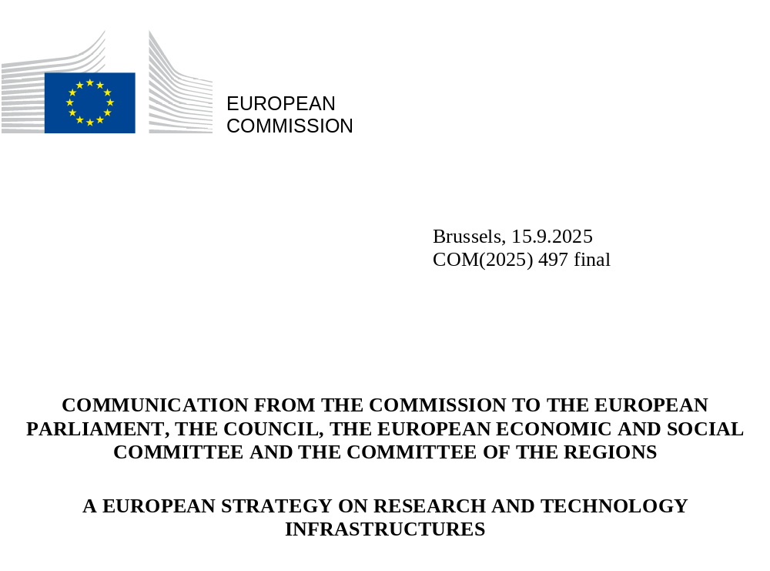

EUROPEAN STRATEGY ON RESEARCH AND TECHNOLOGY INFRASTRUCTURES

Rationale for a long-term strategy

Policy context
Europe’s world-class ecosystem of research and technology infrastructures is a unique asset that enables scientific progress, drives innovation, strengthens competitiveness and connects talent across borders. It is also a compelling reason to choose Europe for pursuing pioneering science and delivering groundbreaking innovation. But to stay ahead, this ecosystem must be continuously reinforced, while becoming ever more integrated and accessible.
The EU needs to invest boldly - on a scale and coherence not seen before - in new capacities for best-in-class research infrastructures, to consolidate Europe’s position as a global leader in science and innovation and attract top talent. In parallel, increased investment in strategically important technology infrastructures fit for driving EU’s competitiveness, resilience and technological sovereignty is needed to translate research into market-ready innovation. They are key for new strategic technologies to be developed and deployed in Europe. In particular, deep-tech startups and scaleups rely disproportionally on access to technology infrastructures to test and validate their innovative technologies.
This European strategy for research and technology infrastructures sets out a long-term vision to expand and strengthen this ecosystem, maximising its contribution to Europe’s scientific, technological and industrial future.
The strategy is in line with the high ambition for infrastructures of the proposal for Horizon Europe in the EU’s next Multiannual Financial Framework (2028-2034) as well as the proposal for the European Competitiveness Fund. It provides a comprehensive strategic framework for guiding the implementation of the relevant research and technology infrastructure actions.
This strategy supports the realisation of the ‘fifth freedom’ of the EU single market regarding the free circulation of researchers, scientific knowledge and technology in the European Research Area (ERA), promoting innovation and technological progress. It will help unlock the full potential of Europe’s leading role as a science powerhouse in various strategic sectors such as artificial intelligence (AI), life sciences, Earth observation, quantum technologies, fusion energy, biotechnology, clean and renewable energy technologies and advanced materials, as well as with the strategy to improve the framework conditions for start-ups and scale-ups in the EU.
As the EU strives to assert its global lead in the clean transition and bolster its competitiveness and strategic autonomy, it is imperative that research and innovation (R&I) efforts are strengthened — fully leveraging the potential of research and technology infrastructures to meet Europe’s target of investing 3% of GDP in research and development (R&D).
Research and technology infrastructures are also critical factors for closing Europe’s innovation gap with other world regions and countries, in line with the Draghi report and the Competitiveness Compass — providing the facilities where breakthrough ideas are developed, matured and transformed into market-ready solutions.
By leveraging their collective strengths and capabilities, these infrastructures have the potential to pool resources, share knowledge, and coordinate efforts across the wider European R&I ecosystem. As research infrastructures and technology infrastructures complement each other, we must adopt a more holistic ecosystem approach to the development of their capacities, to exploit synergies in their services and simplify access for users, in line with EU policy priorities. Such an approach would drive scientific excellence in frontier research, fuel deep tech innovation and revitalise strategic value chains. Europe must provide the capacities for innovative companies, including startups and scaleups, to access advanced facilities, validate technologies, develop corresponding standards and accelerate market entry. An ambitious, coordinated approach to infrastructures is essential to strengthen Europe's innovation fabric and economic security, empower its next generation of industrial champions, and secure a sustainable competitive edge in the global tech race.
Major powers are increasingly disengaging from international cooperation on R&I. Europe must assert and strengthen its position as a beacon of free and open excellent science building on its longstanding global leadership role as a research powerhouse. With a vast talent pool of over two million researchers, Europe is exceptionally well-placed to develop groundbreaking solutions for tomorrow’s world by investing in the R&D of global public goods, in areas such as public health and climate change. By investing strategically in research and technology infrastructures, Europe can cement its reputation as a champion of knowledge-driven progress, attracting global talent in support of the Choose Europe initiative. By building up new capacities, Europe will strengthen its role as a trusted partner for international cooperation, while reinforcing and protecting key assets for its future.

Landscape of European research and technology infrastructures
Research Infrastructures
For decades, Europe has been home to a constellation of world-class research infrastructures, from large single-sited facilities to distributed organisations collaborating across the continent. They form the foundation of Europe’s R&I ecosystem. They are the data producers for science, generating and managing vast amounts of reliable data that drive fundamental research and are indispensable for addressing global challenges such as tackling climate change, pandemic preparedness and combatting hybrid threats.
The primary purpose of research infrastructures is to pursue scientific excellence by ensuring that researchers have access to state-of-the-art equipment, laboratories, and digital resources, particularly those that would be too costly or complex for individual institutions to develop. They include, amongst others, major equipment or set of instruments, collections, archives and scientific data infrastructures, generally publicly owned and sustained.
Since the ERA was launched in 2000, over 60 new pan-European research infrastructures have been established—ranging from large-scale facilities like synchrotrons and lasers to distributed platforms in life sciences, energy, the environment, and the social sciences and humanities. Many operate as European Research Infrastructure Consortia (ERICs), a unique legal framework for research infrastructures of pan-European relevance.
Since 2002 the European landscape is governed by the European Strategy Forum on Research Infrastructures (ESFRI). The roadmaps and landscape analyses of ESFRI guide strategic investment, with the current roadmap representing over EUR 25 billion in investment and more than EUR 2 billion in annual operating costs. EU funding for 2021–2027 adds EUR 2.4 billion to support the scientific instrumentation, access, and design of new infrastructures. ESFRI’s recent analysis maps the ecosystem and identifies critical gaps, increasingly informing national strategies. The European Regional Development Fund has also played an important role in strengthening regional R&I capacity through research infrastructure investment.
However, as the landscape of research infrastructures grows, ensuring its coherence and long-term sustainability becomes more challenging, requiring a long-term strategic approach.
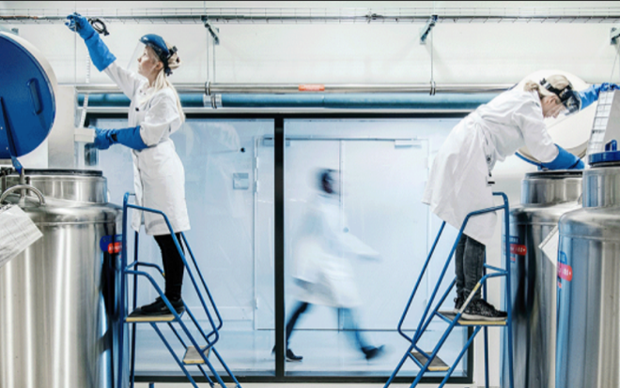
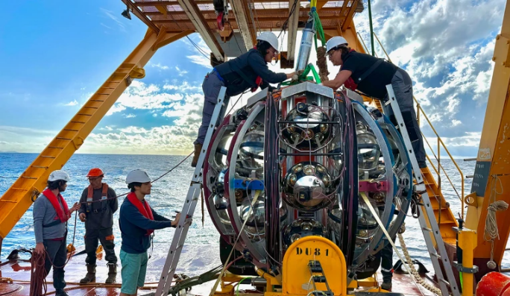
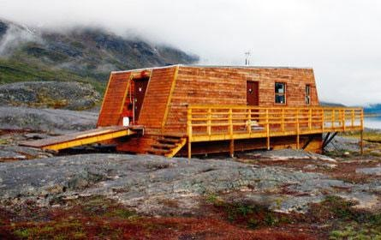
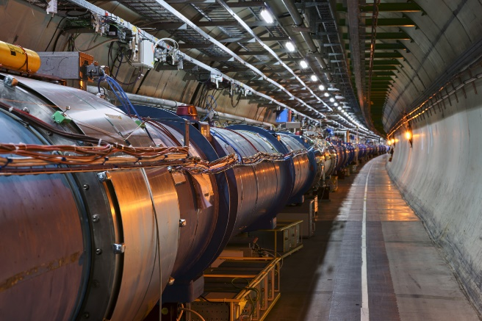
For more examples of pan-European infrastructures see: https://ri-portfolio.esfri.eu/
Examples of research infrastructures
BBMRI-ERIC hosts the world’s largest biobank of human samples. It collaborates with other large research infrastructures in the health domain, such as Euro-Bioimaging ERIC and Instruct ERIC supporting rapid response to global health challenges
The INTERACT research infrastructure network which spans 90 research stations facilitates international scientific collaboration in the strategically sensitive arctic region alongside a growing network of complementary facilities such as icebreaker research vessels and ice and sediment core repositories.
KM3NeT is a deep-sea telescope located 3.5 km beneath the Mediterranean Sea. It uses arrays of optical sensors suspended in seawater to detect high-energy cosmic neutrinos. In 2023, it detected the most energetic neutrino ever recorded, a milestone for fundamental physics.
CERN, the first European research infrastructure established in 1954, is the world’s leading laboratory for particle physics, where scientists from over 100 countries collaborate. It is also famously the birthplace of the World Wide Web.

Technology infrastructures
Alongside research infrastructures, an emerging landscape of technology infrastructures, both in the civilian and military domains, completes a range of facilities and services supporting technology development, testing, validation and scaleup, accelerating the market uptake of research results.
Technology infrastructures are facilities, equipment, capabilities and resources required to develop, test, upscale and validate technology. They include, amongst others, test beds, pilot lines, pilot plants and demonstration facilities, cleanrooms, and living labs. Their primary purpose is to enable and accelerate technological innovations towards societal/market adoption, boosting industrial competitiveness. The key added value of technology infrastructures lies in allowing companies to derisk their R&D&I investments before market introduction and to have ideas and concepts tested and validated for faster uptake at commercial scale.

Examples of technology infrastructures

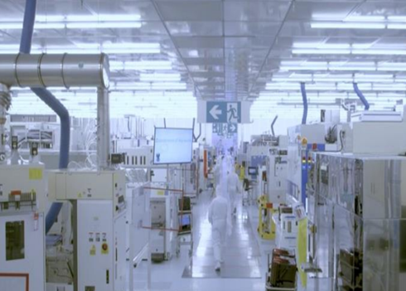  The Imec cleanrooms are three state-of-the-art cleanrooms (FAB1, FAB2 and FAB3) with world-class nano- and semiconductor technology equipment fuelling collaborations with global industrial leaders (e.g. ASML) and supporting a vibrant startup ecosystem. | 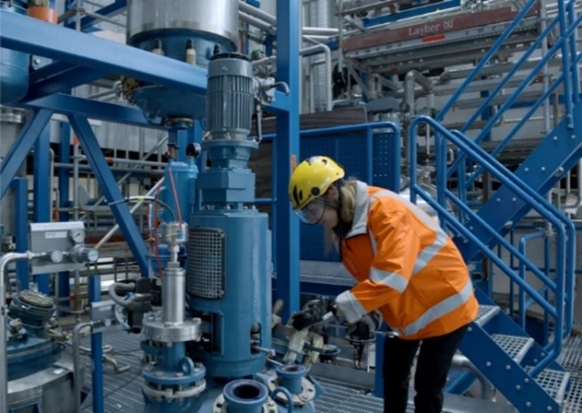  The VTT Bioruukki Pilot Centre for bio-based products and circular economy combines several facilities and services for material and chemical technologies, allowing development, scale-up and demonstration.
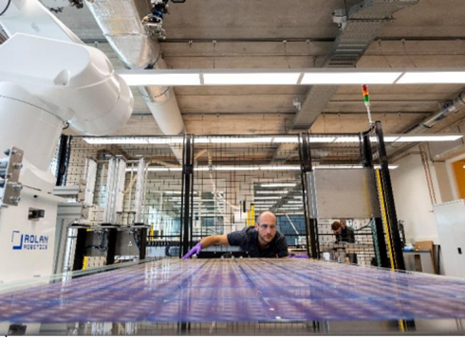  The TNO Solar Lab is a complex of facilities, including state-of-the-art lab space and pilot production lines, enabling solar photovoltaic technology maturation, upscaling, prototyping, and validation. The Lab collaborates with both large industry, SMEs and startups, as well as with public authorities, for example to test the incorporation of solar cells in road surfaces and noise barriers. | 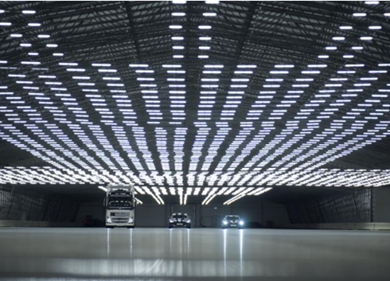  ASTAZERO operates test tracks and proving grounds, including the world’s longest indoor track DryZone, supporting the development and validation of automotive and transportation system technologies, from early concept phase to verification and product performance follow-up. Collaborations include large industry (e.g. Volvo Cars, Ericsson) and a broad range of SMEs.

There is a wealth of technology infrastructures across the EU, both in the civilian and defence domains. However, they operate primarily at the level of local ecosystems. The landscape is fragmented and lacks coordination, with little collaboration at cross-regional or cross-national levels. Their experimentation, testing and validation services are usually not known and not accessible beyond their local or regional ecosystems. This fragmentation prevents researchers, innovators and industry in Europe from having access to a comprehensive range of world-class facilities and tailor-made services in support of scientific and technological excellence.
The mapping exercises conducted in recent years demonstrate a high concentration of technology infrastructures in specific parts of the EU. For example, over 50% of technology infrastructures in clean and renewable energy technologies are hosted in just four countries (Germany, Spain, France and the Netherlands).
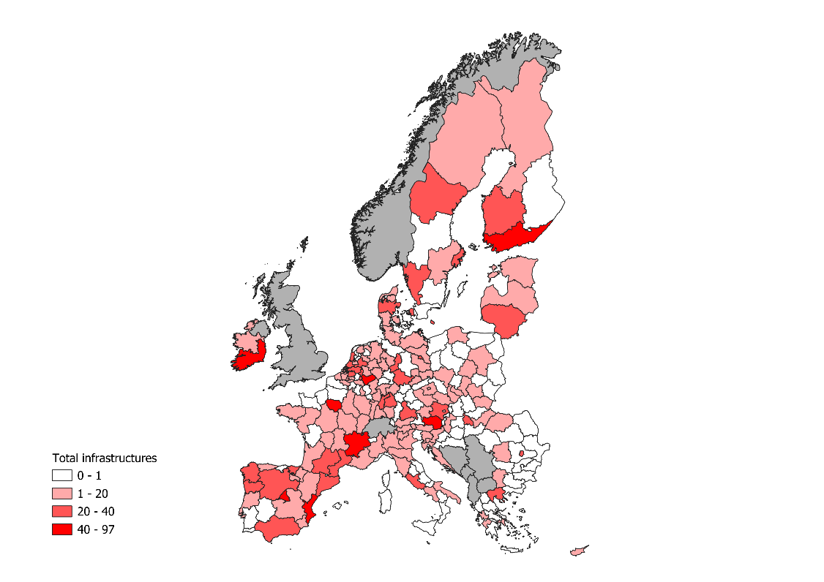
Figure 1: Distribution of technology infrastructures in clean and renewable energy technologies by NUTS-2 region, Source: Mapping of Technology Infrastructures supporting clean and renewable energy industries in Europe (2024)
This uneven distribution is more prominent when considering facilities that require significant initial investment. For example, a quarter of EU cleanrooms are located in just five regions. At the same time, a very high correlation exists between the location of technology infrastructures and the location of companies active in the same technologies. This demonstrates the importance of access to infrastructure services for industrial activity in technology intensive sectors.

Challenges and the need for action
As global competitors ramp up investment in large-scale facilities, Europe must act decisively. This renewed European strategy for research and technology infrastructures is key to staying ahead.
Research and technology infrastructures are vital to tackling complex, interdisciplinary scientific questions and unlock the potential of emerging technologies like advanced materials, biotech, and AI. They must also serve a wider range of users—innovative small and medium-sized enterprises (SMEs), startups, scaleups, and diverse research communities.
Yet Europe’s ability to build a strong infrastructure ecosystem is being held back:
- Fragmented policies and funding across the EU: While research infrastructures benefit from strategic planning via ESFRI, technology infrastructures lack a coherent EU approach to investment. Budget constraints, scattered funding, and limited private investment are slowing progress.
- Limited collaboration across infrastructures: Cross-sector, and cross-border synergies remain underused, restricting access, missing opportunities and reinforcing regional disparities.
- Insufficient access opportunities and complex access procedures: Complex procedures, high costs, and poor visibility limit accessibility to researchers and companies. This is particularly the case for startups as flagged in the EU Startup and Scaleup Strategy.
- Skills gaps: Rapid technological change and an increasingly diverse user base demands constant upskilling to keep infrastructures at the cutting edge, ensure they are attractive to top talent and enrich the experience of their partners
- Untapped potential of digitalisation and AI adoption: increasing digitalisation, data sharing, and the use of AI by infrastructures are needed to strengthen their functionality and resilience and reducing costs of operation and access.
- Hampered reuse of data for research: Soaring research data volumes, particularly in fields with deep AI integration are outpacing our capacity to put it to use. Storing and managing these increasing volumes of data efficiently and securely based on FAIR principles is essential.

Objectives of the Strategy
The strategy’s overarching objective is to ensure that scientists, researchers, innovators, inventors, and industry in Europe have at their disposal easily accessible, cutting-edge facilities, high-quality data and tailored services that drive scientific and technological excellence, industrial competitiveness and well-being of people. This entails:
- strengthening the European ecosystem of research and technology infrastructures through a holistic approach to capacity building and mobilising investments, improving the alignment of user needs and available facilities and services, while ensuring alignment with EU strategic priorities.
- bolstering the accessibility of research and technology infrastructures as a continuum of complementary services for researchers and innovative companies, including startups and scaleups, across the EU, in order to support scientific breakthroughs and boost technology development, testing and validation, accelerating their societal and market-readiness,
- attracting and cultivating talent in Europe through strong career pathways in research and technology infrastructures, from technicians to scientific leaders, developing new skills and competences, benefitting from the wider Choose Europe,
- improving and simplifying the governance framework for research and technology infrastructures to support long-term investment decisions and promote the alignment of priorities among the EU Member States and stakeholders, strengthening coordination across funding sources and increasing the impact of public investment.
- improving the international dimension and resilience of research and technology infrastructures through cooperation with strategic partners addressing global societal challenges, improving the integration of candidate and associated countries in the ERA, while at the same time supporting management of risks, in particular related to access to critical data and facilities, fostering EU’s sovereignty in critical technologies.

Increasing European Research and technology infrastructure capacities and mobilising investments
Increasing capacities - ensuring world-class facilities in Europe
The Draghi report on ‘The Future of EU competitiveness’ and the ‘Align, Act Accelerate’ report by the Commission Expert Group on the Interim Evaluation of Horizon Europe, call for substantially increasing the investments in research and technology infrastructures capacities as the backbone of EU competitiveness.
In particular, Europe must heavily invest in the upgrading and construction of cutting-edge research infrastructures to ensure global leadership in frontier science and enable breakthrough technological development. These facilities are becoming increasingly complex and costly. The scale of financing required is beyond what any single country can manage alone, and the current pace of decision-making for pan-European investments risks leaving Europe trailing behind global competitors. Strategic, large-scale investment is needed to establish and maintain these cutting-edge infrastructures, ensuring Europe remains the premier region for ‘Big Science’, which underpins deep-tech innovation.
Research infrastructures need continuous technology development to upgrade equipment, improve services, and meet the evolving needs of R&I users. Co-creation with industry is essential to building and maintaining these capacities. As highlighted by the ESFRI report on energy and supply challenges, resilience and crisis preparedness require both short-term greening and long-term investment in technological upgrades.
The need to bridge the EU’s innovation gap with its main global competitors requires swift action to identify the unmet needs of EU’s innovative companies for research and technology infrastructures services in strategic industrial sectors and technology areas. Addressing these needs will strengthen the development of new technologies in areas of strategic interest for the EU, supporting climate and competitiveness objectives, defence capabilities and the civil security of citizens.
Boosting the capacities of European technology infrastructures is essential for the development of critical technologies such as advanced materials, semiconductors, biotechnology and quantum technologies, but also holds for energy, health, transport, connectivity and networks, metrology, agriculture and space or defence, as well as the transition to a circular economy. In such strategic areas, the EU would benefit from coordinated assessment of available facilities and services, their competitiveness in the global landscape, and identification of needs and gaps in the context of EU policy priorities. Establishing robust criteria to identify the infrastructures which can support companies beyond their local ecosystems would enable the identification of common European priorities and the development of joint investment roadmaps. These are necessary for better mobilisation and promotion of better alignment of funding at EU, national and regional levels.
Addressing the fragmentation of technology infrastructure services across the EU requires increased collaboration between research and technology organisations, universities and other infrastructure operators to develop joint service offers addressed to innovative companies across the EU. Stronger connections between technology infrastructures and infrastructures operated by industry as well as links with other experimental spaces such as regulatory sandboxes and living labs, should also be pursued.
Mobilising investments
Developing and sustaining research infrastructures as strategic assets for scientific excellence and industrial competitiveness requires major investment, as outlined in the Pact for R&I in Europe. However, slow decision-making on pan-European research infrastructure investments is weakening Europe’s global position. The EU should play a stronger role in supporting cutting-edge infrastructures, alongside Member States and other funding bodies. Closer alignment of EU, national and regional funding is essential - building on existing guidance and best practices.
The ESFRI roadmap and the ERIC framework enable joint investments, but challenges remain: distributed ERICs are not fully recognised in national funding systems, and international partner involvement is limited. These issues prevent the full potential of ERICs from being realised.
The ESFRI report on funding highlights gaps in tracking funding streams and capturing the full cost of research infrastructure lifecycles – from construction and operation to upgrades and evolving needs. Distributed infrastructures face particular financing challenges. Many also contribute to broader EU priorities – such as feeding data into Copernicus – but rely solely on R&I funding, threatening their long-term sustainability. These contributions should be reflected in relevant EU programme funding.
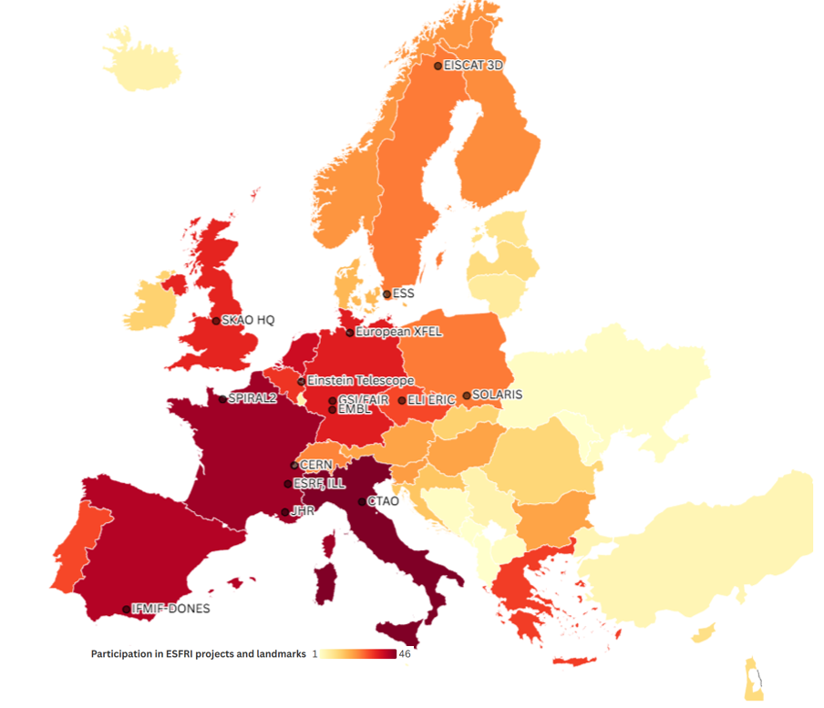
Figure 2 shows the commitment of national governments to supporting research infrastructures on the ESFRI Roadmap, while showing the location of major European research infrastructures. Source: generated by authors based on ESFRI data
Significant investments in technology infrastructures have been made in the EU in recent years. However, recent studies show that the current funding landscape for such investments is fragmented and lacks a common vision and coherence, both at European and national level. There is also a significant funding gap in relation to investment needs, while funding models are often complex and unreliable. A recent study on funding needs for technology infrastructure in the EU suggests that the leading European research and technology organisations will need to mobilise EUR13-16 billion for capital investments in such infrastructures by 2030, in particular in microelectronics and semiconductors, clean energy technologies, quantum, AI & data, avionics and space technologies, circular economy, advanced materials, and advanced manufacturing. This represents a projected growth of around 200% overall compared to the investments made within the last five years, with significantly higher rates for some of the most innovative technologies.
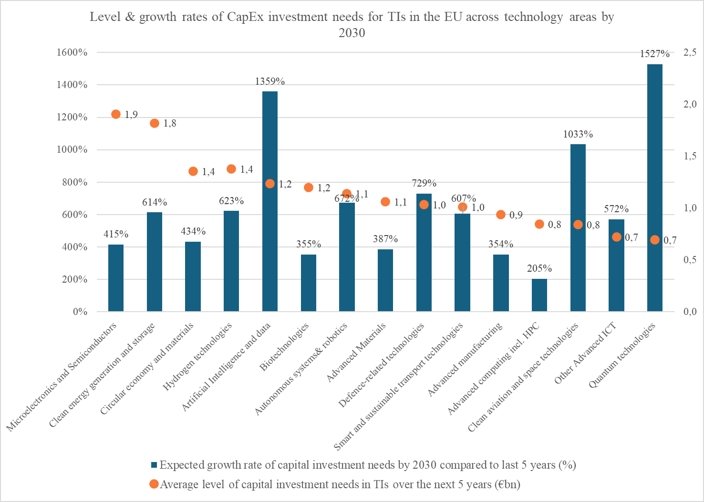
Figure 3: Results of a survey on funding needs for technology infrastructures. Source Technopolis Group (2025)
Identifying common capacity gaps and facilitating the effective pooling of resources that enables efficient implementation of the investments needed, requires strong coordination and collaboration of all relevant actors as done for example for the EuroHPC and Chips Joint Undertakings. EU policies and EU-level actions on the one hand, and national strategies and programmes on the other hand, need to work together to strengthen technology infrastructure capacities and to ensure coherence of strategic priorities and facilitate effective implementation of investments needed.
Capital investments currently rely mostly on public funding and own resources of hosting organisations. With competing priorities for public funding, meeting the investment needs requires broadening of funding sources so that all relevant funding frameworks available at EU, national and regional levels, both public and private, are mobilised for joint investments. A stronger role of the EU funding should serve as catalyst for investments in infrastructures of European interest addressing strategic capacity gaps.
For technology infrastructures, this could include public-private partnerships with an increased role for EU funding, building on the experience of the Chips Pilot Lines and AI Factories, and extending the use of financial instruments available through the InvestEU and the European Investment Bank. The integration of investment priorities into structured collaboration frameworks such as European Partnerships and cross-border collaborations in Important Projects of Common European Interest also needs to be strengthened. Infrastructure investments are becoming more appealing as they can support initiatives that ensure a seamless project pipeline from research and innovation to deployment. The Clean Industrial Deal highlights potential synergies between the Framework Programme for R&I and the Innovation Fund as an example. The improvement of synergies among a broader range of funding sources for technology infrastructures requires clarity and appropriate guidance on the applicable State aid rules. Increased understanding of how best to apply State aid rules across Member States would stimulate cross-border and joint investments. The Commission could facilitate the exchange of experience and good practice among Member States by setting-up a Community of Practice and organising a mutual learning exercise.
To strengthen the research and technology infrastructure capacities, the Joint Research Centre is preparing a series of Flagship projects in view of offering scientists from academia and research institutions, as well as from small businesses, industry, start-ups and scale-ups, further opportunities to develop and test their innovations in a unique research and technology infrastructure continuum with a European perspective.
To increase capacities and investments in European research and technology infrastructures, the Commission will work jointly with Member States and stakeholders to:
- Develop criteria for identifying technology infrastructures of European interest, in synergy with the ESFRI roadmap for research infrastructures.
- Map and assess the research and technology infrastructures capacities in Europe in the context of global competition, policy priorities and user needs, and develop joint capacities investment roadmaps, identifying priority areas for targeted investments in a continuum from research infrastructures to technology infrastructures, including in EU-level sectoral initiatives.
- Invest in building and sustaining critical new capacities for world-class research and technology infrastructures in Europe, spearheaded by EU priorities, facilitating the implementation of strategic initiatives aimed at ensuring long-term global leadership.
- Increase funding opportunities for research and technology infrastructures at EU level and propose specific funding and financing models to encourage a more effective pooling of public and private funding for investments, leading to better exploitation of existing funding frameworks, while also addressing the need to reduce regional disparities.
To further strengthen pan-European research infrastructure capacities, the Commission will:
- Provide a stable framework for maintaining and upgrading world-class research infrastructures by providing the support to the implementation of existing and new roadmaps for research infrastructure technologies, responding to jointly identified needs and commonalities across research infrastructures and, where applicable, across domains; support the roadmapping for new technology needs, taking into account aspects of digitalisation of operation, standardisation, interoperability, resilience and sustainability of research infrastructures.
- Support the mapping of research infrastructure funding sources at national, regional and EU level and promote synergies among complementary funding instruments by promoting good practice and appropriate guidance; where applicable, explore adjusting the conditions and rules of EU funding instruments for combined and complementary funding, notably for research infrastructures regarded as essential infrastructures for EU operational or deployment programmes.
- Propose a revision of the ERIC Regulation on specific aspects that cannot be addressed by revised Practical Guidelines such as facilitating the participation of international partners, promoting this legal framework as a reliable vehicle for joint investments.
To improve and optimise the services of European technology infrastructure, the Commission will work with Member States and stakeholders to:
- Support and implement measures facilitating transnational and multisite collaboration among technology infrastructures, developing coordinated service offers in strategic technologies, including for defence, and promoting their visibility and uptake.
Maximising the potential of digitalisation and AI in Europe’s infrastructures
Digitalisation is not only transforming the way research is conducted; it is also transforming infrastructures. Research infrastructures generate vast amounts of reliable research data. The efficient management, reuse and sharing of these data is essential to maximise their value for driving scientific progress, tackling global challenges and fuelling innovation and AI.
The European Open Science Cloud (EOSC), Europe’s Data Space for R&I, is developing a federation of data repositories and digital services of research infrastructures and other scientific service providers to provide researchers and innovators with a trusted platform for sharing and reusing high quality, FAIR research data, tools and services across disciplines and borders in Europe.
The production of high-volume and high-value data and the use of novel digital technologies, including AI, in service provision can significantly increase the efficiency and accessibility of infrastructures while lowering their operational costs and strengthening security and confidentiality. Building the digital capabilities of research and technology infrastructures includes also computational modelling, digital twins and virtual/extended reality.
Research and technology infrastructures can also play an important role to achieve the goals of the European Strategy for AI in the Science and in the Resource for AI Science in Europe (RAISE) contributing to the pooling of resources, data and computing capacity for accelerating the responsible use of AI in science.
Moreover, issues related to the accessibility of certain categories of data for R&I purposes will be explored in the context of the upcoming ERA Act.
The Commission, will work with Member States and stakeholders to:
- Sustain and enhance the EOSC Federation as Europe’s research and innovation data space, enabling sharing and reuse of high-quality, FAIR research data, scientific results and digital services.
- Support compliance with FAIR principles, increasing FAIR data productivity, and connections to EOSC and other relevant data spaces.
- Support the pooling and development of AI-ready research data as well as tools and services that enable the development of scientific AI models, and their technological applications, accelerating the use of AI in science and, through it, contributing to the pilot phase of RAISE.

Bolstering the accessibility of research and technology infrastructures as a continuum of complementary services
Implementing the ‘fifth freedom’ requires progress towards a single market for research and technology infrastructures services in the EU. From the user and services perspective, the two types of infrastructure form a continuum of complementary facilities and services, which needs to be increasingly reflected in access policy. However, research and technology infrastructures have been developed to serve different needs and hence different primary user communities.
Transnational access to research infrastructures, based on scientific excellence, has been a longstanding feature of successive EU R&I framework programmes. It enables researchers to use cutting-edge facilities beyond their home countries – a cornerstone of the ERA. These schemes benefit less research-intensive countries greatly and thus help close the innovation gap, as Figure 4 shows. However, access remains fragmented and short-term. There is a need for more sustainable schemes, greater visibility – especially for distributed ERICs – and better outreach to new communities and industry. Consultations highlight the importance of expanding remote and virtual access, and of developing common access policies and user-friendly, interoperable service catalogues. A long-term, one-stop-shop European access scheme would be transformative.

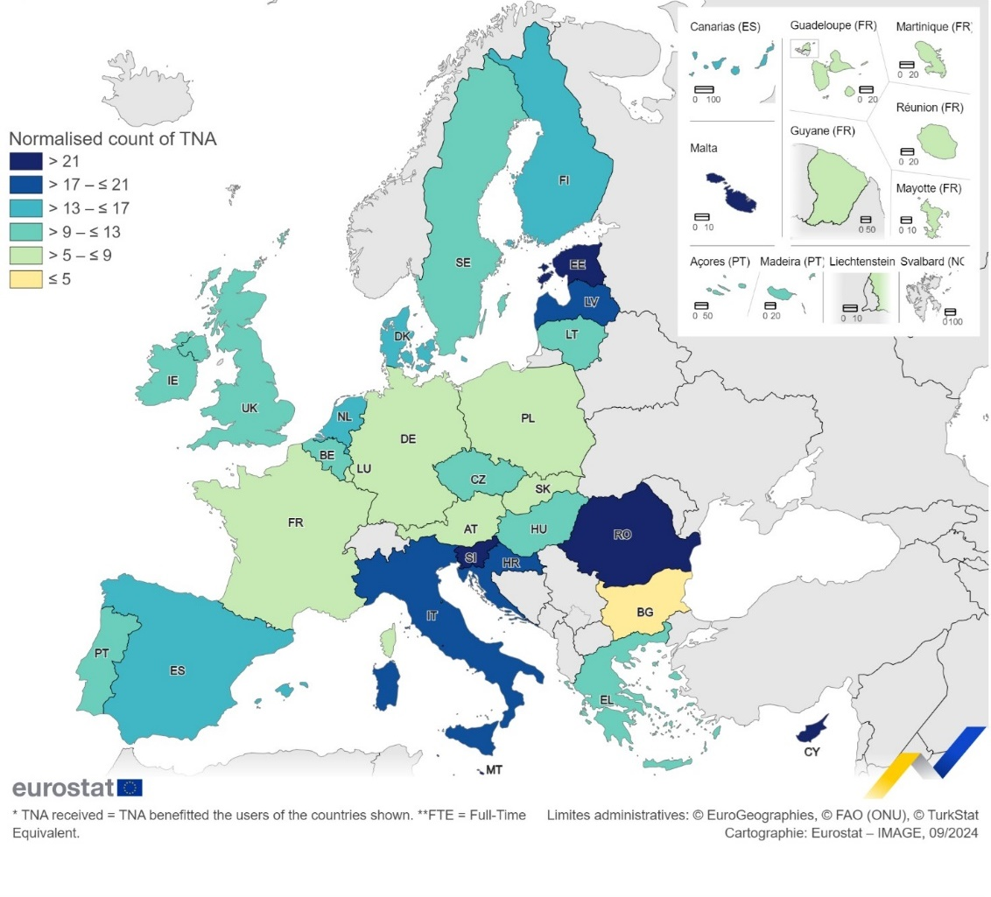
Technology infrastructure accessibility is primarily oriented towards industrial players, as they strive to meet the specific needs of innovative companies, including startups and scale-ups which often face uncertainties about their technological challenges.
Figure 4 shows transnational access to research infrastructures provided by Horizon 2020 projects normalised by the number of researchers in each country. Source: Research Executive Agency, 2025
Industrial users, particularly SMEs and startups, can face significant barriers when accessing technology infrastructures, such as insufficient financial and human resources, asymmetry of information and cultural barriers. These barriers are further exacerbated when considering cross-regional and, in particular, transnational access, where additional language, legal and regulatory issues (e.g. import/export regulations for test samples) arise, while financial costs of access usually grow. This often prevents smaller companies from using the technology infrastructure services available to them, in particular in facilities located in other regions or countries.
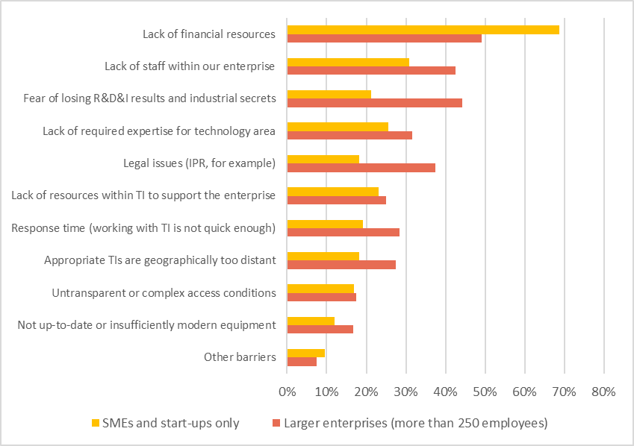
Figure 4 shows the percentage of companies (SMEs and start-ups on one side, larger enterprises on the other side) answering what are their main perceived barriers to access technology infrastructures. This survey collected 328 answers. Source: User needs for technology infrastructures – Analytical report, Publications Office of the European Union, 2025
Beyond these specific access needs, the synergies between the services of research and technology infrastructures remain largely underexploited, in some areas this significantly limits the benefits they can bring to EU researchers, innovators and companies. To optimise these synergies, researchers and innovators need integrated and sustained access opportunities, with more harmonised conditions and procedures, considering needs ranging from frontier to interdisciplinary and applied research.
As part of the EU Startup and Scaleup Strategy, the Commission will develop a Charter of Access for industrial users to research and technology infrastructures to simplify and harmonise diverging access and contractual conditions. It will also provide guidance on applicable State aid rules for public research organisations that grant access to infrastructure. The Commission will engage in promoting the uptake of the Charter among research and technology infrastructures as well as national funding organisations. Building on the Charter, the forthcoming European Innovation Act will promote the access of innovative companies to European research and technology infrastructures through legislative measures. Thus, the regulatory obstacles for SMEs, startups and scaleups will therefore be reduced, and synergies between infrastructures supporting research excellence and industrial competitiveness will be reinforced.
To improve and simplify access to research and technology infrastructures, the Commission will work with Member States and stakeholders to:
- Support the development of an integrated and sustainable scheme for access to state-of-the-art research infrastructures of European interest, offering a ‘one-stop-shop’ for access to them, and to a single European portfolio of complementary and cross-domain R&I services of European interest, including AI assisted research infrastructure service navigation.
- Implement pilot access schemes to technology infrastructures for startups and scaleups, with the view to scaling-up future implementation.
- Test joint research and technology infrastructures transnational access schemes addressing priority areas e.g. advanced materials, clean energy, quantum technologies, AI or health and biotechnology.

Attracting and growing talent in Europe
Europe is home to world-class research and technology infrastructures that attract top talents from all over the globe. Organisations such as CERN, the Joint Research Centre, the European Molecular Biology Laboratory or Imec host scientists, engineers and innovators who come from over 100 different countries, making them global centres of excellence. As Europe faces a skills shortage, research and technology infrastructures have a key role to play in training of science and technology experts and in making Europe an attractive place for the best global talents in research and innovation. As a result, research and technology infrastructures can significantly contribute to the Choose Europe approach.
The effectiveness of research and technology infrastructures and the quality of the services they provide relies on a blend of scientific, technical and managerial expertise of their staff. Significant effort has already been made on the training of managerial and leadership staff in research infrastructures, including through development of an EU-supported Executive Master’s programme. These actions need to be reinforced, including for technology infrastructures, with the aim to strengthen the managerial and entrepreneurial skillset enabling better support for new users, notably non-expert users and users from industry, SMEs, startups and scaleups, and increasing resilience of the infrastructures.
Moreover, as research and economic security become increasingly critical, and technology developments faster, continuous training of technical staff, supported by staff exchanges, is necessary to ensure the robustness of the tools and services they develop. Where relevant, opportunities from EU Skills Academies and Marie Skłodowska-Curie Actions should be further exploited. Finaly, research and technology infrastructure staff, users and outputs should be promoted in research and researcher’s assessment.
The Commission will:
- Develop research and technology infrastructures strategies for attracting talent from outside Europe, in line with the Choose Europe approach.
- Support the training of research infrastructure and technology infrastructure staff, while promoting the recognition of their diverse contributions in research assessment: (i) professionalising the training of managerial and leadership staff, (ii) improving skills and career profiles of technical staff to address evolving needs such as research security, data management, quality assurance, etc, (iii) promoting entrepreneurial skills to capture the potential of infrastructures as centres in deep-tech innovation ecosystems, and (iv) establishing mechanisms for staff exchanges between infrastructures and organisations operating in innovation ecosystems.

Improving and simplifying the governance framework of the research and technology infrastructures ecosystem
To strengthen the European ecosystem of research and technology infrastructures which allows us to identify and agree on European priorities, as well as to mobilise and align strategic investments accordingly, an appropriate governance framework is needed, steering a holistic approach while recognising the different missions of research infrastructures and technology infrastructures respectively. The framework must notably consider the need for a stable and structural support to frontier and excellent research and a more challenge-driven approach for industrial competitiveness and deployment of strategic technologies.
Strategic planning for research infrastructures is supported by the EU-level governance of ESFRI, which should be further consolidated to address the areas with most fragmentation among Member States. The latest ESFRI Roadmap includes over 60 infrastructures representing over EUR 25 billion in investment, much of it expected in the coming years. The accompanying Landscape Analysis offers a detailed overview of the state, services, impact, and future outlook of European research infrastructures. ESFRI also shapes national research infrastructure planning, with many countries aligning their roadmaps with its methodologies. As most ESFRI infrastructures are distributed, they help integrate and connect numerous national facilities and services.
Building on this, the strategy aims to further consolidate and streamline the European landscape of research infrastructures, and strengthening their governance, by promoting a more strategic landscape analysis and monitoring to better address European priorities and economic security needs, and to link to the work on technology infrastructures.
Beyond specific digital technologies such as AI or Digital Twin for the Earth for example, there is currently no coordination mechanism in the EU to facilitate cooperation and dialogue on technology infrastructures among Member States, operators and stakeholders. Setting up an effective and inclusive multi-actor governance framework is necessary to identify existing service gaps and new strategic priorities at EU level in order to meet industry needs and to facilitate coordinated investments in technology infrastructure, leveraging public and private funding for large-scale upgrades or new facilities. A robust coordination mechanism will provide a platform for strategic, forward-looking reflection, mutual learning, development of common standards and monitoring of the implementation and outcomes of agreed actions. This work will be done in cooperation with the Research Infrastructures framework, including ESFRI.
The EU-level coordination mechanism for technology infrastructures needs to be supported by dedicated national strategies leading to the prioritisation of investments and robust funding programmes.
In the longer term, a light overarching EU coordination framework would help align research and technology infrastructures policies and streamlining investment and funding mechanisms, ensuring synergies across the entire European ecosystem of research and technology infrastructures while respecting their specific needs and objectives, and the specific domains and policy contexts they operate in. This framework should facilitate further convergence of the research and technology infrastructures governance. In parallel, coherence will be ensured with other European initiatives, with distinct governance frameworks, that provide capacity and infrastructure, supporting the development, uptake and deployment of digital technologies including beyond research and innovation.
To strengthen the governance framework for research and technology infrastructures, the Commission will:
- Propose an overarching EU coordination framework for the research and technology infrastructures ecosystem steering a holistic, synergy-based approach, while recognising the different missions, objectives and policy contexts of these infrastructures
- Implement a governance mechanism, in collaboration with Member States and stakeholders, that will provide a common framework for a European approach to technology infrastructures.
- Encourage ESFRI, to engage further with relevant stakeholders and review its landscape analysis methodology and long-term vision accordingly. Propose indicators to assess and raise awareness on the strategic relevance of ESFRI Landmarks and ERICs or of their services according to EU priorities, including economic security.

Strengthening the international dimension and resilience of European research and technology infrastructures
The appeal of European research and technology infrastructures lies not only in their excellence, but also in their role as global cooperation hubs.
European research infrastructures are often engaged in international collaboration, especially in Big Science fields like astronomy and particle physics, where costs and expertise demand joint efforts – exemplified by the Square Kilometre Array (SKA) project on radio astronomy. Global cooperation is also vital for addressing challenges like environmental monitoring, where data gains value through global coverage, like in ocean observation. These infrastructures act as tools of science diplomacy, building relationships of trust with regions such as Latin America, Africa, and the Association of Southeast Asian Nations (ASEAN). This form of science diplomacy through research infrastructures is even more valuable where relations between partners are difficult in other fields, as the Synchrotron for Experimental Science and Applications in the Middle East (SESAME) synchrotron has shown.
International connections become increasingly relevant for technology infrastructures as well, mirroring the global supply chains for the key technologies which they address. Supporting the international cooperation activities in research and technology also creates opportunities for European researchers and innovators to access world-class instruments and services in other world regions.
At the same time, a rapidly changing geopolitical context calls for increasing the resilience of the European research and technology infrastructures ecosystem to ensure the EU's autonomy and control over its critical research and technology assets, including data and digital resources. In line with the ProtectEU Strategy adopted in 2025, this requires actions to address threats related to research and technology infrastructures considered as critical infrastructures for EU economic security, for EU strategic interests, including in the critical technology areas of defence and space, and for key societal challenges such as global health, the transition towards a circular economy, energy and food security, climate change, biodiversity loss, and natural or anthropogenic hazards. Such threats can be related to shrinking geographical coverage, loss, leakage or interruption of critical data, limited or expensive access to data, equipment or facilities, as well as to supply of resources and instruments. Access to technology infrastructures dealing with critical technologies needs to be carefully managed.
The integration of candidate countries and potential candidates as well as associated countries in the ERA is also a key element of the resilience of the research and technology infrastructures. Ukraine, in this context, deserve specific support. An assessment of the state of research infrastructures in Ukraine is ongoing while an assessment of technology infrastructures will start shortly. The EU should support Ukrainian authorities in their strategic efforts to develop and reconstruct their R&I capabilities and increase collaboration and networking with other European research and technology infrastructures.

To strengthen European research and technology infrastructures in the international arena, the Commission will work with Member States to:
- Strengthen the international dimension of pan-European research infrastructures and their role for science diplomacy notably through enlarging geographical coverage in high-priority scientific fields, promoting European standards and approaches to access, data management and open science globally, promoting reciprocal access for EU researchers, facilitating exchange of best practices, while ensuring the appropriate levels of security/confidentiality.
- Develop actions to support: (i) the implementation of risk management, mitigation and contingency measures for infrastructures, (ii) aligning and coordinating investments across Europe for trusted and secure storage, processing and sharing of critical data including through EOSC, and (iii) the development of data sovereignty frameworks for secure and efficient data sharing. These will also benefit by cooperating with the EU Observatory on Critical Technologies and relevant research security initiatives of the Protect EU strategy.
- Promote the integration of candidate countries, potential candidate and associated countries, with a focus on Ukraine, into the ERA, by supporting cooperation among research and technology infrastructures, and their host organisations, and by facilitating access to European research and technology infrastructures where appropriate.

Conclusion
Europe’s world-class research and technology infrastructures are key strategic assets for the ERA. They support excellence from fundamental research to breakthrough innovation, underpinning European technological and data sovereignty and strategic autonomy.
The strategy aims to increase European competitiveness by strengthening its position as a global leader in science, technology, and innovation. To achieve this in a fast-evolving global landscape, Europe must take a holistic ecosystem approach to common challenges faced by research and technology infrastructures, while also committing to actions addressing their specific needs.
Implementing the strategy would boost European infrastructure capacities through increased investments and new funding models, new infrastructure technology developments, adoption of digital technologies and AI, and boosting skills. It will improve, secure and harmonise access to infrastructure services, strengthen governance, and strengthen their international dimension, including achieving critical data sovereignty, while protecting European assets.
The Commission will regularly report on implementation of the strategy to the Parliament and the Council.
Annex 1. Timeline for implementation of actions
Action | Starting
Increasing capacities and mobilising investment
- Develop criteria for identifying technology infrastructures of European interest, in synergy with the ESFRI roadmap for research infrastructures | 2025
- Map and assess the research and technology infrastructures capacities in Europe in the context of global competition, policy priorities and user needs, and develop joint capacities investment roadmaps, identifying priority areas for targeted investments in a continuum from research infrastructures to technology infrastructures, including in EU-level sectoral initiatives. | 2026
- Invest in building and sustaining critical new capacities for world-class research and technology infrastructures in Europe, spearheaded by EU priorities, facilitating the implementation of strategic initiatives aimed at ensuring long-term global leadership. | 2027
- Increase funding opportunities for research and technology infrastructures at EU level and propose specific funding and financing models to encourage a more effective pooling of public and private funding for investments, leading to better exploitation of existing funding frameworks, while also addressing the need to reduce regional disparities. | 2026
- Provide a stable framework for maintaining and upgrading world-class research infrastructures by providing the support to the implementation of existing and new roadmaps for research infrastructure technologies, responding to jointly identified needs and commonalities across research infrastructures and, where applicable, across domains; support the roadmapping for new technology needs, taking into account aspects of digitalisation of operation, standardisation, interoperability, resilience and sustainability of research infrastructures | 2025
- Support the mapping of research infrastructure funding sources at national, regional and EU level and promote synergies among complementary funding instruments by promoting good practice and appropriate guidance; where applicable, explore adjusting the conditions and rules of EU funding instruments for combined and complementary funding, notably for research infrastructures regarded as essential infrastructures for EU operational or deployment programmes. | 2025
- Propose a revision of the ERIC Regulation on specific aspects that cannot be addressed by revised Practical Guidelines such as facilitating the participation of international partners, promoting this legal framework as a reliable vehicle for joint investments. | 2026
- Support and implement measures facilitating transnational and multisite collaboration among technology infrastructures, developing coordinated service offers in strategic technologies, including for defence, and promoting their visibility and uptake. | 2026
Maximising the potential of digitalisation and AI
- Sustain and enhance the EOSC Federation as Europe’s research and innovation data space, enabling sharing and reuse of high-quality, FAIR research data, scientific results and digital services. | 2025
- Support compliance with FAIR principles, increasing FAIR data productivity, and connections to EOSC and other relevant data spaces. | 2025
- Support the pooling and development of AI-ready research data as well as tools and services that enable the development of scientific AI models, and their technological applications, accelerating the use of AI in science and, through it, contributing to the pilot phase of RAISE. | 2025
Bolstering accessibility
- Support the development of an integrated and sustainable scheme for access to state-of-the-art research infrastructures of European interest, offering a ‘one-stop-shop’ for access to them, and to a single European portfolio of complementary and cross-domain R&I services of European interest, including AI assisted research infrastructure service navigation. | 2025
- Implement pilot access schemes to technology infrastructures for startups and scaleups, with the view to scaling-up future implementation. | 2026
- Test joint research and technology infrastructures transnational access schemes addressing priority areas e.g. advanced materials, clean energy, quantum technologies, AI or health and biotechnology. | 2027
Attracting and growing talent
- Develop research and technology infrastructures strategies for attracting talent from outside Europe, in line with the Choose Europe approach. | 2026
- Support the training of research infrastructure and technology infrastructure staff, while promoting the recognition of their diverse contributions in research assessment | 2026
Improving and simplifying the governance framework
- Propose an overarching EU coordination framework for the research and technology infrastructures ecosystem steering a holistic, synergy-based approach, while recognising the different missions, objectives and policy contexts of these infrastructures. | 2026
- Implement a governance mechanism, in collaboration with Member States and stakeholders, that will provide a common framework for a European approach to technology infrastructures | 2026
- Encourage ESFRI to engage further with relevant stakeholders and review its landscape analysis methodology and long-term vision accordingly. Propose indicators to assess and raise awareness on the strategic relevance of ESFRI Landmarks and ERICs or of their services according to EU priorities, including economic security. | 2025
Strengthening the international dimension and resilience
- Strengthen the international dimension of pan-European research infrastructures and their role for science diplomacy notably through enlarging geographical coverage in high-priority scientific fields, promoting European standards and approaches to access, data management and open science globally, promoting reciprocal access for EU researchers, facilitating exchange of best practices, while ensuring the appropriate levels of security/confidentiality. | 2025
- Develop actions to support: (i) the implementation of risk management, mitigation and contingency measures for infrastructures, (ii) aligning and coordinating investments across Europe for trusted and secure storage, processing and sharing of critical data including through EOSC, and (iii) the development of data sovereignty frameworks for secure and efficient data sharing. These will also benefit by cooperating with the EU Observatory on Critical Technologies and relevant research security initiatives of the Protect EU strategy. | 2025
- Promote the integration of candidate countries potential candidate and associated countries, with a focus on Ukraine, into the ERA, by supporting cooperation among research and technology infrastructures, and their host organisations, and by facilitating access to European research and technology infrastructures where appropriate. | 2025

Choose Europe : Advancing your research career in the EU
Photograph sources: 1. CERN, 2. BBMRI-ERIC, of the Danish National Bank at the Statens Serrum institute, 3. Interact network, 4. KM3NeT module, credit: Paschal Coyle
Previously described in the Commission Staff Working Document (SWD 2019/158)
Photograph sources: 1. Imec, 2. VTT, 3. TNO, 4.RISE.
Comunidad de Madrid (ES), Rhône-Alpes (FR), Etelä-Suomi (FI), Limburg (NL) and Noord-Brabant (NL).
FAIR stands for data that is Findable, Accessible, Interoperable and Reusable (Wilkinson, M., Dumontier, M., Aalbersberg, I. et al. The FAIR Guiding Principles for scientific data management and stewardship. Sci Data 3, 160018 (2016).)
In accordance with their respective overarching association agreements. Association to Horizon Europe is the closest form of cooperation with non-EU countries, allowing legal entities from an associated country to participate in programme actions on equal terms (rights and obligations) as entities in EU Member States under Article 16 of the Horizon Europe Regulation
Including the EU outermost regions.
https://www.esfri.eu/ESFRI-Report-Energy-and-Supply-Challenges-ri
For the distinction between technology infrastructures and those operated by industry see European Commission: Directorate-General for Research and Innovation, Towards a European policy for technology infrastructures – Building bridges to competitiveness, Publications Office of the European Union, 2025, https://data.europa.eu/doi/10.2777/0876395
https://www.esfri.eu/esfri-report-funding-research-infrastructures
https://www.eib.org/en/publications/20250208-unlocking-innovation-addressing-the-funding-needs-of-eu-technology-infrastructures
ESFRI roadmap: https://roadmap2021.esfri.eu/, ESFRI landscape analysis: https://www.esfri.eu/landscape_analysis, for national roadmaps: https://www.esfri.eu/national-roadmaps
These include, among others, the European Digital Innovation Hubs, High Performance Computing capacities, AI Testing & Experimentation Facilities, as well as AI Factories and Gigafactories as presented in the AI Continent Action Plan.
For more details see International Cooperation in the Research Infrastructure dimension - European Commission
As pan-European research infrastructures contribute towards the aims and objectives of the European Ocean Pact https://eur-lex.europa.eu/legal-content/EN/ALL/?uri=comnat:COM_2025_0281_FIN.
https://home-affairs.ec.europa.eu/news/commission-presents-protecteu-internal-security-strategy-2025-04-01_en
Commission Recommendation (EU) 2023/2113 of 3 October 2023 on critical technology areas for the EU’s economic security for further risk assessment with Member States

