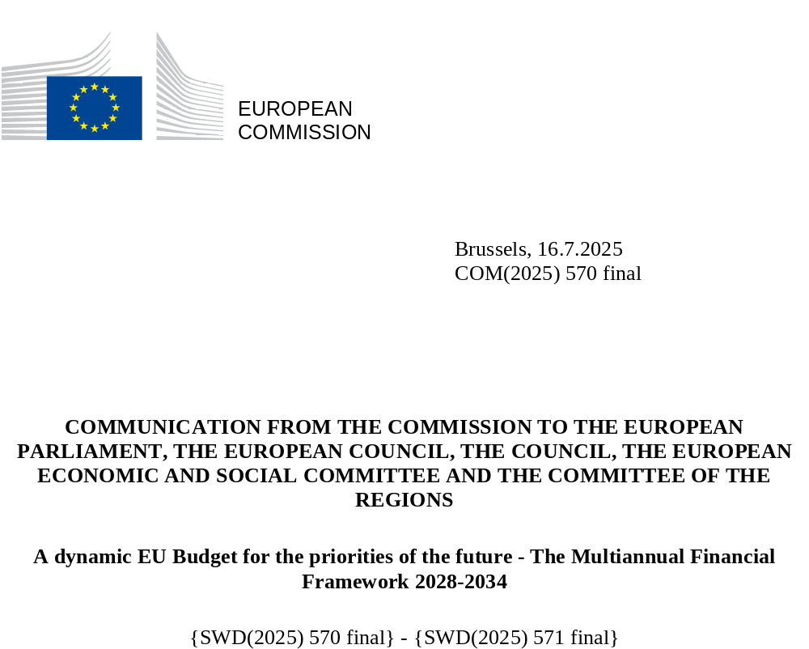

- INTRODUCTION
The 2028-2034 multiannual financial framework will be much more than just a financial plan. It will be a strategic statement of the Union’s collective political ambition to deliver on its priorities and to act with strength and unity on the global stage over the next decade. The EU budget is the Union’s engine, which has time and again shown its transformative impact as a driver of investment and growth, and a powerful expression of European solidarity. In the past five years alone, the EU budget helped to save lives and livelihoods during the pandemic, allowed the Union to overcome energy and supply chain crises, and underpinned the Union’s unwavering support for Ukraine.
It is time to build a more independent Europe, because the Union cannot rely solely on others to ensure its long-term security and prosperity. Russia’s war of aggression at the Union’s borders, wider geopolitical instability, and disruption to global trade relations have been a dramatic wake-up call for Europe. They have forced us to reappraise our strategic priorities and to take urgent action to reduce dependencies and tackle vulnerabilities to a multitude of threats to our security and way of life. This has necessitated a renewed focus on competitiveness, security, defence, migration, food security, strategic autonomy and our preparations for future enlargement of the Union. It has deepened our commitment to the principles and values that unite Europe and make the Union a beacon of stability and progress in a turbulent world.
Taking our common future into our hands means equipping the Union with an ambitious budget in size and design. To create opportunities for current and future generations of Europeans and help those in need. To defend our strategic interests and values. To build on the potential of the single market and harness new technologies to drive growth and innovation. To achieve our climate goals and support businesses, especially small businesses, and citizens in the transition to a zero-emission economy. To protect our environment, preserve our natural resources, promote circularity, and strengthen Europe’s competitiveness and resilience, including water resilience. To guarantee our collective security, restore Europe’s competitive edge, reinforce economic, social and territorial cohesion, and manage the consequences of demographic trends. To strengthen the EU’s external borders, manage migration and ensure the well-functioning of the Schengen area. To seize the historic opportunity of enlargement to further strengthen the Union. And to build strategic global partnerships that make the Union a strong and reliable player on the world stage, firmly anchored in the principles of rules-based international trade.
Europe must now do things differently – and the EU budget is no exception. At a time of heightened geopolitical and economic uncertainty, there are huge expectations on the Union to find answers to a series of generational challenges. The demands are greater than ever and the size of the EU budget must be commensurate with the Union’s growing responsibilities. Yet resources are limited. National budgets are under strain and cannot tackle cross-border challenges alone. The joint borrowing supporting NextGenerationEU will require repayment in the coming years. This means we must make full use of every euro in the EU budget to invest in areas where EU value added is greatest and to attract private and public investment.
The Union needs a more ambitious budget that is simpler, more flexible and more strategic. And above all, the EU budget must deliver. That is the overwhelming message from the Commission’s broad public consultations on the future multiannual financial framework, the recommendations of a dedicated European Citizens’ Panel, and extensive outreach at the European, national, regional and local levels. It is now time to put these lessons into practice and equip the Union with a modern budget for a fast-changing world.
Experience shows that flexibility is crucial. The multiannual financial framework provides the stability and predictability that make the EU budget such a powerful driver of long-term investment. But in an uncertain and volatile world, the EU budget must also have a much stronger structural capacity to adapt to the unexpected. Too often the budgetary response to crises and evolving needs has been ad hoc and improvised. This is not a sound basis for long-term policy. That is why the Commission is proposing a more agile budget, better equipped for both the known – and the unknowns. The role of the European Parliament and Council in steering the budget will ensure a high level of political oversight, transparency and democratic accountability at all times.
The Commission is engaged in an unprecedented effort to make Europe simpler – and this must include the EU budget. The public consultations have confirmed that EU financial programmes have grown too fragmented, with overlaps, gaps and diverging rules. This creates confusion and reduces accessibility, flexibility and impact. The Commission proposes to streamline and harmonise the EU’s financial programmes, making it much easier to identify funding opportunities, unlocking synergies, and creating a lean, transparent and coherent budget at the service of all Europeans.
The next long-term EU budget is an opportunity to reaffirm Europe’s commitment to our common goals and values. The Commission’s proposals are designed to ensure that EU investment is steered by our political priorities, delivering better results than Member States acting alone. They are rooted in respect for the rule of law and reflect a deep commitment to ensuring that EU money is well spent and adheres to the highest standards of sound financial management.
The Commission is proposing an ambitious budget of EUR 1.98 trillion for the 2028-2034 period, equivalent to 1.26% of EU GNI. The Union can only live up to its ambitions if it has a budget to match. This budget will allow the Union to build on the momentum created by NextGenerationEU and deliver on the tasks and responsibilities with which it has been entrusted.
Modernising the financing of the EU budget is an essential part of this package and will allow for stable national contributions despite the increase in the size of the budget. An ambitious budget focused on European priorities should be based on a more modern and European system of revenues. To this end, the Commission proposes an enhanced new own resources package, which includes adjustments to the 2023 proposal on new own resources and additional candidates. The revenue it generates will allow for an EU budget in line with ambitions while meeting the Union’s obligations to repay NextGenerationEU borrowing.
The 2028-2034 multiannual financial framework is a unique opportunity to revamp our long-term budget for a world of constant change. The EU budget and the common policies it supports are part of the fabric of our Union. The fundamental principles and objectives that have shaped the EU budget since its inception will not change. But the challenges facing the Union are such that standing still is not an option. By making the EU budget and its programmes simpler, more flexible and strategically attuned to the priorities of today – and tomorrow – we will give the Union the modern budget it needs to protect European citizens, help European businesses thrive and to strengthen Europe’s social model. And to encourage citizens, researchers and businesses from the EU and beyond to Choose Europe.
In short, to build an independent Europe capable of shaping its own destiny.

- THE EU BUDGET: EU PRIORITIES INTO ACTION
The new EU budget will be a policy-based budget. The next generation of EU financial programmes must form a coherent whole, working together to lift European cooperation to the next level in priority areas such as competitiveness, security, decarbonisation, sustainability, and economic, social and territorial cohesion. The programmes of the revamped EU budget are designed to be complementary, allowing resources to be combined in support of European priorities, both within the Union and worldwide.

- Driving prosperity, sustainability and security – tailored investments and reforms through national and regional partnership plans
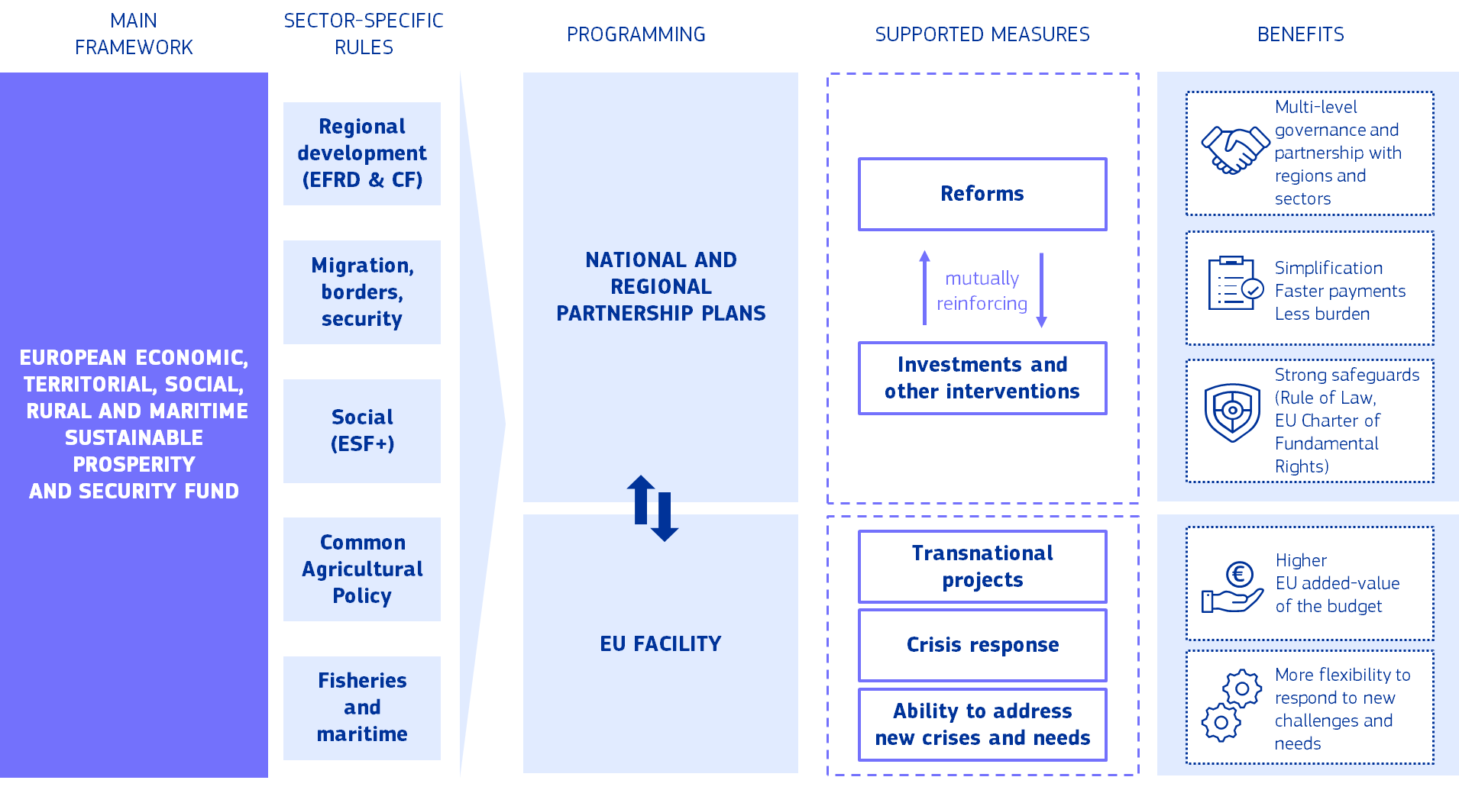
National and regional partnership plans will combine EU funds implemented by Member States and regions into a coherent, tailored planning process – fully aligned with the Union’s common priorities. They will maximise the impact of every euro, provide more flexibility to adapt to regional and local needs, and simplify rules for Member States and regions.
The new national and regional partnership plans for investment and reforms will build on the remarkable track record of Europe’s common policies – and make them stronger and more impactful. The partnerships will increase the synergies among current policies in support of European priorities, reinforcing economic, social and territorial cohesion. And they will boost EU action to remove internal market barriers. With an envelope of EUR 865 billion (including EUR 50 billion from the Social Climate Fund), the plans will ensure continued support for Europe’s common policies with a modernised approach.
The envelope of the National and Regional Partnership Plans 2028-2034
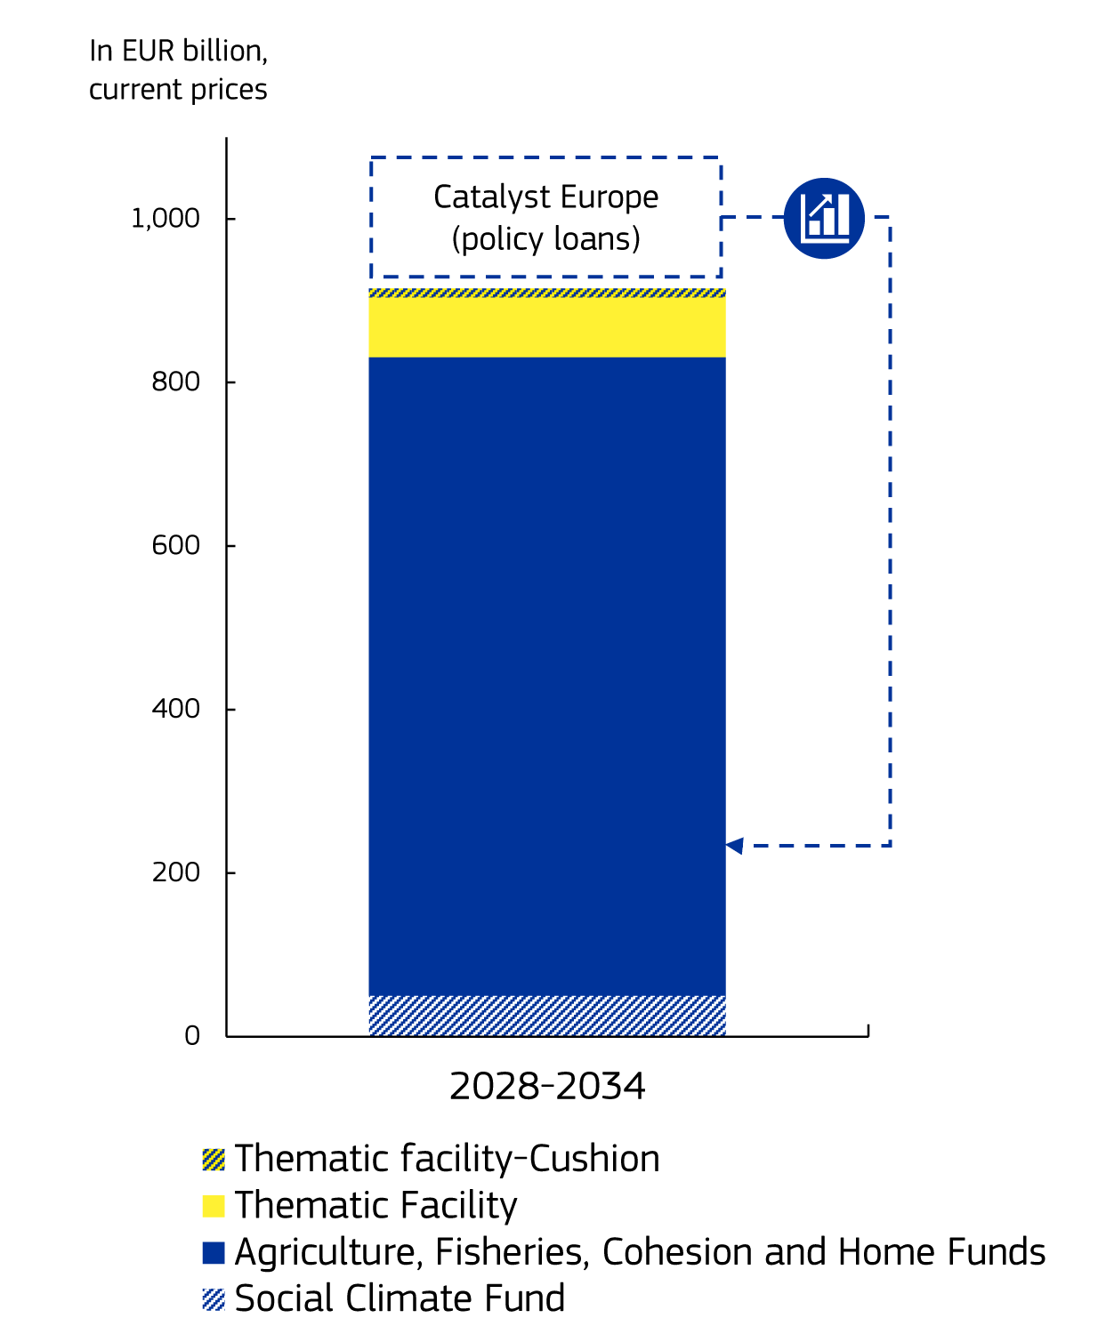
The partnership plans will be anchored in European priorities but tailored to the specific needs of Member States and regions. The plans will respond to the main priorities and challenges identified, including through the European Semester. They will be owned and designed in partnership with national and regional authorities. The new delivery system will accommodate the diversity of the Member States, offering them flexibility to develop national, sectoral and, where relevant, regional and territorial chapters, as under current rules, depending on each Member State’s constitutional structures and traditions. They will provide targeted support across EU policies to urgent needs, such as the challenges faced by Eastern border regions most affected by Russia’s war of aggression against Ukraine. In general, the partnerships will be less prescriptive on how to achieve common objectives, but more demanding on what to achieve, ensuring full respect for the principle of subsidiarity.
The national and regional partnership plans will bring together 14 existing funds and ensure coherence and joint programming between those, while respecting their specificities. This will streamline complex programming processes, cut lengthy validation procedures and create new opportunities for synergies.
- Agriculture and rural areas remain a priority, strengthening the EU’s strategic autonomy, food security and sustainability. The partnerships are an opportunity for the Common Agricultural Policy to evolve towards a simpler, more targeted and more impactful policy framework, to find the right balance between incentives, investments and rules. Farmers will continue to have predictability and stability on their income support from the EU budget while enjoying additional possibilities for investments and joint actions for rural areas. Member States will be able to achieve synergies to better address the challenges faced by farmers and rural communities, creating opportunities for young farmers and promoting generational renewal, while ensuring food security in the long term. The EU will step up its promotion of EU agricultural products to create new market opportunities. And faced with mounting uncertainty in agricultural markets, the EU will protect farmers and stabilise markets in times of market disturbances through the Unity Safety Net.

- Cohesion policy will be strengthened and modernised, with regions at its core, and will continue to uphold its fundamental principles of partnership, multi-level governance, and place-based action. It will work in synergy with the other policies, profit from higher impact due to targeted investments and reforms while continuing to promote a more cohesive Europe, ensuring that all Europeans, regardless of where they live, have access to economic opportunities and a higher quality of life. It will help less developed regions to catch up and just transition regions to ensure that no one is left behind. It will pay close attention to the outermost regions, recognising their unique challenges and potential.

- Europe is only as strong as its citizens are empowered – and therefore supporting people and Europe’s social model will be at the heart of the plans. A social target of 14% will apply to National and Regional Partnership Plans to steer significant investments towards the implementation of the European Pillar of Social Rights, supporting quality employment, skills, social inclusion and housing across all Member States, regions and sectors.

- The partnerships will ensure that the EU’s support to migration, border management and security challenges is tailored to the needs of each Member State and its regions. The link between reforms and investments will give Member States stronger incentives to implement the Pact on Migration and Asylum and the EU’s Internal Security Strategy. The EU Facility will ensure a flexible, common EU response to pressing needs and new challenges.

- Fisheries will remain the lifeblood of our coastal communities and economies. The partnerships will build a closer link between the EU’s fisheries and ocean-based policy, cohesion, and the Common Agricultural Policy, to provide stronger support for our fishermen and women, while helping stimulate economic activities such as aquaculture, tourism and shipping, creating jobs and improving livelihoods in coastal regions.
The national and regional partnership plans, in tandem with other EU programmes, will help the Union stay the course on our commitment to decarbonise Europe by 2050. Investments and reforms supported by the plan will spur innovation, increase resilience to the impacts of climate change, improve connectivity and help Europe become more energy independent. They will support businesses and citizens in all parts of the Union in navigating the challenges and opportunities of the transition to a clean economy, ensuring that no-one is left behind.
Financing for migration and border management in the 2028-2034 budget
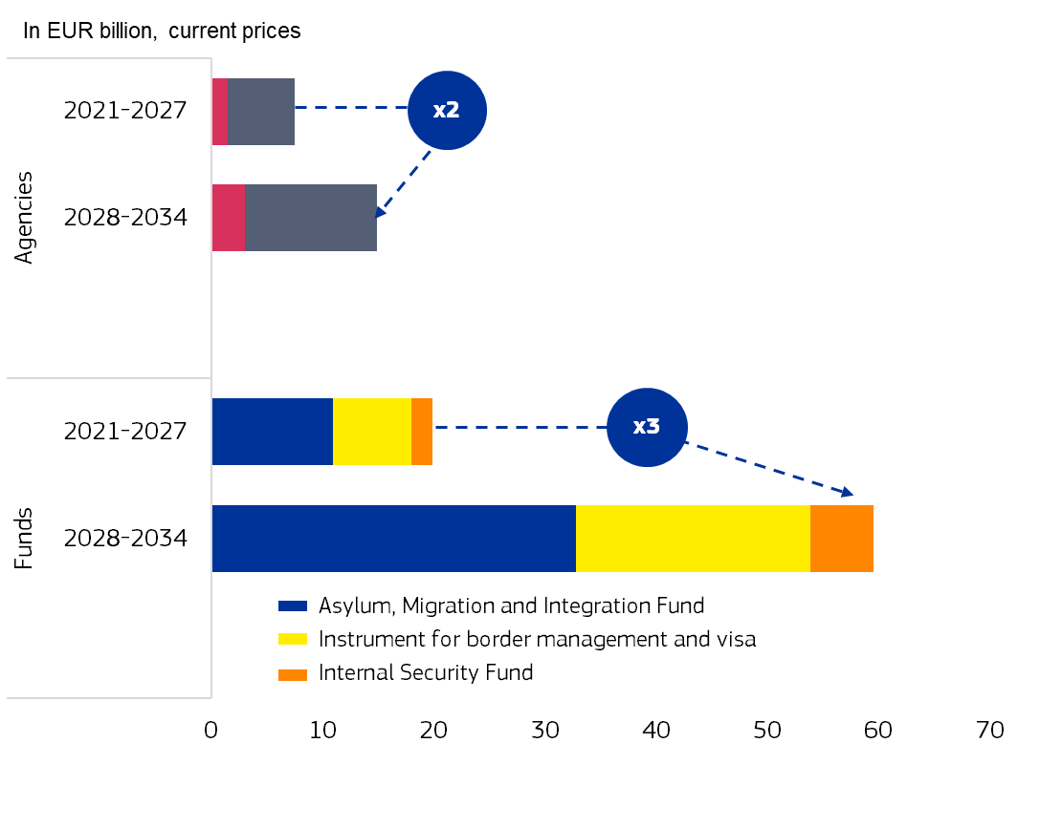
Results-based delivery and the combination of mutually reinforcing investments and reforms will bring more impact and value for money. Payments will be conditional upon the fulfilment of investment and reform milestones and targets linked to agreed priorities. This is expected to deliver funding and results faster and more efficiently. This will put the focus where it should be: on the results of EU spending. Robust audit and control arrangements will ensure that the partnership plans are implemented in accordance with the highest standards of sound financial management.
The principles of the rule of law and the Charter of Fundamental Rights are non-negotiable. The rule of law Conditionality Regulation will continue to apply to the whole of the EU budget (see Section 5). The national and regional partnership plans will strengthen the link between the recommendations in the Rule of Law Report and financial support. In case funds are lost for a Member State due to persisting breaches of the Rule of Law or Charter of Fundamental Rights, they will be available for use in programmes in direct or indirect management, in particular those contributing to supporting Europe’s democracy, civil society, Union values or the fight against corruption.
An EU Facility will support implementation at national and regional level. The facility will support actions that can be delivered more efficiently at Union level, complementing projects implemented by Member States and regions. This includes implementing the exclusive competences of the Union in areas such as the conservation of marine biological resources under the common fisheries policy, supporting ocean policy, promoting social actions and investments in social infrastructure and social economy at EU level, including through the use of guarantee instruments, and promoting inter-regional or inter-city cooperation. The facility will help to respond to natural and man-made disasters, building synergies with other policy areas covered under the partnerships, such as agriculture. An unallocated cushion will provide the possibility to further respond to unexpected events and disasters in Member States, should other flexibilities within the national and regional allocations not be sufficient.
The EU will also continue to provide strong support to the Turkish-Cypriot Community through a dedicated instrument.

- Boosting European competitiveness: the European Competitiveness Fund and Horizon Europe
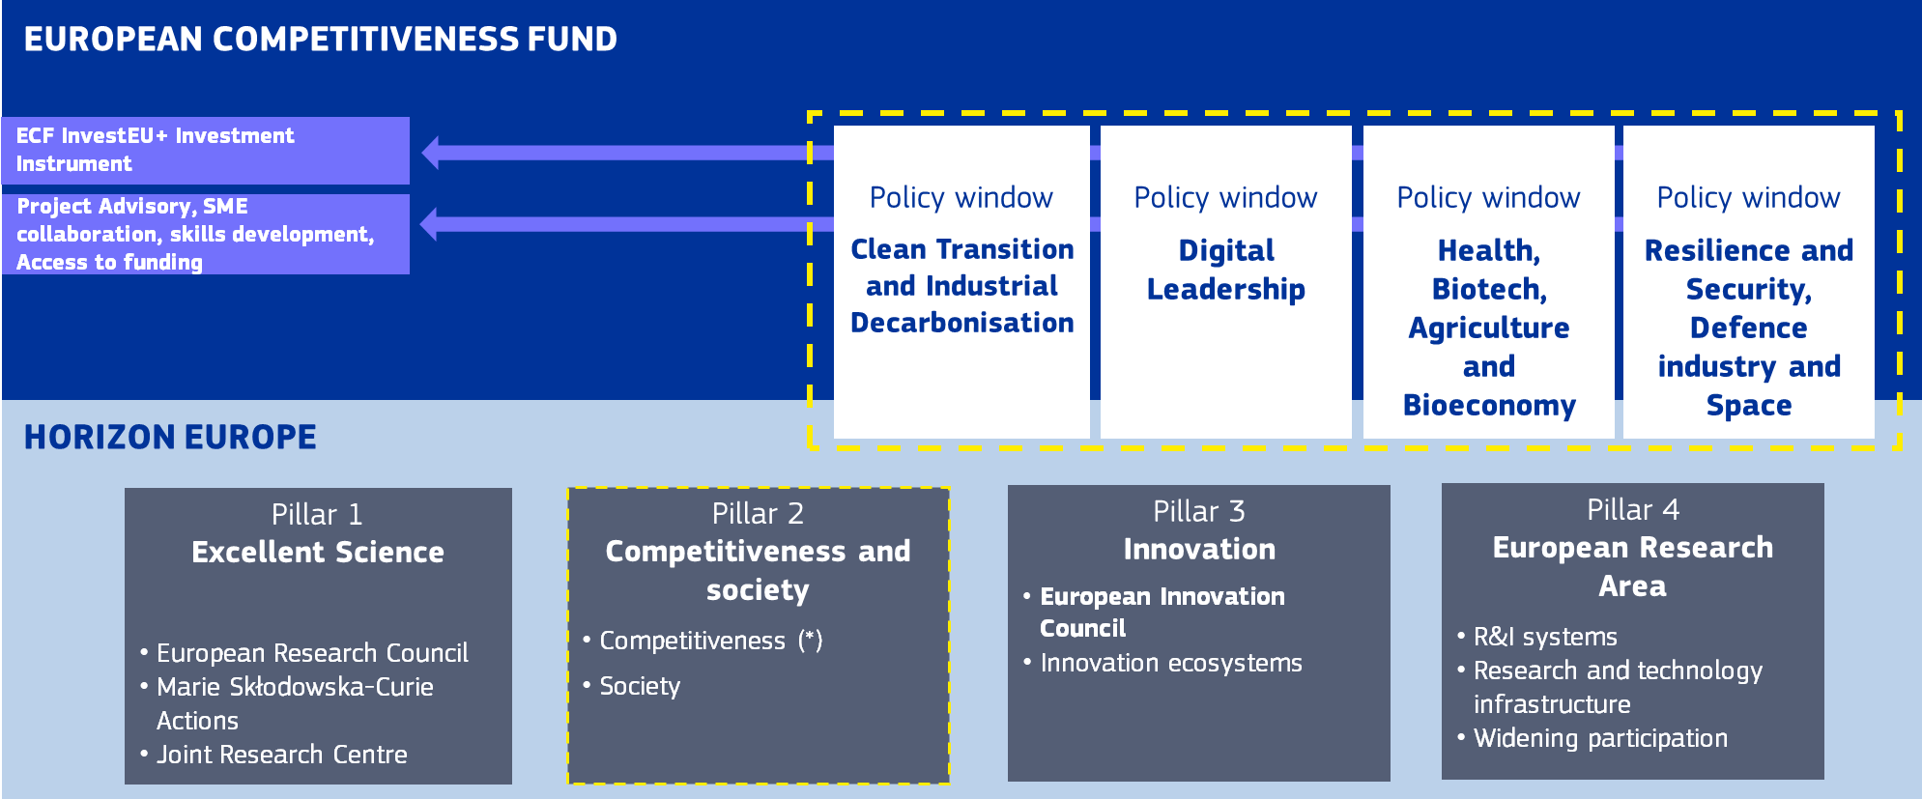
(*) Collaborative R&I consistent with activities in the Competitiveness Fund
The new European Competitiveness Fund, working in synergy with Horizon Europe, will provide seamless support to European innovators from research to deployment, from ideas to start-up to scale-up. It will power the implementation of the Competitiveness Compass and help the Union build a competitive edge in strategic sectors, including by facilitating multi-country and cross-border projects with high EU value added. In this way, it will drive prosperity and the creation of high-quality jobs.
The next EU long-term budget must deliver a step change in European support for competitiveness. Europe is the cradle of innovation, of scientific progress and of entrepreneurship, with a world-class industrial footprint. However, Europe’s competitiveness and economic security is hindered by barriers to the single market, fragmented capital markets, insufficient digitalisation, unfair international competition, high energy prices, skills and labour shortages, weak translation of research into marketable outcomes, and obstacles to bringing projects and funding together.
Europe must do much better at creating the conditions for its best projects and companies to thrive and scale up, as highlighted in the Draghi and Letta reports and in the Competitiveness Compass. As set out in the Clean Industrial Deal, it will be essential to combine decarbonisation and economic growth, through affordable energy prices, support for EU-made clean products (via the Industrial Decarbonisation Accelerator Act), high-quality jobs and reinforced financing, including through the industrial decarbonisation bank. Strengthening Europe’s economic security must also be a core objective — ensuring that key sectors remain resilient and competitive in the face of geopolitical and technological shifts. The EU must also prioritise investments in frontier technologies that hold the key to the future, such as space, artificial intelligence, and quantum. To remain competitive, autonomous and secure, Europe needs to build world-class and secure digital infrastructure, such as high-capacity networks and AI gigafactories.
The European Competitiveness Fund, with a total envelope of EUR 409 billion including Horizon Europe, will provide an unprecedented boost in EU budget support to research, innovation, development and deployment.
The new European Competitiveness Fund will draw together investment firepower at EU level to accelerate the scaling-up, manufacturing and deployment of strategic technologies in Europe. It will become a key tool to bolster the competitiveness of European companies and strengthen the EU’s industrial base, including by supporting ‘made in Europe’ technologies, products and services. Replacing the current patchwork of overlapping programmes, the fund, operating under a single rulebook, will greatly simplify and accelerate EU funding, including for small businesses. It will allow the EU to invest where it matters – and to invest with impact. The fund will feature simplified and fast-tracked selection, evaluation and award procedures, and will provide simplified reporting requirements for recipients of EU funding, bringing funding faster to project promoters.
Following the recommendation of the Draghi report, the European Competitiveness Fund will focus on EU public goods. The fund will support areas critical for EU competitiveness: clean transition and decarbonisation; digital leadership; resilience and security, defence industry and space; and health, biotech, agriculture and bioeconomy. It will also offer advisory services for project promoters.
Public investment at European level has a vital role to play as a catalyst for private investment. The European Competitiveness Fund will offer a comprehensive funding toolkit for crowding in private investment. This will allow each selected project to access the most appropriate form of support, be that grants or loans, procurement, or financial instruments including equity investments. Crucially, the proven firepower of InvestEU will leverage public and private investment towards EU priority sectors, working in close cooperation with its implementing partners – the European Investment Bank and other national promotional banks. The Fund will also support public-private partnerships including Important Projects of Common European Interest.
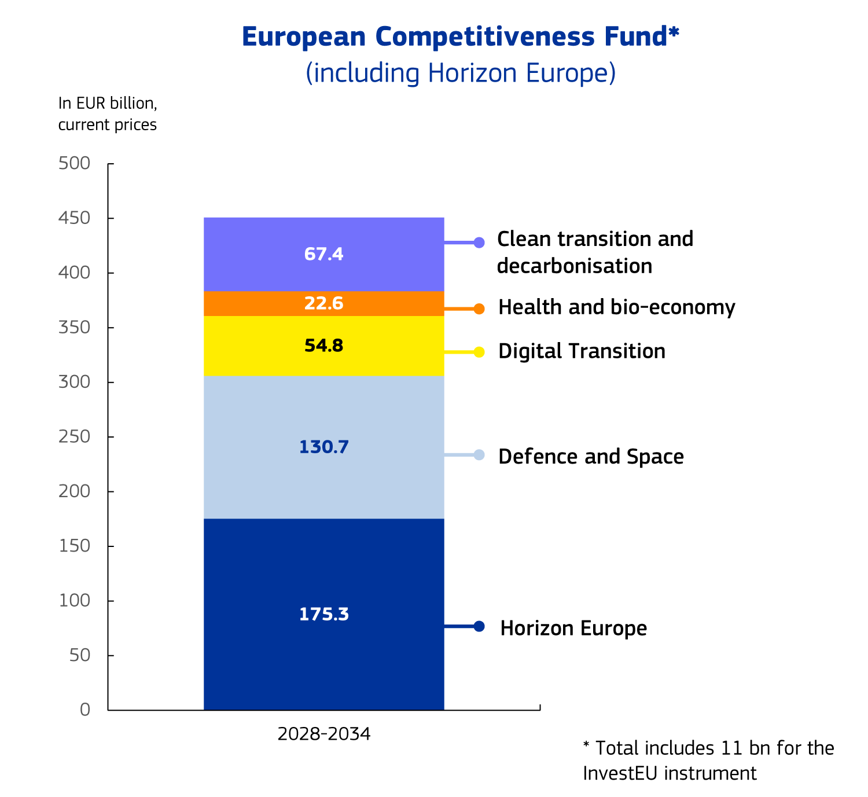
The world-renowned Horizon Europe programme for research and innovation will continue to invest in groundbreaking fundamental and collaborative research as well as disruptive innovation in strategic areas. It will operate as a self-standing programme closely connected to the European Competitiveness Fund through integrated work programmes for collaborative research and a common rulebook. The new Horizon Europe will be simplified and reinforced, enabling faster and more strategic EU spending through clearer rules and more transparent procedures for applicants and stakeholders. It will support cross-sectoral fundamental research actions, relying on its well-established excellence-driven approach and preparing the future engines of growth and technological leadership. Horizon Europe will be built around four pillars: Excellent Science, Competitiveness and Society, Innovation and the European Research Area. An expanded European Research Council will promote fundamental science and the European Innovation Council will be reinforced in its support to start-ups. The Euratom research and training programme will fund nuclear research and training and contribute to the ITER fusion project.

- Building a European Defence Union
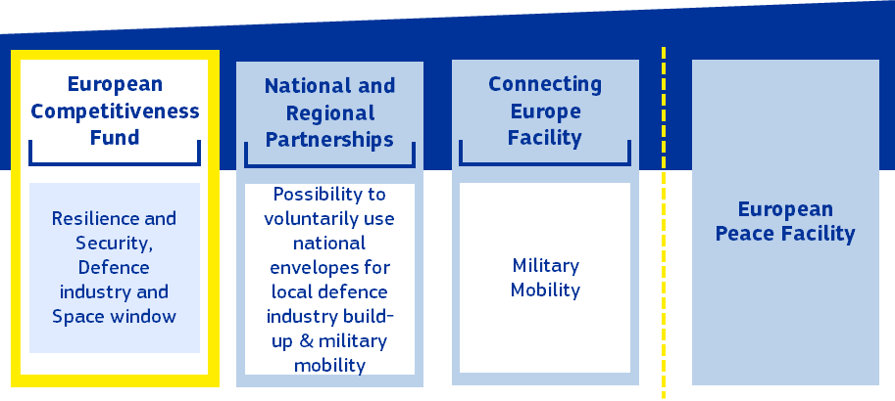
The new long-term EU budget will take the European Defence Union to the next level, an urgent priority at a time of rising threats and uncertainty. Funding from the European Competitiveness Fund, national and regional partnership plans, the Connecting Europe Facility and external funding in combination will bring unprecedented European added value to national defence spending.
The future EU budget must give new impetus to the creation of a true European Defence Union. As Russia’s war of aggression against Ukraine brought war back to European soil, the Union’s capacity to finance defence readiness was reinforced under the current EU long-term budget. This included the new Act in Support of Ammunition Production and Instrument for Common Defence Procurement, as well as the reinforcement of the European Peace Facility.
The White Paper on European Defence – Readiness 2030 has set out what the Union can do to support and coordinate Member States’ efforts to strengthen the defence industrial base and the EU’s overall defence readiness. Within this framework, Member States will have further budgetary leeway to increase defence expenditure, including through additional loans financed by common borrowing (the Security Action for Europe instrument). But this is not enough. The next budget must usher in a new era of strategic investment in European defence capabilities and readiness, including the joint development of European critical defence capabilities. Responding to the challenges faced by Member States most exposed to conventional military threats will be a particular priority, through joint projects such as the Eastern Border Shield.
The European Competitiveness Fund will provide significant support to investment in defence, security and space. The Commission proposes to increase financing substantially compared to the current financial framework. It is also a leap forward in the approach, by providing support along the investment journey from research to development, manufacturing and deployment within a single instrument, and contributing to de-risking common defence projects. This will reinforce coordination through support for dual-use applications and cybersecurity. The EU will continue to upgrade its space systems, notably Galileo, EGNOS, Copernicus and IRIS², while developing new capacities to meet dual use challenges, including an Earth observation governmental service and low Earth orbit positioning, navigation and timing.
The integration of defence and space financing within the European Competitiveness Fund brings several benefits. First, it ensures consistent rules for beneficiaries, facilitating access to funding. Second, it exploits the synergies between support to the defence industry and the space industry, as these present opportunities for cross-fertilisation, while ensuring continued and strong support for EU investment in space infrastructure and key European space assets. Third, it provides access to the full set of financial tools that will be available under the European Competitiveness Fund, to provide a more tailored approach.
Member States and regions will also be able to support investments and reforms in the area of Union defence capabilities and security projects via their funding under the national and regional partnership plans, consistent with EU priorities and in synergy with EU-level funding. Such measures will contribute to the competitiveness of the European defence, security and technological industrial base and to supporting the Union’s preparedness, threat detection and crisis response, including by strengthening cybersecurity and ensuring the resilience of critical infrastructure. Member States will also be able to finance the national parts of trans-European Transport Networks, national energy transmission and distribution networks and Important Projects of Common European Interest (including in defence) under the national and regional partnership plans.
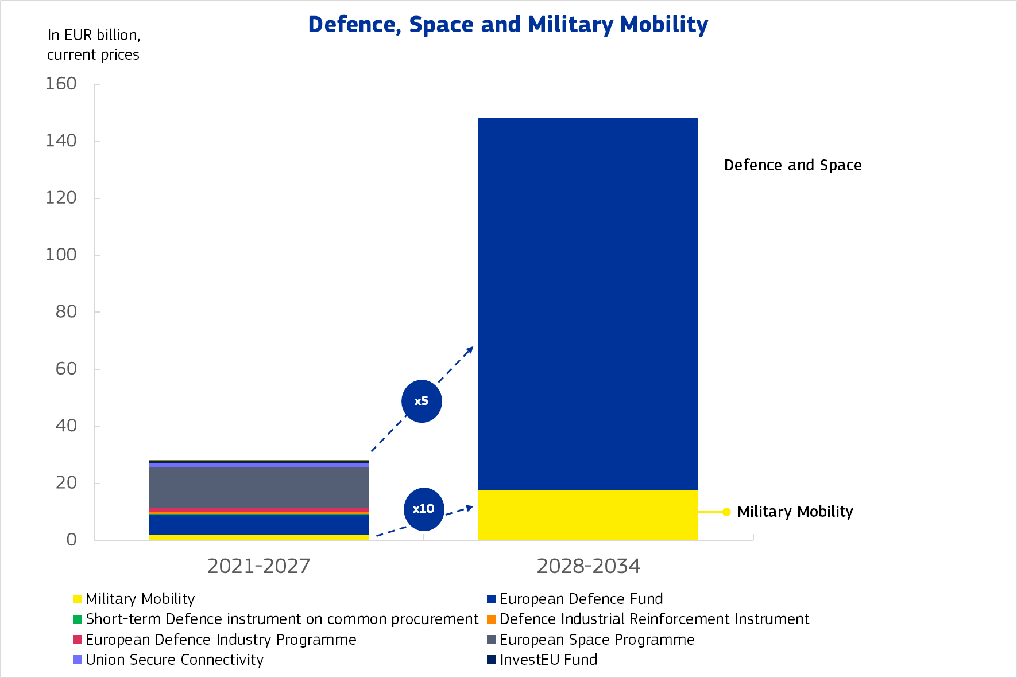
Russia’s war of aggression against Ukraine highlighted the importance of investing in military mobility, to make sure that Member State forces can respond quickly and with sufficient scale to crises erupting at the EU’s external borders and beyond. A reinforced Connecting Europe Facility will therefore increase its focus on military mobility corridors and maximise the synergies with other investments in the transport network. Investments will support the transport of troops and equipment via railways, roads, airports, maritime ports, inland waterways and multimodal terminals.
The European Peace Facility will continue to operate as an off-budget instrument, contributing to the Union’s efforts to preserve peace, prevent conflicts and strengthen international security. The Facility will finance actions decided by the Council under two pillars: the common costs of military operations and missions and assistance measures. In view of the fast-changing geopolitical environment, the Facility should be able to continue supporting partners globally over the timeline of the next financial framework, including Ukraine and reinforced to EUR 30.5 billion.

- Strengthening the European single market
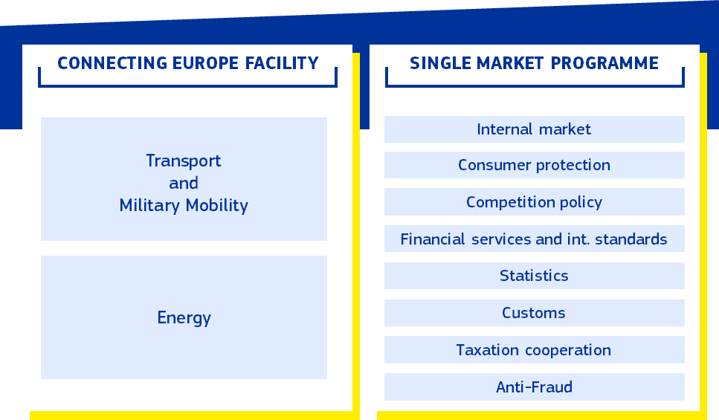
The single market is one of the Union’s defining achievements. Yet the recent Single Market Strategy showed once again that the single market is far from complete. The added value of investment from the EU budget is greatest when it helps to break down barriers and create connections. The new EU budget is designed with this in mind.
The EU budget has always underpinned the widening and deepening of Europe’s single market. It does this through common policies such as cohesion and the common agricultural policy. It also does so via investments in the physical infrastructure that makes trans-European networks a reality, and administrative infrastructure investments that create the conditions for the single market to succeed.
The new Connecting Europe Facility will finance the completion of Trans-European Networks and foster the EU’s clean transition in energy and transport. Russia’s war of aggression against Ukraine and the need to decouple from Russian fossil fuels have underlined the vital importance of a genuine Energy Union and well-integrated EU infrastructure networks. However, progress on key infrastructure such as cross-border rail connections and interconnectors has been too slow. The Facility will give a renewed impulse to these essential investments in Europe’s resilience and security, including by supporting projects in the least connected parts of the Union, such as islands and the outermost regions. It will invest in cross-border interconnectors and grids, cross-border transport connections, offshore networks, renewable energy sources and storage and alternative fuels infrastructure, supporting the Union’s climate ambitions. The Facility will fund dual-use civilian-military transport projects to enable seamless military mobility throughout the EU, a prerequisite for a stronger and better prepared European Defence Union.
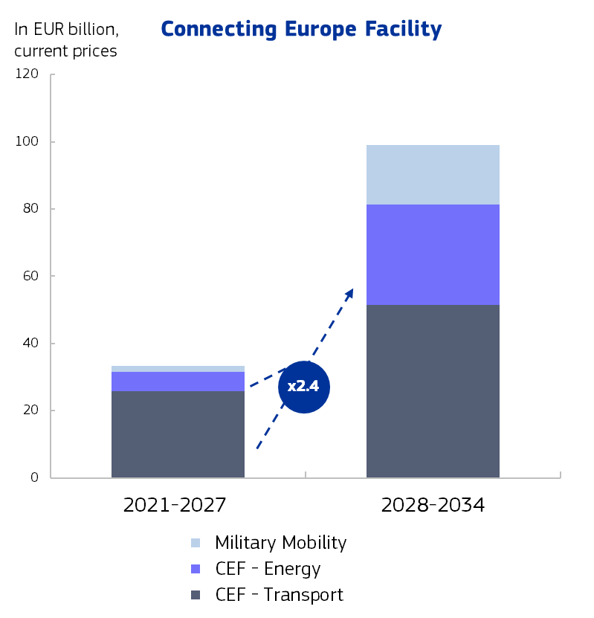
The new Single Market Programme will pool measures supported by the EU budget to break down cross-border and cross-country barriers and foster cooperation between national administrations. It will contribute to enforcement of EU single market legislation and of competition policy, standardisation measures, consumer protection and cooperation between statistical authorities on high-quality statistics to underpin the design, monitoring and evaluation of all Union policies. Moreover, it will remove the remaining fragmentation in EU funding in this area to support cooperation among national administrations and reduce administrative burden in the areas of customs, taxation and anti-fraud, all of which are crucial to the efficient functioning of the single market. It will also contribute to the implementation of the EU customs reform once adopted and of the Savings and Investments Union.
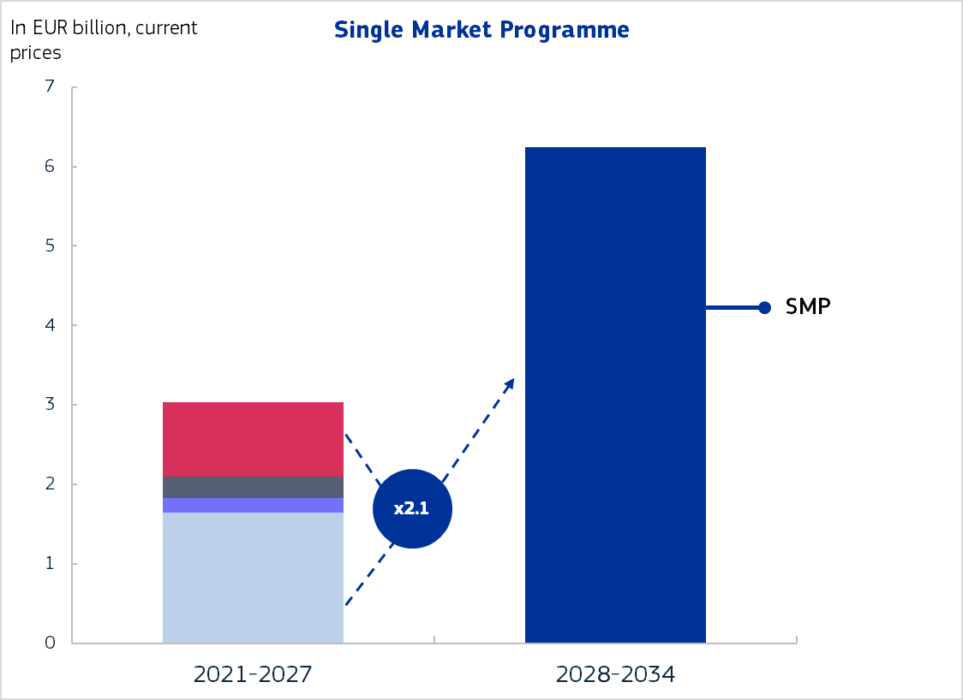

- A strong Europe in an uncertain world: the Global Europe instrument
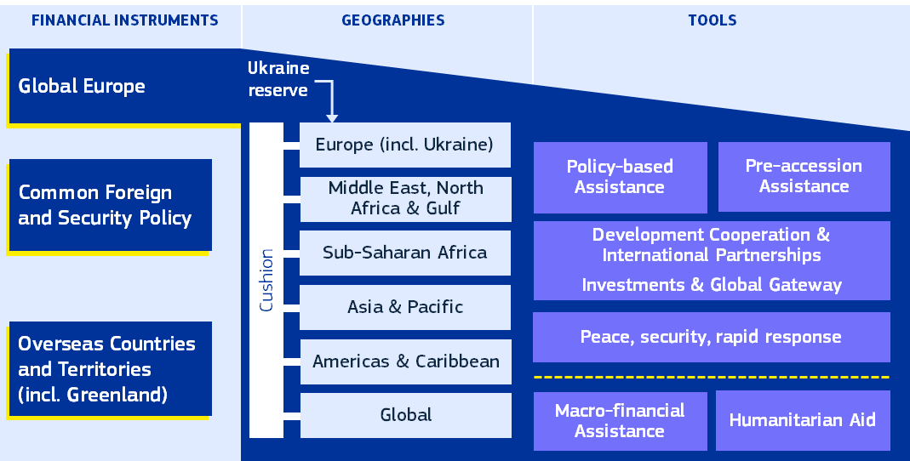
Global Europe will channel EU funds more strategically to key priorities, tailoring support to the needs of Europe’s partners and the Union’s interests, and adapting flexibly as local, regional, and global conditions evolve. It will provide strong support for candidate countries on their European path and promote stability in the Union’s immediate neighbourhood. Global Europe will continue the Union’s unwavering support for Ukraine and underpin the Union’s response to challenges such as conflicts in the Middle East and their aftermath.
The global political and economic landscape is increasingly volatile and unpredictable. There are ongoing and emerging conflicts, unfair competition, and a more assertive economic and geopolitical stance by international actors. Other factors such as climate change, migration pressures, and security threats continue to pose significant challenges to the EU and its partners across the globe.
Against this backdrop, the EU must redesign and strengthen its external action financing in the next financial framework. EU external action needs to be better targeted to our partners and address urgent needs on the ground. It should support the Union’s strategic interests on the global stage by channelling funds towards key political priorities and adapting flexibly to evolving circumstances. A reinforced EUR 200 billion Global Europe instrument will be the basis for this action. Out of this amount, an indicative EUR 25 billion should be dedicated to Humanitarian Aid.
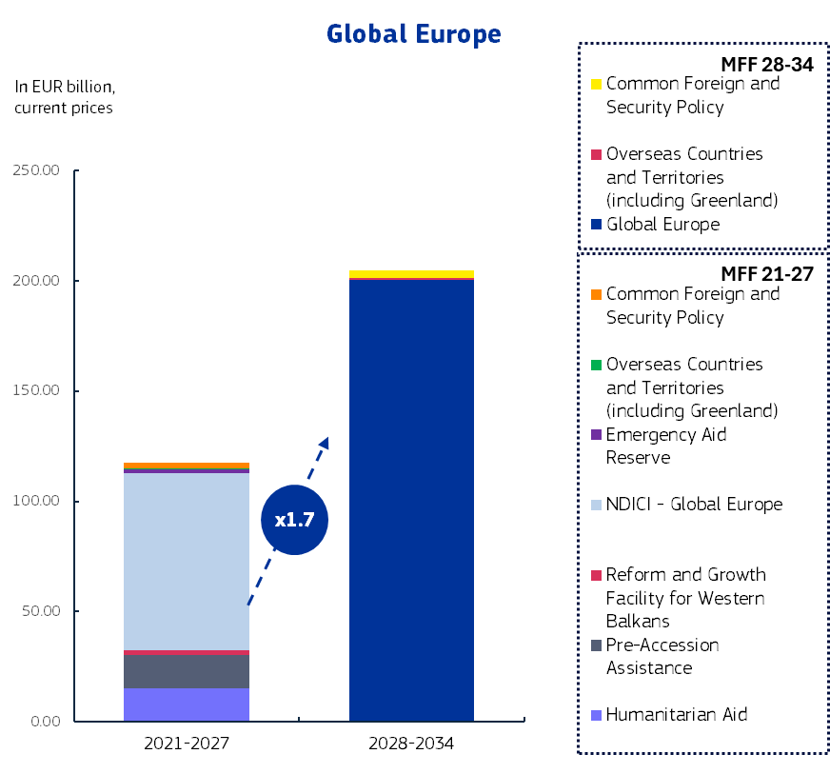
The new Global Europe will optimise, consolidate, and streamline EU external action financing under the next long-term budget. Each macro-region will have an indicative financial allocation to ensure predictability for the Union’s partners, coupled with flexibility to reallocate funds between envelopes and mobilise an overall unallocated reserve to address emerging needs and new priorities. Global Europe will also contain a global pillar for actions that are inherently global in reach, for example financing for initiatives through international organisations like the United Nations. and on issues such as counterterrorism, global health, cybersecurity, Foreign Information, Manipulation and Interference and international climate and ocean governance.
All external action policy tools will be available to target EU support to each macro-region. Global Europe will include multiannual cooperation programmes with partners as well as actions that are non-programmable in nature, such as humanitarian aid and crisis, peace and foreign policy needs. In addition, it will provide assistance based on policy conditions, including reforms and investments. Global Europe will enable the EU to deploy the right combination of policy tools designed to respond most effectively to evolving foreign policy objectives and the specific needs of EU partners.
The EU will offer comprehensive mutually beneficial partnership packages to achieve more effective and targeted external action financing. The partnership packages will be tailor-made for partners or regions, mobilising the appropriate set of policy tools to maximise EU impact on the ground, address EU strategic interests, and improve visibility and understanding of EU external action. It will advance a new European Economic Foreign Policy, strengthening the alignment with EU internal priorities, such as economic security, trade and competitiveness, energy security and decarbonisation, food security, migration management, transport connections, climate and environmental protection, renewable energy production, connectivity offered by trusted vendors, and access to critical raw materials.
Enlargement is a political and geostrategic imperative. Twenty years after the biggest enlargement in EU history, enlargement continues to be a key investment in long-term security, peace, stability and sustainable prosperity in Europe. Russia’s war of aggression against Ukraine has demonstrated the importance of European integration and the need for a larger and stronger Union to address global challenges. The Union is deeply committed to working with candidate countries and potential candidates to prepare for accession, in full respect of the merit-based process and with the firm conviction that their future lies in the European Union. Global Europe will provide essential financial and policy-based support to help candidate countries and potential candidates progress along this path.
The EU will support Ukraine for as long as it takes. From support in the accession process to longer-term reconstruction, the EU will be there for Ukraine. This support will include loans financed via common EU borrowing backed by the headroom of the EU budget. Support for Ukraine will be implemented under the geographic pillar of Global Europe and sourced from above the budget ceilings from a special dedicated reserve given the scale and uncertainty of the needs.
Global Europe will be complemented by other types of EU external action, which, for legal reasons, must be financed under separate programmes. The next long-term EU budget will step up support to Overseas Countries and Territories and will continue financing Common Foreign and Security Policy actions.

- Investing in education, democracy and European values
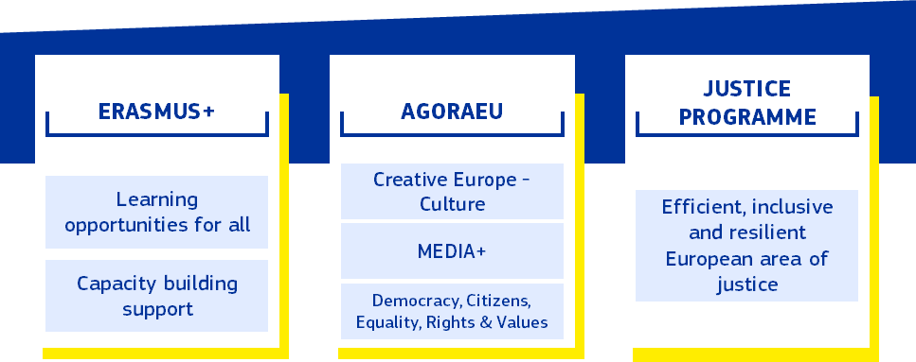
The new long-term EU budget will be a budget for all Europeans. It will step up investment in education and skills to help EU students and workers embrace opportunities across the EU. It will continue to promote Europe’s rich cultural diversity, democratic values and freedoms. It will be rooted in respect for the rights and values that define our Union.
Supporting education, culture, media and democratic values is an investment in our common future. The EU budget has been at the forefront of this support with its programmes. It contributes to addressing transnational collaboration for skills development, addressing and nurturing a sense of EU citizenship and mutual understanding, through the promotion of EU values, supporting democratic and societal resilience, cultural interchange, financial literacy and a trustworthy information space.
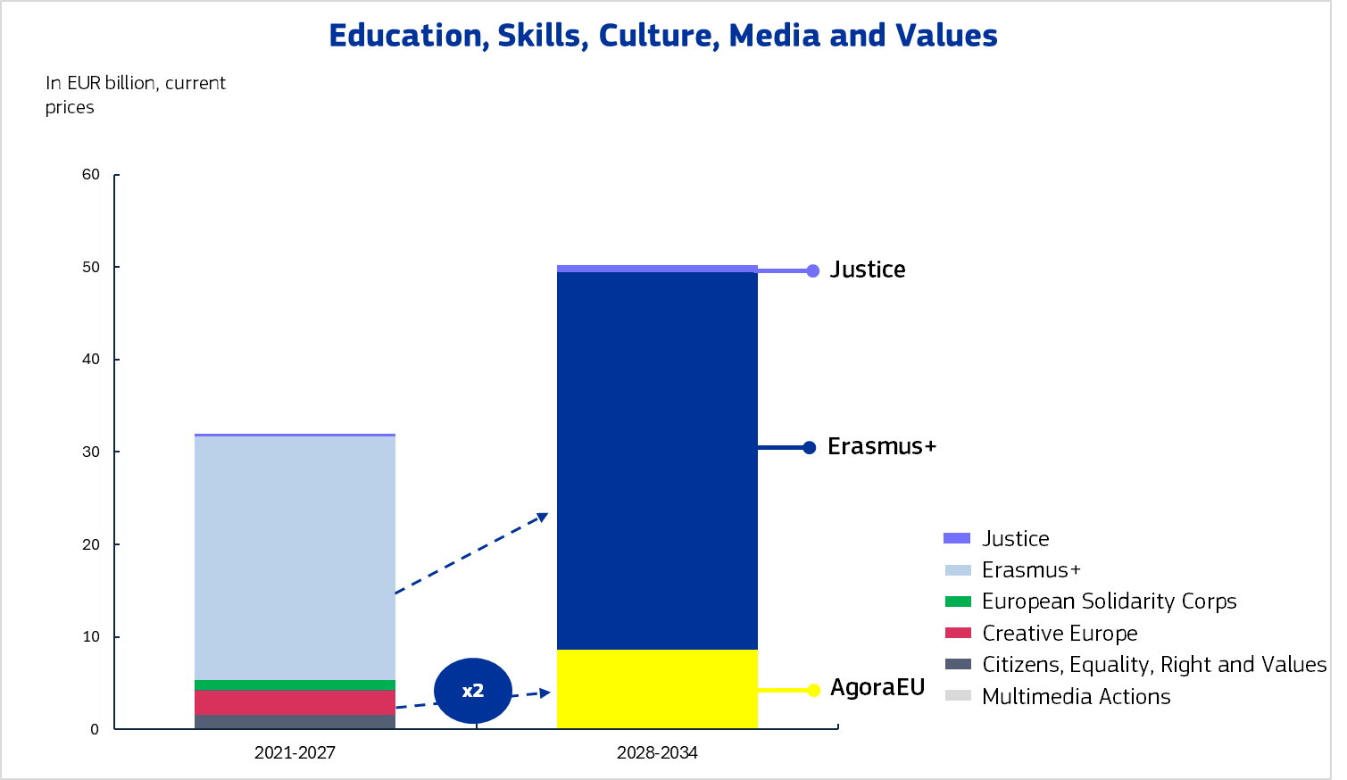
x1.5
The Erasmus+ programme - combining the current Erasmus+ with the European Solidarity Corps - will be strengthened, reflecting its status as one of the most emblematic EU programmes. Erasmus+ will continue to support high quality education and training, boostin g the learning mobility of young people to develop skills and create shared experiences. By investing in youth, volunteering, and sport, Erasmus+ will help build stronger, more connected societies, encourage civic and democratic engagement, and contribute to social cohesion at all levels. The national and regional partnership plans will also provide strong support for reforms and investments supporting skills development and related social infrastructure, fully aligned with country-specific recommendations.
The new AgoraEU programme will support the pillars of a strong democracy, including culture, media and civil society. The EU cultural, creative, audiovisual and media sector is an important pillar of the EU’s economy and society. The audiovisual sector faces strong competition from abroad and challenges related to the increased role of platforms. In the area of news media, decreasing media pluralism and disinformation are becoming a threat to the European project and to democracy. Europe also faces challenges related to democratic participation, equality, cultural diversity and threats to artistic freedom. To counterbalance these trends, well-designed and reinforced financial support at European level plays an important role. Cultural and linguistic diversity, our cultural heritage and our shared values of equality and democracy define the European identity and will continue to be supported in the next long-term budget. Bringing together support to culture, media and civil society under AgoraEU will ensure simpler access for beneficiaries through common rules and funding arrangements.
The Justice programme will contribute to the development of an efficient, inclusive and resilient European area of justice. It will also support the digitalisation of justice at EU level.

- Protecting people and building preparedness and resilience
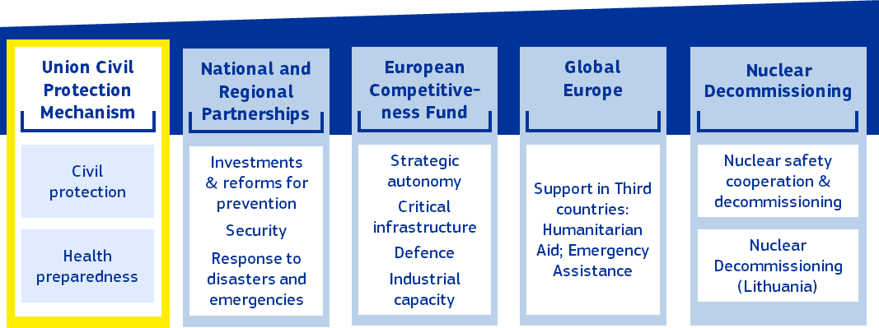
The new long-term EU budget will provide the tools to implement the Preparedness Union and ProtectEU Strategy., Recent disasters and crises, including the pandemic, the war in Ukraine and energy crises, and the many security threats have shown the value added of coordinated EU and Member State action to step up preparedness and safeguard our internal security. The next long-term EU budget will reinforce EU prevention, preparedness and response capacity and invest in a safe and secure Europe.
The Niinistö report highlighted the many threats facing the Union and made concrete recommendations on how to prevent and respond to major crises affecting the EU or some of its Member States. The future long-term budget will address all aspects of crisis management: prevention, preparedness, response, and the recovery and upgrading of the EU’s preparedness toolbox with significant financial support from the EU budget.
The new Union Civil Protection Mechanism and Union support for health emergency preparedness and response will harness the synergies between EU action on civil protection and health emergency preparedness and response. For an MFF built around the ‘preparedness by design principle’, the Commission proposes to increase funding in this area by five times, to EUR 10.7 billion. The Union Civil Protection Mechanism will ensure that response capacities, including stockpiles, are developed and maintained at EU level across all relevant sectors and regions, complementing national efforts. A substantially reinforced Union Civil Protection Mechanism, coupled with health emergency preparedness and response, will ensure better cross-sectoral coordination and address capacity gaps for emergencies created, for example, by climate change, the changing security landscape, including for critical infrastructure, and the evolving global health landscape.
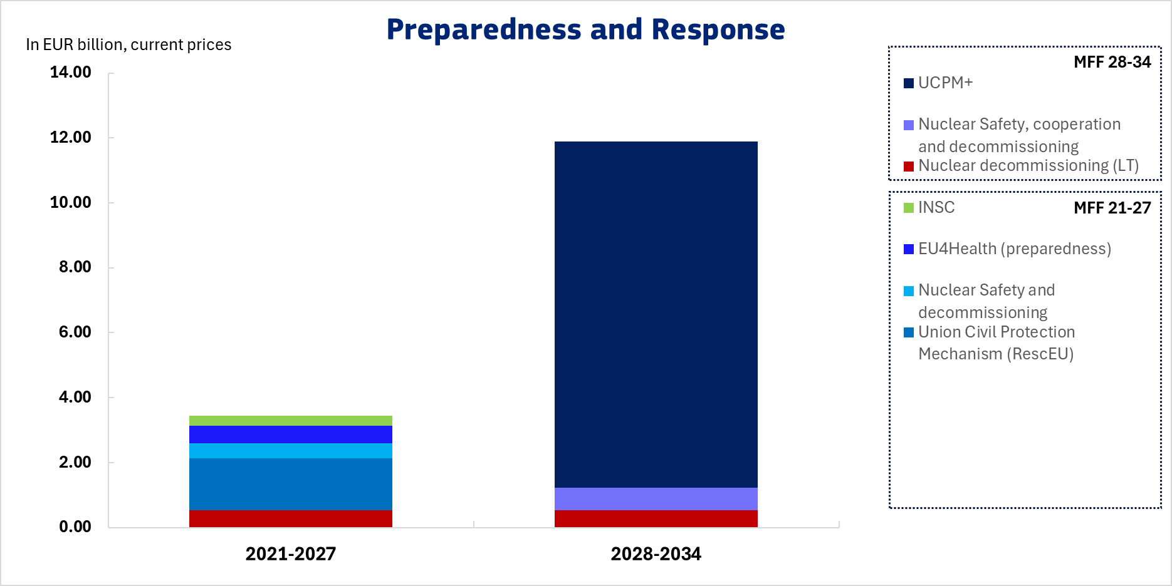
The next financial framework will translate the objective of ‘preparedness by design’ into its structure. In addition to the central EU capacity provided by the Union Civil Protection Mechanism, national and regional partnership plans will support investments and reforms to enhance crisis prevention, climate resilience and preparedness at Member State and regional level. The EU Facility will finance the response to disasters and unexpected events, to supplement national financial allocations or finance actions directly at EU level. The European Competitiveness Fund will enhance the EU’s preparedness and strategic autonomy in key sectors, technologies and infrastructure. It will support building up industrial capacities and cutting-edge technologies (e.g. Copernicus, Galileo and IRIS² crisis support tools; health innovation and manufacturing), contributing to strengthening the resilience of the EU including by investing in the protection of critical infrastructure. Global Europe will offer a comprehensive toolbox for action in third countries.
Security is the bedrock upon which all our freedoms are built. EU Member States’ ability to guarantee security for their citizens is contingent on a unified, European approach to protecting our internal security. The new long-term EU budget will support Europe in making good on its enduring promise of peace and stability. The ProtectEU Strategy sets out the EU’s commitment to a safer and more secure Europe for all its citizens.
The future long-term budget will underpin the commitment to a safer and more secure Europe. It will do so by supporting resilience of critical infrastructures, enabling cooperation between Member States’ emergency services when responding to threats to the internal security of the EU, upgrading systems for information exchange and cooperation, and fostering a common response to serious crimes, including terrorism and organised crime. The new long-term EU budget will also allow closer cooperation with third countries in support of the internal security of the Union, via Global Europe.
The Union will continue to provide support to nuclear safety. This will include international cooperation on nuclear safety, as well as the decommissioning of nuclear activities in Lithuania and of the EU’s own nuclear installations. The EU contribution to the decommissioning of nuclear installations in Bulgaria and Slovakia is expected to be completed by 2027. Financing from the EU budget will contribute to support for the health of workers and the general public, nuclear safety and preventing environmental degradation.

- A modern and efficient public administration for Europe
A 5% reduction in staff in the years 2013 to 2017, followed by a prolonged period of stable staffing has brought considerable savings in administrative expenditure – but also left a significant capacity gap in the Commission and exposed it to business continuity risks. The rapidly evolving economic and global landscape has generated new policy needs and the Commission has been given new initiatives and tasks that require additional resources. To implement these new tasks, the Commission must be equipped with the right level of staffing, with the right profiles. This also implies that the Commission needs to be able to attract the best talent and to improve the geographic balance of its staff.
At the time of the mid-term revision of the 2021-2027 financial framework, the Commission had assessed the needs for all EU institutions resulting from new tasks as well as the need for cybersecurity expertise. Since the mid-term revision proposal was presented, further legislative initiatives have been adopted, without corresponding reinforcement. Other EU institutions have also been faced with new challenges, not least in relation to security, AI and new regulatory obligations which are stretching their capacities to the limit. The gap is also substantial in cybersecurity, given the increased number and severity of attacks.
It is therefore proposed to factor in an increase in staffing of 2500 posts in the administrative heading over the first three years of the new period, covering the established needs and potential developments until 2027, in line with the legislative proposals. By phasing in this increase over the first years of the next period, the Commission would have the necessary resources to ensure the proper implementation and closure of the current programmes, as well as accelerating the start-up of the new generation of programmes and preparing the Union for future enlargements. Looking forward, the proposed simplification and the reduction in the number of programmes are expected to lead to efficiency gains, which will help accommodate new tasks that may arise during the next long-term budget. This, combined with the large-scale review of the Commission’s organisation and operations, should lead to a situation in which the institution can meet future challenges head on, with the best possible staff structure and flexibility to act.
With respect to non-salary related expenditure, an annual increase of 2% during the next financial framework remains feasible, provided that the starting point takes account of the real needs. Several institutions plan major building works over the coming years. Appropriate investment in IT, including for cybersecurity, is required, which will ultimately help to rationalise future costs. Finally, the European External Action Service must be in a position to ensure the security of the delegations. The next long-term budget must cater for uncertainty in price developments which affect in particular fixed costs and other legal obligations (see Section 3).

- A MORE AGILE EU BUDGET
The next long-term EU budget will be a more agile budget, combining stability and predictability with a more structural capacity to adapt to evolving needs and priorities. The next long-term EU budget must be the right budget not only on 1 January 2028 but throughout its implementation until 2034 and beyond: it must be fit for the future.
Flexibility will be a defining feature of the next long-term budget. Flexibility is central to ensuring that the EU budget is future-proof, responsive and relevant for its whole duration. The next long-term budget needs a better balance between investment predictability and flexibility to adjust spending focus and to respond to unexpected needs and crises. Predictability will always be ensured for investments such as major energy and transport investments as well as research and innovation investments that require long-term planning for our beneficiaries, project promoters, and managing authorities. At the same time, reducing the number of headings and programmes will make it easier to redeploy resources that are not pre-programmed within and across programmes. There will be increased possibilities to transfer resources between the strands or windows of EU budget programmes. In addition, the dedicated flexibility tools and instruments will be reinforced.
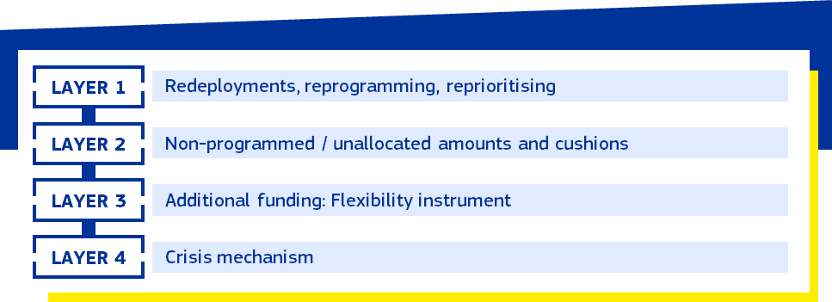
The next financial framework will have a simpler architecture with fewer programmes, a higher share of unprogrammed amounts, as well as mechanisms and in-built reserves allowing for a better, faster and less disruptive response to evolving needs. Redeployments within and across programmes will be facilitated by reducing in-built rigidities in the budget, while continuing to create stable conditions for long-term investment. Response to disasters will be streamlined by integrating the current tools within the ceilings of the financial framework and within programmes, in the form of reserves and cushions, as well as with simplified procedures for redirecting funding. The special instruments ‘over and above’ the ceilings will be rationalised, with the Flexibility Instrument providing support to new or unexpected needs when other flexibilities are not available. The Flexibility Instrument will, in addition to a fixed yearly amount, include amounts equivalent to decommitments made in the previous year as well as to net fines entered in the budget in the previous year.
Recent years have also shown that the frequency, severity and depth of severe crises, hardships and threats have increased. The rigidity of the current budget structure restricted the Union in its response to such crises. This underlined the importance of ensuring that the Union is structurally equipped with flexible and appropriate tools to respond to them.
A new extraordinary and temporary mechanism will be established to respond to the consequences of severe crises, severe hardship or serious threats thereof affecting the Union or its Member States. This extraordinary crisis tool will provide loans to Member States backed by EU borrowing solely for the period of the upcoming long-term budget should a severe crisis occur. The activation of this extraordinary and targeted crisis response tool will be decided by the Council, after obtaining the consent of the European Parliament and considering the specificities and needs of the crisis. The Council will authorise the borrowing by the Commission, on capital markets, of the amount for the loans to Member States, as required and depending on the circumstances. The next long-term budget must be ready to respond quickly and efficiently should a major crisis occur. The implementation of this crisis response tool will ensure institutional balance including through due and adequate involvement of the European Parliament.
A new political steering mechanism will provide strong interinstitutional governance for the allocation of flexible resources. Flexibility will be underpinned by robust governance and a transparent process, with the European Parliament and the Council guiding investment priorities for EU programmes. With greater flexibility in the budget, there is a need for the EU institutions to identify the key priorities to be financed, which will then inform the annual budgetary procedure. The steering mechanism will keep the EU budget more closely aligned with the Union’s priorities and allow it to respond more flexibly to a fast-changing reality. It will be supported by an integrated strategy report, which builds on existing sectoral processes and reports such as the European Semester, the new Competitiveness Coordination Tool, the State of the Energy Union, the National Energy and Climate Plans, the Environmental Implementation review, and the Single Market and Competitiveness Report. Structured by major policy areas, the report will identify EU level priorities to be discussed and agreed by the European Parliament, Council and Commission.
The capacity of the budget should not depend on unexpected inflationary shocks. In recent years, high inflation has weighed substantially on the purchasing power of the EU budget. This led to a reduced budget for regional authorities, farmers or researchers. For the next long-term budget, the Commission is proposing that the ceilings continue to be based on a 2% fixed deflator when EU inflation is between 1% and 3%. When actual inflation is below 1% or above 3%, adjustment will be made based on actual inflation, ensuring that the ability of the EU budget to deliver is not unduly affected.
While flexibility allows for adaptation to changing circumstances, predictability is necessary for beneficiaries and for Member States’ financial planning. Several features of the Commission’s proposals will improve predictability within the next long-term budget, starting with a reduction and rationalisation of instruments above the ceilings. NextGenerationEU repayment will be more predictable than in the current period, as there will be no new net bond issuance. The remaining volatility due to refinancing operations will be covered in full by a fixed annual envelope for NextGenerationEU repayment, covering both interest and principal.

- A SIMPLER, MORE IMPACTFUL EU BUDGET
The EU budget is designed first and foremost with its end recipients in mind. Simplifying and harmonising rules and processes for access to EU funding reduces the burdens for recipients and beneficiaries of EU funds, especially small businesses. With simplified rules and audit arrangements, project promoters will be able to focus on delivering results.
Access to EU funds for beneficiaries will be made easier. A single portal will consolidate information on funding opportunities and provide a single gateway to EU project promoters for simplified access to information, building on the experiences of the Funding and Tenders Portal and the STEP Portal. Advisory and business support services will be streamlined. This will reduce the time needed to locate relevant information on financing opportunities.
The next financial framework will have a simpler architecture, with fewer programmes, reducing administrative burden. This reduces overlaps, maximises synergies and economies of scale and increases the budget’s readability for citizens and stakeholders alike. Furthermore, the creation of stable regulatory frameworks under shared, direct and indirect management reduces administrative burden. With the national and regional partnership plans, we will achieve a significant decrease in programming documents, compared to the current multiplication of plans and work programmes under multiple funds, reducing the burden on national and regional administrations.
To increase impact, the new long-term EU budget will rely extensively on results-based funding. This will shift the focus to the essential: ensuring that investment is delivering the desired outcomes. Results-based financing, where funding can be disbursed for the completion of intermediary steps, will ensure that EU funding reaches the real economy faster. A more widespread use of simplified cost options and financing not linked to costs will significantly reduce the reporting obligations on recipients of funds by focusing checks and controls on the deliverables of the projects rather than on the costs.
Expanded use of financial instruments and budgetary guarantees will increase leverage and allow the EU budget to play a stronger role in de-risking private investment and unlocking financing by institutional investors. Private partners and private sector investment are increasingly relevant for a wide range of policies and programmes. Therefore, budgetary guarantees, financial instruments and blending operations (combining repayable support with a grant component) will become an integral part of the funding toolbox, supporting products such as venture debt, loans and equity investments.
The increased use of financial instruments and budgetary guarantees will be accompanied by simplified governance. A harmonised set of technical rules for both internal and external programmes will promote coherence across the budget and reduce administrative burden for implementing partners. A single budgetary guarantee for internal policies, established within the European Competitiveness Fund but accessible to other programmes, will be established. It will be accompanied by a separate guarantee for external policies established within Global Europe. Open architecture - allowing for cooperation with a variety of International Financial Institutions such as the European Investment Bank, the European Bank for Reconstruction and Development, national promotional banks and Development Finance Institutions - will remain a key feature of the EU long-term budget.
The impact of the next long-term EU budget will be further increased by the use of policy loans to Member States and, under Global Europe, to third countries, further leveraging the EU financial architecture. This will increase the impact of the EU budget, by providing further financial resources to support EU policy goals via borrowing for lending while addressing country-specific challenges. Such additional support will be available to Member States when designing their initial plan, to enable them to access an amount of funding commensurate with their needs and ambitions.
Greater consistency between EU and national investment priorities will maximise the impact and effectiveness of funding. The future national and regional partnership plans will help the EU, Member States and regions to align investment and reform priorities. These partnerships will combine EU and national co-financing to finance initiatives that serve EU priorities while responding to local needs.
An enhanced performance framework will support the delivery of EU policy priorities and increase transparency. It will ensure that horizontal priorities are applied in a consistent way across the EU budget, including for climate and biodiversity, the ‘do no significant harm’ principle, social policies and gender equality.
An overall climate and environment spending target of at least 35% of the total amount of the budget will help steer support towards the goals of the European Green Deal. The performance framework will also provide a single and proportionate set of rules for the implementation of the ‘do no significant harm’ principle across EU programmes.
This performance framework will represent a major simplification, reducing the administrative burdens associated with monitoring and reporting. A single expenditure and performance monitoring system will apply to all relevant programmes, allowing for a comprehensive overview of where EU funds are allocated and what they deliver. The framework replaces over 5,000 indicators with a streamlined set of around 900 output and result indicators, consolidates 32 programme-specific reports into a single Annual Management and Performance Report, and merges more than 30 online portals with information about the budget into one user-friendly entry point (‘Single Gateway’), reducing burden for beneficiaries and improving public access to budget information. In line with recommendations from the European Court of Auditors, it will ensure that the effectiveness and efficiency of the EU budget can be consistently assessed.

- RULE OF LAW, FUNDAMENTAL RIGHTS AND PROTECTION OF THE UNION’S FINANCIAL INTERESTS
Respect for the rule of law is a must for all funds. It is essential that EU spending has strong safeguards on the rule of law to guarantee the protection of the EU’s financial interests. At the same time, experience with the current financing instruments shows that EU financial support for investments and reforms that strengthen the rule of law can offer real added value. The national and regional partnership plans will ensure a strong link between the recommendations in the Rule of Law Report and financial support for targeted reforms and measures that boost institutional and civil society capacities in upholding the rule of law. The combination of financial support for rule of law reforms together with a strict application of safeguards and conditionalities will ensure that the EU budget is protected and is used to deliver on a Union based on democracy, the rule of law and fundamental rights.
The national and regional partnerships will require that Member States respect the principles of the rule of law and the Charter of Fundamental Rights. Building on features of the Common Provisions Regulation and the Recovery and Resilience Facility, this will allow for money to flow when key conditions of compliance with the principles of the rule of law and the Charter of Fundamental Rights are met. In the next financial framework, there should be, as today in NextGenerationEU, a possibility to block payments in case of systemic deficiencies linked to the rule of law, for example by suspending the financing linked to educational institutions in case there is a problem with the fundamental right linked to academic freedom.
The EU budget will also support reforms that strengthen the rule of law in Member States, in line with the recommendations in the annual Rule of Law Report. This will provide positive incentives for all Member States to strengthen their capabilities to uphold the rule of law by sustaining and further developing open, rights-based, democratic, equal and inclusive societies, promoting and upholding the rule of law through strengthening justice systems, anti-corruption frameworks, media pluralism and effective checks and balances, and enhancing the efficiency of public administration and institutional capacity.
The Financial Regulation ensures the protection of the Union’s financial interests and requires Member States to ensure compliance with the Charter of Fundamental Rights and to respect the Union values enshrined in Article 2 TEU relevant in the implementation of the budget. In addition, the Conditionality Regulation, which is not time bound, will continue to protect the EU budget from breaches of the principles of the rule of law. It will be our last line of defence, applying to all EU programmes.
Transparency on the beneficiaries of the EU budget will be reinforced. Starting in 2028, information on the recipients of EU funds will be published in a centralised database on the Commission's website. Furthermore, to protect the EU budget, particularly from misuse to foster radical or extremist views in Member States, the Commission is open to explore new processes or measures for risk-based thorough screening of beneficiaries of EU funding for security risks and incompatibility with EU values. In line with the Financial Regulation as amended in 2024, the conviction for incitement to discrimination, hatred or violence is a new ground for exclusion from EU funding which will be thoroughly applied. The Early Detection and Exclusion System, which protects the EU budget from fraud and irregularities, will be extended to funds implemented under shared management.
The EU budget must rely on a solid audit and control strategy, including close cooperation between the Commission and the European Court of Auditors, to ensure that EU funds are spent in accordance with applicable rules. Regarding the national and regional partnerships, the Commission will rely on controls carried out by the Member States and will complement them by its own controls, focused on the systems put in place by the Member States to ensure the rigorous protection of the financial interests of the EU. It will also combine ex ante and ex post controls on the legality and regularity of payments, i.e. the satisfactory fulfilment of the milestones and targets, starting with the analysis of the plans submitted by the Member States, then carrying out controls on the payment requests submitted, and finally, performing ex post audits.
The ongoing review of the anti-fraud architecture will ensure that all actors involved – including OLAF, the European Public Prosecutors’ office and Europol – collaborate more closely, to fight irregularities fraud and corruption affecting the EU budget. This comprehensive review, involving all the relevant actors within the EU anti-fraud architecture, will create more synergies and efficiencies avoiding duplication at every stage of the anti-fraud cycle: prevention, detection, investigation, correction of fraud, and the recovery of the amounts concerned, including those for the EU budget.

- AN AMBITIOUS EU BUDGET FINANCED BY MODERN REVENUES
The financial firepower of the EU budget must be commensurate with the Union’s ambitions. The scale of the internal challenges facing the Union, coupled with heightened geopolitical uncertainty and intensifying competition, mean that the EU must be equipped with a budget of sufficient magnitude to make a real difference across the priority areas outlined in this communication. And it must do this against the backdrop of the obligation to repay NextGenerationEU borrowing starting from 2028.
The Commission is proposing a long-term EU budget of EUR 1.98 trillion, equivalent to 1.26% of EU GNI. The expenditure and revenue sides of the EU budget are two sides of the same coin. The unique combination of pressing challenges and tight financial constraints presents a unique opportunity to deliver the modernisation on the spending and revenue sides of the budget that is so urgently needed.
To support a more ambitious multiannual financial framework that responds effectively to the Union’s strategic priorities and to cater for the repayment of NextGenerationEU, new own resources are essential. The Union requires a collective financial effort that cannot be borne by national contributions alone. Introducing new own resources will reduce the burden on Member States and ensure the sustainable funding of common EU policies, while keeping national contributions stable overall. The EU budget is about creating European added value for all, which also calls for joint financing of common priorities.
Therefore, as part of the proposal for the new long-term budget, the Commission is proposing a new Own Resources Decision. This proposal modernises and diversifies the sources of revenue for the EU budget. At the same time, the Commission proposes to increase the own resources ceilings for payments to 1.75 % of the EU-27 gross national income to cater for higher financing needs and the necessity to have a sufficient margin to ensure that the Union is able – under any circumstances – to fulfil its financial obligations.
The Interinstitutional Agreement sought to frame and steer the negotiations on new own resources after 2020. These negotiations have stalled. To give negotiations a new impetus, the Commission has undergone a review of the entire revenue side of the EU budget. This includes introducing new categories of own resources and proposing targeted adjustments to existing own resources. The financing of the EU budget can also be reinforced by introducing other revenue sources. The proposed package is in line with the EU’s political priorities, based on existing legislation or the Own Resources Decision itself, and can be implemented with a reasonable administrative burden.
New own resources to finance EU priorities
The Emissions Trading Scheme-based own resource is closely linked to the Union’s climate targets and has significant revenue potential. A possible Emissions Trading Scheme own resource has unique advantages in terms of immediate availability and sufficient scale. While 30% of revenues would go to the EU budget, most revenues from the auctioning of emission allowances would continue to flow to national budgets.
The Carbon Border Adjustment Mechanism own resource can be considered as the ‘external dimension’ of the Emissions Trading Scheme, and the related own resource therefore remains an integral element of the package. The Carbon Border Adjustment Mechanism ensures that imports to the EU are subject to a carbon price equivalent to producing these same goods in the EU.
A new own resource based on the amount of non-collected e-waste would lead to positive environmental outcomes while supporting the Union’s strategic autonomy in critical raw materials. Waste electrical and electronic equipment, or e-waste, is one of the fastest growing waste streams. As e-waste contains important critical raw materials, recycling and re-use play a significant role in reducing dependency on foreign suppliers. Despite notable progress in recycling, the collection rate remains significantly below the Union targets. Implementing a national contribution based on the non-collected waste reported by Member States will incentivise waste reduction and encourage separate collection.
Under the proposed Corporate Resource for Europe, companies will contribute to the financing of the EU budget. Several EU funding programmes support companies in modernising, innovating and expanding. The new long-term EU budget will boost competitiveness and economic growth and improve the business environment through long-term investments, notably through the European Competitiveness Fund. The own resource will, in principle, not apply to SMEs.
A Tobacco Excise Duty Own Resource would support EU health policy objectives, while at the same time generating revenue for the EU budget. Divergent taxation regimes across the Union have negative effects on Member States’ policies to deter tobacco consumption through taxation. The proposal for a Tobacco Excise Duty Own Resource is complementary to the upcoming recast of the tobacco excise duty directive, which aims to adapt EU minimum excise duties and certain categories of traditional tobacco products ensuring a level playing field in the Single Market.
Adjustments to existing own resources
Targeted adjustments to existing own resources are proposed to preserve the revenue base of the EU budget. Traditional Own Resources, consisting primarily of customs duties, are collected by the Member States on behalf of the Union. Furthermore, it is proposed to increase the call rate for the own resource based on non-recycled plastic packaging waste, which was introduced at the start of the current financial framework, to account for inflation developments.
Other revenue
The EU budget can also be financed through other revenue. Other revenue supplements own resources. It flows directly into the EU budget, reducing the pressure on national contributions from Member States. Additional other revenue will be generated, for example, by increasing the level of the existing ETIAS fee to align it with other jurisdictions. The Commission will also continue working towards introducing new fees related to Union policies.
- CONCLUSION
The negotiations on the 2028-2034 multiannual financial framework are an opportunity for the Union to show unity of purpose and to equip the Union with the means to deliver on its collective ambitions.
The Commission is proposing an ambitious, agile and forward-looking EU long-term budget. It builds on the strengths and fundamental principles of the current framework, while making it simpler, more flexible and more impactful. Incremental changes will not be enough to solve a complex budgetary equation, with huge expectations on the Union to deliver while meeting its financial obligations under NextGenerationEU. This means daring to do things differently, ensuring every euro helps to drive Europe forward.
Robust governance, transparency and strong political oversight are integral to every part of these proposals. The Commission will work closely with the European Parliament and the Council to achieve an ambitious, balanced and timely agreement on the next multiannual financial framework and on the sectoral programmes. As budgetary authority, the European Parliament and Council will steer the long-term budget, ensuring it remains fully aligned with our shared priorities throughout its duration.
A more independent Europe must be ready to take its destiny into its own hands. The Union cannot rely solely on others to defend its interests and values. This means we need to use all the tools available to implement our shared agenda and to turn ambitions into reality. The EU budget has the power to unlock the investments and reforms that are key for the Union’s future prosperity, cohesion, security and sustainability.
It is time to work together to make this a reality.

Annex. The 2028-2034 Multiannual Financial Framework - Tables
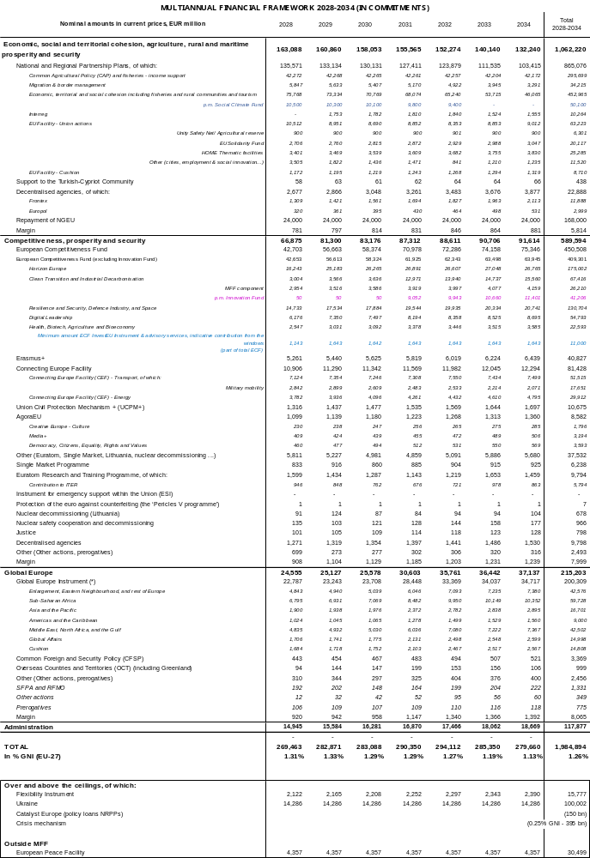

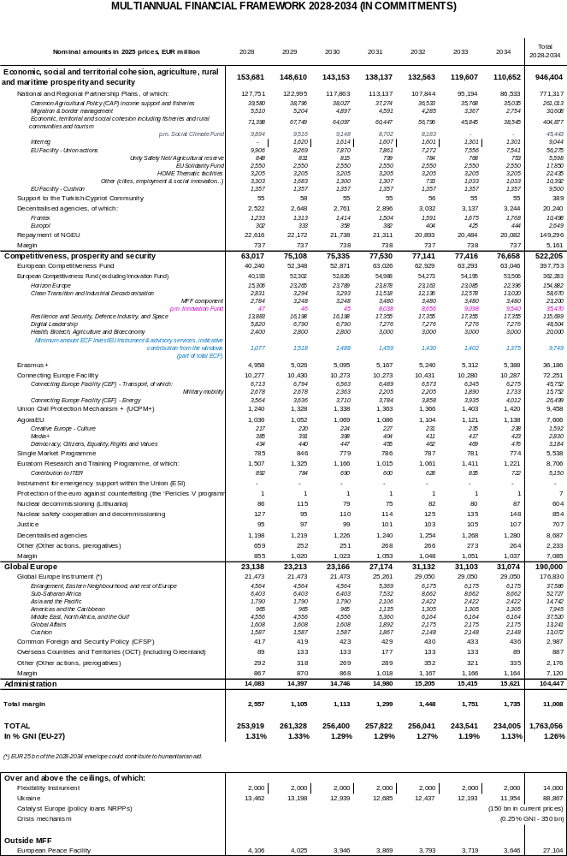

EU’s next long-term budget (MFF) – implementing EU funding with Member States and regions
European Citizens' Panel on the new European budget - European Commission
Regulation (EU, Euratom) 2020/2092 of the European Parliament and of the Council of 16 December 2020 on a general regime of conditionality for the protection of the Union budget.
Draghi, M. (2024) “A competitiveness strategy for Europe”.
Letta, E. (2024) Much more than a market”More than a market”.
Communication from the Commission to the European Parliament, the European Council, the Council, the European Economic and Social Committee and the Committee of the Regions, A Competitiveness Compass for the EU, COM(2025)30 final.
With the addition of support provided by the Innovation Fund, the European Competitiveness Fund and Horizon Europe together amount to EUR 450.8 billion.
Council Regulation (EU) 2025/1106 of 27 May 2025 establishing the Security Action for Europe (SAFE) through the Reinforcement of the European Defence Industry Instrument.
In accordance with Council Decision (CFSP) 2021/509.
Communication from the Commission to the European Parliament, the Council, the European Economic and Social Committee and the Committee of the Regions - The Single Market: our European home market in an uncertain world, COM(2025)500
Council Regulation (EC) No 1257/96 of 20 June 1996 concerning humanitarian aid.
Council Decision (EU) 2021/1764 of 5 October 2021 on the association of the Overseas Countries and Territories with the European Union including relations between the European Union on the one hand, and Greenland and the Kingdom of Denmark on the other (Decision on the Overseas Association, including Greenland) (OJ L 355, 7.10.2021, p. 6, ELI: http://data.europa.eu/eli/dec/2021/1764/oj). 2021/1764
Joint Communication to the European Parliament, the European Council, the Council, the European Economic and Social Committee and the Committee of the Regions on the European Preparedness Union Strategy, JOIN(2025) 130 final.
Communication From The Commission to the European Parliament, the Council, the European Economic and Social Committee and the Committee Of The Regions on ProtectEU: a European Internal Security Strategy, COM(2025) 148 final
Niinistö, S. (2024) Safer together – Strengthening Europe’s civilian and military preparedness and readiness.
SWD(2023) 336 final.
The Commission will propose in due time an amendment of the Financial Regulation prolonging the treatment of negative revenue set out in its Article 48(2) beyond 2027.
This was highlighted by the European Court of Auditors in its 2022 Annual Reports on the implementation of the EU budget for the 2022 financial year and on the activities funded by the 9th, 10th and 11th European Development Funds (EDFs) for the 2022 financial year.
ECA Review 03/2025 Opportunities for the post-2027 Multiannual Financial Framework.

