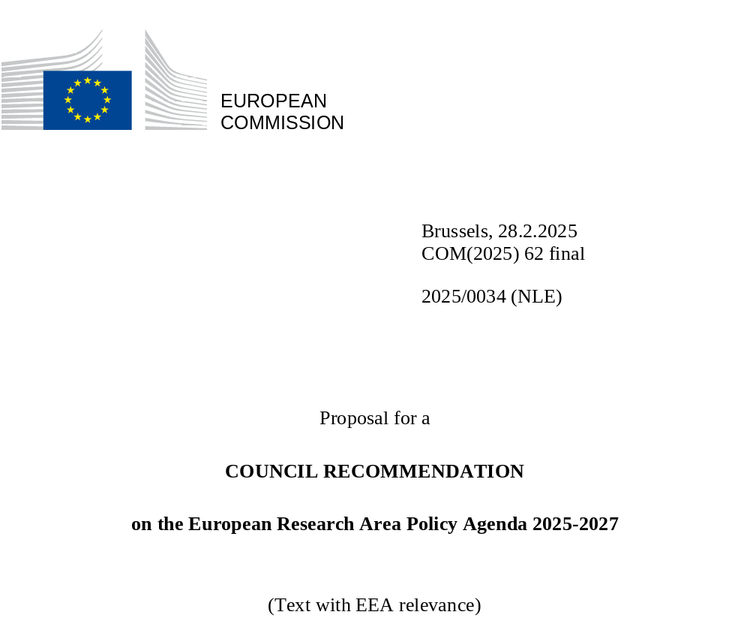

EXPLANATORY MEMORANDUM

1. CONTEXT OF THE PROPOSAL

• Reasons for and objectives of the proposal
The purpose of the European Research Area (ERA) is to create an area where ‘researchers, scientific knowledge and technology circulate freely’ (Article 179 TFEU). The ERA was relaunched in 2020, including the adoption of the Pact for Research and Innovation (R&I) in Europe, articulating the following Member States’ joint priority areas for action:
(1) deepening a truly functioning internal market for knowledge;
(2) taking up together the green transition and digital transformation and other challenges with impact on society, and increasing society’s participation in the ERA;
(3) enhancing access to R&I excellence across the Union and enhancing interconnections between innovation ecosystems across the Union;
(4) advancing concerted R&I investments and reforms.

By setting up new governance structures and a first ERA Policy Agenda 2022-2024 with concrete actions, the EU injected fresh momentum into the ERA, aligning R&I strategies and policies. Notable progress has been made through collaboration with Member States, particularly in addressing the fragmentation of their R&I systems. Initiatives have focused on researcher careers, research infrastructures, open science, building trust in science through citizen engagement and mobilising resources for thematic R&I cooperation. The joint priority-setting process co-created between Member States, stakeholders and the Commission has fostered a sense of ownership and increased commitment to implement the ERA, particularly through the first ERA Policy Agenda.

Like the first ERA Policy Agenda 2022-2024, the second ERA Policy Agenda 2025-2027 outlines concrete ERA activities, serving as a strategic framework to foster collaboration among EU countries, to enhance the effectiveness of R&I systems, and to address societal challenges collectively. Drawing on the lessons learned from implementing the first agenda, the second strikes a balance between deepening action on current priorities through structural policies and broadening the vision for the ERA through new ERA actions. Structural policies are long-term ERA policies such as open science, research infrastructures and research careers, that are not confined to individual policy agendas and are embedded in national and European policy. ERA actions are concise, policy-driven and goal-oriented to provide substantive added value for the EU, Member States and stakeholders. Actions on artificial intelligence in science, research security, science for policy, equity in science were identified as gaps where cooperation was deemed necessary. Overall, this gives the next ERA Policy Agenda 2025-2027 a clearer policy-based focus and a clearer structure to facilitate implementation by national administrations and stakeholders.

The ERA Policy Agenda is a non-binding instrument to steer national and EU-level policies in line with ERA objectives set out in Article 179 of the TFEU. It coordinates Member States’ priorities in the work to advance the ERA based on joint action. It therefore encourages voluntary cooperation and coordination between Member States and the EU. Since it is voluntary, there is no legal enforcement of implementation. The ERA Policy Agenda implementation follows the logic of variable geometry. The ERA Forum, bringing together the European Commission, Member States, Horizon Europe associated countries and EU-level stakeholders, serves as the governance body to jointly coordinate implementation of the ERA activities.
While non-legislative initiatives such as the ERA Policy Agenda 2022-2024 containing voluntary commitments in the form of ERA actions have yielded significant progress, they remain insufficient to address structural barriers. The Commission Communication of 22 October 2024 on ERA implementation highlighted persistent issues such as disparities in research, development and innovation (RDI) performance across Member States, insufficient levels of private and public investment in RDI below the 3% GDP target, fragmented regulatory frameworks, limited technology transfer support, and the fragmentation of research and technology infrastructures. As a conclusion, the Communication underscored the need for stronger governance.
To address the systemic challenges, future legislative initiatives will be complementary to the ERA Policy Agenda and could introduce legislative measures that go beyond voluntary action under the non-binding ERA Policy Agenda. Such initiatives (e.g. an ERA Act) will be an opportunity to tackle issues through harmonisation, uniform application of rules and enforcement of EU policies to create a level playing field across Member States. It could be applied to areas assessed as needing binding rules or structures in order to achieve the objectives of the ERA over and above voluntary coordination and cooperation measures. This should substantially reduce the fragmentation of R&I policies and systems within the EU.

2. LEGAL BASIS, SUBSIDIARITY AND PROPORTIONALITY

• Legal basis
The legal basis for this initiative is Article 292 TFEU. In accordance with Article 292 TFEU, the Council can adopt recommendations and it will act on a proposal from the Commission in all cases where the Treaties provide that it must adopt acts on a proposal from the Commission. In accordance with Article 179(1) TFEU, the EU will pursue the objectives of strengthening its scientific and technological bases by achieving the ERA in which researchers, scientific knowledge and technology circulate freely, and of becoming more competitive, including in its industry, while promoting all the research deemed necessary. In accordance with Article 181 TFEU, the European Union and the Member States must coordinate their research and technological development activities to ensure that national policies and EU policy are mutually consistent.
In close cooperation with the Member States, the Commission may take any useful initiative to promote this coordination, in particular initiatives aiming to create guidelines and indicators, organise the exchange of best practice, and prepare the work needed for regular monitoring and evaluation. The European Parliament must be kept fully informed. Article 182(5) opens up the possibility of complementing the activities planned in the multiannual framework programme by allowing the European Parliament and the Council, acting in accordance with the ordinary legislative procedure and after consulting the Economic and Social Committee, to adopt the measures needed to implement the ERA.

Subsidiarity (for non-exclusive competence)
The purpose of the ERA is to create an area where ‘researchers, scientific knowledge and technology circulate freely’ (Article 179 (1) TFEU). Since this is a multi-level governance initiative and takes a whole-of-government approach (ensuring that policies are aligned at different levels of governance and across policy domains), it is in line with the principle of subsidiarity. It respects the competence of Member States in this area and aims to ensure that R&I policy is coherent across all levels of government (local, regional, national and global). It introduces initiatives that provide most of the EU added value at European level, linked to and building on national and regional policy responses. This initiative meets the subsidiarity principle, given that by virtue of Article 4 (3) of the TFEU the proposal does not fall under the exclusive competence of the European Union.

• Proportionality
The actions proposed are proportionate to the objectives pursued. The proposal supports the achievement of the objectives of the new ERA. It complements national action to create a researcher-centred, value-based, excellent and impact-driven research area. The proposal respects Member States’ practices and takes a differentiated approach reflecting Member States’ different economic, financial and social situations, the diversity of research systems and respective institutions and organisations. It recognises that different national, regional or local conditions could lead to differences in how the proposed recommendation is implemented.

• Choice of the instrument
Following the lessons learned from the first ERA Policy Agenda 2022-2024, choosing a Council Recommendation underscores the Commission’s commitment to reinforce the ERA’s collaborative governance by translating the outcome of the co-creation work with Member States, Horizon Europe associated countries and EU-level stakeholders into a Commission proposal for a Council Recommendation. The aim is to build ownership and a well-informed commitment by Member States and stakeholders as a basis for further cooperation on the agreed actions and structural policies for joint action. It also continues the flexible approach taken to implement ERA actions and the voluntary nature of the ERA Policy Agenda.

3. RESULTS OF EX-POST EVALUATIONS, STAKEHOLDER CONSULTATIONS AND IMPACT ASSESSMENTS

• Collection and use of expertise
The European Commission underpinned its proposal for the ERA Policy Agenda 2025-2027 with evidence from the first ERA monitoring cycle in 2023. The cycle included the first 18-month review on implementation of the ERA Policy Agenda 2022-2024 at EU-level (EU-level report), ERA country reports on all Member States as well as 11 countries associated to Horizon Europe, the first ERA Scoreboard, and the first ERA Dashboard. The 18-month EU-level report provided an assessment on progress on the priority areas for joint action in the ERA, as laid down in the Pact for R&I in Europe, and on implementation of the ERA Policy Agenda. The ERA country reports provided this analysis at national level. The ERA Scoreboard assessed the overall consolidation and collective progress of ERA priorities in 2023 for the EU as a whole and the Dashboard assessed progress at national level. All reports are publicly available on the ERA Policy Platform.

• Impact assessment
There is no impact assessment. As it is a Commission proposal for a Council Recommendation, including ERA activities for the future, impacts cannot be clearly identified ex ante. In addition, the ERA Policy Agenda 2025-2027 has been prepared in co-creation with the ERA Forum expert group, bringing together Member States, Horizon Europe associated countries and stakeholders. The preparatory work was discussed in the Council (notably in the ERAC, as well as through adoption of Council conclusions on strengthening the competitiveness of the EU, reinforcing the ERA and overcoming fragmentation), which evidence that adoption of this document is expected by the Member States and the stakeholders.

• Regulatory fitness and simplification
Not applicable.

• Fundamental rights
Not applicable.

4. BUDGETARY IMPLICATIONS
Not relevant.

5. OTHER ELEMENTS

• Implementation plans and monitoring, evaluation and reporting arrangements
Implementation of the ERA Policy Agenda 2025-2027 is monitored through the ERA monitoring mechanism. The ERA monitoring mechanism is based on the requirements laid down in the Council Recommendation on a Pact for R&I in Europe. On 10 June 2022, the European Commission presented to the Council the ‘Framework for the Future ERA Monitoring Mechanism’, which specifies the components of the mechanism in detail.
To assess implementation of the actions agreed under the ERA Policy Agenda both at national and European level and to assess the EU’s and Member States’ performance in achieving the ERA objectives, the ERA monitoring mechanism comprises both qualitative and quantitative reporting tools.

• Detailed explanation of the specific provisions of the proposal
Not applicable.
2025/0034 (NLE)
Proposal for a
COUNCIL RECOMMENDATION
on the European Research Area Policy Agenda 2025-2027
(Text with EEA relevance)
THE COUNCIL OF THE EUROPEAN UNION,
Having regard to the Treaty on the Functioning of the European Union, and in particular Article 292, first and second sentences, thereof,
Having regard to the proposal from the European Commission,
Whereas:
(1) Today, the EU faces multiple and unprecedented challenges. The global order is changing and the foundations of our societal well-being and security are being shaken by a turbulent geopolitical context, rising economic competition, an unprecedently rapid and transformative technological revolution, and climate change and its consequences. The need to strengthen European leadership and strategic autonomy in key technological domains has become urgent. In this context, science, technology and innovation are crucial to reduce Europe’s vulnerabilities and to unlock its full potential. In addition, research and innovation (R&I) play a critical role in enhancing the European Union’s sustainable competitiveness.
(2) Developing the European Research Area (ERA) is at the heart of our efforts to respond to these challenges. The ambition to create the ERA as a single market for research, technology and innovation was conceived in 2000 and enshrined in the Lisbon Treaty as a specific EU objective. The recent political ambition to establish a ‘Research and Innovation Union’ leading to a joint European R&I strategy and policy and to further pursue ‘the fifth freedom’ show the continuous need to further develop an area where countries come together to coordinate and improve their national R&I policies and ecosystems, and where knowledge, researchers and technology can move freely. Greater EU-wide coordination through the ERA can help stimulate investments and reforms as well as play an essential role in fostering sustainable competitiveness, in line with the objectives of the Competitiveness Compass.
(3) The ERA has produced major achievements over the past 25 years in core policy areas including research infrastructures, open science, international cooperation, gender balance in R&I, joint programming, research careers and researcher mobility. Contributing to these achievements, the Marie Skłodowska-Curie Actions (MSCA) have funded over 150,000 excellent researchers, notably through excellent doctoral programmes, postdoctoral fellowships and R&I staff exchanges, EURAXESS has supported over 2 million researchers in their career development and mobility across Europe and the Open Science Cloud (EOSC) provides seamless access to quality data and digital services while supporting collaboration across borders and disciplines.
(4) In 2021, Member States and the Commission concluded a new vision and policy framework, set out in the Council conclusions on the future governance of the ERA and the Pact for R&I. The vision sets out the common values and principles that will guide R&I and identifies priorities for joint action. In the Pact, Member States reiterated their commitment to work together on the achievements of the ERA objectives to foster integration and cooperation and reduce fragmentation across Europe in scientific research, technology and innovation. Member States reaffirmed their commitment to improve coordination and align national R&I policies to create a more integrated and efficient research ecosystem in the 2024 Council conclusions on strengthening the competitiveness of the EU, reinforcing the ERA and overcoming its fragmentation.
(5) The first ERA Policy Agenda 2022-2024 created a solid foundation to achieve the ERA objectives. It translated the Pact for R&I priority areas into a set of concrete actions. 17 actions were jointly implemented by the Commission, Member States, Horizon Europe associated countries and EU-level stakeholders. As part of the new governance, the ERA Forum and its sub-groups play a unique role in supporting implementation of the ERA and its actions. They act as a bridge between EU-level, national and regional bodies and facilitate collaboration. The inclusive and participatory approach ensures that all voices are heard. This fosters innovative strategies and a shared ownership of policies to strengthen Europe’s R&I ecosystem. As a high-level strategic policy advisory body, the European Research Area and Innovation Committee (ERAC) provides early advice to the Council and the Commission.
(6) The Commission highlighted the achievements of the ERA Policy Agenda 2022-2024 and the new governance in the 2024 Communication ‘Implementation of the European Research Area’. The main achievements in addressing a range of R&I needs across Europe under the first ERA Policy Agenda 2022-2024 include (1) creating the Coalition for Advancing Research Assessment (CoARA), (2) publishing the ‘Zero tolerance code of conduct on counteracting gender-based violence in the EU research and innovation system’, (3) stimulating the green energy transformation by implementing the Strategic Research and Innovation Agenda of the ERA pilot on green hydrogen, (4) creating the ‘R&I and Cohesion Managing Authorities Network’ (RIMA) linking R&I policy actors and managing authorities to assess the innovation divide, increase excellence and capitalise on existing widening instruments, and (5) developing a new ERA monitoring and evaluation framework.
(7) The second ERA Policy Agenda 2025-2027 builds on this approach and is designed to tackle the current challenges. Using the Pact for R&I priority areas for joint action and the implementation outcomes of the first ERA Policy Agenda 2022-2024 as a basis, it outlines 11 ERA structural policies and eight tangible ERA actions. These are the result of an extensive co-creation process within the ERA Forum and ERAC and the aim is to start implementation in 2025. The first and the second ERA Policy Agendas are connected. The ERA Policy Agenda 2025-2027 provides continuity on ongoing policies under the first agenda, tackles the ERA’s core long-term objectives, and has the flexibility needed to respond to new strategic needs.

HEREBY RECOMMENDS THAT:
1. The Member States adopt the ERA Policy Agenda 2025-2027 with 11 structural long-term ERA policies, not confined to individual policy agendas but still have a three-year work plan, and with 8 ERA actions, to be completed within the three-year policy agenda. All ERA proposals are outlined in more detail in the annex.
2. The Member States implement on a voluntary basis the following ERA structural policies and ERA actions, in line with the four Pact for R&I priority areas for joint action. These structural policies and actions focus on (i) bringing clear added value at national and European level, (ii) making an impact by producing specific deliverables and tangible outcomes within three years, (iii) building on constant co-creation between Member States, Commission and stakeholders, (iv) being self-standing with one main activity, meaning no sub-actions, and (v) being implemented in variable geometry, allowing for flexibility in the extent to which countries can get involved.

1. Priority Area: Deepening a truly functioning internal market for knowledge
The free movement of researchers, knowledge and data is essential to build a more efficient and inclusive European R&I system. It helps minimise the duplication of resources and create the critical mass needed to be effective. To strengthen the EU’s competitiveness, it is essential to boost the EU’s international position and scientific leadership by carrying out pioneering fundamental and applied research.

The EU will continue to work on this priority through the following structural policies:
Open science - Enabling open science via sharing and re-use of data, including through the European Open Science Cloud (EOSC); Research infrastructures - Strengthening sustainability, accessibility and resilience of research infrastructures in the European Research Area; Gender equality, equal opportunities for all and inclusiveness - Strengthening inclusive and intersectional gender equality in the ERA; Researchers’ careers and mobility and Research assessment and reward systems - Making research careers more attractive and sustainable as well as reforming research assessment; Knowledge valorisation - Upscaling knowledge valorisation capacities and activities; Global engagement - Global Approach to R&I.

The following ERA actions are proposed for the next three years:
- Equity in open science;
- Advancing the European Science for Policy (S4P) ecosystem;
- Facilitating and accelerating the responsible use of AI in science in the EU;
- Enhancing research security.

2. Priority Area: Taking up together the green transition and digital transformation and other challenges with impact on society, and increasing society’s participation in the ERA
For the ERA to boost competitiveness, improve the quality of life for people in the EU and tackle societal challenges such as the green and digital transitions, it must create synergies with sectoral policies and industrial policy. R&I investment must deliver tangible outcomes that are used and deployed by the market.

The following structural policies have been the core approaches to address this priority area:
Challenge-based initiatives - Making the strategic energy technology (SET) plan a key thematic component of the ERA; Synergies with education and the European Skills Agenda - Improving the articulation between R&I and higher education within the ERA and unleashing the full potential of European R&I ecosystems; An active citizen and societal engagement in R&I – Enhancing trust in science through citizen participation, engagement and science communication.

The following ERA actions are proposed for the next three years:
- Accelerating R&I investments for Europe’s industrial transformation and competitive sustainability;
- Accelerating new approach methodologies (NAMs) to advance biomedical research and testing of medicinal products and medical devices;
- A harmonised and coordinated framework for a European approach to integrity and ethics in R&I in the face of emerging challenges.

3. Priority Area: Enhancing access to research and innovation excellence across the Union and enhancing interconnections between innovation ecosystems across the Union
Research excellence spans all of Europe, across ages, disciplines and sectors. Its full potential has yet to be tapped due to significant disparities in opportunities for researchers and innovators in the ERA. A structural policy to tackle this priority area is to create synergies between EU, national and regional funding programmes - Improve EU access to excellence.

The following ERA action is proposed for the next three years:
- Empowering R&I: A new era in research management.

4. Priority Area: Advancing concerted research and innovation investments and reforms
As the EU focuses on key areas for future competitiveness, sustainability and well-being, it would be counterproductive to duplicate, substitute or fragment R&I investment and initiatives. Cross-border cooperation can boost efficiency by pooling resources to achieve critical mass and increase the knowledge spillover effects to boost innovation. Ensuring that these investments are efficient and impactful will also require in some instances designing, implementing and monitoring structural reforms in national R&D systems. The aim of these reforms will be to increase scientific excellence, extract the valorisation of research results, enhance science-business links and better target policies to support business innovation.
There is no specific ERA action proposed under this objective but it is widely acknowledged that boosting R&I investments and adopting structural reforms remains a key priority for the European Commission and the Member States to work closely together using a set of existing instruments. More precisely, implementing the R&I measures under the EU’s Recovery and Resilience Facility is expected to boost national innovation capacity, especially in countries that continue to lag behind.
Through the European Semester of economic policy coordination, the European Commission carries out an in-depth analysis of the national R&I systems and issues country-specific recommendations on how to boost each country’s innovation potential. The Commission then monitors policy responses by the Member States to assess progress in bridging the R&I gaps identified. To support their efforts to improve their R&I systems through reforms, Member States and associated countries can receive expert support under the Horizon Policy Support Facility, an instrument that has proved highly beneficial in improving policymaking and identifying reform pathways, and the bilateral Enhanced Dialogue with Member States on commonly agreed topics of R&I.

3. The established collaborative framework between the European Commission, Member States, associated countries and stakeholder organisations in the form of the ERA Forum and ERAC should be maintained as a central mechanism of ERA governance. Implementation of the next ERA Policy Agenda 2025-2027 will remain an inclusive and transparent endeavour across all levels of governance to foster co-creation and ownership of the agenda. The ERA Forum remains a sounding board for emerging challenges, outside the activities of the ERA Policy Agenda 2025-2027, that require cross-country collaboration and are covered by the Pact for R&I, such as a follow-up on the freedom of scientific research.
4. Coordinated implementation should ensure the active and broad involvement of EU-level stakeholders across the entire spectrum, from research to innovation and market deployment. The categories of stakeholders in the ERA Forum should be reviewed to achieve a greater representation of the different interests.
5. Member States and the European Commission should support the full involvement of countries associated to the Horizon Europe programme and EU-level umbrella stakeholder organisations in implementing the ERA Policy Agenda 2025-2027.
6. R&I investment in the EU falls short of aspirations and remains below the level of investment in many of the EU’s global competitors. Currently, the EU spends some 2.3% of its GDP on R&D, far below the 3% R&D target set in 2002 in the Barcelona Declaration. To meet the multifaceted challenge of reaching the 3% target, coordinated action is needed to boost public and private R&D investment. Further reforms are also needed to improve national R&I ecosystems and maximise the impact of an increase in investment in R&I. In addition to the Pact for R&I priority area ‘Advancing concerted R&I investments and reforms’, Member States and the Commission should continue their efforts in this direction.
7. The European Commission and the Member States should continue to implement the ERA monitoring mechanism outlined in the Pact for R&I in Europe and detailed in the ‘Framework for the future ERA monitoring mechanism’ presented by the Commission to the Council on 10 June 2022. The ERA monitoring mechanism will assess progress towards the ERA priorities, as defined in the Pact for R&I. The ERA monitoring mechanism should consist of:
(1) an ERA Scoreboard to monitor progress towards the ERA objectives both at EU and national levels, updated regularly;
(2) a regular ERA monitoring report from the Commission to the Council to review implementation of the ERA policy agenda,
(3) regular ERA country reports to review countries’ progress in implementing the ERA Policy Agenda.
Member States will continue to exchange information on the ERA, in particular by providing data and information via the ERA Policy Platform. Member States will also promote implementation of the ERA actions and results in their countries, drawing on the support available.

Done at Brussels,
For the Council
The President

COUNCIL RECOMMENDATION (EU) 2021/2122.
COM(2024) 490.
https://european-research-area.ec.europa.eu/
16179/24.
COM(2025) 30 final
14308/21.
COUNCIL RECOMMENDATION (EU) 2021/2122.
16179/24.
COM(2024) 490.
COUNCIL NOTE 9578/22.

