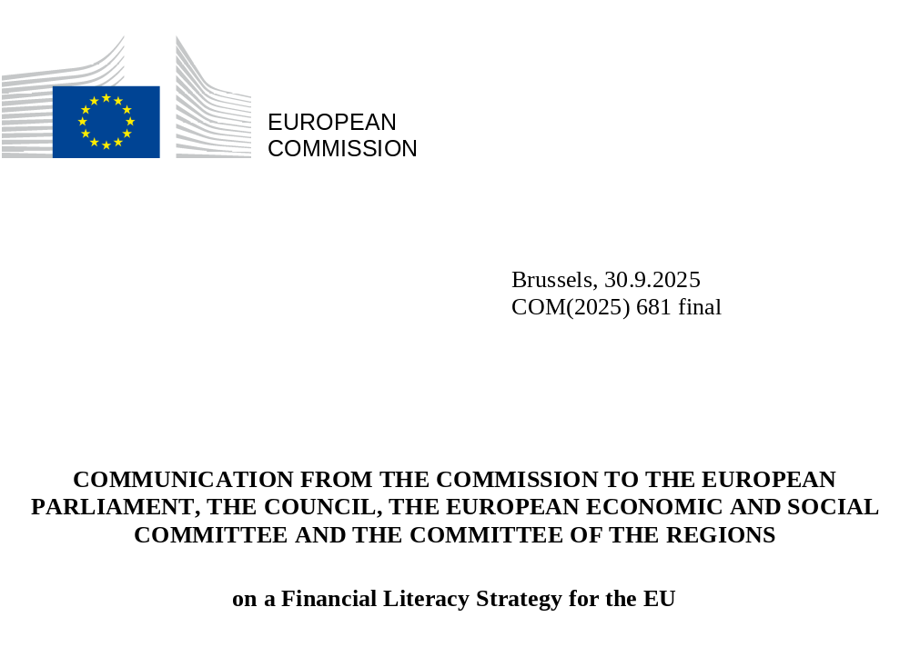

- An EU financial literacy strategy

Financial literacy is an essential life skill. It refers to the combination of financial awareness, knowledge, skills, attitudes, and behaviours necessary to make sound financial decisions. Financial literacy empowers individuals to engage in healthy financial practices such as effective budgeting, informed savings and investment choices, proper long-term financial planning including retirement planning and responsible debt management, thereby contributing to financial independence, risk management and avoidance of fraud and scams. By fostering sound financial habits, individuals and households can improve their financial resilience, leading to greater economic stability and reduced risk of over-indebtedness. Financial literacy is therefore essential to empower citizens to secure their financial independence and well-being. Moreover, its benefits go beyond the individual: by promoting financial inclusion and civic engagement, financial literacy helps build a more resilient society.
Levels of financial literacy in the EU are currently very low (see chart below). According to the 2023 Eurobarometer survey, less than one fifth (18%) of EU citizens have a high level of financial literacy (). Financial literacy levels also differ significantly across Member States and among different demographic cohorts within Member States. Women, younger and older people, people with lower income and with lower level of general education in particular tend to be, on average, less financially literate than other groups.
Eurobarometer: Financial literacy score by Member State
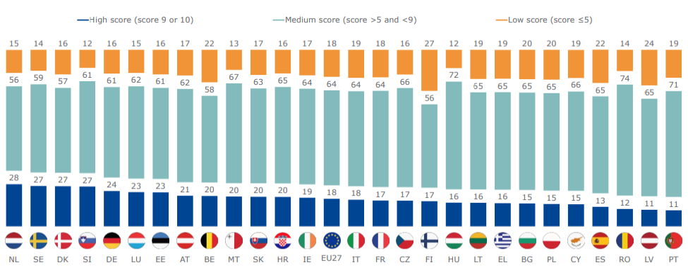
Source: Eurobarometer on Monitoring the level of financial literacy in the EU, 2023
In the EU, almost half (49%) of the population between 18 and 65 years of age do not have enough emergency savings to cover their living expenses for at least three months, without borrowing any money or moving house. Furthermore, 16% do not have any emergency savings at all. Combined with low levels of financial literacy this makes them especially vulnerable to financial shocks or the consequences of poor financial decision-making. The need to improve financial literacy is even more important in today’s increasingly digitalised world, where a wider range financial products and services is more accessible than ever before. Financial literacy must reflect the evolving ways in which financial services are provided, in order to empower people to use them safely and with confidence, taking advantage of the new opportunities this offers, including through Savings and Investments Accounts and with the prospect of the digital euro, while being mindful of the risks, including those linked to frauds or scams, or complex, high-risk and speculative products.
Financial literacy also affects financial decision-making. For instance, it is likely that varying levels of financial literacy are an important factor explaining a relatively low level of retail participation in capital markets across the EU as well as significant divergence in participation rates among Member States (see chart below).

Percent of the population with an investment product (fund, stock or bonds) by Member State
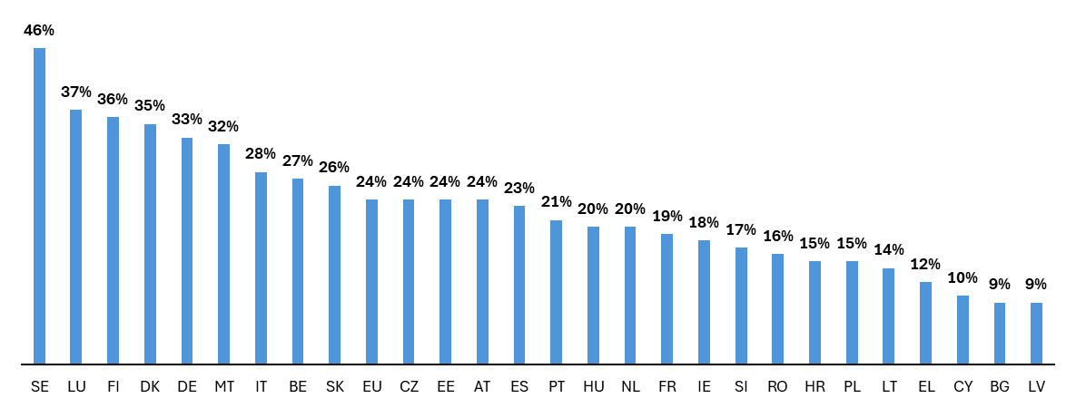
Source: Eurobarometer on Monitoring the level of financial literacy in the EU, 2023

- An EU financial literacy strategy
  - Objectives
Against this background, the Commission has announced a comprehensive financial literacy strategy in its Savings and Investments Union (SIU) Communication () with the overall objective of addressing low levels of financial literacy, in order to empower citizens to make informed decisions regarding their personal finances, and to facilitate their participation in capital markets on a safe and sound basis. This strategy aims to support important financial inclusion objectives including raising awareness to promote access and effective use of financial services, strengthening economic resilience, and advancing policies that target vulnerable groups. It also seeks to deepen investment literacy and understanding of financial products, including real risk-return trade-offs.
Any strategy relating to financial literacy cannot adopt a one-size fits all approach. Initiatives need to address the specific circumstances and needs of different target groups and communities. For instance, while some people do not have savings to invest but could benefit from guidance on dealing with utility bills, credit cards, insurance and accessing social or other benefits, others have savings and could benefit from better access to information on how to better manage those savings. By specifically targeting diverse demographics with dedicated and inclusive financial literacy initiatives including trustworthy debt advice and by adapting the mediums and channels to their needs, such initiatives could contribute to reducing financial inequality, while helping individuals to maximise the benefits of their savings.
Overall, this will enable individuals to manage their budgets and savings efficiently, navigate challenges and opportunities stemming from ongoing digitalisation, and build up their wealth over time, including by investing in capital markets. Such investments have the potential to offer higher returns, while at the same time providing EU companies with additional funding options and thus contributing to economic growth. While individuals should decide for themselves whether to participate in capital markets, it is essential that those who choose to invest are equipped to make sound, informed decisions and are treated fairly. By fostering such an environment, new investors can confidently navigate financial decisions, and existing investors can remain engaged. With improved financial literacy, citizens will also gain deeper awareness of the impact of their investment decisions. This includes a greater understanding of the economic effects of choosing to finance certain activities, as well as their impacts and implications for employment, sustainability, social outcomes and resilience.
  - Building on ongoing initiatives
The strategy builds upon the Commission’s ongoing efforts to improve financial literacy, ensuring continuity and leveraging past initiatives. It complements actions taken to raise awareness and improve financial competences of youth, children and adults via the joint European Commission/Organisation for Economic Cooperation and Development - International Network on Financial Education (OECD-INFE) financial competence frameworks () (), those of entrepreneurs via the European entrepreneurship competence framework (EntreComp ()) and the work developed with the Member States under the Technical Support Instrument (TSI) (). It takes into consideration the Digital Decade Policy Programme that provides a relevant framework for advancing digital skills. It also complements the 2025 Union of Skills Communication (), the upcoming Anti-Poverty Strategy, and other efforts ().
The strategy also responds to calls for action from the Council to the Commission in its 2024 conclusions on financial literacy () to facilitate the exchange of best practices by Member States, to continue monitoring financial literacy levels in the EU and promote the uptake of the financial competence frameworks. Additionally, the Council called on the Commission to support non-legislative actions such as funding financial literacy projects via the TSI and Erasmus+, facilitate training and research opportunities, and strengthen cooperation on financial literacy.
The strategy supports efforts taken by the European Supervisory Authorities (ESAs), the European Central Bank (ECB), and other international organisations, in particular the OECD (), to raise financial awareness and improve financial literacy levels. It is also noted that the European Economic and Social Committee has already adopted its own report (). The European Parliament has also recently adopted reports on the Savings and Investments Union, including financial literacy () and the Commission encourages the European Parliament and its Members to pro-actively promote financial literacy in the EU.
The new strategy aligns with the EU regulatory framework for financial services. It is complementary to investor protection rules in fostering trust and confidence among retail investors. In light of this, the 2023 Commission proposal for a Retail Investment Strategy (RIS) also includes a requirement for Member States to promote financial literacy among retail investors. That proposal is in the legislative process and is now being negotiated by the European Parliament and the Council. Financial literacy is also important to support the success of Savings and Investment Accounts, which is the subject of a Commission Recommendation adopted on the same day as this Communication.
Engagement with stakeholders remains a priority. The strategy builds on the success of the 2024 high-level conference on ‘Financial Literacy, Resilience and Inclusion’ and the accompanying academic conference (). It also incorporates feedback from the Call for Evidence published in the context of the Communication on the Savings and Investments Union, which included considerations on the need to improve the levels of financial literacy in the EU. In addition, it reflects extensive consultations with all Member States through the EU Government Expert Group on Retail Financial Services (GEGRFS).
The strategy seeks to complement and strengthen national financial literacy strategies and initiatives undertaken by public and private stakeholders in Member States, such as consumer and retail investor associations, social partners, civil society organisations, industry associations and other market participants. In particular, consumer and retail investor associations can serve as trusted, independent advocates that ensure that educational efforts remain accessible, unbiased, and aligned with consumers’ interests.
In addition, industry associations can provide in-depth expertise, practical insights and scalable outreach. If properly framed, this can help citizens to have relevant and up-to-date knowledge of financial products and services. Trade unions are also uniquely positioned to promote financial literacy because of their direct access to a broad base of working adults. Through their network, unions can increase the outreach of financial literacy initiatives and deliver practical financial education in the workplace, for example, related to retirement preparedness and planning.

- A comprehensive approach
In line with its supporting and coordinating role in the area of financial literacy, and recognising the numerous existing national and private initiatives already in place across the EU, the Commission aims to complement ongoing efforts. The strategy therefore focuses on areas where EU action can deliver the greatest added value.
In this context, the EU financial literacy strategy adopts a comprehensive approach and is based on four interrelated pillars of action: (i) coordination and best practices; (ii) communication and awareness raising; (iii) funding for financial literacy initiatives including for research; and (iv) monitoring progress and assessing impacts.
Together, actions in these areas aim to promote informed financial decision-making and facilitate the development and exchange of effective ways to monitor, analyse and assess financial literacy ().
  - Coordination and best practices
All Member States either have a financial literacy strategy in place or are in the process of developing one. In addition, various financial literacy initiatives are undertaken by different stakeholders in Member States. Mutual learning and exchange of best practices can help to identify and broaden the roll-out of effective initiatives and to gain insights into key success factors.
The Commission will work with the relevant stakeholders to define key thematic priorities and to identify best practices within those areas. Potential areas for action would include initiatives to foster the “teaching of teachers and trainers” or financial inclusion and other initiatives aimed at specific target groups, including those with low income, women, children, youth or older people, notably by identifying relevant “teachable moments” () for these target groups.
In this context, the Commission will support the collection and exchange of best practices with a view to ensuring that they are discussed with Member States and that the potential for effective implementation across the EU is fully explored while taking into account national specificities. The exchanges with Member States will serve to facilitate mutual learning and foster convergence of approaches where appropriate.
These exchanges will also serve as a platform to identify priority areas and the best way forward for the communication and awareness-raising campaigns and funding opportunities.
By fostering these exchanges, the Commission aims to identify common challenges and collaboratively develop solutions, thereby strengthening collective commitments. Where relevant, the Commission will also coordinate with experts from international organisations and third countries to enrich this process.
Regular high-level discussions at ministerial level will also be organised to foster political ownership and ensure alignment with broader EU policies and effective coordination among EU Member States. These regular discussions would be relevant to establish political momentum and support for financial literacy actions at both EU and Member State level.
The Commission also welcomes the work of the European Supervisory Authorities on financial education, in particular the repository on financial education initiatives, which is key to improve coordination and promote the exchange of good practices. The Commission calls for the ESAs to jointly develop a broader repository on financial education initiatives taken in the sectors they supervise. The repository should be easily accessible online, inclusive, user-friendly and searchable, enabling users to identify existing practices by theme, based on an underlying classification system. Its scope should not be limited to digital financial education.
To facilitate exchanges and help stakeholders to connect with each other, the Commission will also organise regular workshops with financial literacy practitioners bringing together private sector and not-for-profit stakeholders, including consumer and retail investor associations. These workshops will aim to identify guiding principles or practical measures to foster cooperation and will promote the creation of a pan-European community of private and not-for-profit financial literacy practitioners.
The involvement of private stakeholders in improving financial literacy has clear merits as a complement to initiatives by other stakeholders, most notably because it enables the mobilisation of their vast networks, practical expertise and outreach capacity. However, the absence of a standardised code of conduct for these stakeholders can lead to (perceived) conflicts of interest or inconsistencies in the quality and reliability of the information provided. Therefore, the Commission will promote and assist in developing a European code of conduct for private and not-for-profit organisations providing financial literacy initiatives. The voluntary code of conduct should be principle-based and developed jointly by relevant stakeholder representatives under the auspices of the Commission. A robust code of conduct would ensure that the objectives of financial literacy initiatives are transparent, and that educational content is accurate and unbiased, thereby fostering trust among consumers and investors, and enhancing the credibility of the initiatives. It would also help mitigate the risk of potential conflicts of interest, where private entities might promote products or services that benefit their own interests rather than the financial well-being of participants. A well-defined code would promote ethical behaviour, accountability, and continuous improvement, ultimately leading to more effective and equitable financial literacy programmes. In addition, the Commission recommends that Member States consider incorporating the EU code of conduct into their national financial literacy strategies ().
Proposed measures:
- The Commission will organise regular financial literacy thematic meetings of relevant government expert groups, where warranted, to coordinate efforts on communication, awareness raising, monitoring, evaluation and funding of national financial literacy initiatives. The first meeting will be organised in Q1 2026.
- The Commission will work with relevant stakeholders to define thematic priority areas and identify best practices; exchanges on these practices will then be carried out among Member State experts in designing and implementing financial literacy initiatives starting in Q4 2026. These best practices will be presented and discussed with Member States at both technical and political levels. Each Member State will be responsible for evaluating the implementation of the identified best practices and the Commission will publish the results of the discussion.
- The Commission will organise regular workshops bringing together private sector and not-for-profit stakeholders to facilitate exchanges, foster cooperation and promote the creation of a pan-European community of financial literacy practitioners, as of 2026.
- In 2027, the Commission will organise a first ministerial-level event on financial literacy to take stock of progress achieved in the dissemination and implementation of best practices and to review key emerging trends. The event will aim to ensure continued active engagement and political commitment and will be held every two years.
- The Commission will support the development of a voluntary, principle-based European code of conduct for private and not-for-profit organisations in collaboration with relevant stakeholders by Q1 2027. The Commission also recommends that Member States consider incorporating the EU code of conduct into their national financial literacy strategies and monitor progress by tracking the number of organisations adhering to it.

  - Communication and awareness raising
The 2024 Council conclusions emphasise the importance of awareness-raising campaigns in the area of financial literacy, encouraging Member States to take relevant action.
Financial literacy programmes and initiatives are essential but raising awareness of such programmes is an obvious pre-condition for their success. In this context, an EU-level awareness campaign will be designed to bolster existing national actions in this area, complementing communication, awareness and guidance efforts of Member States’ authorities and EU and national consumer and industry associations as well as social partners.
The EU-level awareness-raising campaign will focus on personal finance skills, including budget planning, retirement planning, debt management, risk management and fraud and scam prevention, which are relevant to all EU citizens, particularly vulnerable groups. The campaign will be sufficiently flexible to support tailored national approaches that cater for specific target groups such as people with disabilities, women, young, older and low-income people. These groups can be hard to reach and may have specific needs that may vary across Member States. Therefore, it is important that national strategies utilise existing infrastructures, including community centres or similar social hubs found at the local level, where relevant, and work with trusted and relatable interlocuters to reach these target groups.
At the same time, the campaign would support the broader SIU objectives of fostering “an investment culture” and raising awareness about the risk and opportunities of investing, including risk-return trade-offs and the benefits of diversification. The campaign will include a range of communication materials aimed at helping investors gather information, including on how to participate in capital markets and the features of different investment products, in an inclusive way. It would highlight the benefits of Savings and Investment Accounts (SIAs) in facilitating participation in capital markets, thus complementing the SIA recommendation by contributing to the visibility of SIAs and encouraging their take-up.
In order to support Member States’ initiatives, increase their visibility and ensure consistent messaging, a network of "financial literacy ambassadors" will be established. This network of public figures will champion financial literacy as a European and national cause, going beyond just investment decisions —to include everyday money management and raising consumer awareness. Without these advocates, efforts to increase public awareness have often lacked the necessary visibility and influence to effect meaningful change. Ambassadors could bridge the gap by providing relatable examples and personal testimonies that resonate with diverse audiences, thereby enhancing engagement and encouraging more people to develop essential financial skills.
Ambassadors should have a key role within Member States in guiding citizens towards reliable financial literacy programmes and resources and relevant interlocutors, including consumer and retail investor associations, social partners and national authorities. Ambassadors will be selected and appointed by each Member State to support and amplify overall efforts to advance financial literacy across the EU. These ambassadors will operate at national and local level, engaging with citizens and communities (including those in rural areas), businesses, governments and educational institutions. They will foster the debate at national level, targeting different groups through various channels, including by participating in public events, engaging with mainstream media and connecting with younger generations on social media. They will aid in the promotion of educational programmes, encourage informed financial decision-making, and support initiatives that enable citizens to better manage their finances and participate in capital markets. Member States are encouraged to provide continuous support to the ambassadors in carrying out their tasks.
The Commission will regularly engage with the financial literacy ambassadors, periodically bringing them together to assess progress, exchange insights and ideas, and share best practices at local level. It will also equip them with key messages and communication materials, which the ambassadors can tailor and adapt to the local context. This network of ambassadors could also collaborate with EU and national consumer and retail investor organisations and social partners in implementing the awareness-raising campaign or by promoting the actions of these organisations, including those on financial guidance. This approach aims to leverage on existing national networks and expertise to maximise the campaign's impact and reach.
The EU ambassadors can also play an active role during the OECD/INFE’s Global Money week, an annual global awareness-raising campaign which aims to ensure that young people, from an early age, have the necessary financial knowledge and skills.
In addition, the Commission will organise public events, featuring discussions on financial and investment literacy.
Proposed measures:
- The Commission, together with Member States, will create by Q1 2026 a network of reputable “financial literacy ambassadors” to foster debate at national level. These trusted public figures will help champion financial literacy as a national and European cause and relate to the unique context of the Member State.
- The Commission will run an extensive communication and social media campaign, targeting various groups, including youth, children and vulnerable ones. The campaign will also raise awareness on EU funding schemes in support of national financial literacy strategies and initiatives. The Commission can also help identify specific needs or priority areas and promote specific initiatives at national level to increase their reach and impact.
- The Commission will hold public events focused on financial literacy and its role in supporting financial well-being, as part of broader awareness-raising initiatives.
  - Monitoring progress and assessing impacts
Monitoring progress and assessing impacts will be crucial in evaluating the effectiveness of financial literacy actions. In its conclusions on financial literacy, the Council recommended Member States to take actions to strengthen monitoring and evaluation efforts (). The Eurogroup in inclusive format has decided that it will regularly conduct a structured monitoring to assess the performance of European capital markets and track progress on Capital Markets Union (CMU), including the level of financial literacy ().
To support this, the Commission will conduct a second Flash Eurobarometer survey on financial literacy in 2027 and continue to do so regularly afterwards. By comparing the survey results with those of the 2023 Flash Eurobarometer, financial literacy developments and progress in all EU Member States can be tracked through a common measurement framework (). Besides collecting the comparative data vis-à-vis the 2023 survey, the Commission will consider including additional questions on matters such as budgeting and saving, retirement preparedness and planning, financial resilience and insurance coverage, while avoiding duplication with information already collected through alternative surveys. This data will support the analysis of financial behaviour and provide insight into the correlation between levels of financial literacy and financial well-being, also considering the gender and age dimension. It will also help identify areas where financial literacy initiatives would be particularly helpful. The Commission also encourages Member States to participate in other international surveys on financial literacy.
In addition to monitoring the levels of financial literacy in the EU it is also important to monitor the implementation of the established best practices in Member States. To this end, the Commission proposes that the process of exchanging best practices be complemented by a mechanism for reporting to the Eurogroup in inclusive format. In addition, the Commission will work with Member States and stakeholders to monitor the implementation of the EU code of conduct for private and not-for-profit organisations.
Rigorous evaluation of financial literacy initiatives is key to evaluating their effectiveness, including in delivering behavioural changes, and identifying best practices. The Commission encourages relevant stakeholders () to make use of the Commission’s Learning Lab on Investing in Quality Education and Training for the evaluation of financial literacy initiatives. In addition, the Commission is committed to supporting the development and uptake of evaluation tools by Member States. Existing tools such as the European Institute of Innovation and Technology () methodology for evaluations and the OECD work in this area can serve as a model, while exchanges of best practices can provide an opportunity for a more in-depth discussion, including on methodologies and indicators for measuring concrete outcomes and behavioural changes (such as increased savings rates, use of digital platforms, insurance coverage, supplementary pension participation or levels of participation in capital markets).
Lastly, financial literacy featured prominently in the country reports of the 2025 European Semester, building also on the Technical Support Instrument’s projects. The Commission will continue to assess financial literacy developments in each country report that is part of the European Semester framework. The analysis in these reports could build upon the aforementioned Eurobarometer surveys on financial literacy levels. The analysis will inform the content of country reports and may feed into potential country-specific recommendations.
Proposed measures:
- The Commission will conduct a second Flash Eurobarometer on monitoring levels of financial literacy in the EU in 2027 and will continue to do so regularly afterwards. To further improve monitoring, the Commission encourages Member States to participate in international surveys on financial literacy.
- The Commission will support the development and uptake of evaluation tools by Member States, including by discussing the use of such tools in the exchange of best practices. The Commission will also encourage stakeholders to use the Commission’s Learning Lab on Investing in Quality Education and Training for the evaluation of their financial literacy initiatives.
- The Commission already considers and will continue to consider financial sector issues including financial literacy in the European Semester process. Where warranted, the Commission may propose country-specific recommendations in these areas.

  - Funding for financial literacy initiatives including for research
Securing funding for financial literacy initiatives will be crucial. Adequate funding is necessary to implement comprehensive educational programmes and initiatives that can address the diverse needs of the population.
In implementing this financial literacy strategy, the Commission encourages Member States to make the best use of existing funding channels, including the Erasmus+ programme, the Single Market Programme, the Technical Support Instrument, and the European Social Fund Plus, to finance financial literacy initiatives under the current Multiannual Financial Framework (MFF).
While the Commission has funded financial literacy initiatives through various programmes (), a more structured and coordinated approach could make it easier for stakeholders to identify relevant funding sources. Building also on existing tools, a dedicated website set up by the Commission that gives a comprehensive overview of the relevant EU funding channels for financial literacy would enhance the visibility of funding sources and strengthen the implementation of financial literacy initiatives and research projects.
Academic research can advance financial literacy objectives in several ways (). In line with this, the 2024 Council conclusions on financial literacy recommend to the Commission to facilitate research opportunities and call on the Commission, Member States and stakeholders to stimulate research and collaboration by considering funding opportunities to improve financial literacy in the EU. The Commission will promote the use of existing funding for financial literacy initiatives and research projects. In addition, the Commission will promote the use of the financial literacy competence frameworks in the design of financial literacy initiatives and research projects seeking EU funding, thereby supporting the implementation of these frameworks. The objective of this strategy is to complement, not replace, national financial literacy funding opportunities.
Looking ahead and as mentioned in the Commission’s MFF proposal, the National and Regional Partnership Plans will be expected to support, inter alia, measures, including reforms, to further the Savings and investments Union and foster the development of market-based funding options. This can also include actions on financial literacy.
Proposed measures:
- The Commission will set up a website to help stakeholders find information on existing EU funding channels for financial literacy initiatives and research. The Commission also calls on Member States to improve the visibility of national funding channels for financial literacy initiatives and make them easily accessible for stakeholders.
- The Commission will promote, where relevant, the use of the financial literacy competence frameworks to design financial literacy initiatives and research projects, including where they may benefit from EU funding.
- The Commission will encourage Member States to make the best use of existing and future funding channels, including under the current MFF, such as Erasmus+, European Social Fund +, Single Market Programme, and the Technical Support Instrument.

- Conclusions and next steps
At the heart of this financial literacy strategy lies a fundamental commitment to support citizens in managing their financial well-being. Financial literacy has the potential to unlock doors to better life outcomes: from preventing over indebtedness and securing stable housing to planning for retirement, as well as navigating unexpected challenges with resilience. It is the cornerstone of personal empowerment, economic inclusion, and long-term prosperity for all, benefitting communities and the broader economy. By equipping individuals with the knowledge, skills, and confidence to make informed financial decisions, we are not only contributing to increasing individuals’ financial independence —we are cultivating a resilient, inclusive and forward-looking society where citizens can thrive. Acting without delay is essential, especially since the full impact of any financial literacy strategy will not be immediate and will materialise only over time, as individuals adapt their behaviour.
The next phase will focus on the effective implementation of the strategy, with a strong emphasis on structured cooperation among Member States and key stakeholders to maximise the impact of ongoing and future initiatives.
To track progress, a robust monitoring framework will be established, using existing tools such as the Flash Eurobarometer survey, the Eurogroup monitoring processes, and country-specific monitoring in the European Semester. The Commission will assess the implementation of the financial literacy strategy in the broader context of the planned SIU strategy’s mid-term review in 2027. This review will provide a key opportunity to identify any implementation challenges and refine the strategy as needed, to ensure continued relevance and impact.
Stakeholder engagement will remain central, involving the private sector, consumer and retail investor organisations, social partners, and international partners to share best practices and align efforts. Regular reporting will provide updates and solicit feedback to inform future action. Finally, findings from monitoring and evaluation will inform long-term planning, ensuring financial literacy remains a key priority in EU policy and funding frameworks.

APPENDIX: Table of actions
Pillar | Proposed action | Date
Coordination and best practices | Regular financial literacy thematic meetings of relevant government expert groups to coordinate efforts in terms of communication, awareness raising, monitoring, evaluation and funding of financial literacy initiatives. | As of Q1 2026
Coordination and best practices | Identification of thematic priority areas and exchanges of ‘best practices’ among Member States’ experts in designing and implementing financial literacy initiatives. | Q4 2026
Coordination and best practices | A ministerial event on financial literacy to take stock of progress achieved in the implementation and dissemination of best practices and to review key emerging trends. | As of 2027
Coordination and best practices | Development of a voluntary, principle-based European code of conduct for private and not-for-profit organisations in collaboration with relevant stakeholders. | Q1 2027
Coordination and best practices | Regular workshops with private sector and not-for-profit stakeholders to facilitate exchanges, foster cooperation and promote the creation of a pan-European community of financial literacy practitioners. | As of 2026
Communication and awareness raising | Establishment of a network of well-qualified “financial literacy ambassadors” to foster debate at national level, champion financial literacy as a national and European cause as it relates to the unique context of the Member State. | Q1 2026
Communication and awareness raising | EU-wide communication and social media campaign on financial literacy, targeting various user groups, including youth, children and vulnerable ones. | As of 2026
Communication and awareness raising | Organisation of public events focused on financial literacy and its role in supporting financial well-being, as part of broader awareness-raising initiatives. | As of 2026
Monitoring progress and assessing impacts | Second Flash Eurobarometer survey on monitoring levels of financial literacy in the EU. The Commission will continue to conduct such surveys regularly afterwards. | As of 2027
Monitoring progress and assessing impacts | Support for the development and uptake of evaluation tools by Member States. The Commission will also encourage stakeholders to use the Commission’s Learning Lab on Investing in Quality Education and Training for the evaluation of their financial literacy initiatives. | As of 2026
Monitoring progress and assessing impacts | Inclusion of financial literacy in the European Semester process to promote consistent evaluation and potential country-specific recommendations. | Ongoing
Funding for financial literacy initiatives including for research | Website to help stakeholders retrieve information on existing EU funding channels for financial literacy initiatives and research. | Q4 2026
 | Promotion of the use of the financial literacy competence frameworks to design financial literacy initiatives and research projects, including where they may benefit from EU funding. | Ongoing
 | The Commission will encourage Member States to make the best use of existing and future funding channels, including under the current MFF, such as Erasmus+, European Social Fund +, Single Market Programme, and the Technical Support Instrument. | Ongoing

European Commission (2023). Monitoring the level of financial literacy in the EU (Flash Eurobarometer 525: Survey No. 2953). [online] Available at: https://europa.eu/eurobarometer/surveys/detail/2953
Directorate-General for Financial Stability, Financial Services and Capital Markets Union (2025). Savings and investments union: Strategy to enhance financial opportunities for EU citizens and businesses. [online] Available at: https://finance.ec.europa.eu/publications/savings-and-investments-union-strategy-enhance-financial-opportunities-eu-citizens-and-businesses_en
Directorate-General for Financial Stability, Financial Services and Capital Markets Union (2023). Financial competence framework for children and youth. [online] Available at: https://finance.ec.europa.eu/system/files/2023-09/230927-financial-competence-framework-children-youth_en.pdf https://finance.ec.europa.eu/system/files/2022-01/220111-financial-competence-framework-adults_en.pdf
Directorate-General for Financial Stability, Financial Services and Capital Markets Union (2022). Financial competence framework for adults. [online] Available at: https://finance.ec.europa.eu/system/files/2022-01/220111-financial-competence-framework-adults_en.pdf
Joint Research Centre, in partnership with DG Employment, Social Affairs and Inclusion (2016). EntreComp: The Entrepreneurship Competence Framework. [online] Available at: https://joint-research-centre.ec.europa.eu/entrecomp-entrepreneurship-competence-framework_en
See, for example, Directorate-General for Structural Reform Support (2023). TSI 2024 Flagship ‒ Digital Financial Literacy. [online] Available at: https://reform-support.ec.europa.eu/tsi-2024-flagship-digital-financial-literacy_en
European Commission (2025). Proposal for a Regulation of the European Parliament and of the Council on digital financial literacy (COM(2025) 90 final). [online] Available at: https://eur-lex.europa.eu/legal-content/EN/TXT/PDF/?uri=CELEX%3A52025DC0090
The strategy also builds on the Commission’s ongoing efforts to strengthen statistical and data literacy, helping citizens grasp the key elements needed to make sound financial decisions. See: Eurostat (2024). Improving statistical literacy. [online] Available at: https://cros.ec.europa.eu/book-page/improving-statistical-literacy
Council of the European Union (2024). Draft Council Conclusions on Digital Financial Literacy (ST-9930/2024 INIT). [online] Available at: https://data.consilium.europa.eu/doc/document/ST-9930-2024-INIT/en/pdf
The OECD provides guiding principles through the OECD/INFE Recommendation on Financial Literacy, which supports governments and stakeholders in designing, implementing, and evaluating effective strategies and education programmes. As part of its work, the OECD also conducts regular assessments to measure financial literacy. The 2023 International Survey of Adult Financial Literacy, covering 39 economies, revealed a clear link between higher levels of financial literacy and greater financial resilience and well‑being. Additionally, the 2022 PISA financial literacy assessment evaluated the skills of 15-year-olds, highlighting significant gaps in students’ ability to apply financial knowledge to real-life situations.
European Economic and Social Committee (EESC) (2025). Financial literacy and education for Europeans (Opinion ECO/677-EESC-2025). [online] Available at: https://www.eesc.europa.eu/en/our-work/opinions-information-reports/opinions/financial-literacy-and-education-europeans-0
European Parliament, Resolution of 10 September 2025 on investments and reforms for European competitiveness and the creation of a Capital Markets Union (facilitating the financing of investments and reforms) (TA-10-2025-0185) [online], 10 September 2025. Available at: https://www.europarl.europa.eu/doceo/document/TA-10-2025-0185_EN.html
European Commission; Belgian Financial Services and Markets Authority (FSMA) (2024). Financial literacy, resilience and inclusion (Conference, 20 February 2024). [online] Available at: https://finance.ec.europa.eu/events/financial-literacy-resilience-and-inclusion-2024-02-20_en
It is important to note that financial literacy is different than financial education. While financial literacy focuses on the outcomes—what individuals know, understand, and do regarding their finances—financial education refers to the process through which individuals acquire the knowledge they require to become financially literate. Financial education is learning about budgeting while financial literacy is about applying those principals to one’s own personal finance. Early and ongoing exposure to financial education results in measurable improvements in financial behaviour and knowledge. Member States where financial education is embedded in the national curriculum consistently rank among the top performers in terms of financial literacy in EU-wide surveys. In addition, in line with the scope of the financial competency frameworks, this strategy does not cover financial literacy for entrepreneurs and SMEs, which are covered in other Commission workstreams. Through the EntreComp the Commission promotes entrepreneurship education, including for underrepresented groups like women and youth. Additionally, practical experience and networking are promoted through the Erasmus for Young Entrepreneurs (EYE) and the Enterprise Europe Network.
A teachable moment is the most effective time to deliver education. Citizens are more likely to improve their financial knowledge, improve financial skills or adopt better financial behaviour during teachable moments because it is the time that they are most motivated and receptive to learning. Teachable moments in financial literacy are moments were citizens have the possibility to apply their knowledge in a concrete case of interest to them.
For example, Austria’s national financial literacy strategy includes a code of conduct for the involvement of stakeholders. See: Federal Minister of Finance (Austria) (2024). Overview National Financial Literacy Strategy (Download & Contact Details). [online] Available at: https://www.bmf.gv.at/en/the-ministry/National-Financial-Literacy-Strategy/overview-national-financial-literacy-strategy/download---contact-details.html
Council of the European Union (2024). Capital Markets Union: Council approves conclusions on financial literacy (Press release, 14 May 2024). [online] Available at: https://www.consilium.europa.eu/en/press/press-releases/2024/05/14/capital-markets-union-council-approves-conclusions-on-financial-literacy/
Council of the European Union (2024). CMU Monitoring Framework. [online] Available at: https://www.consilium.europa.eu/media/kljp0mvi/cmu_monitoring_framework.pdf
For an overview, see European Commission (2023). European Financial Stability and Integration Review 2023. [online] Available at: https://finance.ec.europa.eu/document/download/ffc80aa7-96a8-4500-b7a5-eaf1f8e607cf_en?filename=european-financial-stability-and-integration-review-2023_en_0.pdf
The Lab promotes education policy evaluation practices in the EU. It offers general training courses, customised technical support on policy evaluation, including help on designing an evaluation process, and free counterfactual impact evaluation studies of education policies for selected projects. Policy makers and members of the civil society, including social partners and education practitioners, can participate in the Lab. For further information, see: European Commission; Directorate-General for Education, Youth, Sport and Culture (2022). Learning Lab: Investing in Quality Education and Training. [online] Available at: https://education.ec.europa.eu/focus-topics/improving-quality/learning-lab
European Institute of Innovation & Technology (2022). EIT Monitoring and Evaluation Strategy 2022–2027. [online] Available at: https://www.eit.europa.eu/sites/default/files/eit_monitoring_and_evaluation_strategy_2022-2027_1.pdf
Including via the digital financial literacy flagship initiative under the TSI, Erasmus+ and the ESF + and the Single Market Programme. In addition, many financial literacy projects are also funded at national level by public or private stakeholders.
It can help assess the effectiveness of national financial literacy strategies and inform country reports under the European Semester framework (see Section c). It can also identify best practices through cross-country initiatives, overcoming the local focus of national initiatives which might hinder the implementation of national initiatives in countries with different institutional, social and demographic characteristics. Furthermore, it can support the implementation of the voluntary EC/OECD-INFE financial literacy competence frameworks by developing and testing competence-based educational material. This would facilitate the integration of the youth framework in curricula, as schools often lack the expertise to develop rigorous evaluations and identify best practices (see Section a and Section c).

