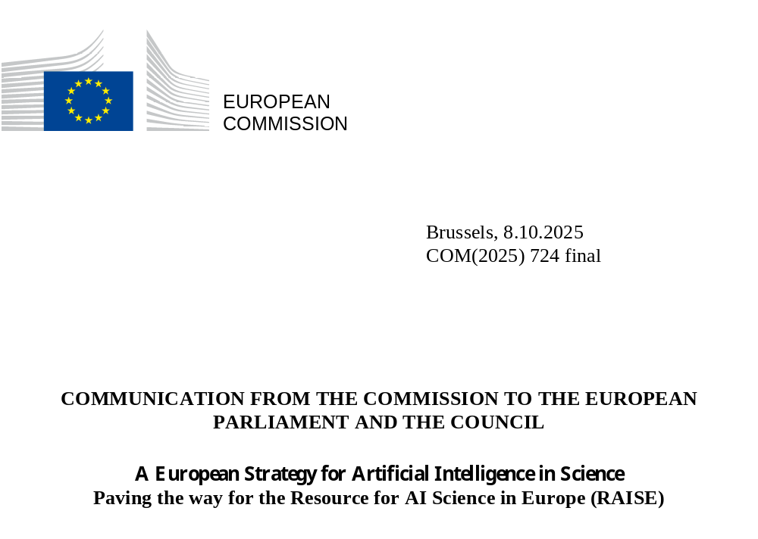

A European Strategy for Artificial Intelligence in Science
Paving the way for the Resource for AI Science in Europe (RAISE)

Introduction
Science has been a driving force for building prosperity in Europe. Today, artificial intelligence (AI) is profoundly transforming the way scientific research is conducted, from assisting with literature reviews to automating lab experiments. Scientists are using AI to tackle complex scientific problems and make faster and more disruptive innovations in all disciplines. In biology, the AI tool AlphaFold earned its creators the 2024 Nobel prize in chemistry and is used by two million researchers. This achievement was made possible thanks to collaboration with the European Molecular Biology Laboratory (EMBL) that provided the high-quality experimental data required. In astronomy, a European project found over 70 free floating planets among millions of unrelated stars using machine learning algorithms.
Europe’s researchers were among the first to integrate AI in their work and, until 2017, were leading in terms of number of scientific publications using AI applications. However, China and the US have since caught up and overtaken the EU, with China leading globally. The EU’s global share of AI computational capacity is less than 5%, compared to the 75% for the US and 15% for China. Europe remains a major hub for basic AI research, reflecting the continent's active AI research community. However, the EU has a small global share of AI players (6%) compared to the US and China, and an even smaller share of AI patents (3%).
Countries like the US, China, Japan and the UK are investing heavily in AI in science and the required resources, such as computational power and datasets. They have launched national AI in science initiatives to boost their scientific ecosystems and their economies, gain and maintain technological sovereignty, protect their national security and increase their political influence. Similarly, major tech companies identify AI in science as a strategic area with high growth potential, establishing internal AI in science teams and partnering with top research institutions.
A European approach to AI in science is required for Europe to strengthen its economic position and competitiveness, in an extremely dynamic context in which AI is reshaping our societies and economies, including the scientific community. Several major reports, have recommended leveraging AI to close the innovation gap and boost productivity and prosperity. The EU must step up its ambition and pursue a strategic and coordinated approach to AI in science and science in AI to become an AI Continent, pushing the frontiers of AI while respecting and enhancing its values.
The EU can lead the way, building on its unique strengths in excellent research across domains and in trustworthy AI. Europe can take advantage of a long-standing academic tradition and respect for research freedom, with world-class scientists and research facilities that collaborate to push technological boundaries, supported by sustained funding. To lead in AI in science, Europe must develop AI solutions that ensure technological sovereignty, both by advancing AI tools for scientific research and by facilitating critical scientific breakthroughs. A European approach to a safe, sustainable, human-centric and trustworthy AI in science is a strategic opportunity in the rapidly changing geopolitical environment.
This European Strategy for Artificial Intelligence in Science (the ‘Strategy’) presents a distinctly European approach to accelerate the adoption of AI by European scientists in all disciplines. It includes building leading European AI scientific models and supporting their innovative potential to boost the impact, quality and productivity of science. A science for policy report by the Joint Research Centre (JRC) accompanies this Communication, providing a detailed analysis of the use of AI in the scientific process and the landscape of AI in science. It is adopted alongside, and complements, the Apply AI Strategy which focuses on boosting AI adoption to enhance the EU's competitiveness, particularly in strategic industries.
The initial actions of this Strategy will primarily be financed through Horizon Europe. Since 2021, Horizon Europe has already supported AI with more than EUR 8 billion in funding. To drive progress and affirm Europe’s position at the forefront of scientific innovation, the Commission will aim to provide significant and dedicated financial support under the next Multiannual Financial Framework (MFF).
The EU needs to address the key challenges faced by the European R&I ecosystem, namely the fragmentation of resources and research efforts, difficulties in accessing computational resources and datasets, and the global competition for top AI and scientific talent. To this end, the Strategy develops the foundations of a Resource for AI Science in Europe (RAISE) as a virtual institute that pools excellent talent, compute, data and research funding for AI. It will advance core AI capabilities through sustained support for basic research, addressing the limitations of AI and ensuring robust, safe and trustworthy AI development. It will expand the tools available to scientists across disciplines and reinforce Europe’s position as a key player in the global scientific landscape.
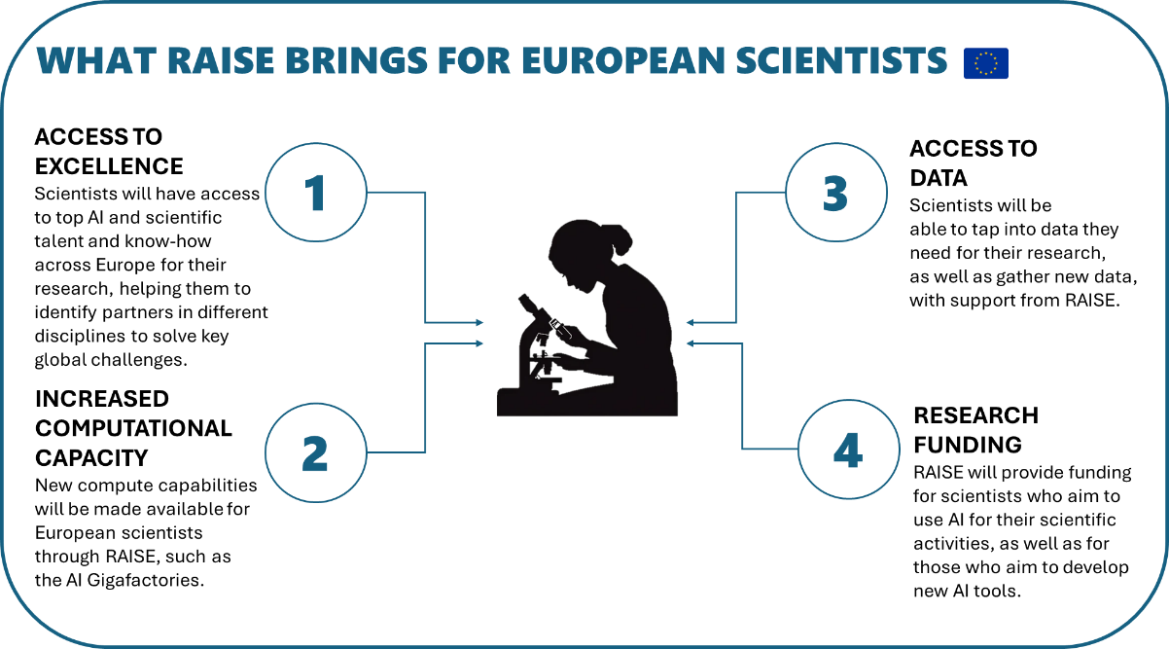

RAISE: The Resource for AI Science in Europe
RAISE will be launched as a virtual European institute that pools, aligns and coordinates essential AI resources, including computational power, data, excellence and talent, and research funding, across the EU, Member States and private sector. RAISE will pursue two complementary and mutually supportive objectives: promoting cutting-edge research in AI (science for AI) as well as the uptake of AI for scientific progress across disciplines (AI in science). These objectives embody the European approach to AI science, based on catalysing close interdisciplinary collaborations between the best scientists in Europe, coming together from different disciplines and perspectives to carry out excellent research with and on AI. Fostering this collaborative interdisciplinary culture is necessary to reduce fragmentation of research efforts and reach a critical mass. This is essential to push the boundaries of science and to develop the next generation of AI, as proposed in the future Horizon Europe moonshot. RAISE will thus ensure that European science is at the forefront of global AI developments and that new breakthroughs in AI capabilities will empower European research to achieve significant advancements across multiple scientific disciplines.
RAISE is founded on the unique strengths and values of European research and a distinctive EU approach to AI. RAISE will support the development of AI systems beyond the current state of the art, that are ethical, explainable, transparent, accountable, reliable, safe, human-centric and aligned with human rights and societal values. The application of these models in scientific research will help mitigate the current limitations and risks of AI and maintain the integrity and transparency of scientific knowledge, thus preserving the credibility of science and increasing confidence in AI-driven science.This collaborative culture and interdisciplinarity is necessary to reduce the fragmentation of research efforts and reach critical mass.
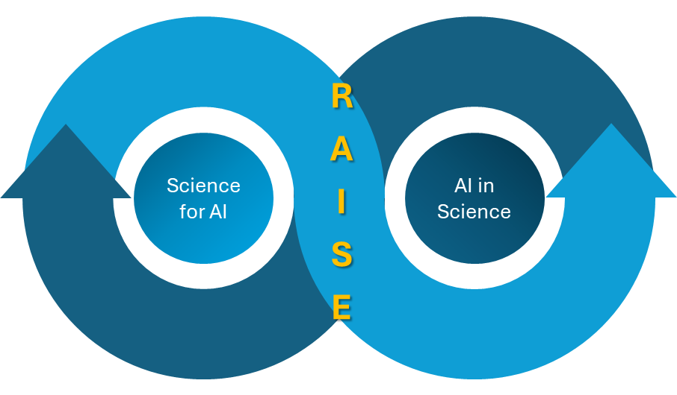
RAISE by and for scientists
RAISE will first and foremost build a dynamic research community, in which scientists in Europe will both advance AI technologies and apply them to the toughest scientific and technological challenges. RAISE will raise the visibility of European AI and AI in science research, strengthening collaborations among leading institutes and promoting world-class developments in the field.
At the heart of the RAISE community will be Thematic Networks of Excellence in AI in science and the European Network of Frontier AI Labs. Every Network will group leading researchers working with AI in a specific scientific discipline or advancing AI capabilities, building a focal point of European excellence in that area. The Networks will have access to the AI resources they need. This means not only targeted and sufficiently long-term funding but also access to the EU’s computational power and datasets, at a scale that can only be coordinated at EU level. Through exchanges within and among networks and coordination across all areas, RAISE will reduce fragmentation and better align research efforts.
RAISE will spread excellence in AI science throughout Europe by supporting training activities for scientists and other academic staff, as well as fellowships, doctoral networks and mobility schemes. Through the lively circulation of talent and ideas, the discoveries made with the help of RAISE will be available for all scientists to build on. RAISE will support scientists in translating their most promising scientific and technological breakthroughs into real-world applications and new products and solutions, laying the groundwork for rapid industrial uptake and future competitiveness. To this end, RAISE will closely cooperate with AI Factories and AI Gigafactories and private sector and industrial partners.

RAISE for Materials Science
As an example, a Thematic Network of Excellence for materials science will bring together excellent research labs deploying AI to analyse, discover and test materials, including in industrial settings. Through collaborative research efforts and aligned research agendas, facilitated through advanced sharing of data and results (folowing standards defined in the Materials Commons), access to dedicated AI infrastructure and data management services, the network will advance the state of the art in this field. AI-ready data sets, foundation models in materials science and automated laboratories will equip the community with powerful tools that facilitate the simulation, design, synthesis and manufacturing of advanced materials.
The development of these tools will bring forward innovative AI techniques, while also paving the way for game-changing innovations based on safer and renewable or low- carbon based materials, materials for quantum technology and energy, including high-performance batteries, photovoltaics, fuel cells, carbon capture materials and more. European spin-offs and startups will capitalise on these results, both in materials and in AI technologies, and benefit from possible regulatory sandboxes. The gained scientific expertise and excellence will be spread through events, fellowships and mobility schemes, further enlarging the pool of European excellence in AI-based materials science.
Building RAISE
To accommodate the fast-paced changes in innovations and the shifting needs of the AI science ecosystem, RAISE will be built using a phased approach, that can grow as its partners, resources, contributions and needs evolve. The Commission will first launch the initial elements of a pilot phase under the Horizon Europe and Digital Europe programmes. To build RAISE and ensure its longer-term sustainability, both in terms of governance and pooled resources, the Commission will work with Member States, research stakeholders, including higher education institutions, and the private sector, with a view to further develop RAISE under the new MFF.
An appropriate governance structure will ensure close interconnection and collaboration between RAISE’s different components and Thematic Networks of Excellence. It will ensure proper representation of both science for AI and AI in science communities, of Member States (linking directly to the AI Board) and the private sector, including AI startups and scaleups. A high-level academic advisory board can provide scientific guidance. Initially, a secretariat will be established via Coordination and Support Actions under Horizon Europe to ensure the symbiosis of RAISE elements. It will also link, use and directly inform the activities of the Apply AI Alliance introduced in the Apply AI Strategy.
To establish RAISE as an engine for AI scientific excellence in Europe, and to enable and support AI in science in Europe more generally, the Commission will implement an action plan, targeting key aspects of the AI in science practice and ecosystem, including actions relating to excellence and talent, computational power, data, research funding, as well as coordination and collaboration.
The Commission will:
- launch the RAISE pilot with EU 108 million funding under Horizon Europe WP 2026-27, during the first edition of the AI in Science Summit in Copenhagen on 3-4 November 2025, under the Danish Presidency of the Council of the EU.
- establish initial RAISE coordination for AI in science through a Coordination and Support Action (CSA) under Horizon Europe (WP 2025).
- partner with Member States and the private sector to build RAISE.
- establish a high-level RAISE academic advisory board.

AI in Science Action Plan: Building the way to RAISE
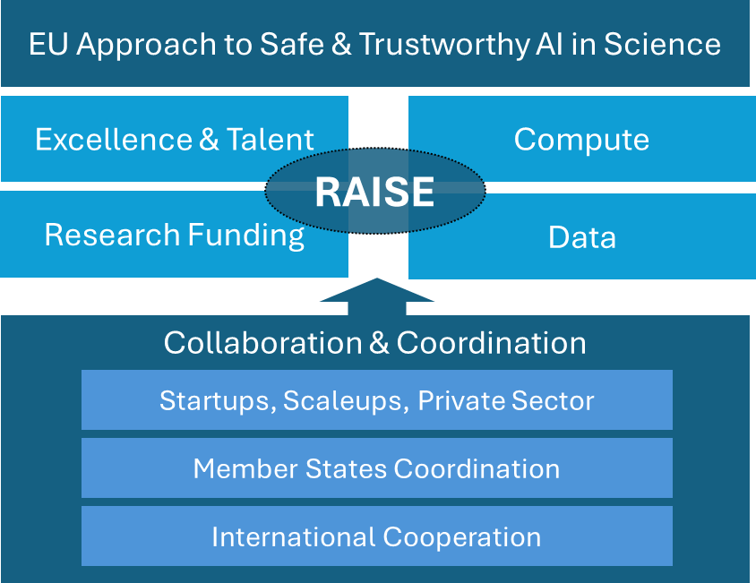

Excellence and talent
Excellence
The European approach to AI is rooted in excellence and trustworthiness. A continued focus on excellence will be essential for the EU to develop AI models to solve complex scientific problems, as exemplified in the RAISE Thematic Networks of Excellence, ensuring EU’s scientific leadership and competitiveness.
Excellent research with AI requires AI solutions which are human-centric, explainable, unbiased and safe. This means addressing, from the start all issues that are related to the technology, from accuracy and reliability to ethical concerns and research integrity challenges. According to one survey, 81% of researchers have concerns relating to AI models (ethics, accuracy, security/privacy, and/or lack of transparency) and 63% to the lack of guidelines, hindering the adoption of AI. To facilitate the responsible uptake of the technology, guidelines and support are fundamental for the scientific and academic community. The Commission has a long-standing tradition of addressing ethical concerns under Horizon Europe, through ethics appraisal frameworks for research with AI and operational guidelines. The Commission will continue to promote the “ethics by design” approach and develop different resources with the scientific community (training, tools, etc.). In addition, the European Group on Ethics in Science and New Technologies (EGE) will be asked to deliver an opinion on AI in science.
Since the use of generative AI has become widespread, issues such as unverified text fragments in papers, fabricated citations, or plagiarism, have become more common. The Commission will regularly update the Living guidelines on the responsible use of generative AI in research, a successful example of practical and actionable guidelines that were co-developed with European Research Area (ERA) members (countries and R&I stakeholders) to respond to emergent challenges in the community.
The Joint Research Centre will support the strategic advancement of trustworthy and reliable AI for science in close collaboration with the European AI Office. This may include assessing the current landscape of scientific AI models through qualitative and quantitative methods, focusing on capabilities, evaluation practices, benchmarks, and possibly developing EU-centric metrics to evaluate their performance and trustworthiness in scientific research.
Talent
Europe is home to world-class research groups and organisations across disciplines, offering a strong foundation to foster a critical mass of talent and ideas. By enhancing connectivity, collaboration and leadership across these groups, they can scale to address more complex scientific questions using AI. Interdisciplinary collaborations are crucial to developing and using cutting-edge AI in solving scientific problems .
The EU needs to enlarge the pool of scientific talent with strong AI knowledge and skills. As stated in the Union of Skills, the EU’s prosperity depends on its skilled human capital, including to strengthen its position in research and innovation, and in AI in science in particular. Not only must Europe train the next generation of scientists and upskill current scientists to be AI-ready, it must also retain this talent and become an attractive beacon for global interdisciplinary talent in AI and its scientific applications. Moreover, given that the development of advanced uses of AI in science requires interdisciplinary research teams, the EU also needs to support other types of profiles, such as research engineers and data stewards, who follow different career paths, in line with Apply AI Strategy’s goal of developing hybrid profiles (e.g. AI specialists with industry-specific expertise). This ambition also requires targeted efforts to strengthen inclusiveness and gender balance in AI, where structural inequalities persist.
AI skills will be increasingly important for researchers and must be developed early on across all disciplines and career stages. As announced in the AI Continent Action Plan, the Commission is already promoting the development of AI and digital skills, including AI literacy and advanced AI skills, through the Digital Education Action Plan, the AI Skills Academy, the STEM Education Strategic Plan, and other education, training and skills development instruments. It will continue to do so with the 2030 Roadmap on the future of digital education and skills, through its dedicated AI dimension. These initiatives are available for researchers to take advantage of AI. To further increase researchers’ awareness of AI literacy as an essential skill, the Commission will update the European Competence Frameworks for Researchers (ResearchComp) and launch a new Self-Assessment Tool that will include AI proficiency among targeted competences. This mirrors the broader efforts to support AI literacy for workers in different sectors and job roles under the Apply AI Strategy.
The EU must retain and attract scientific and AI talent. The Commission has already launched several initiatives to make Europe an attractive place for research and innovation, including improving research careers through the Choose Europe package; lowering barriers to attract and retain talent from non-EU countries through the EU Visa policy strategy and the EU Talent Pool initiative; supporting entrepreneurship through the EU Startup and Scaleup Strategy and the actions proposed by the Apply AI Strategy.
As part of the “Choose Europe for Science” initiative, RAISE will be a focal point for excellence and talent in AI science. The Commission will invest in training the next generation of AI in science researchers by funding RAISE Doctoral Networks on AI in Science using the MSCA Doctoral Networks model. The RAISE Doctoral Networks will provide specific training on AI in science and support aspiring doctoral students using AI in their scientific work. The RAISE Networks of Excellence will retain and attract talent by creating an interdisciplinary and dynamic AI in science ecosystem through training and mobility schemes, including with aspiring research groups.
The Commission will
- fund Doctoral Networks on AI in science to train the next generation of researchers (RAISE pilot).
- fund thematic Networks of Excellence on AI in science (RAISE pilot).
- regularly update the ‘Living Guidelines on the responsible use of generative AI in research’ and other ethics-related operational materials.
- create a JRC Scientific AI Hub to monitor and evaluate AI models and systems for strategic scientific research, in close alignment with the European AI Office.

Compute
Computational capacity is one of the main enablers of AI development and therefore also one of its key bottlenecks. Academia has generally less computational infrastructure at its disposal than Big Tech, while the demand for computational resources is growing as more scientists across different disciplines integrate AI into their work.
Researchers across Member States report difficulties in either accessing sufficient computational resources or in effectively using them. This often leads users to turn to private providers, resulting in vendor lock-in effects (over-dependence on proprietary models developed by private and foreign companies) and increased industry influence. Consultations informing this Strategy have confirmed the growing importance of publicly supported computational infrastructures for the development and deployment of frontier AI models and to enable increasingly complex scientific applications.
Since 2018, the EU has invested in state-of-the-art supercomputing capacities, through the European High Performance Computing Joint Undertaking (EuroHPC JU) and the European Regional Development Fund (ERDF), via its national and regional programmes. Additional AI capabilities for researchers and innovators are currently being developed. The creation of AI Factories, built around new or upgraded AI-optimised EuroHPC supercomputers across the EU in 2025-26, will more than triple the current EuroHPC AI computing capacity for European users, including researchers.
As part of the AI research and innovation support ecosystem (), AI Factories are already improving stakeholder uptake by offering services such as algorithmic development, testing evaluation and validation of large-scale AI models, providing supercomputer-friendly programming facilities and other AI-enabling services. Many of the AI Factories will focus on specific scientific fields. The EuroHPC Access Policy includes a new access mode for “AI for Science and for Collaborative EU Projects”. Through this access mode, selected EU-funded research projects are not subject to an additional evaluation or peer review process and are given priority over other requests.
To further scale the EU’s public AI infrastructure, the Commission proposes the EU to support establishing AI Gigafactories by pooling EU, Member State, regional and private sector resources. AI Gigafactories will take the concept of the AI Factories to the next level. These will be large-scale facilities designed to develop, train, and deploy large AI models and scientific applications at an unprecedented scale, integrating massive computing power together with energy-efficient data centres, and AI-driven automation to optimise AI model training, inference, and deployment. The Commission will continue to anticipate and plan for future computational demands. Infrastructure upgrades will align with the scientific priorities of European researchers, ensuring that capabilities remain fit for purpose and able to anticipate future trends that are relevant for AI, such as quantum computing.
RAISE will benefit from the essential European computational resources of the AI Factories, as well as the future AI Gigafactories. RAISE will work closely with the EuroHPC Joint Undertaking and ensure guaranteed availability and scheduling priority for EU-funded research projects in relation to reserved computational resources.
The Commission will:
- secure dedicated access to AI Gigafactories for EU scientists and startups, including for Horizon Europe specific objectives. Horizon Europe will invest up to EUR 600 million (RAISE pilot).
- continue developing the AI computing resources devoted to science through the AI Factories.

Data
The EU has spearheaded major initiatives in legislation and infrastructure to develop a robust data ecosystem in Europe. These include the European Open Science Cloud (EOSC) as the Common European Data Space for R&I, the other Common European Data Spaces such as the European Health Data Space, the Open Data Directive, the Data Governance Act and the Data Act. These efforts are complemented by additional thematic initiatives like the Cultural Heritage Cloud, Materials Commons, or biodata resources. These initiatives will boost the uptake of AI in science, as high-quality data is a fundamental enabler for scientific applications of AI.
While AI-ready research data are needed to enable AI solutions to scientific questions and workflows, the development and scaling of high-quality scientific datasets still face persistent structural challenges. Europe is a global leader in high-quality, curated, scientific data. Nonetheless, open scientific databases are not used to their full potential due to the fragmentation of research infrastructures, barriers to data sharing, lack of interoperability, data silos and privacy concerns. Initiatives like the Common European Data Spaces, and in particular EOSC, aim to make more data available for access and reuse, addressing some of these challenges. The European Health Data Space enhances the discoverability and reuse of health data across Europe, while providing a trusted framework supporting fairness and excellence in AI-enabled research.
As announced in the AI Continent Action Plan, the above-mentioned initiatives will be complemented and reinforced by the forthcoming Data Union Strategy, by opening new sources of high-quality, large-scale data and enabling businesses and public administrations to share data seamlessly and at scale. In this context, the Commission will set up Data Labs within AI Factories that will federate data from different sources, including the Common European Data Spaces. Data Labs could also offer a range of other services, such as cleaning and enriching datasets, providing technical tools (e.g. standardised formats, synthetic data, shared technical building blocks), supporting regulatory compliance (e.g. GDPR) and fostering interoperability across sectors and borders. The Data Labs will be an important tool for scientists working with AI, connecting data repositories with data services and the EuroHPC infrastructure. Through its Strategy for Research and Technology Infrastructures, the Commission will bolster the capacities, accessibility and sustainability of Europe’s research and technology infrastructure ecosystem and launch actions on Open Science as a key enabler for the development of scientific AI applications.
One objective of the 2025-2027 ERA Policy Agenda in its structural policy on open science is to provide researchers with better legal conditions and resources to access and reuse publicly funded research results and to use publications and data for scientific purposes. In this context, the Commission will gather further evidence, including through stakeholder consultations on existing challenges and possible solutions and policy options.
RAISE will work closely with EOSC, as well as the other Data Spaces, to make high-quality AI-ready data available for AI science. It will support the development and design of the future Data Labs, as part of the AI Factories, to support the needs of scientists (e.g. data gathering, cleaning and enriching services) and promoting its use by the scientific community. RAISE will also help to identify strategic scientific data gaps and support the efforts to gather, curate and integrate the datasets needed for AI science.
The Commission will:
- support the design of Data Labs, and their linking with Common European Data Spaces, in particular EOSC, to ensure their suitability and the accessibility and reusability of data for scientific research.
- support scientists to identify strategic data gaps and gather, curate and integrate the datasets needed through the RAISE Networks (RAISE pilot).
- collect evidence on the need to improve access to and reuse of publicly funded research results and the use of publications and data for scientific purposes.

Research Funding
European research funding is already supporting AI in science projects in a wide range of disciplines, as well as many projects on the science of AI. This has fostered the use of AI as a tool across disciplines and advanced the state of science in those fields (see box below). As AI technologies have become more advanced and widely used, research funding has increased, which is, for example, reflected in the increase in European Research Council (ERC) grants for AI in science (see graph below).
EU-funded AI in science projects
F-IMAGE employed AI to classify and analyse seismic signals and understand the behaviour of faults during earthquakes. By evaluating the short-term evolution of faults, it becomes possible to better understand processes that produce earthquakes.
AI-PREVENT applied AI to datasets covering health and other lifestyle factors, to achieve more predictive and personalised healthcare. The AI-generated models were shown to be powerful tools for identifying specific individuals at risk and in need of preventive care.
BioMonitor4CAP develops biodiversity monitoring systems for agricultural fields that integrate classical indicator methodologies with advanced technological approaches, including AI. Its main goal is to provide knowledge, methods and tools to farmers and the wider public.
Under Horizon Europe, the EU has invested EUR 6.4 billion in AI over the 2021-24 period. The 2025 Horizon Europe Work Programme is investing another EUR 1.6 billion, of which around EUR 0.7 billion for AI in science, and further support for AI in science is planned for the period 2026-27 of Horizon Europe through dedicated topics promoting collaborative research under Pillar II. Additional funding for AI in science comes from bottom-up instruments, such as the ERC, MSCA and the European Innovation Council (EIC). Dedicated actions like GENAI4EU have further streamlined the use of generative AI across domains and applications. The Commission has also provided funding for over EUR 100 million to nine Networks of Excellence in AI to connect top AI research laboratories across Member States and advance AI. In parallel, the Commission has committed an additional EUR 70 million under Horizon Europe and Digital Europe to develop large, multimodal AI models that push the boundaries of current capabilities and support the emergence of frontier AI.
Share of ERC-funded AI in science projects per domain per year
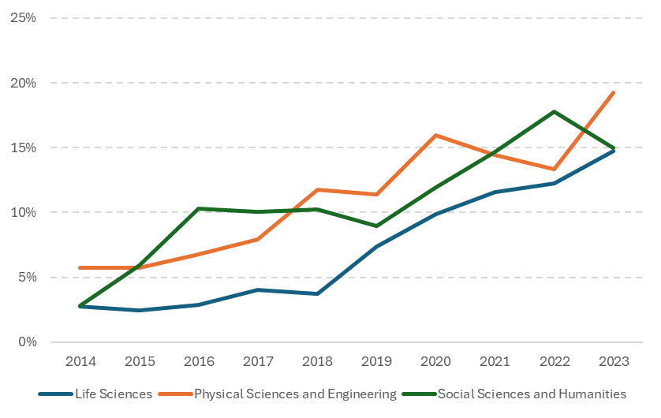
The Commission will further strengthen active coordination and alignment of investments in AI in science, to maximise value and foster strategic investments in thematic areas that can benefit from increased AI capabilities. The Commission is committed to maintaining and strengthening its role as the main provider of European research funding for AI in science, amplifying Horizon Europe’s role as a catalyst for innovative AI-driven scientific approaches. Cohesion Policy funding, particularly the ERDF, is another principal Union instrument for supporting research and innovation, including in AI.
To effectively fund AI in science, it is crucial that funding instruments are tailored to its rapidly evolving nature. Funding should be flexible, agile, and supportive of interdisciplinarity and collaboration. It should be capable of rapidly reacting to new ideas and trends and guarantee access to technical infrastructure and expertise. Additionally, funding programmes should strike a balance between bottom-up and directional calls, different project sizes, individual and collaborative research initiatives, and support the creation and maintenance of necessary infrastructures.
RAISE will mitigate the fragmentation of research efforts by incentivising aligned and coordinated research funding. It will use a variety of instruments under the European Research and Innovation Framework Programme and engage in additional coordination efforts. These will include funding of cross-domain research to build models and AI tools that benefit scientists across disciplines and working with Member States to develop and align national research agendas for AI science.
The Commission will:
- incentivise and coordinate investments in AI in science through an investment agenda in Horizon Europe’s 2026-27 Work Programme (RAISE pilot).
- seek to double current Horizon Europe yearly investment figures in AI, including doubling that for AI in science by 2028.
- fund scientific laboratory automation and the development and update of scientific foundation models, including in industrial settings (RAISE pilot).

Collaboration and coordination
Accelerating the responsible uptake of AI in science requires coordination and collaboration at European level to mobilise additional resources and align efforts. This distinctive European approach will build on three fundamental aspects: (i) building successful collaborations with the private sector, (ii) policy coordination and alignment within the EU, and (iii) alliances and cooperation with other international actors.
Private sector collaboration
The Commission is committed to building a more dynamic and successful entrepreneurial ecosystem in Europe. The recently adopted EU Startup and Scaleup Strategy aims to position the EU as the best place in the world to start and scale global technology-driven companies. Startups and companies with a focus on AI in science will increase in importance in the coming years. These companies base their business model and competitive advantage on new scientific discoveries achieved with AI, the development of new tools to conduct science with AI (e.g. models, research assistants), and new scientific AI services for key sectors.
European AI in science startups
There are many examples of European startups built around the use of AI in science. For example, a French biotechnology company developed an AI foundation model for biology.
An Italian startup focusing on climate risk analytics from space uses machine learning on Earth observation data (from multiple satellite constellations) to quantify how assets are exposed to climate hazards like floods, hurricanes, and droughts.
A Polish AI-powered chemistry startup has built a platform for planning organic synthesis routes, a key but complex and time-consuming step in drug development and materials science.
Companies leveraging AI in science face similar challenges to other European startups and scaleups, such as the lack of a fully integrated Single Market, including for capital, lower investor risk appetite, and regulatory hurdles. In addition, they face an even greater challenge in finding talent, as it is highly specialised, in demand and scarce. The EIC invested more than EUR 150 million in 2024 in AI projects (and more than EUR 400 million in the 2021-24 period) and will continue to play a large role in supporting the startup and scaleup ecosystem of AI in science. It provides venture capital while also supporting early-stage innovative ideas, such as AI research assistants and autonomous research labs. In line with the EU Startup and Scaleup Strategy, the Commission will expand and increase the importance of the EIC and simplify its rules as part of broader simplification efforts to reduce administrative burden for businesses. In addition, the European Institute of Technology (EIT) is supporting AI-related activities throughout their ecosystem, which currently features approximately 800 AI startups with a total valuation of close to EUR 20 billion.
The Commission is committed to supporting the transition from research to market, particularly for products and services based on scientific applications of AI. The AI Act is designed to foster trust while supporting technological advancement. It will create an internal market for AI, avoiding fragmentation and offering legal certainty to investors. The AI Act supports innovation and scientific freedom, as it excludes from its scope AI systems and models specifically developed and put into service for the sole purpose of scientific research and development. As outlined in the AI Continent Action Plan, the Commission is working to support a clear implementation of the AI Act, including help to research institutions, spin offs and startups to navigate the AI regulatory landscape. Support measures include the recent Guidelines and Code of Practice (both on general purpose AI models), the upcoming AI Act Service Desk and the AI Regulatory Sandboxes (which are mandatory in each Member State and should include the scientific research community in their design and operation).
This European AI in Science Strategy goes beyond publicly funded research and the public sector. Private research should also be mobilised and embrace AI as a fundamental tool for research activities. The largest technology companies in the world are establishing internal AI in science teams and establishing partnerships with leading research institutions. For that reason, the Commission will launch a pledging exercise targeted at the private sector, including philanthropic organisations, to help mobilise additional resources and investments. The Commission will also incentivise startups and other companies to participate more actively in EU-funded AI in science research projects that are close to the application stages, for example through participants in the Apply AI Alliance.
The Commission will:
- organise AI in Science Summits, annual flagship events bringing together AI in science communities (scientists, policy makers, startups, tech companies).
- launch a campaign to encourage pledges from private companies on AI in science.
- analyse the implications of the AI Act for the scientific community, for example by assessing the AI Act research exemption for spin-offs.
Member States coordination
The Commission and Member States agree on the strategic importance of AI in science and in developing a common European approach, as reflected in the recent Council Conclusions on AI in science. The Commission is already working with Member States to build capacity, identify challenges and share best practices at national level through a Mutual Learning Exercise (MLE) on AI in science.
Actions and investments at Member States level are crucial for the success of the strategy. Member States need to address their specific needs and act as multipliers of the European efforts within their respective R&I systems, as approximately 90% of public research funding in the EU comes from the national level. Those investments will need to build on the strengths of European science, namely collaboration, academic freedom, and the responsible use of AI. The Commission and Member States could seek to align their research funding agendas on AI in science.
High-level commitments and guidance are needed to ensure that AI in science initiatives align with broader EU and national policies and priorities. Coordinated and aligned policies at both EU and Member States level should support and pave the way for other institutions (universities, research organisations, etc.) to accelerate the uptake of AI in science through more targeted actions. Coordination efforts should foster a culture of co-ownership and collaborative governance. More national AI strategies should include concrete measures to support AI in scientific research.
Coordination will take place under the ERA governance, as part of the 2025-27 ERA policy agenda. Working-level coordination with Member States, Horizon Europe associated countries and R&I stakeholders will ensure that the technical aspects of AI in science are thoroughly addressed. This work will aim to align with the forthcoming ERA Act and the broader strategic objectives of the ERA. It will support and facilitate the design and development of RAISE and future participation of countries.
As recommended by the Heitor Report, this coordination will be supported by a monitoring mechanism that allows for the orientation and timely adaptation of relevant policies and investments. It will track progress of the uptake of AI by scientists at an international level, with Key Performance Indicators (KPIs) such as scientific publications, key foundation models in selected scientific disciplines and their interconnections, strategic enabling datasets, and other aspects (skills, education, start-ups/companies). These insights will be integrated in the Observatory announced in the Apply AI strategy.
The Commission will:
- coordinate with Member States, Associated Countries and R&I stakeholders in the ERA governance, such as the dedicated ERA Action on AI in science.
- monitor the uptake of AI in science with indicators and metrics.
International cooperation
The EU aims to shape the use of AI in science so that it is open, human-centric and rooted in scientific excellence, within the framework of the overall EU policy on AI and in synergy with the Apply AI strategy. The EU seeks to position itself as a frontrunner in aligning technological progress with fundamental rights and promoting this vision internationally. International cooperation thus supports both the EU’s open strategic autonomy and its ambition to shape global standards. The EU’s capacity to lead responsibly in this domain depends on its ability to work with partners who share its principles and to play an active role in shaping the use of AI in science.
This position is based on the international engagement priorities of the EU’s policy on AI. It builds on existing strategic frameworks such as the recent “International Digital Strategy for the European Union”, which aims to shape the global digital agenda around openness, inclusiveness and rights, as well as the EU’s “Global Approach to R&I”, the Horizon Europe association agreements and the Science & Technology Agreements with third countries, subject to their alignment with the international cooperation priorities of the EU AI strategy, which have laid the groundwork for values-based and mutually beneficial international research and innovation cooperation. It may also be anchored in ongoing regional policy dialogues and science diplomacy where AI in science can be integrated and where this is aligned with the international engagement priorities of the EU AI strategy.
Deeper international engagement must be accompanied by safeguards and openness must be balanced with vigilance against unwanted technology transfer or dependencies in strategic areas. Research security is therefore a key component of this approach as articulated in the European Economic Security Strategy, the International Digital Strategy and the Global Approach to R&I. The EU reaches out to trusted partners, amplifying its influence and ensuring that global rules and standards reflect its vision and strategic interests. This effort complements Member States’ bilateral engagements and strengthens the EU’s collective position in multilateral fora such as the G7, G20, UNESCO, the OECD and the Multilateral Dialogue on principles and values.
This approach contributes to a globally connected yet strategically autonomous ERA, where scientific collaboration supports EU competitiveness and global responsibility.
The Commission will:
- address specific issues of AI in science with relevant third countries and regions in the context of the overall EU international engagement on AI, in line with its priorities, and within the existing framework.
- engage through existing regional policy dialogues on R&I to identify joint priorities, co-fund the use of AI in science projects and promote capacity building and mutual learning in the use of AI in science, in alignment with the international cooperation priorities of the EU’s AI strategy.
- promote EU principles and values and standards for the responsible use of AI in science through relevant multilateral fora and international organisations, in alignment with the international cooperation priorities of the EU AI strategy.

AI in Science in Key Sectors: Illustrative cases for AI in Science
Advanced materials and biotechnologies are European R&I priorities and key sectors with a strong scientific foundation, for which AI holds great potential, as identified in the AI Continent Action Plan. Other sectors for the application of AI are covered in the Apply AI Strategy.
AI for advanced materials design
AI can facilitate breakthroughs in the entire cycle of advanced materials from discovery to manufacturing, while it can also enable advanced manufacturing techniques (further developed in the Apply AI Strategy) to develop an industrial base that is interoperable between civil and defence domains.
Advanced materials exhibit superior properties or performance compared to conventional materials. They are typically used in cutting-edge applications such as electronics, energy, biomedical devices or aerospace and are a critical technology for the EU’s economic security. The advanced materials global market can be broadly estimated at around EUR 5 trillion, with the EU representing 25%. Materials science is one of the domains in which AI is being adopted the fastest (growing almost 50% on a yearly basis), as it can significantly reduce the time and resources required for industrial production and accelerate time-to-market. Combining AI and robotics in closed-loop synthesis systems could perform new material identification and validation more than 1000 times faster than conventional techniques.
The demand for innovative advanced materials is expected to increase exponentially. In the coming years, the Commission will put forward an Advanced Materials Act in 2026, providing a framework for the entire lifecycle from research to manufacturing and deployment. The Horizon Europe Work Programme 2025 foresees the creation the Materials Commons for Europe, a federated digital infrastructure for R&D on advanced materials, highlighting the major transformative potential of this technology area.
AI for biotechnology
Biotechnologies are a key sector for the competitiveness of the EU’s economy. Biotechnologies can offer solutions to challenges such as human health, climate change or agrifood supplyand it is a critical technology area for the EU’s economic security. Biotech in the EU represents almost EUR 65 billion in turnover and employs 300 000 people. The Commission is set to propose a Biotech Act in the near future.
AI is rapidly transforming biotechnologies, advancing all domains from drug discovery to precision fermentation. Biological AI models are used to analyse complex biological systems, predict the 3D structure of biomolecules without the need for lengthy experiments and even generate new biological agents from scratch. The number of biological AI models has been rapidly increasing and growing in size and capabilities. While the EU can count on an excellent biotech research ecosystem, leading biological AI models are mostly being developed outside the EU and by private actors.
The biotechnology research sector still faces several challenges to take full advantage of AI. Data interoperability challenges must be overcome and vast amounts of different types of biological data from different organisms, geographic origins and experimental setups require integration. The rapid advances in the capabilities of AI models and their dual-use potential also increase the risk of misuse of the technology, requiring special mitigation measures. Strong collaboration between AI experts, biologists, chemists, clinicians, ethicists, and policymakers is needed, along with robust methods to evaluate and improve AI safety, security and trustworthiness.
The EU has already launched several initiatives that can benefit the uptake of AI in biotech research. These include the Life Sciences Strategy, the European Data Strategy to create a single market for data (including health data via the European Health Data Space) and the Life Sciences AI Factories presented in the AI Continent.

Conclusions
The increased adoption of AI in science will have profound scientific, economic and social implications; it will accelerate discoveries, stimulate economic growth, radically transform entire industries and create new ones. The Commission is committed to harnessing the power of AI in science, reinforcing the EU’s position as a leader in science, and paving the way to a new era of competitiveness.
The European Strategy for AI in Science builds on existing European strengths and embraces a distinctly European approach to AI. It proposes actions to support and further boost European excellence in AI-enabled science to empower researchers and drive breakthroughs. The flagship initiative, embodying these ambitions, is RAISE, a virtual European institute that will pool resources, expertise and talent to advance AI science.
The implementation of this strategy is only possible in close collaboration with Member States, associated countries, the scientific community and other stakeholders, for which the ERA will provide the main governance framework. Coherence with other AI policies and initiatives will be ensured, contributing to the overall European AI governance proposed in the Apply AI strategy, namely coordination at Member State level with the AI Board.
The Commission invites the European Parliament, the European Council, the Council of the EU and stakeholders to endorse the European Strategy for AI in Science and to actively contribute to delivering on the initiatives it sets out. A policy monitoring framework will be developed to monitor progress towards the goals of this strategy. The Commission will report on the implementation of the Strategy by the end of 2027.
In the ongoing global race for AI, the use of AI in science presents the EU with an opportunity to plant the seeds for future innovation and competitiveness, in AI and far beyond. We can seize the moment by joining forces, adopting the European approach to AI and creating a new dynamic in our world-class ecosystem of scientific excellence.

Annex I: Summary of Actions
 | Actions
RAISE | - Launch the pilot of RAISE at the AI in Science Summit (Q4/25)  - Establish initial RAISE coordination for AI in science (Q4/25)  - Partner with Member States and private sector to build RAISE (2028)  - Establish a high-level academic advisory board (Q4/25)
Excellence & talent | - Fund Doctoral Networks on AI in science to train the next generation of researchers (RAISE pilot) (Q4/25)  - Fund Thematic Networks of Excellence on AI in science (RAISE pilot) (Q4/25)  - Update the ‘Living Guidelines on the responsible use of generative AI in research’ and other ethics-related operational materials (on a regular basis)  - Create an AI Evaluation Hub to monitor and evaluate AI models and systems in strategic scientific fields (2027)
Compute | - Secure dedicated access to AI Gigafactories for EU scientists and startups, including for Horizon Europe specific objectives. Horizon Europe will invest up to EUR 600 million (RAISE pilot) (Q4/25)  - Develop the AI computing resources devoted to science through the AI Factories
Data | - Support the design of Data Labs and their linking with Common European Data Spaces, in particular EOSC, to ensure their suitability for scientific research (2026)  - Support scientists to identify strategic data gaps and gather, curate and integrate the datasets needed through the RAISE Networks (RAISE pilot) (Q4/25)  - Collect evidence on the need to improve access to and to reuse publicly funded research results and the use of publications and data for scientific purposes (Q4/25)
Research funding | - Incentivise and coordinate investments in AI in science through an investment agenda on AI in Science in Horizon Europe’s Work Programme 2026-27 (RAISE pilot) (Q4/25)  - Seek to double Horizon Europe investment figures in AI and AI in science by 2028  - Fund scientific laboratory automation and the development and update of scientific foundation models (RAISE pilot) (Q4/25)
Collaboration & Coordination | Private sector collaboration  - Organise AI in science Summits, (First edition in Copenhagen 3-4 November 2025, under the Danish Presidency) (Q4/25)  - Launch a campaign to encourage pledges from private companies (2026)  - Analyse the implications of the AI Act for the scientific community (Q4/25)  Member States coordination  - Coordinate with Member States, Associated Countries and R&I stakeholders through the ERA Action on AI in science (Q4/25)  - Monitor the uptake of AI in science with indicators and metrics. (2026)  International cooperation  - Address specific issues of AI in science with relevant third countries and regions (Q4/25)  - Engage through existing regional policy dialogues on R&I (Q4/25)  - Promote EU values and standards for responsible AI in science through multilateral fora (2026)

() Successful and timely uptake of artificial intelligence in science in the EU, Berlin: SAPEA 2024
() Working paper, ‘Artificial intelligence in science Promises or perils for creativity?’
() "AlphaFold uses open data and AI to discover the 3D protein universe", EMBL
() COSMIC-DANCE project, https://cordis.europa.eu/project/id/682903
() Working paper, ‘Trends in the use of AI in science’, https://data.europa.eu/doi/10.2777/418191
() AI computational capacity with specialised chips (GPUs, TPUs,…) as defined in Pilz et al, 2025
() “The Role of Artificial Intelligence in Scientific Research – A Science for Policy, European Perspective” Publications Office of the European Union, Luxembourg, 2025, JRC143482, DOI: 10.2760/7217497.
() US; China; Japan; UK
() The future of European competitiveness – A competitiveness strategy for Europe
() Much more than a market - Speed, Security, Solidarity
() AI Continent Action Plan, COM(2025) 165 final
() This strategy is informed by the recommendations of the Commission’s Scientific Advice Mechanism.
() “The Role of Artificial Intelligence in Scientific Research – A Science for Policy, European Perspective” Publications Office of the European Union, Luxembourg, 2025, JRC143482, DOI: 10.2760/7217497.
() EUR 6.4 billion for 2021-24 and more than EUR 1.6 billion in the Work Programme 2025
() Advancing both science for AI and AI in science in close interaction has been successfully applied in both public and private contexts (e.g. CNRS AISSAI, Google DeepMind). Different approaches to pooling AI resources for science exist globally but are limited to data and compute, e.g. NAIRR (USA).
() Proposal for a Regulation establishing Horizon Europe for the period 2028-2034, COM(2025) 543 final
() Only 38% of Europeans trust scientific discoveries with AI according to the Eurobarometer.
() established in the AI Act.
() https://digital-strategy.ec.europa.eu/en/library/ethics-guidelines-trustworthy-ai
() https://www.wiley.com/en-de/ai-study/for-researchers
() Ethics By Design and Ethics of Use Approaches for AI, guidance for Horizon Europe
() Living guidelines for the use of generative AI in research
() Article 2(6) AI Act (Regulation (EU) 2024/1689)
() AI Skills and Occupations in the European Start-up Ecosystem, EIT, 2025
() Union of Skills communication, COM(2025) 90 final
() Women represent only 22% of AI professionals globally and account for 13.8% of AI research paper authors. World Economic Forum, 2022. The Roadmap for Women’s Rights highlights the importance of encouraging women and girls’ acquisition of digital skills and competences, including in AI.
() AI talent, skills and literacy | Shaping Europe’s digital future
() Digital Education Action Plan (2021-2027) - European Education Area
() STEM Education Strategic Plan
() EU instruments for education and training include Erasmus+ and the Marie Skłodowska-Curie Actions.
() ResearchComp; as done for the Research Managers Competence Framework (RM Comp)
() Choose Europe for Science
() COM(2025) 270 final
() Choose Europe for Science
() MSCA Doctoral Networks is a bottom-up action focusing on research training that attracts a large proportion of projects with a significant AI component
() “Academia is falling behind industry in frontier AI research. Today, no university in the world can build a frontier AI system on par with industry.” (Stanford Human-Centered AI, 2024)
() According to the results of the consultations with stakeholders for the AI in science Strategy
() https://www.eurohpc-ju.europa.eu/index_en
() See more reference to the role played by the ecosystem of support in the Apply AI Strategy.
() https://eurohpc-ju.europa.eu/ai-factories_en
() Public Consultation on the AI GigaFactories
() https://digital-strategy.ec.europa.eu/en/library/quantum-europe-strategy
() European Open Science Cloud
() https://digital-strategy.ec.europa.eu/en/policies/data-spaces
() Regulation (EU) 2025/327 on the European Health Data Space
() Open Data Directive; Data Governance Act; Data Act
() The Cultural Heritage Cloud
() Communication on Advanced Materials for Industrial Leadership, COM(2024) 98 final
() Communication on Choose Europe for life sciences, COM(2025) 525 final
() Mutual Learning Exercise on AI in science – Second thematic report
() EOSC is being implemented as a federation of data repositories and services. EOSC also provides scientific services that support the uptake of AI.
() https://research-and-innovation.ec.europa.eu/document/009f0f91-74d3-4b94-9d79-55668cfd5a78_en
() Council Recommendation on the European Research Area Policy Agenda 2025-2027
() Complementing existing evidence, see “Improving access to and reuse of research results, publications and data for scientific purposes” https://data.europa.eu/doi/10.2777/633395
() ERCEA, Mapping ERC frontier research artificial intelligence, 2024
() Examples of EU-funded projects using AI in the CORDIS results pack on AI in science and AI in the life sciences
() The ERC grants on AI in science added up to around EUR 450 million in 2023 and overall invested over EUR 2 billion in AI research since 2007. MSCA has funded more than 1000 AI projects with a strong AI component, while EIC is supporting several AI in science startups.
() COM(2024) 28 final
() In particular by using the flexibilities introduced by the Mid-Term Review, including through STEP, to strengthen dual-use investments such as AI applications.
() MLE on AI in science
() For broader collaboration and coordination with the AI providers, industry leaders, public sector organisations, academia and the wider public, see the collaboration mechanism put in place under the Apply AI Strategy: the Apply AI Alliance.
() https://ec.europa.eu/commission/presscorner/detail/en/ip_25_1350
() The EU Startup and Scaleup Strategy, COM(2025) 270 final
() EIC impact report 2025
() https://digital-strategy.ec.europa.eu/en/policies/guidelines-gpai-providers
() https://digital-strategy.ec.europa.eu/en/policies/contents-code-gpai
() Council conclusions ‘Towards the EU strategy on AI in science’, 23 May 2025
() Mutual Learning Exercise (MLE) on AI in science
() All the EU-level funding of public R&D accounts for around one-tenth of the overall public spending on R&D in the Union, The future of European competitiveness: In-depth analysis and recommendations,
() While respecting article 4(3) of Treaty on the Functioning of the European Union and the applicable State Aid rules.
() Based on OECD AI Policy Observatory 2024, section in Bianchini et al., ‘Artificial intelligence in science – Promises or perils for creativity?’, 2025, https://data.europa.eu/doi/10.2777/6693925
() The AI Board -established as part of the AI Act- will be closely linked and kept informed about ERA’s activities.
() Council Recommendation on the European Research Area Policy Agenda 2025-2027
() Align, act, accelerate – Research, technology and innovation to boost European competitiveness, 2024,
() COM(2021) 252 final
() https://research-and-innovation.ec.europa.eu/system/files/2021-05/ec_rtd_com2021-252.pdf
() For more info on AI and materials discovery, please check “The Role of Artificial Intelligence in Scientific Research – A Science for Policy, European Perspective” Publications Office of the European Union, Luxembourg, 2025, JRC143482, DOI: 10.2760/7217497.
() Maqsood A, Chen C, Jacobsson TJ. The Future of Material Scientists in an Age of Artificial Intelligence. Adv Sci (Weinh). 2024 May;11(19):e2401401. doi: 10.1002/advs.202401401.
() COM/2024/137 final
() https://eur-lex.europa.eu/eli/reco/2023/2113
() Data for 2022, https://datam.jrc.ec.europa.eu/datam/mashup/LIFE_SCIENCES_SECTORS/ and https://publications.jrc.ec.europa.eu/repository/handle/JRC142396
() For more info on AI and biomolecules structures, please check “The Role of Artificial Intelligence in Scientific Research – A Science for Policy, European Perspective” Publications Office of the European Union, Luxembourg, 2025, JRC143482, DOI: 10.2760/7217497.
() https://epoch.ai/blog/announcing-expanded-biology-ai-coverage
() AI Index Report 2024 – Artificial Intelligence Index ; https://epoch.ai/blog/announcing-expanded-biology-ai-coverage
() Providers of general-purpose AI models can refer to the AI Act, the Code of Practice and the Guidelines on the scope of obligations for further guidance on risk assessment and mitigation at AI model level.
() Gómez-González, E. and Gómez, E. Artificial intelligence for healthcare and well-being during exceptional times: a recent landscape from a European perspective
() Communication on Choose Europe for life sciences, COM(2025) 525 final
() The European Data Strategy
() https://commission.europa.eu/topics/eu-competitiveness/ai-continent_en

