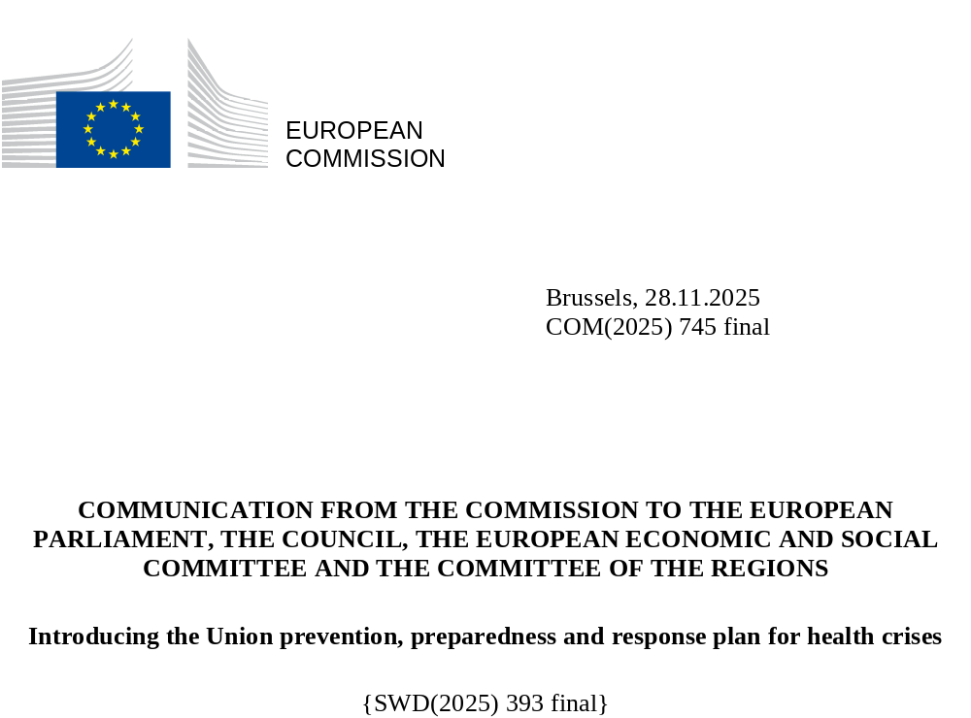

- STRENGTHENING THE EUROPEAN UNION’S PREPAREDNESS AND RESILIENCE AGAINST EMERGING CROSS-BORDER HEALTH THREATS
The European Union is operating in an era of mounting uncertainty and multifaceted threats and risks. It faces a complex and intensifying threat landscape – from pandemics and cyberattacks to disinformation, climate-related disasters and geopolitical instability. These challenges are no longer isolated; they are intertwined, amplifying one another and testing the resilience of societies, economies and democracies. The EU’s security, prosperity and unity depend on its ability to prepare, anticipate and react – not only when crises strike, but long before.
Many of these intersecting threats have the potential to lead to a cross-border health crisis. In today’s volatile landscape, a large-scale health crisis could be profoundly damaging, affecting not only individual well-being but also the overall functioning of societies and economies. The magnitude of the COVID-19 pandemic bore witness to this and taught us many painful yet invaluable lessons that we must continue to draw upon in our efforts to address future health crises. Health systems that are unprepared, fragmented and lack resilience can become overwhelmed during a health crisis, leading to disrupted essential services and diminished public confidence in institutions. However, health crises strike far beyond hospital walls and can disrupt economies, exacerbate social inequalities, halt trade and shake public trust to its core. As health crises disproportionately affect different groups within society, ensuring that prevention, preparedness and response measures are designed and implemented in a way that is inclusive and accessible to all people is essential for strengthening trust, equity and resilience of the Union’s public health systems. Moreover, in an interconnected Europe, health crises can ripple across borders, straining solidarity and shared resources. These cross-border and cross-sector effects clearly demonstrate the importance of robust coordination between Member States and the need for a strong toolbox of measures at both national and EU level.
The cost of inaction in the face of foreseeable threats is immense, measured not only in economic losses but first and foremost in human suffering and diminished resilience. By contrast, prevention and preparedness offer significant returns and are far more cost-effective than merely responding to a crisis (). Societies that are well prepared recover faster, can better protect livelihoods and maintain greater stability.
The lessons from recent years are clear: preparedness for cross-border health crises is not a matter of choice, it is a necessity. The Commission, Member States and EU agencies and bodies have therefore taken decisive steps towards a stronger, more resilient European Health Union, aiming to strengthen the EU’s ability to prepare for and respond to health crises. Key building blocks include the adoption of the EU Regulation on serious cross-border threats to health (), the strengthened mandates for the European Centre for Disease Prevention and Control (ECDC) () and the European Medicines Agency (EMA) (), and the creation of the Commission’s Health Emergency Preparedness and Response Authority (HERA) to improve preparedness and response to serious cross-border threats in the area of medical countermeasures (). Moreover, the Council Regulation on a framework of measures for ensuring the supply of crisis-relevant medical countermeasures in the event of a public health emergency at Union level was adopted ().
Since then, many other strategic EU initiatives have been adopted, aiming to strengthen the EU’s resilience and boost its ability to anticipate, prevent, prepare for, respond to, and recover from crises. In particular, the Preparedness Union Strategy () is a major EU initiative designed to address the interconnected threat environment by strengthening resilience across all levels and sectors. It takes a proactive approach to crisis management based on three mutually reinforcing principles: (i) all-hazards (); (ii) whole-of-government (); and (iii) whole-of-society (). Moreover, it envisages that preparedness and security considerations have to be integrated and mainstreamed across EU legislation, policies and programmes. The Preparedness Union Strategy seeks to build durable capacities that ensure the EU is strong on all fronts and at every level of society.
The Strategy is accompanied by an Action Plan (), outlining 30 key actions to be implemented by the Commission and Member States across the seven thematic areas of the Strategy. There is a need for a coherent and coordinated approach at EU level among the different actors and instruments in the EU’s reinforced health security architecture. Therefore, the Action Plan includes, as one of the concrete actions, to deliver, by the end of 2025, the Union prevention, preparedness and response plan for health crises (the ‘Union plan’), already a legal requirement mandated in the Regulation on serious cross-border threats to health ().
Although the Union plan does not cover health crisis response outside the EU, it is aligned with the EU’s global health priorities and initiatives. Fostering cooperation with non-EU countries and international organisations in the field of public health is crucial for EU and global health resilience and security, as recognised by the Regulation on serious cross-border threats to health () and the Preparedness Union Strategy. The EU’s commitment in this area is guided by the principles and actions set out in the EU Global Health Strategy () and the Global Gateway (). The recent announcement of the Global Health Resilience Initiative in President Ursula von der Leyen’s State of the Union address () in September 2025 reiterates this commitment.

2. THE UNION PREVENTION, PREPAREDNESS AND RESPONSE PLAN FOR HEALTH CRISES

The Union plan: a toolbox for crisis managers
The Union plan, accompanying this Commission Communication, is the EU’s blueprint for action on serious cross-border health threats, covering prevention, preparedness and response. It is a comprehensive toolbox that empowers crisis managers to prevent, prepare for and respond to emergencies swiftly and effectively. It complements national efforts by describing how the EU coordinates prevention and preparedness, which joint capacities and resources can be mobilised, and how solidarity leads to action when it matters most. The Union plan also sets out the process for recognising a public health emergency at Union level and outlines the additional measures and procedures that may be activated, ensuring the EU can act fast and with purpose. Equally important, it fosters a culture of learning and continuous improvement, helping Member States review, revise and strengthen their own systems. This enables the EU to recover quickly and emerge stronger after every crisis.
The Union plan is designed primarily for Member States, particularly for the authorities responsible for crisis management and policy implementation in prevention, preparedness and response planning. However, its value extends much further, benefiting EU agencies and bodies, international partners such as the World Health Organization (WHO) and key players across civil society, academia, the private sector, social partners and the media.
The Union plan was developed through cross-sectoral collaboration and in consultation with Member States and other stakeholders (). It draws on and integrates the EU’s strengthened health security framework and recently published policy documents ().

Preventing, preparing for, responding to and recovering from a health crisis
The Union plan covers a wide range of crises, whether natural, accidental or intentional, including those of biological, chemical, environmental and unknown origin (). It also applies to ‘exceptional emergency situations’ that require an EU coordinated response (), such as armed conflicts or situations where existing measures have proven insufficient to protect people’s health. The Union plan takes an all-hazards, all-sectors, all-society approach, built on the principles of One Health (), whole-of-government and whole-of-society cooperation. This approach is essential, as complex threats and risks require a comprehensive response to effectively manage them.
The Union plan covers the four phases of the health crisis management cycle: (1) prevention and preparedness, (2) detection and assessment, (3) response, and (4) recovery. The plan outlines the EU’s health crisis governance architecture, capacities and resources as well as the support mechanisms in place for each phase.
Phase 1: Preventing and preparing for health crises
The EU must ensure robust prevention and preparedness for potential serious cross-border threats to health to be able to protect the public and safeguard public health security. The following activities help achieve this:
- Member States report periodically on the planning and implementation of their national prevention, preparedness and response plans ().
- Member States coordinate, together with the Commission, in the Health Security Committee () to help prepare their national prevention, preparedness and response plans.
- The ECDC conducts Public Health Emergency Preparedness Assessments () (PHEPA) to assess the state of implementation of national plans and makes recommendations to improve them.
- Member States strengthen healthcare systems and the health workforce so they can be more resilient under pressure; this includes promoting vaccination as one of the most powerful and cost-effective public health tools to prevent disease.
- The Commission, with the assistance and advice of Member States through the HERA Board, supports the development, availability and distribution of medical countermeasures, ranging from vaccines to therapeutics, diagnostics, medical devices, and protective equipment, including related threat anticipation, threat assessment and intelligence gathering.
- As a risk mitigation in the event of future health emergencies, the Commission has reserved vaccine manufacturing capacity through EU FAB to ensure constant readiness and appropriate supply of critical raw materials.
- EU support mechanisms, such as the EU Health Task Force and the Union Civil Protection Mechanism, assist Member States in preparing for health crises.
Preparedness in action: vaccine procurement and vaccination
The outbreak of mpox (formerly known as monkeypox) in the EU/EEA in 2022 highlighted the importance of EU-wide preparedness for serious cross-border health threats. First, the Health Security Committee (HSC) discussed the epidemiological situation. Then, the HERA Board met and helped the Commission secure over 109,000 vaccine doses in June 2022, which were donated to the Member States and EU4Health associated countries within a month of the outbreak.
The Health Security Committee (HSC) also played an important role by adopting recommendations for a common EU approach to mpox vaccination policies (). The HSC opinion set out key considerations for Member States’ national mpox vaccination strategies, in line with guidance issued by the ECDC/WHO and taking into account their national epidemiological and public health circumstances, including vaccine availability.
To strengthen medium- and long-term preparedness for mpox, the Commission also secured up to 2 million doses of the mpox vaccine in 2023 and 2024 through a Joint Procurement Framework (). This gave participating Member States the option to build stockpiles and plan vaccination strategies in advance and prepared for response measures taken in 2024 such as coordinated vaccine donations. These efforts demonstrate how the EU harnessed pooled purchasing and strategic stockpiling to maintain equitable access, mitigate supply risk, and anticipate future health threats.
These mechanisms go beyond reacting to a single outbreak – they exemplify a structured, forward-looking approach to preparedness, enabling the EU to respond more effectively to emerging health threats while strengthening cross-border cooperation, resource planning and evidence-based decision-making for the future.
Phase 2: Detecting and assessing health threats
Effectively detecting and assessing health threats is critical in responding to health crises. The following activities help achieve this.
- The Commission improves surveillance and detection systems through, amongst others, designating EU reference laboratories for public health, and by integrating various surveillance approaches including the One Health framework, laboratory-based monitoring, wastewater analysis and vector surveillance and control.
- The Commission promotes information sharing and data interoperability to improve collective preparedness and response to health crises.
- The Commission supports national and EU-level comprehensive and integrated threat assessment, risk assessment and early warning to inform rapid and effective response measures.
- EU agencies, such as the ECDC, EMA and EFSA (), help carry out rapid public health risk assessments to support data-driven and evidence-based coordination of response efforts at EU level.
Risk assessment in action: the EU’s rapid risk assessment carried out by a unique group of EU agencies
When an EU Member State reports a serious cross-border threat to health, the Commission or the Health Security Committee can request one or more EU agencies and bodies to carry out a public health risk assessment. These assessments aim to support data-driven, evidence-based and expert-advised coordination of the response to such threats.
The ECDC, EMA, EFSA, ECHA (), EEA (), EUDA (), and Europol each contribute to these public health risk assessments based on their respective mandates and expertise. The EU agencies assess the potential severity of the threat to public health and consider the impacts of public health and social measures. To support a comprehensive risk assessment, the Commission shares information related to medical countermeasures with the relevant EU agencies, including on supply, procurement and deployment.
Practical example: Salmonella outbreak response
In October 2025, the ECDC and EFSA jointly published an updated rapid outbreak assessment of the prolonged cross-border outbreak of Salmonella Strathcona ST2559 (), with 437 cases detected between 2023 and 2025 across 15 EU/EEA countries. Tomatoes were found to be the primary vehicle of infection in several national investigations. The detection of S. Strathcona in irrigation water samples collected at a tomato production site confirmed the environmental contribution to tomato contamination. These findings underline the need for a multidisciplinary strategy that integrates environmental assessments to mitigate the risk of Salmonella contamination.

Phase 3: Responding to a health crisis
Responding to a serious cross-border threat to health in a coordinated and complementary manner is critical. The following activities help achieve this:
- In the Health Security Committee (HSC), chaired by the Commission, Member States coordinate response efforts with the Commission and EU agencies and bodies, including crisis management and public health and social measures.
- The Commission, with the support of the HERA Board (), coordinates efforts on matters related to medical countermeasures to ensure their availability and accessibility in response to a serious cross-border threat to health.
- Member States ensure increased situational awareness, risk and crisis communication, and the necessary emergency research and funds to support response efforts.
- Depending on the severity of the threat and the need for and proportionality of additional measures, the Commission may decide to recognise a public health emergency at Union level, which unlocks additional capacities and resources, including extended mandates for certain EU agencies and bodies. The EU’s Advisory Committee on Public Health Emergencies supports the Commission, upon its request, by advising whether a threat constitutes a public health emergency at Union level.
- In the Health Crisis Board, co-chaired by the Commission and the rotating Presidency of the Council, the Council, the Commission, the relevant EU bodies, offices and agencies and Member States coordinate their efforts to ensure the supply of and access to crisis-relevant medical countermeasures. The Health Crisis Board shall be established if a public health emergency at Union level is recognised, and if the Council activates the framework of emergency measures ()
- Member States, with support from the Commission, safeguard continuity of care and assistance across borders, from medical evacuations to providing medical in-kind assistance (including medical countermeasures and equipment) and contact tracing between Member States, while linking up with broader EU crisis management mechanisms managed by the Commission, such as the Union Civil Protection Mechanism (UCPM) and ReliefEU () as well as the Council’s Integrated Political Crisis Response (IPCR) ().
- The Commission may, if the situation merits, introduce temporary travel restrictions and internal border controls in line with the revised Schengen Borders Code (). Additional measures could include export control mechanisms in which customs authorities help secure the supply of critical medical countermeasures by facilitating their import and, where necessary, restricting their export during a crisis.
Response in action: the Integrated Political Crisis Response (IPCR) mechanism
The IPCR of the Council of the European Union (the Council) is the central EU mechanism for rapid and coordinated decision-making at EU political level in response to major or complex crises. Chaired by the Presidency of the Council, the IPCR is scalable according to the gravity of the crisis. In a health emergency, the Health Security Committee (HSC) and the Health Crisis Board work closely with the IPCR to ensure that political coordination at EU level is supported by public health expertise and operational input from Member States by, for example, sharing information, opinions and guidance. For example, during the COVID-19 pandemic, over 100 Integrated Situational Awareness and Analysis (ISAA) reports were produced by the Commission with input from Member States, EU agencies, EU representations and delegations, aiming to provide decision makers with a clear picture of the situation.
Practical example: Alignment between the IPCR and HSC on the COVID-19 response
During the COVID-19 pandemic, the Commission reported to the IPCR on a regular basis about the HSC’s deliberations. For instance, in January 2023, the IPCR adopted the same position as the HSC regarding the sudden increase in COVID-19 cases in China, as expressed in the Opinion of the HSC for a common EU approach in response to the COVID-19 situation in China ().

Phase 4: Recovering from a health crisis
Recovering from health crises and learning lessons is essential for restoring communities and preventing future crises. This involves:
- conducting in-action and after-action reviews to learn from every health crisis;
- turning lessons learnt into policy reforms, updated legal frameworks, and improved preparedness plans, including more resilient health systems;
- evaluating the effectiveness and impact of crisis response and recovery policies with the help of independent experts such as the Scientific Advice Mechanism (SAM) and audits by the European Court of Auditors;
- fostering transparency and trust by communicating clearly about what worked, what can be improved and what needs to change;
- considering the social and economic impacts on groups disproportionately affected by health crises and identifying ways to strengthen equity and an inclusive approach.
Recovery in action: Strengthening EU health security based on lessons learnt from the COVID-19 pandemic
Building on the lessons learnt from the COVID-19 pandemic, the Commission updated the legislation on serious cross-border health threats. This puts in place a more robust system for prevention, surveillance, early warning and response at both EU and national levels and ensure faster coordination, improved information sharing and joint action in times of emergency. HERA was set-up as a Commission service to strengthen the EU’s ability to prevent, detect, and rapidly respond to cross-border health emergencies by ensuring the development, manufacturing, procurement, and equitable distribution of key medical countermeasures. The mandates of key EU agencies were also strengthened: (i) the ECDC now has enhanced powers in surveillance, risk assessment, and the creation of a network of EU reference laboratories for public health, supporting better preparedness and response planning across Member States; and (ii) the EMA plays a central role in preventing and managing shortages of essential medicines and medical devices. Further, a framework of measures for ensuring the supply of crisis-relevant medical countermeasures in the event of a public health emergency at Union level was established. Moreover, the reinforced Union Civil Protection Mechanism (UCPM) legal framework has enabled the Commission to expand the rescEU reserves. This includes creating over 20 rescEU strategic stockpiles located in 16 Member States, containing essential items such as medical countermeasures, intensive care medical equipment, chemical, biological, radiological and nuclear (CBRN) response equipment and personal protective equipment.
Following these legislative reforms, the EU continued to refine its health security framework on the basis of post-pandemic evaluations. The Scientific Advice Mechanism (SAM) provided independent, evidence-based guidance on pandemic preparedness, vaccine strategies and public trust in science. Moreover, the European Court of Auditors carried out a series of reviews and audits on the EU’s response to the COVID-19 pandemic (). In particular, the Court of Auditors assessed the ECDC’s and the EMA’s preparedness for and response to the COVID-19 pandemic, auditing the two agencies’ performance in times of a health crisis (). In general, within the limits of their respective powers and capacities, the audit concluded that the two agencies generally responded well to the COVID-19 crisis. More recently, the operations of the Commission’s service HERA were reviewed (), highlighting HERA’s achievements in strengthening EU-level preparedness and response capacities. However, these reports also identified shortcomings in specific areas and shed light on areas where further work is needed. Additionally, an evaluation of the UCPM, adopted in 2024, recommended strengthening its operational response capabilities to more effectively mitigate large-scale, cross-border risks ().
Insights from these audits and reviews help strengthen the EU’s capabilities in health crisis prevention, preparedness and response. Together, these measures show how the EU has transformed the lessons from the pandemic into lasting improvements in health security – building a healthier, safer and more resilient Europe for the future.

- STRENGTHENING NATIONAL PLANS WHILE ENSURING A COORDINATED EU-LEVEL RESPONSE: A COHESIVE APPROACH TO HEALTH SECURITY
The Union plan takes inspiration from the national prevention, preparedness and response plans that Member States have been developing and updating since the adoption of the Regulation on serious cross-border threats to health in 2022 (). In turn, Member States should align their national plans with the Union plan to the largest extent possible, fostering a cohesive approach to health security. By integrating EU and national plans, a robust and inclusive health security framework can be put in place across the EU. The Union plan therefore serves as both a guiding document and a catalyst for unity: empowering national authorities to strengthen their own national plans while ensuring a coordinated EU-level response to health crises.
Every three years, Member States report to the Commission on their prevention, preparedness and response planning and implementation at national level, providing an overview of their national governance structures, capacities and resources in place dedicated to ensuring their readiness and response to cross-border health crises. The Health Security Committee (HSC) () plays an important role in this self-reporting exercise and in discussions on the EU’s overall state of preparedness. The HSC brings together Member States, the Commission and relevant EU agencies and bodies to discuss and share best practices, promote alignment between the national plans and the Union plan, and foster a culture of collaboration ().
In parallel, also in a three-year cycle, Member States’ prevention, preparedness and response capacities are assessed by the ECDC. Following these Public Health Emergency Preparedness Assessments () (PHEPA), the ECDC makes tailored recommendations to Member States, outlining areas for improvement and suggesting ways to improve their national plans and strengthen their capacities ().
The following figure illustrates the interlocking reporting and assessment cycles of Member States’ prevention, preparedness, and response (PPR) planning. The left side depicts the reporting cycle, in which Member States report on their national PPR plans, which are then discussed in the Health Security Committee and summarised by the Commission in an overview report. The right side depicts the assessment cycle, starting with the PHEPA, followed by ECDC recommendations, and concluding with Member States developing action plans in response. Feedback from both cycles feed into the Commission’s integrated overview of EU preparedness for the European Parliament and the Council, supporting continuous improvement of EU health security.
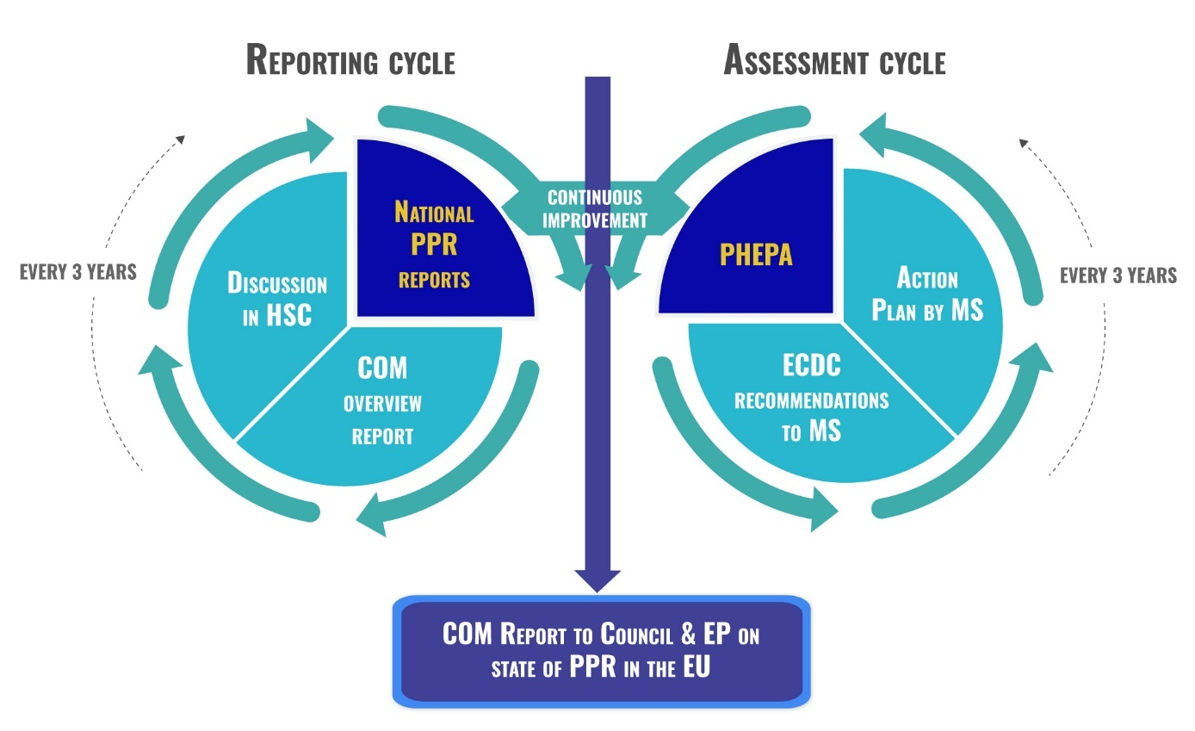
Figure 1. The interlocking Reporting and Assessment cycles of Member States’ prevention, preparedness and response planning.
To date, all 30 EU/EEA countries have national prevention, preparedness and response plans in place and reported on their capacities in the first self-reporting exercise in 2023 (). In 2024 and 2025, 19 EU/EEA countries participated in the PHEPA run by the ECDC.
Using the information collected through the national self-reporting exercise and the results of the PHEPA, the Commission, in cooperation with the ECDC, prepares an overview report on the state of preparedness in the EU (), highlighting gaps and areas for improvement.
Insights into EU/EEA countries’ preparedness capacities from the 2023 self-reporting exercise
All EU/EEA countries have legislative frameworks for health crisis management, but gaps in implementation persist. To effectively tackle serious cross-border health threats, Member States need to adopt a comprehensive approach that emphasises collaboration, equal opportunities, financial resilience and robust coordination at all levels.
On the One Health approach, most EU/EEA countries have incident management systems that link public health to other sectors. However, coordination mechanisms across different sectors and governance levels are rarely tested and revised. To better identify risks early on, Member States should regularly assess all types of threats and incorporate them into comprehensive, One Health and all-hazard health crisis plans, involving all relevant sectors of society. These plans should also integrate medical countermeasures, ensuring that stockpiles and manufacturing capacities are ready to support a rapid and effective response when health crises hit.
Most EU/EEA countries have plans to ensure the availability of their health workforce during health crises, but few review these plans on a regular basis, and many struggle to adequately forecast human resource needs. Systems for deploying medical personnel across borders in an emergency are not yet well established. To manage surges in demand in an emergency, Member States should have plans in place to mobilise additional personnel, including students and retired professionals. They should also set out clear procedures for redeploying health workers across regions and between EU/EEA countries in high demand situations, including in potential conflict scenarios. In general, the operationalisation of mutual assistance and cooperation arrangements is needed to facilitate the movement of personnel, medical equipment, medical countermeasures and patients across borders during emergencies and to enhance host-nation support.
The development and implementation of the national plans, as well as the planning of required capacities within Member States for prevention, preparedness and response for health crises, are therefore a dynamic process which are also influenced by Member States’ political priorities, available resources, and the constantly changing threat and risk landscape. The Commission and EU agencies support Member States by providing technical guidance, organising trainings (³⁷), simulation exercises, and providing expertise (³⁸). Continued dialogue in the Health Security Committee is crucial in this regard.

4. IMPLEMENTING AND FURTHER DEVELOPING THE UNION PLAN
The Union plan, strongly linked to and building on the national plans, will inevitably evolve. Similar to the national plans, political developments, outbreaks, changes in EU legislation and the adoption or implementation of relevant EU initiatives need to be reflected in subsequent versions of the plan. Therefore, when updating the Union plan, it will be crucial to take into account feedback from simulation exercises, lessons learnt from real health crises, evaluations of EU legislation and initiatives, implementation experience and available financial resources.
To ensure that the Union plan continues to meet its aims and objectives, it will be regularly tested through simulation exercises, the first of which is scheduled for 2026. These exercises will test the Union plan’s content in response to various types of emerging threats. Additionally, other simulation exercises, training sessions and workshops are planned that will focus on specific aspects of prevention, preparedness and response to health crises.
If a health crisis emerges, the Commission will carry out in-action and after-action reviews with Member States. Capturing insights from these reviews and incorporating them into the Union plan will be crucial., This will help the plan to remain fit-for-purpose and to be the most effective toolbox possible in all phases of the prevention, preparedness and response cycle.
The results of the ongoing evaluations of two key building blocks of the European Health Union must also be considered: (i) the implementation of the Regulation on serious cross-border threats to health; and (ii) the ECDC in light of its revised mandate. The outcomes of these evaluations are expected to be published in Q1-2026 and Q2-2026, respectively.
The roll-out of various key actions listed in the Action Plan annexed to the Preparedness Union Strategy would need to be taken into account in future revisions of the plan. These include: (i) developing an EU Crisis Coordination Hub, planned for 2027; (ii) drawing up a comprehensive EU risk and threat assessment (2026); (iii) adopting minimum preparedness requirements (2026); and (iv) setting out comprehensive civil-military preparedness arrangements (2027).
The Action Plan annexed to the Preparedness Union Strategy also includes two strategies that were adopted in 2025. The Medical Countermeasures Strategy () aims to reinforce the Union’s preparedness and response capacities for the next health emergency, irrespective of its origin, by ensuring access to and availability of medical countermeasures like vaccines, medicines, diagnostics and other medical tools at all times. The Stockpiling Strategy () aims to build and maintain strategic reserves of essential medical supplies for quick mobilisation. Both strategies’ implementation will focus on specific measures relevant to the Union plan.
Proposals under the next Multiannual Financial Framework, currently being examined by the co-legislators, will also have important implications for the content of the Union plan. In particular, the Commission’s proposal for a European Competitiveness Fund () focuses on fostering innovation and competitiveness in the health sector while ensuring supply security and boosting industrial capacity and capability to address future serious cross-border threats to health in line with the One Health approach.
Moreover, the Commission’s proposal to strengthen the Union Civil Protection Mechanism and Union support for health emergency preparedness and response () aims to reinforce EU crisis prevention, preparedness and response.
In addition, the European partnership on pandemic preparedness (BE READY), a research partnership funded under Horizon Europe (), is set to launch in January 2026 and will bring together a sustainable pan-European research network that can quickly and effectively respond to future health crises ().
The Union plan’s successful implementation and future updates will be driven by a collaborative effort between the Commission, other EU Institutions, agencies and bodies, and Member States. The Health Security Committee will continue to be the platform for regular coordination on the Union plan’s implementation. At the same time, the Commission will actively share knowledge and best practices with all stakeholders, including Member States’ competent authorities, through a range of communication channels including key events. Together, we will work towards a stronger, more inclusive and more resilient European Union in which no one is left behind, and by fostering a culture of cooperation and collective action to protect the public’s health and well-being.

A recent study shows that preventing viral pandemics costs just a fraction of what is lost when they strike: less than 5% of the value of lives lost and 10% of the economic damage from these types of outbreaks. A.S. Bernstein et al., 4 Feb 2022, Science Advances: https://www.science.org/doi/10.1126/sciadv.abl4183.
Regulation (EU) 2022/2371, OJ L 314, 6.12.2022, p. 26.
Regulation (EU) 2022/2370, OJ L 314, 6.12.2022, p. 1.
Regulation (EU) 2022/123, OJ L 20, 31.1.2022, p. 1.
C(2021) 6712 final.
Council Regulation (EU) 2022/2372, OJ L 314, 6.12.2022, p. 64.
https://commission.europa.eu/topics/preparedness_en.
The strategy takes an approach that prepares for a broad range of threats.
The strategy includes taking a more proactive, whole-of-government approach to crisis management, across both civilian and military sectors
The strategy’s whole-of-society approach means that local communities, civil society organisations, business and social partners, academics and other essential actors play a role in fostering a culture of preparedness across the EU.
Annex to the Preparedness Union Strategy: https://commission.europa.eu/topics/preparedness_en.
Article 5 of Regulation (EU) 2022/2371.
Recital 38 of Regulation (EU) 2022/2371.
https://health.ec.europa.eu/system/files/2023-10/international_ghs-report-2022_en.pdf.
https://commission.europa.eu/topics/international-partnerships/global-gateway_en.
https://commission.europa.eu/strategy-and-policy/state-union/state-union-2025_en.
A public consultation (call for evidence) was open from 1 to 29 October 2025, which received 57 responses, mainly from non-governmental organisations and business associations.
e.g. https://commission.europa.eu/topics/defence/safer-together-path-towards-fully-prepared-union_en, https://home-affairs.ec.europa.eu/policies/internal-security_en and https://health.ec.europa.eu/latest-updates/hera-review-taking-stock-reinforce-health-security-eu-2025-03-26_en.
Article 2(1) of Regulation (EU) 2022/2371.
Article 2(4) of Regulation (EU) 2022/2371.
One Health is an approach that recognises the interconnection between human, animal, and environmental health, promoting collaboration across disciplines to prevent, detect, and respond to health threats.
Article 7(1) of Regulation (EU) 2022/2371.
https://health.ec.europa.eu/health-security-and-infectious-diseases/crisis-management_en#health-security-committee.
https://www.ecdc.europa.eu/en/about-ecdc/what-we-do/public-health-emergency-preparedness-assessments.
https://health.ec.europa.eu/publications/recommendations-common-eu-approach-regarding-vaccination-policies-monkeypox-outbreak-response_en.
https://ec.europa.eu/commission/presscorner/detail/en/ip_22_6766.
European Food Safety Authority.
European Chemicals Agency.
European Environment Agency.
European Drugs Agency.
https://www.ecdc.europa.eu/sites/default/files/documents/ROA_%20S_%20Strathcona-ST2559_multi-country.pdf.
In accordance with Commission Decision of 16.9.2021 establishing a Health Emergency Preparedness and Response Authority (HERA), C(2021)6712.
Council Regulation (EU) 2022/2372, OJ L 314, 6.12.2022, p. 64.
https://civil-protection-humanitarian-aid.ec.europa.eu/what/humanitarian-aid/reliefeu_en.
Council Implementing Decision (EU) 2018/1993, OJ L 320, 17.12.2018, pp. 28–34.
Articles 21a and 28 of the revised Schengen Borders Code (Reg 2016/399, as amended by 1717/2024)
https://health.ec.europa.eu/latest-updates/opinion-health-security-committee-common-eu-approach-response-covid-19-situation-china-2023-01-05_en.
https://www.eca.europa.eu/en/covid19.
https://www.eca.europa.eu/en/publications?ref=SR-2024-12.
COM(2025) 147 final.
COM(2024) 212 final.
As part of the implementation of Regulation (EU) 2022/2371, see Articles 6-8.
https://health.ec.europa.eu/health-security-and-infectious-diseases/crisis-management_en#health-security-committee.
Article 10 of Regulation (EU) 2022/2371.
https://www.ecdc.europa.eu/en/about-ecdc/what-we-do/public-health-emergency-preparedness-assessments.
Article 8 of Regulation (EU) 2022/2371.
The reporting is based on a questionnaire (see: https://eur-lex.europa.eu/legal-content/EN/TXT/?uri=CELEX:32023R1808) and will be repeated in 2026 and every three years after that.
Article 7(2) of Regulation (EU) 2022/2371.
For example, exercises dedicated to the management of medical countermeasures or civil-military cooperation.
COM(2025) 529 final of 9 July 2025.
COM(2025) 528 final of 9 July 2025.
COM(2025) 555 final of 16 July 2025.
COM(2025) 548 final of 16 July 2025.
https://ec.europa.eu/info/funding-tenders/opportunities/portal/screen/opportunities/topic-details/horizon-hlth-2024-disease-17-01?order=DESC&pageNumber=1&pageSize=50&sortBy=startDate&isExactMatch=true&status=31094501,31094502&programmePeriod=2021%20-%202027&frameworkProgramme=43108390&callIdentifier=HORIZON-HLTH-2024-DISEASE-17.
https://beready4pandemics.eu/.

