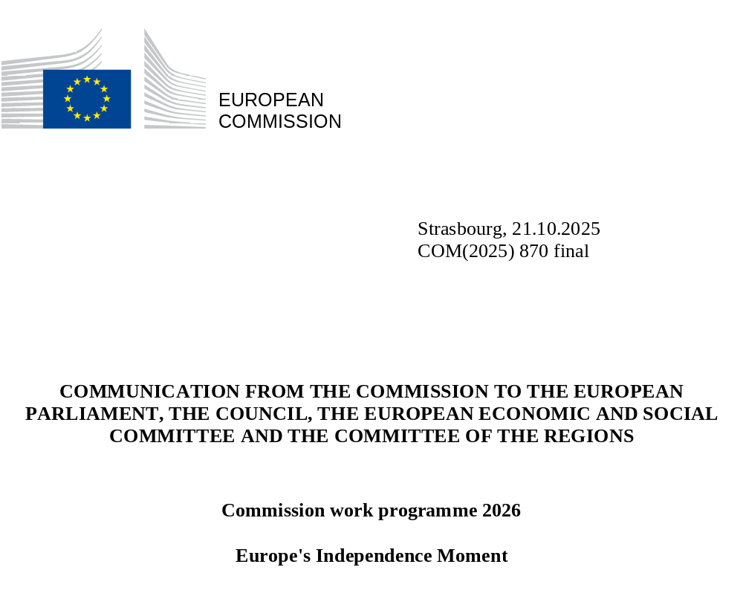

- Introduction
Since this Commission took office, Europe has had to confront a world in its most precarious state for decades. From threats to our security and democracy to risks to our economy and industry, including the reckless airspace incursions and attempts at economic coercions we have witnessed in the past months, and Russia’s ongoing war of aggression against Ukraine. These challenges have come at a time when the international order – on which Europe’s security and prosperity has long relied – is rapidly fraying.
Against this backdrop, this must be Europe's Independence Moment. Europe must step up to secure and shape its own future. To protect its citizens from the impacts of climate change and reduce our impact on ecosystems. To be able to take care of its own defence and security. To take control over the technologies and energy sources that will power our economies. To decide what kind of society and democracy we want to live in. To create quality jobs in a modern economy and strengthen our social model under changing demographic conditions. To develop the future of our European industry and support startups, scaleups and small businesses to thrive in our Single Market. To maintain our social, digital and environmental standards. To ensure that farmers receive a fair price for producing high-quality food and to protect them from unfair trading practices. To be open to the world and choose partnerships with allies – old and new. Ultimately, this is about having the freedom and the power to determine our own destiny.
To deliver on this, Europe must stand united. It must draw on its collective strength and rally around the things we have in common. It must act with speed and a mindset of urgency to respond to the acute and unique requirements of the moment. It needs boldness and ambition to match the scale of the challenges. It needs to focus on what matters the most to Europeans – from the cost of living to tackling illegal migration to protecting the environment – and simplify the way our laws work for people, communities and companies. It must focus on ensuring our sovereignty, whether in digital, the economy or security.
These are the guiding principles behind this Commission work programme. It draws on President von der Leyen’s Political Guidelines, Mission Letters and the ideas set out in the 2025 State of the European Union address. It is also inspired by consultations with the European Parliament and with Member States. It ensures that we stay the course on all the goals we have collectively agreed upon and respond to the most urgent new priorities. In this spirit, the Commission is ready to work with all EU institutions and stakeholders to deliver on our priorities.
- A programme for a united and independent Europe
This Commission work programme is a pitch for unity, a programme for delivery and a plan for togetherness and an independent Europe. It is structured along the main headlines set out in the Political Guidelines voted on by the European Parliament in July 2024, updated for today’s new realities.
Sustainable prosperity and competitiveness
Europe has always been a continent of industry, enterprise and innovation – reinventing itself through industrial and tech revolutions, global competition and changing societies. This strength is in large part down to our unique social market economy, which gives Europe many advantages over competitors. But there are still too many structural brakes on our competitiveness, which we must urgently continue to address in the coming year, speeding up the full implementation of the Draghi Report. In this spirit, we will make further proposals to support our industrial sectors building on the work done through the Strategic Dialogues held with industry in the first year of the mandate. We will continue to support the automotive sector to tackle the challenges that it faces. We will also make proposals to promote small affordable cars and provide further support for battery manufacturing. In addition, we will work on social leasing to make zero-emission vehicles more affordable for all.
We will also focus on unleashing the full potential of the Single Market by 2028 – removing barriers in capital, energy, services and telecoms, and enabling a “fifth freedom” for knowledge and innovation through the European Research Area. We will make doing business and accessing finance in Europe easier for all companies, not least innovative companies, startups and SMEs. We will establish a European Innovation Act and set up the 28th regime for all companies operating across the Single Market, as well as putting forward the remaining proposals to complete the Savings and Investment Union. This will include the strengthening of shareholder rights and a comprehensive analysis on competitiveness in our banking sector. Moreover, with the Cloud and AI Development Act and the Quantum Act we will strengthen our digital sovereignty. And with the Advanced Materials Act we will support the technological leadership of our industry and European strategic autonomy.
In addition, we will finalise our revised guidelines for assessing mergers to give companies clear, up-to-date and positive guidance on when operations can be expected to boost innovation, resilience or investment, while remaining true to the core objectives of our merger rules to protect markets and European consumers.
To ensure that our industrial sectors such as the clean tech, digital, automotive and space and defence sectors have sufficient and timely supplies of Critical Raw Materials, we will propose setting up a Critical Raw Materials Centre to monitor, jointly purchase and stockpile these minerals, which are so essential to our industrial sovereignty.
Bringing down energy prices for households and companies remains a core priority for boosting our competitiveness and our independence, and reducing dependencies. We will ensure a genuine Energy Union by improving its governance, upgrading grids, removing existing bottlenecks, cutting red tape for cross-border energy projects and boosting electrification and the resilience of the electricity system. This will be part of our work to keep Europe on track to meet its climate goals and also put forward an enabling framework for the decade ahead securing Europe’s competitiveness and sustainability. In this spirit, we will also seek to further improve the deployment of infrastructure for electric charging as well as the supply of sustainable alternative fuels for vessels and aircraft. In addition, we will put forward a strategy for setting up the first fusion power plants in Europe, which will contribute to our energy independence.
The future of clean tech must be made in Europe. This is why we need to accelerate work on enabling European lead markets. This is an area where there is a clear need to ramp up now the momentum – in particular on private lead markets for clean materials and sustainable products. We will present a Circular Economy Act to foster demand and supply of circular products and reduce dependencies on critical resources, and continue to speed up the implementation and investment under the Clean Industrial Deal. We will put forward proposals on public procurement to support this work and ensure investment in Europe and its wider objectives is incentivised. We will also look into ways to support our aviation and aeronautical sectors to retain their competitiveness and global leadership as they prepare for transformation.
We will continue our dialogue with tourism stakeholders and prepare a Sustainable tourism strategy to balance economic, social and environmental impacts and strengthen the competitiveness and resilience of the sector.
A new era for European defence and security
Against the backdrop of a growing and evolving threat landscape, Europe’s defence must be developed in Europe. This is why security will cut through all the work of the Commission in the year ahead.
Building on the Readiness 2030 framework, we will strengthen the EU’s defence industry and capacity to respond to threats. The SAFE instrument will support joint procurement, boost production and help close capability gaps – including by involving Ukraine’s defence sector and integrating it into the European Defence Industry Programme. It will be complemented by simplifying defence and sensitive security procurement rules to facilitate cooperation and innovation and further support our critical European defence industrial base. Building on the Defence Readiness Roadmap, we will work on European readiness flagships starting with the European Drone Defence Initiative, which is essential to the Eastern Flank Watch, while the Qualitative Military Edge programme will ensure that Ukraine has immediate access to a steady flow of superior military equipment.
A system-wide shift to managing migration and securing our external borders, which is comprehensive and agile, can allow us to meet the evolving challenges stemming from illegal migration. Next year will be focused on successfully putting the Pact on Migration and Asylum into practice. With the Pact, the EU will have a system in place that prevents abuse, reducing pressure on national systems. It balances out strong responsibility with meaningful solidarity, ensuring a fair and firm approach.
Migrant smuggling is a cruel and criminal business. We will propose sanctions targeting smugglers and traffickers to freeze their assets, restrict their freedom of movement and cut off their profits. With a strong mandate and a reinforced standing corps, Frontex, the European Border and Coast Guard Agency, can expand its presence and strengthen its operational support. Frontex should have a strong role in supporting Member States with returns. The digitalisation of returns will continue the work to modernise the common European return system.
A new European critical communication system will connect police, fire and emergency services across borders, enhancing coordination in crises. We will also propose to strengthen Europol. In addition, we will reinforce the legal framework on combatting organised crime, as well as take measures to better protect children against crime, both online and offline. We will also present new measures to fight trafficking in human beings.
Attracting and retaining international talent will contribute to the EU’s economic growth and competitiveness, strengthen our start-ups and address labour shortages. From recent initiatives like Choose Europe and the start-up and scale-up strategy, to upcoming actions like the visa strategy, we will make Europe more attractive for talented professionals and innovative entrepreneurs, while reducing administrative barriers.
Supporting people and strengthening Europe’s social model
Europe’s competitiveness and security is first and foremost about people, their jobs, families and livelihoods. Our unique social market model, characterised by high standards for working conditions and strong social protection and quality of life, remains a cornerstone of the European project. However, it is increasingly being challenged by demographic, technological and economic transformations. To preserve social cohesion and inter-generational fairness, the EU must innovate and implement policies that strengthen social protection, while fostering sustainable growth and driving competitiveness.
It is therefore essential that workers be empowered if we are to have a competitive economy. This is why we will propose a Quality Jobs Act to ensure that modern employment keeps pace with the modern economy. And the Fair labour mobility package, including the skills mobility initiative, will make qualifications more portable and ensure that workers can seize new opportunities wherever they are in the EU. The Education package aims to equip future generations with the skills and knowledge needed to thrive in a modern, competitive society.
It is imperative that Europe also steps up to tackle the issues, which European families face every day. In this spirit, we will put forward a series of measures to address the affordability and cost of living crisis facing Europeans, such as a new initiative to tackle issues related to short-term rentals, while the European Affordable Housing Plan will stimulate public support and incentivise private investment to boost affordable and sustainable housing. We will update State aid to make it possible for EU Member States to support affordable housing in a faster and simpler way, while the first-ever EU Anti-poverty strategy will address structural causes of exclusion and strengthen support services. The strategy will be backed by a strengthened Child Guarantee that will include investments and reforms to tackle child poverty.
We must also make sure that no region or community is left behind. Through EU cohesion policy, which is essential for the competitiveness, growth and resilience of our regions, we will put forward several territorial strategies, with a focus on the outermost regions and the Eastern border regions, and a Communication on islands and coastal communities.
We must also ensure that young people are given the opportunities they need to thrive and that they are empowered to play a full part in our democracy. This is why each Member of College will continue with their Youth Policy Dialogues, and why the first meeting of the President’s Youth Advisory Board will ensure that the voice of young people is heard. In addition, the Intergenerational fairness strategy will support solidarity across generations.
Sustaining our quality of life: food security, water and nature
Secure food supplies, paired with healthy ecosystems, are essential for Europe’s wellbeing. Building on the outcome of the Strategic Dialogue on the Future of Agriculture and the current Vision for Agriculture and Food, including the work stream on equivalence, we will introduce measures to strengthen the competitiveness of farmers and the agri-food chain, support rural communities and further simplify rules on agriculture.
To further strengthen the position of farmers and ensure the supply of quality European food to people across the EU, we will launch a new buy European food campaign. We will also update the rules on unfair trading practices in the food chain, increase transparency, support cooperation and capacity building and ensure legal certainty. This will also enshrine the principle that farmers should not be forced to systematically sell their products below production costs. In addition, the Commission has stepped up agri-food economic diplomacy, partnership dialogues and agreements, and will work on stronger alignment of production standards at multilateral level.
The Livestock strategy will foster the competitiveness, resilience and sustainability of the EU livestock sector and agri-food chain, while the Vision 2040 for fisheries and aquaculture will boost competitiveness and sustainability in these sectors, and the Ocean Act will guide European ocean governance.
We will press ahead with the implementation of the Water Resilience Strategy with a Digital Action Plan and a Water Resilience Platform to mobilise all actors, drive water efficiency and strengthen the sector’s competitiveness.
We will ensure that preparedness for climate impacts becomes a permanent feature of EU policy including through improved wildfire management, while protecting key ecosystems and investing in natural capital.
Upholding democracy, the rule of law and protecting our values
The freedoms which we rely on are founded on our common values, democracy, rule of law and fundamental rights. Rising extremism, disinformation, cyberattacks and foreign interference undermine trust in our democratic institutions and electoral integrity.
We need an integrated annual cycle on the rule of law – a common rhythm and clear milestones – with an opportunity for all institutions to contribute. And respect for the rule of law is a must for all funds: with the next long-term budget, we have proposed strong safeguards on the rule of law as well as positive incentives for reforms, in line with the recommendations in the annual rule of law reports.
In some communities across Europe, traditional media are struggling. This poses a grave threat to our democracy because when independent media are dismantled or neutralised, disinformation thrives. Informed citizens who can trust what they read and hear are essential to holding power to account, monitoring corruption and preserving democracy. This is why we will step up our work to support and protect our media and independent press. We will launch a new Media Resilience Programme to support independent journalism and media literacy. We have also proposed to significantly boost funding for media as part of the next budget.
We must also ensure that the online environment is safe, fair and empowering so that people can make the most of technology. At the same time, we must do our utmost to protect people online, especially the youngest in our society. We will look closely at the issues around young people, particularly children and social media building on the recommendation of the Panel of experts. Following up on our comprehensive approach to mental health we will consider the broader impacts of social media and excessive screen time on mental health and wellbeing. The Digital Fairness Act will tackle outstanding unfair and deceptive consumer practices, while the Action plan against cyberbullying will create safer online environments for young people.
Democracies thrive when they are supported by independent and effective judicial systems and law enforcement bodies. They must be protected from corruption, disinformation and manipulation. In that context, we will present the new EU Anti-corruption strategy. In parallel, the comprehensive review of the EU’s anti-fraud architecture will strengthen oversight and accountability.
The new Gender equality strategy and updated strategy for the rights of persons with disabilities will reinforce equality, inclusion and participation in all areas of society.
A global Europe
In an uncertain world, Europe must project stability, fairness and strength, and our commitment to the rules-based order. We will translate the new EU–US trade framework into concrete opportunities for our businesses, securing continued access for EU exports to the US market and preserving integrated value chains, while safeguarding jobs and our regulatory standards. The framework also provides a foundation for further cooperation, including on reducing tariffs on more products, addressing non-tariff barriers and enhancing our collaboration on economic security. At the same time, we are continuing to nurture our strategic partnerships and define our global standing. Following the conclusion of a new wave of free trade deals with Mercosur, Mexico, Switzerland and Indonesia, we will continue to expand this network through negotiations with India, Malaysia, Thailand, the United Arab Emirates and the Philippines. We will also build stronger partnerships on trade, transport, energy and digital through a cross-regional connectivity agenda, including between Europe and Central Asia via the Black Sea and Southern Caucasus.
The EU will continue to stand firmly with Ukraine, providing steadfast support for its urgent financial and military needs and reconstruction efforts, while maintaining and expanding sanctions aimed at weakening the Russian war machine. At the same time, the EU will help Ukraine advance on its European path, alongside Moldova, ensuring that progress on integration goes hand in hand with good governance and the rule of law.
Next year, we will roll out our Pact for the Mediterranean to build comprehensive partnerships focused on sustainable investment, economic stability, jobs, clean energy, transport, security, migration and other areas of mutual interest. We will also deepen our work to promote the EU’s role in the Southern Neighbourhood, engaging with local communities to highlight the EU’s contribution and counter anti-EU narratives.
In the Middle East, the EU will continue to support and actively contribute to consolidating durable stability in the region. We will put forward a Middle East strategy, while focusing on supporting inclusive and flourishing democracy in Syria and Lebanon. Recognising that the immediate priority in Gaza is to ensure sufficient humanitarian aid reaches the population, the EU will also contribute by providing support for the governance and reform of the Palestinian Authority and funding reconstruction, including through convening the Palestine Donor Group and by strengthening the presence of its EU CSDP missions.
Europe will also spearhead reform of the global humanitarian aid system, ensuring faster, more effective collective action in times of crisis. The EU will remain a strong advocate and champion of international humanitarian law and principled humanitarian aid.
To ensure that we have the necessary tools and mechanisms to respond quickly to possible emerging health threats, we will adopt the Global health resilience initiative.
Preparing for the Union of tomorrow
To deliver on these ambitions, the EU must equip itself with a modern, flexible and well-funded budget. The proposed EUR 2 trillion Multiannual Financial Framework for 2028 to 2034 will support competitiveness, decarbonisation, security, cohesion and Europe’s global mission.
New National and Regional Partnership Plans will increase the synergies between current policies in support of European priorities, reinforcing economic, social and territorial cohesion. The European Competitiveness Fund will drive industrial innovation and strengthen supply chains. Global Europe will reinforce the EU’s standing as a trusted and reliable partner, while promoting the EU’s strategic interests worldwide.
We will advance on the enlargement path, while facilitating the gradual integration of enlargement partners across different policy areas. We will soon present our pre-enlargement policy reviews that will guide the way to our Union’s future – ensuring readiness in areas such as the rule of law, energy, food security, defence and migration.
- Simpler rules, stronger delivery
Simpler regulation and smoother implementation of EU rules are instrumental to a more competitive and attractive Europe.
The 2026 work programme will further build the simplification momentum. The Commission has already put forward omnibus and other simplification proposals aiming to bring more than EUR 8.6 billion in annual savings for European businesses. More than half of the work programme’s legislative initiatives will focus on making EU law lighter, clearer and easier to implement.
We will continue our work to cut administrative burdens by 25% overall and 35% for SMEs – without lowering standards. A new series of simplification initiatives and omnibus packages will simplify life for people and rules across key areas such as automotive, environment, taxation, food and feed safety, medical devices and simplifying energy product legislation. We will streamline reporting, accelerate permitting and align legislation to changing market conditions. In addition, we will continue to use our new consultation tools – implementation dialogues and reality checks – to find further opportunities for simplification.
Simpler regulation will help unlock innovation, investment and job creation. We will modernise digital legislation and data protection, simplify public procurement, update rules for fair competition in media and review rules applicable to audiovisual media markets.
The Commission will continue to put forward evidence-based initiatives. It will propose legislation only when it is necessary, and provides maximum benefit. In doing so, it will take due account of better law-making principles. However, just like our rules, our better regulation framework must be simplified to enable a simpler and faster Europe. The Commission will therefore apply a more rigorous and structured application of the proportionality principle in better regulation and put forward a communication to that effect in the first half of 2026. The Commission is also screening EU laws and implementing rules to see if they are necessary to reach policy objectives and do not add accumulated and undue burdens.
Strong implementation is as vital as good law-making. Each Commissioner reports annually to Parliament and Council on progress in this area. Complementary to this, the Commission is presenting together with this work programme the first annual Overview Report on Simplification, Implementation and Enforcement. Swift and resolute enforcement action will ensure that EU law delivers benefits equally across all Member States.
The Commission considers that it is extremely important that the EU institutions deploy their best efforts to deliver on the Union’s key priorities. The Commission has carefully and individually examined all the proposals that are pending for adoption by the European Parliament and Council. In line with the interinstitutional agreement on better law-making, and taking into account the position of the co-legislators, the Commission intends to withdraw those proposals whose adoption would no longer be in the general interest in view of their adoption date, lack of progress in the legislative process, potential burden and non-alignment with the Union’s priorities.
- United in ambition and urgency
Europe’s moment is now.
In an era of power politics and uncertainty, complacency is not an option. We must act with unity, courage and conviction to strengthen our competitiveness, lead in clean and digital innovation and ensure our collective security. Ambitious policies require equally ambitious resources and political will. The Commission calls on the European Parliament and Council to swiftly agree on the new Multiannual Financial Framework and to advance the legislative priorities that matter most.
Europe has shown time and again that it can adapt, act quickly and stand united. By deepening cooperation across all levels – from EU institutions to local communities – we can ensure that our Union remains strong, sovereign and ready for the future. Preparing our European Union for tomorrow is a joint endeavour of all institutions. This is why this Commission remains strongly committed to supporting a right of initiative for the Parliament.
Together, we will build a secure, prosperous and independent Europe – one that delivers for its people and leads with confidence in the world.

The position of an initiative in the annexes to this programme does not change the responsibilities set out in the mission letters sent to every Member of the College by President von der Leyen

