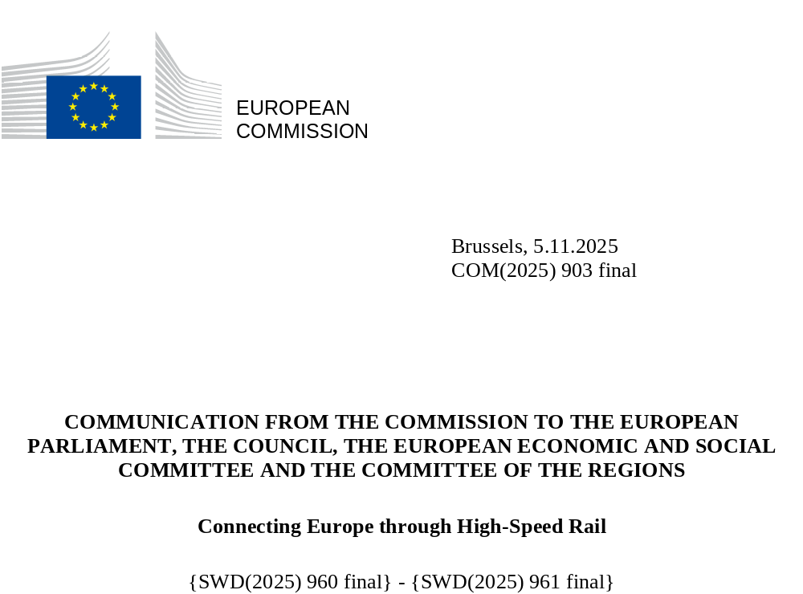

Introduction and objectives
A European high-speed rail network will boost our economy, create quality jobs, foster cohesion, bring citizens closer together, decrease air pollution, and help deliver on our climate goals. High-speed rail is key to making Europe more united and future-ready, while strengthening the competitiveness of European industry.
A high-speed rail network connecting capitals and other major cities in the EU can offer a convenient and clean alternative for travellers to short-to-medium-haul flights, and a fast and comfortable alternative to individual car or bus rides. Better connections can help reduce the demographic pressure on large urban areas, notably on the housing market, while preventing the depopulation of smaller cities.
Taking this into account, the sustainable and smart mobility strategy (SSMS) set targets to double high-speed rail traffic by 2030 compared to 2015 and triple it by 2050. The 2024 TEN-T Regulation lays down the basis for achieving a high-speed rail network in Europe. It requires high-speed rail connections above 200 km/h between major European urban centres and ensures their integration into the rest of the network. This integrated and coherent network is based on the TEN-T core and extended core passenger rail network and is set to be gradually completed by 2040. It will enable fast connections, while ensuring territorial cohesion. In many cases, it is expected to reduce journeys between EU capitals by half or more (see Figure 1).The high-speed rail network should be extended to candidate countries in the medium to long term.
However, so far, the EU is not on track: in 2023, high-speed rail traffic had only increased by 17% compared to 2015, while the length of high-speed rail tracks in operation was 12 128 km, located mainly in Spain, France, Italy and Germany. Central and eastern Europe remain poorly connected. With persisting fragmentation and barriers, a truly connected European high-speed rail network is therefore still far from completion. In his 2024 report, Mario Draghi underlined that investment in infrastructure is critical to strengthen Europe’s competitiveness, cohesion and resilience, while supporting the green and digital transitions. The Letta report made the point clearly that, while high-speed rail transformed national economies and social landscapes, it stopped at national borders.

Figure 1: Examples of major time-savings between selected EU capitals
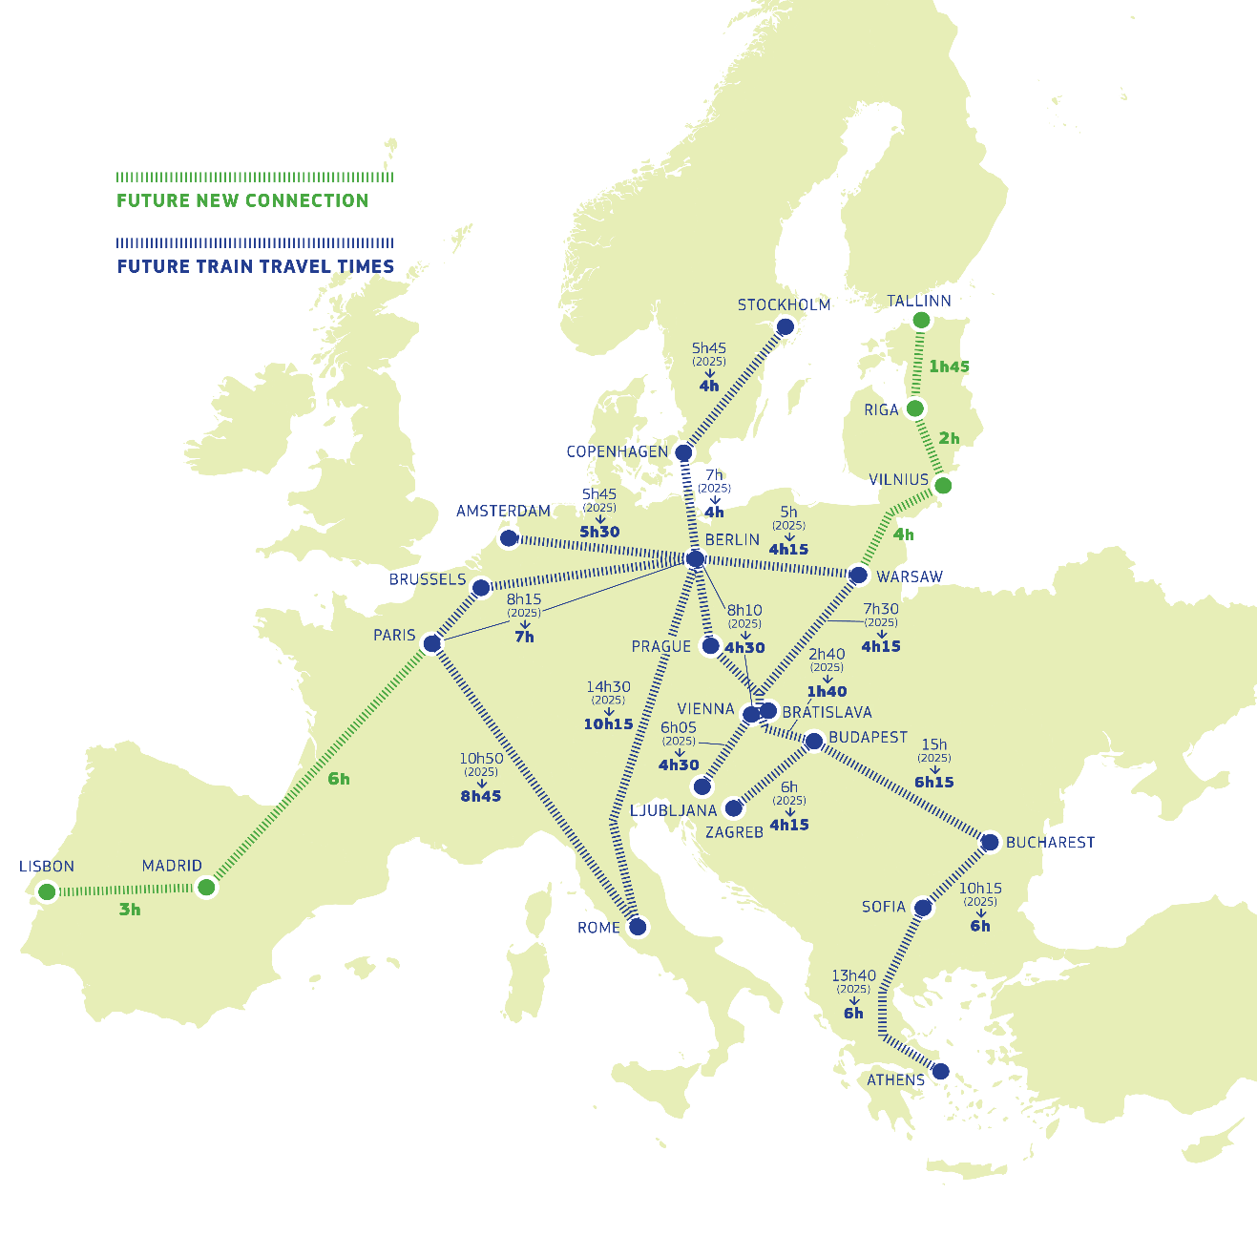

For these reasons, the Commission presents a Communication on connecting Europe through high-speed rail that aims to promote the sustainable competitiveness of Europe by integrating decarbonisation, industrial, competition and economic policies and turning innovation into manufacturing leadership and job creation. To reach the SSMS milestones, delivering the required infrastructure and setting framework conditions that enable attractive services will be crucial. This Communication presents a clear roadmap and concrete measures to achieve the vision of a well-functioning and faster high-speed rail network by 2040. Implementing this plan requires strong and concerted action by the Commission, Member States, the rail sector, private investors and European industry.
The Communication urges Member States to assess and plan for the possibility of exceeding TEN-T minimum requirements, with the aim of upgrading or building, where economically feasible, new high-speed connections including at speeds well above 250 km/h.
In addition, the Communication sets the ambition of significantly cutting the duration of popular rail journeys across Europe, with measures that eliminate market barriers and reduce costs, to ensure a thriving and globally competitive rail industry and affordable choices for passengers. To this end, the Communication sets out specific high-speed infrastructure priorities and calls for achieving high-speed connections among EU capitals and major urban nodes.
For this vision to materialise, large investments will be needed. That is why the Communication presents a plan for a financing strategy. The Communication also tackles infrastructural, commercial and technical barriers, including rolling stock availability and access to service facilities, and announces harmonised requirements and co-creation for the next generation of European high-speed trainsets.
Lastly, the Communication calls for a stronger EU role in the planning, funding and coordinating of such a cross-border high-speed rail network. Every route on this network will by definition operate across multiple borders. Operating at the right scale of governance, in cooperation with nationally managed networks, is essential to ensure that track owners and high-speed train operators can thrive and provide their services to all Europeans with similar standards, satisfying pent-up demand from Europeans for an affordable high-speed rail offer.
The benefits of this plan extend far beyond high-speed rail. It will increase available capacity on the conventional network for improved services at lower speeds, both for passengers and freight, including for military mobility. The latter will also benefit from major infrastructure investments on the TEN-T high-speed rail network, allowing for faster, longer and heavier military transports. Night trains and rail freight will benefit greatly from the proposed improvements to capacity coordination, track access charges, vehicle authorisation and rolling stock financing. Furthermore, the faster deployment of the European Rail Traffic Management System (ERTMS) will enhance safety and interoperability.
The key measures of the plan are presented in the following sections and summarised in the Annex.
The accompanying staff working document illustrates the time-saving benefits in a series of detailed maps and tables of the key connections between major cities on the European transport corridors to be deployed under current planning.

The EU high-speed rail network – need for acceleration and harmonisation
Transport infrastructure works as a network, so if a small segment does not comply or is not operational, it can hamper the efficiency and competitiveness of the system as a whole. The development of a European high-speed rail network requires a long-term vision and framework that enables the targeted implementation of the necessary infrastructure with harmonised requirements.
The 2024 TEN-T Regulation set out such a framework. In addition to harmonised infrastructure requirements for rail, the TEN-T Regulation supports the uptake and deployment of new digital technologies. This includes promoting data exchange and connectivity infrastructure with uninterrupted coverage across the network. The goal is to ensure the highest level of performance for digital infrastructure and reach higher levels of automation.
The connectivity benefits of completing the TEN-T high-speed rail network are significant. However, the complexity of planning, permitting, coordinating and financing major high-speed rail infrastructure projects poses obstacles to their timely implementation and often leads to delays, especially in cross-border projects, an issue this Communication intends to tackle.

Accelerating the roll-out of national and cross-border infrastructure
Since 2013, significant progress has been made in completing national sections of the TEN-T rail network in countries like Spain, France, Italy and Germany. In addition, the high-speed rail ambition is progressing well in parts of central and eastern Europe, such as in Poland, Czechia and on certain stretches in Hungary and Romania.
Key cross-border projects with substantial EU funding support are set for completion mostly by or shortly after 2030. These include the Brenner Base Tunnel, the Lyon-Turin Base Tunnel, the Fehmarn Belt fixed link and Rail Baltica. However, many other cross-border high-speed rail projects or important access routes will still be incomplete by then, leaving physical infrastructure gaps in the network. The investment plans of many major high-speed rail projects that are already planned – particularly those connecting borders – are still not mature with a precise schedule. While many of the gaps would be closed by 2040 (see Figure 2), together with the lack of harmonisation of operational rules, they represent a risk that the full potential of major cross-border infrastructure may remain untapped.

Figure 2. State of play and planned development steps of the EU high-speed railway network along the European Transport Corridors until 2040
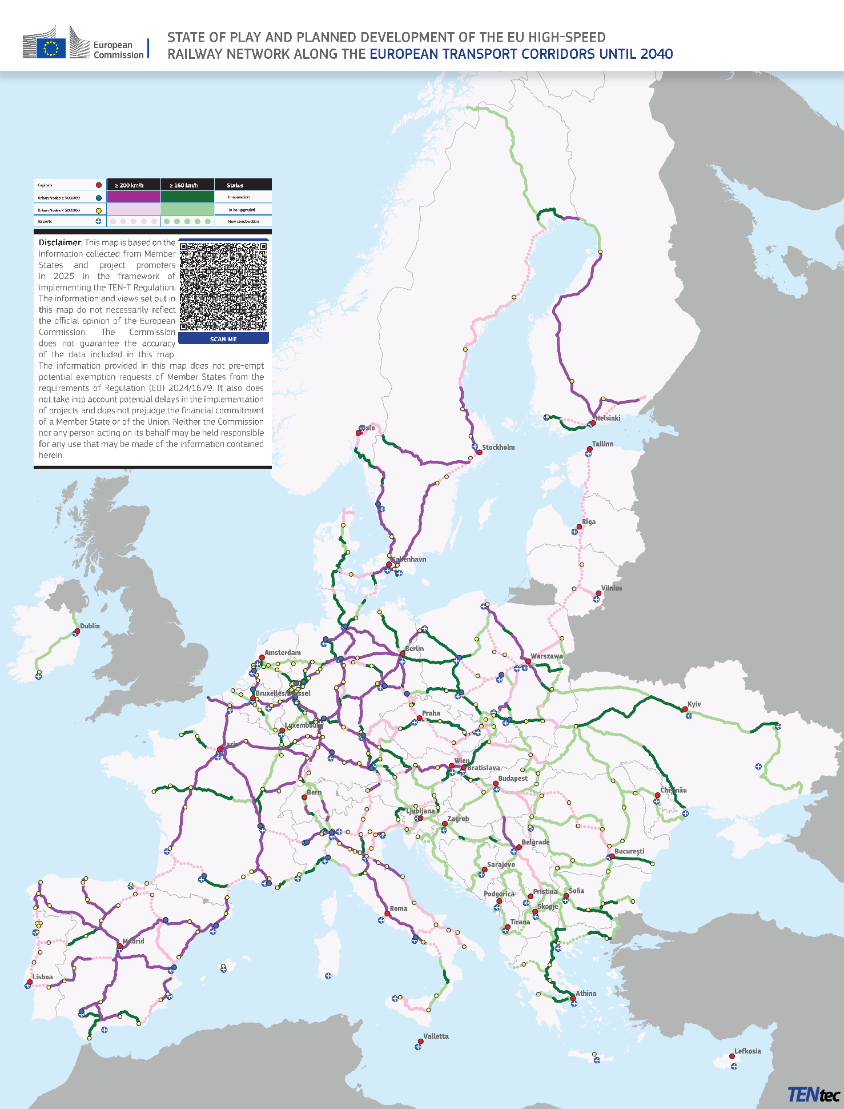

To tackle these issues, the Commission has assigned two specific tasks for 2026 to the European TEN-T Coordinators:
- to propose measures and recommendations in their European transport corridor work plans by mid-2026 for a timely and coordinated removal of cross-border bottlenecks and the completion of missing national links on the TEN-T network;
- to lead discussions with Member States and other key stakeholders on options for higher design speeds to identify priority sections for very high speeds and other areas for subsequent upgrades on the high-speed rail network, including from a cross-corridor perspective.
The aim is to set out implementing decisions for each European transport corridor for the first time by 2027. These decisions will ensure consistent priority setting for infrastructure and investment planning, so that the European high-speed rail network is developed in phases by 2030, 2035 and completed by 2040, covering specific speeds, travel times, funding and financing.
Furthermore, the Commission will review the Streamlining Directive in 2026, aiming to identify implementation gaps of the EU rules on project permitting and cross-border procurement and best practices in Member States.

Boosting investments for high-speed rail
To finalise the currently planned TEN-T high-speed rail network by 2040, the European Commission estimated that EUR 345 billion will be required. According to external estimates, going beyond the TEN-T and tripling the size of the existing EU high-speed rail network at speeds of 250 km/h or well above, would even cost EUR 546 billion. Such investment is expected to create employment and return a net positive benefit to society in the range of EUR 750 billion.
EU funding will be required, in particular, to harness other public and private resources to finance large-scale cross-border infrastructure projects with high construction costs. Over the past 20 years, EU funding instruments – such as the Connecting Europe Facility (CEF), cohesion policy funding, and the Recovery and Resilience Facility (RRF) – have proven essential in encouraging Member States to invest in priority infrastructure projects. Since 2014, more than EUR 100 billion from these programmes has been allocated to rail infrastructure projects. In addition, the European Investment Bank’s (EIB) total lending between 2016 and 2024 for rail (infrastructure and rolling stock) is in the range of EUR 40 billion. Despite this support, the demand for investment has outstripped available funds.
Closing the investment gap in high-speed rail infrastructure projects will require a more strategic and coordinated use of European funds, national measures (grants, state guarantees, Member States’ Emissions Trading System revenue, loans, etc.), user charges, as well as credible action to attract sufficient financial investment from the private sector. Therefore, the Commission will prioritise high-speed rail projects in a 2026 CEF call, paving the way for further investments in high-speed rail in the EU’s next long-term budget (the multiannual financial framework) for 2028-2034. In addition, the Commission has encouraged Member States to use cohesion policy to support the development of high-speed rail on their territories.
In the Commission’s proposals for the next multiannual financial framework of 16 July 2025, transport infrastructure funding doubles under CEF for Transport from EUR 25.8 billion to EUR 51.5 billion for the period 2028-2034, which includes an indicative dedicated envelope of EUR 17.7 billion for upgrading military mobility infrastructure. This will be complemented by the National and Regional Partnerships, the Competitiveness Fund and Horizon Europe, in line with their respective policy objectives.
EU funding has also been essential to de-risk investments and boost a project’s financial viability. However, as experience has shown, this must be accompanied by adequate business conditions to trigger private investment. High-speed infrastructure projects can indeed attract private investment when they are designed with a viable and profitable business model that preserves the competitiveness of rail compared to alternative modes of transport. Blending EU financing instruments with innovative or more conventional approaches can provide additional confidence to investors whether as additional funding or as a new source of revenue (i.e., cross-financing, Member States’ Emissions Trading System revenues, green finance).
Framework conditions for attracting private investment include clarity on the technological choices and the market outlook, expected revenues, regulatory predictability and the potential for economies of scale. The EU will also use all its current and future tools to ensure Europe’s technological sovereignty and industrial resilience for high-speed rail. This includes exploring possibilities for leveraging strategically the EU public procurement framework and its future revision in support of such policy objectives as well as considering, where necessary, using tools that are relevant for advancing economic security, also taking account of security risks potentially posed by foreign State-controlled suppliers in relation to security-critical systems like rail control-command and signalling.
To accelerate private investment and encourage innovative financing models, the Commission will launch the development of an EU financing strategy by the end of 2025. In that framework, the Commission will initiate a strategic dialogue with Member States, infrastructure managers, promotional banks and financial institutions, investors, the rail supply industry and railway undertakings. The aim is to present a ‘High-Speed Rail Deal’ in 2026 that is a multilateral commitment to mobilise the investments needed for priority high-speed rail projects. This deal would give certainty and guidance to investors on the EU and national commitments to support those strategic projects. It could also lay the groundwork for specific regional dialogues to fast-track the financing of strategic corridor high-speed rail projects.
To underpin the high-speed rail deal, the financing strategy will focus on how to carry out the activities outlined below.
- Optimise the use of EU and national public funding by prioritising investments that remove cross-border bottlenecks and missing links; maximising the national co-financing; and interacting with the private sector to deploy cross-border high-speed track or rolling stock.
- Take stock and exchange best practices of financing schemes to facilitate the financing of rail infrastructure and rolling stock. The Commission will present various models, including public-private partnerships (PPPs) and a regulated asset base model (RAB), taking into consideration their impact on national public finances, charges for track access and optimisation of infrastructure use (see examples in Box 1).
- Promote financial sector support. The Commission, together with the EIB, national promotional banks and institutions and financial stakeholders, will work to encourage the use of financial instruments such as budgetary guarantees, combining institutional and private financing of high-speed rail tracks and rolling stock with EU and national funding.
- Mobilise industrial players and financing sector experts to discuss financing the purchase or leasing of rolling stock in compliance with EU State aid rules. Actions will be identified on the basis of an analysis carried out in cooperation with the EIB, national promotional banks and institutions and private financial stakeholders.
- Facilitate access to advisory services. The Commission will explore, together with the EIB, how to best accelerate the delivery of well-targeted advisory services to support Member States’ high-speed rail investment plans. Coordination and cooperation should be put in place as needed, in particular with the European Union Agency for Railways (ERA) for technical guidance and with national promotional banks and institutions for possible joint offers where relevant.
Box 1: Examples of options and best practices for HSR financing schemes
The financing strategy and strategic dialogue with stakeholders will reflect various options and best practices. The chosen solution will reflect national circumstances.
For instance, Spain relies on a specific body, ADIF Alta Velocidad. As the majority of its revenue comes from market activities, the infrastructure manager’s debt is not accounted for as public debt, and investments are not considered to be public expenditure. Italy is exploring the RAB model to provide certainty about future revenues as high-speed rail promises to be a more profitable business. In France and Portugal, PPPs have been used to accelerate the financing of high-speed rail projects, such as the Bordeaux-Tours and Porto-Lisbon railway lines, with the latter also being supported by InvestEU, by CEF funding, and being off the government’s balance sheet.
In Italy, the deployment of performance guarantees supported by InvestEU and the Recovery and Resilience Facility was instrumental in securing the financing of the Palermo-Catania line.
In 2024, using the EU legal framework regulating road tolls, Germany used approximately EUR 6 billion out of EUR 15 billion in total road-toll revenues for cross-financing investments in the rail sector. Another example of blending different financing sources is the Divača–Koper project in Slovenia, which used cross-financing from road to rail, along with a state guarantee, to secure a significant loan from the EIB. Similar initiatives are being developed across Europe, with local taxes (notably for the Grand Projet ferroviaire du Sud-Ouest project connecting Bordeaux, Toulouse and Dax in France) or Member States’ ETS revenue (in particular in Austria and Estonia).

Better resilience and reduced environmental impacts of construction and operation
In recent years, extreme weather events have significantly disrupted transport flows in Europe, destroying critical infrastructure and causing billions of euro in damages. The 2021 floods in Belgium, Germany, the Netherlands, Luxembourg and France led to EUR 38 billion in damages, with EUR 1.3 billion of damage affecting rail infrastructure in Germany alone. In 2023, Storm Daniel destroyed a 50 km section of the main Athens-Thessaloniki line, requiring months of repair. A major flash flood caused by Storm Dana in October 2024 severely disrupted Spain's high-speed rail network, in particular between Madrid and Valencia. As a recent study published by the Commission shows, railways on the TEN-T network are expected to be particularly exposed to the increasing frequency of climate extremes.
To boost the resilience of high-speed rail infrastructure and reduce its own negative impacts on climate and the environment, harmonised life-cycle assessments and climate resilience methodologies need to be developed by standardisation bodies. The objective is to assess and compare different technical solutions’ vulnerability to climate impacts and their environmental footprint, especially during the design phase of infrastructure projects. A wide range of effective climate adaptation and mitigation measures are already available for the construction and operation of high-speed rail infrastructure. Nevertheless, existing best practices still need to be widely deployed, and the emergence of new solutions needs to be stimulated, including through EU funding. In doing so, the Commission will learn from current experiences with climate proofing requirements and calls for proposals dedicated to climate resilience under the CEF programme.
The negative externalities of high-speed rail operations, such as noise and air pollution, which are expected to increase with the projected traffic growth, should also be addressed. The Commission will support Member States’ implementation of applicable noise rules by publishing guidance on preparing national noise action plans by the end of 2025.
The planned high-speed rail network will be electrified, and this will provide a powerful contribution to achieving the EU’s commitment to sustainable transport. Increasing the proportion of clean energy sources, such as solar and wind, in the electricity mix used by rail will be key to making this sector as climate neutral as possible. The Commission will support Member States in deploying renewable energy technologies and sourcing renewable electricity for high-speed rail as set out in the Commission Notice on innovative technologies and forms of renewable energy deployment and the Commission Recommendation related to it. In line with the recommendation, Member States are encouraged to specify the technical standards, in particular safety standards, that infrastructure-integrated renewable energy deployment must comply with.
Europe's high speed rail should become a model of sustainable infrastructure, built with low emission materials, powered by clean energy and designed to be nature-positive and resilient to climate impacts.

An attractive and competitive framework for rail services
The EU high-speed rail offer can only be appealing, affordable and comprehensive for users, serving all passenger segments from business to sustainable tourism, if conditions for train operators are competitive and attractive. Existing EU-wide rules for opening the market for rail services (the Fourth Railway Package) ensure the legal conditions for developing cross-border high-speed services and a general right for railway companies to operate any passenger service anywhere in the EU. However, despite these rules, several obstacles remain, resulting in a limited market offer, barriers for new entrants and high prices for customers.

Capacity allocation that works for cross-border services
One of the main obstacles to boosting long-distance and cross-border passenger services is the difficulty in obtaining attractive cross-border train paths. The Commission proposal for a Regulation on the use of railway infrastructure capacity tackles this problem in a systemic way by setting out an EU framework for capacity planning, allocation and traffic management with a strong focus on cross-border coordination and digitalisation. It should be swiftly adopted by the European Parliament and Council and implemented by the sector. Multiannual capacity framework agreements between infrastructure managers and operators will guarantee long-term stability for operators. Optimised capacity allocation holds substantial benefits for other passenger and freight services as the more efficient, transparent and non-discriminatory allocation of train paths leads to less congestion and better integrates freight and night trains into cross-border timetables.

Supporting the procurement of rolling stock
New railway operators struggle with the purchase and authorisation of new or upgraded rolling stock, which can delay or prevent the launch of new services and impact competitiveness. The Commission will work with financial stakeholders to expand or create new innovative financing tools for new entrants to purchase or lease rolling stock. In line with State aid rules and to promote European industry, this could take the form of budgetary guarantees provided by Member States or the EU as done under InvestEU in the current programming period. In the next multiannual financial framework this is also proposed as part of the European Competitiveness Fund (the ‘ECF InvestEU Instrument’) or as financial instruments as under the National and Regional Partnership Plans, including high-risk instruments for highly innovative technologies. National promotional banks and private investors can play a critical role in providing financial support and innovative structuring to new entrants (see examples in Box 2). This can help mitigate risks in rolling stock transactions, in particular related to revenue streams (i.e., AssetCo or ROSCO schemes and diverse financing approaches such as bonds, equity, quasi-equity instruments, investment funds can be assessed).
Ratification by Member States of the Luxembourg Protocol to the Cape Town Convention, a framework for rail asset identification, may further help stimulate investments in rolling stock.
Purchasing second-hand rolling stock can be a fast and cost-efficient solution for new entrants, but it depends on established operators being willing to sell the trains they no longer use to future competitors. To boost the development of a second-hand rolling stock market, the Commission will propose legislation to ban anticompetitive scrapping of functioning and safe rolling stock and create transparent conditions for its resale and use across all Member States.
Box 2: Examples of private financing for the purchase of rolling stock
Examples in Italy and in France show that private financing can indeed support new entrants. The first private high-speed train operator entering the Italian market was founded by entrepreneurs who raised significant private capital to launch the first passenger service in 2012.
In 2024, in France, a new operator benefited from EUR 1 billion in private investment from an infrastructure investment fund. The goal is to put into operation the first private and independent high-speed train service between Paris and Rennes, Nantes, Angers and Bordeaux, by 2028. The purchase of 12 high-speed trains alone represented a EUR 850 million deal, with positive implications for the industry’s activities and jobs.

Encouraging fair and proportionate track access charges
In each Member State, the level of infrastructure charges (e.g. track access) depends on the level of public funding for infrastructure renewal and maintenance. Where public funding is low, the resulting high track access charges reduce the overall rail offer and lead to high prices for passengers, often resulting in a sub-optimal use of the network. Instead, in line with the new Commission guidelines on track access charges and the recent judgment of the Court of Justice, when setting track access charges, the objective must be to encourage a full and optimal use of the network. This will make it possible for long-distance rail services and night trains to remain affordable and compete with other modes of transport. This can be achieved through adequate market segmentation and temporary newcomer discounts, subject to compliance with State aid rules.

Ensuring access to service facilities and rail-related services
Service and maintenance facilities, such as stations, depots, storage areas and refilling points, play a critical role in the operation of high-speed rail services. Railway companies must have non-discriminatory access to such facilities in line with the applicable rules. However, the geographical distribution of high-speed-specific facilities is uneven, with certain regions lacking adequate infrastructure to support new entrants. Moreover, data on the availability and suitability of these facilities is limited, hindering market transparency and planning.
High-speed rail operators also need equal access to the services within these service facilities, including ticketing systems, passenger information displays and baggage handling services. Incumbent rail operators often own these facilities or manage these services and can use their position to maintain a competitive advantage. Where discriminatory practices occur, regulatory bodies must use their power to act. Moreover, the Commission will strengthen the implementing regulation on access to service facilities and rail-related services to ensure non-discriminatory access for new entrants.

Improving rail ticketing
Buying a rail ticket for cross-border journeys that require several segments operated by different operators remains difficult for passengers. Journeys can be hard to find and combine, and passengers are often not sufficiently protected if they miss a connection due to a cancelled or delayed train. New rail operators face major obstacles in entering and developing in a market due to a lack of access to key distribution channels, which slows the launch of new services and the development of competition. Several competition cases have shown that the conditions under which large rail operators allow platforms to sell their tickets can hinder the development of new distribution channels and impact competition in the ticketing market.
To remedy this issue, in early 2026, the Commission will propose a ticketing initiative. The aim will be to make it easier for passengers to book multimodal and multi-operator tickets, especially in rail, through digital platforms, while improving rail passenger rights. The Commission has also proposed a set of harmonised standards for rail data exchange.

Making rail travel more affordable
High-speed rail must be competitive and affordable. A recent Eurobarometer survey found that 61% of passengers consider price to be the most important factor when planning long-distance journeys, followed by total travel time, which is a concern for 47%.
Competition requires a well-funded and well-maintained infrastructure. The market for passenger rail services has been fully open since 2020, which has led to lower prices and more service options in areas with a quality network and strong competition.
Member States should therefore ensure adequate funding for high-quality infrastructure, in line with regulatory obligations under TEN-T, cohesion and rail legislation. They should also fully implement the rules on opening commercial services to competition and tendering public services. This will enable infrastructure managers to cater for different operators that offer a variety of services, including cross-border, low-cost and night trains and innovative tourism products.
Lastly, developing a pan-European high-speed rail offer requires a level playing field compared to more carbon-intensive modes of transport, including on taxation. Member States have full control over setting VAT rates for passenger transport. Given the principle of fiscal neutrality, Member States should use this flexibility to create fair competition among competing modes of transport. Additionally, Member States should explore and review methods to level the playing field by limiting subsidies and tax benefits for more carbon-intensive modes of transport.

Strengthening connections with other modes of transport
Improving railway connections, in particular high-speed rail services, with other transport modes would strengthen rail as an alternative to short-haul and possibly longer flights within Europe. Currently, airports like Frankfurt and Paris Charles de Gaulle are well connected to high-speed rail, serving as key passenger hubs, but many other airports have limited connections.
The Commission will analyse the connectivity of 40 major airports, including with high-speed, long-distance rail, to identify investment gaps and showcase best practices for improving airport connectivity. The Commission will also analyse current multimodal passenger hubs in urban areas to identify and promote best practices for integrating long-distance and high-speed rail networks into public transport, cycling and shared mobility.
Moreover, a Commission proposal on multimodal passenger rights is being discussed by the European Parliament and Council to protect passengers who switch between modes of transport during their journeys.

A competitive, harmonised and innovative EU rail sector
A vibrant, thriving, competitive and innovative European rail supply industry is crucial for the success of the European high-speed rail network. European rail supply companies are global leaders, employing 650 000 people and contributing 0.35% to EU GDP with an annual growth rate of 3%. The EU rail supply industry is key for European customers and is a pillar of the EU’s global competitiveness as it exports systems and solutions worldwide, including ambitious high-speed rail plans in for example, Egypt, Morocco and Saudi Arabia.
However, global competitors are quickly catching up, entering the EU market and expanding in their own and other markets, while EU players have not yet fully capitalised on the efficiency gains offered by the EU single market. To tackle this, railway companies, infrastructure managers and public service authorities in the EU must further reduce the number of diverging requirements of their individual procurement projects and move towards purchasing off-the-shelf rail products produced using industrialised, standardised processes. This will be easier if Member States eliminate fragmented national rules and standards and agree on EU-wide rules and standards. At the same time, cooperation across business actors in the rail system can help make better use of scarce resources and reap economies of scale, in full respect of antitrust rules and as a complement to competitive markets, while supporting new, open-access cross-border services. Such cooperation should foster a genuine Single European Railway Area where railway companies can operate competitively across borders.

Improving interoperability of rail infrastructure and rolling stock
National technical and operating requirements increase costs due to the duplication of authorisation processes and the complexity of testing to ensure that requirements are met. This delays new services from entering the market and is a burden on production, retrofitting and maintenance.
Therefore, rolling stock certification and authorisation must be simplified and issued for a wider area of use. The ‘system compatibility checks’ for new or upgraded locomotives and trainsets must be made less time- and resource-intensive. The Commission will promote the standardisation of authorisations for high-speed trains that are valid for the whole EU network. This will encourage the emergence of a mature leasing and second-hand market for high-speed rolling stock at EU level, increasing flexibility for new entrants, attracting investors, and facilitating the use of rolling stock for military transports.
A key driver for standardising rolling stock is a faster and harmonised roll-out of the European Rail Traffic Management System (ERTMS), which is of both strategic civilian and military importance. However, a non-harmonised multisystem approach by Member States has led to the cost of ERTMS products doubling in the last five years. The TEN-T legislation requires national signalling systems to be phased out in favour of the ERTMS on the TEN-T network by 2040. A few Member States, including Belgium, Czechia and Denmark, have decided to make the ERTMS the only signalling system in their networks, and Spain, Austria and Poland are investing heavily in deploying radio-based ERTMS. Nevertheless, other Member States are falling behind.
The 2024-2025 ERTMS national implementation plans point to the need to triple Europe’s ERTMS production capacity. Total market opportunities for the rail supply industry are estimated to be more than EUR 18.2 billion for ERTMS on the TEN-T core network alone. To build on these efficiency gains and provide predictability to the ERTMS supply industry, the Commission will strictly enforce ERTMS roll-out obligations and strengthen coordination among Member States. This will be done through a revised European deployment plan for ERTMS in 2026. Implementation must include connecting high-speed lines to city centres and diversionary lines, also to ensure that these can be used for cross-border military transports.
To make the rail professions more attractive, stimulate job creation and help align education, training and professional skills with the needs and opportunities of this strategic sector, and following consultation with social partners, the Commission will reform the EU rules on train drivers’ certification. This will also simplify efforts and create unified professional requirements and certification that would allow train drivers to operate on all trains and rail infrastructure across the whole EU high-speed network.

Research and coordination for competitiveness, safety and security
High-speed technology is cutting-edge, and safety is paramount. Further development and co-creation of EU harmonised digital and automation technologies, such as automatic trains, modern ERTMS signalling, communication and traffic management systems, can increase capacity on existing high-speed infrastructure, improve safety and provide greater flexibility and resilience for services and military transports. Systems must also be protected against disruptions and cyberattacks. To bring these technologies to the market, the rail supply industry, infrastructure managers and railway companies must continue joint research under the 2028-2034 Horizon Europe programme and the proposed European Competitiveness Fund. To stimulate collaborative research for high-speed rail, Europe’s Rail Joint Undertaking will launch a dedicated call in 2026. Member States should use national funding instruments including Important Projects of Common European Interest, in line with State aid rules.
For the European high-speed rail sector to achieve economies of scale and reap the benefits of global competitiveness, the expected demand for state-of-the-art high-speed trains and rail should be matched by corresponding efforts on the supply side to provide the necessary technology in the most standardised way. A way of achieving this objective could be the co-creation of the next generation of harmonised, smart, multi-network trains, to be produced at lower cost and rolled out faster. Such a harmonised approach would also rationalise signalling and infrastructure components, reduce project risk, facilitate private investment and enable manufacturers to increase production capacity and shorten delivery times.

An effective EU governance for high-speed rail
While the vision presented in this Communication relies on market operators to launch and improve their high-speed offer, an effective EU governance is required to ensure that the necessary conditions for a growing and faster EU high-speed rail system, including network infrastructure, are put in place. This stronger governance should apply both broadly at EU-level and specifically to individual high-speed lines.
Therefore, in 2026, the Commission will propose legislation to strengthen ERA’s role in vehicle authorisation and the removal of national rules. It will also empower a strong European deployment manager to ensure an effective roll-out of ERTMS. By efficiently removing redundant national rules, issuing vehicle authorisations and single safety certificates to rail operators and ERTMS trackside approvals, ERA contributes to cost-efficiency of the innovation cycle. To engage the EU rail industry at management level, the Commission will elevate discussions currently within the Commission expert group on the competitiveness of the rail supply industry to the political level.
To better coordinate the use of rail infrastructure capacity under the proposed Capacity Management Regulation, infrastructure managers will be empowered and legally bound to work together to provide predictable and attractive cross-border capacity for long-distance services. In addition, reliability will be strengthened through a common framework for performance management.
To overcome barriers that hinder the creation of cross-border services on specific corridors such as technical barriers, availability of service facilities, and capacity constraints, the Commission will set up roundtable discussions with stakeholders on selected city connections, particularly between capitals and with major hubs. Progress towards the identified solutions as concerns both the development of the network and its functionality will be fostered by the European Coordinators in close collaboration with the relevant authorities (ministries, infrastructure managers and national safety authorities).

The functionality of the European high-speed network will be monitored within the strengthened governance framework established by the forthcoming Regulation on Capacity Management. The European Network of Infrastructure Managers, together with the entities in charge of performance review, will ensure coordinated monitoring and reporting of obstacles affecting circulation. These structures will identify and anticipate disruptions to the circulation of high-speed trains, such as works, incidents or bottlenecks, and facilitate coordinated responses to minimise their impact.

Conclusion: faster, closer, stronger
This Communication will guide the Commission in its efforts to involve all stakeholders in successfully implementing the presented vision. To measure overall progress, the Commission will set up a High-Speed Rail Scoreboard, based on a set of indicators addressing this plan’s key measures. Indicators will include the number of high-speed line kilometres and trends in their development, average speeds, passenger volumes and ERTMS roll-out. The Commission will also carry out an annual high-speed rail survey to gauge perceptions of progress on the plan’s objectives. This will enable the Commission to monitor progress and report to the European Parliament and Member States at the ministerial level and will inform wider industry discussions.
ANNEX: Summary of measures
Pillar I - The EU high-speed rail network – need for acceleration and harmonisation
The Commission will:
- by mid-2026, based on a consultation process led by the European coordinators, adopt the European transport corridor work plans, identifying key cross-border and national infrastructure bottlenecks on the TEN-T rail network and proposing measures and recommendations for their timely and coordinated removal;
- by 2027, set binding timelines in the Corridor Implementing Decisions for eliminating key cross-border and national infrastructure bottlenecks for each European transport corridor, identifying sections to be developed for very high speeds along these corridors;
- in 2026, review the implementation of the Streamlining Directive to improve its effectiveness in speeding up cross-border permitting and procurement;
- in 2026, coordinate, on the basis of a strategic dialogue, a financing strategy for the roll-out of the high-speed rail network, which could be supported by the EU budget, national and private funding, and stakeholders through a ‘high-speed rail deal’;
- in 2026, prioritise high-speed rail projects in the 2026 CEF reflow call;
- as of 2026, together with the EIB, facilitate access to advisory services for project promoters and in support of Member States’ HSR investment plans;
- from 2026, use EU funding to boost the deployment of climate resilience measures and reduce the environmental impact of transport infrastructure construction, and promote green public procurement best practices;
- as of 2025, support Member States in the implementation of the Commission Notice on innovative technologies and forms of renewable energy deployment and the preparation of their noise action plans;
- by 2028, develop harmonised life-cycle assessment and climate resilience methodologies for transport infrastructure projects.
TEN-T coordinators will:
- by mid-2026, draw up dedicated high-speed rail chapters in their corridor work plans, focusing on the completion of the cross-border high-speed rail network.
Member States are invited to:
- support the proposed CEF Regulation 2028-2034, with the associated funding envelope;
- go beyond the minimum speed requirements set out in the TEN-T Regulation and aim for higher design speeds;
- fully use the flexibilities linked to permitting under the Streamlining Directive;
- prioritise cross-border projects to accelerate high-speed rail projects.

Pillar II - An attractive and competitive regulatory framework for rail services

The Commission will:
- as of 2026, facilitate the purchase and leasing of rolling stock (in compliance with EU State aid rules) through innovative financial instruments;
- enforce and, in 2026, assess the rules on access to service facilities to review them subsequently;
- in 2026, propose legislation on ticketing and improved passenger rights when travelling with different transport companies;
- by 2026, identify investment priorities in 40 major airports for better air-to-rail connectivity and put in place multimodal passenger hubs for improved integration with public transport, cycling and shared mobility.
Member States are invited to:
- provide infrastructure managers with sufficient and stable funding, enabling them to lower track access charges for certain market segments;
- promote a level playing field across different modes of transport, especially when setting VAT rates.

Pillar III - A competitive, harmonised and innovative EU rail supply industry
The Commission will:
- in 2026, adopt an ambitious new ERTMS European deployment plan;
- set out a single set of requirements for high-speed trainsets;
- in 2026, launch a dedicated Europe’s Rail Joint Undertaking call to co-create the next generation of European harmonised high-speed rolling stock with multi-network capability for efficient and uninterrupted train operations across networks;
- in 2026, propose revised legislation on common training and single certification for train drivers of EU high-speed trains and other rail services;
- in 2027, propose legislation on reselling and decommissioning rolling stock.
Member States are invited to:
- complete the roll-out of ERTMS on all remaining sections of the high-speed network and prioritise eliminating other technical differences between high-speed lines and access routes to ensure efficient and uninterrupted train operations;
- ensure the efficient use of public funds, in particular EU funds, for infrastructure projects and rolling stock procurement by prioritising standardised railway system solutions and the latest system versions;
- make use, through their relevant entities as appropriate, of the proposed European Competitiveness Fund and State aid, including Important Projects of Common European Interest to fund the next generation of high-speed rail rolling stock;
- ratify the Luxembourg Protocol to the Cape Town Convention.
The European rail supply industry is invited to:
- anticipate demand and expand production capacity in affordable, harmonised, high-performance products.

Pillar IV - Effective EU governance for high-speed rail
The Commission will:
- by 2026, propose a revised ERA Regulation to strengthen safety, digitalisation and cost-efficiency;
- by 2026, set up a scoreboard to monitor progress on high-speed rail development;
- as of 2026, bring discussions currently within the Commission expert group on the competitiveness of the rail supply industry to the political level;
- as of 2026, set up roundtable discussions with stakeholders on selected city connections to find solutions for challenges in developing specific corridors, such as technical barriers, availability of service facilities, capacity constraints and track access charges.

The need for such a network had also been raised in a European Citizens’ Initiative in 2023: https://citizens-initiative.europa.eu/initiatives/details/2023/000004_en.
Communication from the Commission to the European Parliament, the European Council, the Council, the European Economic and Social Committee and the Committee of the Regions, Sustainable and Smart Mobility Strategy – putting European transport on track for the future (COM (2020) 789 final).
Regulation (EU) 2024/1679 of the European Parliament and of the Council of 13 June 2024 on Union guidelines for the development of the trans-European transport network.
EU transport in figures: Statistical Pocketbook 2024, Table 2.3.8., https://transport.ec.europa.eu/facts-funding/studies-data/eu-transport-figures-statistical-pocketbook/statistical-pocketbook-2024_en.
EU Transport in Figures – Statistical Pocketbook 2025 (Figure of high-speed lines including principal railway lines allowing traffic at speeds on the main segments equal to or greater than 200 km/h on upgraded lines and 250 km/h on specially built lines. Dedicated-high-speed railway lines specially built to allow traffic at speeds equal to or greater than 250 km/h).
Draghi, M., The future of European competitiveness, Report for the President of the European Commission, September 2024, https://commission.europa.eu/topics/eu-competitiveness/draghi-report_en.
Letta, E., Much more than a market, April 2024, https://www.consilium.europa.eu/media/ny3j24sm/much-more-than-a-market-report-by-enrico-letta.pdf.
Travel times are indicative and based on publicly available timetable data extracted in April 2025. They reflect the situation at a specific moment in time and may change due to network updates, infrastructure works or timetable revisions. They are not intended to represent an exhaustive assessment of the European transport network. The selection of city pairs follows the methodology described in the accompanying staff working document (SWD) (2025) 960.
As defined in Directive 2012/34/EU, i.e., on ‘passenger rail services operated without intermediate stops between two places separated by a distance of more than 200 km on specially built high-speed lines equipped for speeds generally greater than 250 km/h and running on average at those speeds’.
See accompanying SWD(2025) 960.
See accompanying SWD(2025).
At the end of 2023, the high-speed network reached 3993 km in Spain, 2735 km in France, 1631 km in Germany and 921 km in Italy. Source: EU Transport in Figures – Statistical Pocketbook 2025.
European TEN-T coordinators are appointed by the European Commission in line with Regulation (EU) 1679/2024. The eleven appointed coordinators oversee and guide the implementation of the nine European transport corridors and of the two horizontal TEN-T priorities (ERTMS, European Maritime Space), and therefore act as facilitators of a wide stakeholder dialogue. In particular, they are tasked by the Commission to work with Member States to complete the TEN-T investments in line with the applicable deadlines.
The Streamlining Directive (Directive (EU) 2021/1187) covers pre-identified cross-border and missing links on the TEN-T core network and projects on the European transport corridors exceeding EUR 300 million to ensure: (i) that Member States designate one authority for each project or permit-granting procedure; (ii) simplified procedures with a permit-granting authorisation limited to four years; (iii) clearer and transparent permit-granting procedures for both project promoters and relevant authorities; and (iv) better coordination for cross-border permit-granting and procurement.
EY in collaboration with Bocconi University and Blue Arches for Europe’s Rail Joint Undertaking: ‘Smart and affordable rail services in the EU: a socio-economic and environmental study for High-Speed in 2030 and 2050’, https://rail-research.europa.eu/publications/smart-and-affordable-rail-services-in-the-eu-a-socio-economic-and-environmental-study-for-high-speed-in-2030-and-2050/.
According to a recent study on “Smart and Affordable Rail Services in the EU: a socio-economic and environmental study for High-Speed in 2030 and 2050” from EY, considering only the impact of high-speed rail construction, more than 1.5 million job/year could be created by 2050. https://rail-research.europa.eu/wp-content/uploads/2023/01/HSR_Technical_Report_2_Final_220123.pdf
This includes key cross-border connections, such as the Lyon-Turin base tunnel, which will connect the French and Italian high-speed rail networks, the investments in high-speed rail in Greece to restore the Domokos–Krannonas section of the Athens-Thessaloniki axis after Storm Daniel, and the improvement of the high-speed line Madrid-Sevilla in Spain.
For example, the 2024 CEF call was oversubscribed by more than 6.6 times the available budget.
Communication from the Commission to the European Parliament, the European Council, the Council, the European Economic and Social Committee and the Committee of the Regions, A dynamic EU budget for the priorities of the future – The Multiannual Financial Framework 2028-2034 (COM(2025) 570 final).
See 4.3 ‘Boosting investment opportunities to support the procurement of rolling stock’.
The Regulated asset base model (or RAB) is a financing model for regulated infrastructure projects, providing support for their design, construction, commissioning and operation. In this model, private or corporatised state-owned companies act as the infrastructure manager: they own, invest in and operate infrastructure assets according to the provisions of an agreement with the regulator. The infrastructure manager receives charges revenue from users and/or subsidies to fund its operations and recoup investment costs as decided with the regulator.
‘Support study on the climate adaptation and cross-border investment needs to realise the TEN-T network’, https://op.europa.eu/en/publication-detail/-/publication/26731a63-b904-11ef-91ed-01aa75ed71a1/language-en.
See the recommendations in the Joint final report from the industry and scientific experts working groups on decarbonisation of the transport industry construction: https://transport.ec.europa.eu/document/download/982f3916-d1e7-427a-93cd-4e8ccfddff6c_en?filename=decarbonised_construction.pdf.
Examples of best practices for climate mitigation include optimised structural design, incorporation of renewable energy sources, reuse of excavated materials and selection of low emission products. Best practices on adaptation include: (i) designing for resilience by raising tracks, reinforcing structures, and using temperature-resistant materials; (ii) integrating climate data into asset management for maintenance and replacement; (iii) implementing proactive risk assessments to account for extreme events; and (iv) incorporating adaptive management principles into design and operations.
The higher the train speed, the more particulate matter is produced and released into the atmosphere due to vehicle-track and vehicle-catenary interactions.
See Zero pollution monitoring and outlook 2025, EEA-JRC Report 13/2024 and Environmental noise in Europe 2025, EEA report 05/2025.
Required under the Environmental Noise Directive (2002/49/EC).
See Commission Notice on innovative technologies and forms of renewable energy deployment C(2025)4011 of 2 July 2025 and Commission Recommendation of 2 July 2025 on innovative technologies and forms of renewable energy deployment, on the establishment of areas for grid and storage infrastructure necessary to integrate renewable energy into the electricity system in accordance with Article15(e) of revised Directive (EU) 2018/2001 of the European Parliament and of the Council, and on future proof network charges to reduce energy system costs (C(2025) 4024 final).
The Fourth Railway Package of 2016 is a set of six legislative texts designed to complete the single market for rail services, https://transport.ec.europa.eu/transport-modes/rail/railway-packages/fourth-railway-package-2016_en.
Proposal for a Regulation of the European Parliament and of the Council on the use of railway infrastructure capacity in the single European railway area, amending Directive 2012/34/EU and repealing Regulation (EU) No 913/2010 (COM(2023) 443 final).
Proposal for a Regulation of the European Parliament and of the Council on establishing the European Competitiveness Fund (COM(2025) 555 final).
Proposal for a Regulation of the European Parliament and of the Council establishing the European Fund for economic, social and territorial cohesion, agriculture and rural, fisheries and maritime, prosperity and security for the period 2028-2034 (COM(2025) 565 final).
AssetCo: Asset company dedicated to the purchase, operation, and maintenance of specific assets used for a project.
ROSCO: Rolling stock company: a company that owns and leases locomotives, coaches or freight wagons to operating rail companies.
The Luxembourg Protocol under the Cape Town Convention, https://otif.org/fileadmin/user_upload/otif_verlinkte_files/04_recht/07_dipl_konf/DOCs_e/DCME_LUXEMBOURG_PROTOCOL_FINAL_04.06.07.pdf.
Communication from the Commission – Interpretative guidelines concerning the setting up of charges for the use of railway infrastructure, C/2025/2606.
Judgment of 22 May 2025, C-538/23, ÖBB-Infrastruktur and WESTbahn Management, in particular paragraphs 85 to 89.
Directive 2012/34/EU, in particular Article 13.
Commission Implementing Regulation (EU) 2017/2177 of 22 November 2017 on access to service facilities and rail-related services.
Examples include France, Germany, Sweden, Italy and Spain.
The ticketing initiative is planned to consist of three legal proposals: (i) a proposal for a Multimodal Digital Mobility Services Regulation; (ii) a proposal for a Single Digital Booking and Ticketing Regulation; and (iii) a targeted revision of the Rail Passenger Rights Regulation. The targeted revision aims to ensure that passengers who buy their tickets in a single transaction from a single platform are protected for the entire journey regardless of the number of rail operators involved.
Draft Commission Implementing Regulation on a technical specification relating to the telematics subsystem of the rail system in the European Union for interoperability of data sharing in rail transport and repealing Regulations (EU) No 454/2011 and (EU) No 1305/2014, https://ec.europa.eu/info/law/better-regulation/have-your-say/initiatives/14273-Rail-interoperability-technical-specifications-for-the-telematics-applications-subsystem_en.
Eurobarometer on multimodal digital mobility service, https://europa.eu/eurobarometer/surveys/detail/3178.
‘Study on passenger and freight rail transport services’, 2024: https://op.europa.eu/en/publication-detail/-/publication/4ea76998-7955-11ef-bbbe-01aa75ed71a1/language-en.
Article 48 of Regulation (EU) 2024/1679; Article 8 of Directive 2012/34/EU of the European Parliament and of the Council of 21 November 2012 establishing a single European railway area (recast); Regulation (EU) 2021/1060 requiring comprehensive transport planning at the appropriate level, providing information on financing resources corresponding to the planned investments to cover operation and maintenance costs of the existing and planned infrastructures.
Directive 2012/34/EU of the European Parliament and of the Council of 21 November 2012 establishing a single European railway area (recast).
The Commission will encourage and support Member States to use plans and programmes required or promoted under EU law or initiatives such as sustainable urban mobility plans, air quality plans and noise action plans, to maximise the number of passengers from the region or the urban agglomeration who can reach the high-speed railway stations in a sustainable way.
COM/2023/752 final.
https://www.unife.org/wp-content/uploads/2024/05/UNIFE_Priorities_2024_2029.pdf, with additional data provided by UNIFE.
European Commission: Directorate-General for Transport and Mobility, ERTMS On-board deployment – Analysis of cost drivers, Publications Office of the European Union, Luxembourg, 2025, https://op.europa.eu/en/publication-detail/-/publication/89f05852-1680-11f0-b1a3-01aa75ed71a1.
The current ERTMS European Deployment Plan was adopted in 2017, based on the previous TEN-T Regulation. Commission Implementing Regulation (EU) 2017/6 of 5 January 2017 on the European Rail Traffic Management System European deployment plan.
Lines where a rail service is not scheduled to run, but onto which it is likely to be diverted in case of disruption.
Communication from the Commission to the European Parliament, the European Council, the Council, the European Economic and Social Committee and the Committee or the Regions, “The Union of Skills”, COM(2025) 90 final.
Proposal for a Regulation of the European Parliament and of the Council establishing Horizon Europe, the Framework Programme for Research and Innovation, for the period 2028–2034 (COM(2025) 543 final).
For example, in a joint undertaking financed under the next multiannual financial framework.
Proposal for a Regulation of the European Parliament and of the Council on the use of railway infrastructure capacity in the single European railway area, amending Directive 2012/34/EU and repealing Regulation (EU) No 913/2010 (COM(2023) 443 final).

